PREVALENCE OF CARDIOVASCULAR DISEASE AND ITS DIETARY MANAGEMENT - A REVIEW
¹Chaitee Das, ^{2*}Debasree Ghosh
¹M.Sc. Department of Food and Nutrition, Barrackpore Rastraguru Surendranath College.
^{2*}Faculty, Department of Food and Nutrition, Barrackpore Rastraguru Surendranath College.
85 Middle Road and 6 Riverside Road, Barrackpore, Kolkata-700120.
Corresponding author’s mail id: ^{2*}d.debasree@gmail.com
ABSTRACT:
Cardiovascular disease affects the heart or blood vessels. The risk of diseases may be increased by smoking, alcohol abuse, high blood pressure, unhealthy diet, lack of exercise, high cholesterol and obesity. The most common disease is coronary artery disease that may lead to chest pain, heart attack. Some other diseases include congestive heart failure, heart rhythm problems, congenital heart disease and endo-carditis. Women belongs to 50% higher in developing fatal risk of cardiovascular disease to develop blood clot following heart attack and in major case, they are suffering from after menopause. CVD is often referred to as ‘silent killer’ as people are not aware about their lifestyle and nowadays, CVD is the most common cause of death worldwide. In this paper, we have reviewed the types of foods associated with CVD, its management and mode of control mechanism in course to reduce such type of disorder.
KEYWORDS: Coronary heart disease (CHD), ischemic heart disease (IHD), acute myocardial infarction (AMI), dilated cardio-myopathy (DCM), transient ischemic attack (TIA), atherosclerosis.
INTRODUCTION:
Cardiovascular system consisting of heart and blood vessels is associated with the problems including endocarditis, rheumatic heart disease and conduction system abnormalities [1]. According to a meta-analysis of 37 cohort studies, women belongs to 50% higher in developing fatal risk of cardiovascular disease (CVD) rather than diabetic male [2]. Indians are more predisposed to heart disease for their life style, age, sex and heredity. The incidence of cardiovascular disease is 47% in developing countries whereas it is only 27% in developed countries below 70 years [3]. World Health Organisation (WHO) estimates that 75% premature CVD is preventable and risk factor amelioration helps to reduce CVD burden on both individuals and healthcare providers [4]. CVD risk factors include dyslipidaemia, abdominal obesity, hypertension, diabetes, smoking etc [5]. Atherosclerotic lesion formation leads to myocardial infarction (MI) and stroke formed by impaired endothelial function followed by inflammation of vessel wall[6]. Cardiovascular disease occurs in the form of coronary heart disease (CHD), cerebrovascular disease, peripheral arterial disease, rheumatic and congenital heart disease and venous thromboembolism. And CVD accounts for 31% mortality on the basis of CHD and cerebrovascular accident (CVA) [7]. Studies show that BMI is better determinant of CVD risk and helps in explaining the heterogeneity of CVD risk profile [8]. The major burden is mental illness which commonly appears in CHD, as a result, people also develops mental disorders [9]. People suffers some severe mental illness (SMI) including schizophrenia, bipolar disorder (BPD), major depressive disorder (MDD) responsible for 10-25 years short life expectancy [10].
AIMS AND OBJECTIVES: Aim of this study include the followings
i) to reduce the risk of MI
ii) helps to reduction of stroke
iii) to reduce the cardiac diseases by proper food habits.
DIFFERENT FORMS OF CARDIOVASCULAR DISEASES:
A) CORONARY HEART DISEASE (CHD): It is defined as narrowing or blockage of blood vessels which carries blood and oxygen to heart. Its also known as coronary artery disease (CAD). The prospective study on life cycle and coronary heart disease is based on the sample of ‘Framingham Heart Study’ [11]. By long term epidemiological studies and medical trials, it is demonstrated low density lipoprotein cholesterol (LDL-C) can reduce the risk of this disease and C-reactive protein may be the mediator of atherosclerosis [12]. CHD risk factor may concern hypertensive cardiovascular disease (HCVD) which develops by coronary arteriolar constriction, oxidative stress of vessels, increased ventricular oxygen demand etc [13].

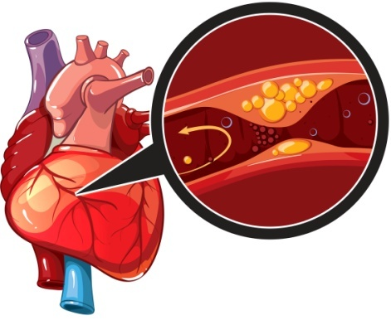
Fig 1. Coronary heart disease
According to the epidemiological study on mental disorder, approximately, 60% from depression, 10% from alcohol, 11% from anxiety or posttraumatic stress disorder and 14% from psychosis or schizophrenia [14].
SIGN AND SYMPTOMS:
- Chest pain
- Shortness of breath (SOB)
- Bodyache
- Feeling faint
- Nausea and vomiting.
RISK FACTORS:
- Chain smoking
- High blood pressure
- Diabetes
- Obesity and
- High LDL
- Age group (older individuals readily getting increases the risk of narrowed arteries)
- Excessive alcohol consumption.
PATHOPHYSIOLOGY:
CHD occurs primarily due to atherosclerosis which is initiated with the plaque formation within the artery, associated with someone’s lifestyle, environment and specially genetic factor [15]. Atherosclerosis is characterised by excessive deposition of fatty substance like, LDL, various inflammatory molecules in the wall of large artery. The monocytes transform into macrophages and oxidised LDL change into foam cells through scavenger receptor and releases interleukins and tumour necrosis factors known as pro-inflammatory cytokines [16].
This process is going on by the migration of smooth muscles from medial layer to the intima followed by fatty streak to complex lesions and they produce extracellular matrix molecules which develops a fibrous cap to cover fatty streak. The foam cells die inside the fibrous cap, so that lipids are released and forms lipid-rich pool [17].
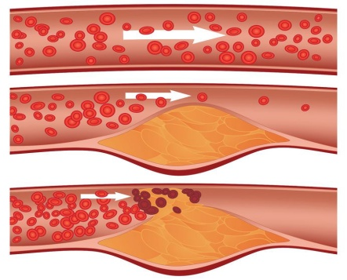
Generally two types of plaques can be defined: i) stable, ii) unstable / vulnerable. Vulnerable plaques are easily breakable, reveal the core of the plaque that circulate coagulated protein caused by thrombosis and an acute coronary syndrome (ACS) occurs during sudden artery lumen occlusion in the form of unstable angina [18].
Fig: Atherosclerosis [2]

Fig 2. Occurrence of Atherosclerosis
B) ACUTE MYOCARDIAL INFARCTION (AMI): It is defined as acute obstruction in coronary artery due to improper blood circulation in artery to the heart muscles [19]. It has two types – i) ST-segment elevation MI (STEMI) , ii) non ST-segment elevation MI (NSTEMI) and occurs due to unstable angina [20]. The most common cause of death in MI is cardiogenic shock which occurs when systolic blood pressure (SBP) is <90 mmHg for 30 min and associated with some clinical signs – i) decreased urine output, ii) altered mental status and iii) peripheral vasoconstriction [21].

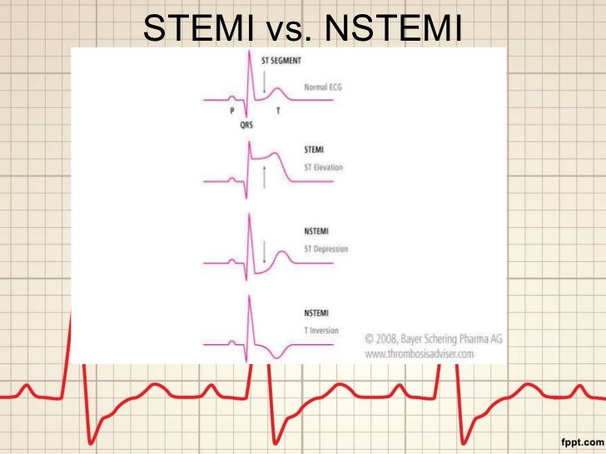
Fig 3. STEMI vs NSTEMI
Acute STEMI occurs due to occlusion of one or more coronary arteries that supply to heart with blood and it’s a myocardial ischemia known as myocardial necrosis [22]. The major risk factors are dislipidemia, type 2 DM, hypertension, smoking, drinking and family history.
NSTEMI occurs when heart does not get enough oxygen according to body’s needs.
SIGN AND SYMPTOMS:
- Pressure or tightness in the chest.
- Pain in chest, back, jaw and other areas of the upper body.
- Shortness of breath
- Sweating
- Nausea and vomiting
- Anxiety.
RISK FACTORS:
- Tobacco use
- Excessive alcoholism
- Overweight and obesity
- Less physical activity
- Thrombophilia states.
PATHOPHYSIOLOGY:
Acute myocardial infarction including ST segment elevation myocardial infarction (STEMI) develops due to the rupture of the atherosclerotic plaque with occlusion of coronary artery [23]. The infarction starts to develop in sub-endocardial area and progressed to subpericardial layers with ongoing duration of coronary occlusion [24] and that development occurs during coronary occlusion which is species-dependent due to differences in the innate collateral circulation but also the resistance to myocardial ischemia. In case of human, estimation from MRI (Magnetic Resonance Imaging) and biomarker analysis, 30-50% area at-risk is viable and salvageable by reperfusion after 4-6 h from the onset of angina problems [25] and infarction size limits by interventional reperfusion even after 12 h of coronary occlusion.
On the basis of morphology, an infarcted myocardium is characterised by myofibrillar contraction bands, swollen and ruptured mitochondria, microvascular destruction, haemorrhage and infiltrating leucocytes [26]. Necrosis is considered as an unregulated mode of cell death whereas more regulated modes of cell death occurs in infracting myocardium. The process of necrosis is introduced by activation of specific receptor- interacting kinases [27] and coronary circulation of ischemic injury manifests microvascular dysfunction, coronary micro-embolization of atherosclerotic particular debris, impaired release of vasoconstrictor substances from atherosclerotic lesion[28].
Most common pathophysiological mechanism is the formation of ROS responsible for myocardial and coronary microvascular ischemia injury but better coronary microvascular function clearly associated with better left ventricular function and less remodelling follows percutaneous coronary intervention [29].
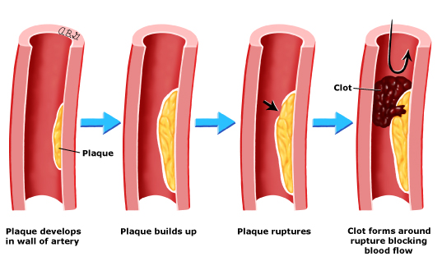
Fig 4. Myocardinal necrosis
C) DILATED CARDIOMYOPATHY (DCM): It is defined as, dilated cardio-myopathy is a condition of heart muscle in which they becomes weaker and enlarged, so that heart becomes disable to pump proper blood to the rest of the body [30]. The enlargement and dilation of one or both ventricles with impaired contractility characterised by <40% left ventricular ejection fraction (LVEF). DCM is classified as i) primary and ii) secondary.
Primary DCM is also known as idiopathic dilated cardiomyopathy characterised by ventricular arrhymias, thromboembolism and heart failure [31].
Secondary DCM causes including infectious myocarditis (eg. viral, Chagas disease, lyme disease etc.), ischemic disease, hypertension (HTN), alcohol abuse, peripartum cardiomayopathy [32].
In histologic examination, myocardium shows nonspecific changes of fibrosis and hypertrophy which discovers myocardial injury with marked infiltration by inflammatory cells [33].
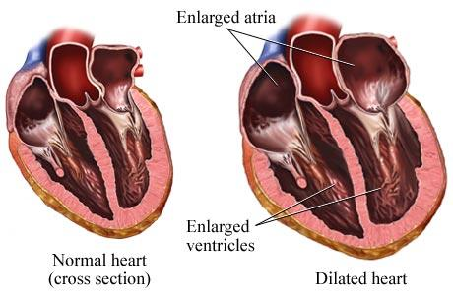
Fig 5. Cross section of healthy heart and dilated cardiomyopathy
SIGN AND SYMPTOMS:
- Fatigue
- Reduced ability to exercise
- Swelling over legs, ankles, feet or belly
- Chest discomfort
- Fast, fluttering or pounding heartbeat.
RISK FACTORS:
- Long term alcohol or drug abuse
- Inflammation of heart muscle from immune system disorder
- Damage to the heart muscle from certain disease called haemochromatosis
- Family history for DCM or cardiac arrest.
PATHOPHYSIOLOGY: The study of development of dilated cardiomyopathy has a wide variety of genes and dislodged intracellular structures.
Some mutated genes such as titin, myosin, actin, troponin, tropomyosin and specially sarcomore gene mutation’s abnormal functioning leads to myocardial dysfunction and DCM [34]. These diseases are characterised by involvement of several degrees of heart and muscle and almost 6% mutations occurs in case of DCM with conduction system disease and atrial fibrillation (AF) often precede this disease [35]. Some mutation occurring proteins such as filamins, dystrophin, desmin, d-sarcoglycan and vinculin all these responsible for muscular dystrophies and Filamin C variants are associated with severe arrhythmogenic DCM in absence of overt skeletal muscle[36].
Defective oxidative phosphorylation when occurs in mitochondria it results in deficient energy production in the form of ATP and hypertrophic, dilated, LV non-compaction takes place which is known as mitochondrial cardiomyopathies. DCM mutation described by ‘phospholamban’ gene which is responsible for inhibition of endoplasmic reticulum Ca²⁺ - ATPase. In case of mutation in the ion channel genes are SCN5A and ABCC9 are typically associated with ventricular dilation and RBM20, an RNA binding protein associated with splicing process [37]. These both are associated with arrhythmic disorder and severe heart failure.
Echocardiogram (ECG) of myocardial function shows that patients with Alzheimer’s disease (AD) also more prone to diastolic dysfunction. A β40 and A β42 are present in heart and their expression is increased in development of AD [38].
D) TRANSIENT ISCHEMIC ATTACK (TIA): Transient ischemic attack defined as sudden onset of neurologic dysfunction due to focal brain, spinal cord or retinal ischemia without acute infarction or tissue injury. It lasts generally <1 hour, more often min [39]. TIA classifies according to the pathophysiological mechanisms of ischemic stroke sub-types. Those includes large artery atherothrombosis, cardiac embolism, small vessel (lacunar), cryptogenic and uncommon sub-types such as vascular dissection, vasculitis. Previous history of stroke may enhance sustainability of recurrent TIA [40].
Prevalence of TIA in United States is approximately 2% and around 1000 of united sates, half of million per year suffering from this disease [40].
SIGN AND SYMPTOMS:
Sudden numbness of face, arm/leg, one side of body
Sudden onset of confusion
Trouble in speaking
Blurry vision
Seizure disorder
Syncope.
RISK FACTORS:
Family history of stroke
Hypertension
Older age (above 55 years and more)
Diabetes mellitus
Heart disease
Smoking, drinking.
PATHOPHYSIOLOGY
The mechanism of intra or extracranial atherothrombosis called ‘large artery atherothrombosis’ may the lack of blood flow to the site of arterial stenosis or artery to artery embolism. Small vessel arteriosclerosis or lipohyalinosis occurs and most common risk factor for TIA is hypertension followed by T₂DM and age. Sudden onset of clot formation in cardiac chamber, most commonly in left atrium, is known as cardiac thromboembolism. The term cryptogenic, often known as ESUS (embolic stroke of unknown source) is used to understand the cortical pattern of ischemia. It has no identifiable large artery atherothrombosis or cardiac source of emboli. Some other uncommon causes are arterial dissection and hypercoagulable states [41].

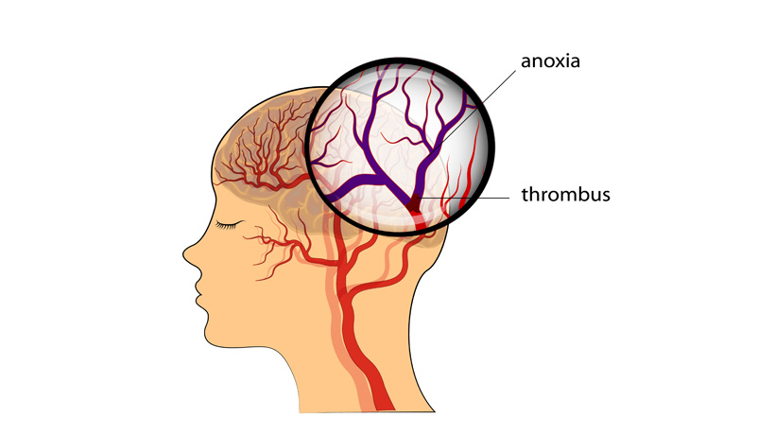
Fig 6. Onset of Mini-stroke
INTER-RELATIONSHIP BETWEEN CYTOKINE STORM AND HEART DISEASE:
Several studies have shown that, inflammatory markers such as CRP, ferritin, interleukin-6 (IL-6), IL-1β, interferon-γ (IFN-γ), monocytes chemoattractant protein-1 (MCP-1) and tumor necrosis factor-α (TNF-α) are increased due to COVID-19 infection leads cytokine storms[42]. The term, cytokine storm is a complex network of multiple molecular events. These include clinical phenotype of systemic inflammation, multi-organ failure.
Uncountable amounts of white blood cell including B cell, T cell, NK cell, machophages, dendritic cells, neutrophils, monocytes and some resident tissue cell releases high amounts of pro-inflammatory cytokines. Those pro-inflammatory cytokines and immune pathways induced by SARS-CoV-2 infection, specially CC chemokine ligand (CCL) 2, CXCL2, CCL8, CXCL1, Il33, CCL3L1 in BALF and CXCL10, TNFSF10, IL18, IL10 etc indicates cytokine storm in patients [43].
Patients with CVD are at higher risk of cytokine storm and that begins when cytokine secreting cells are activates with innate and adaptive immunity mechanism. Patient suffering from myocardial infarction and sudden occurance of COVID-19, have high rate of acute respiratory distress syndrome (ARDS) and frequent required ventilation than whose are without MI [44]. This myocardial injury mediated via ACE2 and other mechanisms of cardiac problems comprises cytokine storm and arbitrate between subclass of T helper cells and severe pneumonia which causes hypoxia [45].
This hypoxia is responsible for ischemic heart disease (IHD) that increase intracellular calcium leads to apoptosis (death of cell) of cardiac myocyte. This results in occurance of troponin leak and elevated BNP level. In case of rabbit, corona virus infection resulted from acute and even chronic heart failure (CHF) which related to human strain of corona virus [46].
MEDICATIONS PRESCRIBED FOR HEART DISEASE:
- Statins- to lower LDL
- Aspirin and Clopidogrel- to prevent clotting
- Warfarin- primarily use for heart valve disease
- Beta-blockers – to treat for heart attack, heart failure and sometimes use to low BP.
Or else, as directed by the cardiologist.
DIETARY MANAGEMENT OF CARDIOVASCULAR DISEASE:
Principle: Low fat particularly low saturated fat, low cholesterol, high in PUFA with ω-6 to ω-3 ratio 4-10 : 1, low calorie, low carbohydrate and normal protein, minerals and vitamins are suggested for patients suffering from cardiovascular disease. High fibre diet with increased amount of antioxidants is also recommended [47].
FOODS TO BE INCLUDED:
- Fish
- Whole grains, sprouted grams
- Walnuts and almonds
- Double toned milk
- Red wine
- Amla and other citrus fruits
- Vegetable oil
- Leafy and other vegetables
- Soya protein
- Onion and garlic.
FOODS TO BE AVOIDED:
- Whole milk and milk products
- Packaged fruit juice
- Chips and chocolates
- Desserts, pastries and puddings
- French toast
- French fries
- Ghee, butter and banaspati
- Paratha, puri
- Coconut
SAMPLE DAILY DIET PLANNING FOR A CARDIAC PATIENT:
Total energy: 1200-1300 kcal
Total protein: According to patient’s body weight (1 g/kg body weight)
Total fat: <20 gm.
3 main meals and 3 side meals.
TIME | FOOD ITEMS | SERVING SIZE
Early morning (6:30-7:00am) | Tea with milk/ liquor tea  Cream cracker/ oats biscuit | 1 cup  2-3 pcs
Breakfast (8:30-9:30 am) | 1) Upma/ poha (semolina/ flaked rice, carrot, beans,onion)  2) Boiled egg white | 1 medium bowl  1 pc
Mid morning (10:30-11:00am) | 1 whole fruit (not juice form) | 1 pc
Lunch (1:30-2:00 pm) | 1) Rice  2) Dal  3) Fish curry  4)Curd  5)Salad (carrot, cucumber, onion, tomato) | 50 gm  25 gm  50-60 gm  1 small bowl
Evening snacks (5:30-6:00pm) | 1) Tea with milk, cream cracker biscuit.  2) Puffed rice with onion, sprouts and cucumber). | 1 cup, 2 pcs  1 small bowl
Dinner (9:30-10:00 pm) | Chapatti  Papaya/ soyabean curry | 2-3 pcs  1 small bowl

DIETARY GUIDELINES:
- Low glycaemic foods may preserve HDL cholesterol and thus have a potentially positive effect in reducing CHD risk.
- Weight loss is preferable ever for a normal body weight person.
- Small and frequent meals are preferred.
- Outside meals should be avoided.
- Functional foods like vitamin-E, carotenoids and β-carotene, vitamin-C, soya protein, garlic, nuts, yogurt and milk, high fibre and spices should be included in a day’s diet [47].
EFFECT OF COVID-19 ON CARDIOVASCULAR SYSTEM:
- In certain cardiac myocytes and alveolar epithelial cells, Novel SARS-CoV-2 has been demonstrated to interact with ACE2 that enters into the host cell, has wide expressions in human body to observed heart, lungs, GI system and kidney.
- That ACE2 plays an important role in neurohormonal regulation and the binding of SARS-CoV-2 to ACE2 causes AMI and lung injury by ACE2 signalling pathways[48].
- ACE2 helps to give protection to the heart against the activation of rennin-angiotensin-aldosteron-system (RAAS) because it does convertion of angiotensin (1-7) from angiotensin II which is a vasoconstrictor, pro-inflammatory mediator and danages capillary endothelium while angiotensin (1-7) is a vasodilator.
- Due to down regulation of ACE2 and increased angiotensin II level leads heart damage and thus ACE2 mitigate heart injury [49].
- COVID-19 infection severely affects cardiac related biochemical pathways such as ACE2 signalling pathway, cardiac muscle integrity, fibrinogen pathways, redox homeostasis and plaque rupture those are silently occurs myocardial injury and cardiac dysfunction [50].
DISCUSSION
Through this article, we have to know various types of heart disease and their diet therapy which is very important for good life. The American guidelines demonstrate about the methods to reduce CVD risk factors by removal of tobacco intake of smoking, drinking and vigorous exercise. Medications are obvious for minimize the critical condition but lifestyle and diet modification can change everything drastically and give the patient’s long life.
CONCLUSION
This review paper is based on cardiovascular diseases with their risk factors, sign and reduce the occurance of major cardiac events thereby reducing premature disability and morbidity which prolongs survival and quality of life.

ACKNOWLEDGEMENT
We acknowledge our college authority to carry on the review work properly without any interruption.
CONFLICT OF INTEREST
There was no conflict of interest for this work.
REFERENCES
1) Olvera, L.V., Ballard, B.D., Jan, A. (2021) – Cardiovascular disease – Stat Pearls – NCBI book.
2) Huxley, R., Barzi, F., Woodward, M. (2006) – Excess risk of fatal coronary heart disease associated with diabetes in men and women.
3) Srilakshmi, B. (2016) – Dietetics, fifth multicolour edition.
4) WHO. The challenge of cardiovascular disease – quick statistics, 2016.
5) Stewart, J., Manmathan, G., Wilkinson, P. (2017) – Primary prevention of cardiovascular disease : A review of contemporary guidance and literature.
6) Dimmeler, S. (2011) – Cardiovascular disease review series (EMBO molecular medicine), 3(12): 697.
7) WHO. Cardiovascular diseases (CVDs). 2016.
8) Despres, J.P. (2012) – Body fat distribution and risk of cardiovascular disease, 126: 1301 –1313.
9) Benziger, C.P., Roth, G.A., Moran, A.E. (2016) – The Global Burden of disease Study and the Preventable Burden of NCD (National Library of Medicine), 11(4): 393-397.
10) Corell, C.U., Detraux, J., Lepeleire, J.D., Hert, M.D. (2015) – Effects of antipsychotics, antidepressants and mood stabilizers on risk for physical diseases in people with schizophrenia, depression and bipolar disorder (National Library of Medicine), 14(2): 119-136.
11) Haynes S.G., Feinleib, M., Levine, S., Scotch, N., Kannel, W.B.(1978) – The relationship of psychosocial factors to coronary heart disease in the Framingham Study. II. Prevalence of coronary heart disease, 107: 384-402.
12) Chilton, R.J. (2004) – Pathophysiology of coronary heart disease: A brief review[PubMed].
13) Frohlich, E.D., Quinlan, P.J. (2014) – Coronary Heart Disease Risk factors: Public impact of Initial and Later-announced risks (The Ochsner Journal), 14(4): 532-537.
14) Alcantara, C., Davidson, K.W.(2013) – Mental disorders and coronary heart disease risk (AHA Journals), 139-141.
15) Sayols-Baixeras, S., Lluis-Ganella, C., Lucas, G., Elosua, R. (2014) – Pathogenesis of coronary artery disease: focus on genetic risk factors and identification of genetic variants.
16) Glass, C.K., Witztum, J.L. (2001) – Atherosclerosis: the road ahead. Cell, 104(4): 503-516.
17) Tabas, I. (2010) – Macrophage death and defective inflammation resolution in atherosclerosis (Nature reviews immunology), 31(1): 21-24
18) Nakahara, T., Dweck, M.R., Narula, N., Pisapia, D., Narula J., Strauss, H.W. (2017) – Coronary artery calcification: From mechamism to molecular imaging (JACC cardiovasc imaging), 10(5): 582-593.
19) Sweis, R.N., Jivan, A.(2020) – Acute myocardial infarction (AMI) [MSD MANUAL].
20) Mechanic. O.J., Gavin, M., Grossman, S.A. (2022) – Acute Myocardial Infarction StatPearls (NCBI).
21) Forrester, J.S., Diamond, Chatterjee, K., Swan, H.J.(1976) – Medical therapy of acute myocardial infarction by application of hemodynamic subsets, 295: 1404-1413.
22) Alpert, J.S., Thygesen, K., Antman, E., Bassand, J.P. (2000) – Myocardial infarction redefined-a consensus document of The Joint European Society of Cardiology/ American College of Cardiology Committee for the redefinition of myocardial infarction, 36(3): 959-969.
23) Dewood, M.A., Spores, J., Notske, R., Mouser, L.T., Burroughs, R., Golden, M.S., Lang, H.T.(1980) – Prevalence of total coronary occlusion during the early hours of the transmural myocardial infarction (N Eng J Med), 303: 897-902.
24) Reimer, K.A., Lowe, J.E., Rasmussen, M.M., Jennings, R.B. (1977) – the wavefront phenomenon of ischemic cell death. 1. Myocardial infarct size vs duration of coronary occlusion in dogs, 56: 786-794.
25) Ibanez, B., Heusch, G., Ovize, M., Van de Werf, F.(2015) – Evolving therapies for myocardial ischemia/ reperfusion injury (J Am Coll Cardiol), 65: 1454-1471.
26) Reimar, K.A., Lowe, J.E., Rasmussen, M.M., Jennings, R.B. (1977) – the wavefront phenomenon of ischemic cell death, 56: 786-794.
27) Oerlemans, M.I., Liu, J., Arslan, F. Den Ouden K, van Middelaar, B.J., Doevendans, P.A., Sluijter, J.P.(2012) – Inhibition of RIP 1-dependent necrosis prevents adverse cardiac remodelling after myocardial ischemia-repurfusion in vivo, 107: 270.
28) Leineweber, K., Boese, D., Vogelsang, M., Haude, M., Erbel, R., Heusch, G. (2006) – Intense vasoconstriction in response to aspirate from stended saphenous vein aortocoronary bypass grafts (J Am Coll Cardiol), 47: 981-986.
29) Abraham, J.M., Gibson, C.M., Pena, G., Sanz, R., AlMahamad, A., Murphy, S.A., Blanco, J., Alonso-Briales, J., Lopez-Mesa, J., Gimeno, F., Sanchez, P.L., Fernandez-Aviles, F., GRACIA-2. (2009) – Association of angiographic perfusion score following percutaneous coronary intervention for ST-elevation myocardial infarction with left ventricular remodelling at 6 weeks in GRACIA-2 (J Thromb Thrombolysis), 27: 253-258.
30) MedlinePlus – National Library of Medicine.
31) Paldino, A., De Angelis, G., Merlo, M., Gigli, M., Dal Ferro, M., Severini, G.M., Mestroni, L., Sinagra, G.(2018) – Genetics of Dilated Cardiomyopathy (Curr Cardiol), 20(10): 83.
32) Vikhorev, P.G., Vikhoreva, N.N.(2018) – Cardiomyopathies and related changes in contractility of human heart muscle (Int J Mol Sci), 19(8).
33) Bakalakos, A., Ritsatos, K., Anastasakis, A.(2018) – Current perspectives on the dilated cardiomyopathy beyond heart failure (Hellenic journal of cardiology).
34) Herman, D.S., Lam, L., Taylor, M.R., et al. (2012) – Truncations of titin causing dilated cardiomyopathy (N Eng J Med), 366(7) : 619-628.
35) McNally, E.M., Golbus, J.R., :Puckelwartz, M.J.(2013) – Genetic mutations and mechanisms in DCM (J Clin Invest), 123: 19-26.
36) Zhou, A.X., Hartwig, J.H., Akyurek, L.M. (2010) - Filamins in cell signalling, transcription and organ development, 20: 113-123.
37) Zaklyazminskaya, E., Dzemeshkevich, S. (2016) – the role of mutations in the SCN5A gene in cardiomyopathies, 1863(7): 1799-1805.
38) Troncone, L., Luciani, M., Coggins, M., Wilker, E.H., Ho, C., Codispoti, K.E., Frosch, M.P., Kayed, R., Monte, F.D.(2016) – Ab amyloid pathology affects the hearts of patients with alzheimer’s disease (J Am Coll Cardiol), 68: 2395-2407.
39) Gennai, S., Giordano-Orsini, G., Lefour, S., Cuisenier, P.(2018) – Transient ischemic attack: limits and challenges of early management, 47(11-12): 934-937.
40) Navis, A., Garcia-santibanez, R., Skliut, M. (2019) – Epidemiology and outcomes of Ischemic Stroke and transient ischemic attack in the adult and geriatric population (J Strole Cerebrovasc Dis), 28(1): 84-89.
41) Panuganti, K.K., Tadi, P., Lui, F.(2022) – Transient Ischemic Attack (NCBI).
42) Wu, C., Chen, X., Cai,Y., Xia, J., Zhou, X. (2020) – Risk factors associated with acute respiratory distress syndrome and death in patients with COVID-19, 180(7): 1-11.
43) Azkur, A.K., Akdis, M., Azkur, D., Sokolowska, M., Vande veen, W. (2020) – Immune response to SARS-CoV-2 and mechanisms of immunopathological changes in COVID-19, 75(7): 1564-1581.
44) Bonow, R.O., Fonarow, G.C., O’Gara, P.T., Yancy, C.W. (2019) – Association of COVID-19 with myocardial injury and mortality (JAMA Cardiol).
45) Zhou, F., Yu, T., Du, R., Fan, G., Liu, Y., Liu, Z. (2020) – Clinical course and risk factors for mortality of adult inpatients with COVID-19 in Wuhan, China: a retrospective cohort study. Lancet, 395: 1054-1062.
46) Small, J.D., Aurelian, L., Squire, R.A., Strandberg, J.D., Melby, E.C., Turner, T.B., Newman, B. (1979) – Rabbit cardiomyopathy associated with a virus antigenically related to human coronavirus strain 229E, (J Am Pathol), 95: 709-729.
47) Srilakshmi, B. (1993) – Dietetics (seventh multi-colour edition).
48) Li, W., Moore, M.J., Vasilieva, N., Sui, J., Wong, S.K. (2003) – Angiotensin-converting enzyme 2 is a functional receptor for the SARS-CoV-2, 426: 450-454.
49) GroB, S., Jahn, C., Cushman, S., Bär, C., Thum, T. (2020) - SARS-CoV-2 receptor ACE2-dependent implications on cardiovascular system: from basic science to clinical implications (J Mol Cell Cardiol), 144: 47-53.
50) Bansal, M. (2020) – Cardiovascular disease and COVID-19, 14: 247-250.

