Maintenance Breeding
Pramod Sargar*^{1,2}, Jwala Pranati^{2,3}, Suma Krishnappa⁴, Shivaji Mehtre⁵, C V Sameer Kumar³ and P. B. Wadikar⁶
1. Vasantrao Naik Marathwada Krishi Vidyapeeth Parbhani. Maharashtra. India 431 402.
2. International Crop Research Institute for the Semi-Arid Tropics, Patancheru, Telangana, India 502 324.
3. Professor Jayashankar Telangana State Agriculture University, Hyderabad, Telangana
India 500 030.
4. University of Agriculture Sciences Bengaluru, Karnataka, India 560 065.
5. Officer Incharge, AICRP on Soybean, V.N.M.K.V., Parbhani. Maharashtra. India 431 402.
6. College of Agriculture Latur, Maharashtra. India 413 512.
*Corresponding author: pramodsargar28@gmail.com

Abstract:
Agriculture is the backbone of the Indian economy. Its success depends on several factors, one of which is the seed. High-quality seeds proved to make a significant contribution to cultivar yield. The purity and integrity of seeds facilitate the growth and development of agriculture to feed India's population, which is growing at an alarming rate. There are different classes of seeds such as nucleus seed, breeder seed, foundation seed and certified seed. Numerous seed health determining factors guide the quality of these seeds. Thus, maintaining the physical and genetic purity of each and every cultivar is of prime importance. It is achieved by “Maintenance Breeding” which aids in multiplication and distribution of quality nucleus and breeder seeds to the chain of seed multiplication. Controlled pollination is the pre-requisite to keep up the purity of seeds and any amount of out crossing will lead to deterioration of its quality. In this view of achieving quality seed production, maintenance breeding involves organized multiplication, effective seed certification and accurate phased testing at the field, processing and storage facilities. Thereby the know-how of maintenance breeding is crucial for a breeder/seed technologist in further development of agriculture. The present chapter elaborates on the features, procedures and importance of maintenance breeding and throws light on procedures to be employed in nucleus and breeder seeds of self- and cross-pollinated crops. It also highlights the causes of varietal deterioration and methods to overcome them for quality seed production.
Keywords: Nucleus seed, Breeder Seed, Cultivar, Maintenance Breeding, Pollination, Varietal deterioration
Introduction
The most reliable and affordable input that impacts the success of agriculture is a seed. High-quality seed is reported to increase crop output by up to 30%. Based on the likelihood of germination, moisture content, disease, and insect occurrence, the quality seed would be determined. The requirement to establish high-quality seed maintenance became essential as a result of current climatic changes, which pose worrisome requirements to feed nine billion people by 2050. Additionally, it would guarantee the crop's vigorous growth and development. Maintenance breeding is the branch of breeding that deals with preserving the consistent expression of a variety for all of the prioritized characteristics across time.
A breeder and/or seed technologist maintains the genetic identity and purity of a released variety as it is produced year after year. This process is known as "maintenance breeding," which aims to keep a variety in its original and purest form. The phrases "maintenance breeding" and "nucleus seed production" are interchangeable. For diverse types of cultivars in various crops, there are several processes for variety preservation and nucleus seed generation. The preservation and proliferation of better open-pollinated varieties (OPVs) and hybrids in cross- and often cross-pollinated crops are barely reported in the literature.
The preservation of local varieties is a dynamic process in which the farmer frequently makes selections based on a specific variability within the variety that is unique to that particular landrace. Farmers often keep the variety's core qualities while allowing for ongoing alterations that aid in adapting to the variable climate and soil properties. Farmers can adapt to these changes because of the genetic diversity seen in landraces, and selection within a genetically varied variety need not always result in noticeable alterations (Thijssen et al., 2008).
The ideas and procedures of seed production to preserve the genetic integrity, physical purity, and health of the seed are known as maintenance breeding. Its basic tenet is the elimination of diseases, off-types and other flaws that degrade the quality of seed production by negative selection of lines within the population. It uses a technique known as varietal maintenance technology to maintain the genetic purity of varieties and hybrids that have been notified or released. Maintaining genetic purity entails keeping a population that is true to type, genetically similar, and homogeneous, which calls for meticulous seed production over many seasons and years.
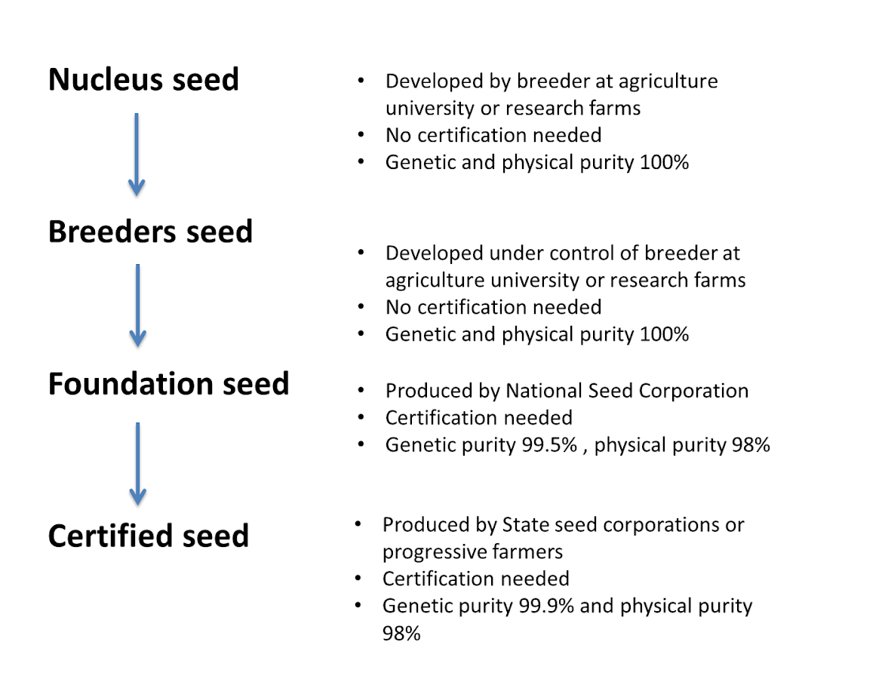
In order to maintain its physical, morphological, and genetic purity, India has a strong and extensive seed manufacturing and supply pipeline. It adheres to a constrained, conventional seed system that primarily emphasizes breeder, foundation, and certified seed. For enhancing the seed supply pipeline with high-quality seed, each level has a distinct seed purity level (Figure 1).

Figure 1: Classes of seed production
In order to achieve the criteria of seed production, the chain of maintenance breeding involves a strong varietal development by the breeder, organized multiplication, effective seed certification, and accurate phased testing at the field, processing, and storage facilities.
Cultivar/Variety Maintenance
The genetic makeup of variations is determined by the method of reproduction. The crops may now be divided into the following four groups:
- Typical cross-pollinating crops.
- Self-pollinating plants that outcross often
- Common self-pollinating plants with minimal outcrossing
- The vegetatively reproduced crops.
Open-pollinated plants like maize have populations that are genetically restricted and have a high frequency of the desired genes. They are difficult to maintain. It is challenging to maintain improved cultivars of category B crops like quinoa (Chenopodium quinoa) and faba beans (Vicia faba). Improved cultivars of category C crops, such as wheat, barley, Hordeum vulgare, and common beans, are very easy to maintain and comprise very comparable desirable genotypes. Improved cultivars of the final group of crops, like the potato, are clones, and it is simple to maintain their genetic integrity. However, maintaining them and keeping them virus- and pathogen-free is quite challenging.
Maintenance of a Cultivar
Every cycle of multiplication must begin with the breeder's seed, which serves as the basic stock seed. When seeds are stored in sufficient quantities at low temperatures, they remain viable. There must be enough data saved to conduct several rounds of multiplication. This necessitates a large storage area for crops with modest rates of reproduction. In many cases, this is not a practical choice. A cultivar should be maintained via maintenance selection if storage is not an option.
Maintenance Selection: The care selection begins with a small plot made up of many evenly spaced BS plants. For crops with a low rate of reproduction, such as potatoes, common beans, faba beans, barley, and wheat, the plants must be adequately spaced to allow for individual plant evaluation and the gathering of enough seed per plant. For progeny testing, a good number of healthy plants of the cultivar type are chosen and marked. Remove any plants that have a seed-borne disease. In the next season, the first-cycle offspring, the seeds of the marked plants are gathered from each plant and planted in tiny plots (Figure 2).
The seed is bulked per progeny and only progeny plants with the necessary uniformity are chosen. The whole offspring should be eliminated even if just one or two plants exhibit phenotypic abnormalities, such as being infected with a virus that is spread by seeds. Crops that undergo cross-pollination cannot preserve their purity for very long. The seeds are kept in the best possible storage conditions for this. The cultivar may experience genetic changes during maintenance selection that are either favourable or negative. Depending on the balance between the contaminating forces and the selection pressure against such forces, either a positive or negative manner will be favoured.

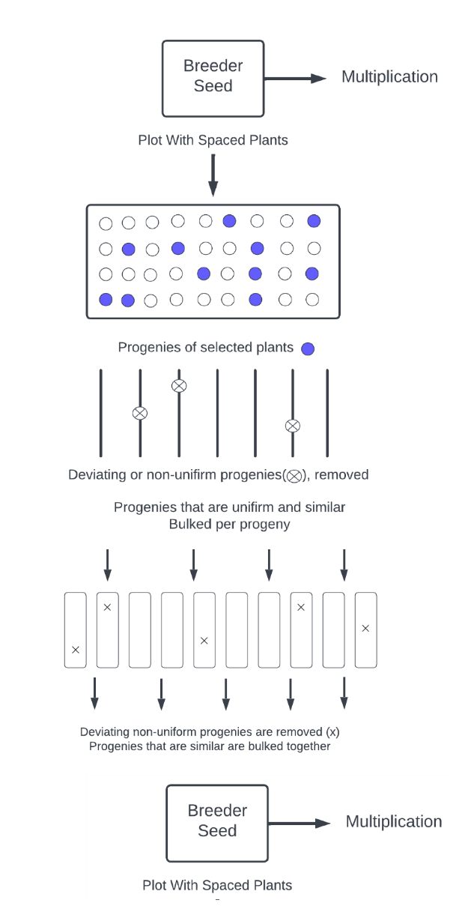
Figure 2: Maintenance selection, general scheme, starting from the bag of breeder seed (BS).
A gene pool that has had its genes rearranged into different genotypes for each generation is a better cultivar. These detrimental effects can be offset by the maintenance selection of powerful genotypes. The BS will get better after every maintenance selection cycle compared to the prior one. If progeny size is maintained at a size that is quite big, repeated maintenance selection will guarantee improvement over time. Depending on whether the progeny is evaluated before or after flowering, the case of cross-pollinating crops is different. Pollination by undesired plants cannot be stopped if evaluated after flowering. Before flowering, features related to vegetative development are often evaluated.
The qualities connected to the generative growth complex, such as seed yield, are typically adversely correlated with selection for larger yields of those traits. Due to this negative association, there is a moderately strong natural selection. When cultivars of late spinach (Spinacia oleracea) are maintained and seeds are produced, there is a significant natural selection towards earlier bolting since leaf yield is favourably correlated with late bolting and negatively correlated with seed yield. If the evaluation is performed prior to flowering, the selection intensity will need to be quite high in order to carry out genotype selection within progenies. Use of the remnants seed technique is advised when the assessment is conducted after flowering (as in the case of maize). Only a tiny portion of the seeds from each ear are planted in the first-generation cycle of maize due to its fast rate of multiplication. The second progeny cycle is planted using the leftover seed from the chosen plants. To accommodate more seeds, the plot in the second cycle might be expanded. To guarantee robust selection, start with a large number of ears.
Features of maintenance breeding:
- Enhancing the lifespan of released or notified varieties and commercial hybrids is one of the key goals of maintenance breeding.
- It is an easy technique for maintaining varietal integrity.
- Purification of improved varieties is accomplished using it.
- It can also be utilized to purify the hybrids' parental lines.
- It keeps variation in the variety.
- Continuous breeder seed production of varieties that have been released publicly or notified is required.
- Breeder seed generation of the parental line of the released variety is carried out through maintenance breeding.
- The key factors taken into account are germination, physical purity, and genetic purity. When enough genetically healthy seeds can be generated to enable the new variety to be produced on a commercial basis across its adoption region, only then can the value of enhanced varieties be fully realized. (Gupta et al.,).
- Generally speaking, seed health is important. Maintenance breeding begins with the breeder and foundation seed. It protects the variety from degrading.
Genetic causes of varietal deterioration
The key issue has been how to maintain or preserve a cultivar in its original form without having its performance degrade over time. The variety degrades throughout stages of repeated multiplication. The factors that contribute to varietal degradation and that the maintenance systems should prevent have been extensively studied (Kadam 1942; Lewis 1970 and Agarwal 1980). Important genetic factors to varietal degradation include:
- Natural cross-pollination
Most of the currently adapted cultivars have become heterogeneous for numerous key agronomic characteristics, including biotic and abiotic stress tolerance, as a result of repeated outcrossing. Additionally, natural outcrossing will seriously hinder the development of pure lines and the maintenance of the purity of cultivars that have been produced. Cross-fertilization must be avoided in order to solve these issues, and this may be done by growing plants in total isolation (Gupta et al., 1980).
In sexually propagated crops, natural crossing can be a significant cause of varietal degradation. The degree of natural cross-fertilization determines the contamination level. Natural crossing with undesired types, diseased plants, or off types causes degeneration. The most crucial element in preventing contamination of cross-fertilized crops is the isolation of seed crops.
- Mutations
Heritable alterations that occur suddenly do not adversely harm variety. Minor mutations that develop spontaneously are sometimes difficult to spot or detect and may disappear over later production cycles due to nature's selective elimination. Yield trials must be conducted to detect those variations.
- Gene frequency modifications brought on by powerful genetic drift
When seeds are multiplied across a broad region, only little amounts are harvested and saved for the following year's planting. Due to such sub-sampling, not all genotypes will be reflected in the following generation, changing the genetic makeup. Genetic drift is the term used to describe the gradual decline of genotypes caused by sampling error. Variations in varietal traits will result from these variations in gene frequency.
- Minor genetic variations
Although the population is phenotypically homogeneous, there may be some little variance. They are often removed by the selection, but they might possibly be carried forward and affect the yield. Care should be given when maintaining the nucleus and breeder seed since it is a common trait in often cross-pollinated species. In self-pollinated crops, the breeder's seed and nucleus seed must be periodically tested for the varieties.
- Non-genetic causes of varietal deterioration
- Mechanical mixtures
Mechanical mixtures, which frequently occur when more than one variety is sown with the same seed drill, through volunteer plants of the same crop in the seed drill, through volunteer plants of the same crop in the seed field, or through different varieties grown in adjacent fields, are the most significant cause of varietal deterioration. Typically, during harvesting and threshing operations, two varieties growing adjacent to each other in a field are combined. The threshing machinery frequently contains seeds from other species. The elevators, seed bins, and gunny bags are all infected as well. To prevent such mechanical contamination, seed manufacturing and processing must be carefully inspected and carried out with the utmost care (Kadam et al., 1942).
- Techniques of the Plant Breeder
Cytogenetic anomalies might lead to serious instabilities in variations in the form of incorrect evaluations when new varieties are released. Early introduction of varieties when they are still being selected for disease resistance and susceptibility or other characteristics might seriously deteriorate them. The variety testing program is responsible for this failure. Other heritable variants caused by recombinations and polyploidization may also occur in varieties during seed production in addition to these reasons; these variations can be prevented by periodic selection during seed stock maintenance.
- The specialized impact of diseases and pests
The degeneration of new crop types is frequently selectively influenced by their susceptibility to newer races of pests and diseases brought on by obligatory parasites. If a virus, fungus, or bacterium infects the vegetatively grown stock, it can degenerate rapidly as well.
- Developmental variations
Developmental differences may arise as distinct growth responses when seed crops are cultivated for multiple successive generations in conditions with various photoperiods or at various altitudes. Therefore, it is preferable to produce certain crop varieties where their developmental transitions occur.
- Varietal deterioration due to repeated multiplication
The same variety will deteriorate if it is multiplied again year after year. This might happen as a result of seed mixtures, unfavourable pollination, outcrossing, etc., which has an impact on crop performance and varietal genetic purity. During seed formation, this deterioration should be prevented. Farmers and seed growers must be made aware of the need to produce high-quality seeds in their fields.
- Adverse agro-climatic conditions
A number of things may deteriorate as a result of unfavourable agro-climatic circumstances such as flood, drought, salt of the soil, etc.
- Techniques for maintaining genetic purity.
In order to maintain the genetic purity of the seed, Horne (1953) proposed a few criteria, including:
- Use only approved seeds from a reputable source for propagating seeds.
- It is essential to inspect the field before planting.
- It is essential to examine the field throughout crop growth for weeds, diseased plants, and off-types.
- Cleaning and sealing of the harvested lots are required.
- The genetic purity of approved stocks should be determined by a grow-out test.
- Also, to preserve the genetic purity, Hartman and Kester (1968) offered some guidelines:
- To prevent mechanical mixing or random pollination, a specified isolation distance must be maintained based on the crop and manner of pollination.
- Off-types and weeds must be kept out of fields.
- In order to prevent genetic drift, crops must be cultivated in appropriate areas.
- strict certification and inspection procedures to maintain purity.
- Grow out tests should be conducted on a regular basis to check the genetic purity.
- It is important to adhere to the generation system.
- Types of maintenance procedures
- Maintenance procedures for crops that are often cross-pollinated and self-pollinated:
While both the genetic and non-genetic elements responsible for purity deterioration exhibit a significant level of diversity due to the necessity to preserve its purity, self-pollinated crops are noted for their uniformity. Maintaining purity is particularly important for the nucleus and breeder seed, which will be used to produce future generations.
- Nucleus seed maintenance for recently released varieties of self-pollinated crops:
Harrington (1952) outlined a procedure to maintain the pre-released and newly released varieties:
- Sampling of the varieties to form the nucleus seed:
- Based on their performance, the lines are chosen and moved forward for sampling.
- The samples should be taken from the middle rows, discarding the borders and diseased plants, and should not contain more than 15 varieties and 200 plants in each variety.
- They are pulled up four to five days before they reach full maturity in order to facilitate harvesting and prevent shattering.
- The samples are collected in bundles and kept in storage until the final yield is estimated.
- Examining the samples on a table:
  - To prevent mechanical mixes, each sample must be threshed, cleaned, and packaged individually.
  - The nucleus seed is formed by taking up the stacks of selected varieties in a variety purification nursery.
- Locating and seeding of the nucleus seed:
  - The seeds must be planted in a clean, fertile field.
  - Each sample contains 200 plants, which are divided into 50 double-row plots in a four-row series with enough room between them for observation and isolation.
- Inspection of the plots:
- To ensure purity, the field should be checked for off-types, weeds, and unhealthy plants. Periodic roughing should also be done.
- Harvesting and post-harvest process of the nucleus seeds:
- The samples must be collected separately, tied together for threshing, and then,
- Treated with a certain fungicide and pesticide before being kept as "breeders seed."
- Maintaining breeding stock of pre-released or recently released types in self-pollinating plants:
  - The breeders stock seed should be planted in the fertile ground with sufficient isolation.
  - To prevent natural crossings and contamination, regular field inspections and roughing are required.
  - The samples must be collected, separated, and labelled.
  - They create the breeder's seed, a part of which must be kept by the breeder.
- Maintaining breeding stock for cultivated varieties in self-pollinating crops:
There are two techniques to retain the breeders' seed:
- By keeping the necessary isolation distance from crops.
- By cultivating a large population of 2000–2500 plants and then screening out those that reflect particular plant characteristics. Further table examination is done. Thus, the chosen seed becomes the breeder seed.
- A part of the breeders seed is to be preserved as carry-over seed by the breeders indicated in order to continue a variety and ensure 100% purity.
2. Breeder seed and nucleus seed maintenance in cross-pollinated plants.
In contrast to self-pollinated crops, cross-pollinated crops require far more effort to maintain variety in their purity. It mostly entails the upkeep of nucleus and breeder seeds from inbred lines. These two methods are briefly outlined.
- Maintenance of nucleus seed of inbred lines
Once a hybrid has been properly examined and found to be suitable, the parental line seeds must be replicated in the way described below:
- Hand pollination
- Inbred nucleus seeds must be maintained by sib pollination, self-pollination, or a mix of both.
- The individual selfed or sib-mated ears should be carefully inspected; any that are off types, inferior in any way, or different in any way—for example, in texture, seed size, seed colour, or shape—should be discarded.
- The individual selfed or sibbed ears can then be separated, threshed, and seeded in double-row plots using the ear-to-row technique.
- Sowing of hand-pollinated seed
- The hand-pollinated seed should be planted in rich ground that is devoid of weeds.
- It is not recommended to plant the same crop in a prior season.
- The hybrid must be released in the region where the seed is to be planted.
- Isolation
- Suitable isolation to prevent natural cross-pollination and the spread of diseases, space should be provided.
- To avoid contamination, use distance or space isolation.
- Inspection of double-row plots and roughing
- Prior to pollen shedding, the double-row plots must be thoroughly inspected for off types.
- Off types are easily distinguished because they are more vigorous than inbred lines.
II. Maintenance of nucleus seed for non-inbred lines
- In cross-pollinated lines, sib mating is preferable to selfing in order to maintain the parent lines.
- To prevent unnecessary pollination, the lines are planted with a specified isolation distance or barriers.
- They are produced using the ear-to-row method, and each ear is meticulously inspected to look for weeds, sick plants, and off types in order to practice roughing.
- The chosen ear heads are then collected and separately threshed to be cultivated using the ear-to-row method or in bulk the following season to create the breeders seed.
III. Maintenance of breeders seed for inbred and non-inbred lines:
- It is isolated to sow the breeders stock seed made from the nucleus seed.
- To preserve the highest level of genetic purity, roughing and inspection are used to identify pollen shedders and off-types.
IV. Maintenance of breeder seed stock for cultivated cross-pollinated variants:
There are two techniques to maintain the breeders' seed:
- By keeping the necessary crop-specific isolation distance
- By choosing plants that exhibit particular plant features from a mass population of 2000–2500 plants. The table is examined once more. Thus, the chosen seed produces the breeders seed.
3. Maintenance of Marker-assisted breeding-derived varieties:
For marker-assisted breeding to be successful, breeding methods must be enhanced and kept up throughout the multiplication processes. To preserve the bred lines, a genetic purity evaluation using specially created gene-based markers and morphological selections is necessary. All phases of seed development require this follow-up.
4. Maintenance of apomictic species:
Although facultative apomictic have a possibility to add to the variety even though apomictic species are often recognized for their asexual reproduction. Additionally, mechanical mixes and mutations deteriorate purity.
Therefore, they must be sustained by expanding in large populations with the necessary separation for precise observations. Before flowering, any inferior plants should be eliminated, and the seed is bulked to create the next breeder's seed bulk.
- Maintenance procedures are generally of two types based on the stage of crop:
- Selection Procedures at field:
- Continuous comprehensive field testing is required.
- The material is subject to spontaneous mutations, outcrossing, and changes in gene frequency.
2. Storage Methods at post harvest:
- Testing in the field is not necessary.
- The seed material is not subjected to outcrossing, mutations, illnesses, insects, mechanical mixing, changes in gene frequency resulting from both natural and artificial selection, nor is it subjected to selection exercised by breeders.
- Breeding approaches used for varietal maintenance (Singh et al., 2021)
The genetic integrity of cultivars and hybrids is preserved in agricultural plants using a number of breeding techniques and technologies. The method of pollination, the crop's genetic make-up, and the choice of breeding process all influence varietal preservation. The following are often employed breeding strategies:
- Positive mass selection
choosing the best harvests from a diverse population, then combining the seeds to grow the following generation. This procedure has been ongoing for several years. Old varieties or land races are typically chosen as the starting point for mass selection. Positive approaches or the selection of suitable plants are frequently used. For varietal purification in many field crops, this technique is frequently utilised. Menbane employed this technique on cotton for the first time in Texas, USA. This technique is now routinely utilised to maintain cotton's varietal integrity.
Advantages of positive mass selection in varietal maintenance
- It is an easy technique for maintaining varietal health.
- It is applied to purify enhanced varieties.
- It can also be used to purify the hybrids' parental lines.
- It keeps variety's diversity.
Disadvantages of positive mass selection in varietal maintenance
  - The phenotype, which may not necessarily be a sign of superior genes, is the basis for selection.
  - There is no progeny test performed.
- By raising the crop in isolation
Growing local varieties in solitary plots and rouging throughout different growth stages allowed the breeder's seed to be preserved. The breeder seed crop is handled in the same way as the breeder's seed of recently released varieties.
- Negative mass selection
Removing undesired crops from a mixed population allows the other crops to reproduce in the following generation. This is typically employed in seed manufacturing and certification procedures for varietal purity. This contributes to the varieties' high genetic integrity, especially in crops that self-pollinate. Another name for it is rouging of off-type plants. It is frequently employed to maintain different field crops' varietal integrity. It has been discovered to be a successful maintenance method for cotton. This is an easy technique. Phenotype-based selection is used; progeny tests are not used.
Merits:
- It is a straightforward technique for maintaining varietal purity in many crops, and it is frequently employed.
- The maintenance process is simple and doesn't require much expertise.
- In comparison to the quantity of plants kept, very few plants are being discarded.
- It can also be utilized to maintain inbred lines that are used to create hybrids.
- The variety's genetic diversity remains unaffected.
- Both self-pollinated species and cross-pollinated species employ it.
Demerits:
- There is no progeny test performed.
- Off-type plants can occasionally escape, which can cause the variety to become contaminated in subsequent cycles of seed multiplication.
- A careful evaluation of off-type plants is necessary.
- Plant-to-row method
This maintenance breeding technique is based on progeny testing. The term "progeny row selection" is often used. The parent variety is used to select large numbers of single plants (500–1000) that are true to the type. Plants that meet a variety's standards are chosen, while the remainder is eliminated. Rows of chosen offspring are cultivated in the next crop season. The progenies that meet the variety's requirements are bulked, and the others are eliminated.
Several researchers have proposed the following adjustments to this plan:
- To evaluate the performance of the variety, some experts believe that progeny tests should be carried out for at least a year.
- Others feel that a progeny test last a year is insufficient. The testing of progeny should last for two, three, or more seasons. A pedigree system or pedigree technique of selection is utilized when several years' worth of progeny testing is conducted.
Below are the merits and demerits of the plant-to-row approach.:
Merits:
  - The breeding value, or offspring performance, which provides a deeper knowledge of the variety, is the basis for selection.
  - Compared to the first three ways, it is a more scientific approach.
  - Both field and lab assessment are included.
  - Large samples are used in progeny testing, which gives greater precession.
Demerits:
- Since it also evaluates the performance of the progeny, it is a more time-consuming and difficult procedure.
- For testing and evaluation, more experimental spaces are needed.
- Testing needs at least two crop seasons.
Model-bulk system
It describes a cultivar that is cultivated in bulk plots F2-F5 with or without selection. The following generation is grown using bulk seed. Following in F6 or later generations was individual plant selection. From the F2 seed bulk or from a balanced bulk of the plants kept as progenitors of breeder's seed and 400–500 plants that match the phenotypic profile of the chosen variety, about 1,000 plants can be cultivated. 100–200 plants that exhibit the traits of the cultivar are chosen for harvest. To be used as breeder's seed, a bulk of seeds from each plant is made in an equal amount. For use in future varietal maintenance and seed production, 50–75 seeds from each plant can be stored individually to act as progenitors of breeder's seed.
This technique was initially utilised by Manning et al. in 1957. In a variety, a large number of single plants (300–500) that are prolific and true to type are chosen according to this approach. Then, under controlled laboratory conditions, these plants are tested for different parameters. The other plants are thrown away while those that meet the variety mean for the characteristics are chosen and their seed is bulked to establish new generations. This technique is frequently employed in maintenance breeding.
Merits:
- This is a straightforward process for varietal purification.
- Compared to the first two procedures, this one is more scientific.
- It is based on observations made in the field and the lab.
- This technique can be utilized in various crops.
Demerits:
- To make a selection, a large population must be raised.
- Phenotype is the basis for selection.
- More labour, time, and space are needed
- Prospects of maintenance breeding:
- The seed's lifespan would be extended while being protected from genetic degradation.
- Increases crop growth, which in turn increases crop productivity.
- Gives farmers access to trustworthy seeds.
- Purifies the parents and cultivars with excellent yields.
Limitations of maintenance breeding
- Although significant efforts are being made to create and disseminate high-quality seed to farmers, there is still a gap that forces farmers to rely on farm-saved seeds since many parts of the nation have seed replacement rates of less than 50% for cereals and 20% for pulses and oilseeds.
- Long cycles of multiplication over time would lead to a decline in quality.
- Random pollination results in genetic drift, which reduces homogeneity.
- Agronomic performance evaluation in the agricultural fields would make it difficult to manage several big cultivars at once.
- Many testing methods now in use simply consider phenotypic performance.
- The progeny row approach takes more time (two to three crop seasons) to assess a variety's purity.
- The majority of testing techniques simply consider phenotypic performance.
- A significant part of the plants is rejected in the positive bulk selection, increasing the cost.
References
Agarwal, R. L. 1980. Seed technology, New Delhi, India: Oxford and India Book House. 685 pp.
Elias, S. G. (2018). The importance of using high-quality seeds in agriculture systems. Agricultural Research & Technology: Open Access Journal, 15(4), 1-2.
Evans, L.T. and Fischer, R.A., 1999, Yield potential: its definition, measurement, and significance. Crop Sci., 39(6): 1544-1551.
Hartman, H. T. and Kester, D. E. 1968. Plant propagation - principles and practices. Prentice-Hall Inc., Englewood Cliffs' N.J. 701 Pp
Horne, F. R. (1953). The significance of weed seeds in relation to crop production. In Proceedings of the 1 st British Weed Control Conference (pp. 372-399).
Kadam, B.S. and Patankar, V.K., 1942, Natural cross-pollination in safflower. Indian J. Genet. Pl. Breed.
Kumar, N. and Singh, M., 2019, Production and maintenance of nucleus and breeder's seed. Annals of Horticulture, 12(1): 88-92.
Lewis, C.F., 1970, Concepts of varietal maintenance in cotton. Cotton Growing Review, 47: 272-84.
Manning, H.L., Faulkner, R.C. and Kibukamusoke, D.E.B., 1957, Plant breeding. Cotton Research Station, Namulonge, Uganda. Progress report for the season 1955-1956. Plant breeding. Cotton Research Station, Namulonge, Uganda. Progress report for the season 1955-1956.
Peng, S., Huang, J., Cassman, K.G., Laza, R.C., Visperas, R.M. and Khush, G.S., 2010, The importance of maintenance breeding: A case study of the first miracle rice variety-IR8. Field crops research, 119(2-3): 342-347.
Rajasekhar, D., Manjunath, P., & Yadav, B. N. P. Maintenance Breeding: Importance and Its Role in Crop Productivity.
Rao, D., & Pashwan, V. R. (2022). Maintenance Breeding for Nucleus and Breeder Seed Production in Self-and Cross-Pollinated Crops. Agriculture & Food E-Newsletter.
Sahu, R. K., Sah, R. P., Sanghamitra, P., Verma, R. L., Patil, N. K. B., Jena, M., ... & Singh, O. N. (2018). Quality seed production and maintenance breeding for enhancing rice yield. ICAR-NRRI.
Singh, A., Mishra, U. Ku, Singh, V., Singh, S., Singh, G. and Pandey, J. 2021, Maintenance Breeding and Its Importance. Biotica Research Today. 3, 4 (Apr. 2021), 225-227.
Singh, P., Singh, R. P., Singh, M. K., & Mohapatra, C. (2014). Quality seed production, its testing, and certification standard. Biologix, 3rd edn. Mewar Institute of Management, Sec-4C, Ghaziabad, 126-142.
Thijsen, M.H., Bishaw, Z., Beshir, A. and De Boef, W.S., 2008, Farmers, seeds and varieties: supporting informal seed supply in Ethiopia. Wageningen International.
Yadav, R.N., Kumar, P.R., Hussain, Z., Yadav, S., Lal, S.K., Kumar, A., Singh, P.K., Bera, A. and Yadav, S.K., 2022, Maintenance Breeding. In Fundamentals of Field Crop Breeding (pp. 703-744). Springer, Singapore.

