Porous Carbonaceous Materials for Pesticide Removal from Various Environmental Matrices: A Brief Overview

Subhasis Sarkar#, Arkadeb Mukhopadhyay# *, Abhishek Mandal* | Manas Barman
Division of Agricultural Chemicals | Department of Soil Science
ICAR-Indian Agricultural Research Institute | Dr. Rajendra Prasad Central Agricultural University
New Delhi-110012, India | Samastipur-848125, India

#Equal contribution and share first authorship
* Correspondence: abhishekmandal.iari@gmail.com (Abhishek Mandal), rschemarka@gmail.com (Arkadeb Mukhopadhyay)

Abstract

Pesticides are considered as an inevitable input in sustainable food production as they play a crucial role in the maximization of agricultural productivity. Despite their useful role in modern farming, the indiscriminate and widespread use of pesticides possess a serious threat to the environment. Around 90% of the applied pesticides are lost into the different environmental compartments, either directly through intentional use (such as agronomic practices) or unintentionally (e.g. spray drift, leaching, surface runoff etc.). For sustainable environmental pollution mitigation, it is necessary to alleviate the ecosystem from unwanted pesticide residues. Adsorption has been demonstrated as a productive, economically feasible, yet, a facile method for removing organic contaminants from different matrices. One of the innovative technologies for eliminating a wide spectrum of pesticide molecules from soil and water is the use of low-cost adsorbents. Talking about such sorbents, porous carbonaceous materials such as graphene and graphene oxides, carbon nanofibers, carbon nanotubes, biochar etc. possess unique physical and chemical properties, as well as diverse electrical and mechanical characteristics which render them useful for potential application in remediation processes. An enhanced contaminant removal efficiency can be achieved by the use of these materials owing to their high surface area, significant pore volume, diverse surface chemistry with immense modification potential and high conductivity. Adsorption of pesticide molecules on porous carbon materials is a complex process that depends upon various factors including not only the physico-chemical properties of the sorbents and the adsorbates but the overall solution chemistry is also involved in the phenomena, as well. Therefore, a spotlight in the form of this chapter, has been shone upon the role of physico-chemical nature of porous carbonaceous materials, used as adsorbents of pesticide residues, the mechanistic perspectives and removal efficiencies from different environmental matrices have been summarized.
Keywords- Pesticides, pollution, adsorption, porous carbon, carbon nanotubes, biochar

I. Introduction

An increase in emerging pollutants in the environment is being caused by anthropogenic activities and industrial outputs [1]. Emerging pollutants are a worry for public health and despite extensive research being done on the subject worldwide, no definitive remedies have been proposed to date. Pharmaceuticals (hormones, antibiotics, etc.), cosmetics, synthetic colours and pesticides are among the developing pollutants that are of the most concern in many parts of the world [2]. Pesticides are used in modern agriculture to raise productivity to a level that is commercially viable [3]. Depending on its intended application, pesticides can be divided into different groups such as insecticides, fungicides, herbicides, miticides, nematicides, bactericides, molluscicides, and rodenticides. Pesticides can be categorised into a number of groups based on their chemical identity, including organochlorines, organophosphorus, carbamates, synthetic pyrethroids, neonicotinoids, etc. Many pesticides are long-lasting and can contaminate areas far from their point of origin by travelling through the soil, water, and air. Ecosystems have been harmed by the infrequent use of pesticides, endangering fish, livestock, domestic animals, birds, and other wildlife [4].
Pesticides can get into the environment intentionally or accidentally by things like transportation mishaps, leaching or run off from the disposal sites or leaks from the industrial storages etc. [5]. After pesticide application to crops, the applied pesticides may reach to the soil through wind action or rain and irrigation water. They then infiltrate surface water and groundwater systems from the soil through runoff and infiltration mechanisms [6]. Moreover, a number of pesticides are pervasive substances that linger in soil and sediments due to their low bioavailability [7]. Pesticides may damage the ecosystem and biodiversity while being extremely hazardous to humans and capable of causing chronic disorders. For instance, long-term exposure to herbicides like atrazine may result in cancer, cardiovascular issues, retinal disorders, and muscle degeneration. Azoxystrobin, a broad-spectrum fungicide, is well known for being extremely hazardous to freshwater fish and estuaries [8].
The commercial interest in porous materials for their use in various fields, such as separation, catalysis, adsorption, energy storage, and conversion, as well as the scientific interest in the synthesis, treatment and characterization have accelerated the research development in this sector in recent decades [9]. With the increase in global population, scientific and industrial advancements related to pesticides are dramatically worsening the pollution of several environmental matrices. A need-based decontamination method is therefore crucial. There have been a number of pesticide decontamination methods created to far, but the adsorption of pesticides onto porous materials is one that is showing the most promise for removing pesticides from soil and water because to its low cost and simplicity of disposal when used on a wide scale. The diameter of the pores that make up porous materials can be used to classify them, according to the International Union of Pure and Applied Chemistry-USA (IUPAC). In contrast to mesoporous and macroporous materials, which have pore diameters that range from 2 to 50 nm and more than 50 nm, respectively, microporous materials have pores that are smaller than 2 nm in size [10]. Because of their huge specific surface area, diversity of functional groups, and structural variety (macro-, meso-, and micropores), porous carbonaceous materials are thought to be the most effective at removing pesticides. This chapter gives the reader a summary of the sorption and remediation properties of several porous carbonaceous adsorbents for the removal of pesticides from environmental matrices including soil and water. Additionally, the role of the physico-chemical properties of porous carbonaceous materials used as pesticide adsorbents has been highlighted in this chapter. The mechanistic perspectives and removal efficiencies from various environmental matrices have also been addressed.

II. Porous Carbonaceous Materials and Their Role in Pesticide Removal from Different Environmental Matrices

A. Graphene and Graphene Oxides
The most commonly used porous carbon adsorbents applied for pesticide removal from soil and water has been shown in Figure 1. In recent years, both the experimental and theoretical scientific communities have paid intense attention to graphene, a type of innovative and fascinating carbon substance. The "mother of all graphitic forms" of nano-carbon i.e graphene are one atom thick two-dimensional (2D) layers of sp²-bonded carbon [11]. It is the main ingredient in the majority of carbon-based nanomaterials, and it also possesses exceptional qualities like great mechanical, electrical, thermal, and optical capabilities as well as a very high specific surface area. They may be a strong contender for use as an adsorbent for the adsorption of compounds in the benzenoid form because their large delocalized electron system can generate a strong stacking interaction with the benzene ring.
The predecessor of graphene, graphene oxide (GO), is a 2D carbon sheet having functional groups that contain oxygen [12]. Due to the conductivity of GO, it can be mixed with polymers and other materials to create composites that have improved tensile strength, elasticity, and conductivity qualities. Due to its distinctive 2D structure, GO is seen as a strong candidate for use as an adsorbent. It has a large surface area and functional groups that are plentiful on the surface that are brought about by the oxidation of graphite. These properties make it a material with a great potential for adsorption [13].

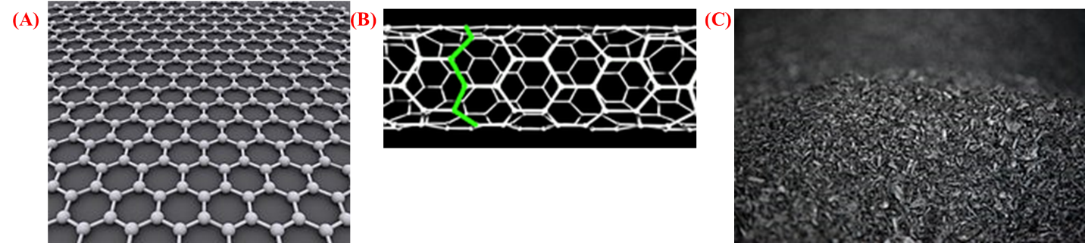

Figure 1: Commonly Used Porous Carbon Adsorbents (A): Graphene, (B) Zigzag Carbon Nanotube, (C) Biochar

Interaction Mechanism with Different Contaminants
The common interaction mechanisms of porous carbonaceous materials with pesticides has been shown in Figure 2. In the case of graphenes and graphene oxides, the weaker noncovalent bond creates the locus of pollution separation because it is primarily involved in adsorption after the mechanical separation of pollutants or their catalysis. Covalent bonds are primarily formed during the formation of composites in this case. The noncovalent bond breakdown is clear evidence that the pollutants must be able to be separated with the least amount of energy possible for mechanical separation and catalysis. The majority of the organic pollutants interact via noncovalent bonds, according to research on the interactions between graphene and its contaminants. The analysis of the adsorption process with a view on thermodynamics and kinetics is facilitated by the study of interactions, which further establishes the types of interactions between the adsorbate and the adsorbent [14].

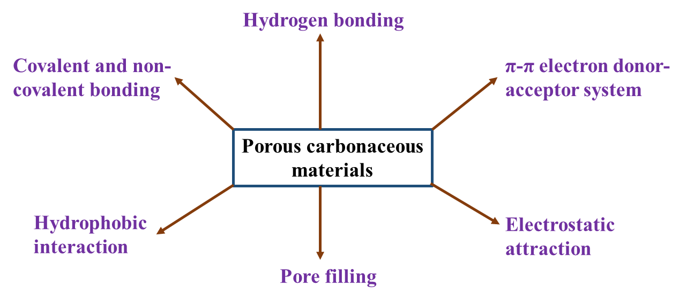
Figure 2: Common Interaction Mechanisms of Porous Carbonaceous Materials with Pesticides

Effect on Removal of Pesticides from Various Environmental Matrices
The effect of most commonly used porous carbonaceous materials on removal of pesticides from different environmental matrices has been depicted in Table 1. Graphene based nanocomposite materials are now-a-days being used as an extracting reagent in analytical studies of pesticide samples in various matrices. Recently, a graphene-based magnetic nanocomposite material has been developed and used as an adsorbent of five carbamate pesticides namely isoprocarb, pirimicarb, carbofuran, metolcarb and diethofencarb from water samples prior to detection by using high performance liquid chromatography-diode array detector [15]. The developed nanocomposites exhibited high adsorption capacity of the test analytes.

Table 1: Effect of Commonly Used Porous Carbonaceous Materials on Removal of Pesticides
Type of porous carbonaceous material | Pesticide removed | Matrix | Reference
Graphene and graphene oxide (GO)s
Cellulose/ graphene oxide composites | Organophosphorus pesticides | Water | [13]
GO functionalized by iron oxide magnetic nanoparticles | Glyphosate | Water | [16]
Carbon nanotubes (CNTs)
Single-walled CNTs | Dicamba | Aqueous solution | [17]
Multi-walled CNTs | Malathion | Water | [18]
Multi-walled CNTs | Organophosphorus pesticides | Soil and water | [19]
Biochar
Wood chips biochar | Carbofuran and Chlorpyrifos | Soil and plant | [20]
Grass biochar | Fluidone | Water | [21]
Wood biochar | Isoproturon | Soil | [22]
Rice straw biochar | Oxamyl | Water | [23]
Rice straw biochar  (H₃PO₄ treated) | Diazinon | Water | [23]

A graphene oxide based adsorbent was developed by functionalization of GO by iron oxide magnetic nanoparticles (α-γ-Fe₂O₃) using ultra sonication process. The prepared material was successfully used for glyphosate removal from water. The equilibrium adsorption time for glyphosate was found to be 2 h and the maximum removal percentage (92%) was achieved at 15 ºC. The maximum adsorption capacity of the developed material was 46.8 mg g⁻¹ [16]. A schematic representation of application of graphene based materials in decontamination of waste water has been explained in Figure 3.

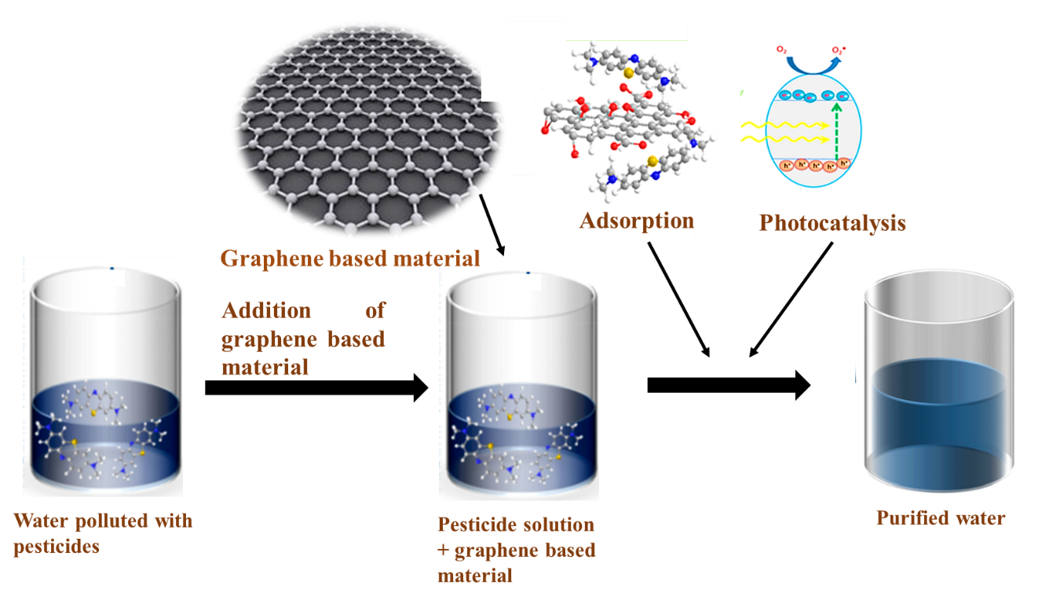
Figure 3: Schematic Representation of Application of Graphene Based Materials in Decontamination of Waste Water (Modified From Ref. [14])

An activated carbon material was developed from sieve-like cellulose/ graphene oxide composites. In this study, corn straw was utilized for development of the composite material. The developed composite was tested for removal of several organophosphorus pesticides from water. The adsorption capacity of the developed composite was found to be superior over the commonly employed sorbents such as multiwall carbon nanotube, activated carbon, graphitised carbon black, C18 and primary secondary amine. The maximum adsorption capacity of prepared composite was found to be 152.5 mg g⁻¹ for chlorpyrifos. Moreover, the adsorption efficiency was > 80% after eight times of recycling, suggesting it as a potent candidate for the removal of organophosphorus pesticides [13].
Another Fe₃O₄/reduced graphene oxide (Fe₃O₄/rGO) nanocomposite had been developed for the adsorption of harmful pesticides from aqueous medium. The test pesticides for this study were atrazine, ametryn, simeton, simazine and prometryn [24]. Efficient adsorption (93.61%) of the test pesticides was achieved due to electrostatic, pep and hydrophobic interactions of the Fe₃O₄/rGO nanocomposite towards the heterocyclic conjugation of the test pesticides. Moreover, the developed adsorbent showed easy and rapid separation from the aqueous matrix using the external magnet for reuse. The adsorption efficiency was 88.66% even up to seven cycles.
Another magnetic graphene oxide based nanocomposite was developed and utilized as adsorbent for the extraction of organophosphorus (OP) pesticide residues (profenofos, malathion, isocarbophos, chlorpyrifos, fenamiphos) from environmental water samples by using magnetic solid phase extraction techniques [25]. For development of the nanocomposite, Fe₃O₄ was coated with SiO₂ first and bonded thereafter with graphene oxide under catalytic activity of the hydrazine hydrate. Thus, the adsorbent material GO based magnetic composites serve as a potent candidate for removal of pesticides from environmental matrices, presenting low cost, superior adsorption capacity and magnetic properties that facilitate easy separation of the adsorbent material from the test matrix.
In another study, graphene quantum dots were prepared by using the microwave-assisted hydrothermal route and evaluated for removal capacities of oxamyl from aqueous solutions using batch adsorption experiments [26]. The results revealed increase in oxamyl removal with increase in oxamyl concentration for all the test contact times.
The photocatalytic activity of a home-made titanium dioxide (TiO₂) and graphene oxide (GO) based composite (GO-TiO₂) had been evaluated in the photo degradation of a pesticide mixture of diuron, isoproturon, alachlor and atrazine under UV–VIS in ultrapure and natural water matrices [27]. These four pesticides have been considered as priority pollutants by the European Union. Natural water resulted in decreased photodegradation of the test pollutants when only bare TiO₂ photocatalyst was used. However, the photo degradation efficiency of the GO-TiO₂ composite was less affected by the variations in water matrices, with high initial pesticide photo degradation rates.

B. Carbon Nanotubes
The development of novel adsorbent material with high sorption capacity and removal efficiency is of utmost importance from the soil and water remediation perspective. Carbon nanotubes have currently emerged as a promising candidate in this domain due to their large specific surface area and tuneable physico-chemical properties. In addition to that, small, hallow, and layered structure of carbon nanotubes (CNTs) make them an efficient adsorbent for the elimination of different organic and inorganic micropollutants from soil and wastewater [28].
Laser vaporization and arc methodology were employed initially to synthesize CNTs. However, due to the high cost of these fabrication technologies, metal catalyst (Ni, Fe, and Co, etc.) were further used as a synthesizing technology to scale up the production of carbon nanotubes. However, structures of CNTs obtained through the catalysis process are not as prominent as the structures of CNTs generated by the arc laser technique. Therefore, the chemical vapour deposition technique (CVD) is widely used at the commercial and laboratory level where vapour of desired carbon precursor is deposited on the surface of suitable metal catalyst [29]. In general, carbon nanotubes are derivatized from graphite and composed of many sheets (graphene sheets) in which sp² hybridized carbon atoms are arranged at the corner of the hexagon in the honeycomb crystal lattice. Based on the structural walls, these graphene sheets can be rolled into a cylindrical form to give rise to multi-walled, double-walled and single-walled CNTs. While single-walled CNTs (SWCNTs) are made of a single layer graphene sheet, multi-walled CNTs (MWCNTs) are produced by staking two or more concentric SWCNTs into a tubular form [30]. The outer diameter of SWCNTs is in the range of several nm to 0.4 nm, but the length of CNTs is in the micrometre range (Length: Diameter is about > 1000) [31]. In MWCNTs, the interlayer distance is around 0.33 nm, roughly the same as the spacing between graphene layers in graphite [32]. SWCNTs are classified into (i) armchair pattern, (ii) chiral structures, (iii) zigzag pattern and (iv) helical pattern, whereas MWCNTs can be categorized into two main groups, i.e., (i) Russion doll model and (ii) parchments like structure.
Structural analysis of CNTs revealed that they exhibit some unique physical characteristics like lower electrical resistivity, higher thermal conductivity, and higher mechanical strength, bringing about a widespread application in the remediation of soil and wastewater. Due to the high chemical stability, large specific surface area, interstitial pore spaces between the graphene sheets and hollow interiors of tubes, CNTs are also considered a potential candidate for the degradation of different emerging pollutants [33]. Functional modification of the surface and structure of CNTs during their fabrication through activation or catalysis improve their sorption capacity significantly. Generally, covalent and non-covalent functionalization does the transformation. In the covalent approach, oxidation of CNTs by acid introduced hydroxyl or carboxylic groups [34], whereas the end functionalization of CNT introduces carbonyl, carboxyl, and hydroxyl groups [35]. The amino group does the surface modification of CNTs and makes them an efficient organophosphorus pesticide adsorbent [36]. The non-covalent approach allows for the attachment of various biochemically active molecules to the CNTs by non-covalent sidewall mechanisms such as π-π stacking, van der Waals forces, hydrophobic contacts, and H-bonding. However, non-covalent modification is preferred more over covalent functionalization because it retains the structural properties of pure CNTs. Moreover, structural and surface transformation improve the performance of CNTs.

Interaction Mechanism with Different Contaminants
The efficiency of pesticide removal by using CNTs from various matrices depends on the sorption potential of the CNTs, which in turn depends on the physico-chemical characteristics of the carbon nanotube and the polarity of the pesticide molecules. The pesticide adsorption mechanism on CNTs is a complex phenomenon. It could be physisorption, chemisorption, interaction with the specific functional groups, intraparticle diffusion, or combining these different interaction mechanisms [37]. Adsorption of pesticides on CNTs completed in two steps. Pesticide molecules diffuse from the mass into the mesopore region in the first step, and then interact with the CNT surface and pores in the second step. Thus, small size compounds adsorbed on the micro and mesopores of the interlayer matrix of the CNTs, while the sorption sites on the surface of CNTs serve for the adsorption of larger species [38]. Therefore considering all these facts, it can be stated that the pesticide adsorption mechanism on CNTs depends on the type and nature of CNT and pesticide molecules.

π -π Interaction Mechanism
Carbon atoms of CNTs contain π electron and they can form π -π bond quickly with the unshared π electron of pesticide molecule. However, the strength of the π -π bond depends upon the differences in hydrophobicity between adsorbent surface and pesticide molecule and the functional groups present on the aromatic ring of the pesticide molecule. Adsorption of carbamazepine on Carbon dot-and magnetite-modified magnetic carbon nanotubes (CMNTs) was investigated by Deng et al. [39]. The result suggested that π -π electron donor-acceptor (EDA) interaction mechanism is highly responsible for removing carbamazepine through CMNTs. Pan et al., 2008 studied the sorption mechanism of 17R-ethinyl estradiol (EE2) and bisphenol A on SWCNT and found that the dominant adsorption mechanism was π -π coupling. A similar finding has also been reported for other endocrine-disrupting compounds by Jung et al. [40].

H-bonding Mechanism
The oxygen-containing functional groups present on the surface of SWCNTs and MWCNTs form H-bond with -OH, -NH₂, -NH containing pesticide molecules, consequently resulting in adsorption of such compounds on the surface of CNTs and subsequent removal from different matrices [41]. Removal of diuron and dichlobenil from wastewater carried out through adsorption on MWCNTs, and H-bonding found to be the prime sorption mechanism [42]. Sun et al. [43] studied the adsorption behaviour of diuron, fluridone, and norflurazon on SWCNT and three MWCNTs. They discovered that H-bonding, Hydrophobic interaction, and oxygen containing functional groups of CNTs were dominant sorption mechanisms. However, the metal ions on the inside of the pesticide molecules may combine with functional groups containing oxygen, interfering with the removal of the pesticide [44, 45].

Electrostatic Interaction Mechanism
The surface of CNTs has both positive and negative charge, which generate electrostatic forces at a zero-point charge. Similarly, due to the differences in pH in the various matrix, pesticide molecules can be protonated or deprotonated, making them charged species. Electrostatic interactions cause adsorption as a result of these electrostatic forces on the surface of pesticide molecules and CNTs. However, the strength of these interactions depends on the functional group's potential to be protonated or deprotonated [46]. Electrostatic interaction is the dominant sorption mechanism for the removal of ibuprofen [47]. Available literature little evidence of pesticide sorption on CNTs through electrostatic interaction; however, this kind of interaction mechanism is widely investigated for pharmaceuticals and personal care products (PCPs).

Hydrophobic Interaction Mechanism
By using different composites of CNTs, hydrophobic pesticides can also be removed from various matrices. Hydrophobic interaction is playing a significant role in such interactions. The highest sorption achieved at zero net point charge of CNTs. In a study by X. Yu et al. [48], the dominant adsorption mechanism for the elimination of sulphonamides was found to be hydrophobic interactions.

Effect on Removal of Pesticides from Various Environmental Matrices
Pesticides are the primary source of groundwater contamination. Extensive use of pesticides in agricultural practice causes a severe problem to live organisms directly or indirectly. So, proper remediation measures need to be taken to alleviate the ecosystem from unwanted pesticide residues. Therefore, in this part of the chapter, attempts have been made to briefly highlight significant studies on removing various pesticides from environmental matrices using different CNTs and composites based on CNTs.
De Martino et al. [49] compared the sorption potential of SWCNT, three MWCNTs, and nanoscale metal oxides on the removal of MCPA (4-chloro-2-methylphenoxyacetic acid) from wastewater. This experiment showed that SWCNT has the highest sorption capacity, followed by MWCNTs and nanoscale metal oxides. SWCNT and MWCNTs can totally remove the herbicide from wastewater on two sorption cycle. In comparison, nano metal oxides need four sorption cycles to remove MCPA from the same wastewater completely. Porous carbonaceous nature, hollow layered structure, and high surface area could be the possible reason for the higher efficiency of CNTs than nanoscale metal oxides. Higher desorption of MCPA from SWCNT also explained the potential reuse capability of SWCNT for many sorption cycles.
Dehghani et al. [18] performed the batch experiment to determine the adsorption capacity of MWCNT to remove organophosphorus pesticide malathion from water. Findings of this study pointed out that adsorption efficiency of the process depends on the initial concentration of the pesticide, pH of the solution, temperature, quantity of adsorbent and contact time. Statistical analysis and three-factor response modelling (RSM) proved that MWCNT efficiently removes malathion from water under optimized condition.
Al-Shaalan et al. [50] prepared low-cost MWCNTs for effective removal of diuron pesticide from aqueous solution. Under optimized condition, 90% removal of diuron has been achieved. Sorption kinetics followed the pseudo-first-order kinetics, and sorption of diuron conformed to the Freundlich, Langmuir and Temkin isotherm. Moreover, negative values of enthalpy suggested that sorption was endothermic.
Dehghani et al. [51] showed that nano adsorbent like MWCNTs could completely remove Diazinon pesticide (100%) from aqueous solution under specified conditions (initial concentration of the pesticide 0.3 mg L⁻¹, the concentration of nano-adsorbent was 0.1 g L⁻¹ at pH 4 and 7 and contact time 15 min). High surface area and the layered and hollow structure of CNTs could be the reason for the efficient removal of the pesticide from water samples.
Youssef et al. [52] prepared cross-linked nanocomposite films of poly (vinyl alcohol) (PVA) incorporated with functionalized multiwall carbon nanotubes (f-MWCNTs) at different concentration. The result suggested that pesticide removal efficiency from wastewater increases with an increase in f-MWCNTs concentration.
Ali et al. [53] prepared inexpensive and efficient MWCNTs (10–40 nm particle sizes and 9.0 m² g⁻¹ surface area) to effectively remove fenuron pesticide from water samples. Under optimized condition (@100 μg L⁻¹ concentration, 60 min contact time, 2.0 g L⁻¹ dose, pH 7, and 25 °C), 90% removal of fenuron has been achieved. Sorption kinetics followed the pseudo-first-order kinetics, and sorption data well fitted to the Freundlich, Langmuir, Temkin and Dubinin-Radushkevich isotherm models. Moreover, negative values of enthalpy suggested that sorption was spontaneous and endothermic.

C. Biochar
Biochar is considered as potential adsorbent for removal of various contaminants from several environmental matrices due to their low cost, higher abundance and superior sorptive capacities [54]. It is a stable organic carbon compound produced by heating the biomass to 300-1000 ℃ under anaerobic condition [55]. Biochar can be classified into two categories i.e activated and non-activated biochar. Activated biochar are those whose properties have been modified by physical, chemical and biological means. Non-activated biochar are without any modification but having been used as precursor for activated carbon production [56]. Various processes such as slow and fast pyrolysis, gasification are used for development of activated or non-activated biochar. The various physicochemical properties of the biochar developed from these processes vary depending upon several factors such as feedstock material, activation technique, process conditions etc. The physico-chemical properties of activated and non-activated biochars produced from various thermochemical processes are shown in Figure 4.

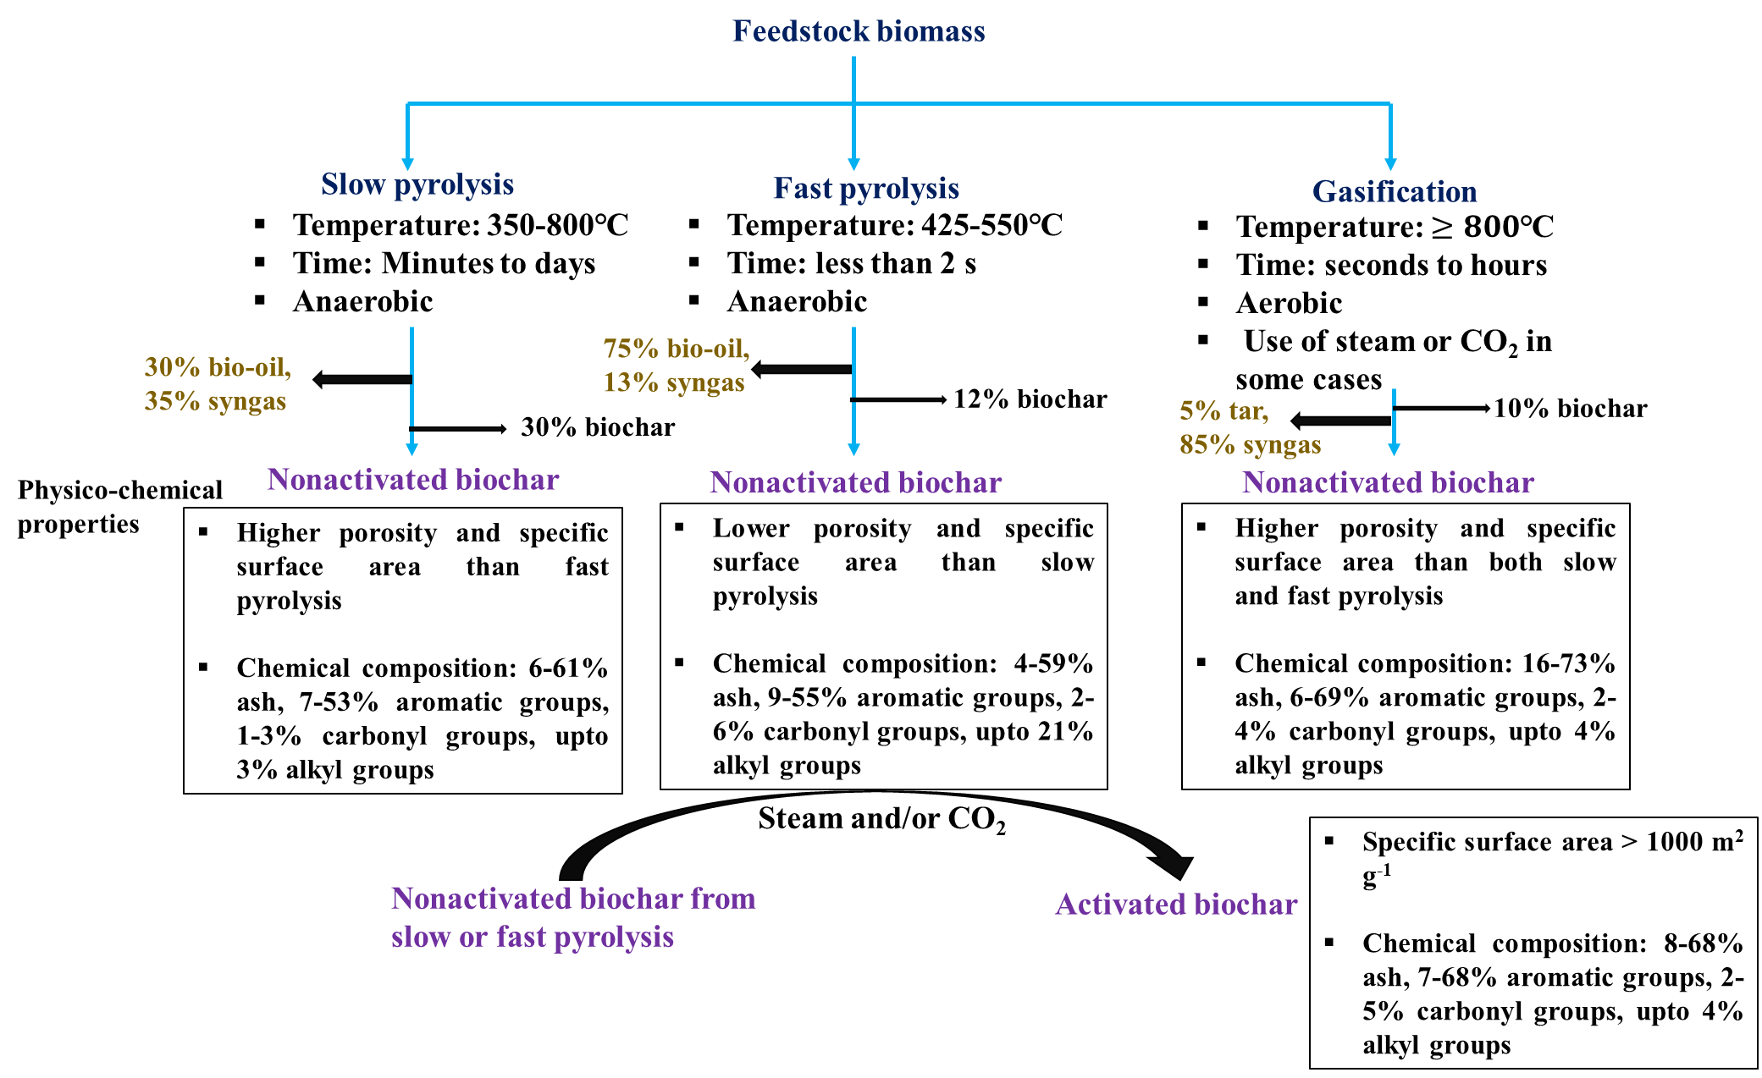
Figure 4: Physico-Chemical Properties of Activated and Non-Activated Biochars Produced from Various Thermochemical Processes (Modified from Ref. [57])

Interaction Mechanism with Different Contaminants
The pyrolysis temperatures, raw materials used, and any post-production processing all play a significant role in determining the high surface area and cation exchange capacity of biochar. As the main method for reducing pollutant mobility in contaminated soils, a high surface area is crucial for the sorption of both organic and inorganic pollutants on biochar [58]. Numerous beneficial immobilisation characteristics of biochar, including its microporous structure, active surface functional groups, high pH, and CEC, allow chemical alterations of contaminants [59].
Higher temperature-produced biochar often has high pH, CEC, and surface areas. On the other hand, biochar made at low temperatures has more active sites and stable carbon-oxygen complexes. Biochar removes pesticides through adsorption, reduction, oxidation, and immobilisation. The matrix of biochar has macro, micro, and nanoporous structures that may help reduce contaminants into less transportable species [60]. Due to the strong affinities of biochar for pollutants and capacity to transfer electrons to adsorbed reactants, the microscopic graphene moieties in biochar may act as both adsorption and redox reaction sites [61]. Furthermore, compared to pesticides in solution, adsorbed pesticides are less accessible for microbial degradation, which is why biochar amendments have been proven to inhibit pesticide degradation in soils [62].

Effect on Removal of Pesticides from Various Environmental Matrices
Several researches have been conducted to study the effect of biochar as a potent adsorbent of pesticides from soil and water. A schematic representation of effect of biochar on pesticide in case of soil matrix has been shown in Figure 5. Zhang et al. [63] developed maize straw based biochar prepared at different temperatures (300, 500 and 700 ℃) to evaluate the adsorption effect on thiacloprid (THI). The study revealed that adsorption of THI on prepared biochars was likely through pore-filling, hydrophobic interaction and p-p interaction. Another group of scientists evaluated the efficacy of a swine manure based biochar on imidacloprid adsorption. Pore filling was found to be principal adsorption mechanism in this study [64].

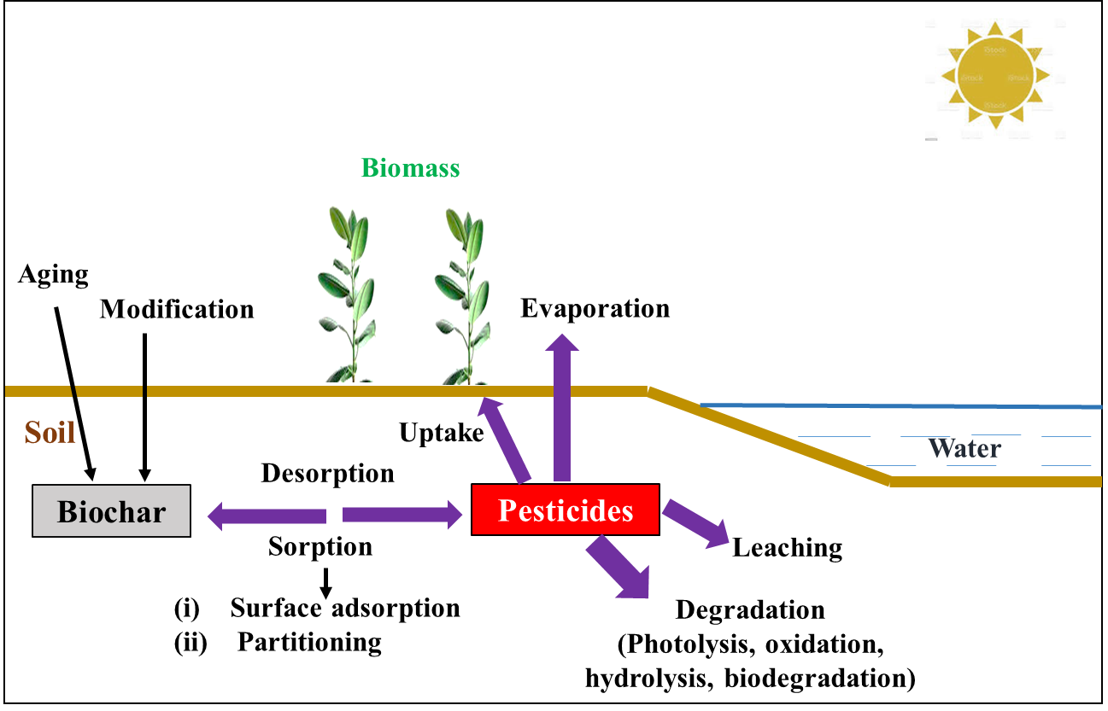
Figure 5: Effect of Biochar on Pesticide Behaviour in Soil Matrix (Modified from Ref. [65])
Different agri-waste based biochar has also potential to decontaminate the pesticide and/or their metabolites mainly by adsorption [66, 67]. Recently, sugarcane bagasse has been used to develop a potent magnetic biochar to adsorb imidacloprid, a neonicotinoid group of insecticide [68]. The research has demonstrated that the spontaneous, endothermic, and randomly increasing rate of test insecticide adsorption on the prepared biochar involving both chemisorption and physisorption. The major mechanisms for the adsorption included pore filling, π-π conjugation, and complexation of oxygen-containing functional groups.
The effect of biochars on removal of pesticides from aqueous solution is not comprehensive, and limited literature can be referenced in this context [69]. In a study by Klasson et al. [70], almond shell activated biochars were used to adsorb dibromochloropropane (DBCP), a soil fumigant, from well waters. The maximum adsorption capacity of the developed matrix was found to be 102 mg g⁻¹.

D. Other Porous Carbon Materials

Hierarchical Porous Carbon
Hierarchical porous carbon (HPC) materials have been gaining attention over the last two decades for various applications [71]. HPC can be developed from various carbon precursor materials such as polyacrylonitrile [72], chitosan [73], polystyrene [74] etc. by chemical activation method and templating with other materials. HPC has various unique structural features for several application arenas, such as unique pore surface chemistry, high porosity, surface area, and electrical conductivity [75]. These unique properties of HPC have enabled them to be used as potent adsorbent of various pesticides.

Activated Carbon
The term activated carbon is typically used to describe highly porous carbonaceous materials. It is the conventionally used adsorbent due to its large surface area ranging from 500 to 3000 m² g⁻¹, low cost, good charge-holding capacity, and ability to generate a variety of functional groups, which may be responsible for the efficient removal of a number of contaminants from aqueous or gaseous media [76]. There are several types of activated carbon for use in a variety of applications, including activated carbon fabric, activated carbon powder, active carbon granules, and extruded activated carbon. Activated carbon is typically made in two steps. To create a carbon surface, raw materials must first undergo carbonization. Following this, the resultant material is activated through chemical oxidation or heat treatment to further improve its surface properties. The adsorption study of three pesticides onto activated carbon developed from chemical and thermal treatment of waste rubber tire revealed the removal of around 93.3%, 87.4% and 74.1% of methoxychlor, atrazine and methyl parathion respectively [77]. In a comparative evaluation of the adsorption of two herbicides, 2, 4-dichlorophenoxyacetic acid (2, 4-D) and 4-chloro-2-methylphenoxyacetic acid (MCPA), on chemically prepared activated carbon from polymer waste (Polyethyleneterephthalate (PET) and Polyacrylonitrile (PAN), the activated carbon obtained with KOH was found to have better adsorption of the test pesticides due to its higher microporosity and specific surface area than that obtained with K₂CO₃ [78].

Metal–Organic Frameworks (MOFs) Derived Porous Carbon
Porous carbonaceous materials can be prepared by using metal-organic frameworks (MOFs) using facile pyrolysis method. The MOF skeleton can be transformed into porous carbon with homogeneous heteroatom ornamentation [79]. The MOF derived porous carbon can also be served as a unique adsorbent having size selectivity. The first MOF-derived porous carbonaceous material had been developed with MOF-5, showing high hydrogen uptake capacitance. Thereafter, several MOF-derived carbon materials have been prepared having diverse applications pollutant removal, energy storage, catalysis etc. [80].
A multifunctional porous carbonaceous material based on β-cyclodextrin metal organic framework MOF (β-CD MOF) was developed by C. Liu et al. [81] to serve as rich potassium source and potential adsorbent of pesticides from waste water. Batch adsorption study expressed the potential of the developed porous material in removal of four amide herbicides from water matrix. The developed porous carbon material revealed effective contribution to rice seedling growth culture in herbicide contaminated water in pot experiments. In a study by Elhussein et al. [82], CeO₂ nanofibers were prepared by using calcination technique from Ce(1,3,5-BTC)(H₂O)₆ metalorganic frameworks (MOFs) and its application on adsorption of 2,4-D, a widely used herbicide, from water was investigated. The maximum adsorption capacity was found to be 84.29 mg g⁻¹ at 318 K temperature.
Another magnetic copper based MOF (M-MOF) was developed for removal of neonicotinoid insecticides from aqueous matrix [83]. The adsorption models expressed that equilibrium data for all the test insecticides except fitted in Freundlich bimolecular layer adsorption and thiacloprid showed Langmuir monolayer adsorption. The developed hybrid adsorbent MOF may serve as a promising tool for rapid removal of neonicotinoid insecticides from environmental water samples.

Carbon Nanofibers
Carbon nanofibers having 50–200 nm average diameters can be made using two techniques, vapour deposition growth and electrospinning. For the synthesis of CNFs, the electrospinning technology has more extensive applicability. In this case, polymer nanofibers are typically used to produce the precursors of CNFs. Several polymers, including lignin, polybenzimidazole, polyvinyl alcohol, polyacrylonitrile, and polyvinyl alcohol can be used to serve the purpose.
A lot of research has been done on the mechanical and thermal transport phenomena of CNF composites, which have good thermal, electrical conductivity, and mechanical properties. The successful polymer synthesis of nanofibers that had been thermally treated up to 1000 °C to carbonise them under varied ambient conditions and temperatures has already been demonstrated to produce CNFs. As a result, the carbonization technique typically results in a volume and weight shift, which reduces the diameter of these nanofibers. Due to their functional groups, high surface area and electron transfer ability, which provide the conditions for their consideration as potent adsorbents, activated carbon nanofibers are used to remove various contaminants from different matrices with high efficiency [76]. Strong catalytic activity towards the breakdown and mineralization of dichlorvos, an organophosphate insecticide, has been demonstrated by copper dispersed-CNFs supported by phenolic carbon beads under mild reaction conditions (Temperature: 200 °C, Pressure: 25 bar). In that study, within 3 hours of reaction time, 150 ppm of original DDVP concentration has been found to be almost completely degraded [84]. In another study, the destructive adsorption of an insecticide, diazinon has been documented by using porous sites of the activated carbon nanofibers containing Al₂O₃ and MgO nanoparticles [85].

III. Conclusion

The brief overview of different porous carbonaceous materials for removing pesticides from various environmental matrices are described in this chapter. It is crucial to consider all the relevant factors when selecting the best material for pesticide removal, including pH, matrix type, temperature, amount of soil and water, cost of the investment, solubility of the pollutants etc. Therefore, before beginning a full-scale remediation treatment, laboratory scale optimization is paramount. Moreover, correlating the physico-chemical properties of the pesticide with its environmental fate, including its molecular weight, solubility, partition coefficient, reactivity with free radicals, etc., is essential to design the best remediation alternative material for effective pesticide removal. The chosen material should also be appropriate for the environmental conditions of the application region and depend on the readily available resources to boost the cost effectiveness of the remediation strategy.

References:

[1] N. Arihilam, and E. Arihilam, “Impact and control of anthropogenic pollution on the ecosystem–a review”, J. Biosci. Biotechnol. Discv., vol. 4(3), pp. 54-59, 2019.
[2] I. B. Gomes, L. C. Simões, and M. Simões, “The effects of emerging environmental contaminants on Stenotrophomonas maltophilia isolated from drinking water in planktonic and sessile states”, Sci. Total Environ., vol. 643, pp. 1348-1356, 2018.
[3] O. Kılıç, İ. Boz, and G. A. Eryılmaz, “Comparison of conventional and good agricultural practices farms: a socio-economic and technical perspective”, J. Cleaner Prod., vol. 258, pp. 120666, 2020.
[4] A. Marican, and E. F. Durán-Lara, “A review on pesticide removal through different processes”, Environ. Sci. Pollut. Res., vol. 25(3), pp. 2051-2064, 2018.
[5] F. I. Khan, T. Husain, and R. Hejazi, “An overview and analysis of site remediation technologies”, J. Environ. Manage., vol. 71(2), pp. 95-122, 2004.
[6] O.Tiryaki, and C. Temur, “The fate of pesticide in the environment”, J. Biol. Environ. Sci., vol. 4(10), pp. 29-38.
[7] G. Odukkathil, and N. Vasudevan, “Toxicity and bioremediation of pesticides in agricultural soil”, Rev. Environ. Sci. Biotechnol., vol. 12(4), pp. 421-444, 2013.
[8] I. A. Saleh, N. Zouari, and M. A. Al-Ghouti, “Removal of pesticides from water and wastewater: chemical, physical and biological treatment approaches”, Environ. Technol. Innovation, vol. 19, pp. 101026, 2020.
[9] M. ben Mosbah, L. Mechi, R. Khiari, and Y. Moussaoui, “Current state of porous carbon for wastewater treatment”, Processes, vol. 8(12), pp. 1651, 2020.
[10] V. Chaudhary, and S. Sharma, “An overview of ordered mesoporous material SBA-15: synthesis, functionalization and application in oxidation reactions”, J. Porous Mater., vol. 24(3), pp. 741-749, 2017.
[11] J. U. Lee, D. Yoon, and H. Cheong, “Estimation of Young’s modulus of graphene by Raman spectroscopy”, Nano Lett., vol. 12(9), pp. 4444-4448, 2012.
[12] X. Huang, Z. Yin, S. Wu, X. Qi, Q. He, Q. Zhang et al., “Graphene‐based materials: synthesis, characterization, properties, and applications”, Small, vol. 7(14), pp. 1876-1902, 2011.
[13] F. Suo, G. Xie, J. Zhang, J. Li, C. Li, X. Liu et al., “A carbonised sieve-like corn straw cellulose–graphene oxide composite for organophosphorus pesticide removal”, RSC Adv., vol. 8(14), pp. 7735-7743, 2018.
[14] K. Thakur, and B. Kandasubramanian, “Graphene and graphene oxide-based composites for removal of organic pollutants: a review”, J. Chem. Eng. Data, vol. 64(3), pp. 833-867, 2019.
[15] Q. Wu, G. Zhao, C. Feng, C. Wang, and Z. Wang, “Preparation of a graphene-based magnetic nanocomposite for the extraction of carbamate pesticides from environmental water samples”, J. Chromatogr. A, vol. 1218(44), pp. 7936-7942, 2011.
[16] T. R. Santos, M. B. Andrade, M. F. Silva, R. Bergamasco, and S. Hamoudi, “Development of α-and γ-Fe₂O₃ decorated graphene oxides for glyphosate removal from water”, Environ. Technol., vol. 40(9), pp. 1118-1137, 2019.
[17] M. Biesaga, and K. Pyrzynska, “The evaluation of carbon nanotubes as a sorbent for dicamba herbicide”, J. Sep. Sci., vol. 29(14), pp. 2241–2244, 2006.
[18] M. H. Dehghani, Z. S. Niasar, M. R. Mehrnia, M. Shayeghi, M. A. Al-Ghouti, B. Heibati, et al., “Optimizing the removal of organophosphorus pesticide malathion from water using multi-walled carbon nanotubes”, Chem. Eng. J., vol. 310, pp. 22–32, 2017
[19] G. Liu, L. Li, X. Huang, S. Zheng, X. Xu, Z. Liu, et al., “Adsorption and removal of organophosphorus pesticides from environmental water and soil samples by using magnetic multi-walled carbon nanotubes @ organic framework ZIF-8”, J. Mater. Sci., vol. 53(15), pp. 10772–10783, 2018.
[20] X. Y. Yu, G. G. Ying, and R. S. Kookana, “Reduced plant uptake of pesticides with biochar additions to soil”, Chemosphere, vol. 76(5), pp. 665-671, 2009.
[21] K. Sun, M. Keiluweit, M. Kleber, Z. Pan, and B. Xing, “Sorption of fluorinated herbicides to plant biomass-derived biochars as a function of molecular structure”, Bioresour. Technol., vol. 102(21), pp. 9897-9903, 2011.
[22] F. Sopeña, K. Semple, S. Sohi, and G. Bending, “Assessing the chemical and biological accessibility of the herbicide isoproturon in soil amended with biochar”, Chemosphere, vol. 88(1), pp. 77-83, 2012.
[23] S. M. Taha, M. E. Amer, A. E. Elmarsafy, and M. Y. Elkady, “Adsorption of 15 different pesticides on untreated and phosphoric acid treated biochar and charcoal from water”, J. Environ. Chem. Eng., vol. 2(4), pp. 2013-2025, 2014.
[24] P. K. Boruah, B. Sharma, N. Hussain, and M. R. Das, “Magnetically recoverable Fe₃O₄/graphene nanocomposite towards efficient removal of triazine pesticides from aqueous solution: investigation of the adsorption phenomenon and specific ion effect”, Chemosphere, vol. 168, pp. 1058-1067, 2017.
[25] P. Wang, M. Luo, D. Liu, J. Zhan, X. Liu, F. Wang et al., “Application of a magnetic graphene nanocomposite for organophosphorus pesticide extraction in environmental water samples”, J. Chromatogr. A, vol. 1535, pp. 9-16, 2018.
[26] S. Agarwal, N. Sadeghi, I. Tyagi, V. K. Gupta, and A. Fakhri, “Adsorption of toxic carbamate pesticide oxamyl from liquid phase by newly synthesized and characterized graphene quantum dots nanomaterials”, J. Colloid Interface Sci., vol. 478, pp. 430-438, 2016.
[27] M. Cruz, C. Gomez, C. J. Duran-Valle, L. M. Pastrana-Martínez, J.L. Faria, A.M. Silva et al., “Bare TiO₂ and graphene oxide TiO₂ photocatalysts on the degradation of selected pesticides and influence of the water matrix”, Appl. Surf. Sci., vol. 416, pp. 1013-1021, 2017.
[28] J. Ahmad, S. Naeem, M. Ahmad, A. R. A. Usman, and M. I. Al-Wabel, “A critical review on organic micropollutants contamination in wastewater and removal through carbon nanotubes”, J. Environ. Manage., vol. 246(May), pp. 214–228.
[29] T. Rasheed, M. Adeel, F. Nabeel, M. Bilal, and H. M. N. Iqbal, “TiO₂/SiO₂ decorated carbon nanostructured materials as a multifunctional platform for emerging pollutants removal”, Sci. Total Environ., vol. 688, pp. 299–311, 2019.
[30] S. Iijima, and T. Ichihashi, “Single-shell carbon nanotubes of 1-nm diameter”, Nature, vol. 363(6430), pp. 603–605, 1993.
[31] A. Aqel, K. M. M. A. El-Nour, R. A. A. Ammar, and A. Al-Warthan, “Carbon nanotubes, science and technology part (I) structure, synthesis and characterisation”, Arabian J. Chem., vol. 5(1), pp. 1–23, 2012.
[32] B. Sarkar, S. Mandal, Y. F. Tsang, P. Kumar, K. H. Kim, and Y. S. Ok, “Designer carbon nanotubes for contaminant removal in water and wastewater: a critical review”, Sci. Total Environ., vol. 612, pp. 561–581, 2018.
[33] T. T. Duong, Q. D. Nguyen, S. K. Hong, D. Kim, S. G. Yoon, and T. H. Pham, “Enhanced photoelectrochemical activity of the TiO ₂/ITO nanocomposites grown onto single-walled carbon nanotubes at a low temperature by nanocluster deposition”, Adv. Mater., vol. 23(46), pp. 5557–5562, 2011.
[34] J. Cha, S. Jin, J. H. Shim, C. S. Park, H. J. Ryu, and S. H. Hong, “Functionalization of carbon nanotubes for fabrication of CNT/epoxy nanocomposites”, Mater. Des., vol. 95, pp. 1–8, 2016.
[35] Z. Spitalsky, D. Tasis, K. Papagelis, and C. Galiotis, “Carbon nanotube-polymer composites: chemistry, processing, mechanical and electrical properties”, Prog. Polym. Sci. (Oxford), vol. 35(3), pp. 357–401, 2010.
[36] G. Yu, W. Wu, Q. Zhao, X. Wei, and Q. Lu, “Efficient immobilization of acetylcholinesterase onto amino functionalized carbon nanotubes for the fabrication of high sensitive organophosphorus pesticides biosensors”, Biosens. Bioelectron., vol. 68, pp. 288–294, 2015.
[37] C. L. Chen, X. K. Wang, and M. Nagatsu, “Europium adsorption on multiwall carbon nanotube/iron oxide magnetic composite in the presence of polyacrylic acid”, Environ. Sci. Technol., vol. 43(7), pp. 2362–2367, 2009.
[38] B. Czech, and P. Oleszczuk, “Sorption of diclofenac and naproxen onto MWCNT in model wastewater treated by H₂O₂ and/or UV”, Chemosphere, vol. 149, pp. 272–278, 2009.
[39] Y. Deng, Y. S. Ok, D. Mohan, C. U. Pittman, and X. Dou, “Carbamazepine removal from water by carbon dot-modified magnetic carbon nanotubes”, Environ. Res., vol. 169, pp. 434–444, 2019.
[40] C. Jung, A. Son, N. Her, K. D. Zoh, J. Cho, and Y. Yoon, “Removal of endocrine disrupting compounds, pharmaceuticals, and personal care products in water using carbon nanotubes: A review”, J. Ind. Eng. Chem., vol. 27, pp. 1–11, 2015.
[41] H. Zhao, X. Liu, Z. Cao, Y. Zhan, X. Shi, Y. Yang, et al., “Adsorption behavior and mechanism of chloramphenicols, sulfonamides, and non-antibiotic pharmaceuticals on multi-walled carbon nanotubes”, J. Hazard. Mater., vol. 310, pp. 235–245, 2016.
[42] J. G. Yu, X. H. Zhao, H. Yang, X. H. Chen, Q. Yang, L. Y. Yu et al., “Aqueous adsorption and removal of organic contaminants by carbon nanotubes”, Sci. Total Environ., vol. 482–483(1), pp. 241–251, 2014.
[43] K. Sun, Z. Zhang, B. Gao, Z. Wang, D. Xu, J. Jin et al., “Adsorption of diuron, fluridone and norflurazon on single-walled and multi-walled carbon nanotubes”, Sci. Total Environ., vol. 439, pp. 1–7, 2012.
[44] I. I. Fasfous, E. S. Radwan, and J. N. Dawoud, “Kinetics, equilibrium and thermodynamics of the sorption of tetrabromobisphenol A on multiwalled carbon nanotubes”, Appl. Surf. Sci., vol. 256(23), pp. 7246–7252, 2010.
[45] H. H. Cho, H. Huang, and K. Schwab, “Effects of solution chemistry on the adsorption of ibuprofen and triclosan onto carbon nanotubes”, Langmuir, vol. 27(21), pp. 12960–12967, 2011.
[46] Y. Wang, J. Zhu, H. Huang, and H. H. Cho, “Carbon nanotube composite membranes for microfiltration of pharmaceuticals and personal care products: capabilities and potential mechanisms”, J. Membr. Sci., vol. 479, pp. 165–174, 2015.
[47] S. W. Nam, D. J. Choi, S. K. Kim, N. Her, and K. D. Zoh, “Adsorption characteristics of selected hydrophilic and hydrophobic micropollutants in water using activated carbon”, J. Hazard. Mater., vol. 270, pp. 144–152, 2014.
[48] X. Yu, L. Zhang, M. Liang, and W. Sun, “pH-dependent sulfonamides adsorption by carbon nanotubes with different surface oxygen contents”, Chem. Eng. J., vol. 279, pp. 363–371, 2015.
[49] A. De Martino, M. Iorio, B. Xing, and R. Capasso, “Removal of 4-chloro-2-methylphenoxyacetic acid from water by sorption on carbon nanotubes and metal oxide nanoparticles”, RSC Adv., vol. 2(13), pp. 5693–5700, 2012.
[50] N. H. Al-Shaalan, I. Ali, Z. A. ALOthman, L. H. Al-Wahaibi, and H. Alabdulmonem, “High performance removal and simulation studies of diuron pesticide in water on MWCNTs”, J. Mol. Liq., vol. 289, pp. 111039, 2019.
[51] M. H. Dehghani, S. Kamalian, M. Shayeghi, M. Yousefi, Z. Heidarinejad, S. Agarwal et al., “High-performance removal of diazinon pesticide from water using multi-walled carbon nanotubes”, Microchem. J., vol. 145, pp. 486–491, 2019.
[52] A. M. Youssef, M. E. El-Naggar, F. M. Malhat, and H. M. El Sharkawi, “Efficient removal of pesticides and heavy metals from wastewater and the antimicrobial activity of f-MWCNTs/PVA nanocomposite film”, J. Clean. Prod., vol. 206, pp. 315–325, 2019.
[53] I. Ali, O. M. L. Alharbi, Z. A. ALOthman, A. M. Al-Mohaimeed, and A. Alwarthan, “Modeling of fenuron pesticide adsorption on CNTs for mechanistic insight and removal in water”, Environ. Res., vol. 170(November 2018), pp. 389–397, 2019.
[54] J. P. Kearns, L. S. Wellborn, R. S. Summers, and D. R. U. Knappe, “2, 4-D adsorption to biochars: Effect of preparation conditions on equilibrium adsorption capacity and comparison with commercial activated carbon literature data”, Water Res., vol. 62, pp. 20-28, 2014.
[55] S. Jeffery, F. G. Verheijen, M. van der Velde, and A. C. Bastos, “A quantitative review of the effects of biochar application to soils on crop productivity using meta-analysis”, Agric. Ecosyst. Environ., vol. 144(1), pp. 175-187, 2011.
[56] P. Girods, A. Dufour, V. Fierro, Y. Rogaume, C. Rogaume, A. Zoulalian et al., “Activated carbons prepared from wood particleboard wastes: characterisation and phenol adsorption capacities”, J. Hazard. Mater., vol. 166(1), pp. 491-501, 2009.
[57] M. Inyang, and E. Dickenson, “The potential role of biochar in the removal of organic and microbial contaminants from potable and reuse water: a review”, Chemosphere, vol. 134, pp. 232-240, 2015.
[58] L. Beesley, and M. Marmiroli, “The immobilisation and retention of soluble arsenic, cadmium and zinc by biochar”, Environ. Pollut., vol. 159(2), pp. 474-480, 2011.
[59] T. Xie, K. R. Reddy, C. Wang, E. Yargicoglu, and K. Spokas, “Characteristics and applications of biochar for environmental remediation: a review”, Crit. Rev. Environ. Sci. Technol., vol. 45(9), pp. 939-969, 2015.
[60] L. Beesley, M. Marmiroli, L. Pagano, V. Pigoni, G. Fellet, T. Fresno, et al., “Biochar addition to an arsenic contaminated soil increases arsenic concentrations in the pore water but reduces uptake to tomato plants (Solanum lycopersicum L.)”, Sci. Total Environ., vol. 454, pp. 598-603, 2013.
[61] S. Y. Oh, J. G. Son, and P. C. Chiu, “Biochar‐mediated reductive transformation of nitro herbicides and explosives”, Environ. Toxicol. Chem., vol. 32(3), pp. 501-508, 2013.
[62] M. Larsbo, E. Löfstrand, D. V. A. de Veer, and B. Ulén, “Pesticide leaching from two Swedish topsoils of contrasting texture amended with biochar”, J. Contam. Hydrol., vol. 147, pp. 73-81, 2013.
[63] P. Zhang, H. Sun, L. Min, and C. Ren, “Biochars change the sorption and degradation of thiacloprid in soil: insights into chemical and biological mechanisms”, Environ. Pollut., vol. 236, pp. 158-167, 2018.
[64] J. Jin, M. Kang, K. Sun, Z. Pan, F. Wu, and B. Xing, “Properties of biochar-amended soils and their sorption of imidacloprid, isoproturon, and atrazine”, Sci. Total Environ., vol. 550, pp. 504-513, 2016.
[65] Y. Liu, L. Lonappan, S. K. Brar, and S. Yang, “Impact of biochar amendment in agricultural soils on the sorption, desorption, and degradation of pesticides: a review”, Sci. Total Environ., vol. 645, pp. 60-70, 2018.
[66] A. Mandal, A. Kumar, and N. Singh, “Sorption mechanisms of pesticides removal from effluent matrix using biochar: conclusions from molecular modelling studies validated by single-, binary and ternary solute experiments”, J. Environ. Manage., vol. 295, pp. 113104, 2021.
[67] A. Mandal, N. Singh, and T. J. Purakayastha, “Characterization of pesticide sorption behaviour of slow pyrolysis biochars as low cost adsorbent for atrazine and imidacloprid removal”, Sci. Total Environ., vol. 577, pp. 376-385, 2017.
[68] Y. Ma, Y. Qi, L. Yang, L. Wu, P. Li, F. Gao et al., “Adsorptive removal of imidacloprid by potassium hydroxide activated magnetic sugarcane bagasse biochar: adsorption efficiency, mechanism and regeneration”, J. Clean. Prod., vol. 292, pp. 126005, 2021.
[69] X. Xiao, B. Chen, Z. Chen, L. Zhu, and J. L. Schnoor, “Insight into multiple and multilevel structures of biochars and their potential environmental applications: a critical review”, Environ. Sci. Technol., vol. 52(9), pp. 5027-5047, 2018.
[70] K. T. Klasson, C. A. Ledbetter, M. Uchimiya, and I. M. Lima, “Activated biochar removes 100% dibromochloropropane from field well water”, Environ. Chem. Lett., vol. 11(3), pp. 271-275, 2013.
[71] M. Gao, C. C. Shih, S. Y. Pan, C. C. Chueh, and W. C. Chen, “Advances and challenges of green materials for electronics and energy storage applications: from design to end-of-life recovery”, J. Mater. Chem. A, vol. 6(42), pp. 20546-20563, 2018.
[72] M. Sun, X. Wang, X. Pan, L. Liu, Y. Li, Z. Zhao et al., “Nitrogen-rich hierarchical porous carbon nanofibers for selective oxidation of hydrogen sulfide”, Fuel Process. Technol., vol. 191, pp. 121–128, 2019.
[73] Y. N. Liu, J. N. Zhang, H. T. Wang, X. H. Kang, and S. W. Bian, “Boosting the electrochemical performance of carbon cloth negative electrodes by constructing hierarchically porous nitrogen-doped carbon nanofiber layers for all-solid-state asymmetric supercapacitors”, Mater. Chem. Front., vol. 3(1), pp. 25–31, 2019.
[74] F. Xu, H. Han, B. Ding, Y. Qiu, E. Zhang, H. Li et al., “Engineering pore ratio in hierarchical porous carbons towards high-rate and large-volumetric performances”, Microporous Mesoporous Mater., vol. 282, pp. 205–210, 2019.
[75] D. Xu, Y. Tong, T. Yan, L. Shi, and D. Zhang, “N,P-codoped meso-/microporous carbon derived from biomass materials via a dual-activation strategy as high-performance electrodes for deionization capacitors”, ACS Sustain. Chem. Eng., vol. 5(7), pp. 5810–5819, 2017.
[76] M. M. Sabzehmeidani, S. Mahnaee, M. Ghaedi, H. Heidari, and V. A. Roy, “Carbon based materials: a review of adsorbents for inorganic and organic compounds”, Mater. Adv., vol. 2(2), pp. 598-627, 2021.
[77] V. K. Gupta, B. Gupta, A. Rastogi, S. Agarwal, and A. Nayak, “Pesticides removal from waste water by activated carbon prepared from waste rubber tire”, Water Res., vol. 45(13), pp. 4047-4055, 2011.
[78] I. P. da Paixão Cansado, C. R. Belo, and P. A. M. Mourão, “Pesticides abatement using activated carbon produced from a mixture of synthetic polymers by chemical activation with KOH and K₂CO₃”, Environ. Nanotechnol. Monit. Manag., vol. 12, pp. 100261, 2019.
[79] Y. Qiu, H. Yang, B. Wen, L. Ma, and Y. Lin, “Facile synthesis of nickel/carbon nanotubes hybrid derived from metal organic framework as a lightweight, strong and efficient microwave absorber”, J. Colloid Interface Sci., vol. 590, pp. 561-570, 2021.
[80] C. Zheng, H. F. Greer, C. Y. Chiang, and W. Zhou, “Microstructural study of the formation mechanism of metal–organic framework MOF-5”, CrystEngComm, vol. 16(6), pp. 1064-1070, 2014.
[81] C. Liu, P. Wang, X. Liu, X. Yi, Z. Zhou, and D. Liu, “Multifunctional β-cyclodextrin MOF-derived porous carbon as efficient herbicides adsorbent and potassium fertilizer”, ACS Sustain. Chem. Eng., vol. 7(17), pp. 14479-14489, 2019.
[82] E. A. A. Elhussein, S. Şahin, and Ş. S. Bayazit, “Preparation of CeO₂ nanofibers derived from Ce-BTC metal-organic frameworks and its application on pesticide adsorption”, J. Mol. Liq., vol. 255, pp. 10-17, 2018.
[83] G. Liu, L. Li, D. Xu, X. Huang, X. Xu, S. Zheng et al., “Metal–organic framework preparation using magnetic graphene oxide–β-cyclodextrin for neonicotinoid pesticide adsorption and removal”, Carbohydr. Polym., vol. 175, pp. 584-591, 2017.
[84] A. Kumar, and N. Verma, “Wet air oxidation of aqueous dichlorvos pesticide over catalytic copper-carbon nanofiberous beads”, Chem. Eng. J., vol. 351, pp. 428-440, 2018.
[85] R. Behnam, M. Morshed, H. Tavanai, and M. Ghiaci, “Destructive adsorption of diazinon pesticide by activated carbon nanofibers containing Al₂O₃ and MgO nanoparticles”, Bull. Environ. Contam. Toxicol., vol. 91(4), pp. 475-480, 2013.

