RAPID DIAGNOSTIC KITS FOR DETECTION OF PHYTOPATHOGENIC BACTERIA
Pamala Prince Jayasimha
Plant Pathology
College of Agriculture, KL University
Vijayawada, India
jayasimha@kluniversity.in
Dumala Sravani
Entomology
College of Agriculture, KL University
Vijayawada, India
dsravani@kluniversity.in
Muthyla Mahendra
Plant Pathology
S. V. Agricultural College, Acharya N G Ranga Agricultural University
Guntur, India
mm676366@gmail.com
Padeti Venkataramanaiah
Plant Pathology
S. V. Agricultural College, Acharya N G Ranga Agricultural University
Guntur, India
ramanaseenu8@gmail.com
Abstract:
In recent years, there has been an increase in demand for quick and precise phytopathogenic bacterial identification. Rapid diagnostic kits are used to detect pathogens locally as the first step in this endeavour. Rapid and precise detection techniques are needed to identify phytopathogenic bacteria since novel plant diseases are constantly appearing. The quick results can be used to inform management choices, such as choosing the best chemical to fight disease. The portable technologies and gadgets that are now on the market for detecting phytopathogenic bacteria are described in this chapter.
Key words: Phytopathogenic bacteria, Rapid diagnostic kits, Plant disease, Management
Introduction
Plant pathogens are crucial to the production and safety of food. Plant Pathogens, animals, and weeds reduce agricultural productivity globally by 20–40% ^{[1]}. Accurate detection and identification of plant pathogens are crucial for understanding and controlling plant diseases. It may be possible to stop the spread of disease and food losses by detecting plant infections in the field early ^{[2]}. According to their importance to science and industry, the top 10 bacterial plant pathogens were recently revealed by the Journal of Molecular Plant Pathology. The top two diseases, Pseudomonas syringae and Ralstonia solanacearum, both affect different crops and are significant economic problems ^{[3]}.
Phytopathogenic bacteria survives inside plants as pathogens and it can also live outside of their hosts as saprophytes and epiphytes ^{[4]}. Adverse environmental factors may decrease bacterial survival and compromise the onset and spread of disease. Leaf spots, blights, wilts, scabs, cankers, tumours, soft rots of roots, storage organs, and fruit, as well as overgrowth, are disease symptoms brought on by bacteria ^{[5]}.
Rapid on-site diagnostic equipment will make it easier to identify pathogen dispersion early and stop the development of disease. Here, we discuss the challenges and limitations of the fast diagnostic kits that are now on the market.
RAPID DIAGNOSTIC KITS:
The rapid tests are intended to deliver quick, dependable answers that may be used in the field to facilitate quicker decision-making, stop the spread of disease, and the environment protection ^{[6]}.
It might be very helpful to employ fast diagnostic tests to find bacterial diseases in field and greenhouse crops. These kits are dependable, sensitive, efficient in terms of cost, and easy to use. They also produce results quickly. In fact, tests frequently have sensitivity levels on par with those of equivalent ELISA tests used in diagnostic laboratories. Rapid diagnostic kit test results are available in between 10 and 30 minutes.
Working principle of lateral flow rapid test strip:
A typical lateral flow quick test strip might include the following elements (Figure 1):
- Sample pad: To ensure the precise and controlled flow of the sample, the sample pad, which serves as the initial stage of the absorption process.
- Conjugate pad: which stores the conjugated labels and antibodies, will receive the sample. The immobilised conjugated antibodies and labels will bind to the target if it is present and move along the test if it is.
- The binding reagents on the nitrocellulose membrane will bind to the target at the test line as the sample travels through the device. Depending on how much of the target is present, a coloured line will form, and the density of the line will change.
- The sample will enter the absorbent pad after passing through the nitrocellulose membrane. The extra sample will be absorbed by the absorbent pad. The amount of sample that can be included in the test will depend on the absorbent pad's specification ^{[7]}.
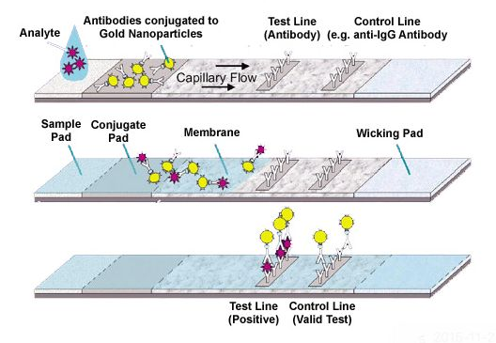
Figure 1. Working principle of lateral flow rapid test strip
1. ImmunoStrip Kits:
ImmunoStrip test is a quick and accurate method for finding bacterial pathogens in plants is the ImmunoStrip test. The assay can be used to examine seeds, fruit, bacterial cultures, and leaves that have pathogen signs ^{[8]}.
ImmunoStrip Kits available for bacterial plant pathogens are
- Acidovorax avenae subsp. citrulli
- Clavibacter michiganensis subsp. Michiganensis
- Erwinia amylovora
- Ralstonia solanacearum
- Xanthomonas axonopodis pv. citri
ImmunoStrips, sample bags containing SEB4 buffer, and a user manual are all included in the kits (ISK).
Test procedure:
- Infected plants' leaves, petioles, or stems should be sampled for analysis. 3 mL of extraction buffer are included in the Agdia sample extract bags; therefore 0.15 g of tissue is needed for the ideal 1:20 dilution. An approximate sample size of 2.5 cm² is sufficient for the majority of samples; however, thick or dense tissues may change the intended 1:20 dilution. Large volumes of dried, highly deteriorated, or extracted tissue may yield inaccurate results when tested. Cut two cross-sectional sections at the first two internodes of the stem while working with stems.
- Cut open the sample extraction bag along the top of the label. Be careful not to spill the buffer
- Near the bottom of the sample extraction bag, insert the sample between the mesh linings.
- By completely macerating the material with an Agdia tissue homogenizer or a blunt instrument like a pen or marker, you can extract it. An appropriately extracted sample will yield a uniform solution that is green or light brown in colour. Before putting the ImmunoStrip in, give the resultant solution three minutes to settle.
- Reclose the container after removing an ImmunoStrip. Always hold the test-named strip by the top when handling the strips. ImmunoStrip's sample end should be inserted into the bag and dipped into the extract all the way to the white line. Insert the ImmunoStrip into the bag's channel for optimal results (no mesh). Avoid letting the ImmunoStrip's side come in contact with foam or bubbles (if present). Additionally, trimming the bag might give you greater control while putting the ImmunoStrip inside.
- Place the bag in an upright letter holder or equivalent device. Allow the ImmunoStrip test to remain in the sample extract for 30 minutes. Positive outcomes could become apparent in as little as 5 minutes (Figure 2).
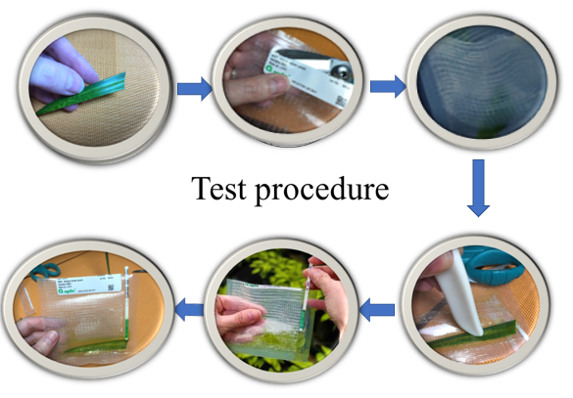
Figure 2: Test procedure of ImmunoStrip
Result Interpretation:
Take the test strip out of the extract, then analyse the results. If you intend to keep the strip as a permanent record, remove the sample pad right away. Next, press the ImmunoStrip between two sheets of paper to absorb any extra liquid. Positive result is indicated if both the control line and the test line are discernible and present at any pink/purple intensity. If only the control line is visible, this indicates a negative result. The ImmunoStrip may not be able to detect samples with small amounts of germs.
2. Portable diagnostic tools
For the on-site identification of viruses, bacteria, and fungus (pathogens) producing disease symptoms in plants, Pocket Diagnostic testing kits are high-quality products ^{[9]}.
Pocket Diagnostic kits available for Erwinia amylovora and Ralstonia solanacearum.
Portable diagnostic tools include a pipette, an instruction manual, a test device, and a bottle of extraction buffer.

Test procedure:
- Choose a section of the plant where healthy and infected tissue meet; do not use dead tissue. Use a material area of about 25 mm².
- Sample should be cut into small bits. Remove the extraction bottle's cap, then put the plant material inside. Replace the lid tightly.
- Shake the bottle vigorously for 30 (or 60, if the substance is hard or woody) seconds, or until the extraction buffer turns coloured. Allow the solution to rest for 30 seconds before drawing liquid into the pipette while avoiding too much plant matter.
- The test device should be unpacked from its foil packaging and set on a flat, upward-facing surface. The test can be done with the device held horizontally in the hand.
- Open the extraction bottle's lid, then take some of the liquid into the pipette. Squeeze two or three droplets of the sample liquid gently into the test device's sample well.
- After about 30 seconds blue dye will start to show up in the viewing window as liquid moves along the test device. A blue line will appear next to the letter ‘C’ on the device. This line verifies that the test is operating correctly. A second blue line, the Test line, will appear next to the letter "T" if the test is positive. Within 10 minutes of adding the sample to the test equipment, lines will start to form (Figure 3).
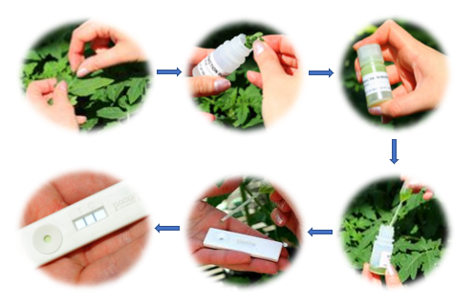
Figure 3: Test procedure of Pocket Diagnostic kit

Interpreting results
The result becomes visible in the viewing window of the test device in a few minutes. In less than 10 minutes, all Pocket Diagnostic tests offer reliable results.
Advantages:
- Rapid: Diagnostic test kits can be used to conduct on-site tests on plants displaying suspicious symptoms. Results can be obtained in 5 to 30 minutes. If a plant diagnostic laboratory receives the sample, shipping time alone could take up to two days.
- Accuracy: For plant material with symptoms, the findings are very precise. The test may occasionally find both the indicated disease and closely related pathogens. The kit instructions will make note of this.
- Simple: No special education or work experience is necessary for the examinations. Everything needed for the test is in the package, with the exception of things that are readily available, such as paper towels, scissors, and a blunt object (such as a marker).
- Security: The test materials are risk-free and secure. Until needed, they can be kept in the refrigerator.
- Wide selection: There are quick test kits available for a lot of plant diseases. includes the more prevalent plant diseases that may be tested for quickly in greenhouses and nurseries.
- Good shelf life: Tests can be obtained in small (5 to 10) or large (25 to 50) volumes, and they have a long shelf life. If properly stored in the refrigerator, the shelf life is one year or longer. Do not remove the desiccant packets from the test kits as they are there to keep the materials dry.
- Low cost: Depending on the specific test and supplier, costs range from 700 ₹ to 1400 ₹ per test (including shipping).
Disadvantages:
- Results interpretation: If a test produces a positive result, the kits do not offer management advice.
- Pathogen-specific results are provided by the tests, which only offer a positive or negative answer for one particular pathogen. The grower might need to do more tests if the results are negative. Contact a plant diagnostic laboratory if additional testing is needed.
- Tests are not available for all pathogens
CONCLUSION:
There is a need for the early detection of several known or unknown plant diseases to prevent agricultural losses in light of the rising plant diseases. Rapid Diagnostic Kits are utilised for the early detection of phytopathogenic bacteria, however there were only a few pathogens for which they were commercially available. Although diagnostic kits might be pricey, the benefits such as fewer crop losses and more environmentally friendly crop management practices can outweigh the expenses. Their development should be made a priority by both the public and private sectors in developing countries.
REFERENCES
[1] Nezhad, A.S., 2014. Future of portable devices for plant pathogen diagnosis. Lab on a Chip, 14(16): 2887-2904.
[2] Chilvers, M.I., 2012. Molecular Diagnostics in Plant Disease Diagnostic Clinics… What’s the Status. Fungal Genome Biol, 2: 102.
[3] Donoso, A. and Valenzuela, S., 2018. In‐field molecular diagnosis of plant pathogens: recent trends and future perspectives. Plant pathology, 67(7): 1451-1461.
[4] Fang, Y. and Ramasamy, R., 2015. Current and prospective methods for plant disease detection. Biosensors, 5(3): 537-561.
[5] Lau, H.Y. and Botella, J.R., 2017. Advanced DNA-based point-of-care diagnostic methods for plant diseases detection. Frontiers in plant science, 8: 2016.
[6] Martinelli, F., Scalenghe, R., Davino, S., Panno, S., Scuderi, G., Ruisi, P., Villa, P., Stroppiana, D., Boschetti, M., Goulart, L.R. and Davis, C.E., 2015. Advanced methods of plant disease detection. A review. Agronomy for Sustainable Development, 35(1): 1-25.
[7] https://www.creative-diagnostics.com/food-analysis/tag-lateral-flow-immunoassay
[8] https://www.agdia-emea.com/en/products-services/plant-pathogen-detection-kits
[9] https://www.pocketdiagnostic.com/products/plant-disease-tests/

