Hybrid Seed Production
Anubhav Thakur
PhD, Department of Seed Science and Technology
College of Horticulture, Dr. YSP UHF Nauni Solan
H.P., India
173230
Anubhavthakur97@gmail.com
Pratibha Sharma
PhD, Department of Plant Pathology
College of Horticulture, Dr. YSP UHF Nauni Solan
H.P., India
173230
Preety8296@gmail.com
Aparna Jyoti
MSc, Department of Seed Science and Technology
CSK HPKV Palampur
H.P., India
175042
Jyoti.aparna06@gmail.com
Sheetal Rana
PhD, Department of Vegetable Science
College of Horticulture, Dr. YSP UHF Nauni Solan
H.P., India
173230
Drsheetalrana1712@gmail.com
Rajesh Kanwar
Assistant Professor, Department of Seed Science and Technology
CSK HPKV Palampur
H.P., India
175042
Intangiblekanwar07@gmail.com

Abstract
Food is the basic necessity of human being and good quality seed is most critical input for enhancing the food productivity. Use of good quality seed can enhance the yield by 15-20% and this can be raised up to 45% by effective management of other inputs. Hybrid seed is a type of seed which have potential of enhancing global food and nutritional security. Hybrid seed are produced by crossing of two homozygous parental lines of two different gene pools. These are also known as F₁ seeds and have more yield, better uniformity and resistance to insect, pests as compared to their parents due to heterosis. Hybrid seeds are produced by the effective manipulation of cross-pollination by a number of methods such as manual emasculation and pollination, use of genetic male sterility (GMS), use of Cytoplasmic male sterility, use of self-incompatibility and use of cytoplasmic- genetic male sterility. Although hybrid seeds provide numerous advantages to the growers, but they also have some shortcomings too. The production of hybrid seeds is a labour intensive and costly process and requires the assistance of skilled personnel. Hybrid breeding of crops for one desired character may often lead to degeneration of other traits in the seed. Hybrid seeds cannot be saved and have to be produced every year due to segregation of generations. This makes it expensive for small and marginal farmers to afford hybrid seeds.
Keywords: Hybrid, Seed, Heterosis, Pollination

- Introduction
Food is the basic necessity of human being (Vishnoni et al. 2022) and good quality seed is most critical input for enhancing the food productivity (Roy et al. 2021). Use of good quality seed can enhance the yield by 15-20% (Ali, 2016) and this can be raised up to 45% by effective management of other inputs. Hybrid seed is a type of seed which have potential of enhancing global food and nutritional security. Hybrid seed are produced by crossing of two homozygous parental lines of two different gene pools (Steeg et al. 2022). These are also known as F₁ seeds and have more yield, better uniformity and resistance to insect, pests as compared to their parents due to heterosis. Steps involved in the hybrid seed production, 1) first, development of inbred lines and 2) crossing of two inbred lines to produce hybrid. After this hybrid seeds are produced which can we done manually/by hand or with the help of insects, wind or through male sterility system if available.
Hybrid seed production also depends upon pollination behaviour of crops. Cross pollination promotes hybrid seed production as compared to self-pollination. Majority of our cereals like wheat, barley, rice is self-pollinated so hybrid seed production is a tedious work in these crops unless male sterility or other mechanism are present. Flower morphology also affects the hybrid seed production. Mechanism like Bisexuality/hermaphrodite, homogamy, cleistogamy, chasmogamy promotes self-pollination and avoids cross-pollination, on the other hand hands mechanism like dicliny, dioecy, heterostyly, portogyny, protandry, self-incompatibility, male sterility and herkogamy promotes the cross pollination (Fig 1). In this chapter we are going to discuss about various techniques, mechanisms and future prospects of hybrid seed production.

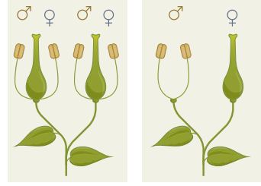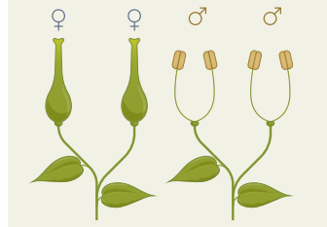
Steeg et al. 2022
Picture 1 a) Hermaphrodite b) Monoecious c) Dioecious flower

- Techniques of Hybrid Seed Production
There are basically 3 steps in hybrid seed production of various crops viz., i) Emasculation of male flower/part ii) Effective pollination iii) Bagging (Kulkarni 2011). From these three steps emasculation is most costly and tedious. It is used only in those crops which produce seeds in large and have low seed rate such as brinjal, tomato, cucurbits and Cole crops. Emasculation involves the manual removal of the male flower or reproductive part from the plant. Emasculation is done in the crops where the female is not sterile. However, in case of the crops with a sterile female line, emasculation is performed. The female line has been found to be sterile in crops like rice, sorghum (jowar), pearl millet (bajra), castor, mustard, sunflower etc (“A line”) while in some crops like brinjal, tomato, okra, chilli, cotton etc. emasculation has to be performed in order to make the female line sterile. The emasculated flowers are then pollinated with the pollens from the desired male parent.
Pollination can be done manually (hand pollination) or allowed to pollinate by insects especially by honey bees. The method of hand pollination is rather costly and requires the assistance of labour. The method of open pollination with insects however requires the presence of sufficient population of bees in the field and can be ensured by installing honeybee hives in the field.
- Requirements for hybrid seed production
The process of development of hybrid seed requires the breeder to consider the responsibilities: i) To develop genetically homozygous pure lines as parents for the hybrid seed development programme, ii) To identify and select the parental lines possessing the desired features, iii) To develop a system for the control of pollens and pollination. However, the breeder may face certain difficulties in the procedures of the programme for maintenance of inbred lines, emasculation of the plants and pollination of the plants.
- Methods of hybrid seeds production
The commercial production of a hybrid vigour is useful only when the outcome of the heterozygous progeny supersedes its homozygous parents. The availability of a cost effective and feasible system is necessary for the production of hybrid seeds (Perez-Prat and van Lookeren Campagne 2002). Hybrid seeds are produced by the effective manipulation of cross-pollination by a number of methods viz. i) Manual emasculation and pollination, ii) Use of genetic male sterility (GMS), iii) Use of Cytoplasmic male sterility, iv) Use of self-incompatibility and v) Use of cytoplasmic- genetic male sterility.
- Genetic male sterility (GMS)
Genetic male sterility also known as nuclear male sterility, has been reported in many crops like pepper, tomato, brinjal, cucurbits and cole crops. GMS is generally controlled by recessive gene, however dominant gene controlling GMS is also reported. An open and isolated field is selected for the production of hybrid seed. In this technique a maintainer line (Msms), which is developed by crossing an isogenic homozygous male fertile parent (MsMs) with the GMS line (msms), is used for the maintenance of the GMS lines (msms). The seeds obtained from the female line contains both male fertile (Msms) and male sterile (msms) plants in ratio 1:1. The male fertile plants are removed from the field prior to anthesis in order to maintain the purity of the hybrid and prepare for cross pollination for hybrid seed production. Hybrid seed is obtained by crossing the male sterile line with a homozygous dominant pollinator line (MsMs).
This system is also known as two-line system for hybrid seed production (Sharma 2018). Although it is difficult to distinguish the male fertile plants from the male sterile plants in the field. However, in some cases the morphological characters expressed in the male fertile line prior to anthesis e.g. larger flower size in case of fertile flowers of chilli may be helpful in identification of the fertile lines for rouging.
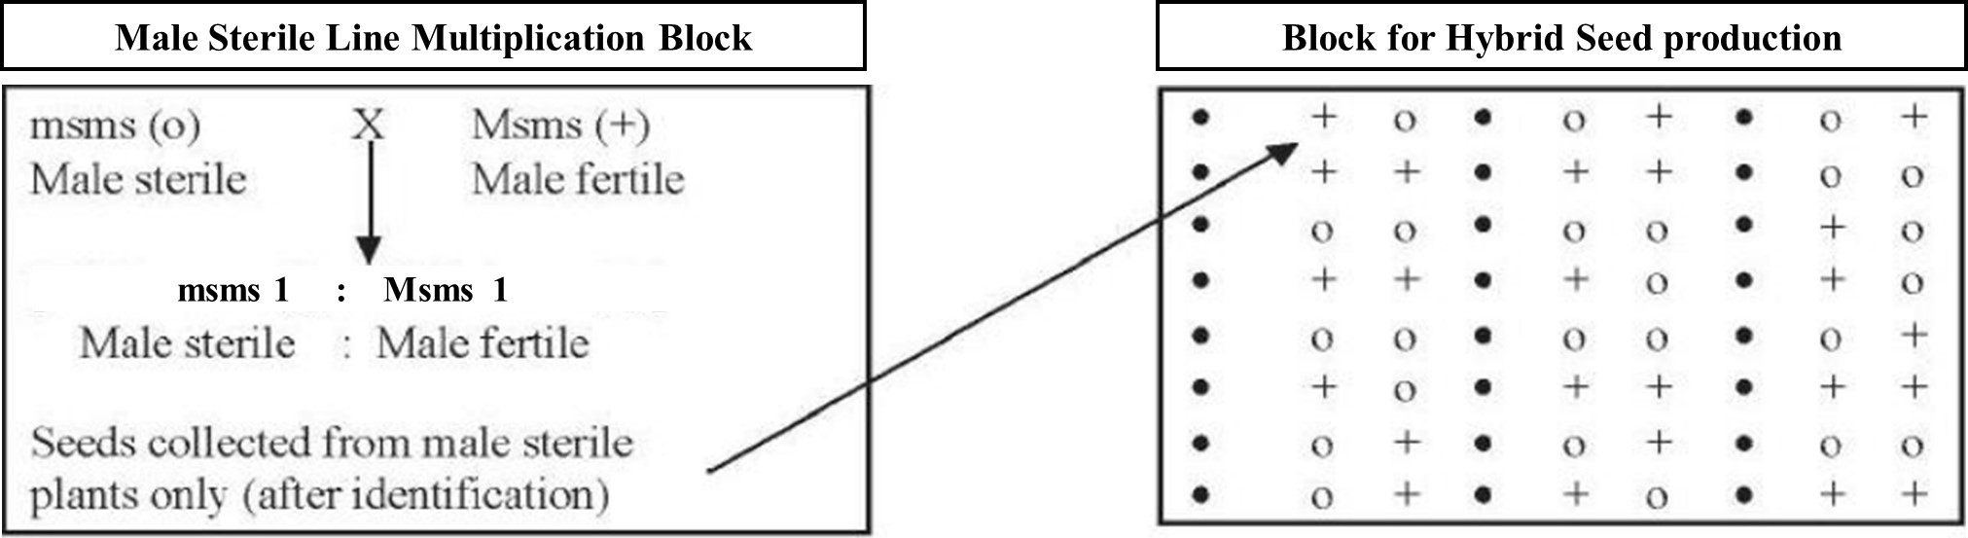
Picture 2 Hybrid seed production using GMS system
- Cytoplasmic male sterility (CMS)
Cytoplasmic male sterility is controlled by the gene(s) present in the mitochondrial genome of the cytoplasm. The progeny of such male sterile plants is always male sterile as the zygote is primarily inherited from the egg cell (Sawant et al 2006). In order to maintain CMS, the male sterile line (A-line) is crossed with a maintainer (B-line), which is male fertile. The hybrid seed is obtained by crossing the A-line with the pollinator strain having a diverse genetic background. The F₁ progeny of this cross is male sterile due to maternally inherited sterile cytoplasm (Havey 2004). This system of hybrid seed production is employed for the crops where the vegetative parts are commercially important rather than the seeds e.g. Cole crops, onion, ornamentals, carrot etc.
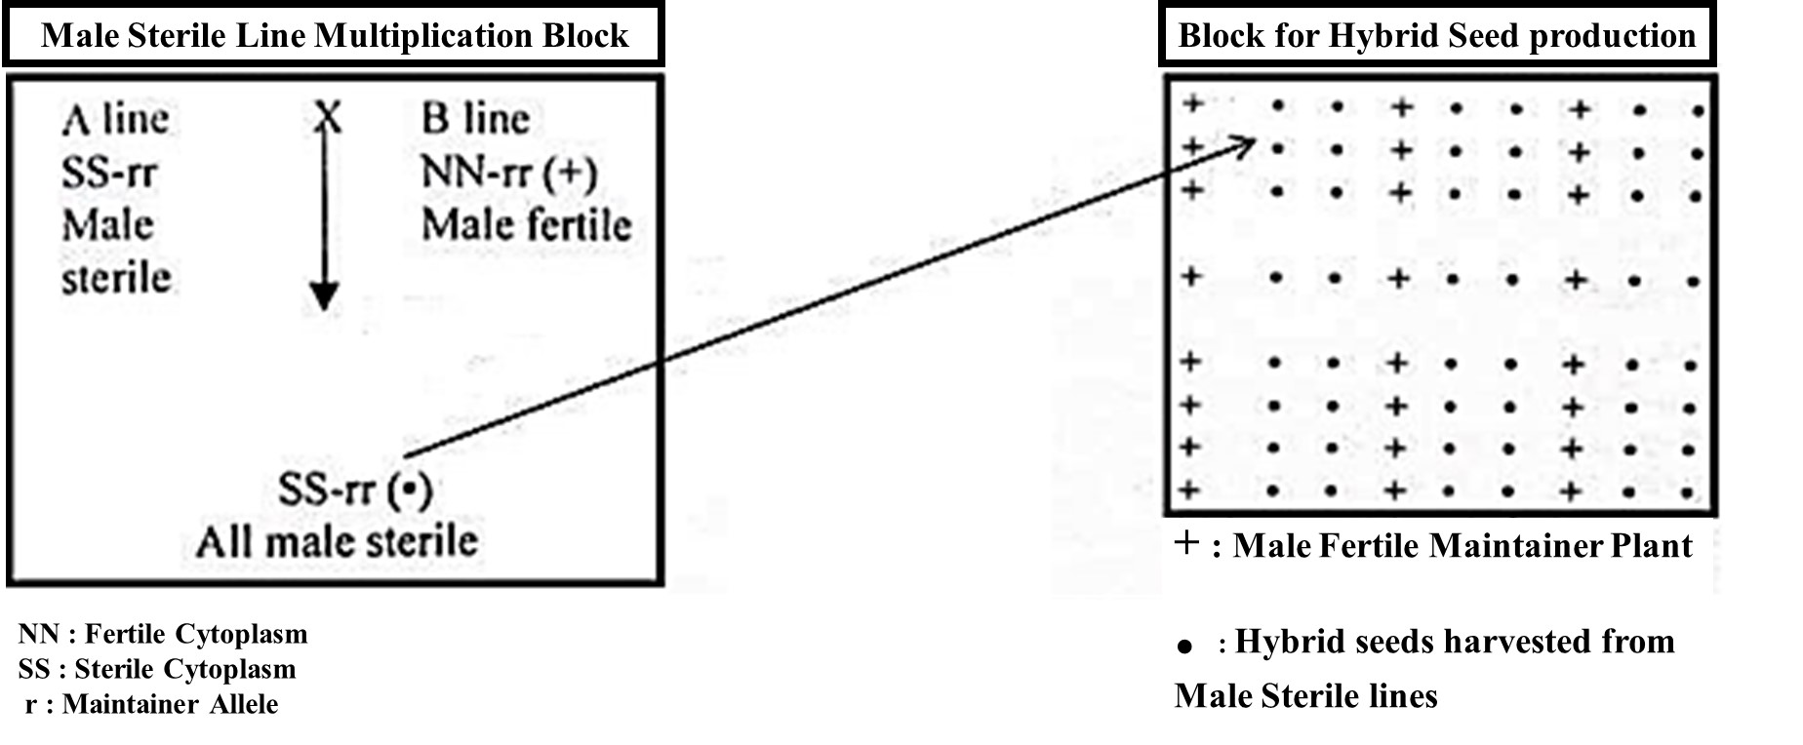Picture 3 Hybrid Seed Production Using CMS System
- Cytoplasmic genetic male sterility (CGMS)
In case of CGMS system for hybrid seed production, a fertility restorer line (R-line) having dominant RR gene, is known. The system is also known as three-line system of hybrid seed production. This type of sterility has been observed in crops like onion, rice chilli, carrot, pigeon pea, Brassica napus etc. CGMS is maintained by crossing the male sterile (A-line) with a pollinator line, having recessive alleles for fertility restoration, as a recurrent parent in the backcross programme (Singh et al 2013). Hybrid seeds are produced by crossing the male sterile line with the restorer (R-line). The seeds obtained from the A-line are utilized as the commercial hybrid seed while the restorer line may produce mixed progeny of sterile and fertile genotypes (Nagaraju et al. 2017). CGMS system of hybrid seed production is utilized in case of crops where seed is commercially important (Singh and Ram 2012). CGMS can be used to obtain cent percent male sterile plants which makes this system more advantageous over GMS.
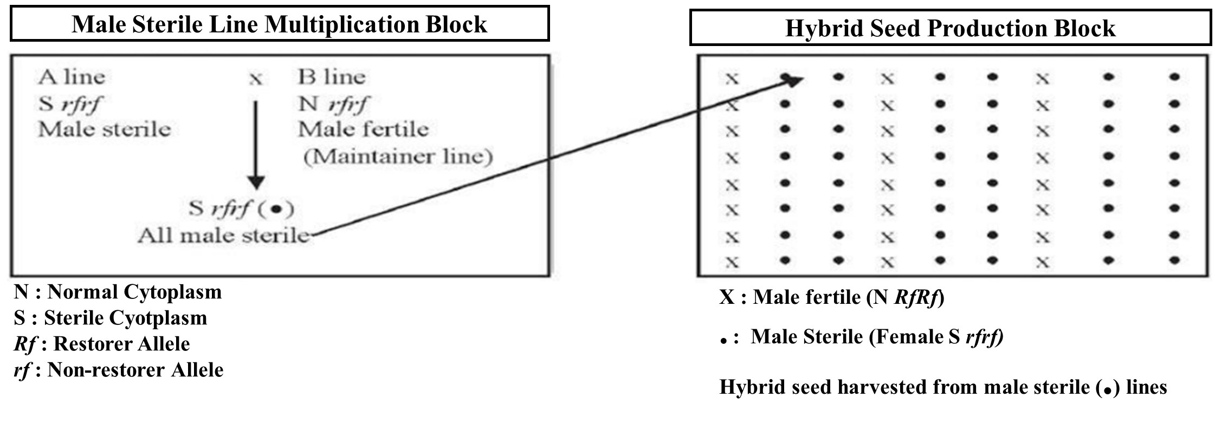
Picture 4 Hybrid Seed Production Using CGMS System
- Self-incompatibility
Self-incompatibility is the inability of the pollen to fertilize the same flower or the other flower of the same plant. Self-incompatibility is a useful mechanism that prevents self-pollination and promotes out-crossing or cross-pollination in the plants (). This eliminates the need to emasculate the flowers and therefore eases the process of hybrid seed production. The homozygous self-incompatible parents are maintained and crossed with a compatible pollinator. The stability of self-incompatibility is largely dependent upon the temperature condition. Self-incompatibility is found in commercially important crops such as tomato, radish, cabbage etc.
- Stages in the production of hybrid seed
The production and multiplication of hybrid seed in India is basically performed by the system of limited generation i.e., i) Breeder seed and ii) Foundation seed and iii) Certified seed. Breeder seed is the seed directly controlled by the sponsoring plant breeder of the breeding programme who is supervised by the qualified plant breeder. The breeder seed is serves as the source for the initial and recurring development of foundation seed. The breeder seed is required to be genetically pure in order to maintain the prescribed standards of purity in the subsequent generations in the system. Breeder seed is labelled with a yellow tag.
The foundation seed is the progeny of breeder seed developed under supervision of qualified plant breeders at National or State Seed Corporation and State Farm corporation. Certified seed is the progeny of the foundation seed and the commercial seed which is distributed for use among the farmers commercially. The certified seed is generally produced in the farms of progressive farmers by the State or National Seed corporation under the supervision of the certifying agency. The foundation seed is labelled with a white tag while certified seed is labelled with Azar blue coloured tag.
- Seed production organisations in India
In India seed production is carried out by two domains: i) Public sector that include National Seed Corporation, State Seed Corporation and State Seed Certifying Agencies and ii) Private sector that includes the private companies.
- National Seed Corporation (NSC): NSC is Government owned seed industry, established in 1963, which undertakes the seed production programmes in different agro-climatic regions of the country. NSC arranges for the production of breeder, foundation as well as certified seed of various crops. It also conducts marketing, consultancy services, training as well as coordination in the production of certified seeds.
- State Seed Corporation (SSCs): SSCs have been established after the launch of National Seed Project in 1976. SSCs have been recognized in 14 states of India. These are responsible for the development and distribution of certified seeds in the respective state.
Table1 list of State Seed Corporations in India
Sr.no | State | SSC | Address
 | Andhra Pradesh | Andhra Pradesh State Seeds Development Corpn.Ltd. | 5-10-193(2nd Floor) HACA Bhavan,Opp.Public Gardens Hyderabad-500 004
 | Karnataka | Karnataka State Seeds Corporation Ltd. | Beej Bhavan, Bellary Road, Hebbal, Bangalore - 560024
 | Rajasthan | Rajasthan State Seeds Corporation Ltd. | Pant Krishi Bhawan, B.D. Road, Jaipur
 | Punjab | Punjab State Seeds Corporation Ltd. | S.C.O. Nos. 835-836, Sector 22-A, Chandigarh
 | Gujarat | Gujarat State Seeds Corporation Ltd. | Beej Bhavan, Sector 10 -A, Gandhinagar - 382010
 | Haryana | Haryana Seeds Development Corporation Ltd. | Bays No.3 - 6, Sector - 2 Panchkula (HR) - 134112
 | Uttarakhand | U.K. Seeds and Tarai Development Corpn. Ltd. | Pantnagar, P.O.: Haldi - 263146, Distt.: U.S. Nagar (Uttaranchal), India
 | West Bengal | West Bengal State Seeds Corp. Ltd. | 4, Gangadhar babu Lane (5th floor), Kolkata - 700012
 | Madhya Pradesh | MP Seeds & Farms Development Corpn .Ltd. | E-1/88, Arera Colony, Bhopal
 | Orissa | Orissa State Seeds Corporation Ltd. | Santrapur, Bhubaneshwar
 | Bihar | Bihar Rajya Beej Nigam Ltd. | Mithapur Farm Campus, Mithapur, Patna - 800001
 | Maharashtra | Maharashtra State Seed Corporation Ltd. | Shastri Nagar, Akola-444001
 | Assam | Assam State Seeds Corporation Ltd., | Sh. Shiv Shankar Dey, MD, Assam State Seeds Corporation Ltd., Khanapara, GUWAHATI - 781022
 | Uttar Pradesh | U.P. Seeds Development Corporation | Sh. M.P.Upadhyay, MD, U.P. Seeds Development Corporation, C-973/74B Faizabad Road, Lucknow 226006
- State Seed Certification Agencies (SSCAs): In India, SSCAs are present in 21 different states. These agencies perform the certification of seed in their respective state. SSCAs is responsible for the verification of source of the seed and also undertakes the field inspections, seed testing for the certification process.
- Private Seed Companies: These are private firms that take up the responsibility to produce quality seed. These companies produce and market hybrid and varietal seeds of different types of crops including flowers, vegetables, field crops etc. There are several private sector seed companies rooted in different states of the country.
- Requirements for Certified seed production
The production of certified seed is handled in such way so that the genetic identity and purity are maintained according to the standards for specific crops conformed by the certifying agency. The certification process is accomplished in the following six phases:
- Reception and inspection of application
- Inspection of the source, class and other requirements that have been used in production of seed
- Field inspections
- Inspection at harvesting and post-harvest processing stages
- Seed sampling and testing for genetic purity
- Grant of certificate, certification tags and sealing

- Source of seed
It is necessary for the person interested in seed certification to provide pertinent evidences such as tags, labels, seals, purchase and sale records, seed containers etc. to the certifying agency in order to confirm the authenticity of the source of seed. The parental lines used for hybrid seed development should be the progeny of approved inbred parental lines. This condition is applicable to all the parental lines used in the hybrid seed production.
- Field requirement
The field selected for development of the seed should be suitable to the crop in all the essential factors such as drainage, free from soil borne disease, pests, volunteer plants and noxious weeds. There should not be history of same crop grown in the previous season in the field and if so, the field should be irrigated three weeks before sowing so that any seeds from previous crop may germinate and be rouged out.
- Isolation requirement
The parental lines are required to be grown in adequate isolation to make sure that no cross pollination takes place with other varieties of the crop grown in the same field. Time isolation can be maintained by adjusting the sowing date of plants of same species in such a way that their flowering of period may not coincide. Isolation of the seed plot helps in avoiding the genetic contamination of the seed crop under certification programme. Space isolation is the minimum distance that is to be maintained to prevent the unwanted pollinated and mechanical mixture. The isolation distance varies in different crops depending upon the crop, climatic conditions (temperature, humidity, wind etc.), size and weight of the pollens. The isolation distance may also vary depending upon the type of contaminant present in or near the field.
Table 2 Isolation distance for certified hybrid seed production in crops
Sr.no | Crop | Minimum distance (meters)
Sr.no | Crop | Foundation seed | Certified seed
 | Rice | 200 | 100
 | Wheat | 200 | 100
 | Maize | 400 | 200
 | Barley | 200 | 100
 | Pearl millets | 1000 | 200
 | Sorghum | 300 | 200
 | Tomato | 200 | 100
 | Brinjal | 200 | 200
 | Cucumber | 1500 | 1000
 | Cole crops | - | 1600
 | Onion | 1200 | 600
 | Radish | - | 1600

- Use of Chemical Hybridizing Agents (CHAs)
CHAs are the chemicals that are capable of induction of artificial and non-genetic male sterility in plants. The CHAs are used to ease the process of hybrid seed development. These are also famously known as gametocides. As these chemicals may result in pollen abortion, the need to develop the maintainer or restorer lines can be used to exempted (Sharma and Sharma 2005). When CHAs are used in the hybrid seed development programme, the Minimum Seed Certification Standards specified for the development of ‘A’ and “B’ lines are not applicable anymore. However, the hybrid seed produced has to be subjected to grow-out test for the grant of certification.
- Field inspection
Field inspection is carried out by authorized personnel from the certifying agency. The purpose of field inspection is to check any factors that may be responsible for the impairment in the seed health and purity. Field inspection can be carried out without any prior notice to the producer. The certifying agency personnel may perform one or more re-inspections to verify the compliance of the crop to the set standards.
- Harvesting and processing of seed
The hybrid seed crop that meets the standards for certification, is harvested and threshed. However, extreme care is taken while harvesting the hybrid seed. The pollen and seed parents are required to be harvested separately. The crop is harvested at appropriate stage of physiological maturity. The seed is dried, bagged and labelled properly with all the details about the pedigree of the seed. The hybrid seed is also subjected to suitable processing operations such as cleaning, drying, grading, priming, etc. for refining the seed quality.
- Seed testing
Once the seed is processed, the certifying agency subjects the seed to several tests in order to verify if the hybrid seed meets the established quality standards. Seed testing is necessary to confirm the genetic and physical purity, germinability, absence of weed seeds and seed-borne pathogen infection (Kumar et al 2020). A representative sample is drawn from the seed lot and seed testing is carried out by seed testing laboratory. The quality assessment tests like i) Seed moisture test, ii) Germination test, iii) Seed viability test, iv) Physical purity test, v) Seed vigour test, v) Seed health test and vi) Grow out test, are carried out according to the prescribed procedures. The certified seeds are supposed to meet the Minimum Standards for genetic purity.
Table 3 Minimum standards for genetic purity of hybrid seed

Sr.no. | Hybrid seed | Pure seed (minimum) % | Inert matter (maximum) % | Other crop seed (maximum) per kg | Weed seeds (maximum) per kg | Germination (minimum) % | Moisture (maximum) %
 | Rice | 98.0 | 2..0 | 10 | 10 | 80 | 13
 | Wheat | 98.0 | 2.0 | 10 | 10 | 85 | 12
 | Maize | 98.0 | 2.0 | 10 | 10 | 90 | 12
 | Barley | 98.0 | 2.0 | 10 | 10 | 85 | 12
 | Pearl millets | 98.0 | 2.0 | 10 | 10 | 75 | 12
 | Sorghum | 98.0 | 2.0 | 10 | 10 | 75 | 12
 | Tomato | 98.0 | 2.0 | 5 | None | 70 | 8
 | Brinjal | 98.0 | 2.0 | None | None | 70 | 8
 | Cucumber | 98.0 | 2.0 | 10 | None | 60 | 7
 | Cole crops | 98.0 | 2.0 | 10 | 10 | 70 | 7
 | Onion | 98.0 | 2.0 | 10 | 10 | 70 | 8
 | Radish | 98.0 | 2.0 | None | None | 70 | 6

- Importance of hybrid seed production
Hybrid seed production is a predominant process in today’s agriculture. Hybrid seed are developed with the objective to improve the quality characteristics such as yield, colour, uniformity, disease and pest resistance etc. of the crop. Hybrid seeds also provide advantages like higher yield in limited space, resistance to economically important crop diseases, better shelf-life and transportation characteristics. Recent hybrid seed production technologies have resulted in the introduction of greater genetic variability that in turn helps in the development of desired agronomic characters in the crops. In rice, hybrid seeds have shown 15-20% increase in yield as compared to traditional varieties. Hybrid rice production in India covers about 3.0 mha area which contributes to 6.8% of total rice area. China however contributes for largest (57%) production area of rice (Rout et al 2020). In maize hybrid seed production, China and USA collectively account for 56% of global production. In vegetable crops, it has been observed that hybrid seeds have increased the yield due to higher seed replacement rate e.g. cabbage (100%), tomato (90%) as compared to cereals and oilseeds (Mohan et al. 2021).
Although hybrid seeds provide numerous advantages to the growers, but they also have some shortcomings too. The production of hybrid seeds is a labour intensive and costly process and requires the assistance of skilled personnel. Hybrid breeding of crops for one desired character may often lead to degeneration of other traits in the seed. Hybrid seeds cannot be saved and have to be produced every year due to segregation of generations. This makes it expensive for small and marginal farmers to afford hybrid seeds.
Therefore, there is a need to develop a sustainable system for hybrid seed production. The seed sector needs new innovations especially in the field of development of better hybrids, transgenic and seed processing technologies in crops like rice, maize, millets, cole crops, rapeseed mustard etc. India also needs strong legislations in seed sector to regulate the production, sale and marketing of hybrid seeds in order to protect the interest of farmers. There is a requisite to promote joint ventures and collaborations among the national and international seed organisations. The adoption and application of biotechnology to develop new improved hybrid seeds would be critical for the betterment of resources of small holder farmers. It is also necessary to raise awareness about the benefits and risks associated with hybrid seeds among the general public and farmers.

References:
Ali AA. Role of seed and its technological innovations in Indian agricultural sector. Bioscience Biotechnology Research Communication. 2016; 9(4): 621–24
Havey MJ. The use of cytoplasmic male sterility for hybrid seed production. Molecular Biology and Biotechnology of Plant Organelle. 2004; pp.623-634
Kulkarni GN. Principles of Seed Technology. Kalyani Publishers, Bangalore, 2011, 230
Kumar A, Gaur A, Gurjar MS, Kumari P and Kiran R. Seed health testing and seed certification. In: Kumar R. and Gupta A. (eds) Seed-borne Diseases of Agricultural Crops: Detection, Diagnosis and Management. Springer, Singapore. 2020; pp.795-808
Mohan C, Srivastva D K, Verma R, Kumar V, Singh V, Chaudhary S and Saini PN. 2021. Current status, challenges and future prospects of vegetable seed system in India. Journal of AgriSearch, 8.
Nagaraju MM, Thomson T, Rao GK and Siva M. Role of male sterility in vegetable hybrid seed production. International Journal of Current Microbiology and Applied Sciences. 2017; 6(7): 134-141
Perez-Prat E and van Lookeren Campagne MM. Hybrid seed production and the challenge of propagating male-sterile plants. Trends in Plant Science. 2002; 7 (5): 199-203
Rout D, Jena D, Singh V, Kumar M, Arsode P, Singh P, Katara JL, Samantaray S and Verma R. Hybrid rice research: current status and prospects. In (Ed.), Recent Advances in Rice Research. IntechOpen. https://doi.org/10.5772/intechopen.93668\
Roy S, Gupta N, Singh N, Manimurugan C, Singh PM and Singh J. Research and development issues prioritization for vegetable seeds in India: A perception study. Indian Journal of Agricultural Sciences. 2021; 91 (1): 34-39
Sawant DS, Kunkerkar RL, Shetye VN and Shirdhankar MM. Inheritance of fertility restoration of five sources of cytoplasmic male sterility in rice (Oryza sativa L.). Annals of Agricultural Research. 2006; 27 (2): 133-138
Sharma S. Hybrid seed production systems. Agrobios Newsletter. 2018; 17(3): 83-84
Sharma Y and Sharma SN. Chemical hybridizing agents- A tool for hybrid production- A review. Agricultural Reviews. 2005; 114-123
Singh R and Ram L. Ideal hybrid rice production package: An overview. Indian Research Journal of Extension. 2012; 2: 244-251
Singh S, Singh P, Singh DK and Singh AK. Hybrid rice development: Two line and three line system. Journal of Biologix. 2013; 178: 178-195
Steeg SME, Struik CP, Visser FGR, Lindhout. Crucial factors for the feasibility of commercial hybrid breeding in food crops. Nature Plants. 2022; 8: 463-673
Vishnoi A, Kamboj P, Yadav A, Priya MS, Subba A and IR Delvadiya. Review on hybrid seed production of wheat: Problems and prospective. The Pharma Innovation Journal. 2022;11(6): 7752

