SYNTHESIS AND CHARACTERIZATION OF LABLAB PURPUREUS DRIED LEAVES EXTRACTS

Giri Prasad Gorumutchu¹ and Chandra Mohan Kurmarayuni²

¹Department of Chemistry, AG & SG Siddhartha Degree College of Arts and Science, Vuyyuru-521165, AP-India.
²Department of Chemistry, Acharya Nagarjuna University, Nagarjuna Nagar, Guntur, 522510, AP-India.
ABSTRACT
The current study was carried out to determine the wavelengths (λ_{max}) and frequency in Lablab purpureus (L.) (L. purpureus) leaves by using molecular spectroscopic technics (FT-IR spectroscopy and UV-Vis Spectrophotometry). A series of extracts were prepared by using solvents (polar and non-polar solvents) and Lablab purpureus dried leaves powder. The polar (double-distilled water, ethanol, and ethyl acetate) and the non-polar solvent extracts (carbon tetrachloride and hexane) were put into the FT-IR spectroscopy and UV-Vis Spectrophotometry. The FT-IR spectra give various peaks at different frequencies in synthesized extracts showing a different functional group with stretching frequencies which represents the carboxylic acids, amides, esters, etc. and also obtained absorbance values corresponding wavelengths from UV-Vis spectrophotometer. From the spectral results, the presence of absorption peaks may be arising due to active biomolecules in the leaf extract with various solvents. According to all wavelengths’, highly conjugated molecules are present.

KEYWORDS: Lablab purpureus leaves, shaded dried leaves, FT-IR, UV-Vis spectrometer, Polar and non-polar solvents.

INTRODUCTION :
Lablab purpureus (L.) (L. purpureus) sweet is a normally short-lived, and summer-growing plant. It is a climbing, twining, upright, or trailing herbaceous plant that can increase to 3-6 cm in length. It gives vigorous taproot, pubescent trailing, or glabrous stems. L. purpureus leaves are trifoliolate and alternate. The leaves are rhomboid in shape with a length and breadth of 7.5-15 cm x 14 cm. The leaves’ upper surface is very soft and short hair is present. This plant containing white to purple or blue in color with 1.5 cm in length. These plant-containing seeds are linear in shape with 4-15 cm length x 1-4 cm breadth. These plant seeds are ovoid, varying in color, dependent on cultivar or variety, normally white to brown, and few seeds are black¹⁻⁴. Lablab is a flexible leguminous plant. Its young pods and seeds, and immature leaves are cooked and edible as vegetables²⁻³. L. purpureus seeds are used in medicine (ethnoveterinary), for example, in Kenya to treat lung and eye problems in goats and sheep³.

The family name of L. purpureus (Hyacinth Bean) is Fabaceae. This tree is naturally occurring in Africa, and it is developed throughout the tropics for diet. The regular names of L. purpureus are lablab-bean⁵, hyacinth bean⁶, Dolichos bean, sem bean, Egyptian kidney bean, bonavist bean, Indian bean, and Australian pea (L. purpureus (L). Various names of L. purpureus in South Asia were depicted in Table 1.

Table 1: Various names in South Asia
Place | Scientific Name
Gujarati | Surti Papdi
West Bengal | Sheem
Kerala | Amarakka
Tamil | mochai
Karnataka | avarekalu saaru
Maharashtra | Shravan ghevda
Andhra Pradesh/Telangana | Hyacinth bean

LITERATURE REVIEW
To prepare nanoparticles using purple color L. purpureus flowers and silver nanoparticles and characterization⁷. By the green approach method, carbon nanospheres are developed from L. purpureus using an electrode-like high-performance supercapacitor⁸. To prepare Zinc oxide nanoparticles with L. purpureus leaves and analysis of its bactericidal and photocatalytic application⁹. Identification and characterization of L. purpureus L. sweet (Dolichos Bean) Recombinant Inbred Lines (RIL) with elevated pod fragrance and great pod yield¹⁰. To evaluate the few germplasms of L. purpureus beans in UP¹¹. Redevelopment analysis in Dolichos bean and lablab bean genotypes¹². L. purpureus L (Hyacinth bean)-An underutilized yield as well as coming potential¹³. L. purpureus L (Hyacinth bean) leaves contain polyamine levels and its relative to deficiency tolerance¹⁴. Lablab leaves used in yolk painting are representative of the food of layers and feed ingredients¹⁵. A review on medical and pharmacology consequence of L. purpureus (Dolichos lablab)¹⁶. Physico-structural variation in L. purpureus (L.) sweet beans. Genetic assessment of yield and concerned characters of Lablab Bean¹⁷. Utilization capacities of L. purpureus (L.) sweet and the restrictions of field insects and infections in Nigeria¹⁸. Consequences of leaf production on natural protein and ore contents of initial growing contours of lablab¹⁹. Evaluation of natural variety of L. purpureus (L.) sweet (Kenyan Dolichos bean) utilizing SSR (simple sequence repeat) indicators²⁰. Molecular diversity of L. purpureus (L.) sweet (Kenyan lablab bean) accesses applying expanded piece size polymorphism indicators²¹. Influence of plant density on food produce and quality of lablab bean and intercropped corn²². Natural diversity evaluation in L. purpureus L (Dolichos Bean) centered on fundamental element assessment and individual connection cluster evaluation²³. A over review on medical status and pharmacology L. purpureus (Dolichos lablab)²⁴. To prepare semi crude peptide of lablab bean to analyze the antimicrobial activity²⁵. Molecular and agronomical estimation of six L. purpureus L. (lablab bean) cultivars²⁶. To study conformity of vicilin from Phaseolus calcaratus and Dolichos lablab by using various scanning calorimetry and FT IR spectroscopy²⁷. Structure, composition, morphology, and physicochemical things of a navy bean, lablab bean, tepary bean velvet bean, and rice bean starches²⁸. A protein (carbohydrate-binding) from the cooked lablab beans successfully acts against the diseases of SARS-CoV-2 and influenza viruses²⁹. An analysis of the properties of starch separated from three kinds of L. purpureus seeds³⁰⁻³¹.
Now present researcher investigates to identify the functional groups in L. purpureus leaves with various solvents (ethanol, ethyl acetate, hexane, and carbon tetrachloride) by using FT IR spectroscopy.

MATERIALS AND METHODS:
Materials
The HPLC grade solvents (ethanol, ethyl acetate, hexane, and carbon tetrachloride) were purchased by Merck company from Mumbai.
Collection and preparation of powder with Lablab purpureus (L. purpureus) leaves
To collect L. purpureus leaves (Figure 1a) in the winter season (Dec-March 2022) from Kaza village, Movva Mandalam, Krishna district, A.P India. These leaves wash through distilled water and dry in shadows for 25-30 days (Figure 1b). After 25-30 days these dried leaves mix with mechanical Shekar up to amorphous powders (Figure 1c).

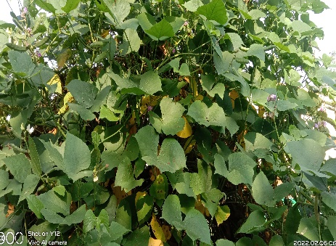
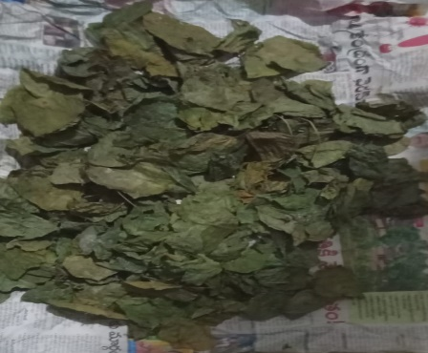
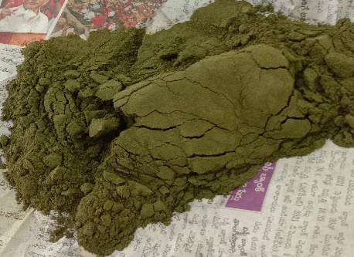
a)
b)
c)

Figure 1. a) L. purpureus leaves, b). Shaded dried leaves, c). Shaded dried leaves powder.
Formulation L. purpureus leaves extract with various solvents
To prepare five types of extracts (Hexane, ethanol, double-distilled water, carbon tetrachloride, and ethyl acetate) using dried powder. This extract was stored in sealed bottles at 5 ºC for further usage Figure 2.

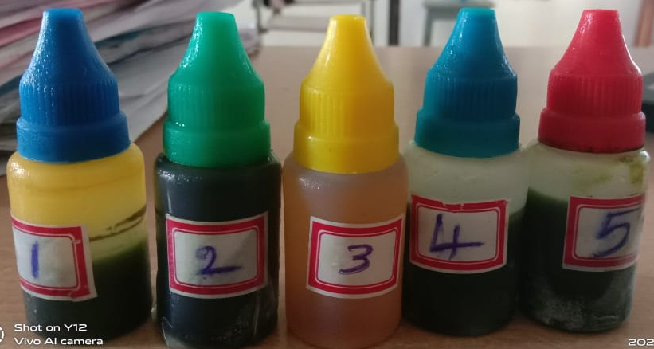

Figure 2. L. purpureus leaves extract with different solvents like hexane (1), ethanol (2), double-distilled water (3), carbon tetrachloride (4), and ethyl acetate (5).

Characterization of L. purpureus leaves extract
To identify the functional group in different samples by using an instrument is like FTIR spectroscopy. Compound (chemical bond) absorbed incident light radiation to get an infrared absorption spectrum. To determine the chemical bond in the molecule by using this interpretation spectrum. Prepare five types of extracts (Hexane, ethanol, double-distilled water, carbon tetrachloride, and ethyl acetate) using dried powder. The prepared extracts were inserted in FTIR spectroscopy (FTIR5300, JASCO), with wavelength range from 400 to 4000 cm⁻¹ and 4 cm⁻¹ resolution.

RESULTS AND DISCUSSION
- FT-IR Spectral analysis
The prepared series (five) of extracts were placed into FT-IR spectroscopy to give series (five) spectra at various frequencies as shown in (Figures 3-7). These spectra give various peak values and the feasible functional groups described in the samples. Based on the ratio of the peak, components were separated. The out coms of FTIR evaluation obeyed the presence of aromatic compounds, alcohol, aldehyde, and ester ³².
The FT-IR spectra are shown (Figure 3) various peaks at different frequencies in hexane and L. purpureus dried leaves powder extract. These spectral peaks observed at frequencies 2923.70 cm⁻¹, 2843.79 cm⁻¹, 1711.04 cm⁻¹, 1452.96 cm⁻¹, 1373.05 cm⁻¹, 1184.62 cm⁻¹, 1080.51 cm⁻¹, 985.51 cm⁻¹, 841.50 cm⁻¹ (Table 2).
The peaks were observed at frequencies 2923.70 cm⁻¹, and 2843.79 cm⁻¹ representing the OH stretching vibrational frequencies. The peaks at frequencies 2923.70 cm⁻¹ and 2843.79 cm⁻¹ are asymmetric starching frequencies and starching frequencies. asymmetric starching frequencies have a greater dipole moment than the symmetric starching frequencies, hence asymmetric starching frequencies are more than symmetric starching frequencies. The peak was observed at 1452.96 cm⁻¹ and 1373.05 cm⁻¹ representing the in-plane bending vibrations i.e., scissoring and rocking. The main functional group is observed at frequency 1711.04 cm⁻¹ representing the “C=O” stretching frequency which represents the carboxylic acid as a functional group. The C-O stretching frequencies are observed at 1184.62 cm⁻¹ and 1080.51 cm⁻¹, which represents the alkoxy group, and finally, two bands are observed at 985.51 cm⁻¹ and 841.50 cm⁻¹, which represents the OH out plane bending vibrations i.e., waging and twisting.
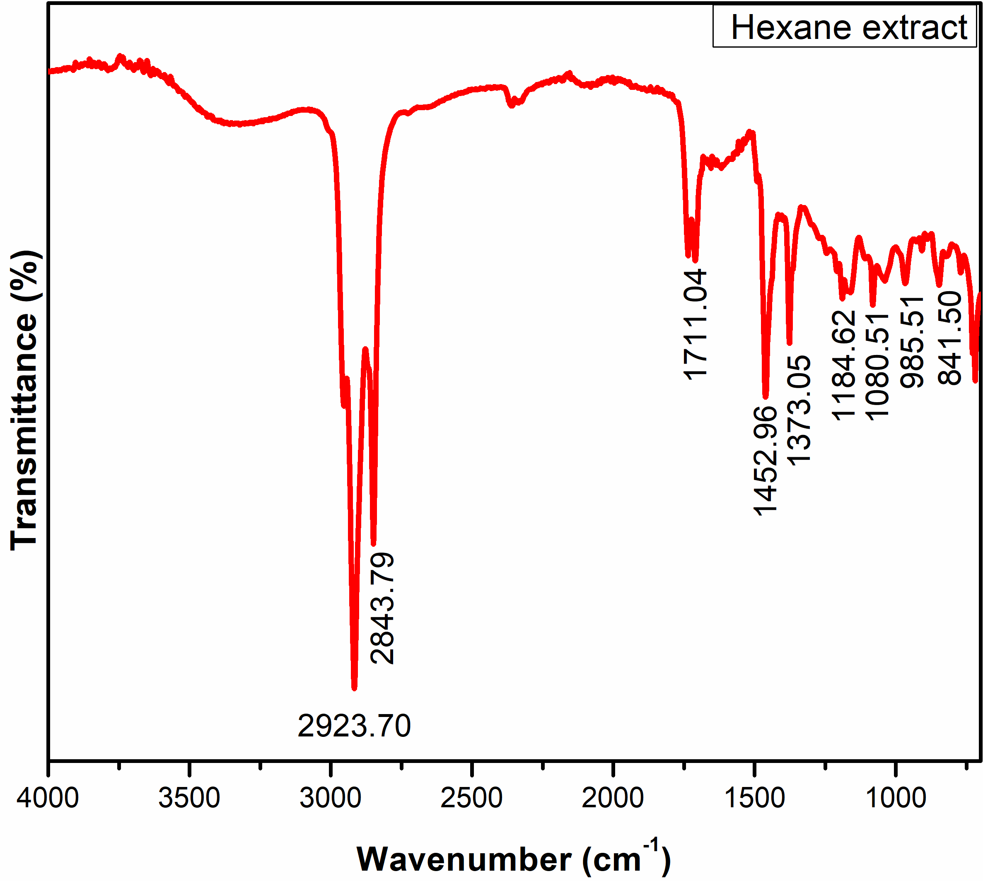
Figure 3. FT-IR spectra obtained by hexane and L. purpureus dried leaves powder extract.

The FT-IR spectra are shown (Figure 4) various finding peaks at different frequencies in Ethanol and L. purpureus dried leaves powder extract. These spectral peaks observed at 3350.41 cm⁻¹, 2938.36 cm⁻¹, 2843.79 cm⁻¹, 1612.06 cm⁻¹, 1392.84 cm⁻¹, 1035.79 cm⁻¹ (Table 2).
The peaks were observed at 2938.36 cm⁻¹, and 2843.79 cm⁻¹ representing the CH stretching vibrational frequencies. The peaks at 2938.36 cm⁻¹ and 2843.79 cm⁻¹ are asymmetric starching frequencies and starching frequencies. asymmetric starching frequencies have a greater dipole moment than the symmetric starching frequencies, hence asymmetric stretching frequencies are more than symmetric stretching frequencies. The peak was observed at 1392.84 cm⁻¹ representing the N-H in-plane bending vibration. The main functional group is observed at 1612.06 cm⁻¹ representing the “C=O” stretching frequency which represents the Amide as a functional group. The C-N stretching frequencies are observed at 1035.79 cm⁻¹ which represents the C-N bond is present.

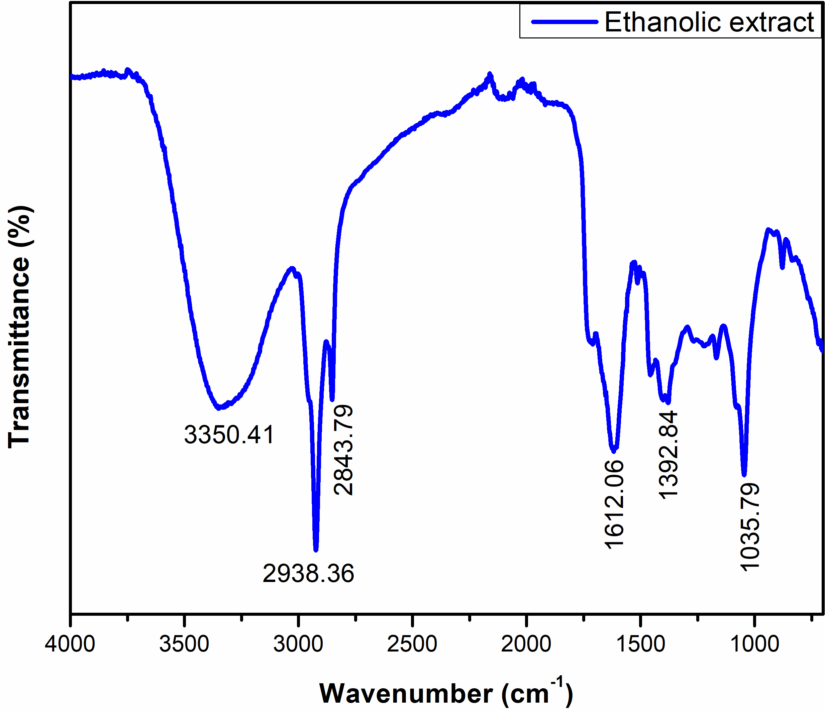
Figure 4. FT-IR spectra with ethanol and L. purpureus dried leaves powder extract.

In Figure 5 shown various peaks of FTIR spectra at different frequencies in double distilled water and L. purpureus dried leaves powder extract. These spectral peaks observed at 3275.53 cm⁻¹, 2068.88 cm⁻¹, 1636.24 cm⁻¹ (Table 2).
The peak frequencies found were at 3275.53 cm⁻¹, and 2843.79 cm⁻¹ representing the NH stretching vibrational frequencies. The main functional group is observed at 1636.24 cm⁻¹ representing the “C=O” stretching frequencies in Amide as a functional group. The C-N stretching frequencies are observed at 2068.88 cm⁻¹ which represents the C=N stretching frequencies.
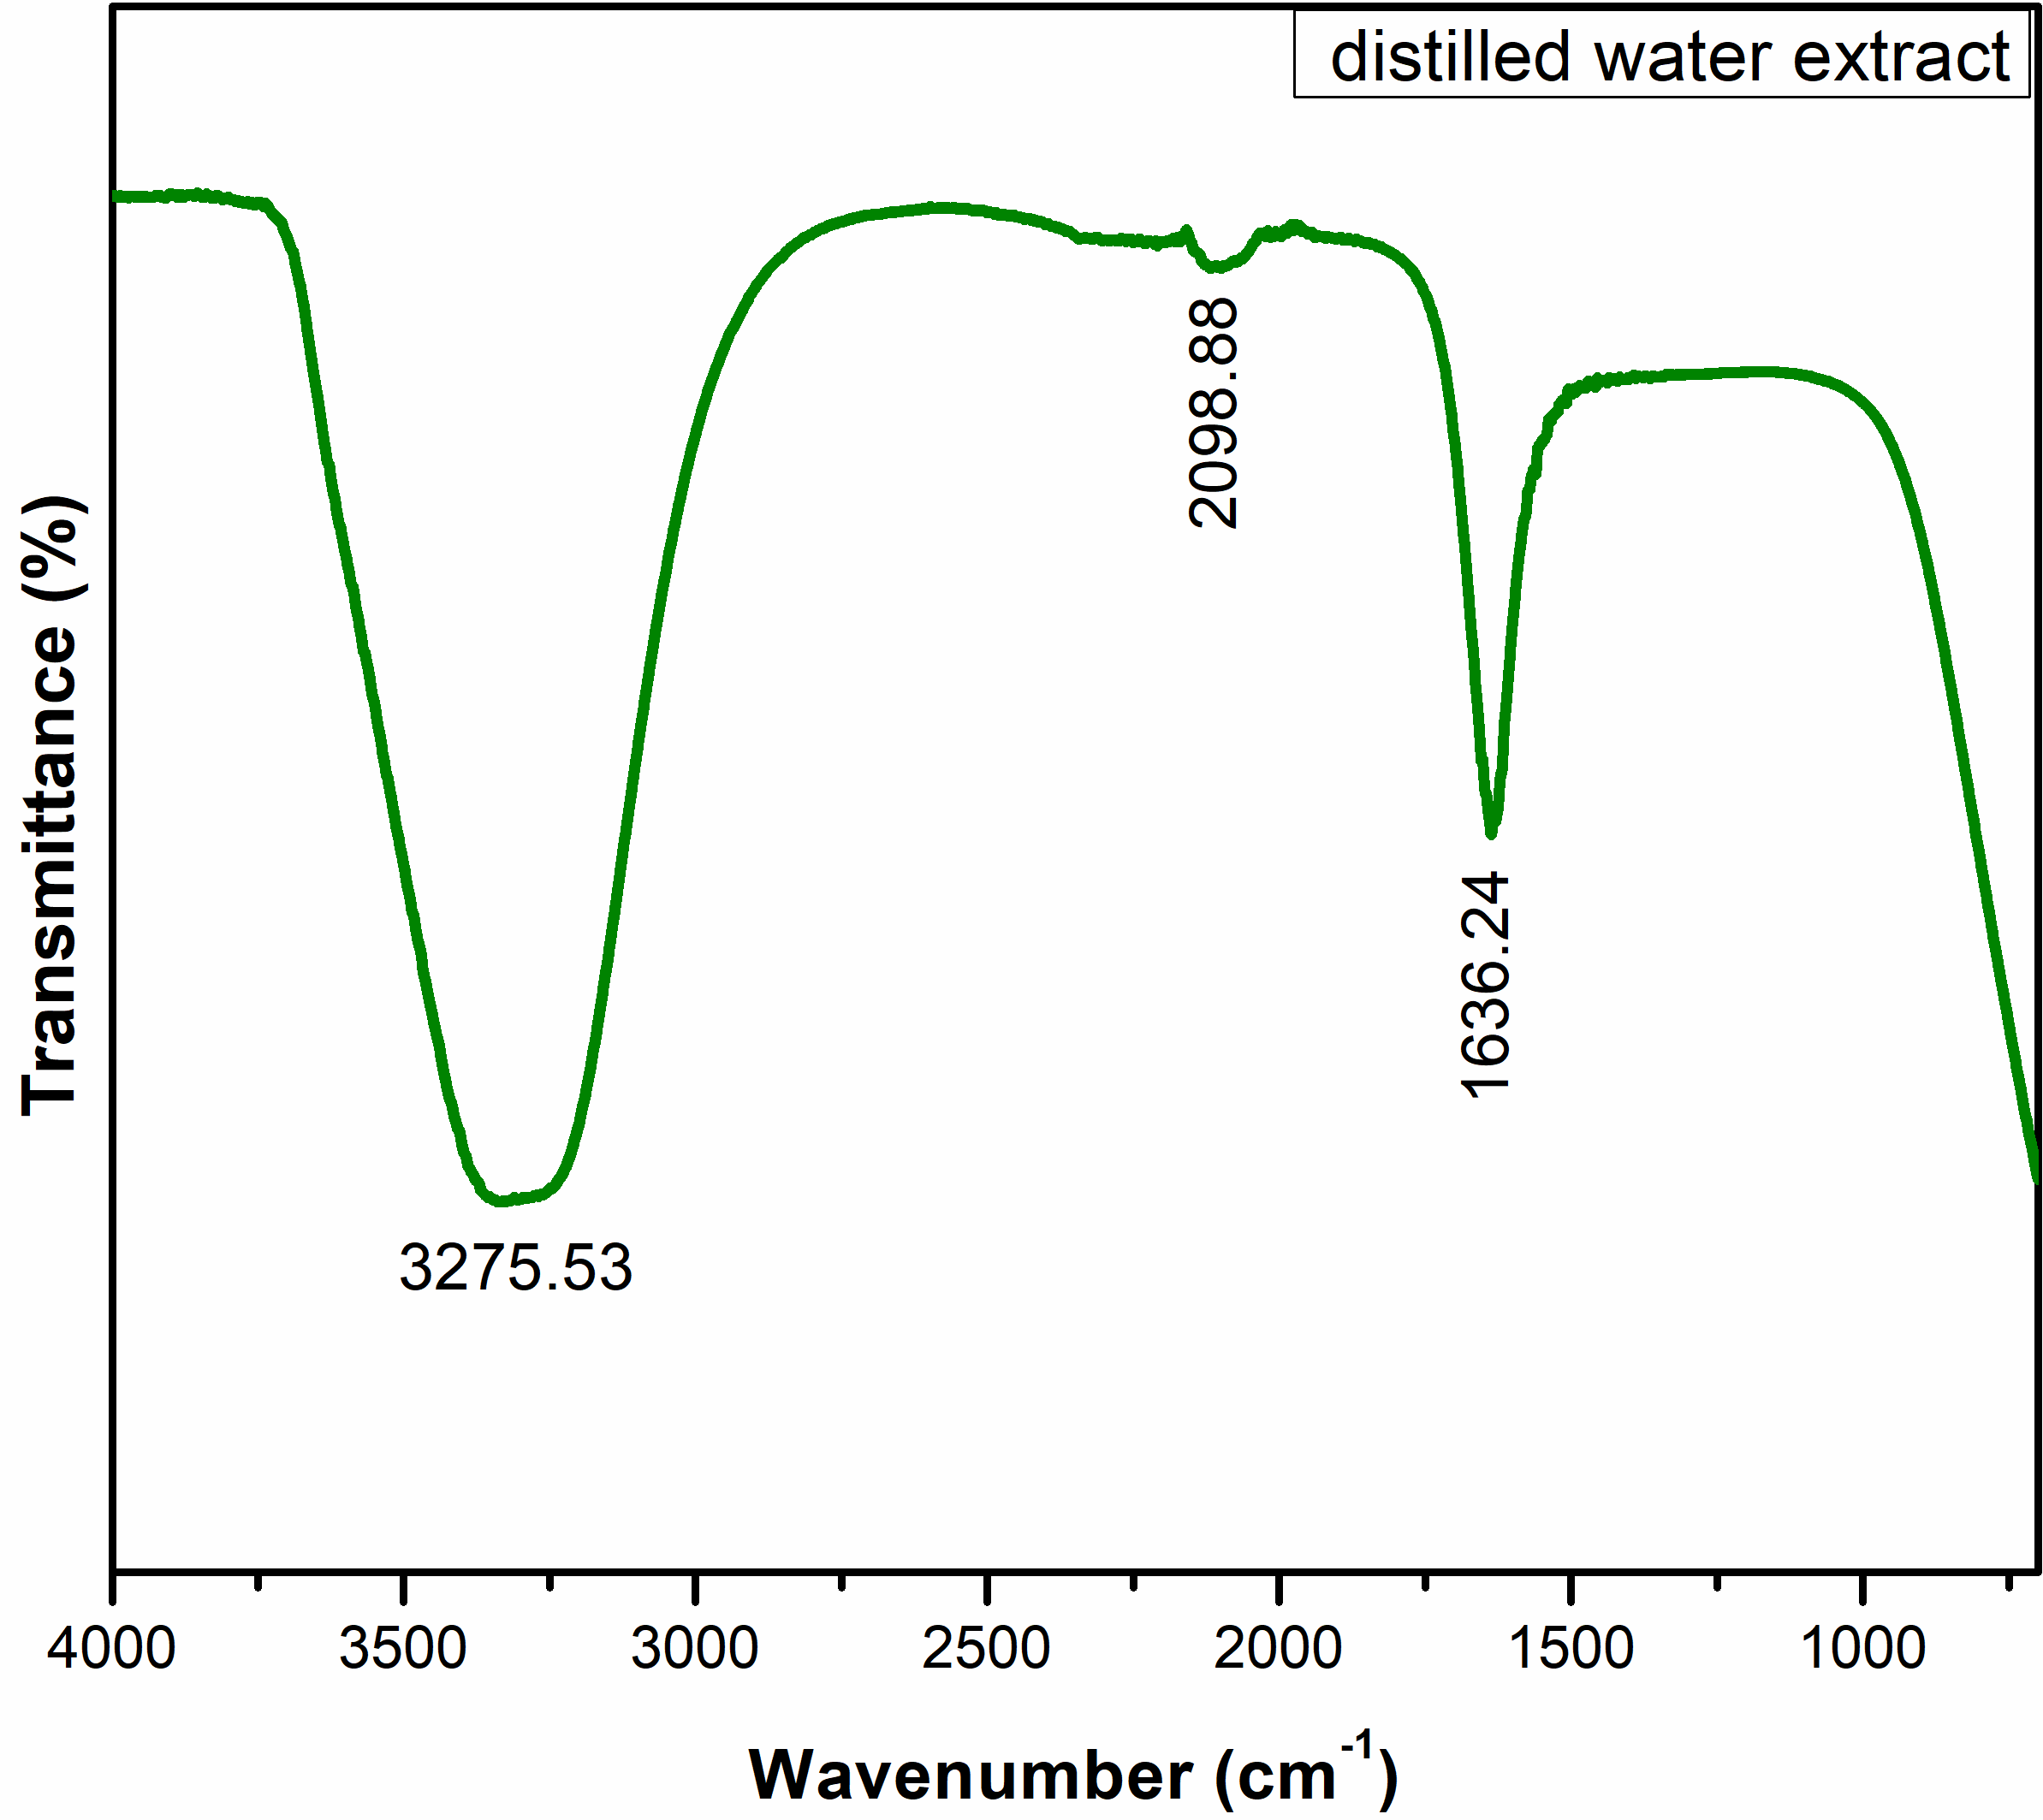
Figure 5. FT-IR spectra with double distilled water and L. purpureus dried leaves powder extract.
The FT-IR spectra are shown (Figure 6) various peaks at different frequencies in Carbon tetrachloride and L. purpureus dried leaves powder extract. To finding the spectral peaks at 2928.10 cm⁻¹, 2854.03 cm⁻¹, 1746.23 cm⁻¹, 1472.76 cm⁻¹, 1378.18 cm⁻¹, 1159 cm⁻¹ (Table 2).
The peaks were observed at frequencies 2928.10 cm⁻¹, and 2854.03 cm⁻¹ representing the CH stretching vibrational frequencies. The peaks at 2928.10 cm⁻¹ and 2854.03 cm⁻¹ are asymmetric starching frequencies and starching frequencies. asymmetric starching frequencies have a greater dipole moment than the symmetric starching frequencies, hence asymmetric starching frequencies are more than symmetric starching frequencies. The peak was observed at 1472.76 cm⁻¹ and 1378.18 cm⁻¹ representing the in-plane bending vibrations i.e scissoring and rocking. The main functional group is observed at 1746.23 cm⁻¹ representing the “C=O” stretching frequency which represents the ester as a functional group. The C-O stretching frequencies are observed at 1159 cm⁻¹ and 1080.51 cm⁻¹, which represents the alkoxy group.
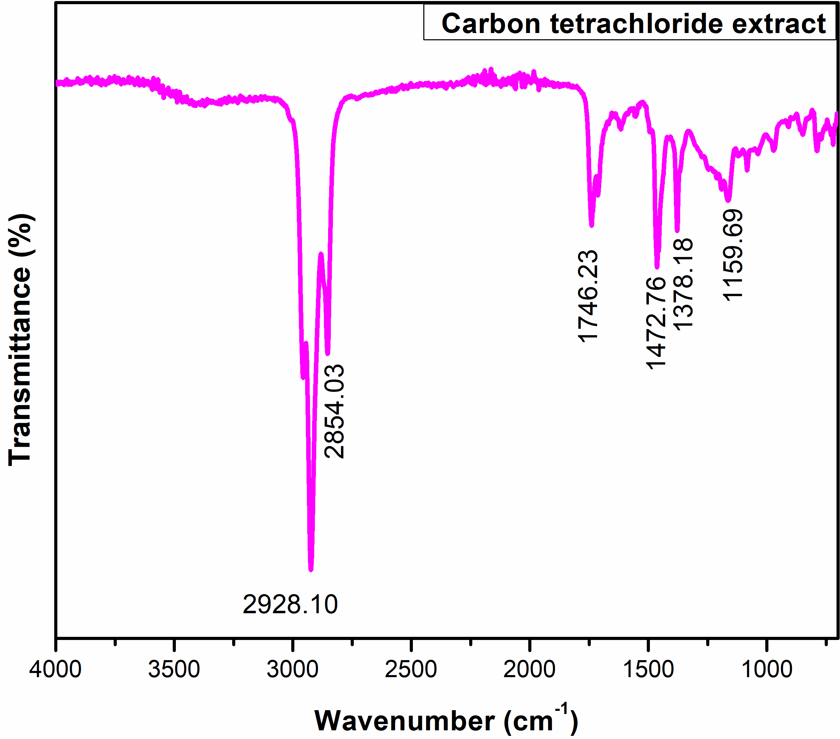
Figure 6. FT-IR spectra with carbon tetra chloride and L. purpureus dried leaves powder extract.
The FT-IR spectra are shown in Figure 7 various peaks at different frequencies in Ethyl acetate and L. purpureus dried leaves powder extract. These spectral peaks observed at 3276.36 cm⁻¹, 2928.10 cm⁻¹, 2838.65 cm⁻¹, 1710.51 cm⁻¹, 1378.18 cm⁻¹, 1238.88 cm⁻¹, 1040.19 cm⁻¹ (Table 2).
The peaks were observed at 2928.10 cm⁻¹, and 2838.65 cm⁻¹ representing the OH stretching vibrational frequencies. The peaks at 2928.10 cm⁻¹ and 2838.65 cm⁻¹ are asymmetric stretching frequencies and stretching frequencies. asymmetric stretching frequencies have a greater dipole moment than the symmetric starching frequencies, hence asymmetric starching frequencies are more than symmetric stretching frequencies. The peak was observed at frequencies 1378.18 cm⁻¹ and 1238.88 cm⁻¹ representing the OH in-plane bending vibrations i.e. scissoring and rocking. The main functional group is observed at 1710.51 cm⁻¹ representing the “C=O” stretching frequency which represents the carboxylic acid as a functional group. The C-O stretching frequency is observed at 1040.19 cm⁻¹, which represents the alkoxy group.
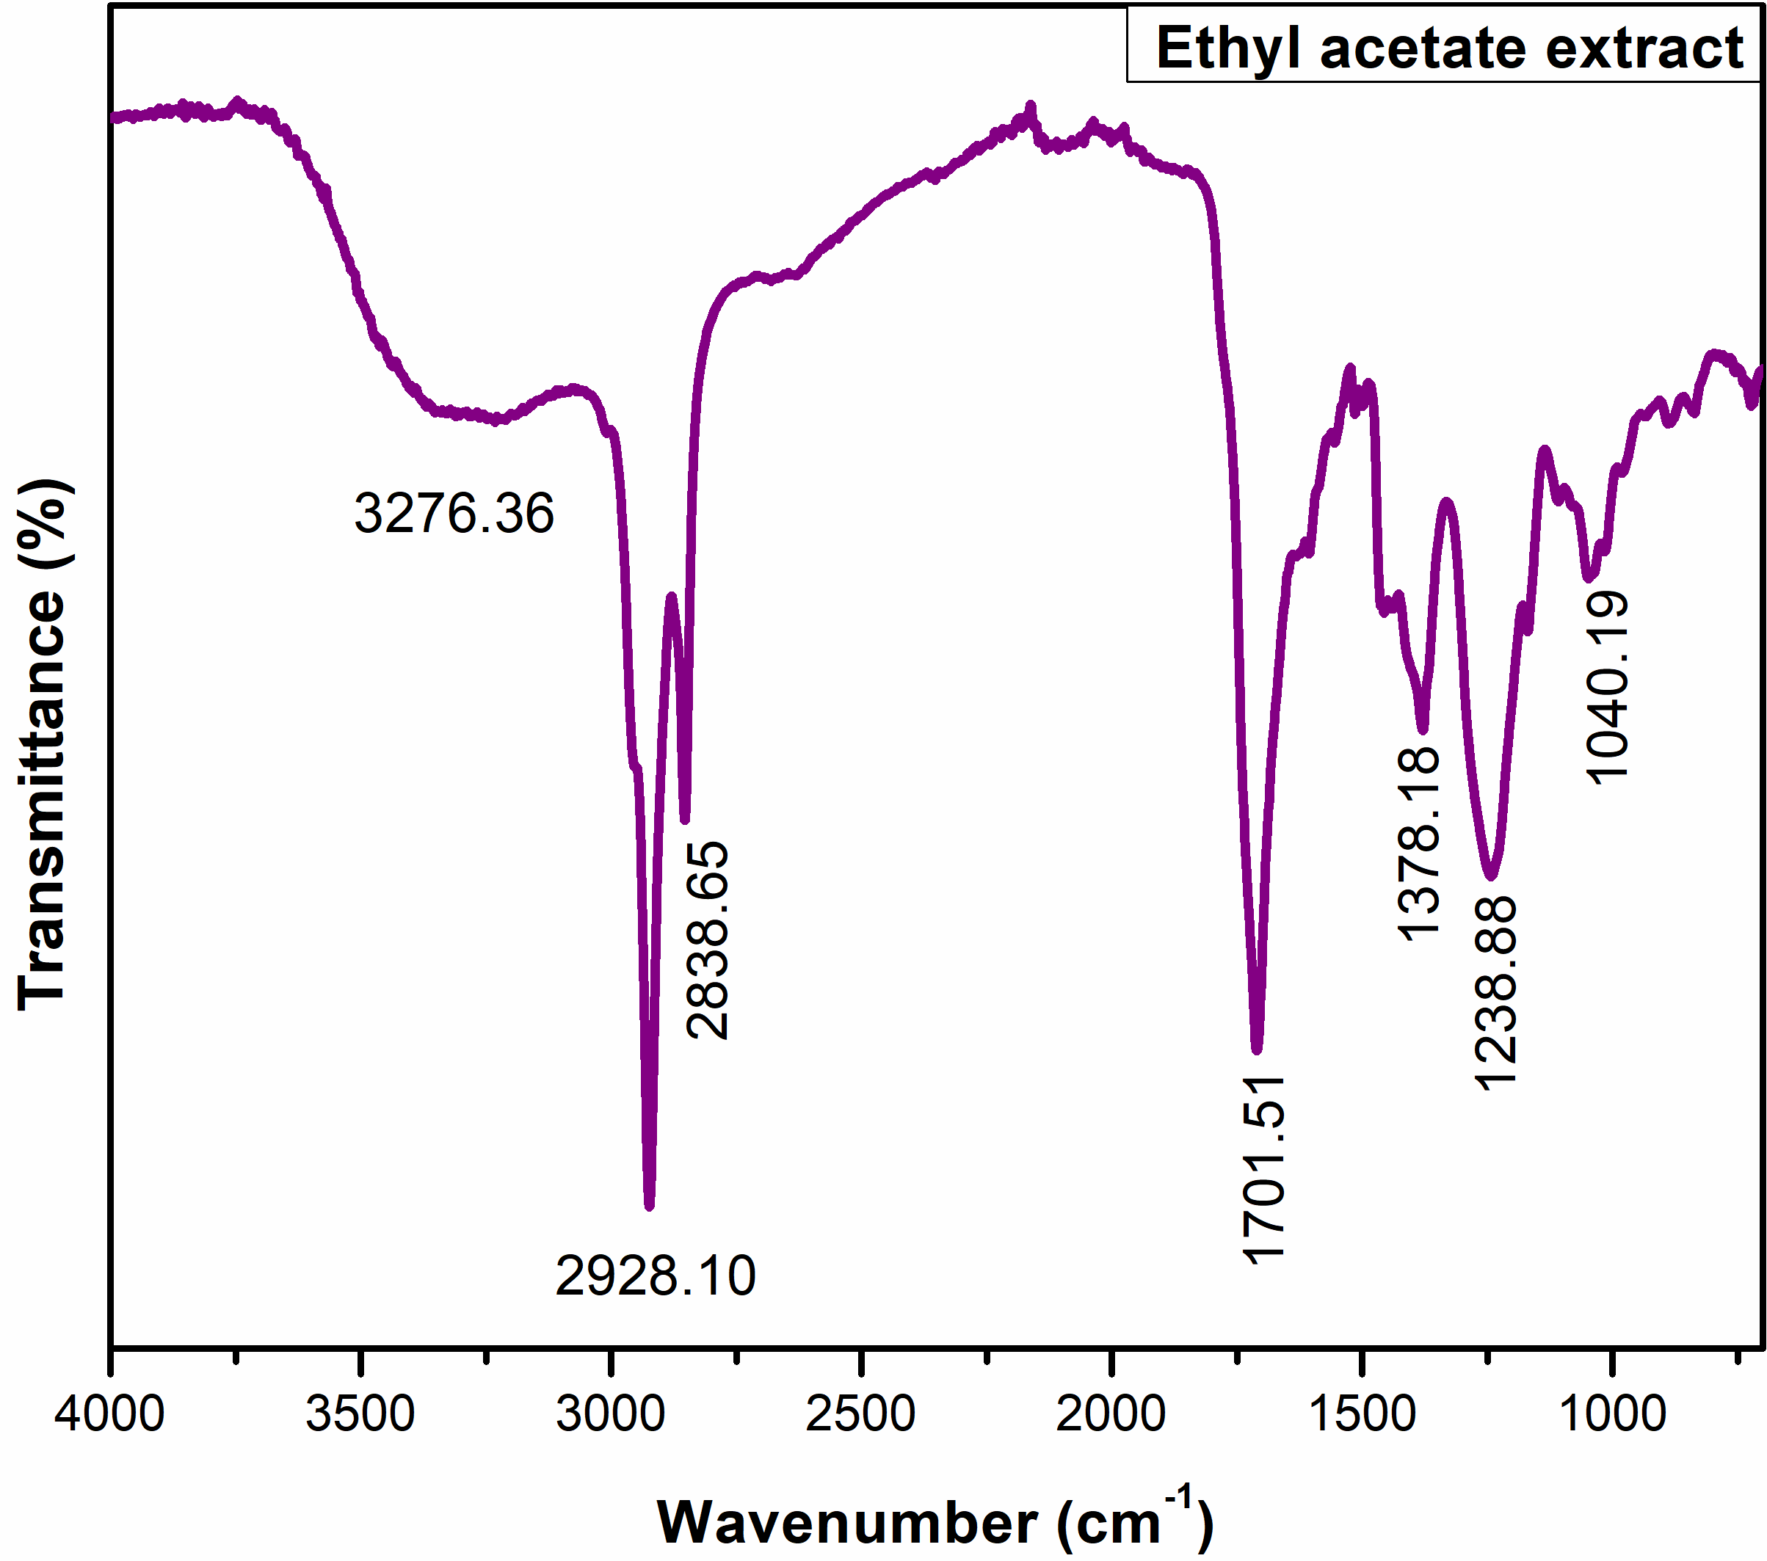
Figure 7. FT-IR Spectra with ethyl acetate and L. purpureus dried leaves powder extract.

Table 2. FT-IR spectral analysis of L. purpureus dried leaves to powder and different solvent extracts.
S.No. | Spectral values | Functional groups
Powder extract with Hexane
1 | 2923.70 cm⁻¹ and 2843.79 cm⁻¹ | OH, asymmetric and asymmetric starching frequencies
2 | 1452.96 cm⁻¹ and 1373.05 cm⁻¹ | OH, in-plane bending vibrations
3 | 1711.04 cm⁻¹ | “C=O” stretching frequency
4 | 1184.62 cm⁻¹ and 1080.51 cm⁻¹ | C-O stretching frequencies
5 | 985.51 cm⁻¹ and 841.50 cm⁻¹ | out plane bending vibrations
Powder extract with Ethanol
6 | 2938.36 cm⁻¹, and 2843.79 cm⁻¹ | CH, asymmetric and asymmetric starching frequencies
7 | 1392.84 cm⁻¹ | N-H in-plane bending vibrations
8 | 1612.06 cm⁻¹ | “C=O” stretching frequency
9 | 1035.79 cm⁻¹ | C-N stretching frequency
Powder extract with Double distilled water
10 | 3275.53 cm⁻¹, and 2843.79 cm⁻¹ | NH stretching vibrational frequencies
11 | 1636.24 cm⁻¹ | “C=O” stretching frequency
12 | 2068.88 cm⁻¹ | C=N stretching frequency
Powder extract with Carbon tetrachloride
13 | 2928.10 cm⁻¹, and 2854.03 cm⁻¹ | CH, asymmetric and asymmetric starching frequencies
14 | 1472.76 cm⁻¹ and 1378.18 cm⁻¹ | CH, in-plane bending vibrations
15 | 1746.23 cm⁻¹ | “C=O” stretching frequency
16 | 1159 cm⁻¹ and 1080.51 cm⁻¹ | C-O stretching frequencies
Powder extract with Ethyl acetate
17 | 2928.10 cm⁻¹, and 2838.65 cm⁻¹ | -OH stretching vibrational frequencies
18 | 1378.18 cm⁻¹ and 1238.88 cm⁻¹ | -OH, in-plane bending vibrations
19 | 1710.51 cm⁻¹ | “C=O” stretching frequency
20 | 1040.19 cm⁻¹ | C-O stretching frequency

UV-Visible spectral analysis
The electromagnetic radiations range in UV-Vis Spectrophotometry is 200-800 nm. This range is split into two regions, one is the UV range (200-400 nm) and the second one is the visible range (400-800 nm). Organic, biological, and conjugated molecules are studied by UV-Vis Spectrophotometry.
The prepared L. purpureus dried leaves with hexane extract was passed into the UV-VIS Spectrophotometer (Figure 8). The results of hexane extract were detected wavelengths at 647 nm and 682 nm and corresponding absorbance at 3.66 and 3.42. These wavelengths (647 nm and 682 nm) give information about the frequency range being between 400-484 Hz and energy range being between 1.65-2.00 eV and also given the absorbed red color region and the visible region color is blue-green. According to Beer’s lamberts law, the highest absorbance (3.66) value represents the highest molar absorptivity or high molar extinction coefficient at minimum concentration. At a minimum concentration, the smallest detection limits are detected. These wavelengths and absorbance values represent the biomolecules and highly conjugated molecules (Note: here scale range from 300- 800 nm are measured).

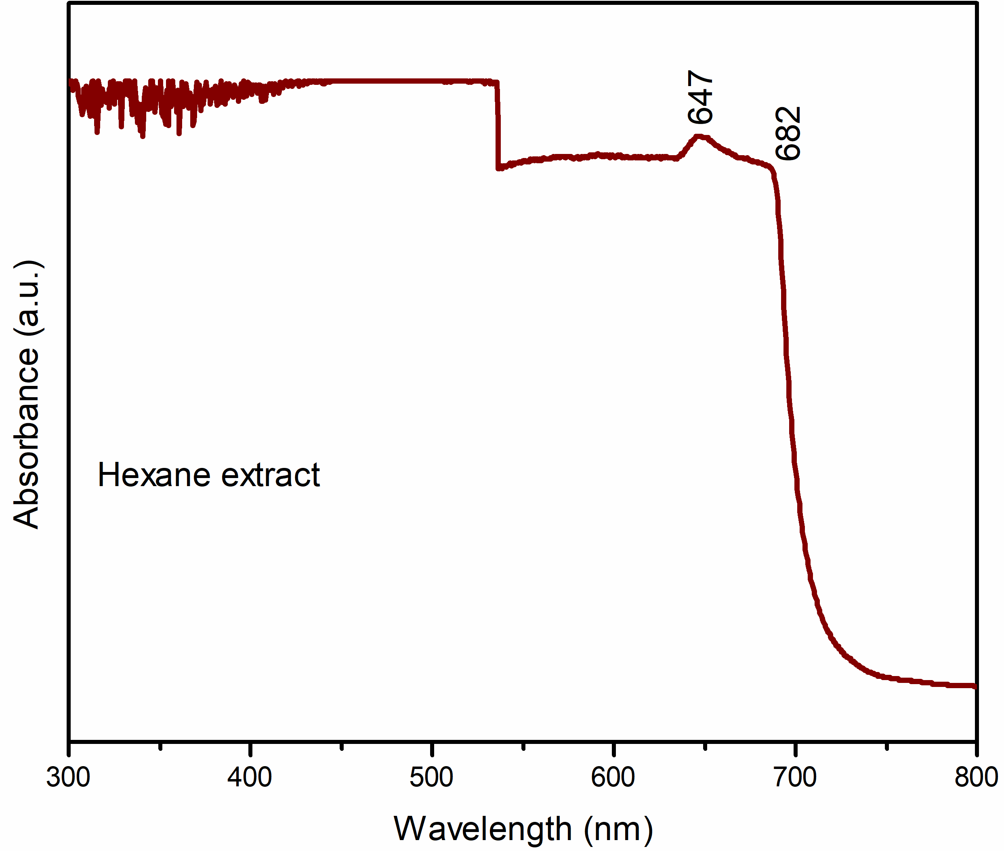
Figure 8. UV-Vis spectra of Hexane extract.
The prepared L. purpureus dried leaves with ethanol extract was passed into the UV-Vis spectrophotometer (Figure 9). The results of ethanol extract were detected wavelengths at 215 nm, 275 nm, 415 nm, and 660 nm, and the corresponding absorbance at 1.635, 0.718, 0.380, and 0.136. The UV region wavelengths at 215 nm and 275 nm give the information simple organic n-π* molecule. The visible region wavelengths at 415 nm and 660 nm give information about highly conjugated organic molecules. According to Beer’s lamberts law, the highest absorbance (1.635) value represents the highest molar absorptivity or high molar extinction coefficient at minimum concentration. At a minimum concentration, the smallest detection limits are detected. These wavelengths and absorbance values represent the biomolecules and highly conjugated molecules.
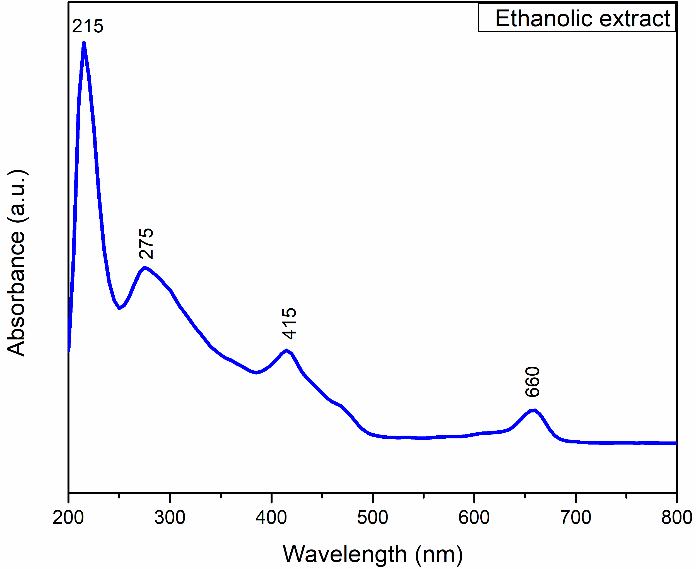
Figure 9. UV-Vis spectra of Ethanol extract.
The prepared L. purpureus dried leaves with double distilled water extract was passed into the UV-Vis spectrophotometer (Figure 10). The results of the double distilled water were detected wavelengths at 219.27 nm, and 272.17 nm, and the corresponding absorbance at 0.040, and 0.003. The UV region wavelengths at 219.27 nm and 272.17 nm give the information simple organic n-π* molecule. According to Beer’s lamberts law, the highest absorbance (0.040) value represents the highest molar absorptivity or high molar extinction coefficient at minimum concentration. At a minimum concentration, the smallest detection limits are detected. These wavelengths and absorbance values represent the biomolecules and highly conjugated molecules.

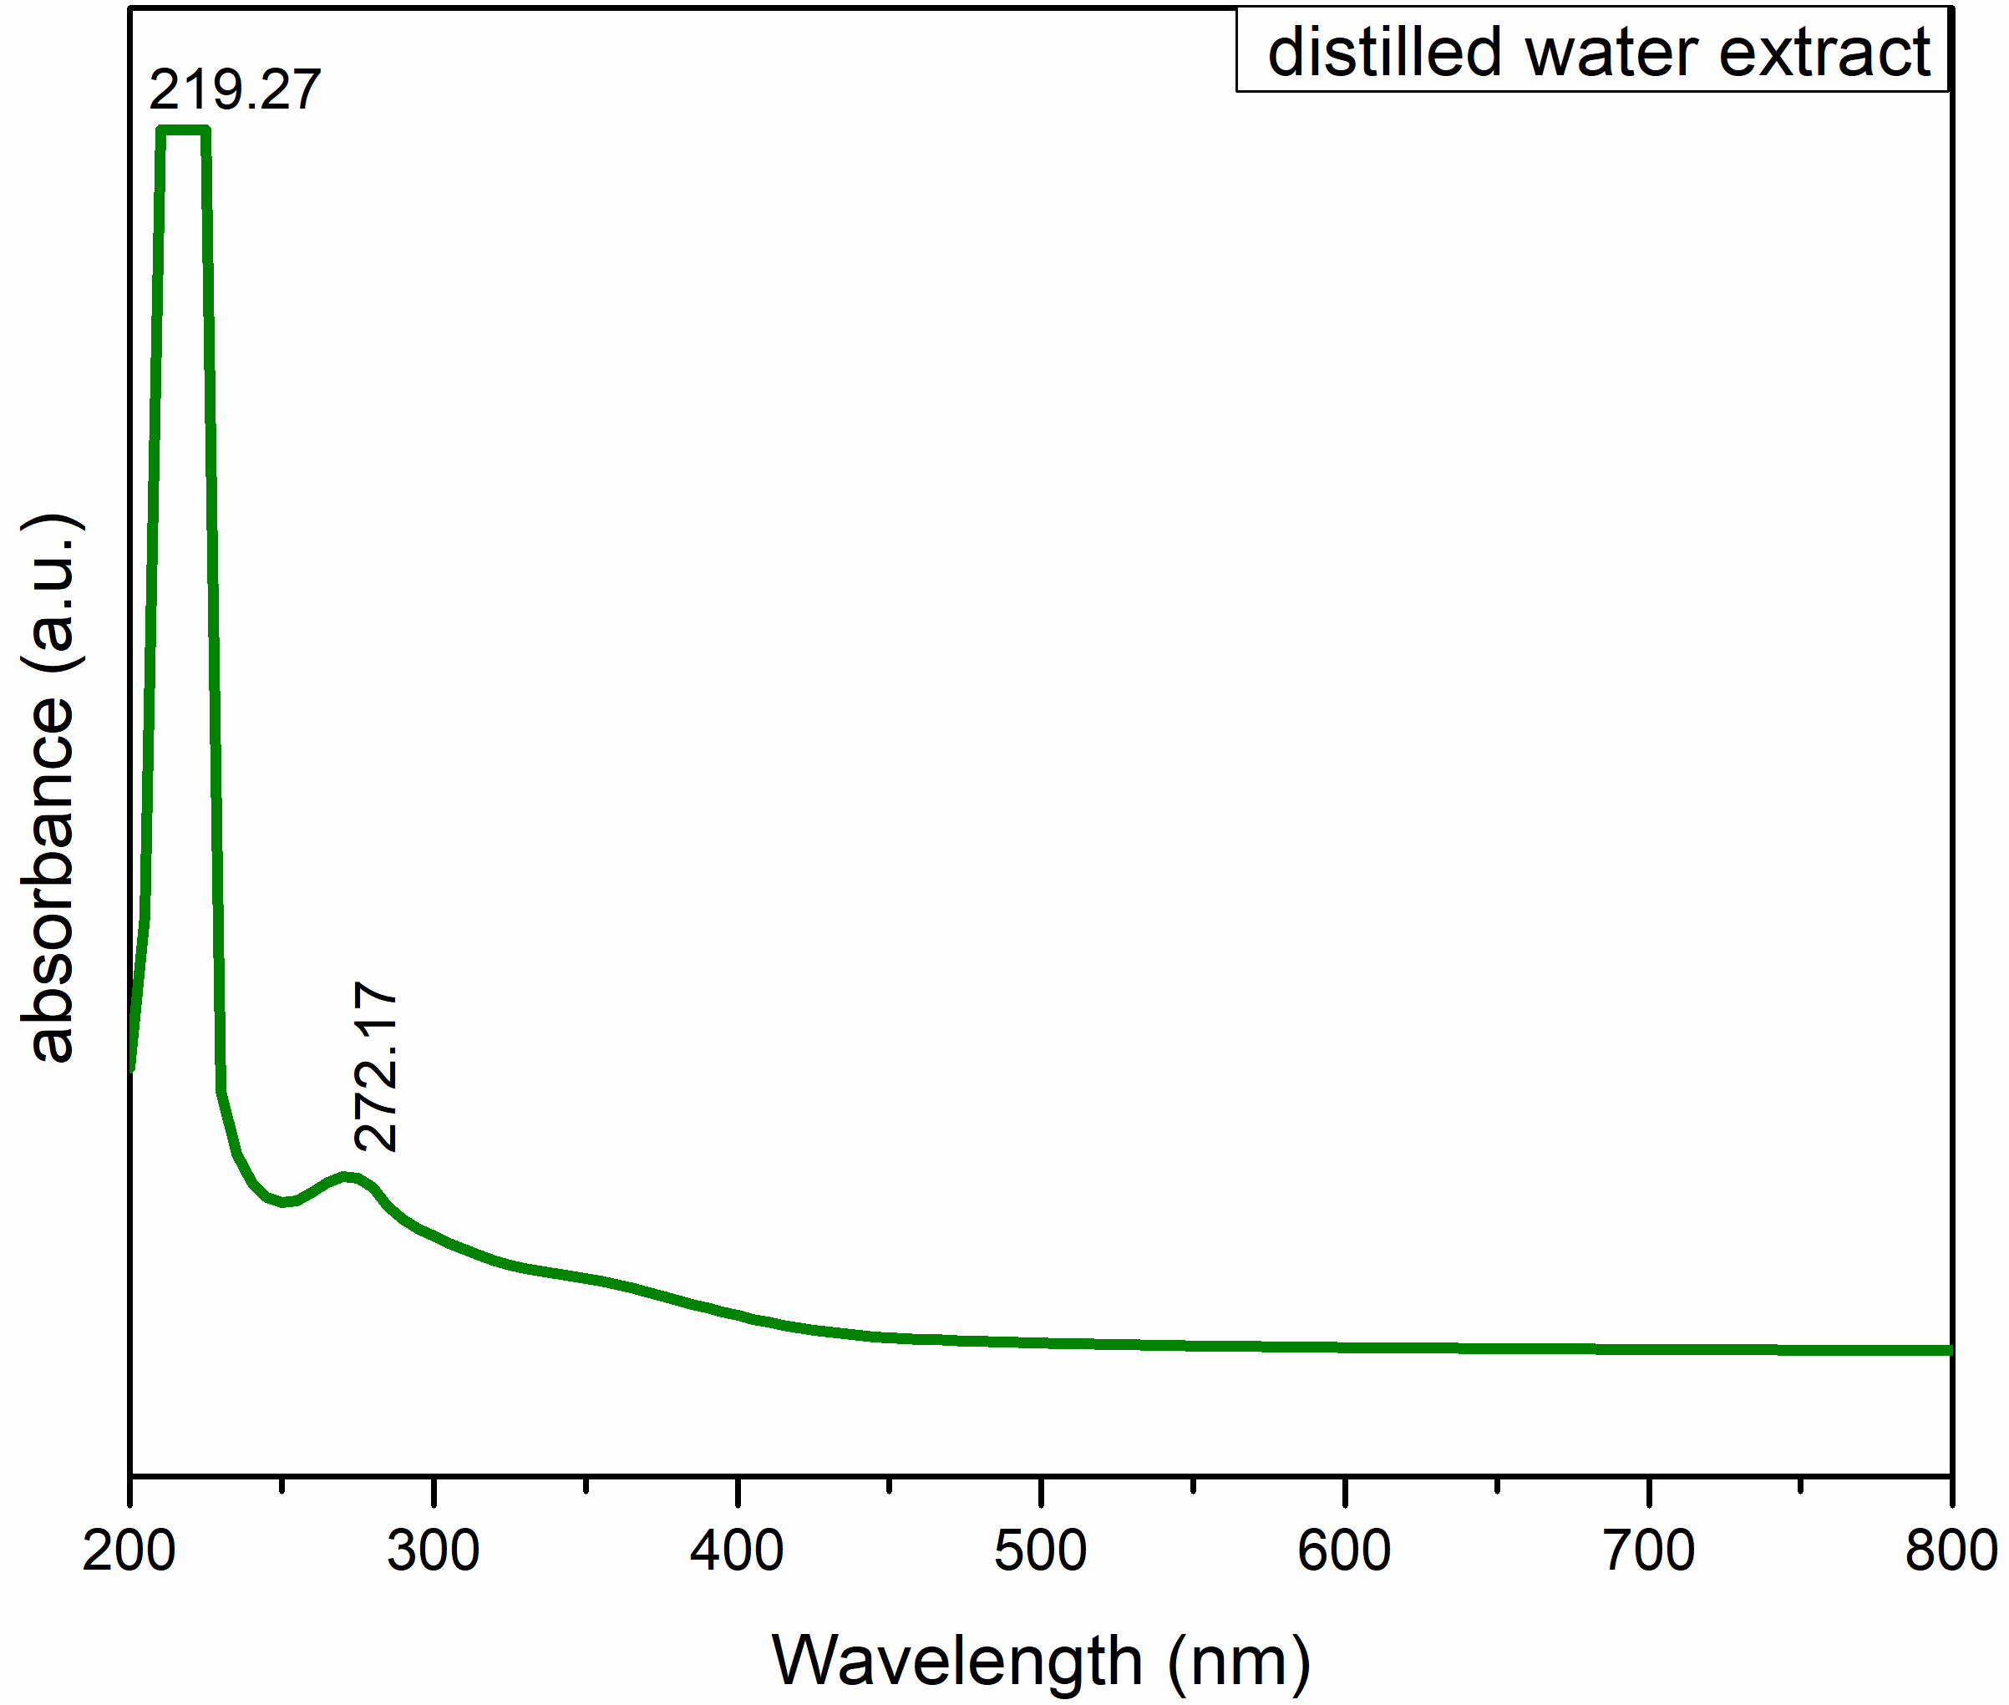
Figure 10. UV-Vis spectra of Double-distilled water extract.
The prepared L. purpureus dried leaves with carbon tetrachloride extract was passed into the UV-Vis spectrophotometer (Figure 11). The results of the carbon tetrachloride extract were detected wavelengths at 260 nm, 418 nm, 455 nm, and 665 nm, and the corresponding absorbance at 0.839, 1.023, 0.783, and 0.538. The UV region wavelengths at 260 nm give the information simple organic n-π* molecule. The visible region wavelengths at 418 nm, 455 nm, and 665 nm give information about highly conjugated organic molecules. According to Beer’s lamberts law, the highest absorbance (1.023) value represents the highest molar absorptivity or high molar extinction coefficient at minimum concentration. At a minimum concentration, the smallest detection limits are detected. These wavelengths and absorbance values represent the biomolecules and highly conjugated molecules.

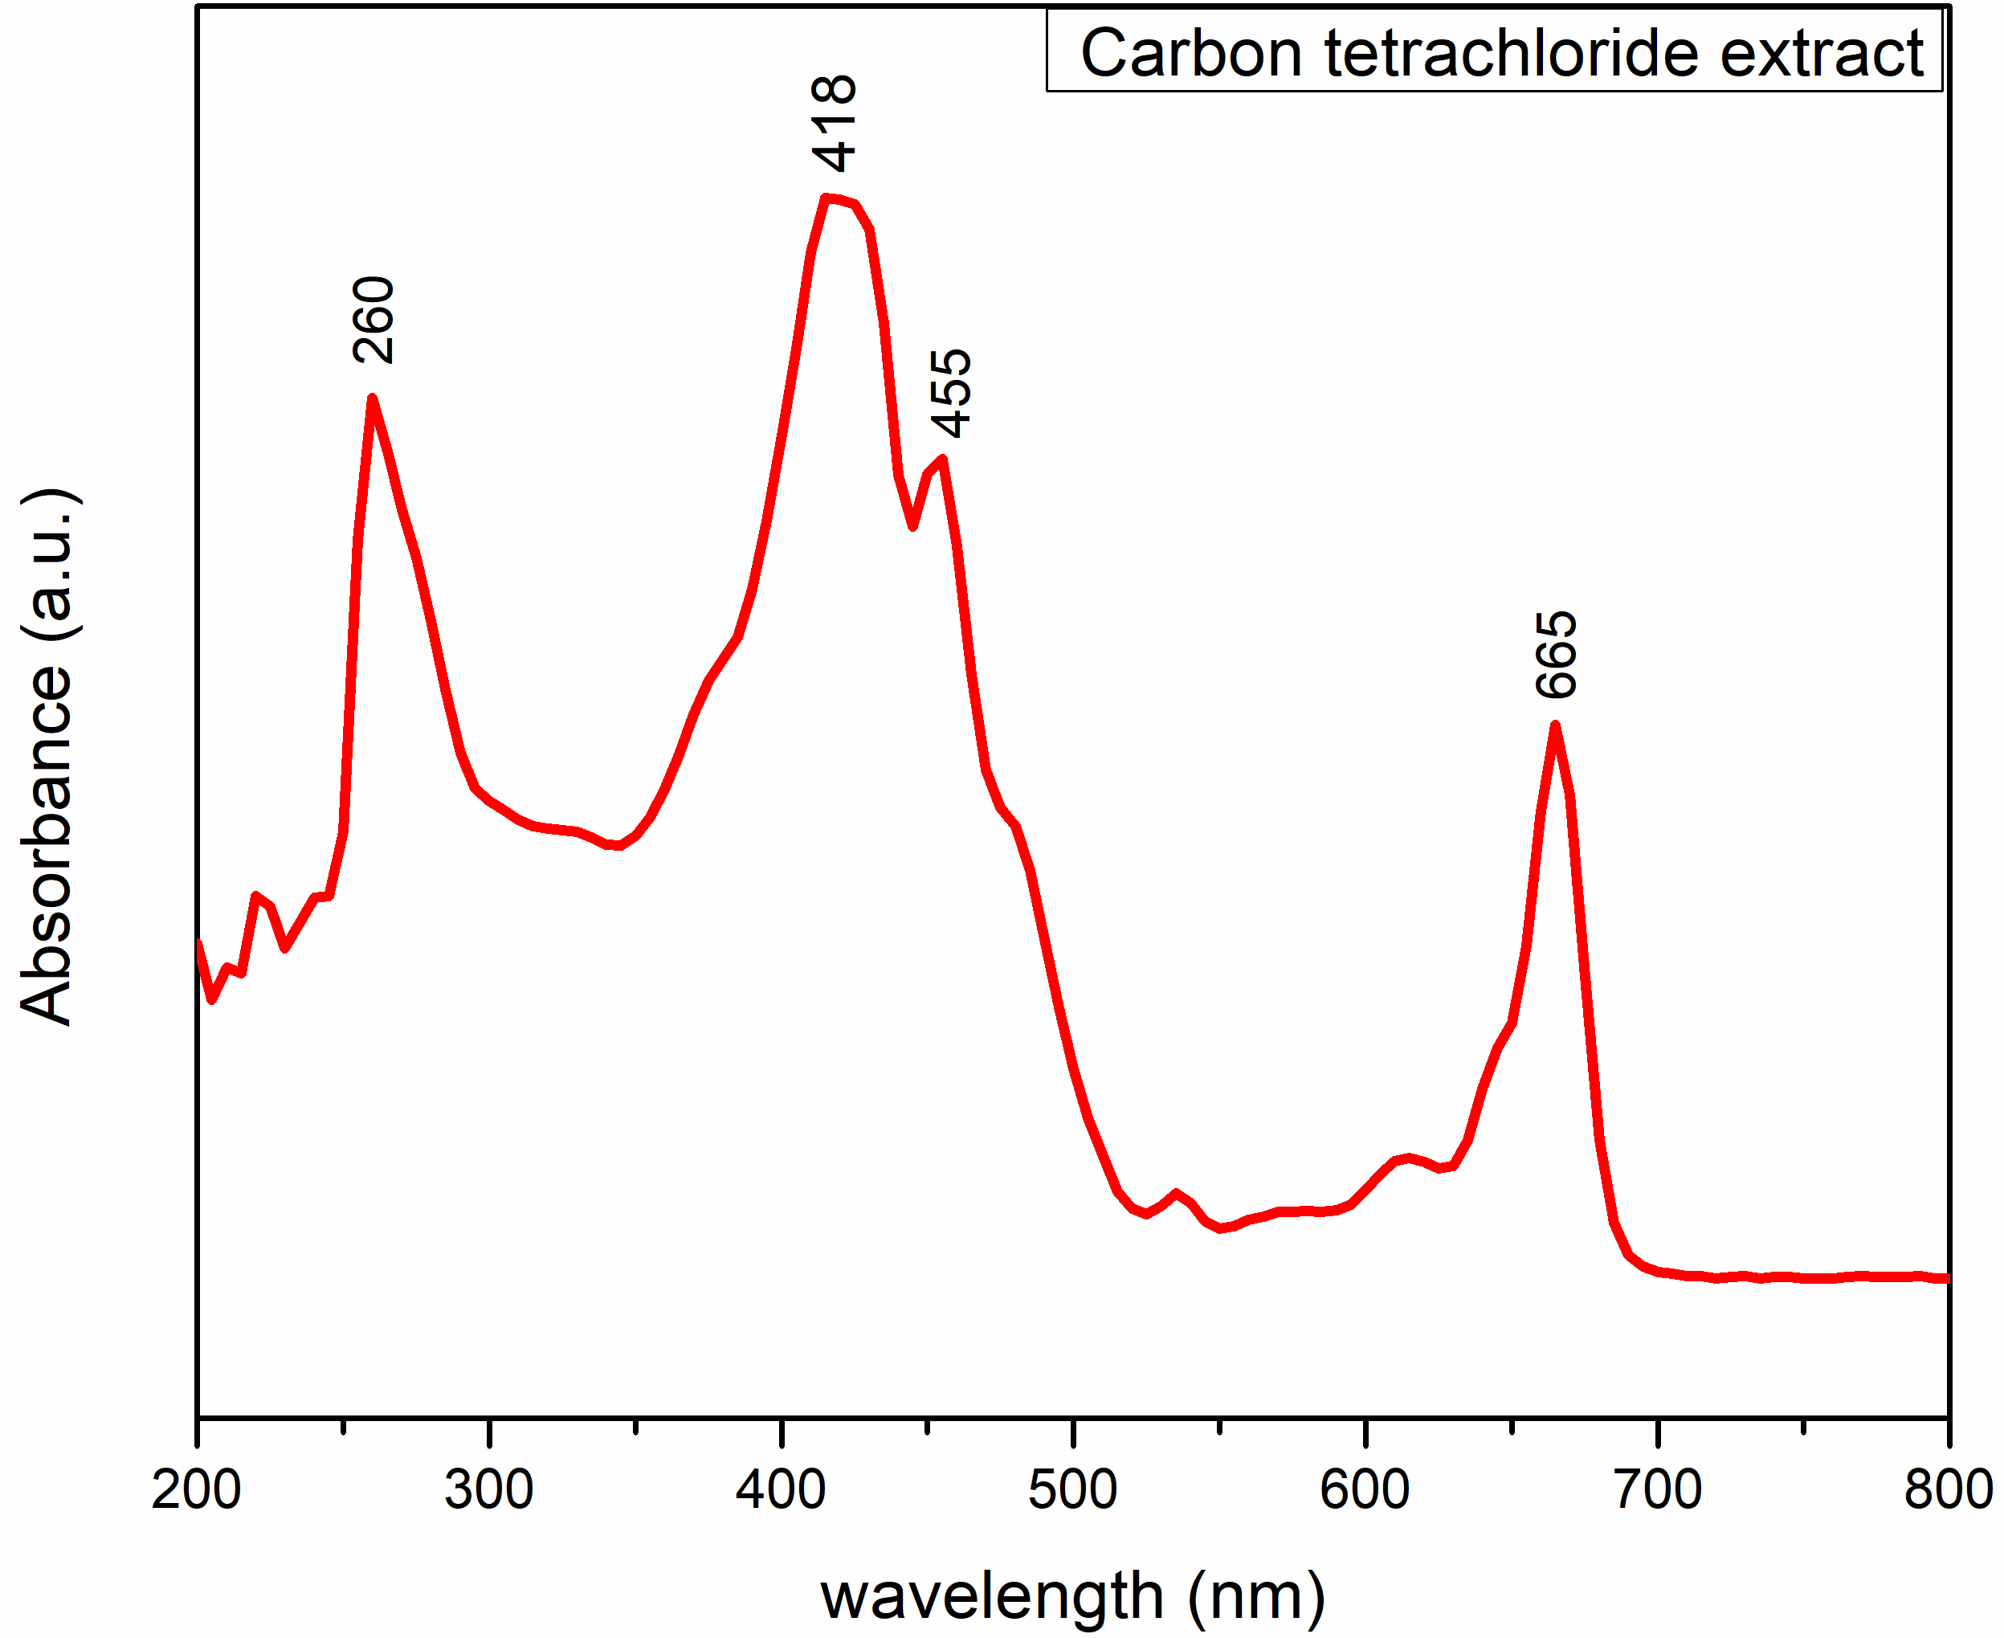
Figure 11. UV-Vis spectra of Carbon tetrachloride extract.
The prepared L. purpureus dried leaves with ethyl acetate extract was passed into the UV-Vis spectrophotometer (Figure 12). The results of the ethyl acetate extract were detected wavelengths at 273 nm, 413 nm, and 665 nm, and the corresponding absorbance at 0.33, 0.618, and 0.205. The UV region wavelengths at 273nm give the information simple organic n-π* molecule. The visible region wavelengths at 413 nm and 665 nm give information about highly conjugated organic molecules. According to Beer’s lamberts law, the highest absorbance (0.618) value represents the highest molar absorptivity or high molar extinction coefficient at minimum concentration. At a minimum concentration, the smallest detection limits are detected. These wavelengths and absorbance values represent the biomolecules and highly conjugated molecules.
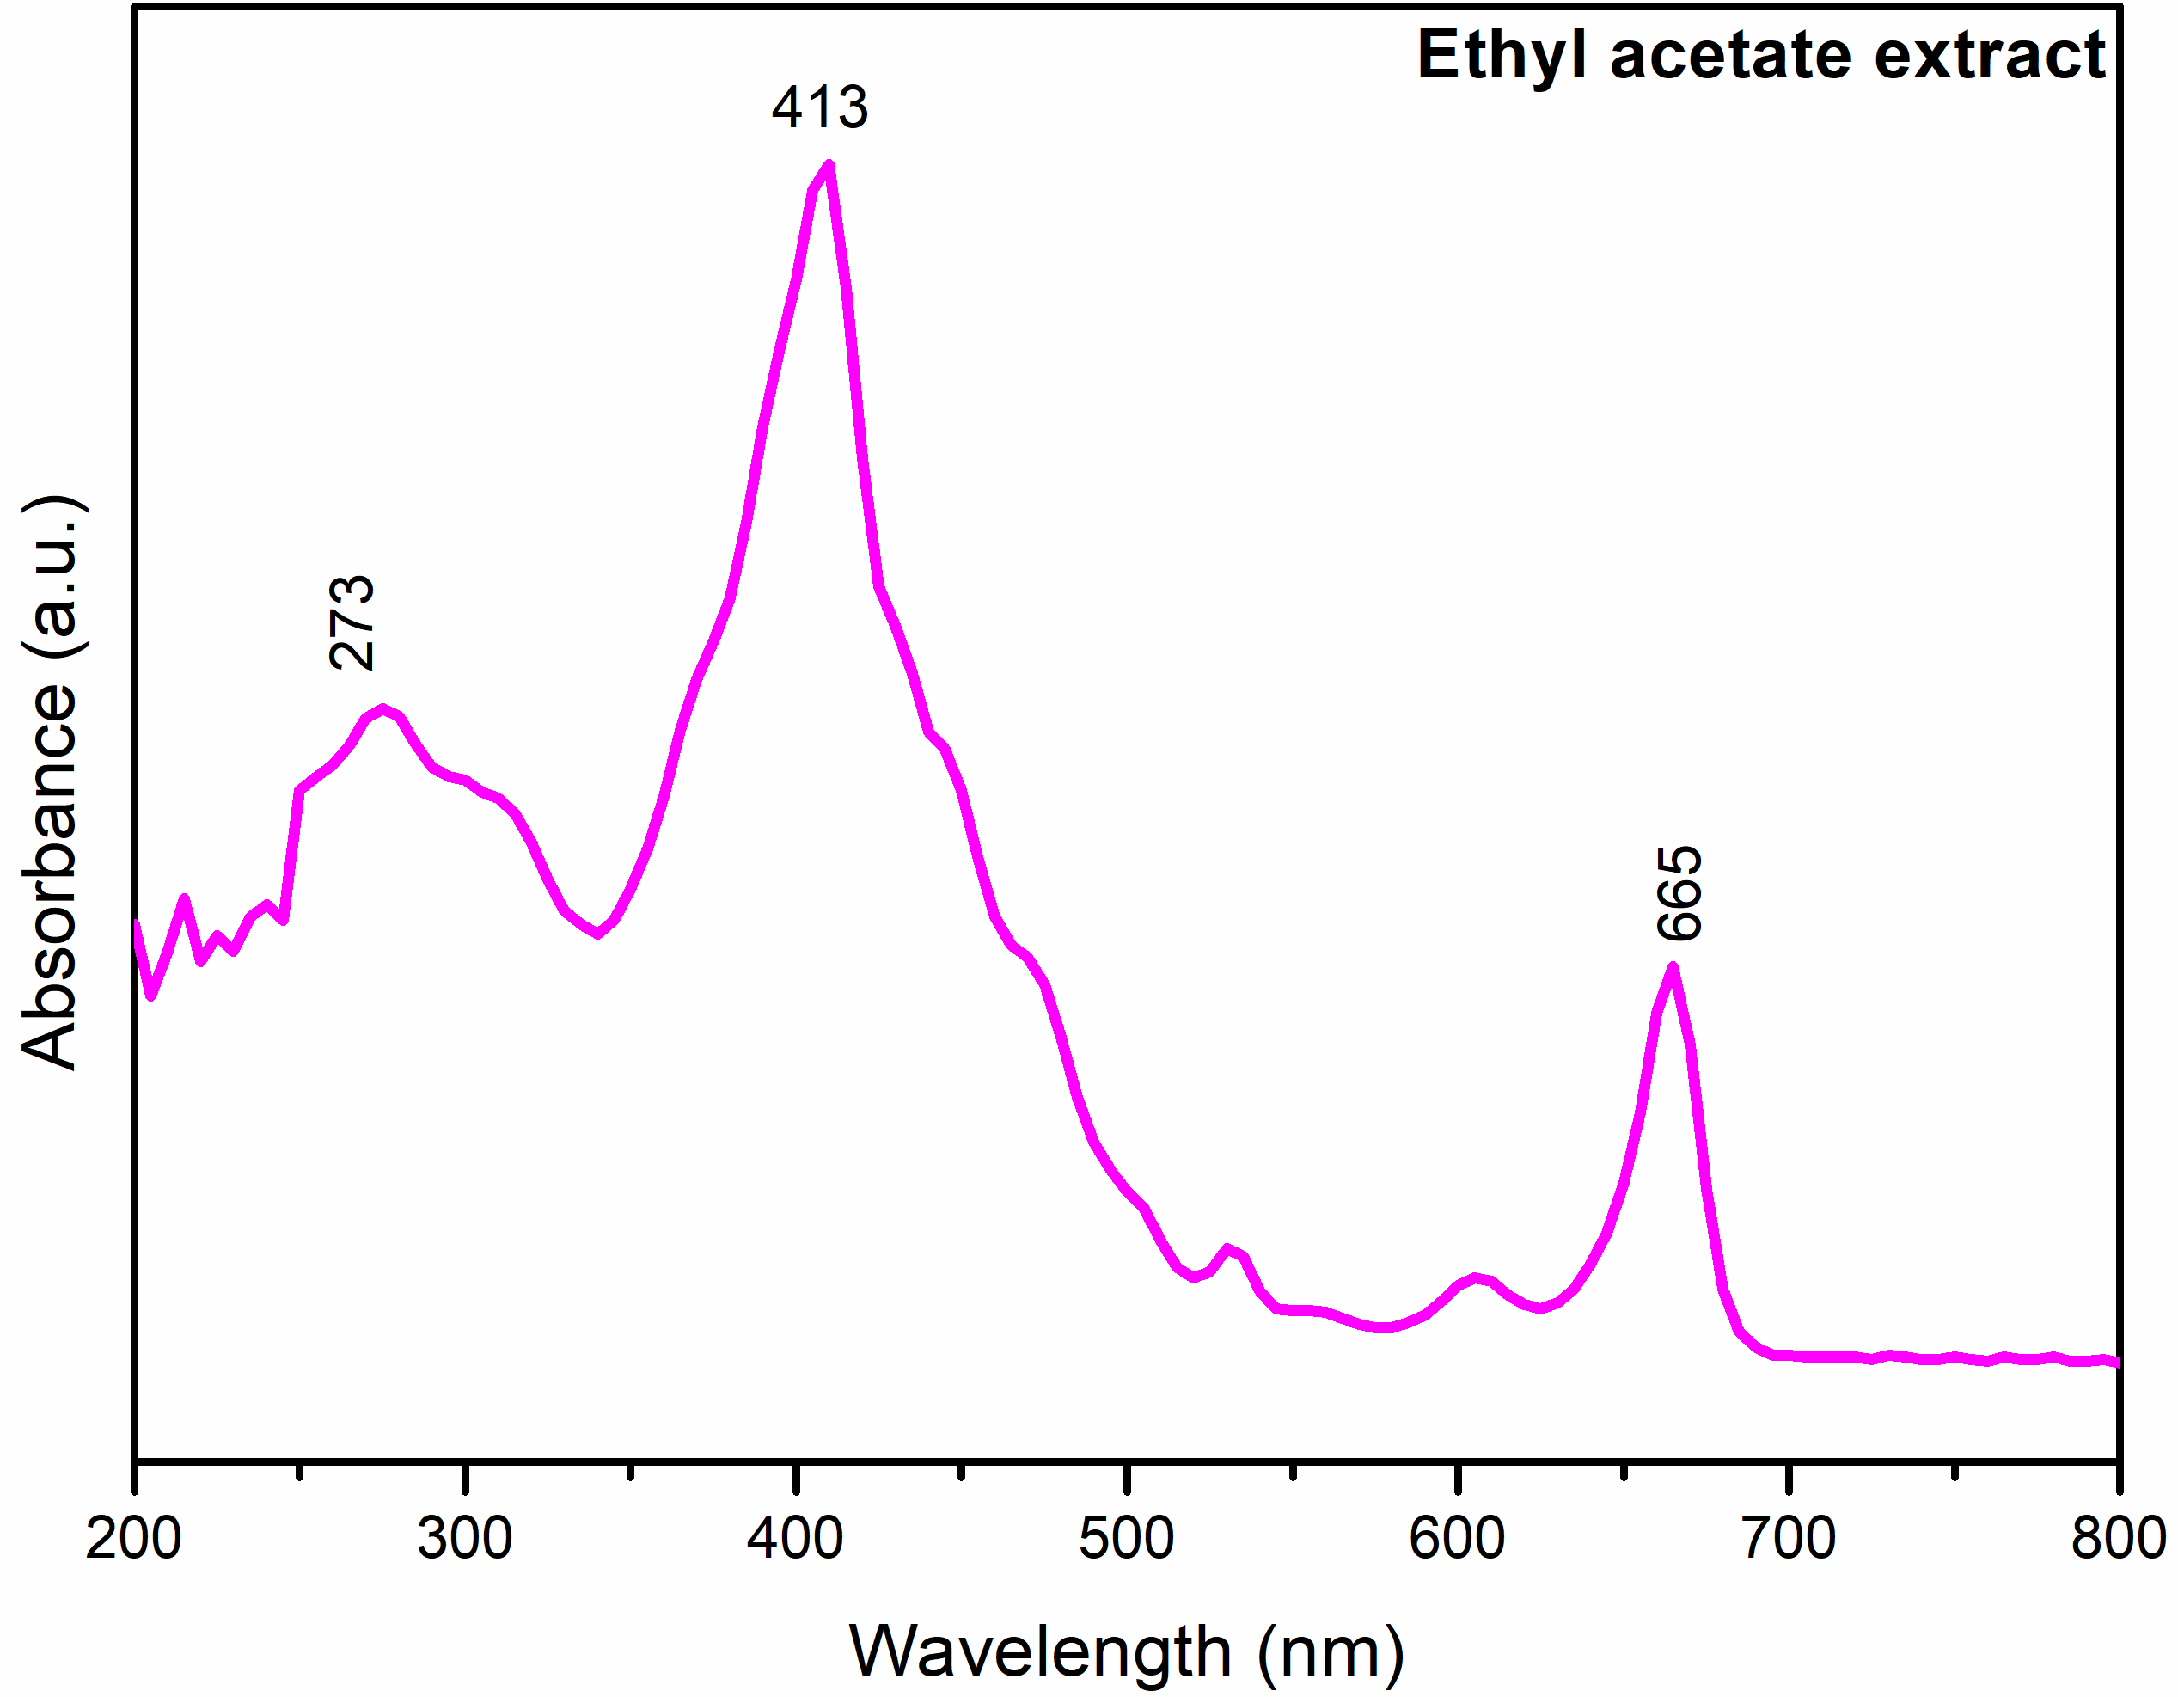
Figure 12. UV-Vis spectra of ethyl acetate extract.
CONCLUSION:
In the present research, the investigation identified the functional group in L. purpureus leaves by using FT IR spectroscopy and UV-Vis spectrophotometer. To prepare five types of extracts using solvents like hexane, ethanol, double-distilled water, carbon tetrachloride, and ethyl acetate with dried powder. The FT-IR spectra give various peaks at different frequencies in synthesized extracts showing a different functional group with stretching frequencies which represents the carboxylic acids, amides, esters, etc. and also obtained absorbance values corresponding wavelengths from UV-Vis spectrophotometer. From the spectral results, the presence of absorption peaks may be arising due to active biomolecules in the leaf extract with various solvents.

CONFLICT OF INTEREST:
The authors have no conflicts of interest regarding this investigation.

ACKNOWLEDGMENTS:
The authors would like to thank the Department of Chemistry A.G&S.G Siddhartha Degree college of arts and science, Vuyyuru, Krishna Dist., Andhra Pradesh, India, and the Department of Chemistry, Acharya Nagarjuna University, Guntur, Andhra Pradesh, India.
REFERENCES:
- FAO. Grassland Index. A searchable catalogue of grass and forage legumes. FAO, Rome, 2014: Italy.https://web.archive.org/web/20170120044942/http://www.fao.org/ag/AGP/AGPC/doc/GB…
- Cook BG, Pengelly BC, Brown SD. Tropical Forages CSIRO. DPI&F (Qld), CIAT and ILRI, Brisbane, Australia. 2005. http://www.tropicalforages.info.
- Adebisi AA, Bosch CH. Lablab purpureus (L.) sweet. record from PROTA4U, Grubben, Denton GJH. (Editors) OA. PROTA (Plant Resources of Tropical Africa / Ressources végétales de l’Afrique tropicale), Wageningen, Netherlands. 2004. http://www.prota4u.org/search.asp.
- Murphy AM, Colucci PE. A tropical forage solution to poor quality ruminant diets: A review of Lablab purpureus. Livestock Research for Rural Development. 1999;11(2):112. http://www.lrrd.org/lrrd11/2/colu112.htm.
- BSBI List 2007. Botanical Society of Britain and Ireland. Archived from the original (xls) on 2015-06-26. Retrieved 2014-10-17.
- USDA, NRCS (n.d.). "Lablab purpureus". The PLANTS Database (plants.usda.gov). Greensboro, North Carolina: National Plant Data Team. Retrieved 22 January 2016.
- Muruganantham N, Govindharaju R, Anitha P, Anusuya V. Synthesis and Characterization of silver nanoparticles using Lablab purpureus flowers (Purple colour) and its anti-microbial activities. international journal of scientific research in biological sciences. 2018;5(6):1-7. DOI:10.26438/ijsrbs/v5i6.17.
- Ali GA, Divyashree A, Supriya S, Chong KF, Ethiraj AS, Reddy MV, Algarni H, Hegde G. Carbon nanospheres derived from Lablab purpureus for high performance supercapacitor electrodes: a green approach. Dalton Transactions. 2017;46(40):14034-44. https://doi.org/10.1039/C7DT02392H.
- Kahsay MH, Tadesse A, RamaDevi D, Belachew N, Basavaiah K. Green synthesis of zinc oxide nanostructures and investigation of their photocatalytic and bactericidal applications. RSC advances. 2019;9(63):36967-81. DOI: 10.1039/c9ra07630a.
- Uday KH, Gowda BM, Ramesh S, Vasundhara M. Characterization and Identification of Dolichos Bean (Lablab purpureus L. sweet) Recombinant Inbred Lines (RIL) with High Pod Yield and High Pod Fragrance. International Journal of Pure Applied Biosciences. 2017;5(6):428-436. DOI: http://dx.doi.org/10.18782/2320-7051.5028.
- Kumar A. Quantitative analysis of some germplasms of lablab bean in Uttar Pradesh. International Journal of Environment, Agriculture and Biotechnology. 2017;2(1): 40-45. http://dx.doi.org/10.22161/ijeab/2.1.7.
- Kshirsagar JK, Sawardekar SV, Sawant GB, Devmore JP, Jadhav SM. In vitro regeneration study in lablab bean and dolichos bean (Lablab purpureus (L). Sweet) Genotypes. Journal of Pharmacognosy and Phytochemistry. 2018;7(1):2782-9.
- Naeem M, Shabbir A, Ansari AA, Aftab T, Khan MM, Uddin M. Hyacinth bean (Lablab purpureus L.)–An underutilised crop with future potential. Scientia Horticulturae. 2020;272(10955):1-12 https://doi.org/10.1016/j.scienta.2020.109551.
- D’souza MR, Kokila S, Devaraj VR. Polyamine levels in leaves of hyacinth bean (Lablab purpureus) and their relation to drought-tolerance. World Applied Sciences Journal. 2014;32(12):2398-2402. DOI: 10.5829/idosi.wasj.2014.32.12.1382.
- Odunsi AA. Assessment of Lablab (Lablab purpureus) leaf meal as a feed ingredient and yolk colouring agent in the diet of layers. International Journal of Poultry Science. 2003;2(1):71-4.
- Al-Snafi AE. The pharmacology and medical importance of Dolichos lablab (Lablab purpureus)-A review. IOSR Journal of Pharmacy. 2017;7(2):22-30. DOI:10.9790/3013-0702012230.
- Rony MB, Islam AA, Rasul MG, Zakaria M. Genetic analysis of yield and related characters of Lablab Bean. Journal of Nepal Agricultural Research Council. 2019;5:1-21. DOI: https://doi.org/10.3126/jnarc.v5i1.23800.
- Ewansiha SU, Ogedegbe SA, Falodun EJ. Utilization potentials of lablab (Lablab purpureus (L.) Sweet) and the constraints of field pests and diseases in Nigeria. Agro-Science. 2016;15(1):11-6. DOI: http://dx.doi.org/10.4314/as.v15i1.3.
- Baloyi BM, Ayodele VI, Addo-Bediako A. Effects of leaf harvest on crude protein and mineral. African Journal of Agricultural Research. 2013;8(5):449-53. DOI: 10.5897/AJAR12.1209.
- Kamotho GN, Kinyua MG, Muasya RM, Gichuki ST, Wanjala BW, Kimani EN, Kamau EN. Assessment of genetic diversity of Kenyan dolichos bean (Lablab purpureus L. Sweet) using simple sequence repeat (SSR) markers.
- Esther NK, Francis NW, Miriam GK. Molecular diversity of Kenyan lablab bean (Lablab purpureus (L.) Sweet) accessions using amplified fragment length polymorphism markers. American Journal of Plant Sciences. 2012; 3:313-321. http://dx.doi.org/10.4236/ajps.2012.33037.
- Armstrong KL, Albrecht KA. Effect of plant density on forage yield and quality of intercropped corn and lablab bean. Crop science. 2008;48(2):814-22. doi: 10.2135/cropsci2007.08.0487.
- Singh SR, Rajan S, Kumar D, Soni VK. Genetic Diversity Assessment in Dolichos Bean (Lablab purpureus L.) Based on Principal Component Analysis and Single Linkage Cluster Analysis. Legume Research-An International Journal. 2021;1:7. DOI: 10.18805/LR-4561
- Al-Snafi AE. The pharmacology and medical importance of Dolichos lablab (Lablab purpureus)-A review. IOSR Journal of Pharmacy. 2017 Feb;7(2):22-30. DOI:10.9790/3013-0702012230.
- Bai-Ngew S, Chuensun T, Wangtueai S, Phongthai S, Jantanasakulwong K, Rachtanapun P, Sakdatorn V, Klunklin W, Regenstein JM, Phimolsiripol Y. Antimicrobial activity of a crude peptide extract from lablab bean (Dolichos lablab) for semi-dried rice noodles shelf-life. Quality Assurance and Safety of Crops & Foods. 2021;13(2):25-33. DOI 10.15586/qas.v13i2.882.
- Abdallah O, Hamza NB, Dagash Y. Agronomic and molecular evaluation of six lablab bean (Lablab purpureus L.) cultivars. International Journal of Science and Research Agriculture Sciences. 2015;2(1):7-15. http://dx.doi.org/10.12983/ijsras-2015-p0007-0015.
- Law HY, Choi SM, Ma CY. Study of conformation of vicilin from Dolichos lablab and Phaseolus calcaratus by Fourier-transform infrared spectroscopy and differential scanning calorimetry. Food research international. 2008;41(7):720-9. doi:10.1016/j.foodres.2008.05.004.
- Maaran S, Hoover R, Donner E, Liu Q. Composition, structure, morphology and physicochemical properties of lablab bean, navy bean, rice bean, tepary bean and velvet bean starches. Food chemistry. 2014 Jun 1;152:491-9. http://dx.doi.org/10.1016/j.foodchem.2013.12.014.
- Liu YM, Shahed-Al-Mahmud M, Chen X, Chen TH, Liao KS, Lo JM, Wu YM, Ho MC, Wu CY, Wong CH, Jan JT. A carbohydrate-binding protein from the edible lablab beans effectively blocks the infections of influenza viruses and SARS-CoV-2. Cell reports. 2020;32(6):1-13. https://doi.org/10.1016/j.celrep.2020.108016.
- Nwokocha LM, Soetan KO, Williams PA. A study of the properties of starch isolated from three varieties of Lablab purpureus seeds. Carbohydrate polymers. 2010;79(3):685-693. doi:10.1016/j.carbpol.2009.09.024.
- Giri Prasad G, Chandra Mohan K, Ramesh K. A Mini-Review on Spectral (UV-Visible, FT-IR, 1H NMR, GC-MS) Analysis of Various Shaded Dried Leaves Extracts. 2022: 13(1): 1-8. DOI (Journal): 10.37591/JoMCCT
- Islam MS, Rahman MM, Hossain T. Physico-morphological variation in hyacinth bean [Lablab purpureus (L.) Sweet]. Bangladesh Journal of Agricultural Research. 2010;35(3):431-438. https://doi.org/10.3329/bjar.v35i3.6450.

