Polyaniline based nanocomposite in biomedical fields

Pradeep Gaikwad
Department of Physics
R.B. Attal Arts, Science and Commerce College Georai, Dist. Beed. (M.S) India.
Email; pdgaikwad11@gmail.com.

Abstract

Polyaniline are a specific category of synthetic polymers with distinctive electro-optic properties, which involve conjugated chains with alternating single and double bonds. Polyaniline (PANI), as one of the most well-known ICPs, has outstanding potential applications in biomedicine because of its high electrical conductivity and biocompatibility caused by its low-toxicity, good environmental stability and nanostructure morphology: This describes the biological activities and applications of conductive PANI-based nanocomposites in the biomedical fields

Keywords: Polyaniline composite electrochemical method, biological activities Biomedical fields.

- Introduction
In the present era, polymers have been extensively investigated. Polymers are generally known for their insulating property. However, in the mid-1970s, the first polymer capable of conducting electricity by Shirakawa [1]. The subsequent discovery by Heeger and MacDiarmid that the polymer undergoes an increase in conductivity of 12 orders of magnitude by oxidative doping [2]. This quickly reverberated around the polymer and electrochemistry communities, and an intensive search for other conducting polymers soon followed. The product is a conducting polymer known as ‘aniline Black’ [3] produced coherent films of PANI with conductivity in the order of 100 S.cm⁻¹ and exhibited excellent air stability. However, the main hindrance of its processibility is in its insolubility in any organic solvents. In 1976, Alan MacDiarmid, Hideki Shirakawa, and Alan Heeger, along with a group of young students started research in the field of conducting polymers and explore the possibility of doping these polymers over the full range from insulator to metal [4]. This was particularly exciting because they were able to create a new field of research and provide a number of opportunities to reduce the boundary between chemistry and condensed-matter physics [5]. Polyaniline are one of the most promising nanocomposites showing an electric conductivity while combining the polyaniline matrix with the conducting. These nanocomposites will improve properties are extensively used in the biomedical field.
In this paper describe biological activities and biomedical applications of conductive Polyaniline based nanocomposite in biomedical fields.

- Synthesis
Synthesis of conducting polymers most important area of the research in materials science [6-11]. The Molecular Structure of Polyaniline may possess either benzenoid or quinonoid units or both types at different properties.
This synthesis flexibility will be a key factor in successful commercialization of conducting polymers. Conducting polymers can be synthesized via chemical or electrochemical routes. Electrochemical polymerization of conducting polymers generally carried out by: 1) constant current 2) constant potential method and 3) sweeping method. Standard electrochemical technique, which employs a divided cell containing a working electrode, a counter electrode and a reference electrode generally, produces the best films [12-18].
In the present work, the conducting polymer i.e. (PANI) with supporting electrolytes PVS, dopants have been synthesized electrochemically on platinum and ITO coated glass substrates in a single compartment glass cell. . Galvanostatic method is more widely used because it provides more control over film thickness, and it is reproducible too. At high potentials, the integrity of reagent to be incorporated into the film may be affected.
3.Results and Discussion
3.1. Potentiometric studies of PANI-PVS composite film
The potentiometrically synthesized PANI-PVS composite is shown in Fig.3.1.
Fig.3.1. Potentiometry of PANI-PVS film synthesized at 1.0 pH, 0.2 M aniline, 0.5 M PVS, 1 mA/cm² current density and T=27 ºC.

The PANI-PVS film was synthesized on ITO coated glass from 0.2 M concentration of aniline and 0.5 M of PVS with 1 mA/cm² current density at 1.0 pH and temp 27 °C. This has resulted conducting PANI-PVS film with uniform and porous surface morphology. The behavior of the potentiometric synthesis overshoot during first few second probably indicates difficult formation of dimmers and oligomers. After this, potential remain constant suggesting that building up of the film proceeds according to the same reaction along the full thickness of the polymer.
The electrical conductivity of synthesized composite PANI-PVS film was measured using four probe technique was 1.6 S/cm.
3.2. FTIR studies of PANI-PVS Composite film;
The peak at 3415.2 cm⁻¹ corresponding to NH stretching peak. The peak at 1533 cm⁻¹ and 1497 cm⁻¹ e quinine and benzene ring stretching deformation respectively. The C-N stretching in the quinoid ring is observed at 1378 cm⁻¹, while C-N stretching of a secondary aromatic amine is observed at peak 1038 cm⁻¹. The peak at 1093 and 1099 cm⁻¹ corresponds to the C-H in plane bending mode. The C=N stretching of quinine diimine unit is observed at 1565 cm⁻¹. The peak observed at 1035 cm⁻¹ and 694.3 cm⁻¹ are due to the symmetric stretching of SO₃¯ group. Thus, the FTIR spectral results confirm the formation of polyaniline film composite with PVS medium.
Fig. 3.2. FTIR spectra of PANI-PVS film synthesized at 1.0 pH, 0.2 M aniline, 0.5 M PVS, 1 mA/cm² current density and T=27 ºC.
3.3. SEM studies of PANI-PVS Composite film
The scanning electron micrograph of synthesized composite PANI-PVS film is as shown in Fig.3.3. The scanning electron micrograph was recorded using JEOL, JSM-6360A SEM machine. It can be seen that the surface morphology is porous, uniform with granular structure.

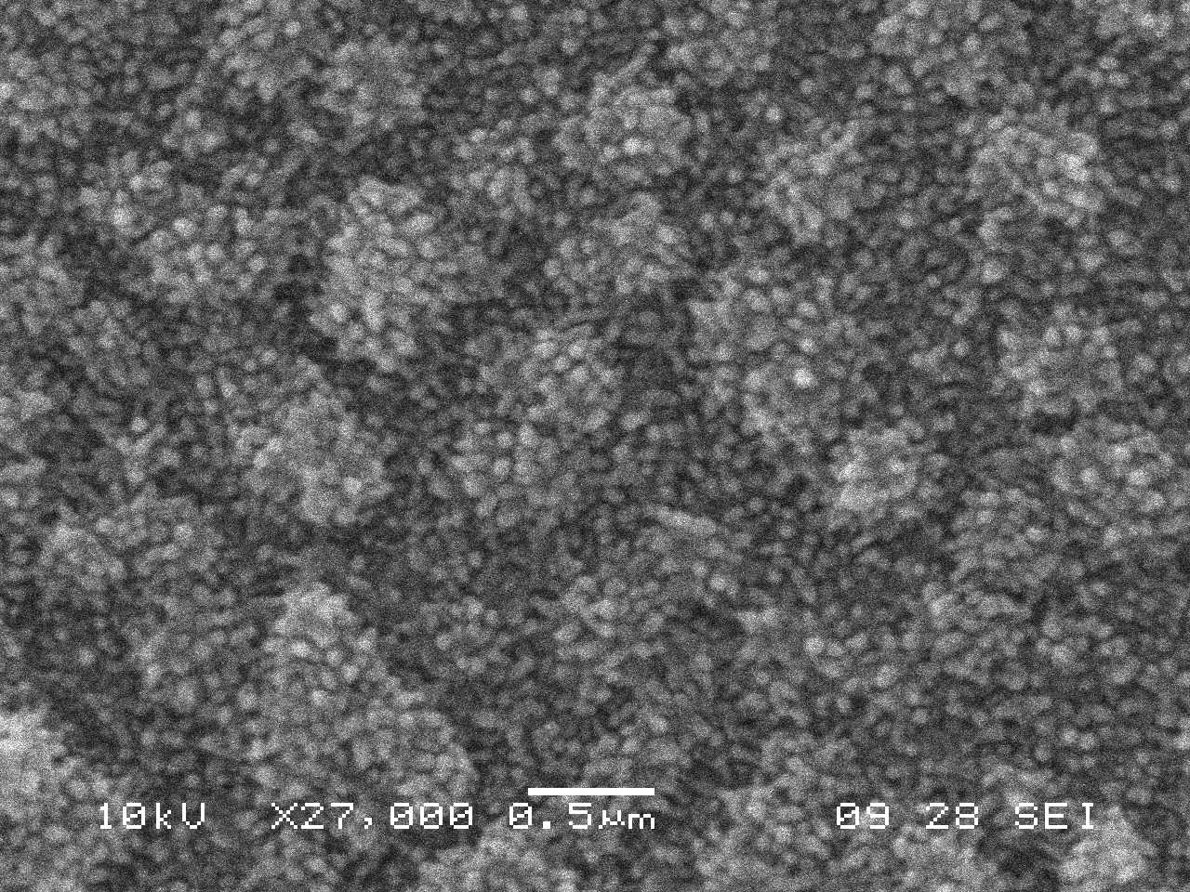

Fig.3.3. SEM micrograph of PANI-PVS film synthesized at 1.0 pH, 0.2 M aniline, 0.5 M PVS, 1 mA/cm² current density and T=27 ºC.

Polyaniline nanocomposite are quickly developing material for biomedical applications are of great importance. The biocompatibility is the ability of the material to co-exist with living things and tissues without damaging them.[19]. Due to conductive of Polyaniline can be used as a drug carrier with electric driven releases.[20].

4.Conclusions
Polyaniline nanocomposite matrix surely in biomedical science for deeper studies and developed research.
Acknowledgement
Authors are thankful to the Dr. Babasaheb Ambedkar Marathwada University Aurangabad for the financial assistance

References

- H Shirakawa, E J Louis, A G MacDiarmid, C K Chiang and A J Heeger, Chem. Commun. (1977) 578.
- R L Greene, G B Street and L J Suter, Phys. Rev. Lett. 34 (1975) 577.
- H Litheby, J Am. Chem. Soc. 15 (1862) 161.
- C K Chiang, C R Fincher, Jr., Y W Park, A J Heeger, H Shirakawa and E J Louis, Phys. Rev. Lett. 39 (1977) 1098.
- W A Little, Phys. Rev. 134 A (1964) 1416.
- D C Trivedi and S K Dhawan, J. Mater. Chem. 2 (1992) 1091.
- D M Big and E J Bradbury, in R B Seymour (ed.), Conductive Polymers, Vol. 15, Plenum, New York, 1981. p. 13.
- F Trinidal, M C Montemayor and E Falas, J. Electrochem. Soc., 138 (1991) 9. T Matsunaga, H Daifuku, T Nakajima and T Kawage, Polym. Adv. Technol.1 (1990) 33.
- A Kitani, J Yano and K Sasaki, J. Electroanal Chem. 209 (1986) 227.
- G Gustafsson, Y Cao, G M Treay, F Klaretter, N Colaneri and A J Heeger, Nature 357 (1992) 477.
- J Lei, Z Cai and R C Martin, Synth. Met. 46 (1992) 53.
- E L Kupila and J Kankare, Synth. Met. 55-57 (1993) 1402.
- V K Gade, D J Shirale, P D Gaikwad, H J Kharat, K P Kakde, P A Savale and M D Shirsat, in: M D Shirsat (Ed), Microwaves and Optoelectronics, Anshan Tunbridge Wells, UK, 2005, p 459.
- R Stankovic, O Pavlovic, M Vojnovic and S Jovanovic, Eur. Polym., J. 30 (3) (1994) 385.
- P D Gaikwad, D J Shirale, V K Gade, H J Kharat, K P Kakde, P A Savale and M D Shirsat, in: M D Shirsat (Ed), Microwaves and Optoelectronics, Anshan Tunbridge Wells, UK, 2005, p 450.
- D D Borole, U R Kapadi, P P Kumbhar and D G Hundiwale, Mater. Lett., 56 (2002) 68
- 5.S J Shaw, Ph.D. Thesis, University of western Sydney, (1994) p.58.
- Humpolicek, P.; Kasparkova, V.; Saha, P.; Stejskal, J. Biocompatibility of Polyaniline. Synth. Met. 2 012, 162 (7–8), 722–727.
- Dai, T.; Jiang, X.; Hua, S.; Wang, X.; Lu, Y. Facile Chem. Commun. 2008, No. 36, 4279– 4281.

