Manufacturing of Eco-Friendly, Low Cost Insulating Coating using Cow Dung

Devendra Pratap Singh¹
Department of Applied Chemistry
Dr. Ambedkar Institute of Technology for Handicapped,
UP, Awadhpuri, Kanpur-208024
Dr. Rajesh Kumar
Department of Chemistry

SDC KANPUR NAGAR

Abstract

The nature that we have gotten is really beautiful. The environment where we leave can be maintained and made healthy. So, for moving towards healthy life there are several technology and management have been used. This paper presents the brief introduction about paint, problems due to conventional paint, need and the contribution of this manufacturing of low cost cow dung based paint. It also includes entrepreneurship opportunities for the local people. It has also been discussed about history of paint, background of paint, types of paint, industrial manufactured eco-friendly paint, properties of an ideal paint and a brief introduction about cow dung, its compositions and properties using some review of literature in which all the literature that has been studied is tabulated by some basic theme. The methodology used in manufacturing process of paint is mentioned, manufacturing process of paint is defined, steps followed for making cow dung paint has been cleared, from used raw materials to implementing of paint is also given. Durability of paint to sustain after implementation, formulation of manufactured, properties of manufactured paint, cost estimation of manufactured paint and conventional paint comparison is also done is defined.

Keywords – Cow dung, Paint, Eco-friendly, Conventional paint, Formulation.

Introduction

The environment where we leave can be maintained for our good and healthy lifestyle. So, for moving towards healthy life there are several technology and management have been used. Like for maintaining the room temperature air condition has been invented, for making cool the things refrigerator has been invented, for generating electricity generator, solar panel and wind energy etc. have been invented. Similarly, for maintaining the decorum of room there are several paints and other chemical things have been used. But due to not too much focusing on its demerits and harmful effect, for the sake of modernity and development there are several environmental issues and health hazards effects have been generated. Which globally affect to the environment like increment of earth temperature, ozone layer depletion, increment of CFC (chlorofluorocarbon), CO (carbon monoxide), CO2 (carbon dioxide) gases etc. it’s also happened due to continuously cutting of trees and exploitation of natural resources. Now, the
several renewable and sustainable technology have been generated which have very less affect to the environment. There are several ways through which it might be possible to control the global warming, energy consumption, ozone layer depletion etc. by using recyclable, eco-friendly materials. This can also be start from local level to world level. For making the life full of color and decoration paint plays an important role. The running conventional paints have many advantages in the field of color and decoration. But due to using so many chemical substances for manufacturing the paints have many harmful effects to the environment and health also. It has been tried to make eco-friendly paint so that the manufacturer of conventional paints try to give a step towards the sustainability and recyclability. With a holistic view regarding the holistic system and technology, it is being important to focus on local resources and its proper utilization. If all the raw materials being used in a process are 5 local and readily available- then it leads to minimal transport, low cost of production and easy availability of the raw materials. This study is related to the manufacturing of low cost cow dung based eco-friendly insulated coating. So, as a concern of mutual fulfilling we are focusing on sustainable material rather than chemical substance. The material used for preparing the paint must be environment friendly, benign and sustainable. But modern industries are producing artificial chemical based paints- not suitable for human heath as well as the environment.

Although the paints are not to be consider as a viable and as important as the other technical tools but it might be possible to go through. In future it can play an important role for the manufacturing of buildings and would be a source to reduce the energy consumption of the building. In today scenario the industries manufacturing paint is based on volatile organic compounds (VOCs). The VOCs react with sunlight and nitrogen oxide present in the atmosphere to form ground level ozone. The World Health Organization (WHO) has reported a 20%-40% increased risk of certain types of cancer (in particular lung cancer) for those who come into regular contact with or work with paint, while Danish researchers point to the added possibility of neurological damage.[6] This health and environmental issues are increasing rapidly due to this conventional paint. That’s why, it has been introduced a low cost cow dung based eco-friendly insulating coating paint. It has no any harmful effect to the environment and health. It is an eco-friendly coating paint. It can be an alternative source for the low energy consumption in house building due to its insulating property. As its ease of availability at local level it can be an entrepreneurship opportunities for the local peoples and villagers so that the people those who are moving towards urban areas can be minimized and the problem of unemployment can be solved. It can also be an extra source of income for the farmers and the villagers.
Background of paint: Paint is a color liquid substance which is used on the surface or base in the form of a thin layer and after a certain period of time it become dry and forms an opaque layer. The main purpose of paint coating is to give the decorative and protective layer to the surface. Today conventional paint gives decorative and attractive seen but not able to produce as protective layer for the environment and health also. So here, it has been introduced about the manufacturing of low cost cow dung based eco-friendly insulating coating is a step towards natural paint. This is water based non-volatile material (NVM) coating paint. This cow dung based insulating coating is eco-friendly, sustainable, locally available and cheaper than the conventional paint. The main components used in manufacturing of paints are binder, pigment, solvent, drier, plasticizer, additives and extenders. [11]

Binder: The binder has properties to bind or hold the pigment particles to the surface. A good quality binder has many properties these are –Lubricants and make strong bond with the surface, Make sure the hardness, Maintain flexibility needed, Resist to water and chemical substances and Hold the color in the present of pigment.

Pigment: Pigment is micro granular solid substance which incorporated with the paint to give color. For making paint it can be spread out through the mediums but not soluble in the medium. The average size of the pigment particles is 0.2 to 20 micrometer. Pigment provides several properties to mixture there are Gives color to make attractive and decorative, to hide the old paint and make new and Give protective and non-corrosive layer.

For example - TiO2, C-Black, Iron Oxides, ZnO2, Cadmium based pigments, Zinc chromate, Manganese based pigments etc.

Drier: Drier are the chemical substance which helps for drying the paint. For example- Octave of cobalt, lead, manganese, zinc etc. Mainly, these are used in oil based binder.

Plasticizers: It is the material which used in paint as a lubricating agent which gives the flexibility to ensure the spreading quality of the film on the surface. For example- Oil of Arandi and Aster etc. The properties of plasticizers are Non-volatile, Suitable for the other material present in the paint film, and are chemically stable.

Additives: After adding a small amount of this chemical substance, gives a special property to the paint is known as an additives. For example- Anti-settling agent, Anti-skinning agent, Anti-foaming agent, similarly, Rheological additives like- Carboxyl Methyl Cellulose (CMC), Ethylene Glycol etc.

Extenders: These are the powdery material having low Refractive Index (R.I.). They enhance the volume of the paint and performance of the coating, for example - BaSO4, CaCO3 etc.
Conventional paints-

The following suppliers sell eco-friendly and non-toxic paints in India-[9]

Asian Paints: Asian Paints is India’s largest paint company that provides paint products for personal, industrial and automotive needs. Asian Paints began its journey into nontoxic paints by removing lead and heavy metals from its paints. The company has also substantially reduced the VOC content in its paints to comply with international standards, as specified by the Green Seal Standard for Paints & Coatings.

Berger Paints: Berger Paints is another leading paint company that has a broad customer base in India. Through their Green Horizon endeavor, the company seeks to protect the environment by producing better products. Berger Paints has removed lead, mercury and chromium from its paints, which are toxic to the human body.

Dulux India: Dulux is a UK based multinational company that has several production units in India. The company complies with the highest environmental standards on paints, especially in the area of VOC content. Dulux promotes water based substitutes actively through its website and other promotional activities.

Kansai Nerolac: Nerolac is now the second largest player in the paints market in India. The company had switched to lead free paints years ago due to the several health hazards associated with lead. All its manufacturing plants are ISO14001 certified, which helps the company to achieve sound environmental performance. Recently, Kansai Nerolac launched a line of water based, low VOC paints that has the National Test House (NTH) certification.

Table 1: Comparative analysis between Conventional paint and considered low VOC paints

Parameter | Conventional paint | Zero/ Low VOC paints
VOC contents (gram/ litre) | 250-800 | 5 for zero VOC/ 50 for low VOC
Color ranges | All colors | Lighter colors
Texture | Flat or glassy | Flat only
Base | Oil or latex | Latex oil in the rare cases
Odour | Suffocating | Less or none
Cost per gallon | INR-720,3000 | INR- 1800,4200
Performance over 20 year | 4-5 coat needed | 1 coat is enough

The VOCs react with sunlight and nitrogen oxide present in the atmosphere to form ground level ozone. A chemical that has a detrimental effect on human health, agriculture crops, forest and eco-systems. These problems can be eliminated using low VOCs paints. Similarly, the paints which are being considered as green paint is not make 100% sure to produce such a
green paint which has no any harmful effect to the environment. Comparatively green paint is better than the conventional one. It is similar to zero or low VOC paints.

Table 2- 2.14.2 Show the difference between green and conventional paints

Green paints | Conventional paints
Air cleaner, Reduced ozone depletion | Contribute to environmental pollution
 | and ozone depletion
Minimal health risks | Significant health risks
Total cost – Same as any high quality | Low but with high operating and
paint and low operating and manufacturing | manufacturing costs
costs
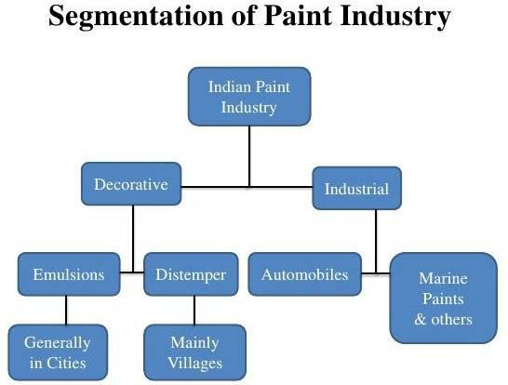

Figure 11– 4.3.1 Segments in paints industries

The above given process are generally used in manufacturing of paint in industries and they are producing in large scale for the purpose of commercialization.

Properties of an ideal paint: As it is being concerned of an ideal paint which is to be as such as we thought with a view of holistic. There should not be any side effect to the environment and health, that paint might be considered as an ideal paint. Some of the typical attributes required can include for ideality: Ease of application, Good to brush marking, Forming a continuous protective, High opacity, Quick drying, Corrosion resistance, Water resistance, Heat resistance, Color stability (i.e. against visible and ultraviolet radiation), Abrasion and scratch resistance, Durability, Exibilty and Easy cleaned

Cow dung: The color of cow dung is usually brown. The fresh cow dung contains both moisture and solid. Generally, India and his neighbor countries use the cow dung in the form
of manure. In India from the very beginning the cow dung has been used as a fuel sources for cooking food and mopping the floor of soil. Mixing the cow dung with lime peoples used it to coat of the cob and mud houses. Dung may also be collected and used to produce biogas to generate electricity and heat. In cold places, cow dung is used to line the walls of rustic houses as a cheap thermal insulator. Most of villagers in India spray fresh cow dung mixed with water in front of the houses to repel insects. It is also dried into cake like shapes and used as replacement for firewood. Cow dung, like any other excreta of ruminants, is composed of fibers (mainly cellulose and hemicelluloses) decomposed by gut microbes. It decomposed cellulose (i.e. plant matter broken down into simpler compounds) could absorb radiation and give protection to living things from radioactive damages, all the grasses and leaves could do that before passing through the gut of an animal. The cow dung have properties to absorb strong radioactivity like the γ (gamma) ray, such that the ray does not pass through, the material has to be a heavy metal like lead. A lead shield of thickness of at least 38 cm or a concrete shield at least 198 cm thick. If one wants to use cow dung to protect oneself from γ-ray, one would need to build a wall of cow dung of at least 366 cm thickness. [22] Figure of cow dung has been given below-
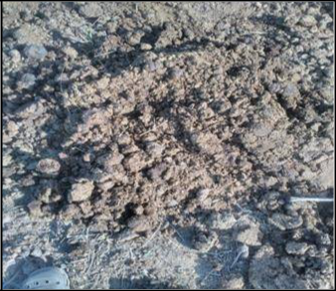

Figure Cow dung (Manviya Siksha Sanskar Sansthan (MS³)-Kanpur, India)

Recent research findings from independent groups in University of Bristol and Sage College in Troy, NY, show cow dung to be an excellent mood enhancing agent. Cow dung contains a bacteria Mycobacterium vaccae, which activates a group of neurons in the brain that produce serotonin a neurotransmitter that contributes to feelings of wellbeing and happiness. So the next time when peer pressure or depressed have you feel try walking into a cow barn and get a lungful of the fresh fragrance of cow dung.

Table 3- 2.16.1 Chemical composition of Cow dung samples

Sample | P | Ca | Mg | K | Zn | Cu | Mn | Fe | Na
(%)
Cow | 0.38 | 1.57 | 0.51 | 0.82 | 0.0052 | 0.0003 | 0.011 | 0.015 | 0.004
dung

Significance of cow dung used in paint

Quality of air can be improved by 50% Natural antiseptic agent

Resist to heat

Minimum cost (Rs.2-5/kg)

No odor of dried cow dung based paint

Cow dung work as an insulator, keep houses cool in summer and vice versa It also keeps free from bacteria and killed them

Cow dung is considered as an environment purifier It work as an anti-radiating agent

Cow dung based paint cost is inversely proportional to the amount cow dung used Save 40000/- cost of an air condition, it self-act as a coolant

Cow dung contains a bacteria Mycobacterium vacate, it activates the neurons to produce serotonin a neurotransmitter that contributes to feelings of wellbeing and happiness
It has texture finish

It has good water resistance in addition of fibers in cow dung support the adhesion and integrity of the film to the concrete surface.
It’s all about the cow dung properties. Its proper used in paint manufacturing and process have been discussed ahead in chapter-4.
Diana, Joao, et al. (2014) has been reported that due to the effect of global warming the normal life and environment are being polluted, temperatures are increasing continuously. So, for protecting the life and energy, it has been suggested some solution by using cool coating on facade and can be reduced the energy consumption. By using total solar reflectance (TSR) concept energy need can be reduce.

E.S. Cozza et al. (2015) proposed their research work to formulate exterior building paints as smart coatings with high IR-reflectance to decrease the use of energy for cooling buildings. They have found the evidence that black color is the most critical case for the light absorption so the study was focused on black pigments, considering its use for realizing both black paints and different shades of grey paints. M.V.Ghamande et al. (2016) Proposed a very useful result of cow dung based paint. It has been explained about properties of cow dung and it usefulness. How the cow dung plays an important role as manure, an antibacterial agent, a neurotransmitter and work as an insulator when use as paint has been mentioned. It is non-volatile, health friendly and washable paint. By using some process cow dung can also be used for producing electricity and heat. It is oil based paint that laterally effects the environment and health. The preservation from
fermentation process has been required. Tina porwal et al, suggested that in today the running conventional paints are affecting our health and environment also. So we have to very much careful about it.

It has been analyzed that headache, trigger allergies, asthmatic reaction, irritate skin, eyes and airways and put increased stress on vital organs such as the heart. A.D. Mahamat et al. (2015) it has been studied about the energy consumption in the building materials used in developing countries and suggested a material sample to save the energy consumption which is combined with clay and cow dung. It can be used in building as a bricks to save the energy consumption due to its thermo-physical characteristics of the cow dung based material. The experimental studied enable them to determine its thermal conductivity, thermal effusively and thermal diffusivity of cow dung based material. It has been found that a good result of thermal conductivity, diffusivity and effusively of cow dung based material, which can be used as building material. As the percentage of cow dung increased the thermal properties have decreased. They also verified their experimental study by analyzing Comsol tool simulation. The data of energy consumption reduce is not mentioned and condition under which it is more useful is also required for further analysis. Some other material mixed with cow dung rather than clay can give a better result in future. Arushi prakash has reported that in conventional paint having volatile organic compounds (VOC) used in solvent, as they get evaporate in the environment its affect to health and environment also. That’s why many companies have thought about alternative eco-friendly paints in India. The available eco-friendly paint in India has been mentioned. But there has not been any guideline for eco-friendly paints so the low volatile organic compounds (LVOC) containing paints have been considered as an eco-friendly paints which can be further modified. Hitesh et al 2011, has been mentioned that by using cow dung cake on solar still plate increase the absorptivity of the sun light due to its porosity. It increased the evaporative heat transfer coefficient so the possibility of waste water, sea water and other sources of water can be treated out by using this cow dung inside the solar still. It’s a type of solar distillation by which water evaporates and then condense so the obtain water is fresh to use. The comparative analysis of solar still plate evaporation and cow dung cake based solar still evaporation has been done experimentally. Graphical representation shows a very clear statement about the cow dung usefulness.

From all the literature review it has been concluded that whatever the paint available in the market are not free from volatile organic compounds (VOCs). Industries are trying to make eco- friendly paint but it has not been prepared to a fully successful applicable paint which can be used.

Proposed Methodology: The essential steps in the process of paints manufacturing are mixing, grinding, and thinning, tinting, straining and canning operations take place after the paint batch has been tested and accepted as meeting the prescribed standards.
- Mixing: The prime purpose of the mixing operation is to combine the ingredients into a uniform paste and to wet the pigments with the vehicle as thoroughly as possible. The mixing operation must be continued until the paste is smooth, uniform and free of un-wetted agglomerates. In the mixing operation the pigment is gradually added to the vehicle keeping the paste relatively stiff. This is done in order to maximize the shearing action as an aid to breaking up large lumps of un-wetted pigment.
- Grinding: The grinding operation is actually a means of dispersing rather than reducing the size of the individual particles of the pigment. Some naturally occurring pigments are reduced in particle size by grinding but most chemical pigments are already fine enough. Frequently these fine particles agglomerate during shipping and storage and it is necessary to disperse them by a grinding operation. The grinding operation also serves to extend the wetting action begun in the mixer. The grinding operation is performed by passing the paint through a series of rollers under great pressure. In some cases the mixing and grinding operations are performed in one operation in what is called a pebble mill. This consists of a revolving cylinder containing hundreds of steel or porcelain balls which bounce about. The materials are subjected to a mixing and grinding action caused by the falling balls. The higher the ratio of balls to paste weight the finer the grind. Pebble mills are used in preference to roller mills for pastes containing highly abrasive materials (e.g. silicates, iron oxides) or when the batches are relatively large.

- Thinning and Tinting: The thinning operation consists of adding the remaining quantities of oils, driers, thinners, and any other liquids called for in the formula but no dry pigments. The consistency of the paste is reduced by gradual addition of the liquids while stirring and mixing the batch. When tinting is required the colors previously ground in oil are added to small portions of the batch, then added to the complete batch and stirred until the color distribution is uniform. At this point samples are sent to the lab for testing. Any adjustments found necessary by the testing procedure are made. The batch is retested and adjusted until final approval is given by the laboratory.

- Straining and Canning: The batch is passed through a series of wire gauze drums where any remaining particles or extraneous material is removed. Another method in widespread use is to strain the batch by means of a centrifuge. The strained batch is loaded into an automatic machine which fills cans carry on a continuous conveyor. This same machine fits the covers to the cans and delivers the filled sealed cans to a point of packaging. The cow dung based paint has been prepared in the laboratory for the purpose of studies and analyzing its properties.

The steps followed for making paint are given below-

Manufacturing of cow dung paint

Generally, in the laboratory the small scale ball mill, triple role mill, bead mill and small scale high speed mixer are commonly used. Here, triple role mill has been used for the manufacturing of cow dung based paint. Figure has been given below-

Methods followed in paint manufacturing
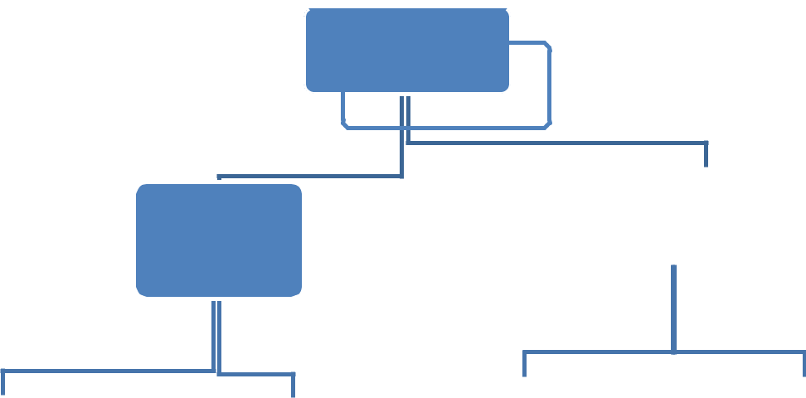

To search raw
Materials




Equipment
used



Processed


Tripple role | Grinding | Mixing
mill | Mixer
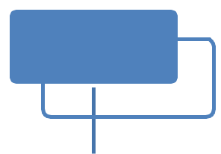

Manufactured
paint



Apply on
boxes



To do thermal analysis

- Triple roll mill- Triple roll mill is a grinding machine in which three roll are fixed by a certain type of device container in which the middle roll move only on its axial point and remaining two roll having one move clockwise on it axial position and another move to anticlockwise on its axial position and they can be adjust according to the requirement of grinding the material. In this grinding triple roll mill machine only the cow dung has been passed through. In each passes it has been checked the amount of fibers present and then passed it again through the triple roll mill until we would not get a satisfactory grind material.

Almost after three passes we can get a satisfactory grind material that can be used for the next process.

- Weighing machine

This is a machine in which limited things can be measured for the purpose of experimental work or for finding a sample of such things. Here, it is being used for measuring the actual amount of cow dung used for making paint, pigments amount, calcite, acrylic etc. whatever the components used for manufacturing of this paint has been measured by this weighing machine. As figure shown below-

For example- Weight of an empty petri dish = 50.20 gram , Weight of petri dish and cow dung = 66.17 gram So, weight of cow dung used = 66.17- 50.20 gram = 15.97 gram

- Hot air oven

For making the non-volatile material (NVM), needed to remove the moisture from cow dung. The moisture present in cow dung can be evaporated by putting it in hot air oven. For that a petri dish is needed to put the cow dung in it and weight and then the petri dish with cow dung has been put in to a hot air oven for 45 minutes. Hot air oven is a machine which is used for removing the moisture and makes it dry. The hot air oven figure has been given below-

- Desiccate vessel

After 45 minutes the petri dish has been taken out from the hot air oven and put it in a desiccate vessel for 5-10 minutes to cool. Desiccate vessel is a tool which is used for cooling the things after a certain period of time. Here, it is being used for making cool to hot petri dish and then weight it. It has been gotten a result of weight i.e. 56.62 gram. Again it has been put in hot air oven for 30 minutes for removing moisture and then for cooling in to desiccate vessel for 5-10 minute and weight again i.e. 54.63 gram. This process has been done many times until we get a constant value of weighing machine. The given below figure in which petri dish with cow dung has been put in to desiccate vessel.
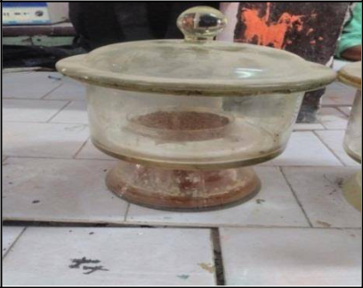

Figure Desiccate vessel for cooling

- Mixture- After being processed in triple roll mill the material comes out and sends for mixing. Where the amount of other material has been already measured like amount of pigment, extender, emulsion and water are mixed together in the mixture. Then all this mixture with cow dung has been poured in to the mixing machine. The paint is water based paint that’s why it is being cared about the mixing of water in the mixture. So that it can be obtained a proper viscosity of manufacturing paint. As figure given bellow.

After all this above process the final product of paint is manufactured. It is as such as the paint available in the market or the conventional one. The picture of manufactured paint has been given below-
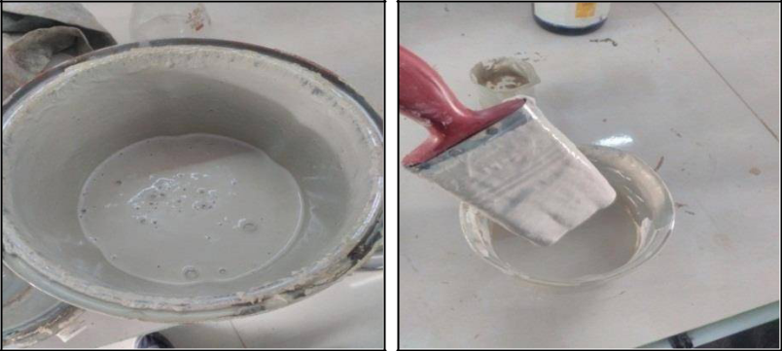

Figure: Prepared cow dung based paint

It is not the only paint that has been prepared by this process. There are some more sample of this cow dung based paint has been manufactured and formulated. The sustainability of this paint has been check out by finding its strength, durability, washability and colour changing properties. It is also being compared with the conventional paint. Some experimental coating has been done on the wall is given below-
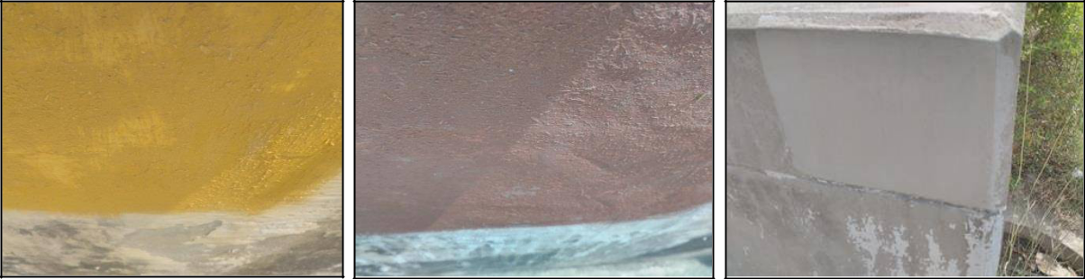

Figure : Different samples of manufactured paints coated on wall,

Result and discussion

As from the used raw materials to till implementing of the manufactured cow dung based paints are
clearly explained in the above. On the basis of this experimental work and methodology some results and formulation have been found. Some has been try to explain by the work process
and some by flow chart. Now the actual formulation from used raw material to cost estimation and resulting insulation property due to this manufactured paint has been explained in this chapter.

Formulation of raw material used

On the basis of above experimental work and used methodology, some results have been found. First of all the raw materials used for making this low cost cow dung based insulating coating paint has been formulated i.e. by weight percent. There are five formulation have been done.

On the basis of these five formulations, five samples of paint are manufactured. All these five formulation are tabulated below-

Table 5- 5.2.1 Formulation of paints

Chemical Name Formulation 1 Formulation 2 Formulation 3 Formulation 4 Formulation 5

Titanium Dioxide |  |  | 3.42% |  | 2.58% |  | 2.9% |  | 3.33% |  | 3.47%
(Anatase)
Calcite |  |  | 17.14% |  | 19.35% |  | 22.20% |  | 20.8% |  | 17.39%
Cow-Dung |  |  | 15.5% |  | 24.19% |  | 27.77% |  | 31.25% |  | 32.6%
(100%NVM)
Acrylic |  |  | 5.71% |  | 6.45% |  | 3.7% |  | 4.16% |  | 4.35%
Emulsion(Solid)
Carboxy | Methyl |  | 0.57% |  | 0.64% |  | 0.74% |  | 0.80% |  | 0.86%
Cellulose (CMC)
Distilled Water |  |  | 51.71 % |  | 46.79% |  | 46.00% |  | 39.6% |  | 42.2%

As the above table show all about the five formulations of the paint and the formulation-1 has been considered as a final product of paint that’s why it is highlighted.

Properties of manufactured paint

Generally the properties considered in paint industries are Viscosity, Volatile content, pH, Color, Film integrity, Water resistance, Brushabilty, Thermal resistance and Weather
resistance. All these properties of the manufactured paint are also considered and tested out in the laboratory. Whatever we have gotten from testing the properties of manufactured paint have been given below-

Table 6- 5.3.1 Properties of paints

Serial | Properties | Formulation 1 | Formulation 2 | Formulation 3 | Formulation 4 | Formulation 5
Number | Properties
1. | Viscosity | 125 Pa-sec. | 120 Pa-sec. | 120 Pa-sec. | 118 Pa-sec. | 120 Pa-sec.
2. | Volatile | 50% | 45% | 43% | 38% | 41%
2. | content
3. | pH | 7-8 | 8 | 7-8 | 8-9 | 8-9
4. | Colour | Off White | Off White | Off White | Off White | Off White
5. | Film Integrity | Excellent | Good | Poor | Poor | Poor
6. | Water | Excellent | Very Good | Good | Good | Fair
6. | Resistance
7. | Brush ability | Good | Fair | Fair | FairFair
8. | Thermal | 3-5*C | Not Checked | Not Checked | Not Checked | Not Checked
8. | Insulation | 3-5*C
9. | Weather | Good | Fair | Fair | Fair | Fair
9. | Resistance

In above table the given formulation is analyzed and measured experimentally. From this table it is being cleared that the manufactured paint properties are better than the conventional paint as table shows. The highlighted column i.e. formulation-1 is considered as final product of paint.

Density and specific gravity measured: The density cups use a cylindrical shape which provides a large opening for easy filling, emptying and cleaning. The tightly fitted stainless steel covers have an upward slope to a small hole in the center to allow excess sample material to be expelled without entrapping air bubbles, which increases accuracy. [25]

The manufactured paint density has been calculated by using this weight per liter cup or
density cup of 50ml capacity container. The calculated density has been given below. When the density are divided by one thousands then the specific gravity of this paint is also obtained.

For calculating density there was measured the weight of empty cup and noted down. Then fill the manufactured paint in to this cup and weight again and note down the reading. By this method the actual weight of paint filled in this cup has been found i.e.

Empty weight of cup = 133.50 gram Weight of cup with paint = 192.90 gram So, Weight of paint = 192.90 - 133.50 = 59.40 gram

Hence, Density of paint = 59.40 gram / 50 ml (50 ml³ cup capacity i.e. volume of cup) = 1.85 Specific gravity of paint = 1.85/1000 = 0.00185

Thermal analysis

Thermal analysis is a branch of materials science where the properties of materials are studied as they change with temperature. Several methods are commonly used – these are distinguished from one another by the property which is measured.

Here, the thermal analysis of the cow dung based insulating coating paint has been done by using some experimental techniques. For analyzing the thermal analysis there has been made two teen boxes of cuboids shape with size of (8×8×8) inches. In which a hole was done from the top surface below one inch to its adjacent side of box. The size of hole will be as such as the thermometer can be passed through it. Then put a thermometer in to this hole and covered its surrounding by putty so that there could not be air passed through and get a better result of insulating property of this manufactured paint. This manufactured paint was coated to one of the box and put another box remain same i.e. uncoated. These two boxes have been put to the outside of room where the sunlight properly comes. As given picture shown below-
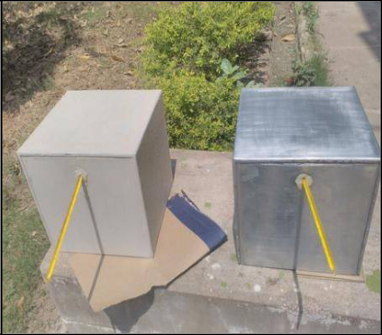

Figure : Coated and Uncoated boxes

The readings of temperature changes have been taken after every fifteen minutes and make a graph i.e. change in temperature versus time graph, which is given below. The resultant

temperature difference effect due to this coating is also shown in this graph. Maximum of 3.5 degree temperature difference has been found.

Below given graph the x- axis have time are mentioned and in y- axis temperature are given. Blue line shows the temperature of CDBP coating, Red line shows the temperature of uncoated box and whatever the temperature difference have been come is shown by green line.

Temp.

6
0
5 | Temp.CDBP
0 | Temp.CDBP
0 | coating
4 | coating
4 | Temp.
0 | Temp.
0 | without
3 | without
3 | coating
0 | coating
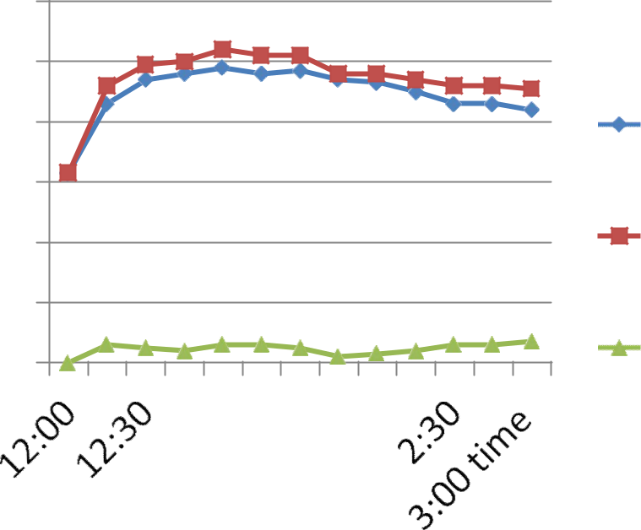

Figure :Thermal analysis graph of coated and uncoated boxes

In the graph above, it has been cleared about the temperature difference by coating of CDBP (Cow Dung Based Paint) coatings and uncoated box. The maximum obtained temperature difference is 3.5 ⁰C. It shows the major possibilities in future regarding this paint and its insulating properties. This is the first graph of thermal analysis of insulating manufactured paint.

After this first thermal analysis it was cleared that the manufactured paint have insulating property and it might be more than that of conventional one. So, the comparative thermal analysis of this manufactured paint and conventional is needed. This comparative thermal analysis is also done by coating both the boxes one with the manufactured paint and another box is coated with conventional paint i.e. Cow Dung Based Paint (CDBP) and Conventional Paint (CP) coating. As shown below-
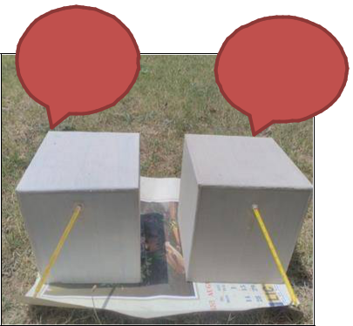
^{CP} CDBP

coating _{Coating}

Figure 24- 5.5.3 CDBP and CP coating

As in the above figures there are two coating have been done in which one is coated with manufactured paint i.e. CDBP and another one is conventional paint (CP) coating. So, the temperature differences obtained with this coating has been shown below by graph-

Temp.
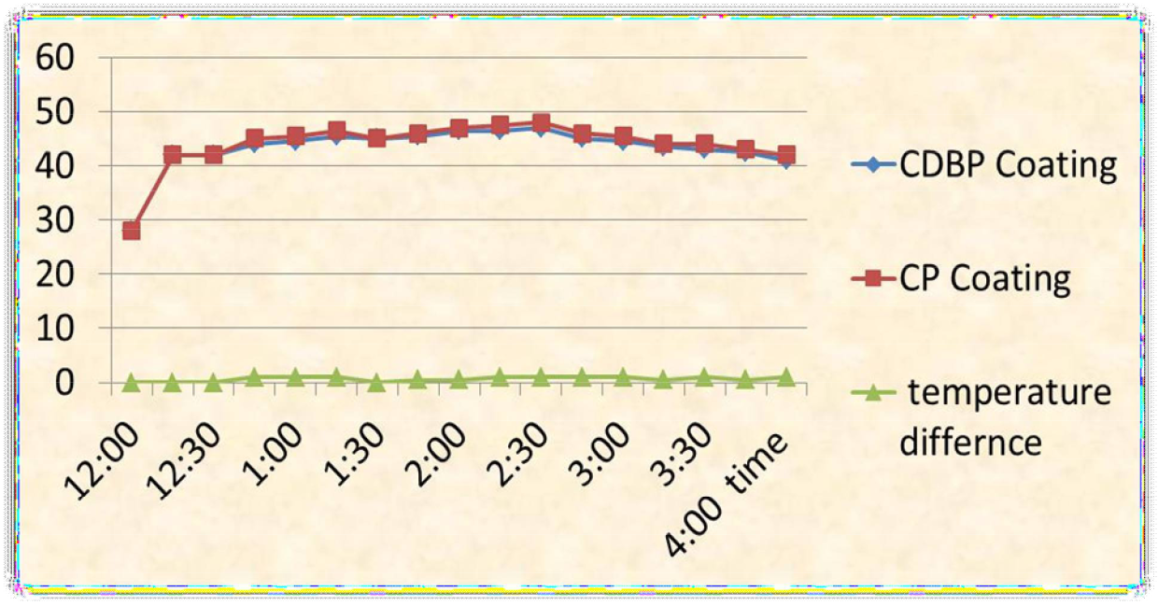

Figure 25- 5.5.4 Thermal analysis graph of CDBP and CP coating

Here, in the above graph the blue line shows the coating of cow dung based paint (CDBP). Red line shows the conventional paint (CP) coating and whatever the temperature difference is obtained are shown by green line. So, it is being cleared by the graph that the CDBP coating has more insulation properties than the conventional paint coating. The temperature difference obtained in ideal condition is from one to one and half degree Celsius due to CDBP coating.
The maximum temperature difference obtained is 1.5 ⁰C.

Cost estimation

The manufacturing cost of this cow dung based paint CDBP is calculated. The cost of the conventional paint is found from the specific source of industries and the comparative analysis of cost of paints has been done properly. The table of manufactured paint cost is given below-

Table 7- 5.6.1 Cost estimation of manufactured paint

Serial |  | Chemicals |  | Percentage |  | Rate |  |  |  | Quantiy |  | Total
Number |  |  |  |  |  |  |  |  |  | (In Kg)
1 |  | Acrylic Emulsion |  | 5.71 |  | 200/- |  |  |  | 0.0571 |  | 11.42
2 |  | Titanium Dioxide |  | 3.42 |  | 120/- |  |  | 0.0342 |  |  | 4.104
3 |  | Calcite |  | 17.14 |  | 10/- |  |  | 0.1714 |  |  | 1.714
4 |  | Cow Dung |  | 21.5 |  | 2-5/- |  |  | 0.215 |  |  | 1.00
5 |  | Carboxy Methyl |  | 0.57 |  | 220/- |  |  | 0.0057 |  |  | 1.254
 |  | Cellulose
6 |  | Distilled Water |  | 51.71 |  | 2-5/- |  |  | 0.5171 |  |  | 1.00
 |  |  |  |  |  | Total |  |  |  | 1.00 Kg |  | Rs. 20.492

Packing Charges = 5% of manufacturing price

- 0.05×20.492

- Rs. 1.0246

- 0.3×20.492

- Rs. 6.1476

Total Cost of 1 kg product = manufacturing Price +Packing Charges + Conversion Charges = Rs. (20.492 + 1.0246 + 6.1476)
= Approx. Rs. 27.67 per kg

Nerolac Paint Distemper cost Packaging Size: 20 Kilogram [26] Categories of

Distemper: Acrylic

Rs 950/Bucket (20 kg)

So the rate of one kg of Nerolac distemper is 950/20 = Rs. 47.5/kg

Now it can be easily compared with the cost of manufactured paint. Hence, the price difference between manufactured acrylic distempers paint and conventional acrylic distemper paint is-

47.5 – 27.67 = Rs. 19.83≈ Rs. 20 (Approx.) (Saving/kg)

The saving of 20 Rupees per kilogram from this manufacturing paint is huge amount than that of the conventional one. So, if this paint comes out in the forms of industrial manufacturing paint for the purpose of commercialize then it will be beneficial for both to the industries and consumers. Due to the ease of availability of raw materials in local areas, it would be a self-reliant entrepreneur for the local people. So, the moving of local peoples or villagers towards the urban areas for the job security can be minimized. It also gives a motivation to the young generation for the innovation. With all these happening by this paint, it is also fruitful for our environment and health as well as recyclable and bio-degradable. It would be a natural product for the paint industries.

Durability of paint

It is found that the durability of acrylic distemper paint is depends on conditions. The condition under which the sustainability of acrylic distemper paints is defined in terms of Weather, variability, Sun lights effects, Properties of wall, Scratching and stretching effects, Moisture, Feasibility, Water resistance
On the basis of these conditions it could not be exactly estimated about the durability of the paints. But under all these conditions the sustainability of paint of manufacture acrylic distemper paint is 2 to 3 years. The durability of conventional acrylic distemper paint is also similar to this manufactured paint.

Conclusion

In this thesis the low cost cow dung based eco-friendly insulating coating paint has been manufactured successfully. Each and every step from the raw material to implementation of this manufactured paint is clearly defined.

With a holistic view regarding the holistic system and technology, the final product produced
be durable and possess the qualities needed to serve the purpose for which it has been produced. Without ensuring the recyclability of the material being used in production, it is going to create pollution in the nature. It has religious values attached to the many Hindu family. As a concern of mutual fulfilling we are focusing on sustainable material rather than chemical substance. The materials used for preparing the paint are environment friendly, benign and sustainable. But modern industries are producing artificial chemical based paints-not suitable for human health as well as the environment.

This cow dung based insulating coating can be easily prepared at home or at local level due to their ease of availability. It is also cheaper than the conventional paint. In this coating, no volatile component has been added; so it is non-volatile material (NVM) water based coating.

Being good thermal non-conductor properties of this paint, the room will be cool in summer and hot in winter. This insulating property has been experimentally defined with the graph also. Thus, by using this coating effectively; it can be a replacement of air conditioner and other such appliances. It is also helpful to reduce the energy consumption of building.

References:

- Diana Dias, Joao Machado, Vítor Leal, Adélio Mendes, Available online 18 January 2014 Impact of using cool paints on energy demand and thermal comfort of a residential building.

- E.S. Cozza, M. Alloisio, A. Comite, G. Di Tanna, S. Vicini, 21 April 2015, NIR-reflecting properties of new paints for energy-efficient buildings.

- M.V.Ghamande, Omkar Nandangiri, Yash Bagul, Rhugwed Ponkshe, Vaishnavi Kale, Riya Bhatmule, April - June 2016, Manufacturing of Cow Dung Paint.

- http://www.essentialchemicalindustry.org/paints.html, 18th March 2013.

- Allen Edgar Bryson, May 15, 1950, the Control of Quality in the Manufacturing of Paint.

- Tina Porwal, September 2015, Paint Pollution Harmful Effects on Environment

- Abdallah Dadi Mahamat, Oumar Idriss Hamid, Malloum Soultan, Mahamoud Youssouf Khayal, Yassine Elhamdouni, Mohammed Garoum and Salif Gaye, June 05, 2015, Effect of Cow’s Dung on Thermo physical Characteristics of Building Materials Based on Clay.

- Culver, Mary M., 2001, Performance Evaluation of Traditional and Modified Distemper Paints

- Arushi Prakash, http://www.ecoideaz.com,environmentallyfriendlypaintsindia
- Hitesh N Panchal, Manish Doshi, Prakash Chavda, Ranvirgiri Goswami, 2011, Effect of Cow dung cakes inside basin on heat transfer coefficients and productivity of single basin single slope solar still

- Dr.P.K.Kamani, 2004, paints, varnishes and lakers, Lucknow publication.

- https://en.wikipedia.org/wiki/History_of_painting

- file:///D:/project/snj/Basics%20of%20Alkyd%20Resin%20Technology%20%20%20Pr

ospector%20Knowledge%20Center.htm

- Michal D.T.clark, 1974, Paints and pigments

- https://www.elledecor.com/homeremodelingrenovating/homerenovation/advice/a2777/ different-types-paint-finishes

- ]https://www.google.com/search?q=types+of+paints&tbm=isch&tbo=u&source=univ&

sa=X&ved=0ahUKEwio1cenvvraAhVLM48KHaBg8QsAQIsAE&biw=1366&bih=654

- www.freelogovector.net

- www.bergerpaint.com

- www.duluxpaint.com

- www.nerolacpaintimages.com

- www.confederation of Indian industry, green paint industries.com

- https://www.quora.com/Does-cow-dung-have-the-ability-to-absorb-the-radioactivity

- O.S. Olokode; P.O. Aiyedun; D.M. Raheem; F.T. Owoeye and B.U. Anyanwu, Accepted 10 September 2012 ,Production and characterization of clay – cow dung insulating fire – bricks

- www.indiandecorativepaintindustries.com

- http://www.kohsieh.com.tw/PDF_Files/BYK-Gardner/Density_Cups.pdf

- https://www.indiamart.com/proddetail/nerolac-paint-distemper-13823025212.html

- www.acrylicwaterbasedpaintimages.com

- www.epoxyresinpaintimages.com

