Future Perspective of Nanoparticle based biofertilizers and Disease Control Agent
R. Kannan^{1*}, and V. Dhivya²
^{1*} Assistant Professor, Kalasalingam School of Agriculture and Horticulture (KSAH),
Kalasalingam Academy of Research and Education (KARE), Krishnankoil-626126

²Research Scholar, Department of Biotechnology, Kalasalingam Academy of Research and Education (KARE), Krishnankoil-626126

^{1*}Corresponding author:kannanrdst@gmail.com
ABSTRACT
Agriculture and Horticulture cultivable land over usage of chemical fertilizer for soil application and then foliar spray for control of dumping pathogen such as pesticide, insecticide, fungicide, herbicide and bacteriacide. This point of view to development sustainable cultivable ecosystem and Nanoparticles based bioagent to agriculture input preparation emerging as promising alternative. Nanoparticle based agriculture fertilizers and pesticide, insecticide, fungicide, herbicide and bactericide support ecofriently nature and reduce transport cost with labour and chemical fertilizer cost. The agriculture and horticulture farming farmers facing lot of problems, farmers urgent require advance technology like nanoparticle based macro, micro nutrients and disease management agents (low cost with feasibility).
Keywords: Nano size particle; Pathogens; Plant; bacteria; Fungi; Biofertilizer; Biopesticide
INTRODUCTION
Nano based plant nutrients and disease control agents is now used agriculture and horticulture practice area widely used in modern agriculture to bring the concept of precision agriculture to life, and it has applications in a variety science sectors. Huge demand of scope open in the fields of agriculture for nanotechnology refers to nanoparticles with one or more dimensions of fewer than 100 nanometers (6). Because of their small size, high surface-to-volume ratio, and unique optical properties, nanomaterials have uses in plant conservation against biotic and abiotic stress, nutrition, and farm management (17). Metal minerals and non metals mineral based, semiconductor are among the components utilised to form nanoparticles (47). In agriculture, chitosan nano particles are used in seed treatment and as a biopesticide to assist plants fight fungal infections. Plants differ in their ability to absorb nanoparticles and their impact on growth and metabolic activities. The concentration of nanoparticles has an impact on plant germination and growth (68). By decreasing the leaching and evaporation of dangerous compounds, nano encapsulation plays a critical role in environmental protection. Pesticides are consumed in around two million tonnes per year around the world, with Europe accounting for 45 percent, the US for twenty five percentage, and other country for 25% (15). Pesticide use that is haphazard and careless promotes disease and insect resistance, lowers diversity soil living organism, and kills beneficial living oraganism from soil; causes pesticide bio magnification, pollinator loss, and disrupts the natural habitat of birds and other Allied farmers (63). Some of the benefits of modern nanotechnology include nano particle-mediated gene or DNA transfer in plants for the development of insect pest resistant varieties and the use of nano materials for the preparation of various types of biosensors that could be useful in remote sensing devices required for precision farming (49). Traditional agricultural solutions such as integrated pest management are insufficient, and the use of chemical pesticides has negative consequences for animals, beneficial soil bacteria, and soil fertility. To address this issue, genetic modified insecticides, according to making low cost product, must be developed (48). Micro fabrication and nanotechnology advances are currently playing a vital role in virus detection, lowering observation level, improving working standard, and low cost technology of viral detecting kits (13).
NANOBIOFERTILIZERS
Biological fertilizers formulation made by different genus and species of bacteria and fungi combine make consortia mode to application that improve nutrient availability to plant roots and ability produce hormones and iron chelating in the rhizosphere zone with modern technology of nano based biofertilizer to elongavation the plant organs. Controlling the delivery of biological fertilizers in the land profile and extending the helathy life of the formulation are fundamental to achieve (27, 39, 60). (Fig.1)
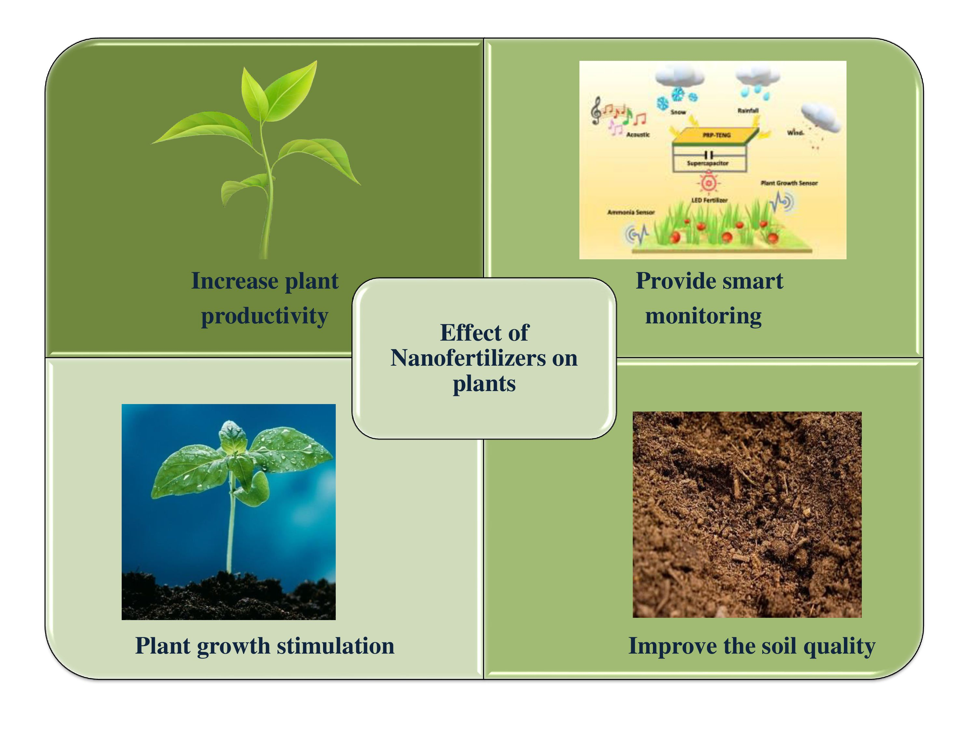
Fig:1 Improvement of Soil, Plant health and Monitoring status by Nanofertilizer
The healthy relation with nanoparticles and plant beneficial microorganisms, as well as the shelf life and delivery of biological fertilizers, are key considerations for the creation of nanobiological fertilizers. The interaction between gold nanoparticles and rhizosphere bacteria that promote plant growth was found to have beneficial results (38, 57). On the other hand, silver nanoparticles cannot be used with biological fertilizers because they can disrupt the biological processes of microorganisms, such as changing the structure and function of cell membranes. Most important the withstand microbes in long duration for incubation (shelf life) of biological fertilizers for these formulations, which can be improved by introducing nanomaterials (Fig.2).
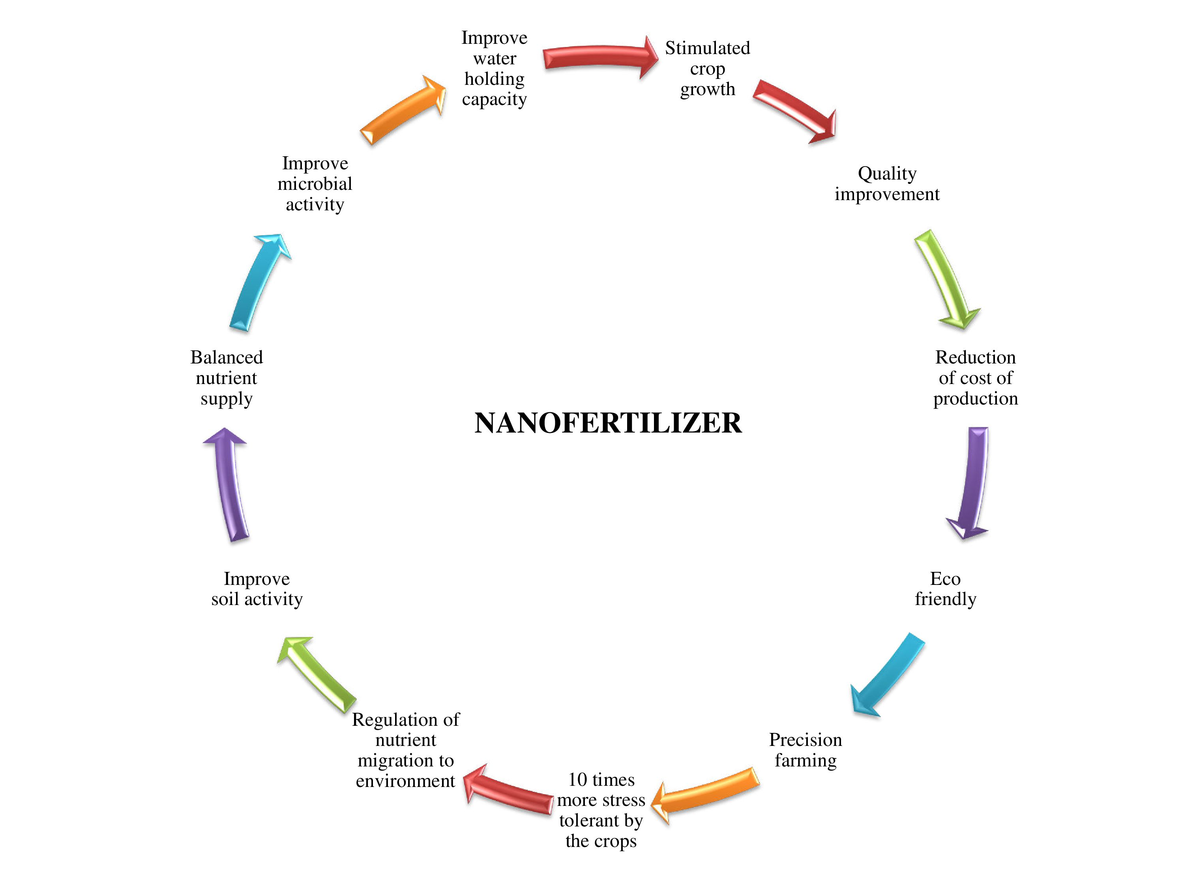
Fig: 2 Nanobiofertilizer mode of action
The use of nano-products helps to improve the stability of biological fertilizers in terms of biotic and abiotic stress. For example, polymer nanoparticle coatings can be used to make anti-drying formulations to extend the life of these items (59, 19). However, since nanostructures are usually smaller than cells, there is a fundamental problem in the manufacture of nano-biofertilizers. In this sense, a macroscopic filter constructed with radically arranged carbon nano tube walls that can intake E. coli will be efficient products that can combine the other beneficial microorganism for ferment the substrate and easily transport the plant root system Therefore, nano-biological fertilizers may overcome some limitations of biological fertilizers, but further research and development are needed (59, 64).
NANOBIOPESTICIDES
Nano biopesticides are compounds with nanoparticles obtained from biological sources and are intended to be used as pesticides. Polymers, metal oxides, active particles mixed with micelles and other materials are used to improve the efficiency and effectiveness of nano biopesticides. Qualified nano biopesticides must have the following qualities: enhance complex molecule to simpler radicals of chemicals and then quickly dissolved in water, segregation of active target molecules through gradually, and not prematurely destroy active list of essential (48). Although the amount of nanobiopesticide used is small, its effectiveness should not be compromised. Additionally, by manufacturing nanobiological pesticides rather than utilizing information on the existence cycle and conduct of plant problematic microorganisms or pests, target specificity and results can be improved. The quality and fate of its active ingredients are significantly affected by nano formulations. Before use, the diameter range, structure or properties of the nanoparticles, the surface characteristics of the nanoparticles, the auxiliaries utilized, and their trademark discharge in the genuine climate over the long run not really settled (48). Nano-biological pesticides consist of active chemical pesticides in nanoparticles or other small man-made structures with insecticidal ability (8). For instance, the fourth larval phase of the filariasis vector Culex quinquefasciatus Say (Diptera: Culicidae) and the malaria vector Anopheles subpictus Grassi (Diptera: Culicidae) were evaluated. Ag nano particle with sizes of 35 and 60 nm reacted to C in a crude aqueous solution. Quinque fasciatus and A. subpictus, which indicates size of the nanoparticles assumes a significant part in the adequacy of the item (31). In the cotton bollworm, the tree leaf extracts of Ficus religious (FR) and Ficus benghalensis (FB) are used to produce Ag NP and have been found to affect the function of intestinal protease activity (50). The modification of nano-biopesticides with biocomposites will produce some characteristics, such as greater spreading, faster degradation of the soil and levels of plant residues lower than the food regulatory standards or rigidity, permeability, crystallinity, thermal stability, solubility and slower degradation (11, 12, 20). Biodegradability is all characteristics of the polymer carrier structure. The larvae of the Egyptian cotton leafworm Spodoptera littoralis are toxic to the pyrethroid nanoparticles (30-100 nm) of novaluron (a water-insoluble insecticide). However, these nanoproducts have been demonstrated to be destructive to the climate and removal has proven challenging. This clearly raises concerns about environmental safety, which must be taken into account when creating nano particle by products (16).
1. Nanofungicides
Fungal diseases produce great economic losses around the world and their control has traditionally been undertaken using chemical fungicides in large quantities, often quite thoughtlessly (46). Such treatment has taken not only pathogenic organisms as its target but caused unwanted effects in the matrices of the environment, namely soil, water, air, biota, etc. Nanobiotechnology is currently considered to be a very useful, novel tool for managing common fungal diseases in plants, using nanoparticles of metal oxides that do not affect the environment and behave as a macronutrient (e.g. MgO, CaO) or micronutrient (e.g. ZnO, CuO) in the soil. Previous studies have shown particularly the antifungal capacity of ZnO-NPs on various fungi (33, 56, 22, 34, 5). In addition, in the interests of a sustainable agriculture that respects biodiversity, there has been encouragement for the study of nanofungicides (1), compounds that involve both nanoparticles (normally of inorganic nature) and nanobiohybrids (a mixture of inorganic and organic materials) to tackle plant fungal pathogens.
Despite the fact that a variety of fungicides are commercially available, their use has negative consequences for plants. Antifungal drugs made from nanoparticles have been tested against harmful fungi. Using nanoparticles of ZnO (35-45 nm), Ag (20-80 nm) and TiO₂ (85-100 nm), the antifungal efficacy of Macrophhomina phaseolina, an important soil-borne pathogen of legumes and oilseeds, was studied. At lower concentrations, silver nanoparticles have a stronger antifungal effect than ZnO and TiO₂ nanoparticles (58). In terms of resistance to soil born fungal plant pathogens, corn treated with nano silica (20-40 nm) was compared with block silica. In leaf extracts obtained from plants treated with nano-silica, the expression of phenolic compounds was higher (2056 and 743 mg / ml, respectively), while the expression of stress response enzymes against these fungi was lower. At 10 and 15 kg / ha, these results indicate that the disease index and the expression of defence enzymes are better than bulk corn. The treated corn has greater resistance. Therefore, SiO₂ based nanotechnology to use strong antifungal agent to replace plant pathogens (62). Ag heavy metal has much stronger antifungal properties than other metals. This is because silver ions deactivate thiol groups in the fungal cell wall, leading to destruction of the transmembrane, energy metabolism, and the electron transport chain. Other pathways include mutations in fungal DNA, dissociation of key enzyme complexes for the respiratory chain, reduced membrane permeability, and cell lysis (65). The efficacy of silver nanoparticles is proportional to their size and shape, and diminishes as particle size increases. The “cidal” effect of truncated triangular particles was found to be larger than that of spherical and rod-shaped particles (42, 43). The antifungal capabilities of silver nanoparticles have been used to treat plant diseases (24). Due to high adherence on the surface of bacterial and fungal cells, well-distributed and sustained Ag metals nanoparticles aqueous can operate as an efficient fungicide (26).
S.No | Nanoparticles | Plant species | Target fungi | Advantages | Disadvantages | Reference
1 | Hexaconozole, Dazomet  and chitosan | Oil palm | Ganoderma boninense | It has high biocompatibility, and biodegradability of formulation constituents | High concentration may cause phytotoxicity | 37
2 | Chitosan and Dazomet | Oil palm | G. boninense | It has high biocompatibility, and biodegradability of formulation constituents | High concentration may cause phytotoxicity | 37
3 | Chitosan/  Pectin | Cucumber  Maize  Tomato | A. parasiticus  And  F. oxysporum | Control release | Phytotoxicity | 30
4. | PHSN | Cucumber | B. cinerea | It facilitates the controlled nutrient transfer and increasing crop protection | High concentration may cause phytotoxicity | 67
5. | Chitosan | Maize grains | F. graminearum | Reduce volatility and enhance fungal disease control | -- | 23
6. | Bacterial ghosts | wheat, cucumber and Barley | L. nodorum,  P. teres,  S fuliginea  and E. graminis, | It possesses a multifunctional delivery platforms | Genetic modification by bacteria under stress condition | 18
7. | PVP and PVP copolymer | Southern yellow pine | G. trabeum | It has excellent solubility in solvents of different polarities, good binding properties, and a stabilizing effect | The high absorption of humidity due to the strong hygroscopicity and hydrophilicity of the PVP can cause a problem such as microbial contamination | 35
8. | Eugenol oil  Nanoemulsion | Seed cotton | F. oxysporum  F. vasinfectum | Displayed better antifungal activity compared to its  conventional form | --- | 54
9. | PVC | Southern and Birch yellow pine | T. versicolor (Turkey tail) G. trabeum | The highly biodegradable and water-soluble polymer | ---- | 36
10. | Nickel ferrite (NiFe2O4) | capsicum, lettuce,  and tomato | F. oxysporum and Colletotrichum gloeosporioides,  Fusarium wilt | Improvement of vegetable production | Continue practice | 55
11. | Zinc oxide | vegetables | Aspergillus flavus and Aspergillus niger. A maximum | Prevent zinc deficiency due to zinc will act as catalyst | ----- | 51
12. | Silica-silver | cucurbits | powdery  mildew | ----- | ----- | 44
13. | Silica-silver | maize | Fusarium oxysporum  Aspergillus niger | ----- | ----- | 62
14. | Silver ions | cereals | Bipolaris sorokiniana  and Magnaporthe  grisea | ----- | ----- | 21
15. | Metal oxides | Coffee crops | Soil borne fungal disease | ----- | ----- | 46
2. Nano-herbicides
Weeds are the most serious hazard to agriculture, as they reduce agricultural productivity by consuming nutrients that would otherwise be available to crop plants. Weed eradication by traditional methods takes a long time. Herbicides are commercially available in a variety of forms. They can destroy unwanted herbs in the field, but they can also damage crops. They should also be responsible for depleting soil fertility and polluting the environment. Nano based herbs control particles major role minimize the herbs in the agriculture and horticulture cultivable in the soil or the environment (45). The encapsulation of the herbicide in polymer nanoparticles also ensures environmental safety (29). Long-term overuse of herbicides will leave residues in the soil and damage subsequent crops (14). Weeds become resistant when the same herbicide is used repeatedly over a long period of time. Zero nanovalent iron (Nano ZVI) has been tested to remove the herbicide atrazine (2-chloro-4-ethylamino-6-isopropylamino-1,3-triazine) from water and soil (52). The transport of herbicide-laden nanoparticles to weed roots has been established. These chemicals enter the root system of weeds, transfer into cells, and block metabolic pathways such as glycolysis, the plants will eventually die from this (41, 4).
3. Nano-insecticides
Through discharge components like disintegration, biodegradation, dissemination, and osmotic pressing factor with particular pH range, nano encapsulation can limit the release of chemicals to specific hosts for pest management (66). Tribolium castaneum uses nanoparticles containing garlic essential oil to successfully combat it (7). Compared with ordinary pesticides, nanocapsule pesticides have the ability to attack specific insects, thereby minimizing the dosage. Compared with traditional pesticides that are washed away in the rain, nano-pesticides will be absorbed on the surface of plants to achieve a longer-lasting release (53). Two pests, Sarocladium oryzae and Rhyzopertha dominica, died three days after exposure to aluminum-treated nanostructured wheat (61). Halloysite nanotubes can be used as nano containers to encapsulate compounds with chemical and physiological activities, such as agricultural drugs and pesticides (2, 40). The pesticide ethiprole is encapsulated in polycaprolactone and poly (lactic acid) nanospheres. According to the nano formulation, the nanospheres do not regulate the segregation of agriculture chemical active principles, but their small size improves the rate of penetration into the plant body compared to traditional solutions (10). In vivo tests on the larvae of the Egyptian cotton leafworm Spodoptera littoralis showed that the toxicity of novaluron nanoparticles is comparable to that of commercial preparations (16). The biological effects of nano-formulations and commercial formulations on two important soybean pests Soybean smut and Bemisia tabaci were tested respectively. Compared to commercial formulations, most imidacloprid controlled release (CR) formulations have better pest control. Aiming at the target pests, the amphiphilic polymer formulation of poly [poly (polyoxyethylene1000) oxy suberoyl] is superior to other CR formulations (3). Compared with commercial formulations and controls, some CR formulations have higher yields. In potato crops, the CR preparations of carbofuran and imidacloprid have excellent or equivalent control effects on the aphid Aphis gossypii and the leafhopper Amrasca biguttula biguttula Ishida. In any formula, carbofuran and imidacloprid residues in potato tubers and soil were not detected at harvest (28). Pheromones are naturally occurring volatile chemical pheromones that are used as biological control agents in an environmentally friendly manner. In the open garden, the pheromone fixed on the nanogel has high residual activity and excellent efficacy. According to reports, the use of pheromones for environmental management of fruit flies can reduce pest populations. Methyl eugenol nanogel, 15 nano fertilizers and nano pesticides in crop improvement applications. Low molecular weight gelling agents, such as all-trans tris (p-phenylene vinylene) dialdoxime, are used to make pheromone 419. Nanogels provide stability in open environmental conditions, reduce evaporation, and allow long-term release of pheromones (9). This formula requires less frequent pheromone supplementation in the garden and can be easily handled and transported without refrigeration. This nano-pheromone also provides a simple sample method for capturing insects in mango and guava orchards. The Nanogel pheromone has been particularly successful in controlling the dorsal fruit fly (Bactrocera dorsalis), which is a common pest of many fruits, such as mango and guava (9).
CONCLUSION
This chapter focuses on reducing fertiliser and pesticide consumption in the agriculture sector, as a result of lower energy consumption by manpower and higher machinery costs. Agriculture will be supported by nanotechnology-based products such as nanofertilizer and nanopesticide, which are both low-cost and high-efficiency. Furthermore, agricultural productivity and output would be zero without the help of soil nutrients and beneficial microbes, while soil-borne pathogens such as pests, bacteria, fungi, insects, and herbs would result in a loss of agriculture production. In addition, microbes-based nanomaterials produced from various heavy metals have the capacity to control plant microbial disease and promote plant health under asbiotic and biotic stress conditions. Farmers who are unaware of the application of nanoparticle-based products would benefit from this information.
REFERENCE
- Abd-Elsalam KA, Alghuthaymi MA (2015) Nanobiofungicides: are they the next-generation of Fungicides. J. Nanotech. Mater. Sci. 2: 1-3
- Abdullayev E, Lvov Y (2011) Halloysite clay nanotubes for controlled release of protective agents. J Nanosci Nanotechnol 11: 10007–10026
- Adak T, Kumar J, Dey D, Shakil NA, Walia S (2012) Residue and bio-efficacy evaluation of controlled release formulations of imidacloprid against pests in soybean (Glycine max). J Environ Sci Health B 47: 226–231
- Ali MA, Rehman I, Iqbal A, Din S, Rao AQ, Latif A, Samiullah TR., Azam S, Husnain T (2014) Nanotechnology: A new frontier in agriculture. Adv. Life Sci. 1: 129-138
- Arciniegas-Grijalba PA, Patino-Portela MC, Mosquera-Sảnchez LP, Guerrero-Vargas JA, Rodriguez-Pảez JE (2017) ZnO nanoparticles (ZNO-NPs) and their antifungal activity against coffee fungus Erythricium salmonicolor. Appl. Nanosci. 7: 225-241
- Auffan M, Rose J, Bottero JY, Lowry GV, Jolivet JP, Wiesner MR (2009) Towards a definition of inorganic nanoparticles from an environmental, health and safety perspective, Nat. Nanotechnol. 4: 634–644
- Barik TK, Sahu B, Swain V (2008) Nanosilica-from medicine to pest control. Parasitol Res103: 253–258
- Bergeson LL (2010b) Nanosilver pesticide products: what does the future hold? Environ. Qual. Manag. 19: 73–82
- Bhagat D, Samanta SK, Bhattacharya S (2013) Efficient management of fruit pests by pheromone nanogels. Sci Rep 3: 1294
- Boehm AL, Martinon I, Zerrouk R, Rump E, Fessi H (2003) Nanoprecipitation technique for the encapsulation of agrochemical active ingredients. J Microencapsul 20: 433–441
- Bordes P, Pollet E, Avérous L (2009) Nano-biocomposites: biodegradable polyester/nanoclay systems. Prog. Polym. Sci. 34: 125–155
- Bouwmeester H, Dekkers S, Noordam MY, Hagens WI, Bulder AS, de Heer C, ten Voorde SECGS, Wijnhoven WP, Marvin HJP, Sips AJAM (2009) Review of health safety aspects of nanotechnologies in food production. Regul. Toxicol. Pharmacol. 53: 52–62
- Cheng X, Chen G, Rodrigue WR (2009) Micro- and nanotechnology for viral detection. Anal. Bioanal. Chem. 393: 487-501
- Chinnamuthu C, Boopathi PM (2009) Nanotechnology and agroecosystem. Madras Agric. J. 96: 17-31
- De A, Bose R, Kumar A, Mozumdar S (2014) Worldwide pesticide use, in: De, A., Bose, R., Kumar, A., and Mozumdar, S. Targeted delivery of pesticides using biodegradable polymeric nanoparticles, (Eds), Springer, India. pp. 5-6
- Elek N, Hoffman R, Ravi U, Resh R, Ishaaya I, Magdassia S (2010) Novaluron nanoparticles: formation and potential use in controlling agricultural insect pests. Colloids Surf. A Physicochem. Eng. Asp. 372: 66–72
- Ghormade V, Deshpande MV, Paknikar KM (2011) Perspectives for nano-biotechnology enabled protection and nutrition of plants, Biotechnol. Adv. 29: 792–803
- Hatfaludi T, Liska M, Zellinger D, Ousman JP, Szostak M, Jalava K, Lubitz W (2004) Bacterial ghost technology for pesticide delivery. J. Agric. Food Chem. 52: 5627–5634
- Jampílek J, Kráľová K (2017) Nanomaterials for delivery of nutrients and growth-promoting compounds to plants, in: Prasad, R., Kumar, M., and Kumar, V. (Eds.), Nanotechnology: An Agricultural Paradigm, Springer, Singapore, pp. 177–226
- Jianhui Y, Kelong H, Yuelong W, Suqin L (2005) Study on anti-pollution nanopreparation of dimethomorph and its performance. Chin. Sci. Bull. 50: 108–112
- Jo YK, Kim BH, Jung G (2009) Antifungal activity of silver ions and nanoparticles on phytopathogenic fungi. Plant Dis. 93:1037–1043
- Kairyte K, Kadys A, Luksiene Z (2013) Antibacterial and antifungal activity of photoactivated ZnO nanoparticles in suspension. J. Photochem. Photobiol. B. Biol. 128: 78-84
- Kalagatur NK, Ghosh OSN, Sundararaj N, Mudili V (2018) Antifungal activity of chitosan nanoparticles encapsulated with Cymbopogon martinii essential oil on plant pathogenic fungi Fusarium graminearum. Front. Pharmacol. 9: 610
- Karimi N, Minaei S, Almassi M, Shahverdi AR (2012) Application of silver nano-particles for protection of seeds in different soils. Afr. J. Agric. Res. 7: 1863-1869
- Khoo KS, Chia WY, Tang DYY, Show PL, Chew KW, Chen W (2020) Nanomaterials Utilization in Biomass for Biofuel and Bioenergy Production. Energies 13: 892
- Kim SW, Kim KS, Lamsal K, Kim YJ, Kim SB, Jung M, Sim SJ, Kim HS, Chang SJ, Kim JK, Lee YS (2009) An in vitro study of the antifungal effect of silver nanoparticles on oak wilt pathogen Raffaelea sp. J. Microbiol. Biotechnol. 19: 760-764
- Kole C Kole P, Randunu MK, Choudhary P, Podila R, Ke PC, Roa AM, Marcus RK (2013) Nanobiotechnology can boost crop production and quality: first evidence from increased plant biomass, fruit yield and phytomedicine content in bittermelon (Momordica charantia). BMC Biotechnol. 13 (1)
- Kumar J, Shakil NA, Khan MA, Malik K, Walia S (2011) Development of controlled release formulations of carbofuran and imidacloprid and their bioefficacy evaluation against aphid, Aphis gossypii and leafhopper, Amrasca biguttula biguttula Ishida on potato crop. J Environ Sci Health B 46: 678–682
- Kumar S, Bhanjana G, Sharma A, Sarita, Sidhu MC, Dilbaghi N (2015) Herbicide loaded carboxymethyl cellulose nanocapsules as potential carrier in agrinanotechnology. Sci. Adv. Mater. 7: 1143-1148
- Kumar S, Kumar D, Dilbaghi N (2017) Preparation, characterization, and bio-efficacy evaluation of controlled release carbendazimloaded polymeric nanoparticles. Environ. Sci. Pollut. Res.24: 926–937
- Lade BD, Gogle DP, Nandeshwar SB (2017) Nano-biopesticide to constraint plant destructive pests. J. Nanomed. Res. 6: 1–9
- Li R, Liu Q (2020) Engineered Bacterial Outer Membrane Vesicles as Multifunctional Delivery Platforms. Front. Mater. 7: 202
- Lilli He ML, Yang Liu, Azlin Mustapha (2011) Antifungal of zinc oxide nanoparticles against botrytis cinerea and penicillium expansum, Microbiol.Res. 166 (3): 207-215
- Lỏpez C, Rodrỉguez-pảez JE (2017) Synthesis and characterization of ZnO nanoparticles: effect of solvent and antifungal capacity of NPs obtained in ethylene glycol. Appl. Phys. A Mater. Sci. Process. 123 748
- Liu Y, Laks P, Heiden P (2002) Controlled release of biocides in solid wood. I. Efficacy against brown rot wood decay fungus (Gloeophyllum trabeum). J. Appl. Polym. Sci. 86: 596–607
- Liu Y, Laks P, Heiden P (2002) Controlled release of biocides in solid wood. II. Efficacy against Trametes versicolor and Gloeophyllum trabeum wood decay fungi. J. Appl. Polym. Sci. 86: 608–614
- Maluin FN, Mohd ZH, Nor Azah Y, Sharida F, Idris AS, Nur Hailini ZH, Leona DJD (2019) Enhanced fungicidal efficacy on Ganoderma boninense by simultaneous co-delivery of hexaconazole and dazomet from their chitosan nanoparticles. RSC Adv. 9: 27083
- Malusá E, Sas-Paszt L, Ciesielska J (2012) Technologies for beneficial microorganisms inocula used as biofertilizers, Transfus. Apher. Sci. 491206
- Malusá E, Vassilev N (2014) A contribution to set a legal framework for biofertilisers, Appl. Microbiol. Biotechnol. 98: 6599–6607
- Murphy K (2008) Nanotechnology: agriculture’s next “industrial” revolution. Financial Partner, Yankee Farm Credit, ACA, Williston, pp. 3–5
- Nair R, Varghese SH, Nair BG, Maekawa T, Yoshida Y, Kumar DS (2010) Nanoparticulate material delivery to plants. Pl. Sci. 179: 154-163
- Pal S, Tak YK, Song JM (2007) Does the antibacterial activity of silver nanoparticles depend on the shape of the nanoparticle? A study of the gram-negative bacterium Escherichia coli. Appl.Environ. Microbiol. 73: 1712-1720
- Panáček A, Kvítek L, Prucek R, Kolář M, Večeřová R, Pizúrová N, Sharma VK, Nevecna T, Zboril R (2006) Silver colloid nanoparticles: synthesis, characterization, and their antibacterial activity. J. Phys. Chem. B. 110: 16248-16253
- Park HP, Kim SH, Kim HJ, Choi HS (2006) A new composition of nanosized silica silver for control of various plant diseases. Plant Pathol J 22(3): 295–302
- Pérez‐de‐Luque A, Rubiales D (2009) Nanotechnology for parasitic plant control. Pest Manag. Sci. 65: 540-545
- Prasad R (2016) Advances and applications through Fungal Nanobiotechnology, Springer International Publishing, Gewerbestrasse – Switzerland
- Puoci F, Lemma F, Spizzirri UG, Cirillo G, Curcio M, Picci N (2008) Polymer in agriculture: a review, Am. J. Agri. Biol. Sci. 3: 299–314
- Ragaei M, Sabry AH (2014) Nanotechnology for insect pest control. Int. J. Sci. Environ. Technol. 3: 528-545
- Rai M, Ingle A (2012) Role of nanotechnology in agriculture with special reference to management of insect pests. Appl. Microbiol. Biotechnol. 94: 287–293
- Rajakumar G, Rahuman AA (2011) Larvicidal activity of synthesized silver nanoparticles using Eclipta prostrata leaf extract against filariasis and malaria vectors. Acta Trop. 118: 196–203
- Rajiv P, Rajeshwari S, Venckatesh R (2013) Bio-fabrication of zinc oxide nanoparticles using leaf extract of Parthenium hysterophorus L. and its size-dependent antifungal activity against plant fungal pathogens, Spectrochim. Acta Mol. Biomol. Spectrosc. 12: 384-7
- Satapanajaru T, Anurakpongsatorn P, Pengthamkeerati P, Boparai H (2008) Remediation of atrazine-contaminated soil and water by nano zerovalent iron. Water Air Soil Poll. 192: 349-359
- Scrinis G, Lyons K (2007) The emerging nano-corporate paradigm: nanotechnology and the transformation of nature, food and agri-food systems. Int J Sociol Food Agric 15: 22–44
- Shao Y, Wu C, Wu T, Li Y, Chen S, Yuan C, Hu Y (2018) Eugenol-chitosan nanoemulsions by ultrasound-mediated emulsification: Formulation, characterization and antimicrobial activity. Carbohydr. Polym. 1: 144–152
- Sharma P, Sharma A, Sharma M, Bhalla N, Estrela P, Jain A, Thakur P, Thakur A (2017) Nanomaterial fungicides: In Vitro and In Vivo Antimycotic activity of cobalt and nickel Nanoferrites on Phytopathogenic Fungi. Glob Chang 1:1700041
- Sharma DSS, Rajput J, Kaith B, Kaur M (2010) Synthesis of ZnO nanoparticles and study of their antibactrial and antifungal properties, Thin Solid Films. 519 (3)
- Shukla SK, Kumar R, Mishra RK, Pandey A, Pathak A, Zaidi MGH, Srivastava SKr, Dikshit A (2015) Prediction and validation of gold nanoparticles (GNPs) on plant growth promoting rhizobacteria (PGPR): a step toward development of nanobiofertilizers. Nanotechnol. Rev. 4: 439–448
- Shyla KK, Natarajan N, Nakkeeran S (2014) Antifungal activity of zinc oxide, silver and titanium dioxide nanoparticles against Macrophomina phaseolina. J. Mycol. Pl. Pathol. 44: 268-273
- Simarmata T, Hersanti T, Turmuktini N, Betty Fitriatin R, Mieke Setiawati Purwanto (2016) Application of bioameliorant and biofertilizers to increase the soil health and rice roductivity, Hayati J. Biosci. 23: 181–184
- Singh BK, Sarma C, Keswani (2016) Agriculturally Important Microorganisms: Commercialization and Regulatory Requirements in Asia, Springer, (Eds.), Singapore, pp. 133–145
- Stadler T, Buteler M, Weaver DK (2010) Novel use of nanostructured alumina as an insecticide. Pest Manage Sci 66: 577–579
- Suriyaprabha R, Karunakaran G, Kavitha K, Yuvakkumar R, Rajendran V, Kannan N (2014) Application of silica nanoparticles in maize to enhance fungal resistance. IET Nanobiotechnol. 8: 133-137
- Tilman D, Cassman KG, Matson PA, Naylor R, Polasky S (2002) Agricultural sustainability and intensive production practices. Nat. 418: 671–77
- Vandergheynst J, Scher H, Guo HY, Schultz D (2007) Water-in-oil emulsions that improve the storage and delivery of the biolarvacide Lagenidium giganteum, BioControl. 52: 207–229
- Velmurugan N, Gnana Kumar G, Sub Han S (2009) Synthesis and characterization of potential fungicidal silver nano-sized particles and chitosan membrane containing silver particles. Iran. Polym. J. 18: 383-392
- Vidyalakshmi R, Bhakyaraj R, Subhasree RS (2009) Encapsulation “the future of probiotics” – a review. Adv Biol Res 3: 96–103
- Zhao P, Cao L, Ma D, Zhou Z, Huang Q, Pan C (2018) Translocation, distribution and degradation of prochloraz-loaded mesoporous silica nanoparticles in cucumber plants. Nanoscale 10: 1798–1806
- Zheng L, Hong F, Lu S, Liu C (2005) Effect of nano-TiO(2) on strength of naturally aged seeds and growth of spinach. Biol. Trace Elem. Res. 104: 83-91

