Application of Smart Vehicular Ad-hoc Network

Kriti Vishesh Jaiswal
Research Scholar
United University
Prayagraj, India
kriti.jaiswal019@gmail.com

Dr. Santosh Kumar Sharma
Department of Computer Science & Engineering
United University
Prayagraj, India
sharma.santosh83@gmail.com

ABSTRACT
Recent advances in communication technology are enabling implementation of different types of network in various environments. One such network is Vehicular Ad-Hoc Network (VANET). It is the challenging sub class of Mobile Ad-Hoc Network (MANET) which enables intelligent communication among vehicles and infrastructure. It is the promising approach for the Intelligent Transport System (ITS). Since the last few years VANET have received increased attention as the potential technology to enhance active and preventive safety on the road, as well as travel comfort. One of the main challenges in VANET is of searching and maintaining an effective route for transporting data information. It is a challenge to ensure reliable, continuous and seamless communication in the presence of speeding vehicles.

Keywords—Vehicular Ad-Hoc Network, Intelligent Transport Domain, Communication, V2V, V2I.

INTRODUCTION

The convergence of telecommunications, computing, wireless, and transportation technologies facilitates that our roads and highways can be both our communication and transportation platforms. These changes will completely revolutionize when and how we access services, communicate, commute, entertain, and navigate in the coming future.
Vehicular Ad Hoc Network (VANET) is a new challenging network environment that pursues the concept of ubiquitous computing for the future. Vehicles equipped with wireless communication technologies and acting like computer nodes will be on the road soon and this will revolutionize the concept of traveling. VANETs bring lots of possibilities for a new range of applications that will not only make travel safer but fun as well. The concept of VANETs is quite simple; by incorporating the wireless communication and data sharing capabilities, the vehicles can be turned into a network providing similar services to the ones which we are used to in our offices or homes.
Vehicular Ad Hoc Networks (VANETs) are special kinds of Mobile Ad Hoc Networks (MANETs) that are formed between moving vehicles on a needed basis. VANET is an emerging technology, which enables a wide range of applications, including road safety, passenger convenience, infotainment, and intelligent transportation. VANETs inherit some of the characteristics such as mobile nodes and self-organizing behavior from MANETs. However, VANETs possess certain unique characteristics such as high mobility of nodes, the time-varying density of nodes, frequent disconnections, a highly partitioned network and dynamically changing topology, which makes them more challenging. It is a challenge to construct networks between vehicles and ensure reliable, continuous, and secure communication among the vehicles in motion. Routing in VANETs is a key issue.
Recently, it has been widely accepted by the academic society and industry that the cooperation between vehicles and road transportation systems can significantly improve driver's safety, and road efficiency and reduce environmental impact. It is supposed that each vehicle has wireless communication equipment to provide ad-hoc network connectivity.
In VANETs, the vehicle can communicate with each other (V2V) also they can connect to infrastructure (V2I) to get some services. Network nodes in VANETs are highly mobile; thus the network topology is ever-changing. Accordingly, the communication link condition between two vehicles suffers from fast variation and it is prone to disconnection due to the vehicle movements. Fortunately, their mobility can be predictable along the road because it is subjected to the traffic networks and their regulations.
In recent years, vehicles are the most popular means of transportation around the world; consequently, the no. of vehicles has increased significantly on the road. Unfortunately, its popularity has led to serious troubles and concerns these days, for instance:
- An increasing number of road accidents,
- The rising cost in terms of victims and injured people,
- An increase in traffic congestion on the roads,
- Lack of parking space,
- Difficulty in predicting the speed of other vehicles and safety distance.

One of the information and communication technologies that have attracted a lot of attention recently is the Intelligent Transportation System (ITS). This technology enhances transportation safety, reliability, security, and productivity by integrating with existing technology. With the development and growth of wireless communication, it has recently become the main technology for implementing various kinds of applications for future ITS. One of the outcomes which have improved the deployment of ITS applications is wireless data communication between vehicles. This communication is divided into two parts: V2V, vehicles communicate directly with neighbor vehicles, and V2I, two vehicles communicate indirectly by third party medium (e.g. roadside equipment). This is known as VANET technology.
The major objectives of VANET can be stated as follows:
• Broadcasting warning messages to neighboring vehicles in case of a car accident, obstacle, bad weather conditions, and emergency braking on the road.
• Provide drivers with the latest real-time traffic information.
• Help emergency vehicles to pass another vehicle quickly etc.
Problem Statement
According to World Health Organization, 1.3 million people lose their lives and 50 million get injured in road traffic accidents each year. In March 2021, United Nations (UN) imparted a mission to reduce this high number of casualties through road traffic accidents by unanimously voting for a global plan for Decade of Actions for Road Safety 2021-2030. The key consideration is to drive innovative solutions in tackling areas like road safety management, road infrastructure, vehicle safety, and post-crash responses. This has led to a demand for more research in the field of road traffic and safety management and significant effort has been devoted to experimenting with various technical aspects of VANETs. Since the last decade, VANET technology has gained a lot of attention from the research community, and several critical lifesaving and comfort-related applications have been designed using this technology. Still working on the make the applications chalk out get applicable in real life, a lot of things have to be worked out for and by those capitalizing.
The main problem in VANET is the selection of mobility model and protocol which provides an accurate vehicle mobility description. Mobility models determine the location of nodes in the topology at any given instant, which strongly affects network connectivity. There are mainly two levels that are macroscopic and microscopic level. At the Macro-Mobility level, all the macroscopic aspects which influence vehicular traffic: are the road topology, constraining cars movements, the pre-road characterization defining speed limits, the number of lanes, overtaking and safety rules over each street of the aforementioned topology, or the traffic signs description establishing the intersections crossing rules. Micro-Mobility level instead refers to the driver’s behavior, traveling speed in different traffic conditions, accelerations, and deceleration & overtaking criteria, and behavior in presence of road intersections and traffic signs. The characterization of vehicular mobility at the microscopic and macroscopic levels is considered the major challenge in VANET. Because of their peculiar characteristics, VANET requires the definition of specific networking techniques whose feasibility and performance are usually tested through simulation. The selection of routing method heavily depends on the nature of the network. Thus, a single routing method is not sufficient enough in meeting all the different types of the ad-hoc network.

VEHICULAR AD-HOC NETWORK (VANET)

An Ad Hoc Network is a collection of nodes that are used in forming a temporary network without the aid of any additional infrastructure and having no centralized control. VANETs represent a rapidly emerging, particularly challenging class of Mobile Ad Hoc Networks (MANETs) [7]. VANETs (Vehicle Ad hoc Networks) are highly mobile wireless ad hoc networks which use equipped vehicles as the network nodes and these nodes are moved relative to each other. VANETs are the special type of MANETs where mobile nodes are vehicles and move more regularly (they follow roads and traffic rules) and at high speeds in other words it is a special kind of infrastructure less wireless network where the vehicles a reacting as nodes moving across the roads or highways along a predefined traffic lane as well as it also acts as a router at the same time for forwarding of data [3].
Network nodes in VANETs are highly mobile, thus the network topology is ever-changing. Accordingly, the communication link condition between two vehicles suffers from fast variation, and it is prone to disconnection due to vehicular movements. Fortunately, their mobility can be predictable along the road because it is subjected to the traffic networks and their regulations. VANET will likely be a fundamental part of future Intelligent Transportation Systems (ITS).
Nowadays, travel, traffic, and transportation have become an integral part of our daily life. Real-time traffic data collection and dissemination can provide backend support to the end users' applications and services e.g. active navigation. Again with the increasing number of vehicles on roads government organizations and vehicle manufacturers need to provide sufficient measures in both planning and development on traffic management and ensuring public safety. The main concern is the traffic data dissemination in a more appropriate and precise way that can be used for real-time decision-making. Intelligent Transportation Systems (ITS) addresses the challenges faced in traffic information collection and dissemination, advanced highway signaling, real-time traffic monitoring and surveillance, mobility data mining and knowledge discovery, and a large number of internet-based applications providing entertainment and multimedia services. All of these ITS technologies depend on the efficiency of the communication techniques between vehicles and roadside infrastructures. Vehicular Communication (VC) is an important component of ITS where vehicles communicate with other vehicles and/or road-side infrastructure, analyze and process received information, and makes decisions based on the analysis.

Intelligent Transport System (ITS)

The creation of VANET has spawned much interest all over the world, Japan the ITS (Intelligent Transportation System) project. In Intelligent Transportation Systems, each vehicle takes on the role of the sender, receiver, and router to broadcast information to the vehicular network. In ITS, each vehicle broadcast the information to the vehicular network or transport agency, which then uses this information to ensure the safe and free flow of traffic. Vehicles must be fitted with hardware that permits detailed position information such as Global Positioning System (GPS).
The communication configuration in ITS includes inter-vehicle, vehicle to the roadside, and routing-based communications, all these configurations require precise, accurate, and up-to-date surrounding information, which, in turn, requires the use of an accurate positioning system and sort communication protocols for exchanging information [8]. For communication to occur between vehicles and Road Side Units (RSUs) vehicles must be equipped with some sort of radio interface or On Board Unit (OBU) that enables short-range wireless ad hoc networks to be formed. ITS includes a variety of applications like cooperative traffic monitoring, control of traffic flows, blind crossing, and collision prevention.

Inter Vehicle Communication
This is also known as Vehicle-to-Vehicle (V2V) communication or pure ad hoc networking. In this category, the vehicles communicate with each other with no infrastructure support. Any valuable information collected from sensors on a vehicle can be sent to neighboring vehicles.

Inter-vehicle communication support multi-hop multicast/broadcast over multiple hops to a group of receivers. ITS is generally concerned with the activity on the road ahead and not on road behind. Naïve broadcasting and intelligent broadcasting are the two message forwarding methods used in inter-vehicle communications. Figure 1 shows inter-vehicle communication.

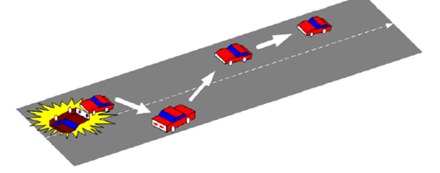

Figure 1: Inter-Vehicle Communication [6]

Vehicle-To-Roadside Communication
This is also known as Vehicle-to-Infrastructure (V2I) communication. In this category, the vehicles can use cellular gateways and wireless local area network access points to connect to the Internet and facilitate vehicular applications. In this type of communication, vehicle communication is done using the single hop broadcasting method where the roadside unit sends a broadcast message to all equipped vehicles. This type of configuration provides a sample amount of bandwidth link between communicating parties and RSU. In vehicle to roadside communication, the maximum load for proper communication is given to the roadside unit, it controls the speed of the vehicle when it observes that a vehicle violates the desired speed limit, it delivers a broadcast message in the form of an auditory or visual warning, requesting the driver to reduce speed. Vehicle-to-roadside communication is shown in Figure 2; Here RSU sends broadcast messages to all the equipped vehicles.

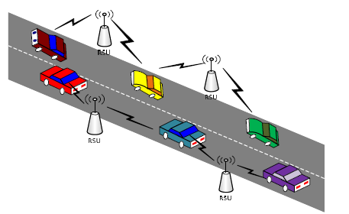

Figure 2: Vehicle-to-Roadside Unit Communication [6]

C. Routing-Based Communication
Multi-hop unicast method is used in routing-based communication configuration. While sending the message, the vehicle sends the message using a multi-hop fashion until it reaches the desired vehicle. The receiving vehicle then sends a unicast message to the requested vehicle. Figure 3 shows the routing-based communication in VANET. Here vehicle A sends a message to vehicle C using routing protocols.

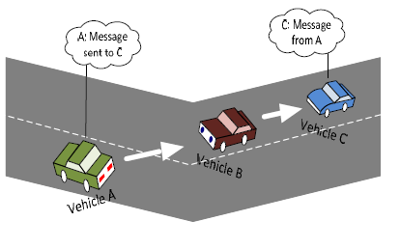
Figure 3: Routing-Based Communication [6]

VANET ARCHITECTURE

The communication between vehicles, or between a vehicle and an RSU is achieved through a wireless medium called WAVE (Wireless Access Vanet Environment). This method of communication provides a wide range of information to drivers and travelers and enables safety applications to enhance road safety and provide comfortable driving. The main system components are the AU, OBU, and RSU [2]. Typically, the RSU hosts an application that provides services and the OBU is a peer device that uses the services provided. The application may reside in the RSU or the OBU; the device that hosts the application is called the provider and the device using the application is described as the user. Each vehicle is equipped with an OBU and a set of sensors to collect and process the information and then send it on as a message to other vehicles or RSUs through the wireless medium; The RSU can also connect to the internet or to another server which allows AU's from multiple vehicles to connect to the Internet [6].

On-Board Unit (OBU)
An OBU is a wave device usually mounted on board a vehicle used for exchanging information with RSUs or with other OBUs. It consists of a Resource Command Processor (RCP), and resources include a read/write memory used to store and retrieve information, a user interface, a specialized interface to connect to other OBUs, and a network device for short-range wireless communication based on IEEE 802.11p radio technology. It also provides communication services to the AU and forwards data on behalf of other OBUs on the network. The main functions of the OBU are wireless radio access, ad hoc and geographical routing, network congestion control, reliable message transfer, data security, and IP mobility.

Application Unit (AU)
The AU is the device equipped within the vehicle that uses the applications provided by the provider using the communication capabilities of the OBU. The AU can be connected to the OBU through a wired or wireless connection and may reside with the OBU in a single physical unit. The AU communicates with the network solely via the OBU which takes responsibility for all mobility and networking functions.

Roadside Unit (RU)
The RSU is a wave device usually fixed along the roadside or in dedicated locations such as at junctions or near parking spaces. The RSU is equipped with one network device for dedicated short-range communication based on IEEE 802.11p radio technology, and can also be equipped with other network devices to be used for communication within the infrastructural network. According to C.C. Communication Consortium, the main functions and procedures associated with the RSU are:
- Extending the communication range of the ad hoc network by re-distributing the information to other OBUs and by sending the information to other RSUs to forward it to other OBUs (Figure 4).

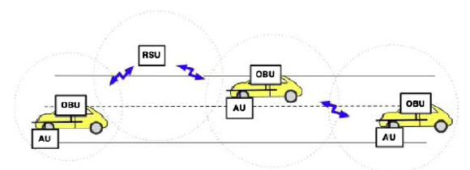
Figure 4: RSU Extends the Range of the Ad Hoc Network by forwarding the Data of OBUs [6]

- Running safety applications such as a low bridge warning, accident warning, or work zone, using Infrastructure to Vehicle communication (I2V) and acting as an information source (Figure 5).
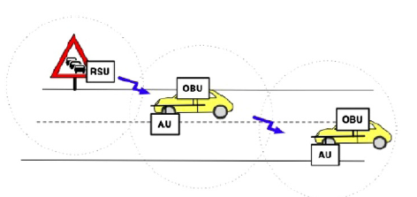
Figure 5: RSU Works as Information Source (Running Safety Application) [6]

- Providing Internet Connectivity to OBUs (Figure 6)
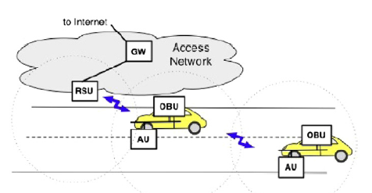
Figure 6: RSU Provides Internet Connectivity to OBUs[6]

VANET COMMUNICATION DOMAIN

As shown in Figure 7, the communication between vehicles and the RSU and the infrastructure form three types of domains [1]:

In-Vehicle Domain
This domain consists of an OBU and one or multiple AUs. The connection could be wired or wireless; an OBU and an AU can reside in a single device. The OBU provides a communication link to the AU to execute one or more of a set of applications provided by the application provider using the communication capabilities of the OBU.

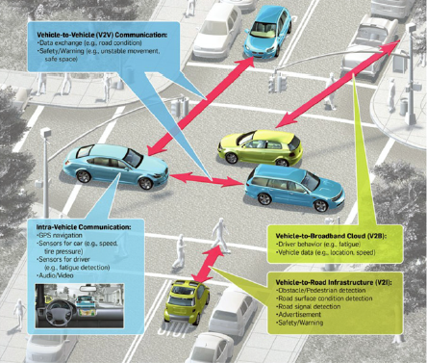

Figure 7: Communication Types in VANET [6]

Ad-Hoc Domain
The ad hoc domain on VANET is composed of vehicles equipped with OBUs and a station along the roadside, the RSU. Two types of communications are available in the ad hoc domain:
- A vehicle communicates with another vehicle directly if there is a direct wireless connection available between them, forming a single hop vehicle to vehicle communication (V2V); when there is no direct connection between them a dedicated routing protocol is used to forward data from one vehicle to another until it reaches the destination point, forming multi-hop vehicle to vehicle communication.
- The vehicle communicates with an RSU to increase the range of communication by sending, receiving, and forwarding data from one node to another or to benefit from the ability of the RSU to process special applications forming V2I communication.

Infrastructural Domain
The RSU can connect to the infrastructural networks or the Internet, allowing the OBU to access the infrastructure network; in this case, the AUs may be registered with the OBU to connect to any internet-based host. OBU can also communicate with other hosts for non-safety applications, using the communication of cellular radio networks.

CONCLUSION

VANET is an area of wireless technologies that is attracting a great deal of interest. VANET is a new communication paradigm that enables communication between vehicles moving at high speeds on the roads. This has opened door to developing several new applications like; traffic engineering, traffic management, dissemination of emergency information to avoid hazardous situations, and other user applications. Integration of network and traffic simulators at runtime helps in modeling emergency scenarios on the roads like accidents etc. The objective of VANET is to build a robust network between mobile vehicles so that vehicles can talk to each other for the safety of human beings. With all these facilities modern vehicles become capable of detecting and sharing the road, traffic, and weather conditions with other vehicles as a consequence road accident can easily be avoided making the journey safer.

REFERENCES

- Al-Sultan, Saif, Al-Doori, Moath M, Al-Bayatti, Ali H. and Zedan, Hussien, 2013. A Comprehensive survey on vehicular ad-hoc networks. Journal of Network & Computer Applications. Available at: http://dx.doi.org/10.1016/j. jnca.2013.02.036 [accessed 5 January 2014].
- Altayeb Marwa and Mahagoub Imad, 2013. A survey of Vehicular Ad-Hoc Networks Routing Protocols, International Journal of Innovation and Applied Studies, ISSN 2028-9324, Vol.3, No. 3, July 2013, pp. 829-846.
- Bisht, Anil Kumar, Kumar, Brajesh, Mishra, Shailendra and Hussain, Akhtar. Simulation Based Analysis of Position Based Routing Protocols in Vehicular Ad-hoc Networks. International Journal of Advances in Computer Networks and its Security.
- Fiore, Marco, Harri, Jerome, Filali, Fethi and Bonnet, Christian. Vehicular Mobility Simulation for VANETs.
- Lochert C., Hartenstein H. and Tian J., 2003, A Routing Strategy for Vehicular ad-hoc networks in city environments. Proceeding of IEEE Intelligent Vehicles Symposium, Columbus, USA, June 2003 pp.156-161
- Olariu and Weigle, 2009. IEEE Trial-use Standard for Wireless Access in Vehicular Environments.
- Taleb, Tarik, Sakhaee, Ehsaan and Jamalipour, Abbas, 2007. A Stable Routing Protocol to Support ITS Services in VANET Networks. IEEE Transactions on Vehicular Technology, 56(6), pp. 3337-3347.
- Zeadally, Sherali, Hunt, Ray, Chen, Yun-Shyan, Irwin, Angela and Hassan, Aamir. Vehicular Ad-hoc networks (VANETs): status, results, and challenges. Telecommum Syst, DOI 10.1007/S11235-010-9400-5.

