The Flipside of Digitization
with Special Reference to India
Dr. Nasheman Bandookwala
Assistant Professor
Department of Rural Economics
Mahadev Desai Gramsewa Sankul
Gujarat Vidyapith, Randheja,
Gandhinagar (Gujarat) India
Email: nasheman@gujaratvidyapith.org
Dr. Hitesh .N. Jagani
Assistant Professor
Department of Rural Development
Mahadev Desai Gramsewa Sankul,
Gujarat Vidyapith, Randheja,
Gandhinagar (Gujarat) India
Email:hitesh28jagani@gmail.com

Abstract
The incredible and tremendous usage of digital platform across world and in India has resulted into a horrendous situation where society and nations are vulnerable to cyber crime. A cyber crime is one that uses computer as means for perpetuating further crimes. It is defined as an unlawful act committed through computers and computer is used as tool or target or both. A criminal is not constrained by geographical location as cyber space is boderless and free flowing. The criminals are not abide with the law of one nation and has many escape windows. Countries across world are attending to this problem with bilateral and multi- lateral agreements. The present study is about understanding internet user in counties of world and cyber crime e in India and its states. Growth in cyber crime in India. Digital India campaign has propelled internet usage and crime as well. The study is an overview of cyber crime in India as a whole.
Key-words: Digitization, Cyber Crime, Cyber Space
1. Introduction
The entire world has been embracing digitization and digital transformation over the past few decades as technology has advanced in leaps and bounds. Digital platform world is mandatory for individual, organizations and countries to keep pace with their counterparts. The pace of technological advancement shows no signs of slowing, and this has pushed us to catastrophic. The major threat to this is phenomenal Cyber crimes across globe. Cybercrime, also called computer crime, the use of a computers as an instrument to further illegal activities. In other words computer is used as subject or object of crime. It is necessary to understand minute difference between crime and cyber crime. The biggest and the most obvious contrast between the two heads- crime and cyber crime is proof of the offense. Conventional offenders, more often than not, end up leaving traceable hints of a crime, either in the form of fingerprints or physical confirmations. On the contrary, the reliance on the virtual network for the committing of a crime leaves no proof of the cyber- criminals. Moreover, the class of perpetrators as well differ. In petty conventional crimes usually include illiterate, unorganized people mainly from the downtrodden sections of the society. But, the perpetrators doing cyber-crimes are usually educated professionals, organized criminal gangs, ideological hackers (hacktivists), etc.
2. Objectives
1. To understand digital platforms and crimes through digitization
2. To evaluate Internet user and cyber crime across countries of world
3. To analyze internet user and cyber crime in states of India
4. To evaluate impact of cyber crime on economy

3. History of Digitization
Digitization essentially began with the advent of computers in the 1950s. Since then, the non-stop march of digitization has transformed nearly everything into computer-friendly -binary 1s and 0s and has changed the way we work, communicate, shop, bank, and even how we relax and entertain ourselves. Transformation of human lives post digital era is exceptional. Some milestone of digital era are
1956 - IBM introduced the business world to magnetic disks and random access data with the 305 RAMAC and the 650 RAMAC (Random Access Memory Accounting), first used in United Airlines’ reservation system. IBM’s press release announcing the RAMAC claimed that, “business transactions will be completely processed right after they occur.”
1960 : American Airlines launched their Sabre flight-reservation system in 1960, which processed 84,000 telephone calls per day and stored 807 megabytes of reservations, flight schedules, and seat inventory.
1968 - U.S. libraries began using Machine Readable Cataloging (MARC) records.
1971- Project Gutenberg was launched with the goal of making copyright-free works electronically available to everyone.
1979- FedEx launched its Customers, Operations, and Services Master Online System.
1984- For the first time, the US Census Bureau asked respondents about their computer use in the home. At the time, 8% of all U.S. households owned a personal computer. By 2016, 89% of US households reported computer ownership (including smartphones), and 81% had a broadband Internet connection.
1991- The first 2G cellular network was launched in Finland
1994- In possibly the first ecommerce transaction ever, a large pepperoni, mushroom, and extra cheese pizza was ordered online from Pizza Hut
2003- For the first time, electronic payments surpassed cash and checks as US consumers’
2014- The number of Internet users worldwide reached 3 billion.
Recent advances in OCR, ICR, and machine learning technology have made transforming paper documents into fully digital assets faster and easier than ever with an ever-increasing degree of accuracy. But this transformation carried with it a vice of crime - Cybercrime. It is imperative to understand about when and how Cybercrime started.
1981– Ian Murphy, known as Captain Zap to his fans, was the first person convicted of a cyber crime. He hacked into the AT&T network and changed the internal clock to charge off-hours rates at peak times. He received 1,000 hours of community service and 2.5 years of probation, a mere slap on the wrist compared to today’s penalties, and was the inspiration for the movie
1982– Elk Cloner, a virus, is written as a joke by a 15 year old kid. It is one of the first known viruses to leave its original operating system and spread in the “wild”. It attacked Apple II operating systems and spread by floppy disk.
1983– The movie War Games was released and brings hacking to the mainstream. The movie depicts a teenage boy who hacks into a government computer system through a back door and nearly brings the world to World War III.
1988– Robert T. Morris jr., a graduate student at Cornell, released a self-replicating worm onto the Defense Department’s APRANET. ARPANET is the precursor to the Internet as we know it today. The worm gets out of hand, infects more than 600,000 networked computers and lands Mr. Morris with a $10,000 fine and 3 years probation, another slap on the wrist.
1994– The World Wide Web is launched, allowing black hat hackers to move their product info from the old bulletin board systems to their very own websites. A student in the UK uses the information to hack into Korea’s nuclear program, NASA and other US agencies using only a Commodore Amiga personal computer and a “blueboxing” program found online.
1995– Macro-viruses appear. Macro-viruses are viruses written in computer languages embedded within applications. These macros run when the application is opened, such as word processing or spreadsheet documents, and are an easy way for hackers to deliver malware. This is why opening unknown email tAttachments can be very risky. Macro-viruses are still hard to detect and are a leading cause of computer infection.
1999 – The Melissa Virus is released. It becomes the most virulent computer infection to date and results in one of the first convictions for someone writing malware. The Melissa Virus was a macro-virus with the intention of taking over email accounts and sending out mass-mailings. The virus writer was accused of causing more than $80 million in damages to computer networks and sentenced to 5 years in prison.
4. Categories of Cyber Crime
Network or device crime : (1) Virus (2) Malware (3) Dos attack
Participated in criminal activities : (1) Phishing emails (2) Cyber stalking (3) Identity theft
Crime can be at individual level, property crime or Government level crime 017 to 2019 93,000 cases of cyber crime were reported in India
5. Internet User Across Countries of World
The world wide usage of internet has phenomenally increased between 2005 to 2019 from 16% to 53% respectively. However, the relative increase usage of internet is more in developed from 8% to 47% that account to 39% while in that of developed countries the increase is 35% between 2005 to 2019. Table :1
Table :1 Internet user world wide
 | 2005 | 2010 | 2017 | 2019
World population | 6.5 billion | 6.9 billion | 7.4 billion | 7.75 billion
World Wide | 16% | 30% | 48% | 53.8%
Developed Countries | 51% | 67% | 81% | 86%
Developing Countries | 8% | 21% | 41% | 47%
Source :wikipedia.org/wiki/List_of_countries_by_number_of_Internet_users
The interesting scenario emerges when country wise use of internet is analyzed. The highest use of internet is at USA with 95.5% of its population being internet user. Followed by Germany, France and Japan with 93.3%,91.5% and 91.5% respectively. India and China reports 61.6%and 69.3% internet user respectively. The country with least internet user among listed here is Afghanistan with only 10.9% of its populace being internet user. In the world among all countries Somania in Africa has only 1.9% of population using internet.
Table : 2 Internet user country wise 2020-2021
Countries | Population | Internet user | % of Population
China | 1,427,647,786 | 988,990,000 | 69.3%
India | 1,352,642,280 | 833,710,000 | 61.6%
USA | 327,096,265 | 312,320,000 | 95.5%
Germany | 83,124,418 | 77,794,405 | 93.3%
Japan | 127,202,192 | 116,350,000 | 91.5%
France | 64,990,511 | 59,470,000 | 91.5%
Malaysia | 31,528,033 | 25,343,685 | 80.4%
Yemen | 28,498,683 | 7,548,512 | 26.5%
Srilanka | 21,228,763 | 7,121,116 | 33.5%
Nepal | 28,095,714 | 10,078,000 | 35.9%
Bhutan | 754,388 | 388,541 | 51.5%
Afghanistan | 37,171,921 | 4,068,194 | 10.9%
Source : wikipedia.org/wiki/List_of_countries_by_number_of_Internet_users t
Chart : 1 Country wise percentage of internet user
his is why

C
Chart :2 Cybercrime in Top ten countries
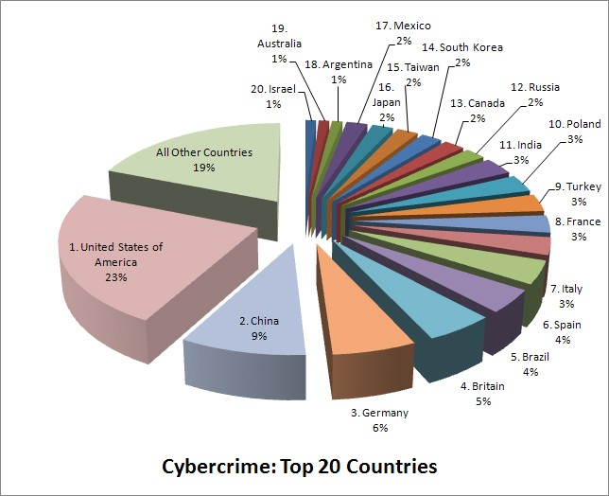
Cha
cha
ll hard to detect and are a leading cause of computer infection.

Table :3 Cybercrime in the countries of world
Countries | Cyber crime
China | 9%
India | 3%
USA | 23%
Germany | 6%
Japan | 2%
France | 3%
Britain | 5%
Source :https://www.enigmasoftware.com/top-20-countries-the-most-cybercrime/

6. State wise internet user in India 2019-20
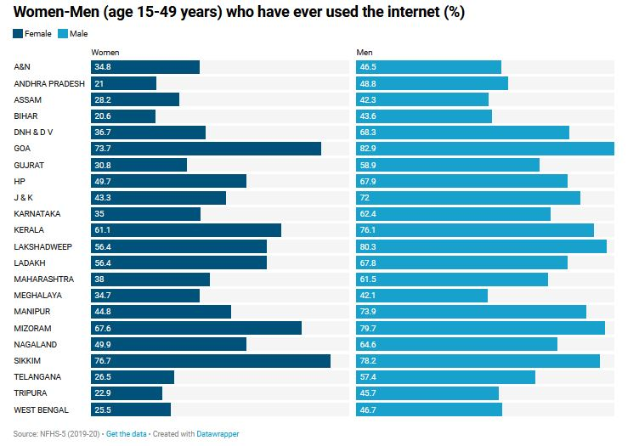
The state wise internet users in India exhibits a very surprising outcome with Sikkim being the sate with highest Men and women using internet 78.2% and 76.7% repectively. Followed by Goa with 73.7% women and 82.9% men using internet . While banglore being hub of information technology Karnataka reports low internet user of 62.4% male and 35% female. Gujarat has 58.9% male user and 30.8% female internet users.
Turning the lime light to cyber crime, The states of Karnataka register cyber crime highest cyber crime among states of India , with Banglore being the part of Karnataka and hub of Information technology. Followed by Uttar pradesh on 28th rank out of 29 states of India. Gujarat is on 18th rank among states of India. The lowest cyber crime of only 3 cases registered is at Nagaland, but the stae might have less internet user.
Table : 4 Cyber crime in states of India 2019
State | Cases Pending Investigation from Previous Year | Cases Reported during the year | Cases Reopened for Investigation | Total Cases for Investigation (Col.3+ Col.4+ Col.5) | Rank
Andhra Pradesh | 1456 | 1886 | 6 | 3348 | 24
Arunachal Pradesh | 9 | 8 | 0 | 17 | 4
Assam | 2181 | 2231 | 0 | 4412 | 26
Bihar | 619 | 1050 | 0 | 1669 | 20
Chhattisgarh | 101 | 175 | 0 | 276 | 12
Goa | 38 | 15 | 0 | 53 | 6
Gujarat | 253 | 784 | 0 | 1037 | 18
Haryana | 191 | 564 | 0 | 755 | 15
Himachal Pradesh | 61 | 76 | 0 | 137 | 8
Jammu & Kashmir | 181 | 73 | 1 | 255 | 11
Jharkhand | 1554 | 1095 | 0 | 2649 | 22
Karnataka | 7996 | 12020 | 0 | 20016 | 29
Kerala | 380 | 307 | 2 | 689 | 14
Madhya Pradesh | 367 | 602 | 0 | 969 | 17
Maharashtra | 6514 | 4967 | 1 | 11482 | 27
Manipur | 119 | 4 | 0 | 123 | 7
Meghalaya | 97 | 89 | 0 | 186 | 9
Mizoram | 7 | 8 | 0 | 15 | 3
Nagaland | 1 | 2 | 0 | 3 | 1
Odisha | 1532 | 1485 | 0 | 3017 | 23
Punjab | 348 | 243 | 1 | 592 | 13
Rajasthan | 364 | 1762 | 0 | 2126 | 21
Sikkim | 1 | 2 | 0 | 3 | 2
Tamil Nadu | 483 | 385 | 1 | 869 | 16
Telangana | 1513 | 2691 | 12 | 4216 | 25
Tripura | 29 | 20 | 0 | 49 | 5
Uttar Pradesh | 4173 | 11416 | 0 | 15589 | 28
Uttarakhand | 99 | 100 | 0 | 199 | 10
West Bengal | 715 | 335 | 0 | 1050 | 19
Total | 31382 | 44395 | 24 | 75801
Source : https://ncrb.gov.in/sites/default/files/crime_in_india_table_additional_table_chapter_reports/Table%209A.1_1.pdf
7. The damages of digitization to the economy
Close to $600 billion , nearly 1% of global GDP is lost due to cyber crime each year ( Report on Economic Impact of cyber crime-No slowing down,2018). The twentieth century has brought to reality the idea of a global village, where digital technology has interconnected and enmeshed the world economies, cultures and populations. India is no exception, with over 560 million internet users as of 2020, making it the second-largest internet population in the world
Cybercrime in India caused 1.25lakh crores loss in 2019. This horrendous scenario therefore needs holistic approach to combat these crimes in all ramifications. Additionally, the country should set up Computer Crime Resource Centre, a body, which will comprise experts and professionals to establish rules, regulations and standards of authentication of each citizen’s working in an organisation , firm or government bodies. Forensics commission should be established, which will be responsible for the training of forensics personnel/law enforcement agencies. Above all, comprehensive law to combat computer and cyber related crimes should be promulgated to fight this phenomenon. Critical infrastructure in the country, collaborative effort from business organizations, training people even at school level and creation of indigenous tools for building secure and cyber-resilient environment in the country.

References
- Juneed Iqbal Bilal Maqbool Beigh (2017), ‘ Cyber crime in India : Trends and challenges’,International Journal of innovation and Advancement in computer science ,pp187-196
- https://ncrb.gov.in/sites/default/files/crime_in_india_table_additional_table_chapter_reports/Table%209A.1_1.pdf
- https://www.enigmasoftware.com/top-20-countries-the-most-cybercrime/
- wikipedia.org/wiki/List_of_countries_by_number_of_Internet_users to
- Kumar Sanjeev and Manhas Anupama ,202, “Cyber crime in India , Trends and Prevention” ,Galaxy International Interdiscriplinary Journal, Vol 9 Issue 5
- Kapila Pallavi, 2020 Research gate “Cyber Crimes and Cyber Laws in India: An Overview”https://www.researchgate.net/publication/350107577_
- https://www.ibm.com/ibm/history/exhibits/storage/storage_350.html
- https://www.sabre.com/files/Sabre-History.pdf
- https://eric.ed.gov/?id=ED029663
- https://www.theatlantic.com/technology/archive/2015/03/a-brief-history-of-the-atm/388547/
- http://www.gutenberg.org/wiki/Gutenberg:About
- https://mip.pmi.org/cosmos
- https://www.census.gov/content/dam/Census/library/publications/2018/acs/ACS-39.pdf
- https://whatsag.com/mobile-technology/the-history-of-2g.php
- https://www.entrepreneur.com/article/230620
- https://www.atmmarketplace.com/news/electronic-payments-surpass-cash-checks/
- https://www.emarketer.com/Article/Ecommerce-Sales-Topped-1-Trillion-First-Time-2012/1009649
- https://www.internetlivestats.com/internet-users/
- https://www.exelatech.com/press-release/mastercard-request-pay-solution-powered-exela-software-receives-enrollment

***************

