New Generation Billing System

¹ Pankaj Kunekar, ² Kiran Bari, ³ Kamlesh Dugade, ⁴ Ajay Wagh, ⁵ Gouri Pawar
¹²³⁴⁵Vishwakarma Institute of Technology Pune, India
pankaj.kunekar@vit.edu, kiran.bari20@vit.edu, kamlesh.dugade20@vit.edu, ajay.wagh20@vit.edu, gouri.pawar20@vit.edu

Abstract –
A shopping boardwalk is a type of store that sells a large range of products. This product might be apparel, drinks, books, food, or any other ménage item. The primary thing of supermarkets is to make all effects available to guests while also saving them time. still, guests might come worried when staying in line at the pay register or while balancing While assessing the overall price of all particulars with their available budget before being billed. Shopping promenades employ this tactic to palliate these issues by adding the number of guests. On weekends in major metropolises, we may see a massive flash at shopping centers. This is amplified when there's a wide range of deals and abatements. People currently buy a range of effects and place them in the shopping wain. After you've finished your shopping, go to the counter to get your bill. The accountant gets ready with the bill using the anthology, which is a time- consuming operation. As a result, lengthy lines form at the pay registers. This conception proposes the creation of a system at shopping promenades to address the forenamed issue. When a client selects an item, it'll be scrutinized using a QR law scanner operation on our phone, which will overlook all of the product's information and will be honored automatically and stored in our phone's memory as well as the memory of the supermarket's system. On the phone's screen, the name of the item and price of the item will be displayed as well as on the TV screen (when the unique client id is entered on super-market system). As a result, the rate is added to the final charge. However, the client can remove the item and the cost of that item will be subtracted from the entire cost, If a client decides to remove effects from the sharp- witted luggage wain. The same data is transferred to the medium billing part through the GSM module.
Keywords -- Scanner, Barcode, Supermarket, Image Processing, Data Mining, Data Prediction

Introduction
We now live in the Internet of effects (IOT) age, where all physical object relations have come a reality. All of our systems have experienced a fresh revolution as a result of this. This redounded in a number of dissensions in the areas of data operation, wireless communication, and real- time decision- timber. We used to produce bills on paper first, and also we switched to using technology. The barcodes were read and scrutinized using a barcode scanner. still, latterly on, we concentrated on the smart billing system, which we enforced using a QR law scanner, which is a scanning program installed on our Android device and used for identification and data collection (1). The anthology may use the android device to pierce or read the data into the QR scanner. A stoner may only use the QR Scanner on our individual phone without consuming any power. When a buyer buys goods, the first thing he or she does is checkup it with a scanner. Our phone comes with a QR scanner operation. When a buyer scans the pricing of a product and other information about it when copping
it, a QR scanner operation scans the information and stores it in the phone's and system's memory (2). And the crucial part is handed by in- budget shopping, which works in such a manner, that a person may set a budget before visiting a store, which can be profitable to a customer (3). When a person goes shopping at a boardwalk, he or she uses a trolley and also proceeds to the counter to pay for their purchases. Billing is done via barcodes, which is a lengthy procedure. We must overlook each and every item grounded on barcode markers fixed to that item in this technology. Because we need to overlook each existent, it must be done by hand. Labeling is done manually. Another debit is that barcodes can not be read from a great distance. As a result, our thing is to produce an automatic billing system grounded on a QR law operation on our phone that will be linked to a supermarket's system (4).

Literature Review

Smart shopping Cart

The main goal was to use self-driving technology to scan items and store them in a mobile database while collecting payment via mobile banking. [1].

An Ingenious Low-Cost Smart Shopping Cart

According to [2] Customers may utilise bargain-priced smart shopping to guide their purchase decisions at retail establishments and convince them of the amazing discounts offered on the goods.

Smart Cart with Automatic Billing

In [3], this composition explains about programmed offers a superstore with anti-theft control system. It'll enable for billing deals to be completed online, as well as give guests with shopping ideas.

A Bascart-based automated billing system for shopping malls

In [4] paper has studies about RFID markers are placed on effects to speed up the billing process, which are also read by a barcode scanner, which displays the cost of the product on the TV screen linked to our shopping list.

Shopping Mall Billing Management and Payment System for Smart Goods

In [5] The main issue with the current research methodologies is that each trolley has its own system, which is connected to the billing system through a wireless communication module. Such suggestions would increase system complexity, inefficiency, and expense.

Using automatic invoicing and machine learning-enabled smart trolleys, optimise shopping goods strategy

In [6] Consumers spend the bulk of their time waiting for billing at a grocery store or shopping mall, according to a study. To get around this difficulty, a fute cart could be more beneficial. After the item is placed in the shopping cart, it may be scanned, invoiced, and used in a few other ways.

Using Blockchain Smart Contracts to Digitize Invoices and Manage VAT Payments

In [7] The purpose of this research study is to apply various ways to handle the difficulty of maintaining and safeguarding taxation data repositories.
1.The smart contract is deployed into BCN, for example, using VAD.
2. The hash code is kept by the vendor."

An Intelligent Invoice Classification Method for Smart Phones Based on Deep Learning

This research [8] To increase IIR performance, presents a deep learning-based approach for intelligently categorizing invoices recorded by smartphones. The end-to-end technique can instantly detect the type of input for various invoice images in a short amount of time. Experiments demonstrate that the proposed technique can obtain a high classification accuracy of 99.05 percent and a fast running speed of 18.16 seconds for 105 invoices...

An Automated Billing System in Shopping Malls Using Bascart

This article [9] Initially, a Bascart-based charging system is created in an effort to address the grocery issue. Reduced wait times are achieved by providing customers with a direct bill from the billing area that has already been saved on the host PC. In order to inform the consumer of their purchase information via messages already recorded in the database, the GSM Module in our system is then used to identify the geo-location of the client's mobile phone.

Using Blockchain Smart Contracts to Digitize Invoices and Manage VAT Payments

This study demonstrates the integration of the decentralized storage network (DSN) with the smart contract in [10], and we provide a novel architecture based on Block chain technology to check transactions, compute VAT, and allow VAT payment (SC).

IOT Based Smart Billing and Direction Controlled Trolley

In [11] This paper helps customers save time at the checkout counter by doing away with the tiresome practise of dragging and pushing the cart. In order to increase trolley efficiency, obstacle avoidance has been included. The automated charging procedure is carried out using a radio frequency identification (RFID) tag and reader.

Block Chain Digital Invoice System Risk Assessment and System Development Research

This [12] One example is paper. The purpose of this research is to look at the hazards connected with the present electronic invoicing system by utilizing technologies such as automatic artificial intelligence identification and graphic image processing. The results demonstrate that the system is effective, safe, and fair; that calculations are time and effort-saving; and that the technology is suitable for massively scaled invoice monitoring and reimbursement records on the block chain.

The impact of Indian consumer style inventory in determining mall attendance intentions in India

According to [13], In order to better understand customer purchasing behavior’s, this study tries to adapt the CSI to the Indian consumer market. This study also aims to examine the connection between consumer purchasing choices and mall visitors' intents. To determine if the scales were appropriate for the Indian market, the researchers performed exploratory factor analysis. In order to investigate the effect of CSI on mall patronage intention, step-wise regression analysis is performed. The results are anticipated to offer crucial recommendations for mall marketing tactics as well as valuable insights into the purchase behaviors of Indian shoppers.

Shopping Mall Billing Management and Payment System for Smart Goods

In [14], This paper specifies a system that, at its core, scans product barcodes; nevertheless, we choose an alternative strategy. For quicker and more precise results, use a barcode scanner. For rapid and reliable results, our prototype uses an Android phone as a barcode scanner. To support card-based payments, this system also makes use of RFID technology. The results of this investigation are supported by simulation and hardware.

Image as a factor for enhancing shopping preferences in Indian malls

In [15] This study investigates how the aesthetic of a mall influences people' purchase decisions. The information for this survey was given to 750 respondents at random from 10 malls in the Delhi NCR (India). The evidence is strong that there exists a one-of-a-kind mix of the ideal retail environment.

Prolem Definition

There are several wonderful marketing strategies for goods and services on demand, but they might cause problems for visitors, hurting their annual budget, which we must not neglect. When customers go to a department store or supermarket, they have a list of things they want to buy and compare the prices of those items to their annual budget to pick which item to buy. When a customer begins taking particulars off the shelf, he or she finds new particulars that entice them to acquire them, which is one cause for the person's yearly(shopping) budget to disintegrate. After then, when a client walks to the billing counter, he must stay for a certain amount of time, which is a time-consuming activity. The individual must retain all of his named effects on the elevator, and the billing counter hand will overlook all of the products, as well as their quantities, and generate a charge ( 6). So, if there are several department stores or supermarkets in one location, we want a specialized/software outcome for both businesses so that our customers are satisfied with our services and wish to shop at our store again and again.

Iv.Objective

The main goal of this design is for the user to be able to obtain information in less time and within their budget. The customer can pre-list effects on the shopping promenade and shop within his or her budget. The bill can also be generated on the customer's behalf, and if the shopping exceeds the budget, the client will be alerted. New marketing techniques captivate and ensnare guests, and their yearly budgets are continually shredded as a result of duplicate purchasing. Our technology limits the client's purchases based on his or her budget (7). It stores obsolete information such as recent orders and frequently used goods (purchase history). As a consequence, our design tries to address these concerns so that our customers are more satisfied with our services and desire to return to our shop, which contains a range of departments, Several enterprises or supermarkets in one location. [8].

V.Proposed Methodology

The primary goal of the unborn system is to provide moxie associated with shopping that is low-cost, easily accessible, and harmonious. The RFID-powered automated shopping wain is intended to improve the overall shopping experience. Computer electronics store customers should understand how to safeguard themselves. After adding an item to the rough list, guests may pierce a variety of item information (9). A shopper initially grabs a shopping wain upon entering a shopping promenade. And then picks and scans the item, and the item is placed in the trolley, and the scanning operation is completed using the phone's QR scanning operation using the phone's camera, and it is reflected in the phone's list with quantum as well as in the system. The obtained object can then be placed in the wain. While the customer inspects the item's phones, a value of the picked-up item is obtained and saved in the system's memory. And it will obtain the ID information from the storage to display on the system's display (10). The most recent product information, as well as the total quantum in the wain, will be displayed on the system's display. It will assist the buyer in remaining inside their popular restrictions. When we press the key, it quickly sends the data to the accountant. The block diagram is as follows:

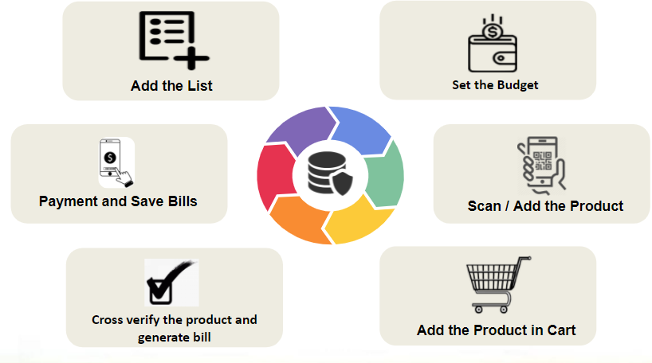

Fig 1. Block Diagram of System

VI .Algorithm

QR Code is an abbreviation for Quick Response Code, and we're all acquainted with QR Canons these days. It is used to make safe and quick internet payments. A QR law employs four stated garbling modes (numeric, alphanumeric, byte/ binary, and kanji) to effectively store data; extensions may also be used (11).
A QR Code is a series of black and white squares that can be read by various QR Code Scanners. It's handy right now because almost every smartphone includes a QR law scanner app. It's also known as ZXing ("Zebra Crossing"), and it's a popular Java API for interpreting QR codes. Its library contains numerous components, and in our Java example, we'll utilize the’ core' to generate QR canons.

VII. Innovation

We are aware that modern marketing strategies entice and seduce customers, resulting in the depletion of their annual budget through unnecessary spending. Our technology thereby controls the client's buying based on his or her spending limit. By enabling visitors to choose their own budgets based on their tastes and start shopping, our design gave a solution to the issue. However, if they go above the limit they established, the customer will be given a warning communication. As a consequence, visitors may take their time protecting.

As we all know, supermarkets have a problem with customers being delayed in line at the register because of a huge crowd. As a result, they may get anxious before being charged, while comparing the total cost of all their items with the budget they have available. To alleviate these problems, our activity employs this system as a strategy to increase the number of consumers. On weekends, we could witness a huge flash at a retail mall in a big city. This is accentuated when there are several bargains and reductions. Currently, people purchase a variety of items and put them in the shopping cart. Go to the counter to obtain your bill once you've completed purchasing. The paymaster prepares the bill using the QR machine that they have on hand, which is a labor-intensive operation. Long lineups begin to form at the cash registers as a result. This design suggests a perspective of system evolution. When a customer chooses an item, it will be examined using a QR code scanner operation on our phone, which will overlook all of the product's information and will be honored automatically and stored in both the memory of our phone and the system of the supermarket. The name of the item and the price of the item will be displayed on the phone's screen as well as on the TV screen (when the unique client id is entered on super-market system).

VIII. Flow of the System
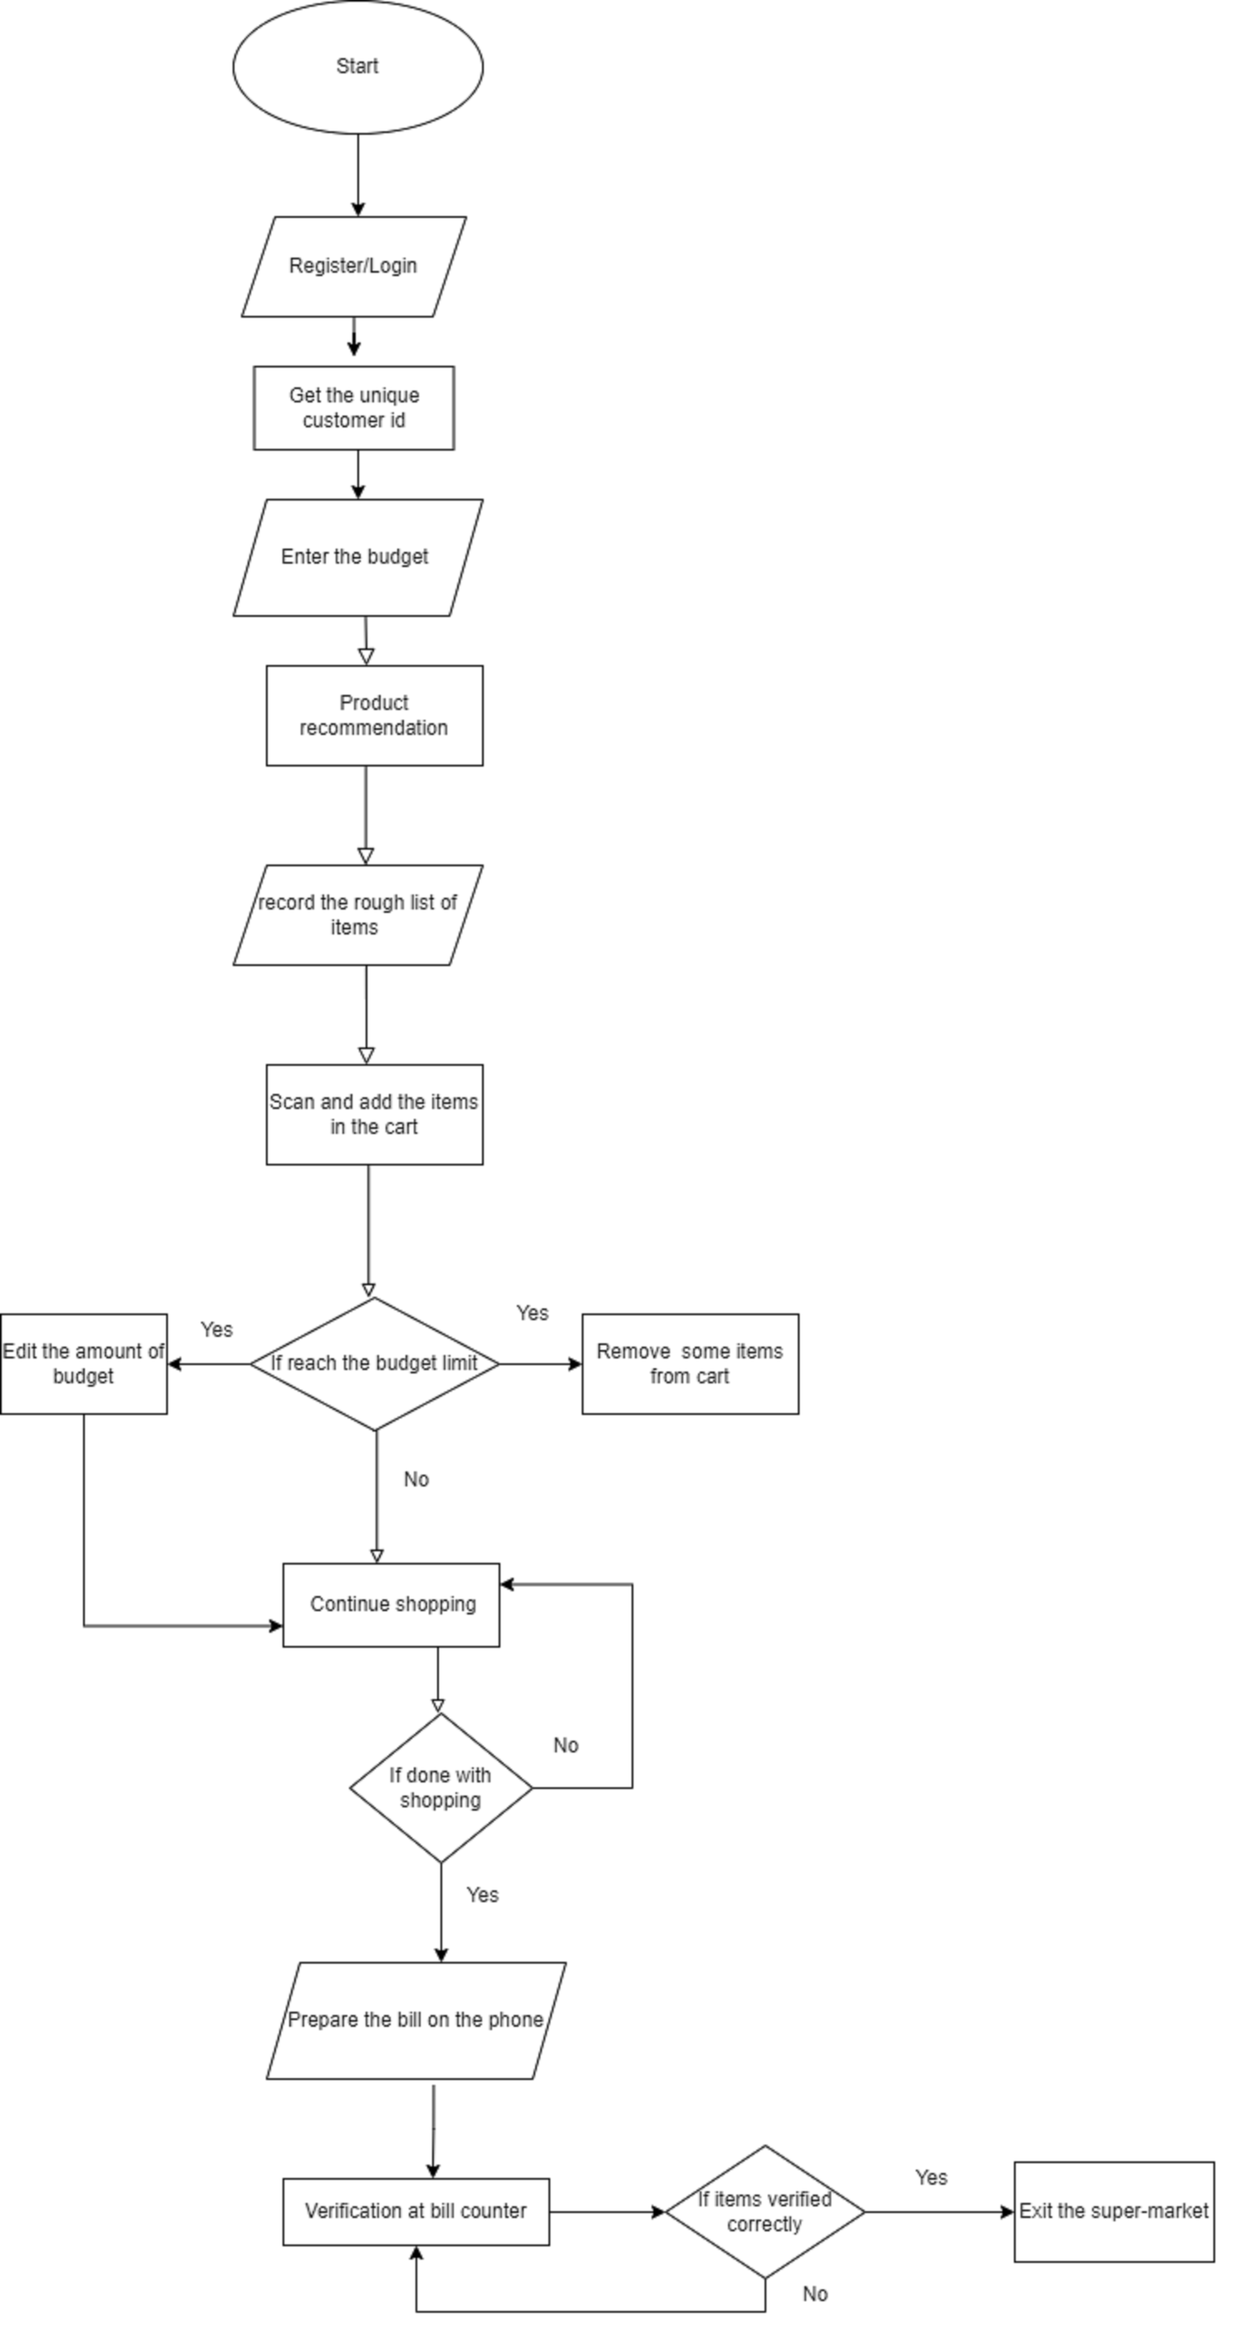

Fig 2. FLOW diagram of System

IX. Future Scope

- LI-FI, NFC, and other communication methods can also be used to implement this system [1][9].
- This system may be improved by employing a Beacon Module instead of an RFID Module, and including a load sensor is also a good idea [6][7].
- Nutritional information for the eatables can be included in addition to the product data.
- Various sensor technologies can be used to accomplish automatic track detection and cart movement [3].
- A shopping budget restriction may be established; if the limit is exceeded, a buzzer should sound to alert you.
- Allowing customers to establish a shopping list ahead of time.
- The same system may be utilized in different locations.

X. CONCLUSION

This initiative believes that using a smart phone may make shopping more convenient and strives to improve smart shopping. At the same time, the cost of goods exceeds the budget. We may utilise the budget technique to identify items to fix this problem. Because we already have a QR scanner software on our phone, it's simple to use and doesn't require a separate component when utilising a supermarket's application with a specific customer id. Because of its efficient capabilities, effective performance, and ease of understanding, the execution portion will be carried out in Java.

Xi. References

[1] K. Machike, M. Golait, R. Rathod, R. Petkar, and P. Goche (2017). RFID and ZIGBEE are used in a new smart trolley technology. 5(2): 256-259 in International Journal on Recent and Innovation Trends in Computing and Communication.
[2] Thiyagarajan M, Aejaz M, Kumar M. [2] Thiyagarajan M, Aejaz M, Kumar M. (2017). For a supermarket, an RFID-based sophisticated trolley has been developed. This is a special issue
[3] Prasad JS, Kumar BOP, Roopa D, Arjun AK, Prasad JS, Kumar BOP, Roopa D, Arjun AK, Prasad
JS, Kumar BOP (2011). A low-cost intelligent shopping cart with a unique design. Pages 1-4 in IEEE 2nd International Conference on Networked Embedded Systems for Enterprise Applications.
[4] Karpagam V, Balapriya S, Kalairubini G, Kalaivani A. [4] Karpagam V, Balapriya S, Kalairubini G, Kalaivani A. (2017). |International Journal of Computer Systems 4(3): 55-58. Smart trolley with smart billing.
[5] A. Gade, N. Bhatt, and N. Thakare (2018). A fresh approach to green computing is a survey on energy efficient cloud computing. Helix, vol. 5, no. 5, pp. 3976-3979. https://doi.org/10.29042/2018-3976-3979.
[6 Sangeetha T. Chandrasekar P. Chandrasekar P. Chandrasekar P. Chandrasekar P. Chandrasekar P. Chand (2014). Smart shopping cart with RFID and Zigbee-based automated invoicing system. ICICES 2014, Information Communication and Embedded Systems, pp. 1–4.
https://doi.org/10.1109/ICICES.2014.7033996.
[7] Ms. Rupali Sawant, Kripa Krishnan, Shweta Bhokre, and Priyanka Bhosale (nine) (2015). The smart shopping cart with RFID technology. The International Journal of Engineering is a peer-reviewed journal that publishes
[8] Suprabha Jadhav1, Shailesh Hambarde, "Android-based Automated Cart System Using Raspberry Pi and GSM," International Journal of Science and Research (IJSR), Volume 5Issue 6, June 2016.
[9] SmitaSinghal and Nikhil Agrawal, "Intelligent shopping cart with NFC," Arduino, Volume 9 Issue 3, December 2018.
[10] Tianyi Song and Runinian Li, "IOT applications on secure smart commerce system," IEEE internet of things journal, volume 4 issue 6, 2017.
[11] Himani Pangasa and Nathi Ram Chauhan, "A research on automated shopping," in Himani Pangasa and Nathi Ram Chauhan, "A study on automatic shopping," in Himani Pangasa
[12] Megamall cart", material science and engineering, volume 1, 2019.
[13] Sarika S Pandey, Soumya R Gupta, and Meena M Shaik, "Smart cart with Arduino and RFID," IRJET, Volume 5 issue 3, 2018.
[14] P Kalaivani, C Raan, and S Sandhiya, "An automatic charging system in retail malls based on Bascart," Bulletin of scientific research, volume 1 issue 1, 2019.
[15] https://www.researchgate.net/publication/314818077_Image_as_a_Factor_for_Enhancing_Shopping_Preferences_in_Indian_Malls

