Mass and Pureline Selection
Amaresh | Aswini Nunavath
Ph. D Scholar,  Division of Genetics,  Indian Agricultural Research Institute,  New Delhi. India. 110 012. | Ph. D Scholar,  Department of Genetics and Plant Breeding,  Professor Jayashankar Telangana State Agricultural University, Hyderabad, Telangana. India. 500 030.
E-mail- amaresh541@gmail.com | E-mail- aswininunavath6@gmail.com
ABSTRACT
Since the commencement of domestication, man has always engaged in conscious or unconscious selection activity. Choosing individuals based on phenotypic superiority is the earliest and most traditional method of crop improvement. Since the beginning of time, our fore farmers and scientists have been instilling their expertise in choosing the best planting material from the already-existing local entries/cultivars to raise the crop for the following season. In order to convey the information on crop improvement in an understandable manner, this chapter briefly discusses the two main selection techniques, mass selection and pure line selection.
Keywords: Crop Improvement, Mass selection, Phenotype and Pureline
INTRODUCTION
Selection is the process that favours survival and continued propagation of some plants having more desirable characters than others. Natural selection operates in nature without human interference. Natural selection favours traits that are necessary for a species to survive. Therefore, in natural selection, adaptation or survival is the primary objective.
On the other hand, artificial selection is created by humans. It favours a plant's characteristics that are associated to yield and quality. Thus productivity of economic product is the primary consideration in human selection. Human selection is the process of identifying and retaining plants from heterogeneous populations that are more beneficial to humans than others.
A key component of plant breeding programmes is selection. Depending on the mode of pollination of a crop species, the gene action and the breeding goal, different selection procedures, such as mass selections, pure-line selection, progeny selection, clonal selection, recurrent selection and disruptive selection, are used in crop improvement programmes.
MASS SELECTION
One of the earliest methods for crop improvement is mass selection. In this method, individual plants are chosen from a mixed population based on their phenotype, and then their seeds are bulked and used to develop the subsequent generation. In other words, it's a breeding strategy in which specific plants are chosen from a mixed population based on their phenotype, then their seeds are bulked and utilized to raise the next generation.
Types of Mass Selection:
There are two types of mass selection, viz.:
1. Positive Mass Selection:
When desirable plants are chosen from a mixed population and their seeds are combined together to produce further generation, it is referred to as positive mass selection. Selection of desirable plants or positive approach is in common use in mass selection.
2. Negative Mass Selection:
Negative mass selection occurs when only unwanted off-type plants are eliminated from the field and the others are permitted to continue growing. This is typically employed in seed production and certification procedures for varietal purity. This contributes to the variety's great genetic purity, especially in self-pollinated species.
The success of mass selection mainly depends on three factors, viz.:
(i) Variability in the base population,
(ii) Mode of inheritance of character to be improved, and
(iii) Heritability of the character.
Mass selection is more successful in old heterogenous variety or land races than in improved varieties.
The general procedure of mass selection is given below:
First Year:
An unimproved old variety or land race is used as a base population which is grown in a large plot. Then, individual plants (200–2000) are chosen based on their phenotypic performance of some characteristics, which include height, maturity, disease resistance, productivity, etc. When mature, the chosen plants are harvested, and the seeds are combined to produce the following generation. Until the desired results are obtained, this process is repeated.
Second Year:
The crop is grown from the bulk seed of selected plants in a different field using standard variety as a check for comparison of performance. In other words, a preliminary yield trial is used to evaluate the material. The same old mixed variety can be used as a comparison check if mass selection is applied to purify it.
Third to Fifth Year:
In main yield trials, the performance of bulk is assessed for yield and adaptation for three to four years, using a standard check for comparision.
Sixth Year:
In the seventh year, the variety is made available to the public, assigned a name, and seed is multiplied. The seed is ready for distribution after eight years.

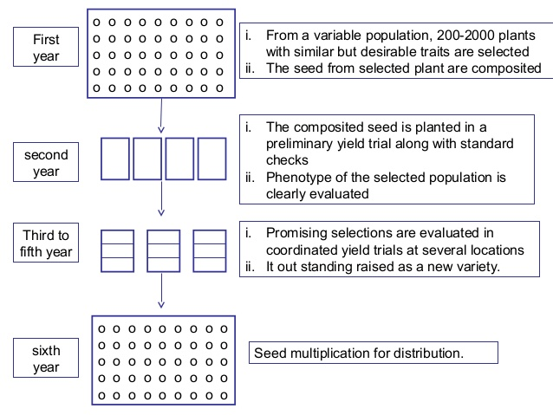

Fig 1: Schematic presentation of mass selection for developing a new variety
There are two defects of mass selection as given below:
(a) No Control on Pollination:
In mass selection there is no control on the pollination. The selected plants are pollinated both by superior and inferior pollen parents.
(b) Selection is based on Phenotype:
The phenotypic performance is greatly influenced by environmental factors such as soil heterogeneity.
In order to address these defects, three modifications of mass selection have been advocated in cross pollinated species.
These modifications are:
(a) Rejection of inferior pollen plants
In this method inferior pollen parents are removed before flowering and rest are allowed for inter-mating. This controls pollination by inferior plants.
(b) Use of composite pollen
In this method, pollen is collected from the selected plants and bulked. This composite pollen is used to pollinate the selected plants. This also controls pollination by inferior plants.
(c) Stratification of the field
This is known as grid method of mass selection and was suggested by Gardner (1962). According to this strategy, the field where mass selection will be employed is divided into small plots, with 40–50 plants in each plot. Now, the best plants are chosen for each small plot. This eliminates the effect of environment [soil heterogeneity] because small plots are more homogeneous than larger plots.
Merits:
- This is a useful technique for improving old varieties and land races. Additionally, this is used to purify improved varieties.
- When compared to pure-lines, mass-selected varieties perform more consistently. In other words, because of heterogeneity, they have a higher buffering capacity than pure-lines.
- Mass-selected varieties offer effective disease defence.
- A rapid and easy method of crop enhancement is mass selection. A new variety can be released after around 8 years, whereas pure-line selection requires roughly 10 years to generate a new variety.
- This method is applicable to both self and cross pollinated species.
Compared to self-pollinated species, mass selection has been more important in the development of new varieties in cross-pollinated species.
Demerits:
- Phenotypic performance is the basis for selection. It's not always the fact that a superior genotype corresponds to a superior phenotype. The performance of a plant's offspring can be used to determine its true breeding value. Progeny test is not carried out in mass selection.
- In cross pollinated species, there is no control on the pollination. The selected plants are pollinated by both superior and inferior pollen parents. This causes the mass-selection-developed variation to rapidly deteriorate.
- In cross-pollinated crops, a large number of plants must be chosen for bulking because an insufficient sample will result in inbreeding depression.
- The produce of varieties developed by mass selection is less uniform man pure lines. This is because mass selected varieties are mixture of several pure lines in self-pollinated crops and consists of several genotypes in cross pollinated species.
- In self-pollinated species, pure line selection is more effective than mass selection, because pure line selection leads to isolation of best line from a mixed or heterogeneous population.
PURELINE SELECTION
The concept of pure-line selection was developed in the middle of 19th century in Sweden. However, Danish biologist Johannsen revealed the genetic basis of pure lines in 1903. The homogenous offspring of a self-pollinated homozygous plant is referred to as pure-line.
Pure-line selection, sometimes referred to as individual plant selection, is the process of development of a new variety by identifying and isolating the best plant progeny. The majority of self-pollinated species employ this technique. This technique was utilized by Vilmorin in Sweden to enhance wheat and barley. In order to create superior cultivars, the best pure line may be employed as a variety or as a parent in a hybridization.
The Pure-line theory:
Johannsen's experiments with the Princess variety of beans (Phaseolus vulgaris) served as the foundation for his pure line concept. He bought the seeds from the market and noticed that the collection included both larger and smaller size seeds. The size of the seeds varied as a result. Johannsen chosen seeds of various sizes and raised each one separately. Larger seeds produced larger seeds, while smaller seeds only produced smaller seeds as offspring.
This demonstrated unequivocally that there is genetic basis for seed size variation in the commercial lot.
Three sources of confirmation data were gathered.
1. He separated the seeds according to weight on line 13 (450 mg seed weight). He separated the line into seeds weighing 200, 300, 400, and 500 mg and looked at the progeny.
In the end, he received lines weighing between 458 and 475. Therefore, the variation shown is entirely a result of environment.
2. Selections for large and small seeds were made from a pure line with 840 mg. The line for large seed as well as for small seed yielded progenies with 680-690 mg after six generations of selection.
The ineffectiveness of selection within a pure line was thus established.
3. When parent-offspring regression was performed, line 13 was found to be zero, indicating that the observed variation is not heritable and is solely the result of the environment.
Procedure of Pure-Line Selection:
First Year:
An old variety or land race is used for pure-line selection. From the heterogeneous population, single plants are chosen by keeping the selection objective. The number of individual plants that must be chosen can range from 200 to 3000 in various crops.
Second Year:
Each chosen plant's progeny is grown independently in a few rows and assessed for the trait in question. The top 15–20 progenies are chosen and varieties are developed by bulking the seeds from all the plants in each progeny.
Third Year:
The second-year strains are tested in replicated field trials and the top few strains are chosen for further evaluation.
Fourth to Sixth Year:
The yield performance of the chosen strains is assessed in field experiments over a period of two to three years. The All India Coordinated Crop Improvement Project in India evaluates the chosen entries (strains). Based on yield performance, the best genotype is determined.
Seventh Year:
The strain that performs the best is made available to the public and designated as a variety. Then are used to produce the breeder, foundation and certified seeds. The production of certified seed takes two years after release of a variety. As a result, it takes ten years for new variety seeds to reach farmers.
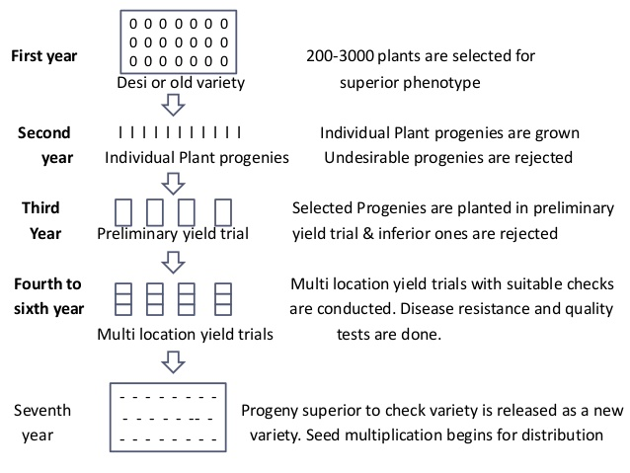

Fig 2: Schematic presentation of pure-line selection for developing a new variety
Origin of genetic variation in purelines
1. Mechanical mixture
Other genotypes may be mixed with a pureline during crop cultivation, harvesting, threshing and storage.
2. Natural hybridization
A low amount of cross pollination do occur in self-pollinated crops at least under some environments. As a result, in purelines genetic variation will be created.
3. Chromosomal aberrations
The chromosomal aberrations lead to duplications and deletions for small chromosome segments, such changes cause genetic variation in purelines.
4. Spontaneous mutation
Mutation is the ultimate source of most of the variation. Spontaneous mutation contributes for variation in pure line. One such example is a variation in pureline variety PB 1 (Pusa Basmati 1) of rice has two sister lines differing slightly were crossed to develop Pusa Basmati 1121, which has higher cooked grain length (20-25 mm) compared to Pusa Basmati 1(15-20 mm).
Merits:
- Using a heterogeneous or mixed population of an old variety, it is possible to isolate the genotype with the best yield, disease resistance, insect resistance, earliness, quality, etc.
- Compared to mass-selected variety, the variety developed by this method is more uniform and appealing.
- Crop improvement using this method is simple and affordable.
Demerits:
- Only superior genotypes from the mixed population can be isolated using this technique. It is unable to create new genotypes.
- Only species that self-pollinate can use this technique. In cross-pollinated species, it cannot be exploited to create variation.
- Because of their limited genetic diversity, pure-line selection produces cultivars with weak adaptation. All the plants of a pure-line have identical genotypes. As a result of their genetic uniformity, these kinds are more vulnerable to the onset of new diseases.
In various self-pollinated crops, including wheat, barley, paddy, peanut, chickpea, black-gram, green-gram, linseed, cotton and tobacco, superior cultivars have been selected by pure-line selection from the heterogeneous populations. Pure-lines are used either as varieties or as parents in hybridization for development of superior varieties or hybrids in self-pollinated species.
Differences between pureline selection and mass selection:

Pureline Selection | Mass selection
The new variety is a pureline | The new variety is a mixture of purelines
The new variety is highly uniform. In fact, the variation within a pureline variety is purely environmental | The variety has genetic variation of quantitative characters, although it is relatively uniform in general appearance
The selected plants are subjected to progeny test | Progeny test is generally not carried out
The variety is generally the best pureline present in the original population. The pureline selection brings about the greatest improvement over the original variety | The variety is inferior to the best pureline because most of the purelines included in it will be inferior to the best pureline
Generally, a pureline variety is expected to have narrower adaptation and lower stability in performance than a mixture of purelines | Usually the variety has a wider adaptation and greater stability than a pureline variety
The plants are selected for the desirability. It is not necessary they should have a similar phenotype | The selected plants have to be similar in phenotype since their seeds are mixed to make up the new variety
It is more demanding because careful progeny tests and yield trials have to be conducted | If a large number of plants are selected, expensive yield trials are not necessary. Thus, it is less demanding to the breeder
Generally, 7-8 years are required to develop a new variety | Generally, 6-7 years are required to develop a new variety
Selection within a pureline variety will be ineffective unless it has become genetically variable | Selection within a variety developed through mass selection will be effective since it has genetic variation
The produce of a pureline variety is uniform in quality | The produce is generally not uniform since different purelines making up the variety may differ in the quality of their gains, etc.
The variety is easily identified in seed certification programmes | The variety is relatively difficult to identify in seed certification programmes
It is used in self-pollinated and often cross-pollinated crops | It is used in both self- and cross-pollinated crops
The method is still used for variety development in crops where breeding is not highly advanced | The method is used for nucleus seed production of pureline varieties

REFERENCES
1. Rathore, R. K., & Ram, M. Role of selection in improving cultivars. Popular Kheti. 2013. 1(2), 45-48.
2. Singh BD. Plant Breeding. Kalyani Publisher, New Delhi. 2006.

