NANOPARTICLE SYNTHESIS AND ITS PROPERTIES
M.Manjuri, T.Kaviya, P.Krishnaveni, N.Jothika, S.Usha and M.Karunakaran*
Thin Film and Nano Science Research Lab, PG and Research Department of Physics, Alagappa Government Arts College, Karaikudi, India – 630 003.
Corresponding Author e-mail: tvdkaruna@gmail.com

Abstract
Due to their superior adjustable physical, chemical, and biological capabilities compared to their bulk counterparts, nanomaterials have become more important in technological advancements. According to their size, content, form, and place of origin, nanomaterials are divided into several groups. Each group benefits more and more as we get better at forecasting the precise characteristics of nanomaterials. When the manufacturing of nanomaterials increases and they are used in more industrial applications, toxicological problems are inevitable. This review's objective is to examine many aspects of nanomaterials, including their characteristics, production processes, and potential uses.
1. Introduction:
The word "nanotechnology" was aptly described by Professor Norio Taniguchi of Tokyo Science University as "the processing of separation, consolidation, and deformation of a material by an atom or a molecule." According to him, it has to do with the area of science that deals with modifying matter at the atomic or molecular level. Nanotechnology was developed as a scientific invention in the twenty-first century [1]. It is an interdisciplinary field that deals with the manufacture, use, and operation of materials that are shrinking in size until they are less than 100 nm in size. It involves controlling matter at the molecular level and has successfully penetrated a wide range of applications. Amazing breakthroughs in nanotechnology, such as surface-enhanced Raman scattering (SERS), nanobiotechnology, quantum dots, and nanotechnology and applied microbiology, have opened up new vistas for both practical and basic research [2].
A peer-reviewed open access scientific magazine called Current Trends in Nanotechnology encompasses a broad spectrum of concepts and recent advances in nanotechnology from all other scientific fields, including chemistry, biology, physics, materials science, and engineering. With recent advancements in fabrication and characterization technologies that encompass the exploration of both key nanotechnology phenomena, nanotechnology research has evolved tremendously. This publication, the most complete and trustworthy source of information on current achievements publishes original papers of a high scientific caliber that describe the findings and conclusions of those investigations. Many people only associate nanotechnology with making tennis rackets, baseball bats, hockey sticks, racing cycles, and other sporting equipment that is lighter and stronger. Nanotechnology, however, offers considerably greater potential. Realistically, it is anticipated to be used extensively by 2020 and will affect practically every element of life. Applications that are particularly extensive in the fields of industry, medical, new computer systems, and sustainability are anticipated to have a significant influence. Here are some fundamental trends to keep an eye on; many of them are related and all are predicted to remain optimistic [3].
In recent years, nanotechnology has sought to make current research and studies accessible to all readers via the internet. All scientists, researchers, and students in the subject of nanotechnology have a platform provided by journals. Nanobiopharmaceutics, nanobiotechnology, nanocomposites, nano cars, nanoelectronics, nanoengineering, nanofabrication, nanofluidics, nanohedron, nanoonics, nanolithography, nanomedicine, nanoparticles, nanotechnology, nano-thermite, nanotoxicology, nanotube, and supermolecules are among the topics covered in the journal [4].
2. Nanoscale:
Understanding and controlled manipulation of objects and events with nanoscale dimensions are referred to as nanoscale science and technology. The Greek prefix "nano," which denotes one billionth of a unit of measurement, has been adopted by scientists. A nanosecond, for example, is one billionth of a second, while a nanometer, abbreviated nm, is one of a meter, etc. We can "see" the world around us thanks to the telescopes and microscopes that humans have created over time. Atoms are around 1/10 or (10⁻¹) nm in size, putting the nano or microcosmos in comparison to our more familiar world [5].
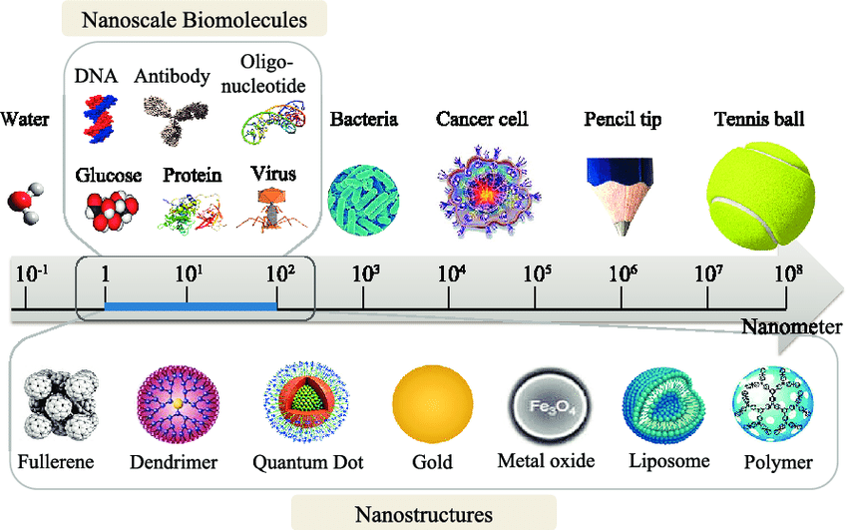
Figure 1: Nanoscale Range Structured Materials

3. Nanotechnology:
However, the concept of creating "tiny" objects is typically credited to Richard Feynman based on his 1959 lecture. The word "nanotechnology" was first used in 1974 by researcher the name of Norio Taniguchi. The term nano, which in Greek means "small old man" or "dwarf," is where the prefix nano- originates. Utilizing the special qualities of particles with sizes between 0.1 and 100 nm (1 nm = 10⁻⁹ m), Nanotechnology aims to develop and apply materials and technologies at the atomic, molecular, and supramolecular levels. The ability to change matter at the level of individual atoms and small groups of atoms has been demonstrated during the last three decades, and researchers have begun to characterize the properties of materials and structures in that form [6]. This capability has helped explain the unexpected finding that characteristics of single materials at the single molecule scale or bulk scale are frequently considerably different from those of small numbers of atoms and clusters of molecules. Nanoscale research and engineering typically try to analyze, explain, and change certain elements of nanoscale matter to create new abilities with probable applications in all fields of science, engineering, technology, and medicine. Nanomaterials, as opposed to bulk materials, have a high surface-to-volume ratio, which is typical of matter that size, and they have unique optical, magnetic, interfacial, electrical, and chemical properties. The use of nanomaterials and nanotechnology is extremely tempting in many industrial domains, including biomedicine, energy, pharmacy, food, agriculture, and the environment [7].
Ultrafine nanomaterials contain several extremely promising qualities that are advantageous to current civilization and human existence. Depending on their structures, nanomaterials behave in various ways, but given all the positive impacts they might have on the environment and living things, it is crucial to assess the hazards they pose. To decrease the potential of toxic residues being discharged into the environment, green technology provides environmentally friendly reagents in the form of reducing and capping agents [8]. As an alternative to chemical and physical methods, green synthesis is a developing field of nanotechnology that provides advantages for both the economy and the environment. This method makes use of non-toxic, bio-safe, and ecologically responsible chemicals. For the manufacture of metal oxide nanoparticles, several naturally occurring materials, including plant extracts, cyclodextrin, chitosan, and many others, have been investigated. Because it is straightforward, affordable, non-toxic, biocompatible, and generally repeatable, greener nanoparticle synthesis is preferable to other methods because it produces more sustainable materials [9].
4. Preparation of Nanoparticles
The medicine that will be placed into the nanoparticles and the polymer's physics-chemical characteristics will determine the best preparation procedure. Nanoparticles are primarily produced using the following methods:
4.1. Emulsion-Solvent Evaporation Method:
The majority of nanoparticle preparations are done in this way. There are primarily two phases in this process. The polymer solution must first be emulsified in an aqueous phase. In the second stage, the polymer solution evaporates and nanospheres are formed by generating polymer precipitation. The nanoparticles are obtained by ultracentrifugation, cleaned of any remaining free medication or material, and then lyophilized for preservation. This process is also referred to as the high-pressure emulsification and solvent evaporation technique. Under high pressure, homogenization and composite stirring are used in this method. Eliminate the organic solvent. The viscosity, temperature, type, and quantity of the dispersion agent of the organic and aqueous phases may all be changed to alter the size. Although this method can be used with fat-soluble medicines, the problems are exacerbated. In this approach, polymers such as PLA, poly (-hydroxybutyrate), poly (caprolactone), PLGA, cellulose acetate phthalate, and EC are employed [10].
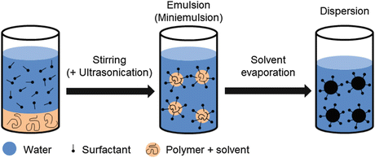
Figure 2: Emulsion-Solvent Evaporation Method
4.2. Double Emulsion and Evaporation Method:
The fundamental problem with this approach is the poor trapping of hydrophilic medicines. As a result, double emulsion technology is used to encapsulate hydrophilic drugs. In this method, aqueous drug solution and organic polymer solution are combined while being vigorously stirred to generate a w/o emulsion. A mixed emulsion (w/o/w) is created by continuously swirling this w/o emulsion into another aqueous phase. The solvent is then evaporated, and high-speed centrifugation can be used to separate the nanoparticles. Before being lyophilized, the produced nanoparticles need to be cleaned. The variables used in this technique include hydrophilic drug volume, polymer volume, aqueous phase volume, and stabilizer concentration. These factors also have an impact on the characterization of nanoparticles [11].
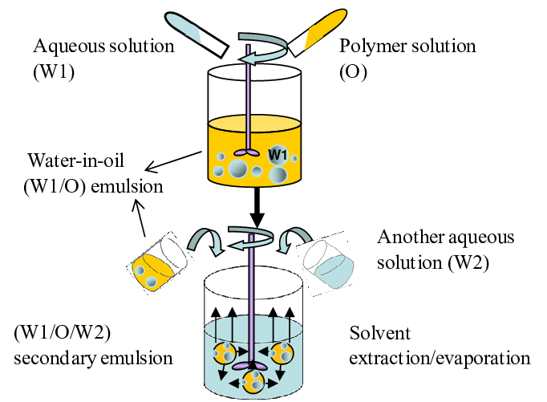
Figure 3: Double Emulsion and Evaporation Method
4.3. Salting-Out Method:
This method uses salting-out to separate water-miscible solution from aqueous solution. The drug and polymer are first dissolved in a solvent to generate a salting agent (electrolytes such as calcium chloride and magnesium chloride, or sucrose in the form of non-electrolytes) and a colloidal stabilizer formed of polyvinylpyrrolidone (PVP) or hydroxyethyl cellulose. In an aqueous gel, where it has been emulsified. The aqueous phase or water is used to dilute this oil in water emulsion. increased solvent diffusion, a sign that nanospheres have formed. There may be variations in several factors, including the electrolyte concentration, the number of polymers in the organic phase, the kind of stabilizer, the rate of stirring, and the internal/external phase ratio. This method produces exceptional efficiency and simplicity in the manufacturing of ethyl cellulose, PLA, and poly (methacrylic acid) nanospheres. Heat-sensitive materials may benefit from salting out since it doesn't need a temperature increase. The limitations of this approach are that it has a specific use for lipophilic medication and requires significant nanoparticle cleaning processes [12–13].
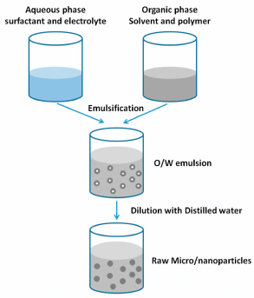
Figure 4: Salting-Out Method
4.4. Emulsion Diffusion Method:
The emulsion diffusion process is another approach that is frequently employed to create nanoparticles. The dissolving of the encasing polymer requires the maintenance of an initial thermodynamic equilibrium between two liquids that are both saturated with water. Examples of such solvents are propylene carbonate and benzyl alcohol, which are somewhat miscible with water. Following that, the stabilizer-containing aqueous solution is used to emulsify the polymer-water saturated solvent phase, allowing the solvent to seep into the outer phase and form nanospheres or nanocapsules depending on the oil to polymer ratio. Depending on the boiling point, the solvent is finally eliminated by filtering or evaporation. This approach has several advantages, including strong batch-to-batch reproducibility, a low need for homogenization, high encapsulation efficiency (often 70%), simplicity, a narrow size dispersion, and ease of scaling up. But this approach has several limitations: Because the water-soluble drug's saturated-aqueous outer phase seeps out during emulsification, there is a high water content removal from the suspension and poor encapsulation efficiency [14–15].]
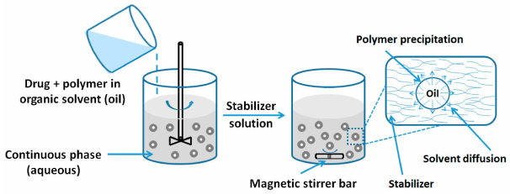
Figure 4: Emulsion Diffusion Method
4.5. Solvent Displacement/Precipitation Method:
The precipitation of an organic solvent, the diffusion of an aqueous medium into an organic solvent in the presence or absence of a surfactant, and the precipitation of a preformed polymer are all part of the "solvent displacement" process. Miscible solvents, polymers, medicines, and lipophilic surfactants such as acetone or ethanol can all be dissolved in semi-polar water. A stabilizer holding an aqueous solution is then filled with the solution, either added or injected via magnetic stirring. Solvent diffusion occurs quickly to produce nanoparticles. After that, the suspension of the solvent is removed at decreased pressure. The pace at which the organic phase is incorporated into the aqueous phase influences particle size as well. It has been shown that decreasing the particle size and drug entrapment requires increasing the mixing rate. The majority of the medicines with limited solubility are well suited to the nanoprecipitation technique. The size of the nanospheres and the rate of drug release may be successfully controlled by altering the preparation conditions. The concentration of the polymers may be changed to produce tiny nanospheres with lower diameters [16].
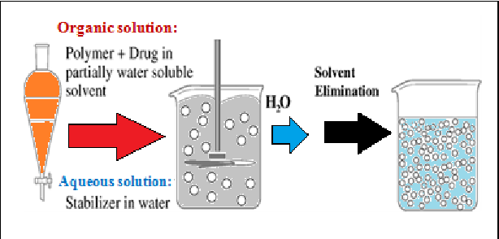
Figure 5: Solvent Displacement/Precipitation Method
4.6. Polymerization Method:
The monomers are polymerized in an aqueous solution, and the medicine is subsequently added to the nanoparticles by adsorption or dissolution in the polymerization medium. The nanoparticle solution is then ultra-centrifuged to remove the various polymerization stabilizers and surfactants, and the particles are re-suspended in an isotonic surfactant-free medium. This approach is said to be capable of producing polybutylene cyanoacrylate or poly (alkyl cyanoacrylate) nanoparticles. The dosage of surfactant and stabilizer used influences the creation of nanocapsules and their particle size [17].
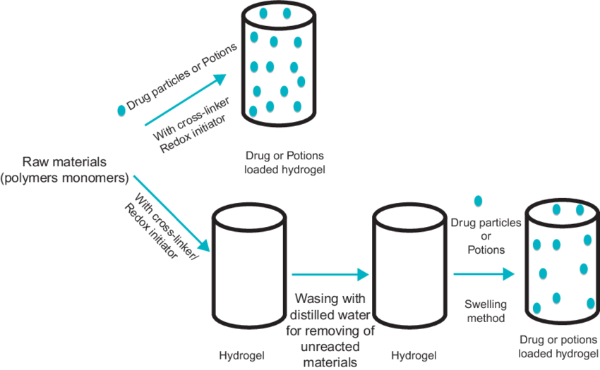
Figure 6: Polymerization Method
4.7. Covalent or Ionic Gel Method:
The covalent or ionic gel technique has been used extensively to create nanoparticles from biodegradable hydrophilic polymers such as chitosan, sodium alginate, and gelatin. The two aqueous phases of this approach are made up of a polymer called chitosan in one phase and a polyanionic in the other. The positively charged amino group of chitosan forms a conservator with an anemometer size limit by engaging with the negatively charged tripolyphosphate. While ionic contact at room temperature causes the transition from liquid to gel due to ionic gelation, conservatives are formed as a result of electrostatic interaction between the two aqueous phases [18].

5. Low-Cost Method Nano Particles Synthesis:
5.1. Sol-gel:
Sol-gel is a physical chemistry method for producing small particles. The primary application is in the synthesis of metal oxides. The initial step in this technique is to convert the monomers, or starting material, into a sol, which is a colloidal solution and is required before forming a gel. Discrete particles or polymers make up this gel. The most often employed precursors are metal alkoxides or chlorides. Colloids are created by polycondensing their precursors after hydrolyzing them. The sol-gel approach is used because of its economic feasibility and low-temperature process, which allows us to regulate the composition of the product formed. Rare earth elements and organic colors, for example, can be included in very minute amounts in the sol to achieve more even dispersion in the end product. In the processing and production of ceramics, the produced substance is employed as an investment casting material. It can also be used to generate a thin metal oxide coating for later applications. Sol-gel processes are used to create a variety of materials that are useful in the fields of energy, space, optics, sensors, electronics, reactive materials, separation technologies (such as chromatography), and medical (such as controlled medication release) [19].
5.2. The phase involved in a sol-gel:
Sol, also known as a colloidal solution, is a liquid in which Brownian motion acts as the only force holding particles of sizes between 0.1 and 1 m in suspension. When the solid and liquid phases mix, a gel is created. The colloidal particles in this technique are first dispersed in a liquid to create a liquid. By spraying, spinning, or depositing this sol onto a substrate, a thin coating can be created. To make a complex network gel, the particles in the sol that stabilised the components are removed and allowed to polymerize further. Finally, heat treatment causes the remaining organic and inorganic components to pyrolyze, forming coatings 2–5 that are either amorphous or crystalline. The hydrolysis of the alcoholic group and its condensation are the two main processes in sol-gel. Using an appropriate casting container, the resulting precursor sol may be given the required form. It may be used to create microsphere or nanosphere powders by dip coating or spin coating a substrate to put a layer on it [20].
5.3. Steps Sol-Gel Process:
Mixing:
In this step of the process, water is used as a solvent to mechanically mix colloidal particles to create a colloidal solution that resists pH precipitation. When the metal alkoxide precursor M(OR) 4 combines with water, it goes through hydrolysis and polycondensation processes, resulting in colloidal dispersions of very tiny particles (1-2 nm), which later develop into 3-D networks of linked inorganic materials.
Casting:
Due to its low viscosity, the sol is simple to cast into a mold or form. To prevent the gel from clinging to the casting container, an appropriate mold should be used. Colloidal particles and condensed silica are transformed during the gelation process into three-dimensional networks. The characteristics of the gel depending on the size of the particles and the gelation process.
Aging:
The term "syneresis" also refers to this phase of the sol-gel procedure. This entails caring after the cast item for a while, which might be anything from a few hours to a few days. During the aging process, the polycondensation continues, and the gel network precipitates together with the solution submerged in it. As a result, the thickness of the interparticle neck increases, but the porosity decreases. As a result, the gel's strength is increased, and a product that is resistant to breaking while drying is formed.
Drying:
Excess solvent is removed from the intricate network during drying. If the pores are tiny, a significant capillary tension may form during the drying process. The only way to prevent the gels from bursting under these forces is to decrease the liquid's surface area. This can be achieved either by adding a surfactant, which can stop the solid and liquid components from mixing, or by performing ultra-fine evaporation, which removes incredibly small holes. The aerogel has a low density after drying. When it is eventually drained after being sandwiched between glass plates, it obtains very good thermal insulation.
Densification:
The gel generated is heated to a high temperature, increasing the gel's density. Additionally, it will destroy the gel's pores and produce a density similar to that of fused quartz or silica. Pore size, connectivity, and surface area all affect temperature density [21].
5.4. Co-precipitation method:
The co-precipitation method is a tried-and-true method for producing iron oxide nanoparticles. This method requires adding a base (such as NaOH) to the precipitate of Fe²⁺ and Fe³⁺ salts (such as chlorides, sulphates, and nitrates) in aqueous solutions. Numerous experimental factors, including the kind of precursors used, their ratio, the surface ligand, reaction temperature, and pH, may be used to alter the size, shape, and composition of the produced nanoparticles. Surfactants, inorganic compounds, and polymers have all been utilized as surface ligands during the precipitation process to improve the size distribution of previously generated nanoparticles. One of the key benefits of this approach is that it may quickly and easily produce high yields of water-soluble nanoparticles. Several commercial iron oxide nanoparticle-based MRI contrast agents, including Feridex, Reservist, and Combidex, are made using this approach. However, because the reaction temperature is limited by the boiling point of water, the products generated by this process may have poor crystallinity. As a result, as compared to the bulk value of 90 amu g⁻¹, the saturation magnetization values of iron oxide nanoparticles created using this technique are typically in the range of 30 to 50 amu g⁻¹.

6. Properties of Nanotechnology:
When a substance is reduced to the nanoscale, its properties radically alter. These qualities are significantly influenced by the method and environment utilized to create the nanoparticle. They may also be made somewhat variable by altering their morphology. We go into more depth about those characteristics in the portion of this chapter that comes next. We chose the categorization based on chemical composition and go through the characteristics of nanoparticles in each class to keep this investigation organized for the reader. We first explain the fundamental characteristics of each class before moving on to the special characteristics of the most prevalent nanomaterial within that class. The following table lists the many subsets of a nanoparticle's various attributes [22].
6.1. Morphological properties
The size, shape, and crystal structure of a nanoparticle are referred to as its morphology. The particle diameter is at the same level as the wavelengths of its motion at nanometric length scales (1–100 nm in general), hence their behaviors are controlled by quantum-level physics. Nanoparticles have very high mobility in free states due to their tiny size. Additionally, under the right conditions, they may frequently penetrate holes as small as submicron. Such a quality was especially advantageous to the biomedical fields, resulting in new approaches to cellular-level therapy and tailored drug delivery. A nanoparticle's specific surface area, or the ratio of surface area to volume, is often greater than that of its bulk equivalent to accommodate improved qualities. Additionally, several crystal structures contain nanoparticles, and these structures significantly influence the behavior of these particles at the nanoscale. Multiple polymorphs of the same material can be discovered, each with a distinct structure [23].
6.2. Surface Effect
The majority of nanoscale particles have a high surface area to volume ratio, which makes them architecturally distinct. This is because the relationship arrangement between atoms on a nanomaterial's surface and those in the corresponding bulk material is substantially different. The surprising comparison of mechanical and physical characteristics in nanoparticles versus their heavy nature can be attributed in part to this surface effect. On such a short length scale, local atomic production is very efficient, and characteristics are affected by crystal structure and particle size. Atoms at the nanoscale, in particular, are always looking for methods to do better. This leads to the anomalous surface tension, which is necessary to produce the minimal energy configuration [24].
6.3. Quantum Size Effect
When a substance is downsized to the nanoscale, its electrical structure in the bulk material changes. Because of the extreme confinement of electrons and holes inside the small crystalline structure, the level of the discrete energy band becomes quantized in nanoscale materials. In contrast to Newton's Physics on Bulk Materials, which is simply a cumulative or average presentation of quantum level physics, it can only be explained by researching physics at the quantum level. The following are some examples of nanoscale properties that change dramatically: opaque copper becomes transparent; inert platinum demonstrates catalytic behavior; aluminium becomes combustible; gold melts at normal temperature; silicon becomes an electrical conductor; and so on. Quantum confinement or effects rely heavily on transactions. The excited electron's location that is tied to the hole it leaves behind is referred to as an exciton. Energy is absorbed by the valence band (VB) and transferred to the conduction band (CB). The diameter of the quantum dots led to the exciton's particular location. An intrinsic characteristic of the material is that the exciton is smaller than the Bohr radius. Quantum confinement can be considered a mild, moderate, or strict form of confinement, depending on its strength. The crystalline radius is with Bohr radius in comparison to the metric for such categorization. The energy change in different power systems is calculated using a variety of factors, including the bulk exciton Bohr radius, electron and hole Bohr radii, exciton mass, and crystallite radius [25-26].
6.4. Some Other Properties:
- Mechanical Properties: In general hardness, tensile and elastic strength, adhesion, and Mechanical properties include friction, etc.
- Thermal properties: Typically, the shape has little effect on the melting and boiling temperatures of bulk materials. Small-scale particles do, nevertheless, have this characteristic. The melting point of nanoparticles has been observed to decline quickly during the past 100 years below a particular size due to significant dependency on dimensions based on different thermodynamics models. Downsizing causes the melting point of several metal nanoparticles to decrease. Additionally, because nanoparticles have the biggest specific surface areas, it is anticipated that they would have higher thermal conductivity and coefficients of thermal expansion than bulk materials.
- Optical properties: Color, refractive index, reflectivity, light penetration, nanoparticle absorption capacity, and other optical parameters are included.
- Electrical Properties: Conductivity, resistivity, and semiconductor behavior can be used to pinpoint electrical qualities.
- Chemical Properties: Chemical properties include stability, reactivity, redox potential, flammability, corrosion resistance, interactions with water, lipids, or other solvents (such as hydrophilicity, hydrophobicity, lipophilicity, and so on), and colloidal aspects of suspension, diffusion, and settling.
- Magnetic properties: Only a limited portion of nanoparticles exhibit Ferro- and superparamagnetic behavior, as well as the transition from one to the other on the nanoscale.
- Antimicrobial properties: The ability of some microbial agents to interact with nanoparticles and combat their growth is crucial in biological applications.

7. Conclusion:
A lot of interest has been paid to nanomaterials in the past 10 years because of all of their potential uses. Research indicates that more nanomaterials are being produced. Several proven nanoparticle preparation procedures may be used to create nanoparticles of different shapes and sizes. Among the low-cost techniques looked at were SILAR, Chemical bath deposition, Spin coating, Sol-gel, and co-precipitation procedures. These procedures produce a variety of nanomaterials.

Reference:
- Virkutyte, Jurate, and Rajender S. Varma. “Chapter 2. Environmentally Friendly Preparation of Metal Nanoparticles.” Green Chemistry Series, 2012, pp. 7–33., https://doi.org/10.1039/9781849735469-00007.
- Bohr, M.T. “Nanotechnology Goals and Challenges for Electronic Applications.” IEEE Transactions on Nanotechnology, vol. 1, no. 1, 2002, pp. 56–62., https://doi.org/10.1109/tnano.2002.1005426.
- Bayda, Samer, et al. “The History of Nanoscience and Nanotechnology: From Chemical–Physical Applications to Nanomedicine.” Molecules, vol. 25, no. 1, 2019, p. 112., https://doi.org/10.3390/molecules25010112.
- Thiruvengadam, Muthu, et al. “Nanotechnology: Current Uses and Future Applications in the Food Industry.” 3 Biotech, vol. 8, no. 1, 2018, https://doi.org/10.1007/s13205-018-1104-7.
- Bawa, Raj. "Drug Delivery at the Nanoscale: A Guide for Scientists, Physicians, and Lawyers." The Road from Nanomedicine to Precision Medicine, 2019, pp. 1–134., https://doi.org/10.1201/9780429295010-1.
- Thakur, Preeti, and Atul Thakur. “Introduction to Nanotechnology.” Synthesis and Applications of Nanoparticles, 2022, pp. 1–17., https://doi.org/10.1007/978-981-16-6819-7_1.
- Patel, Jayvadan K., et al. “Introduction to Nanomaterials and Nanotechnology.” Emerging Technologies for Nanoparticle Manufacturing, 2021, pp. 3–23., https://doi.org/10.1007/978-3-030-50703-9_1.
- Gupta, Ritu, and Huan Xie. "Nanoparticles in Daily Life: Applications, Toxicity, and Regulations." Journal of Environmental Pathology, Toxicology, and Oncology, vol. 37, no. 3, 2018, pp. 209–230., https://doi.org/10.1615/jenvironpatholtoxicoloncol.2018026009.
- Ahmed, Shams Forruque, et al. "Green Approaches in Synthesising Nanomaterials for Environmental Nanobioremediation: Technological Advancements, Applications, Benefits, and Challenges." Environmental Research, vol. 204, 2022, p. 111967., https://doi.org/10.1016/j.envres.2021.111967.
- Latha, S., et al. “Preparation and in-Vitro Evaluation of Pantoprazole Sodium Magnetic Microspheres by Emulsion Solvent Evaporation Method.” BioNanoScience, vol. 11, no. 2, 2021, pp. 643–647., https://doi.org/10.1007/s12668-021-00837-2.
- Zhang, Junjiang, et al. “Polymeric Non-Spherical Coarse Microparticles Fabricated by Double Emulsion-Solvent Evaporation for Simvastatin Delivery.” Colloids and Surfaces B: Biointerfaces, vol. 199, 2021, p. 111560., https://doi.org/10.1016/j.colsurfb.2021.111560.
- Dubey, Surbhi, et al. “Nanobiomaterials.” Nanobiomaterials in Drug Delivery, 2016, pp. 111–146., https://doi.org/10.1016/b978-0-323-42866-8.00004-6.
- Poole, Colin F. “Milestones in the Development of Liquid-Phase Extraction Techniques.” Liquid-Phase Extraction, 2020, pp. 1–44., https://doi.org/10.1016/b978-0-12-816911-7.00001-3.
- Pineda-Reyes, Ana María, et al. “Implementation of the Emulsification-Diffusion Method by Solvent Displacement for Polystyrene Nanoparticles Prepared from Recycled Material.” RSC Advances, vol. 11, no. 4, 2021, pp. 2226–2234., https://doi.org/10.1039/d0ra07749f.
- Piñón-Segundo, Elizabeth, et al. “The Emulsification-Diffusion Method to Obtain Polymeric Nanoparticles.” Nanoscale Fabrication, Optimization, Scale-Up and Biological Aspects of Pharmaceutical Nanotechnology, 2018, pp. 51–83., https://doi.org/10.1016/b978-0-12-813629-4.00002-4.
- Pathak, Chandramani, et al. "Mechanism for Development of Nano based Drug Delivery System." Applications of Targeted Nano Drugs and Delivery Systems, 2019, pp. 35–67., https://doi.org/10.1016/b978-0-12-814029-1.00003-x.
- Shitole, Shubham. “Nanoparticle - Novel Drug Delivery System: A Review.” International Journal for Research in Applied Science and Engineering Technology, vol. 10, no. 1, 2022, pp. 517–530., https://doi.org/10.22214/ijraset.2022.39849.
- Mohammed, M. et al., 2017. An overview of chitosan nanoparticles and its application in non-parenteral drug delivery. Pharmaceutics, 9(4), p.53.
- Liu, C., Tian, Q. & Liao, L., 2020. Sol-gel precursor inks and films. Solution-Processed Metal Oxide Thin Films for Electronic Applications, pp.41–61.
- Schubert, U., 2015. Chemistry and fundamentals of the sol-gel process. The Sol-Gel Handbook, pp.1–28.
- Ulrich, D.R., 1988. Prospects of sol-gel processes. Journal of Non-Crystalline Solids, 100(1-3), pp.174–193.
- Murty, B S, et al. “Unique Properties of Nanomaterials.” Textbook of Nanoscience and Nanotechnology, 2012, pp. 29–65., https://doi.org/10.1007/978-3-642-28030-6_2.
- Jeevanandam, Jaison, et al. "Review on Nanoparticles and Nanostructured Materials: History, Sources, Toxicity, and Regulations." Beilstein Journal of Nanotechnology, vol. 9, 2018, pp. 1050–1074., https://doi.org/10.3762/bjnano.9.98.
- Mourdikoudis, Stefanos, et al. “Characterization Techniques for Nanoparticles: Comparison and Complementarity upon Studying Nanoparticle Properties.” Nanoscale, vol. 10, no. 27, 2018, pp. 12871–12934., https://doi.org/10.1039/c8nr02278j.
- Campos, Alfredo, et al. “Plasmonic Quantum Size Effects in Silver Nanoparticles Are Dominated by Interfaces and Local Environments.” Nature Physics, vol. 15, no. 3, 2018, pp. 275–280., https://doi.org/10.1038/s41567-018-0345-z.
- Adekoya, Joseph Adeyemi, et al. "Band Structure, Morphology, Functionality, and Size-Dependent Properties of Metal Nanoparticles." Noble and Precious Metals - Properties, Nanoscale Effects and Applications, 2018, https://doi.org/10.5772/intechopen.72761.

