Sustaining Medical Ethics and Integrity of healthcare providers
during the Pandemic

ABSTRACT
Ethics are the values and principles of a person, which bind the person to work with high moral standards. This paper discusses medical ethics and integrity maintained by health care providers. During Coronavirus Pandemic, the heart-wrenching conditions of people's ailment and the medical system's inadequate infrastructure made the system horrific for kith and kins of patients seeking medical help during the crisis. The apathy of the medical system and lack of medical practitioners led to an emergency-like situation. There were long queues of patients seeking medical assistance. People formed a line to refill oxygen cylinders, medicines and other supplies. Medical equipment, drugs, and oxygen cylinders were black-market during an emergency. The helplessness of not getting the cylinders, treatment, medication, and shortage of medical equipment was given a path to unethical deeds. Patients and Doctors were in a dilemma. Doctors were worried they did not meet their family members after being exposed to viruses. Patients were concerned because they were overcharged. The doctors treating them were also trying the hit and trial method because contagious diseases like coronavirus never appeared during their medical study and practice. Hence, the study aims to explore some remedial measures for sustaining ethical standards during the Pandemic. It is an exploratory paper. The study findings reveal that there should be some specific guidelines that the health providers must follow.
Keywords: Medical ethics, Pandemic, Sustainability, Integrity, healthcare provider.
INTRODUCTION
In schools, students are introduced to Moral education for being truthful and honest. Similarly, when professional students complete their degrees, they take the oath for dedication to their duty, but the Pandemic forced people to compromise their ethical standards. Scattered dead bodies in hospitals, crematoriums and cemeteries left insights of fear. Resilient medical ethics has become the need of the hour for saving people's lives. The impact of coronavirus has left its deadly scars and horrific experience. This will be remembered as a pandemic forcing people to shut themselves within their homes to keep themselves safe. The worldwide spread of the COVID-19 virus halted the movement of vehicles, a smaller number of occupants, and 50% staff capacity to maintain social distancing, self-quarantine, compulsory quarantine, and sanitization became part and parcel of our lives. The heart-wrenching moments left the scenario fearful.
The entire globe was helpless during the spread of this virus. Tragic incidents were happening, and people were dying an untimely death. There were heaps of dead bodies lying around in hospitals and crematoriums (Pujari & Kumar, 2021). Various governments could not find a remedy and solution to this virus. The crisis of artificial virus developed at Wuhan Lab restricted the movement of people, quarantine, frequent sanitization and social distancing.
The spread of the virus was contagious worldwide, and it continued. Millions of people were in havoc. This virus kept spreading with leaps and bounds throughout global countries day by day. This virus was above all the calamities. Though the various governments struggled to overcome this calamity, there was no solution (Chang, Xu, Rebaza, L. Sharma, & Cruz, 2020). The best way was to seriously follow Coronavirus protocol, government advisories and health department's instructions, but at the same time, lack of facilities led to corruption and malpractices (KA, 2001).
There were various challenges amidst the covid Pandemic, and healthcare providers were resilient. To save more lives, they employed self-adjustment skills to relieve stress. On the other hand, healthcare providers experienced anguish and helplessness over their patients' suffering and deaths. Few healthcare providers and medical professionals compromised their ethical duties for monetary gain (Singhal, 2021). . (Kaur & Gupta, 2020)’s review paper aimed to summarise the activities devoted to developing an effective new coronavirus vaccine, which halted the economy, human health, and life across the globe.
The people, who have a strong urge to serve humanity, generally choose a medical profession as they see this profession as a path toward relieving the pains and sufferings of many people. Historically, the impulse to help and serve others has trumped financial considerations. The medical code of ethics is significantly stricter than the legislation. Most physicians have their internal code of ethics, and professional and medicine-related educational organizations have adopted more codified principles to ensure that their members act ethically (KA, 2001), (Ganesan & Thambusamy, 2020).
Hospitals, medical practices, and healthcare organisations are striving to take advantage of Internet commerce opportunities for healthcare services and goods in light of the Internet's explosive growth. (KA, 2001). Sometimes, financial interests come before the welfare of website visitors. These behaviours may directly violate the Principles of Medical Ethics and other professional standards of conduct depending on how one views internet site visitors—as visitors, clients, healthcare consumers, or patients. Paid physician advisors to medical e-commerce websites could seem to be a conflict of interest to some people but not others. (KA, 2001), (Ganesan & Thambusamy, 2020).

RESEARCH METHODOLOGY:
Patients and their kith and kin visiting hospitals have high expectations from medical staff. At times, unnecessary tests are mentioned to raise the medical bill. Patients are overcharged and recommended to undergo an operation even though the treatment could have been cured by medication. During the pandemic, patients were confined to hospitals without connection, but their attendants paid hefty charges for their treatment. Due to a lack of medical oxygen, medicines, vaccination, and ambulance supply, a lack of workforce led to black-marketing of necessary resources by medical and paramedical staff.
The Study suggests remedial measures for sustaining the ethical standards among medical professionals and healthcare providers when facing moral conflict during the covid Pandemic. The study is based on secondary data. Research papers, articles, survey reports, newspapers, and trade magazines are reviewed to judge the efficacy of medical ethics during the Corona period, i.e., from March 2020 to December 2021.

ETHICAL CONFLICT AMONG HEALTH CARE PROVIDERS AND PROFESSIONALS AMID ONGOING COVID-19
Medical practitioners act as a bridge between society and their patients, assisting the sick in regaining social usefulness and dignity on the one hand, and advocating for individuals against social standards that are sometimes intolerant of disease on the other (Hebbar, Sudha, Dsouza, Chilgod, & Amin, 2020).
Medical professionals must cultivate a specific set of motivations to maintain this mediating capacity between individuals and society. Medical professionals are driven primarily by a desire for public respect and trust and a reputation for excellence among their colleagues rather than by a passion for wealth or power. Wealth incentive could lead to professionals being "captured" by wealthy private interests, while power motivation could lead to their capture by society through politics; either scenario would take them away from their natural mediating role. Professional institutions are intended to create and reinforce acceptable standard operating procedures and codes of ethics. They provide opportunities for professionals to pursue, display, and celebrate their learning and abilities while supporting their values, both in front of one another and in front of the public, for whom the loyalty and regard they are attempting to gain commitment and concern (Latham, 2004).
During the covid Pandemic, medical professionals, especially doctors and nurses, were subjected to hospital administration, family pressure, societal pressure, political pressure, supporting staff pressure, etc. These pressures, in most scenarios, created conflict between professional and personal ethics and commitments (Roy, 2022). Many professionals overcame these burdens and did what was in the best interest of their patients and society at large; however, few succumbed to this pressure and got derailed from the ethical code of conduct (Lee SM, 2018), (Maunder R, 2003) and (Qian Liu, 2020).
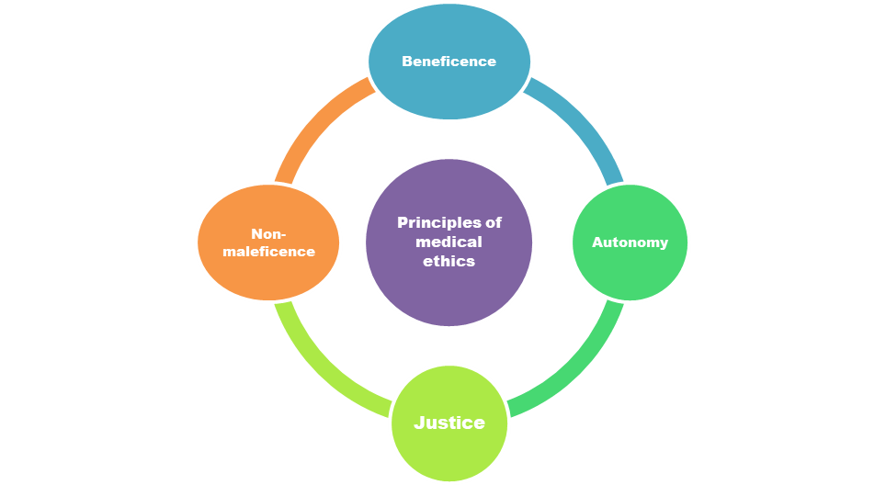
Figure 1: Principles of Medical Ethics
Figure no. 1 illustrates the principles of medical ethics. There are four moral principles, i.e. Autonomy in choosing the treatment. Beneficence is in the patient's best interest; non-maleficence is not the reason for the harm, and justice is equal accessibility of health resources to patients irrespective of caste and creed (G. V., 2020).
REMEDIAL MEASURES
Remedial measures for sustaining ethical standards among medical professionals and health care providers amid ongoing covid-19 have been discussed in the following manner.
- Improvement in medical ethics- Marketing is riddled with ethical snares. The nature of the medical product raises ethical issues; the spirit of pricing raises issues of justice and quality; placement raises agency and access issues; and the promotion increases problems of deceit, lack of knowledge, and conflict of interest (Lloyd, Walker, & Goswami, 2020), (Rosenbaum, Bayer, & Bernheim, 2011). The fifth P of medical marketing should be professionalism. Professionalism is an aspirational ideology; it is a normative explanation of medical professionals' motivations and how they should act rather than a positive description of how they or their professional institutions have worked in the past. Robust professional ethics can minimize the tendency to desire wealth and maximize the propensity to deliver high-quality care to the patients amid ongoing Covid 19 (Latham, 2004).
- Fairness in providing online and offline services - Health care institutions should prioritise the financial capacity of their patients by implementing a fair, professional policy to demonstrate their commitment to fairness. It must show that its primary method of operation is not to take money from patients but to give them an investment in their general health and wellbeing by providing a variety of natural and organic medical or health items. (Ganesan & Thambusamy, 2020). There must be solid political resolve to impose "one drug, one price" across all brands to reduce the non-uniform cost across the organisation. The in-house pharmacy practice of creating a substantial profit margin from patients may change due to a new route called e-pharmacy. However, this lays a heavy burden on the government to control and keep an eye on online pharmacies. Only once a sound legal and regulatory framework has been established should e-pharmacies be promoted. (Anand, et al., 2010), (Crawford SY., 2003).
- Being accountable for humanity- Acknowledging and accepting accountability shows maturity and that all customers appreciate and keep returning to the organization (K & Goldrich, 2006). The cornerstone of maintaining a loyal client base is taking such responsibility seriously, especially during the COVID-19 era, as it is with the corporation under inquiry (Lumens).
- To maintain the decorum of medical professionalism- The understanding of new technology or field of study often advances more quickly than the rules and standards that enable practitioners to act morally in a unique setting. The practice of medicine in the twenty-first century is evolving fast, mainly due to the Internet. For the success of medical practises, we hope that practitioners connected to the medical Internet will uphold high ethical standards despite the quick technical advancements in the field of medicine. Due to social distance, this aspect has become more crucial, so remaining at home is encouraged. (KA, 2001).
- Taking care of Patients' Privacy: Studies show that most adult internet users are unaware that their online actions are tracked and that websites collect their personal information when they visit (Internet healthcare coalition, 2001). Many people who use the internet think they can go to a website and learn about sensitive subjects like AIDS, herpes, or suicide without anyone knowing. Therefore, medical and healthcare websites should adhere to solid security procedures to guarantee that the personal medical information of their site visitors is kept private and does not unintentionally fall into the hands of marketers, employers, or insurance. (Winker, et al., 2020). The ethical standards being created for the Internet must be adaptable enough to consider new forms of communication as they emerge. This is more crucial in the age of pandemics.
- Fighting against fake news- When irresponsible persons transmit misleading or fake news, the challenge of sharing unverified information arises. Unwitting public members may be duped into thinking the notification is accurate in this way. This is unethical, especially when it's done to trick other people. It is the duty of every public member, including doctors and other healthcare workers, to combat false information and fake news. To win this struggle, every public member must read carefully, comprehend how to respond, and only communicate accurate health-related information. (Yousf, Muuti, Ariffin, A., & Tan, 2020) (Yusof, A., Muuti, M. Z., Ariffin, L. A., & Tan, M. (2020)
- Building trust in patients- The confidentiality rule is the cornerstone of the relationship of trust between patients and healthcare providers (HCPs). Because it encourages patients to be honest about their medical histories, this trusting relationship is essential. However, confidentiality is not a universal concept. First, if the disclosure is mandated by law, it is legal. The guidelines also permit dissemination without permission when it is done for the public good. Imagine if hospitals, insurance providers, and medical professionals cannot provide patients with the services required. Customers who purchase healthcare services online may do so from sources with a bad reputation or providers who are not qualified, licenced, or professional. As a result, rather than containing the Pandemic, this will worsen it. Patients' lives could even be in danger. As a result, healthcare providers must establish trust with their patients (Yousf, Muuti, Ariffin, A., & Tan, 2020).
- Compliance with WHO's guidelines for managing ethical issues- As Covid-19 is highly contagious, social distancing measures are necessary with no established cure. However, India's high population density and poor socioeconomic conditions make social distance and proper hygiene standards challenging to execute. Using restrictive tactics in these circumstances raises ethical concerns. Hence, All healthcare providers and medical professionals should adhere to the standards set forth by the WHO and the Indian Council of Medical Research for managing ethical issues in infectious disease outbreaks and should share and practice the same protocols for balancing human emotions and COVID. (Yousf, Muuti, Ariffin, A., & Tan, 2020).
- Promoting positive messaging by the health care professionals on social media- The government has begun spreading positive messaging and thanks for health and sanitation professionals through updated caller tunes and social media since it has realised that, aside from Covid 19, this is a more major challenge of fear, mistrust, and stigmatisation. It is crucial to determine whether the public will find the information entertaining or if it will be beneficial to divulge some facts. Comparing the two might be helpful when deciding how to share knowledge ethically when necessary. Making sure that information is disseminated in an ethical and socially acceptable manner will assist in preserving the public's trust. (Hebbar, Sudha, Dsouza, Chilgod, & Amin, 2020).
- Maintaining essential services while coping with COVID-19- Some ways by which health systems can ensure no disturbance to critical services while dealing with the Pandemic should be followed by the team of healthcare providers like using technology for consultations, improving the preparedness of healthcare facilities, providing medicine at the doorstep, creating a separate place or section to treat non-covid emergency and regular patients, streamlining travel, i.e. Collaborating with cab and auto services during the lockdown periods, ensuring effective and transparent communication at various levels. Establishing a trustworthy and delicate line of communication regarding the strength of the evidence and the status of innovative medications is essential. (Hebbar, Sudha, Dsouza, Chilgod, & Amin, 2020), (G. V., 2020)
- Must be a voluntary duty to care during pandemics and emergencies- The requirement that responsibility to care during pandemics and emergencies be optional appears to be the emerging consensus throughout international ethics recommendations. (Christian MD, 2014). The health system, the government, and society must reciprocate to safeguard providers. Personal safety equipment (PPE), duty schedules that permit proper rest and recovery, accommodations that are suited for stays away from home and loved ones, and sufficient incentives in the form of monetary or non-monetary rewards can all be provided as a result. However, the worry, shame, and dread of passing on the sickness to patients' loved ones are likely to create significant discomfort among medical professionals and impact their care. (G. V., 2020).
It is crucial to consider the health of all healthcare workers, including those who are employed both inside hospitals (doctors, orderlies, nurses, sanitation personnel, etc.) and outside (surveillance teams, quarantine centres, and Accredited Social Health Activists (ASHA)). (Malik, Laux, & Jain, 2020). Hospitals must offer a secure working environment, enough protective supplies, and employees in charge of ongoing training, monitoring, and supervision to lessen uncertainty and fear and improve awareness of infection prevention about control and personal protection abilities. Additionally, healthcare professionals must be covered by insurance to treat ill patients. In addition, comprehensive infection protection practices must be used in housing medical teams from other provinces. Concerns over the virus spreading to family members must be addressed by front-line healthcare workers who reside at home. Supportive conversations and advice like segregating living quarters, changing clothes, and taking a shower directly after duty may help reduce anxiety. (Liu, et al., 2020)
- Providing continuous training via webinars and ethics helplines- It is necessary to address the moral discomfort that healthcare personnel are likely to experience. Support must be provided through counselling to address moral distress that arises while treating patients during a pandemic, in addition to the numerous webinars on training healthcare providers to manage critical care of patients with Covid-19, infection prevention, and control practises within the hospital and isolation ward settings. Healthcare professionals can get advice from an ethical helpline in the hospital setting to sort out ethical issues. The government must establish Clinical Ethics Consultations for any healthcare professional or team facing a moral dilemma, whether over the phone or by video conferencing. (G. V., 2020). All healthcare professionals must get regular and thorough training to improve readiness and effectiveness in crisis management. Infectious intensive care was a field in which many healthcare professionals from other areas lacked practical competence. Training, education, and improved communication are needed when healthcare systems are unprepared to address an infectious disease outbreak. Continued medical education and training are necessary to ensure medical teams are ready to handle public health emergencies. (Liu, et al., 2020). When people from multiple disciplines and hospitals collaborate, there may be differences in corporate cultures, practices, and communication. To guarantee effective and high-quality care, fostering interprofessional and inter-organizational teamwork should be prioritised. Since nurses play a crucial role in fostering cooperation and communication among healthcare team members, fostering an atmosphere of mutual respect and trust is essential.
- Encouraging ethics committees to be innovative- The communities are approached in such a way that they can develop trust with researchers whose ongoing studies suffer from missing data and low sample sizes. Ethics committees are encouraged to be innovative in their support for researchers. They are also encouraged to approve studies quickly while ensuring that informed consent is not jeopardised. Vulnerable individuals are only involved in research that is relevant to their health. Healthcare workers are protected, including from assault.
- Behave appropriately at the time of treatment- Given the significance of psychological care for patients undergoing quarantine, healthcare personnel who have received professional training in psychological care and communication can better cope with patients' emotional issues and act ethically while treating them with Covid.
- Modifications in health administration and management protocols- Palliative care solutions must be incorporated into management procedures to ease patients’ physical and emotional pain and respect their autonomy. Similarly, management should provide mental health support for everyone admitted to isolation and quarantine institutions, regardless of any prior mental health conditions. A mental health nurse, counsellor, or psychiatrist will benefit depending on the care amount. These elements should be part of the routine management and inalienable rights of persons with covid-19 illness rather than on an "if and when" basis. (Malik, Laux, & Jain, 2020).
RECOMMENDATIONS
Ethical practices of medical professionals portray responsible and sensitive behaviour towards patients' welfare. A medical staff takes an oath to treat the patient with utmost dignity. It is desired that medical professionals should have high ethical standards. They must not compromise their ethics and values under any monetary bribe. Remedial measures for sustaining ethical standards suggested during the Pandemic are highlighted as having Improvements in medical ethics, Fairness in providing online and offline services, accountability for humanity, high ethical standards of medical professionalism, Compliance with WHO's guidelines for managing ethical issues, taking care of the patient are some of the essential points to ponder over.
- The following figure represents some suggestions to sustain the principles of medical ethics. To support the direction of Beneficence, the health care providers should be accountable for humanity and always try to build t or faith in patients. Medical professionals and healthcare providers should keep fairness in offline and online services and always be ready to take care of the patients voluntarily to sustain the principle of autonomy. Even there should be time-to-time modifications in the administration and management system to maintain the decorum of the medical profession so that the health care providers can do justice to their medical career. Healthcare providers should follow the covid protocols and fight against fake news to maintain the principle of non-maleficence in medical ethics.
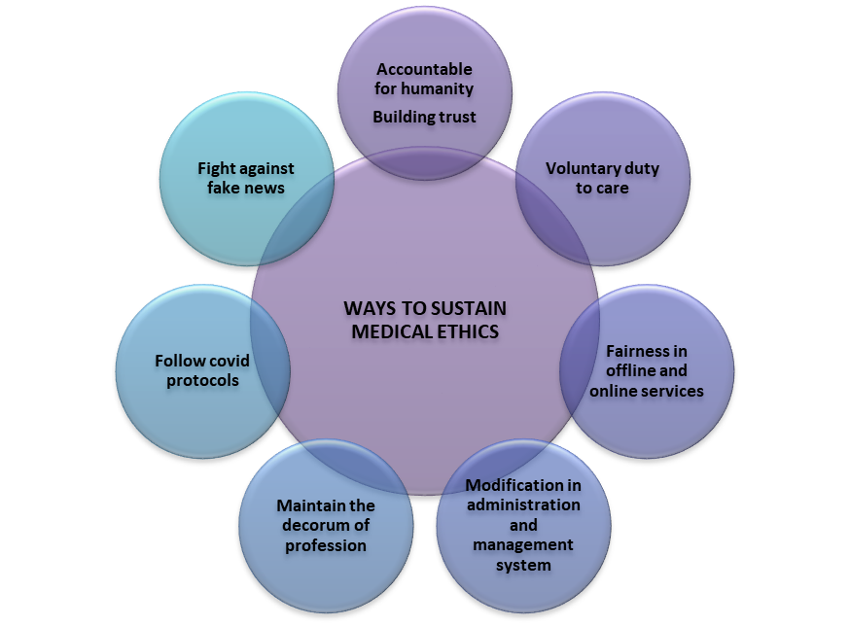
Figure 2: Recommendations for sustaining medical ethics standards
CONCLUSION
Doctor-patient relationships exist on trust and confidence. Hospitals aim to shell out the maximum money from patients' pockets in India, which needs to be stopped with the Governing bodies like NABH(National Accreditation Board for Hospitals & Healthcare Providers) upholding the right to grant or withdraw certification in case of malpractice. Medical ethics enact as a shield for patients when hospitals follow illegal practices. Medical ethics abide by government regulations, and hospitals and medical staff are obliged to the patients, health professionals and society. The research study suggests that medical professionals and healthcare providers measure integrity regarding their duties and responsibility towards patients. They must keep their morale high and serve the patients with humanity. The resilient medical system must not be greedy. Medical facilities should be accessible to everyone, irrespective of their income status. Medical staff must adopt the ethical principles of treating the patient with utmost conviction.
REFERENCES

- Anand, A., Sethi, N., Sharon, G., Mathew, G., Songara, R., & Kumar, P. (2010). Internet pharmacy: Need to be implemented in India. Chron Young Sci., 1:16–25. [Google Scholar].
- Chang, D., Xu, H., Rebaza, A., L., Sharma, C. D., & Cruz. (2020). Protecting health-care workers from subclinical coronavirus infection. Lancet Respir Med., vol. 8, p. 13, .
- Christian MD, S. C. (2014). Triage: care of the critically ill and injured during pandemics and disasters. CHEST consensus statement. Chest; 146:4, pp. Suppl:e61S-e74S.
- Crawford SY. (2003). Internet pharmacy: Issues of access, quality, costs, and regulation. J Med Syst., pp. 27:57–65. [PubMed] [Google Scholar].
- G. V. (2020). Clinical ethics during the Covid-19 pandemic: Missing the trees for the forest. Indian J Med Ethics, vol. 5, no. 3, pp. 182-187,
- Ganesan, R. S., & Thambusamy, R. X. (2020). Ethics in Business: A Case Study of a Pharmaceutical Company. The European Journal of Social & Behavioural Sciences, 28 (2), 105-111. https://doi.org/10.15405/ejsbs.273.
- Hebbar, P., Sudha, A., Dsouza, V., Chilgod, L., & Amin, A. (2020). Healthcare Delivery in India amid the Covid-19 Pandemic: Challenges and Opportunities. Indian Journal of Medical Ethics, pp. 01-04.
- Internet healthcare coalition. (2001, Oct. 4). [press release]. Retrieved from New Survey shows a disparity between Web developers and consumers over Health: URL: http://www.ihealthcoalition.org/about/ihc_pr8.html [accessed 2001 April 17]
- K, H. D., & Goldrich, M. (2006). Physician obligation in disaster preparedness and response. Camb Q Healthc Ethics, 15(4), 417–31.
- KA, D. ( 2001). Ethical Challenges of Medicine and Health on the Internet: A Review. J. Med Internet Res., vol. 3, no. 2, p. 23.
- Kaur, S. P., & Gupta, V. (2020). COVID-19 Vaccine: A comprehensive status report. Virus Research, 288, 198114. https://doi.org/10.1016/j.virusres.2020.198114.
- Latham, S. (2004). Ethics in the marketing of medical services. Mt Sinai J Med., 71(4):243-50. PMID: 15365590.
- Lee SM, K. W.-R. (2018). The psychological impact of the 2015 MERS outbreak on hospital workers and quarantined hemodialysis patients. Compr Psychiatry, 87: 123–27.
- Liu, Q., Luo, D., Haase, J., Guo, Q., Wang, X., Liu, S., . . . Yang, B. (2020). The experiences of healthcare providers during the COVID-19 crisis in China: a qualitative study. Lancet Glob Health, 8(6):e790-e798. DOI: 10.1016/S2214-109.
- Lloyd, S., Walker, S. M., & Goswami, A. (2020). Health information: Applications and challenges in the COVID-19 pandemic. Asia Pacific Journal of Health Management, vol. 15, no. 3, p. 23–28,
- Lumens, (. n. (n.d.). Core requirements of successful businesses. Retrieved from https://courses.lumenlearning.com/boundless-management/chapter/core-requirements-of-successful-managers/
- Malik, C., Laux, T., & Jain, Y. (2020). Clinical ethics during Covid-19: Plan for the whole health ecosystem. Indian Journal of Medical Ethics, 1-2. DOI: 10.20529/IJME.2020.065. Epub ahead of print. PMID: 32546454.
- Maunder R, H. J. (2003). The immediate psychological and occupational impact of the 2003 SARS outbreak in a teaching hospital. . CMAJ, 168: 1245–51.
- Pujari, P., & Kumar, A. (2021). Impact of Covid-19 on the Mental Health of Healthcare Workers: Predisposing factors, prevalence and supportive strategies. Asia Pacific Journal of Health Management, vol. 16, no. 4, pp. 260-265,
- Qian Liu, D. L. (2020). The experiences of health-care providers during the COVID-19 crisis in China: a qualitative study. The Lancet Global Health, 8(6), e790-e798.
- Rosenbaum, S., Bayer, R., & Bernheim, R. (2011). Ethical considerations for decision-making regarding allocating mechanical ventilators during a severe influenza pandemic or another public health emergency. Atlanta: Centers for Disease Control and Prevention.
- Roy, B. K. (2022). Ethical Conflicts Among the Leading Medical and Healthcare Leaders. Asia Pacific Journal of Health Management, 17(1). https://doi.org/10.24083/apjhm.v17i1.1491.
- Singhal, P. ( 2021). Overcharging for Covid treatment: Panchkula private hospitals to return Rs 20 lakh, most refunds processed, say authorities, Panchkula: The Indian Express.
- Winker, M., Flanagin, A., Chi-lum, B., White, J., Andrews, K., & Kennett, R. (2020). Guidelines for medical and health information sites on the Internet: principles governing AMA websites. American Medical Association. JAMA, 283(12):1600-1606.
- Yousf, A., Muuti, Ariffin, M. Z., A., L., & Tan, M. (2020). Sharing Information on COVID-19: the ethical challenges in the Malaysian setting. Asian bioethics review, 12(3), 1–13. Advance Yusof online publication. https://doi.org/10.1007/s41649-020-00132-4.

