Secured Healthcare system using Watermarking and Blockchain Technology
C. Ananth¹ and N. Mohananthini²
¹Assistant Professor/Programmer, Department of Computer and Information Science, Annamalai University, Annamalainagar-608002, Tamilnadu, India email: ¹ananth.prog@gmail.com
²Associate Professor, Department of Electrical and Electronics Engg., Muthayammal Engineering College, Rasipuram-637408, Tamilnadu, India. email: ²mohananthini@yahoo.co.in

- INTRODUCTION
In recent times, digital communication and information technology have developed the potential of a digital multimedia object includes text, image, audio and video. The digital images are certainly one of the important objects for rapid communication through internet from one area to required area. The digital image communications through open network have various threats like illegal copying and modifying the original information without the knowledge of the owner. To overcome this, digital watermarking comes to our rescue as a useful technology for preventing the misuse of an image and protecting the copyright of digital images. Berghel et al. [1] discussed the mode of prevention from illegal copying, by allowing the rightful owner to possess a protected image and the corresponding copyright.
In a single watermarking method, limited information is embedded at a time. An extension in single watermarking technique is needed for the benefit of embedding more different type of related information at the same time. The foretold extension of “single watermarking” technique is called now as ‘Multiple Watermarking’ technique. The primary intension of the present work is to design and develop an efficient algorithm for multiple-watermarking technique. Sheppard et al. [2] and Mohananthini et al. [3] introduced some interesting properties for multiple watermarks and discussed some potential security problems in multiple watermarking applications that are not applicable for single watermarking applications.
The Blockchain technology is extremely popular nowadays; the name itself indicates the Blockchain as a chain of blocks contains information. This technique was regionally described in 1991 by the group of re-structures and was regionally extended to timestamps digitized documents. It is not possible to tamper with them almost like a notary. However, it was first described by Satoshi Nakamoto in 2009 to create digital crypto currency as Bitcoin [4]. The Blockchain is a distributed ledger that is completely open to anyone. Once the block is created, the information can never be erased or altered because of every single transaction is verified by all the group members. The authors [5] conclude with the point that Blockchain applications focus on 80.50% of the papers in Bitcoin system and 19.50% deals with other applications such as healthcare, law enforcement, online music, smart contracts and voting. It is essential to find the present applications developed by using Blockchain technology. Recognizing the different applications help us to understand other directions and ways of using of the Blockchain technology. This technology raises its own privacy and security concerns now as it offers a new concept for distributing the information [6].
The current investigation starts initially with the multiple watermarking techniques without optimization; which in turn helps in addressing different problems like high security, more robustness and to preserve the privacy of the original information. Subsequently, in the present research the multiple watermarking techniques have been carried out with optimization to maximize the performance of imperceptibility and robustness using an artificial bee colony algorithm. Further, the present work is extended to the Blockchain technology. It’s presents a shared, immutable and transparent record of all the
communications to build the applications with trust, transparency and accountability. This technology provides a unique opportunity to develop a trustable and secured data sharing and supervision system.

- MULTIPLE WATERMARKING TECHNIQUES
The current research elaborates the three main categories of multiple watermarking techniques such as successive, segmented and composite watermarking.
  - Successive Watermarking Technique
In successive watermarking technique, the watermarks are embedded one after the other and then the watermarks are extracted in the same order. This technique is useful in the applications, where extract of one watermark should depend on the extraction of other watermark. This approach as also referred as Re-watermarking technique.
  - Segmented Watermarking Technique
In the segmented watermarking technique, the original image is partitioned into disjoint segments and each watermark is embedded into its specific share. In the segmented watermarking technique of embedding process, one watermark is embedded into odd-numbered rows and other watermark is embedded into even-numbered rows in low frequency subbands of the original image. It is also referred as interleaved watermarking.

  - Composite Watermarking Technique
In composite watermarking technique, more than one watermark is combined into a composite watermark which is subsequently embedded into the image. Image fusion is the process of mixing information from two or more images of a scene into a composite image that is certainly more beneficial and is also far better with regard to visible conception or computer finalizing.
- APPLICATIONS OF WATERMARKING TECHNIQUES
Depending on the applications of watermarking, copyright protection and medical safeties are used to prevent an illegal copying, altering or modifying for digital images. Further for Secure Communications, the Blockchain technology is applied to the images. The current investigation of various watermarking algorithm focuses on copyright protection is required to be robustness and the medical safeties can be achieved the confidentiality and security of medical image without being seen by unauthorized persons. A brief review is presented on copyright protection and medical safeties and secure communications.
  - Copyright Protection
Copyright protection is to embed data about the source and thus normally the copyright owner of the data in order to check other parties for claiming the copyright of the data. A very high level of robustness is requiring this application and the watermark is used to decide rightful ownership. Thawkar [7] presented an invisible image watermarking scheme for copyright protection. Their technique provides high capacity and minimum computations.
Ibrahim Alsonosi Nasir and Ahmed Abdurrman [8] proposed a new color image watermarking scheme for copyright protection. Using discrete wavelet domain, the multiple watermark bits are embedded in the luminance component or the blue component of a color image. Experimental results demonstrate that their proposed scheme successfully makes the watermark is perceptually invisible in addition to robust to common signal processing and geometric attacks. Sahraee et al. [9] proposed a robust watermarking algorithm based on quantization of distance among wavelet coefficients for copyright protection. Experimental results show that their proposed method is quite robust against attacks.
  - Medical Safety

The medical safety application of the multiple watermarking techniques ensures that each doctor inserts his diagnosis in the medical image without degrading it. With any new diagnosis insertion, the image must always keep its clarity and its characteristics. Giakoumaki et al. [10] applied multiple watermarking in medical images the physician's digital signature, patient's personal and examination data, keywords for image retrieval, and a reference watermark for the purpose of data integrity control. Their experimental results demonstrate the efficiency and transparency of the watermarking scheme, which conforms to the strict limitations that apply to regions of diagnostic significance.
Nagaraju et al. [11] presented a technique of analysis and estimation of noise during embedding patient information inside medical image. The robustness of their proposed algorithm are tested and analyzed by applying attacks to the medical image with patient data will not degrade its quality. Coatrieux et al. [12] focused on the complementary role of watermarking with respect to medical information security and management. Their reviewed watermarking has been deployed and concluded that watermarking has found a niche role in healthcare systems, as a protection of medical information, for secure handling and sharing of medical images. In image watermarking, the medical images are embedded with hidden information that may be used to assert ownership, verify the numerical integrity and increase the security of medical images.
3.3 Secure Communications
The Blockchain technology, along with some of its significant features and benefits, is discussed in [13]. The technology, still evolving with a lot of scope for different domains and industries, is set to change the world. But, it is not free from challenges; some of them have been highlighted too. Although Blockchain is the technology behind Bitcoin, its use is not limited to financial domain only. The year 2016 revealed Blockchain as more disruptive technology in the retail industry than any other industry and, in 2017, the Blockchain was gradually becoming the dominant hype phrase for retailing. Deepayan Bhowmik and Tian Feng [14] proposed a novel watermarking based multimedia Blockchain framework that can address some of the issues. The unique watermark information contains two pieces of information as cryptographic hash that contains transaction histories and an image hash that preserves the retrievable original media content. Once the watermark is extracted, the first part of the watermark is passed to a distributed ledger to retrieve the historical transaction trial and the latter part is used to identify the edited / tampered regions. Alevtina Dubovitskaya et. al. [15] presented the perspectives on Blockchain based healthcare data management, in particular, for the EMR data sharing between the healthcare providers and the research studies. The framework helps manage and sharing the EMR data for the care of cancer patients.
- IMPLEMENTATION OF BLOCKCHAIN TECHNOLOGY
The main focus is to invent innovative ways by which a secure communication in image watermarking. From the literature review, if is inferred that designing a single watermarking method with robustness is a little difficult task. In this context, it has been decided to undertake an extension of watermarking techniques to achieve better robustness. Multiple watermarks is to convey multiple sets of information designed to suit similar or differing objectives and is used to increase robustness with different methods in which the embedded information is not easily lost. The other attractive scheme is to develop a blockchain technology in healthcare system. The details of these efforts are presented in the following sections.

The Blockchain technology presents a shared, immutable and transparent record of all the communications to build the applications with trust, transparency and accountability. This technology provides a unique opportunity to develop a trustable and secured EMR data sharing and supervision system.
The Blockchain technology has three types as indicated below:
Public: The public Blockchains have ledgers to notice every person on the internet and any person can verify and add a block of transactions to the Blockchain.
Private: The private Blockchains allow only specific persons in the organization to verify and add transaction blocks, but every person on the internet is normally allowed to view.
Consortium: The consortium Blockchains allow only a group of organizations (like banks) which can verify and add transactions, but the ledger can open or restricted to selected groups.
The proposed method discussed three scenarios of multiple watermarking schemes using private Blockchain technology in the healthcare system. The block diagrams of embedding and extraction method are shown in Fig. 1 and Fig. 2.
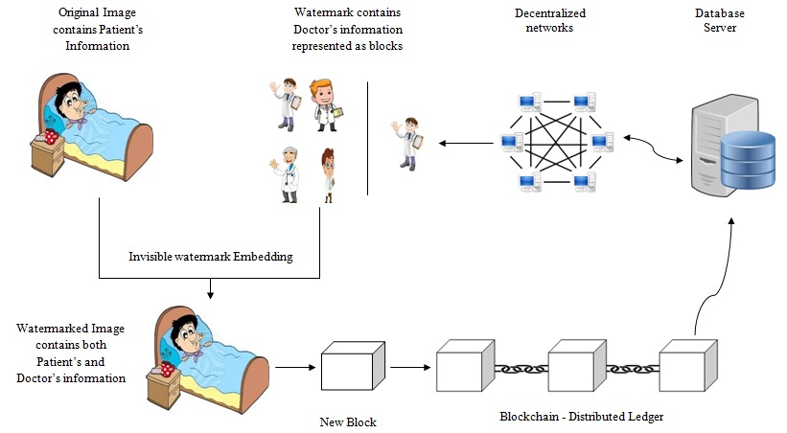
Figure. 1 The block diagram of embedding method

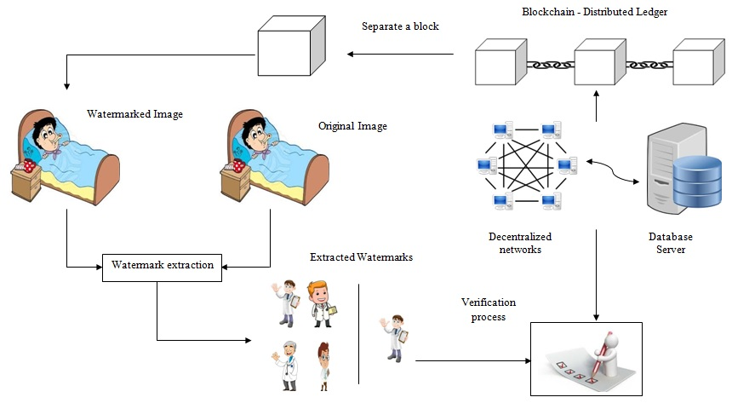
Figure. 2. The block diagram of extraction method
4.1 Healthcare system using Blockchain technology
Fig. 3 shows the overview of healthcare system using the Blockchain technology. It contains three blocks, such as primary care (genesis block), cross-disciplinary referral (block 2) and multidisciplinary approach (block 3). Each block has separate hash and the hash of the previous block. Subsequently, block 3 points the block 2 and the block 2 points the block 1. The initial block is a special, it cannot point the previous block because it is the initial one. Hence, the initial block is called the genesis block. If any change occurs in any block, it will make all the following blocks are invalid, since it no longer has the capacity to store the valid hash of the previous block. Hence, it is not possible to change any block in the distributed ledger of the Blockchain technology.
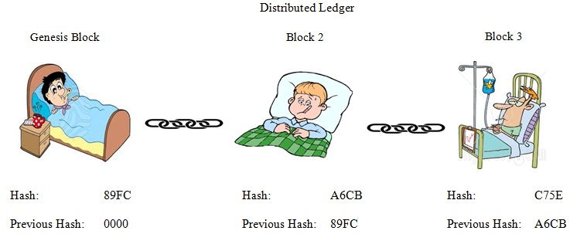
Figure. 3 Overview of Healthcare system using Blockchain technology
- CONCLUSION
The present work investigates the multiple-watermarking techniques with Blockchain Technology. The work analyzes the imperceptibility on watermarked image, high security and more robustness for multiple watermarks. Besides, the proposed work widens the scope for the implementation of blockchain technology in the multiple watermarking. The vital role of this method enables the medical records immutable, keeps them protected and permits sharing inside a decentralized network. In this work, the blocks are defined as high level scenarios and their protocols are essential to apply this new technology in the healthcare system.

- REFERENCES
- H. Berghel and L. O’Gorman, “Protecting Ownership Rights through Digital Watermarking”, IEEE Computer, Vol. 29, No. 7, pp. 101-103, 1996.
- N. P. Sheppard, R. Shafavi-Naini, and P. Ogunbona, “On multiple watermarking”, Proceedings of the ACM Multimedia and Security Workshop (MMSW), pp. 3-6, 2001.
- Mohananthini. N and Yamuna. G. Multiple Image
Watermarking Technique Based on Hybrid DWT-SVD and
Artificial Neural Network, International Journal of Applied
Engineering Research, 10 (3), pp. 7275-7297, 2015.
- Nakamoto, Satoshi. “Bitcoin: A peer-to-peer electronic cash system”, 2008.
- Yli-Huumo J, Ko D, Choi S, Park S, Smolander K, “Where Is Current Research on
Blockchain Technology?—A Systematic Review”, PLoS ONE. 11, 1-27, 2016.
- William Gordon, Adam Landman, “Blockchain in Health Care: Decoding the Hype”,
https://catalyst.nejm.org/decoding-blockchain-technology-health/, 2017.
- Shankar Thawkar, “Digital Image Watermarking for Copyright Protection”, International Journal of Computer Science and Information Technologies, Vol. 3, Issue 2, pp. 3757–3760, 2012.
- Ibrahim Alsonosi Nasir., and Ahmed B. Abdurrman., “A Robust Color Image Watermarking Scheme based on Image Normalization”, Proceedings of the World Congress on Engineering, Vol.3, pp. 2238–2243, 2013.
- Sahraee, M. J., and Ghofrani., “A Robust Blind Watermarking Method using Quantization of Distance between Wavelet Coefficients”, Springer, Vol. 7, pp. 799–807, 2013.
- Giakoumaki, A., Pavlopoulos, S., and Koutsouris, D., “A Multiple Watermarking Scheme Applied to Medical Image Management”, Annual International Conference of the IEEE, Vol. 2, pp. 3241–3244, 2004.
- C. Nagaraju and S. S. ParthaSarathy, “Analysis and Estimation of Noise in Embedded
Medical Images”, I.J. Image, Graphics and Signal Processing, Vol. 3, pp. 45-50, 2015.
- Coatrieux, G., Lecornu, L., Roux, Ch., Fellow, and Sankur, B., “A Review of Image Watermarking Applications in Healthcare”, 28th Annual International Conference of the IEEE on Engineering in Medicine and Biology Society, pp. 4691–4694, 2006.
- Arijit Chakrabarti, Ashesh Kumar Chaudhuri, “Blockchain and its Scope in Retail”,
International Research Journal of Engineering and Technology, 04 (07), 3053-3056, 2017.
- Deepayan Bhowmik, Tian Feng, “The multimedia blockchain: A distributed and tamperproof media transaction framework”, IEEE international conference on Digital Signal Processing, 2017.
- Alevtina Dubovitskaya MS, Zhigang Xu MD, Samuel Ryu MD, Michael Schumacher,
Fusheng Wang, “Secure and Trustable Electronic Medical Records Sharing using
Blockchain”, AMIA Annual Symposium Proceedings, 2017.

