HEALTH PER ACRE

Organic Solutions to Malnutrition In India

INTRODUCTION

Food, nutrition, health, prosperity, future and growth, as well as hunger, disease, poverty, despair, and national collapse are hotly debated topics. There is not only a correlation, but also a cause-and-effect relationship. Farming, one of the oldest and most tried-and-tested occupations in the world, is no longer an economically viable business for most people, as evidenced by the thousands of farmers around the world. India has been suicidal in the past two decades. However, the question that needs to be answered is whether our farmers committed suicide or our country. The main purpose of a country's agriculture is to promote health and feed people, and to propagate a diet that provides all the necessary nutrients. However, profit maximization has been promoted as the goal of agriculture. The sad thing is that the more profitable agriculture is, the higher the farmer's debt and suicides, and the worse the food and nutrition crisis becomes. The irony is that, despite all claims, profit maximization for farmers is still far from achieved[1], but the country has paid a hefty price. Most proponents of conventional agriculture argue that pesticides, one of the most widely used chemicals in agriculture, have a negligible impact on human health. However, millions of tons of pesticides injected into the environment each year in the name of high-yield agriculture somehow reach the human body, as well as water bodies, fish, birds and other animals. This is clear from the fact that quantifiable levels of certain pesticides have been detected in breast milk, placing breastfed infants probable risk [2] the risk is not insignificant but uncertain. The alarming levels of chemicals in honey sold in the Indian market have recently sparked much discussion. Science and technology were born for the benefit of people. In contrast, science and technology in agriculture is beneficial to human greed. Due to the intensive irrigation needs of conventional agriculture, some perennial rivers in the world do not reach the sea but are half-dry. As a major contributor to global warming, conventional agriculture also has negative health impacts. We will limit our discussion in this chapter to the impact of conventional agriculture on populations and individual health. This report compares the nutritional and health aspects of foods from organic farming and foods from conventional farming. The scope of the chapter ranges from nutrition produced per acre of farmland by two farming systems to disease trends in populations and how these trends may be related to the food we consume. Conventional farming measures "yield" per acre while excluding chemical input costs, as well as environmental and health costs of chemicals. "Yield" measures the results of a monoculture, while what we need to measure are the various outcomes of an agricultural system. Yield also doesn't tell us about a food's nutritional value. With a focus on health and nutrition, we measure health per acre rather than yield per acre.

WHAT IS “HEALTH”?

Over the centuries, human health has attracted the attention of many people. The health of individuals, families and populations has shaped society, culture, nation and history. Health is so important at all levels of social organization and ignoring it can not only be futile but also politically and socially irresponsible. Ancient civilizations understood the importance of health on both an individual and on a community level. Various myths around the world have mentioned Gods giving blessings to their followers. Apollo in Greek and Roman mythology and Dhanvantri in Hindu mythology are associated with health and healing. Reality shows that the concept of health is old. Health is not a new achievement for mankind, nor is it a remarkable achievement of recent times.
Although the concept of health is controversial, there are several accepted definitions. According to Ayurveda, a system of traditional medicine that originated in the Indian subcontinent, health is defined as "Samadoshah Samagnischa Samadhatumala kriyaha, Prasanna Atmendria Manaha Swastha Ityabhidheeyate". This definition of health, coined by Vagbhat, means one who always eats healthy food, leads a normal lifestyle, gives and forgives, loves truth and serves others, in good health. Only when a person is in harmony physically, mentally, psychologically and emotionally will he be healthy. Patanjali, the founder of yoga philosophy and practice, states that illness and ill health can hinder the eightfold path leading to Samadhi, a sense of well-being also known as union with the Almighty. Biblical principles, especially the Old Testament, deal with nutrition and health. Ezekiel was tasked with making nutritious multigrain bread. The health laws given to Moses by God did not emphasize the treatment of disease, but rather the promotion of health through the prevention of disease. Moses recognized the effectiveness of prevention rather than cure and propagated the idea of ​​pure food, pure water, clean air, clean body, and healthy dwelling place. Biblical principles are timeless and are as valid today as they were when they were first discovered. According to the Bible, God treats the disease at its source, not the symptoms. The biblical concept of health is very holistic and includes all physical, mental, spiritual, and social aspects of a person. According to the Bible, there is more to health than simply the absence of disease. There is a sense of well-being, fullness,whole, complete, peaceful and prosperous. It focuses on being properly related to God, and therefore appropriately related to everything and everyone else. He is equipped for God's calling and purpose.
Muslims consider good health as a gift from Allah that guarantees salvation in the Hereafter and ensures enjoyment of life in this world. The Quran explicitly mentions "Eat and not be prodigal" (7:31). This guide forces the followers of the Quran to eat or drink the right foods in the right amounts. It also forbids overeating as it is not healthy. The Buddha considered health to be the greatest gift, the gift without which life is not life but a state of suffering and the image of death. According to the Buddha, keeping the body healthy is a duty without which it becomes difficult to keep the mind strong and clear. The Buddhist understanding of good health emphasizes the balanced interaction between mind and body and between life and its environment; Disease tends to occur when this delicate balance is disturbed.
The importance of health need not be quoted from ancient scriptures. We have all seen sickness and death all around us. The pain and suffering associated with poor health became even more evident. The World Health Organization defines health as follows: "Health is a state of complete physical, mental and social well-being and not merely the absence of disease or infirmity". The bibliographic citation for this definition is: Preamble to the Constitution of the World Health Organization adopted by the International Health Assembly, New York, June 19 to July 22, 1946; it was signed by representatives of 61 states and went into effect on April 7, 1948. This definition has been broadened in recent years to include the ability to lead to a "residentially productive life." social and economic." Over the years, we have adopted a new philosophy of health, which can be stated as follows [3]:

1) Health is a basic human right

2) Health is the essence of productive life and not the result of increasing spending on medical care
3) Health is interdisciplinary

4) Health is an integral part of development

5) Health is at the heart of the concept of quality of life

6) Health involves personal, state and international responsibility

7) Health and maintaining it is a great social investment

8) Health is a global social goal

Take a legal stance on health. The Constitution of India, Section 4, stipulates that "The State shall regard the enhancement of the nutritional and living standards of the people and the improvement of public health as one of its principal functions".

Based on the above quotes, we can safely conclude that overall health can be achieved through a combination of physical, mental and social health; together these factors are called the triangle of health. Philosophically, a spiritual component can be added, making it a quadrilateral of health. We can now be sure that social welfare is just as important to achieving good health as a disease-free body and mind. Modern people pay great attention to a completely new type of outdated food that has been scientifically modified to ensure the health of individuals and communities. Are we really sure about the food we eat? Is the nutrition and health provided by this nutrition in harmony with the dreams of Patanjali, Jesus, Muhammad and Buddha? Are we really spreading the word about health?
As of June 24, 1996, the cover story of TIME magazine commented: "Western medicine is at its best in the midst of a crisis, battling acute infections, healing the wounds of war, fighting, replacing a kidney or a heart in America. But increasingly, what has plagued America and other prosperous societies are chronic diseases, such as high blood pressure, back pain etc and acute diseases become chronic, such as cancer and AIDS. In most of them, stress and lifestyle play an important role. “Stress has always been and will always be associated with human life. Whether current levels of stress in people's lives are at an all-time high is debatable. Convenience doesn't seem to have penetrated the suffering mind yet. Why do we react so badly to stress? Are we confident that our changing eating styles are not causing high stress levels? In addition, lifestyle-related diseases may also be referred to as “DIET STYLE-RELATED DISEASES”.
Subsequent paragraphs will shed light on the nutritional value of the foods most consumed by modern humans and will also compare it with the nutritional value of the foods that should ideally be consumed. The food dilemma is all too clear with the advent of success stories created by giant agribusiness organizations, which act out of greed and gluttony rather than compassion and promise to solve the global food crisis

WHAT IS NUTRITION?

Nutrition can be defined as the science of food and its relationship to health [3]. It is mainly concerned with the role of nutrients in the growth, development and maintenance of the body. Good nutrition means “maintaining a nutritional state that helps us grow well and stay healthy”. Nutrients are organic and inorganic complexes found in foods. Each nutrient has a specific function in the body. Nutrients can be classified as follows:
1) Macronutrients: they are the main components of food. These are proteins, carbohydrates and lipids.
2) Micronutrients: they are needed in small amounts. These are vitamins and minerals.
Today, food is viewed very differently than merely a source of the nutrients mentioned above. There are a number of bioactive compounds in plant foods, some of which have health benefits attributed to the presence of such compounds in the diet. Studies have shown that people who increase their consumption of fruits and vegetables have lower rates of chronic non-communicable diseases such as cancer, heart disease, diabetes, and age-related cognitive decline [4]. . Scientists agree on the health benefits of eating fruits and vegetables. The American Heart Association and The American Cancer Society recommend consuming plenty of fruits and vegetables daily. Previously, it was thought that the health benefits of fruits and vegetables could be attributed to the antioxidant effects of the micronutrients contained in them in high amounts.
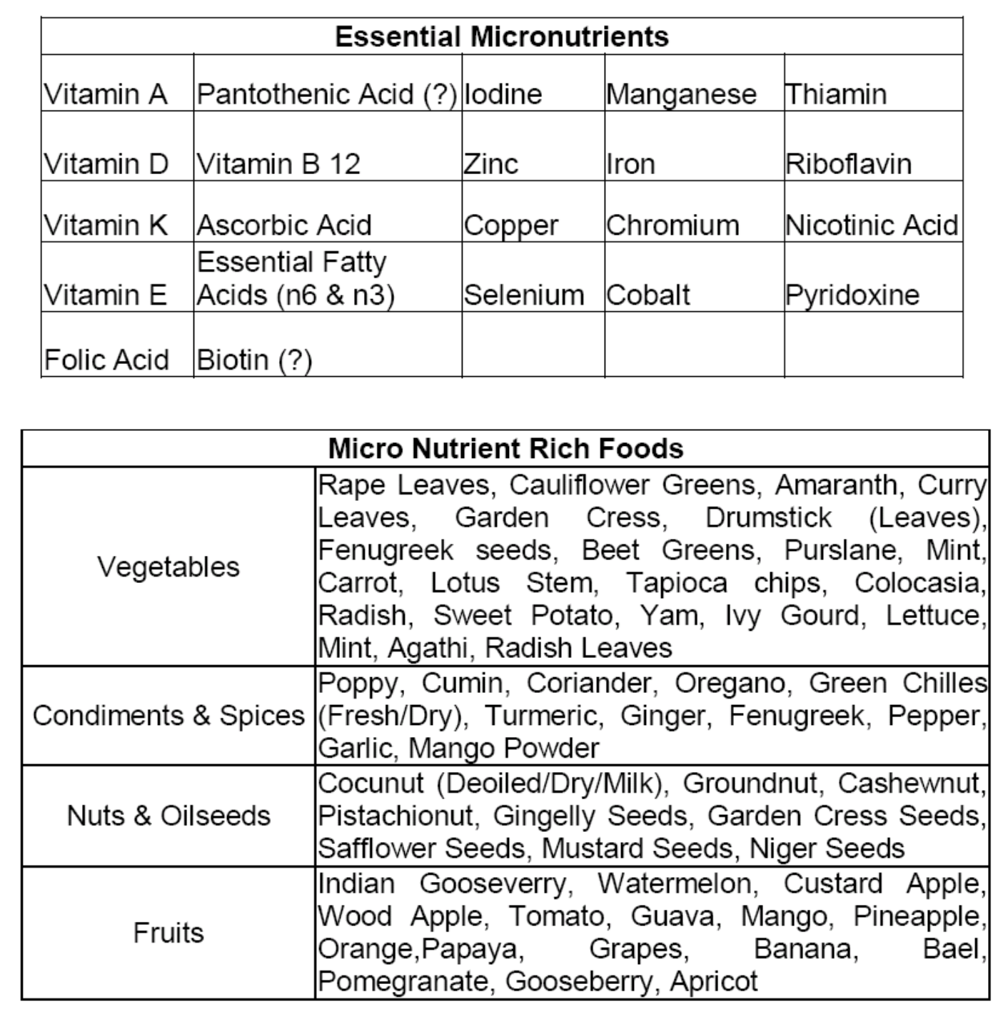

It also calls for the need for further research to isolate these protective compounds in plant foods for therapeutic purposes. Scientists studied the incidence of various chronic diseases in people consuming vitamin, mineral and antioxidant supplements. Incidentally, these people are no better off than the general population in terms of rates of cancer, heart disease, and other chronic diseases. The researchers were forced to think outside the box. There are some other things to grow food that are
Unknown. Finally, compounds such as phytochemicals, phenols, flavonoids, etc., found in plants have been recognized as health-promoting chemicals [4,5,6,7,8]. Studies have linked these bioactive compounds with the prevention of chronic noncommunicable diseases [7,8]. These compounds contribute significantly to the total antioxidant activity of fruits and vegetables. These compounds give an electron to reactive oxygen species (ROS produced in the body due to stress, smoking, illness, etc.) ROS is highly reactive and damages cellular macromolecules (proteins, membranes, DNA, RNA, etc.). ROS is believed to be the cause of cancer, cardiovascular disease, diabetes, and other long-term chronic diseases.

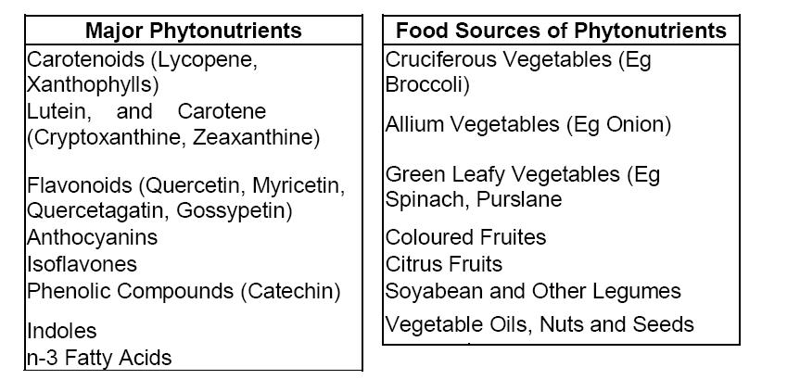

In addition, reports from WHO and The Food and Agriculture Organization of the United Nations point to a link between food and nutrition with the prevention of non-communicable diseases, as well as between phytochemicals with the prevention of heart disease and cancer. Many of these phytochemicals have been present in the traditional Indian diet (mostly vegetarian with Indian spices), a fact that may explain the low incidence of cancer in the Indian population compared to other developed countries. Many aspects of nutrition are still unknown to us. To act safely, we should always obtain food from a variety of sources [8.10]. So the concept of a balanced diet is as wise today as it once was. The following is an excerpt from a report issued by the Planning Commission, Govt. of India [11]
“Three basic approaches to addressing micronutrient deficiencies are: drug supplementation, food fortification, and dietary fortification through diversification and increased intake of micronutrient-rich foods. The first two approaches can only support one or two nutrients. For long-term sustainability and to ensure adequate intake of less recognized but deficient nutrients and phytochemicals, dietary diversification is the most sensible and sustainable option. Moreover, its implementation can be done by the community and it can be linked to income generation, especially for rural women.
Summary of Recommended Daily Allowance for Indians[3]
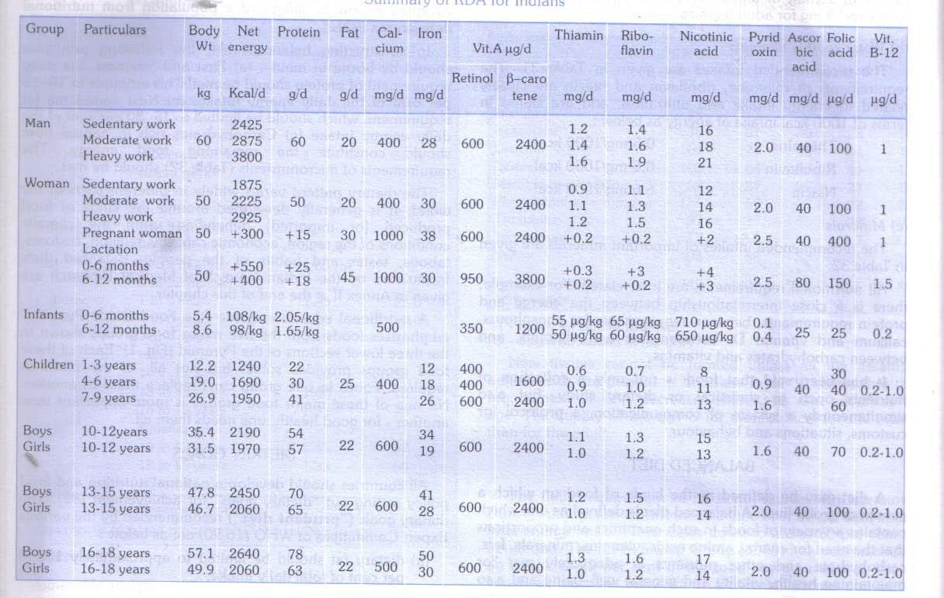

Underneath, we present a brief description of some of the major nutrients[3].
Proteins

Protein plays an important role in the human diet. They are complex organic nitrogen compounds. Proteins are made up of smaller units called amino acids. The human body needs about 24 amino acids, of which 9 are essential because they cannot be synthesized by the human body in adequate quantities. Therefore, these nine amino acids must come from dietary protein. The essential amino acids are leucine, isoleucine, lysine, methionine, phenylalanine, threonine, valine, tryptophan, and histidine. A protein is said to be biologically complete if it contains all the essential amino acids. Proteins are required for body building, maintenance of vital functions, repair, maintenance of osmotic pressure, and synthesis of antibodies, plasma proteins, haemoglobin, enzymes, hormones, and coagulation factors. Cereals and pulses are the main sources of dietary protein in India. Daily human requirement of protein is 1 g of protein per kg of lean body weight. 1 g of protein produces 4 kcal of energy. Insufficient intake or malnutrition leads to protein-energy malnutrition manifesting in two clinical forms, kwashiorkor and marasmus. The prevalence of protein-energy malnutrition among preschool children in India is about 12%. Good nutrition is especially important during the first 5 years of life. Malnutrition in children affects their mental and physical development, sometimes leaving them permanently disabled. Such undernutrition often leads to deficiency syndrome, where many nutrients are deficient in the same patient

.

NUTRITIONAL STATUS OF INDIAN CHILDREN

STATE | 1 | 2 | 3 | 4 | 5 | 6
India | 24.5 | 46.3 |  | 55.8 | 38.4 |  | 19 | 45.9
Andhra Pradesh | 24.6 | 62.7 |  | 63.7 | 33.9 |  | 13 | 36.5
Arunachal
Pradesh | 58.6 | 60 |  | 77.6 | 34.2 |  | 17 | 36.9
Assam | 50.9 | 63.1 |  | 59.6 | 34.8 |  | 13 | 40.4
Bihar | 3.7 | 27.9 |  | 57.3 | 42.3 |  | 28 | 58.4
Chhatisgarh | 25 | 82 |  | 54.5 | 45.4 |  | 18 | 52.1
Goa | 59.4 | 17.7 |  | 69.8 | 21.3 |  | 12 | 29.3
Gujarat | 27.8 | 47.8 |  | 57.1 | 42.4 |  | 17 | 47.4
Haryana | 22.1 | 16.9 |  | 44.8 | 35.9 |  | 17 | 41.9
Himachal Pradesh | 45.4 | 27.1 |  | 66 | 26.6 |  | 19 | 36.2
Jammu & Kashmir | 31.6 | 42.3 |  | 58.3 | 27.6 |  | 15 | 29.4

Jharkhand |  | 10.7 | 47.8 | 65.3 | 41 | 31 | 59.2
karnataka |  | 35.7 | 58 | 72.5 | 38 | 18 | 41.1
Kerala |  | 56.5 | 56.2 | 93.6 | 21.1 | 16 | 28.8
Madhya Pradesh |  | 15.9 | 21.6 | 51.9 | 39.9 | 33 | 60.3
Maharashtra |  | 52 | 53 | 47.8 | 37.9 | 15 | 39.7
Manipur |  | 57.8 | 61.7 | 78.1 | 24.7 | 8.3 | 23.8
Meghalaya |  | 57.8 | 26.3 | 76.3 | 41.7 | 28 | 46.3
Mizoram |  | 66.4 | 46.1 | 84.6 | 30.1 | 9.2 | 21.6
Nagaland |  | 54.2 | 29.2 | 71 | 30.3 | 15 | 29.7
Orissa |  | 54.8 | 50.2 | 67.5 | 38.3 | 19 | 44
Punjab |  | 12.7 | 36 | 50 | 27.9 | 9 | 27
Rajasthan |  | 14.1 | 33.2 | 38.7 | 33.7 | 20 | 44
Sikkim |  | 42.9 | 37.2 | 89.6 | 28.9 | 13 | 22.6
Tamil Nadu |  | 58.8 | 33.3 | 77.9 | 25.1 | 22 | 33.2
Tripura |  | 34.6 | 36.1 | 59.8 | 30 | 20 | 39
Uttar Pradesh |  | 7.3 | 51.3 | 45.5 | 46 | 14 | 47.3
Uttarakhand |  | 33.5 | 31.2 | 51.6 | 31.9 | 16 | 38
West Bengal |  | 23.5 | 58.6 | 55.9 | 33 | 19 | 43.5
A & N Islands | " | " | " | " |  | " | "
Chandigarh | " | " | " | " |  | " | "
D & N Haveli | " | " | " | " |  | " | "
Daman & Diu | " | " | " | " |  | " | "
Delhi |  | 21 | 34.5 | 59.8 | 35.4 | 16 | 33.1
Lakshadweep | " | " | " | " |  | " | "
Puducherry | " | " | " | " |  | " | "

1- Percentage of children who are breast fed within one hour of birth

2- Percentage of children of age 0-5 months who are exclusively breastfed

3- Percentage of children of age 6-9 months who receive semisolid food with breast milk

4- Percentage of children under three years of age who are stunted

5- Percentage of children under three years of age who are wasted

6- Percentage of children under three years of age who are underweight

Source: http://www.medindia.net/health_statistics/diseases/children-breastfed.asp

Fats

Fat is solid at 20 degrees Celsius. If it is liquid at this temperature, it is called an oil. Fats and oils are concentrated sources of energy.

A) Simple lipids - triglycerides

B) Complex lipids - phospholipids

C) Derived lipids - cholesterol.

The human body can endogenously synthesize triglycerides and cholesterol. 99% of body fat in adipose tissue is in the form of triglycerides. Fats provide fatty acids and glycerol when hydrolyzed. Fatty acids are classified into saturated and unsaturated fatty acids, and further divided into monounsaturated fatty acids (MUFA) and polyunsaturated fatty acids (PUFA). Polyunsaturated fats are found in vegetable oils, and saturated fats are found mainly in non-fish animal fats. Essential fatty acids are linoleic acid, linolenic acid, and arachidonic acid that cannot be synthesized in the body. 1g of fat provides 9kcal of energy. By providing energy, fat uses and conserves protein for energy. Fat acts as a vehicle for fat-soluble vitamins (vitamins A, D, E, and K). Fat supports the intestines and protects the body from the cold

Nutritional Status of men and woman in India

STATE | 1 | 2 | 3 | 4
India | 35.6 | 34.2 |  | 12.6 | 9.3
Andhra Pradesh | 33.5 | 30.8 |  | 15.6 | 13.6
Arunachal
Pradesh | 16.4 | 15.2 |  | 8.8 | 7.1
Assam | 36.5 | 35.6 |  | 7.8 | 5
Bihar | 45.1 | 35.3 |  | 4.6 | 6.3

Chhatisgarh |  | 43.4 | 38.5 | 5.6 | 4.9
Goa |  | 27.9 | 24.6 | 20.2 | 15.4
Gujarat |  | 36.3 | 36.1 | 16.7 | 11.3
Haryana |  | 31.3 | 30.9 | 17.4 | 10.8
Himachal Pradesh |  | 29.9 | 29.7 | 13.5 | 10.6
Jammu & Kashmir |  | 24.6 | 28 | 16.7 | 6.2
Jharkhand |  | 43 | 38.6 | 5.4 | 4.9
karnataka |  | 33.5 | 33.9 | 15.3 | 10.9
Kerala |  | 18 | 21.5 | 28.1 | 17.8
Madhya Pradesh |  | 41.7 | 41.6 | 7.6 | 4.3
Maharashtra |  | 36.2 | 33.5 | 14.5 | 11.9
Manipur |  | 14.8 | 16.3 | 13.3 | 9.2
Meghalaya |  | 14.6 | 14.1 | 5.3 | 5.9
Mizoram |  | 14 | 9.2 | 10.6 | 11.4
Nagaland |  | 17.4 | 14.2 | 6.4 | 5.7
Orissa |  | 41.4 | 35.7 | 6.6 | 6
Punjab |  | 18.9 | 20.6 | 29.9 | 22.2
Rajasthan |  | 36.7 | 40.5 | 8.9 | 6.2
Sikkim |  | 11.2 | 12.2 | 15.4 | 11.9
Tamil Nadu |  | 28.4 | 27.1 | 20.9 | 14.5
Tripura |  | 36.9 | 41.7 | 7.1 | 4.8
Uttar Pradesh |  | 36 | 38.3 | 9.2 | 7.3
Uttarakhand |  | 30 | 28.4 | 12.8 | 7.9
West Bengal |  | 39.1 | 35.2 | 11.4 | 5.5
A & N Islands | " | " | " |  | "
Chandigarh | " | " | " |  | "
D & N Haveli | " | " | " |  | "
Daman & Diu | " | " | " |  | "
Delhi |  | 14.8 | 15.7 | 26.4 | 16.8
Lakshadweep | " | " | " |  | "
Puducherry | " | " | " |  | "

1- Percentage of woman whose body mass index (BMI) is below normal

2- Percentage of men whose body mass index is below normal

3- Percentage of woman who are overweight or obese

4- Percentage of men who are overweight or obese

SOURCE: http://www.medindia.net/health_statistics/diseases/nutritional-status.asp

Carbohydrate
Carbohydrates are the main source of energy. 1g of carbohydrate provides 4kcal of energy. There are three main sources of carbohydrates: starches, sugars and cellulose. Cellulose is an indigestible component that contributes to dietary fiber. Starches and complex carbohydrates are digested slowly and help keep body fat in check. Simple carbohydrates or sugars trigger insulin secretion and are quickly absorbed into fat.

Vitamin A

Vitamin A is involved in the maintenance of normal vision, the integrity and normal functioning of glandular and epithelial tissues, skeletal growth, maintenance of immunity, and protection against certain types of cancer such as bronchial carcinoma. Deficiency of vitamin A causes xerophthalmia, which includes ocular (eye) conditions such as night blindness, xeroconjunctiva, Vito's spots, xerokeratosis, and keratomalacia. Vitamin A deficiency also causes follicular keratosis, anorexia, growth retardation, respiratory and intestinal infections, and infant mortality. Malnutrition and vitamin A deficiency are the leading causes of blindness in children.

ESTIMATED PREVALENCE OF BLINDNESS PER 1000 POPULATION

STATE | 1 | 2 | 3 | 4 | 5 | 6
India | 6396 |  | 57565 | 2068087 | 1002063 | 1129985 | 2132048
Andhra Pradesh | 453 |  | 4075 | 146404 | 70938 | 79994 | 150932
ArunachalPradesh | 8 |  | 72 | 2574 | 1247 | 1407 | 2654
Assam | 165 |  | 1486 | 53399 | 25874 | 29177 | 55050
Bihar | 438 |  | 3946 | 141750 | 68683 | 77451 | 146134
Chhatisgarh | 175 |  | 1571 | 56450 | 27352 | 30844 | 58196
Goa | 11 |  | 95 | 3430 | 1662 | 1874 | 3536
Gujarat | 306 |  | 2757 | 99058 | 47997 | 54125 | 102122
Haryana | 126 |  | 1134 | 40740 | 19740 | 22260 | 42000
Himachal Pradesh | 44 |  | 393 | 14104 | 6834 | 7706 | 14540
Jammu & Kashmir | 64 |  | 579 | 20789 | 10073 | 11359 | 21432
Jharkhand | 206 |  | 1857 | 66705 | 32321 | 36447 | 68768
Karnataka | 328 |  | 2953 | 106104 | 514111 | 57975 | 109386
Kerala | 200 |  | 1802 | 64728 | 31363 | 35367 | 66730
Madhya Pradesh | 339 |  | 3050 | 109577 | 53094 | 59872 | 112966
Maharashtra | 569 |  | 5121 | 183993 | 89151 | 100533 | 189684
Manipur | 17 |  | 151 | 5428 | 2630 | 2966 | 55596
Meghalaya | 16 |  | 146 | 5248 | 2543 | 2867 | 5410

Mizoram | 6 | 57 | 2058 | 997 | 11125 | 2122
Nagaland | 11 | 102 | 3655 | 1771 | 1997 | 3768
Orissa | 223 | 2003 | 71957 | 34866 | 39316 | 74182
Punjab | 147 | 1325 | 47600 | 23064 | 26008 | 49072
Rajasthan | 345 | 3103 | 111480 | 54016 | 6912 | 111928
Sikkim | 4 | 34 | 1207 | 558 | 659 | 1244
Tamil Nadu | 383 | 3443 | 123689 | 59932 | 67582 | 1275144
Tripura | 25 | 227 | 8152 | 3950 | 4454 | 8404
Uttar Pradesh | 1118 | 10060 | 361416 | 175119 | 197475 | 372594
Uttarakhand | 56 | 503 | 18069 | 8755 | 9873 | 18628
West Bengal | 498 | 4486 | 161177 | 78096 | 88066 | 166162
A & N Islands | 3 | 23 | 832 | 403 | 455 | 858
Chandigarh | 6 | 53 | 1921 | 931 | 1049 | 1980
D & N Haveli | 1 | 11 | 411 | 199 | 225 | 424
Daman & Diu | 1 | 8 | 301 | 146 | 164 | 310
Delhi | 96 | 866 | 31129 | 15083 | 17009 | 32092
Lakshadweep | 0 | 4 | 153 | 74 | 84 | 158
Puducherry | 7 | 67 | 2398 | 1162 | 1310 | 2472

1- 0-14 YEARS

2- 15-49 YEARS

3- 50+ YEARS

4- MALE

5- FEMALE

6- ALL AGES

SOURCE: http://www.medindia.net/health_statistics/diseases/prevalence-of-blindness-2004.asp

Vitamin E
Also called tocopherol. Acts as an antioxidant in lipid (fat) media.
Vitamin K
Vitamin K exists in two forms, K1 and K2. The role of vitamin K is to stimulate the production and release of specific blood clotting factors.
Thiamine (B1)
Important for carbohydrate utilization (direct glucose oxidation pathway). Thiamine is easily lost from rice during the rice milling process. Deficiency of thiamine causes beriberi and Wernick encephalopathy. These diseases are also manifested by excessive alcohol consumption.
Riboflavin (B2)
Plays a fundamental role in cellular oxidation, plays an important role in maintaining the integrity of mucosal structures, and is a cofactor for many enzymes involved in energy metabolism.
Niacin (B3)
Important in protein, fat and carbohydrate metabolism. It is also essential for the normal functioning of the skin, intestines and nervous system. Niacin deficiency causes pellagra, a disease characterized by diarrhea, dermatitis, and dementia.
B6 (Pyridoxine)
Important for metabolism of amino acids, fats and carbohydrates. B6 deficiency is associated with peripheral neuritis. The anti-tuberculous drug INH causes impaired utilization of B6
Folic acid
Folic acid is involved in the synthesis of nucleic acids (chromosomes). Folic acid deficiency causes megaloblastic anemia, glossitis, cheilitis, gastrointestinal disorders, infertility and infertility. It is also required for normal development of blood cells in the bone marrow.
Vitamin C
Powerful antioxidant in aqueous (water) media. It has an important function in tissue oxidation and is required for the formation of collagen. It plays an important role in healing and scarring. A lack of vitamin C results in scurvy. Once a major deficiency, scurvy is no longer a disease of global importance.
Vitamin B12
Vitamin B12 is a complex organometallic compound containing a cobalt atom. Along with folic acid, it promotes the synthesis of DNA. Milk is a good source of this vitamin. Vitamin B12 deficiency is associated with megaloblastic anemia, demyelinating neuropathies of the spinal cord, and infertility.
Calcium
Ionized calcium in plasma has many important functions, including bone and tooth formation, blood clotting, muscle contraction, membrane maintenance, enzyme and hormone metabolism, and heart activity. Milk and dairy products are good sources of calcium.
Iron
Iron is necessary for many important functions in the body, including the formation of hemoglobin, brain development and function, thermoregulation, muscle activity, and catecholamine metabolism.

INCIDENCE OF ANEMIA IN INDIA

STATE | 1 | 2 | 3 | 4
India | 69.5 | 55.3 | 57.8 | 24.2
Andhra Pradesh | 70.8 | 62.9 | 56.4 | 23.3
ArunachalPradesh | 56.9 | 50.6 | 49.2 | 28
Assam | 69.6 | 69.5 | 72 | 39.6
Bihar | 78 | 67.4 | 60.2 | 34.3
Chhattisgarh | 71.2 | 57.5 | 63.1 | 27
Goa | 38.2 | 38 | 36.9 | 10.4
Gujarat | 67.7 | 55.3 | 60.8 | 22.2
Haryana | 72.3 | 56.1 | 69.7 | 19.2
Himachal Pradesh | 54.7 | 43.3 | 37 | 18.9
Jammu & Kashmir | 58.6 | 53.1 | 54 | 19.5
Jharkhand | 70.3 | 69.5 | 68.4 | 36.5
Karnataka | 70.4 | 51.5 | 59.5 | 19.1
Kerala | 44.5 | 32.8 | 33.1 | 8
Madhya Pradesh | 74.1 | 56 | 57.9 | 25.6
Maharashtra | 63.4 | 48.4 | 57.8 | 16.8
Manipur | 41.1 | 35.7 | 36.4 | 11.4
Meghalaya | 64.4 | 47.2 | 56.1 | 36.7

Mizoram | 44.2 | 38.6 | 49.3 | 19.4
Nagaland | “ | “ | “ | “
Orissa | 65 | 61.2 | 68.1 | 33.9
Punjab | 66.4 | 38 | 41.6 | 13.6
Rajasthan | 69.7 | 53.1 | 61.2 | 23.6
Sikkim | 59.2 | 60 | 53.1 | 25
Tamil Nadu | 64.2 | 53.2 | 53.3 | 16.5
Tripura | 62.9 | 65.1 | 57.6 | 35.5
Uttar Pradesh | 73.9 | 40.9 | 51.6 | 24.3
Uttarakhand | 61.4 | 55.2 | 45.2 | 29.2
West Bengal | 61 | 63.2 | 62.6 | 32.3
A & N Islands | “ | “ | “ | “
Chandigarh | “ | “ | “ | “
D & N Haveli | “ | “ | “ | “
Daman & Diu | “ | “ | “ | “
Delhi | 57 | 44.3 | 29.9 | 17.8
Lakshadweep | “ | “ | “ | “
Puducherry | “ | “ | “ | “

1- Percentage of Children of age 6-59 months who are anemic

2- Percentage of ever married woman of age 15-49 years who are anemic

3- Percentage of pregnant woman of age 15-49 years who are anemic

4- Percentage of ever married men of age 15-49 years who are anemic

Source: http://www.medindia.net/health_statistics/diseases/Anaemia.asp

Iodine
Iodine is an essential micronutrient. It is necessary for the synthesis of thyroid hormones. Iodine deficiency leads to goiter.
Zinc
Zinc is a component of more than 300 enzymes in the human body. It is active in protein metabolism and is necessary for insulin synthesis and maintenance of immunity. Zinc deficiency leads to stunted growth and impaired sexual function in adolescents. It also causes loss of taste and slows down the healing process. Zinc deficiency in pregnant women leads to spontaneous abortion and birth defects. Zinc also acts as an antioxidant. Milk is a reliable source of zinc.

Cobalt
It is part of vitamin B12. Recently, cobalt deficiency and cobaltiodine ratio in soil have been shown to cause goiter in humans. It is thought that cobalt may be necessary for the first step in hormone production, i.e. iodine uptake by the cobalt glands may interact with iodine and affect its use.
Chromium
Chromium is thought to play a role in the function of carbohydrates and insulin.
Molybdenum
Molybdenum deficiency has been linked to cancers of the mouth and esophagus.

Food, health and nutrition

Usually individual's medical condition and eating habits are related. We have enough empirical evidence to reveal a causal link between the two. Diseases are generally classified into two groups, infectious and non-infectious. These two diseases are directly or indirectly related to nutrition.
The human body is a delicate and beautiful creation of nature.
Modern medicine has been criticized for treating the human body like a machine; a misaligned function will result in a particular part being immobilized and the machine starting to work again, requiring a fixed input and providing a constant output at a particular efficiency quotient. However, this is not true for the human body. Science is still trying to decipher all the inputs (macro as well as micro) that the human body needs. The human body is complex and there is general agreement that the balance, if disturbed, leads to abnormal physiological functions and can cause disease. Much of this delicate balance depends on the air we breathe, the water we drink and the food we eat. A large portion of consumers have lost confidence in the foods they eat, in the bodies that certify them as safe, and in policies that maintain the supply chain. Changing consumer perceptions is a concern.
One topic that is hotly debated around the globe is: "WHAT FOOD IS BETTER FOR WE EAT ORGANIC OR CONVENTIONAL?" The exact answer to this question still requires a lot of research. However, we have compelling evidence in favor of organically grown foods. Many myths and assumptions need to be addressed, which is one of the goals of this chapter. We will discuss these assumptions one by one and provide evidence to challenge them. During the reporting process, the reader should have a clear idea
perspective of organic versus conventional farming, taking into account factors such as yield, nutrition, effects on health and the opinion of the scientific community.

NUTRITION PER ACRE

Proponents of conventional chemical farming pride themselves on the high yields obtained from this farming method. According to them, conventional agriculture is the solution to the global food crisis. Surprisingly, comparable yields have also been achieved through organic farming practices [1]. "Organic versus conventional", a distinction derived from the philosophies of the two agricultural practices, in intention. On the one hand, organic farming methods promote independence, and on the other hand, traditional methods prescribe absolute dependence. The main goals of organic farming practices are sustainability, ecological consideration, low input, high returns and large profits for the farmer. The main objectives of conventional farming are unsustainability, negative environmental impact, large inputs, relatively moderate returns, and large corporate profits. The debate depends on how we view agriculture. Are we more interested in making profits than in food security? Are we growing food to feed people or are we growing crops to maximize profits from trading goods? Advocates of conventional agriculture argue that it is the only way to ensure food security. This commitment to food security comes at a time when about 40% of the world's food grains destined for livestock are slaughtered on the scheduled date and when a large portion of the world's population is in short supply of nutrition. Perhaps, we don't have enough grain to make hamburgers. We may have entered an age where we need to think more like citizens of the world than like Indians, Americans or Europeans.
In this section, we compare nutrients produced on an acre of farmland through organic and conventional farming. First, we use yield data [1], obtained through two agricultural practices, collected by Navdanya in the four Indian states of Sikkim, Rajasthan, Kerala and Uttaranchal. We also used yield data from 3 case studies conducted on farms in Navdanya. We then used the nutritional data [12] of each food by referring to "Nutritional Value of Indian Food"
Food” published by National Institute of Nutrition, Indian Medical Research Council, Hyderabad. Throughout this report, the following abbreviations are used for minerals.

 | MINERAL |  |  | ABBREVIATION
 | CALCIUM |  |  | Ca
 | IRON |  |  | Fe
PHOSPHOROUS |  |  |  | P
MAGNESIUM |  |  |  | Mg
 | SODIUM |  |  | Na
 | POTASSIUM |  |  | K
 | CHLORINE |  |  | Cl
 | COPPER |  |  | Cu
MANGANESE |  |  |  | Mn
MOLYBDENUM |  |  |  | Mo
 | ZINC |  |  | Zn
 | CHROMIUM |  |  | Cr
 | SULPHUR |  |  | S

SIKKIM

CASE STUDY 1

Table 1: Analysis of the yield from organic mixed cropping versus the yield from conventional mono cropping in Kharif season in Sikkim.

Table S-1: Yield produced per acre-Mixed cropping versus mono cropping.

Mixed cropping (yield/acre) | Mono cropping (yield/acre)
Maize= 4 Qt | Maize= 5 Qt.
Radish= 2 Qt
Mustard leaves (saag)= 100 bundles
Peas= 2 Qt
Total= 9 Qt. | Total= 5 Qt
Source: Navdanya.

Table S-2: Analysis of macronutrients produced per acre in the two system of farming integrating the ICMR data into the above table.
 | Protein | Carbohydrate(kg) | Fat(kg) | Energy(kcal)
 | (kg)
MIXED CROPPING
Maize (4 Qt) | 44.4 | 264.8 | 14.4 | 13,68,000
Radish (2Qt) | 1.4 | 6.8 | 0.2 | 34000
Mustard leaves | 4.0 | 0.6 | 2.4 | 34,000
(saag)(1qt)
Peas (2Qt) | 14.4 | 31.8 | 0.2 | 1,86,000
Total (9 Qt.) | 64.2 | 304.0 | 17.2 | 16,22,000
MONO CROPPING
Maize (5 Qt.) | 55.5 | 331.0 | 18.0 | 1,710,000
Total | 55.5 | 331.0 | 18.0 | 1,710,000

Source: 1) Navdanya, 2) Nutritive value of Indian foods, ICMR.

Percentage of calories from protein in mixed organic cropping = 17.81% Percentage of calories from protein in mono cropping = 14.61%

Table S-3: Analysis of vitamins produced per acre- organic mixed cropping vs. conventional mono cropping

 | Carotene | Thiamine | Riboflavin | Niacin | B6 | Folic | Vit. C | Choline (mg)
 | (mg) | (mg) | (mg) | (mg) | mg | acid | (mg)
 |  |  |  |  |  | (mg)
Mixed
cropping
Maize (4 |  |  |  |  |  |  |  | -
Qt.) | 360 | 1,680 | 400 | 7,200 | - | 80 | 0
Radish |  |  |  |  |  |  |  | 1,26,000
(2 Qt.) | 6 | 120 | 40 | 1,000 | - | - | 30,000
Mustard |  |  |  |  |  |  |  | -
leaves | 2,622 | 30 | - | - | - | - | 33,000
(1 Qt.)
Peas (2 |  |  |  |  |  |  |  | 40,000
Qt.) | 166 | 500 | 20 | 1,600 | - | - | 18,000
Total |  |  |  |  |  |  |  | 1,66,000
(9Qt.) | 3,154 | 2,330 | 460 | 9,800 |  | 80 | 81,000
Mono

cropping
Maize |  |  |  |  |  |  | -
(5 Qt.) | 450 | 2,100 | 500 | 9,000 | - | 100 | 0
Total |  |  |  |  |  |  | 0
(5 Qt.) | 450 | 2,100 | 500 | 9,000 | - | 100 | 0

Source: 1) Navdanya, 2) Nutritive value of Indian foods, ICMR.

Total amount of vitamins in milligram produced per acre of farmland in mixed cropping= 2,62,824 mg

Total amount of vitamins in milligram produced per acre of farmland in mono cropping = 12,150 mg

Organic mixed farming produces 21.6 times as much vitamin per acre of farmland in Sikkim as conventional mono cropping does.

Table S-4: Analysis of major mineral produced per acre of farmland- organic mixed cropping vs. conventional mono cropping.

 | Ca (g) | Fe (g) | P (g) | Mg (g) | Na (g) | K (g) | Cl (g)
Mixed
cropping
Maize | 40 | 9.2 | 1392 | 556 | 63.6 | 1544 | 132
(4 Qt.)
Radish | 70 | 0.8 | 44 | - | 66.0 | 176 | -
(2 Qt.)
Mustard | 155 | 16.3 | 26 | 22 | - | - | -
leaves
(1 Qt.)
Peas (2 | 40 | 3.0 | 278 | 68 | 15.6 | 158 | 40
Qt.)
Total | 305 | 29.3 | 1740 | 626 | 145.2 | 1878 | 172
(9Qt.)
Mono
cropping
Maize | 50 | 11.5 | 1740 | 695 | 79.5 | 1430 | 165
(5 Qt.)

Total | 50 | 11.5 | 1740 | 695 | 79.5 | 1430 | 165
(5 Qt.)

Source: 1) Navdanya, 2) Nutritive value of Indian foods, ICMR. Total minerals produced per acre (organic) = 4895.5 g Total minerals produced per acre (conventional) = 4161 g

Nutritional anemia is a public health problem in India. It is largely caused by deficiency of iron in diet. Except for calcium and iron, deficiency of other major minerals is not so relevant from the Indian public health perspective[3]. Organic mixed cropping produces 2.6 times as much dietary iron per acre of farmland in Sikkim as conventional mono cropping does.

Table S-5: Analysis of trace elements produced per acre farmland- organic mixed cropping versus conventional mono cropping.

 | Cu (mg) | Mn (mg) | Mo (mg) | Zn (mg) | Cr (mg) | S (mg)
Mixed
cropping
Maize (4
Qt.) | 1,640 | 1,920 | 152 | 11,200 | 16 | 4,56,000
Radish (2
Qt.) | 800 | - | - | - | - | -
Mustard
leaves (1 | 2,690 | 530 | - | 740 | - | -
Qt.)
Peas (2
Qt.) | 1,290 | 580 | 638 | 2,300 | 32 | 1,89,000
Total
(9Qt.) | 6,420 | 3,030 | 790 | 14,240 | 48 | 6,45,000
Mono
cropping
Maize (5
Qt.) | 2,050 | 2,400 | 190 | 14,000 | 20 | 5,70,000
Total (5
Qt.) | 2,050 | 2,400 | 190 | 14,000 | 20 | 5,70,000

Source: 1) Navdanya, 2) Nutritive value of Indian foods, ICMR. Total amount of trace minerals per acre (organic) = 6,69,528 mg. Total amount of trace minerals per acre (conventional) = 5,88,660

Indian diet has been becoming increasingly deficient of trace elements. These trace elements are required in minute quantity, but are required for maintenance of good health. Protective effects of such trace elements in prevention of cancer, cardiovascular disease and other chronic diseases have been noticed. Organic mixed farming produces 3.13 times as much copper, 1.26 times as much manganese, 4.16 times as much molybdenum, equal amount of zinc, 2.4 times as much chromium, and 1.13 times as much sulfur, per acre of farmland, in Sikkim as conventional mono cropping does.

RAJASTHAN

Three case studies were conducted by Navdanya in the Jodhpur area of Rajasthan that compared conventional mono cropping and mixed cropping using less pesticides. We shall take each study one by one and shall compare the nutrition produced per unit area of farmland in the two cropping systems.

Case study 1:

Table R-A-1: Comparative study on macronutrients produced in mono cropping (pearl millet) versus mixed cropping (pearl millet, moth, sesame) per unit land

 | Protein (kg) | Carbohydrate | Fat (kg) | Total energy
 |  | (kg) |  | (kcal)
Mixed
cropping
Pearl Millet (9 | 104.4 | 607.5 | 4.5 | 32,49,000
qtl.)
Moth (3.5 qtl.) | 82.6 | 197.75 | 3.85 | 11,55,000
Sesame ( 0.4 | 7.32 | 10.0 | 17.32 | 2,25,200
qtl.)
Total = 12.9 | 194.32 | 815.25 | 25.67 | 46,29,200
qtl.
Mono
cropping
Pearl Millet | 139.2 | 810.0 | 6.0 | 43,32,000
(12 qtl.)

Total = 12 qtl. | 139.2 | 810.0 | 6.0 | 43,32,000

Source: 1) Navdanya, 2) Nutritive value of Indian foods, ICMR.

Mono cropping produces 71.63% of the protein produced by mixed cropping, a difference that is very critical in an arid region like Rajasthan where vagaries of nature put a limitation on agriculture.

Table R-A-2: Comparative study on vitamins produced per unit farmland in mono cropping versus mixed cropping.

 | Carotene | Thiamine | Riboflavin | Niacin | B6 | Folic | Vit. C | Choline
 | (mg) | (mg) | (mg) | (mg) | (mg) | acid | (mg) | (mg)
 |  |  |  |  |  | (mg)
Mixed
cropping
Pearl | 1,188 | 2,970 | 2,250 | 20700 | - | 409.5 | 0 | 0
Millet (9
qtl.)
Moth | 31.5 | 1575 | 315 | 5250 | - | - | 7000 | -
(3.5 qtl.)
Sesame | 24 | 404 | 136 | 1760 | - | 53.6 | 0 | -
( 0.4 qtl.)
Total = | 1243.5 | 4949 | 2701 | 27710 | 0 | 463.1 | 7000 | 0
12.9 qtl.
Mono
cropping
Pearl | 1,584 | 3,960 | 3,000 | 27,600 | - | 546 | 0 | 0
Millet
(12 qtl.)
Total = | 1,584 | 3,960 | 3,000 | 27,600 | - | 546 | 0 | 0
12 qtl.
Source: 1) Navdanya; 2) Nutritive value of Indian Foods, ICMR.

Sum of all vitamins produced by mono cropping was 83.26% of the sum of all vitamins produced by mixed farming. To put more simply, if mixed cropping produced 100 mg of different vitamins per unit farmland, then mono cropping produces only 83.26 mg of different vitamins in the same unit of farmland; we assume the remaining conditions to be similar.
Table R-A-3: Comparative study on major minerals produced per unit farmland-mixed cropping versus mono cropping.

 | Ca (g) | Fe (g) | P (g) | Mg (g) | Na (g) | K | Cl (g)
 |  |  |  |  |  | (g)
Mixed
cropping
Pearl | 378 | 72 | 2,664 | 1,233 | 98.1 | 2763 | 351
Millet (9
qtl.)
Moth | 707 | 33.25 | 805 | 787.5 | 103.25 | 3836 | 31.5
(3.5 qtl.)
Sesame | 580 | 3.72 | 228 | - | - | - | -
( 0.4
qtl.)
Total = | 1665 | 108.97 | 3697 | 2020.5 | 201.35 | 6599 | 382.5
12.9 qtl.
Mono
cropping
Pearl | 504 | 96 | 3,552 | 1644 | 130.8 | 3684 | 468
Millet
(12 qtl.)
Total = | 504 | 96 | 3,552 | 1644 | 130.8 | 3684 | 468
12 qtl.

Source: 1) Navdanya; 2) Nutritive value of Indian Foods, ICMR.

Total amount of major minerals per unit farmland (mixed cropping) = 14,674.32 g.

Total amount of major minerals per unit farmland ( mono cropping) = 10,078.80 g.

Iron produced per unit farmland in mono cropping is 88.10% of the iron produced per unit farmland in mixed cropping.

Table R-A-4: Comparative study on trace elements produced per unit farmland in mono cropping versus mixed cropping
 | Cu (mg) | Mn (mg) | Mo (mg) | Zn (mg) | Cr (mg) | S (mg)
Mixed
cropping
Pearl | 9,540 | 10,350 | 621 | 27,900 | 207 | 13,23,000
Millet (9
qtl.)
Moth | 2,975 | - | - | - | - | 6,30,000
(3.5 qtl.)
Sesame ( | 916 | 528 | 81.6 | 4,880 | 34.8 | -
0.4 qtl.)
Total = | 13,431 | 10,878 | 702.6 | 32,780 | 241.8 | 19,53,000
12.9 qtl.
Mono
cropping
Pearl | 12,720 | 13,800 | 828 | 37,200 | 276 | 17,64,000
Millet (12
qtl.)
Total = | 12,720 | 13,800 | 828 | 37,200 | 276 | 17,64,000
12 qtl.

Source: 1) Navdanya; 2) Nutritive value of Indian Foods, ICMR.

In this case study we observed that trace minerals produced by two system of cropping are comparable.

Case study: 2

In this study, mono cropping in an acre farmland was associated with a yield of 10.5 qt. of pearl millet, where as mixed farming in an acre of land was associated with a yield of 10.4 qt. of pearl millet and1.5 qt. of mungbean.

Table R-B-1: Comparative study of macronutrients produced per acre of farmland- mixed cropping versus mono cropping.

 | Protein (kg) | Carbohydrate | Fat (kg) |  | Total energy
 |  | (kg) |  |  | (kcal)
Mixed
Cropping
Pearl Millet= | 120.64 | 702.00 |  | 52.00 | 37,54,400

10.4 qt.
Mungbean= | 36.00 | 85.05 | 1.95 | 5,01,000
1.5 qt.
Total= 11.9 | 156.64 | 787.05 | 53.95 | 42,55,400
qt.
Mono
Cropping
Pearl millet= | 121.80 | 708.75 | 52.50 | 37,90,500
10.5 qt.
Total= 10.5 | 121.80 | 708.75 | 52.50 | 37,90,500
qt.

Source: 1) Navdanya; 2) Nutritive value of Indian Foods, ICMR.

Protein produced by mono cropping per acre of farmland is 77.76% of the protein produced by mixed cropping per acre of farmland. In other words, mixed cropping produced 28.6% more protein than mono cropping per acre farmland.

Table R-B-2: Comparative study of vitamins produced per acre of farmland-mixed cropping versus mono cropping.

 | Carotene | Thiamine | Riboflavin | Niacin | B6 | Folic | Vit. | Choline
 | (mg) | (mg) | (mg) | (mg) | mg | acid | C | (mg)
 |  |  |  |  |  | (mg) | (mg)
Mixed
Cropping
Pearl | 1372.8 | 3432.0 | 2600.0 | 23920 | - | 473.2 | 0 | 0
Millet=
10.4 qt.
Mungbean= | 141.0 | 705.0 | 405.0 | 3150 | - | - | 0 | 250500
1.5 qt.
Total= 11.9 | 1513.8 | 4137.0 | 3005.0 | 27070 |  | 473.2 | 0 | 250500
qt.

Mono
Cropping
Pearl | 1386.0 | 3465.0 | 2625.0 | 24150 | - | 477.8 | 0 | 0
millet=
10.5 qt.
Total= 10.5 | 1386.0 | 3465.0 | 2625.0 | 24150 | - | 477.8 | 0 | 0
qt.

Source: 1) Navdanya; 2) Nutritive value of Indian Foods, ICMR.

Total vitamin produced per acre farmland (mixed cropping) = 2,86,699 mg Total vitamin produced per acre farmland ( mono cropping) = 32,104 mg

Vitamins produced by mono cropping is 11.20% of the vitamins produced by mixed cropping per acre of farmland. To put more simply, mixed farming produced 793% more vitamins than that produced by mono cropping per acre of farmland.

Table R-B-3: Comparative study of major minerals produced per acre of farmland- mixed cropping versus mono cropping.

 | Ca (g) | Fe (g) | P (g) | Mg (g) | Na (g) | K (g) | Cl (g)
Mixed
Cropping
Pearl | 436.8 | 83.2 | 3078.4 | 1424.8 | 113.4 | 3192.8 | 405.6
Millet=
10.4 qt.
Mungbean= | 186.0 | 6.6 | 489.0 | 190.5 | 42.0 | 1264.5 | 18.0
1.5 qt.
Total= 11.9 | 622.8 | 89.8 | 3567.4 | 1615.3 | 155.4 | 4457.3 | 423.6

qt.
Mono
Cropping
Pearl | 441.0 | 84.0 | 3108.0 | 1438.5 | 114.5 | 3223.5 | 409.5
millet=
10.5 qt.
Total= 10.5 | 441.0 | 84.0 | 3108.0 | 1438.5 | 114.5 | 3223.5 | 409.5
qt.

Source: 1) Navdanya; 2) Nutritive value of Indian Foods, ICMR.

Total amount of major minerals per acre farmland ( mixed cropping)= 10,932 g.

Total amount of major minerals per acre farmland ( mono cropping) = 8,819 g.

Mixed cropping produced 6.9 % more iron per acre farmland than that produced by mono cropping per acre farmland.

Table R-B-4: Comparative study of the trace minerals produced per acre of farmland- mixed cropping versus mono cropping.

 | Cu (mg) | Mn (mg) | Mo (mg) | Zn (mg) | Cr (mg) | S (mg)
Mixed
Cropping
Pearl | 11,024.0 | 11,960 | 717.6 | 32,240 | 239.2 | 15,28,800
Millet=
10.4 qt.
Mungbean= | 585.0 | 3,705.0 | 456.0 | 4500 | 21 | 2,82,000
1.5 qt.
Total= 11.9 | 11,609.0 | 15,665 | 1,173.6 | 36,740.0 | 260.2 | 18,10,800
qt.
Mono
Cropping

Pearl | 11,130.0 | 12,075 | 724.5 | 32,550 | 241.5 | 15,43,500
millet=
10.5 qt.
Total= 10.5 | 11,130.0 | 12,075 | 724.5 | 32,550 | 241.5 | 15,43,500
qt.
Source: 1) Navdanya; 2) Nutritive value of Indian Foods, ICMR.

Total amount of trace minerals produced per acre farmland (mixed cropping)= 1876.25 g

Total amount of trace minerals produced per acre farmland (mono cropping)= 1600.22 g

Mixed cropping produced 17.25 % more trace minerals than mono cropping.

Case study 3

In a third study conducted at Rajathan, 14 qt. of Maize was produced per acre of farmland in mono cropping whereas mixed farming observed a total yield of 11 qt. of Maize and 2.5 qt. of cowpea per acre of farmland.

Table R-C-1: Comparative study of macronutrients produced per acre farmland- mixed cropping versus mono cropping.

 | Protein (kg) | Carbohydrate | Fat (kg) |  | Total energy
 |  | (kg) |  |  | (kcal)
Mixed
cropping
Maize= 11 qt. | 122.1 | 728.2 |  | 39.6 | 37,62,000
Cowpea= 2.5 | 60.3 | 136.3 |  | 2.5 | 8,07,500
qt.
Total= 13.5 | 182.4 | 864.5 |  | 42.1 | 45,69,500
qt.
Mono
cropping
Maize= 14 qt. | 155.4 | 926.8 |  | 50.4 | 47,88,000

Total= 14 qt. | 155.4 | 926.8 | 50.4 | 47,88,000

Source: 1) Navdanya; 2) Nutritive value of Indian Foods, ICMR.

Mixed cropping produced 17.37 % more protein than that produced by mono cropping per acre farmland.

Table R-C-2: Comparative study of vitamins produced per acre farmland- mixed cropping versus mono cropping.

 | Carotene | Thiamine | Riboflavin | Niacin | B6 | Folic | Vit. C | Choline
 | (mg) | (mg) | (mg) | (mg) | mg | acid | (mg) | (mg)
 |  |  |  |  |  | (mg)
Mixed
cropping
Maize= | 990.0 | 4,620.0 | 1,100.0 | 19,800 | - | 220.0 | 0 | -
11 qt.
Cowpea= | 30.0 | 1,275.0 | 500.0 | 3,250 | - | 332.5 | 0 | 5,05,00
2.5 qt. |  |  |  |  |  |  |  | 0
Total= | 1020.0 | 5895.0 | 1,600.0 | 23,050 | 0 | 552.5 | 0 | 5,05,00
13.5 qt. |  |  |  |  |  |  |  | 0
Mono
cropping
Maize= | 1,260 | 5,880 | 1,400 | 25,200 | - | 280 | 0 | -
14 qt.
Total= 14 | 1,260 | 5,880 | 1,400 | 25,200 | - | 280 | 0 | -
qt.
Source: 1) Navdanya; 2) Nutritive value of Indian Foods, ICMR.

Total amount of vitamin produced per acre farmland (mixed cropping)=537118mg

Total amount of vitamin produced per acre farmland (mono cropping)=34,020 mg

Mixed cropping produced 1479% more vitamin per acre farmland than that produced by mono cropping per acre farmland.

Table R-C-3: Comparative study of major minerals produced per acre farmland-mixed cropping versus mono cropping.

 | Ca (g) | Fe (g) | P (g) | Mg (g) | Na (g) | K (g) | Cl (g)
Mixed
cropping
Maize= | 110.0 | 25.3 | 3,828.0 | 1,529.0 | 174.9 | 3146.0 | 363.0
11 qt.
Cowpea= | 192.5 | 21.5 | 1,035.0 | 525.0 | 58.0 | 2827.5 | 25.0
2.5 qt.
Total= | 302.5 | 46.8 | 4863.0 | 2054.0 | 232.9 | 5973.5 | 388.0
13.5 qt.
Mono
cropping
Maize= | 140.0 | 32.2 | 4,872.0 | 1,946.0 | 222.6 | 4004.0 | 462.0
14 qt.
Total= | 140.0 | 32.2 | 4,872.0 | 1,946.0 | 222.6 | 4004.0 | 462.0
14 qt.

Source: 1) Navdanya; 2) Nutritive value of Indian Foods, ICMR.

Total amount of major minerals produced per acre farmland (mixed cropping)=13.86 kg.

Total amount of major minerals produced per acre farmland (mono cropping) = 11.68 kg.

Mixed cropping produces 45.34% more iron than that produced by mono cropping in an acre of farmland.

Table R-C-4: Comparative study of trace minerals produced per acre farmland-mixed cropping versus mono cropping.

Cu (mg) Mn (mg) Mo (mg) Zn (mg) Cr (mg) S (mg)

Mixed
cropping

Maize= | 4,510.0 | 5280.0 | 418.0 | 30,800.0 | 44.0 | 12,54,000.0
11 qt.
Cowpea= | 2,175.0 | 3,350.0 | 4,725.0 | 11,500.0 | 72.5 | 4,12,500.0
2.5 qt.
Total= | 6,685.0 | 8,630.0 | 5143.0 | 42,300.0 | 116.5 | 1,666,500.0
13.5 qt.
Mono
cropping
Maize= | 5,740.0 | 6,720.0 | 532.0 | 39,200.0 | 56.0 | 15,96,000.0
14 qt.
Total= | 5,740.0 | 6,720.0 | 532.0 | 39,200.0 | 56.0 | 15,96,000.0
14 qt.

Source: 1) Navdanya; 2) Nutritive value of Indian Foods, ICMR.

Total amount of trace minerals produced per acre farmland (mixed cropping)= 1729.38 g.

Total amount of trace minerals produced per acre farmland (mono cropping)= 1648.25 g.

Mixed cropping produced 4.92 % more trace minerals than that produced by mono cropping per acre farmland.

UTTARANCHAL

Navdanya conducted a study in which 10 farmers were chosen. 7 of these 10 farmers practised organic farming in mixed cropping systems and the remaining three practised mono cropping. We compared the nutrition produced per acre in the two cropping systems in 5 different case studies. We shall take each case study one by one.

CASE STUDY 1:

Under mono cropping of Paddy, a yield of 12 qt. per acre was observed, whereas under mixed cropping a production of 3 qt. of Mandua (Ragi), 2 qt. of
Jhangora (Sanwa millet), 4 qt. of Gahat (Horsegram), and 5 qt. of Bhatt ( Black bean or Rajmah) was realized.

Table: U-A-1: Comparative study of macronutrients produced per acre farmland-mixed cropping versus mono cropping.

 | Protein (kg) | Carbohydrate | Fat (kg) | Total energy
 |  | (kg) |  | (kcal)
Mixed
Cropping
Mandua=3qt. | 21.9 | 216.0 | 3.9 | 9,84,000
Jhangora=2 | 12.4 | 131.0 | 4.4 | 6,14,000
qt.
Gahat=4 qt. | 88.0 | 228.8 | 2.0 | 12,84,000
Bhatt=5 qt. | 216.0 | 104.5 | 97.5 | 21,60,000
Total=14 qt | 338.3 | 680.3 | 107.8 | 50,42,000
Mono
Cropping
Paddy=12 qt. | 90.0 | 920.4 | 12.0 | 41,52,000
Total= 12 qt. | 90.0 | 920.4 | 12.0 | 41,52,000

Source: 1) Navdanya; 2) Nutritive value of Indian Foods, ICMR.

Organic Mixed Farming produced 276% more protein per acre farmland than that produced by conventional mono cropping.

Table: U-A-2: Comparative study of vitamins produced per acre farmland- mixed cropping versus mono cropping.

 | Carotene | Thiamine | Riboflavin | Niacin | B6 | Folic | Vit. | Choline
 | (mg) | (mg) | (mg) | (mg) | mg | acid | C | (mg)
 |  |  |  |  |  | (mg) | (mg)

Mixed
Cropping
Mandua | 126 | 1260 | 570 | 3300 | 0 | 54.9 | 0 | 0
=3qt.
Jhangora | 0 | 660 | 200 | 8400 | 0 | 0 | 0 | 0
=2 qt.
Gahat=4 | 284 | 1680 | 800 | 6000 | 0 | 0 | 400 | 0
qt.
Bhatt=5 | 2130 | 3650 | 1950 | 16000 | - | 500 | - | -
qt.
Total=14 | 2540.0 | 7250.0 | 3520.0 | 33700 | 0 | 554.9 | 400 | 0
qt
Mono
Cropping
Paddy=12 | 24 | 2520 | 1,920 | 46800 | 0 | 0 | 0 | 924000
qt.
Total= 12 | 24 | 2520 | 1,920 | 46800 | 0 | 0 | 0 | 924000
qt.

Source: 1) Navdanya; 2) Nutritive value of Indian Foods, ICMR.

Organic mixed cropping produced 10483% more carotene, 188% more thiamine, and 83% more riboflavin per acre farmland than those produced by conventional mono cropping per acre farmland.

Organic mixed cropping produced generous amounts of vitamin B6, folic acid, and vitamin C that conventional mono cropping did not produce.

However, conventional mono cropping produced 39 % more Niacin per acre farmland than that produced by organic mixed farming per acre farmland. The increase in production of niacin and choline is attributed to the fact that paddy is a rich source of these vitamins and 13 qt. of paddy was grown per acre.

Table U-A-3: Comparative study of major minerals produced per acre farmland-mixed cropping versus mono cropping.

Ca (g) Fe (g) P (g) Mg (g) Na (g) K (g) Cl (g)

Mixed

Cropping
Mandua=3qt. | 1032.0 | 11.7 | 849.0 | 411.0 | 33.0 | 1224.0 | 132.0
Jhangora=2 | 40.0 | 10.0 | 560.0 | 164.0 | 0 | 0 | 0
qt.
Gahat=4 qt. | 1,148.0 | 27.1 | 1,244.0 | 624.0 | 46.0 | 3,048.0 | 32.0
Bhatt=5 qt. | 1200.0 | 52.0 | 3450.0 | 1190.0 | - | - | -
Total=14 qt | 3420.0 | 100.8 | 6103.0 | 2389.0 | 79.0 | 4272.0 | 164.0
Mono
Cropping
Paddy=12 qt. | 120.0 | 38.4 | 2,280.0 | 1,884.0 | 0 | 0 | 0
Total= 12 qt. | 120.0 | 38.4 | 2,280.0 | 1,884.0 | 0 | 0 | 0

Source: 1) Navdanya; 2) Nutritive value of Indian Foods, ICMR.

Total amount of major minerals produced per acre farmland (organic mixed cropping)= 16527.8 g

Total amount of major minerals produced per acre farmland (conventional mono cropping)=4,322 g

Organic mixed cropping produced 282 % more major minerals per acre farmland than those produced by conventional mono cropping per acre farmland. Moreover, organic mixed cropping produced 163% iron per acre farmland than that produced by conventional mono cropping.

Table U-A-4: Comparative study of trace minerals produced per acre farmland-mixed cropping versus mono cropping.

 | Cu (mg) | Mn (mg) | Mo (mg) | Zn (mg) | Cr | S (mg)
 |  |  |  |  | (mg)
Mixed
Cropping
Mandua=3qt. | 1,410.0 | 16,470.0 | 306.0 | 6,900.0 | 84.0 | 4,80,000.0
Jhangora=2 | 1,200.0 | 1,920.0 | 0 | 6,000.0 | 180.0 | 0
qt.
Gahat=4 qt. | 7,240.0 | 6,280.0 | 2,996.0 | 11,200.0 | 96.0 | 7,24,000.0
Bhatt=5 qt. | 5600.0 | 10550.0 | - | 17000 | 140.0 | -
Total=14 qt | 15450.0 | 35220.0 | 3302.0 | 41100.0 | 500.0 | 1204000.0
Mono

Cropping
Paddy=12 qt. | 2,880.0 | 13,200.0 | 936.0 | 16,800.0 | 108.0 | 0
Total= 12 qt. | 2,880.0 | 13,200.0 | 936.0 | 16,800.0 | 108.0 | 0

Source: 1) Navdanya; 2) Nutritive value of Indian Foods, ICMR.

Total amount of trace minerals produced per acre farmland (organic mixed cropping)= 1299572 mg.

Total amount of trace minerals produced per acre farmland (conventional mono cropping)= 33,924 mg.

Organic mixed copping producd 3731% more trace minerals than those produced by conventional mono cropping, per acre farmland.

Case study 2:

Table U-B-1: Comparative study of major macronutrients produced per acre farmland- mixed cropping versus mono cropping.

 | Protein (kg) | Carbohydrate | Fat (kg) |  | Total energy
 |  | (kg) |  |  | (kcal)
Mixed
Cropping
Mandua=6 qt. | 43.8 | 432.0 |  | 7.8 | 19,68,000
Foxtail | 36.9 | 182.7 |  | 12.9 | 9,93,000
millet=3 qt.
French | 5.1 | 13.5 |  | 0.3 | 78,000
beans=3 qt.
Amaranth= 2 | 28.0 | 130.0 |  | 14.0 | 7,42,000
qt.
Total=14 qt. | 113.8 | 758.2 |  | 35.0 | 37,81,000
Mono

cropping
Paddy= 12 qt. | 90.0 | 920.4 | 12.0 | 41,52,000
Total= 12 qt. | 90.0 | 920.4 | 12.0 | 41,52,000

Source: 1) Navdanya; 2) Nutritive value of Indian Foods, ICMR.

Organic mixed cropping produced 26% more protein than that produced by conventional mono cropping, per acre farmland.

Table: U-B-2: Comparative study of vitamins produced per acre farmland-

mixed cropping versus mono cropping.

 | Carotene | Thiamine | Riboflavin | Niacin | B6 | Folic acid | Vit. C | Choline
 | (mg) | (mg) | (mg) | (mg) | mg | (mg) | (mg) | (mg)
Mixed
Cropping
Mandua | 252 | 2520 | 1140 | 6600 | 0 | 109.8 | 0 | 0
=6 qt.
Foxtail | 96 | 1770 | 330 | 9600 | 0 | 45 | 0 | 0
millet=3
qt.
French | 396 | 240 | 180 | 900 | 0 | 136.5 | 7200 | 0
beans |  |  |  |  |  |  | 0
=3 qt.
Amaranth | - | 200 | 400 | 1800 | 120 | 164 | 6000 | -
= 2 qt. |  |  |  |  | 0
Total=14 | 744 | 4730 | 2050 | 18900 | 120 | 455.3 | 7800 | 0
qt. |  |  |  |  | 0 |  | 0
Mono
cropping
Paddy= | 24 | 2520 | 1,920.0 | 46800 | 0 | 0 | 0 | 924000
12 qt.
Total= | 24 | 2520 | 1,920.0 | 46800 | 0 | 0 | 0 | 924000
12 qt.

Source: 1) Navdanya; 2) Nutritive value of Indian Foods, ICMR.

Organic mixed cropping produced 3000 % carotene and 88% more thiamine than those produced by conventional mono cropping. Moreover, organic mixed
cropping produced folic acid, vitamin B6, and vitamin C that conventional mono cropping did not produce. However, mono cropping produced more more niacin and choline because paddy is a rich source of these vitamins.

Table U-B-3: Comparative study of major minerals produced per acre farmland-mixed cropping versus mono cropping.

 | Ca (g) | Fe (g) | P (g) | Mg (g) | Na (g) | K (g) | Cl (g)
Mixed
Cropping
Mandua=6 | 2064.0 | 23.4 | 1698.0 | 822.0 | 66.0 | 2,448.0 | 264.0
qt.
Foxtail | 93.0 | 8.4 | 870.0 | 243.0 | 13.8 | 750.0 | 111.0
millet=3
qt.
French | 150.0 | 1.83 | 84.0 | 114.0 | 12.9 | 360.0 | 30.0
beans=3
qt.
Amaranth= | 318.0 | 15.2 | 1114.0 | 6.8 | - | 1016.0 | -
2 qt.
Total=14 | 2625.0 | 48.8 | 3766.0 | 1185.8 | 92.7 | 4574.0 | 405.0
qt.
Mono
cropping
Paddy= 12 | 120.0 | 38.4 | 2,280.0 | 1,884.0 | 0 | 0 | 0
qt.
Total= 12 | 120.0 | 38.4 | 2,280.0 | 1,884.0 | 0 | 0 | 0
qt.

Source: 1) Navdanya; 2) Nutritive value of Indian Foods, ICMR.

Total amount of minerals produced per acre farmland (organic mixed cropping)= 12,696 g.

Total amount of minerals produced per acre farmland (conventional mono cropping)= 4,322 g.

Organic mixed cropping produced 194% more minerals than those produced by conventional mono cropping, per acre farmland. Moreover, organic mixed cropping produced 27% more iron than that produced conventional mono cropping, per acre farmland.

Table U-B-4: Comparative study of trace minerals produced per acre farmland-mixed cropping versus mono cropping.

 | Cu (mg) | Mn (mg) | Mo (mg) | Zn (mg) | Cr (mg) | S (mg)
Mixed
Cropping
Mandua=6 | 2,820.0 | 32,940.0 | 612.0 | 13,800.0 | 168.0 | 9,60,000
qt.
Foxtail | 4,200.0 | 1,800.0 | 210.0 | 7,200.0 | 90 | 5,13,000
millet=3
qt.
French | 180.0 | 360.0 | 60.0 | 1,260.0 | 18.0 | 11,000
beans=3
qt.
Amaranth= | 1,600.0 | 6,800.0 | - | 5,800.0 | - | -
2 qt.
Total=14 | 8,800.0 | 41,900.0 | 882.0 | 28,060.0 | 276.0 | 1484000
qt.
Mono
cropping
Paddy= 12 | 2,880.0 | 13,200.0 | 936.0 | 16,800.0 | 108.0 | 0
qt.
Total= 12 | 2,880.0 | 13,200.0 | 936.0 | 16,800.0 | 108.0 | 0
qt.

Source: 1) Navdanya; 2) Nutritive value of Indian Foods, ICMR.

Total amount of trace minerals produced per acre farmland (organic mixed cropping)= 15,63,918 mg.

Total amount of trace minerals produced per acre farmland (conventional mono cropping)= 33,924 mg.

Organic mixed cropping produced 4510% more trace minerals than those produced by conventional mono cropping, per acre farmland.

Case study 3:

Table U-C-1: Comparative study of major macronutrients produced per acre farmland- mixed cropping versus mono cropping.
 | Protein (kg) | Carbohydrate Fat (kg) |  | Total energy
 |  | (kg) |  | (kcal)
Mixed
cropping
Barnyard | 12.4 | 131.0 | 4.4 | 6,14,000
millet=2 qt.
Black gram= | 144.0 | 357.6 | 8.4 | 20,82,000
6 qt.
Horse gram= | 88.0 | 228.8 | 2.0 | 12,84,000
4 qt.
Amaranth= 2 | 28.0 | 130.0 | 14 | 7,42,000
qt.
Potato= 2 qt. | 3.2 | 45.2 | 0.2 | 1,94,000
Total= 16 qt. | 275.6 | 891.8 | 16.4 | 49,16,000
Mono
cropping
Potato= 13 | 20.8 | 293.8 | 1.3 | 12,61,000
qt.
Total= 13 qt. | 20.8 | 293.8 | 1.3 | 12,61,000

Source: 1) Navdanya; 2) Nutritive value of Indian Foods, ICMR.

Organic mixed cropping produced 1225% more protein than that produced by conventional mono cropping, per acre farmland.

Table U-C-2: Comparative study of vitamins produced per acre farmland- mixed cropping versus mono cropping.

 | Carotene | Thiamine | Riboflavin | Niacin | B6 | Folic | Vit. C | Choline
 | (mg) | (mg) | (mg) | (mg) | mg | acid | (mg) | (mg)
 |  |  |  |  |  | (mg)
Mixed
cropping
Barnyard | 0 | 660 | 200 | 8400 | - | - | - | -
millet=2
qt.
Black | 228 | 2520 | 1200 | 12000 | 0 | 792 | 0 | 1236000
gram= 6
qt.
Horse | 284 | 1680 | 800 | 6000 | 0 | 0 | 400 | 0
gram=

4 qt.
Amaranth= | - | 200 | 400 | 1800 | 1200 | 164 | 6000 | -
2 qt.
Potato= | 48 | 200 | 20 | 2400 | - | 14 | 34000 | 200000
2 qt.
Total= 16 | 560 | 5260 | 2620 | 30600 | 1200 | 970 | 40400 | 1436000
qt.
Mono
cropping
Potato= | 312 | 1300 | 130 | 15600 | - | 91 | 221000 | 1300000
13 qt.
Total= 13 | 312 | 1300 | 130 | 15600 | - | 91 | 221000 | 1300000
qt.

Source: 1) Navdanya; 2) Nutritive value of Indian Foods, ICMR.

Organic mixed cropping produced 80% more carotene, 305% more thiamine, 1915% more riboflavin, 96% more niacin, and 966% more folic acid than those produced by conventional mono cropping, per acre farm land. Organic mixed cropping produced vitamin B6 that conventional mono cropping did not produce. Conventional mono cropping produced more of Vitamin C and choline because potato is a richer source of these vitamins and is grown in an amount equal to 13 qt.

Table U-C-3: Comparative study of major minerals produced per acre farmland-mixed cropping versus mono cropping.

 | Ca (g) | Fe (g) | P (g) | Mg (g) | Na (g) | K (g) | Cl (g)
Mixed
cropping
Barnyard | 40.0 | 10.0 | 560.0 | 164.0 | - | - | -
millet=2
qt.
Black | 924.0 | 22.8 | 2310.0 | 780.0 | 238.8 | 4800.0 | 54.0
gram= 6
qt.
Horse | 1,148.0 | 27.1 | 1,244.0 | 624.0 | 46.0 | 3,048.0 | 32.0
gram= 4

qt.
Amaranth= | 318.0 | 15.2 | 1114.0 | 6.8 | - | 1016.0 | -
2 qt.
Potato= 2 | 20.0 | 1.0 | 80.0 | 60.0 | 22.0 | 494.0 | 32.0
qt.
Total= 16 | 2450.0 | 76.1 | 5308.0 | 1634.0 | 306.8 | 9358.0 | 118.0
qt.
Mono
cropping
Potato= | 130.0 | 6.2 | 520.0 | 390.0 | 143.0 | 3211.0 | 208.0
13 qt.
Total= 13 | 130.0 | 6.2 | 520.0 | 390.0 | 143.0 | 3211.0 | 208.0
qt.

Source: 1) Navdanya; 2) Nutritive value of Indian Foods, ICMR.

Total amount of major minerals produced per acre farmland (organic mixed cropping)= 19,251 g.

Total amount of major minerals produced per acre farmland (conventional mono cropping)= 4,608 g.

Organic mixed cropping produced 318% more major minerals and 1127% more iron than those produced by conventionl mono cropping, per acre farmland.

Table U-C-4: Comaprative study of trace minerals produced per acre farmland:

mixed cropping versus mono cropping

 | Cu (mg) | Mn (mg) | Mo (mg) | Zn (mg) | Cr (mg) | S (mg)
Mixed
cropping
Barnyard | 1200.0 | 1,920.0 | - | 6,000.0 | 180.0 | -
millet=2
qt.
Black | 5580.0 | 5,760.0 | 2550.0 | 18,000.0 | 174.0 | 10,44,000.0
gram= 6
qt.
Horse | 7,240.0 | 6,280.0 | 2,996.0 | 11,200.0 | 96.0 | 7,24,000.0

gram= 4
qt.
Amaranth= | 1600.0 | 6800.0 | - | 5,800.0 | - | -
2 qt.
Potato= 2 | 320.0 | 260.0 | 140.0 | 1,060.0 | 14.0 | 74,000.0
qt.
Total= 16 | 15,940.0 | 21,020 | 7506.0 | 42,060.0 | 464.0 | 18,42,000.0
qt.
Mono
cropping
Potato= | 2080.0 | 1,690.0 | 910.0 | 6890.0 | 91.0 | 4,81,000.0
13 qt.
Total= 13 | 2080.0 | 1,690.0 | 910.0 | 6890.0 | 91.0 | 4,81,000.0
qt.

Source: 1) Navdanya; 2) Nutritive value of Indian Foods, ICMR.

Total amount of trace minerals produced per acre farmland (organic mixed cropping)= 20,15,980mg.

Total amount of trace minerals produced per acre farmland (conventional mono cropping)= 4,92,661 mg.

Organic mixed cropping produced 309% more trace minerals than those produced by conventional mono cropping, per acre farmland.

Case study 4:

Table U-D-1: Comparative study of major macronutrients produced per acre

farmland: Mixed cropping versus Mono cropping.

 | Protein (kg) | Carbohydrate | Fat (kg) |  | Total energy
 |  | (kg) |  |  | (kcal)
Mixed
cropping
Kidney | 45.8 | 121.2 |  | 2.6 | 6,92,000
beans=2 qt.
Amaranth=4 | 56.0 | 260.0 |  | 28.0 | 14,84,000
qt.
Potato= 3 qt. | 4.8 | 67.8 |  | 0.3 | 2,91,000

Total=9 qt. | 106.6 | 449.0 | 30.9 | 24,67,000
Mono
cropping
Potato=13 qt. | 20.8 | 293.8 | 1.3 | 12,61,000
Total= 13 qt. | 20.8 | 293.8 | 1.3 | 12,61,000

Source: 1) Navdanya; 2) Nutritive value of Indian Foods, ICMR.

Organic mixed cropping produced 413% more protein than that produced by conventional mixed cropping, per acre farmland.

Table U-D-2: Comparative study of vitamins produced per acre farmland-mixed cropping versus mono cropping.

 | Carotene | Thiamine | Riboflavin | Niacin | B6 | Folic | Vit. C | Choline
 | (mg) | (mg) | (mg) | (mg) | (mg) | acid | (mg) | (mg)
 |  |  |  |  |  | (mg)
Mixed
cropping
Kidney | - | 1752 | 412 | 3918 | 618 | 852 | 0 | 132990
beans=2 qt.
Amaranth=4 | 0 | 400 | 800 | 3600 | 2900 | 328 | 12000 | -
qt.
Potato= 3 | 72 | 300 | 30 | 3600 | - | 21 | 51000 | 300000
qt.
Total=9 qt. | 72 | 2452 | 1242 | 11118 | 3518 | 1201 | 63000 | 432990
Mono
cropping
Potato=13 | 312 | 1300 | 130 | 15600 | - | 91 | 221000 | 1300000
qt.
Total= 13 | 312 | 1300 | 130 | 15600 | - | 91 | 221000 | 1300000
qt.

Source: 1) Navdanya; 2) Nutritive value of Indian Foods, ICMR.

Organic mixed cropping produced amounts of different vitamins comparable to the amounts produced by conventional mono cropping.

Table U-D-3: Comparative study of major minerals produced per acre farmland-mixed cropping versus mono cropping.

 | Ca (g) | Fe (g) | P (g) | Mg (g) | Na (g) | K (g) | Cl (g)
Mixed
cropping
Kidney | 520.0 | 10.2 | 820.0 | 368.0 | - | - | -
beans=2 qt.
Amaranth=4 | 636.0 | 30.4 | 2228.0 | 13.6 | - | 2032.0 | -
qt.
Potato= 3 | 30.0 | 1.4 | 120.0 | 90.0 | 33.0 | 741.0 | 48.0
qt.
Total=9 qt. | 1186.0 | 42.0 | 3168.0 | 471.6 | 33.0 | 2773.0 | 48.0
Mono
cropping
Potato=13 | 130.0 | 6.2 | 520.0 | 390.0 | 143.0 | 3211.0 | 208.0
qt.
Total= 13 | 130.0 | 6.2 | 520.0 | 390.0 | 143.0 | 3211.0 | 208.0
qt.

Source: 1) Navdanya; 2) Nutritive value of Indian Foods, ICMR.

Organic mixed cropping produced 812% more calcium, 577% more iron, 509% more phosphorous, and 20% more magnesium than those produced by
conventional mono cropping. The amounts of sodium, potassium, and chlorine are not as relevant as the above mentioned minerals from the Indian dietary perspective.

Table U-D-4: Comparative study of trace minerals produced per acre farmland-mixed cropping versus mono cropping.

 | Cu (mg) | Mn (mg) | Mo (mg) | Zn (mg) | Cr (mg) | S (mg)
Mixed
cropping
Kidney | 2900.0 | 3,200.0 | - | 9,000.0 | 58.0 | -
beans=2 qt.
Amaranth=4 | 3200.0 | 13,600.0 | - | 11,600.0 | - | -
qt.
Potato= 3 | 480.0 | 390.0 | 210.0 | 1,590.0 | 21.0 | 1,11,000
qt.
Total=9 qt. | 6580.0 | 17,190.0 | 210.0 | 22,190.0 | 79.0 | 1,11,000
Mono
cropping
Potato=13 | 2080.0 | 1,690.0 | 910 | 6,890.0 | 91.0 | 4,81,000
qt.
Total= 13 | 2080.0 | 1,690.0 | 910 | 6,890.0 | 91.0 | 4,81,000
qt.

Source: 1) Navdanya; 2) Nutritive value of Indian Foods, ICMR.

If we exclude sulphur, deficiency of which is highly unlikely, from our analysis, then organic mixed cropping produces 297% more trace minerals (excluding
sulphur) than those produced by conventional mono cropping, per acre farmland.

Case study 5:

Table U-E-1: Comparative study of macronutrients produced per acre farmland-mixed cropping versus mono cropping.

 | Protein (kg) | Carbohydrate Fat (kg) |  | Total energy
 |  | (kg) |  | (kcal)
Mixed
cropping
Wheat=4 qt. | 47.2 | 284.8 | 6.0 | 13,84,000
Mustard=2 qt. | 40.0 | 47.6 | 79.4 | 10,82,000
Barley=2 qt. | 23 | 139.2 | 2.6 | 6,72,000
Peas=2 qt. | 14.4 | 31.8 | 0.2 | 1,86,000
Lentil= 1 qt. | 25.1 | 59 | 0.7 | 3,43,000
Total=11 qt. | 149.7 | 562.4 | 88.9 | 36,67,000
Mono
cropping
Wheat=10 qt. | 118.0 | 1139.2 | 15.0 | 34,60,000
Total=10 qt. | 118.0 | 1139.2 | 15.0 | 34,60,000

Source: 1) Navdanya; 2) Nutritive value of Indian Foods, ICMR.

Organic mixed cropping produced 27% more protein than that produced by conventional mono cropping, per acre farmland.

Table U-E-2: Comparative study of vitamins produced per acre farmland- mixed cropping versus mono cropping.

 | Caroten | Thiamin | Riboflavi | Niacin | B6 | Folic | Vit. C | Choline
 | e (mg) | e (mg) | n (mg) | (mg) | mg | acid | (mg) | (mg)
 |  |  |  |  |  | (mg)
Mixed
cropping
Wheat | 256 | 1800 | 680 | 22,00 | 228 | 14 | 0 | -
=4 qt. |  |  |  | 0 | 0 | 4
Mustar | 324 | 1300 | 520 | 8000 | - | - | 0 | 42200
d =2 qt. |  |  |  |  |  |  |  | 0
Barley | 20 | 940 | 400 | 10800 | - | - | 0 | -
=2 qt.
Peas | 166 | 500 | 20 | 1600 | - | - | 1800 | 40000
=2 qt. |  |  |  |  |  |  | 0
Lentil | 270 | 450 | 200 | 2600 | - | 36 | 0 | 29900
=1 qt. |  |  |  |  |  |  |  | 0
Total | 1036 | 4990 | 1820 | 45000 | 228 | 18 | 1800 | 76100
=11 qt. |  |  |  |  | 0 | 0 | 0 | 0
Mono
cropping
Wheat | 640 | 4500 | 1700 | 55000 | 570 | 36 | 0 | 0
=10 qt. |  |  |  |  | 0 | 0
Total | 640 | 4500 | 1700 | 55000 | 570 | 36 | 0 | 0

=10 qt. | 0 | 0

Source: 1) Navdanya; 2) Nutritive value of Indian Foods, ICMR.

Total amount of vitamins produced per acre farmland (organic mixed cropping)= 8,34,306 mg.

Total amount of vitamins produced per acre farmland (conventional mono cropping)= 67,900 mg.

Organic mixed cropping produced 1129% more vitamins than those produced by conventional mono cropping, per acre farmland.

Table U-E-3: Comparative study of major minerals produced per acre farmland-mixed cropping versus mono cropping

 | Ca (g) | Fe (g) | P (g) | Mg (g) | Na (g) | K (g) | Cl (g)
Mixed
cropping
Wheat=4 | 164 | 21.2 | 1224 | 552 | 68.4 | 1136 | 188
qt.
Mustard=2 | 980 | 15.8 | 1400 | - | - | - | -
qt.
Barley=2 | 52 | 3.34 | 430 | 42 | - | - | 182
qt.
Peas=2 qt. | 40 | 3.0 | 278 | 68 | 15.6 | 158 | 40
Lentil= 1 | 69 | 7.6 | 293 | 80 | 40.1 | 629 | 199
qt.
Total=11 | 1,305 | 50.9 | 3625 | 742 | 124.1 | 1923 | 609
qt.
Mono
cropping
Wheat=10 | 410 | 53 | 3060 | 1380 | 171 | 2840 | 470
qt.
Total=10 | 410 | 53 | 3060 | 1380 | 171 | 2840 | 470
qt.

Source: 1) Navdanya; 2) Nutritive value of Indian Foods, ICMR.

Both methods of farming produced almost equal amount of major minerals.

Table U-E-4: Comparative study of trace minerals produced per acre farmland-mixed cropping versus mono cropping.

 | Cu (mg) | Mn (mg) | Mo (mg) | Zn (mg) | Cr (mg) | S (mg)
Mixed
cropping
Wheat=4 | 2720 | 9160 | 204 | 10800 | 48 | 5,12,000
qt.
Mustard=2 | 1660 | 5120 | 178 | 9600 | 126 | -
qt.
Barley=2 | 2380 | 2060 | 0 | 2400 | 32 | 2,60,000
qt.
Peas=2 qt. | 460 | - | - | - | - | 1,90,000
Lentil= 1 | 1870 | 1040 | 171 | 2800 | 24 | 1,04,000
qt.
Total=11 | 9,090 | 17,380 | 553 | 25,600 | 230 | 10,66,000
qt.
Mono
cropping
Wheat=10 | 6800 | 22900 | 510 | 27000 | 120 | 12,80,000
qt.
Total=10 | 6,800 | 22,900 | 510 | 27,000 | 120 | 12,80,000
qt.

Source: 1) Navdanya; 2) Nutritive value of Indian Foods, ICMR.

Both methods of farming produced comparable amounts of trace minerals, if we exclude sulphur from our analysis (deficiency of sulphur is highly unlikely).

NAVDANYA FARMS

Navdanya conducted field experiments in its organic farm in which farmers grew 12 crops (Baranaja), 9 crops (Navdanya), and 7 crops (Septrashi). It compared the yield produced by mixed cropping with that produced by mono cropping in a land of the same size.

CASE STUDY 1- BARANAJA

The original data uses the unit hectare. We converted the yield per hectare to yield per acre for our current report.

 |  |  |  | Average | Average
 |  |  |  | production/hectare | production/acre
 | Organic Mixed
 | Cropping- Baranaja
1) | Bajra |  |  | 440.0 kg | 178.14 kg=1.78 qt
2) | Maize |  |  | 1280.0 kg | 518.22 kg=5.18 qt
3) | Sefed Chemi |  |  | 600.0 kg | 242.91 kg=2.43 qt
4) | Ogal |  |  | 360.0 kg | 145.75 kg=1.46 qt
5) | Mandua |  |  | 600.0 kg | 242.91 kg=2.43 qt
6) | Jhangora |  |  | 440.0 kg | 178.14 kg=1.78 qt
7) | Urd |  |  | 600.0 kg | 242.91 kg=2.43 qt
8) | Navrangi |  |  | 680.0 kg | 275.30 kg=2.75 qt
9) | Koni No. 1 |  |  | 280.0 kg | 113.36 kg=1.13 qt
10) | Lobia |  |  | 600.0 kg | 242.91 kg=2.43 qt
11) | Till |  |  | 400.0 kg | 161.94 kg=1.62 qt
12) | Koni No. 2 |  |  | 340.0 kg | 137.65 kg=1.38 qt

 | Total | 6620.0 kg | 2680.14 kg=
 |  |  | 26.8 qt
 | Mono Cropping
1) | Maize | 5400.0 kg | 2186.23 kg=
 |  |  | 21.86 qt
 | Total | 5400.0 kg | 2186.23 kg=
 |  |  | 21.86 qt

Table N-A-1: Comparision of macronutrients produced per acre farmland-Organic mixed cropping (Baranaja) versus conventional mono cropping

 |  |  | Protein (kg) | Carbohydrate | Fat (kg) | Total
 |  |  |  | (kg) |  | energy
 |  |  |  |  |  | (kcal)
 | Organic Mixed
 | Cropping-
 | Baranaja
 | Bajra= |  | 20.7 | 120.2 | 8.9 | 642580
 | 1.78 qt
 | Maize= |  | 57.5 | 342.9 | 18.7 | 1771560
 | 5.18 qt
 | Sefed Chemi= |  | 55.7 | 147.3 | 3.2 | 840780
 | 2.43 qt
 | Ogal= |  | 15.0 | 95.1 | 3.5 | 471580
 | 1.46 qt
 | Mandua= |  | 17.7 | 175.0 | 3.2 | 797040
 | 2.43 qt
 | Jhangora= |  | 11.0 | 116.6 | 3.9 | 546460
 | 1.78 qt
 | Urd= |  | 58.3 | 144.8 | 3.4 | 843210
 | 2.43 qt
 | Navrangi= |  | 66.0 | 155.9 | 3.6 | 918500
 | 2.75 qt
 | Koni No. 1= |  | 13.9 | 68.8 | 4.9 | 374030
 | 1.13 qt
 | Lobia= |  | 58.6 | 132.4 | 2.4 | 784890

2.43 qt
Till= | 29.7 | 40.5 | 70.2 | 912060
1.62 qt
Koni No. 2= | 17.0 | 84.0 | 5.9 | 456780
1.38 qt
Total= | 421.1 | 1622.9 | 131.8 | 9359470
26.8 qt
Mono Cropping
Maize= | 242.7 | 1447.1 | 78.7 | 7476120
21.86 qt
Total= | 242.7 | 1447.1 | 78.7 | 7476120
21.86 qt

Source: 1) Navdanya; 2) Nutritive value of Indian Foods, ICMR.

Organic Baranaja produced 73.5 % more protein than conventional mono cropping did, in an acre of farmland.

Table N-A-2: Comparision of vitamins produced per acre farmland- mixed organic cropping (baranaja) versus mono cropping

 | Carotene | Thiamine | Riboflavin | Niacin | B6 mg | Folic | Vit. | Choline
 | (mg) | (mg) | (mg) | (mg) |  | acid | C | (mg)
 |  |  |  |  |  | (mg) | (mg)
Organic
Mixed
Cropping
Bajra= | 235.0 | 587.4 | 445.0 | 4090.0 | - | 81.0 | - | -
1.78 qt
Maize= | 466.2 | 2175.6 | 5180.0 | 9324.0 | - | 103.6 | - | -
5.18 qt
Sefed | - | 2129.2 | 500.6 | 4759.9 | 751.4 | 1078.4 | - | 161582
Chemi=
2.43 qt
Ogal= | - | 1314.0 | 496.4 | 6424.0 | - | - | - | -
1.46 qt
Mandua= | 102.1 | 1021.0 | 461.7 | 2673.0 | - | 44.5 | - | -

2.43 qt
Jhangora= |  | - | 587.4 | 178.0 | 7476.0 | - | - | - | -
1.78 qt
Urd= |  | 92.3 | 1020.6 | 486.0 | 4860.0 | - | 320.8 | - | 500580
2.43 qt
Navrangi= |  | 258.5 | 1292.5 | 742.5 | 5775.0 | - | - | - | 459250
2.75 qt
Koni No. |  | 36.2 | 666.7 | 124.3 | 3616.0 | - | 17.0 | - | -
1= | 1.13
qt
Lobia= |  | 29.2 | 1239.3 | 486.0 | 3159.0 | - | 323.2 | - | 490860
2.43 qt
Till= |  | 97.2 | 1636.2 | 550.8 | 7128.0 | - | 217.1 | - | -
1.62 qt
Koni No. |  | 44.2 | 814.2 | 151.8 | 4416.0 | - | 20.7 | - | -
2= | 1.38
qt
Total= |  | 1360.9 | 14484.1 | 9803.1 | 63700.9 | 751.4 | 2206.3 | - | 1612272
26.8 qt
Mono
Cropping
Maize= |  | 1967.4 | 9181.2 | 2186.0 | 39348.0 | - | 437.2 | - | -
21.86 qt
Total= |  | 1967.4 | 9181.2 | 2186.0 | 39348.0 | - | 437.2 | - | -
21.86 qt

Source: 1) Navdanya; 2) Nutritive value of Indian Foods, ICMR.

Total amount of vitamins produced per acre by organic baranaja= 1704579 mg.

Total amount of vitamins produced per acre by conventional mono cropping= 53120 mg.

Organic baranaja produced 32 times as much vitamin as conventional mono cropping did, in an acre of farmland.

Table N-A-3: Comparision of major minerals produced per acre farmland-organic mixed cropping (baranaja) versus mono cropping

Ca (g) Fe (g) P (g) Mg (g) Na (g) K (g) Cl (g)

Organic
Mixed
Cropping
Bajra= | 74.8 | 14.2 | 526.9 | 243.9 | 19.4 | 546.5 | 69.4
1.78 qt
Maize= | 51.8 | 11.9 | 1802.6 | 720.0 | 82.4 | 1481.5 | 170.9
5.18 qt
Sefed | 631.8 | 12.4 | 996.3 | 447.1 | - | - | -
Chemi=
2.43 qt
Ogal= | 93.4 | 22.6 | 518.3 | 331.4 | 23.7 | 528.5 | 8.8
1.46 qt
Mandua= | 835.9 | 9.5 | 687.7 | 332.9 | 26.7 | 991.4 | 106.9
2.43 qt
Jhangora= | 35.6 | 8.9 | 498.4 | 150.0 | - | - | -
1.78 qt
Urd= | 374.2 | 9.2 | 935.6 | 315.9 | 96.7 | 1944.0 | 21.9
2.43 qt
Navrangi= | 341.0 | 12.1 | 896.5 | 349.3 | 77.0 | 2318.3 | 33.0
2.75 qt
Koni No. 1= | 35.0 | 3.2 | 327.7 | 91.5 | 5.2 | 282.5 | 41.8
1.13 qt
Lobia= | 187.1 | 20.9 | 1006.0 | 510.3 | 56.4 | 2748.3 | 24.3
2.43 qt
Till= | 2349 | 15.1 | 912.0 | - | - | - | -
1.62 qt
Koni No. 2= | 42.8 | 3.9 | 400.2 | 111.8 | 6.4 | 345.0 | 51.1
1.38 qt
Total= | 5052.4 | 143.9 | 9508.2 | 3604.1 | 393.9 | 11186.0 | 528.1
26.8 qt
Mono
Cropping
Maize= | 218.6 | 50.3 | 7607.3 | 3038.5 | 347.6 | 6252.0 | 721.4
21.86 qt
Total= | 218.6 | 50.3 | 7607.3 | 3038.5 | 347.6 | 6252.0 | 721.4
21.86 qt
Source: 1) Navdanya; 2) Nutritive value of Indian Foods, ICMR.

Total amount of major minerals produced per acre by organic baranaja= 30417 g.

Total amount of major minerals produced per acre by conventional mono cropping= 18236 g

Organic baranaja produced 67% more minerals than conventional mono cropping did, per acre farmland. Moreover, organic baranaja produced 186% more iron than conventional mono cropping did, per acre farmland.

Table N-A-4: Comparision of trace minerals produced per acre farmland-organic mixed cropping (baranaja) versus mono cropping

 | Cu (mg) | Mn (mg) | Mo (mg) | Zn (mg) | Cr (mg) | S (mg)
Organic Mixed
Cropping
Bajra= | 1886.8 | 2047.0 | 122.8 | 5518.0 | 40.9 | 261660
1.78 qt
Maize= | 2123.8 | 2486.4 | 196.8 | 14504.0 | 20.7 | 590520
5.18 qt
Sefed Chemi= | 3523.5 | 3888.0 | - | 10935.0 | 70.5 | -
2.43 qt
Ogal= | 248.2 | - | - | - | - | 216080
1.46 qt
Mandua= | 1142.1 | 13340.7 | 247.9 | 5589.0 | 68.0 | 388800
2.43 qt
Jhangora= | 1068.0 | 1708.8 | - | 5340.0 | 160.2 | -
1.78 qt
Urd= | 2259.9 | 2332.8 | 1032.8 | 7290.0 | 70.5 | 422820
2.43 qt
Navrangi= | 1072.5 | 6792.5 | 836.0 | 8250.0 | 38.5 | 517000
2.75 qt
Koni No. 1= | 1582.0 | 678.0 | 79.1 | 2712.0 | 33.9 | 193230
1.13 qt
Lobia= | 2114.1 | 3256.2 | 4592.7 | 11178.0 | 70.5 | 400950
2.43 qt
Till= | 3709.8 | 2138.4 | 330.5 | 19764.0 | 140.9 | -
1.62 qt

Koni No. 2= | 1932.0 | 828.0 | 96.6 | 3312.0 | 41.4 | 235980
1.38 qt
Total= | 22662.7 | 39496.8 | 7535.2 | 94392.0 | 756.0 | 3227040
26.8 qt
Mono
Cropping
Maize= | 8962.6 | 10492.8 | 830.7 | 61208.0 | 87.4 | 2492040
21.86 qt
Total= | 8962.6 | 10492.8 | 830.7 | 61208.0 | 87.4 | 2492040
21.86 qt

Source: 1) Navdanya; 2) Nutritive value of Indian Foods, ICMR.

Total amount of trace minerals produced per acre farmland by organic baranaja= 3391883 mg.

Total amount of trace minerals produced per acre farmland by conventional mono cropping= 2573622 mg.

Organic baranaja produced 32 % more trace minerals than conventional mono cropping did, per acre farmland.

Case Study 2- Navdanya

Navdanya refers to growing 9 different crops on a single farmland. The table below converts the production per hectare to production per acre in organic mixed cropping (Navdanya) and in conventional mono cropping for this report under consideration.

 |  |  |  | Average | Average
 |  |  |  | prouction/hectare | production/acre
 |  | Organic mixed
 |  | cropping-
 |  | Navdanya
1. |  | Till |  | 400 kg | 161.9 kg=1.62 qt
2. |  | Sefed chemi |  | 720 kg | 291.5 kg= 2.92 qt
3. |  | Mandua |  | 1120 kg | 453.4 kg=4.53 qt
4. |  | Dholiya dal |  | 640 kg | 259.1 kg=2.59 qt
5. |  | Sefed bhatt |  | 760 kg | 307.7 kg=3.08 qt

6. | Lobia | 800 kg | 323.9 kg=3.24 qt
7. | Jhongora | 520 kg | 210.5 kg=2.11 qt
8. | Maize | 560 kg | 226.7 kg=2.27 qt
9. | Gahat | 480 kg | 194.3 kg=1.94 qt
 | Total | 6000 kg | 2429.2 kg=
 |  |  | 24.29 qt
 | Conventional
 | mono cropping
1. | Mandua | 3600 kg | 1457.5 kg=
 |  |  | 14.58 qt
 | Total | 3600 kg | 14.58 qt

Table N-B-1: Comparision of macronutrients produced per acre farmland-organic mixed cropping (Navdanya) versus conventional mono cropping

 |  |  | Protein (kg) | Carbohydrate | Fat (kg) | Total energy
 |  |  |  | (kg) |  | (kcal)
 | Organic
 | mixed
 | cropping-
 | Navdanya
 | Till= |  | 29.7 | 40.5 | 70.2 | 912060
 | 1.62 qt
 | Sefed chemi= |  | 67.0 | 177.2 | 3.8 | 1011696
 | 2.92 qt
 | Mandua= |  | 33.1 | 326.2 | 5.9 | 1485840
 | 4.53 qt
 | Dholiya dal= |  | 62.2 | 146.9 | 3.4 | 865060
 | 2.59 qt
 | Sefed bhatt= |  | 133.1 | 64.4 | 60.1 | 1330560
 | 3.08 qt
 | Lobia= |  | 78.1 | 176.6 | 3.2 | 1046520
 | 3.24 qt
 | Jhongora= |  | 13.1 | 138.2 | 4.6 | 647770
 | 2.11 qt
 | Maize= |  | 25.2 | 150.3 | 8.2 | 776340

2.27 qt
Gahat= | 42.7 | 111.0 | 1.0 | 622740
1.94 qt
Total= | 484.2 | 1331.3 | 160.4 | 8698586
24.29 qt
Conventional
mono
cropping
Mandua= | 106.4 | 1049.8 | 19.0 | 4782240
14.58 qt
Total= | 106.4 | 1049.8 | 19.0 | 4782240
14.58 qt

Source: 1) Navdanya; 2) Nutritive value of Indian Foods, ICMR.

Organic Navdanya produced 355% more protein than conventional mono cropping did, per acre of farmland.

Table N-B-2: Comparision of vitamins produced per acre farmland- organic

mixed cropping (Navdanya) versus conventional mono cropping.

 |  |  | Carotene | Thiamine | Riboflavin | Niacin | B6 | Folic | Vit. C |  | Choline
 |  |  | (mg) | (mg) | (mg) | (mg) | (mg) | acid | (mg) |  | (mg)
 |  |  |  |  |  |  |  | (mg)
 | Organic
 | mixed
 | cropping-
 | Navdanya
 | Till= 1.62 qt |  | 97.2 | 1636.2 | 550.8 | 7128.0 | - | 217.1 |  | - | -
 | Sefed |  | - | 2562.0 | 602.3 | 5727.5 | 904.1 | 1297.7 |  | - | 194429
 | chemi= 2.92
 | qt
 | Mandua= |  | 190.3 | 1903.0 | 860.7 | 4983.0 | - | 82.9 |  | - | -
 | 4.53 qt
 | Dholiya dal= |  | 243.5 | 1217.3 | 699.3 | 5439.0 | - | - |  | - | 432530
 | 2.59 qt
 | Sefed bhatt= |  | 1312.1 | 2248.4 | 1201.2 | 9856.0 | - | 308.0 |  | - | -
 | 3.08 qt
 | Lobia= 3.24 |  | 38.9 | 1652.4 | 648.0 | 4212.0 | - | 430.9 |  | - | 654480

qt
Jhongora= | - | 696.3 | 211.0 | 8862.0 | - | - | - | -
2.11 qt
Maize= 2.27 | 204.3 | 953.4 | 227.0 | 4086.0 | - | 45.4 | - | -
qt
Gahat= 1.94 | 137.7 | 814.8 | 388.0 | 2910.0 | - | - | 1940.0 | -
qt
Total= 24.29 | 2224.0 | 13683.8 | 5388.3 | 53203.5 | 904.1 | 2382.0 | 1940.0 | 1281439
qt
Conventional
mono
cropping
Mandua= | 612.4 | 6124.0 | 2770.2 | 16038.0 | - | 266.8 | - | -
14.58 qt
Total= 14.58 | 612.4 | 6124.0 | 2770.2 | 16038.0 | - | 266.8 | - | -
qt

Source: 1) Navdanya; 2) Nutritive value of Indian Foods, ICMR.

Total amount of vitamins produced per acre farmland by organic navdanya= 1361165 mg.

Total amount of vitamins produced per acre farmland by conventional mono cropping= 25812 mg.

Organic navdanya produced 5174% more vitamins than conventional mono cropping did, per acre farmland.

Table N-B-3: Comparision of major minerals produced per acre farmland-organic mixed cropping (Navdanya) versus conventional mono cropping

 |  |  | Ca (g) | Fe (g) | P (g) | Mg (g) | Na (g) | K | (g) | Cl (g)
 | Organic
 | mixed
 | cropping-
 | Navdanya
 | Till= |  | 234.0 | 15.1 | 912.0 | - | - |  | - | -
 | 1.62 qt
 | Sefed |  | 760.2 | 15.0 | 1198.8 | 538.0 | - |  | - | -
 | chemi=
 | 2.92 qt

Mandua= | 1558.3 | 17.7 | 1282.0 | 620.6 | 49.8 | 1848.2 | 199.3
4.53 qt
Dholiya dal= | 321.2 | 11.4 | 844.3 | 328.9 | 72.5 | 2183.4 | 31.1
2.59 qt
Sefed bhatt= | 739.2 | 32.0 | 2125.2 | 539.0 | - | - | -
3.08 qt
Lobia= | 249.5 | 27.9 | 1341.4 | 680.4 | 75.2 | 3664.4 | 32.4
3.24 qt
Jhongora= | 42.2 | 10.6 | 590.8 | 173.0 | - | - | -
2.11 qt
Maize= | 22.7 | 5.2 | 790.0 | 315.5 | 36.1 | 649.2 | 74.9
2.27 qt
Gahat= | 556.8 | 13.1 | 603.3 | 302.6 | 22.3 | 1478.3 | 15.5
1.94 qt
Total= | 4484.1 | 148.0 | 9687.8 | 3498.0 | 255.9 | 9823.5 | 353.2
24.29 qt
Conventional
mono
cropping
Mandua= | 5015.5 | 56.9 | 4126.1 | 1997.5 | 160.4 | 5948.6 | 641.5
14.58 qt
Total= | 5015.5 | 56.9 | 4126.1 | 1997.5 | 160.4 | 5948.6 | 641.5
14.58 qt

Source: 1) Navdanya; 2) Nutritive value of Indian Foods, ICMR.

Total amount of major minerals produced per acre farmland by organic navdanya= 28,251 g.

Total amount of major minerals produced per acre farmland by conventional mono cropping= 17,947 g.

Organic navdanya produced 57% more major minerals than conventional mono cropping did, per acre farmland. Organic Navdanya produced 160% more iron than conventional mono cropping did, per acre farmland.

Table N-B-4: Comparision of trace minerals produced per acre farmland-organic mixed cropping (Navdanya) versus conventional mono cropping
 |  |  | Cu (mg) | Mn (mg) | Mo (mg) | Zn (mg) | Cr (mg) | S (mg)
 | Organic
 | mixed
 | cropping-
 | Navdanya
 | Till= |  | 3709.8 | 2138.4 | 330.5 | 19764.0 | 140.9 | -
 | 1.62 qt
 | Sefed |  | 4239.8 | 4678.4 | - | 12931.0 | 84.8 | -
 | chemi=
 | 2.92 qt
 | Mandua= |  | 2129.1 | 24869.7 | 462.1 | 10419.0 | 126.8 | 724800
 | 4.53 qt
 | Dholiya dal= |  | 1010.1 | 6397.3 | 787.4 | 7770.0 | 36.3 | 486920
 | 2.59 qt
 | Sefed bhatt= |  | 3449.6 | 6498.8 | - | 10472.0 | 86.2 | -
 | 3.08 qt
 | Lobia= |  | 2818.8 | 4341.6 | 6123.6 | 14904.0 | 93.7 | 534600
 | 3.24 qt
 | Jhongora= |  | 1266.0 | 2025.6 | - | 6330.0 | 189.9 | -
 | 2.11 qt
 | Maize= |  | 930.7 | 1089.6 | 86.3 | 6356.0 | 9.1 | 258780
 | 2.27 qt
 | Gahat= |  | 3511.4 | 3045.8 | 1453.1 | 5432.0 | 46.6 | 351140
 | 1.94 qt
 | Total= |  | 23065.3 | 55085.2 | 9243.0 | 94378.0 | 814.3 | 2356240
 | 24.29 qt
 | Conventional
 | mono
 | cropping
 | Mandua= |  | 6852.6 | 80044.2 | 1487.2 | 33534.0 | 408.2 | 2332800
 | 14.58 qt
 | Total= |  | 6852.6 | 80044.2 | 1487.2 | 33534.0 | 408.2 | 2332800
 | 14.58 qt

Source: 1) Navdanya; 2) Nutritive value of Indian Foods, ICMR.

Total amount of trace minerals produced per acre farmland by organic navdanya= 25,38,826 mg.
Total amount of trace minerals produced per acre farmland by conventional mono cropping= 24,55,126 mg.

Case study 3- Septrashi

Septrashi is the practice of growing a mixture of 7 crops in one farmland. The table below converts the production per hectare to production per acre in organic mixed cropping (Septrashi) and in conventional mono cropping.

 |  | Average | Average
 |  | production/hectare | production/acre
 | Organic mixed
 | cropping
 | (Septrashi)
1. | Urd | 600 kg | 242.9 kg=2.43 qt
2. | Moong | 520 kg | 210.5 kg=2.11 qt
3. | Mandua | 560 kg | 226.7 kg=2.27 qt
4. | Sefed Bhatt | 680 kg | 275.3 kg= 2.75qt
5. | Dohyalya dal | 560 kg | 226.7 kg= 2.27qt
6. | Maize | 680 kg | 275.3 kg= 2.75qt
7. | Lobia dal | 600 kg | 242.9 kg= 2.43qt
 | Total | 4200 kg | 1700.4 kg= 17.0
 |  |  | qt
 | Conventional
 | Mixed Cropping
1. | Urd | 2400 kg | 971.7 kg= 9.72qt
 | Total | 2400 kg | 971.7 kg= 9.72qt

Table N-C-1: Comparision of macronutrients produced per acre farmland-organic mixed cropping (Septrashi) versus conventional mono cropping.

 | Protein (kg) | Carbohydrate | Fat (kg) | Total energy
 |  | (kg) |  | (kcal)

Organic
mixed
cropping
(Septrashi)
Urd= | 58.3 | 144.8 | 3.4 | 843210
2.43 qt
Moong= | 50.6 | 119.6 | 2.7 | 704740
2.11 qt
Mandua= | 16.6 | 163.4 | 3.0 | 744560
2.27 qt
Sefed Bhatt= | 118.8 | 57.5 | 53.6 | 1188000
2.75 qt
Dohyalya | 54.5 | 128.7 | 3.0 | 758180
dal=
2.27 qt
Maize= | 30.5 | 182.1 | 9.9 | 940500
2.75 qt
Lobia dal= | 58.6 | 132.4 | 2.4 | 784890
2.43 qt
Total= | 388.0 | 928.5 | 78.1 | 5964080
17.0
Conventional
Mixed
Cropping
Urd= | 233.3 | 579.3 | 13.6 | 3372840
9.72 qt
Total= | 233.3 | 579.3 | 13.6 | 3372840
9.72 qt

Source: 1) Navdanya; 2) Nutritive value of Indian Foods, ICMR.

Organic Septrashi produced 66% more protein than conventional mono cropping did, per acre farmland.

Table N-C-2: Comparision of vitamins produced per acre farmland- organic mixed cropping (Septrashi) versus conventional mono cropping

 | Carotene | Thiamine | Riboflavin | Niacin | B6 | Folic | Vit. | Choline (mg)
 | (mg) | (mg) | (mg) | (mg) | mg | acid | C

 |  |  |  |  |  | (mg) | (mg)
Organic
mixed
cropping
(Septrashi)
Urd= | 92.3 | 1020.6 | 486.0 | 4860 | - | 320.8 | - | 500580
2.43 qt
Moong= | 198.3 | 991.7 | 569.7 | 4431 | - | - | - | 352370
2.11 qt
Mandua= | 95.3 | 953.0 | 431.3 | 2497 | - | 41.5 | - | -
2.27 qt
Sefed | 1171.5 | 2007.5 | 1072.5 | 8800 | - | 275.0 | - | -
Bhatt=
2.75 qt
Dohyalya | 213.4 | 1066.9 | 612.9 | 4767 | - | - | - | 379090
dal=
2.27 qt
Maize= | 247.5 | 1155.0 | 275.0 | 4950 | - | 55.0 | - | -
2.75 qt
Lobia dal= | 29.2 | 1239.3 | 486.0 | 3159 | - | 323.2 | - | 490860
2.43 qt
Total= | 2047.5 | 8434.0 | 3933.4 | 33464 | - | 1015.5 | - | 1722900
17.0 qt
Conventional
Mixed
Cropping
Urd= | 369.4 | 4082.4 | 1944.0 | 19440 | - | 1283.0 | - | 2002320
9.72 qt
Total= | 369.4 | 4082.4 | 1944.0 | 19440 | - | 1283.0 | - | 2002320
9.72 qt
Source: 1) Navdanya; 2) Nutritive value of Indian Foods, ICMR.

Total amount of vitamins produced per acre farmland by organic septrashi= 1771795 mg.

Total amount of vitamins produced per acre farmland by conventional mono cropping= 2029438 mg.

However, if we exclude choline, which is abundantly present in Urd, then organic septrashi produced 454% more carotene, 107% more thiamine, 102%
more riboflavin, and 72% more niacin than conventional mono cropping did, per acre farmland.

Table N-C-3: Comparision of major minerals prouced per acre farmland-organic mixed cropping (Septrashi) versus conventional mono cropping

 | Ca (g) | Fe (g) | P (g) | Mg (g) | Na (g) | K (g) | Cl (g)
Organic
mixed
cropping
(Septrashi)
Urd= | 374.2 | 9.2 | 935.6 | 315.9 | 96.7 | 1944.0 | 21.9
2.43 qt
Moong= | 261.6 | 9.3 | 687.9 | 268.0 | 59.1 | 1778.7 | 25.3
2.11 qt
Mandua= | 780.9 | 8.9 | 642.4 | 311.0 | 25.0 | 926.2 | 99.9
2.27 qt
Sefed | 660.0 | 28.6 | 1897.5 | 481.3 | - | - | -
Bhatt=
2.75 qt
Dohyalya | 281.5 | 10.0 | 740.0 | 288.3 | 63.6 | 1913.6 | 27.2
dal=
2.27 qt
Maize= | 27.5 | 6.3 | 957.0 | 382.3 | 43.7 | 786.5 | 90.8
2.75 qt
Lobia dal= | 187.1 | 20.9 | 1006.0 | 510.3 | 56.4 | 2748.3 | 24.3
2.43 qt
Total= | 2572.8 | 93.2 | 6866.4 | 2557.1 | 344.5 | 10097.3 | 289.4
17.0
Conventional
Mixed
Cropping
Urd= | 1496.9 | 36.9 | 3742.2 | 1263.6 | 386.9 | 7776.0 | 87.5
9.72 qt
Total= | 1496.9 | 36.9 | 3742.2 | 1263.6 | 386.9 | 7776.0 | 87.5
9.72 qt

Source: 1) Navdanya; 2) Nutritive value of Indian Foods, ICMR.

Total amount of major minerals produced per acre farmland by organic septrashi= 22821 g.

Total amount of major minerals produced per acre farmland by conventional mono cropping= 14790 g.

Organic septrashi produced 54% more major minerals than conventional mono cropping did, per acre farmland. Organic septrashi produced 153% more iron than conventional mono cropping did, per acre farmland.

Table N-C-4: Comparision of trace minerals produced per acre farmland-organic mixed cropping (Septrashi) versus conventional mono cropping.

 | Cu (mg) | Mn (mg) | Mo (mg) | Zn (mg) | Cr (mg) | S (mg)
Organic
mixed
cropping
(Septrashi)
Urd= | 2259.9 | 2332.8 | 1032.8 | 7290.0 | 70.5 | 422820
2.43 qt
Moong= | 822.9 | 5211.7 | 641.4 | 6330.0 | 29.5 | 396680
2.11 qt
Mandua= | 1066.9 | 12462.3 | 231.5 | 5221.0 | 63.6 | 363200
2.27 qt
Sefed | 3080.0 | 5802.5 | - | 9350.0 | 77.0 | -
Bhatt=
2.75 qt
Dohyalya | 885.3 | 5606.9 | 690.1 | 6810.0 | 31.8 | 426760
dal=
2.27 qt
Maize= | 1127.5 | 1320.0 | 104.5 | 7700.0 | 11.0 | 313500
2.75 qt
Lobia dal= | 2114.1 | 3256.2 | 4592.7 | 11178.0 | 70.5 | 400950
2.43 qt
Total= | 11356.6 | 35992.4 | 7293.0 | 53879.0 | 353.9 | 2323910
17.0
Conventional

Mixed
Cropping
Urd= | 9039.6 | 9331.2 | 4131.0 | 29160.0 | 281.9 | 1691280
9.72 qt
Total= | 9039.6 | 9331.2 | 4131.0 | 29160.0 | 281.9 | 1691280
9.72 qt

Source: 1) Navdanya; 2) Nutritive value of Indian Foods, ICMR.

Total amount of trace minerals produced per acre farmland by organic septrashi= 2432785 mg.

Total amount of trace minerals produced per acre farmland by conventional mono cropping= 1743223 mg.

Organic septrashi produced 40% more trace minerals than conventional mono cropping did, per acre farmland.

WHAT DO THESE TABLES INDICATE?

Researchers and physicians worldwide have reached a general consensus that one should obtain nutrition from a variety of sources [8,10]. How varied our meal or thali would be if our farm didn't have one. There is a concept in finance that emphasizes portfolio diversification to minimize risk. This financial concept seems to be equally valid for agriculture, health and nutrition. Rui Hai Liu of the Department of Food Science, Cornell University, Ithaca, NY advises: “We believe that recommending that consumers eat 5-10 servings of a variety of fruits and vegetables per day is an appropriate strategy to significantly reduce the risk of chronic diseases and meet their nutrient needs for optimal health. How can we expect to consume such a wide variety of foods if we do not grow such a wide variety? The following table was published by the Planning Commission of India in 1999 [11].

Researchers and doctors, globally, have reached a collective consensus that one should derive his or her nutrition from diverse sources[8,10]. How will our meal plate or thali be diverse if our farms aren’t . There is a concept in finance that emphasizes upon diversification of portfolio to reduce risk. This concept of finance seems to be equally valuable for agriculture, health, and nutrition. Rui Hai Liu from Department of Food Science, Cornell University, Ithaca,NY recommends, “We believe that a recommendation that consumers eat 5 to 10 servings of a wide variety of fruits and vegetables daily is an appropriate strategy for significantly reducing the risk of chronic diseases and to meet their nutrient requirements for optimum health.” How can we expect to consume such wide variety of foods if we do not grow such a wide variety? The following table was published by the Planning Commission of India in 1999[11].
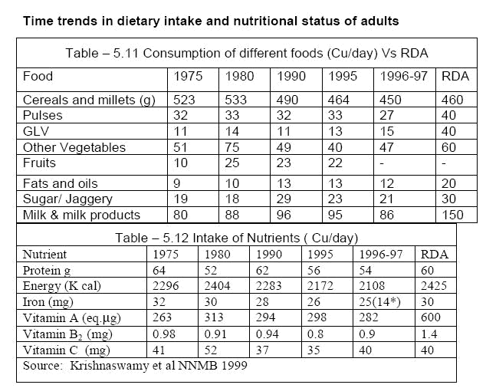

If we look closely at the table, we will realize that our nutrition per capita or per capita nutrition per day has decreased significantly from 1975 to 1999. The period from 1975 to 1999 also means important meaning from the point of view of the green revolution in 1975. . The green revolution and conventional farming were insignificant, while in 1999 conventional farming practices had largely influenced our society. One of the possible reasons for such a change in average nutrient consumption could be due to population explosion. However, attributing everything to population growth would be far-fetched and superficial. Further research is needed to prove a strong correlation. Another interesting fact that emerged is that an acre of land cultivated under conventional agriculture produces low amounts of most nutrients. However,
these farmlands have overproduced some exotic nutrients. This probably reflects on our national health; on the one hand, we struggle to treat and eliminate deficiency diseases such as protein-energy malnutrition, night blindness, anemia, etc. and on the other hand, this country is afflicted by debilitating effects of overeating such as obesity, fortified vitamins, cardiovascular disease, diabetes, etc. However, to demonstrate a strong correlation, further in-depth studies are needed. Diversification is not just important from the point of view of “the amount of nutrients produced per acre”. Research has suggested that traditional foods and various fruits and vegetables contain a number of bioactive compounds that are effective in preventing cancer, diabetes, cardiovascular disease, and degenerative diseases. [7,8]. To date, not all of these compounds have been identified, the role of these bioactive compounds in the prevention of these degenerative diseases has not been determined, and a mixture of nutrients ideal for humans has not yet been recognized [13]. We are almost there, but not quite. Therefore, physicians prescribe a diet derived from a variety of sources and such recommendations have also proven to be helpful [10].
In order to provide a more comprehensible picture, we took the average (arithmetic mean) of nutrients produced per acre farmland from all the case studies above. The sample mean of this chapter should be a fairly good estimator of the population mean. The population in this case is the total arable land in India. Hence, the average production of nutrients per acre of farmland is a reasonably fair point estimator of the average production per acre farmland on a national scale. Moreover, data has been collected from different states ranging from an arid state, Rajasthan, to an organic state, Uttaranchal. Therefore, the margin of error will be quite small. The purpose of all the statistics is to allow the reader to have an overview of the true impact of the two-agriculture scenario at the national level. The questions are how to maximize nutrient yields, how to minimize environmental risks, and how to ensure a sustainable alternative to solving the food crisis national and global.

Average production of macronutrients per acre farmland- organic mixed cropping versus conventional mono cropping

 | Protein (kg) | Carbohydrate | Fat (kg) |  | Total energy
 |  | (kg) |  |  | (kcal)
Average
production of
nutrients
from organic
mixed | 240 | 833 |  | 66 | 4,914,270
farming | 240 | 833 |  | 66 | 4,914,270
Average
production of
nutrients
from
conventional
mono | 116 | 785 |  | 23 | 3,711,475
cropping | 116 | 785 |  | 23 | 3,711,475

According to this table, if we convert an acre of farmland from conventional monoculture to organic mixed farming, we will be able to produce 124 kg more protein than before. The quality of mixed culture protein is better than that of single cultured protein. Organic mixed protein is complete as it provides all the essential amino acids and is comparable to animal protein. Plant proteins (with the exception of soy) can be an inadequate source of all the individual essential amino acids. However, when plant proteins are mixed, they become a complete source of all the essential amino acids. For example, the protein in roti or dal, individually, is incomplete because it contains all the essential amino acids, but when roti and dal are eaten together, they become a complete source of all the essential amino acids. [3]. Therefore, the protein produced per acre from an organic mixed crop will be more adequate than the amount produced per acre from a conventional monoculture.
On average, organic polyculture produced 124 kg more protein than conventional monoculture, per acre of cultivated land. 124 kg of protein is enough to meet the protein needs of 2,000 adults per day. According to Central
Water Commission, government of India, the total arable land area (200304) in India is 183 M. Ha, equivalent to 452202848 acres. If all of this land were used for organic polyculture instead of conventional monoculture, the country would produce 56,073,153 tons more protein than it did in the past. This is enough to meet the protein needs of 2.5 billion adults all year round. The remarkable fact is that we only took a difference of 124 kg of protein per acre between organic polyculture and conventional monoculture. The extra protein that we will produce by switching from conventional to organic farming is enough to meet the protein needs of 2.5 billion adults for an entire year. If we consider the total amount of protein produced domestically through organic mixed farming, projecting the average of our sample over the total arable land, we will produce enough protein to meet Protein needs of about 5 billion adults for the whole year. That's enough protein to feed our entire population and erase protein-energy malnutrition from the planet.
If an acre of farmland is converted from conventional monoculture to organic mixed farming, we will produce additional feed containing 12.02,795 kcal of additional energy to consume. This is enough to provide 2500 kcal of energy for 481 adults per day. If we project this to 183 M. Ha. out of total arable land in India, we would produce enough extra calories in food to meet the energy needs of 600 million adults for the whole year. We'd like to reiterate that we only looked at the extra calories created by switching from conventional to organic food. If we consider the average calories produced per acre through organic mixed farming, then nationally we will produce enough calories to provide 2500 kcal/day for 2.4 billion people. mature in 1 year. If we switch from conventional to organic production, we can ensure that no one goes hungry in our country. In fact, if only India switched from conventional farming to organic farming, we could solve the world hunger problem as only one billion poorest people in the world go hungry.

Average production of vitamins per acre farmland- organic mixed cropping versus conventional mono cropping

 | Carotene | Thiamine | Riboflavin | Niacin | B6 | Folic | Vit. C | Choline
 | (mg) | (mg) | (mg) | (mg) | mg | acid | (mg) | (mg)
 |  |  |  |  |  | (mg)
Average
production
of nutrients
from organic
mixed | 2,919 | 6,550 | 3179 | 31,443 | 821 | 878 | 24145 | 680675
farming
Average
production
of nutrients
from
conventional
mono | 745 | 3,911 | 1685 | 28,381 | 475 | 328 | 36833 | 537527
cropping

If one acre of farmland were used for organic mixed farming instead of conventional monoculture, we would produce 2174 mg more carotene than would have been produced otherwise. That's enough carotene to meet the vitamin A needs of about 900 adults per day. Nationwide, we will organically produce 982,670 tons more carotene than conventional production. In other words, we will produce 164106 tons of retinol equivalent (1 unit of Bcarotene = 0.167 units of RE [3]) more than conventional production. 164,106 tons of RE (retinol equivalent) is enough to meet the daily vitamin A needs of 750 million adults for 1 year. 164,106 tons of ER enough to handle and fully reverse
1.3 billion early cases of xerophthalmia. Here, we assume that all these equivalent amounts of retinol in food could be isolated and given to patients with blood cancers. The term xerophthalmia (dry eye) includes all ocular manifestations of vitamin A deficiency, from night blindness to acacia. Vitamin A deficiency first causes night blindness, then progresses to corneal ulcers, a serious condition that can leave residual corneal scarring, affecting vision. Corneal keratosis or liquefaction is the main cause of blindness in India
The cornea becomes tender and may rupture. This is probably the kind of impact that additional carotene generated, by organic conversion across the country, could have on the health of our population. If we use a sample of the average amount of carotene produced per acre of organic mixed farming to calculate the total amount of carotene produced nationally, we can produce enough carotene to meet the demand. meet the daily vitamin A needs of 1.5 billion adults for a year.
Likewise, the amount of additional thiamine created per acre, switching from conventional to organic, is enough to provide thiamine for approximately 2,100 adults per day. Nationally, the amount of supplemental thiamine produced by switching from conventional to organic would be enough to meet the daily thiamine needs of 2.6 billion adults for one year. If we consider all the thiamine that can be produced biologically in the country, the amount of thiamine produced would be enough for about 5 billion adults for a year. Mild thiamine deficiency is common in some parts of the country [3]. With nationwide organic farming, we can root out and eliminate all forms of thiamine deficiency in the population.
Growing organic mixes in an acre of farmland produces additional amounts of riboflavin that, compared with conventional monocultures per acre, can meet the recommended riboflavin intake for 1000 adults per day. Nationwide, we can provide enough riboflavin for an additional 1.2 billion adults in one year. Riboflavin deficiency is widespread in India, especially among populations where rice is the staple food [3]. The reality is that we are currently not producing enough riboflavin. Organic culture seems to be a promising solution to the riboflavin crisis.
Folic acid deficiency can occur rapidly in pregnant and lactating women and growing children, because the body's folate stores are not large, about 510 mg. One acre of farmland through organic mixed farming can produce extra folic acid that can feed about 1375 pregnant women for a day. Nationally, the additional folate produced by organic mixed farming is, compared with conventional practices, enough to provide folic acid for 1.7 billion pregnant women, who need four times as much folic acid. compared with the average adult, for one year. .
Our sample shows that vitamin C produced by conventional monoculture is better than that produced by organic polyculture. However, there are a few points that need to be emphasized. Although the mean vitamin C yield in our sample favors conventional monoculture, the mean value of zero in conventional monoculture versus organic polyculture has a mean value of 4470 mg. Practice shows that a farmer in Rajasthan or Sikkim, practicing conventional monoculture, will contract Vit. Lack of C, while farmers in Uttaranchal who overproduce vitamin C excrete excess vitamin C in their urine, we assume that farmers only consume the food they grow.
According to a research publication by Virginia Worthington on the nutritional quality of organic fruits, vegetables and whole grains compared with conventional fruits, vegetables and whole grains, Journal of Alternative and Complementary Medicine, Volume 7, No. 2, 2001, foods from organic organic products contain an average of 27% more vitamin C. , than conventionally grown foods [14]. If we include a 27% difference in our sample mean, the difference is significantly reduced.

Average production of major minerals per acre farmland- organic mixed cropping versus conventional mono cropping

 | Ca (g) | Fe (g) | P (g) | Mg (g) | Na (g) | K (g) | Cl (g)
Average
production
of nutrients
from organic
mixed | 2,166 | 82 | 5,158 | 1,866 | 197 | 6,076 | 323
farming
Average
production
of nutrients
from
conventional
mono | 731 | 43 | 3117 | 1,496 | 158 | 3,465 | 320
cropping

Iron is of great importance to human health. The adult human body contains about 34 g of iron, of which 6070% is in the blood. Iron is needed for many bodily functions such as hemoglobin formation, brain development and function, body temperature regulation, muscle function, and catecholamine metabolism. The central functions of iron are oxygen transport and cellular respiration. The bioavailability of non-heme (mostly vegetarian) iron is low due to the presence of phytates, oxalates, carbonates, phosphates, and dietary fiber. The Indian diet, which is mainly vegetarian, contains large amounts of phytate inhibitors in bran, phosphates in egg yolks, tannins in tea and oxalates in vegetables. Iron deficiency in the diet leading to iron deficiency anemia or nutritional anemia is a major public health problem in India. A group of experts from WHO has proposed that anemia is considered to exist when the hemoglobin is below the following levels

Cut off points for diagnosis of anemia[3]

 |  | Haemoglobin (g/dl) in
 |  | venous blood
Adult Males |  | 13
Adult female- non pregnant |  | 12
Adult female- pregnant |  | 11
Children- 6 months to 6 years |  | 11
Children- 6 to 14 years |  | 12
 | Requirement of iron for different age groups[3]
Age group |  | Iron in mg that should be absorbed
 |  | daily
Infants (5-12 months) |  | 0.7
Children (1-12 years) |  | 1.0
Adolescents (13-16 years)
 | Male | 1.8
Female |  | 2.4
Adult male |  | 0.9
Adult female
Menstruation |  | 2.8
Pregnancy
 | -First half | 0.8

-Second half | 3.5
Lactation | 2.4
Post menopause | 0.7

When an acre of farmland is used for organic mixed farming instead of a conventional monoculture, an additional 39 g of iron is produced. This amount is enough to provide iron for 16,250 nursing mothers for a day. Nationally, the amount of bioavailable iron supplemented with will be enough to meet the needs of 20 billion nursing mothers. To reach this conclusion, we assume that all iron consumed will be absorbed.

Average production of trace minerals per acre farmland- organic mixed cropping versus conventional mono cropping

 | Cu (mg) | Mn (mg) | Mo (mg) | Zn (mg) | Cr (mg) | S (mg)
Average
production
of nutrients
from organic
mixed | 12,591 | 25,124 | 3,694 | 43,977 | 345 | 1,640,791
farming
Average
production
of nutrients
from
conventional
mono | 6,101 | 15,629 | 1077 | 26,769 | 157 | 1,303,224
cropping

Is genetic engineering the solution to hunger and malnutrition?
Part of the scientific community proposes genetic engineering as an important solution to this problem. William Ockham (12851349) was an English philosopher who argued that a complicated explanation should not be accepted without good reason. William Ockham wrote "Frustra fit per pluria, quod fieri potest per pauciora", which means that doing more than can be done with less is futile. Organic polyculture can increase the production of micronutrients, intended for consumption, by 72%. Furthermore, it is a durable, tested, sensible, smart, cost-effective and eco-friendly solution to the problem. GM crops may require increased concentrations of one or two micronutrients. Gene editing is in no way able to provide an ideal mixture of all trace elements. In contrast, organic polyculture resulted in an overall increase in the production of these micronutrients for consumption. Crop genetic engineering is an experimental technology. Companies promoting GM crops want to use our farmland as a testing ground. Profits belong to the company, while society bears the risks associated with GM crops without any reward. All that society gets is fantasies and serious environmental risks. Scientists agree that GM crops do not always work as expected and the results can be surprising [15].
The variable nature of what genetic engineers do cannot be quantified. The full effects of gene transfer between species and kingdoms are unknown to even the most skilled genetic engineers. Before a technology is put into common use, the positive effect of the technology is weighed against its undesirable effects. Only when the benefits outweigh the risks can a technological product be put to use. A new drug is only introduced in pharmacies when its effects outweigh its side effects. However, genetic modification of crops does not allow for this useful comparison because the full range of effects is still unknown. The situation is metaphorically similar to one in which an individual is introduced in a tiger cage claiming that
it is good for the individual to learn a few traits from the tiger what the tiger shall do to the individual is unknown and unpredictable. Tiger is a very revered animal, but GM crops carry the potential to turn the planet into a cage and the natural habitat into an invincible monster looking at us humans. Similar to pollution of air and pollution of water, genetic modification of crops is pollution of gene pool, and like pollution of water and pollution of air, this pollution of gene pool shall hit back. The following are some of the known uncertainities with GM crops[15]:
Risks to human health
Results can be predicted but they cannot be guaranteed
Antibiotic resistance
Allergens and food allergy
Genetic pollution
Threat to wildlife, insects, and soil organisms
Issues in food security such as patents, monopolies, monocultures
The following was published by the National Agricultural Law Centre, University of Arkansas, School of Law, Division of Agriculture, “ Precaution before profitsan overview of issues in genetically modified foods and crops” by Sophia Kolehmainen (2001)
The GM food that, supposedly, cannot promote growth in rats is thought to solve the malnutrition crisis among humans, and all this propoganda is coming at a time when we have clearly indicated that organic mixed cropping can
enhance micronutrient production for consumption by 72% without any risk to the human health, to the environment, and to the soceity at large.
The following article[16] was published by The Journal of Agrobiotechnology Management and Economics (volume 2//number 3 & 4//article 3). The title of the paper was "Ten Reasons Biotechnology Won't Ensure Food Security, Environmental Protection, and Poverty Alleviation in Developing Countries". The paper's authors are Miguel A. Altieri and Peter Rosset, University of California, Berkeley & Food First/Food and Development Policy Institute.
Biotech companies often claim that genetically modified organisms (GMOs) – specifically genetically modified seeds – are the essential scientific breakthrough needed to feed the world, protect the environment, and protect the environment. and poverty alleviation in developing countries. The Consultative Group on International Agricultural Research (CGIAR) and the group of international centers around the world responsible for research to improve food security in developing countries echo this view, based on two main assumptions. First, hunger is caused by a gap between food production and population density or growth. The second is that genetic engineering is the only or best way to increase agricultural production and, therefore, to meet future food needs.
Our goal is to challenge the notion that biotechnology is the silver bullet for all evils in agriculture, clarifying misconceptions about these basic assumptions.
1. There is no relationship between the hunger rate in a given country and its population. For every populous and hungry country like Bangladesh or Haiti, there is a sparse and hungry country like Brazil and Indonesia. The world today produces more food per capita than ever before. Food is enough to provide each person with 4.3 pounds per day: 2.5 pounds of whole grains, beans, and nuts, about a pound of meat, dairy, and eggs, and a pound of other fruits and vegetables. The real causes of hunger are poverty, inequality and lack of access to food and land. Too many people are too poor to buy readily available (but often poorly distributed) food or lack the land and resources to grow their own (Lappe, Collins & Rosset, 1998).
2. Most innovations in agricultural biotechnology are driven by profit rather than demand. The real goal of the genetic engineering industry is not to make Third World agriculture more productive, but to make it profitable (Busch et al., 1990). This is illustrated by looking at the key technologies on the market today: (1) herbicide-resistant crops, such as Monsanto's "Roundup Ready" soybeans, Monsanto's Roundup herbicide tolerant seeds and (2) "Bt" crops (Bacillus thuringiensis) designed to produce their own insecticides. Initially, the goal was to capture a larger market share of herbicides for a particular product and
second, to stimulate seed sales at the expense of reducing the usefulness of a key pest control product (microbiological pesticides made from Bacillus thuringiensis) that many farmers, including most Organic farmers consider it an effective alternative to pesticides. These technologies address the need of biotech companies to increase farmers' dependence on seeds protected by so-called "intellectual property rights", which are in direct conflict with the rights of farmers. farmers to reproduce, share or store seeds (Hobbelink, l991). Whenever possible, companies will require farmers to purchase company-branded inputs and will prohibit farmers from saving or selling seeds. By controlling the sprouts for sale and forcing farmers to pay high prices for packages of seed chemicals, companies are determined to get the most out of their investment (Krimsky & Wrubel, l996).
3. The combination of the seed and chemical industries seems to accelerate the increase in seed and chemical spending per acre, resulting in significantly lower returns for growers. Companies that develop herbicide-tolerant crops try to shift the cost per acre of herbicide to seed as much as possible through seed costs and technology fees. Increasingly, the reduction in herbicide prices will be more and more limited to growers who purchase a technology package. In Illinois, the adoption of herbicide-resistant crops makes most
4. Recent experimental tests show that GM seeds do not increase crop yield. A recent study by the United States Department of Agriculture (USDA) Economic Research Service found that in 1998, yields were not significantly different between modified and non-transformed crops in 12 of No. 18 crop complex / region. In the six crop/region combinations where Bt crops or herbicide-resistant (HTC) crops performed better, they showed a 530% increase in yield. Glyphosate-tolerant cotton showed no significant yield increase in the two regions it was studied. This was confirmed in another study examining more than 8,000 field trials, in which Roundup Ready soybeans were found to produce fewer bushels of soybeans than similar conventionally bred varieties (USDA, l999).
5. Many scientists assert that it is safe to eat genetically modified foods. However, recent evidence suggests that there are potential risks associated with the consumption of such foods, as the newly created proteins in these foods can: (1) act on their own as allergens or toxins; (2) alter the metabolism of food-producing plants or animals, causing them to produce new allergens or toxins; or (3) reduce its quality or nutritional value. In case (3), herbicide-resistant soybeans may contain as little as
Isoflavones, an important phytoestrogen found in soybeans, are thought to protect women against certain cancers. Currently, developing countries import soybeans and corn from the United States, Argentina and Brazil. Genetically modified foods are beginning to flood the markets of importing countries, but no one can predict the harmful effects they will have on the health of consumers who do not know they are consuming these foods. Because genetically modified foods are not labeled, consumers cannot distinguish between genetically modified (GM) and non-GMO foods, and if serious health problems arise , it would be extremely difficult to determine their origin. Non-labelling also helps protect companies from potential liability (Lappe & Bailey, l998).
6. Transgenic plants that produce their own pesticides follow the pesticide model, which itself quickly fails due to the pest's resistance to pesticides. Instead of the unsuccessful "one gene, one stone" model, genetic engineering emphasizes the "one gene, one stone" approach, which has been proven time and time again in laboratory tests. was unsuccessful, because the pests quickly adapted and developed resistance to the insecticides present in the plant (Alstad & Andow, 1995). Not only do new varieties fail in the short to medium term, despite so-called voluntary resistance management systems (Mallet and Porter, l992), but in the process it can expose pesticides to Bt is naturally rendered useless by some organic farmers and others who wish to reduce their dependence on chemicals. . Bt crops violate the basic and widely accepted principle of Integrated Pest Management (IPM), which is reliance on a single pest management technology that tends to trigger changes in pest species or the evolution of resistance through one or more mechanisms (NRC, l996). In general, the greater the selection pressure over time and space, the faster and deeper the evolutionary response of the pest. One obvious reason to apply this principle is that it reduces the pest's exposure to pesticides, thereby delaying the development of resistance. But when the product is incorporated into the plant itself, the potential for pest exposure increases from minimal and infrequent exposure to extensive and continuous exposure, which rapidly increases tolerance (Gould, l994 ). Bacillus thuringiensis will quickly become useless, both as a feature of new seeds and as a stockpile of old to be sprayed as needed by farmers wanting off the pesticide conveyor belt (Pimentel et al., l989).
7. The competition for global market share leads companies to massively deploy GM crops worldwide (over 30 million hectares in 1998) without proper prior testing for short- or long-term effects for human health and ecosystems. In the United States, pressure from the private sector led the White House to order "no significant difference" between the modified seed and the regular seed, thus avoiding the usual inspections of the seed. Food and Drug Administration (FDA) and Environmental Protection Agency (EPA). . Confidential documents made public as part of an ongoing class-action lawsuit have revealed that FDA scientists disagreed with the decision. One reason is that many scientists are concerned that the large-scale use of transgenic crops poses a range of environmental risks that threaten the sustainability of agriculture (Goldberg, l992; Paoletti &
Pimentel, 1996; Snow and Moran, 1997; Rissler and Mellon, 1996; Kendall et al., 1997; Royal Society,
l998). These areas of risk are as follows:
o Trends in creating large international markets for unique products, simplifying crop systems and creating genetic homogeneity in rural landscapes. History is showing
that a large area is planted with a cultivar that is highly susceptible to new strains of pathogens or pests, respectively. Furthermore, the widespread use of homogenous transgenic varieties will inevitably lead to 'genetic erosion', as the races used by thousands of farmers in developing countries will be replaced by new varieties (Robinson, 1996).
o The use of herbicide-resistant crops compromises the ability of crops to diversify, thereby reducing agro-biodiversity over time and space (Altieri, l994).
o Potential transfer through gene flow from herbicide-resistant crops to wild or semi-domestic relatives could lead to the generation of superweeds (Lutman, l999). o Herbicide-resistant varieties can become important weeds in other crops
o Massive use of Bt crops affects non-target organisms and ecological processes. Recent evidence suggests that Bt toxins can affect beneficial insect predators that feed on harmful insects on Bt crops (Hilbeck et al., L998). In addition, wind-blown pollen from Bt crops, found on natural vegetation around transgenic fields, can kill off-target insects such as monarch butterflies (Losey et al., l999). . In addition, the Bt toxin present in
After harvest, crop foliage can adhere to soil colloids for up to 3 months, adversely affecting soil invertebrate populations that degrade organic matter and perform other ecological roles (Donnegan et al. associates, l995; Palm et al. l996). o Capable of vector recombinant to generate new virulent virus strains, especially in transgenic plants designed to be resistant to virus with virus genes. In plants containing coat protein genes, it is possible that these genes are used by unrelated viruses that infect the plant. In such situations, the foreign gene alters the structure of the virus envelope and can confer properties, such as altered modes of transmission between plants. A second potential risk is that recombination between viral RNA and viral RNA within transgenic cultures could create new pathogens that lead to more serious disease problems. Some researchers have shown that recombination occurs in transgenic plants and under certain conditions produces a new virus strain with altered host range (Steinbrecher, 1996). Ecological theory predicts that large-scale landscape homogenization with transgenic crops will exacerbate the ecological problems inherent in monoculture.
The undoubted expansion of this technology in developing countries is perhaps neither wise nor desirable. The agricultural diversity of many of these countries is a strength and it should not be constrained or diminished by widespread monoculture, especially when the consequences of doing so lead to social problems. and severe environment (Altieri, 1996).
Although the issue of ecological risk has been discussed in governmental, international and scientific circles, discussions are often pursued from a narrow perspective, which has reduced the severity of the risk. ro (Kendall et al., 1997; Royal Society, 1998). In practice, methods for risk assessment of transgenic crops have not been well developed (Kjellsson & Simmsen, 1994) and there is a legitimate concern that biosafety field trials tell a great deal. little about the potential environmental risks associated with commercial-scale GM crop production. One major concern is that international pressures for markets and profits are driving companies to release transgenic crops too quickly without giving due consideration to the long-term impacts on people or ecosystems. thai.

8. There are many unanswered ecological questions regarding the impact of transgenic crops. Many environmental groups have advocated the creation of appropriate regulations to arbitrate the testing and release of GM crops to offset environmental risks and are demanding a much better assessment and understanding of the issues. ecology related to genetic engineering. This is important, as many results from the environmental performance of released transgenic crops suggest that in the development of resistant crops, it is not only necessary to test for direct effects on insects. or weeds, but also indirect effects on plants. Plant growth, nutrient content, metabolic changes, and effects on soil and non-target organisms all need to be considered. Unfortunately, funding for environmental risk assessment research is very limited. For example, the USDA spends only 1% of its biotech research funds on risk assessment, or about $12 million a year. With the current level of GM tree deployment, such resources are not even enough to explore the “tip of the iceberg”. It is a tragedy that millions of hectares are planted without adequate biosecurity standards. Worldwide, these areas increased significantly in 1998, with GM cotton reaching 6.3 million acres, GM corn 20.8 million acres and GM soybean 36.3 million acres. This expansion has been supported by marketing and distribution agreements signed by companies and distributors (i.e. Ciba County with Growmark and Mycogen Plant Sciences with Cargill), and a lack of regulation in many developing country. Unlike an oil spill, genetic contamination cannot be controlled by bombing around it.
9. As the private sector has become increasingly dominant in the advancement of new biotechnology, the public sector has had to invest more and more of its meager resources to improve
biotechnology capacity in public institutions, including CGIAR, and in assessing and responding to challenges posed by the integration of private sector technology into existing agricultural systems. These funds would be much better used to expand support for agro-ecological research, as all the biological problems targeted by biotechnology can be solved using the agronomic approach. The strong effects of crop rotation and intercropping on crop health and yield, as well as the use of biological control agents for pest control, have been repeatedly confirmed by scientific studies. determined. The problem is that research in public institutions increasingly reflects the interests of private donors to the detriment of research in the public interest, such as biological control, organic production systems and general agricultural engineering. Civil society must ask universities and other public institutions to do more research on alternatives to biotechnology (Krimsky & Wrubel, 1996). There is also an urgent need to challenge the patent and intellectual property rights system inherent in the World Trade Organization (WTO), which not only grants multinational corporations the right to hold and Patented genetic resources will also accelerate the rate at which the market forces. has encouraged monoculture with genetically identical transgenic varieties. Based on ecological history and theory, it is not difficult to predict the negative effects of such environmental simplification on the health of modern agriculture (Altieri, 1996).
10. Much of the food needed can be produced by smallholder farmers around the world using agricultural technology (Uphoff & Altieri, l999). In fact, new rural development approaches and low-input technologies implemented by farmers and non-governmental organizations (NGOs) around the world have been contributing significantly to food security. at household, country and regional levels in Africa, Asia and Latin America (Pretty, l995). Increased production is achieved using technological approaches, based on agronomic principles emphasizing diversity, synergy, recycling and integration; and social processes that emphasize community participation and empowerment (Rosset, 1999). When these properties are optimized, productivity improvements and production stability as well as a wide range of ecological services such as biodiversity conservation, soil and water conservation and restoration, are achieved. improve natural pest regulation mechanisms, etc. (Altieri et al., 1998). These results represent a breakthrough for achieving food security and environmental sustainability in developing countries, but their potential and future dissemination depends on investment, policy, support institutional support and fundamental changes by policymakers and the scientific community; especially CGIAR, which will devote much of its efforts to the 320 million poor farmers living in marginal environments. The failure to promote such human-centred agricultural research and development as a result of a shift in funding and expertise to biotechnology has curtailed the historic opportunity to increase agricultural productivity. in an economically efficient, environmentally friendly and socially uplifting manner.
Organic farming is the only solution to fighting hunger in this country. It is sustainable and, unlike the Green Revolution hoax, it will solve the problem of food security without creating a new and larger problem. The abundance of micronutrients in the Indian diet can be obtained by diversification and not by genetic modification. In addition to these known micronutrients, there are a number of unknown compounds of nutritional importance, the supply of which in the Indian diet can be obtained through organic mixed farming. resources and biodiversity, and all of this is made possible by microeconomic progress at the local and village level, sustainability, security and equitable distribution.

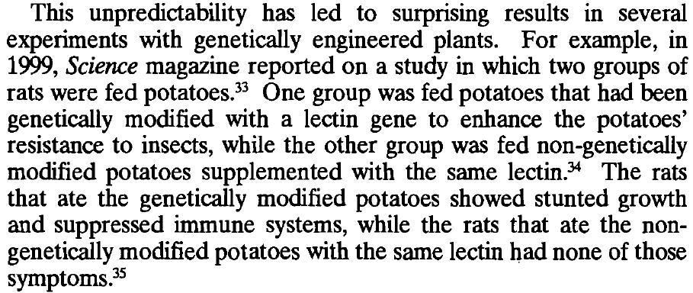

FOOD QUALITY ORGANIC PRODUCTS
AN OVERVIEW
In our comparison above, we have assumed that the quality of organically and conventionally produced foods is the same, with no difference in the nutritional composition of foods grown. by two farming systems and this has no impact on human health whether the food consumed is grown organically or conventionally. In the qualitative overview below, we will weaken this assumption and show that organically grown foods have higher nutritional value and are less hazardous.
The nutritional superiority of the food and the health risk of the food are two different aspects of food quality. Nutritional primacy indicates the presence of more nutrients and bioactives and the presence of these nutrients in greater quantities per unit weight. Instead, the health hazard posed by a food depends on the presence of various chemicals and organisms that adversely alter human metabolism, leading to disorders. acute, chronic, or acute over chronic disorder. In the process of writing this qualitative review, we sifted through hundreds of research papers and identified two schools of thought. One school of thought supports the idea that organic food is better than conventional food, while the other school of thought supports the convention that there is no difference between organic and conventional foods. However, there are very few articles
mention that organic food is inferior to conventional food (some articles have shown a risk of Escherichia coli infection from eating organic food, but this is not true because if manure has been properly composted there is absolutely no Therefore, from a review of the research literature, one can safely and randomly conclude that organic food is the same or superior to conventional food. poor quality organic food. Incidentally, scientific research supports the superiority of organic foods over conventional foods in many ways. The protein quality in organic food is better than in conventional food. Organic foods contain higher amounts of minerals and vitamins than conventional foods. Donald R. Davis and colleagues conducted a study to evaluate possible changes in USDA nutrient content data for 43 vegetables between 1950 and 1999 and found that all 43 varieties All foods decreased (from 6% for protein to 38% for riboflavin) for the 6 nutrients. protein, calcium, phosphorus, iron, riboflavin, ascorbic acid [17]. They conclude, "We hypothesize that Mayer and our findings on global nutrient depletion may be the significant result of decades of crossbreeding high-yielding food crops, with unintended trade-offs due to reduced nutrient concentrations." Paolo Bergamo and colleagues found significantly higher amounts of healthy fatty acids and fat-soluble vitamins in organic milk and dairy products. Virginia Worthington did the same study, comparing the nutrient content of organic and conventional foods; She noticed a decline in crop nutrition in the United States and United Kingdom over the previous sixty-five years, as shown below sixty years ago when food was no longer naturally grown.

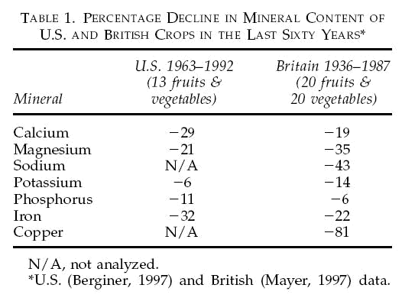

Virginia worthington also reviewed literature and found significant differences in the food grown organically and that grown conventionally as presented below.
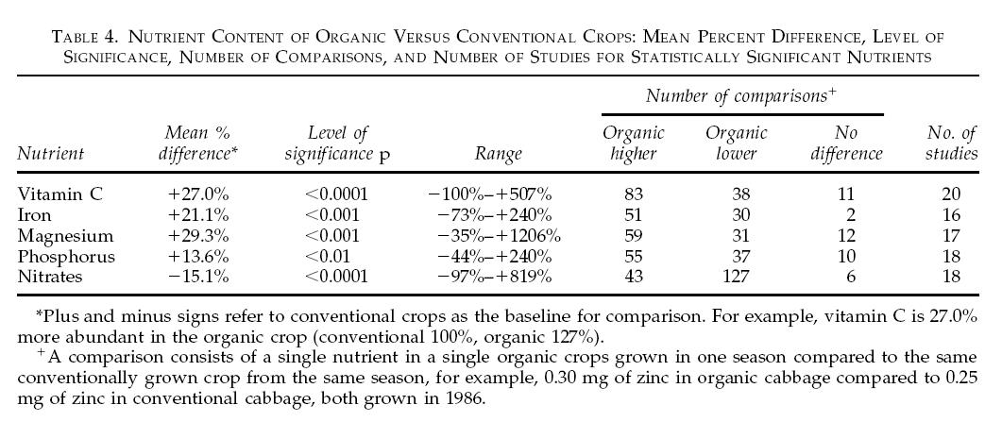
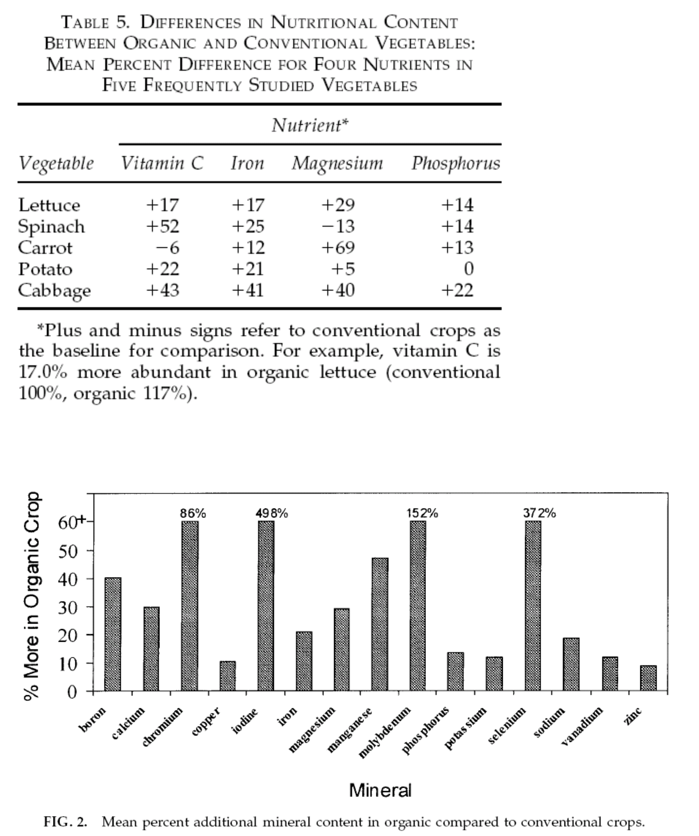

Conventional agriculture is pulling a lot of land at an unsustainable rate, leading to land depletion. In turn, plants grown on depleted soil will suffer from a lack of nutrients. The consumption of these plants is a major source of malnutrition in the world. The idea was rightly given by Empty Harvest

“…all animals get their food directly or indirectly from plants, and all plants get their food from the soil. Therefore, mineral -deficient soil may be one of the greatest original sources of disease in the world today. According to D. W. Cavanaugh, M.D., of Cornell University, ‘There is only one major disease and that is malnutrition. All ailments and afflictions to which we may fall heir are directly traceable to this major disease.’ Simply stated, food crops grown on depleted soil produce malnourished bodies, and disease preys on malnourished bodies.”

– Empty Harvest, 1990.
A report conducted by the Center for Organic and professors from the Department of Horticulture at the University of Florida and Washington State University provides evidence that the average organic food contains 11 nutrients 25 percent more than common foods. The report is based on estimated differences in nutrient levels across 236 comparisons between organic and conventionally grown foods.
Source: "New evidence confirms the nutritional superiority of plant-based organic foods",
One study found that organic soups sold commercially in the UK contained almost six times more salicylic acid than non-organic soups. John Paterson, a biochemist at the Royal Dumfries and Galloway Hospital, and scientists from the University of Strathclyde in Scotland analyzed 11 brands of organic soups and compared their concentrations of salicylic acid to those of non-organic soups. Organic. Salicylic acid, responsible for aspirin's anti-inflammatory activity, has been shown to help prevent hardening of the arteries and bowel cancer. Medium
The level of salicylic acid in 11 brands of organic vegetable soup was 117 nanograms/gram, compared with 20 nanograms/gram in 24 non-organic soups. The highest levels (1,040 nanograms/gram) were found in organic carrot and coriander soups. Four of the regular soups had no detectable salicylic acid content.
Source: New Scientist magazine, March 16, 2002, p. 10; European Journal of Nutrition, Vol. 40, page 289. Research by chemistry professor Theo Clark and undergraduate students at Truman State University in Missouri has found that organically grown oranges contain 30% more vitamin C than conventionally grown oranges. Presenting the results at the June 2 Great Lakes Regional Meeting of the American Chemical Society, Clark said he expected conventional oranges, which are much larger than organic oranges, to contain twice as much vitamin C. double that of organic oranges. Instead, chemical isolation combined with nuclear magnetic resonance spectroscopy showed the highest levels in organic oranges. Source: Science Daily, June 2, 2002.
A study commissioned by the Organic Growers and Retailers Association of Australia (ORGAA) found that commonly grown fruit and vegetables purchased from supermarkets and other commercial stores have ten times less mineral content. compared to organically grown fruits and vegetables. For the study, tomatoes, beans, peppers and turnips grown on a certified organic farm using soil regeneration techniques were analyzed for mineral elements. The Australian Government Analytical Laboratory also analyzed a similar range of commonly grown vegetables purchased from supermarkets. However, a major flaw in the study was that it compared farm fresh produce with supermarket produce. As a result, there may be differences in freshness, which may affect the measured nutrients.
Source: Australian Organic Growers and Retailers Association, 2000, as cited in Pesticides and You, Vol. 20, issue 1, spring 2000, News from Beyond Pesticides / National Coalition Against Pesticides Abuse.
A comparative study conducted by researchers at the Research Institute of Organic Agriculture (FiBL) in Switzerland found that organically grown apples are superior to conventionally grown apples in terms of health-related parameters. health and taste (taste score, sweet and sour index, dietary fiber phenol content and "vigor index" according to quality assessment methods for total quality assessment).
Source: "Are organic apples tastier and healthier?" A comparative field study using conventional and alternative methods to measure fruit quality”, F.P. Weibel, R. Bickel, S. Leuthold and T. Alföldi), Acta Hort. 517: 417427 (year 2000).
Research by Alyson Mitchell of the University of California Davis has shown that flavonoid content increases over time in crops grown in organically grown fields. The results of the study showed that organic tomatoes contained more quercetin and kaempferol aglycones (beneficial flavonoids) that were 79 and 97 percent higher on average, respectively, than conventionally grown tomatoes. In the study, Mitchell and colleagues compared the levels of major flavonoids in tomatoes harvested over a ten-year period from two suitable fields, one organically grown and one grown with Conventional methods include commercial fertilizers. The researchers analyzed organic and conventional tomatoes that were dried and stored under identical conditions between 1994 and 2004. “Flavonoid levels increased over time in samples from this method. organic treatments, while flavonoid levels were not significantly changed under conventional treatments,” the report said. declare.
Source: Journal of Agricultural and Food Chemistry, published June 23, 2007.
A research team from the University of California, Davis has found that organic kiwifruit has a much higher total polyphenol content than conventional kiwifruit, which has higher antioxidant activity than conventional fruits. Research results also show that organic kiwifruit has a higher vitamin C content. The kiwis studied came from neighboring vineyards on the same farm in Marysville, California.
Source: March 27, 2007, Journal of Agricultural and Food Science, online edition.
At the 2005 International Congress on Organic Agriculture, Food Quality and Human Health, Professor Carlo Leifert of the University of Newcastle reported the results that organically produced foods have high levels of antioxidants. Higher chemical specificity and lower mycotoxin levels compared with conventional samples and organic cattle diets reduced the risk of E. coli infection while conventional grain-based diets did. increased risk.
A Dane's findings show that organic vegetables have higher levels of natural antioxidants called flavonoids. The randomized double-blind study had two intervention periods, with trial participants receiving either organic or conventional foods for three weeks. Results are based on tested blood and urine samples. The study was carried out by the Institute for Food Safety and Nutrition of the Danish Food and Veterinary Department, the Department of Human Nutrition and the Center for Advanced Food Research of the Royal College of Veterinary Medicine and Agriculture and the Department of Agriculture and Rural Development. National experiment from Risø. Source: Journal of Agricultural and Food Chemistry, Vol. 51, No. 19, 2003, p. 56715676.
According to study results published by researchers at the University of California, Davis, organic fruits and vegetables have significantly higher levels of antioxidants than conventionally grown fruits. For the study, researchers led by food scientist Alyson Mitchell compared antioxidant levels in sustainably grown, organic corn, strawberries, and blueberries (using fertilizers but no pesticides). herbicides or pesticides) and conventional organic. Antioxidant levels in sustainably grown maize have been
58.5% more than conventionally grown corn, while organically and sustainably grown puppets contain about 50% more antioxidants than conventionally grown berries. Organic and sustainable strawberries contain 19% more antioxidants than regular strawberries. The results were published in the February 26, 2003 print edition of the peer-reviewed Journal of Agricultural and Food Chemistry of the American Chemical Society. Research also shows that organic and sustainably grown produce contains more ascorbic acid, which the body converts into vitamin C.
Marionberry, frozen, air-dried strawberries and corn are grown using conventional, organic and sustainable agricultural methods,” said D.K. Asami, YJ Hong, D.M. Barrett, and A.E. Mitchell, Journal of Agricultural and Food Chemistry, 51 (5): 1 , 2371,241 (2003)

If we combine these additional numbers, the gap between the average nutrition produced per acre organically and the nutrient produced per acre conventionally increases dramatically. There are a number of cases where researchers have found the nutritional advantage of organic foods

A report conducted by the Center for Organic and professors from the Department of Horticulture at the University of Florida and Washington State University provides evidence that the average organic food contains 11 nutrients 25 percent more than common foods. The report is based on estimated differences in nutrient levels across 236 comparisons between organic and conventionally grown foods.
Source: "New evidence supports superior nutrition of plant-based organic foods",
One study found that organic soups sold commercially in the UK contained nearly six times more salicylic acid than non-organic soups. John Paterson, a biochemist at the Royal Dumfries and Galloway Hospital, and scientists from the University of Strathclyde in Scotland analyzed 11 brands of organic soups and compared their concentrations of salicylic acid to those of non-organic soups. Organic. Salicylic acid, responsible for aspirin's anti-inflammatory activity, has been shown to help prevent hardening of the arteries and bowel cancer. Medium
The level of salicylic acid in 11 brands of organic vegetable soup was 117 nanograms/gram, compared with 20 nanograms/gram in 24 non-organic soups. The highest levels (1,040 nanograms/gram) were found in organic carrot and coriander soups. Four of the regular soups had no detectable salicylic acid content.
Source: New Scientist magazine, March 16, 2002, p. 10; European Journal of Nutrition, Vol. 40, page 289. Research by chemistry professor Theo Clark and undergraduate students from Truman State University in Missouri have found that organically grown oranges contain 30% more vitamin C than conventionally grown oranges. Presenting the results at the June 2 Great Lakes Regional Meeting of the American Chemical Society, Clark said he expected conventional oranges, much larger than organic oranges, to contain twice as much vitamin C. double that of organic oranges. Instead, chemical isolation combined with nuclear magnetic resonance spectroscopy showed the highest levels in organic oranges. Source: Science Daily, June 2, 2002.
A study commissioned by the Organic Growers and Retailers Association of Australia (ORGAA) found that commonly grown fruit and vegetables purchased from supermarkets and other commercial outlets have ten times less mineral content. compared to organically grown fruits and vegetables. For the study, tomatoes, beans, peppers and turnips grown on a certified organic farm using soil regeneration techniques were analyzed for mineral elements. The Australian Government Analytical Laboratory also analyzed a similar range of commonly grown vegetables purchased from supermarkets. One major flaw of the study, however, was that it compared farm fresh produce with supermarket produce. As a result, there may be differences in freshness, which may affect the measured nutrients.
Source: Australian Organic Growers and Retailers Association, 2000, as cited in Pesticides and You, Vol. 20, issue 1, spring 2000, News from Beyond Pesticides / National Coalition Against Pesticides Abuse.
A comparative study conducted by researchers at the Research Institute of Organic Agriculture (FiBL) in Switzerland found that organically grown apples are superior to conventionally grown apples in terms of health-related parameters. health and taste (taste score, sweet and sour index, dietary fiber phenol content and "vigor index" according to quality assessment methods for total quality assessment).
Source: "Are organic apples tastier and healthier?" A comparative field study using conventional and alternative methods to measure fruit quality”, F.P. Weibel, R. Bickel, S. Leuthold and T. Alföldi), Acta Hort. 517: 417427 (2000).
Research by Alyson Mitchell of the University of California Davis has shown that flavonoid content increases over time in crops grown in organically grown fields. The results of the study showed that organic tomatoes contained more quercetin and kaempferol aglycones (beneficial flavonoids) that were 79 and 97 percent higher on average, respectively, than conventionally grown tomatoes. In the study, Mitchell and colleagues compared the levels of major flavonoids in tomatoes harvested over a ten-year period from two suitable fields, one organically grown and one grown with Conventional methods include commercial fertilizers. The researchers analyzed organic and conventional tomatoes that were dried and stored under identical conditions between 1994 and 2004. “Flavonoid levels increased over time in samples from the method. organic treatments, while flavonoid levels were not significantly changed under conventional treatments,” the report said. declare.
Source: Journal of Agricultural and Food Chemistry, published June 23, 2007.
A research team from the University of California, Davis has found that organic kiwifruit has a much higher total polyphenol content than conventional kiwi fruit, which has higher antioxidant activity than conventional kiwi fruit. Research results also show that organic kiwifruit has a higher vitamin C content. The kiwis studied came from neighboring vineyards on the same farm in Marysville, California.
Source: March 27, 2007, Journal of Agricultural and Food Science, online edition.
At the 2005 International Congress on Organic Agriculture, Food Quality and Human Health, Professor Carlo Leifert of the University of Newcastle reported the results that organically produced foods have high levels of antioxidants. Higher chemical specificity and lower mycotoxin levels compared with conventional samples and organic cattle diets reduced the risk of E.coli infection while conventional grain-based diets did. increased risk.
A Dane's findings show that organic vegetables have higher levels of natural antioxidants called flavonoids. The randomized double-blind study had two intervention periods, with trial participants receiving either organic or conventional foods for three weeks. Results are based on tested blood and urine samples. The study was carried out by the Institute for Food Safety and Nutrition of the Danish Food and Veterinary Department, the Department of Human Nutrition and the Center for Advanced Food Research of the Royal College of Veterinary Medicine and Agriculture and the Department of Agriculture and Rural Development. National experiment from Risø. Source: Journal of Agricultural and Food Chemistry, Vol. 51, No. 19, 2003, p. 56715676.
According to study results published by researchers at the University of California, Davis, organic fruits and vegetables have significantly higher levels of antioxidants than conventionally grown fruits. For the study, researchers led by food scientist Alyson Mitchell compared antioxidant levels in sustainably grown, organic corn, strawberries, and blueberries (using fertilizers but no pesticides). herbicides or pesticides) and conventional organic. Antioxidant levels in sustainably grown maize have been
58.5% more than conventionally grown corn, while organically and sustainably grown puppets contain about 50% more antioxidants than conventionally grown berries. Organic and sustainable strawberries contain 19% more antioxidants than regular strawberries. The results were published in the February 26, 2003 print edition of the Journal of Agricultural and Food Chemistry approved by the American Chemical Society. Research also shows that organic and sustainably grown produce contains more ascorbic acid, which the body converts into vitamin C.
Marionberry, frozen, air-dried strawberries and corn are grown using conventional, organic and sustainable farming methods,” said D.K. Asami, YJ Hong, D.M. Barrett, and A.E. Mitchell, Journal of Agricultural and Food Chemistry, 51 (5): 1 , 2371,241 (2003)

A European research team led by Swiss scientist Lukas Rist has found that mothers who consume mainly organic milk and meat products have higher levels of rumen acid, a linoleic acid linked cases, about 50% higher in breast milk.
Source: British Journal of Nutrition June 200

Organic food has several bioactive compounds, plant phenols, phytochemicals, and flavinoids in abundance that conventional food is deficient in. These bioactive compounds are produced as a result of natural defense mechanism of plants produced in response to stress. Pests, herbs, fungi, other organisms, environment, etc., put the plant under stress. Since plants grown organically are not treated with such chemicals as pesticides, herbicides, fungicides, fertilizers, etc., these plants produce bioactive compounds and phytochemicals, abundantly and naturally, as a result of stress. Consumption of these bioactive compounds and phytochemicals is known to decrease the risk of chronic diseases such as cancer, cardiovascular diseases, and diabetes. Several studies have demonstrated that organic foods contain higher amounts of these bioactive compounds and phytochemicals (phenols, flavonoids, etc.). Marie E. Olsson et al conducted a study on the effects of organic and conventionally grown strawberry extracts on the proliferation of colon and breast cancer cells in vitro. . The article concludes: "Excerpt from
Organically grown strawberries had higher antiproliferative activity against both cell types at the highest concentrations than conventionally grown strawberries, which may indicate a secondary metabolite content with antiproliferative properties. cancer is higher in organically grown strawberries. Furthermore, the concentration of these phytochemicals and bioactive compounds seems to increase over the years when farmland is treated only organically as indicated in the famous study conducted by A.E. Mitchell showed that the flavonoid content of organic tomatoes increased over a ten-year period in treated farmland. organically. Other studies showing increased concentrations of phytochemicals and bioactive compounds in organic foods are listed below.

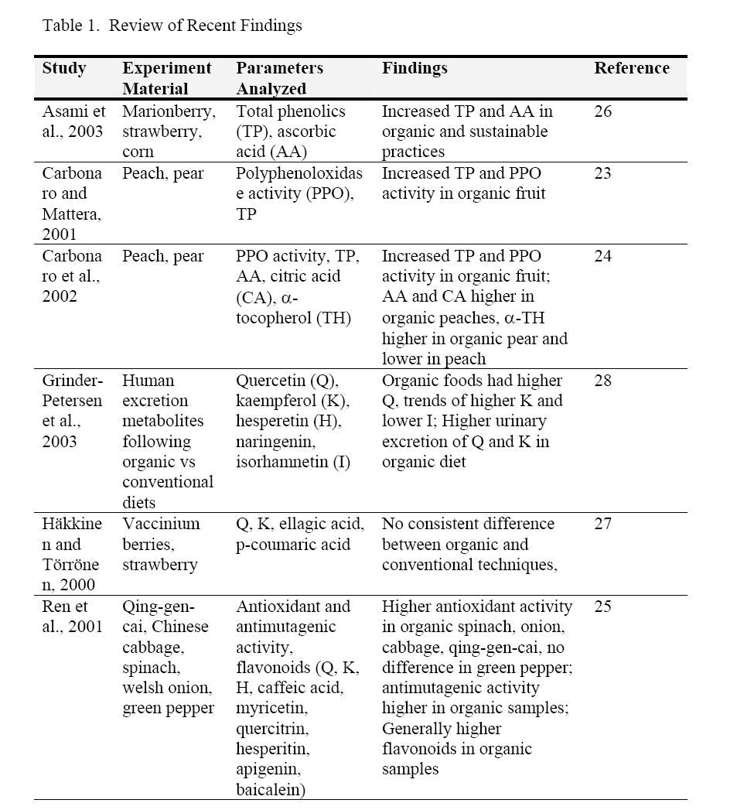

As a result, there is a great deal of scientific evidence to support the nutritional superiority of organic products. Organic products contain more vitamins, minerals and bioactive compounds than conventional products. We need these unique blends of nutrients to lead an active, disease-free life and improve the health of our entire population. Anemia is very common in India
population for which the National Family Health Survey II (199899) showed that 74.3% of children under three years of age were anemic. Every pregnant woman in India is advised to consume iron and folic acid tablets as most cases of anemia in our country are caused by iron deficiency in the diet. Don't we need to increase the iron concentration in plants to get more iron in our diet? Similar correlations have been found between reduced dietary vitamin B-complex levels and psychiatric disorders such as stress and depression [24]. Don't we need more B-complex vitamins in our crops to increase the amount of this vitamin in our diets? We don't need higher levels of trace minerals in our crops to increase consumption and improve the overall health of our population, and we don't need higher levels of antioxidants, phytochemicals, and compounds. bioactivity in our crops so that our population is better equipped to fight chronic diseases like cancer and diabetes? We also need high levels of vitamin C in every Indian meal to reduce the amount of iron in our diet to the form of iron that our bodies absorb, the oxidized form of iron, iron, which is not absorbed. absorbed by humans. As a homemade experiment, cut an apple in half and drizzle antioxidant-rich lemon juice over one and leave the rest without the lemon. The part without the lemon will turn reddish brown due to oxidation from the iron form to the iron form. This form of iron is not absorbed by the body and does not need to be consumed. The Indian diet is rich in phytates that make iron unabsorbable, which partly explains the prevalence of iron-deficiency anemia in India. We can counteract the effects of phytates by increasing the level of vitamin C in our diet, vitamin C prevents the formation of soluble non-heme iron by phytates. The easiest way to increase the amount of vitamin C and antioxidants in the Indian diet is to grow plants with higher concentrations of vitamin C, antioxidants, phytochemicals and bioactive compounds. .
Consider another qualitative aspect of the food hazard presented by food. Organic foods contain less nitrates than conventional foods. Nitrate is the main form of nitrogen supplied to plants from the soil, and its content in food has always been a matter of uncertainty. Two possible effects of high levels of nitrates in the stomach are methemoglobinemia in infants and neonates (Craun et al., 1981; Avery, 2001b) and the formation of carcinogenic Nnitroso compounds (BruningFann et al. Kaneene, 1993;
Vermeer and van Maanen, 2001). Such nitrates have not been shown to produce carcinogenic effects in animals, but can be converted to nitrite by bacteria in human saliva and in the gut, thereby possibly reacting with some amines and amides, normally present in the body, to make nitrosamines (BruningFann and Kaneene, 1993; Vermeer and van Maanen, 2001). Approximately 300 nitrosamines have been tested for carcinogenicity in high-dose animal cancer trials, and about 90% of these have been shown to be carcinogenic (Havender and Coulombe, 1996). Nitrosamine has the ability to initiate and promote the cancer process.

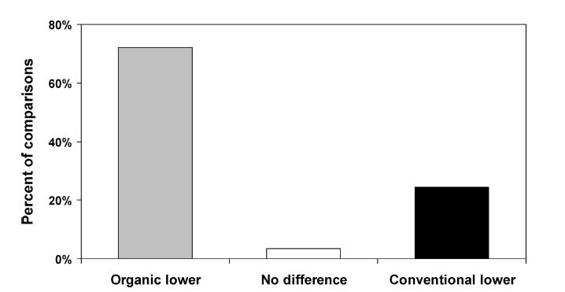

Figure 6 Nitrate content of organic and conventional crops. The results from 18 published studies including a total of 176 comparisons on the nitrate content of organic and conventional crops, including beetroot, cabbage, carrot, celeriac, chard, corn salad, endive, kale, leek, lettuce, potato, radish, spinach, and turnip, are presented. The percent of total comparisons indicating lower (gray bars), equal (white bars), or higher (black bars) nitrate content in organic compared with conventional produce is shown. Derived from Worthington (2001).

In conventional agriculture, there are certain chemicals that are used wisely or unwisely. Most of these chemicals pose threats to the environment, wildlife, biodiversity and people. The world is experiencing species extinction, the development of resistant strains of pests and weeds, the development of dead zones in the oceans, desertification and salinization of farmland. Only 0.1% of the pesticides used reach their target, i.e. the pests. The remaining 99.9% has an impact on the environment. The debate of
The total impact of pesticides on health is very large. About 1600 different pesticides are used worldwide. Some of these chemicals are found at alarming levels in some animals by bioaccumulation. These chemicals are also found in breast milk. These fat-soluble pesticides bioaccumulate in humans and end up in breast milk [2]. Unfortunately, this breastfed infant was exposed to these toxic chemicals. DDT and its metabolites, dieldrin, aldrin, endrin, lindane, hexachlorobenzene, the insecticide cyclodiene, polychlorinated biphenyls, dioxins and dibenzofurans were among the many agricultural pesticides detected in human milk. The risk that these chemicals pose to a breastfed infant needs to be quantified. However, the risk is not insignificant but uncertain. Curl et al also found that children with a predominantly organic diet had significantly lower exposure to organophosphate pesticides than children with a predominantly conventional diet [25]. Dose estimates generated from pesticide metabolite data suggest that organic diets can reduce children's exposure from above to below the chronic EPA United States reference dose. period, thereby shifting exposure from a series of uncertain risks to a series of insignificant risks. Consuming organic produce is a relatively simple way for parents to reduce their children's pesticide exposure. Organic produce contains less pesticide residues and is less likely to contain residues of certain pesticides than conventional produce.

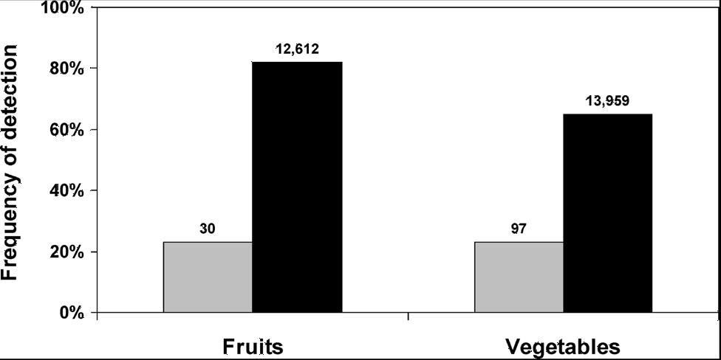

Figure 1 Frequency of detecting at least one type of pesticide residue in organic and conventional fruits and vegetables. Data on pesticide residues in organically grown foods
(gray bars) and foods with no market claim (assumed to be conventionally grown; black bars) were collected from the Pesticide Data Program of the US Department of Agriculture. The total number of samples tested is shown on top of the respective bars. Derived from Baker et al. (2002).
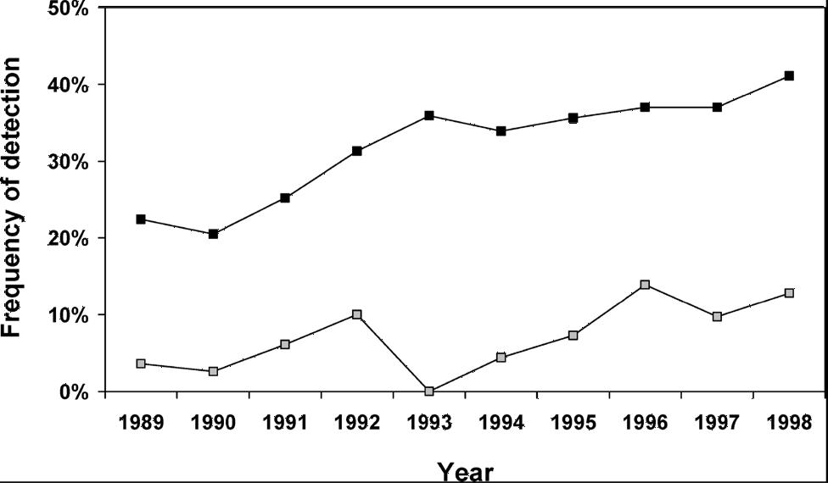

Figure 2 Ten-year trends of contamination rates with pesticides of organic and conventional fruits and vegetables. Data on pesticide residues in organically grown foods (gray squares) and foods with no market claim (assumed to be conventionally grown; black squares) were collected from the Marketplace Surveillance Program of the California Department of Pesticide Regulation. A total of 67,154 samples (1,097 organic and 66,057 conventional) were examined. Derived from Baker et al (2002)
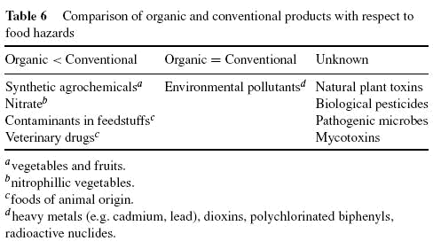

The Navdanya Pesticide Hazards Resource Handbook provides a more detailed list of pesticides and their health hazards. There is not a single organ or tissue in the body that is not affected by pesticides. Below is a table that provides an overview of the actual situation
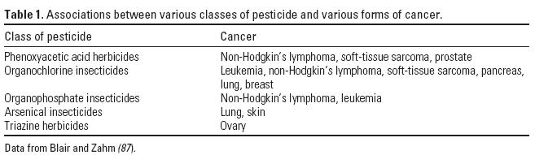

Pesticides have both short-term and long-term effects on human health. The United Nations estimates that around 2 million poisonings and 10,000 deaths occur each year due to pesticides, about three-quarters of which occur in developing countries. Pesticides widely used in industrial agriculture have been linked to high cancer risks for workers and consumers and are coming under closer scrutiny for their link to endocrine and endocrine disorders. reproductive dysfunction.
CONCLUSION: HEALTH per Acer IS A CORRECT SOLUTION TO Malnutrition

Malnutrition is a major public health problem in India. The causes of malnutrition are many ranging from inefficient farming practices, crop failures, and lack of adequate production of food to inequitable distribution, inflation, and poor governmental policies and intervention. India is an immensely densely populated country, has a population greater than 1 billion, and is expected to stabilize at a population of size 1.65 billion by the middle of this century. Malnutrition has already gripped the Indian population, and with such a massive population growth rate, India has the potential to harbor the maximum number of wasted and cognitively degenerated individuals who, in the past as children, were malnourished and who, in the future as adults, see little hope of their struggle coming to an end. This is especially not expected from a country- India- that is proposed to deserve a place in the United Nations Security Council, that is experiencing a booming economic growth, and that is looked at as an emerging superpower; India has to act as a responsible country because stability of India is essential to the global stability. The right to food to its entire population is one among many targets that India has to achieve in order to comply with what is expected from it.

In India, malnutrition is not just a clinical diagnosis, but rather a reflection of corruption in society, governmental inadequacy, poor policies, and debilitating farming practices. The following is extracted from HNP (Health, Nutrition, and Population) paper, World Bank-India’s undernourished children: A call for reform and action by Michele Gragnolati et al-

The consequences of child undernutrition for morbidity and mortality are enormous – and there is, in addition, an appreciable impact of undernutrition on productivity so that a failure to invest in combating nutrition reduces potential economic growth. In India, with one of the highest percentages of undernourished children in the world, the situation is dire. Moreover, inequalities in undernutrition between demographic, socioeconomic and geographic groups increased during the 1990s. More, and better, investments are needed if India is to reach the nutrition MDGs. Economic growth will not be enough.

The prevalence of underweight among children in India is amongst the highest in the world, and nearly double that of Sub-Saharan Africa. In 1998/99, 47 percent of children under three were underweight or
severely underweight, and a further 26 percent were mildly underweight such that, in total, underweight afflicted almost three-quarters of Indian children. Levels of malnutrition have declined modestly, with the prevalence of underweight among children under three falling by 11 percent between 1992/93 and 1998/99. However, this lags far behind that achieved by countries with similar economic growth rates.

Undernutrition, both protein-energy malnutrition and micronutrient deficiencies, directly affects many aspects of children’s development. In particular, it retards their physical and cognitive growth and increases susceptibility to infection, further increasing the probability of malnutrition. Child malnutrition is responsible for 22 percent of India’s burden of disease. Undernutrition also undermines educational attainment, and productivity, with adverse implications for income and economic growth.

Disaggregation of underweight statistics by socioeconomic and demographic characteristics reveals which groups are most at risk of malnutrition. Most growth retardation occurs by the age of two, and is largely irreversible. Underweight prevalence is higher in rural areas (50 percent) than in urban areas (38 percent);
higher among girls (48.9 percent) than among boys (45.5 percent); higher among scheduled castes (53.2 percent) and scheduled tribes (56.2 percent) than among other castes (44.1 percent); and, although underweight is pervasive throughout the wealth distribution, the prevalence of underweight reaches as high as
- percent in the lowest wealth quintile. Moreover, during the 1990s, urban-rural, inter-caste, male-female and inter-quintile inequalities in nutritional status widened.

There is also large inter-state variation in the patterns and trends in underweight. In six states, at least one in two children are underweight, namely Maharashtra, Orissa, Bihar, Madhya Pradesh, Uttar Pradesh, and Rajasthan. The four latter states account for more than 43 percent of all underweight children in India. Moreover, the prevalence in underweight is falling more slowly in the high prevalence states. Finally, the demographic and socioeconomic patterns at the state level do not necessarily mirror those at the national level and nutrition policy should take cognizance of these variations.

Undernutrition is concentrated in a relatively small number of districts and villages with a mere 10 percent of villages and districts accounting for 27-28 percent of all underweight children, and a quarter of districts and villages accounting for more than half of all underweight children.

Micronutrient deficiencies are also widespread in India. More than 75 percent of preschool children suffer from iron deficiency anemia (IDA) and 57 percent of preschool children have sub -clinical Vitamin A deficiency (VAD). Iodine deficiency is endemic in 85 percent of districts. Progress in reducing the prevalence of micronutrient deficiencies in India has been slow. As with underweight, the prevalence of different micronutrient deficiencies varies widely across states.

The intervention that promises to solve the malnutrition crises should have many facets and should also have many levels. By facets, we mean that we will have to choose areas where change is needed- maximizing food production, controlling inflation, distributing justly and equitably, educating, and implementing sound health policies. By levels, we mean that each area of intervention should identify the target and the limiting factors and put in effort accordingly- diversifying food production, controlling food inflation, distributing in rural areas and among schedule tribes and schedule caste, educating woman, and implementing policies that keenly caters to the need of under five children and women. Maximizing nutritional production is rather a more appropriate approach than maximizing production of specific food items. Although malnutrition refers to both over nutrition and under nutrition, under nutrition has reached a crisis stage in India. Moreover, macronutrient and micronutrient deficiencies have to be dealt with simultaneously. Health per acre is a concept that covers nutrition produced per acre of farmland, that deals with diversification of farmlands because dietary diversification is current recommendation, that describes quality of food produced, and that also takes into account the environmental and ecological cost of food produced.

Organic biodiversity based mixed cropping is the foundation of the concept of health per acre. It is a system of farming that increases nutrition produced per acre of farmland. A great amount of food, as well as a variety of food, produced and consumed at local level helps in equitable distribution. The system promotes growing traditional local foods, and hence, also promotes the consumption of such foods at local level. The wide variety of local food items
covers the entire profile of nutrients required essentially by human body. Organic mixed cropping methods maximize the nutrition produced per acre and, hence, help control inflation of food items. Another reason why such cropping method would control food price is that food produced and consumed locally avoids the huge cost of transportation and storage usually included in the price consumer pays for food item. Population, at large, usually knows quite a lot about local food items and its health benefit. As a result, educating people, especially woman, with the various aspects of health and nutrition becomes easier. Implementation of such knowledge also becomes easier as adaption, availability, and cost are not mutually exclusive, but rather facilitating one another. The approach focuses more on the root cause of the problem of under nutrition rather than on the treatment of current cases of malnutrition. Treatment is just one aspect of solving the crises. However, irrespective of how sophisticated treatment we offer, under nutrition cannot be eradicated until we make adequate quantity of a variety of food available to the target population, sustainably.

Nutrition produced per acre gives an insight and a glimpse of the impact that organic mixed cropping method can have on the health of the population. Till now, we have focused primarily on the yield per acre. Looking at agriculture and health in terms of yield per acre makes an important assumption that maximizing yield of specific food items would solve the under nutrition crisis. However, a few food items produced abundantly cannot ensure an ideal blend of nutrients supplied to every person in the society because any single food item is not the adequate source of all nutrients needed by human body. To ensure proper nutrition we need dietary diversification, and to ensure dietary diversification, we need to diversify our farmlands. There is a huge discussion that tries to find the answer to the question that which farming practice can ensure food security - organic mixed cropping or conventional mono copping. The yield per acre of specific food items, used as a measure of effectiveness, appeared to favor conventional mono cropping. However, when nutrition produced per acre of farmland in the two farming systems were compared, strikingly different results came out. What needs to be pointed out is whether abundant production of rice, wheat, corn, or soybean would solve the crisis of under nutrition or abundant production of all the different nutrients would. Organic biodiversity based mixed cropping is sustainable, time tested,reasonable, intelligent, cost effective and ecological solution to the problem of malnutrition in India.

REFERENCES

- Biodiversity based organic farming- A new paradigm for food security and food safety by Navdanya.

- Chemical contaminants in human milk: an overview by Babasaheb R. Sonawane, U.S. Environmental Protection Agency, Washington, DC.
- Textbook of Preventive and Social Medicine by K. Park.
- Heber D. Vegetables, fruits and phytoestrogens in the prevention of diseases. J Postgrad Med [serial online] 2004 [cited 2010 Nov 14];50:145-9.

- Health-promoting properties of common herbs, American Journal of Clinical Nutrition, Vol. 70, No. 3, 491S-499S, September 1999.

- Flavonoid rich fraction from Sageretia theezans leaves scavenges reactive oxygen radical species and increases the resistance of low density lipoproteins to oxidation, J Med food 12 (6), 2009, 1310-1315.
- Bioactive Compounds in Foods: Their Role in the Prevention of Cardiovascular Disease and Cancer by Penny M. Kris-Etherton, PhD, RD, Kari D. Hecker, MS, RD, Andrea Bonanome, MD, Stacie M. Coval, MS, Amy E. Binkoski, BS, RD, Kirsten F. Hilpert, BS, Amy E. Griel, MEd, Terry D. Etherton, PhD.
- Potential Synergy of Phytochemicals in Cancer Prevention:
Mechanism of Action, International Research Conference on Food, Nutrition, and Cancer, Rui Hai Liu.

- Biochemical and Molecular Actions of Nutrients, Flavonoids from Almond Skins Are Bioavailable and Act Synergistically with Vitamins C and E to Enhance Hamster and Human LDL Resistance to Oxidation, by Chung Yen Chen et al, J.

Nutr. 135:1366-1373, June 2005.
- Diet and Lifestyle Recommendations Revision 2006 - A Scientific Statement from the American Heart Association Nutrition Committee

- Report of the steering committee of nutrition, Planning Commission, Govt. of India, New Delhi.

- “Nutritive value of Indian Foods” published by National Institute of Nutrition, Indian Council of Medical Research, Hyderabad.

- Proposed Criteria for Assessing the Efficacy of Cancer Reduction by Plant Foods Enriched in Carotenoids, Glucosinolates, Polyphenols and Selenocompounds by John W. Finley, Oxford Journals, Life Sciences, Annals of Botany, Volume 95, Issue 7.

- Virginia Worthington- Nutritional quality of organic versus conventional fruits, vegetables, and grains, The Journal of Alternative and Complementary Medicine, volume 7, number 2, 2001.
- Precaution before Profits: An Overview of Issues in Genetically Engineered Food and Crops by Sophia Kolehmainen Originally published in VIRGINIA ENVIRONMENTAL LAW JOURNAL, 20 VA. ENVTL. L. J. 267 (200)
- The Journal of Agrobiotechnology Management and Economics (volume 2//number 3 & 4//article 3)- Ten reasons why biotechnology will not ensure food security, protect the environment, and reduce poverty in developing world, by Miguel A. Altieri and Peter Rosset, University of California, Berkeley & Food First/Institute for Food and Development Policy.

- Changes in USDA Food Composition Data for 43 Garden Crops, 1950 to
1999 by Donald R. Davis, PhD, FACN, Melvin D. Epp, PhD and Hugh D. Riordan, MD, Bio-Communications Research Institute, Wichita, Kansas (D.R.D., M.D.E., H.D.R.), Biochemical Institute, The University of Texas, Austin, Texas (D.R.D.)

- New Evidence Confirms the Nutritional Superiority of Plant-Based Organic Foods, by The Organic Center and the University of Florida, Department of Horticulture and Washington State University.

- New Scientist magazine, March 16, 2002, page 10; European Journal of Nutrition, Vol. 40, page 289.

- Organic Retailers and Growers Association of Australia, 2000, as cited in Pesticides and You, Vol. 20, No. 1, Spring 2000, News from Beyond Pesticides/National Coalition Against the Misuse of Pesticides.
- Are organically grown apples tastier and healthier?- A comparative field study using conventional and alternative methods to measure fruit quality,” F.P. Weibel, R.Bickel, S. Leuthold, and T. Alföldi), Acta Hort. 517: 417-427 (2000).

- Comparison of the Total Phenolic and Ascorbic Acid Content of Freeze-Dried and Air-Dried Marionberry, Strawberry, and Corn Grown Using Conventional, Organic, and Sustainable Agricultural Practices by DANNY K.
ASAMI, YUN-JEONG HONG, DIANE M. BARRETT, AND ALYSON E. MITCHELL, J. Agric. Food Chem. 2003, 51, 1237-1241 1237

- Ten-Year Comparison of the Influence of Organic and Conventional Crop Management Practices on the Content of Flavonoids in Tomatoes by MITCHELL A.E. et al, Journal of Agricultural and Food Chemistry 23jun2007
- Folate and cobalamin in psychiatric illness by Burton R. Hutto, Department of Psychiatry, School of Medicine, University of North Carolina at Chapel Hill, Chapel Hill, NC, USA, Comprehensive psychiatry volume 38, issue 6, November-December 1997, Pages 305-314

- Organophosphorus Pesticide Exposure of Urban and Suburban Preschool Children with Organic and Conventional Diets by Cynthia L. Curl, Richard A. Fenske, Kai Elgethun, Department of Environmental Health, School
of Public Health and Community Medicine, University of Washington, Seattle, Washington, USA.

ACKNOWLEDGEMENT

We would like to thank the following persons for helping us to complete this project:

- Dr. V.P. Singh, Professor, GB Pant University of Agriculture and Technology, Pantnagar,

- Dr. D.K. Singh, Professor, GB Pant University of Agriculture and Technology, Pantnagar,

- Mr. Praveen Kumar, Central Library, Banaras Hindu University,
- Ms. Venessa Goodall, volunteer, Navdanya.

