STRUCTURAL AND TRANSPORT PROPERTIES OF SPRAY PYROLYSED Ce:CdO NANOCRYSTALLINE THIN FILMS
¹S.J.Helen, ²Suganthi Devadason*, ³M. Haris, ⁴T. Mahalingam, ⁵R. Chandramohan and ⁶SR. Srikumar
¹PG Department of Physics, Idhaya College for Women, Sarugani - 63041, India
²Department of Physics, Hindustan Institute of Technology and Science,
Chennai - 603103, India
³Department of Physics, Karunya University, Coimbatore - 641114, India
⁴Department of Physics, Alagappa University, Karaikudi - 630 003, India
⁵PG Department of Physics, Vidhyaa Giri College of Arts and Sciences, Puduvayal - 630002, India
⁶Department of Physics, Kalasalingam Academy of Science and Engineering, Krishnankoil - 626126, India
Corresponding Author e-mail: rathinam.chandramohan@gmail.com

Abstract
In this study, a straightforward chemical spray pyrolysis technique was used to develop pristine and Cerium (Ce) doped Cadmium oxide (CdO) thin films onto previously cleaned glass substrates. It is documented how different Ce-doping levels affect the structural, morphological, and transport (optical and electrical) capabilities of CdO thin films. The films thickness was evaluated using cross-sectional SEM images, which showed that the thickness of the films ranged from 360 to 480 nm, with an average thickness of 420 nm. With increasing concentrations of Ce doping, slight morphological abnormalities are seen. According to estimates, the energy band gap values for 3 to 7 weight percent Ce doped CdO thin films are in the range of 2.47 and 2.50 eV. The broad emission found in the photoluminescence spectra of CdO thin film indicates defect-related luminescence (550–650 nm). Low resistivity (10⁻⁴ cm) and high conductivity (10⁴ cm⁻¹) are seen in 5 wt% Ce-doped CdO thin films. The findings of the light responsivity investigations showed that the photoresponse increased as the amount of Ce ions in the CdO thin films increased. The thin films displayed up to 70% photo responsiveness.

1. INTRODUCTION
Material science in the future explores the extraordinary properties of novel materials, novel phenomena, and the utilisation of such materials in novel applications. Oxide materials give several potential as well as challenges. Future study might focus on understanding their properties, ferromagnetism at room temperature, and phonon-aided processes. Doping also gives a wide variety of weak magnetic properties, making them attractive for spintronic applications. [1.2]. The II-VI family of metal chalcogenides, which includes CdO, is an excellent n-type material with a wide variety of uses [3-5]. Over the last ten years, more emphasis has been placed on pristine and doped CdO thin films due to their numerous optoelectronic applications such as transparent conducting oxide (TCO), smart windows, solar cells, optical communications, flat-panel displays, and photo-transistors, as well as other uses such as infrared (IR) heat mirrors, gas sensors, low-emissive windows, thin-film resistors, and so on. Numerous studies describe the doping of CdO films with transition or rare earth metallic ions to adjust their optical and electrical characteristics [12,13]. Dakhel [14,15], Ravikumar et al [16, 18, 19], Helen et al [17, 21,] and Velusamy et al [20] found improvements in electrical properties and decreases in optical properties of metal-doped CdO films generated using vacuum evaporation and spray pyrolysis, respectively. For the large-area deposition of any binary or ternary semiconducting compound with exceptional characteristics, spray pyrolysis is a straightforward and practical method, especially for TCO materials [16–23]. Ce exists in two valence states: Ce³⁺ and Ce⁴⁺. Due to the matching ionic radius in the crystal structure of CdO, Ce⁴⁺ ions can replace some Cd²⁺ ions. The ionic radii of Ce³⁺ and Ce⁴⁺ are 0.103 and 0.087 nm, respectively, and Ce has a coordination number of 6. This demonstrates that Ce⁴⁺ is more likely to occupy metallic sites through the screening effect due to its lower ionic radius compared to Cd²⁺, which is 0.097 nm [20]. Spray pyrolysed Ce doped CdO thin films with a doping concentration of less than 0.9 wt% percent were the subject of experiments by Velusamy et al. [20]. Our group has reported the spray pyrolysis of Mo-doped CdO thin films using a traditional spray method [21]. As a consequence of modifying the composition of the CdO spraying solution with significantly increasing quantities of Ce precursor (3wt%, 5wt%, and 7wt%), Ce atoms are added to CdO thin films in this work. The effect of different levels of Ce-doping using a traditional spray system on the structural, optical, morphological, and electrical properties of these thin films is then investigated.
2. EXPERIMENTAL TECHNIQUES
Spray pyrolysis was utilised to deposit CdO and Ce-doped CdO thin films on clean glass substrates. The pyrolysis system was a spraying Holmarc Model No. H0-TH-04. In order to effectively control the film growth, the various deposition parameters, such as spray rate, substrate temperature, dopant concentration, and nozzle-substrate distance, are optimised after several depositions. An ultrasonic cleaner was used to clean the glass substrates prior to deposition. They were then placed on a substrate holder that was consistently held at 400 °C for all of the depositions. A space of 18 cm was maintained between the spray nozzle and the substrate to provide a uniform covering of films. For the creation of CdO thin films, cadmium acetate dihydrate (Cd(CH3COO)2•2H2O) was employed as the precursor material. Using distilled water and methanol in a 1:1 ratio as a solvent, 0.1 M of cadmium acetate dihydrate was created. Cerium chloride heptahydrate at the proper concentrations (Sigma, 99.9% purity) was utilized to make doped films. The cerium chloride solution's weight percentage was changed to 3, 5, and 7 wt%, respectively. Apart from the dopant system, the deposition circumstances remained consistent. Using air as the career gas, the heated glass substrates were covered with the prepared solution by spraying. Many sets of films have been made for each concentration, and structural, optical, and electrical experiments have been done on them. An X-Ray Diffractometer (Pananalytical Xpert pro X) was used to measure the structural characteristics while utilizing CuK. Energy-dispersive X-ray spectroscopy (EDS) was utilised to determine the composition of the spray-coated thin films, and scanning electron microscopy (SEM - Hitachi Japan) was employed to examine the surface shape and thickness. UV-Vis spectrophotometer was used to investigate optical characteristics (JASCO V-670). The electrical characteristics of thin films were characterised using an I-V characterization set-up (NI PXI - 1044) and a Hall-effect instrument (ECOPIA HMS 3000), respectively.

3. RESULT AND DISCUSSION
3.1 Structural studies

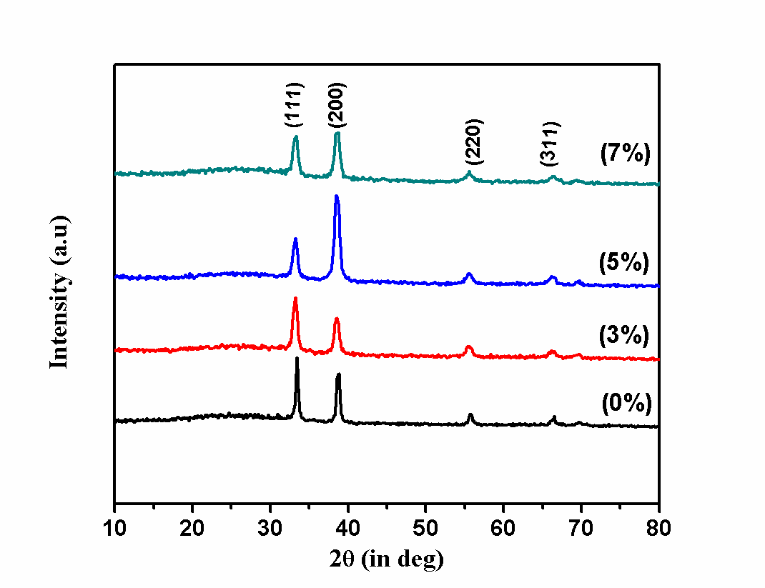
Figure. 1: XRD patterns of Ce doped CdO thin films
Figure 1 depicts the usual XRD patterns for the created undoped and Ce-doped CdO thin films. You can observe the crystallographic planes (111), (200), (220), and (311) X-ray diffraction peaks. The polycrystalline nature of CdO thin films is demonstrated. The diffraction peaks correlate with JCPDF card No. 05-0640, which is part of the cubic crystal structure of CdO, and the peak that is most intense for undoped CdO thin films is along the (111) plane. However, the adjoining peak to the (111) plane, or the (200) peak intensity, changed as a result of Ce inclusion (111). This might be related to the crystallisation process in the production of polycrystalline thin films, and it could be produced by micro-strain fluctuations generated by doping. The microstrain, which is brought on by doping, is due to the difference in ionic radii between the host Cd²⁺ ions and the Ce³⁺ or Ce⁴⁺ contaminants. For the decreased Ce-doping (3 wt%) in the precursor solution, the preferred orientation shifted from the (200) plane to the (111) plane. The favored orientation returns to the (200) plane with increasing doping doses. This is due to the random alteration of the nucleation and growth process of the deposited CdO thin films caused by the replacement of Cd2+ by Ce3+ or Ce4+ ions inside the CdO lattice[15]. Using standard methods, the diffraction data were used to determine the microstructural parameters. The size of the crystallites (D) in CdO thin film is calculated using Debye Scherer’s formula from the XRD data;
$D=\frac{0\text{.}9λ}{β\text{cos}θ}$ (1)
where D is the crystallite size, β is the FWHM of the observed peak, λ is the wavelength of the x-ray, and θ is the angle of diffraction [22]. It was found that the crystallite size ranged from 23 to 9 nm and gradually shrank as the concentration of Ce-doping increases. Equation (2) is used to determine the dislocation density, which is defined as the length of dislocation lines per unit volume.;
(2)
where δ measures the number of faults in a crystal.
For dopant concentrations of 3 and 5%, a larger dislocation density value implies that there are more faults in the films. Utilizing the usual relation, strain is determined,
ε = β cos θ/4 (3)

The texture coefficient is calculated using the formula [23]
(4)
where N is the reflection number, I is the measured intensity of the (h k l) plane, and I₀ is the standard intensity. The TC divergence of a given plane from unity reflects the desired orientation along that plane. According to the computed TC values shown in Table 1, all of the films appear to have a value larger than unity, indicating that the thin films are well-textured. According to the investigations, the rise in the TC value for the (200) plane, from 1.587 to 2.079 about the concentration of cerium, indicates that the surface preparation has become more texturized. Indicating a rise in disorder at the lattice sites for doped films, the computed stacking fault "values of CdO films point to increased stacking fault for the (200) plane. In crystals that are devoid of any flaws, the local strain (microstrain) corresponds to small atomic displacements about their locations.
Williamson-Hall technique was used to understand the role of microstrain in crystallite size. Drawing the Williamson Hall plot does this. This method accounts for the crystal size of the crystallites as well as the crystallographic distortions brought on by Lorentzian intensity distributions. As established in figure 2, (β cosθ) versus (4sin θ) plots a straight line with a y-intercept corresponding to the inverse of the regular crystallite size (D_{W–H}) and the slope relating to the average value of the microstrains. These values were evaluated and then provided. The y-intercept makes it possible to calculate the average crystallite size. With the other crystallite metrics in Table 1, they exhibited a correlation. The investigations showed that doping increases the number of strains in the body. The surface is rebuilt without changing the system volume through the sacrifice of various metallic or vacant sites at the price of crystallite size. The W-H estimate for the 7% system is somewhat bigger than typical Debye estimates. This could be related to the thin film's greater thickness. Williamson-size-strain Hall's plot (SSP) approach takes the widening of peaks into account as a function of the diffraction angle (2θ), which is supposed to reflect the combined impact of size- and strain-induced broadening. Debye Sherrer, however, merely approximates the size and form of grains. As a result, the estimates produced by these two methodologies diverge.
Doping often doesn't result in any change and only very slight variations in shape and intensity are seen. We show the environment and thin film deposition conditions. The qualities dependent on deposition variables are cited as the cause of the variability. More ions can occupy metallic sites thanks to an increase in the dopant ion concentration. Conditions for spray pyrolysis favor homogenous ion distribution and subsequent reactions.

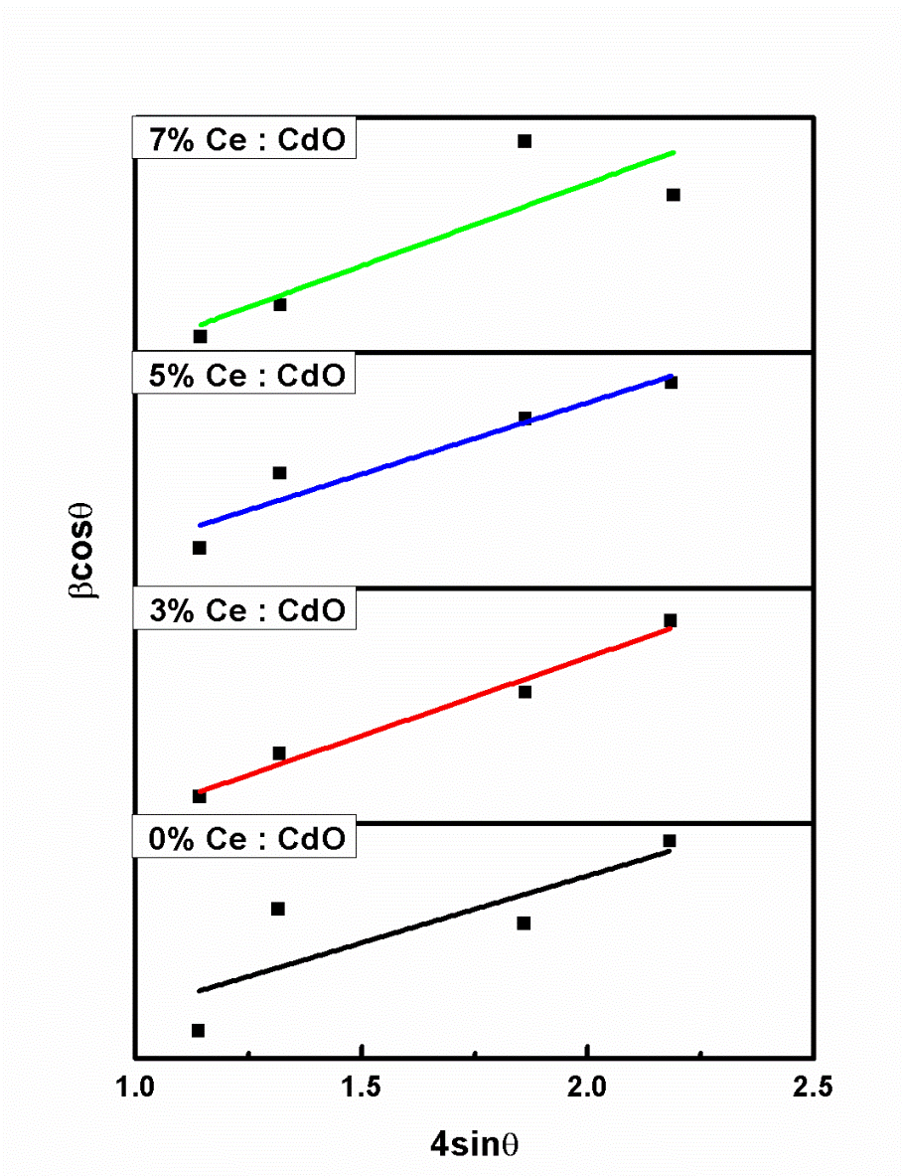
Figure 2: Ce-doped CdO film's W-H plot

Table 1 Structural parameters of Ce: CdO thin films
Percentage of doping (%) | 2θ (200)  Degree | FWHM  (Radian) | D  (nm) | D _{W-H}  (nm) | Microstrain using formula  (x10⁻³) | Lattice strain  using W-H plot  (x10⁻³) | Dislocation density  (x10¹⁵)m⁻² | Texture coefficient | Stacking fault probability (α) | Thickness  (nm)
0 | 38.39 | 0.360 | 23 | 29 | 1.483 | 5.08 | 1.832 | 1.587 | 0.0032 | 360
3 | 38.47 | 0.733 | 11 | 13 | 3.019 | 5.77 | 7.579 | 1.327 | 0.0605 | 376
5 | 38.51 | 0.772 | 10 | 12 | 3.180 | 2.14 | 8.405 | 2.079 | 0.0731 | 468
7 | 38.53 | 0.851 | 9 | 23 | 3.505 | 3.00 | 0.102 | 1.543 | 0.0794 | 480

3.2 Morphological Studies
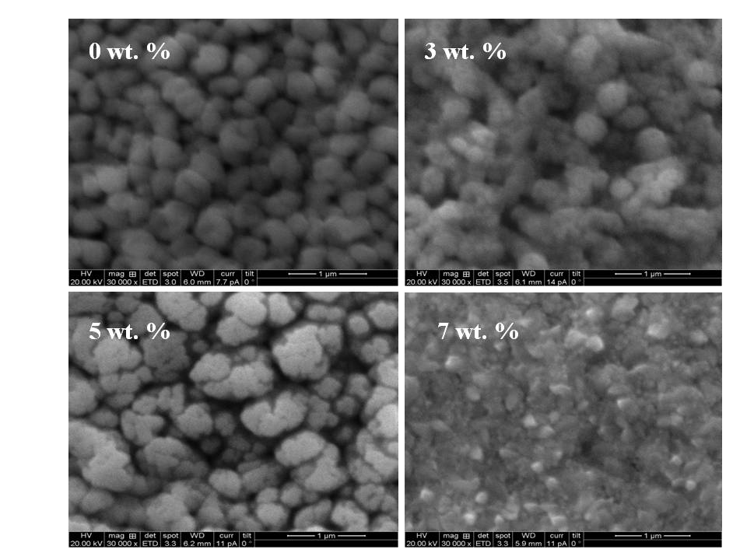
Figure 3(i)
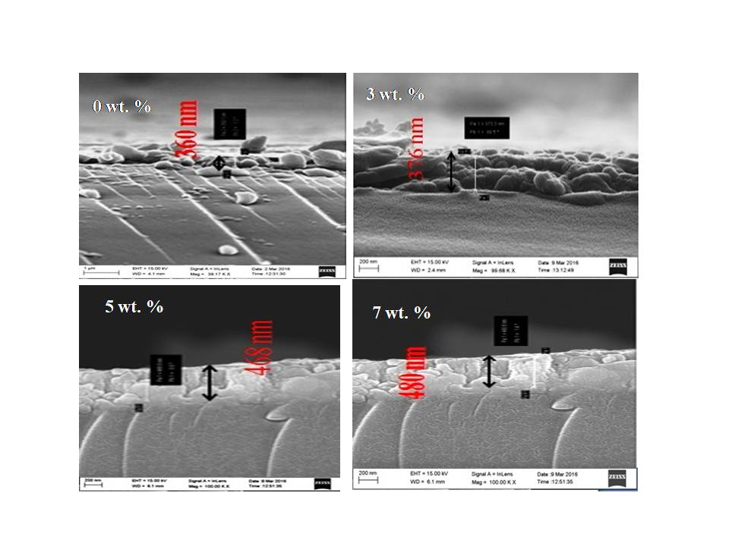
Fig 3 (ii)

Figure 3(i) FE-SEM Micrographs of pure and Ce doped CdO thin films (a) 0%, (b) 3% (c) 5% (d) 7% respectively Figure 3 (ii) The cross sectional image of pure and Ce doped CdO thin films (a) 0%, (b) 3% (c) 5% (d) 7% respectively
Undoped CdO thin film features spherical-shaped grains evenly scattered across its surface. The films from 3, 5, and 7 weight percent cerium doped CdO surface microstructures are shown in Figures 3(i) and 3(ii). In the film with 3 weight percent cerium doping, the surface gets smoother with more agglomerations, and in the film with 5 weight percent cerium doping, the grains increase bigger. Smaller-sized grains may be seen on the surface of the film doped with 7 weight percent of cerium, and the surface microstructures reveal microscopic gaps in the stacking. The film's thickness ranges from 360 to 480 nm and was determined using cross-sectional SEM images, as shown in Table 1.
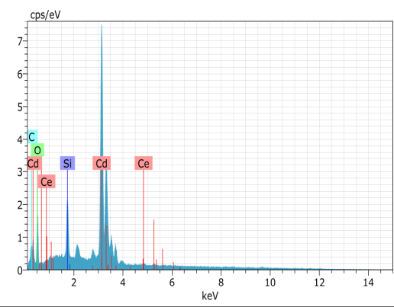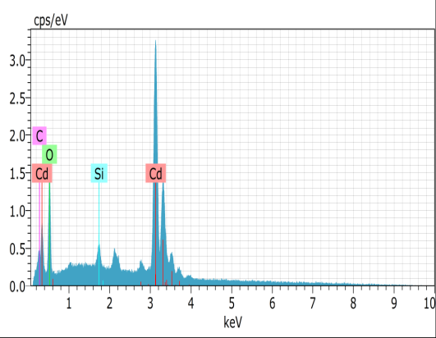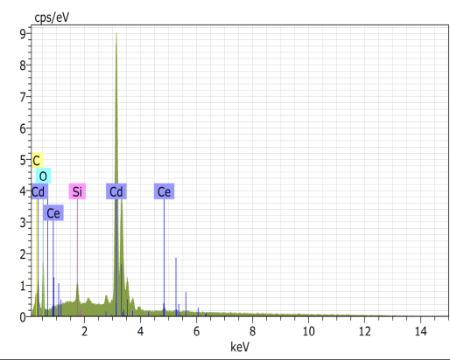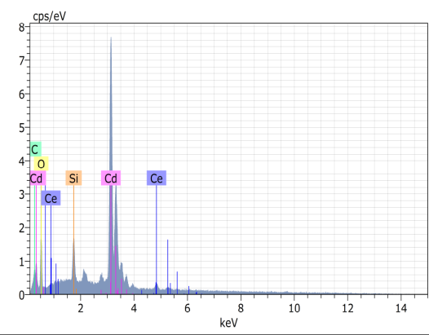
0%
3%
5%
7%
Figure 4 EDAX spectra of Ce doped CdO films
Figure 4 displays the EDAX spectra for typical Ce-doped CdO films at various dopant concentrations. The existence of Cd (L spectral lines), O (k spectral lines), and Ce (L spectral traces) is thus made evident. There is also Si from the glass substrate. There are no additional impurities found. The intensities of Cd, O, and Ce, in that order, were used to calculate their respective weights and atomic ratios. Table 2's measurement of the ratios demonstrates unequivocally that Ce was present in the spray-deposited doped CdO thin films. The number of atoms in a sample determines the atomic percentage. The investigations show that there are fewer dopant atoms on the surface than was anticipated. However, the spray method's adaptability to change the chemical composition of the spraying precursor solution can change the number of Ce atoms in the films.
Table 2 Elemental composition of Ce doped CdO films
Ce doping concentration | Percentage of Element  Wt% |  |  | Percentage of Element  at%
 | Cd | O | Ce | Cd | O | Ce
0% | 87.68 | 12.32 | 0.00 | 50.32 | 49.68 | 0.00
3% | 84.24 | 13.79 | 1.98 | 46.11 | 53.02 | 0.87
5% | 83.78 | 13.17 | 3.05 | 46.87 | 51.76 | 1.37
7% | 81.93 | 12.64 | 5.43 | 46.79 | 50.72 | 2.49

3.3 Optical properties

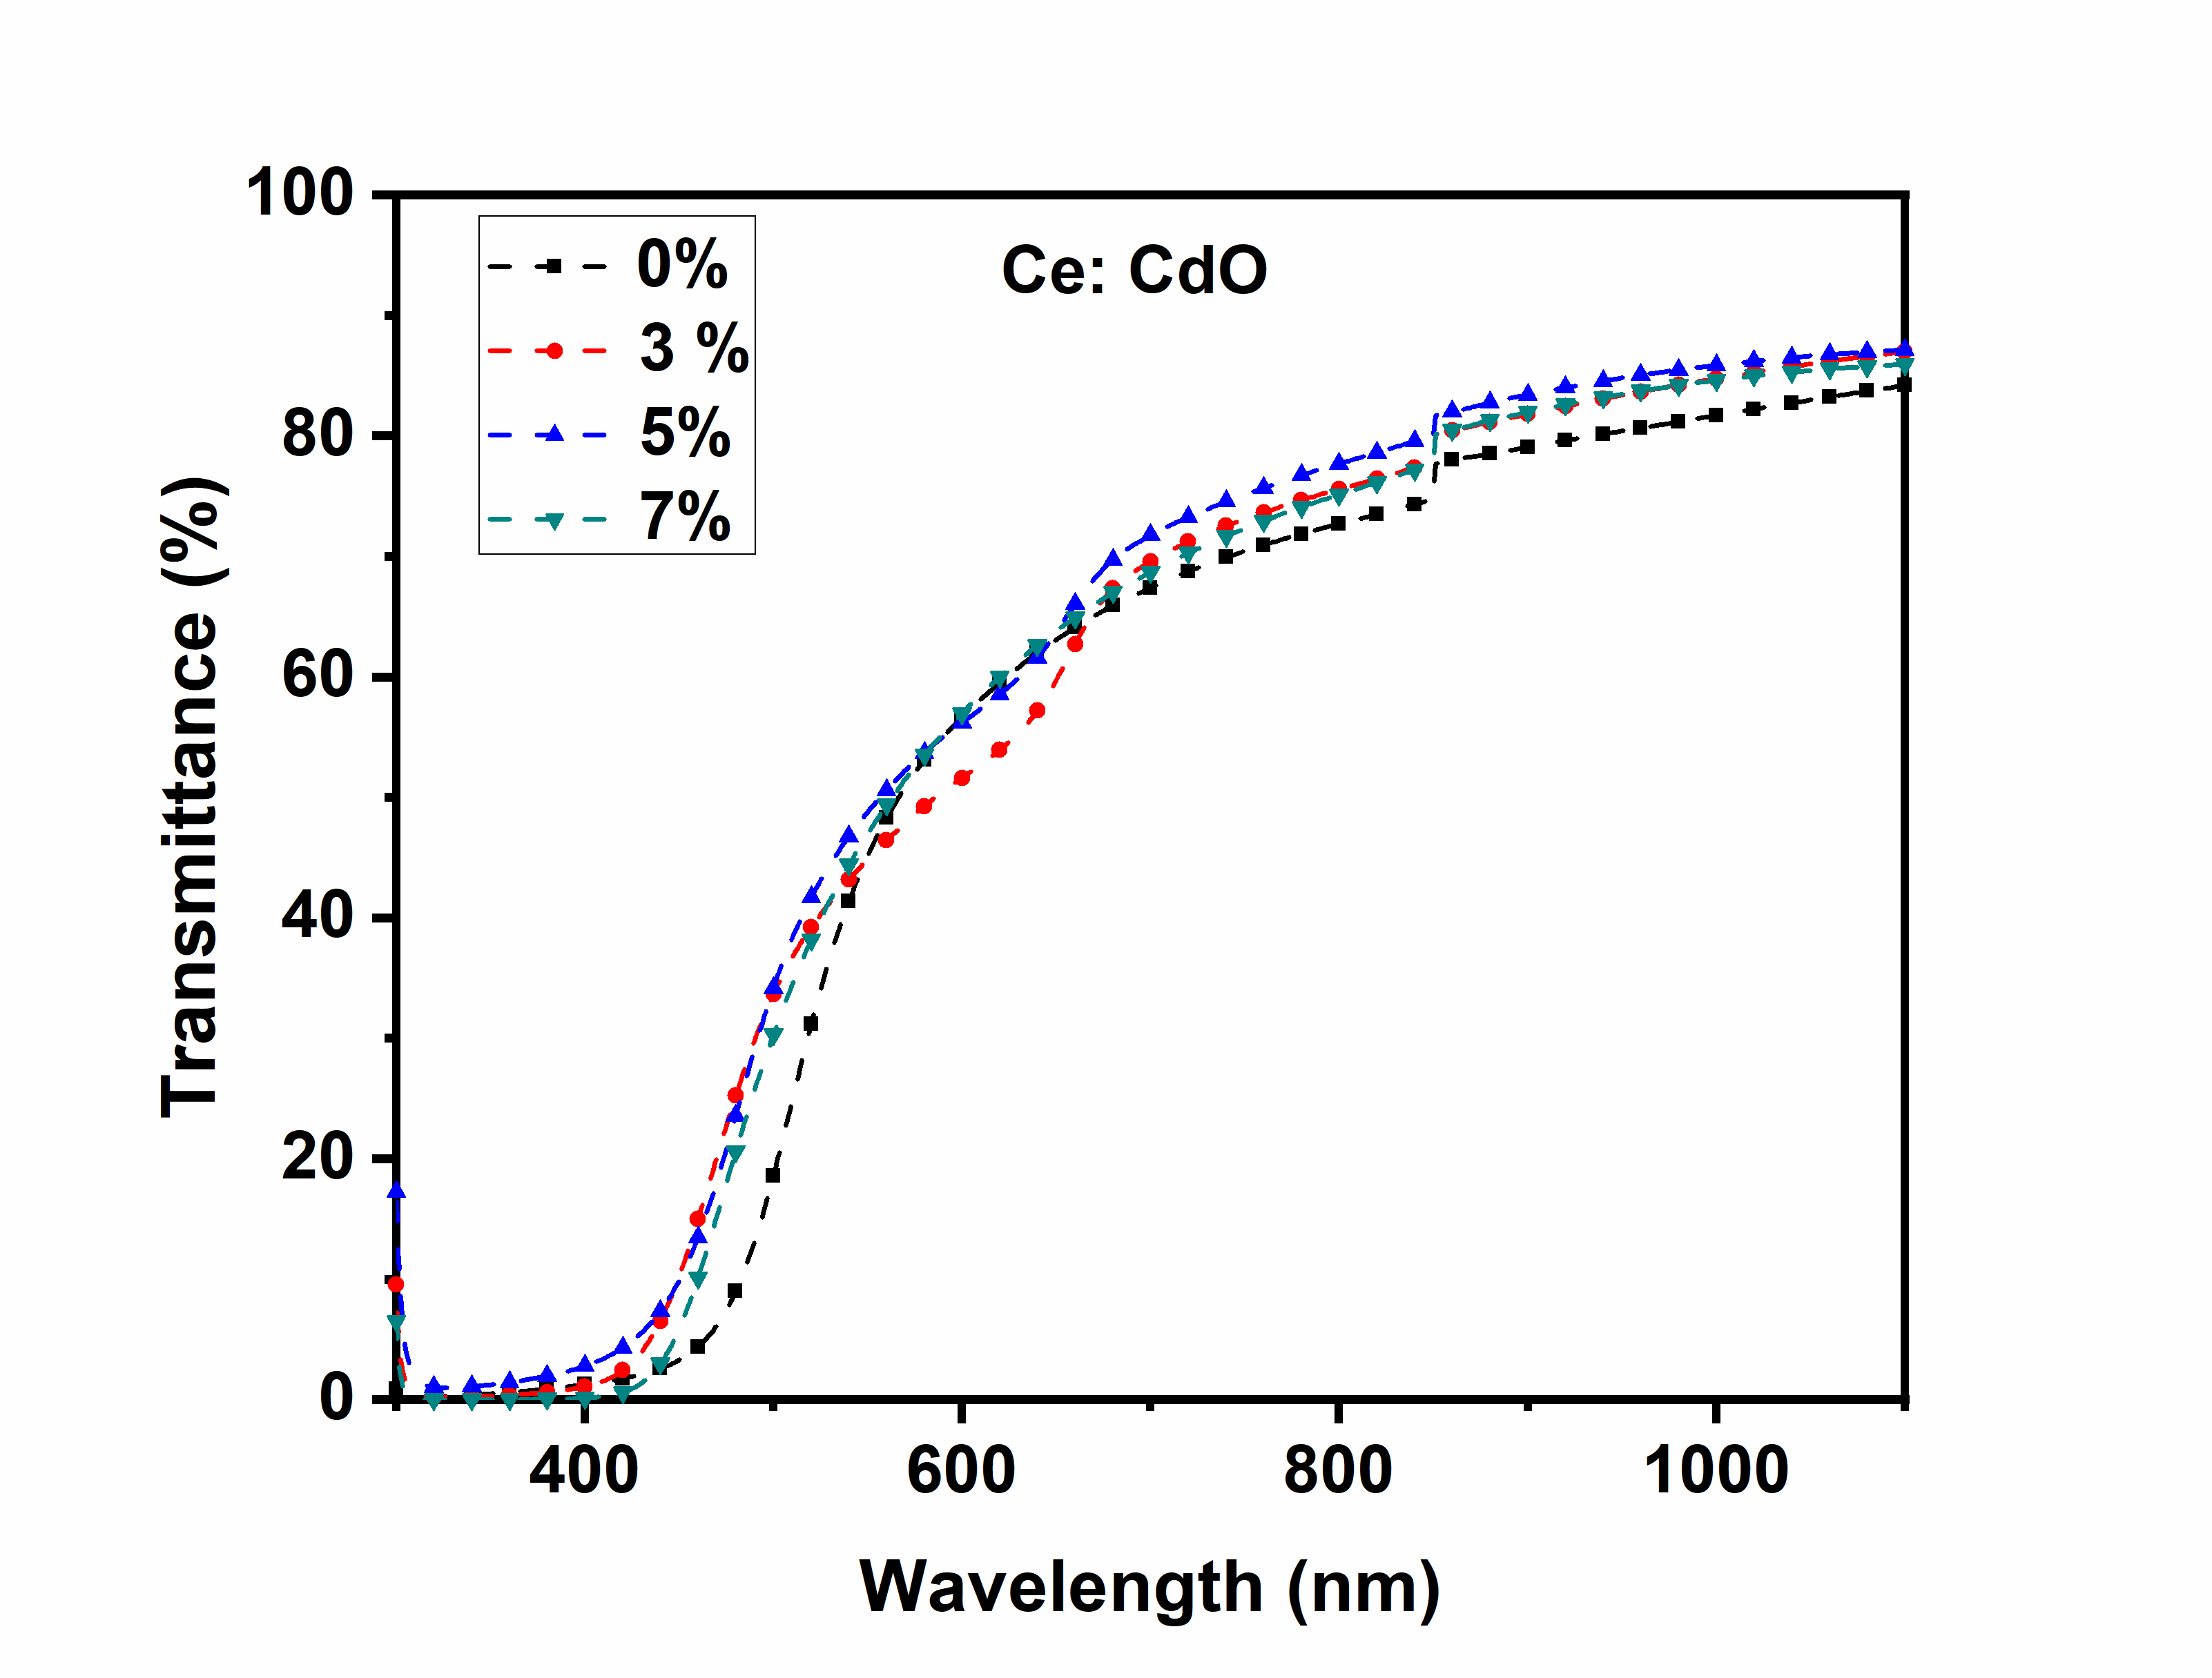
Figure 5 Optical transmittance of undoped and Ce doped CdO thin films

The optical transmittance spectra of Ce-doped and undoped CdO thin films that were formed on glass substrates are shown in Figure 5. The deposited Ce-doped CdO films have high optical transmittance of around 80% in the non-absorption area, and this optical transmittance rises with increasing Ce concentration in the longer wavelength region. The absorption edge exhibits a blue shift as a result of the Ce doping. The Moss-Burstein phenomenon provides a reason for band gap broadening, sometimes referred to as the blue shift of the absorption zone [13]. The increase of the Fermi level up to the conduction band may have caused the band gap to expand in damaged semiconductors. This can lead to a blue shift in the absorption edge. The following method is used to calculate the absorption coefficient (α) as a function of wavelength (λ).
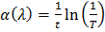 (5)
where t is the thickness of the films and T is the transmittance. The following equation describes the relationship between the and the incident photon energy (hv).
(6)

where "m" is an index that varies depending on the type of optical transition, "A" is an energy-independent constant, "E_{g}" is an optical band gap, and "m" has values of 1/2, 3/2, 2, and 3 depending on whether the transition is direct-allowed, direct-forbidden, indirect-allowed, or indirect-forbidden. Since CdO is known to be a direct-allowed semiconducting material based on theoretical and experimental findings, m is set to 2. By projecting the linear part to the h axis from the (hv)² versus h plot (Tauc's Plot), the direct optical band gap has been calculated. Figure 6 depicts the sketched version of Tauc's plan. For CdO films that are 3 to 5 weight percent doped, the energy band gap values are 2.47 and 2.50 eV, respectively. The band gap found to expand due to Ce doping in CdO films illustrates the blue shift.
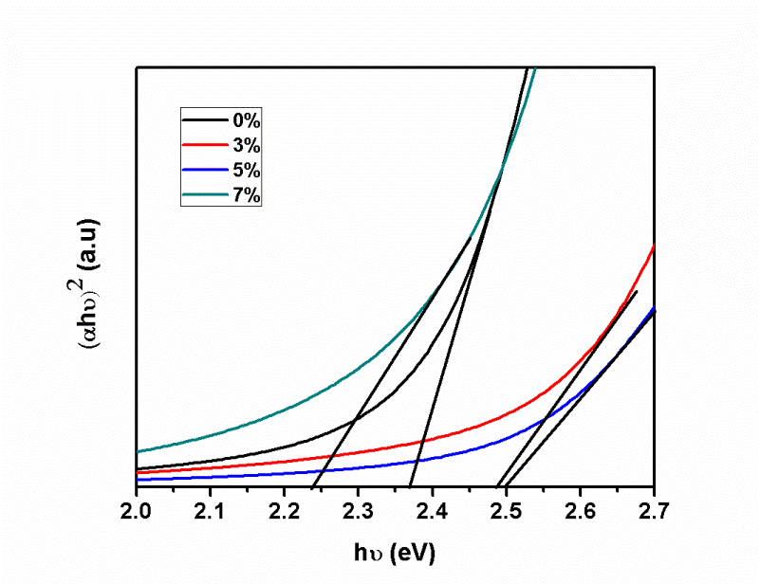
Figure 6 Energy bandgap of undoped and Ce doped CdO thin films
3.4 Photoluminescence studies

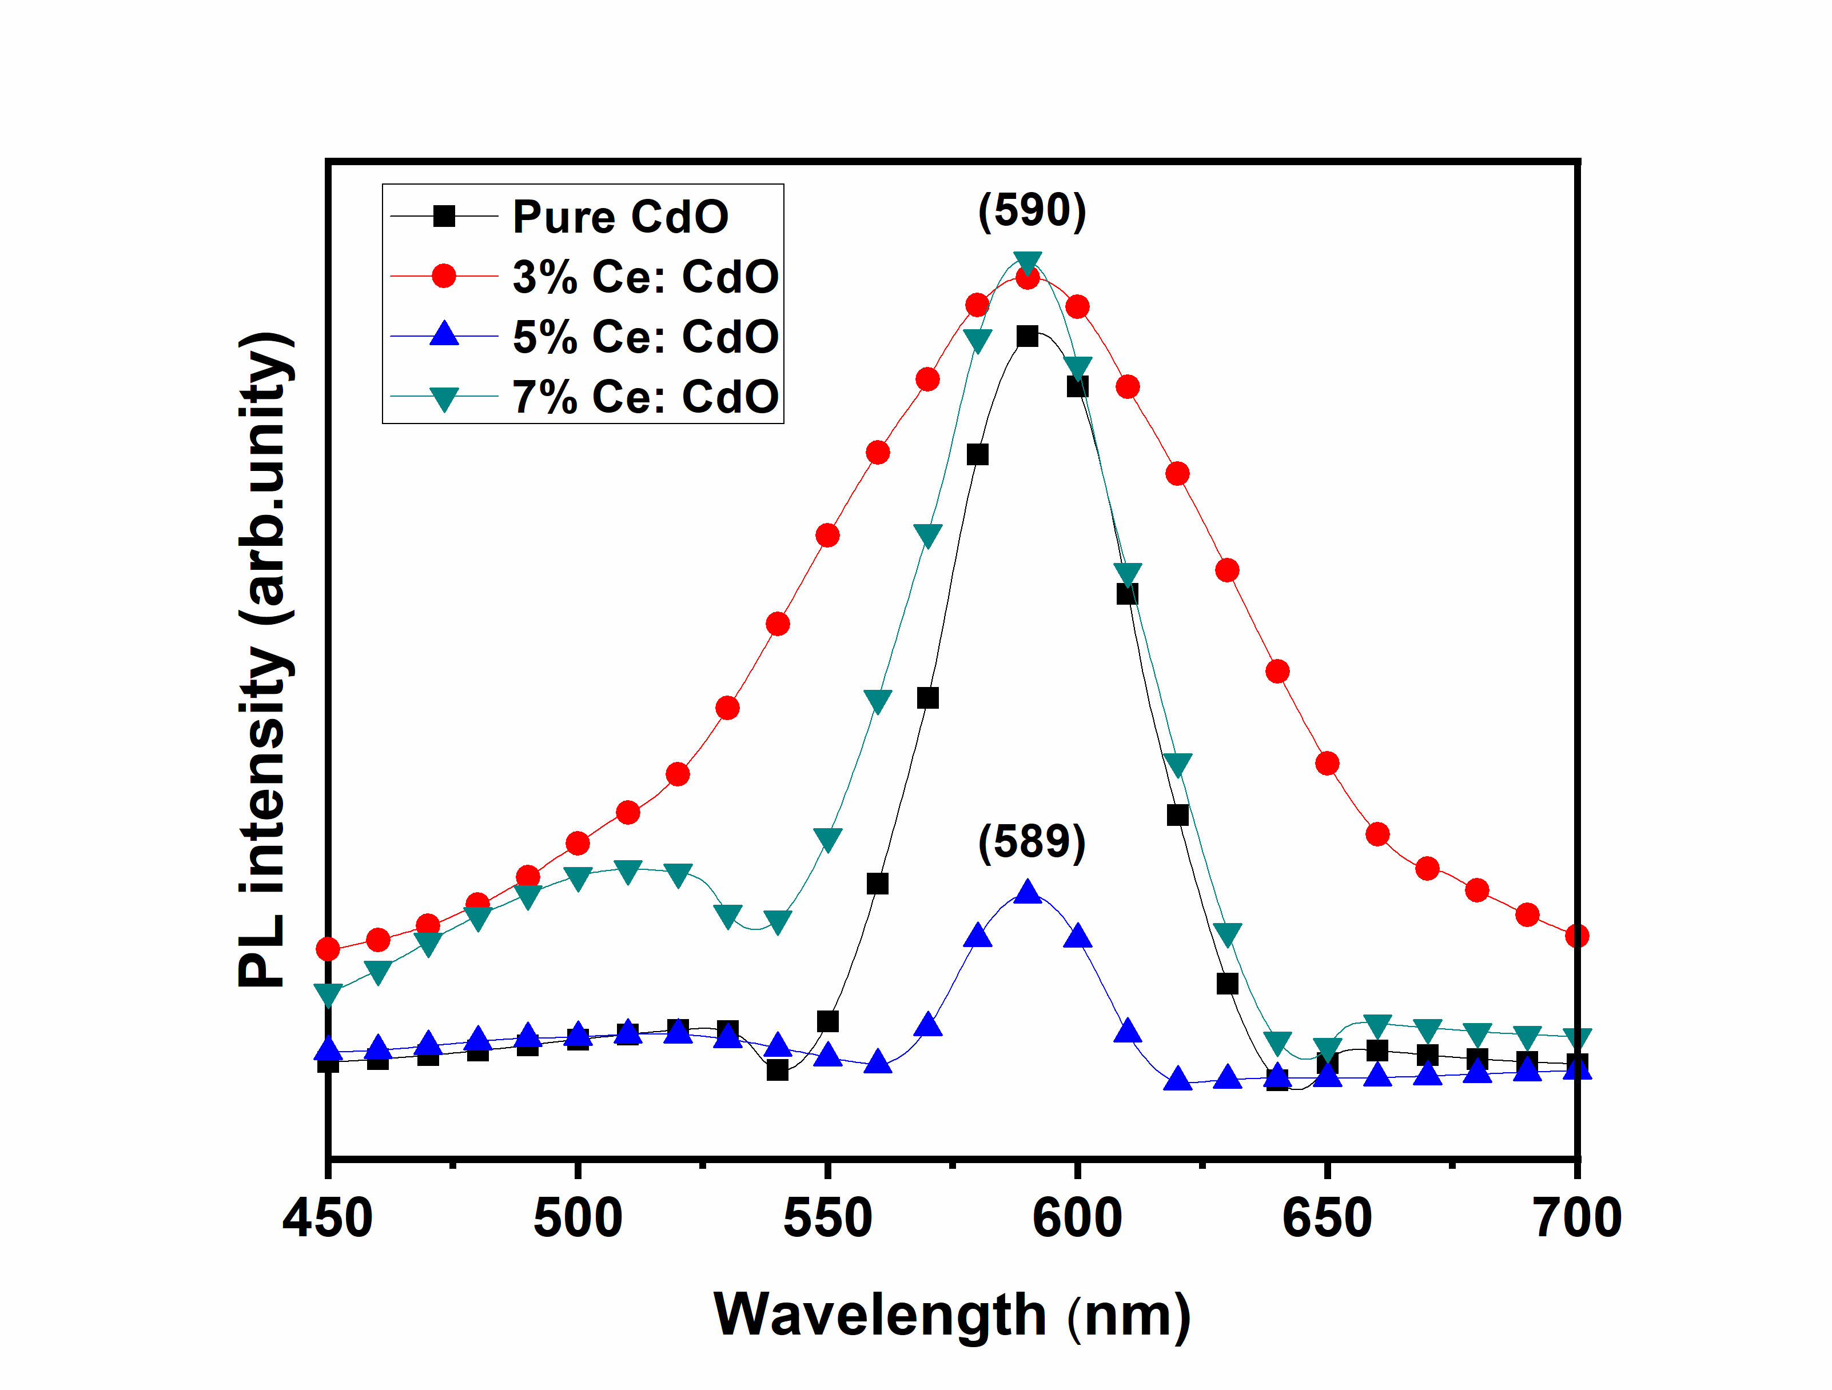
Figure 7 PL spectra of Ce doped CdO films
Figure 7 shows the PL spectra of thin Ce-doped CdO films. To excite evenly, 320 nm of light was employed as the light wavelength. The PL spectra of produced Ce-doped CdO thin films reveal a diversity of emission properties. Figure 7 illustrates how the strength and location of the PL emission peak alter as the doping concentration changes. In the system with this excitation, the near edge emission linked to the CdO host is missing or not dominating. The ionised oxygen vacancies in the CdO thin films may be the cause of the deep-level or trap-state emission that gives rise to the CdO film's highly strong PL peak at 590 nm (orange emission). The peak's strength rises as the doping concentration rises. The broadband emission that was observed (550–650 nm) in the photoluminescence spectra of CdO thin film indicates the defect-related luminescence peak. The main mechanism, which predominates host emissions, is the radiative transition between oxygen vacancies or Cd interstitials, which function as shallow donors and Cd vacancies, which act as deep acceptors. The absence of blueshift in PL is explained by the dominance of excitable traps in the emission process. These cheap-cost prepared thin films have the appealing property of having such excitable traps or flaws.
3.5 Electrical properties
Electrical investigations have shown that the deposition of films is very conductive. Numerous electrically related characteristics, including carrier concentration (n), carrier mobility (μ), and resistivity (ρ), of unmodified CdO and Ce-modified CdO films are calculated using Hall measurements and depicted graphically in figures 8 and 9, respectively. The n-type conductivity of the films is verified by the Hall coefficient's negative sign. As a neutral contaminant, Ce³⁺ works to enhance neutral impurity scattering, which in turn lowers carrier concentration and mobility and alters surface shape. For 5% Ce-doped CdO thin films, a high carrier concentration of 1.54 1021 cm⁻³ is attained.
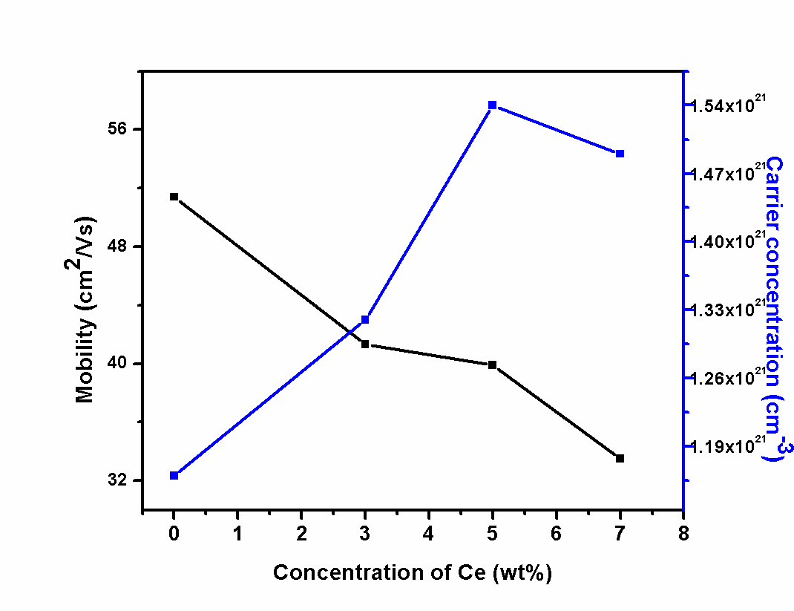
Figure 8 Mobility and carrier concentration of Ce doped CdO

For 5-weight percent Ce-doped CdO thin films, low resistivity (1.02× 10⁻⁴ cm) and high conductivity (9.84 ×103 cm⁻¹) are reported (Figure 9). Because Ce³⁺ replaces Cd²⁺ in the CdO lattice, more electrons are produced, leading to an increase in carrier concentration.
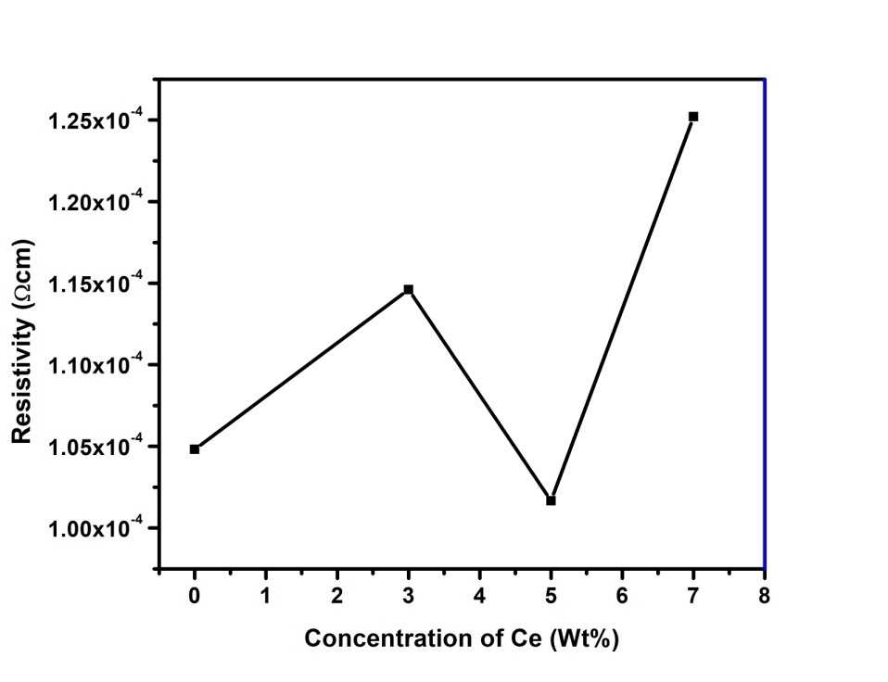
Figure 9 Resistivity of undoped and Ce doped CdO thin films

3.6 I-V characteristics under light illumination

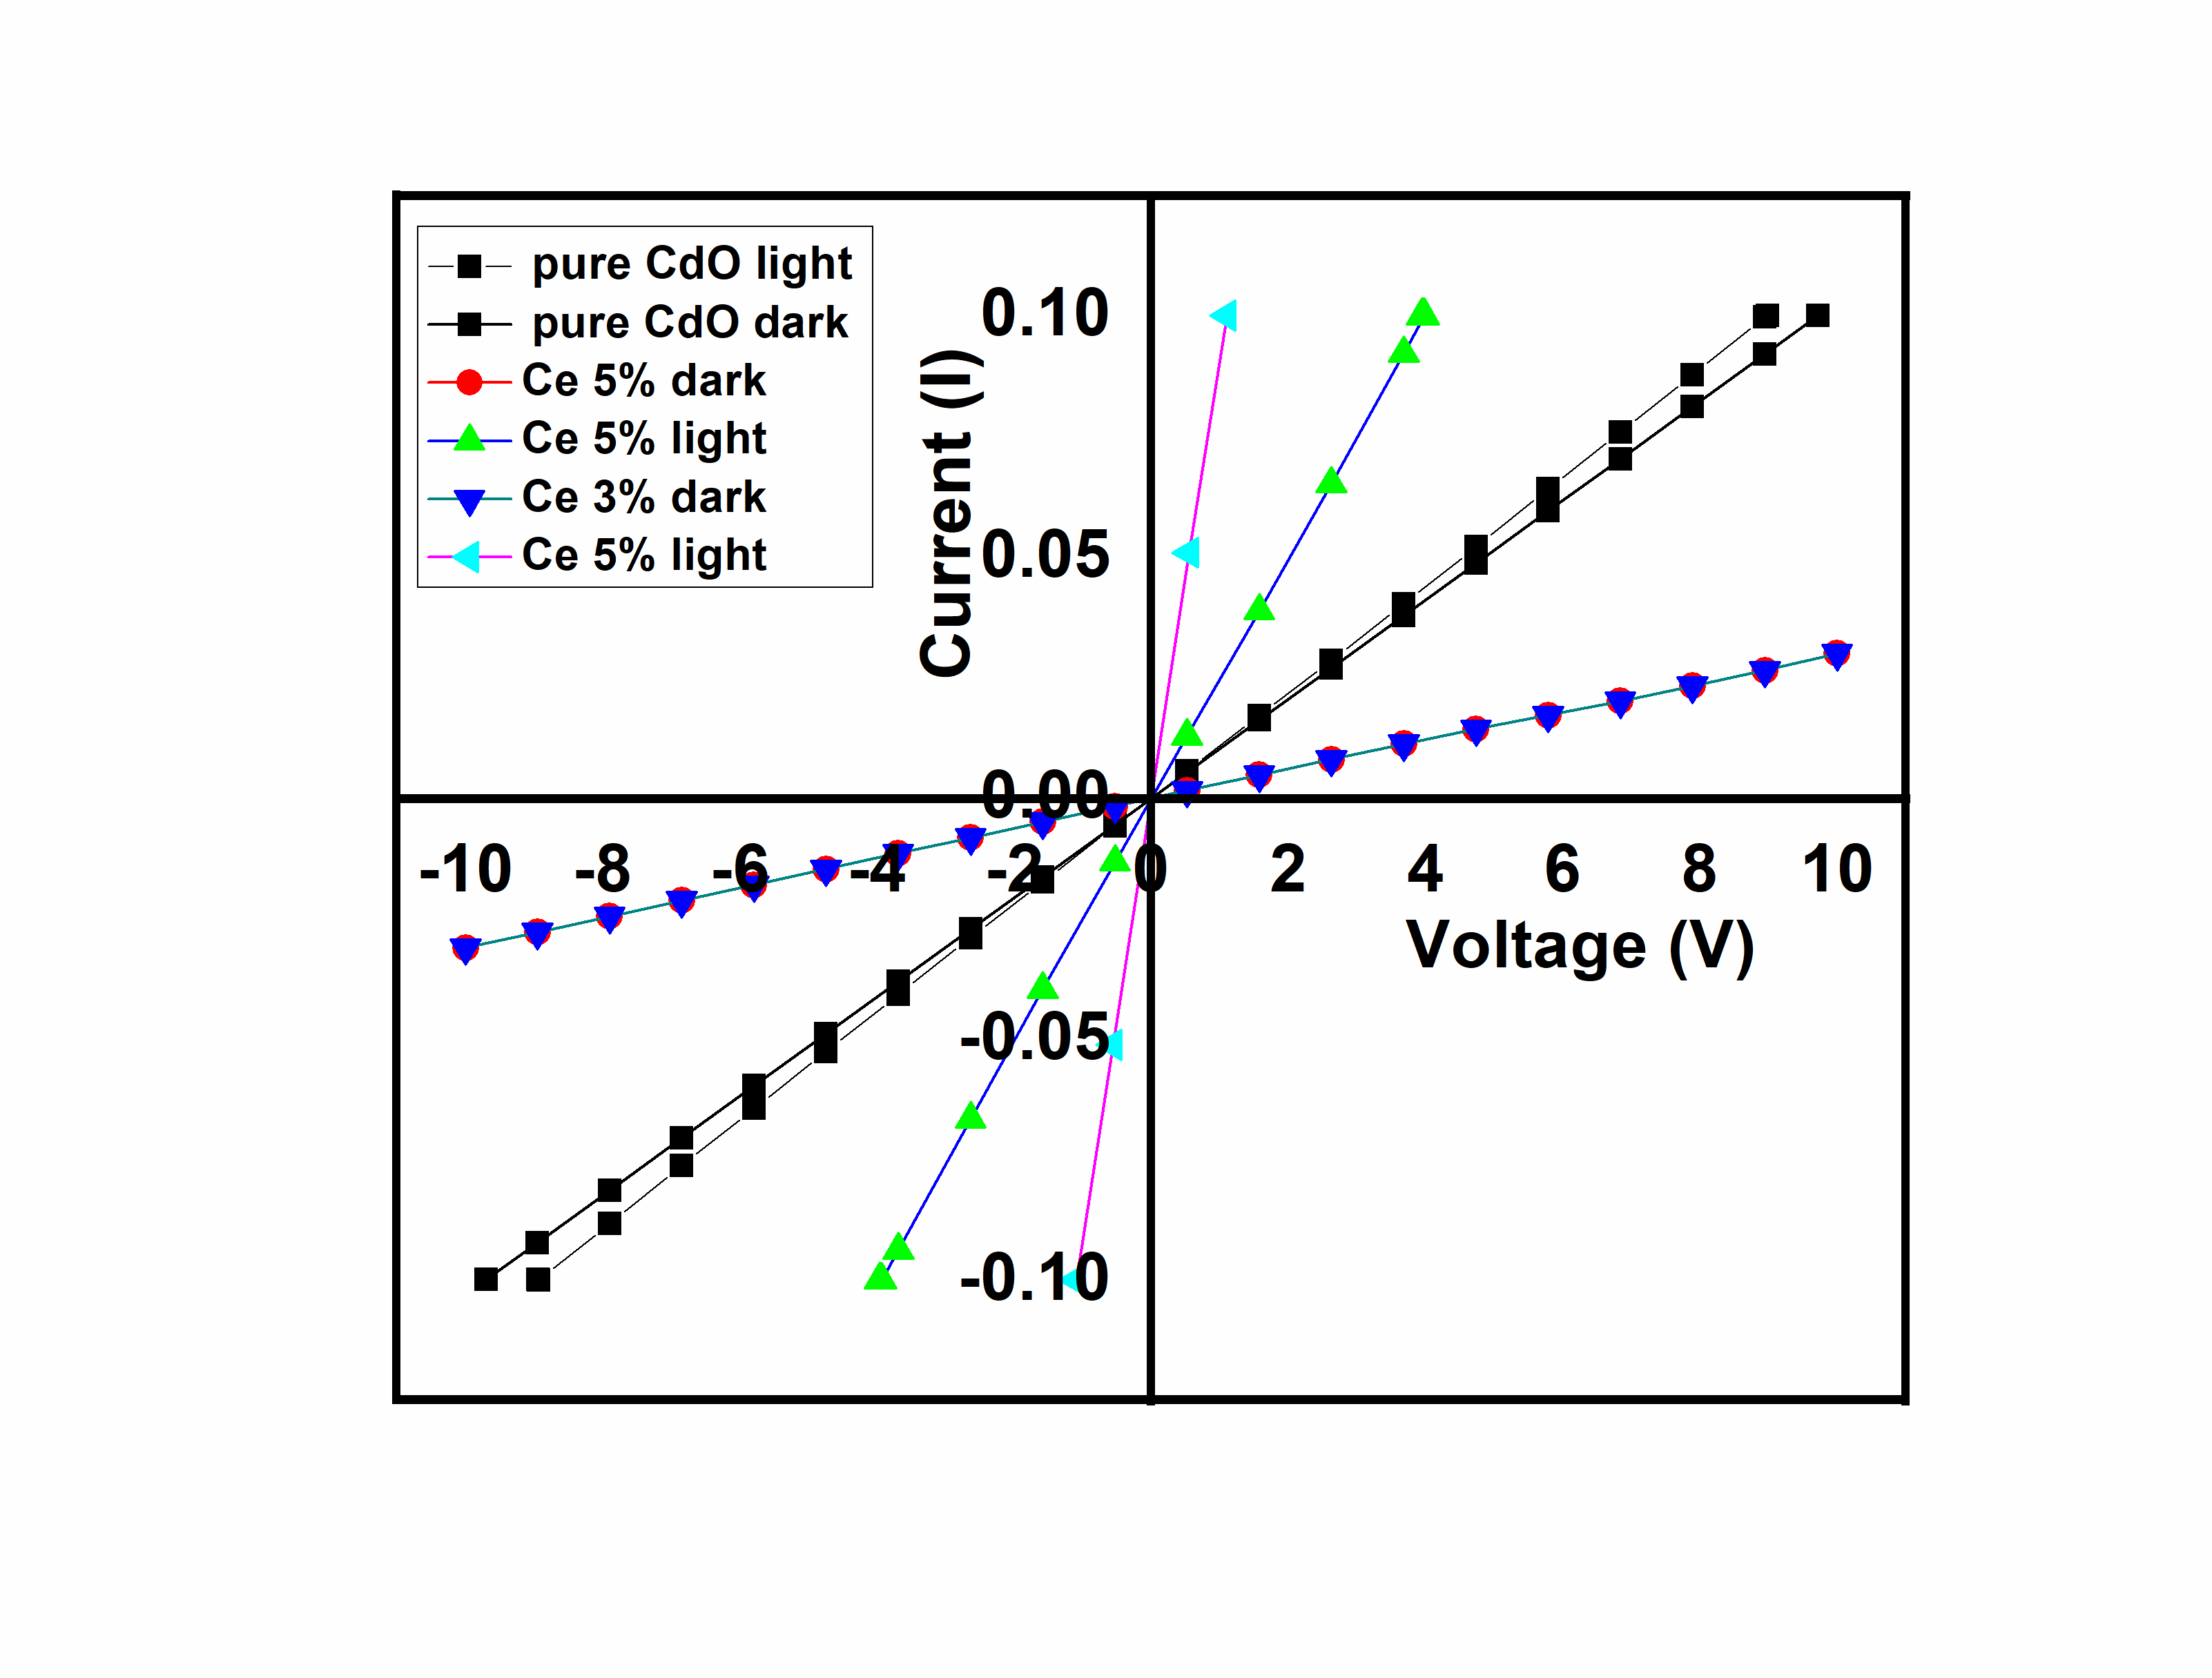
Figure 10 I-V characteristics under dark and light illumination of undoped and
Ce doped CdO thin films
Figure 10 depicts the typical I-V properties of undoped and Ce-doped CdO thin films under dark and light illumination. The I-V values during illumination were recorded using halogen light. It has been noted that the films display ohmic behavior, demonstrating the material's excellent conductivity. The extra photogenerated charge carriers present in the film are also shown to have boosted conductivity for the film at Ce 5% of doping level to ∼70% on illumination.
4. CONCLUSIONS
Investigations have been made into the impact of Ce-doping at different concentrations on the structural, morphological, optical, and electrical characteristics of CdO thin films produced via spray pyrolysis. Studies of the structure show that it is polycrystalline and has a cubic structure. The size of the crystallites changes depending on the Ce doping level, from 11 to 9 nm. The films are homogeneous, with spherical-shaped grains, as seen by SEM. EDAX research has verified the existence of Ce atoms in doped films. In the longer wavelength region, ce-doped CdO films have a high transmittance of about 80%. For 5-weight percent Ce-doped CdO thin films, low resistivity (1.02× 10⁻⁴ Ωcm) and high conductivity (9.84× 103 Ωcm⁻¹) are reported. Due to the extra photogenerated charge carriers produced in the film, 5% of Ce doping level exhibits an improved conductivity up to ∼70% under illumination. The investigations showed that the spray pyrolysis technique may be used to create Ce-doped CdO thin films with improved TCO and photogeneration capabilities.
5. REFERENCES

1. Agnes C Nkele, Assumpta C Nwanya, Nwankwo U Nwankwo, A B C Ekwealor, Rose U Osuji, R Bucher, Malik Maaza and Fabian I Ezema, 2019 Structural, optical and electrochemical properties of SILAR-deposited zirconium-doped cadmium oxide thin films, Materials Research Express, Volume 6, Number 9
2. Gan Siew Mei, P Susthitha Menon, and Gurumurthy Hegde, 2020 ZnO for performance enhancement of surface plasmon resonance biosensor: a review, Mater. Res. Express 7 012003.
5
3. S. Vasheghani Fahrahani, T. D. Veal, P. D. C. King, J. Zúñiga-Pérez, V. Muñoz-Sanjoé, and C. F. McConville,2011 “Electron mobility in CdO films,” J. Appl. Phys. 109, 073712.
4. Rituparna Chatterjee, Gopes Chandra Das and Kalyan Kumar Chattopadhyay 2020 Luminescence properties of nano and bulk ZnWO4 : Eu3+ phosphors for solid state lighting applications, Mater. Res. Express 7 074002.
5. Vanasundaram N, Muneer Ahmad, A K Chaudhary and Praveen Kumar Sharma, 2020 Surface charge doping induced carrier type reversal in spin coated CdS/rGO layered nanohybrid films, Mater. Res. Express 7 025015.
6. Evan L. Runnerstrom, Kyle P. Kelley, Edward Sachet, Christopher T. Shelton, and
Jon-Paul Maria 2017 Epsilon-near-Zero Modes and Surface Plasmon Resonance in
Fluorine-Doped Cadmium Oxide Thin Films. ACS Photonics, 4, 1885-1892
7. Kyle P. Kelley, Edward Sachet, Christopher T. Shelton, and Jon-Paul Maria, 2017 High mobility yttrium doped cadmium oxide thin films, APL Materials 5, 076105.
8. Zeke Liu, Yaxu Zhong, Ibrahim Shafei, Soojin Jeong, Liguang Wang, Hoai T. Nguyen, Cheng-Jun Sun, Tao Li, Jun Chen, Lei Chen, Yaroslav Losovyj, Xinfeng Gao, Wanli Ma, Xingchen Ye. 2020Broadband Tunable Mid-infrared Plasmon Resonances in Cadmium Oxide Nanocrystals Induced by Size-Dependent Nonstoichiometry. Nano Letters , 20 (4) , 2821-2828..
9. Hui Chen, Lei Sun, Guo-Dong Li, Xiaoxin Zou. Well-Tuned Surface Oxygen Chemistry of Cation Off-Stoichiometric Spinel Oxides for Highly Selective and Sensitive Formaldehyde Detection. Chemistry of Materials 2018, 30 (6) , 2018-2027
10. Chao Ping Liu, Chun Yuen Ho, Roberto dos Reis, Yishu Foo, Peng Fei Guo, Juan Antonio Zapien, Wladek Walukiewicz, and Kin Man Yu . Room-Temperature-Synthesized High-Mobility Transparent Amorphous CdO–Ga2O3 Alloys with Widely Tunable Electronic Bands. ACS Applied Materials & Interfaces 2018, 10 (8) , 7239-7247.
11. M Ravikumar, R Chandramohan, K Deva Arun Kumar, S Valanarasu, A Kathalingam, V Ganesh, Mohd Shkir, S AlFaify, H Algarni, Effect of Pr3+ doping on key properties of CdO thin films deposited by spray pyrolysis using perfume atomizer, Journal of Physics and Chemistry of Solids, 118, 211-220(2018).
12. M Ravikumar, V Ganesh, Mohd Shkir, R Chandramohan, K Deva Arun Kumar, S Valanarasu, A Kathalingam, S Alfaify, Fabrication of Eu doped CdO [Al/Eu-nCdO/p-Si/Al] photodiodes by perfume atomizer based spray technique for opto-electronic applications, journal of Molecular Structure, 1160 , 311-18 (2018)
13. M Ravikumar, R Chandramohan, K Deva Arun Kumar, S Valanarasu, A Kathalingam, V Ganesh, Mohd Shkir, S AlFaify, Effect of Gd³⁺ doping on key structural, morphological, optical, and electrical properties of CdO thin films fabricated by spray pyrolysis using perfume atomizer, Journal of Sol-Gel Science and Technology, 85, 31-40(2018).
14. Dakhel, A.A. Impact of Silicon Doping on the Properties of Transparent Conducting CdO Thin Films. Silicon 11, 525–532 (2019).
15. Dakhel, A.A., Hamad, H. Electronic and Bandgap Tuning of Hydrogenated Ti-doped CdO Semiconductor. Journal of Elec Materi 48, 4293–4299 (2019).
16. M Ravikumar, R Chandramohan, K Deva Arun Kumar, S Valanarasu, V Ganesh, Mohd Shkir, S Alfaify, A Kathalingamm, Effect of Nd doping on structural and opto-electronic properties of CdO thin films fabricated by a perfume atomizer spray method, Bulletin of Materials Science, 42, 1, (2019)
17. S. J. Helen, Suganthi Devadason and T. Mahalingam, Improved physical properties of spray pyrolysed Al:CdO nanocrystalline thin films. J Mater Sci: Mater Electron 27 (5), 4426 (2016).

18. R David Prabu, S Valanarasu, V Ganesh, Mohd Shkir, S AlFaify, A Kathalingam, SR Srikumar, R Chandramohan An effect of temperature on structural, optical, photoluminescence and electrical properties of copper oxide thin films deposited by nebulizer spray pyrolysis technique, , Materials Science in Semiconductor Processing,74, 129-135, (2018).
19 . K. Ravichandran, G Muruganantham, K Saravanakumar, S Karnan, B Kannan, R Chandramohan, B Sakthivel, Doubly doped tin oxide films from cost effective spray technique using perfume atomiser, 25, Surface Engineering, Pages, 82-87(2009).
20. P. Velusamy, R. Ramesh Babu,K. Ramamurthi, M. S. Dahlemc and E. Elangovan, Highly transparent conducting cerium incorporated CdO thin films deposited by a spray pyrolytic technique, RSC Advances 5, 102741 (2015).
21. SJ Helen, Suganthi Devadason, M Haris, T Mahalingam, Journal of Electronic Materials, Transparent conducting Mo-doped CdO thin films by spray pyrolysis method for solar cell applications, 47, 2439-2446, (2018)
22. Mario Burbano, David O. Scanlon, and Graeme W. Watson, 2011 Sources of Conductivity and Doping Limits in CdO from Hybrid Density Functional Theory, Journal of the American Chemical Society 133 (38), 15065-15072.

23. S Rex Rosario, I Kulandaisamy, A M S Arulanantham, K Deva Arun kumar, S Valanarasu, Mohamed S Hamdy, K S Al-Namshah and Abdullah M Alhanash 2019 Analysis of Cu doping concentration on PbS thin films for the fabrication of solar cell using feasible nebulizer spray pyrolysis 6 5 111574.

