Prospects of Biochar in Soil Health Management-SDG and Indian Perspectives

Prarthana Priyom Hazarika, Bhaskar Jyoti Buragohain, Monoranjan Nath and Ritu Thakur*
North Eastern Regional Institute of Water and Land Management, Tezpur 784027, Assam, India
Corresponding author *: thritu12@gmail.com
Abstract
The recent developments in human civilization have paved a way to numerous changes in the environment, including climate change and it’s all other related effects, which in turn is affecting all dimensions of food security as food availability, food accessibility, food utilization, and food systems stability. It is also affecting human health, livelihood assets, food production and distribution channels. Keeping in view, the present chapter is puts a focus on biochar, reviewing its application in the agricultural sector and its waste to wealth conversion potentiality as well as its role in attaining the sustainable Development Goals. Present agriculture is highly intensive leading to the mining of nutrients and reduction in soil organic matter levels through repetitive harvesting of crops. The most widespread solution to this depletion is the application of soil amendments in the form of fertilizers containing the three major nutrients, viz., N, P, K along with sufficient organic matter. Hence, biochar, which is usually produced by pyrolysis of biomass at around temperature range of 300–600 ° C, is discussed in the chapter as a potential factor in the dimension of all round soil improvement and soil-water relationship management.The application of biochar as seen is primarily targeting four important SDGs including clean water and sanitation (SGD6), affordable and clean energy (SDG7), responsible consumption and production (SDG12) and climate action (SDG13).The use of Biochar is altogether paving a way towards Circular Economy.
Keywords: Biochar, agricultural waste, pyrolysis, Sustainable Development Goals, Circular economy
Introduction
The origin and use of biochar as a source to improve soil fertility is reported in the dark Amazonian land where it is locally known as “Terra Preta do Índio” (TPI) (Lehmann and Joseph, 2009).Biochar is obtained by the decomposition of organic matter exposed to temperatures between 200-900 °C in an inert atmosphere with low or no oxygen concentration by a process called pyrolysis (Farobieet al., 2022), generally divided into fast, intermediate and slow depending on the residence time (time required to complete the pyrolysis process) and the exposure temperature of the biomass.The engineered biochar are the form of biochar that are modified using materials as metals, nanomaterials, microorganisms, hydroxides etc., to enhance the characteristics or confer such characteristics to the biocharwhich are not as such found in the raw biochar. They are classified as mineral biochar, metal biochar, microorganism biochar, carbonaceous nano-composites and layered double hydroxide (LDH) biochar composites (Wang et al., 2021). In low scale, biochar can be prepared by the farmers themselves by using the locally available agricultural wastes viz., rice straw and toriastover. Biochar can be prepared by slow pyrolysis (250 ºC - 350 ºC), using low cost oil drum (Medhiet al., 2021). Higher yields of biochar is obtained at lower temperature conditions but, at higher pyrolysis temperature, biochar with strongly developed specific surface area, high porosity, pH as well as content of ash and carbon, but with lowvalues of CEC and content of volatile matter can be obtained(Tomczyket al., 2020). The composition of biochar varies with the feedstock type and temperature of the process. Higher Si content is seen in the biochar prepared from rice plant waste and as such, high silica content in rice husk biochar provides better nutrient retention, turgidity, and structure for plant (Karamet al., 2022). An increase in the temperature of pyrolysis increased the concentration of Ca, Mg and K (Mohamed et al., 2021). Moreover, amounts of volatile compounds decrease with increasing pyrolysis temperature (Neogiet al., 2021). The physical and the chemical properties of biochar are conditioned by various factors as the size and density of the pyrolyzed particle, the concentration of inorganic (ash content, Ca, Mg, and inorganic carbonates) and organic (cellulose, lignin, and hemicelluloses) compounds, and the type of waste.Biochar obtained from forages, woody plants or cacti shows different physical and chemical characteristics due to their carbon fixation metabolisms. The high carbon contents present in organic matter, which are more resistant to biological and chemical decomposition, are stabilized by pyrolysis. (Sánchez-Reinosoet al., 2020).
The application of biochar is generally governed by its physicochemical characteristics, which in turn are determined by the feedstock type and conditions of pyrolysis. Biochar possesses useful properties like high surface area, large pore size, stable structure and presence of functional groups, which makes it suitable for wide range of applications (Aliet al.,2022). Biochar has been commonly used for soil amendment and enhancing soil properties for better nutrient availability, increasing soil fertility, buffering soil pH and enhancing carbon sequestration. Currently, the use ofbiochar is also reported in animal feedstock for efficient nutrient uptake in livestock farming for improving animal health and enhancing the productivity. Biochar, being enriched with nitrogen-rich organic compounds during the digestion process, the excreted biochar-manure becomes a more valuable organic fertilizer causing lower nutrient losses and greenhouse gas emissions during storage and soil application (Schmidt et al., 2019).Biochar has multifunctional values that include the use of it assoil amendment to improve soil health, nutrient and microbial carrier, immobilising agent for remediation of toxic metals and organic contaminants in soil and water, catalyst for industrial applications, porous material for mitigating greenhouse gas emissions and odorous compounds and feed supplement to improve animal health and nutrient intake efficiency and thus, productivity (Bolan et al.,2019).
Pyrolysis is a thermochemical technique that produces biochar, bio-oil, and syngas derived from biomass. The process basically involves heating and thermally decomposing biomass under anaerobic conditions or limited oxygen supply (low stoichiometric oxygen atmosphere) with temperatures ranging between 400°C and 1200°C (Borelet al., 2018). The absence of oxygen enables biomass heating beyond its thermal stability limit, causing the creation of more robust products, including solid residues. An anaerobic atmosphere ensures a non- combustion environment when the biomass is heated. It is a highly complex process involving many distinct reactions. Properties of biochar produced depend on the composition, type of biomass or the feedstockand the conditions under which it is carbonized(Table 1).Both physical and chemical characterizations are necessary when identifying the basic properties of biochar and predicting the various application uses (Armah et al.,2022). Depending on the operating parameters, namely temperature, heating rate, and residence time, pyrolysis can be divided into several types as slow pyrolysis, fast pyrolysis, flash pyrolysisand gasification(Table 1). Each classification of pyrolysis has its own specific benefits and drawbacks (Al-Rumaihiet al.,2022) . The ash content of the biochar increases significantly with increasing pyrolysis temperature, which may be due to the fact that the ash mainly remains in the solid fraction and increasing temperature increases the concentrations of minerals and combusted organic residues. Ash is an important factor that influences the sorption behavior of hydrophobic organic compounds (HOCs) which can block surface sorption sites in biochar or make it difficult to access due to their interactions with inorganic moieties The subclasses in question foster an environment for different reaction conditions and mechanisms to have various products(Das et al.,2021). The mechanism of pyrolysis is given in Fig. 1
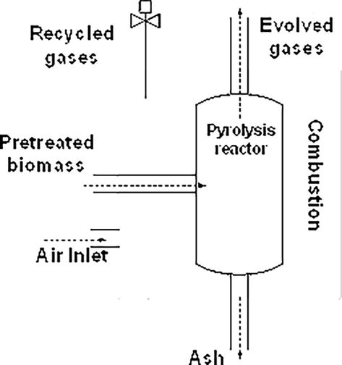
Fig1 : Representation of a pyrolysis process (Armah et al.,2022)
Table 1: Effect of feedstock and pyrolysis temperature on the biochar properties (Armahet al.,2022).
Pyrolysis temperature | Feedstock | Biochar properties
Pyrolysis temperature | Feedstock | C (%) | H (%) | O (%) | pH | Surface area (m² .g⁻¹)
250 °C | Walnut shells, Corn straw and cobs, Rice straw | 59.99- 75.76 | 4.37-5.67 | 11.04-9.99 | 6.47-9.36 | <8.55
400 °C | Walnut shells, Corn cobs and corn straw, Rice straw | 76.02- 85.65 | 19.58- 4.04 | 1.69-2.43 | 8.80-10.66 | <8.55
600 °C | Walnut shells, Corn cobs and corn straw, Rice straw | 89.88- 90.79 | 3.01-3.85 | 6.48-8.14 | 10.00-12.39 | 211.94-320.77

Table 2: Parameters and products of different pyrolysis methods
Modes | Parameters |  |  | Products (Yield %)
 | Temperature (°C) | Retention time (s) | Heating Rate (°C/min) | Gas | Oil |  |  | Char
Slow pyrolysis | < 600 | 300-350 | 1-10 | 35 |  | 30 | 35
Fast pyrolysis | >600 | 0.5-10 | 10-200 | 13 |  | 75 | 12
Flash pyrolysis | 800-1200 | <0.5 | >1000 | 40 (gas+oil) |  |  | 60
Gasification | >750 | 10-20 | - | 85 |  | 5 | 10

Agricultural crop residue burning contribute towards the emission of greenhouse gases (CO₂, N₂O, CH₄), air pollutants (CO, NH₃, NO_{x}, SO₂, NMHC, volatile organic compounds), particulates matter and smoke thereby posing threat to human health. India is a country based on agriculture and as such large amounts of agricultural wastes are generated every year from each part of the country, which is increasing year after year. Agricultural residues are the biomass left in the field after harvesting of the economic components eg.grain in case of cereals. Processing of farm produce through milling also produces large amount of residues. These residues are used as animal feed, thatching for rural homes, residential cooking fuel and industrial fuel. However, a large portion of the crop residues is not utilized or recycled and left in the fields. The disposal of such a large amount of crop residues is a major challenge and as such, the farmers use to burn the residues in situ. Thus the residues burnt in the field itself have great opportunities to be utilised as feedstock for the production of biochar, that can be an excellent conditioner as well as amendment to the soil (Das et al., 2021).
Current status of crop residue production of the country:
The use of the agricultural residues for the production of biochar is one more step toward circular economy. The Normal Estimates of Area, Production and Yield of Selected Principal Crops, 2021, Government of India Ministry of Agriculture and Farmers Welfare was taken into consideration to calculate generation of crop residues of rice , wheat, mustard and sugarcane as in the year 2019-20.
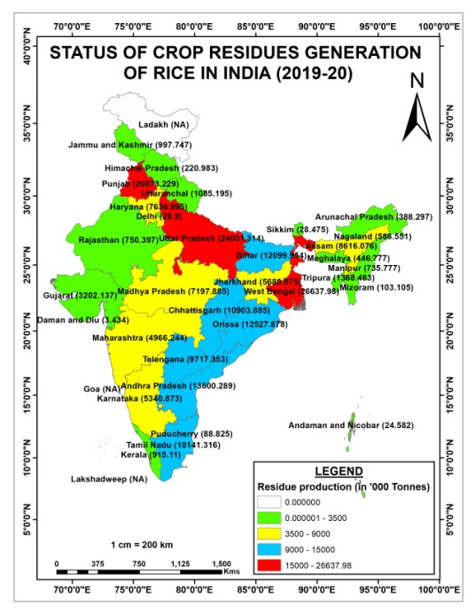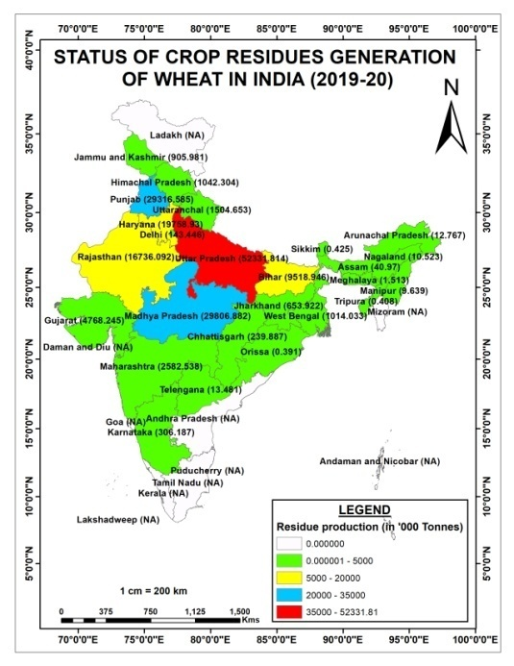
Fig 2 (i) Fig 2 (ii)
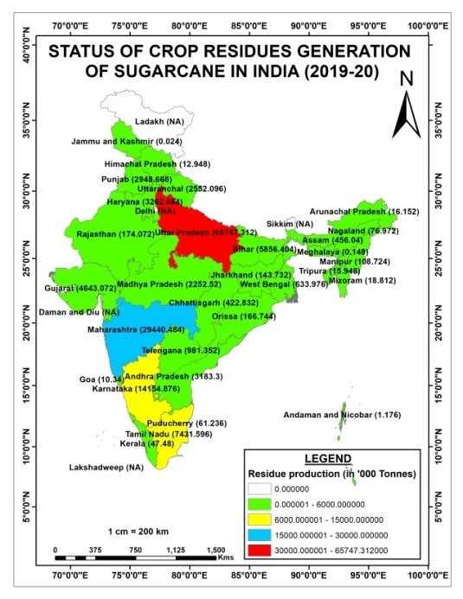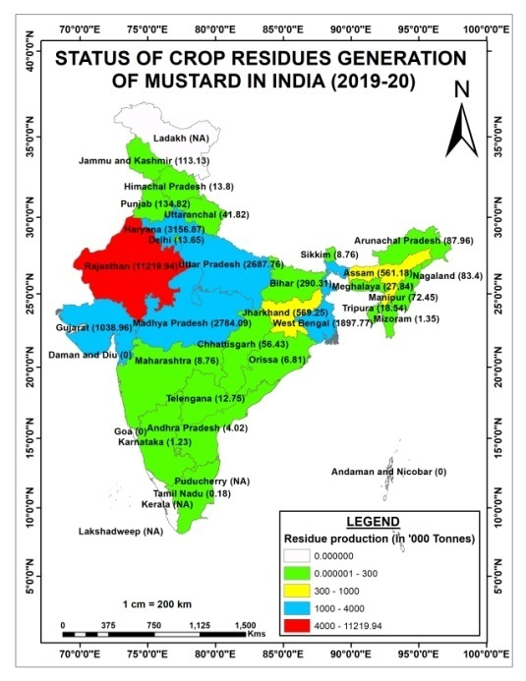
Fig 2 (iii) Fig 2 (iv)

The residue to grain ratio was considered as 1.5–1.7 for cereal crops, 2.15–3.0 for fibre crops, 2.0–3.0 for oilseed crops and 0.4 for sugarcane (Jain et. al., 2014) . The data were integrated into GIS platform to generate the thematic maps. The figures indicates the potential waste residues produced in India in terms of rice, wheat, sugarcane and mustard put forward in Fig 2(i), 2(ii), 2(iii) and 2(iv) respectively, that has the potentiality to be used as feedstock for the production of biochar.
Thus the utilization of agricultural waste based feedstock for the preparation of biochar will help all together to attain a circular economy (Neogiet al.,2022).
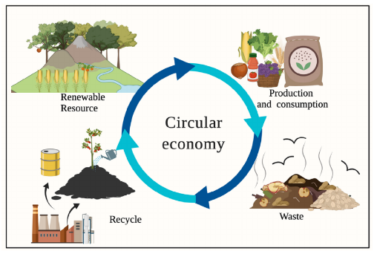
Fig3 :Biochar from biomass and industrial waste to achieve circular bioeconomy (Neogiet al.,2022).
Biochar and soil physical health
Soil physical health is the ability of a given soil to meet plant and ecosystem requirements for water, aeration, and strength over time and to resist and recover from processes that might diminish that ability. The effect of biochar was reported to be the highest in coarse and medium textured soil in improving the water holding capacity of the soil as compared to the fine textured soil (Jeffryet al., 2011). Surface area is an important soil physical health indicator that influences essential functions of soil fertility, including water, nutrient retention, aeration, and microbial activity. Biochar-specific surfaces, being generally higher than sand and comparable to or higher than clay, causes a net increase in the total soil-specific surface when added as an amendment. The high surface area of biochar provides space for formation of bonds and complexes with cations and anions with metals and elements of soil on its surface, which may improve the water and nutrient retention capacity of soil (Berglund et al. 2011). A long-term soil column incubation study by Laird et al. (2010) indicated increases in specific surface area of an amended clayey soil from 130 to 153 m² g⁻¹ as the biochar concentration increased from 0 to 20 g kg⁻¹. There are also other associated factors such total porosity or PSD which can play important roles in altering properties of biochar-amended soil surface (Jones et al., 2010).
Application of biochar is also reported to decrease the bulk density of soil.Excluding some rare case of increased bulk density due to column leaching, biochar is an excellent agent for decreasing the bulk density of the soil (Rogovska et al.,2011). However, the difference among the various feedstocks in reducing the bulk density is not significant, although the decrease was significantly greater for high and medium doses than for the lower doses of biochar (Singh et al., 2022). The density of biochar being less (<0.6 g cm⁻³) as compared to the soil (1.25 g cm⁻³), the bulk density of the biochar applied soil was affected and reduced (Blanco-Canqui, 2017). As bulk density is directly related to the total porosity of the soil, biochar is also capable in increasing the total porosity (micro- and macro-pores) which in turn increases the overall soil physical quality because micropores are involved in molecular adsorption and transport while macropores affect aeration and hydrology (Razzaghi et al.,2020).
As observed by Razzaghiet al.(2020), biochar increases the Field Capacity, Permanent Wilting Point as well the Available water in Coarse and medium textured soil .The increase in the soil moisture retention variable may be attributed to the increased micropores due to the application of biochar. (Liu et al., 2017). The smaller size pores are more capable to hold the water than the macro pores. However, in case of the fine textured soil, the retention variables were seen to be decreasing due to the fact that biochar may block the micropores already existing in the soil.
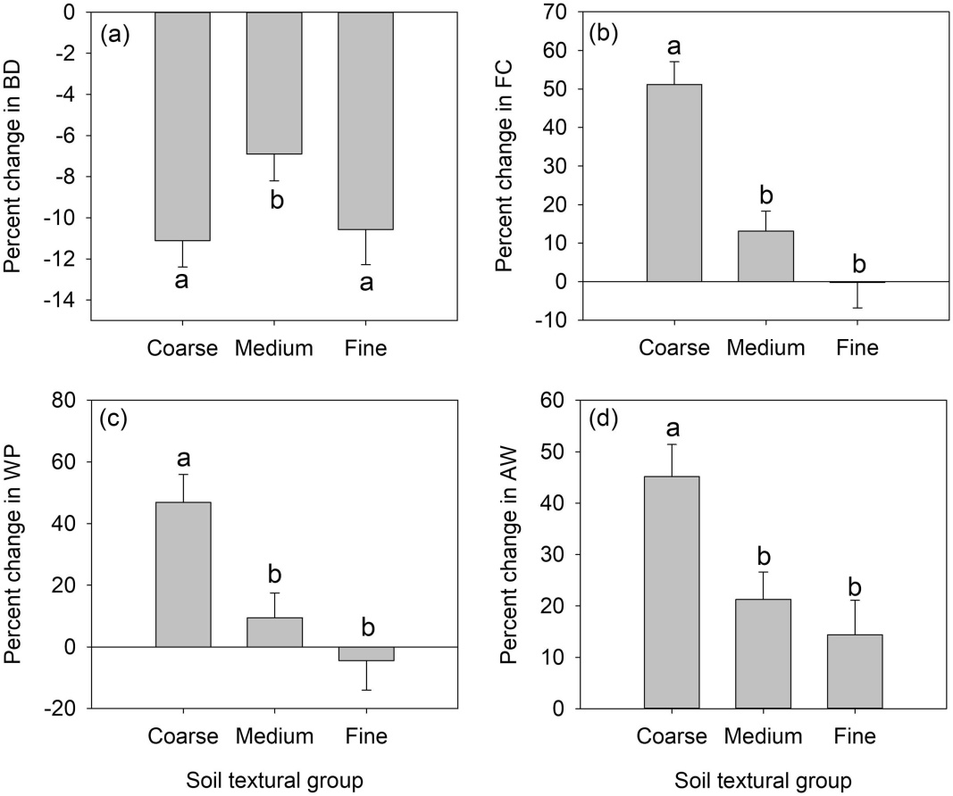
Fig 4: The effect of biochar application on bulk density and soil water retention variables (Razzaghiet al.,2020)
The present world scenario of ever increasing population and the subsequent use of agro-chemicals to increase the productivity to feed such a huge population have led to the contamination of soil as well as water with numerous pollutants as heavy metals, organic pollutants, residual chemicals etc (Khalid et al. 2020). The effect of biochar in reducing the effects of such contaminants is found significant in several studies. The concentrations of two metalaxyl (MET) enantiomers (RMET and S-MET) reduced considerably after wood wastederivedbiochar (WBC) was added to amend the soil (You et al. 2021). The reduced MET uptake may be due to the reduced bioavailability of R- and S-MET in the WBC amended soils, due to the excellent elimination capacity of WBC to R-/S-MET and a shift in the soil bacterial community, particularly the enhanced abundance of degrading bacteria, such as Hydrogenophaga, Methylophilus, andLuteimonas(Boskovicet al. 2021). Bovine manure biochar at a temperature of 700◦C is capable of reducing the effect of tetracycline upto 99.70% which was owing to the infuences of π-π interactions and hydrophobic effects (Zhao et al., 2021). Biochar obtained from sugarcane in the agro-industry is capable of removing approximately 70% of thiamethoxam in 60 min (Fernandeset al. 2021). Also, biochar synthesized from phosphoric acid-treated rice straw (T-RSBC) is capble of removing atrazine (ATZ), azoxystrobin (AZOXY), and imidacloprid (IMIDA) upto several extent (Mandalet al. 2021).
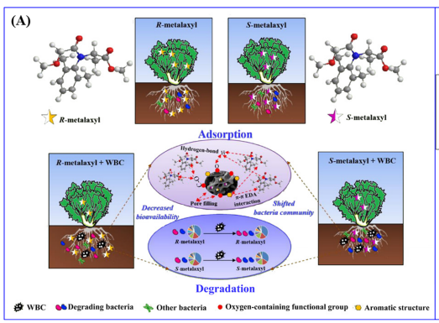
Fig5 : Mechanisms underlying the decreased uptake and accumulation of the two MET enantiomers by the lettuce cultivated in the soil amended with WBC (You et al. 2021).
The heavy metals, that has serious implications on entering the food chain can also be remediated upto several extent with the aid of different biochars. The adsorption mechanisms of heavy metals on biochar mainly involve several mechanisms as physical-adsorption, ion-exchange interactions, electrostatic attraction, functional groups combination, surface complexation and precipitation which further depends on the properties of the specific metal (Li et al.,2019). According to Nieet al. (2021), animal derived biochars have more capacity to remove and adsorb the pollutants from the soil as well the water than the plants derievedbiochars, owing to their relatively high ash content, surface alkalinity, pH and more oxygen groups (such as C–O, C=O). Owing to the abundant surface functional groups, bone biochar produced at low temperature pyrolysis is capable to immobilize Zn and Cd in polluted soils (Azeemet al.,2021). Removal efficiency of 92.24% was obtained for Chromium (VI) by biochar obtained from the biomass of Eichhorniacrassipes (water hyacinth) roots (Giriet al.,2012). Chestnut shell biochar activated with magnetic gelatineincreased the As adsorbtion from 17.5 mg/g to 45.8 mg/g due to increased surface area and improved magnetic properties (Dai et al.,2017). Removal efficiency of 99.09%, 65.95%, 7.98%, 33.93%, 30.48% and 29.02%, respectively was obtained for Pb²⁺, Cu²⁺, Co²⁺, Ni²⁺, Zn²⁺ and Cd²⁺ with the help of rice husk biochar (Yu et al.,2018). According to Baiet al.(2022), biochar colloids-mycelial pellets (BC-MP) removed 57.66 % Cadmium (II). In studies performed by Zhou et al.(2017), 99.63 % Cu , biochar was reported for the removal of Cu, 98.06% Zn and 79.6% Mn was reported to be adsorbed from sewage and sludge.
Biochar and Sustainable Development Goals
The United Nations has specified seventeen numbers of sustainable developmental goals that are to be fulfilled by 2030. The necessity of efficient consumption of natural resources, inexpensive and clean energy, clean potable water and sanitation, and mitigation strategies for climate changeare the strategies that are needed to be implemented to attain these goals. In this regard, biochar has become one of the efficient tools because it is inexpensive in nature, capable to remediate the contaminated soil as well as water and also efficiently improve the soil conditions and increase water retention and contribute towards food productivity. Biochar will contribute towards SGD 1 which signifies No poverty by self-reliance and cost reduction along with rise in crop productivity. In regard to SDG 2, ie., Zero Hunger, biochar can efficiently contribute by remediating the degraded soil and improving the quality of the soil that in turn would help increase the productivity of the soil. The SDG 3 (Good health and well-being) can be achieved through the use of biochar as biochar when used scientifically is capable of producing good quality food and improving the health of the people by preventing the notorious contaminants from entering the food chain. Biochar with its capability to sorb the contaminants from the soil may also fulfil the SDG 6 (Clean water and Sanitation). Biochar itself is a clean and affordable form of energy that can be generated by the pyrolysis of the farm waste. Thus fulfilling SDG 7 (Affordable and clean energy) biochar is competent to replace the high cost chemicals that the small scale farmers are not able to use. SDG 8 (Decent work and economic growth) can be achieved through the attainment of SDG 1 and 2. SDG 9 (industry, innovation and infrastructure) can be achieved by the development of low cost biochar production klin that can be used by the poor farmers without any scientific knowledge (Hamid et al.,2020). Regarding SDG 10 (reduced inequality), bio-char can help small holder farmers in rural areas becoming self-suffcient and and recycle their own farm waste improving women’s health attributable to clean cooking technology; The access of biochar to the poor farmers and will help minimize the inequalities between rural and urban places. For SDG 11 (sustainable cities and communities), urban abandoned contaminated land may be remediated using the various enriched biochars (Wang et al., 2020). The use of biochar in urban planting can also be prove helpful in this regard(Chen et al., 2021). Biochar production through biomass pyrolysis can shift the consumption of C-rich non-renewable resources to on farm crop recycling which in turn would encourage to fulfil the SDG 12(responsible consumption and production) and can foster ground based C storage (SDG 13, climate action) (Kammannet al., 2017). For SDG 13 (climate action), relatively high recalcitrant nature of biochar organic C, and reducing emissions of N₂O, CH₄ and CO₂ from amended soils lead to climate amelioration (Ahmad et al., 2019).For SDG 15 (life on land), biochar addition, not only improve the soil fertility but also increase the diversity ofbeneficial soil microorganisms, ensuring better soil health. Thus through the multiple application ways and benefits of biocharand its role in attaining SDGs can be ascertained (Yu et al., 2020).
Conclusion
The agricultural crop residues has immense potentiality to be converted tobiochar as the residue to grain ratio in most of the major crops is more than 1, thus indicating the huge lot of feedstock left in the country that can be converted to biochar which would rather be burnt, contributing to global warming and green house emission. Thus, more research as well as public awareness is required in this regard that would further come up with sustainable farming and circular economy within the farm.
References

Ahmad, M.; Ahmad, M.; Usman, A.; Ok, Y.; Wabel, A. (2019) Date palm waste-derived biochar composites with silica and zeolite: synthesis, characterization and implication for carbon stability and recalcitrant potential. Environmental Geochemistry and Health. 41:1687–1704
- Al-Rumaihi, A.; Ansari, T. (2022). A review of pyrolysis technologies and feedstock: a blending approach for plastic and biomass towards optimum biochar yield. Renewable and Sustainable Energy Reviews. 167: 1123-1134

Armah, E.K.; Chetty, M.; Adedeji, A.; Estrice, D.E,; Singh, N.; Tshemese, Z. (2022). Biochar: Production, Application and the Future. Biochar - Productive Technologies, Properties and Application.55: 20-28
- Azeem, M.; Ali, A.; Arockiamjeyasundar, P.G.S.; Bashir, S.; Hussain, Q.; Wahid, F.; Ali, E.F.; Abdelrahman, H.; Li, R,.; Antoniadis, V.; Rinklebe, J.; Shaheen, S.M.; Li, G.; Zhang, Z. (2021) Effects of sheep bone biochar on soil quality, maize growth, and fractionation and phytoavailability of Cd and Zn in a mining-contaminated soil. Chemosphere. 282:131016-22

Bai, S.; Wang, L.; Ma, F.; Zhu, S.; Xiao, T.; Yu, T.; Wang, Y. (2020).Self-assembly biochar colloids mycelial pellet for heavy metal removal from aqueous solution.Chemosphere. 242:125182-90
- Berglund, O.; Berglund, K. (2011) Influence of water table level and soil properties on emissions of greenhouse gases from cultivated peat soil. Soil Biol. Biochem. 43: 923–931
- Biederman, L.A.; Harpole, W.S. (2013) Biochar and its effects on plant productivity and nutrient cycling: a meta-analysis. GCB bioenergy. 5(2):202-214.

Bolan, L.; Hoang, S.A.; Gupta.S.; Hou, D. (2021) Multifunctional applications of biochar beyond carbon storage.International Materials Review.67(2): 22-35
- Borel, L.D.; Lira, T.S.; Ribeiro, J.A.; Ataíde, C.H.; Barrozo, M.A. (2018). Pyrolysis of brewer’s spent grain: Kinetic study and products identification. Industrial Crops and Products. 121:388-395
- Boskovic, N.; Bilkova, Z.; Sudoma, M.; Bielska, L.; Skulcova, L.; Ribitsch, D.; Soja, G.; Hofman, J..0 (2021) Conazole fungicides epoxiconazole and tebuconazole in biochar amended soils: degradation and bioaccumulation in earthworms. Chemosphere. 274:129700-717
- Canqui, H. (2017) Biochar and Soil Physical Properties. Soil Science Society of America Journal.2017: 687-711
- Cao, X.; Harris, W. (2010) Properties of dairy-manure-derived biochar pertinent to its potential use in remediation. Bioresour. Technol. 101: 5222–5228.
- Chen, S.; Tsang, D.; He, M.; Sun, Y.; Lazu, L.; Hou, D.; Mohanty, S. (2021) Designing sustainable drainage systems in subtropical cities: Challenges and opportunities.Journal of Cleaner Production. 280( 2):124418-25

Dai, Z.; Zhang, X.; Tang, C.; Muhammad, N.; Wu, J.; Xu, J. (2017) Potential role of biochars in decreasing soil acidification - A critical review.Science of The Total Environment. 581–582: Pages 601-611

Das, S.; Mohanty, S.; Sahu, G.; Rana, M.; Pilli, K. (2021)Biochar: A Sustainable Approach for Improving Soil Health and Environment. Soil Erosion.Soil Erosion. 55-67

Farobie, O.; Amrullah, A.; Bayu, A.; Hartulistiyoso, E. (2022).In-depth study of bio-oil and biochar production from macroalgae Sargassum sp. via slow pyrolysis.Royal Society of Chemistry Advances.12: 9567-9578
- Fernandes, J.O.; Bernardino, C.A.R.; Mahler, C.F.; Santelli, R.E.; Braz, B.F.; Borges, R.C.; da, Cunha Veloso, M.C.; Romeiro, G.A.; Cincotto, F.H. (2021) Biochar generated from agro-Industry sugarcane residue by low temperature pyrolysis utilized as an adsorption agent for the removal of thiamethoxam pesticide in wastewater. Water Air Soil Poll . 26: 232:67
- Giri, A. K.; Patel, R.; Mandal, S. (2012). Removal of Cr (VI) from aqueous solution by Eichhorniacrassipes root biomass-derived activated carbon. Chemical Engineering Journal. 185-186: 71-81
- H. Blanco-Canqui. (2017) Biochar and soil physical properties. Soil Sci. Soc. Am. J., 81 (4) : 687-711

Hamid, Y.; Tang, L.; Hussain, B.; Usman, M.; Rashid, M.; Yang, X. (2020) Efficiency of lime, biochar, Fe containing biochar and composite amendments for Cd and Pb immobilization in a co-contaminated alluvial soil.Environmental Pollution. 257:113609-15
- Jeffery, S.; Verheijen, F.G.; Kammann, C.; Abalos, D. (2016) Biochar effects on methane emissions from soils: a meta-analysis. Soil Biol Biochem. 101:251-258.
- Jeffery, S.; Verheijen, F.G.A.; van der, Velde. M.; Bastos, A.C. (2011) A quantitative review of the effects of biochar application to soils on crop productivity using meta-analysis. Agriculture, Ecosystems & Environment.144:175-187
- Jones, B.E.H.; Haynes, R.J.; Phillips, I.R. (2010) Effect of amendment of bauxite processing sand with organic materials on its chemical, physical and microbial properties. J. Environ. Manag. 91: 2281–2288
- Kammann, C.; Ippolito, J.; Hagemann, N.; Borchard, N.; Cayuela, M. L.; Estavillo, J. M.; Fuertes-Mendizabal, T.; Jeffery, S.; KERN, J.; Novak, J.; Rasse, D.; Saarnio, S.; Schmidt, H.-P.; Spokas, K.; Wrage-Mönnig, N. (2018). Biochar as a tool to reduce the agricultural greenhouse-gas burden – knowns, unknowns and future research needs. Journal of Environmental Engineering and Landscape Management, 25(2), 114-139.

Karam, D.; Nagabovanalli, P.; Rajoo, K.S.; Ishak, C.; Abdu, A.; Rosli, Z.; Zulperi, D. (2022). An overview on the preparation of rice husk biochar, factors affecting its properties, and its agriculture application.Journal of the Saudi Society of Agricultural Sciences. 21(3): 149-159
- Khalid, S.; Shahid, M.; Murtaza, B.; Bibi, I.; Naeem, M.A.; Niazi, N.K. (2020) A critical review of diferent factors governing the fate of pesticides in soil under biochar application. Sci Total Environ. 711:134645-134657
- Laird, D.A.; Fleming. P.; Davis, D.D.; Horton, R.; Wang, B.Q.; Karlen, D.L. (2010) Impact of biochar amendments on the quality of a typical midwestern agricultural soil. Geoderma.158:443-449
- Lehmann, J.; Joseph, S. (2009) Biochar for environmental management: an introduction. Biochar for Environmental ManagementScience and Technology. UK: Earthscan:33-46.
- Liu, B.; Dugan, C.A.; Masiello, H.M.; Gonnermann, L. (2017) Biochar particle size, shape, and porosity act together to influence soil water properties
- Mandal, A.; Kumar, A.; Singh, N. (2021) Sorption mechanisms of pesticides removal from efuent matrix using biochar: conclusions from molecular modelling studies validated by single-, binary and ternary solute experiments. J Environ Manage. 295:113104
- Medhi, B.K.; Hazarika, I,H.; Hazarika P.P.; Thakuria, R.K.; Swami, S. (2021) Assessment of groundwater arsenic vulnerable zones using Geographic Information System for employing biochar as soil amendment in irrigated rice ecosystem – A case study from Central Assam. Journal of Environmental Biology. 42: 462-470.
- Niveta Jain* ,Arti Bhatia, HimanshuPathak. ( 2014) Emission of Air Pollutants from Crop Residue Burning in India. Aerosol and Air Quality Research, 14: 422–430.
- Normal Estimates of Area, Production and Yield of Selected Principal Crops. May 2021, Government of India Ministry of Agriculture and Farmers Welfare Department of Agriculture, Cooperation and Farmers Welfare Directorate of Economics & Statistics Agricultural Statistics Division New Delhi
- Razzaghi, F.; Obour, P.B.; Arthur, E. (2020). Does biochar improve soil water retention? A Systematic Review and Meta-Analysis. Geoderma 361:114055-61
- Rogovska, N.; Laird, D.; Cruse, R.; Fleming, P.; Parkin, T.; Meek, D. (2011) Impact of biochar on manure carbon stabilization and greenhouse gas emissions. Soil Sci. Soc. Am. J. 75: 871–879.

Schmidt, H.; Hagemann, N.; Draper, K.; Kammann, C.; (2019).The use of biochar in animal feeding.Peer J. 7: e7373-81.
- Schulz, H.; Dunst, G.; Glaser, B. (2013) Positive effects of composted biochar on plant growth and soil fertility. Agronr Sustain Dev. 33(4):817-827.
- Singh, H.; Northup, B.K.; Rice, C.; Prasad, P.V. (2022). Biochar applications infuence soil physical and chemical properties, microbial diversity, and crop productivity: a meta-analysis. Biochar. 4:8-15

Tomczyk, A.; Sokolowska, Z.; Boguta, P. (2020) Biochar physicochemical properties: pyrolysis temperature and feedstock kind effects. Reviews in Environmental Science and Bio/Technology.19:191–215
- Tripathi, M.; Sahu, J.N.; Ganesan, P. (2016) Effect of process parameters on production of biochar from biomass waste through pyrolysis: A review. Renewable and Sustainable Energy Reviews. Biochar - Productive Technologies, Properties and Application 55:467-481
- Wang, L.; Ok, Y.S.; Tsang, D.C.W.; Alessi, D.S.; Rinklebe, J.; Maˇsek, O.; Bolan, N.S.; Hou, D. (2021) Biochar Composites: Emerging Trends, Field Successes and Sustainability Implications. Soil Use and Management. 38(1):14-38
- You, X.; Suo, F.; Yin, S.; Wang, X.; Zheng, H.; Fang, S.; Zhang, C.; Li, F. (2021) Biochar decreased enantioselective uptake of chiral pesticide metalaxyl by lettuce and shifted bacterial community in agricultural soil. J Hazard Mater. 417:126047-55

Yu, J.; Zhu, Z.; Zhang, H.; Qui, Y.; Yin, D. (2018) Mg–Fe layered double hydroxide assembled on biochar derived from rice husk ash: facile synthesis and application in efficient removal of heavy metals. Environmental Science and Pollution Research. 25: 24293–24304

Yu, X.; Liu, Y.; Wang, Y.; Feng, X.; Tu, M. (2020).Role of bioengineering and laborers in integration of farmland resources toward to improve dimension of sustainable agriculture in China.Bioengineered.11(1)
- Zhao, C.; Hu, L.; Zhang, C.; Wang, S.; Wang, X.; Huo, Z. (2021) Preparation of biochar-interpenetrated iron-alginate hydrogel as a pH-independent sorbent for removal of Cr(VI) and Pb(II). Environ Pollut. 287:117303-20

Zhou, C.; Lv, P.; Yang, L.; Xing, S.; Luo, W. (2018).Biodiesel synthesis over biochar-based catalyst from biomass waste pomelopeel.Energy Conversion and Management. 160:477-485

