Secured Healthcare system using Watermarking and Blockchain Technology
C. Ananth¹ and N. Mohananthini²
¹Assistant Professor/Programmer, Department of Computer and Information Science, Annamalai University, Annamalainagar-608002, Tamilnadu, India email: ¹ananth.prog@gmail.com
²Associate Professor, Department of Electrical and Electronics Engg., Muthayammal Engineering College, Rasipuram-637408, Tamilnadu, India. email: ²mohananthini@yahoo.co.in

- INTRODUCTION
In recent times, digital communication and information technology have developed the potential of a digital multimedia object includes text, image, audio and video. The digital images are certainly one of the important objects for rapid communication through internet from one area to required area. The digital image communications through open network have various threats like illegal copying and modifying the original information without the knowledge of the owner. To overcome this, digital watermarking comes to our rescue as a useful technology for preventing the misuse of an image and protecting the copyright of digital images. Berghel et al. [1] discussed the mode of prevention from illegal copying, by allowing the rightful owner to possess a protected image and the corresponding copyright.
In a single watermarking method, limited information is embedded at a time. An extension in single watermarking technique is needed for the benefit of embedding more different type of related information at the same time. The foretold extension of “single watermarking” technique is called now as ‘Multiple Watermarking’ technique. The primary intension of the present work is to design and develop an efficient algorithm for multiple-watermarking technique. Sheppard et al. [2] and Mohananthini et al. [3] proposed various attractive possessions for multiple watermarks along with discussed possible safety issues for the applications of multiple watermarking so as to are not related for applications of single watermarking.
Blockchain technology is very well known these days; the actual name demonstrates that Blockchain is a chain of blocks containing data. This method was first portrayed by Satoshi Nakamoto in 2009 to make computerized cryptographic money as Bitcoin [4]. The Blockchain is a conveyed record that is totally open to anybody. When the block is made, the data can never be eradicated or modified on the grounds that each and every exchange is confirmed by all the gathering individuals. The creators [5] finish up with the point that Blockchain applications center around 80.50% of the papers in the Bitcoin framework and 19.50% arrangement with different applications like medical care, policing, music, savvy agreements, and casting a ballot. It is fundamental for find the current applications created by utilizing Blockchain innovation. Perceiving the various applications assist us with figuring out different headings and approaches to utilizing Blockchain innovation. This innovation raises its own protection and a security concern now as it offers another idea for dispersing the data [6].
In the current investigation starts initially with the multiple watermarking techniques without optimization; this in turn helps in solving many problems such as more robustness, higher security and to safeguard the privacy of the original information. Further, present work extended to the Blockchain technology. Its presents a common, unchanging and straightforward record of the relative multitude of correspondences to fabricate the applications with trust, straightforwardness and responsibility. This innovation gives an extraordinary chance to foster a trustable and got information sharing and oversight framework.

- MULTIPLE WATERMARKING TECHNIQUES
The proposed chapter detailed three different types of multiple watermarking techniques for instance re-watermarking, segmented and composite watermarking.
  - Re-watermarking Technique
In re-watermarking technique, the watermarks are inserted one by one then the watermarks are extracted one by one. It is helpful in applications, where extract one watermark have to depend on extraction of previous watermark. This advance like too named as successive watermarking technique.
  - Segmented Watermarking Technique
The original image is divided into pieces of equal parts and each watermark is inserted into its exact part. It is also referred as interleaved watermarking.

  - Composite Watermarking Technique
In composite watermarking technique, more than one watermark is collective hooked on composite watermark then inserted into the image.
- APPLICATIONS OF WATERMARKING TECHNIQUES
Depending on the applications of watermarking, copyright protection and medical safeties are used to prevent an illegal copying, altering or modifying for digital images. Further for Secure Communications, the Blockchain technology is applied to the images. The current investigation of various watermarking algorithm focuses on copyright protection is required to be robustness and the medical safeties can be achieved the confidentiality and security of medical image without being seen by unauthorized persons. A brief review is presented on copyright protection and medical safeties and secure communications.
  - Copyright Protection
Copyright Production is to implant information about the source and subsequently ordinarily the copyright proprietor of the information to really take a look at different gatherings for guaranteeing the copyright of the information. An extremely elevated degree of strength is requiring this application and the watermark is utilized to choose legitimate proprietorship. Thawkar [7] introduced an imperceptible picture watermarking plan for copyright assurance. Their method gives high limit and least calculations.
Ibrahim Alsonosi Nasir and Ahmed Abdurrman [8] proposed another variety picture watermarking plan for copyright security. Utilizing discrete wavelet space, the various watermark pieces are implanted in the luminance part or the blue part of a variety picture. Trial results show that their proposed conspire effectively makes the watermark is perceptually imperceptible notwithstanding vigorous to normal sign handling and mathematical assaults. Sahraee et al. [9] proposed a hearty watermarking calculation in light of quantization of distance among wavelet coefficients for copyright security. Exploratory outcomes show that their proposed technique is very hearty against assaults.
  - Medical Safety

The medical safety use of the different watermarking methods guarantees that each specialist embeds his conclusion in the medical picture without debasing it. With any new conclusion inclusion, the picture should constantly keep its clearness and its attributes. Giakoumaki et al. [10] applied numerous watermarking in medical pictures the doctor's computerized signature, patient's private and assessment information, watchwords for picture recovery, and a reference watermark with the end goal of information uprightness control. Their exploratory outcomes show the productivity and straightforwardness of the watermarking plan, which adjusts to the severe limits that apply to locales of symptomatic importance.

Nagaraju et al. [11] introduced a method of investigation and assessment of commotion during inserting patient data inside medical picture. The power of their proposed calculation are tried and dissected by applying assaults to the medical picture with patient information won't debase its quality. Coatrieux et al. [12] zeroed in on the correlative job of watermarking as for medical data security and the executives. Their checked on watermarking has been conveyed and presumed that watermarking has tracked down a specialty job in medical services frameworks, as an insurance of medical data, for secure dealing with and sharing of medical pictures. In picture watermarking, the medical pictures are implanted with stowed away data that might be utilized to attest proprietorship, check the mathematical trustworthiness and increment the security of medical pictures.
- BLOCKCHAIN TECHNOLOGY
The Blockchain technology, alongside a portion of its huge elements and advantages, is examined in [13]. The technology, actually developing with a ton of degree for various spaces and businesses, is set to impact the world. In any case, it isn't liberated from difficulties; some of them have been featured as well. In spite of the fact that Blockchain is the technology behind Bitcoin, its utilization isn't restricted to monetary area as it were. The year 2016 uncovered Blockchain as more troublesome technology in the retail business than some other industry and, in 2017, the Blockchain was steadily turning into the prevailing publicity express for retailing. Deepayan Bhowmik and Tian Feng [14] proposed a novel watermarking based media Blockchain structure that can address a portion of the issues. The remarkable watermark data contains two snippets of data as cryptographic hash that contains exchange accounts and a picture hash that saves the retrievable unique media content. When the watermark is extricated, the initial segment of the watermark is passed to a conveyed record to recover the verifiable exchange preliminary and the last option part is utilized to recognize the altered/altered districts. Alevtina Dubovitskaya et. al. [15] introduced the points of view on Blockchain based medical care information the executives, specifically, for the EMR information dividing among the medical care suppliers and the examination studies. The system oversees and sharing the EMR information for the consideration of disease patients.

- IMPLEMENTATION OF BLOCKCHAIN TECHNOLOGY
The main focus is to invent innovative ways by which a secure communication in image watermarking. From the literature review, if is inferred that designing a single watermarking method with robustness is a little difficult task. In this context, it has been decided to undertake an extension of watermarking techniques to achieve better robustness. Numerous watermarks to express various sets of information planned towards related or not-related task and use towards raise robustness with diverse methods in which the embedded data is not easily lost. The erstwhile smart scheme is to extend Blockchain technology in healthcare model.

The Blockchain technology presents a common, unchanging and straightforward record of the multitude of interchanges to fabricate the applications with trust, straightforwardness and responsibility. This technology gives an extraordinary chance to create a trustable and got EMR information sharing and management framework.
The Blockchain technology has three sorts as demonstrated underneath:
Public: The public Blockchain’s have records to see each individual on the web and any individual can confirm and add a block of exchanges to the Blockchain.
Private: The confidential Blockchain’s permit just unambiguous people in the association to confirm and add exchange blocks, however every individual on the web is typically permitted to see.
Consortium: The consortium Blockchain’s permit just a gathering of associations (like banks) which can confirm and add exchanges, however the record can open or confined to chosen gatherings.
The proposed technique talked about three situations of different watermarking plans involving private Blockchain technology in the medical services framework. The block charts of implanting and extraction strategy are displayed in Fig. 1 and Fig. 2.
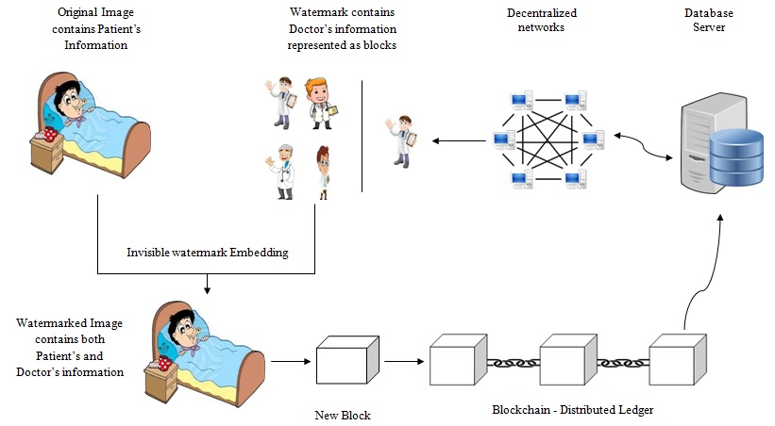
Figure. 1 The block diagram of embedding method
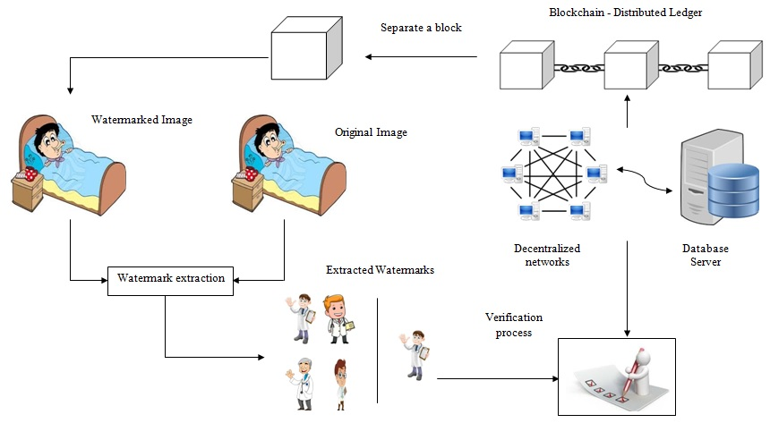
Figure. 2. The block diagram of extraction method
5.1 Healthcare system using Blockchain technology
Fig. 3 shows the outline of medical services framework utilizing the Blockchain technology. It contains three blocks, like essential consideration (beginning block), cross-disciplinary reference (block 2) and multidisciplinary approach (block 3). Each block has separate hash and the hash of the past block. Hence, block 3 focuses the block 2 and the block 2 focuses the block 1. The underlying block is a unique, it can't point the past block since it is the underlying one. Thus, the underlying block is known as the beginning block. In the event that any change happens in any block, it will make every one of the accompanying blocks are invalid, since it no longer has the ability to store the substantial hash of the past block. Consequently, changing any block in the conveyed record of the Blockchain technology is beyond the realm of possibilities.
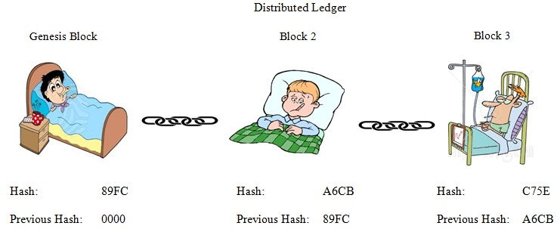
Figure. 3 Overview of Healthcare system using Blockchain technology

- CONCLUSION
The present work investigates the multiple-watermarking techniques with Blockchain Technology. The work analyzes the imperceptibility on watermarked image, high security and more robustness for multiple watermarks. Besides, the proposed work widens the scope for the execution of Blockchain technology in the multiple watermarking. The vital role of this method enables the medical records immutable, keeps them protected and permits sharing inside a decentralized network. In this proposed chapter, the blocks are defined as higher level situation and their procedures are necessary to concern this novel technology in the healthcare model.

- REFERENCES
- H. Berghel and L. O’Gorman, “Protecting Ownership Rights through Digital Watermarking”, IEEE Computer, Vol. 29, No. 7, pp. 101-103, 1996.
- N. P. Sheppard, R. Shafavi-Naini, and P. Ogunbona, “On multiple watermarking”, Proceedings of the ACM Multimedia and Security Workshop (MMSW), pp. 3-6, 2001.
- Mohananthini. N and Yamuna. G. Multiple Image
Watermarking Technique Based on Hybrid DWT-SVD and
Artificial Neural Network, International Journal of Applied
Engineering Research, 10 (3), pp. 7275-7297, 2015.
- Nakamoto, Satoshi. “Bitcoin: A peer-to-peer electronic cash system”, 2008.
- Yli-Huumo J, Ko D, Choi S, Park S, Smolander K, “Where Is Current Research on
Blockchain Technology?—A Systematic Review”, PLoS ONE. 11, 1-27, 2016.
- William Gordon, Adam Landman, “Blockchain in Health Care: Decoding the Hype”,
https://catalyst.nejm.org/decoding-blockchain-technology-health/, 2017.
- Shankar Thawkar, “Digital Image Watermarking for Copyright Protection”, International Journal of Computer Science and Information Technologies, Vol. 3, Issue 2, pp. 3757–3760, 2012.
- Ibrahim Alsonosi Nasir., and Ahmed B. Abdurrman., “A Robust Color Image Watermarking Scheme based on Image Normalization”, Proceedings of the World Congress on Engineering, Vol.3, pp. 2238–2243, 2013.
- Sahraee, M. J., and Ghofrani., “A Robust Blind Watermarking Method using Quantization of Distance between Wavelet Coefficients”, Springer, Vol. 7, pp. 799–807, 2013.
- Giakoumaki, A., Pavlopoulos, S., and Koutsouris, D., “A Multiple Watermarking Scheme Applied to Medical Image Management”, Annual International Conference of the IEEE, Vol. 2, pp. 3241–3244, 2004.
- C. Nagaraju and S. S. ParthaSarathy, “Analysis and Estimation of Noise in Embedded
Medical Images”, I.J. Image, Graphics and Signal Processing, Vol. 3, pp. 45-50, 2015.
- Coatrieux, G., Lecornu, L., Roux, Ch., Fellow, and Sankur, B., “A Review of Image Watermarking Applications in Healthcare”, 28th Annual International Conference of the IEEE on Engineering in Medicine and Biology Society, pp. 4691–4694, 2006.
- Arijit Chakrabarti, Ashesh Kumar Chaudhuri, “Blockchain and its Scope in Retail”,
International Research Journal of Engineering and Technology, 04 (07), 3053-3056, 2017.
- Deepayan Bhowmik, Tian Feng, “The multimedia blockchain: A distributed and tamperproof media transaction framework”, IEEE international conference on Digital Signal Processing, 2017.
- Alevtina Dubovitskaya MS, Zhigang Xu MD, Samuel Ryu MD, Michael Schumacher,
Fusheng Wang, “Secure and Trustable Electronic Medical Records Sharing using
Blockchain”, AMIA Annual Symposium Proceedings, 2017.

