Excited State Proton Transfer in Gemini Reverse Micelle and

Cationic Alkyl Quaternary Ammonium Reverse Micelles

: A Comparative Study
Romen Chutiaª and Aparajita Phukon^{b}
ªChemistry Department, Debraj Roy College, Golaghat-785621, Assam, India
^{b}Indian Institute of Technology Guwahati, Guwahati-781039, Assam, India

aorkromen@gmail.com
Abstract
Gemini cationic surfactants are compounds with two hydrophilic head groups and two hydrophobic tails linked by a spacer at the head. This study aims to investigate the effect of the nature of the headgroup of surfactant molecules on interfacial properties of cationic reverse micelle. Two Gemini surfactants (G-12-2-12 and G-16-2-16) and two cationic surfactants (DTAB and CTAB) with matching alkyl tails were selected for an effective comparison. The change in interfacial properties are monitored using excited-state proton transfer (ESPT) and fluorescence anisotropy decay technique of an interface localized anionic fluorophore, 8-hydroxypyrene-1,3,6-trisulfonate (HPTS), and its methyl analogue, 8-methoxypyrene-1,3,6-trisulfonate (MPTS), within the reverse micellar interfaces. The steady state, time resolved fluorescence as well as anisotropy studies clearly reveal about the compact and highly packed less hydrophilic nature of Gemini reverse micelle.
Key words: ESPT, HPTS, Gemini Surfactant, Reverse micelle, Anisotropy.
Introduction
Gemini surfactants are dimeric surfactant molecules, with two hydrophilic head groups and two hydrophobic groups covalently joined together through a spacer (Figure 1). Quaternary ammonium gemini surfactants have a nomenclature of the type m-s-m where m indicates the number of carbons atoms in the hydrophobic chain, and s indicates those in the spacer. These surfactants possess surface active properties superior to those of corresponding conventional surfactants with one hydrophilic and one hydrophobic group like lower critical micelle concentration (CMC), low Kraft temperature.¹ The CMC values of gemini surfactants depends on the length of spacer; longer spacer decreases the CMC value. Therefore, Gemini surfactants can be broadly applied in various fields, like soil remediation, separation of biomaterials, enhanced oil recovery and drug entrapment and release, skin care either as micelle, reverse micelle, vesicles etc.
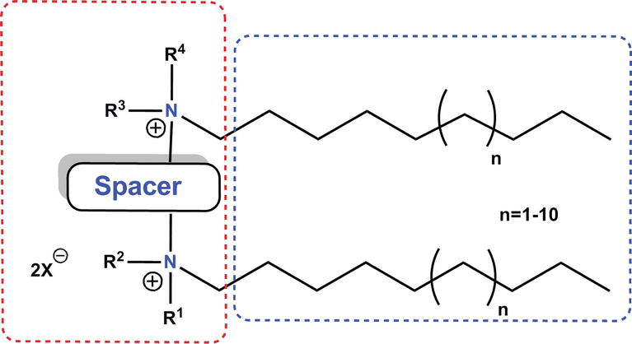
Scheme 1: Schematic representation of Gemini surfactant structure.
Reverse micelle is one of the surfactant assemblies containing an inner core of water molecules, dispersed in a continuous organic solvent medium. Similar to cationic surfactants, such as cetyltrimethylammoniumbromide (CTAB), gemini surfactants need assistance of co-surfactant in order to form stable RMs.The water trapped in the reverse micelle is used to study as a model of specific water in biological systems because the properties of encaged water can be easily tuned just by changing size of reverse micelles by injecting different amount of water using the relation,w₀ = [H₂O]/ [surfactant]. The FT-IR experiments revealed presence of four different water types inside the RMs: bulk-like water, cation-bound water, or anion bound water and free water, which structures depend on the W₀value.²
The Excited state proton transfer (ESPT) study has been widely applied to sense the nature and dynamics of water inside various self-assemblies. 8-hydroxypyrene-1,3,6-trisulfonate (HPTS) is a strong anionic photo-acid with -3 and -4,respectively, in the protonated and deprotonated forms. Thereby, HPTS acts as a promising anionic prototype that can be selectively localized at the interface of cationic reverse micelle. Moreover, the ESPT dynamics of HPTS is very sensitive to the level of hydration level of the assembled environment.³ It exhibits quite distinct optical properties of the protonated (ROH) and deprotonated (RO⁻) forms, which facilitate the study of ESPT dynamics.^{4,5}
Here, we used the ESPT dynamics as well as anisotropy decay of HPTS to compare interfacial packing of the cationic and gemini reverse micelles. In addition, we used a methyl analogue of HPTS, 8-methoxypyrene-1,3,6-trisulfonic acid (MPTS), to monitor the fluorescence anisotropy decay. MPTS is deliberately used for the fluorescence anisotropy measurement, as it lacks an ESPT process. A detailed comparison of the results obtained for the two reverse micelles may elucidate on the organization of the surfactants at the reverse micelle interfaces. Interestingly, we found remarkable similarity, as well as, notable dissimilarity between the two types of reverse micelles.

Experimental Section
  - Materials used: 8-Hydroxypyrene-1,3,6-trisulfonic acid trisodium salt (HPTS, pyranine),8-Methoxypyrene-1,3,6-trisulfonic acid trisodium salt (MPTS) cetyltrimethylammonium bromide (CTAB, 98%) and n-pentanol (99%), 1,2-bis(dimethylamino)ethane, 1-bromododecane, 1-bromohexadecane were purchased from Sigma-Aldrich. Benzene (HPLC grade), n-pentanol, ethanol, ethyl-acetate, ethyl ether, chloroform were purchased from Spectrochem, India. Water (resistivity 18.2 MΩ cm) from a Millipore system was used in the study. The Gemini surfactants (G12-2-12, G16-2-16) were synthesized^{6,7}.
  - Instruments and detection methods: A Perkin-Elmer Lamda-750 spectrophotometer was used to measure absorption spectra and Jobin-Yvon FluoroMax4 spectrofluorometer was used to measure emission spectra. The time-resolved fluorescence was recorded by a time-correlated single photon counting (TCSPC) setup (Horiba Instruments) using a picosecond laser diode 375 (Horiba Instruments) with an excitation wavelength of 375 nm. The FWHM of the set up was typically ~160 ps. The fluorescence decays were fitted using DAS6 software. The fluorescence transients were recorded by keeping the analyzer at the magic angle (55°) with respect to the polarizer.
To measure fluorescence anisotropy decays, the analyzer was rotated at regular intervals to obtain parallel () and perpendicular () decay components of a fluorescence decay separately. The anisotropy function, r(t) was constructed using the expression
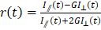 (1)
The G value of the setup was measured at 440 nm emission wavelength of HPTS and was found to be 0.68. The DAS6 software has been used to fit fluorescence anisotropy decays.
  - Preparation of reverse micelle solution: To prepare reverse micelle, first 0.1 M surfactant solution in benzene was prepared. The co-surfactant pentanol is added, maintaining the pentanol to surfactant ratio (p₀) at 7. Reverse micelles at various w₀s was prepared by injecting a requisite amount of water (using the relation, w₀ = [H₂O]/ [surfactant]) into the above mentioned solution. The benzene/Gemini/n-pentanol systems require a minimum amount of water to solubilize the surfactant⁸, for [Gemini] = 0.1M the minimum w₀ value required is w₀^{min} = 5.To incorporate the probe into the reverse micelle (RM) solution, a required amount of a stock solution of HPTS/MPTS in water were injected into the reverse micelle solution and this amount of water was included in the w₀ calculation. In all the experiments, we kept the HPTS/MPTS concentration at ∼8μM. MPTS is used in the anisotropy measurement to avoid ESPT, i.e. mixing of de-protonated band to the protonated one.

Results:

Steady State Spectroscopy:
The photoacid HPTS displays a very similar type of absorption spectra inside all the reverse micelles used; with a common absorption maximum at ~ 405 nm. The absence of any absorbance at higher wavelengths (<430 nm) eliminates the possibility of any ground state deprotonation of HPTS at a bulk pH of 5.6.
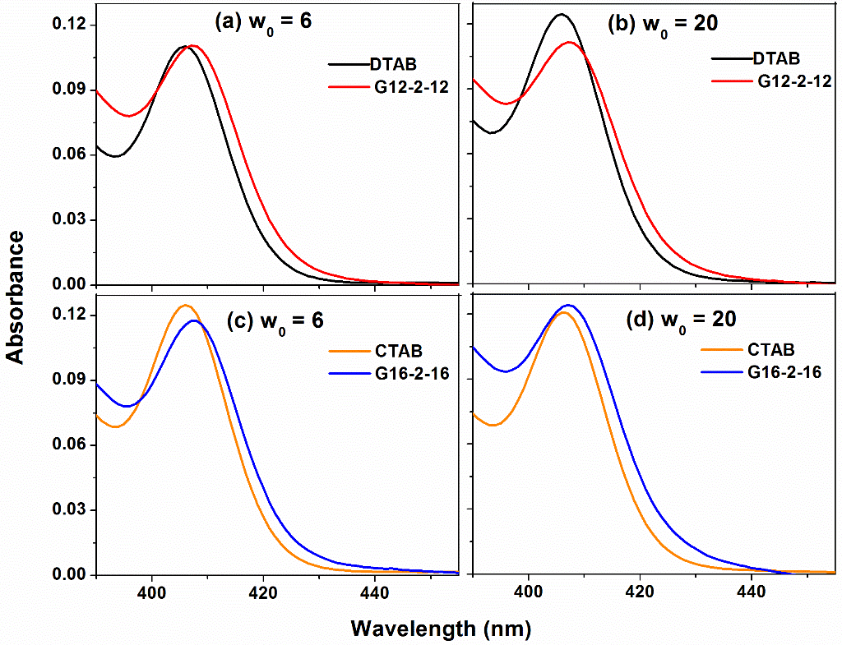
Figure 1: Comparison of the absorption spectra of HPTS in the cationic and Gemini reverse micelle at p₀ = 7.
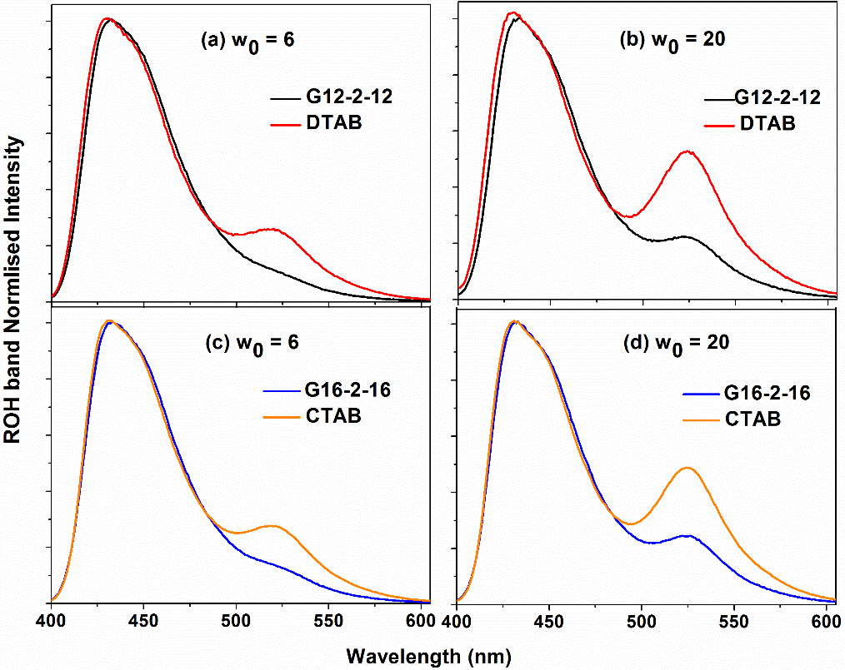
Figure 2: Comparison of Emission spectra (normalized at the protonated emission band) of HPTS inside different reverse micelles at w₀ = 6, 20. The black line for G12-2-12, red for DTAB, blue for G16-2-16 and orange for CTAB reverse micelle at p₀ = 7n-pentanol to surfactant concentration.

The emission spectra of the fluorophore HPTS are highly dominated by protonated band at 430nm for cationic reverse micelle and 433nm for Gemini reverse micellar medium. The deprotonated band becomes prominent on increasing w₀ value, at expense of protonated emission band. The deprotonated band appears at 520nm at low w₀ (=6) and undergoes a red shift to 525 nm at higher w₀ (=20) value for cationic reverse micelle. However, for Gemini (G12-2-12, G16-2-16) reverse micelle the deprotonated emission band arises at 525nm. Noted ESPT dynamics is quite slow in the Gemini reverse micelle even at higher w₀ value unlike the cationic reverse micelle (Figure 2).

Time-Resolved Fluorescence.
We recorded fluorescence transients of HPTS at two selective emission wavelengths representative of the protonated (425 nm) and deprotonated (570 nm) emission band; to investigate the ESPT dynamics of HPTS. The selected wavelength,425 nm is slightly higher in energy compared to the protonated emission maxima (), whereas, 570 nm is lower in energy compared to the de-protonated emission maxima (). We have intentionally pick these wavelengths to avoid undesirable mixing of the contribution of the two respective forms.^{9,10}
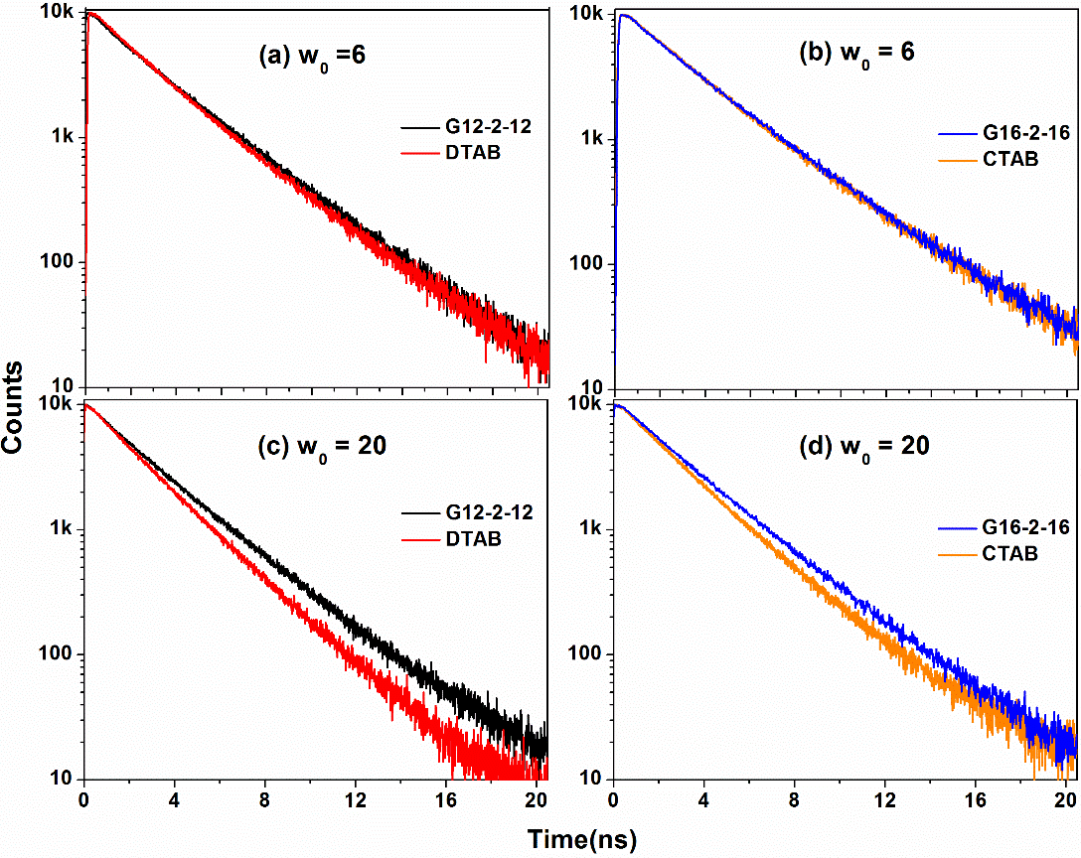
Figure 3a: Fluorescence transients of the protonated form of HPTS inside different reverse micelles of w₀ = 6, 20 (λ_{em}= 425 nm).
The fluorescence transients of HPTS monitored at 425 nm is slightly faster in the cationic DTAB RM than in G12-2-12 and almost similar for CTAB and G16-2-16. However, we observe notable variation at higher w₀ (= 20) value (Figure 3a).
In the deprotonated emission transients, a clear ultra slow rise component indicates presence of the ESPT phenomena. The rise times of the deprotonated form are of similar magnitude to that of the decay times of the corresponding protonated emission (Table 1). The rise times also become longer for the Gemini reverse micelles than those of the cationic reverse micelles for the same tail length of the surfactants.Thus, the ESPT dynamics in the Gemini reverse micelles are more retarded than those of the corresponding cationic reverse micelles. The emission decays for both protonated and deprotonated form are fitted by a tri-exponential fitting function.
ROH*(t)] or [] = +
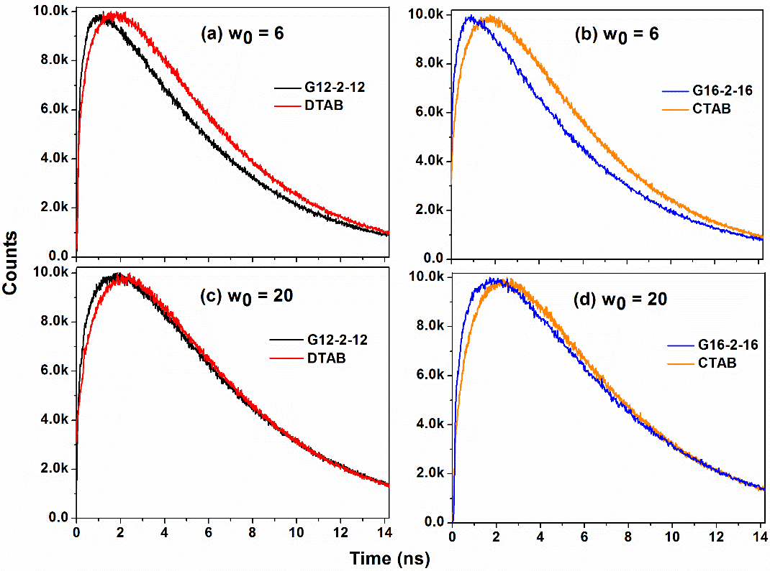
Figure 3b: Fluorescence transients of the de-protonated form of HPTS inside different reverse micelles of w₀ = 6, 20 (λ_{em}= 570 nm).
Table 1. Table of fitting parameters of the protonated (ROH*, λ_{em} = 425 nm) and deprotonated (ROH-*,
λ_{em} = 570 nm) emission transients of HPTS inside different reverse micelles with matching decay and rise time.
ROH* |  |  |  |  | RO^{-*}
w₀ = 6 | τ₁(ps) | τ₂ (ps) | τ₃ (ps) | χ² | τ₁(ps) | τ₂ (ps) | τ₃ (ps) | χ²
DTAB | 315  (0.17) | 2165  (0.53) | 3605  (0.30) | 1.21 | 315  (-0.96) | 2165  (-4.74) | 4065  (6.70) | 1.16
G12-2-12 | 545  (0.12) | 2775  (0.66) | 4150  (0.22) | 1.04 | 545  (-0.71) | 2775  (-1.73) | 4385  (3.44) | 1.09
CTAB | 330  (0.07) | 2125  (0.58) | 3900  (0.35) | 1.1 | 330  (-0.68) | 2125  (-4.03) | 4125  (5.71) | 1.1
G16-2-16 | 605  (0.04) | 2580  (0.71) | 4180  (0.25) | 1.1 | 605  (-0.41) | 2580  (-0.81) | 4480  (2.22) | 1.1
w₀ = 20 | τ₁(ps) | τ₂ (ps) | τ₃ (ps) | χ² | τ₁(ps) | τ₂ (ps) | τ₃ (ps) | χ²
DTAB | 330  (0.13) | 1995  (0.68) | 3185  (0.20) | 1.1 | 330  (-0.34) | 1995  (-5.06) | 4735  (6.40) | 1.1
G12-2-12 | 580  (0.23) | 2765  (0.74) | 5470  (0.03) | 1.1 | 580  (-1.08) | 2765  (-4.23) | 4715  (6.31) | 1.1
CTAB | 560  (0.20) | 2450  (0.78) | 5935  (0.03) | 1.1 | 560  (-1.09) | 2450  (-6.77) | 4565  (8.86) | 1.1
G16-2-16 | 690  (0.19) | 2815  (0.78) | 5350  (0.03) | 1.1 | 690  (-1.10) | 2815  (-3.86) | 4710  (5.96) | 1.07
The higher lifetime constant of the protonated form of HPTS and slower rise time of de-protonated form in Gemini RM imply the HPTS tendency to stay more time in the protonated form at the Gemini RM interface unlike in the cationic RM (Table 1). This observation is consistent even for higher w₀ values.
The fluorescence transients measured at particular wavelength representing the protonated and the de-protonated emission give a qualitative idea of the time scale of ESPT, but emission spectrum at different times may be more convenient and more informative. Time resolved emission spectra (TRES) or time resolved area normalized emission spectra (TRANES) are better representations of the ESPT phenomenon. TRES denotes emission spectrum at different times, reconstructed from fluorescence decays measured at regular intervals of wavelengths (5nm interval) across the steady state emission and the steady state emission intensity distribution. TRANES are obtained just by dividing the TRES by its area. This simple construct simplifies interpretation of ESPT process greatly. The emission intensity (or excited state population) of the protonated form decays as a result of proton transfer (conversion to the deprotonated form) and relaxation to the ground state. On the other hand, the intensity of the deprotonated form can develop from the protonated form and simultaneously can also decay to the ground state. In TRANES, total area (excited state population of protonated and de-protonated forms) is fixed and thus, more clearly displays the inter-conversion of the two forms.
The ESPT dynamics of HPTS at different reverse micelles, vary depending on the nature of headgroup, the length of the alkyl tail or the counterion at the interface. The fluorescence transients and the reconstructed TRANES data clearly revealed a less favorable ESPT dynamics inside the gemini reverse micelles compared with those of the cationic reverse micelles with the same alkyl tail. The ESPT may be slower because of the lesser hydration inside the gemini reverse micellar interface unlike that of the cationic surfactant reverse micelles.
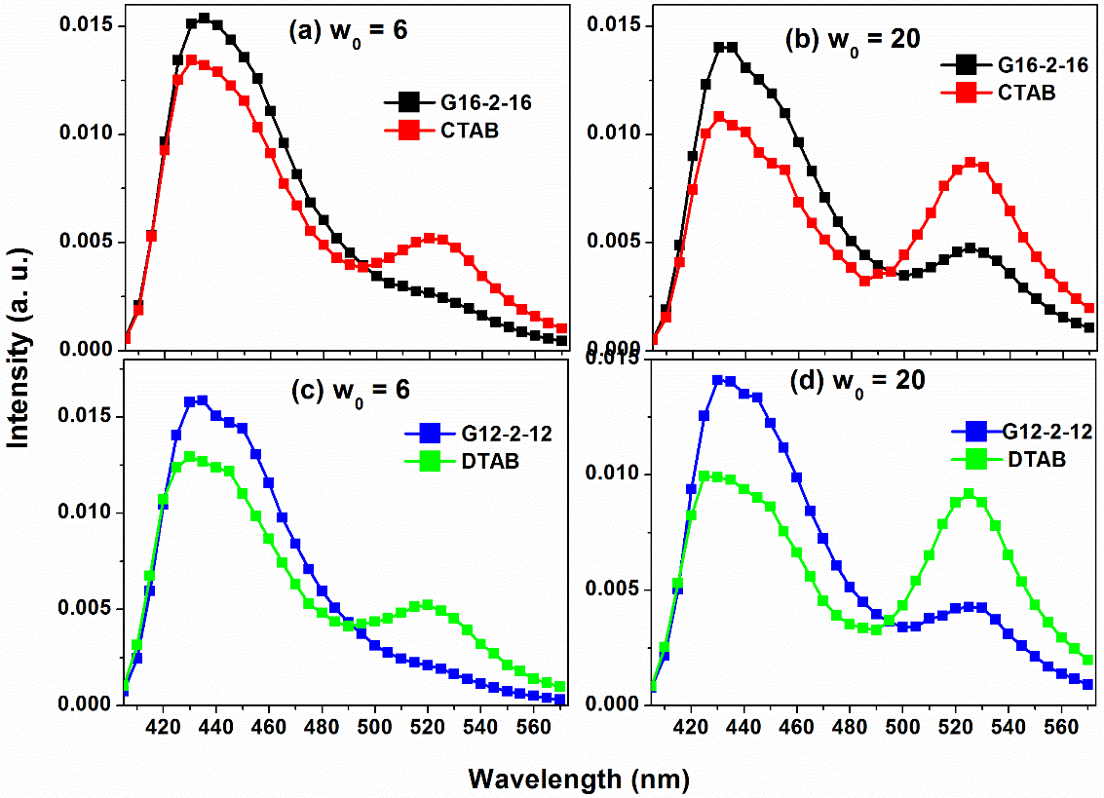
Figure 3. Time-resolved area normalised emission spectra (TRANES) of HPTS inside the cationic and Gemini RM of w₀ = 6 and 20 at t = 5ns.
Furthermore, the ESPT dynamics gets slower for surfactants with longer tails within the same surfactant series. This implies a promising impact of the tail length of the surfactant on the interfacial environment of the reverse micelles. Slower ESPT usually indicates a higher confinement of HPTS with less access to water.
Fluorescence Anisotropy Decay.
The anisotropy decays can be fitted by a bi-exponential function retaining a constant residual anisotropy
(5)
Where r₀ is initial anisotropy; _{s} and _{f}are the slow and fast rotational time constants, respectively and a_{s} is the amplitude of the slow component. The fitting parameters were further analyzed using the “wobbling-in-cone (WIC)” model. According to the model, the fluorophore may undergo a wobbling motion traversing a cone with a semi-cone angle of ⎝ and may also diffusion along the interface. Assigning time constants for these motions as _{W}, _{D} respectively, the anisotropy decay may be modeled as
(6)
Where S is an order parameter and is related to the semi-cone angle ⎝ as
(7)
Equating (6) and (7) one obtains
(8)
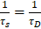 (9)
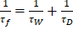 (10)
The diffusion coefficient for wobbling (D_{W}) of HPTS inside the CTAB RM interface can be obtained using the relation
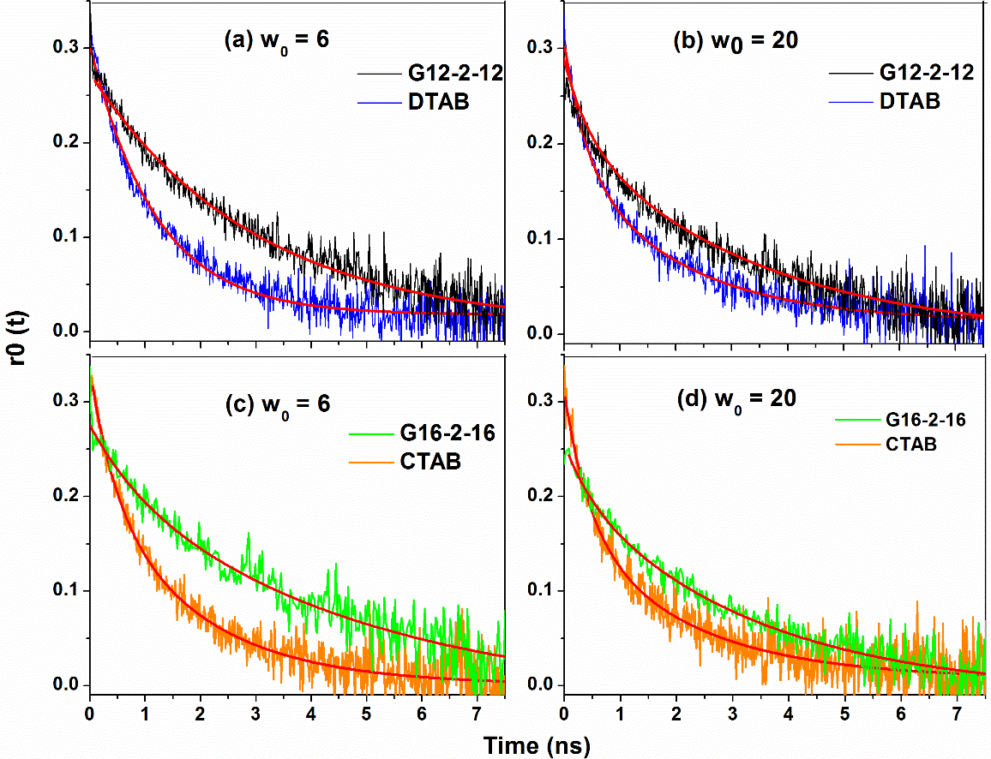
Figure 4. Fluorescence anisotropy decay of MPTS inside different reverse micelles (λ_{em}= 430 nm). The probe can rotate freely in cationic RM compared to in Gemini surfactant.
The anionic fluorophore MPTS binds loosely to the polar head group of the cationic (CTAB, DTAB) RM and rotate with faster time constant in the both in low and high w₀ values.However, as the Gemini RM interface possess more electropositive nature, MPTS binds strongly; which leads to slower rotation time (Figure 4).
The wobbling time constants (τ_{W}), the semi-cone angle (θ), and the wobbling diffusion coefficient (D_{W}) are shown in Table 2. The semi-cone angle is smaller in the gemini reverse micelle than in the reverse micelle of their cationic analogue; that signifies strong probe binding; i.e. lesser interfacial fluidity at the gemini RM interface. In the Gemini RM, the wobbling time constants and the translational time constants are longer than the corresponding cationic reverse micelles; unlike the wobbling diffusion constants that are higher for the cationic reverse micelles. These results indicate that the interface of the gemini reverse micelles is more compact compared to the cationic reverse micelles having identical tail length.
Table 2. Fitting Parameters of the Anisotropy Decays of MPTS (λ_{em}= 430 nm) inside different reverse Micelles for w₀ values 6 and 20.
w₀ = 6 | a_{s} | r_{α} | r₀ | τ_{f} (ns) | τ_{s} (ns) |  | τ_{w} (ns) | ϴ |  | D_{w}(ns)⁻¹ | x²
CTAB | 0.66 | 0.001 | 0.32 | 0.450 | 1.845 |  | 1.68 | 41.2 |  | 0.0425 | 1.05
G16-2-16 | 0.83 | -0.018 | 0.28 | 0.875 | 4.655 |  | 0.928 | 28.1 |  | 0.0214 | 1.05
DTAB | 0.45 | 0.001 | 0.30 | 0.540 | 2.67 |  | 1.19 | 55.1 |  | 0.130 | 0.986
G12-2-12 | 0.82 | -0.011 | 0.27 | 0.555 | 3.96 |  | 1.55 | 29 |  | 0.0144 | 0.983
w₀ = 20
CTAB | 0.56 | 0.0072 | 0.31 | 0.445 |  | 2.065 | 1.76 |  | 47.9 | 0.063 | 1
G16-2-16 | 0.78 | 0.0179 | 0.29 | 0.705 |  | 3.615 | 1.14 |  | 32.3 | 0.029 | 1.1
DTAB | 0.47 | 0.0066 | 0.31 | 0.495 |  | 2.67 | 1.65 |  | 53.8 | 0.090 | 1.03
G12-2-12 | 0.75 | 0.0342 | 0.32 | 0.6 |  | 3.57 | 1.39 |  | 34.6 | 0.031 | 1.03
The fluorescence anisotropy decay of MPTS also dramatically slows down upon binding to the reverse micelles. The extent of retardation of the rotational dynamics is more dramatic for the Gemini surfactant reverse micelles compared to that of the cationic reverse micelles with an equal chain length. The result implies a closed interfacial packing of the Gemini surfactant headgroups unlike at cationic reverse micelles. With the increase in the surfactant chain length, the rotational dynamics was found to be faster within a specific surfactant series. Chakrabarty et al also reported similar results,¹¹ they found that the rotational dynamics of coumarin 102 inside alkyl-trimethyl-ammonium bromide micelles become slower with an increase in the alkyl chain lengths of the surfactant. They concluded that the increase in the length of the alkyl chain leads to a more compact interface.¹¹ Thus, the increase in the chain length may indirectly affect the headgroup packing, which resulted in a more confined environment for the fluorophore (HPTS or MPTS) to exert slower ESPT or rotational dynamics.

Conclusion:
In summary, we compared the interfacial properties, in particular, rigidity as well as the interfacial hydration level of gemini and cationic reverse micelles of similar alkyl tail length. We have employed ESPT dynamics and rotational anisotropy of two anionic fluorophores, HPTS and MPTS. A slower ESPT and rotational dynamics have been recorded inside the Gemini reverse micelles compared to the cationic reverse micelles. These reveal presence of a more compact and less hydrated interface in Gemini reverse micelles compared to the cationic alkyl-ammonium reverse micelles with an identical alkyl tail length. Probably, the interfacial water molecules may form strong H-bonds with the headgroups of surfactants, reducing the mobility of confined water that makes the ESPT slower.

References:
(1) Menger, F. M.; Littau, C. A.: Gemini-surfactants: synthesis and properties. J. Am. Chem. Soc.1991, 113, 1451-1452.
(2) Zhao, J.; Deng, S.; Liu, J.; Lin, C.; Zheng, O.: Fourier transform infrared investigation on the state of water in reverse micelles of quaternary ammonium gemini surfactants C12-s-C12⋅2Br in n-heptane. J. Colloid Interface Sci.2007, 311, 237-242.
(3) Phukon, A.; Sahu, K.: The strikingly different miscibility of n-octanol in highly-confined and quasi-confined water. Chem. Commun.2015, 51, 14103-14106.
(4) Phukon, A.; Ray, S.; Sahu, K.: Effect of Cosurfactants on the Interfacial Hydration of CTAB Quaternary Reverse Micelle Probed Using Excited State Proton Transfer. Langmuir2016, 32, 10659-10667.
(5) Phukon, A.; Barman, N.; Sahu, K.: Wet Interface of Benzylhexadecyldimethylammonium Chloride Reverse Micelle Revealed by Excited State Proton Transfer of a Localized Probe. Langmuir2015, 31, 12587-12596.
(6) Zana, R.; Benrraou, M.; Rueff, R.: Alkanediyl-.alpha.,.omega.-bis(dimethylalkylammonium bromide) surfactants. 1. Effect of the spacer chain length on the critical micelle concentration and micelle ionization degree. Langmuir1991, 7, 1072-1075.
(7) Danino, D.; Talmon, Y.; Zana, R.: Alkanediyl-.alpha.,.omega.-Bis(Dimethylalkylammonium Bromide) Surfactants (Dimeric Surfactants). 5. Aggregation and Microstructure in Aqueous Solutions. Langmuir1995, 11, 1448-1456.
(8) Cuenca, V. E.; Falcone, R. D.; Silber, J. J.; Correa, N. M.: How the Type of Cosurfactant Impacts Strongly on the Size and Interfacial Composition in Gemini 12-2-12 RMs Explored by DLS, SLS, and FTIR Techniques. J. Phys. Chem. B2016, 120, 467-476.
(9) Roy, D.; Karmakar, R.; Mondal, S. K.; Sahu, K.; Bhattacharyya, K.: Excited state proton transfer from pyranine to acetate in a CTAB micelle. Chem. Phys. Lett.2004, 399, 147-151.
(10) Mondal, S. K.; Sahu, K.; Sen, P.; Roy, D.; Ghosh, S.; Bhattacharyya, K.: Excited state proton transfer of pyranine in a γ-cyclodextrin cavity. Chem. Phys. Lett.2005, 412, 228-234.
(11) Chakrabarty, D.; Chakraborty, A.; Seth, D.; Hazra, P.; Sarkar, N.: Effect of alkyl chain length and size of the headgroups of the surfactant on solvent and rotational relaxation of Coumarin 480 in micelles and mixed micelles. J. Chem. Phys.2005, 122, 184516.

