Security Approaches at Physical layer security of IOT
Dr. Santosh Kumar Sharma¹, Dr. Shashikant Upadyay², Jay Prakash Pandey³, Banasmita Moharana⁴
Associate Professor, Department of Computer Science & Engineering
Assistant Professor, Department of Allied Mathematics
sharma.santosh83@gmail.com, skantupadhyay@gmail.com,
jay288.iet@gmail.com, bansmita84@gmail.com
United University, Prayagraj, Uttar Pradesh, India.
United University, Prayagraj, Uttar Pradesh, India.
Feroze Gandhi Institute of Engineering & Technology , Raebareli –UP,India

Abstract
The internet of things is a sensor base computing devices which connect and communicate with each other using internet. To provide security for smart health care system is a challenging task. There are many smart applications are available and in certain circumstances if the control of smart devices will go in wrong hand then there is a possibility of evil work This chapter has recommended Three Pass Multilayer Security Approach to handle multiple security threats available at element layer of IOT framework such as Unauthorized access, Eaves dropping and Spoofing using - [E3(E2(E1(P, K) DS) MAC].
Keywords: MAC, IOT, EMO, Cryptography, Attacks, AVISPA, Authentication

- Introduction
The purpose of this scientific study is to develop the multilayered security approach to provide resilient security for IOT devices which is further discussed in details using four different layers. First of all, by conducting the survey of many research article and journals we have collected different types of security challenges which are found in internet of things infrastructure. Praveen et al. [1] after analyzing the many facts we are able to divide the research work in four different layer. In first layer we have designed the encrusted cryptography technique known as MAC-Omura using public cryptography, digital signature and message authentication code to solve many security threats from single interface. The second layer is network security layer where distributed cryptography is used for facilitating an end to end security services using distributed authentication security service and LOKi91 cryptography technique. In third layer service layer security is available in which security challenges is solved using three security technique that is biometric authentication, one-time password and honey encryption to stop brute force attack. At last application layer security comes which provides the security services using Kerberos authentication tool and cryptography. From table 4.1 security layer and security services are illustrated:
Table 1 Security layer with security services
SECURITY LAYERS | SECURITY SERVICES APPLIED
Application Layer Security | Authentication Protocol, Honey Encryption
Service Layer Security | Biometric, OTP, Cryptography
Network Layer Security | Distributed Authentication Security Services, Loki91 Cryptography
Physical Layer Security | Digital Signature, Message authentication Code, Public key

The element layer is the fourth layer of an IOT infrastructure. The element layer work is to provide reliable communication between sensors and nodes. During data transmission devices may suffer from threats such as unauthorized access, eavesdropping, and spoofing. At element layer we can implement various generic arithmetic and encryption modules technique. The fundamental security services of internet of things provide the basic security functions such as one-way hash, message digest, and secure hash algorithms. Key exchange security services include Diffie Hellman, elliptic curve, RSA algorithms, digital signature standards, message authentication code, and security certificate services includes X.509 certificate standard. This layer encompasses the all required cryptographic elementary functions for the Internet of things infrastructure. The network layer transmits the data collected by the element layer. The network layer is responsible to get the data from element layer and send data to service layer after assuring end to end security services. There are many security issues which is need to be addressed at the network layer, such as denial of service attacks, man-in-the-middle attacks, unauthorized access and malicious code injection. The availability function and non-denial of services are used to implement router filtering to encounter denial of service attacks at network layer.
The service layer processes the data to the application layer which is received from element and network layer. The service layer security provides the most common services includes peer-entity authentication, data origin authentication, data confidentiality using service layer security services such as biometric authentication, one-time password and encryption algorithm. In addition to that Service layer security build connection confidentiality, connectionless confidentiality, selective field confidentiality, and traffic flow confidentiality. Integrity service in this environment means that changes need to be done only by authorized entities and through authorized mechanisms. Integrity services include connection integrity, connectionless integrity, selective field integrity and nonrepudiation services including origin nonrepudiation and destination nonrepudiation. The application layer security is concern with authentication exchange and data confidentiality between user and service provider. For providing the authentication they use authentication protocol and cryptography. In this layer there is a threat from distributed denial of service attack, malicious code injection attack and phishing attack. The security business policy management layer is concerned to manage business user requirements. Application layer security provides the prevention and detection of all attacks from a different vulnerability points and provide privacy for all smart devices and protect the smart application from numerous attacks.
Andreas Burg et al. [2] due to the rapid growth in field of smart application it raising the challenges mostly related to network connectivity and data security. So it is the responsibility of IOT expert to provide strong network connectivity and reliable security mechanism to protect the network. As we have discussed the necessity of different type of security tools to secure the data and maintain confidentiality with data integrity. We have studied Massey Omura et al. have studied many versions of algorithms and concluded the work by proposing the extended feature of EMO-1 to EMO-2 by adding message authentication code to entire message.
Final equation of EMO-2 is:
C.T = E3 [E2[E1(P, K) DS] MAC]
EMO-1 has introduced prime modulus concept using combine mechanism to generate the value by performing the product operation for two different prime values. In this way the system is catered with a level of protection and EMO-2 is created by adding the digital signature of prime product. Digital signature permits the receiver to encrypted message with additional feature of EMO-2 protocol to provide authentication between sender and receiver with more security. After development of the EMO-2 which consists integrated feature of MAC and digital signature provides facility to receiver to compare and verify the identity of the sender at two levels.
From the above discussion of EMO-1 technique we have seen that how the digital signature is proving their liability to improve the security but due to minor flaws in digital signature-EMO-1 technique it come difficult to use. So to solve the problem of EMO-1, we have made strong system by adding the Message authentication code to EMO-2. Message authentication code is primarily known as tag value which is additional secret alphanumerical or special values associated with the cipher text for additional authentication. It can be elaborate to proof that message come from authentic user and without any alteration, which is verified by the receiver side.
- Cryptography
William Stalling et al. (Network security and Cryptography) Cryptography is a process which is used to convert normal plain text to cipher text (encoded value) using encryption key. Cryptography can be implemented in two ways i.e. reversible and irreversible using private and public key.
Security services can be generally separated into four areas:
- Confidentiality: Should not be exposed to anyone other than for whom is written during communication.
- Authentication: This is a mechanism which is used to prove the legality of sender and receiver.
- Integrity: The data should not be altered during transmission from sender to receiver.
- Non-repudiation: This is a statement to setup the secure communication between sender and receiver using authentication technique. Both side communications have to bind and accept the secure agreement for future communication.
There are two general types of cryptography algorithms:
- Symmetric-key cryptography: This is a process of encoding and decoding where normal plain text converted into cipher text using secret key. These keys are classified into two categories:
- Public or open key which is available in the public domain.
- Private Key should be hold by only authorized private user and should not sharable to anyone. In symmetric key cryptography same key is used for encryption and decryption whereas in asymmetric two different keys are used.
- Asymmetric- key cryptography: In this type of cryptography we use two different keys for encoding and decoding. Here public key can be shared with anyone but the private key should not be shared. The scenario of this type of cryptography is called asymmetric key cryptography.
Types of Attacks
- Passive Attack: In passive attack hackers don’t react instantly, they observe conversation illegally. The objective of the malicious user is to hack the data during communication between two parties such as phone discussion, an electronic mail message, and an exchanged of record.
- Active Attack: In active attack there is instant event release by the hacker on any of the parties or on both. Some of the active attacks are replay attack, masquerade, fabrication etc.
- Security Approach

A security architecture is the conceptual model that defines the security components, security structure and functionality of security tools. Our proposed system is a narrative framework to show the security workflow. From fig-4.1 Operational architecture of IOT security is illustrated.

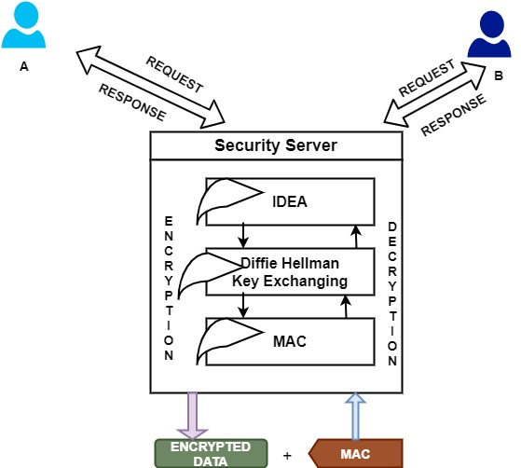

Figure 1 Architecture of Encrusted security for IOT using Message authentication code with OMURA

From the above architecture, it is clearly demonstrated that how the communication occurs between the end-users. Here one end user sends the data by encrypting using three techniques, at the first stage end-user applies IDEA encryption, in second stage DIFFIE HELLMAN algorithm applies for key exchange between the end-users and finally MAC applies to the entire data. This MAC will be generated and cross verified by the receiver. And if MAC is found correct then it moves to the next stage otherwise, it will terminate the transaction. After successful verification Diffie Hellman algorithm applies by entering the secret key, if the secret key is matched then it enters into the next stage for decrypting the data using the IDEA algorithm. Finally, the decrypted data reaches the end-user. The objective of this proposed architecture is to find out the different types of security threats and challenges which is available during data transfer and access management with strong network connectivity. In this concern we have studied the different type of network threats with available solution and concluded that one type of security mechanism is not enough to provide the complete security. Due to these reason researcher has put their focused to develop integrated approach of different security tools from a single interface to provide maximum security. Kien A. Hua et. al discussed the many application of smart gadgets base on IOT technology and its demand in future. Kien et al. also shown the impact of IOT on the society with reference to present and future. Klara Nahrstedt et al. has investigated the distinctive application of IOT and shown the effect of innovation on humans. Due to the wide variety of smart application it commits to satisfy the requirement of society. In future it will be the most demanded technology which will handle the smart appliances and smart applications. IOT innovation has raised several questions related to the security of the data and how present security standards and policies are fulfilling the requirement of IOT security. This is an extraordinary ratification to make out the system related issue with the advancement IOT. In relation to the Security requirements to provide secure mechanism for big Data on a large scale of Internet of Things is a challengeable job. Massey Omura technique is a member of private key encryption family and dedicated to design the secure communication between ends to end the transaction with organized security structure. To design the MO technique prime modulus used but due to the cryptanalysis it is empowered with a digital signature and a final version is concluded with a message authentication code.

- Recommended Approach

In recommended system we have studied many different techniques to provide secure data transfer and authentication management. Even though the digital signature algorithm is highly computational but due to fraudulent feature we have included another security technique known as message authentication code. MAC uses a hash technique to generate the additional code for the entire message to authenticate from any type of malicious alteration. MAC code works as an additional authentication code which is associated with the cipher text for additional authentication. It can be elaborate to proof that messages come from authentic users and without any alteration, which is verified by the receiver side. MAC is known for data integrity during communication with end users

- System Design- System design is defining the theory to develop application and product. System design consists of modules, system engineering process, data storage, retrieval process and application interfaces.
- Architectural scheme- This scheme is discussing that how the system architecture can by designed with the additional description of structure of the system, behaviour and communication interface with system analysis.
- Logical scheme- Logical designs present the virtual blue print of the entire system or subsystems. Logical design shows the relationship between the modules. This scheme discusses the specific framework which handles the different theoretical information stream, different sources of data. Logical scheme helps the system analysis to organize the formal concept of logical structure and relationship with different modules.
- Physical scheme- The physical scheme identifies the real time data and defines the procedure to upload this data in physical framework. In this system define the procedure to check the accuracy, validation of data and how it should be handled along with the visual representation of data. In physical scheme system decide how the following module will interact with each other and chosen:
- Input module constraint
- Desire output
- Scheme of data storage and retrieval process
- Components require for Processing
- Maintenance and recovery system.

The physical structure can be divided into three sub-modules:
- User Interface Design: UID is take a concern for uploading and delivery of data to the user interface.
- Data Design: This module is concern of visual representation of data to the users using GUI.
- Process Design: Process Design is concerned about how the scheduling can be done for reliable data flow in physical system.
MAC (MESSAGE AUTHENTICATION CODE) OMURA
In an information security concept message authentication code is a security code or security tag which is attached with every data frame as a security seal. MAC verified by both parties using same functions to assure extreme security and it provides the validness of the transmitted data by generating and verifying the code. Figure-4.2 is showing the MAC-Omura block diagram for both side.
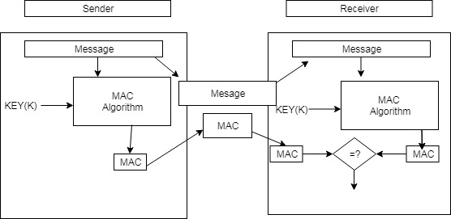

Figure 2: Message authentication code and OMURA block diagram

- User Interface
User interface design can be done to upload the data by the clients with security key. In this interface both users will involve in exchanging of data along with code generation and verification. Figure 4.3 is showing the visualization of user interface.

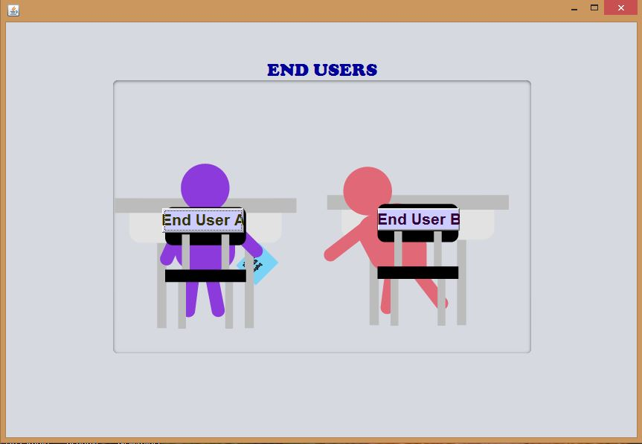
Figure 3: User Interface diagram
- Verification phase and Data Uploading
In the verification phase sender and receiver must be verified before exchanging the data over the client server communication. Verified users can only involve in exchanging data where users can be verified by providing valid credentials of user through authentication and authorization techniques.
- Data encoding using an encryption technique

In cryptography we have used symmetric block cipher block technique using international data encryption algorithm (IDEA). In this process 64-bit plain text is isolated into 4 to 16-bit parts and then processed into encryption cycles. Encryption cycle consists of four 16-bit block and process with multiple operation such as modular addition, multiplication and bitwise exclusive OR (XOR). Figure-4.4 is showing the sender message window of input text and operational function of IDEA.

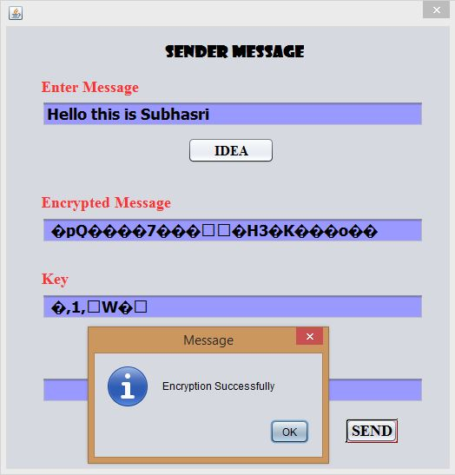

Figure 4: Communication Message diagram between sender and receiver

- Key Generation and Updating

Diffie-Hellman is a method for creating a mutual security between two individuals so that the secure and confidential data can't be seen by any malicious people. This is especially valuable since user can utilize this procedure to make an encryption key without third party involvement. Figure-4.5: showing the key generation and key updating process.

The essential thought works this way:
- User has considered two prime numbers g and p and tell you what they are.
- You then pick a secret number (a), but you don't tell anyone. Instead, you compute xª mod y and send that result back to me. (We'll call that A since it came from a).
- I do the same thing, but we'll call by secret number of b and the computed number B. So I compute x^{b} mod y and send you the result (called "B")
- Now, you take the number I sent you and do the exact same operation with it. So that's Bª mod y.
- I do the same operation with the result you sent me, so: A^{b} mod y.
Here modulo exponents is presented as,
(xª mod y)^{b} mod y= x^{ab} mod y
(x^{b} mod y)ª mod y = x^{ba} mod y
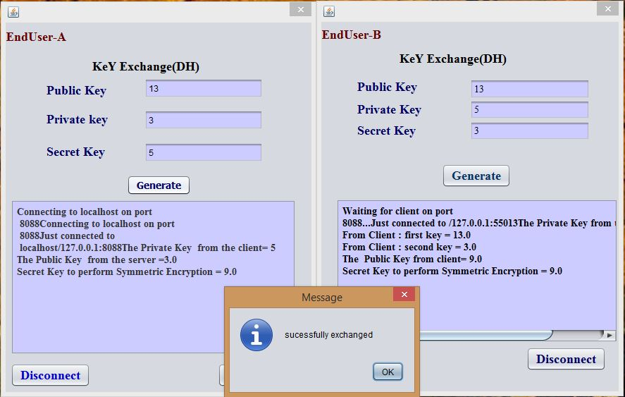
Figure 5: Key Generation and Updating diagram

- Authentication using Digital Signature and update
S. Goldwasser et al. [3] Digital signature is a well-known proven authentication technique that is used to provide the identity of authenticator. A digital signature is a noble security service for verifying the individual source of origin and destination. The specific document which is to be transported over a public network must be get verified sign using digital signature before sending. Digital Signature can also incorporate automatically series of secret codes, date and time stamps, which possess a vital function in business transactions while improving the security and accuracy.
- Cipher generation and Decryption Process
In this phase generating of cipher and decryption process is discussed. For example, the estimations of sub keys K1 to K4 are substituted by the converse of K49– K52 for the individual gathering task. In addition to K1 to K4, K5 and K6 of each gathering should to be substituted by K47 and K48 for decoding with the principal of corresponding key substitution. Figure -4.6 is illustrate the receiver message window with MAC and Decryption. Below the receiver message window algorithm is written to demonstrate the verification and decryption process.
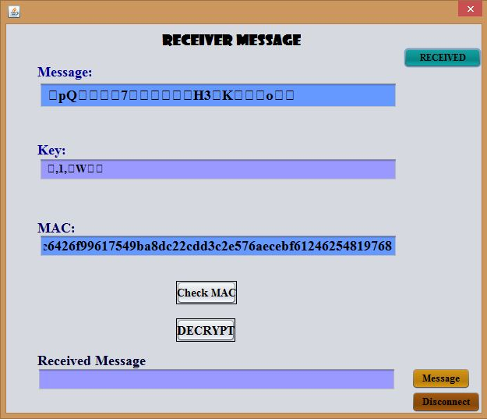
Figure 6: Receiver Message for updating
Algorithm: Verification algorithm for MAC and decryption process
Variable declaration:
/ *Let ‘x’ be a message. ‘x’ is converted into numerical by using the scheme ‘H’.
S₁ has the keys w_{i}=k₁ x_{i}=k₂ y_{i}=k₃ z_{i}=k₄.
S₂ has the keys w_{j}=k₅ x_{j}=k₆ y_{j}=k₇ z_{j}=k₈. In this a MAC Code is added to the digital signature.*/
Step1: Let be a message (msg) ‘X’.
Step2: Convert message (msg) ’X’ into Num(X) ←H
Step3: S_{1 ↔} P₀=Ency + K₀ →C₁
Step4: C₁ ↔ P₁=Ency + K₁→C2
Step5: S₁ →S₂ //S₁ sends C₂ , S₂
Step6: S₂ → P₁ // Decrypt C₂
Further, P₁←K₀ // Encrypt C₃
Step7: S₂←S₁ // Sends C₂
Further, Decrypt (C3, K)→P₀
Step8: S₁ adds layer of Encry key.
Step9: Add P₀ + Digital Signature.
P₀ + Sign → msg →Encoded Text (P₂)
Step10: S₁, Add P₂←MAC_{k}(X)= D
Then, S₁ → S₂
After, S₂ || MAC_{x}(D) → P₃
If (P₂ = P₃)
{
Accept ();
}
Else
{
Reject ();
}

Repeat loop (with new value);

- Message authentication code verification and update
In cryptography process message verification code (MAC) is a secure code which is added by the creater as a additional security. Message authentication code is created and verified by both the parties(sender and receiver).

Algorithm for MAC
1. Let ‘X’ be a message.
2. ‘K’ be a Key.
3. S1 ↔ MACk(X)=D
4. Append D → X=(X,D)
5. S2 ↔ MACk(X)=D|
6. Compare D and D|
7. If(D= D|)
{
Accept;
}
Else
{
Reject;
}

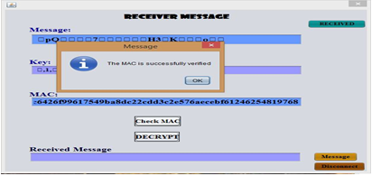
Figure 7: Receiver Message for Verification
From the figure 4.7 it is shown that after successful verification of MAC data will be accepted by receiver.
- MAC Performance verification using AVISPA tool
HLPSL Sample Code
Role subha (A,B: agent,
G: text,
F: function,
PSK: symmetric key,
SND_B, RCV_B: channel (dy))
played by A
def= local Ni, SA1, SA2, DHX: text,
Nr: text, KEr: message, %% more specifically: exp(text,text)
SK: message,
State: nat,
MA: text,
MB: text,
AUTH_B: message
constsec_a_SK : protocol_id
init State := 0
transition
%% The IKE_SA_INIT exchange:
1. State = 0 /\ RCV_B(start) =|>
State’:= 2 /\ SA1’ := new()
/\ DHX’ := new()
/\ Ni’ := new()
/\ SND_B( SA1’.exp(G,DHX’).Ni’ )
%% Subha receives message 2 of IKE_SA_INIT, checks that Sri has
%% indeed sent the same nonce in SAr1, and then sends the first
%% message of IKE_AUTH. %% As authentication Data, she signs her first message and Sri’s nonce.
2. State = 2 /\ RCV_B(SA1.KEr’.Nr’) =|>
State’ = 4 /\ SA2’ := new()
/\ SK’ := F(Ni.Nr’.SA1.exp(KEr’,DHX))
/\ SND_B( {A.F(PSK.SA1.exp(G,DHX).Ni.Nr’).SA2’}_SK’ )
3. State = 4 /\ RCV_B({B.F(PSK.SA1.KEr.Ni.Nr).SA2}_SK) =|>
State’:= 6 /\ MA’ := new()
/\ SND_B({MA’.zero}_SK)
/\ AUTH_B’ := F(PSK.SA1.KEr.Ni.Nr)
/\ witness(A,B,sk1,SK)
4. State = 6 /\ RCV_B({MB’.one}_SK) =|>
State’:= 8 /\ secret(SK,sec_a_SK,{A,B})
/\ request(A,B,sk2,SK)

end role
role sri (B,A:agent,
G: text,
F: function,
PSK: symmetric key,
SND_A, RCV_A: channel (dy))
played by B
def=
local Ni, SA1, SA2: text,
Nr, DHY: text,
SK, KEi: message,
State: nat,
MA: text,
MB: text,
AUTH_A: message
constsec_b_SK : protocol_id
init State := 1
transition
1. State = 1 /\ RCV_A( SA1’.KEi’.Ni’ ) =|>
State’:= 3 /\ DHY’ := new()
/\ Nr’ := new()
/\ SND_A(SA1’.exp(G,DHY’).Nr’)
/\ SK’ := F(Ni’.Nr’.SA1’.exp(KEi’,DHY’))
2. State = 3 /\ RCV_A( {A.F(PSK.SA1.KEi.Ni.Nr).SA2’}_SK ) =|>
State’:= 5 /\ SND_A( {B.F(PSK.SA1.exp(G,DHY).Ni.Nr).SA2’}_SK )
/\ AUTH_A’ := F(PSK.SA1.KEi.Ni.Nr)
/\ witness(B,A,sk2,SK)
3. State = 5 /\ RCV_A({MA’.zero}_SK) =|>
State’:= 7 /\ MB’ := new()
/\ SND_A({MB’.one}_SK)
/\ secret(SK,sec_b_SK,{A,B})
/\ request(B,A,sk1,SK)
end role

role session(A, B: agent,
PSK: symmetric_key,
G: text,
F: function)
def=
local SA, RA, SB, RB: channel (dy)
compositionsubha(A,B,G,F,PSK,SA,RA)
/\ sri(B,A,G,F,PSK,SB,RB)
end role

role environment()
goal
%secrecy_of SK
secrecy of sec_a_SK, sec_b_SK % Addresses G9
%Subha authenticates Sri on sk
authentication_on sk1 % Addresses G1, G2, G3, G7, G10
%Sri authenticates Subha on sk
authentication_on sk2 % Addresses G1, G2, G3, G7, G10
end goal
environment()

- Simulation Result

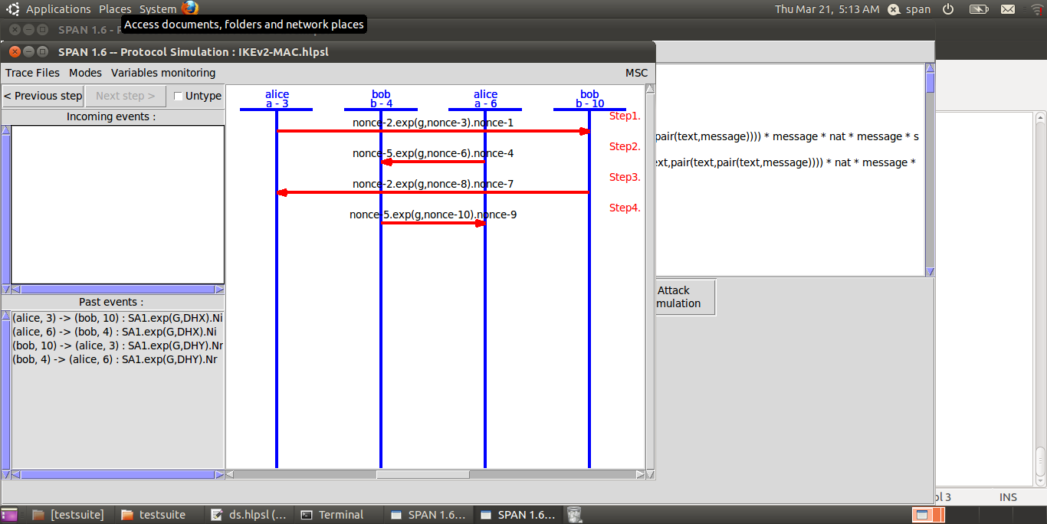
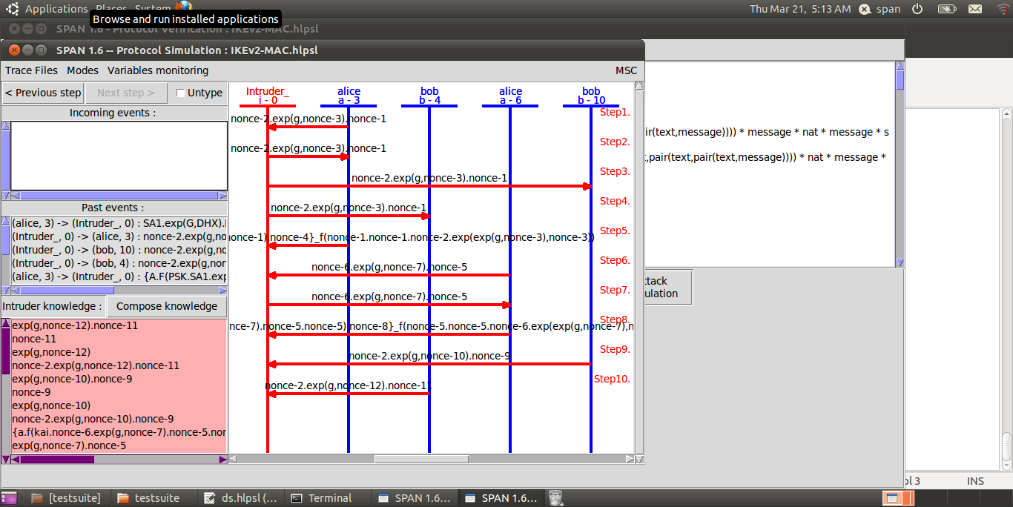
Figure 8: Simulation Results

- Conclusion

From this proposed security approach we are able to handle three different cyber security threats named as unauthorized access, eavesdropping and spoofing. To handle this security issue have used IDEA cryptography technique, DHM and message authentication code to provide the maximum integrity at physical layer. The validation of the applied technique is done by AVISPA – Advance Validation of Internet Security Protocol and Application. Finally our security approach appears like CT= E3 [E2 [E1(P,K)+DS]+MAC]. From this equation it can be narrated that only one type of security mechanism is not enough to provide security which made new security principle integrated approach such as public cryptography, Digital signature and Message authentication for peer to peer security.

References

- A, Praveena, Achieving data security in wireless sensor networks using ultra encryption standard version — IV algorithm,(2017).
- Burg, Andreas & Chattopadhyay, Anupam & Lam, Kwok-Yan,Wireless Communication and Security Issues for Cyber–Physical Systems and the Internet-of-Things,(2018).
- S, Goldwasser and S, Micali and R, Rivest, A digital signature scheme secure against adaptive chosenmessage attacks, SIAM J. Comput, 17(2), 1–28, 1988.

