Abstract: Plant leaf classification techniques classify leaves based on its different features and these has got wide applications in various fields such as botany, Ayurveda, Agriculture etc. There are different classification techniques like, Probabilistic Neural Network, Support Vector Machine and SURF feature extractor and classifiers which successfully classifies the leaf species. Deciding a method and features for classification is difficult because the difference in the accuracy of the results for different Leaf data sets. This paper presents a comparitive study of classification techniques which are applicable for plant leaf classification. The objective of this work is to provide an overview of different classification techniques for plant leaf classification using Flavia Leaf Dataset.
COMPARITIVE STUDY OF DIFFERENT CLASSIFICATION TECHNIQUES FOR LEAF IDENTIFICATION
Juby George¹
Research Scholar, School of Computer Science, Mahatma Gandhi University, Kottayam, 686560 Email: jubygeorgek@rediffmail.com
Gladston Raj S²
Department of Computer Science, Govt. College Nedumangad, Thiruvananthapuram, Kerala Email: gladston@rediffmail.com
.
Keywords: - Leaf classification, image preprocessing, classifier, PNN, SVM, SURF, FLANN

INTRODUCTION

Plant species recognition has got broad applications in agriculture, ayurveda and medicine to preserve the bio diversity. Many plants are at the risk of extinction because of no proper species identification mechanism so that they can be conserved. Leaf identification plays an important role in plant classification. Different features are used for Identifying Leaf species Shape and vein of leaves helps to characterize and recognize plant species more accurately.

This paper presents how leaf features are extracted for species detection and the recognition accuracy. The first species classification technique for leaf identification discuss Probabilistic neural network. Then a discussion of how Support vector machine for leaf recognition happens and the accuracy is analysed. Both these techniques uses leaf features such as color, shape and vein.

The comparitive study further explores the leaf species recognition using SURF feature extraction and FLANN matcher techniques using feature descriptors. In SURF the work concentrated more into the vein features and so it outperforms all other leaf recognition techniques.

Digital leaf image recognition refers to the processing of acquiring digital leaf images and extracting the leaf features by means of a computer. The extracted leaf features are then used for recognizing a leaf image. This work focuses on using digital image processing for the purpose of image recognition. Digital images of plant leaves are processed using various algorithms to extract shape related features. Finally, the classification is done based on the extracted features.

An image classification process can generally be divided into the following steps depicted in Fig.1.1.

Image Acquisition

Preprocessing
Feature extraction and description

Classification

Fig.1. Generic step of an image based plant species identification system

Image acquisition— The purpose of this step is to obtain image of a whole plant or its organs so that analysis towards classification can be performed. In this work mainly images of plant leaves are used from Flavia leaf image datasets.

Preprocessing— The aim of image preprocessing is enhancing image data so that undesired distortions are suppressed and image features that are relevant for further processing are emphasized. The preprocessing sub-process receives an image as input and generates a modified image as output, suitable for the next step, the feature extraction. Preprocessing typically includes operations like image denoising, image content enhancement, and extracting region of interest. These can be applied in parallel or individually, and they may be performed several times until the quality of the image is satisfactory [1].

Feature extraction and description—Feature extraction refers to by taking measurements, geometric or otherwise, of possibly segmented, meaningful regions in the image. Features are described by a set of numbers that characterize some property of the plant or the plant’s organs captured in the images [1]. Most of the features extracted will not improve the accuracy of classification. Feature extraction, searches for features which characterizes the data for classification. The result of the feature extraction stage is called feature vector. The space of all possible feature vectors is called the feature space. PCA is a statistical technique to reduce the dimensionality of a data vector while retaining most of the information that the data vector contains. The task of feature extractor is to produce a representation about the data that enables an easy classification. On the other hand, the task of the classifier is to produce the best classification accuracy.

Classification— In the classification step, all extracted features like geometrical and morphological features are concatenated into a feature vector, which can be used for classification. The feature vector matches a class that is the most appropriate one. The classifier can be thought as a mapping from the feature space to the set of possible classes. The abstraction offered by the concept of feature vector makes it to develop a general application independent theory for the design of classifiers.

PROBABILISTIC NEURAL NETWORK

Probabilistic neural networks can be used for classification problems. It has parallel distributed processor that has a natural tendency for storing experiential knowledge. PNN is derived from Radial Basis Function (RBF) Network. PNN basically works with 3 layers. First layer is input layer. The input layer accepts an input vector. When an input is presented, first layer computes distances from the input vector to the training input vectors and produces a vector whose elements indicate how close the input is to a training input [2]. The second layer sums these contributions for each class of inputs to produce as its net output a vector of probabilities. Radial Basis Layer evaluates vector distances between input vector and row weight vectors in weight matrix. These distances are scaled by Radial Basis Function nonlinearly [2]. The last layer i.e. competitive layer in PNN structure produces a classification decision, in which a class with maximum probabilities will be assigned by 1 and other classes will be assigned by 0. A key benefit of neural networks is that a model of the system can be built from the available data. Fig.2 shows architecture of PNN.

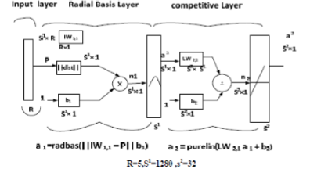
Fig 2. Architecture of PNN

SUPPORT VECTOR MACHINE

Support vector machine (SVM) is a non-linear classifier. The idea behind the method is to nonlinearly map the input data to some high dimensional space, where the data can be linearly separated, thus providing great classification performance. Support Vector Machine is a machine learning tool and has emerged as a powerful technique for learning from data and in particular for solving binary classification problems [2]. The main concepts of SVM are to first transform input data into a higher dimensional space by means of a kernel function and then construct an OSH (Optimal Separating Hyper Plane) between the two classes in the transformed space [2]. For plant leaf classification it will transform feature vector extracted from leaf’s contour. SVM finds the OSH by maximizing the margin between the classes. Data vectors nearest to the constructed line in the transformed space are called the support vectors. The SVM estimates a function for classifying data into two classes. Using a nonlinear transformation that depends on a regularization parameter, the input vectors are placed into a high-dimensional feature space, where a linear separation is employed.

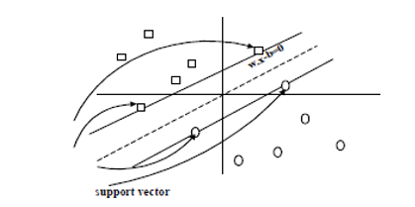
Fig.3. Linear separating hyperplanes support vectors are circled.

LEAF IDENTIFICATION USING SURF FEATURE EXTRACTOR AND FLANN MATCHER

This paper presents how leaf veins are segmented and extracted using frequency estimation and region mask. The enhanced leaf vein image is then used to identify keypoints using Harris corner detection. The keypoints extracted is used for retrieving features by SURF feature detector and the obtained feature is used by FLAAN matcher. The matching score thus obtained is used for identifying leaf species. A minimum matching score accurately predict the correct leaf species. Proposed Leaf Identification Algorithm [8].
Step 1: Pre-processing and enhancement of leaf vein image using ridge frequency estimation and region mask.
Step 2: Keypoint identification in vein image using Harris corner detection.
Step 3: The number of keypoints extracted from the Standard image and query images are analysed and if it falls within the limit then go to step 4 otherwise a mismatch.
Step 4: Extract Leaf feature descriptors from the keypoints using SURF feature descriptor.
Step 5: Match the feature descriptors of Standard image and query image using FLANN matcher. [8]

PREPROCESSING AND LEAF VEIN ENHANCEMENT
Fig 4. Leaf vein enhancement process

NORMALIZATION
The first step in the leaf vein enhancement process is image normalisation. Normalisation is used to standardise the intensity values in an image by adjusting the range of grey-level values so that it lies within a desired range of values [2]. Let represent the grey-level value at pixel, and represent the normalised grey-level value at pixel . The grey-level value for each pixel is then compared with the average grey level value for the host block. For a pixel belonging to a block of average grey-level value of M₀, the result of comparison produced a normalized grey-level value

ORIENTATION IMAGE ESTIMATION AND FREQUENCY IMAGE ESTIMATION
After normalization the estimation of the orientation of the image is carried out. Given a normalized image , the algorithm works by dividing the whole image into blocks of size 16×16 The steps are [3]:
- Compute the gradients at each pixel (i, j).
- Estimate the local orientation of each block centered at pixel (i, j) is computed by
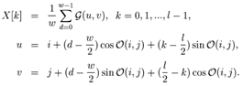
Whereis the least square estimate of the local ridge orientation at the block centered at pixel (i, j). Let be the normalized image and θ(i, j) be the orientation image, the steps for frequency estimation are as follows:
- Divide into block size of 16 X 16.
- For each block centered at pixel(i, j), compute an oriented window size l x w

The angles between the blocks are then smoothened by passing the image through a low pass filter. Region mask is obtained by classifying each block in the normalized image. The frequency values for this blocks need to be interpolated from the frequency of the neighbouring blocks which have a well-defined frequency. meshX and meshY used for interpolation is calculated using the meshgrid function. A low pass filter is then used to remove the outliers. The enhanced leaf image is outputted as the result. The result is shown in the Fig.5.

B. KEYPOINT EXTRACTION USING HARRIS CORNER DETECTION

The search for discrete image point in an image correspondence can be divided into three main steps.
- Interest points are selected at distinctive locations in the image such as corners, blobs and T-junctions [4]. The most valuable property of an interest point detector is its repeatability. The repeatability expresses the reliability of a detector for finding the same physical interest points under different viewing conditions.
- The neighbourhood of every interest point is represented by a feature vector. This descriptor has to be distinctive and at the same time robust to noise, detection displacements and geometric and photometric deformations [4, 7].
- Finally the descriptor vectors are matched between different images. The matching is based on a distance between the vectors. The dimension of the descriptor have a direct impact on the time, and less dimension are desirable for fast interest point matching [4].

C. FEATURE EXTRACTION USING SURF [Speed Up Robust Feature]

After identifying the keypoints, the next step is to come up with a descriptor for the feature centered at each keypoint. This descriptor is the representation used to compare the features in different images to see if they match or not. The Speed-Up Robust Features (SURF) detector-descriptor scheme developed by Bayetal [4] is designed as an efficient alternative to SIFT. It is much faster, and more robust as opposed to SIFT. Its basic idea is to approximate the second order Gaussian derivatives in an efficient way with the help of integral images using as setoff box ﬁlters. The idea of SURF is based on sums of 2D Haar wavelet responses and makes an efficient use of integral images. For features, it uses the sum of the Haar wavelet response around the point of interest with the aid of integral image[8].

The SURF [4, 5] descriptor starts by constructing a square region centered around the detected interest point, and oriented along its main orientation. The size of this window is 20s, where s is the scale at which the interest point is detected. Then, the interest region is further divided into smaller 4×4 sub-regions and for each sub region the Harr wavelet responses in the vertical and horizontal directions (denoted dx and dy, respectively) are computed at a 5×5 sampled points as shown in Fig.5.

These responses are weighted with a Gaussian window centered at the interest point to increase the robustness against geometric deformations and localization errors. The wavelet responses dx and dy are summed up for each sub-region and entered in a feature vector v, where
Fig. 5. Result of Pre-processing and Enhancement
Input Image | Enhanced Vein Image
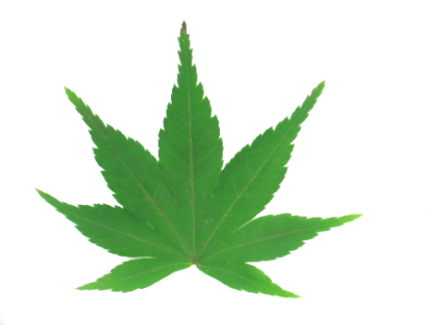 | 
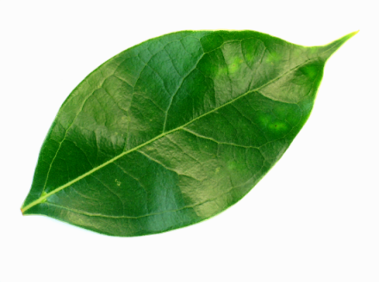 | 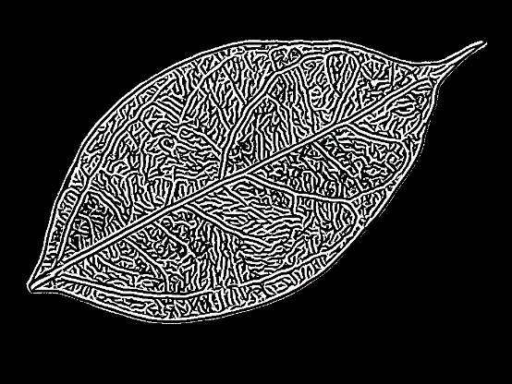
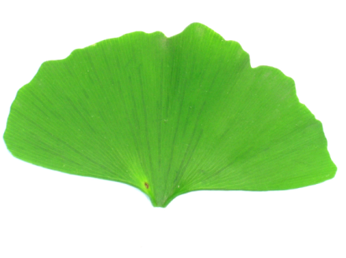 | 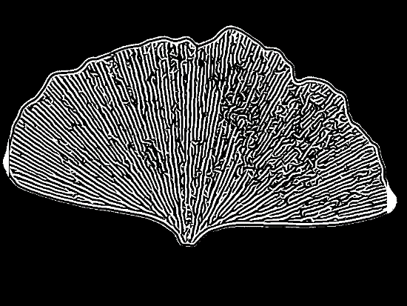

Fig. 6 Example of keypoint extraction using Harris Corner Detection using Flavia Leaf Database

Input Image | Keypoints Extracted using Harris Corner
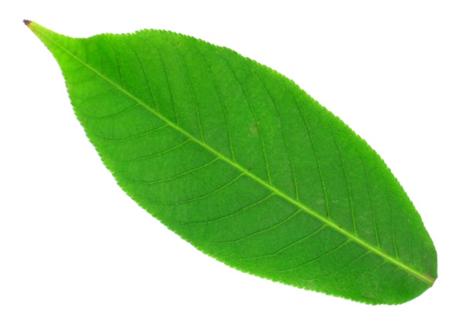 | 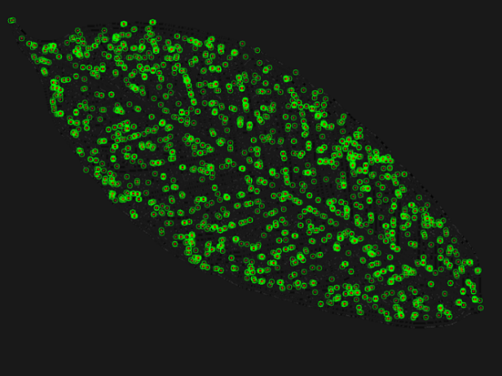
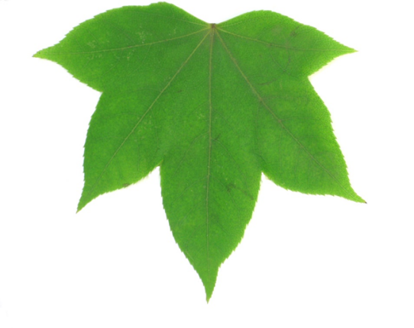 | 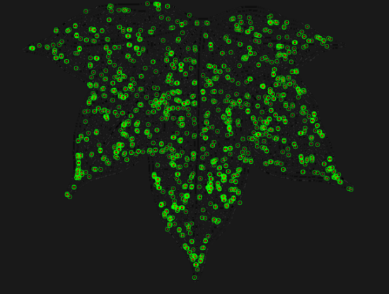

Fig. 6. Dividing the interest region into 4×4 sub-regions for computing the SURF descriptor

D. FEATURE MATCHING WITH FLANN (FAST LIBRARY FOR APPROXIMATE NEAREST NEIGHBORS)

After unique keypoints and descriptors are extracted from both leaf images, a matching should be done. The FLANN [6] library contains a collection of algorithms optimized for fast nearest neighbour search in large datasets and for high dimensional features, and it works faster for large datasets. Two main optimized algorithm used are Randomized k-d Tree Algorithm and Priority k-means algorithm.

Flavia dataset is used for identification of leaves. Entire Method was implemented using opencv and Qt. The matching score of different leaf species was taken and it was observed that a score of less than 2.00 or a minimum score predicts the same class of leaf species. If the number of keypoints for the test image and query image is greater than 700 keypoints, no need to proceed with feature extraction and matching and assumed automatically as different category of leaves. Otherwise the features are extracted and matching scores are calculated [8].

V. RESULTS AND DISCUSSION

The Flavia dataset is a benchmark used by researchers to compare and evaluate methods across studies and publications. The dataset contains leaf images of 32 different species. Table 1 shows a comparison of different methods applied for the species recognition on the Flavia dataset.

The PNN learns rapidly compared to the traditional back-propagation, and guarantees to converge to a Bayes classifier if enough training examples are provided, it also enables faster incremental training and is robust to noisy training samples.

SVM outperforms PNN with good generalization capability. SVMs can be robust, even when the training sample has some bias. Main advantage of SVM is it has a simple geometric interpretation and gives a sparse solution. Unlike neural networks, the computational complexity of SVMs does not depend on the dimensionality of the input space One of the bottlenecks of the SVM is the large number of support vectors used from the training set to perform classification tasks.

An accuracy of 98.75% resulted using the proposed methods. The accuracy of recognition is improved when compared to other recognition methods[8].

Table 1: Accuracy comparison of different recognition methods
Sl.No | Recognition Methods | % of Recognition
1 | Probabilistic Neural Network | 90.31%
2 | SVM | 94.50%
3 | SURF Feature and FLAAN Matcher  (Proposed Method) | 98.75%

VI. CONCLUSION AND FUTURE WORK

From study of above classification techniques resulted in the following conclusion. Classifying using PNN and SVM can further be explored by researchers, SVM being relatively a new machine learning tool. The most important advantage of PNN is that training is easy and instantaneous.

Additionally, neural networks are tolerant to noisy inputs. But in neural network it’s difficult to understand structure of algorithm. SVM was found competitive with the best available machine learning algorithms in classifying high-dimensional data sets. In SVM computational complexity is reduced to quadratic optimization problem and it’s easy to control complexity of decision rule and frequency of error. Drawback of SVM is it’s difficult to determine optimal parameters when training data is not linearly separable.

The proposed vein enhancement method segments the leaves from its background and extracts the veins clearly. This vein enhancement method can be efficiently used for object identification and extracting ROI in images. The vein image is thus good enough for extracting keypoints using Harris corner detection method. SURF uses an intermediate image representation called Integral Image, which is computed from the input image and is used to speed up the calculations in any rectangular area. It is formed by summing up the pixel values of the x, y co-ordinates from origin to the end of the image. This makes computation time invariant to change in size and is particularly useful while encountering large images. The SURF detector is based on the determinant of the Hessian matrix. Since this method is rotation invariant, it is possible to successfully detect objects in any orientation, cases where the Haar classifier fails miserably. FLANN matcher helps to match descriptors which is accurate and fast. The proposed method of object identification and matching can be useful for different category of image object and the matching certainty score will vary for different type of images[8].
Mobile applications for plant leaf classification can be created which can be best learning tool for botany students. Also this application can be used in agricultural field for weed identification which in turn will help for proper determination of pesticides and fertilizers.

REFERENCES
- Gonzalez RC, Woods RE (2007) Digital image processing, 3rd edn. Pearson Prentice-Hall Inc, NJ. ISBN: 978-0131687288.
- Krishna Singh, Indra Gupta, Sangeeta Gupta, Retrieval and classification of leaf shape by support vector machine using binary decision tree, probabilistic neural network and generic Fourier moment technique: a comparative study, IADIS International Conferences Computer Graphics, Visualization, Computer Vision and Image Processing 2010
- Lin Hong, Yifei Wan, Anil Jain. Fingerprint Image Enhancement: Algorithm and Performance Evaluation. IEEE Transactions on Pattern Analysis and Machine Intelligence. Volume 20 Issue 8, August 1998. Page 777-789
- Marius Muja, David G. Lowe. Fast Approximate Nearest Neighbors with Automatic Algorithm Configuration, 2009
- https://github.com/alexanderb14/Harris-Corner-Detector
- Chris Harris, Mike Stephens (1988). A Combined Corner and Edge Detector, Alvey Vision Conference. 15.
- Konstantinos G. Derpanis (2004), The Harris corner detector, York University.
- Gladston Raj S, Juby George (2019), Leaf Identification using Harris Corner Detection, SURF Feature and FLANN Matcher, International Journal of Innovative Technology and Exploring Engineering (IJITEE), Vol.8, Issue 11, Page 8.

AUTHORS PROFILE

Ms. Juby George: Completed MCA and MPhil and qualified UGC-NET. Presently working as Assistant Professor, Department of Computer Applications, Marian college Kuttikkanam [Autonomous]. Presently registered as a research scholar at Mahatma Gandhi University Kottayam at School of Computer Science under the guidance of Dr,Gladston Raj S. Having 14 years of Teaching experience, published research papers in two conference and journals and won best research paper award organized by IFERP at VOC College thoothukudi in the year 2018. Serving as member board of study at Fatima Matha College Kollam and question paper setter at Kerala University. Served as organizing committee member for international conferences.

Dr.Gladston Raj S: He took MSc, MTech and PhD in Computer Science from University of Kerala and having qualified with UGC-NET and PGDCH. Presently serving as Associate Professor and Head, Department of Computer Science @ Government College Nedumangad. Having guideship at University of Kerala and MG University Kottayam. He produced seven PhDs, submitted two more thesis and guiding three research scholars at University of Kerala. With 20 years of teaching and research, he published more than 45 research papers in reputed journals. He is an Academic Council member and Chairman, Board of Studies (Computer Science) of University of Kerala and also chairman and member of various Universities/ Autonomous colleges in Kerala. He served as resource person for more than 100 National/International conferences/workshops sessions. He is the subject expert at SCERT, Trivandrum and Technical advisor to File Flow Management System (FFMS) of DCE, Govt. of Kerala.

 

