An Overview of Gas Sensors
M. Sathya¹, G. Selvan¹, M. Karunakaran^{2*}, K. Kasirajan³, S. Usha², S. Maheswari⁴, P. Baskaran⁵
¹PG and Research Department of Physics, Thanthai Hans Roever College (Autonomous), Perambalur, Affiliated to Bharathidasan University, Trichy, India – 621 220.
²Thin Film and Nanoscience Research Lab, PG and Research Department of Physics, Alagappa Government Arts College, Karaikudi, India – 630 003.
³Division of Advanced Materials Engineering, Kongju National University, South Koorea.
⁴Department of Physics, Caussanel College of Arts & Science, Ramanathapuram - 623523, India.
⁵Department of Physics, Government Arts and Science College, Veppanthattai, Perambalur, India – 621 116.
*Corresponding author Email: tvdkaruna@gmail.com

Abstract:
In recent times, gas sensors are at the center of significant innovation in a variety of sectors, including environmental sciences and medicine. High-performance gas sensors have been created as a result of substantial advancements in sensor design, nanofabrication technology, and the utilization of newly created materials in recent years. There have been several different material gas sensors developed and researched in the past, and each form of sensor has its benefits and disadvantages in terms of sensing resolution, operating power, recovery time, and responsiveness. An overview of current developments in a variety of gas-sensing technologies is provided in this study. The sensors' working mechanisms, as well as their designs and combinations, are investigated. Finally, the potential applications of each type of sensor are discussed, as well as the prospects for future development.
1. Introduction
Due to increased environmental pollution and industrialization, the sensor is now much more focused on environmental monitoring to improve the health and environmental production of harmful and flammable gases. Gas sensors are urgently needed for a variety of applications, including the classification of items like coffee and spices, quality control of packaging, weather stations, the detection of harmful gases in landmines, medical diagnostic and health care production, and security [1-3]. Three basic groups of specifications are used to identify various gases [4];
- Oxygen: To regulate the atmosphere's oxygen and to manage the combustion process such as boilers and internal combustion engines. The oxygen concentration of 20% and 0 – 5% is needed for this process.
- Toxic gases: The identification and control of toxic gases are important for health production in various workplaces. The toxic gas exposure levels are between one and several hundred ppm.
- Flammable gases: To prevent the fire or explosion unintentionally. The flammable gas concentrations are up to the lowest explosive level (LEL), which is low as a few percent for most gases.
The entire climate contains the natural gas ammonia. 55–56% of the world's agricultural emissions are attributed to an ammonia concentration in the atmosphere. Even though ammonia is a gas that is frequently utilized across a variety of industrial sectors, ammonia detection has recently become much more sensitive, selective, and valuable. Human activity directly or indirectly releases the majority of the ammonia in our atmosphere. Ammonia is a very dangerous chemical that can be extremely poisonous if inhaled in large enough concentrations. So one of the trickiest tasks is identifying ammonia at low concentrations and room temperature.
Different flammable, explosive, poisonous, and dangerous gases can be consistently and effectively found using gas sensors. The usage of ammonia gas sensors increased significantly across a wide range of technological fields, including food processing, chemical processing, energy plants, medical diagnosis, climatic safety, and industrial process. The most sensitive, highly selective, and practical chemical sensors were developed to precisely identify and measure the presence of dangerous gases and human exposure rates. These sensors are now notably attentive to human health, production, and process control in industrial applications.
The most popular method for doing this is to use inexpensive, fast-acting vapor or gas sensors built on metal oxide semiconductors (MOSs). SnO2 is the semiconductor that has the best potential for detecting dangerous and harmful gases and it offers the best features for chemical sensors, such as durability, compact size, low power concept, and ease of fabrication. So exposure to ammonia causes chronic lung disease, irritates, and even burns the airways, among other things. This is critical for monitoring ammonia gases and developing an improved ammonia gas sensor.
1.2 Sensors
A sensor is a device that receives signals or other stimuli and reacts to them. The quantity, property, or condition sensed and transformed into an electrical signal may serve as the measurement or stimulus. A sensor's goal is to respond to a physical or chemical input that is compatible with electrical circuits and transform that response into an electronic signal. The sensor is a system that responds to a physical or chemical stimulus (such as heat, light, sound, pressure, etc.) and transmits a reward as a result (for measurement or control operation) [5, 6]. Therefore, the sensor can recognize an input signal and transform it into the proper output signal. In general, sensors act as a bridge between electronic devices and the real world, usually by translating chemical, physical, or non-electrical equipment into electrical signals.
1.2.1 Classification of sensor:
According to their mechanism of conversion-the physical or chemical effects upon which they operate-sensors are typically divided into two categories: chemical sensors and physical sensors [7]. The division of sensors is shown in Fig. 1.1. Physical qualities used in sensors include magnetostriction, piezoelectricity, ionization, photo electricity, thermoelectricity, magnetoelectricity, and others.
1.3 Chemical sensor:
A chemical sensor is a piece of equipment that transforms chemical data into an analytically usable signal, ranging from the concentration of a particular sample component to the analysis of the sample's overall makeup [8]. The gadgets, which are small and portable, are made to selectively and continuously track the concentration of a particular gas in complex samples online. These devices convert physical or chemical characteristics into an application signal, such as the composition of an entire system or the concentration of a particular gas. These makeup chemical sensors' core elements.
- Sensing element
- Chemical / analyte / gas recognition system
- The physicochemical transducer
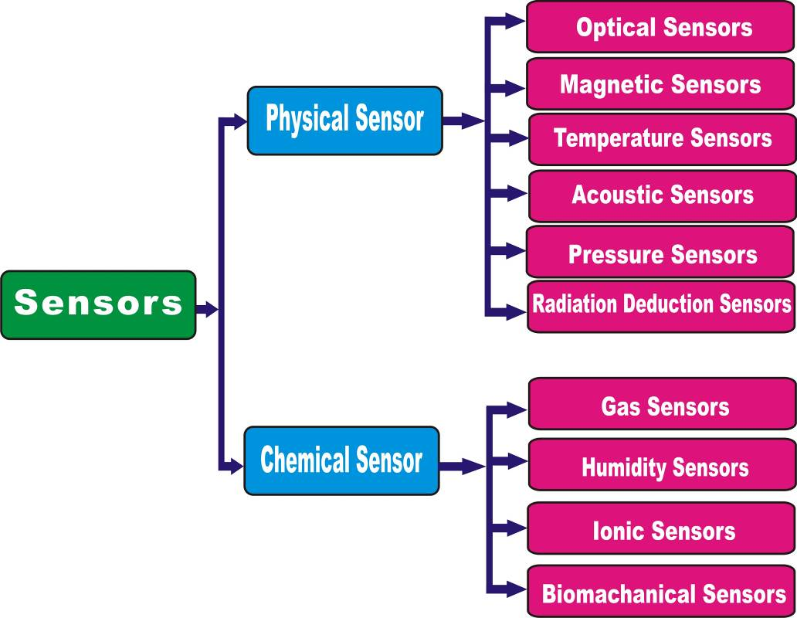
Fig. 1.1 Classification of sensors
1.3.1 Types of chemical sensors:
When chemical sensors make it possible to modify specific physical characteristics like weight, distance, resistance, etc., gas molecules interact with the detecting material. Chemical sensors detect changes in physical objects, which are then directly translated to an electric signal via transducers. Depending on the chemical processes and signal processing, various sensor kinds are available. These include amperometric [9], conductometric [10], potentiometric [11], volumetric [12], impedencemetric [13], chemometric [14], chemoresisters [14], calorimetric [10], field-effect transistor [15], conducting polymer [16], chromatographic [17], carbon nanotubes [18], and biochemical [19] sensors.

1.4 Gas Sensors
A device known as a gas sensor system, sometimes known as an electronic nose system, can detect and analyze signals brought on by particular and reproducible interactions with gas molecules in one or more integrated sensitive layers. Only through the systematic production and characterization of novel sensing materials, the availability of quick and accurate electronic measurement systems, and the rapidly expanding understanding of information theory to analyze multidimensional complex data was the development of this kind of device possible. When the sensing layer and electrical circuitry are combined in one chip, the system's size can be drastically reduced and its manufacturing costs can be greatly reduced. To identify specific contaminants or evaporating mixes, commercial gas sensor systems have already been employed. To improve these devices' performance, selectivity, and affordability, however, there is still much work to be done.
1.4.1 Main characteristics of gas sensors
The gas sensor should ideally offer data on a chemical compound's concentration. When determining the sensor's output, as with any instrument, a different parameter can typically be taken into account. Other aspects to think about while utilizing a chemical sensor are sensitivity, selectivity, and stability. It is also necessary to take into account repeatability, reversibility, reaction, and recovery times, as well as the detection threshold.
1.4.1.1 Sensitivity/Response:
The sensor's ability to detect changes in the physical and/or chemical properties of the gas exposure sensing material is known as sensitivity or response. The phrase is frequently used to describe either the smallest measurable concentration or the lowest detectable concentration in the sensing system. It is portrayed in numerous ways. In other terms, sensor response/sensitivity is the ratio of the change in resistance in the test gas (R=Ra-Rg) to the value of resistance in the air (Ra), where Rg is the resistance in the presence of the test gas.
The percentage of sensitivity (%S) is given by equation [20]:
$\text{Sensitivity}=\left\{\frac{R_{a}−R_{g}}{R_{a}}\right\}×\text{100}\text{\%}$ (1.1)
Or it is defined as the ratio of the resistance of the sample measured in the air to the target gas-containing atmosphere.
Sensitivity for Reducing gases, S =R_{a}/ R_{g} (R_{g} < R_{a})
Sensitivity for Oxidizing gases, S = R_{g} / R_{a} (R_{g} > R_{a})
1.4.1.2 Selectivity / Specificity:
Selectivity refers to a sensor's capacity to react to a particular gas in the presence of competing gases. Given that the sensor is frequently used to detect gas in a multi-gas environment, this parameter should be considered in real-world applications.
1.4.1.3 Stability:
The capacity of a sensor to maintain its sensitivity and response characteristics over time is known as stability. Depending on the application, the duration can be anywhere from hours to years. Stability can be defined as the amount of drift in the sensor response.
1.4.1.4 Response time (T_{res}):
The response time (Tres) is the time it takes for the sensor output signal to reach 90% of its saturation value after applying the target gas in a step function [21].
1.4.1.5 Recovery time (T_{rec}):
The recovery or decay time (Trec) is the time it takes for the sensor output signal to fall to 90% of its saturation value once the target gas is turned off in a step function.
1.4.1.6 Limit of detection (LOD):
LOD is three times the standard deviation of conductance mean noise. Values over LOD indicate the existence of a target gas, whereas values below LOD indicate that no analysis can be observed.
1.4.1.7 Reproducibility:
The reproducibility of gas sensors refers to their ability to produce the same response for the same gases. If the system treats the gas in the same way regardless of the number of observations or the interval between readings. Time and flexibility for response recovery are required for reproducibility.
1.5 Metal oxide gas sensors
Metal oxide-based gas sensors have gotten a lot of interest in the field of gas sensing because of their advantages such as simplicity, low cost, manufacturing adaptability, and strong process compatibility. SnO₂, ZnO, WO₃, and MoO₃ are the most often employed metal oxides in ammonia sensors [22-24]. Metal oxides are classified as n-type and p-type semiconducting metal oxides as gas sensing materials, and their high-performance electrical properties extend from 250°C to 550°C. In most cases, n-type semiconducting metal oxides are used for gas detection. In general, the electronic structure of the metal oxide is the most important aspect in the collection and comprehension of a suitable metal oxide for the detection of different oxides [25].
Metal oxides can also be divided into transition and non-transition metal oxides [26].
- Transition-metal oxides, for example (Fe₂O₃, NiO, Cr₂O₃, etc.)
- Non-transition-metal oxides, which include (a) pre-transition-metal oxides (MgO, Al₂O₃, and so on) and (b) post-transition-metal oxides (MgO, Al₂O₃, and so on) (ZnO, SnO₂, etc.).
Seiyama et al. [27] proposed the first ZnO-based sensor for liquefied petroleum gas (LPG) in 1962. Other metal oxides discovered in the literature include Cr₂O₃, Mn₂O₃, CuO, Co₃O₄, NiO, SrO, In₂O₃, WO₃, TiO₂, V₂O₃, Fe₂O₃, Nb₂O₅, Ta₂O₅, La₂O₃, CeO₂, Nd₂O₃, and SnO₂ [28]. Tin oxide is widely utilized and researched among these oxides because of its high gas sensitivity and chemical stability in polluted environments.
1.5.1 Thin film metal oxide gas sensors:
Thin films have several advantages in semiconductor gas sensor applications, including reduced resource losses, a high surface/volume ratio, low power conception, readily integrated circuit compliance, and simple change of electrical properties through adjusted manufacturing settings. Thin film technology allows for the modification of film properties while preserving significant control over the thickness parameter. Thin films are easily introduced into the unit during the material production cycle. When made in several layers, these can also be employed as electronic circuit components [29]. Thin-film metal oxides are used to detect a wide range of gases, including carbon-based (CO, CO₂, CH₄, C₂H₅OH, C₃H₈), nitrogen-based (NH₃, NO, NO₂), H₂, H₂S, ethanol, acetone, LPG, and moisture.
1.6 Ammonia Gas Sensor
Ammonia (NH3), a prevalent pollutant and poisonous gas, can have several negative impacts on a person's health, including irritation of the eyes, skin, throat, and respiratory system. The Occupational Safety and Health Administration (OSHA) in the US has said that exposure to ammonia levels of under 35 parts per million (ppm) for 15 minutes or under 25 ppm for 8 hours may be harmful to people's health [30,31]. The importance of ammonia sensing is shown by the fact that humans cannot smell ammonia below 50 ppm. Therefore, in today's world, a highly sensitive and selective NH3 gas sensor operating at room temperature is extremely desirable [32, 33]. Ammonia gas sensors now employ the majority of available nanomaterials. Which also contains alkaline, conductive polymers, IV-VI metal chalcogenides, and a product with two dimensions [34–36]. As a result of their affordability, high sensitivity, and environmental friendliness, tin monoxide and tin oxides are also among the goods used to develop ammonia gas sensors [37, 38].
1.6.1 Ammonia gas sensing methods
However, the most common sensing techniques can be divided into three main categories (Fig. 1.2), including solid-state sensing (metal oxide sensors and conducting polymer sensors), optical methods (optical sensors using tunable diode laser spectroscopy), and other methods (electrochemical sensors, surface acoustic wave sensors, and field-effect transistor sensors). There are many ways to find sensors as well. Their sensor mechanism and operating principles as NH₃ gas sensors are also covered in the chapters that follow, based on sensing materials and detection methods.
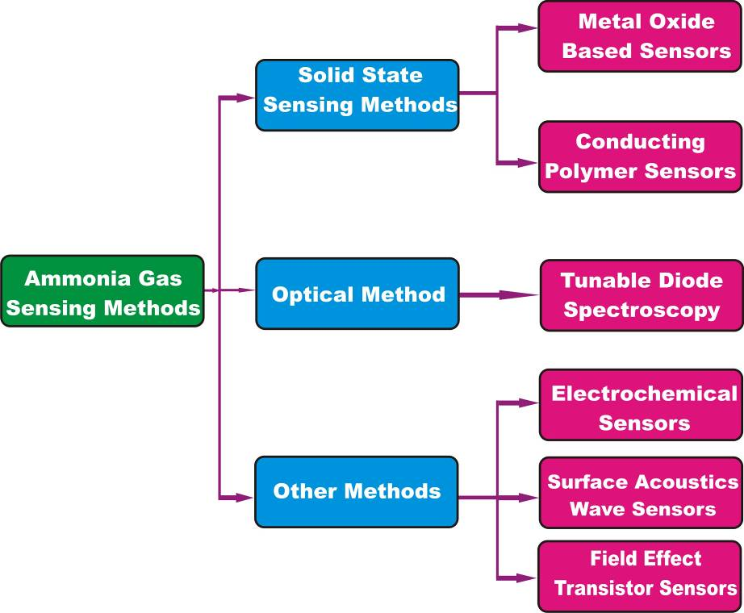
Fig. 1.2 Classification of ammonia sensors

    - Gas sensing mechanism
The gas detection concept for metal oxides is based on the variable depletion layer of the grain limits, which causes the modulation of energy barriers in terms of height in the presence of gas reduction or oxidation. The change in barrier height affects the passage of charge carriers, which causes a change in the conductivity of the sensing materials. The active detecting layer of the sintered and thin-film-style gas sensor is made up of several linked metal oxide grains. The formation of O²⁻, O⁻, and O²⁻ oxygen ion spaces as a result of O₂ absorption further establishes depletion capabilities at grain borders by removing charge transporters (electron) from the grain surface region [39]. Equation (1.1) - (1.3) defines the reaction rate as a function of temperature and describes the reaction mechanism. The partial oxygen pressure and the characteristics of the metal oxide surface are used to determine the depth of the oxidation layer. The depletion layer on the grain boundaries raises the potential barrier, which causes the grain limits to become a barrier for electric grain-grain movement. When the sensor is exposed to fuel gases, the surface oxygen species react to produce combustion products. The reaction reduces the distribution of oxygen atoms and restores most of the oxide content's electron-free carrier as well as electrical conductivity. The sensor's gas response signal is the modulated conduction of this surface reaction. Chemical-sensor forms typically have a sensor part that is made of semiconductor material with a high surface-to-volume ratio on a substrate with ohmic connections to measure changes in resistance and conductance [40]. Due to the combustion process that occurs with the oxygen species in the region of metal particles, when a sample is contacted on the surface of a metal oxide semiconductor, gas, and volatile organic compounds (VOC), the basic idea of detection changes in strength and shape [41,42].
O₂ (gas) → O₂ (adsorbed) (1.1)
O₂ (adsorbed) +e⁻ → O2⁻ (adsorbed); T < 100^{ο}C (1.2)
O₂⁻ (adsorbed) + e⁻ → 2O⁻(lattice); T < 100^{ο} - 300^{ο} C (1.3)

Ammonia on the surface of SnO2 may oxidize through potential reactions [43, 44].
2NH₃ + 3O⁻ → N₂ + 3H₂O + 3e⁻ (1.4)
4NH₃ + 5O⁻₂ → 4NO + 6H₂O + 5e⁻ (1.5)

The presence of ammonia in the operating temperature range (25–200°C) is responsible for the phenomenon of increasing resistance in SnO2 films, which can be attributed to the dominance of the reaction (1.5). No reaction was produced in reaction (1.4), which can be easily transferred to an oxidizing species NO_{x} if oxygen is present.
The type of chemical reaction will determine the depth of the depletion layer in the presence of the specific gas species. In the presence of gas reduction, the depletion layer is thin (sensing materials resistance drops), but the depletion zone expands in the presence of oxidation gas, leading to an increase in sensing materials resistance. The symmetric diagram of the gas detecting system is shown in Fig. 1.3.
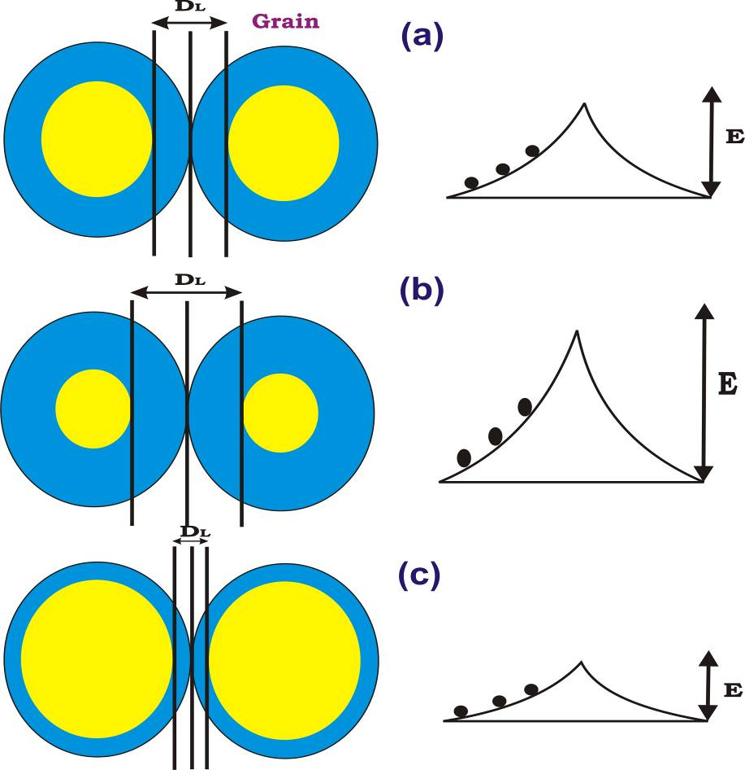
Fig. 1.3 Potential barrier in the presence of (a) dry air, (b) oxidizing gas, and (c) reducing gas. (E and DL are barrier height and depletion layer width, respectively)

  - Conclusion
In this comprehensive review, we investigated the most recent advancements in the field of energy-saving gas sensors, and sensing methodologies, covering various sensing materials as well as energy-saving approaches. Because of the rapid advancement of technology, gas sensors will be in high demand and significantly incorporated into everyday electronic devices such as smart watches, smartphones, and so on shortly. So we need flexible, very sensitive, selective, affordable, and stable gas sensors with quick reaction and recovery periods that are widely required for these applications. This article simply emphasizes understanding the functioning mechanism of gas sensors while also assisting in the advancement of these sorts of gas sensors to improve environmental cleanup.

References:
- P. Sazama, J. Dedeek, Mater. Lett. 62 (2008) 4239-4241.
- R.G. Deshmukh, S.S. Badadhe, M.V. Vaishampayan, I.S. Mulla, Mater. Lett. 62 (2008) 4328-4331.
- K.Lee, J.H. Kwon, S.L. Moon, W.S. Cho, B. K. Ju, Y. H. Lee, Mater. Lett. 61 (2007) 3201-3204.
- C. O. Park, S. A. Akbar, J. Mater. Sci. 38, (2003) 4611-4637.
- Merriams - Websters Collegiate Dictionary, An Encyclopedia Britannia Company, 11th edn, 2008.
- S. M. Sze, Semiconductor Sensors, John Wiley & Sons, Inc, New York U.S.A., 1994.
- T. G. Nenov and S. P. Yordanov, Ceramic Sensors: Technology and Applications, Technomic Pub. Lancaster 1996.
- H. Patel, The Electronic Nose: Ortificial Olfaction Tech., (2013) 143-180.
- E. I. Iwuoha, A. Al-Ahmed, M. Sekota, T. Waryo, P. Baker, Encyclopedia of Supramolecular Chemistry, Taylor and Francis, (2004) 1-18.
- F. Winquist, Microchima Acta, 163 (2008) 3-10.
- E.J. Calvo, M. Otero Springer Verlag Berlin Heidelberg (2008) 241-257.
- J.I. Janata, Prin. Chem. Sensors, (2009) 119-199.
- S. Achmann, G. Hagen, J. Kita, I. Malkowsky, C. Kiener, R. Moos, Sensors, 9 (3), (2009) 1574-1589.
- V.L. Kopparthy, S.M. Tangutooru, G.G. Nestorova, E.J. Guilbeau, Sensor Actuat B -Chem, 166-167, (2012), 608-615.
- D. Liu, M. Liu, G. Liu, S. Zhang, Y. Wu, X. Zhang, Analytical Chemistry, 82(1) (2009), 66-68.
- P. Grundler, Chemical Sensors: An Introduction for Scientists and Engineers: Springer Berlin Heidelberge, 2007.
- B. Adhikari, S. Mujumdar, Progress in Polymer Science, 29(7), (2004), 699-766.
- L. Gomez De Arco, Doctoral Dissertation, University of Southern California, U.S.A., 2010.
- J. Anzai, Encyclopedia of Supramolecular Chemistry. Taylor and Francis, (2004) 115-119.
- Kamalpreet Khun Khun, Aman Mahajan, R.K Bedi, J. Appl. Phys, 106, (2009), 124509. (formula)
- M.E. Franke, T.J. Koplin, U. Simon, 2006, “Metal and Metal Oxide Nanoparticles in Chemoresistors: Does the Nanoscale Matter?” Small, 2(1), 36-50.
- J. Huang, J. Wang, C. Gu, K. Yu, F. Meng, J. Liu, Sensor Actuat A – Phys. 150 (2009), 218–223.
- Y.M. Zhao, Y.Q. Zhu, Sensor Actuat. B - Chem. 137 (2009) 27–31.
- G. Wang, Y. Ji, X. Huang, X. Yang, P.I. Gouma, M. Dudley, J. Phys. Chem. B 110 (2006) 23777–23782.
- G. Korotcenkov, Mater. Sci. Eng. B Solid-State Mater. Adv. Technol. 139 (2007) 1–23.
- Dongwook Kwak, Yu Lei, Radenka Maric, Talanta 204 (2019) 713–730.
- T. Seiyama, S. Kagawa, Anal. Chem. 38 (1966) 1069–1073.
- Chengxiang Wang, Longwei Yin, Luyuan Zhang, Dong Xiang and Rui Gao, Sensors 2010, 10, 2088-2106.
- Fatma sarf, Metal oxide gas sensors by nanostructures, Intechopen, gas sensors, 6, 2019.
- Kumar, R.; Kushwaha, N.; Mittal, J. Sensor. Actuat B - Chem. 2017, 244, 243–251.
- Sharma, S.; Kumar, A.; Singh, N.; Kaur, D. Sensor. Actuat B - Chem. 2018, 275, 499–507.
- Wang, X.; Li, C.; Huanga, Y.; Zhai, H.; Liu, Z.; Jin, D., Sensor. Actuat B - Chem. 2018, 275, 451–458.
- Kumar, R.; Kushwaha, N.; Mittal, J. Sens. Lett. 2016, 14, 300–303.
- Chhowalla, M.; Shin, H.S.; Eda, G.; Li, L.J.; Loh, K.P.; Zhang, H., Chem. 2013, 5, 263–275.
- Choi, W.; Choudhary, N.; Han, G.H.; Park, J.; Akinwande, D.; Lee, Y.H. Mater. Today 2017, 20, 116–130.
- Ning, C.; Qian, L.; Jin, L.; Yong, W.; Bai, Y. Chem. Eng. J. 2017, 326, 17–28.
- Zhang, F.; Zhu, J.; Zhang, D.; Schwingenschlögl, U.; Alshareef, H.N., Nano Lett. 2017, 17, 1302–1311.
- Han Wu, Zhong Ma, Zixia Lin, Haizeng Song, Shancheng Yan and Yi Shi, Nanomaterials 2019, 9, 388.
- M. Batzill, Sensors, 2016, 6, 1345-1366.
- J. Fraden, Handbook of modern sensors: Physics, designs, and applications‖, 3rd ed., Springer-Verlag, 2003.
- C.M. Ghimbue, J. Schoonman, M. Lumbreras, M. Siadat, Appl. Surf. Sci. 253, 7483(2007).
- F. Hellegouarc’H, F. Arefi-Khonsari, R. Planda, J. Amouroux, Sensor. Actuat B - Chem 73, 27 (2001).
- I. Jimenez, A. m. Vila, A. C. Calveras, R.Morante, IEEE Sens. J. 5, 385, (2005).
- D. H. Yun, C. H. Kwon, H. Hong, S. Kim, K. Lee, H. G. Song, J. E. Kim, Proceedings International solid state Sensors and Actuators Conference (Transducers ’97) 2, 959, (1997).

