PERFORMANCE IMPROVEMENT OF PRIMARY USER DETECTION IN COGNITIVE RADIO NETWORKS
Amardeep A.Shirolkar, S.V.Sankpal*
Department of Technology,
Shivaji University, Kolhapur-416004 India
*D.Y.Patil College of Engineering, Kolhapur-416006 India

Abstract

Cooperative spectrum sensing in cognitive radio networks uses signal power and threshold alone to detect the primary user (PU) using traditional methods. The choice of threshold has a key role in determining the degree of PU detection accuracy. This study focuses on the prediction of the existence of PU using machine learning and recorded data training. It also provides a solution to the problem of diverse signal strength ambiguities. Support vector machine (SVM) based linear binary classifiers are used to test the model utilising combinations of recorded signal strengths from synthetic experimental data. Long short term memory (LSTM) and gated recurrent unit (GRU) layers in a recurrent neural network are used in the model to test the deep learning-based approach.. The performance is compared for the accuracy of PU detection and deep learning approach shows better performance.
Keywords: Cooperative Sensing, Cognitive Radio Network, SVM, LSTM, GRU, Performance.

1.0 Introduction
Today's networks require on-demand spectrum distribution for secondary users (SU), hence this article addresses the issue of spectrum scarcity. Allocating spectrum to SUs has a number of difficulties, but a key one is the necessity to identify the primary user (PU). The basis for this detection is cooperative spectrum power sensing, which exhibits a variety of missed detections. The strength of the signal is directly correlated with the locations of the equipment, and channel noise levels fluctuate with distance. Long distance path loss, concealed node, and reflecting interference have all been observed in various instances to interfere with the accurate identification of PUs. Since the noise levels are nonlinear, it may be difficult to model them precisely to address the problem. Therefore, during the detection procedure, various noise management methods are needed. The use of filtering algorithms can reduce the noises that fall into a defined category to a certain extent. There are additional issues with energy sensing, such as incorrect level observation, which falls under the three primary categories. Path loss, which has a low power level even when the principal user is present, is the first. Hidden node problems are the second, and shadowing during sensing is the third. The chance of detection has significantly increased using the traditional methods. Additionally, it is discovered that when loss components are taken into account, performance for such experimental settings drops because path loss, hidden node, and shadowing effects have a significant impact on both the chance of detection and the probability of a false alarm.
Recurrent neural networks (RNNs) can be used to detect PU in the age of deep neural networks. Over traditional neural network models, the inclusion of long short term memory (LSTM) and gated recurrent units (GRU) can improve categorization. With regard to the ground truth of the presence of PUs and the corresponding felt power, the recorded dataset can be used to train these networks. Additionally, the trained model can be utilised to identify PUs in relation to input felt power.

2.0 Related work
Regarding the techniques employed in cooperative relaying, various publications are examined. In order to create the framework for the planned task, a few of them are addressed in this section.
M. Golvaei et al. [1] devised a quick decision-making technique in which the spectrum usages are identified by a threshold. For locating the PUs, the Power Spectral Density (PSD) measurement feature vectors are taken into account. The PSD coefficients are derived from an array of many sensors. In a comparison study using an SVM classifier, a choice made via PSD sampling produces higher results. Although detection probability is similar, sampling-based methods are preferred for low latency networks because they directly reduce the average training time needed for SVMs.
K-nearest neighbour and support vector machines have been used by Z. Shi et al. [2] for the sensing model in cooperative spectrum sensing. When learning-based algorithms are utilised for the prediction of the presence of these nodes, it is seen that the precision in the detection of Pus and Sus exhibits superior performance.
The study by X. Wu et al. [3] concentrated on the application of soft threshold decision, which performs quantization to several levels. When establishing the noise levels in various scenarios, the Rayleigh fading channel and white Gaussian noise models are taken into account in order to determine the threshold for determining the presence of PUs.
In order to detect PUs, Z. Liu et al. [4] have focused on communication events in cooperative sensing mechanisms. In order to capture communication events and use the Hawkes process to detect PUs in wireless transceiver environments, the forwarding action or acknowledgement is taken into consideration..
Fusion rule was utilised by X. Liu et al. [5] to determine the global threshold level at the fusion centre. the choices made by SUs with enough energy when energy harvesting-based cooperative spectrum sensing is implemented and SUs operate on captured energy. By taking into account dynamic threshold, zones with an energy and spectrum deficiency are detected from the installed SUs network scenario. It is determined what final decision threshold will optimise projected achievable throughput..
Attack modes have been taken into account in spectrum sensing by Z. Luo et al. [6]. The authors demonstrate the detection of fraudulent sensing data over the actual situation and the avoidance of an attacked sensing system utilising a noninvasive approach. According to this, the mitigation of assaults on sensing mechanisms can be successful up to 82% of the time.
According to Y. Zhang et al. [7], listen-before-talk and listen-and-talk protocols should be used. The performance of the sensing mechanism is assessed to reduce spectrum waste, and it demonstrates enhanced accuracy and robustness.
Based on the fading effects of Rayleigh channels seen in spectrum sensing, H. Sun et al. [8] have employed sub-Nyquist criteria. The impacts of aliasing in the wideband spectrum are reduced by criteria-based spectrum sensing and threshold level finalisation.
Pietra-Ricci index was used by D. A. Guimares [9] to separate the forms of the received signal. In both cases, where PU is present and absent, sampling of the covariance matrices is taken into account. Even though the noise levels are chaotic, the algorithm's performance is improved..

3.0 Plan of the work
In the suggested work, three scenarios—shadowing effect, path loss, and hidden node—are taken into consideration for the identification of PU. Figure 1 displays the three routes that the destination node can take to determine whether the primary user is present..
- A straight line of sight path where direct signal sending for main user detection is possible.
- Due to a coverage issue, one of the nodes relays and repeats the signal about the presence of the principal user, with node 2 acting as the relay node.
- A different route using node 3 as a relay node, which raises the certainty of the presence of PU due to several detections that are comparable.
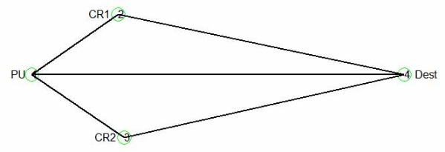
Figure1: The paths available for destination node to detect PU
In wireless networks, the route loss exponent determines the signal's energy. The binary assumption that the signal, y (t), is either present or absent can be used to determine the signal that can be identified from the three routes accessible in the scenario as illustrated in figure 1. This theory can be expressed as follows:,
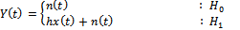

Where, x(t)= is signal sent by primary user,
h = gain of the channel
n(t)= AWGN noise
The second scenario is one in which a barrier exists between one of the cognitive relays and the primary user, causing shadowing to occur when the primary user's presence is being detected. The case being considered is elaborated in Figure 2..
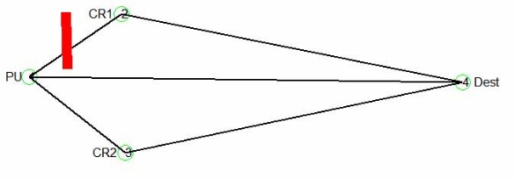
Figure 2: Case of obstacle in CR and PU for shadowing effect analysis
The third scenario is taken into consideration, where a hidden node problem is produced by positioning the nodes so that one of the cognitive relays and the destination node are separated by an obstruction. The obstruction is in charge of concealing the primary user, which then makes it harder to detect their existence. The case being considered is elaborated in Figure 3.
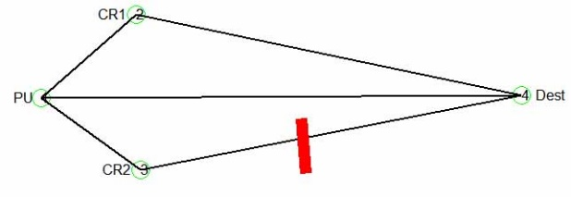

Figure 3: Case of hidden node issue when obstacle is present between cognitive relay and destination node.

The platform for the examination of the likelihood of detection with respect to threshold is provided by the three scenarios that are jointly treated here.
The dataset of recorded signal power and actual PU presence is taken from the simulated experimentation. A neural network model is trained using the dataset. SVM-based experiments are run first, and then an RNN model is applied. Figure 4 displays the RNN model.
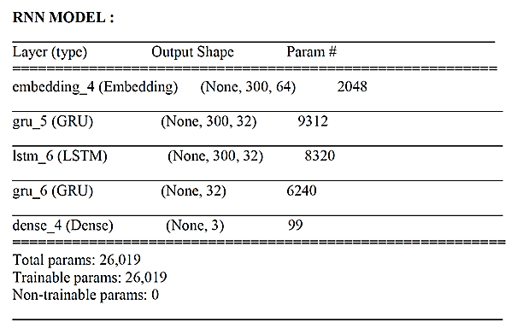
Figure 4: Configuration of RNN based model

4.0 Results and analysis

The neural network classifier's accuracy is assessed after training for PU detection. Results from RNN and Support Vector Machine (SVM) models are compared using different parameters, as shown in Table 1.

Table 1: Formulae For Performance Evaluation Parameters
Parameter | Formula
Sensitivity
Specificity
Accuracy

Whereas true positive (TP) denotes the presence of an actual PU and its detection as present, true negative (TN) denotes the presence of an actual PU but its detection as absent, false positive (FP) denotes the presence of an actual PU but its detection as present, and false negative (FN) denotes the absence of an actual PU and its detection as absent.
Table 2: Comparison of machine learning and deep learning methods
Method | Accuracy | Specificity | Sensitivity
RNN Model | 0.985 | 0.91 | 0.92
SVM | 0.956 | 0.91 | 0.89

Compared to models 1, 2, and 3, the RNN model performs better in terms of sensitivity, specificity, and accuracy. The comparison of machine learning SVM model and deep learning model is shown in figure 5 in which outperforms in terms of accuracy of 98.5%, specificity of 0.91 and sensitivity of 0.92.
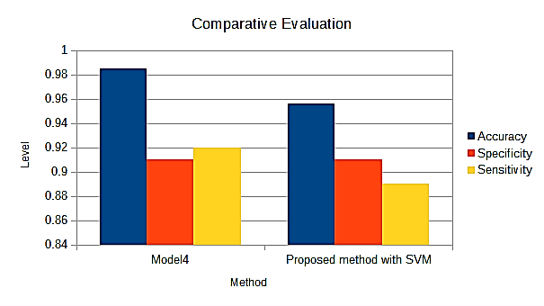
Figure 5: Performance comparison

5.0 Conclusion
In this research, the presence of PU during the spectrum sensing method is predicted. The dataset in which manual labelled entries are made to clarify the existence of PU is generated by taking into account the concealed node, path loss, and shadowing effects. For the purpose of detecting PU, the innovative model ECoSense is created. Due to the employment of a prediction model, the sensed power level is independent of any kind of dynamic threshold, therefore its sparse ness due to various problems has no effect on detection accuracy. The comparative performance assessment reveals that the RNN model beats the traditional neural network model SVM in terms of accuracy, specificity, and sensitivity..

References:
- M. Golvaei and M. Fakharzadeh, "A Fast Soft Decision Algorithm for Cooperative Spectrum Sensing," in IEEE Transactions on Circuits and Systems II: Express Briefs, vol. 68, no. 1, pp. 241-245, Jan. 2021, doi: 10.1109/TCSII.2020.3010587.
- Z. Shi, W. Gao, S. Zhang, J. Liu and N. Kato, "Machine Learning-Enabled Cooperative Spectrum Sensing for Non-Orthogonal Multiple Access," in IEEE Transactions on Wireless Communications, vol. 19, no. 9, pp. 5692-5702, Sept. 2020, doi: 10.1109/TWC.2020.2995594.
- X. Wu, L. Zhang and Z. Wu, "Quantized Soft-Decision-Based Compressive Reporting Design for Underlay/Overlay Cooperative Cognitive Radio Networks," in IEEE Transactions on Cognitive Communications and Networking, vol. 6, no. 3, pp. 1044-1055, Sept. 2020, doi: 10.1109/TCCN.2020.2988479.
- Z. Liu, G. Ding, Z. Wang, S. Zheng, J. Sun and Q. Wu, "Cooperative Topology Sensing of Wireless Networks with Distributed Sensors," in IEEE Transactions on Cognitive Communications and Networking, doi: 10.1109/TCCN.2020.3019601.
- X. Liu, K. Zheng, K. Chi and Y. -H. Zhu, "Cooperative Spectrum Sensing Optimization in Energy-Harvesting Cognitive Radio Networks," in IEEE Transactions on Wireless Communications, vol. 19, no. 11, pp. 7663-7676, Nov. 2020, doi: 10.1109/TWC.2020.3015260.
- Z. Luo, S. Zhao, Z. Lu, J. Xu and Y. Sagduyu, "When Attackers Meet AI: Learning-empowered Attacks in Cooperative Spectrum Sensing," in IEEE Transactions on Mobile Computing, doi: 10.1109/TMC.2020.3030061.
- Y. Zhang, Q. Wu and M. R. Shikh-Bahaei, "On Ensemble Learning-Based Secure Fusion Strategy for Robust Cooperative Sensing in Full-Duplex Cognitive Radio Networks," in IEEE Transactions on Communications, vol. 68, no. 10, pp. 6086-6100, Oct. 2020, doi: 10.1109/TCOMM.2020.3005708.
- H. Sun, A. Nallanathan, S. Cui and C. -X. Wang, "Cooperative Wideband Spectrum Sensing Over Fading Channels," in IEEE Transactions on Vehicular Technology, vol. 65, no. 3, pp. 1382-1394, March 2016, doi: 10.1109/TVT.2015.2407700.
- D. A. Guimarães, "Pietra-Ricci Index Detector for Centralized Data Fusion Cooperative Spectrum Sensing," in IEEE Transactions on Vehicular Technology, vol. 69, no. 10, pp. 12354-12358, Oct. 2020, doi: 10.1109/TVT.2020.3009440.

