Role of Information Technology in Plant Diseases Detection and Management
Shri. V. D. Jadhav*¹,
^{*1}IT Professional, Research Scholar, Khed, Maharashtra, India
Dr. P. R. Kolhe¹,
²Officer In-charge, Agril. Knowledge Management Unit(AKMU), Dr. BSKKV, Dapoli
Mr. A. R. Patil²,
²Senior Research Assistant, Agril. Knowledge Management Unit(AKMU), Dr. BSKKV, Dapoli
Shri. B. R. Gujar^{2,}
²IT Professional, Research Scholar, Chiplun, Maharashtra, India
Dr. M. H. Tharkar³
³Assistant Professor, CAET, Dr. BSKKV, Dapoli

Abstract
Agriculture in India is nowadays improving with the technology. Now, the government of India is giving the priority to doubling farmer’s income. Due to interaction of technology or information technology industry, it has become possible to do some technical and computational processes quickly. With the help and use of technology many processes in agriculture are becoming quick and came out as very popular system in agriculture. The technology can add more easy entities in agriculture field. With the use of machines or hardware like, the Tractor, the Motocultor, the Rake, Machete, Escardilla, Shovel, Peak, Wheelbarrow, the Harvester, plow tractor, the Harrow, Sprinkler, seeder and fertilizer, Baler etc. are the hardware instruments which are making hard and time-consuming work easy and quick for the farmers. But these instruments need to operate manually. If farmers did the plantation of some plants and then on plant’s fruits or leaves found some diseases. So, if farmers want to know about these diseases and find the solution of it then it takes more time and peoples involvement in it. This paper is dealing with find diseases name and proper solution for these diseases from Experts, Subject Matter Specialist (SMS) and scientist.
Keywords: Agriculture, Information Technology, Plant Diseases, Scientist, Plantation.
Introduction
The Agriculture and the education departments are two elements where the ICT can play the very important role in the development of the country (V. D. Jadhav, IRJET-Vol 06 Issue 02, Feb 2019). There are many agricultural machines or instruments are available like, the Tractor, the Motocultor, the Rake, Machete, Escardilla, Shovel, Peak, Wheelbarrow, the Harvester, plow tractor, the Harrow, Sprinkler, seeder and fertilizer, Baler etc. which are making hard and time-consuming work easy and quick for the farmers. But these instruments need to operate manually. The farmers make a farm all set for cultivation and starts to cultivate plants. Plants grows after some time period, But if he found some disease in plant e.g. White or Black dots on leaf of fruit etc. then farmer is still unknown about the name, symptoms and solution of disease. If there is a resource to find these types of details about the diseases then it will be very easy to manage these diseases. There must be a way to send a photo of the disease on leaf or fruit to scientists/experts. Then the experts can send back the solution on disease. The farmer can get exact information about symptoms and management of the diseases. The system must have the disease detection facility in it. The system can be made up with Graphical User Interface (GUI) for easy to operate for farmers. The Database will be there with samples of various diseases. There will be the service to load information about diseases from anywhere only using the photographs of the leaf or fruit which is unhealthy. Now as increasing the work on machines and it is all changing fast and vastly to reach desired output. So, it is necessary to stay with it and stuck with the market flow country (V. D. Jadhav, The Pharma Journal- 2019). There will be big data to store in database for this project. The user registration and login facility will act there to specify the database of specific farmer. The farmer can ask about query from his registered account.
1. Data Preparation and detection:-
The database must cover all type of detailed information about plant, fruits, land, water system, insecticides, fungicides and relative information etc. The database may cover the detailed knowledge about plantation, seed germination, plant protection and harvesting etc. The information about diseases, symptoms of diseases and solution on these diseases etc. will available there.
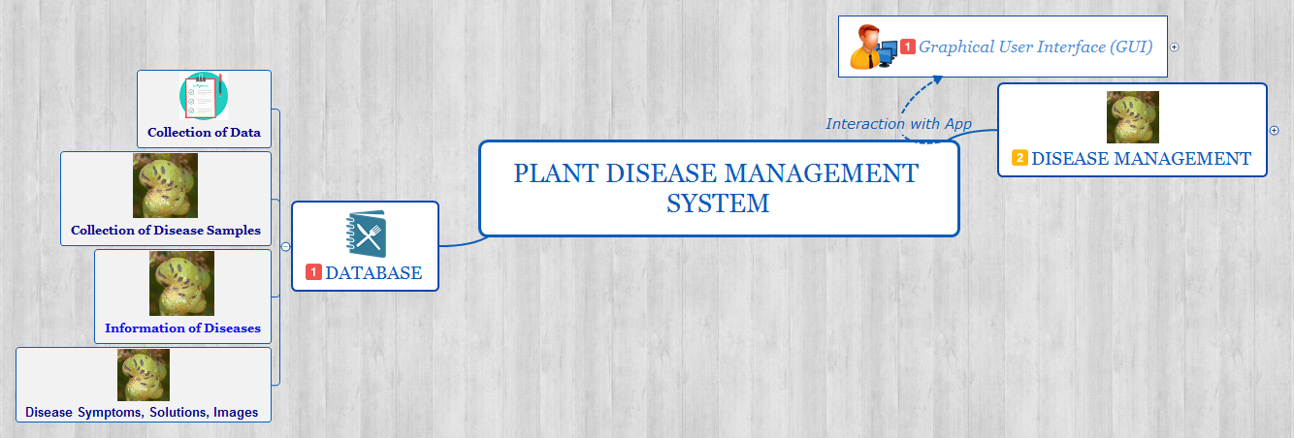
Fig (1): Database & database fields
As above figure shows database and database fields are, Collection of Data, Collection of Disease Sample, Information of Diseases and Disease Symptoms, Solutions, Images etc. Thus all details about diseases must be collected.
2. User Interface:-
The user interface for the system must be understandable to farmers and very easy to use. The functions will be smooth to work and very light. User interface may contain user registration for famers and experts too.
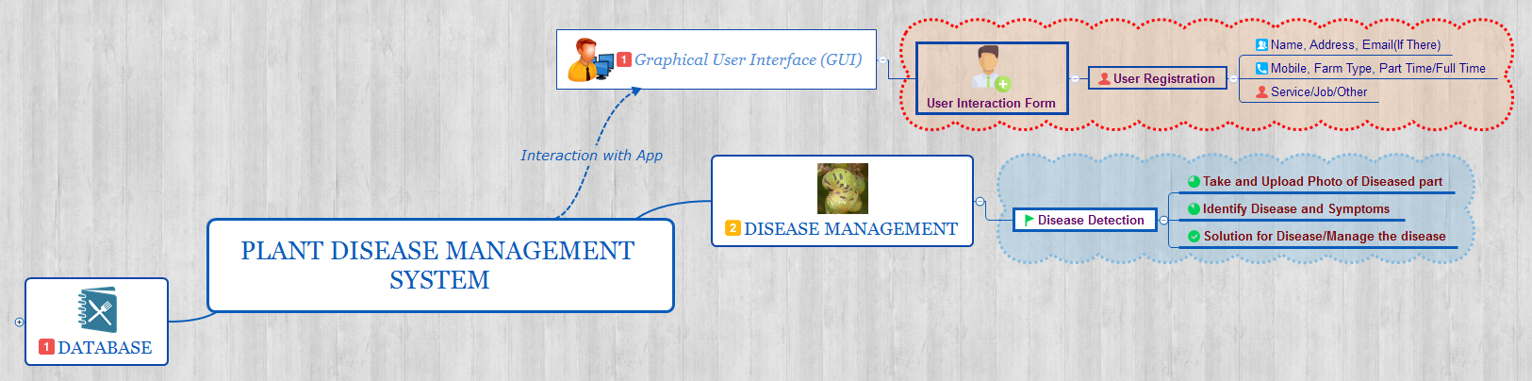
Fig (2): User Interface
The figure shows the- registration for user may require some fields like, User interaction form, name, address, contact no., job/work etc. .
3. Diseases Detection:-
The diseases detection is the desirable output of the disease query asked by the farmer or any user. This may directly related to the database which contains all the details about plants, diseases etc.
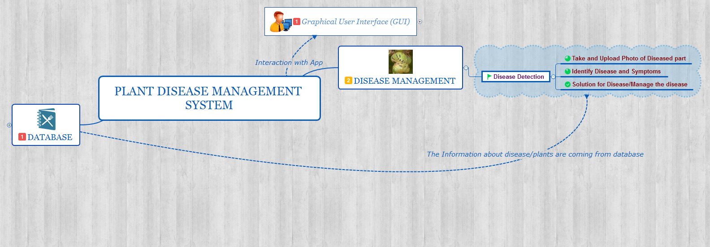
Fig (3): Diseases Detection & Database relation
The figure shows the information about diseases will come from the database which was pre created. The samples of diseases and its solutions are already stored in the database. The figure above shows the relation between database and diseases detection or output. Example- if we take image below or disease from farm and load it to our system then we will get the proper information about that disease. To show out the details of diseased fruit to farmer we must already add the disease image, plant information, land information, climate details for this plant in our system database.
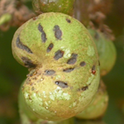
Fig (4): Diseased fruit
4. Processing for Disease Detection:-
4.1 Using of Tool/Computer program for Disease Detection:-
We have used Python programming language. It requires Numpy for identify the exact dimensions of the image which will be uploaded by the farmers.
import cv2
import numpy as np
#Create CascadeClassifier Object
face_cascade=cv2.CascadeClassifier('C:/Users/Personal/AppData/Local/Programs/Python/Python37-32/Lib/site-packages/cv2/data/haarcascade_frontalface_default.xml')
def face_extractor(img):
gray=cv2.cvtColor(img,cv2.COLOR_BGR2GRAY)
faces=face_cascade.detectMultiScale(gray,1.3,5)

if faces is():
return None
for (x,y,w,h) in faces:
cropped_face=img[y:y+h, x:x+w]
return cropped_face

cap=cv2.VideoCapture(0)
count=0
while True:
rel, frame=cap.read()
if face_extractor(frame) is not None:
count+=1
face=cv2.resize(face_extractor(frame),(200,200))
face=cv2.cvtColor(face, cv2.COLOR_BGR2GRAY)
file_name_path='E:/New Python Course/Plant_Detection_Project/Plant_Detection_Identify/user'+str(count)+'.jpg'
cv2.imwrite(file_name_path,face)
cv2.putText(face,str(count),(50,50), cv2.FONT_HERSHEY_COMPLEX,1,(0,255,0),2)
cv2.imshow('face Cropper',face)
else:
print("Face Not Found")
pass
if cv2.waitKey(1)==13 or count==50:
break
cap.release()
cv2.destroyAllWindows()
print("Collecting Samples Completed !!!")

The above code will identify the uploaded image by more camera angles.
4.2. Code for Disease Detection:-
import cv2
#Create CascadeClassifier Object
face_cascade=cv2.CascadeClassifier('haarcascade_frontalface_default.xml')

#Reading The image as it is
img=cv2.imread('vishnuj.jpg')

#Reading the image as Gray Scale image
gray_img=cv2.cvtColor(img, cv2.COLOR_BGR2GRAY)

#Search The Coordinates of the image
faces=face_cascade.detectMultiScale(gray_img, 1.1,5)
for x,y,w,h in faces:
cv2.rectangle(img, (x,y), (x+w,y+h), (0, 255, 0), 3)

cv2.imshow('img',img)
cv2.waitKey(delay=0)

***Note: For detecting the disease we have a program same as of face detection system.
For the better detection take more angles of photographs, more images of it, give the coordinates as more correctness. This is the exact concept through which we can detect the plant diseases and provide the proper information about the disease and management to the farmers.

The output of the above program will be,
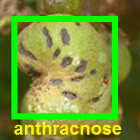
Fig 4(a):Uploaded image Fig 4(b):Disease detected image

5. Advantages:-
  - There will be available resource to find these types of details about the diseases then it will become very easy to manage these diseases.
  - The farmer can get exact information about symptoms and management of the diseases.
  - Due to Graphical User Interface (GUI) it will be easy to operate for farmers.
  - Service to load information about diseases from anywhere only using the photographs of the leaf or fruit which is unhealthy.
  - The functions will be smooth to work and very light.
  - Quick response from server.
  - No need to know much more about disease, you can get that information by uploading the image of disease.

6. Conclusion:-
The paper is dealing with how we can use the information technology for agriculture fields. We can do the agricultural calculation by using information technology. The paper shows how we can develop disease detection system in python programming language. There are many agricultural machines or instruments are available like, the Tractor, the Motocultor, the Rake, Machete, Escardilla, Shovel, Peak, Wheelbarrow, the Harvester, plow tractor, the Harrow, Sprinkler, seeder and fertilizer, Baler etc. which are making hard and time-consuming work easy and quick for the farmers. But these instruments need to operate manually. If there is a resource to find these types of details about the diseases then it will be very easy to manage these diseases. There must be a way to send a photo of the disease on leaf or fruit to scientists/experts. Then the experts can send back the solution on disease. The farmer can get exact information about symptoms and management of the diseases. The system must have the disease detection facility in it. The system can be made up with Graphical User Interface (GUI) for easy to operate for farmers. The information about diseases, symptoms of diseases and solution on these diseases etc. will available there. Taking many pictures of diseased entity in many angles makes more accuracy of result. The special server is required for thus type of big data storage. By using this system the farmers can get fast answer about the diseases and all information about symptoms as well as management of disease. The experts and scientists will be connected to this system therefore the farmer can use that suggestions on the field quickly after asking of query of disease. Thus the system will work on client server system. The FAQs will be there to fast search about disease. It will make very easy and quick operations and manages the system properly as question answer manner. This system used by farmers as well as scientists so, it is needed to agricultural field operations. This is another type of how information technology can embedded with the agriculture.

7. Bibliography:-
1. www.google.com
2. Pdf of “Python Notes for Professionals” from GoalKicker.com
3. V. D. Jadhav, 2019, “Use of Information Communication Technology in Education Services” IRJET, Volume 06 Issue 02, Feb 2019
4. Prakash R Kolhe, P P Kolhe, Vishnu Jadhav, N Mirajdar: “Computer C Language Program for Calculation of the Estimation of Catch and Effort of Fishing” IJARSET Vol-5 Issue-4 April 2018.
5. Prakash R Kolhe, P P Kolhe, Vishnu Jadhav: “Growth Analysis of Plant by Using Computer C Language Program” JETER,Vol-6, Issue-4,April 2018.
6. Vishnu D. Jadhav, Prakash R Kolhe, Atul R Patil: “Use and role of artificial intelligence and data science in the automotive industry” The Pharma Journal 2019 (295-300).

