Readmission Prediction among Diabetic Patients Based on Expert System

Sushma Jaiswal Priyanka Gupta
Guru Ghasidas Vishwavidyalaya Bilaspur (C.G.) Guru Ghasidas Vishwavidyalaya Bilaspur (C.G.)
Bilaspur, India Bilaspur, India
jaiswal1302@gmail.com priyanka13666@gmail.com

ABSTRACT
Diabetes Mellitus depicts a group of chronic metabolic disorders affecting more than 450 million people worldwide. Diabetes is a hazardous and incurable disease. The root cause of this is yet to be ascertained. Many researchers have worked on this area to make it easier for medical professionals to examine it. In this study, recent literature was analyzed. It is to be accounted that different Machine Learning models have obtained state-of-the-art results and perform well in many diabetes-associated tasks. This research investigates the causes of readmission and hospital readmission within 30 days of deliverance amongst diabetic patients. The proposed work is implemented on the Diabetes Readmission dataset. The model obtains benchmarked score which is 98% for the stacking model and Long Short Term Memory (LSTM) gives 98.5% precision. The framework assists in classifying whether the diabetic patient will be readmitted to the hospital within 30 days or not.

Keywords- Machine Learning, Classification, LSTM, Diabetes Mellitus.

INTRODUCTION
The aim of this research is to investigate and classify whether the patient is admitted to the hospital or not and the efficacy of outdoor diabetes patient’s standard care on 30-day hospital readmission rates Diabetes is a long lasting incurable disease. It is very difficult to rid of this, so it is better that this diseases should not happen. It is very important to keep lifestyle right so that we can stay away from diseases. Many people get it at a very young age and many people get it after a long time. But it is dangerous in both cases. Diabetes falls under the category of metabolic diseases defined by hyperglycemia occurring due to imperfections in insulin secretion, insulin action, or both of them. Diabetes diseases become even more dangerous with increasing age because in what quantity, how much sugar is to be eaten, it is a big problem. To identify glucose levels in blood, diabetic person have to pay money as well as their time. To regulate the amount of glucose insulin has an important role in the body which is released by the pancreas. As stated by etiopathology of diabetes, on the basis of clinical institution it is classified into three main parts Type 1 diabetes, Type 2 diabetes, and gestational diabetes mellitus. Another category because of certain reason comprises with latent autoimmune diabetes of adulthood and maturity-onset diabetes of the young age people. There is no long-term treatment for diabetes diseases; it can be managed and controlled only when it is detected as the earliest. Diabetes prevention is essential; due to diabetes diagnosis, people have to spend a lot of money. The Government launches many schemes for diabetes prevention to help the people. On the International Diabetes Federation (IDF) report, approximately 450 million people suffer from this severe disease, which will increase to 493 million by 2045. This article developed one of the robust and accurate sets of techniques for predicting diabetes chronic diseases. The research includes the PID dataset acquired from the UCI machine learning repository and the DiabetesType dataset from the data world repository. Diabetes is commonly occurring in people due to augmentation of busy and bad lifestyles, the early recognizance and willpower of diabetes is the sole way to stay away from its stumbling block. The models have been developed with different classifiers, and after comparing them, the best model will be sucked out of them. Data preprocessing takes a very important place for developing the model. The models have high accuracy scores with the help of statistical analytics techniques and deep learning algorithms. It creates a predictive model for healthcare professionals. Diabetes Prevention Program is initiated by India and other countries so that the people with diabetes and in the group of diabetic individuals in India and different evaluative countries are getting holds the advantages of the schemes. It is essential to for a person living with diabetes to maintain their blood glucose levels in a normal range. Apart from that, hyperglycemia or hypoglycemia can cause short and long-term difficulty in micro vascular and macro vascular, incorporating neuropathy, nephropathy, retinopathy, stroke, cardiovascular disease, and peripheral vascular diseases.

II. Literature Review

Machine Learning, artificial intelligence and specifically deep learning, an ensemble type of machine learning, have been put in favorable approaches with optimistic results. According to the World Health Organization in 1980 the number of diabetic person recorded is 108 million and in 2014 it enhanced with 422 million. As health care industry develops and generates a mass of useful data such as patient’s record, electronic medical records of diabetic person, diagnosis and treatment data, and etc., this can serve as a key resource for knowledge extraction that can support decision making and cost reduction system. [1] The author suggested a new LASSOQ model, which ensures better glycemic control than Standard Formula. It gives an expert system for diabetes prediction. [2] The author focused on DCNN and achieved 86 % accuracy and 0.91 areas under curve result. [3] In this section the author introduced CRNN model for glucose level forecasting using Silico dataset and a clinical dataset. Specially used for capture patterns of features of multi-dimensional time series data. The moderate RNN have the ability to analyzing the prevenient sequential data and producing the predictive BG. The proposed CRNN method represents surpassing result in forecasting BG levels (RMSE and MARD) in the silico and clinical observation. [4] In this paper the author implemented two novel feature extraction techniques for finding the best risk-factors, after that applying a machine learning model for prediction of type 2 diabetes chronic diseases. The recommended methods have been defined and gathered the clinical data over a long period of time, known as the San Antonio Heart Study. The framework achieves 95.94% accuracy in predicting whether the person will have type 2 diabetes within the next 7–8 years or not. [5] Choubey et al. the author used PID dataset and a regional dataset from Bombay upper bazaar medical hall Ranchi Jharkhand. The classification approaches include logistic regression, naïve bayes, KNN, ID3 DT and C4.5 DT They used PCA and PSO technique for feature reduction and found that PCA outperform better. [6] Developed SVM framework for prediction of diabetes. They used chi-squared test, extra trees, and lasso feature selection techniques with 83.20% accuracy, 87.20% sensitivity and 79% specificity. [7] They focused on DL technique convolutional neural network long short term memory (CNN-LSTM) and PID dataset is used for prognostication of diabetes mellitus. The obtained accuracy was achieved by the authors is 68-74%. Fathi et al. [8] the author’s point of convergence is to develop decision support system for Type 1 diabetic person. The framework equipped properly medical records from 15 contributors with physiologically workable licensed model parameters. [9] They introduced perspective uses the multiple K-nearest neighbor algorithms to predict postprandial glucose profile due to the nominal therapy and recommend a correction to time and/or amount of the meal bolus. This model has been prosperous validated on the adult in silico population of the UVA/PADOVA simulator. [10] Introduced dataset of china from 2009 to 2015 and achieved 58.24% F3 score, sensitivity 91%, and G-mean 86.69%. The study shows that processing is crucial for model before feeding the dataset into a machine learning algorithm. [11] In this framework the author focused to design a statistical model for diabetes data to obtain better classification accuracy score. They extracted features with the help of principal component analysis then, implementing a linear regression method on these newly formed attributes. The accuracy score obtained by the classifier is 82.1% for prediction of diabetes mellitus. [12] The author use two datasets: first is 130-us and the second is Pima Indian diabetes dataset. Datasets are retrieved from UCI machine learning repository. The model provides better accuracy of 93.62% in case of PID dataset and for 130-US it gives 88.56% accuracy. [13] A stacked auto encoders, Deep Learning framework was developed in this paper for classification of Type 2 Diabetes data. The framework is implemented on PID Dataset contains 768 records and 8 features. The author achieved accuracy of 86.26% for prediction of diabetes mellitus. [15] The present study come up with stacking meta classifier provides better accuracy of 93.62% in case of PID dataset. In case of large dataset 130-us hospital 88.56% accuracy was produced using an ensemble method. The model fabricates better accuracy in ensemble method as compare to single prediction algorithm.
III. Methodology
Diabetes mellitus is a widely known disease; classification of diabetes mellitus has been effectuated using a variety of methods. After familiarized the data collection and setting the methodology is explained explicitly. This perspective is formed of several components: preprocessing, feature selection and using different types of machine learning models also developed ensemble model to enhance the outcomes achieved by the classifiers. The framework of the proposed model is shown in Fig. 1.

Following are the steps to building a model for diabetes patients Readmission prediction:
- Data acquisition
- Feature Engineering
- Training / Validation/ test samples
- Model consideration
- Model Evaluation

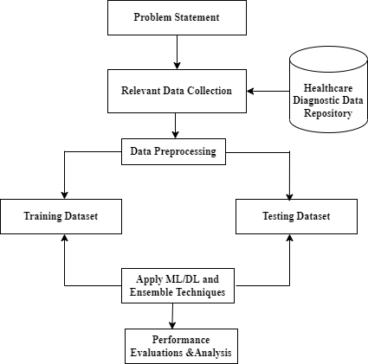

Figure 1. The Framework of the Proposed Model

- Dataset Acquisitions

The Readmission Diabetes Dataset is considering for this framework. Table 1 demonstrates the details of Readmission dataset. The diabetes mellitus dataset is used as input for further processing. The Readmission Diabetes Mellitus dataset is acquired from the UCI Repository in the area of medical science contains 55 attribute and 100000 records of the patients. The dataset contains some missing values and some features of the dataset are not important so we have to discard it. A detailed look at the dataset contains categorical, numerical and free-text columns. The records of the columns will be discussed in more detail below. The most useful columns here is readmitted also called target column, it keeps the details of the patient that the patient stays in the hospital within 30 days, greater than 30 days or not readmitted.

- Feature Engineering

It is a process to formulate the appropriate input dataset, because all machine learning model use these input data to create output. In this segment, we will fabricate features for predictive system. For each fragment we are adding novel variables to the data frame and then sustain the track of which columns is the desired columns of the data frame that is utilized as part of the predictive model features. After that divide this segment into numerical features, categorical features and extra features. The numerical features in the readmission dataset, the missing numbers were accomplished with a question mark. It can be replaced with a nan representation. The most convenient type of features to take is numerical features for building the model because it is easy to use and produce better result, also these features do not need any transformation. The numerical columns utilized are time_in_hospital, num_lab_proocedures, num_procedures, num_medications, number_outpatient, number_emergency, number_inpatient, number_diagnoses.
Some records of the columns: race, payer_code, and medical_speciality are missing. The mentioned columns are categorical then the best solution is to add another categorical type for unknown or missing data. The one-hot encoding technique is used to convert the categorical features in the dataset into numerical features; here a new column has to be created for each unique value. The value of the column value will be 1 if the unique value is present in the sample. If not, the value of the column will be 0. There are two extra features age and weight of the person. In this dataset these are categorical in the nature normally it is numerical only. One choice could be to generate categorical data, since there is a natural order to these value, it might make more sense to transform these to numerical data. Creating a variable is better than creating an ordinal feature. So that it can be known whether the value of weight is filled or not. The appearance of a variable might be predictive regardless of the value.

- Building training / Validation/ test samples

In this segment we have analyzed the data and generate features from the categorical data. After doing all these things now time to split the data. Splitting the data means: how does the model behave for unseen data. Normally data is split into three parts:
Training samples: In this phase some parts of the dataset is taken for training, so that we can train the model.
Validation samples: In this phase some samples of data are taken from training data so that the model can be improved.
Test samples: In this phase some parts of the dataset are used to observe the performance of the classifiers.

For designing the model we will split the data into 70% train, 15% validation, 15% test. Now we have to investigate what percent of individuals are hospitalized within 30 days. In can be called prevalence; all three groups have same level of prevalence. Here we can see that with the help of data visualization techniques that dataset have an imbalanced data where negative cases are more than positive cases. Due to which the model is not able to produce the correct result. For this we will need to give more weight to positive cases. For this there are various approaches which are generally used – applying appropriate evaluation metrics for models generated using imbalanced data can be useful. For samples that are drawn from larger sample which is more dominant class: resampling can also be a good option, here two techniques are used oversampling the minority class or under sampling the majority class. Since we have a lot of class imbalanced so chosen to subsample the data. After sub-sample the data we have balanced data by which the model will produce better result. Many machine learning classifiers do not give good results if the size of the dataset is (0-100, vs 1-100000), for dealing with that we can scale the data using scikit learn’s standard scaler which removes the mean and scales to unit variance. Now build a scaler using all the training data. Original dataset shape is (0-54635, 1-5071) while new dataset shape becomes (0-54635, 1-54635) after sub-sample the data.

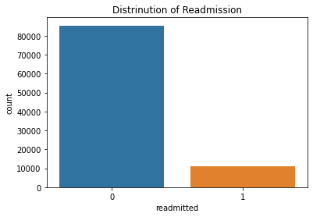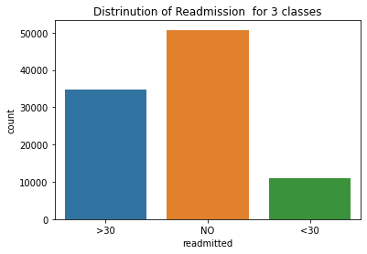
Figure 2. Distribution of the Dataset

- Model Consideration
In this context, we train the machine learning models and use hyperparameter tuning techniques for optimizing them. Based on literature, four most known machine learning prediction techniques were deliberated over. Machine learning (ML) enables the artificial intelligence to learn and extract patterns from data to create well-organized and appropriate models. Best model selected on the basis of performance and validation set. In this section we will compare different machine learning models using hyperparameter tuning.

- Model Evaluation

In this article various machine learning, ensemble techniques and deep learning models are utilized. Machine learning models such as Naïve Bayes, K-Nearest Neighbors, Support Vector Machine, Multi Layer Perceptron, Decision Tree, Random Forest, Logistic Regression, is used for developed a system that can predict whether they will be readmitted in 30 days or not. The combination of machine learning models such as, Boosting: Gradient Boosting, Adaboost and XGBoost model are consider and averaging techniques, and voting, stacking methods are used. In deep learning model LSTM and BLSTM models are evaluated.

Table 1. Sample Performance Analysis of the algorithms
Algorithm |  | Result
 |  | Accuracy  Mean ± SD | Precision  Mean ±SD | Recall  Mean ± SD |  | F1-Score  Mean ± SD |  | LogLoss  Mean ± SD |  | MSE  Mean ± SD |  | AUC  Mean ± SD
Machine Learning Classifiers
Naïve Bayes | 59.8±0.3 |  | 56±0.5 | 58±0.4 | 56.98 |  | 13.90±0.01 |  | 0.40±0.13 |  | 0.59±0.30
KNN | 78.3±0.5 |  | 71±0.7 | 78±0.4 | 74.33 |  | 7.33±0.12 |  | 0.21±0.52 |  | 0.77±0.22
SVM | 71±0.3 |  | 69±0.8 | 78±0.3 | 73.22 |  | 9.93±0.01 |  | 0.28±0.23 |  | 0.71±0.23
MLP | 92±0.7 |  | 90±0.5 | 91±0.7 | 90.4 |  | 6.22±0.5 |  | 0.30±0.56 |  | 0.80±00.04
DT | 90±0.3 |  | 92±0.5 | 87±0.3 | 89.43 |  | 7.62±0.3 |  | 0.10±0.34 |  | 0.65±0.32
RF | 89±0.6 |  | 89±0.6 | 89±0.2 | 89 |  | 9.21±0.7 |  | 0.31±0.21 |  | 0.55±0.23
LR | 74±0.5 |  | 75±0.8 | 72±0.5 | 73.46 |  | 8.72±0.2 |  | 0.48±0.41 |  | 0.71±0.27
Ensemble Learning Models (Average Method)
LR+RF | 94±0.3 |  | 97±0.5 | 91±0.6 | 93.90 |  | 2.80±0.04 |  | 0.06±0.02 |  | 0.81±0.11
RF+KNN+SVM | 95±0.4 |  | 96±0.3 | 90±0.7 | 92.90 |  | 1.92±0.04 |  | 0.08±0.11± |  | 0.91±0.03
Ensemble Learning Models (Max Voting Method)
LR+RF | 92±0.4 |  | 91±0.6 | 90±0.8 | 90.49 |  | 2.93±0.3 |  | 0.09±0.01 |  | 0.91±0.05
RF+KNN+SVM | 96±0.5 |  | 97±0.4 | 95±0.3 | 95.98 |  | 2.50±0.6 |  | 0.07±0.02 |  | 0.90±0.05
Ensemble Learning Models (Stacking Method)
LR+RF | 84±0.8 |  | 96±0.5 | 72±0.5 | 82.28 |  | 5.40±0.31 |  | 0.15±0.4 |  | 0.79±0.20
RF+KNN+SVM | 98±0.5 |  | 96±0.3 | 97±0.4 | 96.49 |  | 1.90±0.04 |  | 0.13±0.7 |  | 0.90±0.01
Boosting Techniques
Gradient Boosting | 91±0.7 |  | 90±0.3 | 93±0.6 | 91.47 |  | 3.5±0.4 |  | 0.08±0.5 |  | 0.8±0.05
Adaboost | 87±0.5 |  | 84±0.5 | 85±0.5 | 84.49 |  | 5.33±0.64 |  | 0.8±0.3 |  | 0.7±0.04
XGBoost | 94±0.4 |  | 94±0.2 | 94±0.6 | 94 |  | 2.2±0.05 |  | 0.07±0.21 |  | 0.9±0.08
Deep Learning Models
LSTM | 95±0.5 |  | 98.5±0.3 | 97±0.5 | 97.74 |  | 2.5±0.3 |  | 0.06±0.21 |  | 0.96±0.02
BLSTM | 95±0.2 |  | 97±0.6 | 95±0.7 | 95.98 |  | 1.95±0.03 |  | 0.05±0.32 |  | 0.98±0.01

IV. Result and Discussion
Based on the practical implementation it is observed that the presented ensemble techniques for diabetes prediction whether the person have diabetes or not. It can be used substantial tool for the disease diagnosis steps. It is clearly shown in the Table 1 that ensemble stacking method gives 98% accuracy while in deep learning model LSTM provide 98.5% precision. Hyperparameter tuning effect the results of the models because different model have their own statistics and they perform well when they utilize their resources. We have shown the mean and standard deviation of the results so that we can analyze the output in a better way. Different ML and DL techniques are considered for the experiment of this research. Deep learning model gives satisfactory results with hyperparameter tuning.

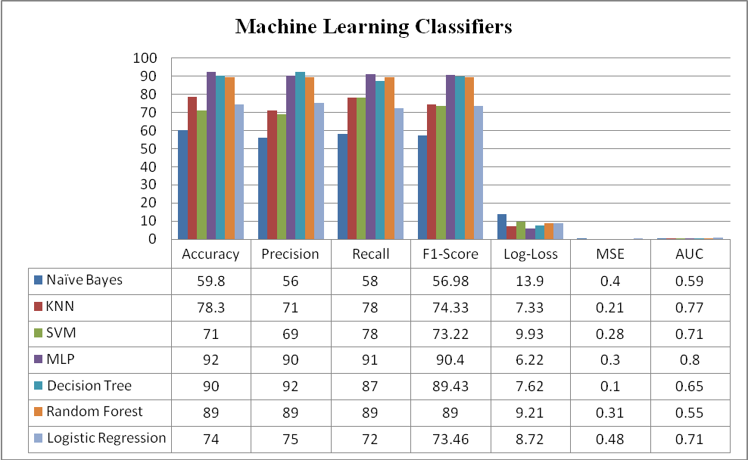

Figure 3. Machine Learning Classifiers Results Comparison Using Different Parameters

In Fig. 3 Multilayer Perceptron algorithms gives satisfactory result while Naïve Bayes gives less accuracy as compare to others. The hyperparameter are tuned according to the classifiers so the model gives better prediction rate.

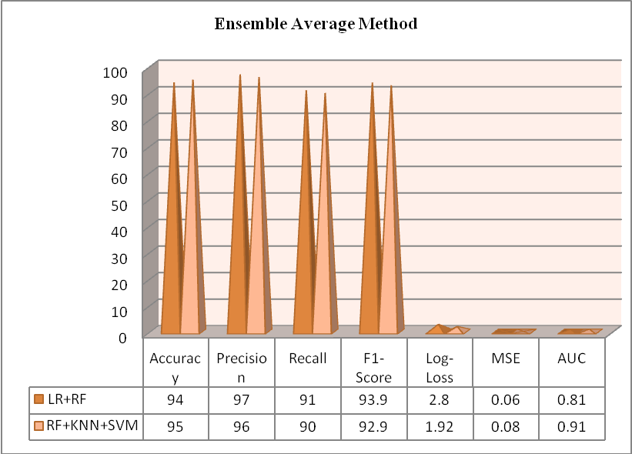
Figure 4. Result Comparison of Ensemble Average Method using Different Parameters

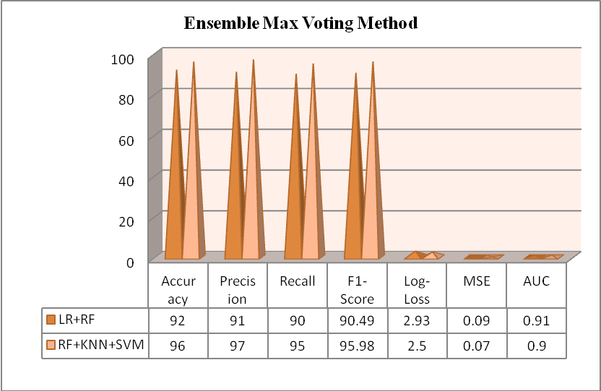
Figure 5. Result Comparison of Ensemble Max Voting Method using Different Parameters

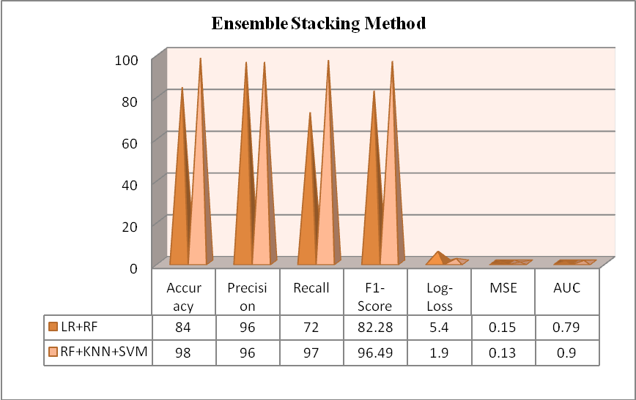
Figure 6. Result Comparison of Ensemble Stacking Method using Different Parameters

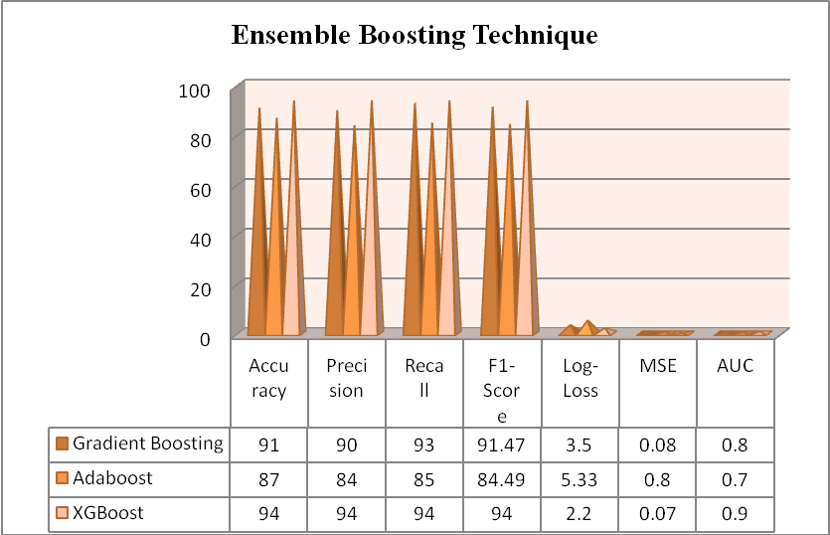
Figure 7. Result Comparison of Ensemble Boosting Techniques using Different Parameters

Fig. 4 demonstrated the ensemble average method results. Ensemble approach average method gives better precision result 97% and also the mean squared error achieved by the ensemble average method is very less. In Fig. 5 Ensemble max voting method results are represented. The graph had shown that 96% accuracy and 90% area under curve. Fig. 6 represented Ensemble stacking method which gives 98% highest prediction accuracy as compare to other related work. In Fig. 7 the ensemble boosting algorithms are represented XGBoost model gives 94% accuracy and 0.07 mean squared error. Table 2 depict the comparison of different classifiers vs our proposed method.

Table 1. Comparative Analysis of the Classifiers State-of-art Method
Authors & Year | Model | Result
Hammoudeh A. et al. [16] 2018 | CNN | AUC 95%  Accuracy 92%  F1-score 92%
Cuong, Le et al. [17] 2021 | XGBOOST | Accuracy 96%,  Recall rate 92%,  Precision 98%  F1 score 90%
Goudjerkan, T et al. [18] 2019 | MLP | Accuracy 95%  Precision 93%  Recall 99%  AUC 95%.
Jouhari S. et al. [19] 2020 | DNN | Accuracy 95.2%  AUC97.4%
Our Proposed Work 2022 | Stacking (RF+KNN+SVM) | Accuracy 98%
Our Proposed Work 2022 | LSTM | 98.5% Precision

V. Conclusion

There are many records and the number of features in it is also very high in the readmission dataset. That’s why we needed feature engineering process. It is very important to know which feature is important. Considering this as the base, it was found that many such features can also be swallowed. And in many records the number of missing value is very much high which is replaced by the mean method. Due to preprocess of readmission data, the model is producing very good result as compared to others. This implementation is extremely beneficial for healthcare professionals, doctors, clinical practitioners and patients. People don’t understand the complications of diabetes diseases due to lack of literacy and awareness about their health. In this study we developed ML and DL model also put in practice the ensemble techniques. The ensemble techniques achieved 98% accuracy for stacking model and Long Short Term Memory (LSTM) gives 98.5% precision. Deep learning models and ensemble learning methods gives satisfactory result because the dataset is too large and required pre-processing and feature engineering methods.

REFERENCES

- G. Noaro, G. Cappon, M. Vettoretti, G. Sparacino, S. D. Favero and A. Facchinetti, "Machine-Learning Based Model to Improve Insulin Bolus Calculation in Type 1 Diabetes Therapy," in IEEE Transactions on Biomedical Engineering, vol. 68, no. 1, pp. 247-255, Jan., doi: 10.1109/TBME.2020.3004031, 2021

- Alex, S.A., Nayahi, J.J.V., Shine, H. et al. Deep convolutional neural network for diabetes mellitus prediction. Neural Comput & Applic , https://doi.org/10.1007/s00521-021-06431-7, 2021

- K. Li, J. Daniels, C. Liu, P. Herrero and P. Georgiou, "Convolutional Recurrent Neural Networks for Glucose Prediction," in IEEE Journal of Biomedical and Health Informatics, vol. 24, no. 2, pp. 603-613, Feb., (2020), doi: 10.1109/JBHI.2019.2908488, 2020

- M. S. Islam, M. K. Qaraqe, S. B. Belhaouari and M. A. Abdul-Ghani, "Advanced Techniques for Predicting the Future Progression of Type 2 Diabetes," in IEEE Access, vol. 8, pp. 120537-120547, doi: 10.1109/ACCESS.2020.3005540, 2020

- Choubey D. K., Kumar, P., Tripathi, S. et al. “Performance evaluation of classification methods with PCA and PSO for diabetes”, Netw Model Anal Health Inform Bioinforma 9, Vol. 5, https://doi.org/10.1007/s13721-019-0210-8, 2020

- Ramesh J, Aburukba R, Sagahyroon A., “A remote healthcare monitoring framework for diabetes prediction using machine learning”, Healthc Technol Lett. 2 Vol. 8(3), pp. 45-57, doi: 10.1049/htl2.12010, 2021

- Sainte S. L. M., Aburahmah L, Almohaini R, Saba T. “Current Techniques for Diabetes Prediction: Review and Case Study”, Applied Sciences, Vol. 9(21):4604, https://doi.org/10.3390/app9214604, 2019

- Fathi AE, Kearney RE, Palisaitis E, Boulet B, Haidar A., “A Model-Based Insulin Dose Optimization Algorithm for People With Type 1 Diabetes on Multiple Daily Injections Therapy”, IEEE Trans Biomed Eng., Apr; Vol. 68(4), pp., 1208-1219, doi: 10.1109/TBME.2020.3023555, 2021

- E. M. Aiello, C. Toffanin, M. Messori, C. Cobelli and L. Magni, "Postprandial Glucose Regulation via KNN Meal Classification in Type 1 Diabetes," in IEEE Control Systems Letters, vol. 3, no. 2, pp. 230-235, April, doi: 10.1109/LCSYS.2018.2844179, 2019

- Wei, X., Jiang, F., Wei, F., Zhang J., Liao, W., and Cheng S., “An Ensemble Model for Diabetes Diagnosis in Large-scale and Imbalanced Dataset”, Proceedings of the Computing Frontiers Conference, pp.71-78, https://doi.org/10.1145/3075564.3075576, 2017

- H, Roopa & T, Asha. (2019). A Linear Model Based on Principal Component Analysis for Disease Prediction. IEEE Access. PP. 1-1, 10.1109/ACCESS, 2931956, 2019

- Alehegn, M., Joshi, R. R., & Mulay, P., “Diabetes Analysis and Prediction Using Random Forest, KNN, Naïve Bayes And J48: An Ensemble Approach”, Int. J. Sci. Technol. Res, Vol. 8(9), pp. 1346-1354, 2019

- Hochreiter S, and Schmidhuber J., “Long short-term memory”, Neural Comput 9(8):1735–1780, https://doi.org/10.1162/neco. 1997.9.8.1735, 1997

- Kannadasan, K. Damodar R. E., Venkatanareshbabu K., “Type 2 diabetes data classification using stacked autoencoders in deep neural networks”, Clinical Epidemiology and Global Health, Volume 7, ( Issue 4, 530 – 535, 2019

- Alehegn, M., Joshi, R. R., & Mulay, P. Diabetes Analysis and Prediction Using Random Forest, KNN, Naïve Bayes And J48: An Ensemble Approach. Int. J. Sci. Technol. Res, 8(9), 1346-1354, 2019

- Ahmad Hammoudeh, Ghazi Al-Naymat, Ibrahim Ghannam, Nadim Obied, “Predicting Hospital Readmission among Diabetics using Deep Learning”, Procedia Computer Science, Volume 141, Pages 484-489, ISSN 1877-0509, https://doi.org/10.1016/j.procs.2018.10.138, 2018

- Cuong, Le & Wang, Dong. A comparison of Machine Learning Methods to predict Hospital Readmission of Diabetic Patient. Studies of Applied Economics, 39. 10.25115/eea.v39i4.4475, 2017

- Goudjerkan, Ti'Jay & Jayabalan, Manoj. Predicting 30-day Hospital Readmission for Diabetes Patients Using Multilayer Perceptron. International Journal of Advanced Computer Science and Applications, 10. 268-275. 10.14569/IJACSA.2019.0100236, 2019

- Jauhari, Sarthak & Shukla, Shikhar & Tripathi, Surya. EmbPred30: Assessing 30-days Readmission for Diabetic Patients using Categorical Embeddings, 2020

.

