Mix Design of Polymer Concrete for Pothole Repair

K. S. Leong  Department of Civil Engineering  Universiti Malaysia Sarawak  Kota Samarahan, Malaysia  holmes1210@hotail.com | J. A Magreen  Department of Civil Engineering  Universiti Malaysia Sarawak  Kota Samarahan, Malaysia  jacobmagreen@gmail.com
Dr Lee Shyue Leong  Department of Civil Engineering  Universiti Malaysia Sarawak  Kota Samarahan, Malaysia  shyueleonglee@hotmail.com | Dr. Mohammad Abdul Mannan  Professor  Department of Civil Engineering  Universiti Malaysia Sarawak  Kota Samarahan, Malaysia  mannan@unimas.my

ABSTRACT
The increased traffic load due to rapid urbanization causes pavement distresses resulting reduction of service life of flexible pavement. Pavement distress is harmful to road user and vehicle, and it causes accident. Polymer concrete having several advantages can be considered as alternative material for pothole repair. Thus, this study has focused on mix design development of polymer concrete through various performances. In this study, orthophthalic unsaturated polyester resin as binder, methyl ethyl ketone peroxide (MEKP) as hardener, acetone and lacquer thinner as diluent, fly ash, silica fume, limestone coarse and fine aggregates, and limestone quarry dust as filler have been used. Three different aggressive solutions such as (i) sodium hydroxide (NaOH), (ii) sodium chloride (NaCl) and (iii) sulphuric acid (H₂SO₄) are used to determine resistance capacity of polymer concrete for Mix-1 polymer concrete. The recommended Mix-1 of polymer concrete is resin with 304 kg, acetone with 16 kg, aggregate with 1,600 kg and fly ash with 320 kg for one cubic meter and the aggregate proportion is 60% coarse aggregate size 10.00 – 5.00 mm and 40% fine aggregate size 3.35 – 1.18 mm. The compressive strength using 100 dia.X200mm cylindrical are 12.12 MPa at age of 7-hour and 44.93MPa at age of 7-day. The resistance capacity of Mix-1 polymer concrete under 90-day continuous immersion in aggressive chemical solutions are noticed through compressive strength test. Polymer concrete has shown strength reduction over 90- day immersion with 31.18% in water, 31.32% in sodium chloride, 34.50% in sulphuric acid and 44.38% in sodium hydroxide solution compared with control sample. The another recommended Mix-2 of polymer concrete is made using ratio, 1:1:2 by weight (resin: fly ash: limestone quarry dust) with incorporation of two-ply jute fabric. The size fraction of limestone quarry dust is in range of passing 5mm sieve and retained on 1.18mm sieve. The compressive strengths using 50mm cube sample are 9.12 MPa at age of 4-hour and 83.59MPa at age of 7-day without using two-ply jute fabric. The flexural strengths with two-ply jute fabric are 13.83 MPa at age of 4-hour and 25.87MPa at age of 7-day. Thus, this developed polymer concrete can be considered as alternative to pothole repair in flexible pavement in short time with simplified method.

Keywords—polymer concrete, resin, diluent, limestone coarse and fine aggregates, limestone quarry dust, fly ash, silica fume

- INTRODUCTION

A. Background
The exponential growth of human population has brought forth rapid urbanization and has resulted in significant demand of Global Civil Engineering Market to reach USD 11.72 Trillion by 2025. The rapid development of a country’s growth leads to increase in road construction projects. Generally, pavement worldwide is constructed using either flexible pavement or rigid pavement. Flexible pavement is constructed using asphalt concrete (AC) as surface course and it is mixture of coarse aggregate, fine aggregate, asphalt and filler. Aggregates take up approximately 90 to 95% by weight of AC [1]. In Malaysia, road network makes with 1,700km Expressway, 17,500km Federal road and 61,100km State road. The huge amount of aggregate required in road industry can cause environmental impact because of the continuation of quarry activities.
The increased traffic load on flexural pavement causes distress resulting reduction of service life of pavement. The flexible pavement is weak in flexural strength. Pavement distress is harmful to road user and vehicle, and it causes accident. Figure 1 shows some distresses occurred in flexible pavement [2]. This indicates that flexible pavement is unable to sustain repetition of load from the increase of traffic volume even for maintained area. In addition, long-hour road closure is needed for flexible pavement maintenance work using hot mix asphalt. In order to reduce the duration of the road closure, a fast hardening pavement-repair material is preferable.
On the other hand, polymer concrete shows excellent mechanical and durability performances [2, 3, 4, 5] and it has wide application particularly in civil engineering. It shows fast curing and high strength gain in short time, so this polymer concrete is the best option for pavement surface repair (Figures 1 and 2). Hence, the aim of this study is to formulate mix design of polymer concrete through several considerations for potential use in pothole repair in flexible pavement.

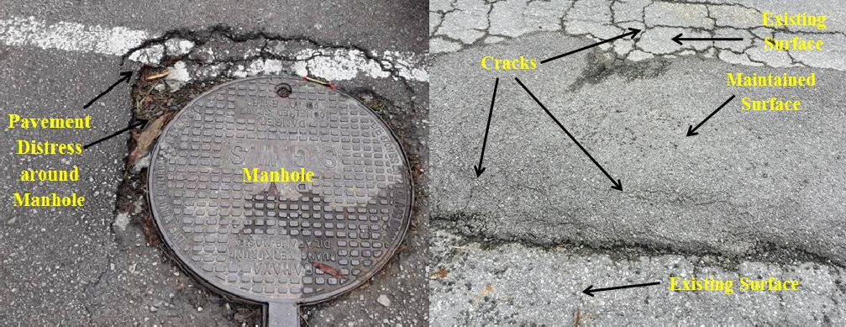  - Distress occurred around manhole built in flexible pavement. | - Distress occurred on maintained flexible pavement.
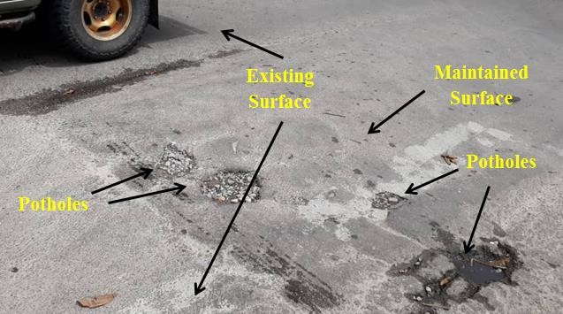

- Distress occurred on maintained flexible pavement.

Figure 1: Few distresses on flexible pavement. [2]

Figure 2: Proposed polymer concrete as repair material for flexible pavement. [2]
- MATERIALS

The materials used in making polymer concrete are limestone aggregate, limestone quarry dust, orthophthalic unsaturated polyester resin, hardener, fly ash, silica fume, acetone and lacquer thinner, jute fabric. The chemicals used in this study are sodium hydroxide (NaOH), sodium chloride (NaCl) and sulphuric acid (H₂SO₄) to observe durability performance of polymer concrete. Water (H₂O) is used as control environment. Polymer concrete samples are directly immersed into these chemical solutions for the designated period prior to test. The related standards are used to experimental investigation.

A. Limestone Coarse and Fine Aggregates
In this study, the aggregate used is crushed limestone. Throughout the testing, the physical properties of fine and coarse crushed limestone used are shown in the Table 1. These physical properties are determined using standards [6, 7, 8, 9]. Physical and mechanical properties of crushed Limestone aggregate and recommended values in guidelines are shown in Table 2.

Table 1: Relative Density Properties of Crushed Limestone for Different Size Fractions

Description | Size fractions of crushed Limestone, mm
Description | Fine aggregate |  | Coarse aggregate
Description | 1.18 - 3.35 | 3.35 - 5.00 | 5.00 - 10.00
Relative Density - Specific Gravity-Oven dried | 2.65 | 2.69 | 2.68
Relative Density (Specific Gravity-Saturated Surface Dried) | 2.67 | 2.70 | 2.69
Apparent Relative Density (Apparent Specific Gravity) | 2.69 | 2.73 | 2.71

Table 2: Physical and Mechanical Properties of Crushed Limestone Aggregate and Recommended Values in Guidelines

Description | In This Study  Result | Recommended Value by JKR (Public Works Department), Malaysia |  | [10]
Description | In This Study  Result | Flexible Pavement | Concrete | [10]
Water Absorption, % | 0.30 – 0.60 | Not more than 2 | Not more than 8 | -
Aggregate Impact Value, % [10] | 12.00 | - | - | 30*
Aggregate Crushing Value, % [11] | 23.35 | Not more than 30 | Not more than 40 | -
Los Angeles Abrasion, % [12] | 18.61 | Not more than 25 | - | -
* - If the AIV was greater than 30%, a statement that the results obtained should be treated with caution.

B. Quarry Dust
Quarry dust used in this study is from limestone quarry available locally. The size fraction of quarry dust used here is having range of passing 5mm sieve and retained on 1.18mm sieve.

C. Orthophthalic Unsaturated Polyester Resin
Unsaturated polyester resin is the most common polymeric resin used in the polymer concrete due to low cost, available locally and good mechanical properties [13]. Hence, the resin binder used was orthophthalic unsaturated polyester resins prepared by REVERTEX (MALAYSIA) SDN. BHD. Reversol P 9509 is the name of their product. The specifications and typical properties of Reversol P 9509 are shown in the Tables 3 and 4.

Table 3: Specification of Orthophthalic Unsaturated Polyester Resin

Description | Properties
Appearance | Hazy; pinkish
Specific Gravity | 1.12
Volumetric Shrinkage, % | 8
Viscosity @ 25 °C, cps  Brookfield, #3/60  Brookfield, #3/6 | 450-600  900-1350
Gel Time @ 25 °C,  - 1% MEKP | 18-23

Table 4: Typical Properties of Orthophthalic Unsaturated Polyester Resin

Description | Properties
Tensile Strength, MPa | 62
Elongation at Break, % | 2.2
Water Absorption 24 hr at 25⁰C, mg | 20
Deflection Temperature (under load 1.80 MPa), ⁰C | 55
Barcol Hardness (Model GYZJ 934-1) | 40

According to Summit Composites Pty. Ltd. [14], ortho and iso polyester resins are classified as hazardous. This product is classified as Class 3 Flammable Liquid. The risks to use this product are flammable, harmful by inhalation, and irritating to eyes and skin. This product should be treated careful and use in a place with good ventilation.

D. Hardener
The hardener used is Methyl Ethyl Ketone Peroxide (MEKP). Unsaturated polyester resin is pre-promoted for ambient temperature cure with addition of MEKP. It is produced by REVERTEX (MALAYSIA) SDN. BHD. Table 5 shows the physical and chemical properties of MEKP which is retrieved from Safety Data Sheet: MEKP Catalyst with copyright of Easy Composites [15].

Table 5: Physical Appearance and Properties of MEKP

Description | Properties
Physical state | Liquid
Colour | Clear and Colourless
Odour | Faint and minty
Boiling point | Not applicable (decomposes)
Flash point | < 75⁰C
Explosive properties | No
Lower explosion limit (LEL) | Not applicable
Upper explosion limit (UEL) | Not applicable
Oxidising properties | No
Vapour pressure at 84 ⁰C, kPa | 0.10
Vicosity at 20⁰C, mPas | 9 – 23
pH | 4 – 7
Active oxygen, % | 8.7 – 9.8
Self-accelerating decomposition temperature (SADT), (oC) | 60
Density at 20⁰C, g/cm³ | 1.00 – 1.16
Solubility in water | Immiscible

E. Diluent
Diluent is used to reduce the resin ratio in the polymer concrete. In this study, acetone and lacquer thinner are selected due to availability and low cost. It is produced by the KINLUCK MARKETING SDN. BHD. with the UN number 1263. Besides, acetone used is Acetone AR (Propanone) 2.5L with brand BENDOSEN (C0011). These two types of solvents are compared throughout the observation on surface cracking, workability and harden time when mix with resin. Then, the selected diluent is continued with further tests. Table 6 shows the physical and chemical properties of lacquer thinner reprinted from material safety data sheet: Lacquer thinner with copyright [16]. Besides, Table 7 shows the physical and chemical properties of acetone reprinted from material safety data sheet: acetone msds with copyright 2013 by [17].

Table 6: Physical and Chemical Properties of Lacquer Thinner

Description | Properties
Physical States | Liquid
Boiling Point | 60 ⁰C
Flash Point | -20 ⁰C
Vapour Pressure (vs. Air or mm Hg) | 115 MM HG at 68 F
Vapour Density (vs. Air=1) | > 1
Evaporation Rate | > 1
Solubility in Water | Slight
Percent Volatile | 100% by weight
Volatile Organic Compounds | 590 G/L
Viscosity | Water thin
Appearance and Odor | Water White / Free and Clear

Table 7: Physical and Chemical Properties of Acetone

Description | Properties
Physical State | Liquid
Odor | Fruity. Mint-like. Fragrant. Ethereal
Taste | Pungent, Sweetish
Molecular Weight | 58.08 g/mole
Colour | Colourless. Clear
pH (1% soln/water) | Not available
Boiling Point | 56.2 ⁰C
Melting Point | -95.35 ⁰C
Critical Temperature | 235 ⁰C
Specific Gravity | 0.79 (Water = 1)
Vapour Pressure | 24 kPa (@20⁰C)
Vapour Density | 2 (Air = 1)
Volatility | Not available
Odor Threshold | 62 ppm
Water/Oil Dist. Coeff. | The product more soluble in water; log (oil/water) = -0.2
Ionicity (in Water) | Not available
Dispersion Properties | See solubility in water
Solubility | Easily soluble in cold water, hot water

According to [17], acetone is hazardous and causes irritating to skin and eyes, ingestion, and inhalation. It also a highly flammable product. The container is needed to keep in a well-ventilated place and keep away from sources of ignition. In case of contact with eyes, rinse immediately with plenty of water and seek medical advice. [16] claimed that lacquer thinner is hazardous product. It is extremely flammable and poison. It may be fatal or cause blindness if swallowed. It should be used in a space where adequate ventilation is present. Besides, it also may cause dizziness, headache and so on.

F. Fly Ash
Malaysia has substantial coal resources, amounting to around 1.9 billion metric tons. About 69 per cent of the Malaysian coal reserves are found in Sarawak. Fly ash is waste of the combustion of pulverized coal in electric power generating plants. There are two ash ponds situated beside the power station, Sejingkat Coal-Fired Power Station, Kuching, Sarawak with each pond size of about 81,000m² in area and 2.4m deep [18]. The properties of fly ash are shown in Table 8 and 9.

Table 8: Physical Properties of Fly Ash [19]

Description | Property
Colour | Grey
Specific gravity | 2.4
Particle retained on 45micron sieve (%) | 11.2
Median particle D₁₀ | 1.85
Median particle D₅₀ | 13.0
Median particle D₉₀ | 46.5
Mean diameter | 19.4
Surface area (cm²/g) | 21,947.7

Table 9: Chemical Properties of Fly ash [19]

Description | Property  (%) | [20]  Requirement for Fly ash (%)
Silicon Dioxide (SiO₂) | 55.0 | SiO₂+Al₂O₃+Fe₂O₃>70
Aluminum oxide (Al₂O₃) | 24.5 | SiO₂+Al₂O₃+Fe₂O₃>70
Ferric oxide (Fe₂O₃) | 7.1 | SiO₂+Al₂O₃+Fe₂O₃>70
Calcium oxide (CaO) | 4.2 | <10.0 Class F
Magnesium oxide (MgO) | 1.95 | <5.0
Sulphur trioxide (SO₃) | 0.08 | <5.0
Potassium oxide (K₂O) | 3.88 | -
Titanium oxide (TiO₂) | 2.02 | -
Sodium oxide (Na₂O) | 0.30 | <1.5
Loss on Ignition (LOI) | 0.32 | <6.0

G. Silica Fume
Ferroalloy Industry, Bintulu, Sarawak, Malaysia produces silica fume waste of around 120,000MT annually. The specific gravity of silica fume used is 2.23 [21]. The chemical properties of used silica fume are shown in Table 10.

Table 10: Chemical Composition of Silica Fume (Ref. Samalaju Downstream S/B test sheet, Sarawak)

Description | Results (%)
Silicon Dioxide (SiO₂) | 90.27
Aluminium oxide (Al₂O₃) | 0.27
Ferric oxide (Fe₂O₃) | 0.71
Calcium Oxide (CaO) | 0.58
Sulphur trioxide (SO₃) | 0.39
Sodium Oxide (Na₂O) | 0.16
Potassium Oxide (K₂O) | 0.63
Chloride (Cl) | 0.12
LOI | 2.38

H. Jute Fabric
Jute is a natural biodegradable fiber characterized by good tensile strength and good thermal conductivity [22]. According to [23], Jute is one of the cheap and abundantly available lignocellulosic fibre which is suitable as reinforcing material. Due to the sustainability of earth structures, it is necessary to define a reinforcement system that is eco-friendly. Jute fabric has many advantages, such as cost effective, can enhance the flexural strength of the polymer concrete and it can mix perfectly with resin. Table 11 shows some properties of jute fabric. Figure 3 shows sample of jute fabric.

Table 11: Properties of Jute Fabric

Description | Properties
Tensile strength, N/m width | 900
Mass of fabric, gm/m² area | 460

Figure 3: Sample of jute fabric.

I. Aggressive Solutions
Three different aggressive solutions are used in this research. The solutions are (i) sodium hydroxide (NaOH), (ii) sodium chloride (NaCl) and (iii) sulphuric acid (H₂SO₄). Besides that, water (H₂O) is also used. H₂O is used to simulate flooding situation where the road will be completely flooded. NaCl is to simulate the application of polymer concrete near seaside to investigate the effect of chloride ions. H₂SO₄ and NaOH are to simulate the spilling of these chemical solutions on road caused by lorry accidents.
For laboratory works, increasing the concentration of aggressive solution is one of the methods to obtain the high degradation of concrete and is known as accelerated test [24]. Therefore, in this study, the concentrations of the chemicals used are 1 M (molar) and 1.1M for durability test. The purpose is to accelerate the chemical attack on specimens in order to simulate the worse condition that the specimen can sustain and to investigate the strength capacity of the specimens. According to [25], 1 litre of seawater contains 35 grams of salts, mostly is sodium chloride dissolved in it. This also can be expressed as 0.6 M NaCl. Furthermore, the pH value of acid rain usually in between 4.2 and 4.4 [26]. This indicates the concentration of hydrogen ions in the rain is in between 40μ to 63μ mol/L. Table 12 shows the concentration of chemicals used in this study.

Table 12: Concentration of Chemical Used

Chemical name | Molarity, mol | Amount of chemical in 1 litre water
NaOH | 1.0 | 40.00gm
NaCl | 1.1 | 64.28gm
H2SO4 | 1.0 | 54.30ml

- MIX PROPORTION OF AGGREGATES

The coarse aggregate passing 10 mm and retained on 5 mm and the fine aggregate passing 3.35 mm and retained on 1.18 mm are used in this study. The target is to obtain the better compressive strength of concrete with low void. Table 13 shows the mix ratio of limestone aggregate.

Table 13: Mix Ratio of Limestone Aggregate

Crushed aggregate type | Mix amount, %
Crushed aggregate type | Passing 10 mm retained onto 5 mm | Passing 3.35 mm retained onto 1.18 mm
Limestone | 80 | 20
Limestone | 70 | 30
Limestone | 60 | 40

- COMPRESSIVE STRENGTH OF PURE RESIN MIXED WITH HARDENER

The compressive strength of pure resin mixed with hardener is done using 50mm cube from 2-hour to 24-hour (1-day) at laboratory condition. The results are shown in Table 14. The compression test is done as per [27].

Table 14: Compressive Strength of Pure Resin

Sl | Age on test  (hr) | Compressive strength  (N/mm²)
1 | 2 | 13.8
2 | 4 | 30.7
3 | 6 | 32.7
4 | 24 | 42.4

- MIX PROPORTION OF DILUTED POLYESTER RESIN

In this part, the mix proportion of resin to diluent solution is determined by referring to the workability of different percentages of diluent used in the mixture. The chosen diluents are lacquer thinner and acetone. A small cylinder samples with diameter 27mm and height 54mm or small bottle samples are cast to observe the workability and crack observation after demoulding. Small specimen is used in order to reduce the wastage of material and it is a feasibility study. The mix proportion of diluted polyester resins is shown in the Table 15.

Table 15: Mix proportion of Diluted Polyester Resin

Description | Percentage of dilution, %
Resin with hardener + Lacquer Thinner as diluent | 10
Resin with hardener + Lacquer Thinner as diluent | 20
Resin with hardener + Lacquer Thinner as diluent | 30
Resin with hardener + Acetone as diluent | 10
Resin with hardener + Acetone as diluent | 20
Resin with hardener + Acetone as diluent | 25
Resin with hardener + Acetone as diluent | 30
Resin with hardener + Acetone as diluent | 40
Resin with hardener + Acetone as diluent | 50

The procedure of preparing the specimens as shown in below;
- An amount of resin is taken and placed in a paper cup.
- An amount of diluent is added into the same paper cup by referring to the percentage of dilution shown above and stirred for 100 times.
- An amount of MEKP (resin-hardener ratio= 20kg of resin: 200ml of hardener) is added into the mixture and stirred for 100 times.
- The mixture is then poured into a small cylinder samples with diameter 27mm and height 54mm or small bottle samples.
- The workability and crack observations after demolded of the specimen are recorded.

- RESULTS ON POLYMER PASTE AND POLYMER CONCRETE WITH INCORPORATION OF LIMESTONE COARSE AND FINE AGGREGATES, FLY ASH, SILICA FUME AND DILUENT

A. Mix Observation on Diluted Resin
It is intention to dilute resin with low cost diluent for making cost effective product. Several mix proportions of resin to diluent solution are evaluated through the workability and crack observation after demolding. Table 16 shows the observations obtained from the tests. The percentage of diluent added into pure resin is based on the mass instead of volume.

Table 16: Observation on Different Mix Proportion of Diluted Polyester Resin

Description | Percentage of dilution, % | Remarks after demoulding
Resin with hardener + Lacquer Thinner as diluent | 10 | No crack
Resin with hardener + Lacquer Thinner as diluent | 20 | No crack
Resin with hardener + Lacquer Thinner as diluent | 30 | Serious crack
Resin with hardener + Acetone as diluent | 10 | No crack
Resin with hardener + Acetone as diluent | 20 | No crack
Resin with hardener + Acetone as diluent | 25 | Crack within 48 hours
Resin with hardener + Acetone as diluent | 30 | Crack
Resin with hardener + Acetone as diluent | 40 | Crack
Resin with hardener + Acetone as diluent | 50 | Crack

From Table 16, mixture of resin mixed with lacquer thinner has shown serious cracking after demoulding when the percentage of dilution is increased to 30%. It shows that the resin cannot be suggested to be diluted more than 30% or otherwise it can cause cracking of the samples. On the contrary, mixture of resin and acetone has shown cracking after demoulding when the percentage of dilution is increased to 25%. Hence, the percentage of dilution using acetone as diluent is suggested not more than 25%.
Figure 4 (i) and (ii) shows the colour of the diluted resin from pink to “dirty” grey with increasing of dilution percentage of acetone. On the other hands, Figure 4 (iii) and (iv) also shows the decolourisation of the sample. Figure 4 (i) and (ii) shows serious cracking of the samples. In addition, the workability of the mixture is observed throughout the tests. It shows that with the increase of the percentage of dilution, the workability of the mixture also increases.

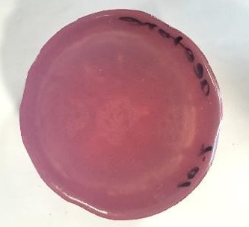  Resin + 10% Acetone | 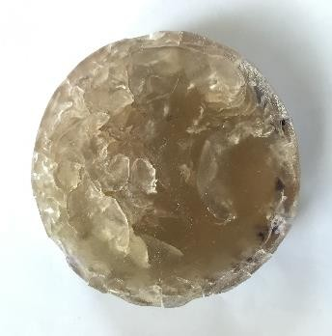  Resin + 50% Acetone
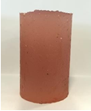  Resin + 10% Lacquer Thinner | 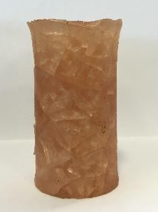  Resin + 30% Lacquer Thinner

Figure 4: Physical observation diluted resin mixed with thinner and acetone.

B. Observation on Polymer Paste
The selected mix proportion of diluted polyester resin is further mixed with the filler to observe the workability and crack observation after demolding. Tables 17 and 18 show the results of observation on mix proportion of polymer paste using different fillers. The ratio of diluted polymer resin to fly ash/silica fume is based on the mass.

Table 17: Remarks on Polymer Paste using Silica Fume Filler

Resin + Different Percentages of Dilution | Remarks  (Diluted Resin : Silica fume)
Resin + Different Percentages of Dilution | 1:1.0
Resin + 25% Lacquer Thinner as diluent | Crack
Resin + 30% Lacquer Thinner as diluent | Crack
Resin + 40% Lacquer Thinner as diluent | Crack
Resin + 25% Acetone as diluent | Crack
Resin + 30% Acetone as diluent | Crack
Resin + 40% Acetone as diluent | Crack

Table 18: Remarks on Polymer Paste using Fly Ash Filler

Resin + Different Percentages of Dilution | Remarks  (Diluted Resin : Fly ash)
Resin + Different Percentages of Dilution | 1:1.0 | 1:1.5 | 1:2.0 | 1:2.5
Resin + 25% Lacquer Thinner as diluent | No crack | No crack | No crack | No crack
Resin + 30% Lacquer Thinner as diluent | Crack | Crack | No crack | No crack
Resin + 40% Lacquer Thinner as diluent | Crack | Crack | Crack | No crack
Resin + 25% Acetone as diluent | No crack | No crack | No crack | No crack
Resin + 30% Acetone as diluent | Crack | No crack | No crack | No crack
Resin + 40% Acetone as diluent | Crack | Crack | Crack | No crack

Based on Table 17, the performance of diluted resin mixed with silica fume is unacceptable. Cracks are observed in all samples. Besides, the workability of the mixture has decreased with increase of silica fume. Figure 5 shows the sample observed after the ratio of diluted resin to silica fume is increased to 1:1.5. The sample cannot hold itself into the cylinder shape and crumbles after demoulding (Figure 5).

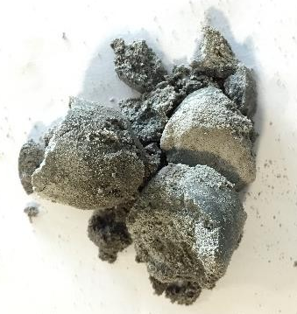

Figure 5: Ratio of diluted resin to silica fume, 1:1.5.

The crack is observed for lower ratio of diluted resin to fly ash filler as shown in Table 18. In contrast, the workability of the polymer paste has decreased with increase of ratio for diluted resin to fly ash filler. Figure 6 shows the crack observed on different paste samples.

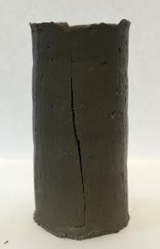  Diluted resin (resin + 30% of acetone) to fly ash, 1:1.0. | 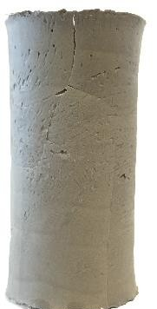  Diluted resin (resin + 30% of lacquer thinner) to fly ash, 1:1.0.

Figure 6: Physical observation of diluted polymer paste.

Based on above observation in Tables 17 and 18, fly ash as filler shows better performance in workability compared to silica fume as filler. Hence, fly ash is chosen for next tests. On the other hands, acetone as diluent shows less crack in different ratios of polymer paste compared to lacquer thinner as diluent. So, acetone is chosen for the next tests.

C. Compressive Strength of Polymer Paste
Based on the above observations, acetone and fly ash are chosen as diluent and filler in polymer paste, respectively. In this part, the selected mix proportion of polymer paste is tested for compressive strength using 50mm cube. The selected mix proportions are 1:1.0 and 1:1.5 of resin to fly ash with the percentage of acetone used to dilute the resin is 5%, 10% and 15%. Table 19 shows the compressive strength of different polymer pastes at age of 3 days. The compression test is done as per [27].

Table 19: Compressive Strength of Different Mixes of Polymer Paste

Percentage of Dilution with resin,% | Ratio Binder (resin+acetone) to Fly ash filler | Average comp. st. at 3-day, (MPa)
5 | 1:1.0 | 49.8
5 | 1:1.5 | 54.3
10 | 1:1.0 | 16.2
10 | 1:1.5 | 28.9
15 | 1:1.0 | 15.0
15 | 1:1.5 | 14.3

Table 19 shows the polymer paste with 5% of dilution has the highest compressive strength among them. It is believed that the compressive strength of polymer paste is affected by the percentage of dilution. Besides, the ratio of diluted resin to fly ash, 1:1.5, shows better compressive strength than 1:1.0. This is because the interface structure of the polymer paste can be improved by increasing fly ash. But, the workability of the ratio of diluted resin to fly ash, 1:1.5 is lower than ratio, 1:1.0.

D. Mix Design of Polymer Concrete using Limestone Coarse and Fine Aggregates
The selected mix proportion of polymer concrete based on above study is fixed with 304 kg resin, 16kg acetone, 1,600kg aggregate and 320kg fly ash for one cubic meter as shown in Table 20. The aggregate proportion is 60% coarse aggregate size, 10.00 – 5.00 mm and 40% fine aggregate size, 3.35 – 1.18 mm. Required resin is placed in mixing bowl and mixed with hardener for homogeneous mixing, followed by admission of fly ash and limestone aggregates within 60 seconds. The work is done at laboratory ambient condition (Temp. 25±3 ºC and RH of 70-89%). The compression test is done as per [27].
Table 21 shows the compressive strength of polymer concrete with different testing ages. It can be observed that the strength development is fast. At 2, 5 and 7-hour of testing ages, the compressive strength is 6.52%, 13.63% and 28.64%, respectively, as compared to 7 days’ compressive strength. At 48-hour (2-day) of testing age, the compressive strength is 87.03% as compared to 7-day compressive strength. In addition, at day 7 (168 hours), polymer concrete achieves the minimum compressive strength requirement, 40 MPa, in accordance with Road Engineering Association of Malaysia (REAM) [28]. It means polymer concrete can develop high strength in short time. In road industry, the faster the concrete can achieve high strength, the faster the road can be reopened for public access.

Table 20: Mix Design of Polymer Concrete Using Limestone Coarse and Fine Aggregates including Fly Ash for 1m³ Volume
Binder | Diluent | Filler
Resin with hardener  (kg) | Acetone  (kg) | Fly ash  (kg) | Limestone  coarse aggregate  (kg) | Limestone fine aggregate  (kg)
303.92 | 15.98 | 319.90 | 959.89 | 639.93

Table 21: Compressive Strength of Polymer Concrete Using Table 20 Mix
Age on test  (hr) | Density  (kg/m³) | Cylinder compressive strength  (N/mm²)
2 | 2186 | 1.95
5 | 2186 | 5.22
7 | 2186 | 12.12
48 (2-day) | 2186 | 38.97
168 (7-day) | 2186 | 44.93

E. Effect of Aggressive Chemical Solution on Polymer Concrete
The resistance capacity of above polymer concrete under aggressive chemical attack is tested for compressive strength. The results are shown in Table 22. It is noticed that polymer concrete shows strength reduction over 90- day immersion with 31.18% in water, 31.32% in sodium chloride, 34.50% in sulphuric acid and 44.38% in sodium hydroxide solution compared with control sample. As compared to research done by [29], that sodium hydroxide solution has caused 28% strength reduction of polymer concrete.
Limestone aggregate in sulphuric acid solution is exposed to the surface as seen in Figure 7. It means sulphuric acid has removed the surface binder of the polymer concrete. The limestone surface is in powder form. This is because the principal mineral component of limestone is calcium carbonate (CaCO3). It reacts with the sulphuric acid to form calcium sulphate (CaSO4) which is crystalline white rock. The chemical equation is shown in Equation 1 below.

CaCO₃ + H2SO₄ → CaSO₄ + CO₂ + H₂O (1)

The cloth is used to remove extra water from Polymer concrete cylinders which has been placed in NaOH solution for 3 months. Yellow stain is seen in cloth after removing surface water from cylinders. There are no any significant visual changes of surface of concrete cylinders after removing from solution of NaCl and water.

Table 22: Resistance Capacity of Polymer Concrete Under Aggressive Chemical Solutions

Age of sample  (days) | Compressive strength (MPa)
Age of sample  (days) | H₂SO₄  (1M solution) | NaCl  (1.1M solution) | NaOH  (1M solution) | H₂O
Control | 44.93
30 | 37.49 | 36.8 | 33.80 | 40.56
90 | 29.43 | 30.86 | 24.99 | 30.92

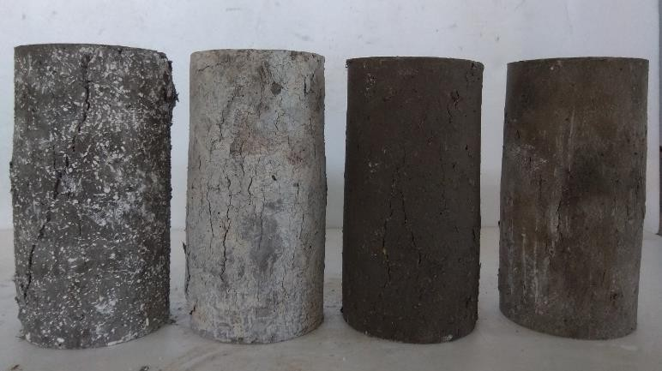

Figure 7: Surface of polymer concrete (100mm dia X 200mm height cylinder) after removing from aggressive solutions (from left to right: H2SO4, NaOH, NaCl, and Water).

VII RESULTS ON POLYMER CONCRETE USING LIMESTONE QUARRY DUST INCORPORATION OF FLY ASH AND JUTE FABRIC

A. Mix Design using Limestone Quarry Dust
The polymer concrete is a mixture of resin, fly ash and quarry dust. 1% of hardener iss added with this resin to rapid hardening process. Both fly ash and quarry dust are used as filler. The mix ratio after several trial mixes is fixed at 1: 1: 2 by weight. Table 23 shows the proportion of the mix design.

Table 23: Mix Ratio of Polymer Concrete Using Resin, Fly Ash and Quarry Dust

Description | Binder | Filler
Materials | Resin with hardener | Fly ash | Quarry dust
Ratio by weight | 1 | 1 | 2

B. Mix Procedure using Resin, Fly Ash and Quarry Dust
Two types of concrete samples such as 50mm cube for compressive strength and 50x50x200mm beams for flexural strength tests are made. The 50mm cubes are made without jute fabric and beam samples are made with and without two-ply of jute fabric as reinforcement on tension face of beam. Both cube and beam samples are cast using same polymer concrete mix as shown in Table 23. The resin is mixed with hardener in bowl first followed by admission of fly ash and quarry dust within 60 seconds in laboratory condition as shown above.
After mixing process completed, a thin layer of mixture is poured into the beam mould (Figure 8). Then, two-ply jute fabric is immersed into the mixture to ensure the jute fabric in well contact with the mixture. The remaining mixture is placed in beam mould and compacted for 10 seconds using vibrating table to remove entrapped air. The same procedure is used to cast cube moulds without two-ply jute fabric.
In fresh condition, the polymer concrete mixture has shown good workability to fill mould easily. The filling ability of workable mixture is governed by the flow spread. When placed on top of vibrating table the mixture can flow and spread faster. As the times goes by, the mixture would generate heat due to the copolymerization reaction between binder and filler. This phase it starts to harden. The fresh polymer concrete has turned from semi- liquid into gel form, then solid form.

Figure 8: Position of two-ply jute fabric in beam mould.

C. Compressive Strength Result
Table 24 shows the development of compressive and flexural strengths of polymer concrete using mix as shown in Table 23. The compression test is done as per [27]. The compressive strength has reached 93% of its final compressive strength within one day, which is from 78.63MPa to 84.27MPa. The result of the compressive strength development of polymer concrete in this study has shown good strength development which has strength more than 85% of its final strength in one day. The polymer concrete strength development has slowed down after one day of curing. The highest compressive strength, 84.27MPa is noticed at age of 14-day. The strength is already stable from 48-hour to 336-hour. Thus the polymer concrete shows good early strength development. Both Figures 9 and 10 show crushed cubes after compressive strength test.

Table 24: Strength Development of Polymer Concrete using Table 2.7 Mix Design

Age on test  (hr) | Density  (kg/m³) | Compressive strength  (N/mm²) | Flexural strength (N/mm²)
Age on test  (hr) | Density  (kg/m³) | Compressive strength  (N/mm²) | With jute fabric | Without jute fabric
2 | 1979 | 0.00 | 1.78 | -
4 | 1979 | 9.12 | 13.83 | -
6 | 1979 | 38.28 | 19.76 | -
24 (1-day) | 1979 | 78.63 | 21.44 | -
48 (2-day) | 1979 | 82.46 | 23.99 | -
72 (3-day) | 1979 | 82.69 | 24.27 | -
168 (7-day) | 1979 | 83.59 | 25.87 | 23.86
336 (14-day) | 1979 | 84.27 | 26.24 | 24.16

Figure 9: Crushing pattern of 50mm cube during compressive strength test for 2-hour age sample.

Figure 10: Crushing pattern of 50mm cube during compressive strength test for 14-day age sample.

D. Flexural Strength Result
Table 24 also shows the development of flexural strengths of polymer concrete using mix as shown in Table 23. The flexural strength is done as per [30]. Flexural strength is to measure the tensile strength of polymer concrete which is to resist failure in bending. The specimens for this flexural test is reinforced with and without two-ply jute fabric and cured in room temperature.
After each period, the specimens are tested. The specimen in Figure 11 is 2-hr age sample. This sample is not hardening yet. The lower part of the specimen is still in contact because it is held by jute fabric. Meanwhile, specimen using jute fabric in Figure 12 is tested at age of 14-day. This shows that the specimen is hardened fully to resist the forced applied onto it.
Based on Table 24, one-day age sample has reached the flexural strength, 82% of final strength, which is from 21.44MPa to 26.24MPa. The strength development has increased rapidly from age 2-hour to 6-hour. Thus, polymer concrete applied in pavement distress repair will take very short period. The repair method using polymer concrete needs simple mix facility at site. It also does not need any compaction facility at site as fresh polymer concrete is very workable. The polymer concrete starts hardening very fast, so the casting should be done within 10 minutes.

Figure 11: Crushing pattern of 50x50x200mm beam during flexural strength test using 2-hour age sample.

Figure 12: Crushing pattern of 50x50x200mm beam during flexural strength test using 14-day age sample.

- CONCLUSIONS

This study has focused on mix design development through various performance observations in order to pothole repair in pavement using minimum manpower and machinery facility. Two types of mixes are formulated. The followings are main findings in the laboratory based investigation.
The recommended Mix-1 of polymer concrete is made using 304kg resin, 16kg acetone, 1,600kg aggregate and 320kg fly ash for one cubic meter and the aggregate proportion is 60% coarse aggregate, 10.00 – 5.00 mm and 40% fine aggregate, 3.35 – 1.18 mm. The compressive strength using 100 dia.X200mm cylindrical are 12.12 MPa at age of 7-hour and 44.93MPa at age of 7-day.
The resistance capacity of Mix-1 polymer concrete under 90-day continuous immersion in aggressive chemical solutions are noticed through compressive strength test. Polymer concrete has shown strength reduction over 90- day immersion with 31.18% in water, 31.32% in sodium chloride, 34.50% in sulphuric acid and 44.38% in sodium hydroxide solution compared with control sample.
The another recommended Mix-2 of polymer concrete is formulated using ratio of 1:1:2 by weight (resin: fly ash: limestone quarry dust) with incorporation of two-ply jute fabric. The size fraction of limestone quarry dust is in range of passing 5mm sieve and retained on 1.18mm sieve. The compressive strengths using 50mm cube sample are 9.12 MPa at age of 4-hour and 83.59MPa at age of 7-day without using two-ply jute fabric. The flexural strengths with two-ply jute fabric are 13.83 MPa at age of 4-hour and 25.87MPa at age of 7-day.

REFERENCES

[1] Fwa, T. F. (2006). The handbook of highway engineering. 4207 United States: CRC Press.
[2] Lee S. L. (2021). Mechanical and Durability Performances of Geotextile Reinforced Polymer Concrete as Pavement Surface Course, unpublished PhD Thesis, Universiti Malaysia Sarawak, Sarawak, Malaysia
[3] Yeon, K.S., Kim, K.K., Kim, C.Y., & Yeon, J.H. (2015). Comparative study on the elastic modulus of polymer concrete. Advanced Materials Research, 1129, 145-150.
[4] Sousa, S.P.B., Ribeiro, M.C.S., Cruz, E.M., Barrera, G.M., & Ferreira, 4389 A.J.M. (2017). Mechanical behaviour analysis of polyester polymer mortars reinforced with tire rubber fibres. Ciência & Tecnologia dos Materiais, 29, 162–166.
[5] Hashemi, M.J., Jamshidi, M., Aghdam, J.H. (2018). Investigating fracture mechanics and flexural properties of unsaturated polyester polymer concrete (UP-PC). Construction and Building Materials, 163, 767–775.
[6] ASTM C 127, (2007). Standard Test Method for Density, Relative Density (Specific Gravity), and Absorption of Coarse Aggregate. ASTM International, 1–7.
[7] BS 812-Part 2, (1995). Methods of Determination of Density.
[8] ASTM C 128, (2001). Standard Test Method for Density, Relative Density (Specific Gravity), and Absorption of Fine Aggregate. ASTM International, 1–6.
[9] ASTM D 854, (2002). Standard Test Methods for Specific Gravity of Soil Solids by Water Pycnometer. Astm D854, 2458000(C), 1–7.
[10] BS 812-112, (1990). Testing aggregates (Part 112) - Method for determination of aggregate impact value (AIV).
[11] BS 812-110, (1990). Testing aggregates (Part 110) - Methods for determination of aggragate crushing value (ACV).
[12] ASTM C 131, (2006). Standard Test Methods for Resistance to Degradation of Small- Size Coarse Aggregate by Abrasion and Impact in the Los Angeles Machine, 4–7.
[13] Bedi, R., Chandra, R., & Singh, S. P. (2013). Mechanical Properties of Polymer Concrete.
[14] Summit Composites Pty Ltd. (2010). Ortho and iso polyester resin rangers-Material safety data sheet. Retrieved from http://summitcomposites.com.au/wp-content/ uploads/2013/06/ORTHO-ISO-POLYESTER-RESINS-08sept10.pdf
[15] Easy Composites. (2012). Safety data sheet: MEKP catalyst. Retrieved from http://easycomposites.asia/downloads/MSDS/EC-MSDS-MEKP-Catalyst.pdf
[16] Bar, W. M. (2013). Material Safety Data Sheet Lacquer Thinner. Retrieved from https://www.google.com/url?sa=t&rct=j&q=&esrc=s&source=web&cd=3&cad=rj a&uact=8&ved=0ahUKEwj2kpGy0JbbAhVLM48KHVzZCZkQFghEMAI&url=ht tp%3A%2F%2Fwww1.mscdirect.com%2FMSDS%2FMSDS00053%2F70250733-
[17] ScienceLab.com. (2013). Material Safety Data Sheet Acetone MSDS, 4, 4–9. Retrieved from http://www.sciencelab.com/msds.php?msdsId=9927062
[18] Abubakar, A. U., & Baharudin, K. S. (2012). Potential use of malaysian thermal power plants coal
bottom ash in construction. International Journal of Sustainable Construction Engineering and Technology, 3(2), 25-37.
[19] Brabha H. N (2016). Utilisation of agricultural and industrial waste in self-compacting concrete, unpublished PhD Thesis, Universiti Malaysia Sabah, Sabah, Malaysia
[20] ASTM C150 [brabha thesis]
[21] ASTM C 188, (2003). Standard Test Method for Density of Hydraulic Cement, 37–39.
20130629.PDF&usg=AOvVaw3bs-obAC4Ts5SwfUKQ8Z2P
[22] Fagone, M., Loccarini, F., & Ranocchiai, G. (2017). Strength evaluation of jute fabric for the reinforcement of rammed earth structures. Composites Part B: Engineering, 113, 1–13. Retrieved from: https://doi.org/10.1016/j.compositesb.2016.12.054
[23] Das, S. (2017). Mechanical properties of waste paper/jute fabric reinforced polyester resin matrix hybrid composites. Carbohydrate Polymers, 172, 60–67. Retrieved from: https://doi.org/10.1016/j.carbpol.2017.05.036
[24] Hani, A., Yang, M.J., Zhang, D.L., & Gao, Z.L. (2016). Bond strength of PCC pavement repairs using metakaolin-based geopolymer mortar. Cement and Concrete Composites, 65, 75-82.
[25] ScienceDaily. (2018). Seawater. Retrieved from https://www.sciencedaily.com/terms/ seawater.htm
[26] United States Environmental Protection Agency. (2017). What is acid rain. Retrieved from https://www.epa.gov/acidrain/what-acid-rain
[27] Malaysian Standard, MS EN 12390-3:2012, Testing hardened concrete -Part 3: Compressive strength of test specimens
[28] Road Engineering Association of Malaysia (REAM). (2004). Guidelines to the design of plain concrete pavement. REAM-GL 7/2004
[29] Mebarkia, S., & Vipulanandan, C. (1995). Mechanical Properties and Water Diffusion in Polyester Polymer Concrete. Journal of Engineering Mechanics, 121(12), 1359– 1365.
[30] Malaysian Standard, MS EN 12390-5:2012, Testing hardened concrete -Part 5: Flexural strength of test specimens

