Analysis of Resources and Strategies on Construction Company Performance by SPSS Tool

Deepa. D, Rishikesan. R

School of Civil Engineering, Sastra Deemed University, Thanjavur – 613 401. India
deepa@src.sastra.edu*, rishiram.kesan@gmail.com

ABSTRACT:
Company performance is depending on the overall performance of the company in certain periods of time, which is influenced by qualitative measurements such as capabilities and resources, project management strategies, strength of relationships and strategic decisions. Thus, this study aims at taking such important factors - Resources of a company and Strategies adopted by it in the impact assessment of the company’s performance through the questionnaire survey. This questionnaire was directed to 50 construction companies across Tamil Nadu in cities such as Chennai, Trichy, Thanjavur, Madurai and the results of the survey were analysed using a statistical software named SPSS. The findings indicated that capabilities and resources, project management strategies influence the company performance indirectly and analysis was done using tools Reliability analysis, Pearson correlation analysis and Importance Index to conclude which one among these has the most impact in deciding the performance of a construction company indirectly.
KEY WORDS: Construction projects, Factors, Resources, Strategies, company performance.

1. INTRODUCTION
A. General
Globalized competition between various construction companies from around the world has led to a lot of research regarding the factors that truly contribute to the success and performance of a construction company. The performance of a company is realized as an evidence system which organizes strategy and policy to attain feedback [1]. Measuring the performance of a construction company is essential to forecast company to see how efficiently it is functioning as well as to check the satisfaction of the client which leads to contest their future diplomacies [2]. Client requirement obviously the powerful force to measure the company performance [4]. If the investor is not satisfied, that obviously meant that the company did not carry out the project in the best manner, having deficit either in quality or money or time or other factors, this ultimately affect the performance of the company was not at its best. Rather, it had some flaws in execution or is not capable enough to carry out the project. Thus, for the success of a construction company, measuring its own performance based on qualitative measures and the investigation of traditional measures which are expressed in terms of financial [5]. The performance management process is the process by which the company manages its performance in line with its corporate and functional strategies and objectives [6]. Therefore, different measurement parameters become necessary for the company to grow and also to surpass its competitive construction companies [7].
Several models for measuring performance employing critical success elements, performance measurements, and indicators have been established, according to current construction management literature. However, it also suggests that these studies are primarily focused on manufacturing industries rather than construction, and that the few studies undertaken in the construction business are primarily concerned with measuring project performance rather than company performance [8]. Key indicators of company performance are varying for different countries based on their market situations, culture, environment and policies and strategies and the studies were reported [9]. Benchmarking is used to evaluate the performance of companies in two different ways. Comparing an organization's products, services, and performance to those of its immediate competitors in the same industry is what competitive benchmarking is all about. Functional benchmarking finds and compares best practises in every type of organisation [10- 12]. This means that there are some hidden factors that contribute significantly to the performance of the construction company. So, it was concluded that money was not the only thing that decided the performance of a company. – of course, financial resource played its part but there was something behind the veil that decided the success of a project. Thus, began the inclusive of qualitative measurements in this process and new parameters such as customer satisfaction, quality etc. were added [13,14]. But since there are several factors, not just one factor that decides the performance of a construction company as said above, the need to assess each factor arose. In this project, two such factors - resources and strategies adopted by a construction company in completing the given project are considered. Under this, four variables are identified - Strength of relationships, Resources and capabilities, Project management competencies and Strategic decisions are considered, and the data are collected accordingly [15-19].

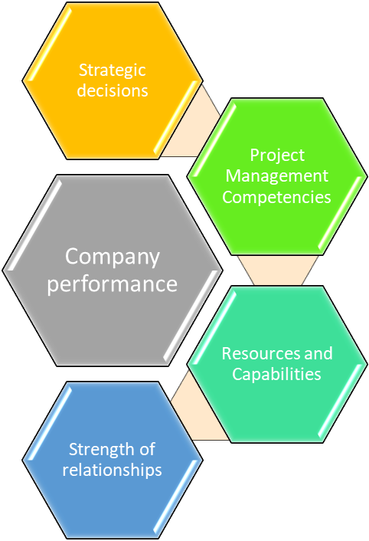

These four variables were chosen because they cover important aspects of resources and strategies. These variables include the most important factors in them.
- Strength of relationships that include Relationship with client, Relationship with government and also Relationship with labour unions.
- Resources and Capabilities that include financial resources, Manpower, Experience, Knowledge, Technical competency etc.
- Project Management Competencies that include Cost management, Schedule management, Quality management, Claims management, Risk management etc.
- Strategic decisions that include Project selection strategies, Client selection strategies, Market selection strategies, Project management strategies etc.

These four variables cover the almost all the factors that can possibly affect the performance of a construction company. All these factors do influence the performance in one way or the other, but there must be some factors which play more important role in success of a factor and without which the project will not be successful which will also invariably lead to the decline and failure in the performance of that construction company.
So, it is imperative that the factor which has a higher role in deciding the performance of a construction company is decided - be it manpower or machinery or knowledge or good relationship or quality management or project handling strategies. And analyzing such a factor has been very crucial these days - owing to the immense competition in the construction sector among peers involving huge manpower at stake, thus making this study, one of the most needed in this present hour. Main objective for this research study is
- To determine the factors which affect the performance of various types of construction projects.
- To sort out the possible reasons that cause cost and schedule overruns or dispute in a project.
- To enlighten the parameter that has a major impact on the performance of a construction company.
- To provide a suitable solution to various types of construction projects regarding increasing the performance of their project.

3. METHODOLOGY

A. Questionnaire Preparation
First work is to list down the main factors that affect the performance of a construction project through the literature review and pilot study. Based on these, the final questionnaire is prepared. It consists of 2 sections - first one is Demographic details which consist of the basic details, and the second section consists of the four important parameters that can affect the performance of the construction company namely Strength of Relationships, Resources and Capabilities, Project Management competencies and Strategic decisions. These 4 factors have number of sub-factors or parameters in them. The questionnaire is prepared considering all these factors.

B. Survey
The questionnaire was prepared through Google forms. It was then circulated to various set of personnel in our construction industry such as Project managers, Contractors, Site engineers etc. Stationed in various parts of Tamil Nadu. Printed copies were also circulated to construction personnel in and around Thanjavur. The responses were collected based on a linear scale called ‘Likert scale’. This is a scale of 1 to 5 in which 1 = strongly disagree, 2 = disagree, 3 = neither agree nor disagree, 4 = agree, 5 = strongly agree. Thus, a person can either disagree, agree, or remain neutral on a statement based on his experience and perception. Totally 90 samples were collected through the Google forms and Printed copies and were used for analysis.

C. Analysis
When the data were obtained, demographic analysis was checked to know how well the responses are distributed, Reliability analysis for checking the reliability of data for further analysis, Importance Index was found and used to rank each factor in a variable to find out their importance and influence in influencing the project and improving their performance. Correlation analysis for identifying the linear relationship with the factors using Pearson correlation, Model fit analysis for assessing the goodness and acceptance of created model using Confirmatory Factor Analysis were done to assess the significant factors. Based on these analyses, the data is interpreted, and the conclusion is arrived based on these results.

4. RESULTS AND DISCUSSIONS
A. Demographic Analysis
The demographic analysis is done based on the frequencies of each respondent’s educational qualifications, designation, and work experience in the construction sector. These demographic facets are listed below. Figure 1 shows the responses of various organizations.

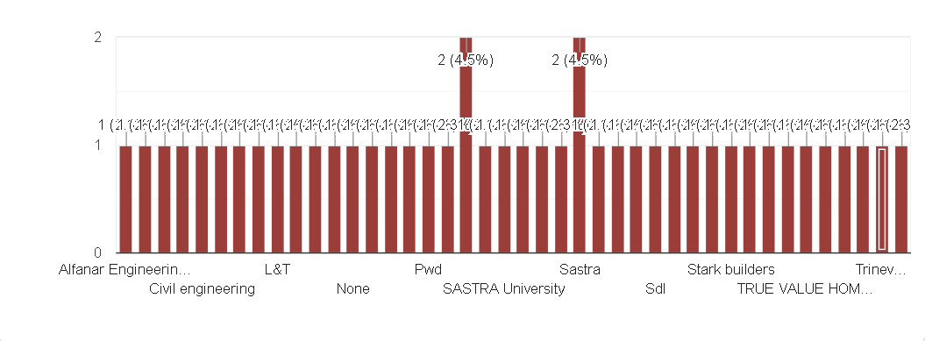
Figure 1: Organization

As you can see, respondents are from various organizations such as L&T, True value homes, Nadhi constructions, Malar constructions, Stark homes, Trinerva constructions, PWD, Arun excello etc. Some samples were also collected from the site engineers working in SASTRA Deemed University’s hostel block construction. So, it is evident that respondents are from reputed construction forms who have relevant knowledge and experience in the field of construction. Their roles in these firms also varies from Contractors, Site engineers to Construction managers, thus considering the diversity of profiles and experiences in the responses and analyses,
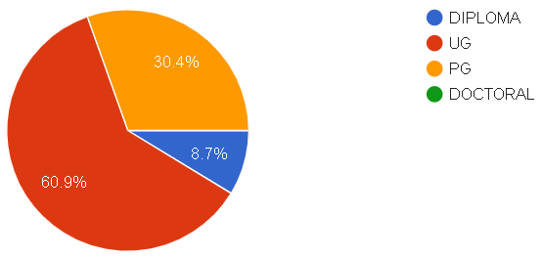
Figure 2: Educational Qualifications

As per figure 2, nearly 61% of respondents hold an undergraduate degree that is B.Tech /B.E, 8.7% are Diploma holders who are mostly contractors and site engineers, and the rest are Post graduate, that is M.Tech /M.E holders who are Project managers in reputed organizations. No doctorate respondents were included.
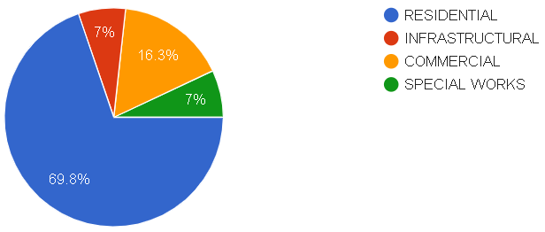

Figure 3: Current Project Type

From figure 3, it is observed that almost 70% of the respondents work in residential constructions, 16.3% work in commercial works which involve constructing educational institutions, hospitals, malls etc. 7% respondents work infrastructural works which includes road constructions (metro) and the remaining fall under special works.

B. Reliability Analysis
Reliability is the measure of stability or consistency of the collected data. This measures the reliability or internal consistency. It is how good a test or a survey has focussed on its primary objective and its end goal. For this, Cronbach’s alpha is used. A greater alpha value may mean that the items in the test are largely correlated and interrelated. But, α is also sensitive to the number of items in a test. Increase in the number of items may lead to a larger α value, and a smaller number of items may lead to a smaller α value. In other words, it is the test to see if the multiple question Lakers scale is reliable. So, it is very essential to start the analysis with the reliability test. To investigate the reliability of data, Cronbach’s test was followed. This correlation gives the reliability of data. It was found that Cronbach’s alpha should bear values from 0 to 1. Below shows the table 1 which represents the Cronbach’s alpha value for the collected 90 samples of data.

Table 1: Reliability test results
Variable | Cronbach’s alpha
Strength of Relationships | 0.775
Resources ad Capabilities | 0.833
Project Management Competencies | 0.926
Strategic decisions | 0.870

The conventional value for the Cronbach’s alpha value for higher reliability is greater than or equal to 0.7. This limit is also the acceptable value. In our case, we are obtaining a value of 0.75, which indicates the data are reliable and the research set up which we have created is measuring the variable of interest. So, from this, we can do further analysis with those data.

C. Importance Index
Data analysis is a process of inspecting, transforming, and modelling the obtained data set with the goal of discovering useful information, obtaining conclusions, and supporting decision-making. This study is based on the calculation of importance index, which requires two other components namely, Severity index and Frequency index. Based on the formula Frequency index and Severity index can be calculated from the obtained data.

FI(%) = $\frac{\sum_{i=1}^{5}{b\text{.}z}}{5Z}×\text{100}$ …………………………………..(i)

Where, FI is the frequency index; b_{i} = number of respondents who chose necessary frequency; z_{i} = degree of frequency ranging from 1 to 5; Z = total number of responses received.

SI(%) = $\frac{\sum_{i=1}^{5}{b\text{.}z}}{5Z}×\text{100}$ ………………………………….(ii)

Where SI is the Severity index; b_{i} = count of respondents who chose necessary severity; z_{i} = degree of frequency of responses from very low to more severe; Z = total number of responses received.

Importance Index (IMP.I)(%) = $\frac{\text{FI}∗\text{SI}}{\text{100}}$ ……………………………….(iii)

Table 2: Factors considered

Sl. No | Variables | Factors
1. | Strength of Relationships | Relationship with Client
2. | Strength of Relationships | Relationship with Government
3. | Strength of Relationships | Relationship with Labour unions
4. | Resources and Capabilities | Financial resources
5. | Resources and Capabilities | Technical competency
6. | Resources and Capabilities | Experience
7. | Resources and Capabilities | Labour resources
8. | Resources and Capabilities | Company image
9. | Project Management Competencies | Cost management
10. | Project Management Competencies | Schedule management
11. | Project Management Competencies | Quality management
12. | Project Management Competencies | Claims management
13. | Project Management Competencies | Risk management
15. | Strategic Decisions | Client selection strategies
16. | Strategic Decisions | Market selection strategies
17. | Strategic Decisions | Project selection strategies
18. | Strategic Decisions | Project management strategies
19. | Strategic Decisions | Investment strategies

Table 2 shows the factors and variables for evaluation. Thus, the factors are grouped under five variables. These factors are ranked in their respective as all these variables are mutually exclusive. These variables are all requires for the successful completion of a project, but the numerous factors which come under these variables need to rank and prioritized based on the data obtained, as these factors will truly contribute to the success of a project and its improved performance. The most influencing factors under the variable Resources and Capabilities are listed down in the tables 3, 4,5, and 6.

Table 3: Most influencing factors under the variable Strength of Relationships

Variable | Factors | Imp. Index | Rank
Strength of Relationships | Relationship with Client | 68.58 | 1
Strength of Relationships | Relationship with Labour unions | 61.71 | 2
Strength of Relationships | Relationship with Government | 59.19 | 3

Similarly, we must find the top factors influencing the performance of a company under the variable Resources and Capabilities. There are many resources that a company can have, but not all of them will have influencing character on the project.

Table 4: Most influencing factors under the variable Resources and Capabilities

Variable | Factors | Imp. Index | Rank
Resources and Capabilities | Financial resources | 69.65 | 1
Resources and Capabilities | Labour resources | 67.52 | 2
Resources and Capabilities | Technical competency | 64.46 | 3
Resources and Capabilities | Company image | 57.38 | 4
Resources and Capabilities | Experience | 51.17 | 5

From the above table 4 we can conclude that financial resources are the most important resource for improving the performance of a company since the money can be invested to have better resources and machinery.

Table 5: Most influencing factors under Project Management Competencies

Variable | Factors | Imp. Index | Rank
Project Management Competencies | Cost management | 65.37 | 1
Project Management Competencies | Schedule management | 64.98 | 2
Project Management Competencies | Quality management | 64.05 | 3
Project Management Competencies | Risk management | 63.19 | 4
Project Management Competencies | Claims management | 59.33 | 5

The last variable, which is Strategic decisions also has several factors that can probably influence the success and performance of a construction project, but the actual factors which do have a profound impact are given below.

Table 6: Most influencing factors under Strategic Decisions

Variable | Factors | Imp. Index | Rank
Strategic Decisions | Project management strategies | 67.45 | 1
Strategic Decisions | Investment strategies | 64.93 | 2
Strategic Decisions | Project selection strategies | 58.69 | 3
Strategic Decisions | Client selection strategies | 55.21 | 4
Strategic Decisions | Market selection strategies | 50.15 | 5
D. Pearson Correlation Analysis
A Pearson correlation analysis was evaluated amongst the four variables namely Strength of Relationships, Resources and Capabilities, Project management competencies and Strategic decisions. Cohen's standard was obtained to assess the various factors, where coefficients in the range of .10 and .29 denote a reduced effective value size, coefficients between .30 and .49 denote a moderate effective value size, and coefficients above .50 indicate a large effective value size. Linearity - A Pearson correlation conditions that the inter-relationship between various pair of variables chosen should be linear. This assumption is discarded if there is a curvature amongst the points on the scatter plot between any two pair of variables. Figure 4 and Figure 5 presents the scatter plots of the correlations. A regression line has been added to assist the interpretation.
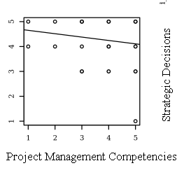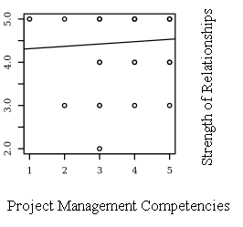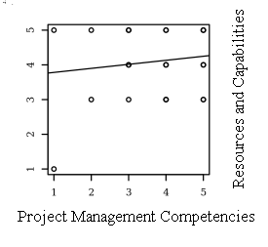

Figure 4: Scatter plots between each variable with the regression line added

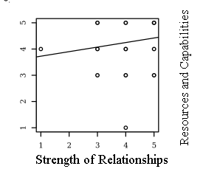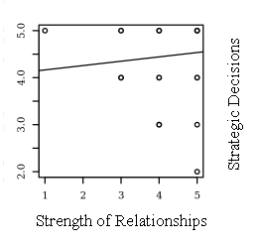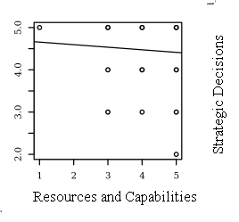
Figure 5: Scatter plots between each variable with the regression line added
The correlations were analyzed using Holm corrections to correct for various alternative comparisons based on an alpha value of 0.05. There were no significant correlations between any pairs of variables.

- CONCLUSIONS

The samples were collected in and around Tamil Nadu from various personnel in the field of construction industry. The above analyses consisting of Pearson correlation and Confirmatory Factor Analyses clearly depict that all the four variables are mutually exclusive in nature. This brings us to the conclusion that all the variables, be it Strength of Relationships, Resources and Capabilities, Project management competencies and Strategic decisions are independent in nature. All these variables are required for the better administration of the project and to improve its performance. But, as concluded from the Importance Index, only those factors such as Relationship with Client, Financial resources, Cost management and Project management strategies have the greatest influence in the performance of the construction project. These are the factors on which the company must focus on to grow as a company in better execution of the project, satisfaction of the client, and as a result, emerge as leaders in the competitive construction market.
But a company must not neglect other factors, even though they may have a little less importance than the above stated factors. For example, to achieve client satisfaction and build a good relationship with the client, schedule management and quality management are also necessary along with the cost management. To develop better project management strategies, a company must also have adequate manpower and machinery along with financial resources. But this also depends on the type of project they handle. The bitter fact today is most people neglect better relationships with the client and contractor. Also, strategies are either not planned or executed properly.
So, all the four factors - Relationship with Clients, Financial resources, Cost management, and Project management strategies should be given primary importance followed by the other factors to ensure the company’s performance in the project and it gains a good image in the market.

REFERNCES

- Warszawski, Abraham, “Strategic planning in construction companies,” Journal of Construction Engineering and Management-ASCE 122, 1996, 133-140.
- Memon, Aftab & Roslan, Nadzirah & Zainun, Noor Yasmin, “Improving Time Performance in Construction Projects, Perspective of Contractor,” Journal of American Science, 10, 2014, 46-50.
- Edum-fotwe F, Thorpe A, Mccaffer R, “Exploring Complexity in construction projects,” Project Management Advances, Training & Certification in the Mediterranean, 2008,1–62.
- Le-Hoai L, Lee YD, Nguyen AT, “Estimating time performance for building construction projects in Vietnam,” KSCE Journal of civil engineering, 2013, 17(1), 1–83.
- Chan, Albert P, C, David Steven Scott and Ada P, L, Chan, “Factors Affecting the Success of a Construction Project,” Journal of Construction Engineering and Management-ASCE 130, 2004, 153-155.
- Andrew R, J, Dainty , Mei-LI Cheng and David R, Moore, “Defining Performance measures for construction project managers, an empirical evaluation”, Construction Management and Economics, 21, 2003,209–21.
- Atuahene, B,T et al, “Factors affecting the Client- Contractor relationship in the Ghanaian Construction Industry”, International Conference on Infrastructure development in Africa, 2017.
- Semple Cheryl, Francis T, Hartman and George Jergeas, “Construction Claims and Disputes, Causes and Cost/Time Overruns,” Journal of Construction Engineering and Management-asce 120, 1994, 785-795.
- Kiew, Poh & Ismail, Syuhaida & Yusof, Aminah, “Integration of Quality Management System In the Malaysian Construction Industry”, Journal of Organizational Management Studies, 2016, 1-9.
- Yu, Ilhan & Kim, Kyungrai & Jung, Youngsoo & Chin, Sangyoon, “Comparable Performance Measurement System for Construction Companies”, Journal of Management in Engineering, 23, 2007, 131-139.
- Memon, Aftab & Abdul Rahman, Ismail & Abdullah, Mohd & Azis, Ade, Factors affecting construction cost performance in project management projects, Case of MARA large projects, International Journal of Civil Engineering and Built Environment, 1, 2014, 30-35.
- Barney, Jay, “Firm Resources and Sustained Competitive Advantage,” Journal of Management 17, no. 1, March 1991, 99–120.
- Kululanga, F,T, Edum-Fotwe and R, McCaffer, “Measuring constructioncontractors' organizational learning”, Building Research and Information, 2014, 29(1).
- Bresnen, Mike & Marshall, Nick, “Partnering in Construction, a Critical Review of Issues, Problems and Dilemmas”, Construction Management & Economics, 18,2000,229-237. 10,1080/014461900370852,
- Akintan, Obafemi & Morledge, Roy, “Improving the Collaboration between Main Contractors and Subcontractors within Traditional Construction Procurement”, Journal of Construction Engineering, 2013.
- K, Ringen, J, Seegal and A, Englund, “SafetyandHealth in the Construction industry”, Annual Rev,Public health, 16, 1995,165-88.
- Syed M, Ahmedand Roozbeh Kangari, “Analysis Ofclient-Satisfaction Factors In Construction Industry”, Journal of Management in Engineering, 11(2), 1995, 36-44,
- Suat Gunhan and David Arditi, “Factors of international construction,” Journal of Construction engineering and management, 131(3), 2015, 273-282.
- Arukala, suchith reddy, “Risk Management in Construction Industry - A Case Study”, International Journal of Innovative Research in Computer and Communication Engineering, 4,2015.

