Utilization of laminates for strengthening of RCCbeam

Siddharth¹
Research Scholar
Department of Civil Engineering
National Institute of Technology, Patna, Bihar, India

Sagar Sarangi²*
Assistant Professor
Department of Civil Engineering,
Sarala Birla University, Ranchi, Jharkhand, India sagarsarangicit@gmail.com

ABSTRACT
The present investigation paper summarized the utilization of retrofitting techniques for strengthening the beam using low-cost fibrous material and resin. For this study, thirty reinforced concrete beam prism specimens as per BIS standard were cast using locally available construction materials. Here, we strengthen the specimen externally with the help of hardener, resin and fibrous material. Here, U wraps and bottom wrap technique was adopted for retrofitting. The sample after the wrap was tested in UTM using a two-point loading system and observed results. From the result, it was shown to improve the ultimate load-bearing capacity and flexural strength of the proposed specimen as compared to the control specimen. In the case of single synthetic u-wrap and single cotton, the u-wrap specimen improved flexural strength by 8.66% & 11.22%, respectively, of the control specimen at 28 days, which is lesser than any other material fiber collected from previous research mentioned in literature. However, it gives impressive economic and economic results, so it can be applicable in rehabilitating defected RC structures due to age, defective design and corrosion of steel reinforcement in adverse environmental conditions.
Keywords— Retrofitting, Flexural strength, Rehabilitation, Fiber, Fiber Reinforced Polymer (FRP)
Highlights
- Economic retrofitting technique
- Strengthen of RC beam by using fibrous material
- Useful techniques for rehabilitation of defected RC structures

- Introduction
Nowadays, the beautiful and essential structures built from the ancient period will be affected by their structural integrity due to adverse environmental conditions. The durability of that structure is only possible by using various protective technology. Nowadays, lamination technology is one of researchers' leading interests for improving old structures for rehabilitating purposes. It is verymuch essential due to flaws in structural design, deterioration of reinforcement due to corrosion, ageing of concrete and many more. To date, many techniques have been developed by researchers and young scientists for strengthening an RC beam, and apart from that, external strengthening using FRP technique is quite interesting; also, it is acceptable worldwide due to its easy on-site possibility. FRP is a composite matrix of material fiber and resin, where carbon fiber, and glass fiber are treated as reinforcing agents and resin as a binder. By using this technique, material fiber can be utilized to enhance the tensile strength of the beam. But, due to economic considerations, glass, carbon, and aramid fibres are unsuitable for financially challenged rural beneficiaries. To overcome that obstacle, young scientists utilized natural fiber, such as jute, hemp, flax, etc., as reinforcing agents for making FRP composite. In this investigation, we used polyester from ester functional group polymer fiber and cotton fiber sheet as a reinforcing agent for making FRP composite. This is economical as compared to other types of fiber. (Campione, 2006) investigated on retrofitting of the beam by using CFRP. From his observation derived a relationship between strength and length of the composite wrap. Using GFRC in RC beam was investigated by (Pannirselvam et al., 2009) and observed impressive growth in beam flexural strength after wrapping (Murali & Pannirselvam, 2011; Pannirselvam et al., 2009). (Adi et al., 2014) carried out a similar investigation as (Pannirselvam et al., 2009) and observed the relationship between crack growth of concrete and GFRP wrap area is vice versa. (Huang et al., 2005)observed the retrofitting of RC beam by pre-stressed GFRC composite able to reduce the spalling of concrete. Using carbon fiber reinforced polymer in strengthening technique able to enhance stiffness significantly, the first cracking load was observed by researcher (Ramana et al., 2000). In case of fatigue behaviour of carbon fiber reinforced plastic laminated RC beam technique was not acceptable recommended by (Heffernan & Erki, 2004). From the previous study in this research work, we are utilizing synthetic fiber and cotton fiber as raw materials as reinforcing agents for making FRP with resin.

- Experimental Investigation
In experimental work in the laboratory, 150mm x 150mm x 700mm RCC beam specimens were cast. Where 8mm Ø# 5 numbers and 6mm Ø@ 125mm spacing (Centre-Centre) TMT bar used as tension and shear reinforcement, respectively. The reinforcement details on the beam are shown in "Figure 1".

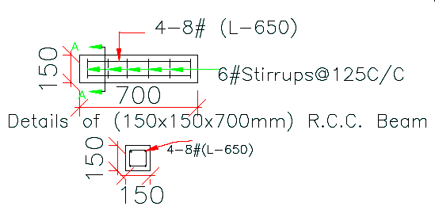
Figure 1:Detailing of Reinforcement in RC Beam Specimen

Material
For this work, Portland Slag Cement manufactured by "Ultra Tech Cement Ltd" conforming to IS 455 (Bureau of Indian Standards, 1989), utilized as binding material and the properties are shown in "Table-1". Locally available river sand and crushed granite stone MSA of 20mm conforming to IS 383:1970(Bureau of Indian Standards, 1970) used fine aggregate and coarse aggregate, respectively. The properties of the aggregate are shown in "Table-2". HYSD Fe- 500 8mm Ø #5 number and Fe-250 6mm Ø TMT bar @ 125mm spacing (Centre- Centre) used as tension and shear reinforcement, respectively; properties of the bar shown in "Table-3" and detailing of reinforcement shown in "Figure 1". Waste Polyester and cotton textile fiber sheet collected from the local textile shop (Tailor Shop) were utilized for wrapping purpose over precast concrete beam specimen. Araldite epoxy resin and hardener are used as matrix for composite material.
Table 1: Properties of Cement
Chemical Properties | Obtained | As per Indian Standard 455:1989
SO₃ | 1.08 | <3% Max
MgO | 5.27 | <10%
S | 0.66 | <1.5%
SO₃ | 1.08 | <3%
Insoluble residue | 1.10 | <4%
Loss on ignition | 1.16 | <5%
Na₂O | 0.3
Total Chloride Content | 0.05 | <0.10%
Physical Properties
Fineness | 349 | 225 M²/Kg Min
Consistency | 32%
Initial Setting Time | 50 min | >30 minutes
Final Setting Time | 320 min | <600 minutes
Soundness | 1 | 10mm Max
Compressive Strength 3 Days | 18 | 16 MPa Min
Compressive Strength 7 Days | 24 | 22 MPa Min
Compressive Strength 28 Days | 36 | 33 MPa Min

Table 2: Properties of Aggregate
Properties | Fine Aggregate | Coarse Aggregate
Fineness Modulus | 2.602 | 4.08
Sp. Gravity | 2.60 | 2.63
Bulk Density | 1.479 | 1.61
Moisture content (1day) | 1% | 3%
Impact value | - | 25.37%
Zone | II

Table 3: Properties of Reinforced bar
Ultimate Tensile Strength @ 8mm Ø (MPa) | Modulus of Elasticity 8mm Ø (kN/mm²)
62.240 | 61.68

- Methodology

Sampling
A mix of M20 grade concrete was designed for making precast concrete specimens of size 150mm X 150mm X 700mm, and the quantity are shown in "Table-4". Allowed for submerged curing for the ageing of 7 days and 28days. After air-dried cleaning and roughing of the outer surface was carried out by using sandpaper for better interfacial bonding between the composite material and the beam specimen. Fiber sheets were cut into the desired size, wrapped in the outer surface of the specimen with the help of resin and hardener, and dried for a period of 24hr or a day.

Table 4: Mix proportion
Cement | FA | CA | Water
372 Kg | 833 Kg | 1125 Kg | 186 lit.
1 | 2.23 | 3.03 | 0.5

Experimental Setup
To investigate the modulus of rupture, a flexural test of two-point loading methods was conducted in the flexural testing apparatus as specified by Indian standards. One control set specimen was also tested for a comparative study between pre and post-treatment of rehabilitating beam specimens. While increasing the load initial visible crakes were obtained and recorded in the observation register, and the applied load was increased till achieving its maximum fracture load. By computing could be predict the betterment of the structure pre and post-rehabilitation process. Average of three specimen were noted the flexural or modulus of rupture of the specimen. The experimental setup was shown in "Figure 2".
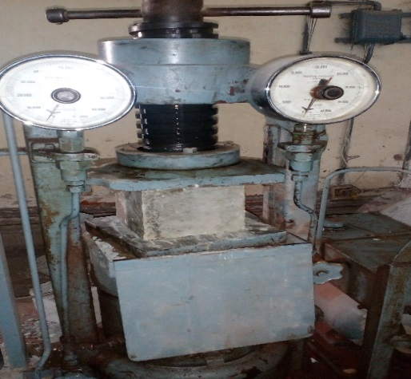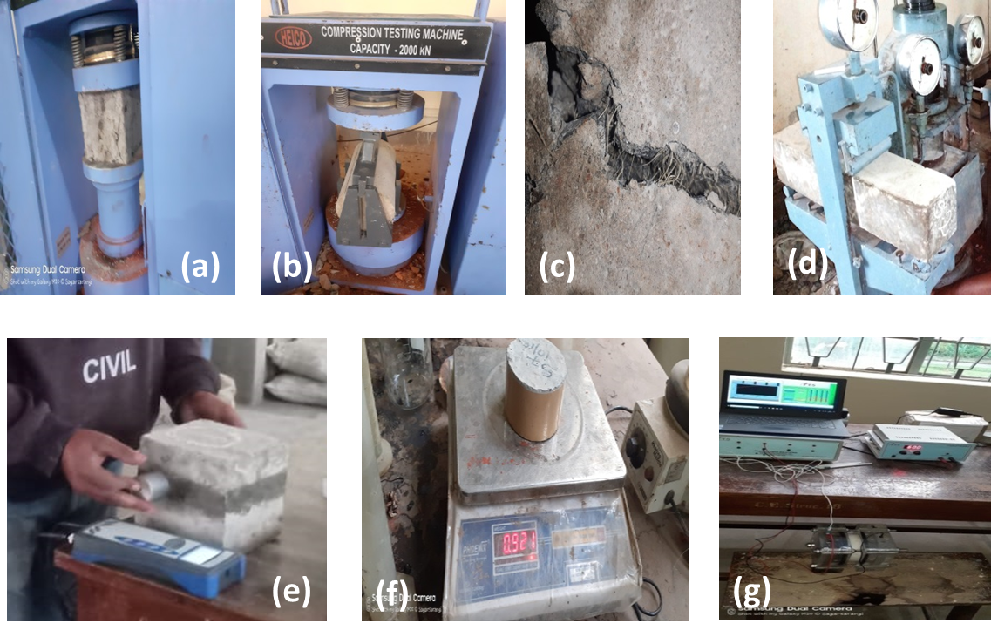
(a) (b)
Figure 2: Experimental Setup (a. CTM b. Flexural Strength Testing Machine)
- Methodology
From the experimental investigation results are shown in "Table-6" and "Figure 3".

Compressive Strength
After removing from the curing tank and allowed for air dry till the negligible moisture content present on the outer surface of the specimen compressive strength of concrete cubes was determined by using the universal testing machine according to IS 516 (Bureau of Indian Standards, 1959). Average of three cubical samples was calculated as per eq(1) and the results are shown in "Table-5".
Compressive strength (MPa) = Fracture Load / Cross-sectional area of specimen (Mpa). (1)

4.2 Flexural Strength Test
Precast reinforced beam prism after a moisture dried fixed into flexural strength testing machine set up shown in Figure-2(b) allowed an axial load using a two-point loading system for finding out the fracture load of the specimen. By computing the load using equation (2), the modulus of rupture of flexural strength of the given specimen was easily calculated. As per (Bureau of Indian Standards, 1959) average of three samples were considered.

Flexural strength = 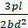 (2)
Where
p: fracture load of the specimen in Newton
l: length of the sample specimen in mm
b: breadth of the specimen in mm
d: depth of the sample specimen in mm
- Results and Discussion
  - Compressive strength
Average of three sample's compressive strength of M20 grade design mix concrete shown in Table-5 for 7 days and 28days curing period. Slag based cement content 5% MgO along with finer easily starts hydration process as a results more C-S-H gel formed in the interfacial transition zone by virtue of which achieved its target strength at the curing age of 28 days i.e. 36.0 N/mm² whereas flexural strength 25.96 N/mm².
.
Table 5: Compressive strength of concrete

7days Compressive strength | 28days compressive strength
24.44 N/mm² | - N/mm²

  - Flexural Strength
After retrofitting of beam using various techniques like orientation of fiber sheet with resin flexural strength test were performed and the average of three results shown in Table-6 and Graphical representation in Figure-3. From the table observed that Single synthetic fiber sheet bottom wrap enhanced upto 10.51% than the control specimen. However, cotton single bottom wrap enhanced upto 1.78% due to lower physiochemical properties of natural textile over synthetic one. Similarly, U-wrap type retrofitting technique slightly enhanced the flexural strength of the prism than single bottom wrap(Siddharth & Paul, 2016).

Table 6: Flexural Strength Results
Sl No | Specimen ID | 7days N/mm² | 28days N/mm² | Changes (%) at 28days
1 | S-1[Control] | 18.92 | 25.96 | Ref.
2 | SS-2[Synthetic Single Bottom wrap] | 21.35 | 29.01 | 10.51
3 | SS-3[Synthetic Single u-wrap] | 22.10 | 29.24 | 11.22
4 | SC-1[Cotton Single Bottom wrap] | 19.33 | 26.43 | 1.78
5 | SC-2 [Cotton Single u-wrap] | 20.69 | 28.42 | 8.66

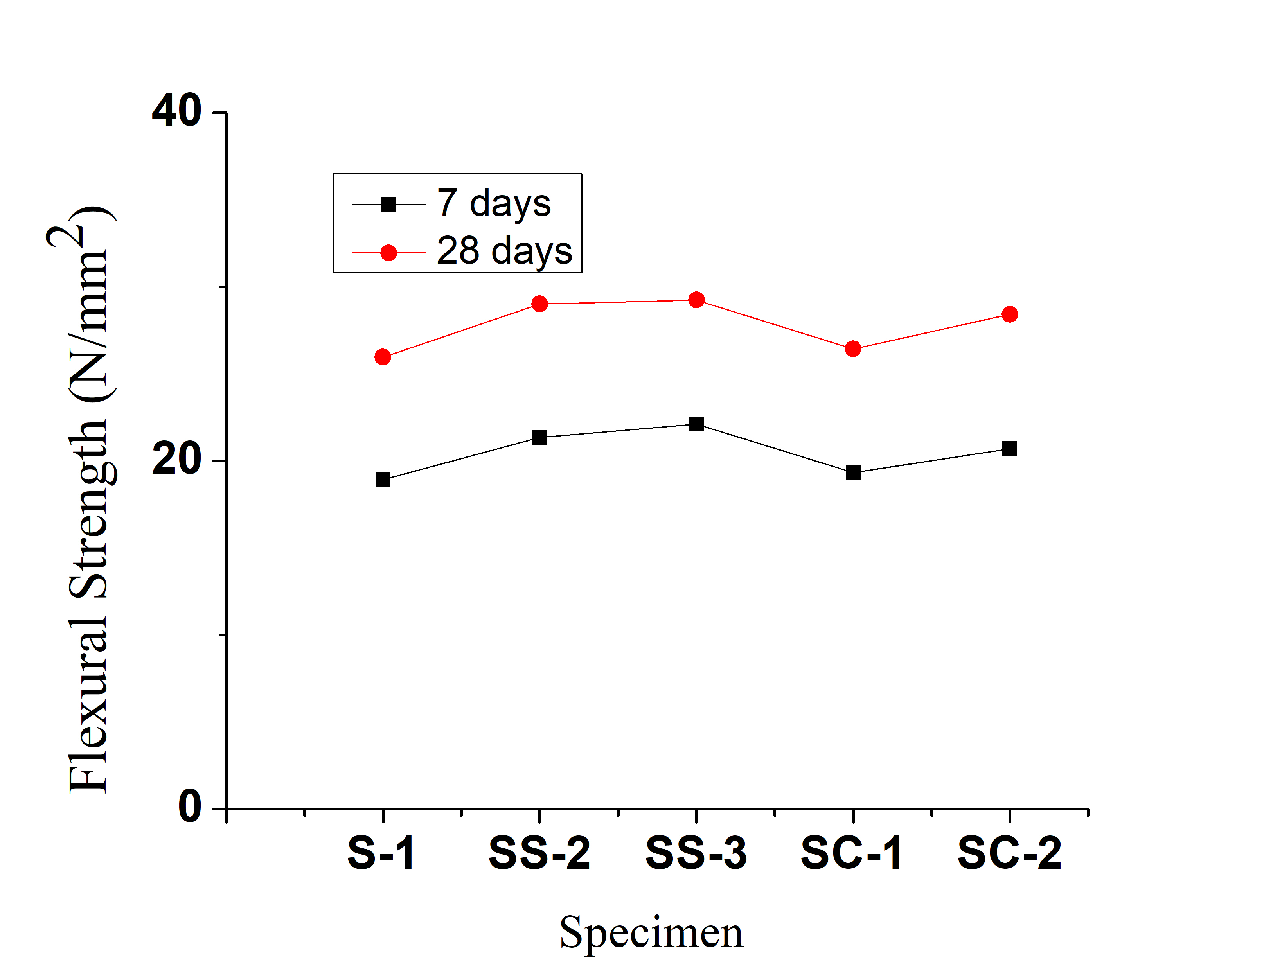
Figure 3: Flexural Strength result
- Conclusion
From this investigation, it is shown that ultimate fracture load of beam specimen can be achieved impressively by laminate FRP sheets. We concluded that by using waste textile fiber sheet and hardener could be one of the economic retrofitting techniques for repairing of older concrete structure and health monitoring purposes.

Reference

- Adi, A. S., Karkare, B. S., & Abbass, M. M. (2014). Effect of width and layers of GFRP strips on deflection of Reinforced Concrete – GFRP Composite Beam. 3(10), 71–75.
- Bureau of Indian Standards. (1959). IS 516-1959, Indian Standard Specification for Methods of Tests for Strength of Concrete.
- Bureau of Indian Standards. (1970). IS 383-1970 Indian Standard Specification for Coarse and Fine Aggregates from Natural Sources for Concrete.
- Bureau of Indian Standards. (1989). IS 455-1989 Indian Standard Portland Slag Cement- Specification.
- Campione, G. (2006). Influence of FRP wrapping techniques on the compressive behavior of concrete prisms. Cement and Concrete Composites. https://doi.org/10.1016/j.cemconcomp.2006.01.002
- Heffernan, P. J., & Erki, M. A. (2004). Fatigue behavior of reinforced concrete beams strengthened with carbon fiber reinforced plastic laminates. Journal of Composites for Construction. https://doi.org/10.1061/(ASCE)1090-0268(2004)8:2(132)
- Huang, Y. L., Wu, J. H., Yen, T., Hung, C. H., & Lin, Y. (2005). Strengthening reinforced concrete beams using prestressed glass fiber-reinforced polymer - Part I: Experimental study. Journal of Zhejiang University: Science. https://doi.org/10.1631/jzus.2005.A0166
- Murali, G., & Pannirselvam, N. (2011). Flexural strengthening of reinforced concrete beams using fibre reinforced polymer laminate: A review. In Journal of Engineering and Applied Sciences.
- Pannirselvam, N., Nagaradjane, V., & Chandramouli, K. (2009). Strength behaviour of fibre reinforced polymer strengthened beam. Journal of Engineering and Applied Sciences.
- Ramana, V. P. V., Kant, T., Morton, S. E., Dutta, P. K., Mukherjee, A., & Desai, Y. M. (2000). Behavior of CFRPC strengthened reinforced concrete beams with varying degrees of strengthening. Composites Part B: Engineering. https://doi.org/10.1016/S1359-8368(00)00022-6
- Siddharth, & Paul, K. (2016). Strengthening of a RC beam using synthetic FRP laminates. Indian Journal of Science and Technology, 9(41). https://doi.org/10.17485/ijst/2016/v9i41/99224

