INTEGRATED CIRCUITS FABRICATION TECHNIQUES FOR C-MOS, N-MOS and BJT

Shivam Bhardwaj, Shivam, Jay Varshney,
Inderpreet Kaur, Sourabh Pathak, Hari Kumar Singh
Department of Electronics and Communication Engineering
F.E.T, M.J.P. Rohilkhand University, Bareilly (U.P.), India
shivambhardwaj3399@gmail.com, shivamsharmabhartia@gmail.com,
jayvarshney0210@gmail.com, inderpreet.mjpru.ac.in,
harsdik@gmail.com, sourabhpathak13@gmail.com

ABSTRACT

One of several potential fabrication techniques may be used to realize integrated circuit designs. After being created on a die, the circuit will subsequently be packaged inside a suitable defensive housing. The precise fabrication process to utilize will depend on several variables, including cost, practicality, and the capabilities of the circuit elements. The creation of today's excessively dense integrated circuits requires complex procedures and generation using tiny dimensions. Chemical vapor deposition, oxidation diffusion, and ion implantation are the three main unit techniques for circuit construction that are discussed in this study. Lithography and metallization These concurrent developments have ushered in a new era of very large scale, including VLSI circuits with low micrometer to submicron characteristics, resulting in denser, quicker, and more complicated technology.

Keywords-- VLSI Technology, CMOS IC Fabrication, NMOS IC Fabrication, BJT IC Fabrication, Fabrication, Etching, Diffusion Metallization

I. INTRODUCTION

The incorporated circuits (IC’s) are virtual electronics circuits that are set up on the small digital chip. Large numbers of devices, inclusive of MOSFETs (metal Oxide Semiconductor Discipline Impact Transistor), transistors, microcontrollers, laptop processors, and many more, are created with the assistance of the fabrication approach. Due to their strong structures, silicon and germanium are the most commonly used substances inside the semiconductor industry for fabrication. Other materials which might be used in fabrication industries are carbon steel, silver, aluminium, magnesium, copper, wood, thermoplastics, resins, and plenty more.
In the fabrication method, commercial products are built. We can also outline it as a set of strategies to fabricate a virtual device or product. For example, silicon semiconductor chips, and so forth. In the case of metals, fabrication is a way used to convert the raw materials into the furnished

II. NMOS IC FABRICATION
The first technology we will discussing is the n channel metal oxide semiconductor i.e. NMOS. It has three terminals which includes source, drain and gate. The impurities that will be doped in the NMOS will be pentavalent in nature (five valence electron), for eg. Boron and antimony. As the name suggest, a n-type channel is created on a p-type substrate. The NMOS fabrication procedure is the least complex because it requires the least number of lithography levels. Furthermore, the fundamental aspects of the NMOS technology are also important for the complementary metal - oxide - semiconductor (CMOS) technology. The NMOS fabrication steps are discussed below:

Step 1: Substrate Formation

The first step to begin with is to create a p - type substrate. This p-type substrate includes impurities (trivalent in nature) such as boron (conc. level up to 1016/cm³). A pure skinny film of the Silicon wafer is chosen on the p type impurities as crystals. The diameter of the wafer is selected to be about 0.15m or 150mm. The most suitable wafer material is silicon because it is clean and high-quality semiconductor material and generally preferred for fabrication.
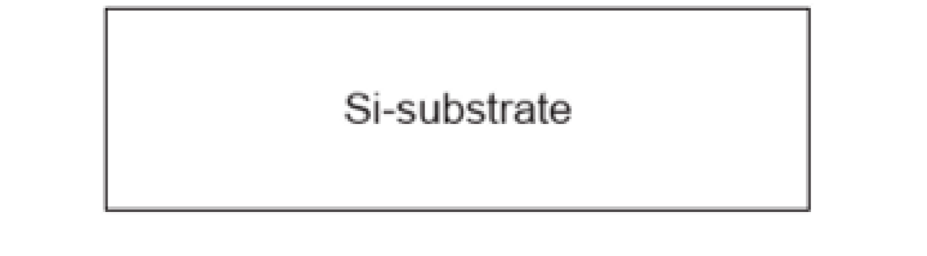

Step 2: Growth of SiO₂ layer

A SiO2 layer is grown on the surface of silicon wafer. This SiO2 layer acts as a barrier to the dopant throughout the processing and acts as an insulating substrate on to which various layers might be deposited and patterned. The thickness of this layer is generally around 0.000001m, which is very small.
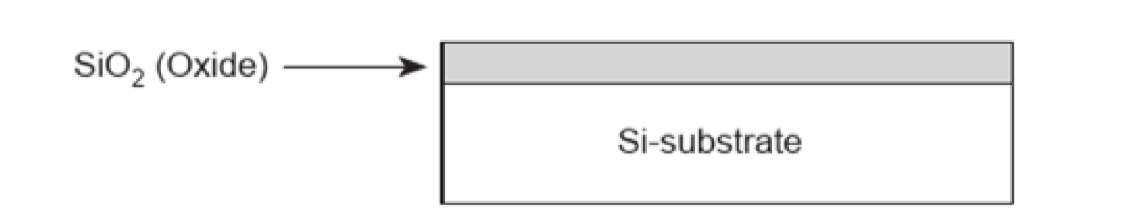

Step 3: Coating of photoresist material on SiO₂ layer

Now, on the surface of SiO₂ layer, a layer of photoresist material is coated. This Photoresist material layer gets deposited onto the wafer and spread uniformly to obtain required thickness.
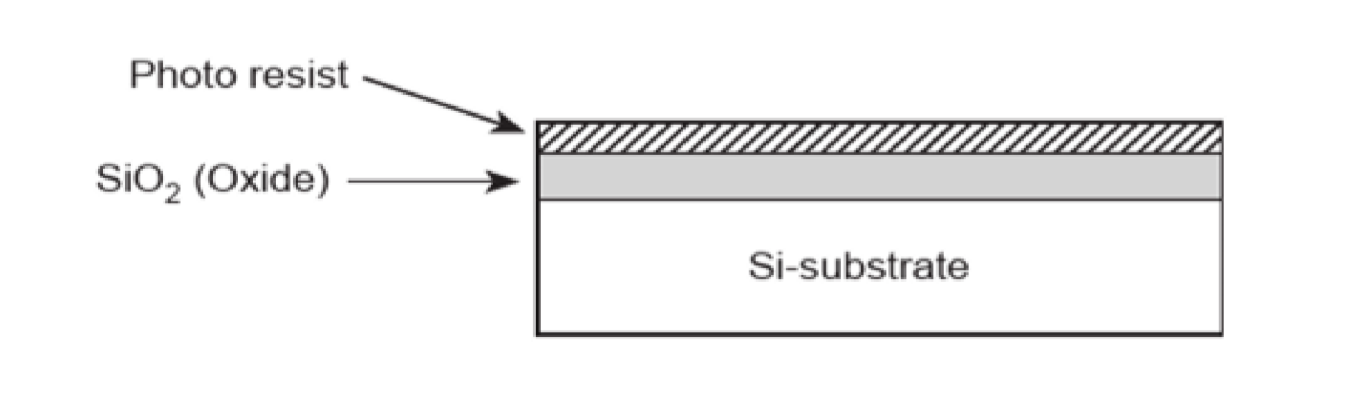

Step 4: Process of Photolithography

The photoresist layer deposited in the previous step is now exposed to ultraviolet radiation. For this a mask is created. Mask determines the regions through which the diffusion will takes place. The mask will split into two regions, one which is covered and another which is exposed to UV radiation. The areas which get exposed by UV radiation becomes polymerized (hardened). The areas where diffusion process will take place are guarded by the mask.

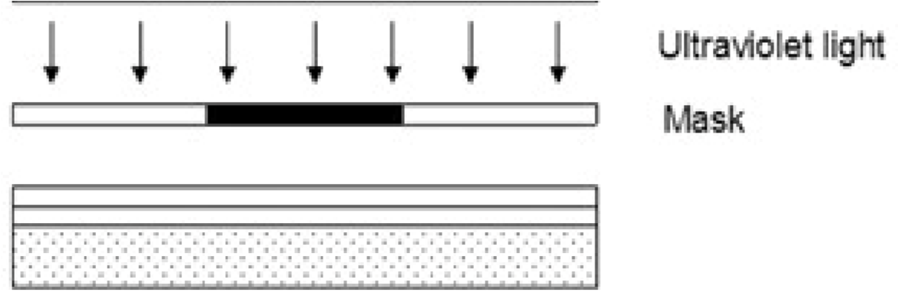

Step 5: Etching

The unexposed areas are removed from the surface and the regions are etched together to form a clean wafer surface as shown below:
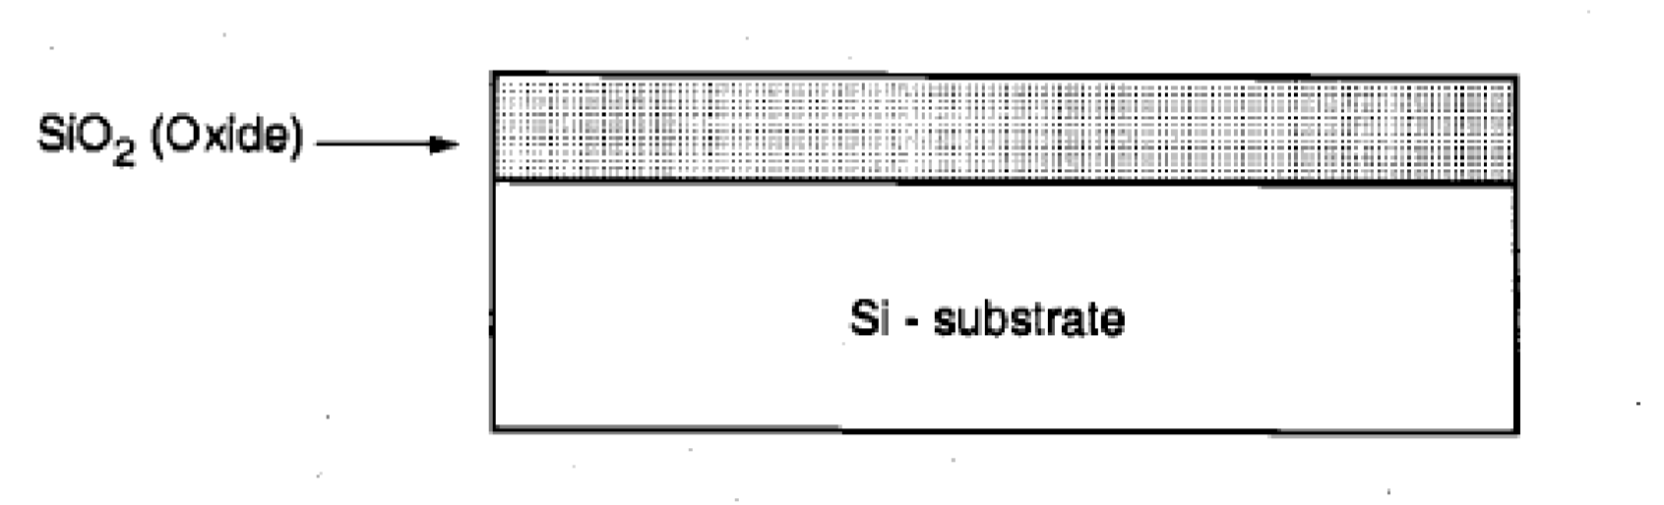

Step 6: Growth of SiO₂ and Polysilicon layer

Now another layer of SiO₂ of 0.2 pm thickness is deposited over the entire surface. Then a layer of polysilicon is grown above the oxide layer. The polysilicon layer is deposited by CVD method, this forms gate structure of NMOS.

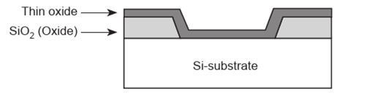

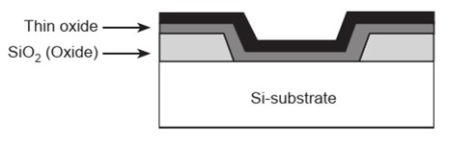

Step 7: Diffusion Process

The oxide and the polysilicon layer on the surface of the wafer is etched and n-type impurities are introduced by the diffusion process into the specified exposed area. The n-channels at the source and drain terminals are established.

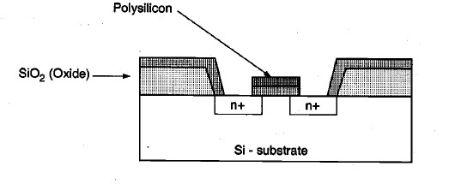

Step 8: SiO₂ and photoresist is again deposited on the source and drain terminals

The process in step 6 is again repeated to protect the source and drain terminal. The oxide layer is etched from the surface of the wafer so that the two terminals can be created. The SiO2 and photoresists are deposited and photolithography process is repeated. The contact holes area are left exposed and space for connection are left behind.
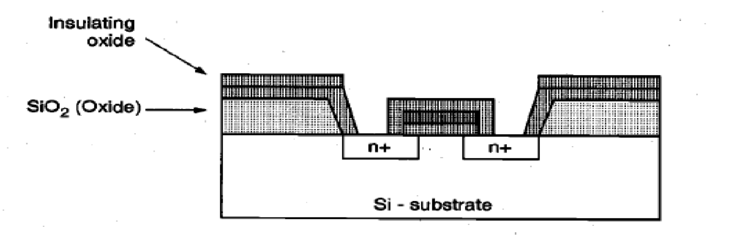

Step 9: Deposition of Metal layer

This is the last step of the NMOS fabrication process. A layer of evaporated aluminium is spreaded on the surface of wafer including the contact holes. This aluminium layer is around 1um thick. The metallic layer is again masked and etched (photolithography) to form the desired interconnection pattern.
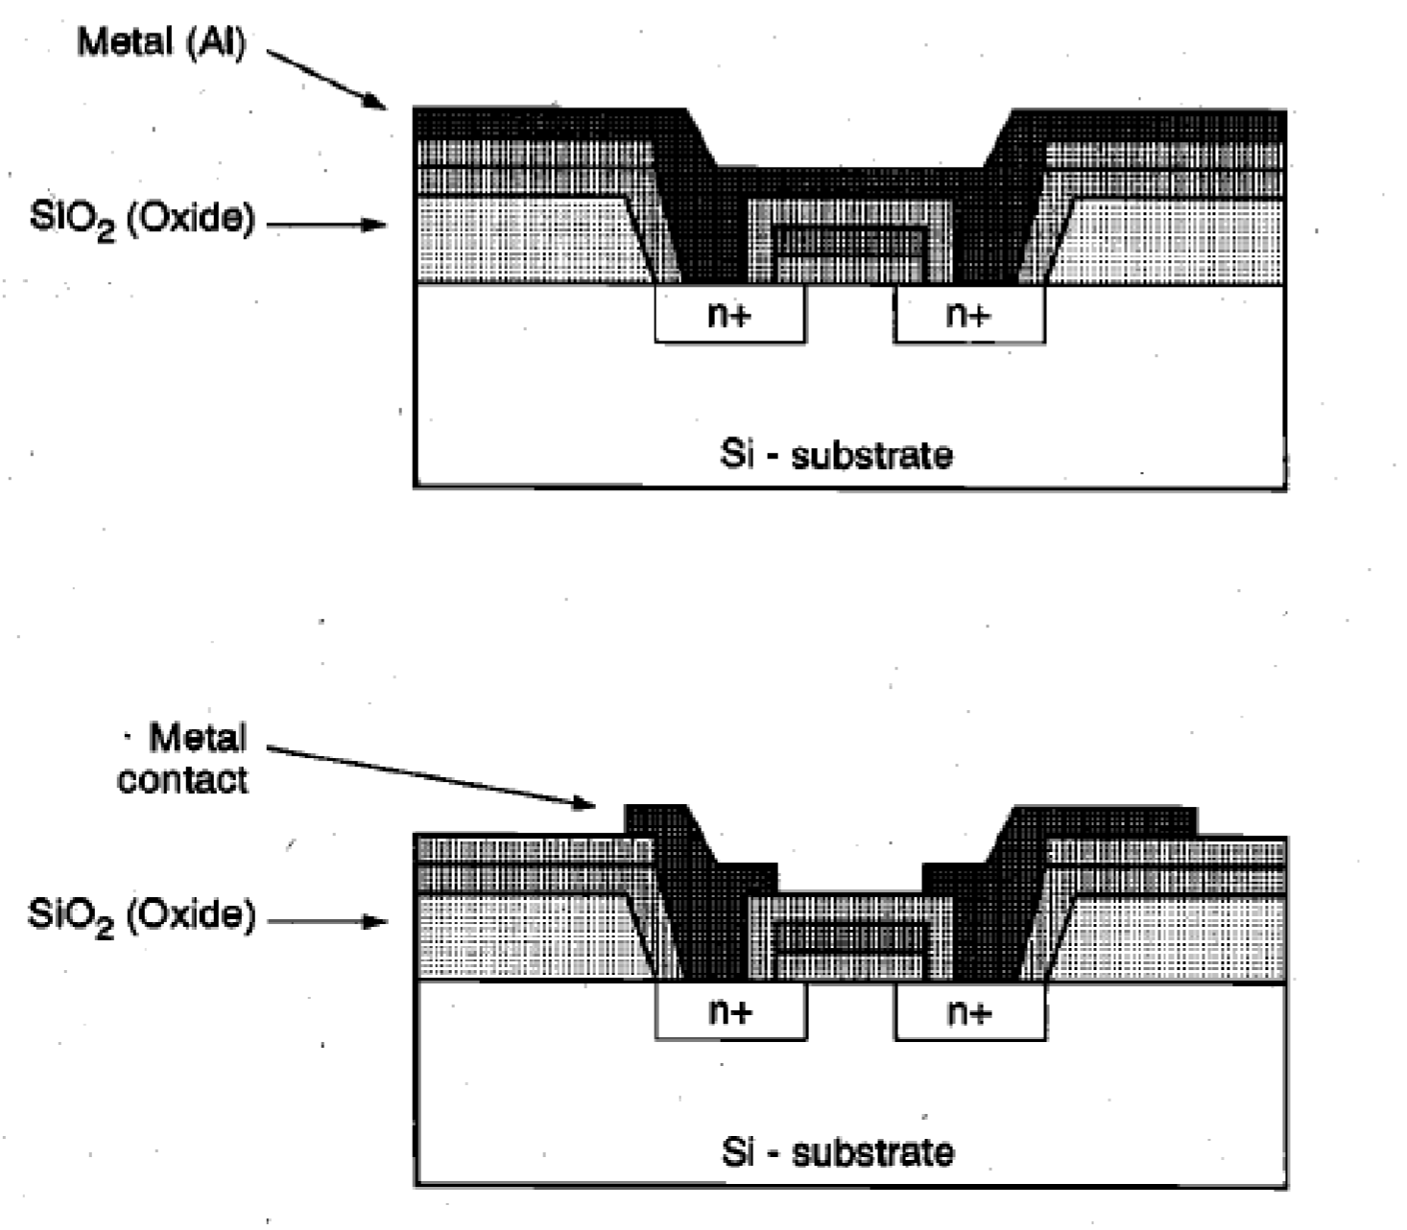

III. CMOS IC FABRICATION

CMOS stands for Complementary Metal Oxide Semiconductor and this is the next technology whose fabrication process will be studied in this section. It is a combination of NMOS and PMOS which are fabricated in different ways. In this a PMOS is produced by placing it in the n-well which has a p-type channel. And NMOS is similarly created as discussed in NMOS fabrication section.

The various steps involving CMOS fabrication process is discussed below:

Step 1: Wafer Selection

We select a silicon wafer in which we will dope p-type impurities and these impurities are trivalent in nature and so the doped wafer formed will be a p-type substrate.


Step 2: Growth of SiO₂ layer

A SiO₂ layer is grown on the surface of silicon wafer that protects the substrate as discussed in the step 2 of NMOS fabrication process section.

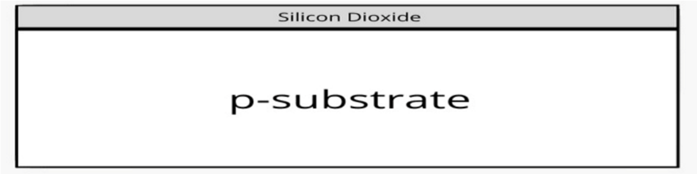

Step 3: Coating of photoresist material on SiO₂ layer

In this, on the surface of SiO₂ layer, photoresist material is coated. It will help us in forming the n-well on the p-type substrate.
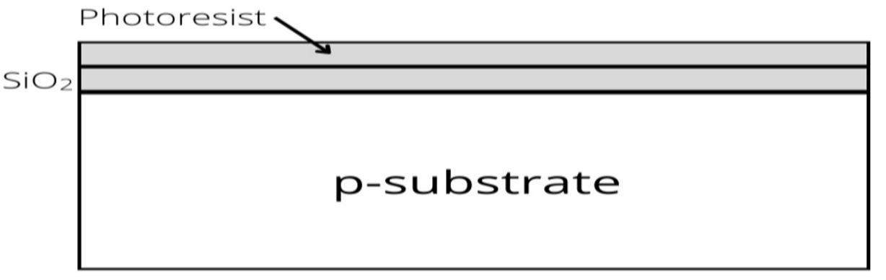

Step 4: Formation of N-Well

At this stage, the photoresist material is highly insoluble so we place a mask over the substrate covered by SiO₂ and photoresist layer. Through this n-well mask uv light is exposed (photolithography).

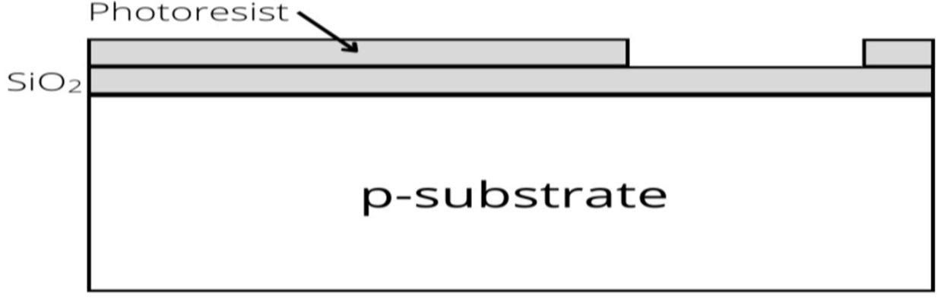

Step 5: Oxide Etching

As we saw in the previous figure the right side of the wafer is not covered by the photoresist. Since we have to form a n-well in this part we will etch the oxide layer using Hydrofluoric acid. So, along with the oxide layer the remaining photoresist will also be etched. Now, our silicon wafer is ready to get dopped in the n-well area.
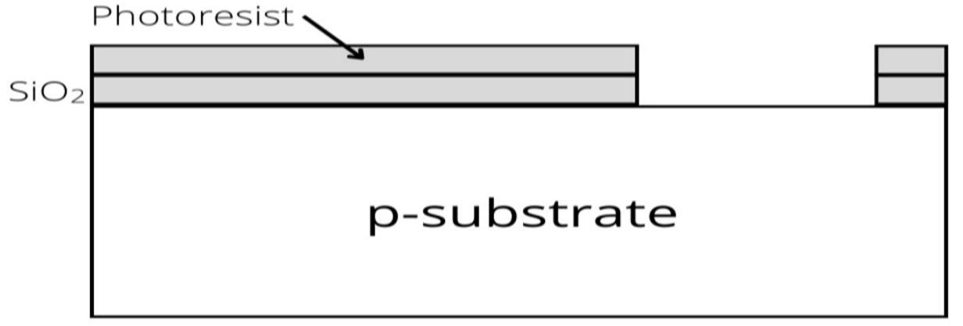

Step 6: Diffusion in N-Well

Now, we will use the diffusion process to form a n-well on the right side of the wafer. Using this diffusion process impurities will be added to the right part. Ion implantation can also be used to create the n-well.
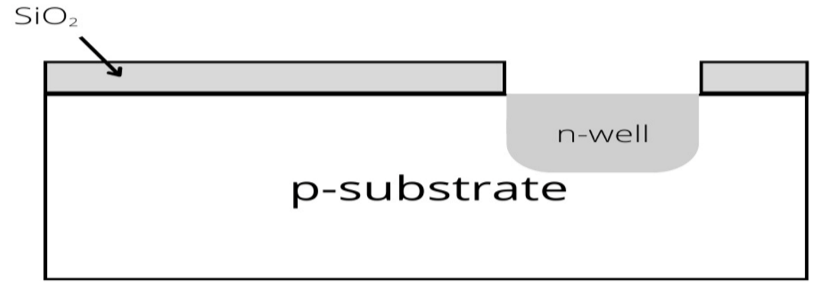

Step 7: Removal of SiO₂

The remaining oxide on the surface of the wafer is etched with the help of Hydrofluoric acid (photolithography process is repeated).

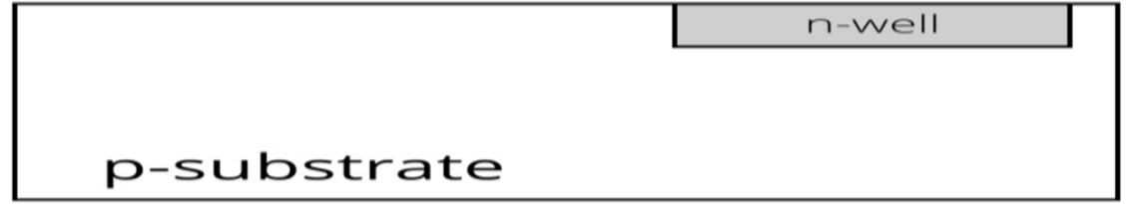

Step 8: Gate Formation

In the previous step, we removed the remaining oxide layer to create a gate junction. A polysilicon layer is added to the surface of the wafer by using CVD process to form a gate structure. This layer of polysilicon is heavily doped over a thin gate oxide.

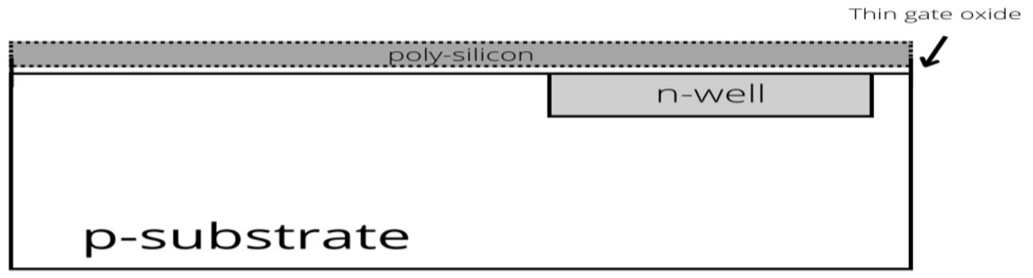

Step 9: Patterning of polysilicon layer

As we know CMOS is a combination of PMOS and NMOS, so we need two separate gate terminals. To obtain these two separate gate terminals photolithography process is repeated. The two gate terminals which are formed are shown below in the figure.

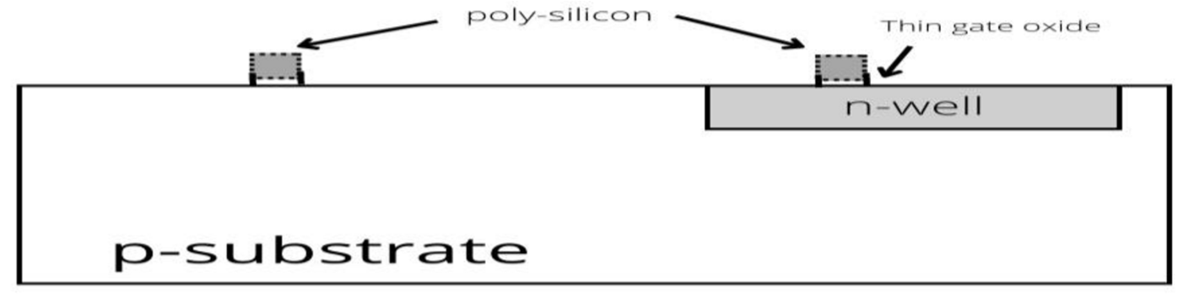

Step 10: Diffusion Pattern

The entire surface of the wafer is covered by a protective thin layer of the oxide. The purpose of this thin layer is to protect the two gate terminals.

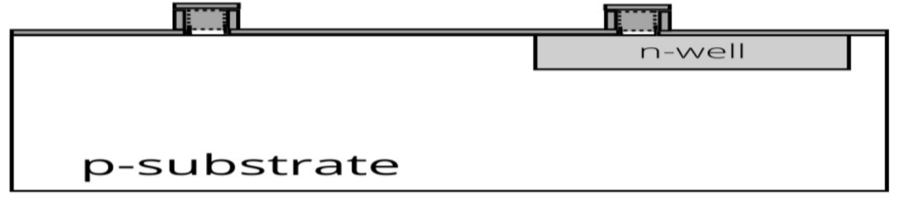

Step 11: Formation of source and drain

To form the source and drain terminals the protective oxide is removed using photolithography process. After the photolithography process is completed two vacant areas are created.

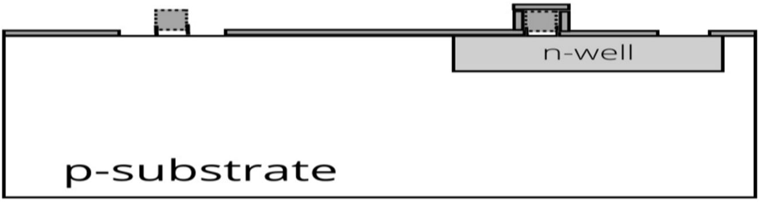

Step 12: N-Diffusion Regions

The two vacant areas mentioned above includes two source terminals and two drain terminals on each side. The N-diffusion regions are produced either by diffusion or ion implantation process. Now, the source and drain terminals are automatically formed on the adjacent sides of the gate terminals. During this process the wafer is heated to a high temperature to create a n-well regions through the diffusion process.
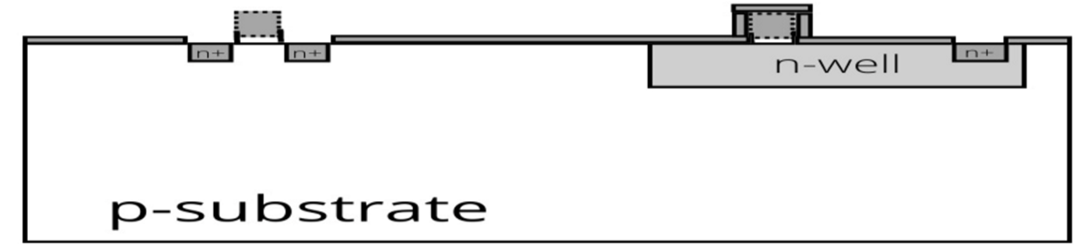

Step 13: P-diffusion

In the earlier step, the n+ regions are already created and since NMOS has n+ source and drain regions while the PMOS has p+ regions. Now, the p+ diffusion mask is used (photolithography) which completes our formation of all the active regions of the MOS transistors.
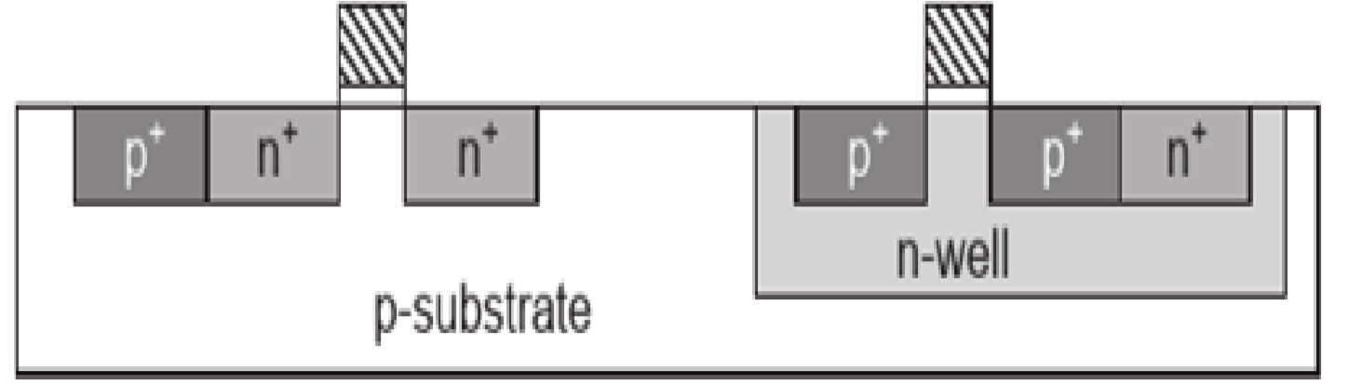

Step 14: Insulating field oxide deposition

In order to insulate the wafer, the field oxide SiO₂ is deposited on the surface. Now, we will etch the oxide where contact cuts are needed.

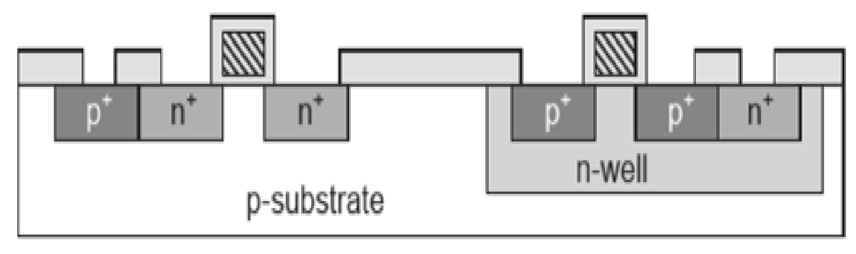
Step 15: Metal Formation

Now, evaporated aluminium is coated on the surface of the wafer. This forms a metal layer on the surface of the wafer. Now, patterning (photolithography) is done to obtain the contact holes.

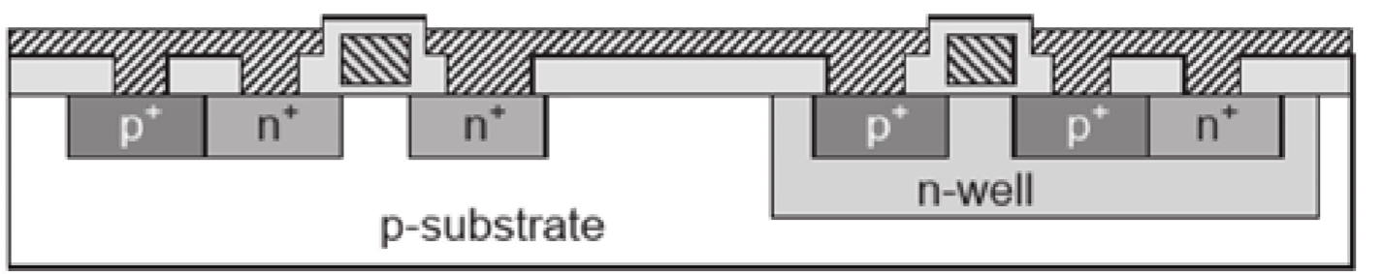

The formation of CMOS is completed.

IV. BJT FABRICATION

Bipolar transistor fabrication and their shape has come a protracted manner since the first transistors were made. Today’s transistors are made suing sophisticated tactics and the structure of transistor permits them to have very high stage of performance. The unique transistor made by Bardeen, Brattain and Shockley consisted of two very narrowly spaced contacts on a germanium base. The shape of this transistor consisted of two-point contacts on a base of germanium. These days the transistors are made by using various methods and of different structures. They might be diffused, epitaxially grown or they will use a mesa production. In essence a transistor consists of an area of both p -type of n type semiconductor sandwiched among areas of oppositely doped silicon. As such gadgets can be either a p-n-p or an n-p-n configuration.
There are 3 terminals, namely the emitter, base, and the collector. The base is the only within the centre and it's far bounded via the emitter and collector. Of the two outer the collector is frequently made large as that is in which most of the heat is dissipated.
The base derives its name from the first point attached transistors in which the centre connection also fashioned the mechanical "base" for the structure. It's important that this region need to be as skinny if high stages of modern advantage are to be executed. Often it can be handiest for about 1 micro meter throughout. An emitter is where the current is emitted, and the collector is wherein they're collected. BJT Fabrication steps are as follows:-
Step 1: The BJT Fabrication - starting fabric

The starting material for a vertical n-p-n arrangement is p-type substrate doped at 10^s16 /cm3 or less.



Step 2: The BJT Fabrication - First Oxide Deposition

Using a Chemical Vapour Deposition (CVD), oxide is deposited at the surface of wafer.


Step 3: Patterning of the First Oxide

Photoresist spun on the top of the oxide and is exposed using the buried layer mask. The BL mask is commonly generated mechanically from other masks.
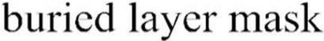
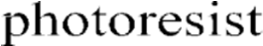

Step 4: Etching of the First Oxide

Using wet etching process, a window which is corresponding to the buried layer mask is opened in the oxide.

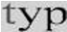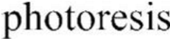

Step 5: The Final Buried Layer Window

After the left over photoresist is stripped, the deposited oxide has an opening etched within the location provided by the buried layer mask.
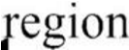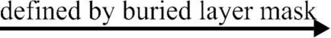

Step 6: Implant of Buried Layer

The buried layer is fashioned with a excessive density (dose) implant of n-type dopant, typically phosphorous. A few lateral diffusion of dopants takes area in the course of the implant. Dopant is also brought into the overlaying oxide.

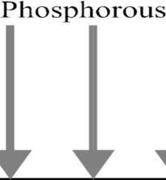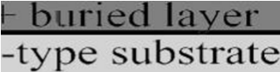

Step7: The final Buried Layer

After the overlaying oxide is eliminated (etched), the result is a surprisingly doped buried layer place in the unique silicon substrate.

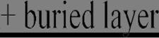

Step 8: Deposition of Epitaxial Layer

Using epitaxial deposition (just like CVD), a layer of very excessive high-quality (crystalline) silicon is deposited at the surface. Some diffusion of dopants happens from the tremendously doped buried layer into the greater lightly doped epitaxial layer.


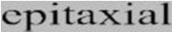
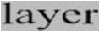

Step 9: The final Epitaxial Layer

The resulting epitaxial layer will shape the collector location within the BJT, with the highly doped buried layer forming an equipotential region under the device. The buried layer is now completely enclosed in silicon fabric. 4

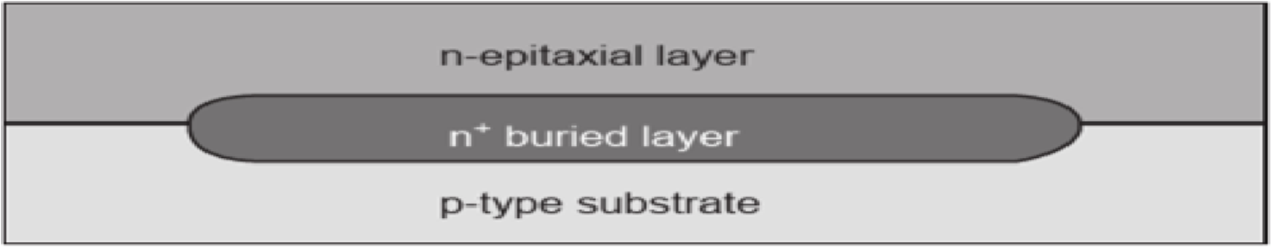

Step 10: Isolation of the exposure region

Layers of masking oxide layer and photoresist are fashioned at the surface. The photoresist is uncovered or exposed using an isolation implant mask.

Step 11: Isolation Implantation

A heavy p-type doping through ion implantation forms the p+ isolation regions. Implantation between the isolation regions is prevent by masking oxide which absorbs dopant.
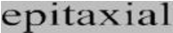
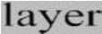
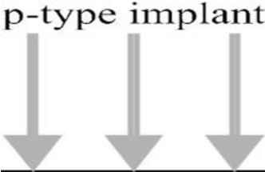

Step 12: Final Isolated Structure

Once the isolation reaches the underlying substrate the masking oxide is removed.

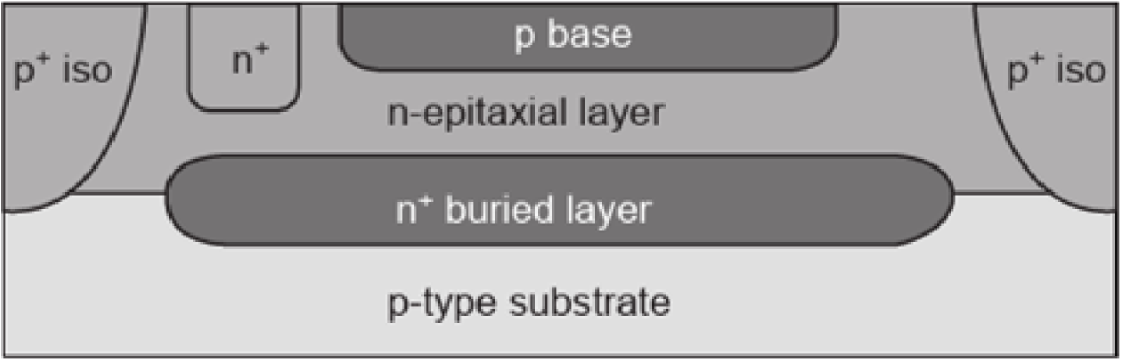

Step 13: Illustration of p+ Isolation

Through connecting to the underlying substrate, the p+ isolation implants electrically disconnect regions of the epi layer from every other. The pn junction formed between the p+ implants and the n type epi layer provides the isolation electrically.

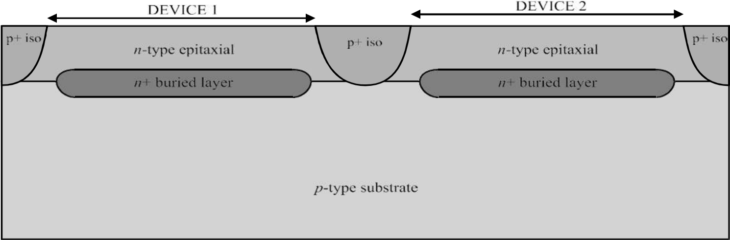

Step 14: Sinker mask exposure

Connection may be made to the buried layer (collector) by usage of a sinker, an implantation of high concentration and significant depth. Oxide and PR layers are exposed through a sinker mask.

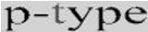

Step 15: Sinker Implantation

N type impurities are implanted into the window etched in the oxide to form a sinker.
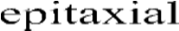
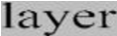
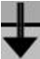

Step16: Final Sinker structure

Whether the sinker will reach down the buried layer or not depends on the condition of the implantation and thickness of the buried layer.
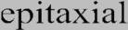
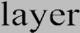
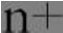
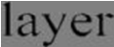
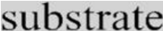
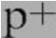

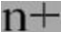

Step 17: Base mask publicity

The oxide is formed and the region in which active base has to be formed is exposed using the base mask.

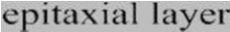
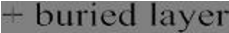

Step 18: Base area Implantation

Implantation is performed into the epi layer using a p type impurity (usually boron) through the oxide window and p type base region is formed.
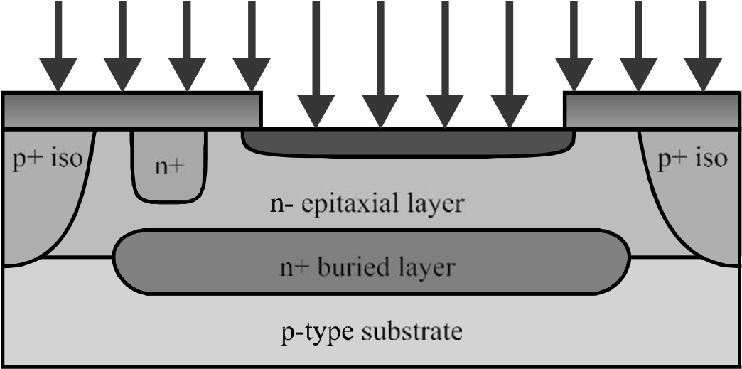

Step 19: Final Base Region

After base area implantation is complete, a counter doped base region has been created in the n-type collector.

Step 20: Now the Emitter Region Exposure

PR layers are exposed using an emitter mask on the glass plate.

Step 21: Emitter Implantation

A very heavy n-type dopant (usually Arsenic) is implanted through the oxide opening to form the emitter. It is quite critical for the BJT’s working.
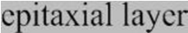
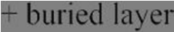
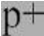
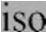
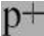
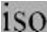

Step 22: At the end Emitter Structure and Contact Cut Exposure

N+ emitter region in the p-base completes the basic BJT structure, only metal contacts remain. Now thin Oxide is deposited which will isolate metal connections. Photo Resist is exposed using contact cut mask.
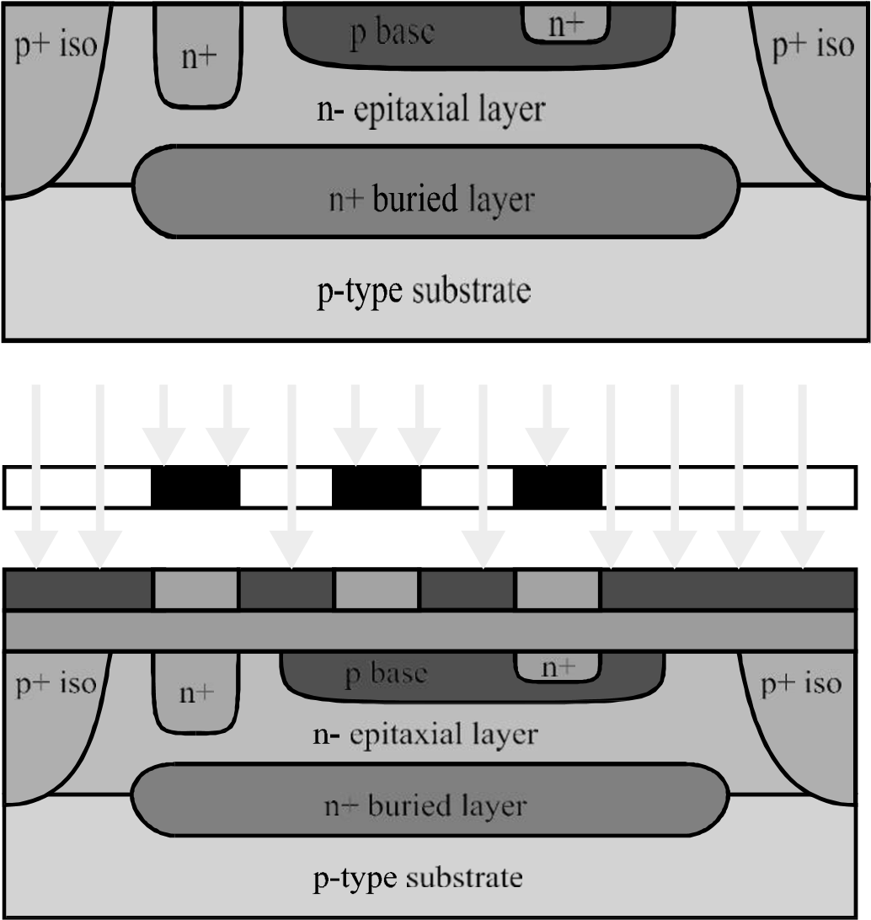

Step 23: Contact Etching

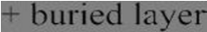
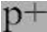
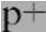
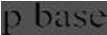
This openings requires selectivity so etching process does not remove emitter region, therefore wet Chemicals used.

Step 24: Final Contact Cuts after etching

Openings have been created in the oxide layer which will allow access to the collector, base and emitter regions.

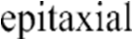
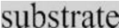
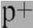
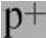
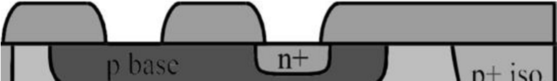
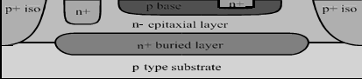

Step 25: Metal Deposition and its Exposure

After metal is deposited and Photo Resist formed on the surface, the exposure is performed with the help of a metal mask.
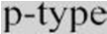
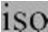
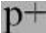
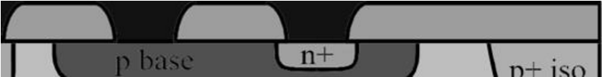

Step 26:- Final Interconnect Structure

As the metal has been etched to form the interconnections between contacts, the final structure is complete. The Modern processes would use more than one layers of metal.
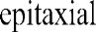
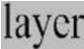
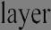
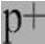
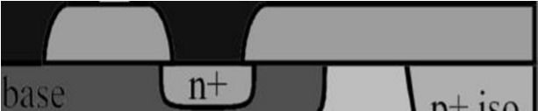

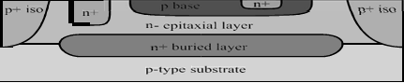

Step 27: Single Emitter, Base and Collector regions

Top view shows the various masks used to realize the structure. The Cross section is duplicated to show the correspondence. Buried layer and the isolation masks can be generated automatically by based on size of base region and position of collector region.

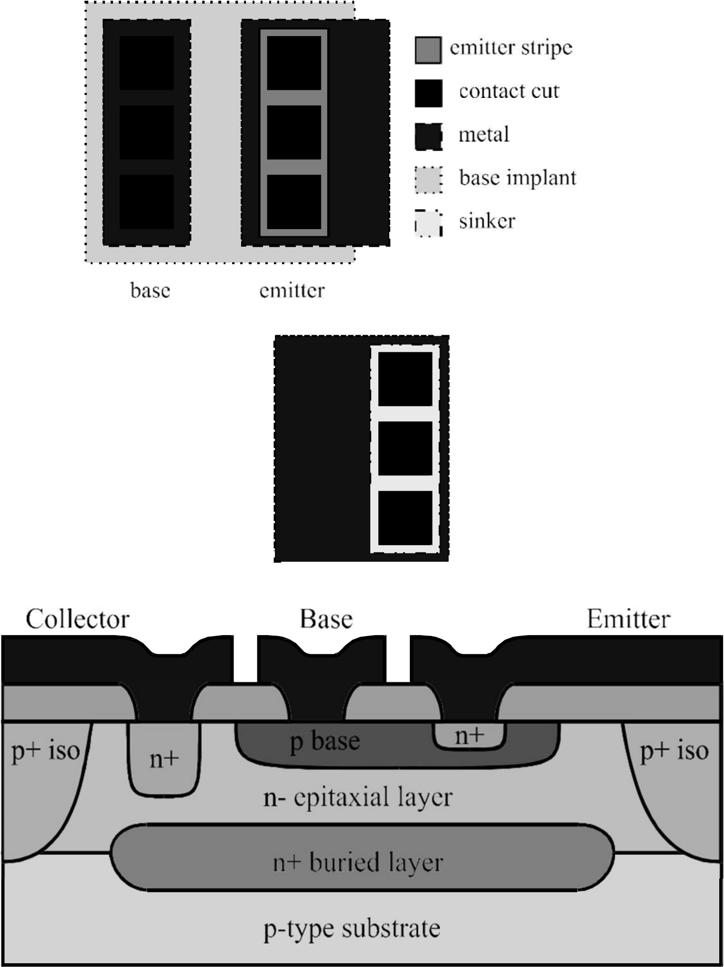

REFERENCES

- S.M. Sze, VLSI Technology, 2nd ed., Tata McGraw Hill Education Pvt. Ltd , New Delhi, pp.466-513.
- S.M. Sze Semiconductor Devices : Physics and Technology, Wiley , New York, 1985.
- Dr.Ahmed Khairy,(2020).Integrated Circuits Technologies, ECE 344 Course, AIET Lectures.
- L.M. Branscomb, “The Computer’s Debt to Science,” Perspectives in Computing, Vol. 3, No. 3, October 1983, pp. 4–19.
- K.M. Gardiner and S.R. Halley, “Manufacturing High-Density Memory Chips,” Solid State Technology, October 1981, pp. 117–122.
- W.G. Oldham, “The Fabrication of Microelectronic Circuits,” The Microelectric Revolution: The Complete Guide to the New Technology and Its Impact on Society,” Edited by T. Forester, MIT Press, 1980.
- W. Helgeland, K. Kerwin and C. Chartier, “Growing Semiconductor Crystals Using the Czochralski Method,” Microelectronic Manufacturing and Testing, April 1983, pp. 41–44.
- C.A. Deckert and D.L. Ross, “Microlithography- Key to Solid State Device Fabrication,” J. Electroch. Soc, Vol. 127, No. 3, March 1980, pp. 45–56.
- D.A. Buckley and P.A. Hunt, “Resists for Microlithography: The State of the Art,” Microelectronic Manufacturing and Testing, February 1982, pp. 15–19.
- B.E. Deal, “The Thermal Oxidation of Silicon,” Proceedings of the Tutorial Symposium on Semiconductor Technology, ed. by D. Doane and D. Fraser, The Electrochemical Society, 1982, pp. 15–42.
- M.I. Current and K.A. Pickar, “Ion Implantation Processing,” Proceedings of the Tutorial Symposium on Semiconductor Technology, ed. by D. Doane and D. Fraser, The Electrochemical Society, 1982, pp. 65–84.
- K.N. Tu, “Thin Alloy Films for Metallization in Microelectronic Devices,“ Treatise on Materials Science and Technology-Vol. 24: Preparation and Properties of Thin Films, ed. by K.N. Tu and R. Rosenberg, Academic Press, New York, 1982.
- M.A. Nicolet and S. Lau, “Formation and Characterization of Transition-Metal Silicides,” VLSI Electronics-Microstructure Science-Vol. 6: Materials and Process Characterization, ed. by N.G. Einspruch and G. Larrabee, Academic Press, New York, 1983.
- J.W. Coburn, “Plasma Assisted Etching,” Proceedings of the Tutorial Symposium on Semiconductor Technology, ed. by D. Doane and D. Fraser, The Electrochemical Society, 1982, pp. 177–217.
- D.L. Flamm, V.M. Donnelly, and D.E. Ibbotson, “Basic Principles of Plasma Etching for Silicon Devices,” VLSI Electronics-Vol. 8: Plasma Processing for VLSI, ed. by N. Einspruch and D. Brown, Academic Press, New York, 1984.
- J.A. Mucha, “The Gases of Plasma Etching: Silicon-Based Technology,” Solid State Technology, March 1985, pp. 123–127.
- L.S. Goldman and P.A. Totta, “Area Array Solder Interconnections for VLSI,” Solid State Technology, June 1983, pp. 91–97

