Recent Advances in Radiotracer Techniques for Soil Erosion and Sedimentation Studies
Moumita Ash¹, Plabani Roy¹
¹Division of Soil Science and Agricultural Chemistry, ICAR-Indian Agricultural Research Institute, New Delhi, India, PIN-110012
¹Ph.D. Research scholar (e mail: moumitaiari2019@gmail.com), ¹Ph.D. Research scholar (e mail: plabaniroyiari@gmail.com)

ABSTRACT

Soil degradation induced by erosion represents a major threat to food production and ecosystem service globally. In India, around 95 million ha of the land area is impacted by soil erosion. There is an urgent need to obtain reliable quantitative data on the extent and rates of soil erosion to provide a more comprehensive assessment of the magnitude of the problems and to underpin the selection of effective soil conservation measures. This chapter describes the use of fallout radionuclides (FRNs) particularly, ¹³⁷Cs, ⁷Be, ²¹⁰Pb excess, etc. afford an effective and valuable means for studying erosion and deposition within the landscape. The key advantage of this approach is that it can provide retrospective information on short- term (few days), medium-term (30–40 years), and long-term (100 years) erosion/deposition rates and spatial patterns of soil redistribution, without the need for long-term monitoring programs. Different theoretical models have been used to convert these fallout radionuclide inventory data to quantitative estimates of erosion and deposition rates. The models varied in complexity from the simple proportional model (PM) to more complex mass balance models (MBMs) and models which attempt to describe the key processes controlling the distribution of these FRNs in the soil profile. Mass balance model- 3 (MBM-3) is considered as one of the superior models, as it additionally considers soil redistribution due to tillage erosion. The spatial patterns of soil redistribution provided by the ¹³⁷Cs and soil- morphological methods are also generally similar. However, the USLE-based model provides good estimates of sediment mobilization from the slopes but fails to provide an adequate representation of the spatial pattern of soil redistribution because it takes no account of within-slope redeposition. However, a large number of databases are required for further validation on the use of the radiotracer technique in different landscapes and land uses.

Key words: fallout radionuclides (FRNs), simple proportional model (PM), mass balance models (MBMs), USLE
INTRODUCTION
Natural or geological soil erosion is a constructive process with numerous ecological functions viz. formation of alluvial and aeolian (loess) soils, weathering of aluminosilicates and sequestration of atmospheric CO₂, formation and evolution of the landscape with distinct soil types in relation to landscape position, biogeochemical recycling, etc. However, anthropogenic perturbations have drastically accelerated the process leading to severe negative effects on ecosystem functions and services and adverse transformation/dissection of the landscape. Globally soil erosion has reached a level that endangers the sustainable supply of food for the growing global population. It already threatens food production and ecosystem service delivery. Globally, 1.1 billion hectares (b ha) of land area is affected by soil erosion of which about 0.75 b ha is in a severe state. In India, total 82.6 million hectares (m ha) of land area is subjected to water erosion. Approximately 12.4 m ha of land area is impacted by wind erosion. Around 61% of net sown area and 45% of gross cultivated area is affected by any of the two forms of erosion (NRAA, 2008). Being a complex transformational process, accelerated soil erosion has numerous on-site and off-site impacts (Figure 1) (Lal, 2014)

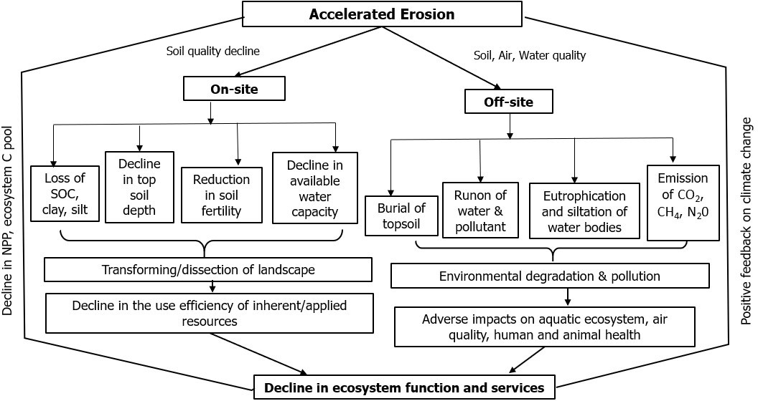

Figure 1 Adverse effects of accelerated soil erosion on ecosystem functions and services

In the light of the serious threat that soil erosion poses, there is a pressing need for a systematic assessment of land degradation due to erosion using appropriate techniques. Radiotracer techniques particularly include environmental radionuclides or fallout radionuclides (FRN) such as caesium-137 (¹³⁷Cs), excess lead-210 (²¹⁰Pbex), and Beryllium-7 (⁷Be), that are being increasingly used to obtain information on soil redistribution rates associated with soil erosion and sediment budget investigations (Zapata, 2002).

SOIL EROSION ASSESSMENT: CONVENTIONAL VERSUS RADIOTRACER TECHNIQUE
Various research projects on water erosion processes and erosion risks assessment based on different conventional techniques such as remote sensing, morphometric investigation combining geographic information system (GIS), digital elevation model (DEM), radar photos, sediment transport models and sediment loading measurements, runoff plots and rainfall erosivity measurements etc. have been widely presented. Traditional monitoring and modelling techniques for soil erosion/sedimentation require many parameters and years of measurements of inter-annual and mid-term climatic variability and cropping practices evolution (Mabit et al. 2002). Conventional erosion and sedimentation methods are limited to provide mid-term trends in soil erosion. Nuclear techniques including fallout radionuclides (FRN), artificially labelled radionuclide have proven to be very powerful tools to trace soil erosion and sedimentation within the landscape from plot to basin scale and can complement the information provided by conventional erosion measurements and modelling. Major limitations of conventional methods and specific advantages of radiotracer techniques have mentioned in Table 1.

Table: 1 The main advantages of the use of the nuclear tracer technique versus conventional erosion and sedimentation techniques

Major limitations of Conventional  Methods  Modelling:  - Complexity, user friendliness  - Advanced IT facilities are required  - Precise information (e.g. Digital Elevation Model (DEM), climatic, soil and land-use data) is required  - Realistic model should be validated by real data collected by other conventional approaches or FRN  Erosion plots and rainfall simulator:  - Need at least 10 to 15 years of measurement  to integrate climatic variability  - All the erosion forms not taken into account due to the short scale of measurement  - Climatic dependence  Watershed measurement:  - No information obtained about the soil redistribution within the watershed as just the net erosion can be measured  - Need at least 10 to 15 years of measurement to integrate climatic variability  - Climatic dependence  - Measures net sediment production, not erosion rates | Advantages of radiotracer techniques  Fallout radionuclide Technique  - Single sampling within a short time  - Site disturbances is minimum  - Retrospective measurement of both erosion and deposition rate  - Short, medium, and long-term soil redistribution rate  - Time and resource efficiency  - All type of erosion  - Avoids long term monitoring programme  Artificial labeling of radionuclide  - Time and location independency  Fingerprinting Technique  Sediment source identification, tracking of sediment movement across the landscape at various temporal and spatial scales

Technique: 1

THE USEFULNESS OF FALLOUT RADIONUCLIDES (FRN) APPROACHES TO INVESTIGATE SOIL REDISTRIBUTION IN AGRICULTURAL LANDSCAPE

Three FRN isotopes (¹³⁷Cs, ²¹⁰Pb and ⁷Be) have been used worldwide to assess long, medium and short- term soil erosion and deposition processes (Mabit et al. 2018)
- Caesium-137 (¹³⁷Cs) with a half-life of 30.2 years, an artificial radionuclide originating from thermonuclear weapon tests and nuclear reactors releases. The spatial distribution of the ¹³⁷Cs fallout was determined by the location of the weapons testing, the pattern of stratospheric circulation and transport, and the annual precipitation amount. It shows a clear latitudinal zoning, with total fallout in the northern hemisphere being substantially greater than in the southern hemisphere. ¹³⁷Cs inventories in the southern hemisphere are, however, still measurable using appropriate detectors and counting times. The fallout of ¹³⁷Cs released into the troposphere by nuclear accidents e.g. Chernobyl had a more heterogeneous distribution, reflecting the atmospheric circulation and precipitation distribution immediately after the release.
- Lead-210 (²¹⁰Pb) with a half-life of 22 years, is a geogenic radioisotope that originates from the decay of ²²⁶Ra which produces short-lived gaseous ²²²Rn (half-life = 3.8 days). Most of this ²²²Rn decays to ²¹⁰Pb within the soil, producing supported ²¹⁰Pb, which is essentially in equilibrium with the parent ²²⁶Ra. However, some of the ²²²Rn diffuses upwards into the atmosphere, where it rapidly decays to ²¹⁰Pb. This ²¹⁰Pb is deposited as fallout, and, since it is not in equilibrium with the parent ²²⁶Ra, it is commonly termed unsupported or excess ²¹⁰Pb (²¹⁰Pbex), to distinguish it from the supported ²¹⁰Pb in the soil which is in equilibrium with the parent ²²⁶Ra.
- Beryllium-7 (⁷Be) is a short-lived cosmogenic radioisotope with a half-life of 53 days produced in the upper atmosphere by cosmic ray spallation on nitrogen and oxygen nuclei.

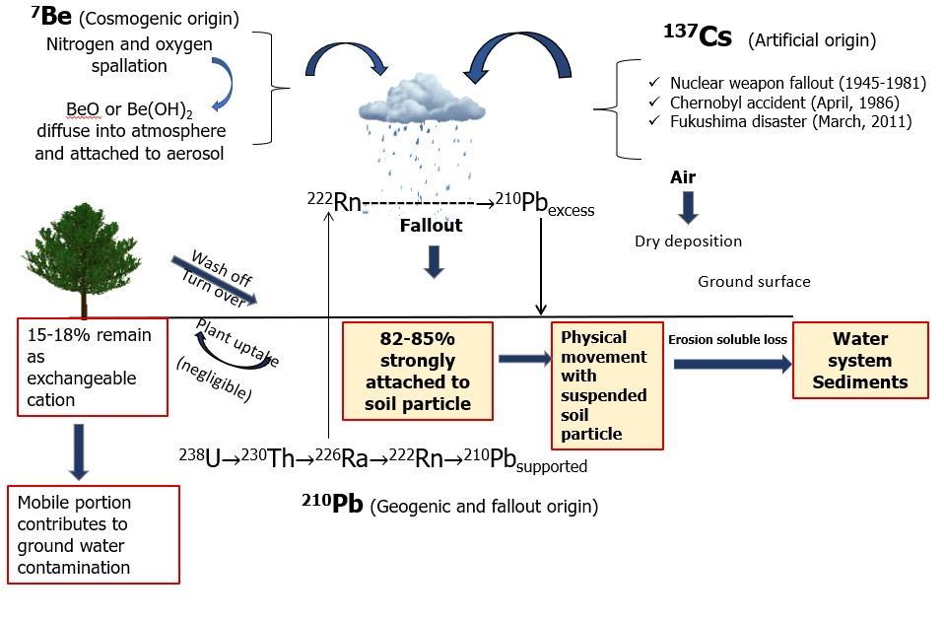

Figure 2 Origin of fallout radionuclides (Zupanc et al. 2010)

Due to their rapid and strong adsorption by fine soil particles, ¹³⁷Cs, ⁷Be and ²¹⁰Pbex are redistributed by mechanical processes of moving soil particles such as erosion. The use of these isotopes as well as their measurements is safe and they are already present in soil, one just measures the FRN soil activity background. Fallout radionuclide techniques allow the estimation of short and medium-term rates of soil redistribution integrating land use and climatic variability. Fallout radionuclide can be used to obtain average soil redistribution figures for time scales ranging from single event to many years of erosion processes, while direct measurements on erosion plots are related to single rainfall event or rather short periods of time. FRN methodologies integrate all processes involving soil particle movements and allow quantification of soil loss and deposition associated with sheet erosion, which is difficult to assess using other conventional approaches. Sampling of individual points allows spatially distributed information on rates and patterns of soil redistribution. Key features of these FRN are mentioned in Table 2.

Table: 2 Comparison of the key features of fallout radionuclides

Features | ¹³⁷Cs (decade) | Excess ²¹⁰Pb (100 years) | ⁷Be (few days)
Half life | 30.2 years | 22.3 years | 53.3 days
Covered time period | Since 1954 | > 100 years | Days-month
Scale of application | Plot to large watershed | Plot to watershed | Plot to field
Required analytical  facilities | Gamma ray spectroscopy | Gamma ray spectroscopy | Gamma ray  spectroscopy
Global patterns of reference inventory | High in northern hemisphere, low in  southern hemisphere | Largely unknown | Largely unknown
Depth distribution at eroding sites under  - Cultivation  - Pasture | - Uniform  distribution  - Exponential decrease | - Uniform  distribution  - Exponential decrease | Exponential decrease (both)
Energy (𝛾 emitter)  (keV) | 662 | 46 | 477

FALLOUTRADIONUCLIDE TECHNIQUE: IMPORTANT PARAMETERS

  - Activity Concentration: Radioactivity per unit of volume or mass e.g. Bq L⁻¹; Bq kg⁻¹

  - Inventory: Radioactivity per unit area (Bq m⁻²) or areal activity.
Inventory= CM/S
Where C is activity concentration (Bq kg⁻¹), m is dry mass of collected soil core and S is cross- sectional area of sampling tube

  - Cumulative mass depth (𝜻) or areal mass (kg m ⁻²):
𝒛

𝜻 = ƒ 𝝆 (𝒛')𝒅𝒛′
𝟎

Where, 𝜌 is soil density, z is actual soil depth
  - Relaxation mass depth (𝒉₀ ): The soil mass depth (kg m⁻²) at which the concentration of RNs reduces to 1/e of the concentration at the ground surface.

RECENT ADVANCES IN THEORITICAL MODELS ASSOCIATED WITH FALLOUT RADIONUCLIDE TECHNIQUE
Use of environmental radionuclide or FRN inventory to estimate rates of erosion and deposition is founded on comparison of the inventories at individual sampling points with a reference inventory, representing the local fallout input and thus the inventory to be expected at a site experiencing neither erosion nor deposition. A measured inventory for an individual sampling point less than the reference value is indicative of erosion, whereas an inventory greater than the reference value is indicative of deposition. Although such comparisons of measured inventories with the local reference value provide useful qualitative information on the spatial distribution of erosion and deposition in the landscape and on the relative magnitude of the values involved, in most instances quantitative estimates of erosion and deposition rates are required. The derivation of quantitative estimates is heavily dependent upon the existence of a reliable means of converting the magnitude of the measured inventory at a specific sampling point, relative to the local reference inventory, to an estimate of the rate of erosion or deposition at that point. Many different approaches have been used to convert FRN inventory measurements to quantitative estimates of erosion and deposition rates (Walling and He, 1993). These methods include both empirical relationships, and theoretical models and accounting procedures. The models varied in complexity from the simple proportional model to more complex mass balance models and models which attempt to describe the key processes controlling the distribution of FRN in the soil profile. Here attention has focussed on ¹³⁷Cs, excess ²¹⁰Pbex (Mabit et al. 2018) and ⁷Be (Blake et al.1999). These other radionuclides share most of the following assumptions associated with the ¹³⁷Cs technique:
- Wet deposition from rainfall is the dominant source
Strong affinity with soil particles, particularly the fine particles
- Exponential decrease of mass concentration and inventory with depth down a undisturbed soil profile and a homogenised distribution within the plough layer for cultivated sites
- Near uniform spatial distribution of inventories on undisturbed (uneroded) sites
- Once absorbed by soil particles, subsequent movement will only occur in association with soil particle

Table: 3 Various conversion models applicable to specific land-use
 | Cultivated | Pasture
137Cs | - Proportional model  - Simplified mass balance model  - Mass balance model 2  - Mass balance model with tillage | - Profile shape model  - Diffusion and migration model
210Pb | - Mass balance model 2  - Mass balance model with tillage | - Diffusion and migration model
⁷Be | - Profile Shape model | - Profile shape model

Table: 4 A list of parameter requirements for individual models

Model | Parameters required
Proportional model and Simplified mass balance model | Tillage depth, bulk density, year of tillage commencement
Mass balance model | Tillage depth, year of tillage commencement  proportional factor, relaxation depth, annual fallout flux
Mass balance model with tillage | Tillage depth, tillage constant, proportional factor, relaxation depth, slope length and slope gradient for each section of the  transact, annual fallout flux
Profile shape model | Profile shape factor

Use of ¹³⁷Cs as a tracer for assessment of soil erosion and sedimentation studies
Sac et al. (2015) conducted an experiment at western turkey to compare the annual erosion rate using ¹³⁷Cs and USLE technique. Proportional model was used for the uncultivated soil and two models that is proportional model (PM) and simplified mass balance model (SMBM) were used for two cultivated soil. In general, the difference between the two models becomes more important for the high soil erosion rates as it is in Kayısalan case (Table 5). The erosion rates derived from the PM remain always lower than those predicted with the SMBM. It is because, in contrary with PM, SMBM takes into account the effect of surfaced ¹³⁷Cs loss by erosion on change in the ¹³⁷Cs distribution in time along the plough depth.

Table: 5 Estimation of average annual erosion rates using ¹³⁷Cs technique and USLE model

Site No. | Sampling sites | USLE  (t ha⁻¹ yr⁻¹) | ¹³⁷Cs technique (t ha⁻¹ yr⁻¹)
Site No. | Sampling sites | USLE  (t ha⁻¹ yr⁻¹) | PDM | PM | SMBM
1 | Peynirli (uncultivated) | 16 | 15
2 | Yatagan (uncultivated) | 29 | 36
3 | Kirtas (uncultivated) | 28 | 27
4 | Umez (cultivated) | 46 |  | 47 | 70
5 | Kayisalan (cultivated) | 74 |  | 65 | 116

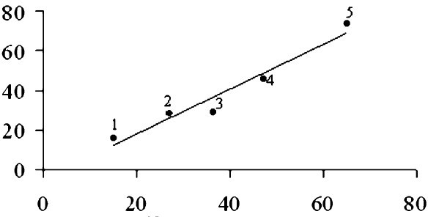


A good agreement (R=0.97) was also observed between soil losses predicted by two ¹³⁷Cs and USLE techniques (Figure 3). This indicates that in the all the regions studied, the soil loss by wind is not much effective since USLE technique does not include the wind erosion whereas ¹³⁷Cs technique does. The high erosion rates obtained in the cultivated sites in both techniques have pointed out a significant tillage contribution to soil loss and yet the water erosion seems to be the major component among several factors. That is why SMBM approach would be more suitable for water affected erosion studies in cultivated sites.

r= 0.97

¹³⁷ Cs technique (t ha-1 yr-1)
-1-1
USLE (t ha yr )

Figure 3 Relative agreement of soil erosion rate estimated through ¹³⁷Cs techniques and USLE method

Belyaev et al. (2005) revealed the superiority of ¹³⁷Cs technique in estimating soil redistribution rate over other conventional method like soil geomorphological mapping and USLE method. All the techniques employed document significant rates of soil redistribution, although the precise values vary substantially from 8.7 to 24.1 t ha⁻¹ year⁻¹ for gross erosion; 6.4 to 63.8 t ha⁻¹ year⁻¹ for within-slope redeposition that is gross erosion; and 2.2 to 12.2 t ha⁻¹ year⁻¹ for net erosion (Table 6). The most notable difference between the results is that for the estimates of sediment redeposition on the slopes and the lower parts provided by ¹³⁷Cs measurements and the soil-morphological method. Soil geomorphological mapping produced much higher rates of redeposition (63.8 t ha⁻¹ year⁻¹), whereas both ¹³⁷Cs calibration models yielded moderate values (6.4 t ha⁻¹ year⁻¹ from the proportional model and 11.8 t ha⁻¹ year⁻¹ from the mass balance model). The main reasons for this apparent discrepancy are probably: (a) a change in the spatial-temporal pattern of soil redistribution towards decreased deposition and increased erosion after the change in land use in the early 1950s; (b) selective deposition of coarser particles in the bottom, with the finer particles carrying the highest ¹³⁷Cs activities being transported further to the main valley bottom; (c) the possible influence of deep linear erosion features, such as ephemeral gullies, mobilizing subsoil material bearing no atmospheric fallout radionuclide content; (d) the insufficient depth of the bulk ¹³⁷Cs sampling within depositional locations.

Table: 6 Soil redistribution rates estimated by different methods

Method | 137Cs |  | Soil Geomorphological  Mapping (1864-2002) | USLE  (1864-  2002)
Method | Proportional model (1954-  2002) | Mass balance model  (1954-2002) | Soil Geomorphological  Mapping (1864-2002) | USLE  (1864-  2002)
Eroded area (ha) | 9.0 | 9.7 | 10.5 | 16.9
Gross erosion rate (t ha⁻¹ yr⁻¹) | 13.7 | 24.1 | 8.7 | 11.6
Volume eroded (t yr⁻¹) | 123 | 233 | 91 | 196
Gross deposition rate (t ha-1 yr-1) | 6.4 | 11.8 | 63.8
Net erosion rate (t ha⁻¹ yr⁻¹) | 6.5 | 12.2 | 2.2
Average annual sediment export (t yr⁻¹) | 117 | 222 | 40

The spatial patterns of soil redistribution provided by the ¹³⁷Cs and soil-morphological methods are also generally similar (Figure 4).
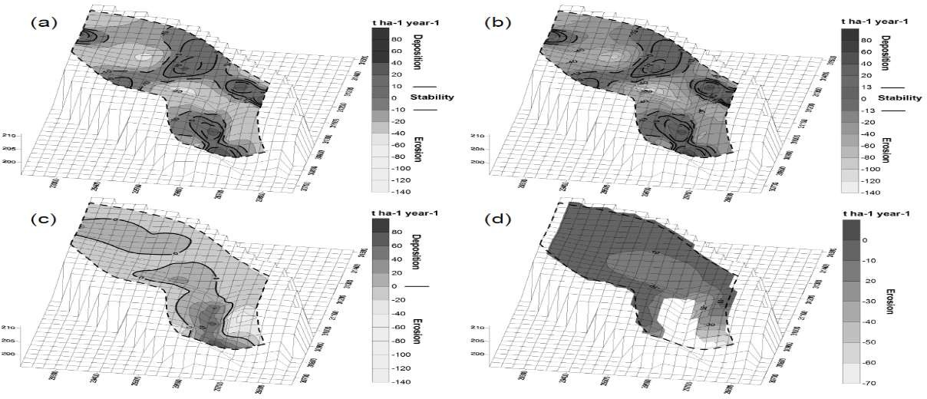

Figure 4 Sediment budget and spatial pattern of soil redistribution estimated by(a) ¹³⁷Cs method (proportional model); (b) ¹³⁷Cs method (Mass balance model); (c) Geomorphological method; (d)USLE based model
The use of ¹³⁷Cs as a potential environmental marker was examined for estimating soil erosion induced carbon losses on slopping agricultural land. Since soil erosion preferentially removes the finer soil particles, these results were used to assess erosion induced loss of OC. Mandal et al. (2019) used ¹³⁷Cs inventory data and convert it to soil loss by proportional model at doon valley in India and compared the data generated with actual field scale assessment. Although, 3–4% overestimation was observed in slightly and moderately eroded phases, but the accuracy level varied from 96% to 97% (Table 7). Thus, ¹³⁷Cs technology is a better method for soil erosion studies in the severely intensive croplands. It gives more accurate results for all types of erosion studies, including erosion due to water, wind and gravity, unlike the other traditional practices. Erosion induced carbon loss (EICL) value with soil erosion loss, CAR, SOC. CAR values ranged from 2.96 in slightly eroded phase to 2.69 in very severely eroded phase. In the present study, EICL was calculated from erosion rate, SOC concentration and CAR that varied from 136.68 to 383.84 kg ha^{–1} year^{–1} for different erosion phases (Table 8), leading to 27.33–76.76 kg C ha^{–1} year^{–1} as net C source to the atmosphere Carbon erosion was calculated using the following formula: The USLE-based model provides good estimates of sediment mobilization from the slopes but fails to provide an adequate representation of the spatial pattern of soil redistribution, because it takes no account of within-slope redeposition

Erosion induced carbon loss (EICL) or C-erosion (kg ha⁻¹ year⁻¹) = 𝑬𝒓𝒐𝒔𝒊𝒐𝒏×𝑺𝑶𝑪×𝑪𝑨𝑹×𝟏𝟎𝟎𝟎
𝟏𝟎𝟎
CAR (Carbon amplification ratio) = 𝑺𝑶𝑪 𝒄𝒐𝒏𝒕𝒆𝒏𝒕 𝒊𝒏 𝒔𝒆𝒅𝒊𝒎𝒆𝒏𝒕
𝑺𝑶𝑪 𝒄𝒐𝒏𝒕𝒆𝒏𝒕 𝒊𝒏 𝒐𝒓𝒊𝒈𝒊𝒏𝒂𝒍 𝒔𝒐𝒊𝒍

Table: 7 Accuracy percentage calculated for erosion rate using ¹³⁷Cs over actual field scale assessment
Experimental plot | Soil erosion measurement | Erosion rate (Mg ha⁻¹ yr⁻¹) | Accuracy (%)
Slightly eroded phase | Actual measurement | 7.6 | -
Slightly eroded phase | ¹³⁷Cs method | 7.90 | 103
Moderately eroded phase | Actual measurement | 11.6 | -
Moderately eroded phase | ¹³⁷Cs method | 12.10 | 104
Severely eroded phase | Actual measurement | 19.44 | -
Severely eroded phase | ¹³⁷Cs method | 19.26 | 99
Very severely eroded phase | Actual measurement | 33.60 | -
Very severely eroded phase | ¹³⁷Cs method | 31.46 | 93
Table:8 Estimation of erosion induced carbon loss (EICL) through ¹³⁷Cs technique

Erosion phases | % ¹³⁷Cs loss  (𝐀𝐫𝐞𝐟–𝐀 ×  𝐀𝐫𝐞𝐟  𝟏𝟎𝟎) | Erosion  (t ha⁻¹ yr⁻¹) | SOC (%) | CAR | EICL  (kg ha⁻¹ yr⁻⁻¹)
Slightly eroded phase | 21.88 | 7.90 | 0.59 | 2.96 | 136.88
Moderately eroded phase | 32.51 | 12.23 | 0.55 | 2.85 | 188.77
Severely eroded phases | 49.89 | 19.26 | 0.49 | 2.76 | 261.96
Very severely eroded phase | 81.48 | 31.46 | 0.46 | 2.54 | 383.84

Use of multi-radionuclide for soil erosion studies
While ¹³⁷Cs is the most commonly used radioisotope in soil erosion and sedimentation research, there is a compelling need to stay ahead of ²³⁹⁺ ²⁴⁰Pu suitability, as more than 60% of ¹³⁷Cs has already decayed, and it also has some additional advantages due to the following characteristics:
- Half-life 24,110 and 6,561 years for ²³⁹Pu and ²⁴⁰Pu respectively
- It is 𝑎𝑛 𝛼 emitters, decays to U 236
- It can be easily assessed by ICP-MS
Two separate experiment carried out by Alewell et al. (2014) and Meusburger et al. (2016) at Switzerland and Korea, they have found that there is a strong correlation between ¹³⁷Cs and ²³⁹⁺ ²⁴⁰Pu with r² value ranges from 0.91 in Switzerland and 0.99 at Korea (Figure 5)
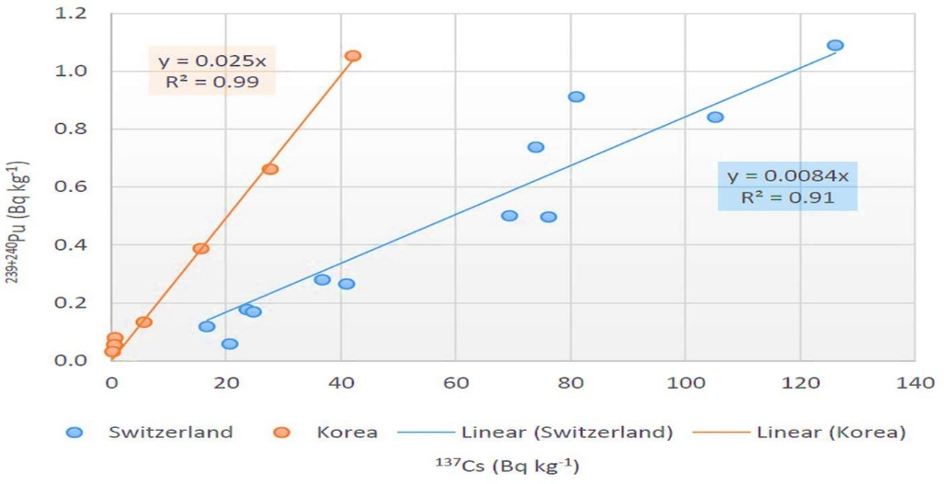

Figure 5 Examples of correlation between ²³⁹⁺²⁴⁰Pu and ¹³⁷Cs content in soils of two Swiss Alpine Grasslands and one catchment from the Republic of Korea
As ¹³⁷Cs is able to predict the erosion pattern for decades as up to 50 years it is technique which could be used singly, but other fallout radionuclides are having some limitation, like the difficulty in detection of ²¹⁰Pb excess and short half-life associated with ⁷Be, so most of experiment involve other FRN, results were also compared with Cs technique. Meusburger et al. (2016) estimated soil redistribution by ¹³⁷Cs and ²³⁹⁺²⁴⁰Pu Technique in two different fields i.e recently harvested maize field and the cabbage field, they have found that results from these two techniques are very similar and perfectly match with each other (Figure 6). Only the discrepancy found at the downslope which is may be due difference in the configuration of low land in cabbage field which does not allow accumulation of FRN or the changes in the fallout pattern

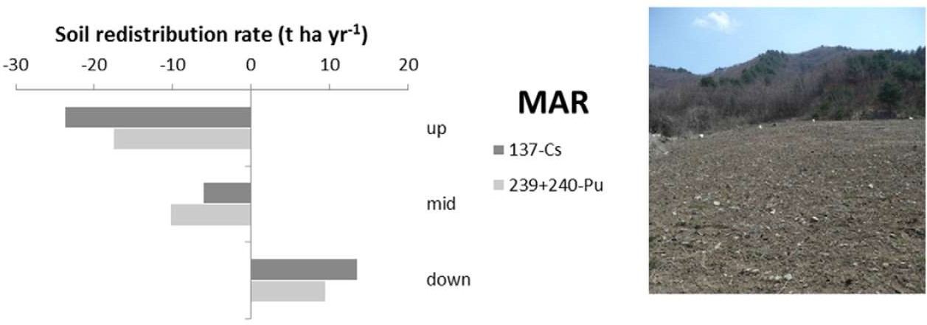
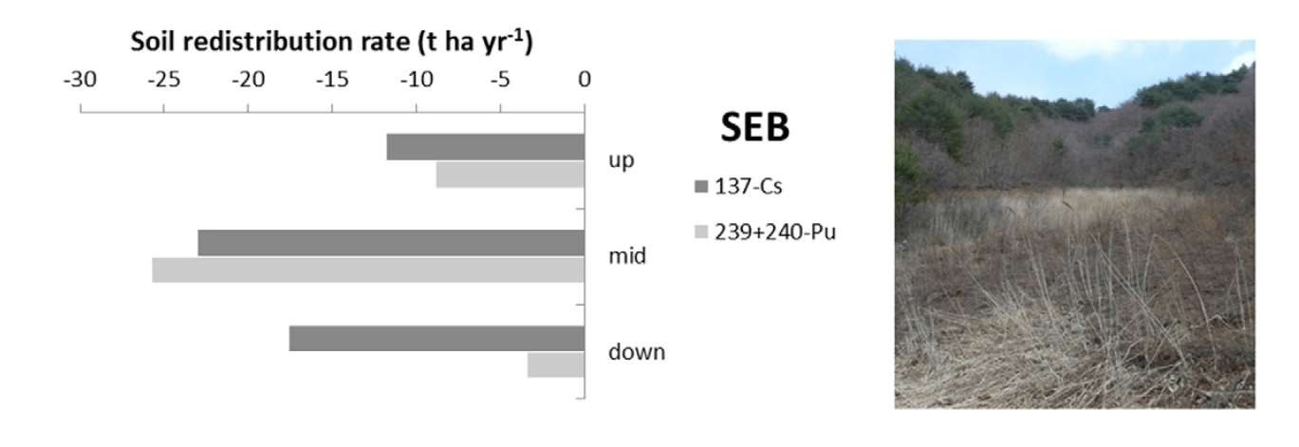
Cabbage field
Recently deforested maize field

Figure 6 Example of soil redistribution assessment for three specific transects with ¹³⁷Cs and 239+240Pu
Benmansour et al. (2013) calculated the sediment delivery ratio i.e, how much soil sediments are actually removing from the field. Despite the different period covered by radio isotopic techniques, the overall soil redistribution rates over 50 years (for ¹³⁷Cs) and 100 years (for ²¹⁰Pbex) seem to be similar and indicate that the soil erosion processes have not changed drastically over the past decades (Table 9). The high sediment delivery ratio (SDR), corresponding to the ratio of the net erosion to the gross erosion rate obtained with ¹³⁷Cs and ²¹⁰Pbex. All the approaches, highlighted that most of the sediment mobilized was moved out of the field. This is a logical result based on the fact that the soil cultivation is done in the main slope direction with slopes of 17%. This high SDR also reflects the fact that using the ¹³⁷Cs and ²¹⁰Pbex technique, the eroded area represents 92 to 93% of the field surface and the deposition area only 7 to 8%. In general, the data on erosion rates obtained by RUSLE and radionuclides using MBM 2 were similar. However, the sedimentation process such as the mean and gross deposition within the field was found to be higher with the RUSLE model, leading to a SDR slightly lower than the one obtained with both radio isotopic approaches. The RUSLE model that doesn’t take into account the tillage effect provided values of soil loss rates slightly lower than those obtained by the MBM 3. However, due to the high deposition rate estimated by RUSLE (5.3 t ha⁻¹ yr⁻¹) relative to the value provided by MBM 2 (1.2 t ha⁻¹ yr⁻¹) , the SDR estimated by RUSLE model was not found to be higher than that provided by the MBM 3, as expected, in contrast a clear difference was found for the comparison between MBM 2 and MBM 3 (92 and 70% respectively). The uncertainties and assumptions related to both approaches (empirical modelling and radionuclides) combined with the different periods covered (10 years for RUSLE and 50 to 100 years for ¹³⁷Cs and ²¹⁰Pbex could explain the difference between the two approaches

Table: 9 Sediment delivery ratios calculated through different techniques and models

Erosion rate (t ha⁻¹ yr⁻¹) | ²¹⁰Pb period (~100 years) | ¹³⁷Cs period (~𝟓0 years) |  | RUSLE (10  years)
Erosion rate (t ha⁻¹ yr⁻¹) | ²¹⁰Pb period (~100 years) | Mass balance 2 | Mass balance 3 | RUSLE (10  years)
Erosion range | 8-27 | 4-30 | 8-70 | 4-56
Mean erosion | 15.0 | 17.9 | 26.0 | 19.5
Mean deposition | 4.1 | 6.3 | 12.8 | 14.3
Gross erosion | 12.9 | 15.4 | 22.0 | 17.4
Gross deposition | 0.8 | 1.2 | 6.5 | 5.3
Net erosion | 12.1 | 14.3 | 15.5 | 12.1
Sediment delivery ratio | 93% | 92% | 70% | 69%

A simple spatialization of the dataset was used viz. inverse distance weighting power two (IDW 2) to spatialize soil redistribution based on ¹³⁷Cs and ²¹⁰Pbex results. Contour maps and soil redistribution budgets were established (Figure 7A). Similar results were obtained for ¹³⁷Cs and ²¹⁰Pbex. IDW2 is and interpolation technique where weights are proportional to the inverse of the distance (between the data point and the prediction location) raised to the power value p (Figure 7B). As the distance increases, the weights decrease rapidly. The rate at which the weights decrease is dependent on the value of p. If p = 0, there is no decrease with distance, the prediction will be the mean of all the data values in the search neighborhood. As p increases, the weights for distant points decrease rapidly. If the p value is very high, only the immediate surrounding points will influence the prediction.
A simple spatialization of the dataset was used viz. inverse distance weighting power two (IDW 2) to spatialize soil redistribution based on ¹³⁷Cs and ²¹⁰Pbex results. Contour maps and soil redistribution budgets were established (Figure 7A). Similar results were obtained for ¹³⁷Cs and ²¹⁰Pbex. IDW2 is and interpolation technique where weights are proportional to the inverse of the distance (between the data point and the prediction location) raised to the power value p (Figure 7B). As the distance increases, the weights decrease rapidly. The rate at which the weights decrease is dependent on the value of p. If p = 0, there is no decrease with distance, the prediction will be the mean of all the data values in the search neighborhood. As p increases, the weights for distant points decrease rapidly. If the p value is very high, only the immediate surrounding points will influence the prediction.

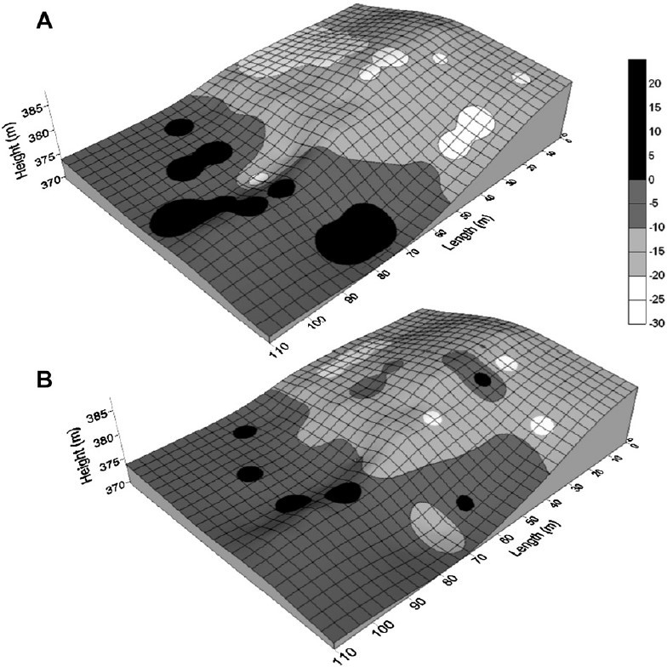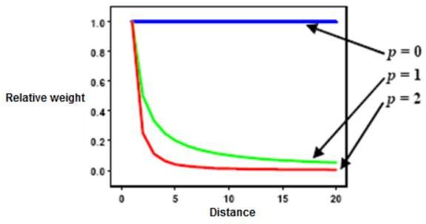

137Cs

210Pb
A

B

Figure 7 (A) Contour map with soil redistribution budget using IDW2 interpolation; (B) IDW2 interpolation
Technique:2

USE OF ARTIFICIALLY LABELLED RADIONUCLIDE APPROACH FOR SOIL EROSION STUDIES
Syversen et al. (2001) showed relative changes in ¹³⁴Cs activity levels (%) at selected points in the tilled area during the experimental period compared with the initial application (100%). Decrease in initial value in ¹³⁴Cs activity at selected points in the at the surface contaminated soil indicates erosion of particles containing ¹³⁴Cs (Figure 8). Whereas in the buffer zone the activity percentage increased from the background level. It shows a considerable soil redistribution within the field was there, that could be correctly assessed by ¹³⁴Cs.

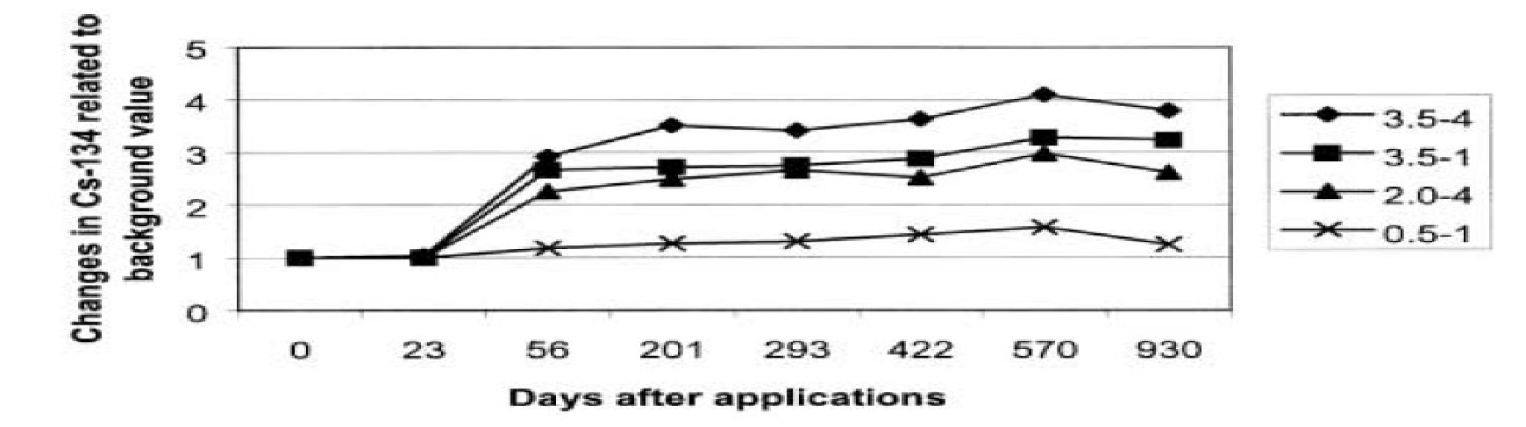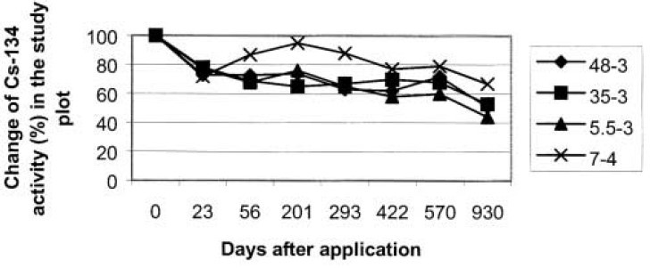
Surface contamination withCsCl
134
Sampling site No.
Buffer zone not contaminated withCscl
134
Sampling site No.

Figure 8: Use ¹³⁴Cs as a tracer to study particle transport processes within a small catchment with a buffer zone

Technique:3

FINGERPRINTING TECHNIQUE USED FOR SEDIMENT TRACING BY COMPOUND SPECIFIC STABLE ISOTOPE APPROACH
- The CSSI techniques, a forensic tool, identify sources of soil erosion in landscapes with different land uses
- All plants that grow in a particular land use produce a range of organic biomarkers (e.g. fatty acids) with carbon chain containing between 14 to 24 carbon atoms
- Different fatty acids have unique 𝛿¹³C isotopic signatures specific to a particular plant
- Differences in carbon isotope signatures allows easy tracing of sediments

Blake et al. (2012) have applied the CSSI assisted sediment tracing approach in agricultural catchment compared with geochemical fingerprinting technique. This method was able to identify the sediment yield from two cultivated field separately i.e. winter wheat and maize, whereas geochemical fingerprinting technique was fail to distinguish between them. Sediment yield in t ha⁻¹ was quite higher in winter wheat i.e 0.44 t ha⁻¹ as compared to maize field i.e 0.14 t ha⁻¹. Total sediment yield in t ha⁻¹ was quite similar in both the cases (Table 10)

Table: 10 Crop-specific sediment sources in agricultural catchments with compound specific stable isotope (CSSI) sediment tracing approach

Source type | Area (ha) | Sediment yield
Source type | Area (ha) | Total (t) | (t ha-1)
CSSI Technique (CSSI)
Maize stubble | 24 | 3.4 | 0.14
Winter wheat | 16 | 7.0 | 0.44
Grass land | 85 | 11.0 | 0.13
Geochemical fingerprinting (GC)
Cultivated | 40 | 13.3 | 0.34
Pasture | 85 | 8.9 | 0.10
Woodland | 5 | 0.5 | 0.10

CSSI signatures suggested that soil derived from pasture sources dominated the sediment load, noting that pasture represents approximately 65% of the catchment area (85 ha) at the time of sampling. Comparison of temporal patterns in source response from the CSSI tracers with those from the geochemical fingerprints highlights discrepancies whereby the geochemical fingerprints appeared to be over-estimating contributions from the cultivated source (Figure 9), where CSSI-based cultivated loadings represent the sum of estimated maize and wheat loads. It is likely that the geochemical sediment fingerprinting method will overestimate cultivated land contributions where ley pasture represents a significant proportion of land cover in a catchment and hence sampling strategies should aim to quantify these differences in the context of records of changing land use. CSSI-derived sediment source data have the potential to close this knowledge gap providing crop-specific sediment yields at the stream outlet.

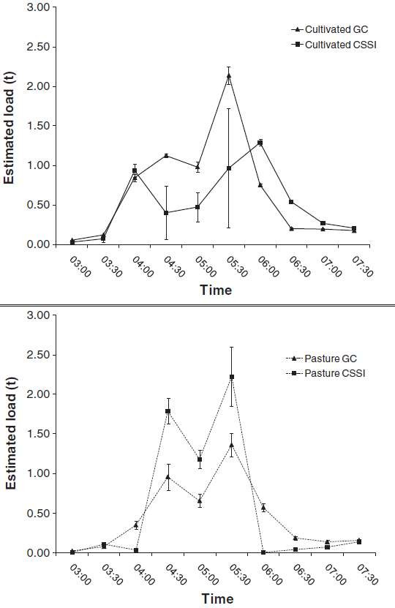

Figure 9 Comparison of results from CSSI and geochemical fingerprinting where CSSI-derived cultivated signal is the sum of maize and winter wheat loadings

RESEARCH INTO PRACTICE-LINKING RADIOISOTOPE INVENTORY TO LAND MANAGEMENT POLICY CHANGE FOR IMPROVED FOOD SECURITY

Use of ¹³⁷Cs for assessment of the effectiveness of conservation efficiency of terracing

Zhang et al. (2014) assessed the efficiency of conservation practices with the aid of ¹³⁷Cs technique. In the slope farmland of the Dingjiagou catchment, the upper position contained the highest amount of ¹³⁷Cs whereas the lower position had the lowest ¹³⁷Cs. The amounts of ¹³⁷Cs of sampling sites decreased from upper, mid and lower positions in the slope farmland. The inventories of ¹³⁷Cs were 1079.1, 862.4 and 296.3 Bq m⁻² on the upper, middle and lower slope positions, respectively (Figure 10). Using the ¹³⁷Cs converting model, soil erosion rates are correspondingly calculated to be 23.6, 27.1, and 36.3 Mg per hectare per year on the upper, middle and lower slope position. In contrast to the slope farmland, the amounts of ¹³⁷Cs of sampling sites have no significant difference at different positions on the terrace farmland. The inventories of ¹³⁷Cs were 1183.5, 947.8, and 831.8 Bq m⁻² on the upper, middle and lower positions, respectively. Correspondingly, the erosion rates slightly increased in the following order: upper < middle < lower with the rates of 21.9, 25.7, and 27.6 Mg per hectare per year, respectively Compared with the slope farmland, the terrace measure reduced soil erosion by 7.7, 5.4 and 31.5% on the upper, middle and lower slope positions. In total, the terrace measure reduced soil erosion by 15.7% for the entire slope.
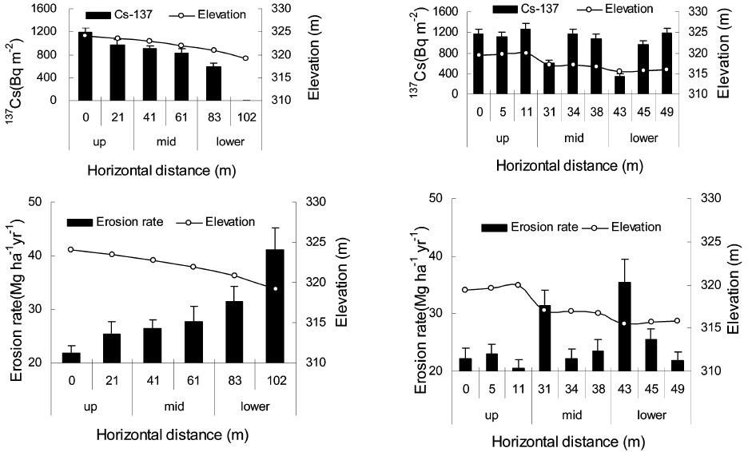
A
B

Figure 10 Inventory of ¹³⁷Cs and erosion rates at the different slope positions on the (A) slope farmland and (B) terrace farmland in the Dingjiagou catchment
Whereas, in the Xingsheng catchment, the upper and lower positions contained a higher amount of ¹³⁷Cs whereas the middle position had a less ¹³⁷Cs inventory for the slope farmland. The inventories of ¹³⁷Cs were 809.4, 612.4, and 929.3 Bq m⁻² on the upper, middle and lower slope positions, respectively. Correspondingly, along the downslope positions, erosion rates were calculated to be 32.5, 39.9, and 31.5 Mg ha⁻¹yr⁻¹ on the upper, middle and lower slope positions, respectively (Figure 11). While on the contour cropping farmland, the amount of ¹³⁷Cs and soil erosion rates had no significant difference among the different slope positions. The amounts of ¹³⁷Cs were 1052.7, 1190.4, and 1196.5 Bq m⁻² on the upper, middle and lower slope positions, respectively. Correspondingly, soil erosion rates on the contour cropping farmland were calculated to be 23.1, 21.8, and 22.9 Mg ha⁻¹yr⁻¹ on the upper, middle and lower slope positions, respectively. Compared with slope farmland, contour cultivation reduced soil erosion by 40.9, 83.5 and 37.6% on the upper, middle and lower slope positions, respectively. In total, the contour cultivation reduced soil erosion by 53.5% for the entire slope.

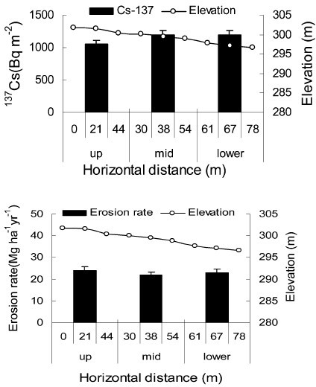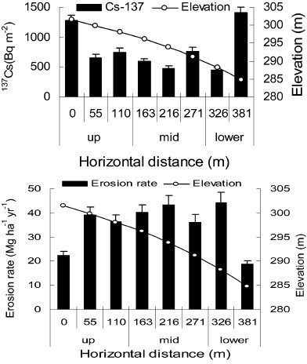
A
B

Figure 11 ¹³⁷Cs inventory and erosion rates at the different slope positions on the slope (A) farmland and (B) contour farming in the Xingsheng catchment.

Use of ⁷Be for short-term assessment of the effect of tillage practices on soil loss

Due to the short half life ⁷Be has a huge potential for short-term assessment of the effect of tillage practices on soil loss. Yassin et al. (2017) evidently showed that, at both the sites (Machouch and herchane site) conventional tillage results in a soil loss in the range of 7 to 17 t ha⁻¹ yr⁻¹, whereas soil loss due to no till system remains below 11 t ha⁻¹ yr⁻¹ (Figure 12)

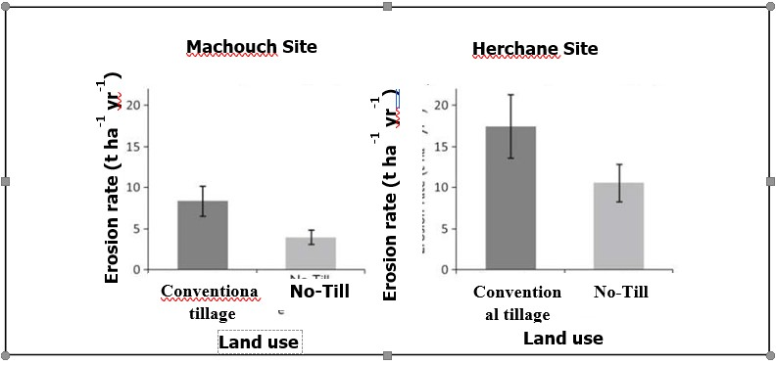

CHALLENGES IN IMPLEMENTING RADIOTRACER TECHNIQUES FOR SOIL EROSION STUDIES
The main limitations of the use of radiotracer technique are as follows: (adapted after Mabit et al. 2002)

- Need for a multidisciplinary team for the successful application of the technique. This is a particular limitation in most developing countries with limited scientific staff.
- Specialised laboratories with sample preparation and costly gamma counting equipment are required.
- Requirements for quality assurance/control of low-level gamma spectrometry measurements.
- The technique is effectively limited to documentation of sheet and general surface lowering, but it can be applied to study rill erosion in cultivated areas
- Absence of universal conversion model and standardized protocol
- Requirement of reference site with identical fallout pattern and geomorphological feature
- Initial fallout of radionuclide was not accurately estimated
- Artificially labelled isotope approach for erosion studies involves additional cost of application and also not applicable for large catchment
- The technique needs further standardization of the protocols for its worldwide application

However, the significance of these limitations, in particular the cost, must be evaluated in the context of the specific advantages of the ¹³⁷Cs technique and the limitations of other techniques.

CONCLUSIONS
- Soil erosion, deposition and sediment budget on a time scale of short-term (few days or single storm event), medium-term (~ 50 years) and long-term (~ 100 years) can by accurately assessed by ⁷Be, ¹³⁷Cs, excess ²¹⁰Pb, respectively
- Mass balance model-3 (MBM-3) is considered as one of the superior models as it additionally considers soil redistribution due to tillage erosion
- ¹³⁷Cs technology is a better method for soil erosion studies in the severely intensive croplands as the accuracy level varied in the range of 96 to 97%
- ¹³⁷Cs technique can also be used as a potential environmental marker for assessing erosion- induced soil organic carbon loss (EICL)
- ¹³⁷Cs technique is able to assess the conservation efficiency of erosion control practices
- Short-term evaluation of the effectiveness of tillage practices can by accurately assessed by ⁷Be
- Compound specific stable isotope (CSSI) techniques are able to trace the source of sedimentation in landscapes with different land uses

FUTURE PERSPECTIVE
- Extending the timescale for using ⁷Be measurements to document soil redistribution by erosion throughout wet season by developing new conversion model
- There is a huge potential for application of ⁷Be and ²¹⁰Pbex in erosion studies southern part of India as ¹³⁷Cs fallout is negligible
- Development of fallout radionuclide (FRN) inventory data is needed in the potentially eroded land across the country and calibration with actual field scale measurement data
- Development of a universal conversion model is required that could be applied irrespective of land use and geomorphological feature
- For further validation on the use of radiotracer technique, a large number of databases are needed in different landscapes and land uses

References
Alewell, C., Meusburger, K., Juretzko, G., Mabit, L., & Ketterer, M. E. (2014). Suitability of ²³⁹⁺ ²⁴⁰Pu and ¹³⁷Cs as tracers for soil erosion assessment in mountain grasslands. Chemosphere, 103, 274- 280.

Belyaev, V. R., Golosov, V. N., Ivanova, N. N., Markelov, M. V., & Tishkina, E. V. (2005). Human- accelerated soil redistribution within an intensively cultivated dry valley catchment in southern European Russia. International Association of Hydrological Sciences- Publication, 291, 11-20.

Benmansour, M., Mabit, L., Nouira, A., Moussadek, R., Bouksirate, H., Duchemin, M., & Benkdad, A. (2013). Assessment of soil erosion and deposition rates in a Moroccan agricultural field using fallout ¹³⁷Cs and ²¹⁰Pbex. Journal of Environmental Radioactivity, 115, 97-106.

Blake, W. H., Ficken, K. J., Taylor, P., Russell, M. A., & Walling, D. E. (2012). Tracing crop-specific sediment sources in agricultural catchments. Geomorphology, 139, 322-329.

Blake, W. H., Walling, D. E., & He, Q. (1999). Fallout beryllium-7 as a tracer in soil erosion investigations. Applied Radiation and Isotopes, 51, 599-605.

Lal, R. (2014). Soil conservation and ecosystem services. International Soil and Water Conservation Research, 2, 36-47.
Mabit, L., Bernard, C., Laverdière, M. R. (2002) Quantification of soil redistribution and sediment budget in a Canadian watershed from fallout caesium-137 (¹³⁷Cs) data. Canadian Journal of Soil Science 82, 4.

Mabit, L., Bernard, C., Lee Zhi Yi, A., Fulajtar, E., Dercon, G., Zaman, M. & Heng, L. (2018). Promoting the use of isotopic techniques to combat soil erosion: An overview of the key role played by the SWMCN Subprogramme of the Joint FAO/IAEA Division over the last 20 years. Land Degradation & Development, 29, 3077-3091.

Mandal, D., Giri, N., Srivastava, P., Sah, C., Bhusan, R., Naregundi, K. & Shrivastava, M. (2019). ¹³⁷Cs-a potential environmental marker for assessing erosion-induced soil organic carbon loss in India. Current Science (00113891), 117.

Meusburger, K., Mabit, L., Ketterer, M., Park, J. H., Sandor, T., Porto, P., & Alewell, C. (2016). A multi-radionuclide approach to evaluate the suitability of ²³⁹⁺ ²⁴⁰Pu as soil erosion tracer. Science of the Total Environment, 566, 1489-1499.

NRAA (National Rainfed Area Authority) (2008). Harmonization of Wastelands/Degraded Lands Datasets of India. Ministry of Agriculture, Govt. of India, New Delhi.

Syversen, N., Øygarden, L., & Salbu, B. (2001). Cesium‐134 as a tracer to study particle transport processes within a small catchment with a buffer zone. Journal of environmental quality, 30, 1771-1783.

Walling, D. E. and He, Q. (1993). Towards improved interpretation of ¹³⁷Cs profiles in lake sediments. In: Geomorphology and Sedimentology of Lakes and Reservoirs (ed. J. McManus & R. W. Duck), 31-53. Wiley, Chichester, UK.

Yassin, M., Benmansour, M., Chikhaoui, M., Ismaili Alaoui, F. Z., El Bahi, S., Babaou,Y. (2017). Contribution à l’évaluation de l’impact de l’aménagement des bassins versants de l’Oued Mellah et Allal El Fassi au Maroc. Annales de la Recherche Forestière au Maroc, 44, 79–96.

Zapata, F. (Ed.). (2002). Handbook for the Assessment of Soil Erosion and Sedimentation Using Environmental Radionuclides (Vol. 219, 9348054-9). Dordrecht: Kluwer Academic Publishers.
Zhang, Q. W., & Li, Y. (2014). Effectiveness assessment of soil conservation measures in reducing soil erosion in Baiquan County of North-eastern China by using ¹³⁷ Cs techniques. Environmental Science: Processes & Impacts, 16, 1480-1488.

Zupanc, V., & Mabit, L. (2010). Nuclear techniques support to assess erosion and sedimentation processes: preliminary results of the use of ¹³⁷Cs as soil tracer in Slovenia. Dela, 33, 21-36.

