IMPLEMENTATION OF GREEN SOLVENT SYSTEM FOR THE ANALYSIS OF ADAPALENE IN BULK AND TOPICAL GEL FORMULATION BY RP-HPLC
Ramreddy Godela^{1*}, Yagnambhatla Rajendra², Dr. Beda Durgaprasad¹, Rani Dumpala³
¹Bhaskar Pharmacy College, Moinabad, Rangareddy, Telangana, India
²MAK College of Pharmacy, Moinabad, Rangareddy, Telangana, India
³Chaitanya College of Pharmacy Education & Research, Hanmakonda, Telangana, India *E-mail: ramreddy.godela@gmail.com

ABSTRACT

A simple and rapid stability-indicating, RP-HPLC method was ascertained to determine adapalene in bulk and gel formulation. Separation was achieved on enable C₁₈ column (150 x 4.6mm; 5μm) under the isocratic mode of elution by using mobile system mixture of green solvents tetrahydrofuran and methanol (30:70 V/V). The flow rate was maintained at 1.0 ml/min with runtime 10min. UV detection was done at 360 nm. The method was found to be linear for series concentration ranges from 20-100µg/ml. The limit of detection and quantification were found to be 3.27and 0.025µg/ml. Results of precision and accuracy obtained were within the limits. The suggested approach was effectively employed for the determination of adapalene in a labelled formulation (gel), with a % assay of 99%. The suggested method's stability-indicating capacity is shown by evaluating forced degradation samples in which the peak purity of adapalene is determined as well as the resolution of degradant from the analyte peak. The collected findings demonstrate that the provided approach is a stability indicating method. The stated HPLC method has been verified in terms of specificity, precision, sensitivity, accuracy, linearity, and robustness according toICH.
Keywords: Adapalene, HPLC, Validation, Stability indicating method, Sensitivity. Isocratic elution.

- INTRODUCTION

Acne vulgaris is a chronic, inflammatory illness pilosebaceous unit. Acne vulgaris affects areas include face, chest and back identified by presence of papules, pustules, comedones, cysts, nodules and scars [1-2]. Topical retinoids and vitamin-A derivatives have been using for around three decades in the treatment of acne vulgaris. Tretinoin, is the metabolic product and active form of vitamin-A is the only topical retinoids available for Acne vulgaris disease, prior to Adapalene gel invention[3-4]. Adapalene is a derivative of naphthoic acid having ratinoid activity. The biological properties of Adapalene are quite similar to Tretinoin. But Adapalene is more stable and lipophilic than Tretinoin. Hence, Adapalene in higher concentrations adsorbed to pilosebaceous unit. Adapalene specially binds to retinoic acid receptors (β and γ) and retinoid X receptors leads to regulation of gene transcription results in normalization and differentiation of the follicular epithelial cells causes decrease in microcomedone formation[3-5]. Chemically Adapalene is6-[3-(1-adamantyl)-4-methoxyphenyl]naphthalene-2-carboxylic acid[6]. Due to advantages of Adapalene over topical retinoids, most of the physicians are prescribing Adapalene topical gel formulation[3]. To ensure the quality, stability conditions and percentage purity of Adapalene an economical and sensitive analytical method should be required. Until recently, numerous analytical methods such UV-Visible and HPLC have been reported [5-9]. But the disadvantages of the methods like longer retention time, complex solvent system and less sensitivity. Thus efforts were done to develop a stability indicating reverse phase HPLC with cost effective and high sensitivity. The chemical structure of Adapaline was shown in figure 1.

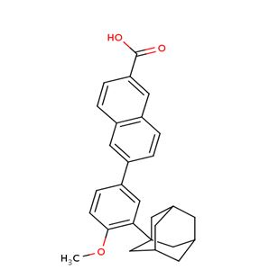
Figure 1: Molecular structure of Adapalene

- MATERIALS AND METHODS

Working standard of Adapalene with batch number CPD/10110140 was obtained from Harman Finochem Ltd as gift sample. HPLC grade solvents and water were purchased from Merck India Ltd.

- Chromatographic conditions

The proposed RP-HPLC method was carried out on Shimadzu (LC-20AT) with photometric detector (SPD-20A) and manual injecting system; data-processing and data integration was done by LC-Solution 100 software. The separation was achieved on C₁₈ column (150 x 4.6mm; 5μm) under the isocratic mode of elution by using mobile phase mixture of green solvents Tetrahydrofuran (THF) and methanol (30:70 V/V). The flow rate was maintained at 1.0 ml/min with runtime of 10min. The detection of analyte carried out at 360nm wavelength. 40⁰C temperature was maintained constantly in the flow cell of the detector. The 0.45μm povidone filters were used for filtration of mobile phase and sample solutions before introduce in to HPLC system.

- Preparation of standard solution

10mg of Adapalene pure powder was weighed accurately and dissolved with mobile in 100ml volumetric flask up to the mark. The produced solution was consecutively diluted with mobile phase in such a way to obtain 100µg/ml concentration.

- Preparation of sample solution

The ADAFERIN gel equivalent to 10mg of Adapalene was weighed accurately and dissolved with mobile in 100ml volumetric flask up to the mark. The produced solution was consecutively diluted with mobile phase in such a way to obtain 100µg/ml concentration. Sample solution was filtered through 0.25µm Nylon filter before introducing into HPLC system.

- METHOD VALIDATION

The method validation was ascertained as per Q2 specifications of ICH guidelines.

- System suitability Test

System suitability test was performed by analyzing 60 µg/ml solution of Adapalene in 5 replicates and further computation of like percentage relative standard deviation (%RSD), number of theoretical plates (N) and peak asymmetry or tailing factor (T) were done to obtained chromatograms.

- Linearity

A direct proportional relationship between input attributes (concentrations) and outcomes (peak areas) of the analytical method was represented by the linearity. In the present method a concentrations ranges about 20µg/ml to 100µg/ml of Adapalene were injected and a liner graph was plotted for concentration versus peak areas. Regression coefficient (r²) and intercept values were reckoned.

- Precision

An intimacy conformity among the observed peak areas of the homogenous analyte on a number of samplings referred as precision. Generally it is a measure of repeatability and reproducibility). The repeatability and reproducibility of the existing method was done by injecting working standard solution of 20µg/ml to 100µg/ml for three replicate injections in a day and three repeatability’s for three consecutive days. The % RSD for resultant peak areas were reckoned.

D. Accuracy

The method's accuracy was achieved by recovery procedures in which a known quantity of sample was spiked to three distinct concentration levels of standard such as 50, 100, and 150%. The mean % recovery of the sample quantity spiked was computed at each concentration level.
- Specificity

The capability of the method to evaluate the analyte under examination in the incidence of additional substances includes impurities, degradants, matrix and placebo without any interference referred as specificity of the analytical method. In current method specificity was performed by injecting standard solution, blank and standard solution with placebo or impurities in consecutively. Observation was done to occurrence of any interference between the retention RT of analyte and RT of placebo or impurities.

- Sensitivity

The LOD and LOQ concentrations were determined by the help of following formulae.
LOD=3σ/S
LOQ = 10 σ/S
Where, σ - Standard deviation of intercept
S -Slope of the linear graph

- Robustness

The method said to be robust, when small and deliberate changes in the method parameters cannot affect the methods performance significantly. In the current method slight changes in the flow rate, temperature of flow cell and detection wavelength were made. HPLC system was run the altered condition and % RSD value was calculated for resultant peak areas.

- FORCED DEGRADATION STUDIES

In the forced degradation method deliberately drug substance is placed in more intensive stress conditions higher than accelerated stability conditions. Those studies helpful in the assessment of the stability of drug substance, which is a basic consideration to develop a stable dosage form.. As per ICH Q1and Q2 recommendations the forced degradation studies were done.

- Acid hydrolysis

A mixture of 10ml of stock solution of Adapalene and 2ml of 1N HCl was refluxed for 2hr at 70⁰ C, further kept at room temperature for 24 hr and the resultant solution neutralized with 1N NaOH .The above solution was diluted again to get a concentration of 100µg/ml.
- Alkali hydrolysis

A mixture of 10ml of stock solution of Adapalene and 2ml of 1N NaoH was refluxed for 2hr at 70⁰ C, further kept at room temperature for 24 hr and the resultant solution neutralized with 1N HCl .The above solution was diluted again to get a concentration of 100µg/ml.

- Oxidative degradation

A mixture of 10ml of stock solution of Adapalene and 2ml of 15% w/v hydrogen peroxide was was refluxed for 2hr at 70⁰ C, further kept at room temperature for 24 hr, and the resultant solution was diluted again to get a concentration of 100µg/ml.

- Thermal and photo degradation

10ml of Adapalene stock solution was placed in hot air oven at 80°C/75% RH and for UV chamber for 24hr for thermal and photo degradation and the resultant solution was diluted again to get a concentration of 100µg/ml.

The assay of Adapalene was performed by injecting standard solution and sample solution consecutively. The percentage purity of Adapalene was estimated by using a method described elsewere [10-11].

- RESULT AND DISCUSSION

Initially, the solubility of Adapalene was checked for selection and optimization of mobile phase. Adapalene was found to be soluble in THF, mixture of methanol and THF. Based on the solubility of drug in methanol and THF in (70:30) ratio selected as diluents and mobile phase.

- Method optimization

The method was optimized by doing several trials, where different solvent systems and different ratios of solvent system and different flow rates were used to get peak in the chromatogram with acceptable tailing factor and efficiency (N). Finally a method with C₁₈ column (150 x 4.6mm; 5μm) and the isocratic mode of elution using a mobile phase composition of tetrahydrofuran and methanol (30:70 V/V) was selected. 1.0 ml/min of flow rate with a runtime of 10min was used. The detection of analyte carried out at 360nm wavelength. 40⁰C temperature was maintained constantly in the flow cell of the detector. The results of trial and error method were affirmed in Table-1, trial-7 chromatographic conditions were successfully opted, where Adapalene eluted at 3.5 min and the chromatogram of optimized method was shown in Figure-2.

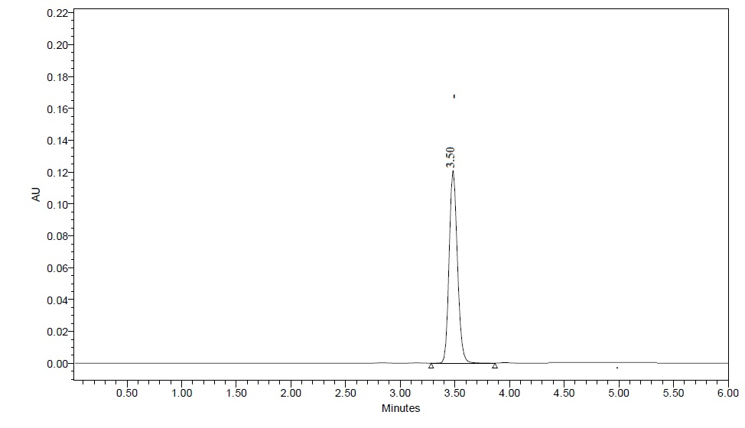
Figure 2: Optimized HPLC chromatogram of the Adapalene, Retention time was observed at 3.5minutes

Table 1: Different trials details based on trial and error method
Trial | Type of column | Mobile Phase or solvent phase | Flow rate (ml/min) | Observation
1 | C₁₈ column (150×4.6mm,5µm) | Tetrahydrofuran | 1 | Peak fortuning observed
2 | C₁₈ column (150×4.6mm,5µm) | Methanol :ACN : THF  (80:10:12 ) | 1 | Broad peak observed
3 | C₁₈ column (150×4.6mm,5µm) | Methanol :ACN : THF  (70:20:10) | 1 | Efficiency of peak was not good
4 | C₁₈ column (150×4.6mm,5µm) | THF: Triethylamine (90:10) | 1 | Peak tailing observed
5 | C₁₈ column (150×4.6mm,5µm) | Methanol : THF  (90 : 10) | 1 | Longer RT
6 | C₁₈ column (150×4.6mm,5µm) | Methanol : THF  (80 : 20) | 1 | Broad peak observed
7 | C₁₈ column (150×4.6mm,5µm) | Methanol : THF  (70 : 30) | 1 | Good efficiency and acceptable tailing was observed

- Method validation

The parameters, tailing factor, like %RSD and plate count results mentioned in Table 2 were not diverged from the approval limits (Table 3) of Q2 provisions of ICH. The R² value for the Adapalene concentrations about 20 to 100µg/ml was 0.998 which illustrated that the method has considerable linear response for the mentioned concentration range. The obtained results were mentioned in Figure 3 and Table 4. The % recoveries at different levels of concentrations were within the ICH guidelines consideration (100%±2) was shown in Table 5. The % RSD of working standard solutions of Adapalene was ≤ 2 (Table 6). This was showing the considerable precision of the current method. The LOD and LOQ of Adapalene were assessed as 3.27µg/ml and 9.71μg/ml respectively. Hence, the method said to be highly sensitive. Even though small and deliberate changes in the method parameters cannot affect the methods flow rate, column temperature and detection wave length were cannot affect the methods performance and significantly produces %RSD values in the ICH consideration limit (Table 7) were the strong substantiation for the robustness of the approach.

Table 2: Results of System Suitability Test for Adapalene
S.No | Sample Name | Peak Area | NO. of Plates (N) | Tailing(T)
1 | Injection-1 | 321541 | 4563 | 1.56
2 | Injection-2 | 322632 | 4501 | 1.53
3 | Injection-3 | 332315 | 4489 | 1.56
4 | Injection-4 | 325496 | 4527 | 1.51
5 | Injection-5 | 324598 | 4501 | 1.56
 | Mean | 325316 | 4516.2 | 1.544
 | SD | 4212.731 | 29.61756 | 0.023022
 | %RSD | 1.2 | 0.65 | 1.49

Table 3: Acceptance criteria of system suitability parameters
Parameter | ICH limit
Plate count(N) | > 2000
Tailing (T) | ≤ 2
%RSD | ≤ 2
Resolution (R) | > 2

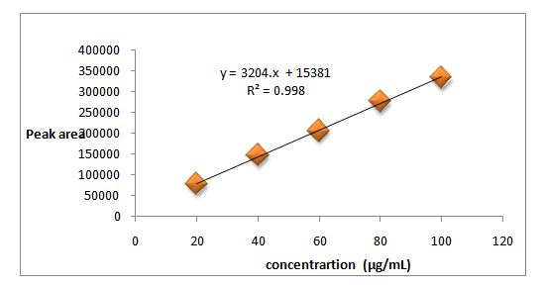
Figure 3: Calibration curve of Adapalene

Table 4: Linearity data of Adapalene
S.NO | Concentration (µg/ml) |  | Peak area
1 | 20 |  | 77057
2 | 40 |  | 146927
3 | 60 |  | 205190
4 | 80 |  | 276053
5 | 100 |  | 332903
Slope |  | 3204
Intercept |  | 15381
Regression co-efficient(R²) |  | 0.998

Table 5:Results of percentage recovery of Adapalene at three different level
%Level  (N=3) | Amount Added  (µg/ml) | Standard Solution Peak Area | Average peak area of spiked (Standard +Sample | Amount Recovered | %Recovery
50 % | 40 | 146927 | 288315.5 | 40 | 100
100% | 60 | 205190 | 408619.7 | 59.48 | 99.1
150% | 80 | 276053 | 553592.7 | 80.43 | 100.5

Table 6: Results of Repeatability and Reproducibility of Adapalene (%RSD for n=6)
Concentration  (µg/ml) | Peak area |  |  | Mean | SD | %RSD
Repeatability | Injection-1 | Injection-2 | Injection-3 | Mean | SD | %RSD
20 | 83654 | 81245 | 80024 | 81641 | 1508.16 | 1.84
40 | 146358 | 147859 | 152431 | 148883 | 2582.8 | 1.73
60 | 206534 | 204527 | 197898 | 202986 | 3690.11 | 1.81
80 | 257463 | 256475 | 249987 | 254642 | 3315.97 | 1.3
100 | 342510 | 336541 | 338741 | 339264 | 2464.74 | 0.72
Reproducibility | Day-1 | Day-2 | Day-3 | Mean | SD | %RSD
20 | 79998 | 82451 | 81657 | 81368.67 | 1021.977 | 1.255983
40 | 150213 | 146572 | 149985 | 148923.3 | 1665.247 | 1.118191
60 | 201457 | 204758 | 203231 | 203148.7 | 1348.885 | 0.663989
80 | 257899 | 260021 | 249978 | 255966 | 4321.869 | 1.688454
100 | 345287 | 335874 | 339987 | 340382.7 | 3853.012 | 1.131965

Table 7: Results of robustness of the Adapalene by changing method parameters
Parameter |  | %RSD
Column Temperature (±2⁰C) | 38⁰C | 0.285754
Column Temperature (±2⁰C) | 42⁰C | 1.449437
Wavelength(±2nm) | 358nm | 0.953445
Wavelength(±2nm) | 362nm | 1.68458
Flow rate  (0.2 ml/min) | 0.8ml/min | 0.236392
Flow rate  (0.2 ml/min) | 1.2ml/min | 1.30028

- Forced degradation (FD)

The FD conditions used in the current method were causes considerable degradation of Adapalene. At the mentioned photolytic and thermal condition degradation of Adapalene was negligible. Hence, at this condition Adapalene pure and gel form were stable. Results were revealed in Table 8.

Table 8: % Degradation of Adapalene at different stressed condition
Degradation conditions | % Degradation
Acidic/1N HCl/ reflux at 70⁰C/24 hr | 8.2
Basic/1N NaOH/ reflux at 70⁰C/24 hr | 6.8
Oxidation/ 15%H₂O_{2/}/ 70⁰C/24 hr | 5.1
Thermal/80°C/75% RH for 24hr | 0.5
Photolytic/UV light/24hr | 0.2

%purity of the Adapalene in marketed tablets was assessed to be 99.7% (Table-9).

Table 9: % assay of Adapalene marketed gel form
Drug | Solution name | RT (Min) | Peak respone | Tailing factor | Plate count | % Assay
Adapalene | Standard | 3.5 | 332903 | 1.59 | 4058 | 99.7%
Adapalene | Test | 3.5 | 331982 | 1.51 | 4201 | 99.7%
Acceptance limit |  |  |  | ≤2 | >2000 | 100±2

In most situations, the stability indicating RP-HPLC technique plays an important role in drug analysis. Until recently, there had not been documented a single RP-HPLC technique with stability indicative and excellent sensitivity and decreased RT. The sensitivity, RT, and linear concentration range of the available techniques were poor. As a result, an effort was undertaken to design an efficient, sensitive RP-HPLC technique for determining stability. The RT in the current proposed procedure was 3.5 minutes for Adapalene indicates the approach with reduced RT, may be regarded to be inexpensive. The statistical results of the present method's validation parameters were within the ICH recommendations' acceptability range.
- CONCLUSION

An affordable, sensitive and trouble-free RP HPLC approach using isocratic elution was established to qualitative and quantitative determination of Adapalene bulk and its gel form. Different FD studies were performed on drug substance to evaluate the stability representing asset of the projected method. The current method was effectively separate Adapalene and quantifies the Adapalene contents in both drug substance and drug product at nano concentration level. Therefore, the developed method is projected as revival in regular analysis of Adapalene in production and formulation units.

To qualitative and quantitatively determine Adapalene bulk and gel form, an affordable, sensitive, and easy RP HPLC approach using isocratic mode of elution was devised. Various FD tests were performed on medication solutions to assess the method's stability and asset. The present technology efficiently separates Adapalene and measures the Adapalene content in both the drug ingredient and the drug product at the smallest concentration level. As a result, the proposed technology is expected to be rejuvenated in routine Adapalene analysis in the pharmaceutical business.
Acknowledgment
All the authors were very thankful to management of Chaitanya College of Pharmacy Education and Research and Bhaskar Pharmacy College.

Declaration of interest
no conflict of interest among all the authors

Abbreviations
HPLC-High Performance Liquid Chromatography
THF- Tetrahydrofuran
%RSD- Percentage Relative Standard Deviation
ACN- Acetonitrile
LOD-Limit of Detection
LOQ –Limit of Quantification
SD- Standard deviation

REFERENCES
- Irby C.E, Yentzer B.A, Feldman S.R, “A Review of Adapalene in the Treatment of Acne Vulgaris”. Journal of Adolescent Health, 43, 421–424, 2008
- Piskin S, Uzunali E, “A review of the use of adapalene for the treatment of acne vulgaris”, Ther Clin Risk Manag 3,621–624, 2007.
- Czernielewski J, Michel S, Bouclier M, Baker M, Hensby JC, “Adapalene biochemistry and the evolution of a new topical retinoid for treatment of acne”, J Eur Acad Dermatol Venereol 15(3), 5–12,2001
- Millikan L.E, “Adapalene: an update on newer comparative studies between the various retinoids”. Int J Dermatol, 39, 784–788,200.
- Barange H, “Development of Analytical Method for Simultaneous Estimation of Adapalene and Benzoyl Peroxide in Gel Formulation by RP-HPLC”. GJPPS ,4,2014.
- Chowdhury R, Chowdhury M.H, Saha P. Rahman H, Haque S.M.E. “Development and validation of RP-HPLC method for the simultaneous determination of Adapalene-Benzoyl Peroxide combination gel”, Int j sci eng Technol1:1-9,2012.
- Martins L.A, Meneghini L.Z, Junqueira C.A, Ceni D.C, Bergold A.M, “A Simple HPLC-DAD Method for Determination of Adapalene in Topical Gel Formulation”, J Chromatogr Sci 49: 796–800, 2011.
- Patel R.B, Patel M.R, Chaudhari M.D, “Stability indicating high performance liquid chromatographic method for estimation of adapalene in tablet formulation”, J Liq Chromatogr Relat Technol 37:379-390, 2014.
- Tolba MM, El-Gamal R. M, “Determination of adapalene in gel formulation by conventional and derivative synchronous fluorimetric approaches. Application to stability studies and in vitro diffusion test”. Chem Cent J, 10,2016.
- Godela R, Bhavani S, “A simple reverse phase-high-performance liquid chromatography method development and validation of Valsartan in bulk and it’s tablet dosage form”, Asian J Pharm Clin Res, 10: 333-337,2017.
- Godela R, “An effective stability indicating RP-HPLC method for simultaneous estimation of Dolutegravir and Lamivudine in bulk and their tablet dosage form”, Future J Pharm Sci 6: 1-9, 2020.

