**RAPID DIAGNOSTIC KITS FOR DETECTION OF PHYTOPATHOGENIC BACTERIA**

Pamala Prince Jayasimha

Plant Pathology

College of Agriculture, KL University

Vijayawada, India

jayasimha@kluniversity.in

Dumala Sravani

Entomology

College of Agriculture, KL University

Vijayawada, India

dsravani@kluniversity.in

Muthyla Mahendra

Plant Pathology

S. V. Agricultural College, Acharya N G Ranga Agricultural University

Guntur, India

mm676366@gmail.com

Padeti Venkataramanaiah

Plant Pathology

S. V. Agricultural College, Acharya N G Ranga Agricultural University

Guntur, India

ramanaseenu8@gmail.com

**Abstract:**

The demand for rapid and accurate detection of phytopathogenic bacteria has risen in the last years. On-site detection of pathogens using rapid diagnostic kits is the first step in this endeavour. Due to emerging new plant diseases, the rapid and accurate detection techniques are required to identify phytopathogenic bacteria. The rapid results can be used to guide management decisions, including selection of the appropriate chemical for disease control. In this review, we detail the currently available portable devices and technologies used for detecting phytopathogenic bacteria.

Key words: Phytopathogenic bacteria, Rapid diagnostic kits, Plant disease, Management

**Introduction**

The plant pathogens play an important role in the food safety and production. The plant pathogens, animals and weeds cause 20-40 percent losses in world agriculture productivity [1]. For understanding and managing of plant diseases the accurate detection and identification of the plant pathogens are essential. Early detection of plant pathogens in field might prevent diseases spread and food losses [2]. Recently, the Journal of Molecular Plant Pathology announced the top ten bacterial plant pathogens based on both their economic and scientific importance. *Pseudomonas syringae* and *Ralstonia solanacearum* ranked first and second respectively, and are economically important diseases that infect various crops [3].

Phytopathogenic bacteria might survive in diverse environments: in plants as pathogens and outside their hosts as saprophytes and epiphytes [4]. Adverse environmental conditions might reduce bacterial survival and compromise disease initiation and dissemination. Disease symptoms caused by bacteria include leaf spots, blights, wilts, scabs, cankers, tumours and soft rots of roots, storage organs and fruit and overgrowth [5].

The rapid on-site diagnostic tools will facilitate the early detection of pathogens distribution to prevent the spread of diseases. Here, we review rapid diagnostic kits currently available in the market as well as their challenges and limitations.

**RAPID DIAGNOSTIC KITS:**

The rapid tests are designed to provide quick, reliable, in the field results to enable faster decision making and prevent the spread of disease for efficient crop disease management, and environmental protection [6].

Using rapid diagnostic kits for detecting bacterial diseases in field and greenhouse crops can be very beneficial. These kits produce results in a short period of time and are reliable, sensitive, cost effective and user friendly. In fact, tests are usually as sensitive as their comparable ELISA test counterparts that are used in diagnostic labs. Results from rapid diagnostic kit tests are ready in about 10-30 minutes.

**Working principle of lateral flow rapid test strip:**

A typical lateral flow rapid test strip consists of the following components:

* The sample pad acts as the first stage of the absorption process, and in some cases contains a filter, to ensure the accurate and controlled flow of the sample.
* The conjugate pad, which stores the conjugated labels and antibodies, will receive the sample. If the target is present, the immobilised conjugated antibodies and labels will bind to the target and continue to migrate along the test.
* As the sample moves along the device the binding reagents situated on the nitrocellulose membrane will bind to the target at the test line. A coloured line will form and the density of the line will vary depending on the quantity of the target present. Some targets may require quantification to determine target concentration. This is where a rapid test can be combined with a reader to provide quantitative results.
* The sample will pass through the nitrocellulose membrane into the absorbent pad. The absorbent pad will absorb the excess sample. The specification of the absorbent pad will have an impact on the volume of sample the test can incorporate [7].

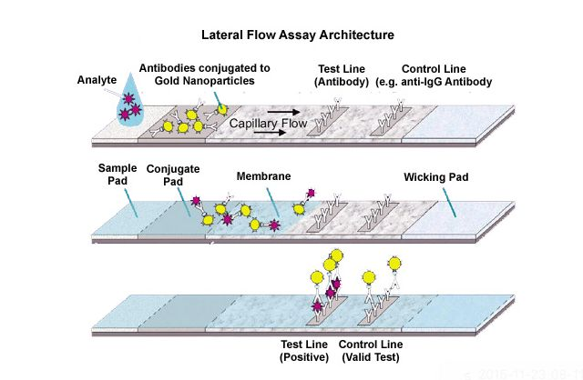

**Figure 1. Working principle of lateral flow rapid test strip**

**1. ImmunoStrip Kits:**

ImmunoStrip test is a rapid and reliable tool for detection of bacterial plant pathogens in plants. The assay can be used to test leaves, fruit, bacterial cultures, and seedlings exhibiting symptoms of pathogens [8].

**ImmunoStrip Kits available for bacterial plant pathogens are**

* *Acidovorax avenae* subsp. *citrulli*
* C*lavibacter michiganensis* subsp. *Michiganensis*
* *Erwinia amylovora*
* *Ralstonia solanacearum*
* *Xanthomonas axonopodis* pv. *citri*

Kit (ISK) Includes: ImmunoStrips, Sample bags containing SEB4 buffer and User Guide

**Test procedure:**

1. Samples should be taken from leaves, petioles, or stems of plants showing signs of infection. Agdia sample extract bags contain 3 mL of extraction buffer, requiring 0.15 g tissue for the optimal 1:20 dilution. For most samples, an approximate sample size of 2.5 cm2 or 1 inch 2 is adequate; however, thick or dense tissues can alter the targeted 1:20 dilution. Extraction and testing of overly degraded, dried, or large amounts of tissue can cause erroneous results. When working with stems cut two cross section pieces at the first two internodes from the crown. The stem can be cut into smaller sections for easier grinding.
2. Cut open the sample extraction bag along the top of the label. Be careful not to spill the buffer
3. Insert the sample between the mesh linings near the bottom of the sample extraction bag.
4. Extract the sample by thoroughly macerating it with an Agdia tissue homogenizer or a blunt object such as a pen or marker. An adequately extracted sample will result in a homogenous green or light brown coloured solution. Allow the resulting solution to settle for 3 minutes before inserting the ImmunoStrip.
5. Remove an ImmunoStrip then reclose the container. When handling the strips, always grasp the top of the strip marked with the test name. Do not remove the protective covering. Insert the sample end of ImmunoStrip into the bag until submerged in the extract up to the white line. For best results, insert the ImmunoStrip into the channel portion of the bag (no mesh). Do not allow the side of the ImmunoStrip to come into contact with foam or bubbles (if present). Trimming the bag may also allow for more control when inserting the ImmunoStrip into the bag.
6. Place the bag in a letter holder or other device in upright position. Allow the ImmunoStrip test to remain in the sample extract for 30 minutes. Positive results may be visible in as little as 5 minutes (Figure 2).

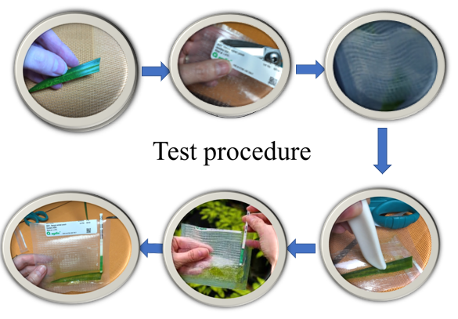

**Figure 2: Test procedure of ImmunoStrip**

**Interpret Results:**

Remove test strip from extract and interpret results. Use the images provided as a guide to determine results. If storing the strip as a permanent record, immediately cut the sample pad off the strip, then press the ImmunoStrip between paper towels to remove excess liquid. If the control line is visible and the test line is also present at any intensity of pink/purple, this indicates a positive result. If only the control line is visible, this indicates a negative result. Samples with low levels of bacteria may not be detected with the ImmunoStrip.

**2. Pocket Diagnostic kits:**

Pocket Diagnostic tests kits are quality products, designed for the on-site detection of viruses, bacteria and fungi (pathogens) causing disease symptoms in plants [9].

Pocket Diagnostic kits available for*Erwinia amylovora* and *Ralstonia solanacearum*

Pocket Diagnostic kits Includes:Test device, Bottle of extraction buffer, Pipette and User Guide

**Test procedure:**

1. Select a part of the plant here diseased and healthy material meet, do not use dead material. Use approximately 25 mm2 of material.
2. Cut or tear sample into small pieces. Unscrew the extraction bottle lid and add the plant material. Replace the lid tightly.
3. Shake the bottle firmly for 30 seconds (60 seconds if the material is hard or woody), until the extraction buffer is no longer colourless. Wait 30 seconds allow the solution to settle and draw liquid into pipette avoiding too much plant material.
4. Remove the test device from its foil packing and place on a level surface with the viewing window upwards. The test can be carried out with the device held horizontally in the hand.
5. Remove the lid from the extraction bottle and draw some of the liquid into the pipette. Gently squeeze 2 or 3 drops of the sample liquid into the sample well of the test device.
6. After about 30 seconds blue dye will appear in the viewing window as liquid flows along the test device. A blue line (the Control line) will appear next to the letter ‘C’ on the device. This line confirms the test is working properly. If the test is positive, a second blue line, the Test line (next to the letter ‘T’), will appear. The lines will appear within 10 minutes after adding sample to the test device (Figure 3).

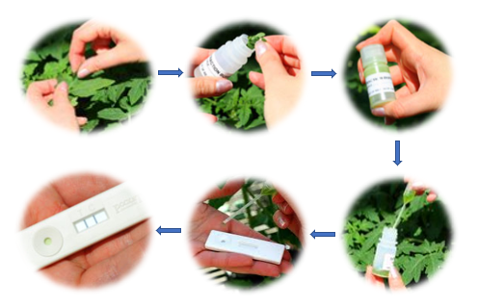

**Figure 3: Test procedure of Pocket Diagnostic kit**

**Interpreting results**

The result becomes visible in the viewing window of the test device in a few minutes. All Pocket Diagnostic tests produce valid results in less than 10 minutes. Ignore any changes to the test device

**Advantages:**

* **Rapid:** Plants exhibiting suspicious symptoms can be tested on-site with diagnostic test kits. Results are available in 5 minutes to 30 minutes. If the sample is sent to a plant diagnostic laboratory, delivery alone may take two days or more.
* **Accurate:** The results are highly accurate for symptomatic plantmaterial. In some cases, the test will detect the listed organism,as well as closely related pathogens. This will be indicated onthe kit instructions.
* **Simple:** The tests do not require any specialized training or experience. All materials are included in the test kit, exceptcommonly available supplies including paper towels, scissorsand a blunt object (such as a marker).
* **Safety:** The test materials are safe and non-hazardous. They can be stored in the refrigerator until needed.
* **Wide selection:** Rapid test kits are available for a large number of plantpathogens. lists the more common plant pathogens in greenhouses and nurseries that can be testedwith rapid tests.
* **Good shelf life:** Tests can be purchased in small (5 to 10) or large (25to 50) quantities. Shelf-life is one year or more, if properlystored in the refrigerator. Desiccant packets are included tokeep materials dry, so do not remove them from the test kits.
* **Low cost:** Cost is 700 ₹ to 1400 ₹ per test (including shipping), depending on the exact test and supplier. Shipping costs to the diagnosticplant laboratory or time taken to drive to an Extension officegenerally cost more.

**Disadvantages:**

* Interpretation of results: If a test yields a positive result, the kits do not provide management recommendations. Consult the local county Extension office, Extension Specialist, or chemical representative for guidance.
* Results are pathogen specific: The tests only provide a positive or negative result for a single pathogen. If the results are negative, the grower may need to test for additional organisms. Contact a plant diagnostic laboratory if additional testing is needed.
* Tests are not available for all pathogens

**CONCLUSION:**

Based on the emerging plant diseases, there is an urgent need for rapid detection of multiple known or unknown plant pathogens to reduce crop losses. Rapid Diagnostic kits are used for early detection phytopathogenic bacteria but in the market, it was available for only few pathogens. Diagnostic kits are may be expensive, but the costs can be offset by gains, such as reduced crop losses and more environment-friendly crop-management practices. Their development should be made a priority by both the public and private sectors in developing countries.

**REFERENCES**

[1] Nezhad, A.S., 2014. Future of portable devices for plant pathogen diagnosis. *Lab on a Chip*, *14*(16): 2887-2904.

[2] Chilvers, M.I., 2012. Molecular Diagnostics in Plant Disease Diagnostic Clinics… What’s the Status. *Fungal Genome Biol*, *2*: 102.

[3] Donoso, A. and Valenzuela, S., 2018. In‐field molecular diagnosis of plant pathogens: recent trends and future perspectives. *Plant pathology*, *67*(7): 1451-1461.

[4] Fang, Y. and Ramasamy, R., 2015. Current and prospective methods for plant disease detection. *Biosensors*, *5*(3): 537-561.

[5] Lau, H.Y. and Botella, J.R., 2017. Advanced DNA-based point-of-care diagnostic methods for plant diseases detection. *Frontiers in plant science*, *8*: 2016.

[6] Martinelli, F., Scalenghe, R., Davino, S., Panno, S., Scuderi, G., Ruisi, P., Villa, P., Stroppiana, D., Boschetti, M., Goulart, L.R. and Davis, C.E., 2015. Advanced methods of plant disease detection. A review. *Agronomy for Sustainable Development*, *35*(1): 1-25.

[7] https://www.creative-diagnostics.com/food-analysis/tag-lateral-flow-immunoassay

[8] https://www.agdia-emea.com/en/products-services/plant-pathogen-detection-kits

[9] https://www.pocketdiagnostic.com/products/plant-disease-tests/