Effect of Groundnut Husk based Non-Damaging Drilling Fluid (NDDF) on Shale Formation

University Project – II Report submitted to the Presidency University, Bengaluru in partial fulfillment of the requirements for award of Degree of

BACHELOR OF TECHNOLOGY

in

PETROLEUM ENGINEERING

by

Ayan Assadi | ID No.: 20181PET0015
Faizanulla Meer | ID No.: 20181PET0024
Rahul Kumar Dash | ID No.: 20181PET0072

Under the Supervision of

Dr. Deepjyoti Mech

Assistant Professor



DEPARTMENT OF PETROLEUM ENGINEERING

PRESIDENCY UNIVERSITY
(Private University established in Karnataka State by Act No. 41 of 2013)
Itgalpur, Rajanakunte, Yelahanka, Bengaluru – 560064
Website: www.presidencyuniversity.in

June, 2022

PRESIDENCY UNIVERSITY
Bengaluru
Department of Petroleum Engineering


Certificate

This is to certify that the University Project – II work entitled “Effect of Groundnut Husk based Non-Damaging Drilling Fluid (NDDF) on Shale Formation” was carried out by Ayan Assadi (ID No. 20181PET0015), Faizanulla Meer (ID No. 20181PET0024), Rahul Kumar Dash (ID No. 20181PET0072), who are bonafide students of VIII Semester B.Tech. Petroleum Engineering in Presidency University. This is in partial fulfillment of the course work in place of Professional Practice – II of Bachelor of Engineering in Presidency University, Bengaluru, during the year 2021 - 2022.

Dr. Deepjyoti Mech |  | Dr. Suman Paul
Supervisor & Assistant Professor |  | Professor & Head
Department of Petroleum Engineering |  | Department of Petroleum Engineering

Dr. Abdul Sharief
Professor & Dean
School of Engineering

DECLARATION

We do hereby declare that the Project Report entitled “Effect of Groundnut Husk based Non-Damaging Drilling Fluid (NDDF) on Shale Formation” is a record of an original work done by us under the guidance of Dr. Deepjyoti Mech Professor in the Department of Petroleum Engineering, Presidency University, Bengaluru. This report is submitted by us in partial fulfillment of the requirements for the award of degree of Bachelor of Technology in Petroleum Engineering to Presidency University, Bengaluru in the month of June, 2022. The results embodied in this report have not been submitted to any other University or Institute for the award of any degree or diploma.

Ayan Assadi
ID No.: 20181PET0015 __________________________________________

Faizanulla Meer
ID No.: 20181PET0024 ____________________________________________

Rahul Kumar Dash
ID No.: 20181PET0072 ____________________________________________

ACKNOWLEDGEMENT

We would like to express our sincere thanks to the supervisor, Dr. Deepjyoti Mech, Assistant Professor, Department of Petroleum Engineering for his morale boosting, meticulous guidance, cooperation and supervision throughout this project work.

We would like to owe our heartiest gratitude to Dr. Suman Paul, Professor and Head of the Department of Petroleum Engineering for his encouragement during the progress of this project work.

We would also like to pay our sincere thanks to Dr. Abdul Sharief, Dean, School of Engineering for sharing his valuable experience in completing project work.

We would like to convey our sincere thanks to the Management of our university for providing us required infrastructure within college campus.

We would like to thank both teaching and non-teaching staff members of the Department of Petroleum Engineering for their kind cooperation and all sorts of help to complete this project work successfully.

We would also like to thank all of our juniors, classmates and friends for their valuable suggestions to complete our project work in time.

Last but not the least we would like to thank our parents for always staying beside us and encouraging all the time.

Date: 18-06-2022
Place: Presidency University, Bengaluru

Ayan Assadi | ID No.: 20181PET0015
Faizanulla Meer | ID No.: 20181PET0024
Rahul Kumar Dash | ID No.: 20181PET0072

ABSTRACT

Drilling fluid is one of the most essential parts of a drilling process. It counterbalances formation pressure, lubricates the drill bit, carries out the cuttings and many more. One of the disadvantages of drilling fluid is that it causes formation damage. Conventional drilling fluids contain bentonite, which react with shales to cause extensive damage in shale formations. Swelling and spalling have big repercussions during drilling such as borehole collapse and stuck pipe. So, a non-damaging drilling fluid was developed free from bentonite and barite which minimizes formation damage and is less reactive to shales. This fluid is generally used in shale formations as mentioned and in pay zone. The goal of this project is to formulate a non-damaging drilling fluid with the additives chosen and compare their performance with another non-damaging drilling fluid of similar concentration.

CONTENTS

Title |  |  | Page No.
CERTIFICATE
DECLARATION |  |  | I
ACKNOWLEDGEMENT |  |  | II
ABSTRACT |  |  | III
CONTENTS |  |  | i-ii
LIST OF FIGURES |  |  | iii
LIST OF TABLES |  |  | iv
LIST OF GRAPHS |  |  | v
ABBREVIATIONS AND ACRONYMS |  |  | vi
CHAPTER 1 | INTRODUCTION |  | 1 – 4
 | 1.1 | Introduction | 1
 | 1.2 | Drilling fluids and types | 1
 | 1.3 | Non-Damaging Drilling Fluid | 2
 | 1.4 | Advantages of Non-Damaging Drilling Fluid (NDDF). | 3
 | 1.5 | Literature Survey | 3
 | 1.6 | Objectives of Work | 4
CHAPTER 2 | EXPERIMENTAL SECTION |  | 5-9
 | 2.1 | Additives of NDDF | 5
 | 2.2 | Plan of Work | 6
 | 2.3 | Equipment And Materials | 6
 | 2.4 | Experimental Setup | 7
 | 2.5 | Experimental Procedure | 9
CHAPTER 3 | WORK DONE |  | 11-34
 | 3.1 | Formulation of NDDF | 11
 | 3.1.1 | Carboxymethyl cellulose (CMC) | 11
 | 3.1.2 | Calcium carbonate (CaCO3) | 11
 | 3.1.3 | Groundnut Husk | 12
 | 3.1.4 | Psyllium Husk | 12
 | 3.1.5 | Potato Starch | 13
 | 3.2 | GH & PH Rheological properties. | 14
 | 3.3 | GH & PH comparison | 21
 | 3.4 | Shale stability test | 23

CHAPTER 4 | CONCLUSIONS |  | 28
 | 4.1 | Future Scope of Work | 29
REFERENCE |  |  | 30

LIST OF FIGURES

Figure No. | Figure Caption | Page No.
Fig 2.1 | Hamilton-Beach stand mixer | 2
Fig 2.2 | Marsh Funnel | 7
Fig 2.3 | Mud Balance | 13
Fig 2.4 | Water Analyzer  . | 22
Fig 2.5 | Hand crank viscometer | 23
Fig 3.1 | Graphical representation of YP/PV Ratio of 24g of Groundnut husk | 24
Fig 3.3 | Graphical representation of YP/PV Ratio of 26g of Groundnut husk | 17
Fig 3.4 | Graphical representation of rheological properties psyllium husk | 18
Fig 3.5 | Graphical representation of YP/PV Ratio of 15g, 8g & 5g of psyllium husk | 18
Fig 3.6 | Graphical representation of gel strength of 15g,8g & 5g of psyllium husk. | 19
Fig 3.7 | Graphical representation of YP/PV Ratio of 25g of groundnut husk | 20
Fig 3.8 | Graphical representation of gel strength of 25g of groundnut husk of mud-1. | 21
Fig 3.9 | Graphical representation of gel strength of 25g of groundnut husk of mud-2. | 21
Fig 4.1 | YP/PV ratio of groundnut husk. | 23
Fig 4.2 | YP/PV ratio of psyllium husk. | 23
Fig 4.3 | pH of groundnut husk | 23
Fig 4.4 | pH of psyllium husk | 23

LIST OF TABLES

Table No. | Table Caption | Page No.
Table 3.1 | Rheological properties for various concentrations of Groundnut husk with CMC | 15
Table 3.2 | Rheological properties for various concentrations of psyllium husk with CMC | 17
Table 3.2.1 | Rheological properties for various concentrations of Groundnut husk with CMC | 20
Table 3.3 | Rheological properties of Groundnut husk and Psyllium husk | 22
Table 3.4 | Rheological properties of Groundnut husk and Psyllium husk | 23
Table 3.4.1 | Shale stability test readings | 25
Table 3.4.2 | Results from Shale immersion test | 27
Table 3.4.3 | Shale stability test readings | 27

Chapter 1: Introduction

  - Introduction

During the exploring and exploiting process for the energy resources, drilling plays a vital role. Different fluids are used in the bore-hole for drilling, the chemical and physical compatibility of the fluids with reservoir rock is the most important factor in maximizing production [1]. The term “fluids” is preferred by most of the drilling companies and author’s [2]. Fluid used for drilling is called Drilling mud or drilling fluid, it’s defined as circulating fluid used in drilling to perform various drilling operations. In “Baker Hughes drilling fluids” reference it is mentioned that a drilling fluid is a fluid formulated with chemicals to obtain specific chemical and physical characteristics for circulating during the rotary drilling process [3]. When the fluids start encouraging formation damage in different ways, the well’s productivity might gradually reduce. And drilling fluids are kept at a high pressure than the formation pressure to hinder the invasion of fluids present in the formation. The drilling fluid compositional solids, polymer particles and drilled cuttings present in the drilling fluid have the tendency to reduce the rock permeability through blocking the pores [4]. The filtrate will react with the formation minerals to mobilize and following re-deposit them, hydrate the clay envelope in pay zone particles and the scales produced from the chemical reaction with the formation minerals leads to reduce the formation permeability. Therefore, it is always important to reduce the exchange of fluids between the well and the rock formation and solid invasion in the formation [5]. For this we generally add particulate material to the drilling fluid, formation of low permeable filter cake takes place which helps to minimize the invasion of minerals and solids subsequently, in order to increase the flow area the cake must be removed. The polymers are used in NDDF, that reduce fluid invasion by sealing the walls of borehole and viscosity effects, acid soluble solids are also added to NDDF in order to reduce fluid penetration and plugging [6].

1.2 Drilling fluids and types

Drilling fluid, considered the “blood” of drilling engineering and it is one of the key factors for successful drilling. Drilling fluid is important for obtaining information about the wellbore, to cool and lubricate the drill string, to reduce the formation damage, to prevent the well control issues & transporting drilled cuttings from the well bore to the surface. To perform the above functions various additives are added to the drilling fluid [7]. There are two types of drilling fluid, WBM (Water based drilling mud) & OBM (oil based drilling mud). WBM is commonly used drilling mud type. An oil well’s productivity is focused on the control over formation damage during drilling. If the formation damage is least, more oil can be produced [8]. The use of convectional water-based mud in water sensitive clays and shale formations may cause wellbore instability, formation damage, torque & drag, stuck pipe, logging and primary cementation failures, borehole washouts etc. These problems may become even more dangerous in directional or horizontal wells. The alternative option of oil based mud is not capable of being done due to the severe environmental rules and regulations and also it’s not economically feasible. The main cause of formation damage is solid invasion. Fine particles penetrate deep to the formation and are not removed easily by back-flushing [9].

1.3 Non-Damaging Drilling Fluid (NDDF)

Non-damaging drilling fluid (NDDF) is clay and barite free mud system mostly used in pay zone section to avoid formation damage. It is a method to increase oil production of a well by controlling formation damage [9]. NDDF was introduced in the Asset for drilling pay zones in the Linch field of Mehsana block [4]. An extensive range of particle sizes are used. It contains long-chain, high molecular weight polymers in systems either to prevent dispersion or to coat the shale for inhibition as well as to increase viscosity and reduce fluid loss. On de-hydration, these particles fit together into a strongly compacted very low permeable mud cake on the surface of the rocks to quickly seals off the permeable paths of the pay zone [10]. Application of NDDF is the most direct method for controlling formation damage during drilling. Field optimization of NDDF formulation in three wells of Linch field has shown encouraging results in terms of compatible mud parameters, No complications were faced during drilling and testing, gauge holes have shown good quality of logs. The wells have given a distinctively increased productivity in terms of oil production with instant activation [11]. Mehsana Asset of ONGC, in North Cambay Basin in India gives special importance on increased oil production with the use of new technologies, where NDDF is the fundamental change in approach. Distribution of bridging particle sizes has a significant role in designing a drilling mud. Mud with suitable particle sizes will give good result in minimizing solid invasion into formation pores and reduce the fluid loss to the formation. The key elements credited to formation damage due to solid invasion are, formation plugging by drill cuttings, by drilling fluid’s compositional solids like clay and by polymer particles, change in wettability by filtrate, mud invasion into pay zone due to induced lost circulation, formation of scales due to chemical reaction between the formation minerals and mud filtrates, mud circulation rate, over balanced pressure, concentration of mud solids and rheology [11, 12]. To counter the above mentioned formation damage mechanisms the optimally designed fluid (a) should contain specialized sized materials to bridge all the exposed pore openings, (b) should retain all the relevant characteristics of drilling fluid, (c) should reduce the formation damage, lower overall well cost and optimize production without neglecting HSE regulations, (d) minimum drilled fine solids, reduced filtration loss and filtrate should not undergo chemical reaction with formation minerals to form insoluble precipitate, (e) effective check on polymer’s particles invasion into pay zone[13]. Non damaging drilling fluid (NDDF) provides all of the mentioned qualities for an optimally designed fluid for formation damage control during drilling.

1.4 Advantages of Non-Damaging Drilling Fluid (NDDF)

NDDF has distinct advantages over conventional dispersed muds and controls formation damage. Mud filtrate swells the clay envelops around sand particles of pay zone obstructing oil flow. NDDF generates saline inhibitive filtrate, so clay swelling does not take place [14]. The fine solids in the conventional muds enter deep into formation and not removed easily by back-flushing and choke the oil passage from reservoir to well and presence of dispersant generates fine clay particles inside the formation, these particles migrate further to clog the pores. NDDF does not contain fine solids (clay) and the thixotropic property of drilling fluid is provided by the additive-XC polymer which is bio-degradable. Since it does not contain any dispersant, no clogging takes place due to dispersion generated fines [15]. Properly selected sized particles of CaCO3 present in the NDDF, bridge the pore throats on the formation surface to form an external filter cake. External filter cakes are used to minimize fluid loss and to prevent the solid invasion to the formation from the wellbore. An external filter cake is much easier to be removed than an internal filter cake which is inside the formation matrix[16]. Calcium carbonate is also used to impart higher specific gravity to NDDF. Calcium Carbonate is acid soluble and can be removed later on, instead of barite used in conventional muds.

1.5 Literature Survey

The use of commercial organic polymers as fluid loss control agents in drilling muds leads to increase in the cost of the fluids; hence, researchers focus on applying cost effective and best in terms of use in fluid loss control additive. This work study is focused on the effect of groundnut based NDDF on shale formations. We had a detailed study on the previous usage of the various additives used in the formation of NDDF and understand their requisite properties of each additive for its effective use.it is observed that the NDDF is less reactive as compared to the convectional bentonite mud and rice husk showed a potential impact on pay zones [17]. Another notable observation is that the additives used gave good results in terms of filtration loss and hole stability [18]. On this paper based on the effect of cashew nut shell liquid esters in drilling fluid, where they used KCl as major component showed variation in the rheological values with time, using groundnut husk as replacement of KCl will maintains the rheological properties. Research regarding the formulation of cellulose from groundnut done with WBM revealed some of the properties of groundnut husk. It showed good fluid loss control, Eco-friendly, cost effective. Here in this paper we are conducting a comparative study between groundnut husk and psyllium husk [19]. Procurement of the materials to be used for both Non-Damaging Drilling fluid and shale study. Groundnut husk literature is studied in respect to water based drilling fluid, and work on it as a Non Damaging Drilling Fluid isn’t studied yet.

1.6 Objectives of Work

The objectives of this project being carried out are as follows:
- To synthesis the NDDF with an optimum number of natural additives
- To investigate the rheological properties of the optimized NDDF
- To verify the shale stability performance in the presence of NDDF

CHAPTER 2: Experimental Section

2.1. Additives of NDDF

Various additives are used in the formulation of NDDF. Each performs a separate function which is necessary for optimal functioning of NDDF. The various additives present in NDDF are
- Base fluid (distilled water): the base fluid is also referred to as water number. This drilling fluid is used as a wetting agent in the external phase of the drilling operation. As water-based mud is less prone to affect the environment.
- Viscosifier: xanthan gum biopolymer is a premium grade viscosifier to oilfield drilling and completion fluids. Polymer allows for high penetration rate, hole cleaning and has a shearing thinning property and good suspension characteristics.
- Fluid loss control/coating agent: it is the act or means of usually lowering the volume of a fluid. Control of fluid loss for a mud can be achieved by several means, one of it is by adding of fluid loss control material to the mud system. Example: groundnut husk
- Formation clay/shale inhibitors (Carboxymethyl cellulose): Carboxymethyl cellulose can be used as a shale inhibitor when encountering shale during the drilling operation. Carboxymethyl cellulose gives additional viscosity and carrying capacity for the formation of clay.
- Weighing and bridging materials (Calcium Carbonate): calcium carbonate densifies and prevents formation damages and has a high specific gravity and also controls formation pressures with can be vividly used for bridging and weighing.
- Other additives: additive lubricates and reduces wear and year. They ensure that the drilling mud has the necessary viscosity to easily carry and flush rock cuttings provides additional strength to the drilling mud. Example: potato starch.

2.2. Plan Of Work

Have a detailed study of the previous usage of additives used and compared with studied non-damaging drilling fluid, which is considered primary and understand the requisites properties of each substances and its effective usage, which will be useful in obtaining desired results. In consideration to experimental setup, the procurement of the materials to be used for both, Non-damaging and shale study. Which gives creating the test environment for the conduction of experiments. Which is followed by observing the physical changes and calculating the values obtained. Using this data, an optimum concentration of NDDF was to be chosen for the experiment. The concentrations that were studied in different ranges. The optimum concentration of NDDF that was chosen will be compared with the formulated NDDF at a later stage. The polymers such as Carboxymethyl cellulose (CMC), have high characteristics of corrosion inhabitation in an aggressive environment [20]. Using viscometer technique the effect of CMC on NDDF could be evaluated. The effect of CMC, CaCO₃, potato starch, groundnut husk and psyllium husk in formulating an NDDF is to be studied. By using Marsh funnel viscometer, water analyzer, Hamilton beach mixture, the particular effects are to be evaluated. The variable measured by it is the time, in seconds, required for a given quantity of the mud to pass through the tube of the instrument, the latter being simply a standardized funnel.
Then the rheological and electrical properties of the formulated NDDF are to be studied. This includes various properties such as density; apparent viscosity; effective viscosity; plastic viscosity; yield point; gel strength; variation of properties with temperature; pH; salinity; electrical conductivity; cation exchange capacity. The filtration properties of the formulated NDDF are then studied. When the formulated drilling fluid is used in the field it undergoes certain effects. The amount of mud in the borehole could differ in a while as the mud could intrude into the formation and we lose mud. Once the NDDF is formulated, its performance is to be compared with another NDDF-based mud with the same additives at the same concentration. The rheological properties of both fluids are measured over time, and the changes caused the degradation of the drilling fluid. The final piece of work is to be the determination of how the formulated NDDF reacts with shale formation when kept under observation for a period of 24 hours.

2.3 Materials

There are various elements used in the formulation of non damaging drilling fluid (NDDF). There are five additives used in its formation which are; CMC, CaCO₃, potato starch, groundnut husk, and psyllium husk. Each carries out a specific function in the formulation of the drilling fluid. Bentonite is used in the experiment. A NDDF was used for comparison with the NDDF for better results. Distilled water was also used for formulating the various drilling fluids.

2.4 Experimental Setup
A Hamilton beach mixer (Figure 2.1) is used to mix the component materials of the mud being formulated to make a fluid with uniform properties. Most drilling fluid formulations contain a base liquid and additives which must be dissolved or mechanically dispersed into the liquid to form a homogenous fluid. A marsh funnel (Figure 2.2) is also required. The marsh funnel is a simple device for measuring viscosity by observing the time it takes a known volume of liquid to flow from a cone through a short tube. It is standardized for use by mud engineers to check the quality of drilling mud. Other cones with different geometries and orifice arrangements are called flow cones but have the same operating principle. The resulting fluid may contain one or more of the following: water-dispersible (soluble) polymers or resins, clays or other insoluble but dispersible fine solids, and soluble salts. In respect to find out the Specific Gravity and pH of sample, a Mud balance (Figure 2.3) and Water analyzer (Figure 2.4). An hand crank viscometer (Figure 2.5) is used to measure the plastic viscosity, yield point and gel strengths of the drilling fluid.

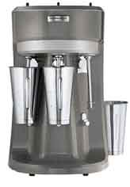
Fig 2.1: Hamilton-Beach stand mixer

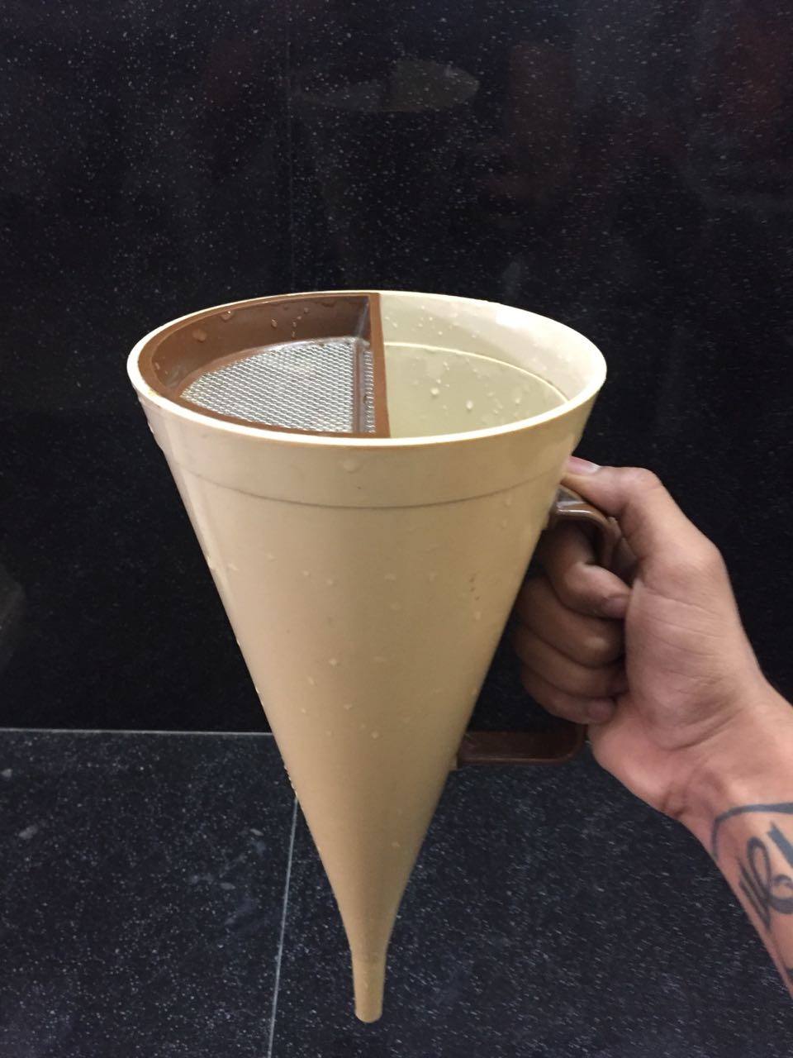
Fig 2.2: Marsh Funnel

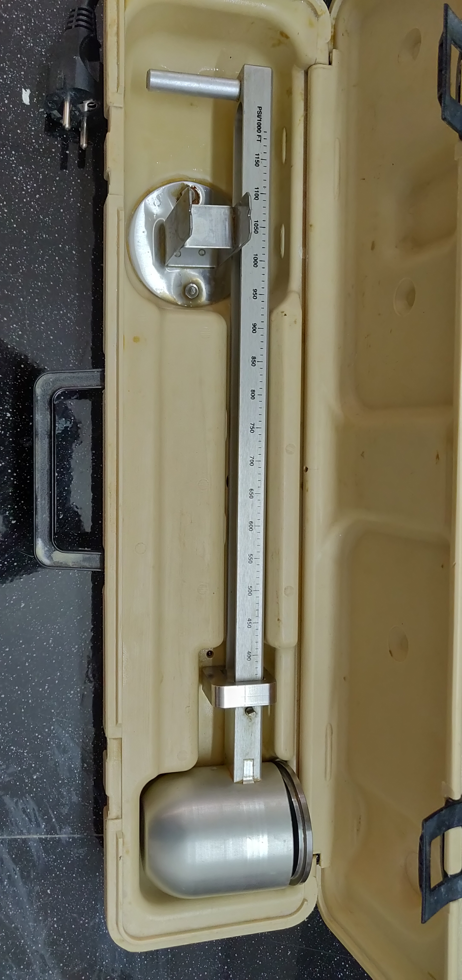
Fig 2.3: Mud Balance

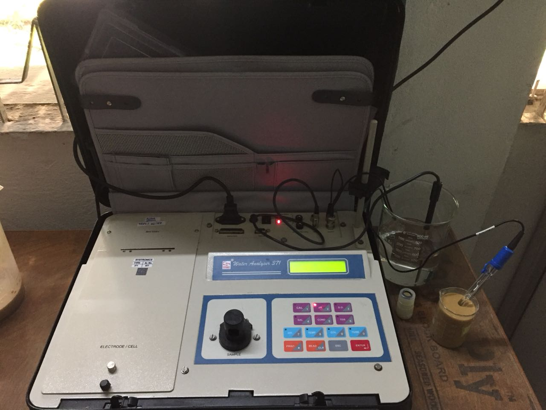
Fig 2.4: Water Analyzer

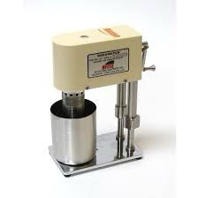
Fig 2.5: Hand crank viscometer

2.5 Experimental Procedure

A pre-determined concentration of the additive was taken. The sample was weighed and added to 1500 mL of distilled water. The mixture was thoroughly stirred and was then mixed using a laboratory Hamilton Beach mixer. This smoothens out the fluid and has uniform properties and density throughout the fluid. The density of this fluid is measured using a mud balance. 950 mL of the drilling fluid prepared is taken in Marsh funnel and the fluid was allowed time to flow out of the Marsh funnel freely. The time taken for the fluid to flow out of the marsh funnel was recorded. Three trials are conducted and the average time taken is determined from the three trials. This is used to determine the apparent and effective viscosities of the drilling fluid using the formula given below. The calculations required to determine the apparent and effective viscosity were carried out. The same procedure was carried out for every concentration of drilling fluid to be tested and evaluated.
Apparent Viscosity: ꝭ (t-28)
Effective Viscosity: ꝭ (t-25)
Where, ꝭ = density of formulated mud, g/cc
t = time taken for the fluid to flow out of the Marsh funnel, sec
The pH of each drilling mud for different concentrations of the drilling was determined. The plastic viscosity, gel strength, and yield point were determined for each concentration of the drilling fluid using a hand crank viscometer. The viscometer gives the shear stress readouts which are to be converted. The results from all these tests for different concentrations are to be compared with each other and a drilling fluid with an optimum concentration of each additive is to be formulated. This formulated drilling fluid was then compared with a NDDF. This fluid has the same additives as the NDDF but along with different type of NDDF.

Chapter 3: Work done

3.1. Formulation of NDDF

Non damaging drilling fluids (NDDF) are mostly water Based drilling muds and consists of bridging elements (such as calcium carbonate) and polymeric additives. Because NDDF can prevent formation damage, it is the system of choice in the reservoir sections. The drilling fluid being created in this project consists mostly of six additives.
- Carboxymethyl cellulose (CMC)
- Calcium Carbonate (CaCO₃)
- Groundnut Husk
- Psyllium Husk
- Potato Starch
- Formaldehyde

Each addition has a specific role to play in modifying the rheological properties of the drilling fluid and increasing particular qualities. Various concentrations of each additive will be tested, with the findings being used to identify the ideal concentration for each additive and, ultimately, to manufacture the drilling fluid.

3.1.1 Carboxymethyl cellulose (CMC)

Carboxymethyl cellulose (CMC) is a viscosifier as well as a fluid loss control component in drilling fluids. To make CMC sodium salt, natural cellulose is combined with monochloroacetic acid and sodium hydroxide. It's possible that up to 20% of the product obtained contains NaCl, which is processed to remove the NaCl. CMC was the first component we employed in our NDDF formulation. For the laboratory testing, the following CMC concentrations were used: 4.8g, 4.9g, and 5g in 1500 mL of distilled water. 5g of CMC in 1500 ml of distilled water is used for making the groundnut husk and psyllium husk. Density, specific gravity, pH, apparent viscosity, effective viscosity, plastic viscosity, gel strength, and filtrate loss are all the same rheological parameters tested.

3.1.2 Calcium Carbonate (CaCO₃)

CaCO3 is used in drilling fluids for two main reasons: as a weighing agent and as a bridging element. We employed the addition in this case for both of these reasons. When CaCO3 acts as a bridging element, it reduces formation damage. It closes the pores in the formation and creates a filter cake layer over it to block off the permeable zones. This lowers formation damage while also reducing filtrate loss and boosting the drilling mud density. This feature is particularly beneficial to NDDF since it functions as a substitute for barite. For the laboratory testing, the following CaCO3 concentrations were used: 3.15g in 1500 mL distilled water, along with the previously measured 5g of CMC. Density, specific gravity, pH, apparent viscosity, effective viscosity, plastic viscosity, gel strength, and filtrate loss are all the same rheological parameters. The same experiments were performed on this additive as they were on CMC.

3.1.3 Groundnut Husk

Groundnut husk is a by-product of flour mills and oil refineries, and it is produced in enormous quantities and burned as agricultural waste. Drilling fluids, which account for around a fifth (15-18%) of the overall cost of drilling a petroleum well, must meet three critical criteria: they must be simple to use, affordable, and ecologically beneficial. The multifunctional drilling fluid performs numerous tasks at the same time. They're supposed to clean the well, keep the cuttings suspended, avoid caving, keep the well wall tight, and produce an impenetrable cake near the wellbore. Groundnut husk powder enhances rheological qualities, minimizes filtering loss, and is environmentally friendly, cost-effective, and thermally stable when added to drilling fluid. Because groundnut husks are biodegradable, easily disposable, and have no impact on the ecology, they have shown to be a sustainable approach for keeping the environment healthy. Groundnut Husk contains cellulose, which impacts the rheological qualities and overall performance of the drilling mud. The apparent viscosity, plastic viscosity, yield point, and Gel strength (10 sec gel, 10 min gel) of the designed mud are all taken into consideration. The current study shows how to build and analyse a sustainable drilling fluid system that uses biodegradable groundnut husk as a rheological modifier. The cellulose obtained from groundnut husk is being used as an alternative to the polyanionic cellulose (PAC) currently used in the formulation of drilling fluids. The following groundnut husk concentrations were employed in the laboratory testing: 24g, 25g, and 26g in 1500 mL distilled water, as well as the previously determined 5g of CMC and 3.15g of CaCO3. Rheological metrics include density, specific gravity, pH, apparent viscosity, effective viscosity, plastic viscosity, gel strength, and filtrate loss. 24g of groundnut husk is been taken for throughout the samples.

3.1.4 Psyllium Husk

Psyllium is derived from the seeds of the Plantago genus, which has over 200 species. India dominates the global market, producing over 39,000 t of Psyllium seed annually. 85 percent of the global market is covered by this. The major product extracted from the seed is psyllium husk, with the remainder being utilized as animal feed. It's a transparent colourless mucilaginous gel made up of white fibrous hydrophilic substance. Psyllium, which is made from the seed husk of the Plantago genus plant, has around 80% soluble fibre and is a good source of both soluble and insoluble fractions in the diet. Psyllium husk, which is widely utilized in the health and food industries, is made from the seeds of a plant that is commercially farmed and manufactured in cool and dry climates. The performance of Psyllium husk as an environmentally friendly ingredient in water-based mud is evaluated in this study. To make water-based Psyllium husk mud, psyllium husk is mixed with pure water in various concentrations. It has a delicate gel structure that forms rapidly over time. When Psyllium husk mud with a concentration of 1% by weight is used instead of the standard bentonite mud, the filter volume is reduced by 13%. Psyllium husk's insoluble portions produce a very thin filter cake capable of sealing large holes and reducing water loss into forms. When compared to bentonite-based mud, psyllium husk is more resistant to salinity in make-up water and can produce higher viscosity when added to saline water. Insoluble components that can potentially block big pores and lower filtrate volume are an advantage of Psyllium husk over currently utilized water soluble polymers such as Starch and CMC (Sodium Carboxymethylcellulose).In the laboratory, the following psyllium husk concentrations were used: 24g, 25g, and 26g in 1500 mL distilled water. Density, specific gravity, pH, apparent viscosity, effective viscosity, plastic viscosity, gel strength, and filtrate loss are all rheological measures. Throughout the samples, 24g of psyllium husk is used.

3.1.5 Potato Starch

In situations where potato starch's qualities are particularly appropriate, it is favoured over maize starch and other starches. It has the following key characteristics: (a) high consistency on pasting, followed by a decrease in viscosity with additional heating and agitation, (b) excellent flexible film production, (c) binding power, and (d) low gelatinization temperature. The rheological qualities of potato starch mud improved when the pH of the drilling fluid was raised, according to the findings of this investigation. At low pH (about 8.6), potato starch might be used to improve gel strength, while at high pH mud, it could be used to improve viscosity (approximately 10.8). The following potato starch concentrations were employed in
the lab: 4.5g in 1500 mL distilled water. Rheological measurements include density, specific gravity, pH, apparent viscosity, effective viscosity, plastic viscosity, gel strength, and filtrate loss.

3.2. GH & PH Rheological properties

In this work, carboxymethyl cellulose (CMC), calcium carbonate (CaCO3), psyllium husk, groundnut husk, potato starch, and formaldehyde are used to develop a non-damaging drilling fluid (NDDF) that is water-based. To make the NDDF, these additives were mixed in with distilled water (DW) in a step-by-step process. Each addition has a specific function in distilled water (DW) in a step-by-step process. Each addition has a specific function in modifying the parameters of the drilling fluid and increasing particular qualities. Different concentration of each additive will be studied, with the results being taken to identify the ideal concentration for each additive and, ultimately, to create the NDDF. The concentration of each of sample taken and observed for period of time was considered and its rheological properties were found, as shown in table 3.1. modifying the parameters of the drilling fluid and increasing particular qualities. Different concentration of each additive will be studied, with the results being taken to identify the ideal concentration for each additive and, ultimately, to create the NDDF. The concentration of each of sample taken and observed for period of time was considered and its rheological properties were found, as shown in table 3.1.

