Dr.M.Assmee,
Assistant Professor,
Vinayaka Missions Sankarachariyar Dental College,
Vinayaka Missions Research Foundation Deemed to be University,Sankari Main Road, Salem.
Mail ID:asmibi01@gmail.com.

Contemporary Esthetic management :

Introduction :
Smiles are instinctive, a universal sign of friendliness. Smile is a major expression of emotions like happiness, love and excitement. It can enhance personal and professional relationships and inspire others in many ways. White marks and white lesions commonly found on anterior teeth can be unsightly. They ruin the looks through discoloration. Patients often seek treatment to have these marks eradicated. White spot lesions are defined as the enamel lesions that look chalky white and opaque. It can arise from developmental cause such as fluorosis,trauma, early caries lesion,medicine intake during enamel mineralization, molar incisor hypomineralization, premature birth can exhibit enamel white spot lesions or idiopathic cause .

Dental Flourosis :

Dental fluorosis is a condition of enamel hypomineralization because of the effects of excessive fluoride on ameloblasts during enamel formation resulting in surface and subsurface porosities and subsequent optical and physical changes.

Trauma :

Traumatic dental injuries (TDIs) are considered an emerging public health problem. TDI to primary teeth may compromise both primary teeth and their permanent successors.

Dental Caries:

Dental caries is defined as the destruction of tooth structure by acid
that is generated as a by-product of bacterial metabolism in dental plaque. WHO reports caries prevalence was around 60–90% in children going to school, and it was almost common among adults in majority of the countries.2
White spot lesions appear clinically, which is a first sign of enamel caries. It is a subsurface area with most of the lost mineral beneath the relatively intact enamel surface. It is also known as “initial” or “incipient” lesion. It is softer than the adjacent sound enamel and is much whiter when dried with air, which precedes cavitation. In these lesions, the mineralized layer is lost. This makes the translucent enamel porous and changes its refractive index (RI).

Remineralization:
Remineralization is one of the noninvasive treatment options for early carious lesions, e.g., through fluoridation, improved oral hygiene, or other processes. A number of methods and agents are available to remineralize early enamel lesions. The mineralrich concentrates can be topically applied for remineralization of incipient caries lesions. These provide calcium (Ca+2 ) and phosphate (PO4−) ions that can easily diffuse through porous enamel in order to remineralize incipient enamel lesion.
Milk and milk products were considered to prevent the development of caries due to the existence of casein, calcium, and phosphate contents. Later investigations on the purpose of casein and calcium phosphate concentrates on remineralization concluded that casein phosphopeptide (CPP) complexes stabilized the calcium phosphate and remineralized the incipient caries lesions.
The combination of CPP–ACP and fluoride also brings about the remineralization of the incipient caries lesions. A noninvasive technique, application of CPP–ACP with fluoride (CPP–ACP Plus), is considered to be a better alternative to treat early enamel caries lesions. CPP–ACP Plus contains fluoride which helps in the formation of fluorhydroxyapatite. This complex formed is more resistant to undergo demineralization as compared to hydroxyapatite.
A new concept called caries infiltration to treat white spot lesions was introduced. Caries infiltration product ICON-DMG™ was introduced in the year 2009 in Germany; it is a low-viscosity resin that fills, strengthens, and stabilizes demineralized enamel, without causing any damage to healthy tooth structure. It would also inhibit caries progression in initial carious lesions. Evaluating the physical property such as hardness of initial enamel caries lesions treated with different techniques and materials will yield a better option to treat these lesions.

Opaque white spots on the facial surfaces of the teeth can be an unsightly appearance. The whitish appearance is due to the presence of internal porosities beneath an apparently intact surface layer
that alters the refractive index of usually translucent enamel.
Today, the concept of minimum intervention dentistry has
been well accepted and should be based on five generally accepted principles:
- Scientifically orientated caries diagnosis of early lesions including adequate diagnostic devices.
- Disease control by reduction of cariogenic bacteria/modification of the oral flora and patient education.
- Remineralization of the earliest Lesions.
- Minimum surgical intervention of cavitated lesions and
- Repair in favor of replacement of defective restorations.
Proximal caries constitutes a large health problem, and, at the age of 21 years, up to 50% of patients show
carious or restored proximal surfaces. Therefore, a much more tissue preserving approach to arrest and control of proximal (or smooth surface) carious lesions has been considered beneficial.
There is a wide array of treatments available, which includes whitening as a first choice and bonding over the
mark as a last option. In today’s dental world, we are conscious of providing minimally invasive treatments that maintain a conservative approach to patients. Until now, our choices have been limited to invasive methods of varying degree to treat white spots.
This concept aims at infiltrating the highly porous structures of incipient enamel lesions by means of low viscous resins. Consequently, a dedicated resin (Icon caries infiltrant, DMG) with a low viscosity and a high penetration coefficient has been developed by the Berlin research group and has been marketed since March 2009.
Resin infiltration:
White spot lesions disturb the esthetic appearance of the enamel of the front teeth(8), and also they are an initial stage of enamel caries that can progress to a stage at which restoration will be needed if the patient has inadequate oral hygiene.So there are two aspects of treating white spot
lesions considering: arresting lesion progression,
and addressing the esthetic disturbance.
White spot lesions show irregular mineralization patterns and are histologically characterized by highly porous hypomineralized subsurface enamel. The removal of the surface layer may enable access to the volume of porous enamel, which could be penetrated by a resin with a refractive index (RI) similar to sound enamel afterwards. Adapting the RI of the lesion to the RI of enamel would allow masking of the subsurface enamel alteration.The objective of infiltration in esthetic areas is thus to fill up the microporosities of hypomineralized enamel with a resin whose RI is close to that of healthy enamel, in order to mask the enamel defect.
Resin infiltration (DMG) is an innovative product for the micro-invasive treatment of cervical and proximal dental lesions. Driven by capillary forces, the infiltrat, a highly fluid resin, penetrates into the enamel caries and blocks the diffusion paths for cariogenic acids, thus promoting the early arrest of caries. Resin closes the gap between preventive therapies and corrective restorations.

Technique:
After Rubber dam application, the teeth was cleaned using prophylaxis paste, the surface of the lesion is conditioned with 15% hydrochloric acid gel (ICON ETCH, composed of 15% hydrochloric acid, DMG) in a circular motion with a contact time of 2 min, the etching gel is then rinsed away (30 s) using water spray. To completely dry the body of the lesion, ethanol is applied. A resin infiltrant is applied on the lesion surface using a microbrush in two steps to minimize porosities and light-cured after light curing theapplication of infiltrant should be repeated once again to minimize enamel porosity. Then, the surface is polished with polishing disc (Figure1).

Conclusion:
Dental caries is a localised process, involving a progressive destruction of surface minerals by acids. Microorganisms which colonize on the tooth can produce acids in the presence of fermentable carbohydrates, and these acids diffuse into the healthy enamel surface and release hydrogen ions, which dissolve the underlying enamel (demineralization) and the dissolved minerals diffuse to the surface again and get precipitated. It is also known as subsurface lesion because it has an apparently sound enamel surface underneath is an area of
demineralization. The intact surface enamel is due to the reprecipitation of minerals (remineralization) dissolved from the subsurface.
RI of the sound enamel is 1.62, whereas the RI of the
porous enamel is 1.33 when it is filled with watery medium and 1.0 when filled by air. This significant difference in refractive indices, which causes changes in the scattering of light leading to the formation of white spots, termed as white spot lesion.
The choice of treatment is always the application of
remineralizing agents, but these treatment modalities
can cause only surface remineralization, the aim of this
novel therapy is to occlude the subsurface microporosities

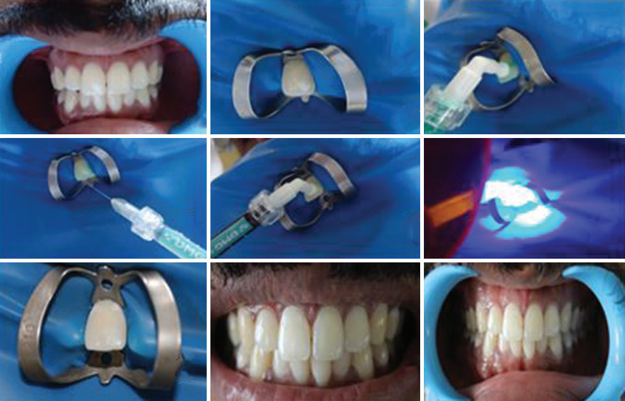

Figure 1

and also to create a surface barrier within the body of the
lesion and not on the surface. The principle on which the masking effect happens is based on the alteration in the RI of the porous subsurface medium. Icon infiltrant is a clear hydrophobic light curable resin Tri Ethylene Glycol Dimethacrylate. It has a low viscosity, low contact angle, high surface tension and high penetration coefficient. The RI of the infiltrant is 1.47. The resultant RI is 1.52, which is close to that of healthy enamel, resulting in masking of the white spot
lesion. The mineralized surface interferes with the resin
penetration. To overcome this, the surface of the lesion
is conditioned with 15% hydrochloric acid gel[8] (ICON
ETCH, DMG). Active lesions show better penetration than inactive lesion. During the management of inactive lesion,
ethanol can be used to evaluate the complete erosion
of the surface. If there is evident color change after
application of ethanol, sufficient erosion is being
achieved. When the color change is not evident, ethanol
has not reached the body of the lesion, so etching should
be repeated.
Caries infiltration occludes the microporosites in the
subsurface, which produces a diffusion pathway for
both acids and minerals, but the fate of the bacteria
trapped in the base of the lesion can trigger the carious process.There is enough evidence in the literature that
these entrapped bacteria, when properly sealed are not
detrimental and uncavitated lesions have comparatively
less bacteria in the subsurface. Resin infiltrates to
the body of the lesion by capillary forces and forms
resin infiltrated parts of the lesion, depth of infiltration
of the resin is up to 100 µm. It is considered to be
a micro-invasive procedure because tissue prevention is
maximum, When compared to microabrasion only 30–40
µm is eroded in this technique and erosion of the healthy
and demineralized enamel is similar because no pressure
is applied.
The disadvantages of this technique are that Tri Ethylene
Glycol Dimetha Acrylate is an hydrophobic resin which
raises a question about the hydric stress and there is
no enough literature about the aging of this kind of
restorations.Extending the application of this technique
to other conditions that exhibit white spots such as
fluorosis, hypoplasia, erosion, and trauma are also to be
evaluated.

This caries infiltration procedure bridges the gap between
preventive therapies and conventional restorative
therapies, which can sometimes be invasive. With the
increasing demand on less invasive esthetic treatments,
caries infiltration is a novel alternative for management
of enamel white spot lesion. This technique not only
arrests the lesion progression but also improves the
esthetics, which is considered to be a positive side
effect. Caries infiltration proves to be a micro invasive
treatment of smooth-surface white spot lesions and also
one that allows for the instant recovery of natural tooth
appearance, resulting in high patient satisfaction.

References :
1. Greenwall L. White lesion eradication using resin infiltration. Int
Dent Afr Ed. 2013;3:54-62.
2. Paris S, Meyer-Lueckel H. Masking of labial enamel white spot
lesions by resin infiltration – A clinical report. Quintessence Int
2009;40:713-8.
3. Meyer-Lueckel H, Paris S, Kielbassa AM. Surface layer erosion
of natural caries lesions with phosphoric and hydrochloric
acid gels in preparation for resin infiltration. Caries Res
2007;41:223-30.
4. Rosin-Grget K, Lincir I. Current concept on the anticaries
fluoride mechanism of the action. Coll Antropol 2001;25:703-12.
5. Meyer-Lueckel H, Paris S. Improved resin infiltration of natural
caries lesions. J Dent Res 2008;87:1112-6.
6. Tirlet G, Chabouis HF, Attal JP. Infiltration, a new therapy for
masking enamel white spots: A 19-month follow-up case series.
Eur J Esthet Dent 2013;8:180-90.
7. Mattousch TJ, van der Veen MH, Zentner A. Caries lesions after
orthodontic treatment followed by quantitative light-induced
fluorescence: A 2-year follow-up. Eur J Orthod 2007;29:294-8.
8. Tong LS, Pang MK, Mok NY, King NM, Wei SH. The effects
of etching, micro-abrasion, and bleaching on surface enamel.
J Dent Res 1993;72:67-71.
9. Kidd EA. How ‘clean’ must a cavity be before restoration?
Caries Res 2004;38:305-13.
10.Paris S, Meyer-Lueckel H, Kielbassa AM. Resin
infiltration of natural caries lesions. J Dent Res
2007;86(7):662–6.
11. Reston EG, Corba DV, Ruschel K, Tovo MF, Barbosa
AN. Conservative approach for esthetic treatment of
enamel hypoplasia. Oper Dent 2011;36(3):340–3.
12.Mehta R, Nandlal B, Prashanth S. Comparative evaluation of
remineralization potential of casein phosphopeptide-amorphous
calcium phosphate and casein phosphopeptide-amorphous calcium phosphate fluoride on artificial enamel white spot lesion: an in vitro light fluorescence study. Indian J Dent Res 2013;24:681–689. DOI: 10.4103/0970-9290.127610.

