Components of Automatic irrigation system

Dr. Mahesh Tripathi (Assistant Professor, Agricultural Engineering), Department of Agricultural Engineering, Dr. Khem Singh Gill Akal college of Agriculture, Eternal University, Baru Sahib (H.P.) India -173101
maheshagriengg@gmail.com

Introduction
Today farmers in Hills face major problems in irrigating crops. That's because they don't have an accurate idea of the availability of forces. Even if they are available, they have to pump water and wait for the fields to be properly irrigated, stopping other activities that are also important to them, wasting valuable time and effort. But there is a solution. Automatic irrigation systems help farmers as well as others to water their fields.

This automatic irrigation supply system detects the moisture level of the soil and automatically turns on the pump when the power is turned on. Proper use of the irrigation system is very important. The main reason is the lack of water and the lack of water to secure land due to unplanned use of water, wasting a large amount of water. Therefore, we are using these automatic irrigation systems, so it is very useful in all weathers condition.
The automation of micro irrigation system is usually achieved by a centralized decision controller, supported by a set of hardware (control valve, relay, etc.), executing irrigation commands and sensors, for irrigation decisions. Enter the irrigation values.
The basic structure and components of a relatively comprehensive irrigation management system are shown below.
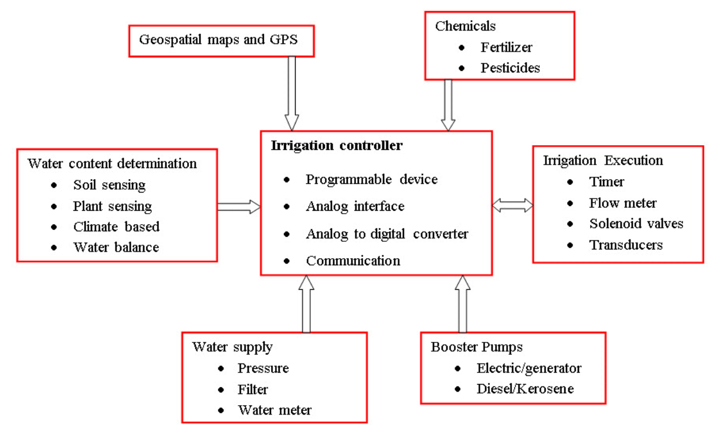
A working model of irrigation control system
(Source: Wang et al. 2013)
Components of Automation in Irrigation System
The most important and basic component of an automatic irrigation system is the sensor. It responds to the changes in resistance in response to soil moisture.
Automated irrigation includes components which include sensors, communique traces, controls and actuators, fertigation units, filters & filter backwashing equipment may be automatically operated by the micro irrigation system at the same time. The following sections briefly describe other types of sensors, communication lines, controllers & actuators. The main components of the automatic irrigation system are:
1.1 Sensors
A sensor is distinct as an element which senses changes in input drive and produces different or the same type of change in energy. The following kinds of sensors are used to observer soil and crop constraints.
i) Electromagnetic sensor
ii) The optical sensors
iii) Mechanical sensor
iv) Electrochemical sensor
v) The airflow and Soil moisture sensor
vi) Infrared sensors
- The electromagnetic sensors
They are use electrical circuits to calculate the ability of soil particles to conduct either store charges. With its sensor, the ground come to be portion of Electromagnetic circuit & changes in local condition can quickly affects the signal record through the data loggers. There is severally such sensor on the market. For example, one way to evaluate Electrical conductivity of soil is by Electromagnetic induction uses a geonics limited EM38* commercial measure. Its coil of the transmitter induce a magnetic field the strengths of which depends on the depth of the ground. You can measure different ground depths up to 1.5 meters by changing magnetic field strength/depth ratio to the ground. The received coil calculates the primary & secondary "inductive" currents of the soil & associates the two with the electrical conductivity of the soil. Another commercially available soil EC mapping device, the Veris® EC probe, measures EC much more directly. These use a set of Coulter electrodes that send electrical signals through the ground. The signal is received by two sets of electrode arrays that measure the voltage drop due to soil resistivity and display soil ECs in two different depth ranges.
ii) Optical sensors
These Sensors are characterized using light reflection the ground. This sensor can be simulate the human eye looks at the ground and calculate near-infrared, mid-infrared, or polarized reflectance. Vehicle-based optical sensors use the same basic technology as remote sensing. Several researchers have been working for the development of optical sensor for predicting clay, organic & moisture levels. Instead of using light reflections, some researchers were using earth penetrating radar to study the movement of waves by the ground, changes in the wave reflection can indicates change in ground density or ground layer limits.
iii) The mechanical sensor
These can be used to evaluate mechanical strength of the soil (often associated with compact). Its sensor uses a mechanisms that penetrate either cut through ground and record the force calculated through a strain gauge either load cell. Several researchers have developed prototypes that demonstrate the feasibility of continue soil resistivity mapping, but nothing of these devices are sale. The tractor's draft sensor or "traction control system" uses similar technique to control the 3-points hitch on the go.

iv) The electro-chemical sensor
They Provides necessary data (soil nutrient levels and soil pH) needed for precision agriculture. We follow some standard laboratory procedures when sending soil samples to a soil laboratory, its steps include trial preparation and calculated, some measurements (particular pH calculates) are performed using ion-selective electrodes (using glass either polymer membranes or ion sensitive field effect transistors). These electrodes detect the activity of specific ions (nitrate, potassium, or hydrogen at pH, the process, some investigators are trying to getting existing soil preparation and measurement procedures for laboratory testing. These data ​​obtained may not be as accurate as in the laboratory tests, but higher sample densities may improve the complete accurateness of the result soil nutrients either pH map.
v) Soil Moisture Sensors
Soil moisture measurements made with any device or method can show fluctuations in soil moisture. Soil moisture sampling at a location represents only the condition at that particular point and requires a series of measurements to determine the average moisture content of the field. Generally, in areas where the soil is fairly uniform and homogeneous, soil samples are collected from four locations and the amount of water applied for irrigation is based on the average of these four locations. Not surprisingly, watering with this system tends to damage plants in dry areas, resulting in reduced yields. This can be prevented by automated irrigation, which measures soil moisture at multiple points at the same time and activates according to the conditions of the driest areas. Commonly used soil moisture sensors for automation purposes are tension gauges, resistance blocks, and granular matrix types. Fig. 1 shows section of soil moisture sensor.
Nylon Cloth Gypsum Wafer

Granular Matrix
Steel Electrode
Brass nut and bolt
Electrical wire
PVC Pipe
Body
Wire Mesh
Fig. 1 Section of soil moisture sensor.
(Source: Tiwari et al., (2002))

a) Tensiometer: A tension meter is a device that directly measures the tenacity of water retained from the soil. Changes in soil moisture cause corresponding changes in tension of soil moisture. In automatic irrigation control, the tension gauge is modified to measure changes in tension of soil moisture with respect to changes in tension or resistivity. It consists of an electric tension meter, an electronic exchange unit, and a solenoid valve.

A tension meter is a device that directly measures the tenacity of water retained from the soil, fluctuations in soil moisture cause corresponding changes in tension of soil moisture. The automatic irrigation control, the tension gauge is modified to measure changes in soil moisture tension with respect to changes in tension or resistivity. It consists of an electric tension meter, an electronic exchange unit, and a solenoid valve.
b) The resistance block: in this type of sensor the two electrodes changes depending on the moisture in the soil and the humidity of the resistance block in equilibrium. The presence of salt or salinity in the irrigation water or soil will affect observations. Gypsum block and granular matrix type sensors are commonly used to determine soil moisture.

c) The gypsum block: Which consists of two electrode embedded in a block of plaster, gypsum neutralizes the effects of salt. Although Gypsum blocks are easy to use and economical, the inherent drawback of this sensor is that the gypsum dissolves in water and the calibration curve changes over time in the same place.
d) Granular Matrix: These sensors reduce the problems inherent in gypsum blocks (ie, loss of contact with soil due to dissolution or uneven pore size distribution) by using a granular matrix supported by a metal or plastic screen. The electrodes in the sensor are embedded in a granular filler on a gypsum wafer. Gypsum wafers slowly neutralize the salt content of the soil solution and do not affect the electrical resistance between electrode. The particle size of the granular filler and its compression determine the pore size distribution and response of the sensor. Such sensors require little maintenance during the growing season and help detect soil moisture potential and automatically control the irrigation system. They have the advantage of a low unit price and a simple installation procedure similar to that used for tension meters. The Granular Matrix Soil Moisture Sensor was developed at IITK haragpur and is shown in Figure 3. The developed sensor was used to automate a micro-irrigation system installed for sugar cane. (Joshi et al., 2000).

vi) The airflow sensor
These sensors are used to measure the aeration of soil along the way therefore the pressure required to force a specified amount of air into the ground at a given depth was compare with some properties the soil. Experiments have demonstrated the ability to discriminate between different soil type, moistures level & soil structure/compact.

vii) Infrared sensor for leaf air temperature

Plant temperatures measured remotely using An infrared thermometer can be used to detect moisture stress in plant and signal the need for watering before the plants show visible symptoms of drought. This is because water-stressed plants struggle to get enough water from the soil to meet their atmospheric needs. This reduces evaporative cooling of the leaves. As crop water stress index (CWSI) method uses crops and lack of temp. & vapor pressure to conclude whether the crop has sufficient moisture (CWSI = 0) or severe moisture stress (CWSI = 1). To judge. The infrared thermometer can be operated continuously by hand or cantilever. Similar information can be obtained from thermal scanners on board satellites and aircraft to map crop temperatures across fields and farms. Thermal data provide the most useful information in dry or semi-arid areas where irrigation is usually required to grow crops and the temperature difference between stressed and well irrigated plants is large.
viii) The sensors for climatological parameters
The sensors that measure many climatic parameters such as solar radiation, max. and min. temperatures, wind speed, relative humidity, and pot evaporation are connected to the computer to estimate plant evaporation and initiate irrigation based on evaporation needs. increase. Figure 1.2 shows a typical assembly of components for an automatic irrigation system.
Fig. 1.2 Typical assembly of components of automated irrigation system.
(Source: Tiwari et al., (2002))
Sensors that measure evaporation from the pot are connected to the irrigation controller to activate and deactivate the irrigation system. Figure 1.2 shows a typical assembly of components in an automatic irrigation system.
26.2 Data communication
Data communication is essential for intelligent transmitters where the sensor output communicates with the host via the bus system. The encoded data is processed by the software processor for communication, and the appropriate interface system communicates between the processor and the bus. All intelligent sensors / transmitters always have a local operating system in ROM consisting of ADC and DAC hardware, bus driver hardware, local interface hardware, and application programs and library modules for LCD / keyboard hardware. It is attached. A typical transmitter using the HART protocol looks like Figure 26.2. The communication line is used to connect the soil moisture sensor and the irrigation valve with irrigation control. They can be hydraulic or electric. There are three types of telecommunications lines:
- Analogue,
- Digital and Microwave.
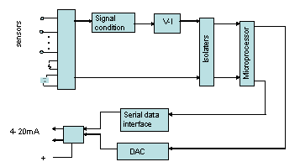
Fig.26.2 A smart transmitter
(Source: Tiwari et al., (2002))

26.3 Controllers
The irrigation controller is a device that combines, An electronic calendar & a watch & is housed in a suitable case to protect them from element. These controllers provide a few voltage outputs (normally 12 or 24 volt DC either 24 volt AC) to valves and controllers in specific zones. As long as voltage is applied, the valve remains open and water is supplied for irrigation. Most remote control valves are "normally closed". That is, the valve closes until the controller activates the solenoid. The normally open control valve remain open until the solenoid is actuated. The normally open valve can be used as the main valve in the system. This is when the mainline should be continuously pressurized, but with a main valve which to be closed in the event of excessive flow either other alarm conditions. The function of the controller is to monitor the actuator with or without feedback from the sensor. Use a microprocessor or computer to connect the actuator to the software and turn irrigation on and off. There are three types of irrigation controllers: microprocessor / computer, timer, and speed control valve. The function of the controller is to monitor the actuator with or without feedback from the sensor. Use a microprocessor or computer to connect the actuator to the software and turn irrigation on and off. There are three different types of irrigation control
i) Microcontrollers/Microprocessors/Computers
ii) Timers
iii) Volume control valves
Today, microcontroller-based irrigation controllers are becoming more popular because they are easy to program.

i) Electromechanical Controllers
Electromechanical control uses electrical drives clock & a mechanical circuit (gears array) to-be activates irrigation station, this type of controller are generally very reliable & less sensitive to the qualities of available powers, they were usually unaffected by power spikes and will continue to operate unless a surge or voltage drop is large enough to damage the motor. In the event of power outage the programme scheduled is does not lost & is usually late single during power outage. Though, as it is a machine-based component, it offers limited functionality.

ii) Electronic Controllers
Electronic control relies at solid state & integrated circuits to offer clock / timing, memory & control function. This types of system are much sensitive to power line quality than electromechanical control & can be affected by voltage spikes, surges, and sags. Spikes and surges are common in many parts of Florida where lightning is frequent. These types of systems may require electrical suppression to function reliably. Due to the inherent flexibility of electrical devices, these controllers tend to be very flexible and offer a no. of feature at a comparatively few cost.
26.4 Actuators
Actuators receive signals from controller. Actuators are of two types
They are of two types:
i) Electrically driven
ii) Hydraulic
Actuators that use both hydropower and power are also commonly used for irrigation purposes. Soil moisture measurement and its importance in irrigation planning are well recognized. However, limited knowledge is available about the design and development of soil moisture meters and the interface between these sensors and personal computers / microprocessors / microcontrollers to automate irrigation schedules. Most of this work was done in developed countries. They use complex irrigation planning techniques to automate the irrigation system. These systems are very expensive commercially and no details of their complete structure are available. Manufacturers use off-the-shelf circuits to connect soil moisture sensors and irrigation control valves to computers, increasing the cost of the system. These expensive sensors and irrigation systems are not suitable for marginal and small-scale agricultural applications. Approximately low cost technologies for capturing and automating irrigation have great potential for development in the Indian situation.
Keywords: Actuators, Components of automation, Controllers, Sensor, Optical sensor, Mechanical sensor & electrochemical sensors, Soil Moisture Sensors,

Reference:
K. N Tiwari, Joshi Ajay, S. Banerjee 1999 Automated Irrigation controller Patent Application # 6/Cal/99 year 1999, IIT KGP.
R. G. Allen., Pereira, L. S., Raes, D., and Smith, M.1998. “Crop evapotranspiration: Guidelines for calculating crop requirement. “Irrigation and Drainage Paper No.56, FAO Food and AgricultureOrganization, Rome.
American Society of Agricultural Engineers ASAE.2000. “Test pro-cedure for determining the uniformity of water distribution of centerpivot and lateral move irrigation machines equipped with spray orsprinkler nozzles.”American Society of Agricultural Engineers stan-dards, ANSI/ASAE S436.1, 48th Ed., ASAE, St. Joseph, Mich.
Wang D., S A., O’Shaughnessy & Bradly King (2013). Automated Irrigation Management with Soil and Canopy Mapping (In Agricultural Automation Fundamentals & Practices. Edited by Zhang Qin and Pierce, F. J.) CRC Press Taylor & Francis, Chapman & Hall Book NW: 295-322

