SAP – LAP ANALYSIS
Er.Ramkumar. R¹, Er.P Prajeeth², Dr.B.Ravinder³
1,2 QSCM NICMAR, 3 Associate professor NICMAR
1,2 ramkumarravi@yahoo.com
3 bravinder@nicmar.ac.in

ABSTRACT
Research is being done to learn additional ways that can be used to improve a company's core competencies globally. The Situations, Actors, and Processes - Learning, Action, and Performance (SAP-LAP) framework was used as the technique. Situations in the highly competitive industrial world change extremely quickly, thus the actors must be adaptable enough to adjust the process of releasing new, better products with new features at competitive prices. An ideal research footprint is paved by embracing new technology. The SAP-LAP framework has identified those circumstances in which there exist learning resources. In each scenario, the roles that several players played have been explained. Each situation's learning challenges have been identified, along with potential solutions and performance evaluations. The above method is implemented in the case studies and the results are discussed in the findings.

Key Words: Situations, Actors, Processes, Learning, Action, Performance

1. INTRODUCTION:
Small and medium-sized manufacturers in India are under more pressure due to globalization to continuously cut costs while maintaining or even increasing quality and services. The continual provision of innovative and customized products using the best process technologies, the reduction of lead times for delivery and product life cycles, etc. are other significant difficulties for small and medium-sized businesses. Product complexity has increased due to rival capabilities improving, and accessibility to new technical innovations has increased.

In this project, we used SAP-LAP analysis to analyze the adoption of supply chain management in small and medium-sized businesses in the construction sector.

This case study makes use of the Situation-Actor-Process (SAP)-Learning-Action-Performance (LAP) paradigm. The circumstance is a representation of the organization's current position. Actors are the players who influence the development of various business processes. According to SAP, a number of learning-related challenges have been examined. This analysis will assist determine the best course of action for enhancing performance.

1.1 METHODLOGY:

Data from primary and secondary sources were used to create a case study. The major method used to gather primary data and information was semi-structured interviews with the relevant managers in each department. Published sources have been used to gather secondary data.

This research analyzes supply chain problems in the industrial industry using the SAP-LAP approach (Sushil, 2000). It does a thorough analysis of a company and interacts with LAP and SAP. Figure 1 depicts the SAP-LAP structure in detail.
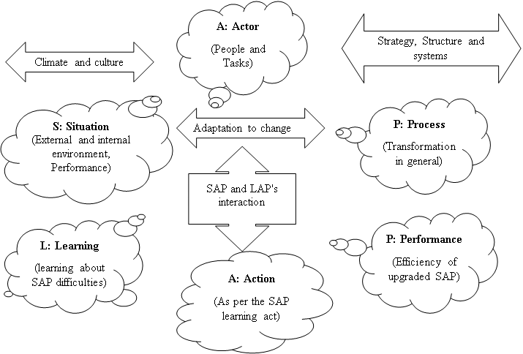
Figure 1: SAP-LAP framework
In every management environment, it considers three fundamental entities: circumstance, actor, and process. An actor or group of actors must use a process or group of procedures to address a circumstance. Out of the three fundamental entities, the actor, who may be an individual, a group, a department, or the entire organization, has the most freedom of choice.

The appropriate actors must be determined based on the circumstances. Different performers may find themselves in different situations. An actor's process could be another actor's circumstance, and vice versa. For instance, the project manager will go through a procedure when carrying out a project, but senior management may base its strategy decisions on this condition. "External flexibility" refers to the freedom of action made possible by the circumstances for the actor, and it differs from organization to organization.
Learning, action, and performance (LAP) are the results of the interaction of situation, actor, and process (SAP). Flexible systems management operates through a dynamic interaction of learning, action, and performance rather than the typical management mentality of planning, organizing, and regulating. Any managerial investigation results in new information or understanding about the problem, the actors, and the process. The knowledge gained would guide potential course of action for dealing with the upcoming circumstance, which would affect the system's performance.

The performance's feedback will on the one hand offer more learning opportunities and on the other, it will highlight the necessary corrective measures. The circumstance, actor, and process may shift to a new level with fresh learnings and actions. Such a fluid interaction between SAP and LAP will serve as the foundation for further management research.

The analytical and synthetic modes of system inquiry are combined in the SAP-LAP. The entire is broken down into components (analysis) in an analytical mode, which are subsequently combined back into the whole. This provides an explanation of the system's operation. The synthetic style of inquiry, on the other hand, aims to respond to the query of why a system should exist or what is its function.
2 CASE I: xxx Limited – Concrete Product Division:
In this case study we will be discussing the SAP – LAP analysis done by xxx Limited– Concrete Product Division (Company name changed) with conventional manufacturing of the following elements. (i) Concrete poles and (ii) Telecom towers.
2.1 CONCRETE POLE:
a) SITUATION:
The expansion of the electric power industry has a direct impact on the demand for pre-cast/reinforced concrete-cement (PCC) poles. Only overhead electricity transmission and distribution to consumer units is intended for these poles. The distribution network will need to be expanded and strengthened as power generation rises. Fresh materials for transmission towers, PCC poles, and other items are required for this new task. India is a growing nation where access to infrastructure facilities is essential for the quick growth of the national economy and prestige. Only by establishing effective generation and distribution standards would a vast network of energy distribution for rural electrifications, agricultural and irrigational consumptions be able to be met. Overhead electricity transmission and distribution are supported by electrical transmission towers, steel poles, and PCC poles. All of the current transmission grids are either inefficient or in poor shape. These networks need to be updated. They cannot carry more electricity until and until those transmission lines are replaced by new ones. Then, all those regions where this facility is now lacking must have access to electrical light and electricity. All of these things will essentially increase demand for poles as well as distribution materials like electrical equipment.
b) ACTORS:
- Manchukonda Prakasham Industries India Private Limited, Punjagutta, Hyderabad, Telangana – Manufacturing of flat Concrete Poles for Power Transmission.
- XXX Limited – Concrete Product Division, Laxmapur Road, Aliabad Village, Shameerpet Mandal, Rangareddy Dist, and Hyderabad. – Manufacturing of Precast Pre-stressed Spun Concrete Poles for Power Transmission.
c) PROCESS:
P.C.C. Poles, as seen in Figure 3, are mostly built of concrete and are thus less expensive and easier to maintain than traditional steel poles. Depending on how the pole will be used, they come in two varieties: low tensile and high tension lines. The latter is mostly employed for electrical transmission. Concrete is the primary component of precast cement concrete poles. The pre-made molds are filled with high tensile steel. For earthing, galvanized wire is attached inside the mold before the proper percentage of concrete mix is poured. The concrete is then vibrated into a compressed state to create high strength concrete poles. The poles are covered with a water spray system for 28 days once the demoulding is finished, which takes place after 72 hours. (Before being put up for inspection, concrete cubes are tested for strength.)
d) LEARNING:
As the conventional flat PCC poles doesn’t have good stability against high winds during cyclone (especially in coastal areas) XXX Limited – Concrete Products Division offers state-of-the-art technology Precast Pre-stressed Spun Concrete Poles (as shown in Figure 4) for Power Transmission.
e) ACTION:
XXX Limited – Concrete Products Division produces the most useful and cost-effective transmission poles are made of spun concrete. The dense, long-lasting concrete, thin, and attractive Spun Poles are the outcome of technological know-how employing centrifugal casting and spinning.Due to its round shape and lack of edges or angles, spun concrete poles make a great choice for wind energy projects since the wind forces acting on them are spread and are less powerful than those acting on rectangular poles for the same intended area. These poles are available in single segment heights between 11 and 13 meters, thus they may be used for double and triple circuits as well. The Table.1 lists the uses for spinning concrete poles of various heights (as seen in Figure 2).

TABLE 1: APPLICATIONS OF SPUN CONCRETE POLES OF VARIOUS HEIGHTS
S.No. | Length (m) | Application | Top End Diameter(mm) | Bottom End Diameter(mm)
1 | 11 | Street Lighting | 160 | 307
2 | 11 | 11/33 KV Lines | 190 | 337
3 | 11 | 11/33 KV Lines | 230 | 377
4 | 12 | 11/33 KV Lines | 190 | 350
5 | 12.5 | 11/33 KV Lines | 190 | 357
6 | 12.9 | 33 KV Lines | 190 | 362
7 | 13 | 33 KV Lines | 230 | 404
8 | 13 | 33 KV Lines | 250 | 424
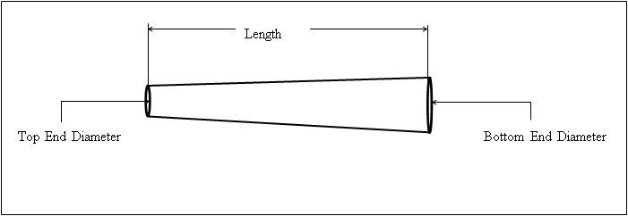
Figure 2: Spun Concrete Pole Sketch

f) PERFORMANCE:
The following are some superior features of Concrete Spun Poles over the flat PCC poles.
- Cost-effective.
- Simple accessibility.
- Anti-pilferage.
- Non-maintenance.
- Simple to handle and transport.
- More durable and uniform.
- Aesthetic Improvement.
- There is equal force in all directions.
- A significant decrease in stay anchoring.

The cost of manufacturing of Spun Concrete poles will be Rs. 8,000 – 22,000 (rates are specified by Mr. Phanikumar, Operation Manager, XXX Limited) for sizes varying from 9m to 30 m whereas the cost of manufacturing of flat PCC poles will be Rs. 2,000 – 4,000. Even though the cost of spun concrete poles is costlier they are more durable, has good stability against high winds and no maintenance is required after the installation is done but the flat PCC poles are less durable, has poor stability against high winds, it has to be replaced frequently when the damage occurs. A SAP – LAP model has been developed as shown in Figure 5.
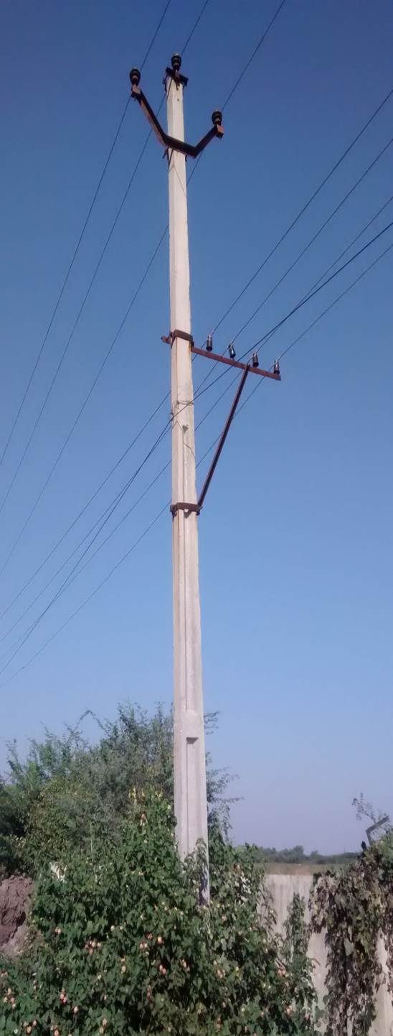 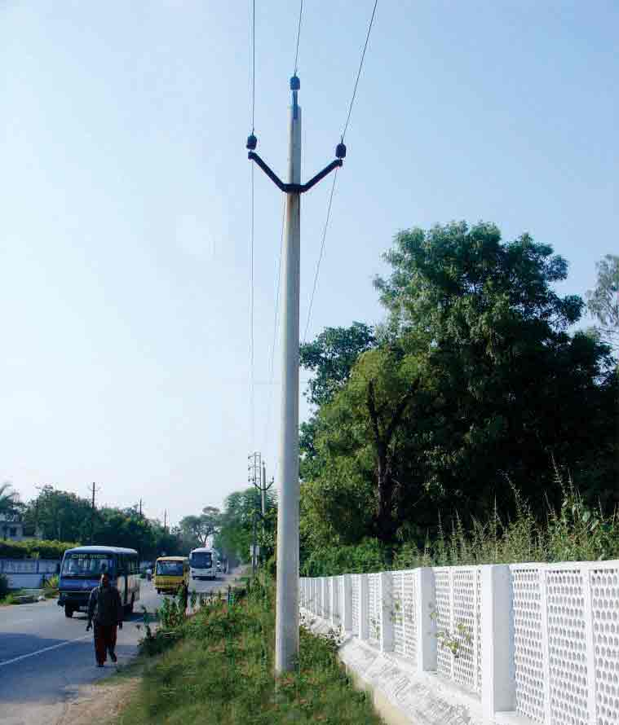 Figure 3: Flat Concrete Pole Figure 4: Spun Concrete Pole
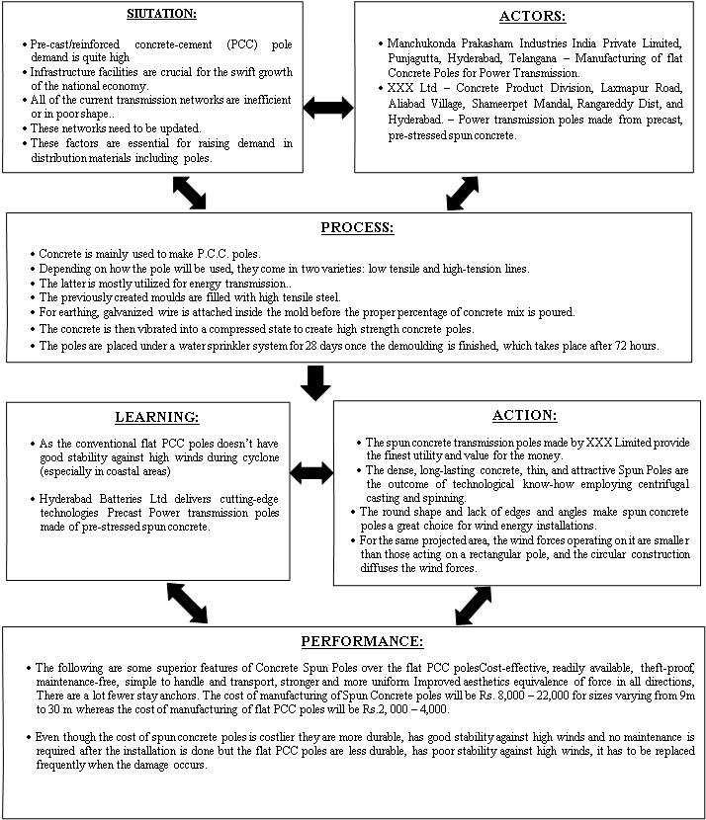
Figure 5: SAP – LAP Model for Concrete Poles

2.2 TELECOM TOWERS:

a) SITUATION:
People communicate with one another through telecommunication towers. These towers link all of the antennas for wireless communication, mobile networking, radio broadcasting, and television. In order to link people via telecommunications, a complete telecommunication tower consists of a large group of mechanical structures and an electronic signal processing unit. These towers connect all of the phone lines and mobile phone services. These towers are also utilized by the military for radar and other systems. Towers of various heights are utilized for various purposes and locations. They can range from 15 to 60 meters, sometimes even longer if necessary. For instance, towers might be 15 to 30 meters high in hilly places but 30 to 60 meters high in flat areas since they are higher in the soil. Different types of telecommunications towers, such as monopole, self-supporting, and guyed towers, are in use. The self-supporting towers are the most popular in the telecommunications industry. The factory produces telecommunication towers, which are then built on the construction site. Depending on the location and height of the telecommunication towers, a tower might take up to two weeks to build.
b) ACTORS:
- Savitek Engineering Private Limited, Bollarum, Hyderabad, Telangana – Manufacturing of Steel Telecom Towers.

- XXX Limited – Concrete Product Division, Laxmapur Road, Aliabad Village, Shameerpet Mandal, Rangareddy Dist, and Hyderabad. – Manufacturing of Precast Pre-stressed Spun Concrete Telecom Towers.
c) PROCESS:
The manufacturing processes of telecommunication towers can easily be understood by the following flow chart in figure 6.
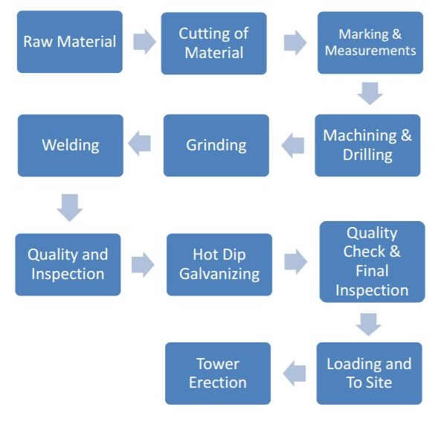
Figure 6: Flow Chart of manufacturing process of Telecom Towers
d) LEARNING:
The fabricated steel telecom towers (as shown in Figure 7) require more land area for installation and they are likely to get damaged during cyclones causing communication failure. In order to overcome this issue, XXX Limited has started manufacturing Spun Concrete Towers (as shown in Figure 8) for telecom industries. Installations of Spun Concrete Monopole are suited for areas with limited space as well as prime positions to boost aesthetic impacts. This tower may be readily accommodated in metro cities, parks, and even on motorways and traffic barriers. Major signal interruptions occur often while traveling via long elevated flyways in urban areas; this might be due to a lack of available ground space. Due of its incredibly small footprint requirements, monopole is the sole option for this issue.
e) ACTION:
The Spun Concrete Towers are produced in varying length like 8m, 10m and 12m. Based on the requirement the pieces are connected by welding. It produces a tower of length 50m and customized length based on the client requirements. The design is carried out with reference to Indian Standard IS 875: 1987 (Part III) for telecom towers. The raw material required are cement, sand or /robo sand, coarse aggregate of 12mm and 20mm size which should have smooth edges and a customized type of steel which is specially manufactured and supplied by the steel manufacturing plants. The Micro silica is used as admixture to produce a grade of M50 concrete. SP430 is used as the retarder. The raw materials are mixed in the batching plants and the concrete is transported through conveyor into the manufacturing plant. The moulds are prepared and the reinforcement is placed inside the moulds and prestressed before placing the concrete. As soon as the concrete is poured the moulds are tightened with bolts and nuts and the moulds are transported to spinning machine where the moulds are spinned for a certain period of time to compact the concrete. Later the moulds are shifted to curing tanks. First the stream curing is done at 65⁰C for 6 – 8 hrs. Later the top cover slab of curing tank is kept opened for 2 – 3 hrs to bring done the temperature to 35⁰C – 25⁰C. Then the demoulding is done and the precast member is immersed into water curing tank for 3 - 7 days. Later the precast member is stacked at the yard. The top diameter ranges are 190mm, 160mm, 230mm, 250mm and 400mm. The bottom diameter varies with the slope of 13.5mm for top. The 1/6th of height of the tower is placed in foundation. The ends of each member would be fixed with circular steel plates which has a provision for bolting. While erecting the tower the plates are aligned and the jointing is done by welding through the perimeter. Spun Concrete towers have been created for a variety of uses, including:
- Telecom Towers.
- Radio Communication E.g., TETRA projects, installation of FM radio antennas etc.
- Disaster management - Installation of security equipment in high wind and cyclone prone areas.
- Electrical Transmission (132KV, 66KV lines).

f) PERFORMANCE - TELECOM TOWERS:
The following are some superior features of Concrete Spun telecom towers over the fabricated steel towers.
- Extremely slim and elegant style.
- Affordable and Theft-Proof.
- uses a lot less ground space (Bottom dia. 1.2Mtr).
- Simple to erect and install in a short amount of time.
- Extremely strong and long-lasting (no degradation, corrosion, or chemical reaction). Even under the most extreme and persistent weather conditions, there is essentially no deterioration.
- completely non-maintenance.
- Better wind resistance capability.
- Resistant to strong gale and wind loads; suitable for cyclone-prone areas.
- Eco-friendly, aesthetically pleasing, and adaptable to the particular application.
- Towers can also be outfitted with solar panels to provide sustainable energy.
- Meets all safety regulations and standards.
- The most effective camouflaging.
- Globally Proven Technology.
The cost of manufacturing of Spun Concrete telecom towers will be Rs. 8, 00,000 (rates are specified by Mr. Phanikumar, Operation Manager, XXX Limited) for length of 30 m whereas the cost of manufacturing of fabricated steel towers will be Rs.2, 00,000 – 4, 00,000. Even though the cost of spun concrete telecom towers is costlier they are more durable, has good stability against high winds, require less ground space and no maintenance is required after the installation is done but the fabricated steel towers has poor stability against high winds, and if any damage occurs to the telecom towers, there will be a huge communication failure which causes inconvenience to the people. A SAP – LAP model has been developed as shown in Figure 9.
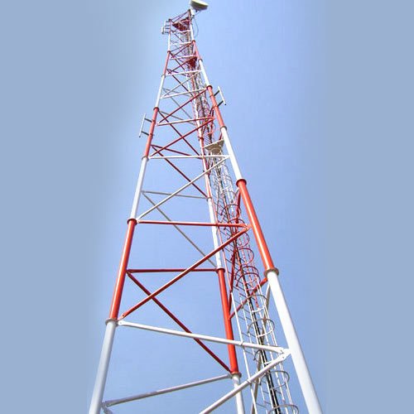 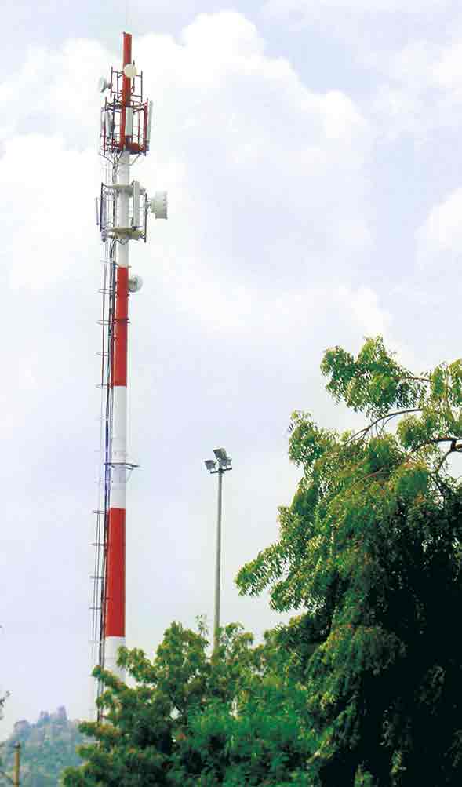 Figure 7: Fabricated Steel Tower Figure 8: Spun Concrete Tower
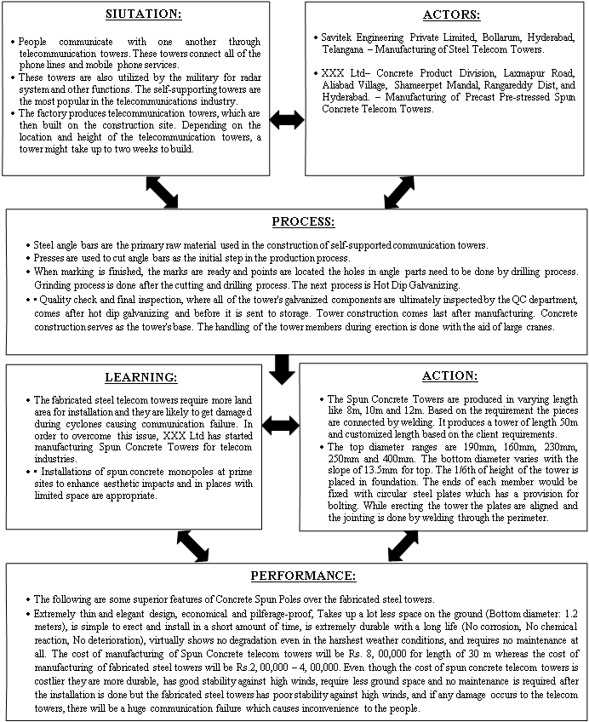
Figure 9: SAP – LAP Model for Concrete Tower

3. CASE - II: Comparison of clay bricks and cement blocks, cement mortar plastering with Plaster of Paris punning and gypsum plastering.
a) SITUATION:
In this case study use of clay bricks (190*90*90 mm) for brick work and Cement Mortar (1:6) for walls in construction of a building is considered.

- Availability of Raw materials: Availability of clay bricks is difficult than cement bricks as for making clay bricks good quality of clay is required and for manufacturing cement bricks - 43 grade cement, robo sand with by product from crushing plant of size 4mm which are easily available are used.

- For cement mortar - cement, natural sand (to avoid shrinkage cracks) are required, Plaster of Paris is used after plastering to give good even and finishing surface before painting, so gypsum can replace both cement mortar plastering and POP punning for better finishing. Availability of natural sand is also difficult.

- Labor Requirement: Skilled and Un-skilled labors for block work masonry and plastering are required.

- Time involved: Manufacturing of clay bricks require more than 2 weeks, plastering with cement mortar including curing, finishing with Plaster of Paris requires 8 days.
Cost incurred: Each clay brick cost Rs.6.

b) ACTORS:
Employer, contractor, Clay Bricks, Cement bricks, Cement, Natural Sand, Robo sand, gypsum suppliers

c) PROCESS:
The processes identified are
- Manufacturing time of clay bricks.
- Deficiency of materials like clay, natural sand is studied
- Labor requirement for block work, plastering, finishing works
- Calculation of cost involved in using clay bricks and plastering & finishing with cement mortar & Plaster of Paris.
- The Rate Analysis for Cement Mortar (1:6) is given in Table 2.
- The Rate Analysis for Cement Mortar (1:3) is given in Table 3.
- The Rate Analysis for Clay Brickwork (1:6) is given in Table 4.
- The Rate Analysis for plastering works is given in Table 5.
- The Rate Analysis for POP punning is given in Table 6.

TABLE 2: RATE ANALYSIS FOR CEMENT MORTAR (1:6)
S.No | Description CM (1:6) | Units | Constant/Unit | Rate/Unit  (Rs) | Amount (Rs)
Materials
1 | Cement | Kg | 254.2 | 7.00 | 1779.40
2 | Sand | Kg | 1.096 | 2560.00 | 2805.76
3 | Water | Lit | 140 | 0.10 | 14.00
Total Cost for Cement Mortar (1:6) per Cum |  |  |  |  | 4599.16

TABLE 3: RATE ANALYSIS FOR CEMENT MORTAR (1:3)

S.No | Description CM (1:3) | Units | Constant/Unit | Rate/Unit  (Rs) | Amount (Rs)
Materials
1 | Cement | Kg | 493.03 | 7.00 | 3451.21
2 | Sand | Kg | 1.096 | 2560.00 | 2805.76
3 | Water | Lit | 140 | 0.10 | 14.00
Total Cost for Cement Mortar (1:3) per Cum |  |  |  |  | 6270.97

CLAY BRICK MASONRY:
TABLE 4: RATE ANALYSIS FOR CLAY BRICKWORK CM (1:6)
S.No. | Description | Units | Constant / Unit | Rate/Unit  (Rs) | Amount (Rs)
1 | Materials
a) | Bricks | Nos | 525 | 6.00 | 3150.00
b) | CM(1:6) | Cum | 0.229 | 4599.16 | 1053.21
2 | Labour
a) | Mason | Cum | 0.92 | 500.00 | 460.00
b) | Mazdoor | Cum | 1.81 | 350.00 | 633.50
c) | Bhisti | Cum | 0.20 | 330.00 | 66.00
Total Basic Cost (1+2) |  |  |  |  | 5362.71
Overhead Charges (2.5%) |  |  |  |  | 134.07
Establishment Charges (5%) |  |  |  |  | 268.14
Total Cost without profit |  |  |  |  | 5764.91
Profit (10%) |  |  |  |  | 576.49
Rate to be quoted for Clay Brickwork CM (1:6) per Cum |  |  |  |  | 6341.40

TABLE 5: RATE ANALYSIS OF PLASTERING TWO COATS (9+4) mm THICK:
S.No. | Description | Units | Constant / Unit | Rate/Unit(Rs) | Amount (Rs)
1 | Materials
a) | CM(1:6) – FIRST COAT | Cum / 10 Sqm | 0.133 | 4599.16 | 611.69
b) | CM(1:3) – SECOND COAT | Cum / 10 Sqm | 0.037 | 6270.97 | 232.03
2 | Labor
2.1 | First Coat
a) | Plasterer | 10 Sqm | 0.52 | 500.00 | 260.00
b) | Mazdoor | 10 Sqm | 0.92 | 350.00 | 322.00
c) | Bhisti | 10 Sqm | 0.4 | 330.00 | 132.00
2.2 | Second Coat
a) | Plasterer | 10 Sqm | 0.34 | 500.00 | 170.00
b) | Mazdoor | 10 Sqm | 0.74 | 350.00 | 259.00
c) | Bhisti | 10 Sqm | 0.2 | 330.00 | 66.00
Total Basic Cost (1+2) |  |  |  |  | 2052.72
Overhead Charges (2.5%) |  |  |  |  | 51.32
Establishment Charges (5%) |  |  |  |  | 102.64
Total Cost without profit |  |  |  |  | 2206.68
Profit (10%) |  |  |  |  | 220.67
Rate to be quoted for Plastering of Two Coats per 10 Sqm |  |  |  |  | 2427.35
TABLE 6: RATE ANALYSIS OF POP PUNNING WITH 20 MM THICKNESS:
S.No. | Description | Units | Constant / Unit | Rate/Unit(Rs) | Amount (Rs)
1 | Material
A | POP | Kgs | 1600 | 6.50 | 10400.00
B | Water | Lts | 283.2 | 0.10 | 28.32
2 | Labor
A | Plasterer | Sqm | 0.052 | 500.00 | 26.00
B | Mazdoor | Sqm | 0.092 | 350.00 | 32.20
C | Bhisti | Sqm | 0.04 | 330.00 | 13.20
Total Cost (1+2) |  |  |  |  | 10499.72
Overhead Charges (2.5%) |  |  |  |  | 262.49
Establishment Charges (5%) |  |  |  |  | 524.98
Total Cost without profit |  |  |  |  | 11287.19
Profit (10%) |  |  |  |  | 1128.72
Rate to be quoted for POP Punning with 20 mm Thickness per Sqm |  |  |  |  | 12415.91
d) LEARNING:

- Manufacturing of clay bricks takes more than 14 days but cement bricks can be used after 7 days from manufacturing.
- Clay bricks can be replaced with cement bricks of good quality and are easily available in market.
- Cement mortar plastering and finishing with Plaster of Paris can be replaced with gypsum plastering.
- No special labor is required for working with cement bricks or no special training is required for labors.
- Training should be given for labors for using gypsum like safety standards followed while doing gypsum works, mixing proportions.
- Comparison of cost of clay bricks with cement bricks and cement mortar plastering with gypsum plastering.
- The Rate Analysis for Cement Block Masonry (1:6) is given in Table 7.
- The Rate Analysis for Gypsum Plastering is given in Table 8.
- The details of the materials are given in Table 9.
- The Comparison of Clay Bricks and Cement Blocks are given in Table 10.

e) ACTIONS:
- Clay bricks are replaced with Cement blocks.
- Gypsum is used in place of cement mortar and POP finishing.
- Training is given for labors on how to use Gypsum in plastering.

f) PERFORMANCE:
- Time incurred in construction of brickwork using clay bricks is more than the time required in constructing wall with cement blocks.
- The cost incurred in cement block work is cheaper than clay brick work.
- Gypsum plastering comprising of gypsum powder and water comparatively is better than conventional plastering which comprises of cement and sand (robo sand).
- Gypsum plastering is cheaper than conventional cement mortar plastering.
- Cement and sand plaster is applied with level patches which do not ensure line & level surfaces and it requires minimum of 7 days of curing. If POP is used for leveling purpose it requires 3 days for complete drying.
- Gypsum plaster is applied within level strips which ensure line & level surfaces and it does not require curing. So gypsum plaster replaces two coat processes i.e., cement mortar plastering & POP punning with a single coat gypsum plaster.

CEMENT BLOCK MASONRY:
TABLE 7: RATE ANALYSIS OF BLOCK MASONRY (290mm*200mm*190mm)
[FULL BRICK WALLS]:
S.No. | Description | Unit | Constant / Unit | Rate/Unit(Rs.) | Amount (Rs.)
1 | Material
A | Bricks | Nos | 96 | 31.00 | 2914.00
B | CM(1:6) | Cum | 0.096 | 4599.16 | 441.52
2 | Labor
A | Mason | Cum | 1.48 | 500.00 | 740.00
B | Mazdoor | Cum | 2.18 | 350.00 | 763.00
Total Cost (1+2) |  |  |  |  |  | 4920.52
Overhead Charges (2.5%) |  |  |  |  |  | 123.01
Establishment Charges (5%) |  |  |  |  |  | 246.02
Total Cost without profit |  |  |  |  |  | 5289.55
Profit (10%) |  |  |  |  |  | 528.96
Rate to be quoted for Block masonry of per Cum |  |  |  |  |  | 5818.50
TABLE 8: RATE ANALYSIS OF GYPSUM PLASTERING WITH 20 MM THICKNESS:
S.No. | Description | Units | Constant / Unit | Rate/Unit(Rs) | Amount(Rs)
1 | Material
A | Gypsum | Kgs | 472 | 11.00 | 5192.00
B | Water | Lts | 283.2 | 0.10 | 28.32
2 | Labor
A | Plasterer | Sqm | 0.052 | 500.00 | 26.00
B | Mazdoor | Sqm | 0.092 | 350.00 | 32.20
C | Bhisti | Sqm | 0.04 | 330.00 | 13.20
Total Cost (1+2) |  |  |  |  | 5291.72
Overhead Charges (2.5%) |  |  |  |  | 132.29
Establishment Charges (5%) |  |  |  |  | 264.58
Total Cost without profit |  |  |  |  | 5688.60
Profit (10%) |  |  |  |  | 568.86
Rate to be quoted for gypsum plastering with 20 mm thickness per Sqm |  |  |  |  | 6257.46

TABLE 9: DETAILS OF GYPSUM MATERIAL:
Material name | Gyproc
Company | Saint-Gobain
Rate | 275 Rs/25Kgs
Coverage Area | 90 Sqm/1000 Kgs

TABLE 10: COMPARISON OF CLAY BRICKS AND CEMENT BLOCKS:
S.No | Parameter | Cement Blocks | Clay Bricks
1 | Size(mm) | 300*200*200 | 230*115*75
2 | Variations in Dimensions | +/-2mm | +/-5mm
3 | Compressive Strength (Kg/cm²) | 25-35 | 25-30
4 | Fire Resistance | 4-5 Hrs | 2-3 Hrs
5 | Sound reduction (DB) | 37-42 depends on thickness | 40
6 | Thermal conductivity (w/mk) | 0.15-2.08 depends on thickness | 0.8
7 | Water absorption | Less than 20% | High
8 | Ageing | Gains strength with age | No
9 | Eco friendliness | Pollution Free, Low CO₂ releases | High

4. FINDINGS:
CASE I: XXX Limited – Concrete Product Division:
In this case study, the XXX Limited – Concreter Product Division has done a SAP – LAP analysis in the conventional manufacturing of Concrete poles and Telecommunication Towers and they have learned the possibilities of improvement which resulted them to start a Precast Spun concrete Poles and Spun Concrete Towers which has most performance than the conventional products.

CASE II: Comparison of cement blocks with gypsum plastering instead of clay bricks with cement mortar plastering and pop punning:

The total brick masonry work costed Rs. 6341.40 when clay bricks are used, it costed to Rs. 5818.50 by using cement blocks. So that Rs. 522.90 per cum can be saved if cement blocks are used rather than clay bricks. Similarly we have done comparison for costs of cement plastering with POP punning and gypsum plastering. It revealed that it costed Rs. 12658.65 per Sqm for cement mortar plastering with POP punning and it costed Rs. 6257.46 per Sqm for plastering with gypsum. So, Rs. 6401.18 per Sqm can be saved if gypsum is used for plastering instead of cement mortar and POP.

5. CONCLUSION:
While analyzing various situations it was evident that certain change management scheme could be implemented. By means of actor process matrix, quantification and SAP-LAP analysis clear and distinct results were formed.
From the case – I, we have understood how the XXX Limited – Concrete Product Division has studied the conventional manufacturing of transmission poles and telecommunication towers by implementing the SAP – LAP analysis and based on the analysis, they started to the manufacture the precast poles and piles which can be used as an alternate of conventional transmission poles and telecommunication towers.
From the case – III, we have understood the cost impact of replacing the conventional clay brick masonry, cement mortar plastering and POP punning with cement block masonry and gypsum plastering by implementing the SAP – LAP analysis. An equation has been arrived to get the cost savings by replacing the conventional clay brick masonry, cement mortar plastering and POP punning with cement block masonry and gypsum plastering for any quantity.

REFERENCES:

- Sushil, IIT New Delhi, SAP-LAP models of Inquiry, Management Decision (pg. no.:347-353)
- Ravinder Kumar, Rajesh K Singh, Ravi Shankar, Supply Chain Management Issues in an Indian SME: A Sap-Lap Analysis, Journal of Supply Chain Management Systems, Volume 1 Issue 2 April 2012.
- http://www.hbl.in/
- http://www.dudhigypsum.com/technological.php
- http://www.constructionweekonline.in/gypsum-plaster-a-solution-of-choice/

