IMPACT OF ARTIFICIAL INTELLIGENCE ON THE NEXT GENERATION WORKFORCES

Dr. R. Prema
Associate Professor of Commerce, KPR College of Arts Science and Research, Coimbatore
Email: rprems6@gmail.com, prema.r@kprcas.ac.in
Ms. K. S. Hansadvani
III B.Com, KPR College of Arts Science and Research, Coimbatore
Email: hansadvani.ks24@gmail.com

ABSTRACT

This chapter deals with reflections on the Artificial Intelligence (AI). The principal objective of AI is that a machine can have a kind of common intelligence equivalent to a human and is one of the most important innovation in the digitalized era ever wished-for by science. In terms difficulty, it could be compared with vast scientific goals, such as revealing the source of life or the cosmos, or attempting to discover the composition of the issue. Technology driven innovative organizations are competing with each other to incorporate AI into day-to-day activities of the humans, which will lay the road for really great and electrifying AI’s future.
Keywords: Artificial Intelligence, Ethical Issue in AI, Human Intelligence.

INTRODUCTION

The every latest discovery will have both upsides and downsides; however, humans have ability to deal with this and utilize the advantages of the invention to improvise the world. The distinguished advantages of AI are tremendous. The fundamental responsibility of the humans is to monitor the "upsurge of the robots" from getting immensely wild. Some argue that AI, if it falls into some unacceptable hands, has the ability to obliterate human civilization. Regardless of how, nevertheless of the AI applications were constructed at the level that had the ability to destroy or enslave humans.

AI has progressed swiftly and is no longer merely an idea from science fiction (sci-fi) motion pictures and books, with driverless vehicles and voice mechanization in houses. The 2054 forecasts made in the acclaimed movie "Minority Report" are coming true faster than expected. A study conducted by the researchers at Oxford University, found that AI will outperform humans in different tasks by the years 2024, 2026, 2031, 2049, 2053, and 2031 with regards to composing essays for school, selling products, and authoring well known books. In the imminent years, artificial intelligence (AI) will compass every demeanor of our life and in due course surpasses human intellectual capacity.
Imagining about using facial recognition system rather than a key to enter into the hotel room; the facial feature of the human will give his identity, making day-to-day talks more straightforward and practicable. Modest drones bring the retail purchases right to the doorstep with no time of placing an order.
Artificial technology-based virtual assistants are capable of making human-like phone calls to counterfeit an appointment with the local dentist. All humans need to be prepared to experience a medical surgery with a robot surgeon. In a couple of years, a physical paramedic will not be fascinated in the process, as an alternative, a robot will make it happen and help patients in better grasping their treatment choices. These are some instances in which AI will modify the future. Although technological developments seem to arrive in the future far off, it will happen quicker than we can envision. Top technical companies are competing with each other to assimilate AI into day-to-day activities, which will lead to a great and astonishing AI future.

AI’S INTERFERENCE IN MODERN PERIOD

In the current scenario, AI seems to be a hot topic especially in the educational and employment field. Despite the fact that talking about exceptional trend in technological advancements, it is to be noticed that AI is becoming one of the proficiency that job seekers are most looking for.
Artificial intelligence is a topic that combines computer science and substantial datasets to grease the wheels in critical thinking. Besides, it incorporates the branches of AI such as deep learning and machine learning that are commonly dealt with together. These fields utilize AI algorithms to fabricate expert systems which make forecasts or classify information in light of inward data.
With the data provided the AI makes decisions and choices by themselves according to the environment without the intervention of the external factors. The way AI has been depicted in the media has fluctuated broadly, and keeping in mind that nobody can foresee with certainty how it will foster in the future, the current patterns and progressions offer a different image of what AI will mean for human’s day-to-day activities. AI is already in use all over the places, impacting everything from our web search tool results to our chances of finding love online. According to data prevailing during the last four years, the application of AI has increased by 270% across numerous corporate sectors.

High level web search engines, such as Google Search, proposal frameworks, understanding human speech (Siri and Alexa), self-driven vehicles like Waymo, generative or imaginative devices, computerized navigation, and contending at the most significant level in strategy game frameworks (like chess and go) are examples of AI applications. Affect is a phenomenon where tasks that were once thought demands intelligence, as computers become more adept, now frequently excluded from the concept of AI.Though it is a common technique, rapid optical character recognition is omitted from what is regarded as AI.

AI research is devised into various subfields, every one of which has its own targets and set of devices. Customary targets of AI research incorporate natural language processing, reasoning, vision, knowledge representation, and the capacity to move and control objects. Artificial neutral networks, formal logic, search and mathematical optimization, method-based statistics, probability, and economics are just a few of the tools that AI researchers have adapted and integrated to address this issue. AI draws on different disciplines, including software engineering, psychology, etymology, and philosophy.

Since 1956, AI has gone through numerous waves of optimism, dissatisfaction, and financial loss trailed by new systems, achievements, and expanded subsidizing. Since its beginning, research has accomplished different things with deserted procedures, including mind simulation, human critical thinking modeling, formal rationale, a sizable store of data, and animal behavior imitation. Mathematical, statistical machine learning has dominated the discipline in the first decade of the 21st century, and this approach has been very effective in assisting with the resolution of difficult problems in both industry and academics.

GROWTH OF AI

1950 sees the arrival of Computing Machinery and Intelligence by Alan Turing. Turing, who acquired reputation during the Second World War for figuring out the Nazi Puzzle code, proposes in the paper to resolve the inquiry, "Can machines think?" and set up the Turing Test to sort out whether a computer can exhibit a similar intelligence (or the results of the same intelligence) as a human. Afterwards, individuals have fought over the Turing test's helpfulness.

1956: John McCarthy introduces the phrase "Artificial Intelligence" during the inaugural AI conference held at Dartmouth College. The Lisp programming language was created by McCarthy. Throughout that year, Allen Newell, J.C. Shaw, and Herbert Simon fostered the Logic Theorist, the very first working artificial intelligence programming application.

1967 see the formation of Mark-I Perceptron by Frank Rosenblatt, the principal machine to utilize a neural network that enlarged by committing errors. Perceptron, a book authored by Marvin Minsky and Seymour Papert, is published and distributed a year later. It is a good foundation for exemplary work on neural networks and a counterargument to further research on neural networks.

The 1980s see the far and wide adaptation of neural networks in artificial intelligence applications, which train themselves utilizing a back propagation strategy.
1997 saw IBM's Deep Blue outperform the previous world chess champion Garry Kasparov in a chess match (and rematch).
2011: Ken Jennings and Brad Rutter were defeated by IBM Watson on Jeopardy!
2015: To distinguish and sorting images with more precisely than the typical individual, Baidu's Minwa supercomputer utilizes an exceptional kind of deep neural network called a convolution based neural network.

In the five-game battle 2016, Lee Sodol, the dominant world champion Go player, was crushed by DeepMind's AlphaGo computer, which is controlled by a profound neural network. Considering that there is a stunning measure of moves that can be made as the game proceeds (more than 14.5 trillion after just four moves!), the win is imperative. Later on, Google apparently paid $400 million to secure DeepMind.

AI ON PAR COMPARISON WITH HUMAN INTELLIGENCE:

AI field was established by characterizing human intelligence and thereby a machine may be created to stimulate it. These concerns have previously been investigated by myth, literature, and philosophy since antiquity. This brought up philosophical discussions concerning the mind and the ethical ramifications of constructing artificial beings endowed with human-like intellect. Since then, computer scientists and philosophers have argued that if artificial intelligence (AI) is not guided in using its logical skills for the benefit of society, it may end up becoming an extension of humans.
Human capability is being raised while age-old human tasks are being disturbed by the digital life. With accessible data and network, code-driven frameworks have arrived at the greater part of the total population, offering opportunities and threats. Experts state that organized AI will increment human performance while posing a threat to their independence, agency, and dexterity. They argued about the various conceivable outcomes, such as the likelihood that computers could match or outperform human intelligence and abilities on tasks like complex navigation, thinking & reasoning, learning, visual acuity, speech recognition, language translation, and complicated analytics. It is claimed that Smart frameworks in urban areas, vehicles, buildings and utilities, farms and business activities would diminish costs, save livelihood, and grant individuals the opportunity to live added individualized futures.

Numerous hopeful remarks of AI uses focus on medical services, patient diagnosis and treatment, and better existences of senior citizens. Likewise, they were excited about the commitment that AI could make large-scale public-health initiatives based on large volumes of data that might be assembled in the near future about anything from nutrition to individual genomes. Several experts also projected that AI would make feasible long awaited enhancements to official and informal educational systems.

Yet, the majority of experts, whether they are pessimistic or not, voiced worries about how these new technologies will affect the fundamental aspects of what it means to be a person in the long run. The most voiced out concerns about AI within the future human lifestyle are:
- Human Agency: People are encountering a loss of command over their lives.
- Data Abuse: Data use and surveillance in complex frameworks is intended for income or for implementing power.
- Loss of Employment: Jobs associated with AI will boost financial crisis, directing to social disorder.
- Dependence lock-in: Decrease of people's mental, social and survival abilities
- Commotion: Automated weapons, cybercrime and armed information.

The robots probably are not immediately entering into the day-to-day activities of the humans, to some extent, need not be worried. In a part of preferred science concoction films, it is clear that the improvement of this innovation has raised concern about the possibility that people might one day at any point become excess in the working environment. By considering all these things, many tasks that were earlier completed by human hands have become automated as technology has enhanced.

But there is unneeded to be so pessimistic. Artificial intelligence and the future of work was the topic of a recent paper written by the MIT Task Force on the Work of the Future that took an intricate look at these advancements and how they relate to the workplace. The tone of the paper is more upbeat. The article reveals that AI will not encourage the destruction of manual work, but instead it will lead to massive innovation that will assist various ongoing organizations and may open doors for expansion, prompting to make supplementary job positions. It is to be noted that humans are able to develop "generalized intelligence" that incorporates some sort of critical thinking, unique idea, and critical judgment that will stay essential in the corporate world. Regardless of whether human intuition is not necessitated for each work, it is permissible at each level and in each industry.

There are a lot of other things that could stop AI from developing too quickly. AI frequently calls for learning which might include enormous volumes of data. This raises concerns about the availability of the proper kind of data, emphasizes the need for classification, and draws attention to concerns about privacy and security related to such data. Moreover, calculation and processing capacity have their limits. One high geared language model AI was expected to outlay $4.6 million in electricity alone.

There are still ethical concerns with regard to AI research, development, and application even though we are a long way from the robot-run world in the classic science fiction story. The truth is that there is already technology based on AI in use around the world. It is in charge of analytics, research, and automation in a variety of industries, including manufacturing, transportation, healthcare, and education.

While there is plenty to be optimistic about in terms of development and potential, the quick and successful growth of AI products has shown a diversity and demographic imbalance. Ethical AI cannot be overlooked in the quest to build a world that is increasingly digital and technologically advanced.

AI’S CURRENT POSITION IN THE WORLD

AI technologies are currently used in a wide range of industries, from consumer electronics to customer service software and technological arms races. Both the collection of patient data and the formulation of patient-specific health findings involve their utilization in the healthcare sector. During the COVID-19 pandemic, AI techniques were utilized to monitor people's health behaviors, which have the potential to save lives.

Even in space, AI is assisting astronauts and looking for NASA scientists around the cosmos. It is employed in the creation of autonomous vehicles, in trade and banking, and even in military applications like as training and unmanned weaponry. The boundaries of AI applications are still being explored, and businesses, organizations, and institutions all around the world are integrating AI technology into their operations and advancements. The existing uses of AI have led to unfairness and ethical concerns, quite apart from the exciting insight into future possibilities they provide.

ETHICAL ISSUE OF AI APPLICATION

The question of whether a product has reliable AI isn't really the heart of AI ethics. Use AI in healthcare as an example to better grasp the causes of ethical issues and machine bias. An algorithm created to inform hospitals and insurance providers about which patients would benefit from further care was shown to be racially biased, according to a study published in science. The AI programme, which was created to concentrate attention on sicker individuals, favoured white patients over black patients due to the cost discrepancy in the data used to train it. This incident is not unique. Think about the following scenarios where AI could have disastrous results. For instance, racial profiling-prone police departments deploy AI facial recognition technology, or job profiles are trained using gender stereotypes. When AI research and development are not inclusive, ethical issues arise. Ethical considerations must be taken into account as artificial intelligence is integrated into institutions that people rely on for their health, safety, identification, and other needs as well as when it has an impact on real-world systems.

FUTURE WITH ETHICAL AI

There are already implemented and in use AI systems. AI researchers, developers, and leaders have to make sure there is as much diversity as possible. As more funds are invested in the creation of AI technology, designers should take proactive steps to remove bias from their creations. The elimination of prejudices and moral conundrums relating to AI can be facilitated by broader expertise and demographic inclusiveness, including variety in cultures, sexual orientations, races, and genders, as well as various backgrounds and knowledge areas.

ETHICAL AIS EVOLUTION IN VARIOUS FIELDS OF JOBS

AI and robots are not meant out to steal our jobs or our livelihoods. They are instead there to somehow improve the quality of our lives. The development of robotics and artificial intelligence will present humans with a wide range of opportunities in the future. Various studies reveal that AI is anticipated to create 97 million new job positions by 2025, felt that approximately 1.7 million positions have been lost since 2000, when it comes to the number of employments that have been lost to automation. All of the listed sectors, as well as a number of others, can soon benefit from the technological developments of artificial intelligence. The human element or emotional connection that these sectors demand, however, cannot be duplicated by technologies.

While entering into the digital era, humans need to collaborate with a digitalized world, and obviously, it should be accomplished with the help of technology, as the presence of innovation in our day to day lives demands to adapt to its presence. In any case, this shouldn't change the fact that the human touch will constantly be both a necessity and a fashion. Experts predict that AI will benefit humanity in many ways. The amount of time that people spend on laborious duties, which are obviously a part of their overall obligations, may be reduced. The ability of the resource to concentrate on matching initiatives is anticipated. This will enable him to best serve the needs of the resource and the company. There is a need to face the change and no way to escape from the effects of change. To survive in this competitive world, humans must be trained to admit that things will intermittently change.

A sophisticated, well developed living environment is not too far off. Time is nearing to get great transition. There will be a significant transformation. It is only a matter of time before we stop complaining about it and begin acting on it. There are numerous compromises that must be made in the context of modifications. Not preparing for the future and focusing just on the here and now is utterly unfair and irresponsible. A person's capacity for kindness, compassion, understanding, and love for others will also be regarded as strength. There is no viable alternative for the power of graciousness, which will constantly offset all other considerations. It is obvious that research in the area of AI is growing rapidly. There are several applications being employed in practically every market category. They encompass autonomous vehicles, academics, infrastructure, healthcare, social security and defense, cancer diagnosis, and the creation of farming yield models in a diversity of methods, among other things, in one way or another. The range of AI research is growing. The use cases range practically every industry, from driverless automobiles to cancer detection models. In the same line, a variety of platforms concurrently put forward AI implanted academic degrees and certificates, machine learning, and deep learning. Nonetheless, there are exceptionally a small amount of workers in these fields. The threat to unskilled occupations will be outweighed by the creation of a clear demarcation between jobs that can be mastered with the right training and instruction. There are still plenty of jobs available when going through learning and upgrading the skills, despite the fact that artificial intelligence has also replaced many of them.

Global poll results from Allegis revealed some extremely intriguing data points. According to the poll, 21% of respondents said that they were enthusiastic about AI. According to the findings of a poll completed by 17% of respondents, there is a significant belief among them within the next ten years, AI would interrupt and make possible the employment of group. Just 9% of Americans, however, agree that most employment will be replaced by artificial intelligence in the future.

Without a doubt, artificial intelligence will soon be able to carry out tasks that humans undertake, eliminating some jobs that need human characteristics while also opening up new career prospects. There are two sides to this coin: robots and AI will dislodge a few human occupations while likewise generating new ones. 1.7 million manufacturing job positions have been lost starting around 2000 because of robots and automation advancements. On the other hand, it is usual that by 2025, AI would create 97 million new job positions. AI engineers, AI trainers, engineers who are expertise in natural language processing, AI trained professionals, deep learning engineers with computer vision abilities, as well as various blends like AI & deep learning, deep learning and machine learning, deep learning and data scientists are the famous job profiles in the years to come.

Although AI can be used in many jobs, there are still those that cannot be replaced by it and can only be aided by human nature. These few occupations include teachers, writers, lawyers, social workers, doctors, therapists, and management experts. As indicated by numerous skilled specialists, one of Artificial Intelligence's most prominent scopes is its ability to liberate people from being required to complete tedious, repetitive tasks that are important for their overall responsibilities. This permits them to focus on more complex and advantageous projects.

HOW AI WILL CREATE JOBS

Numerous people from worldwide are still engaged with AI Research and Development. New York Times article states that researchers in AI seek to make frameworks that can gain from little amounts of data. The number of people obligated to offer better technologies expands tremendously. However, it could be switched from being pessimistic on how elevated technology will affect society to essentially causative to its growth and expansion. With regards to AI, there is a necessity for training, information, maintenance support, and handling of each of the special cases that are happening. How might human listen attentively to artificial intelligence? How would humans educate it? How to ensure that AI isn't acting mischievously? Those will transform into new positions.

There are some things that AI can complete faster and more efficiently than humans. Nonetheless, this technology will free up human time for other duties rather than completely replacing them. For instance, voice-based AI systems like "Alexa" or "Siri" have evolved into our very own virtual personal assistants. In view of their capacities, Weak, Strong, and Super AI are the three significant sorts of Artificial Intelligence.
Weak AI: Pertaining to a single objective and can't go beyond those limits (commonly used in day-to-day life)
Strong AI: Able of learning and understanding any intellectual work that an individual would be able (Scientists, Researchers are endeavoring to reach a powerful AI)
Super AI: Surpasses human knowledge and is superior to humans in all tasks. (However it is still just a Machine)

ADVANTAGES OF AI
- Decrease in human mistake
- Faces challenges rather than people
- Accessible 24x7
- Assisting in monotonous jobs
- Computerized assistance
- Quicker decisions
- Day-to-day applications
- New inventions

DISADVANTAGES OF AI
- Comparatively expensive for creation
- Possibility in making people lethargic
- Considerable joblessness
- No feelings
- Lacking out of box thinking

HOW WILL AI CHANGE THE FUTURE?

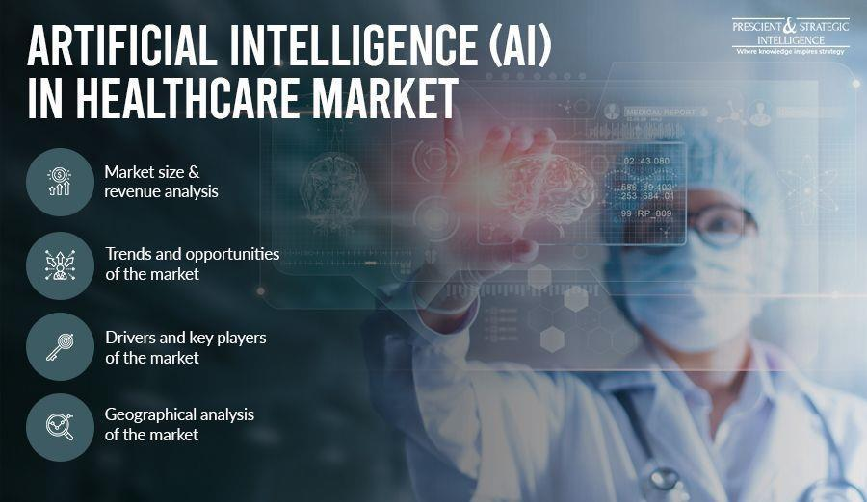
Artificial Intelligence Future in Healthcare

Artificial Intelligence will be a deep-seated element in predicting around 86% of errors in the medical services. The use of AI in medical sector will be beneficial to both patients and healthcare competent by minimizing costs and enhancing accuracy through predictive treatment. AI and predictive examination can be utilized to figure out the various components (birthplace, dietary propensities, local air contamination levels, etc.,) that influence an individual's health. Future clinical administration frameworks fueled by AI ought to have the option to imagine when an individual is probably going to foster a chronic illness and deal pre-emptive treatment to stop it before it deteriorates.

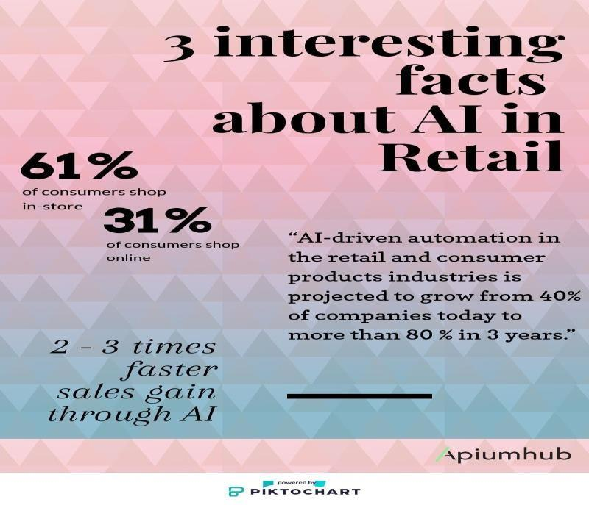
Artificial Intelligence Future in Retail

At the end of 2023, it is predicted that the worldwide market for AI in retail will get increment by more than $5 million. Retail users could save more than $340 billion by 2023 while implementing AI in all of their business tasks, as per the Cap Gemini study on the impact of Artificial Intelligence in retail. According to Accenture, investments in artificial intelligence will increase retail sales by 38% by the end of 2002.


Artificial Intelligence Future in Banking

At the close of 2030, it is anticipated that AI in Banking will attain a $300 billion global economic impact. With reduced costs, higher efficiency, and better client experiences, AI is set out to rule areas like business intelligence and security in the approaching decade. Robotic advisers in assets management is expected to change the banking industry, saving both customers and asset managers in a great deal. The future of banks will be greatly connected with AI in personalizing customer experiences as well as customizing their products and services.

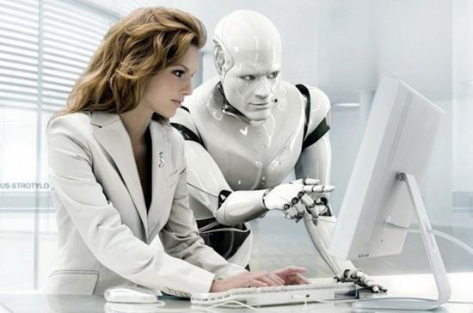
AI to Open-up Millions of New Job Opportunities
The most pervasive concern about AI in the future is that it will oust us from our employment. It should be seen that a more agreeable future for human being with AI automating a wide range of work, which will make new positions instead of replacing the existing mechanism. World Economic Forum research on the Future of Employment predicts that by 2022, AI will create 58 million new positions. It is also predicted that by 2030, there will be an excellent likelihood that AI will perform superior than humans on most of the mental tasks, yet it doesn't mean that the job positions will be eliminated. Because of these AI developments in the society and the labor force, it is necessary to develop and coincide with advanced AI in the future. Depending on the usage of technology in the future, using AI might either be a blessing or a sin.

CONCLUSION
In this computerized era, Artificial Intelligence is having a persistent effect on the present labor force. Fortunately, AI will upgrade occupations that require critical thinking, inventiveness, and sympathy to another level. The new age of laborers should have the option to adjust to the new changes in the labor force. Computer based intelligence will improve efficiency through automated repetitive tasks. As per PWC research, by the mid-2030s, 33% of all work will be in danger of being automated. The labor force segment with a low level of education probably is going to be impacted. In recent days, client care services in different locations are being automated. However, the clients are frequently stuck in a constant loop of conversations with bots. On the other hand, it should be commonly agreed that conversing with a human executive that could totally comprehend our concern and resolve it rapidly. Yet, AI has also shaped new job opportunities in different areas like AI developments, machine learning etc. AI leads in expanding productivity in various industries by working constantly and eagerly. It also aids shifts in job roles, abilities required, and arrangements of work. It is the need of great importance for business organizations to get ready for the impact of artificial intelligence. To accommodate AI, organizations should first access and review the current technologies that they are being used. This will assist them with understanding how they can adjust and incorporate current technology with AI. Further, there is a need to consider the potential investments required to carry out artificial intelligence. This could incorporate hardware, software, and technical team to shape and execute AI strategy. In addition to this, organizations ought to think about the legal and ethical implications of AI.
REFERENCE
- Masayuki, M. O. R. I. K. A. W. A., “The Effects of Artificial Intelligence and Robotics on Business and Employment: Evidence from a survey on Japanese firms”, Res. Inst. Econ. TradeInd, vol 16, 2016. https://ideas.repec.org/p/eti/dpaper/16066.html.
- Kaur, Bhajneet, and Sanskriti Sharma., “Will Artificial Intelligence take over our jobs a human Perspective on Employment Future”, International Journal of Engineering Applied and Management Sciences Paradigms, pp216-218, 2016.
- Frey, Carl Benedikt, and Michael A. Osborne, “The future of employment: How susceptible are jobs to computerization?”, Technological forecasting and social change, vol 114, pp254-280, 2017. https://www.sciencedirect.com/science/article/abs/pii/S0040162516302244.
- Fossen, Frank M., and Alina Sorgner, “The effects of digitalization on employment and entrepreneurship”, Conference proceeding paper, IZA–Institute of Labour Economics2018.https://conference.iza.org/conference_files/MacroEcon_2018/sorgner_a21493.pdf.
- Jarrahi,M.H, “Artificial intelligence and the future of work: Human-AI symbiosis in organizational decision making”, Business horizons, Vol 61(4), pp577-586, 2018. https://www.sciencedirect.com/science/article/abs/pii/S0007681318300387.
- Frank, Morgan R., etal, “Toward understanding the impact of artificial intelligence on labor”. Proceedings of the National Academy of Sciences vol116.14, pp6531-6539, 2019. https://pubmed.ncbi.nlm.nih.gov/30910965/.
- Muro, Mark, Robert Maxim, and Jacob Whiton, “Automation and artificial intelligence: How machines are affecting people and places” 2019. https://www.brookings.edu/articles/automation-and-artificial-intelligence-how-machines-affect-people-and-places/.
- Ernst, Ekkehardt, Rossana Merola, and Daniel Samaan, “Economics of artificial intelligence: Implications for the future of work”, International Labour Organisation, 2019.https://www.ilo.org/wcmsp5/groups/public/dgreports/cabinet/documents/publication/wcms_647306.pdf.
- Mrowinski, Benjamin, David Brougham, and David Tappin, “Managers' perceptions of Artificial Intelligence and Automation: Insights into the future of work. New Zealand Journal of Employment Relations vol44.3, pp76-91, 2019.
https://www.researchgate.net/publication/344234962_Managers'_Perceptions_of_Artificial_Intelligence_and_Automation_Insights_into_the_Future_of_Work.
- Singh, Dheeraj, and Geetali Tilak, “Employment Transformation through Artificial Intelligence in India”, 2019.https://www.researchgate.net/publication/349685344_Employment_Transformation_through_Artificial_Intelligence_in_India.
- Furman, Jason, and Robert Seamans, “AI and the Economy”, Innovation policy and the economy, vol19.1, pp161-191, 2019. https://www.journals.uchicago.edu/doi/full/10.1086/699936
- Daron Acemoglu, Pascual Restrepo March, “The wrong kind of AI? Artificial intelligence and the future of labour demand”, Cambridge Journal of Regions, Economy and Society, Volume13, 2020. https://www.nber.org/papers/w25682.
- Jameel, Kiran, et al.,“Current and future impact of artificial intelligence: an employment perspective based on case studies”, PalArch's Journal of Archaeology of Egypt/Egyptology vol17.9, pp660-675, 2020. file:///C:/Users/szc/Downloads/4307-Article%20Text-8218-1-10-20201228.pdf.
- Yang, Yu., “Analysis of the impact of artificial intelligence development on employment”, International Conference on Computer Engineering and Application (ICCEA), 2020. https://e-tarjome.com/storage/panel/fileuploads/2020-07-26/1595765701_E15091-e-tarjome.pdf
- Graglia, Marcelo Augusto Vieira, and Patricia Giannoccaro Von Huelsen, “The sixth wave of innovation: Artificial intelligence and the impacts on employment”, Journal on Innovation and Sustainability RISUS vol11.1,pp3-17, 2020. https://revistas.pucsp.br/index.php/risus/article/view/48820
- Benbya, Hind, Thomas H. Davenport, and Stella Pachidi, “Artificial intelligence in organizations: Current state and future opportunities”, MIS Quarterly Executive vol19.4, 2020.https://papers.ssrn.com/sol3/papers.cfm?abstract_id=3741983
- Wang, Fenglian, Mingqing Hu, and Min Zhu, “Threat or Opportunity– Analysis of the Impact of Artificial Intelligence on Future Employment”, Digital Human Modeling and Applications in Health, Safety, Ergonomics and Risk Management. Human Communication, Organizationand Work: 11th International Conference, DHM 2020, Heldas Part of the 22nd HCI International Conference, HCII 2020, Copenhagen, Denmark, July19–24, 2020, Proceedings, Part II 22. Springer International Publishing. https://dl.acm.org/doi/10.1007/978-3-030-49907-5_21
- Moradi,P.,& Levy,K., “The future of work in the age of AI: Displacement or Risk-Shifting?”, 2020 https://papers.ssrn.com/sol3/papers.cfm?abstract_id=3647367
- Shaukat, K., et al, “The impact of artificial intelligence and robotics on the future employment opportunities”, Trends Comput. Sci. Inf. Technol vol5, pp50-54, 2020. https://www.researchgate.net/publication/344310616_The_Impact_of_Artificial_intelligence_and_Robotics_on_the_Future_Employment_Opportunities
- Rauf, Muhammad Abdul, et al., “A comparative study on the impact of artificial intelligence on employment opportunities for university graduates in Germany and the Netherlands: AI opportunities and risks”, International Journal of Environment, Workplace and Employment”, vol 6.3, pp185-204, 2020.
- Boyd, Ross, “Work employment and unemployment after AI”, The Routledge social science handbook of AI. Routledge, pp74-900, 2021.
https://www.taylorfrancis.com/chapters/edit/10.4324/9780429198533-6/work-employment-unemployment-ai-1-ross-boyd
- Anagnoste, Sorin, et al., The role of chat bots in end-to-end intelligent automation and future employment dynamics. Business Revolution in a Digital Era: 14th International Conference on Business Excellence, ICBE 2020, Bucharest, Romania. Springer International Publishing, 2021. https://ideas.repec.org/h/spr/prbchp/978-3-030-59972-0_20.html
- Ekaningrum, Nurul Efri, Muhammad Syahrul Hidayat and FaridaYuliati, Exploring the Future of Work: Impact of Automation and Artificial Intelligence on Employment”, Endless: International journal of future studies vol,6.1pp125-136,2021. https://endless-journal.com/index.php/endless/article/view/131

