**STRAIN IMPROVEMENT BY CRISPR/Cas9 FOR ENHANCING BIOFUEL PRODUCTION**

Bushra Khan1; Shifa Ahmad2; Miss Madhurima TiwariCo;Dr. Deepika Delsa DeanCo.

Department of Biotechnology

Isabella Thoburn college

Uttar Pradesh, Lucknow, India

bk7682372@gmail.com

**ABSTRACT**

With quick advancement in the fields of manufactured science and metabolic designing, there are potential applications to create an extensive variety of advance biofuels with maximum yield and efficiency to accomplish a more manageable bioprocess with reduced carbon impressions. Among the diverse molecular biology tools, clustered regularly interspaced short palindromic repeats-CRISPR-associated proteins (CRISPR-Cas9) innovation stands apart with potential designated genome altering, showing a more exact and precise quality of gene knock-out and knock-in better than its ancestors, for instance, example zinc finger nucleases (ZFN) and transcription activator-like effector nucleases (TALEN). There are reports engaged with the high-level microbial genome designing devices for biofuels creation; nonetheless, there is the absence of a far-reaching survey about the CRISPR-Cas9 based-procedures in improved biofuel creation alongside the techniques to lessen the off-target impact that guarantees the achievement and security of this strategy. In this review, we make an effort to systematically remark on the CRISPR-Cas9 mechanism and its use in microbial biofuel production. This comprises bioethanol, biobutanol, and other hydrocarbons that successively implement different recommendations for boosting the effectiveness of targeted genes. It is also addressed how inducible on/off genetic circuits that respond to environmental factors can regulate targeted genome editing (TGE) by reducing metabolic load and increasing fermentation efficiency. The necessary strict regulatory requirements to guarantee minimal off-target cleavage with maximal effectiveness and the total biosafety of this technology are also considered here.

**Keywords:**CRISPR-Cas9; Biofuels; gene-editing; biodiesel; biobutanol; bioethanol; fermentation

# **INTRODUCTION**

The demand for fuel is increasing nowadays due to its utilization in transportation, generation of energy, and industries. As of late, the interest in petrol-based fuel has brought about various financial and natural worries, and mindful endeavors are expected to support the arising elective powers [1]. The creation of biofuels from biomass is a practical and environmentally responsible solution to combat the depletion of fossil fuels. Industry, decision-makers, and scientists have started to pay more attention to these interchangeable and inexhaustible fuel sources, such biodiesel and bioethanol, because of their considerable benefits [2].While biodiesel is produced by transesterifying lipids taken from soybeans, canola seeds, and other crops, ethanol and butanol production is primarily dependent on the fermentation of sugar or starch feedstocks [3]. The financially savvy and boundless natural substances, for example, lignocellulosic feedstock got from farming squanders, (for example, sugar stick bagasse, sugar beet, or corn stalks) and energy crops, (for example, famous or switchgrass) are utilized to produce biofuels adding a benefit of not seriously influencing food supplies [4].

Numerous microbial strains have been shown to have the ability to produce biofuels during fermentation. *Saccharomyces cerevisiae* is one of the yeasts that is most frequently utilised for the industrial-scale fermentation of monomeric carbohydrates into ethanol. The bacterial species used for fermentation include *Zymomonas mobilis, Clostridium thermosaccharolyticum, C. thermohydrosulfuricum, Thermoanaerobacter mathranii, T. brockii,* and *T. ethanolicus*. Site-specific genome editing, a cutting-edge area of genomics, appears to be effective in enhancing microbial strains for the production of biofuels. To manipulate a specific trait in the native microorganisms, site-specific alterations in the genome, including knocking down, knocking out, and knocking in genes, are frequently carried out through genetic engineering. Contrary to conventional genetic engineering, which involves first isolating the gene to be altered, altering it in vitro, and adding it back to the host, or using genetic transformation techniques to introduce a heterologous gene to alter a specific trait of the organism [5].

The site-specific genome editing techniques RNA-guided endonuclease-mediated (REM) and modified endonuclease-mediated (MEM) have recently been used for strain enhancement. A common example of a REM-based genetic engineering technique and versatile tool for genetic engineering, CRISPR/Cas9 (CRISPR-associated nuclease 9) is a natural bacterial defense mechanism that uses a guide RNA (gRNA) to direct Cas9 to a specific nucleotide. This simple RNA-guided genome-engineering technique has been hailed as a breakthrough in biology and offers various creative applications in producing biofuels [6]. In industrial research, the CRISPR/Cas9 technique has shown to be a creative and clever tool that has been used to modify the genomes of numerous microorganisms, including bacteria, yeast, filamentous fungi, and algae. CRISPR/developers Cas9 has transformed this tool into a flexible and reliable method for genetic editing [7,8,9].

# **AIM OF REVIEW**

This review focuses on the potential of CRISPR/Cas to improve biofuel production. It discusses how metabolic load reduction and improved fermentation efficiency can control targeted genome editing (TGE) using inducible on/off genetic circuits that react to environmental conditions. The complete biosafety of this technique is also taken into consideration, as well as the stringent regulatory standards required to ensure minimal off-target cleavage with maximum efficiency.

# **REVIEW OF LITERATURE**

## **Sources and generation of biofuel**

**Biofuels** are liquid fuels produced from various biological elements including animal waste and plant waste [10] Biofuels are divided into 2 categories.

**Primary biofuel-:** Primary biofuels are often used raw for heating, cooking, and electricity production. Fuel wood, pellets, wood chips, crop residues, landfill gas, and fuel-wood pellets are some examples of primary biofuels. [11]

**Secondary biofuels-:** Secondary biofuels are a refined version of primary biofuels, which can be produced as gases, liquids, or solids (for example, biodiesel, bioethanol, and bio-oil) (e.g. biogas, and hydrogen). Biodiesel, bioethanol, and biogas are examples of secondary biofuels that are utilized in a variety of industrial operations as well as in motor vehicles. These are produced by biologically digesting biomass. [13]

According to the biological processes and raw materials used in their production. The four generations of secondary biofuels are as follows:

1. First-generation biofuel
2. Second-generation biofuel
3. Third-generation biofuel
4. Fourth-generation biofuel

**First-generation biofuel-** First-generation biofuels like butanol and bioethanol are often produced through the fermentation of starches (from sources like potato, barley, wheat, and corn) or sugars (from sources like sugarbeet and sugarcane). Whereas bioethanol, which is produced by fermenting carbohydrates extracted from crop plants, is regarded as the most notable biofuel of the first generation [12]. *S. cerevisiae*-produced enzymes are used to ferment crops with a high concentration of carbohydrates into bioethanol. *S. cerevisiae* makes bioethanol by using six-carbon carbohydrates, typically glucose. Biodiesel, which is produced by trans-esterifying or breaking straight vegetable oils from sebaceous plants (such as sunflower, palm, rapeseed, soybeans, and coconut, among others), is another extremely effective first-generation biofuel. (fig.2)[14]

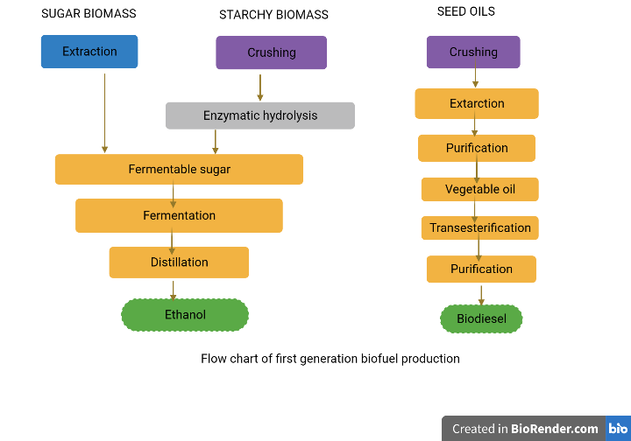

**Figure 2: Flow chart for first-generation biofuel production**

**Second-generation biofuel-** Traditional technologies are utilized to produce second-generation bioethanol and biodiesel from novel starch, sugar, and fatty crops like jatropha, cassava, or miscanthus. Other well-known second-generation biofuels made from lignocellulosic materials include biobutanol and Syndiesel® (e.g. straw, wood, and grass) [12].The advantage of second-generation biofuels is the lower cost of raw materials and the use of inedible lignocellulosic biomass (the woody section of plants), which does not compete with food [13]. Sources of lignocellulosic material include non-edible parts of corn or sugarcane, forest harvesting waste, agricultural trash, and wood processing waste like leaves, straw, or wood chips. However, the process that turns lignocellulosic materials into sugars is expensive and requires the employment of specialized enzymes (fig.3). This simply indicates that it is not now practicable to produce second-generation biofuels on a commercial scale [14]

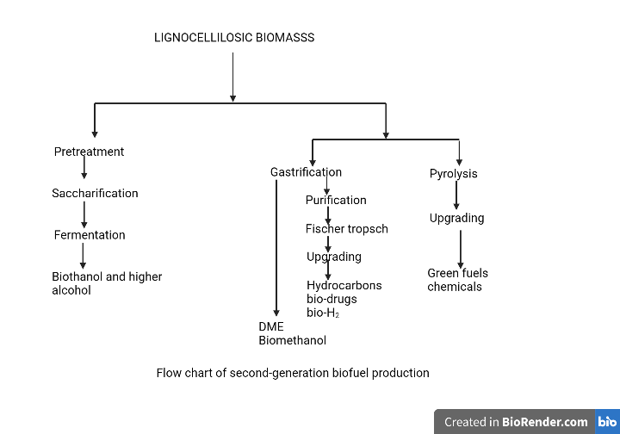

**Figure 3: Flow chart for second generation biofuel production**

**Third-generation biofuel-** Third-generation biofuels are produced using microalgal biomass. Aquatic microalgae, like cyanobacteria, are autotrophic living forms [15].When compared to conventional lignocellulosic biomass, the growth yield of microalgal biomass is quite unusual [16]. The abundance of oil in algae makes it the most promising characteristic for usage as third generation biofuel. Due to their high oil content (between 60 and 70%), the three types of green algae *Chlorella vulgaris*, *Chlamydomonas reinhardtii,* and *Dunaliella salina* are the most commonly used for producing biofuels [17]. Despite having many benefits, third-generation biofuel technology is still in its infancy and has several drawbacks. The main drawbacks are its high anticipated cost and use of fossil fuels throughout production phases, which increases environmental concerns. [18]

**Fourth-generation biofuel-** Modern procedures like geo-synthesis or low pressure, improved biochemistry, petroleum hydro-processing, and low-temperature electrochemical processes are used to create the fourth generation of biofuels. These methods create fourth-generation biofuels by capturing carbon from the environment [19].

The fourth-generation biofuels have been defined in a variety of ways by various authors. For instance, Lü et al. (2011) [20] produced fourth-generation microalgae using metabolically modified forms. This concept has been applied to the chemical production of non-renewable fourth-generation biofuels. According to Demirbas (2009), fourth-generation biofuel refers to the process of converting biodiesel and vegetable oil into biogasoline using advance technology.

## **CONVERSION OF RAW MATERIAL INTO BIOFUELS**

Three processes are involved in the bioconversion of feedstocks into biofuels: pre-treatment, hydrolysis, and fermentation. The pre-treatment process is the most significant, challenging, and expensive stage in converting biomass into biofuel.

There are four types of pre-treatment processes:

1. Physical treatment
2. Physiochemical treatment
3. Solvent treatment
4. Biological treatment

The majority of the time, they are employed to dissolve cell walls so that cellulose and hemicellulose can undergo additional processing.The feedstock is hydrolyzed with acid or an enzyme following pre-treatment. [21,22]. All pre-treatment methods are often combined for maximum effectiveness The polysaccharides included in the input material are transformed into fermentable sugars by the hydrolysis process. Finally, via microbial fermentation, monomeric carbohydrates like glucose, galactose, and mannose are transformed into ethanol or other alcohol [23,24].

Four process configurations have been created for the generation of biofuels: separate hydrolysis and fermentation (SHF), simultaneous saccharification and fermentation (SSF), simultaneous saccharification and co-fermentation (SSCF), and consolidated bioprocessing (CBP) [25].

**Separate hydrolysis and fermentation (SHF):**

This process requires the hydrolysis of the substrate in two stages:

* Saccharification
* Fermentation

Enzymatic hydrolysis and fermentation are carried out separately under ideal circumstances in separate hydrolysis and fermentation (SHF). Numerous advantages of this method include the fact that each phase is completed in an ideal environment and that little or no contact exists between fermentation and saccharification [26]. Cellulose is completely broken down into monomeric sugars as a result of the SHF. 50 °C and 35 °C, respectively, are the ideal temperatures for cellulases-mediated hydrolysis and fermentation [27].

**Simultaneous saccharification and fermentation (SSF):**

In this method, fermentation and saccharification are carried out simultaneously in a single vessel. By instantly converting monomeric sugars produced by the enzymatic hydrolysis process into ethanol through fermentation, simultaneous saccharification and fermentation (SSF) minimize difficulties such as sugar build-up, enzyme activity retardation, and contamination [27]. In SSF, the hydrolysis of raw materials containing starch is accomplished by first treating the material with an endoenzyme (glucoamylase in this case) at 90 to 110 °C for 30 minutes. While glucoamylase transforms dextrins into glucose, amylase hydrolyses starch into dextrins. The fermentation of hexose sugars is then done for the production of biofuel at a lower temperature (30-32 °C). This process has been heavily used to produce bioethanol.

**Simultaneous saccharification and co-fermentation (SSCF):**

Five and six-carbon sugars can be fermented simultaneously using the simultaneous saccharification and co-fermentation (SSCF) technique, but the main requirement for this method is the use of co-fermenting bacteria that are compatible and have good pH and temperature tolerance. Finding a single possible bacterium that can ferment both hexose and pentose sugar is challenging. The lack of appropriate co-fermenting microbial strains for commercial biofuel production is another drawback of this method [28]. The entire conversion of monomeric sugars (generated from feedstock hydrolysis) into biofuel has been demonstrated to be possible using the mixed-culture technique, which combines both C6-fermenting and C5-fermenting bacteria*. S. cerevisiae* and *Candida shehatae*, which are recognized for their synergistic action, have reportedly been shown to be the most effective microorganisms for the SSCF procedure.

**Consolidated bioprocessing (CBP):**

Consolidated bioprocessing (CBP) is another method of process architecture in which a single microbe performs both the fermentation and saccharification processes. All phases of bioconversion, including fermentation and enzymatic hydrolysis, are carried out sequentially in a single reactor. The CBP procedure is a cost-effective method because it requires little capital input [27,29]. Numerous bacterial species, including *C. thermocellum*, and fungi, including *Fusarium oxysporum*, *Neurospora crassa*, and *Paecilomyces* sp., have been observed to exhibit these behaviors [30].

1. **GENOME ALTERATION: THE NEW UPSET IN GENOMICS**

A single organism's genome can be modified effectively to impart desired traits. This procedure precisely modifies the native genome of a microorganism to change its physiological characteristics and increase the production of a certain metabolite [31,32]. This method allows for the introduction, deletion, and up-or-down-regulation of a gene at a particular location within an organism. Unlike traditional genetic engineering, this method did not involve traditional gene isolation, in vitro engineering, and subsequent retransfer to the host cell to alter the physiological characteristics of that particular person.

There are two approaches to accomplishing genome engineering:

* RNA-guided endonuclease-mediated (REM); and
* modified endonuclease-mediated (MEM) genome engineering

REM is responsible for genome engineering using the CRISPR/CRISPR-associated protein 9 (Cas9) technology [33]; whereas the MEM technique uses the zinc finger nucleases (ZFNs) system and transcription activator-like effector nucleases (TALENs) system [34]. All of these genome engineering methods have completely altered the biological sciences and related fields of research. While ZFNs and TALENs have their drawbacks, the CRISPR/Cas9 system has emerged as a promising solution. The limitations of ZFNs and TALENs include the absence of efficient delivery mechanisms, off-target effects, toxicity, and poor efficiency [35]. (Table 1)

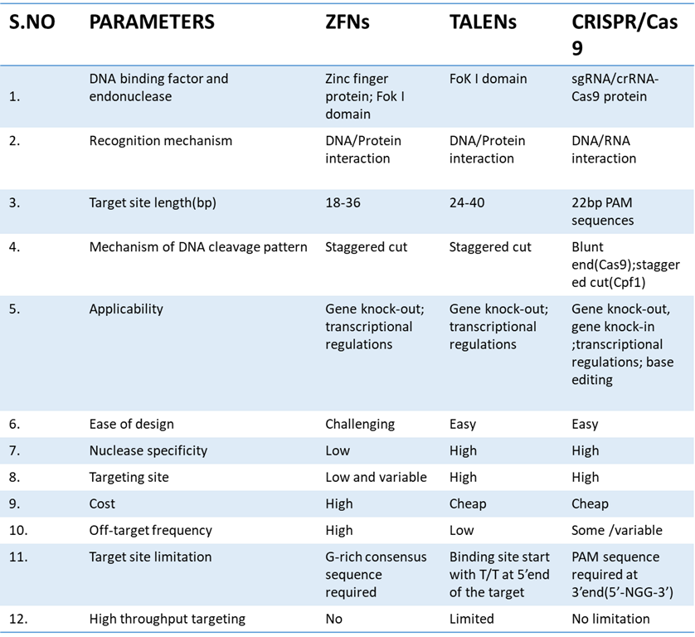**Table:1-Comparison between different types of genome editing tools[36]**

## **CRISPR-CAS9: A PROMISING APPROACH IN GENE MODIFICATION**

The biological sciences are being fundamentally changed by a succession of recent discoveries that use prokaryotes' adaptive immune systems to undertake targeted genome editing. Genetic research has grown in thousands of labs throughout the world thanks to the identification of Clustered Regularly Interspaced Short Palindromic Repeats (CRISPR) and CRISPR-associated (Cas9) proteins.

The bacterial CRISPR locus was first described by Francisco Mojica, and it was later determined that it constituted an essential part of the prokaryotic adaptive immune system. The locus consists of short palindromic repeat sequences called "spacers," which were found in between several viral or plasmid DNA pieces.The Cas9 protein was later discovered in *Streptococcus thermophilus* by Alexander Bolotin. Contrary to other known Cas genes, Cas9 was a large gene that encoded a single-effector protein with nuclease activity. Additionally, they found a characteristic sequence that was later given the name protospacer-adjacent motif (PAM) in the spacer-nearby region of the target DNA. To find and bind its target DNA, Cas9 has to recognise this pattern. Later studies found that spacers were transcriptionally added to the CRISPR RNAs (crRNAs), which guide the Cas proteins to the target DNA sequence. Research has revealed that a crucial part of the CRISPR system is the trans-activating CRISPR RNA (tracrRNA), which combines with the crRNA to drive Cas9 to its target DNA. [37]. The introduction of a synthetic single-guide RNA construct (sgRNA), which combines crRNA and tracrRNA (fig. 4), made this technology's potential applications simpler. [38].

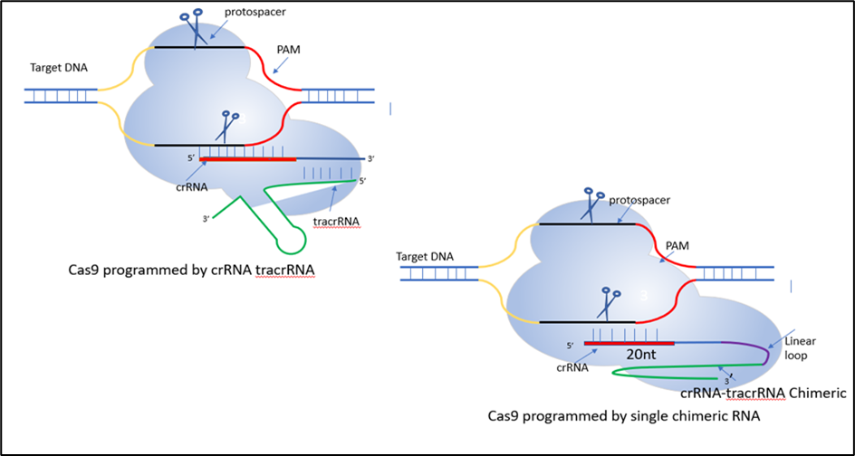

**Figure 4: CRISPR/Cas9 System**

CRISPR/Cas9 is a simple two-part technique for effective targeted gene editing. The first element is the single-effector Cas9 protein, which possesses both the RuvC and HNH endonuclease domains. RuvC cleaves the DNA strand that is not complementary to the spacer sequence, whereas HNH cleaves the complimentary strand of DNA. These domains jointly cause double-stranded breaks (DSBs) in the target DNA. A single guide RNA (sgRNA) carrying a scaffold sequence that makes it easier for Cas9 to bind to it and a 20-base pair spacer sequence that is complementary to the target gene and just next to the PAM region is the second component of successfully focused gene editing. The CRISPR/Cas9 system is directed to the desired genomic area by this sgRNA. Then, one of two internal DNA repair mechanisms is used by the editing system: (fig.5)

* Nonhomologous end-joining (NHEJ) or
* Homology-directed repair (HDR)

NHEJ involves the random insertion and deletion of base pairs, or indels, at the cut site, and is far more common in most cell types. A premature stop codon and/or a non-functional polypeptide are frequently produced by this error-prone mechanism's frameshift mutations. This method has proven particularly effective in functional genomic CRISPR screenings and genetic knockout research, but it can also be helpful in the clinic when gene disruption offers a therapeutic possibility. The other method is the error-free HDR pathway, which is particularly appealing to use for therapeutic applications. In this process, the damaged DNA is corrected by utilizing a homologous portion of an unaltered DNA strand as a template, leading to error-free repair. In an experiment, this pathway can be utilized by combining an external donor template with the CRISPR/Cas9 technology to enable the required genome alteration. [39]

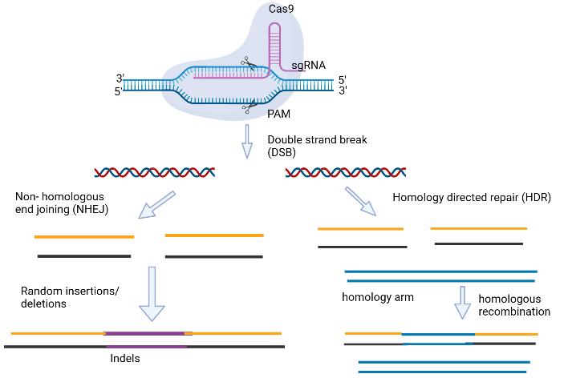

**Figure 5: Gene editing carried out via CRISPR/Cas9. [99]**

Site-directed mutagenesis has so far been utilized in a variety of basic and practical research fields. It can be used as a cutting-edge technology for genome editing of microbial cells to increase the generation of biofuels. *Bacillus subtilis* has been successfully engineered utilizing CRISPR/Cas9 technology in several investigations for the development of new traits like the production of b-cyclodextrin glycosyltransferase and resistance to spore formation. Similar changes were made to the genome of *S. cerevisiae* to improve xylose utilization and mevalonate or (R-R)-2,3-butanediol synthesis. Better CRISPR/Cas9 protocols are being published every day, and we anticipate that this approach will become more and more integrated into routine laboratory procedures over time. [40]

## **GENOME MODIFICATION OF MICROBIAL CELLS USING CRISPR/CAS9 FOR INCREASED BIOFUEL PRODUCTION**

Researchers are hopeful that within the next five to ten years, cutting-edge technologies will enable them to fully use microbial cells for increased biofuel production. To achieve these objectives, site-directed mutagenesis using CRISPR/Cas9 is required to enhance the metabolic performance of the microbial cells. Recent studies on the use of CRISPR/Cas9-mediated genome engineering of microbial cells for improved biofuel production have surfaced in many publications. [41]

The systems can be altered for the production of biofuel among a variety of traditional and non-conventional bacterial hosts due to the availability of various forms of CRISPR-Cas9 machinery with varying capabilities. With the availability of specialized CRISPR expression cassettes from major genetic engineering companies like Synthego and Genscript, building a CRISPR experiment is currently thought to be an easy and quick process. The volume of CRISPR-Cas9 research being done in developing nations highlights the importance of non-profit repositories like the Addgene vector database (https://www.addgene.org), where researchers from all over the world can deposit and share their plasmids for a small fee, making CRISPR technology an accessible and practical option, particularly in the gene modification of microbial strains for the production of biofuels. Here, we try to highlight the various changes that CRISPR has brought about.

**Restricting competitive biofuel production pathways**

Due to the possibility of supplying a sizable market, the manufacture of alcohols like bioethanol and biobutanol employing diverse industrial microbes from different renewable resources is in great demand [42]. Bioethanol is also added to gasoline in a variety of percentages in several developed nations [43]. Except bioethanol, higher alcohols (>2 carbons), particularly biobutanol, are regarded as superior substitutes for traditional petroleum-based fuels because of their high energy density, which results in less hygroscopicity and engine corrosivity [44,45]. Historically, *Clostridium* species have been used to produce alcohol on a significant scale [46]. However, due to their complicated genomic configurations and the lack of effective genetic tools for delivering targeted genomic changes, this host species has fallen behind *E. coli* in the commercial production of these alcohols.

A review by Xue et al.[47] highlighted the initial reports on the genomic alterations made by CRISPR-Cas in *Clostridium* species. Due to the low recombination efficiency, lethality of Cas9 early expression, and vector integration event, which poses a severe obstacle over CRISPR-Cas9 machinery, CRISPR-Cas9 genome editing in *Clostridium* previously resulted in decreased transformation efficiency with few or no transformants. However, the use of plasmid-borne editing DNA templates, which substitute the linear template, addressed these issues, and the regulation of early Cas9 expression under inducible promoters reduced its lethality [48,49]. By outlining techniques to improve genome editing for improved production, the subsequent developments in the use of CRISPR, notably for the enhanced production of biobutanol and bioethanol by *Clostridium* species and *E. coli*, are further explained.

To increase the butanol synthesis and selectivity, a powerful CRISPR-Cas9 genome engineering technique for the non-model hyper butanol-producing *C. saccharoperbutylacetonicum* N1- 4 was created [50]. In this investigation, a previously modified CRISPR-Cas9 method for *C. beijerinckii* was adopted and tested in *C. saccharoperbutylacetonicum* for the targeted genome editing of phosphotransacetylase *(pta)* and butyrate kinase (*buk)* genes, for the synthesis of acetate and butyrate, respectively. To create the *pta* and *buk* single and double mutants, the Cas9 open reading frame (ORF) from S. pyogenes was expressed under the lactose inducible promoter *(bgaL*), and the sgRNA was translated by a short RNA promoter (PsRNA) from *C. beijerinckii*. The customized high-efficiency genome engineering technique of *C. beijerinckii*, however, cannot be done well in the non-model organism due in part to the fact that the genome engineering efficiency was considerably lower (18.5% mutation rate) as compared to *C. beijerinckii* (100%) [49]. Therefore, a variety of promoters, including *Pvegb* from *B. subtilis*, *Pvegc* from *C. saccharoperbutylacetonicum*, and *PJ23119* from *E. coli*, were screened for the powerful expression of gRNA. Of these, the *PJ23119* promoter showed a high mutation rate of 75% *pta* gene with the transformation efficiency of 1.6 104 CFU/mg of DNA. The production of acetate and butyrate was dramatically reduced by the double deletion mutant, and biobutanol production of 19 g/L was achieved with a higher selectivity for ethanol (20.8%) over acetone (15.6%) [51]

**Table 2:-Application of the CRISPR-Cas9 system to different microorganisms for the generation of biofuels [98]**

|  |  |  |  |  |  |  |
| --- | --- | --- | --- | --- | --- | --- |
| **Microbial strains** | **Target genes** | **CRISPR-Cas9 machinery** | | | **Editing efficiency** | **Final products** |
|  |  | **gRNA promoter** | **Cas (Variants)** | **Cas promoter** |  |  |
| *Clostridium saccharoperbutylacetonicum*N1-4 | *Dpta, Dbuk* | *Pj23119* | Cas9 | *Lac* | 75% | Butanol (19.0 g/L) |
| *Escherichia coli* | *gltA (down-regulated)* | *-* | Cas9 | *-* | 75% | Butanol(1.08g/l) |
| *Clostridium*  *ljungdahii* DSM13528 | *Dpta, DadhE1, Dctf, DpyrE* | *paraE* | Cas9 | *Pthl* | 50-100% | Ethanol(0.25 g/l) |
| *Clostridium acetobutylicum*  ATCC 824 | *Dupp* | *Pthl* | Cas9 | *aTC*  anhydrotetracycline | 100% | Isopropanol(4.45 ± 0.34 g/L) |
| *Clostridium tyrobutyricum* | *Cat1 (to replace adhE1 or adhE2)* | Small RNA promoter | Casa9 | *Plac* lactose inducible promoter | 93.3% | Biobutanol(26.2 g/L) |
| *Escherichia coli* PA14 | *Dthl, DatoDA, DctfAB, Dadc, Dadh* | *Pj23119* | dCas9 | Native promoter | 80% | Isopropanol(7.1 g/L) |
| *Escherichia coli* BW25113 | *pta, frdA, ldhA, and adhE* | *Pj23119* | dCas9 | *PrhaBAD* | - | n-butanol1.06 g/L) |
| *Clostridium*  *cellulovorans*  DSM743B | *Dhyd, DClocel-2243* | *Pj23119* | dCas9 | *Pthl* | 95.3% | Butanol(11.5 g/L)  Biosolvent(22.1g/l) |
| *Escherichia coli* | *gabD, ybgC and tesB* | *Pj23119* | dCas9 | *PLtetO1* | - | 1,4-butanediol(1.8 g/L) |

**Metabolic flux redirection for better solvent generation**

Another effective strategy for boosting the production of biobutanol in a microbial system is considered to be the restoration of state and diverting the carbon flux, in addition to suppressing the competitive pathways [61,62]

By over-expressing the natural alcohol dehydrogenase *(adhE2)* from *C. acetobutylicum,* formate dehydrogenase *(fdh1*) from *C. boidinii*, and acetoacetyl-CoA thiolase *(thl),* an engineered *E. coli* EMJ50 strain that can create biobutanol utilizing glucose was achieved. In aerobic or microaerobic conditions*, C. acetobutylicum's* aldehyde/alcohol dehydrogenase *(adhE2)* is extremely oxygen sensitive [63]. To reconstruct strain EMJ50 so that it can produce 0.82 g/L of butanol with yields of 0.068 g/g of glucose under microaerobic conditions, CoA-acylating propionaldehyde dehydrogenase *(PduP)* from *S. enteric*, which can convert butyryl-CoA into butanol via the oxygen-tolerant pathway, and alcohol dehydrogenase *(adhA)* from *L. lactis*[64]. The modified EMJ50's butanol yield at microaerobic conditions is slightly lower than in anaerobic conditions (0.082 g/g of glucose), most likely because acetyl-CoA, which is a precursor for both the butanol and citric acid cycles, is lost to citric acid production. To produce butanol, the carbon flux was diverted by employing CRISPR Cas9 to reduce the expression level of the citrate synthase *(gltA)* 5'UTR and the UTR designer tool to alter the 5'UTR. The *SacB* (levansucrase) gene promoter from *Bacillus subtilis* was in charge of the Cas9, crRNA, and tracrRNA employed for editing. EMJ52 (55% cit) was one of four mutants produced with various levels of *gltA* expression. Additionally, the *gltA* deleted mutant produced the highest yield of butanol (0.120 g/g of glucose), demonstrating that the CRISPR-Cas9 genome modification of citrate synthase's 5'-UTR caused the carbon flux to be redirected from the citric acid cycle to acetoacetyl-CoA, which was also positively correlated with citrate synthase activity(Table 2).[53]

Another appealing biofuel is biodiesel, which can be combined with chemically manufactured diesel in a certain ratio or used in currently operating engines. Single-cell oil (SCO) from oleaginous microorganisms is receiving more attention, and its additional characteristics, such as rapid growth, significant lipid accumulation, and absence of space constraints, all contribute to the possible creation of biofuels [65,66].Some oleaginous microbes were used to produce biodiesel using a variety of feedstocks, including corn stalks, poplar leaves, rice straw hydrolysates, etc. Some of these microbes could produce up to 20% of their weight in triacylglycerols (TAGs), while others showed maximal butanol titers with 1.3-fold increases in production [67,68].

Although CRISPR-Cas9 technology for biodiesel production is still in its infancy, the post-genomics era's accessibility to significant genetic alterations on oleaginous bacteria will speed its remarkable advancement using a combined CRISPR-Cas9/l red recombineering approach, genes involved in fatty acid (FA) metabolism, including the fatty acid regulatory transcription factor *(fadR),* D9 desaturase (*delta9),* and acetyl-CoA carboxylase *(acc),* were introduced into *E. coli* to create a *fadR/delta9* and *acc* knock-in bacterial strain [69]. Although the recombinant strain's FA composition was unaltered from the wild-type strain's, a 5.3% greater FA content was found. The ground-breaking accomplishment offers fresh perspectives on the viability of integrating entire pathways into appropriate microbial systems to enable the synthesis of biodiesel at industrial levels.

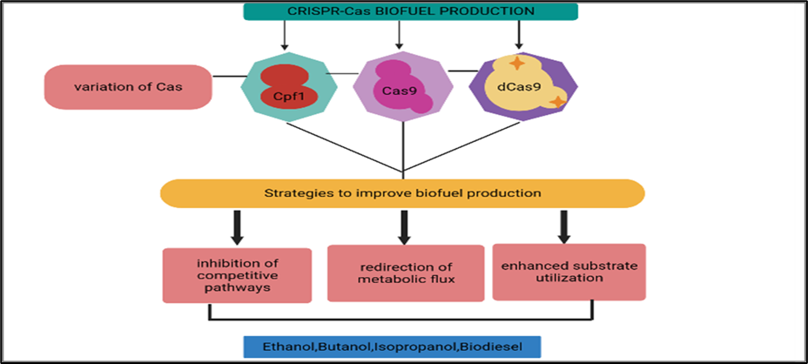

**Figure 7: A summary of how the CRISPR Cas system has improved the production of different biofuels. [98]**

**Improvement in the ability to use substrates**

One significant step toward lowering production costs is the modification of industrial Clostridial strains for the use of low-cost feedstock to produce greater alcohol fermentation [70]. Using carbon catabolite suppression, the presence of glucose in the feedstock prevents the *Clostridium* species from using other sugars. This restriction can be overcome by altering the genes involved in sugar uptake [71] Through the repression of the kinase/phosphorylase *(hprK)* gene, Bruder et al. [72] used SpCRISPR-dCas9 to target the carbon catabolite repression (CCR) of *C. acetobutylicumDSM792* and *C. pasteurianum* ATC Furthermore, the manufacture of biobutanol utilizing glycerol, a significant by-product of the biodiesel industry, was highlighted by this work on carbon catabolite suppression.C6013, resulting in the co-utilization of glucose and xylose from lignocellulosic feedstock.

By using the CRISPR-Cas9 method created for *E. coli*, Huang et al. showed the CRISPR-Cas9 genome editing of *C. ljungdahlii*. [73]. To prevent unwanted homologous recombination between the finished plasmid and chromosome, they created an autonomous plasmid with sgRNA, specificity Cas9 (SpCas9), and DNA repair templates. To determine their expression, the original *C. ljungdahlii* promoters were swapped out with heterologous promoters from *C. acetobutylicum*, and the region upstream of a promoter-less *lacZ* reporter gene was also cloned. *Pthl* and ParaE both showed higher activity to express Cas9 and sgRNA among the four examined promoters *(Pptb, Padc, ParaE, and Pthl).*sgRNA expression cassettes that targeted four genes viz., *pta* (CLJUc12770 gene encoding phosphotransacetylase), *adhE1* (CLJUc16510, encoding a bifunctional aldehyde/alcohol dehydrogenase), *ctf* (CLJU_c39430, encoding acyl-CoA transferase) and *pyrE* (CLJUc35680, encoding orotate phosphoribosyl-transferase) resulted in the deletion of 1000, 2600, 1200 and 570 bp fragments with editing efficiencies of 100, >75, 100 and > 50%, respectively. A mixed population of wild types and mutants was successfully created using antibiotic selection at 100% efficiency. In the potential biofuel perspective, phenotypic perceptions showed that the adhE1 freaks showed a fundamentally decreased creation of ethanol (Table 2), subsequently portraying the exact idea of chromosomal controls in *C. ljungdahlii*, and the outcomes likewise featured the potential for applying CRISPR to the famously troublesome objective cycle in the *Clostridium* species. Ordinarily, CRISPR-Cas9 methodologies for the upgrade of biofuel creation depicted above used a single-plasmid framework comprising of the hereditary components (Cas9 quality, sgRNA, altering DNA layouts with their advertisers and eliminators), in addition to antibiotic resistance genes and origin of replication. In any case, the customary bacterial hosts viz., *Clostridium* or *E. coli* utilized in genome designing frequently brings about getting not many transformants as a result of the hardships in presenting the single huge plasmid and their low change effectiveness, which at last difficulties the progress of the entire designing cycle. Wasels et al. [55] have created a two-plasmid method that can outperform a single plasmid harboring bigger gene segments to facilitate CRISPR-Cas9 genome editing in the solventogenic strain *C. acetobutylicum* *ATCC 824*. SpCRISPR-Cas9 was used because *ATCC 824* lacks endogenous CRISPR-Cas9 machinery. Codon-optimized Cas9 was kept under the control of the anhydrotetracycline-inducible promoter, while the gRNA expression cassettes were under the control of mini *Pthl* promoter along with the three editing templates on a second plasmid. Stringent inducible expression of Cas9 was made possible under the inducible promoter, producing altered cells. The second plasmid, which encoded an expression cassette for sgRNA targeting the *upp* gene, was introduced concurrently (*CAC2279,* coding for a phosphoribosyl transferase) A higher titer of isopropanol production than the wild-type cells was eventually shown with the subsequent introduction of two plasmids, with accurate changes detected in 100% effective transformation of cells (using three separate editing templates). (Table 2). Therefore, other novel biofuel/biochemical routes can be introduced in different *Clostridium* hosts that produce biofuels using this two-plasmid inducible CRISPR-Cas9 editing method (fig.8).

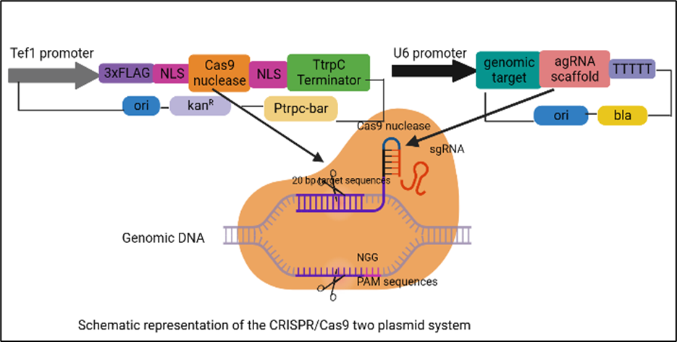

**Figure 8: CRISPR/Cas9 two plasmid system (Adapted from https://www.researchgate.net/figure/Schematic-representation-of-the-CRISPR-Cas9-two-plasmid-system-in-this-study_fig1_312047270)**

**Expanding host-specificity in biofuel production by using endogenous CRISPR-Cas9**

Numerous studies on CRISPR-Cas9 mediated genome editing in different *Clostridium* species have been reported, in addition to altering the genes responsible for the synthesis of biobutanol and other alcoholic beverages. Other non-conventional species from the same genus with distinctive metabolic characteristics that were previously hampered by their intractable genomic arrangements and lack of efficient genetic tools have also been genetically modified via CRISPR-Cas9 machinery, allowing more affordable biofuel production. These non-conventional species are from the same genus as the traditional model strains *C. acetobutylicum* and *C. beijerinckii*. A few research that deal with preferential sugar utilization, modifying the carbon flux, and using inducible promoters are covered in this review because they are all effective methods used in the generation of various alcohols by *Clostridium* species. However, a variety of microorganisms showed low to moderate levels of toxicity when using the Type II CRISPR-Cas9 system adapted from *S. pyogenes* [74]. Due to the unique characteristics of prokaryotic chromosomes, heterologous Cas9 expression is extremely toxic and results in lethal chromosomal breakage, which simultaneously reduces transformation efficiency and renders genome engineering unsuccessful. The possibility of using/harnessing host-encoded CRISPR-Cas9 machinery can help alleviate the issues caused by Cas9 toxicity and poor transformation efficiency because prokaryotic CRISPR-Cas9 machinery is so abundant (74% of species in *Clostridium* harbor CRISPR-loci) [76]. Pyne et al.[77] provided a proof-of-concept compared the efficacy of Type II CRISPR-Cas9 and host-encoded Type I CRISPR-Cas9 system for genome editing in *C. pasteurianum*, a prospective bacterial strain capable of converting waste glycerol into butanol. This experiment revealed that host cells must be able to interfere with the endogenous Type I-B CRISPR-Cas9 system, which is composed of 37-spacer CRISPR tags rather than the Type II 3' PAM sequence. Comparing the endogenous Type I-B approach to the *S. pyogenes* CRISPR-Cas9 machinery revealed 100% editing efficiency (10/10 correct colonies) in the *C. pasteurianum,* demonstrating the robustness of this method to be used in other *Clostridium* species, including *C. autoethanogenum, C. tetani*, and *C. thermocellum*. Thus, the sole prerequisite for using this methodology on any target organism that contains an active Type I CRISPR-Cas9 machinery is a functional PAM sequence positioned in 5’ to the protospacers and the plasmid transformation procedure. To avoid the toxicity caused by the heterologous nuclease/nickase (CRISPR-Cas9/nCas9/AsCpf1)[78]. Zhang et al.[56] used the indigenous Type-1B CRISPR-Cas9 for genome editing in *C. tyrobutyricum*. To increase the production of butanol, the alcohol dehydrogenase genes *(adhE1/adhE2)* were integrated using endogenous CRISPR-Cas9. The endogenous CRISPR-Cas9 system produced 103 CFU/mL transformants with 93.3% editing effectiveness using the putative PAM sequence. The cat1 gene was replaced with *adhE1/adhE2*, which was kept under the cat1 promoter sequences, using this established CRISPR-Cas9 engineering technique in *C. tyrobutyricum*. With a butanol production titer of 26.2 g/L, the resulting mutants *(Dcat1:adhE2)* were discovered to be hyper-butanol producers.

**The multiplex automated genome engineering (MAGE) platform for the generation of biofuels**

The main barrier to obtaining the desired phenotype with superior genetic traits, such as high biofuel productivity, is the production of an adequate number of variants with desired mutations, followed by the time-consuming screening process to isolate rare positive transformants from a large stream of unedited background material [79]. Traditional genome editing often produces a small number of transformants with very low transformation efficiency, takes a lot of time and effort, and targets just one location of the genome in a single round [80]. The editing effectiveness was substantially improved with the introduction of the CRISPR-Cas9 genome engineering system, which greatly extended the possibilities for multiple genome editing of DNA sequences in two or more loci (with distinct guide RNA) in a single cycle of mutagenesis. Due to the large diversity of the mutants produced by the multiplex automated genome engineering (MAGE) technique, which can afford to omit the screening and selection of modified mutants, a wide range of mutations in specific genes can be produced while leaving other genes unaltered [80]. In the first example, the 1-deoxy-D-xylulose-5-phosphate (DXP) biosynthetic pathway was successfully optimized to boost lycopene production in *E. coli* by up to five times [81].The Cas9-based platform's quick development makes it possible for the MAGE strategy to increase the genetic diversity of bacteria and perhaps generate synthetic biofuel pathways. Additionally, nuclease-mediated MAGE has recently been utilized in bacterial systems. For enhancing isopropanol synthesis in *E. coli*, Liang et al.[57] developed the multiplex genome engineering technique known as CREATE (CRISPR Enabled Trackable genome Engineering) by combining MAGE with CRISPR-Cas9 and barcoding technology. The modified strain PA06 was found to manufacture isopropanol at the highest productivity of 0.40 g/L/h (yield of 0.62 mol/mol) with the codon optimization of five *genes (thl, atoDA, ctfAB,* *adc,* and *adh*) [82] under the control of a constitutive promoter *PJ23119* on a low-copy-number plasmid pACYC184-IPA-2. After the synthetic pathway was incorporated into the *E. coli* genome, the best variant strain PA14 with primarily upregulated *adc* and *adh* genes underwent CREATE technology to obtain the highest productivity up to 0.62 g/L/h (yield of 0.75 mol/mol). This means that the MAGE-derived CREATE method proved its capacity to quickly create and test close to hundreds of designed strains in a short amount of time, which can be easily adapted for the creation of superior performers with superior biofuel-producing capabilities.

In addition to the Cas9 module, Cpf1 has also been used for multiplex CRISPR genome editing in many chromosomal loci using a single CRISPR array that encodes numerous spacer sequences [83]. However, Cas9-Cpf1's toxicity and longer spacer arms remained the major restrictions that resulted in the lower transformation rates that also limit its uses in multiplex editing. To simultaneously target two genes, *pyrF* (encoding the orotidine 5-phosphate decarboxylase) and *spoOA* (encoding the sporation regulator), Zhang et al.[84,56] investigated the endogenous Type I B CRISPR-Cas9 system in *C. tyrobutyricum.* The chromosome-targeted deletion of these two genes, achieved with the aid of a synthetic CRISPR array, was seen to have a 100% editing efficiency, demonstrating the first success of the endogenous CRISPR-Cas9 system-mediated multiplex genome editing, which can be further developed as genome engineering tools in other microorganisms, such as *Clostridium* species.

**CRISPR toolkit optimization to increase biofuel production**

1. **Off-target consequences in the CRISPR/Cas system**

Off-target consequences can have a big impact, especially when CRISPR is used in gene therapy applications. The severe consequences of off-target impacts are far less frequently described in microbial energy biotechnology but cannot be readily ignored. As a result, this review looks at the implications of off-target effects on prokaryotic systems. The lack of a recognized eukaryotic function for Cas9 proteins, in contrast to ZFN and TALEN, raises the possibility that greater off-target effects may occur. The bacterial genome has less genetic variety simply because it is smaller, which leads to a lesser tendency for off-target mutations caused by Cas9 and, as a result, gives researchers another reason to create biofuels in prokaryotic platforms [90].

1. **Off-target effects are decreased by sgRNA design**

Many sgRNAs can generate the same TGE, but a greater successful TGE degree depends on carefully choosing a target site with few or no nearby genetically related sequences numerous algorithm-based tools, such as CHOPCHOP, E-CRISP, and CRISPR DESIGN, were created with varied degrees of superiority, depending on a variety of variables, such as the sequence similarity, quantity, and placement of mismatches, etc.[90]. Furthermore, correlations between the gRNA to Cas9 ratio and the number of off-target effects were established by Ran et al.[91] and Fu et al.[92] presented another significant analogy between the length of gRNA and low off-target effects. It was demonstrated that shortened gRNAs of 17–18 nucleotides (nt) would produce very little off-target effects while preserving on-target effectiveness, along with the finding that smaller genomes and more complex genomes had fewer "wrong" target sites for gRNA base pairing.

1. **Modifying Cas9 to reduce off-target effects**

The timing, locus-specificity, and spatial regulation of Cas9 protein expression determine how successful a CRISPR process is. Continuous Cas9 protein expression is occasionally undesirable, and it is especially possible when Cas9 and gRNA are co-expressed on the same plasmid. However, it will result in a significant setback because the targeted genes are crucial for host cell survival, and the extended production of Cas9 may have off-target consequences or activate a DNA damage response [93]. Transient expression of Cas9 and the use of inducible promoters are preventative measures used to reduce Cas9 toxicity. The "codon-optimized" procedure might be used on the nucleotide composition of the particular and appropriate species to further fine-tune Cas9 expression for various microbiological species [94]. The *Fok I* nuclease domain, an essential component of both ZFNs and TALENs, is used in an exciting and effective method for Cas9 modification to minimize off-target effects. TGE specificity was observed to be quadrupled when the catalytically inactive Cas9 (dCas9) was linked to the *Fok I* nuclease domain [95]. Due to *Fok I's* strict dimerization requirements (as opposed to Cas9's monomer requirement), the increased specificity helped the target binding to the target more effectively.

High-fidelity Cas9 (SpCas9-HF1), a modified variant of Cas9, was created by quadrupling alanine substitution at the locations where four Cas9-assisted hydrogen bonds connect to genomic DNA. Even a single mismatch at the 5' end of the gRNA can cause the Cas9 protein to cleave off-target. To resolve this issue, "nickases," modified Cas9 proteins with a single inactive catalytic domain, such as RuvC or HNH, may be used. The Cas9 nickase only cuts one strand of the target DNA, resulting in a single-strand break, or "nick," because it only has one active nuclease domain [95]. A Cas9 nickase is still able to bind DNA based on gRNA specificity, similar to the inactive dCas9 (RuvC or HNH), but it can only cut one of the DNA strands. The bulk of CRISPR plasmids are generated from S. pyogenes, and a D10A mutation can inactivate the RuvC domain while an H840A mutation can do the same for the HNH domain. Through the HDR pathway, a single-strand break is often promptly repaired by employing the complementary DNA strand that is still intact as a template. The term "double nick" or "dual nickase" CRISPR system is frequently used when two proximal, opposite strand nicks generated by a Cas9 nickase are processed as a DSB. Depending on the desired effect on the target genes, either NHEJ or HDR can repair a double nick-induced DSB. Additionally, Slaymaker et al.[96] created another notable Cas9 variant known as the enhanced specificity Cas9 (eSpCas9), and they hypothesized that off-target cleavage was caused by Cas9's propensity to unwind and rewind DNA at non-target locations. The non-target strand was altered to have a low affinity for Cas9 by creating a positively charged groove using the crystallographic analysis of the Cas9-gRNA and its target DNA from Streptococcus species.

To sum up, the majority of the concerns about off-target CRISPR mutagenesis can be answered by using an appropriate Cas9 variant in conjunction with a careful and strategic gRNA design. Additionally, it was established that novel nucleases from Type V CRISPR-Cas9 systems, like Cpf-1, had benefits over Cas9 and eSpCas9. The most crucial is that it can cleave DNA with a crRNA rather than the longer tracrRNA, reducing the expense of creating sgRNA. It can also form sticky edges with 4 or 5 nt overhangs, allowing NHEJ-mediated knock-ins Cpf-1 also induces RNAse III activity in addition to creating DSBs, enabling multiplex genome engineering and pre-crRNA processing with little to no off-target consequences.To dramatically increase the effectiveness of genome editing, the effector protein Cpf1 can additionally detect T-rich PAM regions rather than G-rich PAM .In addition to the sophisticated Cpf-1, Zhang's team also found 53 class II CRISPR-Cas possibilities categorized as members of the C2c1, C2c2, and C2c3 families with potential gene knockdown capabilities, increasing the scope of genome editing[97] The CRISPR technique would once again demonstrate its superiority over the competition as more advanced sequencing methods like GUIDE-Seq and Digenome-Seq become available to laboratories around the world.

# **CONCLUSION**

Microorganisms play a major role in the production of biofuel but the product obtained by native strains is not economical, thus it is necessary to develop and improve these strains in order to get better and high yield. The implementation of CRISPR-Cas9 can be used to overcome these issues. With the development of CRISPR-Cas9 technology, the possibility of widespread metabolic reprogramming for the sustainable generation of diverse biofuels has advanced quickly. This technique can be used to develop and design strains of microbes with improved and enhanced ability to generate biofuel by knocking-in or knocking-out the targeted gene. The introduction of Cpf1 can further reduce the cost of plasmid construction as a tracrRNA is not required for the editing, which can save time and simplify plasmid construction. With the development of this technology, improvements are made to significantly reduce the size of the expression plasmid without the bulky editing templates. Additionally, by using a double plasmid method, it is possible to do numerous alterations at once while also significantly reducing costs and labor associated with recycling the selection marker. Therefore, researchers around the world can more effectively convert non-edible energy crops, such as *Jatropha curcas, Pongamia* *pinnata*, and *Ricinus communis*, into biofuels and other products with added value by applying this technique to their understanding of microbial hosts.

### **REFERENCES**

1. Gowen, C. M., & Fong, S. S. (2011). Applications of systems biology towards microbial fuel production. Trends in microbiology, 19(10), 516-524.
2. Xing, M. N., Zhang, X. Z., & Huang, H. (2012). Application of metagenomic techniques in mining enzymes from microbial communities for biofuel synthesis. Biotechnology advances, 30(4), 920-929.
3. Munasinghe, P. C., & Khanal, S. K. (2010). Biomass-derived syngas fermentation into biofuels: opportunities and challenges. Bioresource technology, 101(13), 5013-5022.
4. Bajpai, P., & Bajpai, P. (2017). General considerations on the use of lignocellulosic residues. Single cell protein production from lignocellulosic biomass, 11-16.
5. Garneau, J. E., Dupuis, M. È., Villion, M., Romero, D. A., Barrangou, R., Boyaval, P., & Moineau, S. (2010). The CRISPR/Cas bacterial immune system cleaves bacteriophage and plasmid DNA. Nature, 468(7320), 67-71.
6. Wiedenheft, B., Sternberg, S. H., & Doudna, J. A. (2012). RNA-guided genetic silencing systems in bacteria and archaea. Nature, 482(7385), 331-338.
7. DiCarlo, J. E., Norville, J. E., Mali, P., Rios, X., Aach, J., & Church, G. M. (2013). Genome engineering in *Saccharomyces cerevisiae* using CRISPR-Cas systems. Nucleic acids research, 41(7), 4336-4343.
8. Javed, M. R., Noman, M., Shahid, M., Ahmed, T., Khurshid, M., Rashid, M. H., & Khan, F. (2019). Current situation of biofuel production and its enhancement by CRISPR/Cas9-mediated genome engineering of microbial cells. Microbiological research, 219, 1-11.
9. Wang, Y., Zhang, Z. T., Seo, S. O., Lynn, P., Lu, T., Jin, Y. S., & Blaschek, H. P. (2016). Bacterial genome editing with CRISPR-Cas9: deletion, integration, single nucleotide modification, and desirable “clean” mutant selection in *Clostridium beijerinckii* as an example. ACS synthetic biology, 5(7), 721-732.
10. Rodionova, M. V., Poudyal, R. S., Tiwari, I., Voloshin, R. A., Zharmukhamedov, S. K., Nam, H. G.,& Allakhverdiev, S. I. (2017). Biofuel production: challenges and opportunities. International Journal of Hydrogen Energy, 42(12), 8450-8461.
11. Doshi, A., Pascoe, S., Coglan, L., & Rainey, T. J. (2016). Economic and policy issues in the production of algae-based biofuels: A review. Renewable and sustainable energy reviews, 64, 329-337.
12. Naik, S. N., Goud, V. V., Rout, P. K., & Dalai, A. K. (2010). Production of first-and second generation biofuels: a comprehensive review. Renewable and sustainable energy reviews, 14(2), 578-597.
13. Nigam, P. S., & Singh, A. (2011). Production of liquid biofuels from renewable resources. Progress in energy and combustion science, 37(1), 52-68.
14. Havlík, P., Schneider, U. A., Schmid, E., Böttcher, H., Fritz, S., Skalský, R., & Obersteiner, M. (2011). Global land-use implications of first-and-second generation biofuel targets. Energy policy, 39(10), 5690-5702.
15. Schenk, P. M., Thomas-Hall, S. R., Stephens, E., Marx, U. C., Mussgnug, J. H., Posten, C., & Hankamer, B. (2008). Second generation biofuels: high-efficiency microalgae for biodiesel production. Bioenergy research, 1, 20-43.
16. Brennan, L., & Owende, P. (2010). Biofuels from microalgae—a review of technologies for production, processing, and extractions of biofuels and co-products. Renewable and sustainable energy reviews, 14(2), 557-577.
17. Lee, R. A., & Lavoie, J. M. (2013). From first-to third-generation biofuels: Challenges of producing a commodity from a biomass of increasing complexity. Animal Frontiers, 3(2), 6-11
18. Scott, S. A., Davey, M. P., Dennis, J. S., Horst, I., Howe, C. J., Lea-Smith, D. J., & Smith, A. G. (2010). Biodiesel from algae: challenges and prospects. Current opinion in biotechnology, 21(3), 277-286.
19. Azad, A. K., Rasul, M. G., Khan, M. M. K., & Sharma, S. C. (2014, May). Review of biodiesel production from microalgae: a novel source of green energy. In Int Green Energy Conf (pp. 1-9).
20. Lü, J., Sheahan, C., & Fu, P. (2011). Metabolic engineering of algae for fourth generation biofuels production. Energy & Environmental Science, 4(7), 2451-2466.
21. Alvira, P., Tomás-Pejó, E., Ballesteros, M., & Negro, M. J. (2010). Pretreatment technologies for an efficient bioethanol production process based on enzymatic hydrolysis: a review. Bioresource technology, 101(13), 4851-4861.
22. Mood, S. H., Golfeshan, A. H., Tabatabaei, M., Jouzani, G. S., Najafi, G. H., Gholami, M., & Ardjmand, M. (2013). Lignocellulosic biomass to bioethanol, a comprehensive review with a focus on pretreatment. Renewable and Sustainable Energy Reviews, 27, 77-93.
23. Liu, K., Atiyeh, H. K., Pardo-Planas, O., Ezeji, T. C., Ujor, V., Overton, J. C., & Tanner, R. S. (2015). Butanol production from hydrothermolysis-pretreated switchgrass: quantification of inhibitors and detoxification of hydrolyzate. Bioresource technology, 189, 292-301.
24. Liu, K., Atiyeh, H. K., Pardo-Planas, O., Ramachandriya, K. D., Wilkins, M. R., Ezeji, T. C., & Tanner, R. S. (2015). Process development for biological production of butanol from Eastern redcedar. Bioresource Technology, 176, 88-97.
25. Devarapalli, M., & Atiyeh, H. K. (2015). A review of conversion processes for bioethanol production with a focus on syngas fermentation. Biofuel Research Journal, 2(3), 268-280.
26. Saini, J. K., Saini, R., & Tewari, L. (2015). Lignocellulosic agriculture wastes as biomass feedstocks for second-generation bioethanol production: concepts and recent developments. 3 Biotech, 5, 337-353.
27. Zhao, X. Q., Zi, L. H., Bai, F. W., Lin, H. L., Hao, X. M., Yue, G. J., & Ho, N. W. (2012). Bioethanol from lignocellulosic biomass. Biotechnology in China III: Biofuels and bioenergy, 25-51.
28. Talebnia, F., Karakashev, D., & Angelidaki, I. (2010). Production of bioethanol from wheat straw: an overview on pretreatment, hydrolysis and fermentation. Bioresource technology, 101(13), 4744-4753.
29. Kang, Q., Appels, L., Tan, T., & Dewil, R. (2014). Bioethanol from lignocellulosic biomass: current findings determine research priorities. The Scientific World Journal, 2014.
30. Sethi, A., & Scharf, M. E. (2013). Biofuels: fungal, bacterial and insect degraders of lignocellulose. eLS.
31. Singhania, R. R., Patel, A. K., Pandey, A., & Ganansounou, E. (2017). Genetic modification: a tool for enhancing beta-glucosidase production for biofuel application. Bioresource technology, 245, 1352-1361.
32. Ulaganathan, K., Goud, S., Reddy, M., & Kayalvili, U. (2017). Genome engineering for breaking barriers in lignocellulosic bioethanol production. Renewable and Sustainable Energy Reviews, 74, 1080-1107.
33. Horvath, P., & Barrangou, R. (2010). CRISPR/Cas, the immune system of bacteria and archaea. Science, 327(5962), 167-170.
34. Miller, J. C., Tan, S., Qiao, G., Barlow, K. A., Wang, J., Xia, D. F., & Rebar, E. J. (2011). A TALE nuclease architecture for efficient genome editing. Nature biotechnology, 29(2), 143-148.
35. Kim, S., Lee, M. J., Kim, H., Kang, M., & Kim, J. S. (2011). Preassembled zinc-finger arrays for rapid construction of ZFNs. Nature methods, 8(1), 7.
36. Gaj, T., Gersbach, C. A., & Barbas, C. F. (2013). ZFN, TALEN, and CRISPR/Cas-based methods for genome engineering. Trends in biotechnology, 31(7), 397-405.
37. Deltcheva, E., Chylinski, K., Sharma, C. M., Gonzales, K., Chao, Y., Pirzada, Z. A., & Charpentier, E. (2011). CRISPR RNA maturation by trans-encoded small RNA and host factor RNase III. Nature, 471(7340), 602-607.
38. Jinek M, Chylinski K, Fonfara I, Hauer M, Doudna JA, Charpentier E. A. (2012). Programmable dual-RNA-guided DNA endonuclease in adaptive bacterial immunity. Science. 337:816–21.
39. Ran, F. A., Hsu, P. D., Wright, J., Agarwala, V., Scott, D. A., & Zhang, F. (2013). Genome engineering using the CRISPR-Cas9 system. Nature protocols, 8(11), 2281-2308.
40. Ulaganathan, K., Goud, S., Reddy, M., & Kayalvili, U. (2017). Genome engineering for breaking barriers in lignocellulosic bioethanol production. Renewable and Sustainable Energy Reviews, 74, 1080-1107.
41. Nymark, M., Sharma, A. K., Sparstad, T., Bones, A. M., & Winge, P. (2016). A CRISPR/Cas9 system adapted for gene editing in marine algae. Scientific reports, 6(1), 24951.
42. Voloshin, R. A., Rodionova, M. V., Zharmukhamedov, S. K., Veziroglu, T. N., & Allakhverdiev, S. I. (2019). Biofuel production from plant and algal biomass. Alternative Energy and Ecology (ISJAEE), (7-9), 12-31.
43. Muruaga, M. L., Carvalho, K. G., Domínguez, J. M., de Souza Oliveira, R. P., & Perotti, N. (2016). Isolation and characterization of *Saccharomyces* species for bioethanol production from sugarcane molasses: Studies of scale up in bioreactor. Renewable Energy, 85, 649-656.
44. Shanmugam, S., Sun, C., Zeng, X., & Wu, Y. R. (2018). High-efficient production of biobutanol by a novel *Clostridium* sp. strain WST with uncontrolled pH strategy. Bioresource technology, 256, 543-547.
45. Nimbalkar, P. R., Khedkar, M. A., Chavan, P. V., & Bankar, S. B. (2018). Biobutanol production using pea pod waste as substrate: Impact of drying on saccharification and fermentation. Renewable Energy, 117, 520-529.
46. Bankar, S. B., Jurgens, G., Survase, S. A., Ojamo, H., & Granström, T. (2015). Genetic engineering of *Clostridium acetobutylicum* to enhance isopropanol-butanol-ethanol production with an integrated DNA-technology approach. Renewable Energy, 83, 1076-1083.
47. Xue,C., Zhao,J., Chen,L., Yang,S.-T.,Bai,F. (2017) Recent advances and state-of-the- art strategies in strain and process engineering for biobutanol production by *Clostridium acetobutylicum*, Biotechnol. Adv. 35 (2)
48. Wang.Y., Zhang, Z.T., Seo,S.O., Choi,K., Lu,T., Jin,Y.-S., (2015) Blaschek, Markerless chromosomal gene deletion in *Clostridium beijerinckii* using CRISPR/ Cas9 system, J. Biotechnol. 200
49. Wang, Y., Zhang, Z. T., Seo, S. O., Lynn, P., Lu, T., Jin, Y. S., & Blaschek, H. P. (2016). Bacterial genome editing with CRISPR-Cas9: deletion, integration, single nucleotide modification, and desirable “clean” mutant selection in *Clostridium beijerinckii* as an example. ACS synthetic biology, 5(7), 721-732.
50. Wang, S., Dong, S., Wang, P., Tao, Y., & Wang, Y. (2017). Genome editing in *Clostridium saccharoperbutylacetonicum* N1-4 with the CRISPR-Cas9 system. Applied and environmental microbiology, 83(10), e00233-17.
51. Xu, T., Li, Y., Van Nostrand, J. D., He, Z., & Zhou, J. (2014). Cas9-based tools for targeted genome editing and transcriptional control. Applied and environmental microbiology, 80(5), 1544-1552.
52. Jang, Y. S., Lee, J. Y., Lee, J., Park, J. H., Im, J. A., Eom, M. H., & Lee, S. Y. (2012). Enhanced butanol production obtained by reinforcing the direct butanol-forming route in *Clostridium acetobutylicum*. MBio, 3(5), e00314-12.
53. Heo, M. J., Jung, H. M., Um, J., Lee, S. W., & Oh, M. K. (2017). Controlling citrate synthase expression by CRISPR/Cas9 genome editing for n-butanol production in *Escherichia coli.* ACS synthetic biology, 6(2), 182-189.
54. Huang, H., Chai, C., Li, N., Rowe, P., Minton, N. P., Yang, S., & Gu, Y. (2016). CRISPR/Cas9-based efficient genome editing in *Clostridium ljungdahlii*, an autotrophic gas-fermenting bacterium. ACS synthetic biology, 5(12), 1355-1361.
55. Wasels, F., Jean-Marie, J., Collas, F., López-Contreras, A. M., & Ferreira, N. L. (2017). A two-plasmid inducible CRISPR/Cas9 genome editing tool for *Clostridium acetobutylicum*. Journal of microbiological methods, 140, 5-11.
56. Zhang, J., Zong, W., Hong, W., Zhang, Z. T., & Wang, Y. (2018). Exploiting endogenous CRISPR-Cas system for multiplex genome editing in *Clostridium tyrobutyricum* and engineer the strain for high-level butanol production. Metabolic engineering, 47, 49-59.
57. Liang, L., Liu, R., Garst, A. D., Lee, T., i Nogué, V. S., Beckham, G. T., & Gill, R. T. (2016)., CRISPR Enabled Trackable genome Engineering for isopropanol production in *Escherichia coli*, Metabolic Engineering.
58. Kim, S. K., Seong, W., Han, G. H., Lee, D. H., & Lee, S. G. (2017). CRISPR interference-guided multiplex repression of endogenous competing pathway genes for redirecting metabolic flux in *Escherichia coli*. Microbial cell factories, 16, 1-15.
59. Wen, Z., Minton, N. P., Zhang, Y., Li, Q., Liu, J., Jiang, Y., & Yang, S. (2017). Enhanced solvent production by metabolic engineering of a twin-clostridial consortium. Metabolic engineering, 39, 38-48.
60. Wu, M. Y., Sung, L. Y., Li, H., Huang, C. H., & Hu, Y. C. (2017). Combining CRISPR and CRISPRi systems for metabolic engineering of *E. coli* and 1, 4-BDO biosynthesis. ACS Synthetic Biology, 6(12), 2350-2361.
61. Lim, J. H., Seo, S. W., Kim, S. Y., & Jung, G. Y. (2013). Model-driven rebalancing of the intracellular redox state for optimization of a heterologous n-butanol pathway in *Escherichia coli*. Metabolic Engineering, 20, 56-62.
62. Saini, M., Li, S. Y., Wang, Z. W., Chiang, C. J., & Chao, Y. P. (2016). Systematic engineering of the central metabolism in Escherichia coli for effective production of n-butanol. Biotechnology for biofuels, 9, 1-10.
63. Fontaine, L., Meynial-Salles, I., Girbal, L., Yang, X., Croux, C., & Soucaille, P. (2002). Molecular characterization and transcriptional analysis of adhE2, the gene encoding the NADH-dependent aldehyde/alcohol dehydrogenase responsible for butanol production in alcohologenic cultures of Clostridium acetobutylicum ATCC 824. Journal of bacteriology, 184(3), 821-830.
64. Bogorad,I.W.,Chen,C.T., Theisen,M.K., Schlenz,A.R., Lam,A.T., Liao, J.C. (2014) , Building carbonecarbon bonds using a biocatalytic methanol condensation cycle, Proc. Natl. Acad. Sci. U.S.A. 111 (45)
65. Angerbauer, C., Siebenhofer, M., Mittelbach, M., & Guebitz, G. M. (2008). Conversion of sewage sludge into lipids by Lipomyces starkeyi for biodiesel production. Bioresource technology, 99(8), 3051-3056.
66. Yellapu, S. K., Kaur, R., Kumar, L. R., Tiwari, B., Zhang, X., & Tyagi, R. D. (2018). Recent developments of downstream processing for microbial lipids and conversion to biodiesel. Bioresource technology, 256, 515-528.
67. Huang, C., Zong, M. H., Wu, H., & Liu, Q. P. (2009). Microbial oil production from rice straw hydrolysate by Trichosporon fermentans. Bioresource Technology, 100(19), 4535-4538.
68. Taskin, M., Ortucu, S., Aydogan, M. N., & Arslan, N. P. (2016). Lipid production from sugar beet molasses under non-aseptic culture conditions using the oleaginous yeast Rhodotorula glutinis TR29. Renewable energy, 99, 198-204.
69. Xia, J., Wang, L., Zhu, J. B., Sun, C. J., Zheng, M. G., Zheng, L., & Shi, L. (2016). Expression of Shewanella frigidimarina fatty acid metabolic genes in E. coli by CRISPR/cas9-coupled lambda Red recombineering. Biotechnology letters, 38, 117-122.
70. Al-Shorgani, N. K. N., Isa, M. H. M., Yusoff, W. M. W., Kalil, M. S., & Hamid, A. A. (2016). Isolation of a *Clostridium acetobutylicum* strain and characterization of its fermentation performance on agricultural wastes. Renewable Energy, 86, 459-465.
71. Y. Gu, Y. Jiang, S. Yang, W. Jiang, Utilization of economical substrate-derived carbohydrates by solventogenic clostridia: pathway dissection, regulation and engineering, Curr. Opin. Biotechnol. 29 (2014) 124e131, https://doi.org/ 10.1016/j.copbio.2014.04.004.
72. M.R. Bruder, M.E. Pyne, M. Moo-Young, D.A. Chung, C.P. Chou, Extending CRISPR-cas9 technology from genome editing to transcriptional engineering in the genus Clostridium, Appl. Environ. Microbiol. 82 (20) (2016) 6109e6119, https://doi.org/10.1128/AEM.02128-16.
73. Jiang, Y., Chen, B., Duan, C., Sun, B., Yang, J., & Yang, S. (2015). Multigene editing in the Escherichia coli genome via the CRISPR-Cas9 system. Applied and environmental microbiology, 81(7), 2506-2514.
74. H. Wang, H. Yang, C.S. Shivalila, M.M. Dawlaty, A.W. Cheng, F. Zhang,R. Jaenisch, One-step generation of mice carrying mutations in multiple genes by CRISPR/Cas-mediated genome engineering, Cell 153 (4) (2013) 910e918
75. Charpentier, E., & Doudna, J. A. (2013). Rewriting a genome. Nature, 495(7439), 50-51.
76. Jacobs, J. Z., Ciccaglione, K. M., Tournier, V., & Zaratiegui, M. (2014). Implementation of the CRISPR-Cas9 system in fission yeast. Nature communications, 5(1), 5344.
77. Pyne, M. E., Bruder, M. R., Moo-Young, M., Chung, D. A., & Chou, C. P. (2016). Harnessing heterologous and endogenous CRISPR-Cas machineries for efficient markerless genome editing in Clostridium. Scientific reports, 6(1), 1-15.
78. Johnson, D. T., & Taconi, K. A. (2007). The glycerin glut: Options for the value‐added conversion of crude glycerol resulting from biodiesel production. Environmental Progress, 26(4), 338-348.
79. Vervoort, Y., Linares, A. G., Roncoroni, M., Liu, C., Steensels, J., & Verstrepen, K. J. (2017). High-throughput system-wide engineering and screening for microbial biotechnology. Current opinion in biotechnology, 46, 120-125.
80. Carr, P.A., Church, G.M. (2016) Genome engineering, Nat. Biotechnol. 27 (12) 1151,
81. Bao, Z., Cobb, R. E., & Zhao, H. (2016). Accelerated genome engineering through multiplexing. Wiley Interdisciplinary Reviews: Systems Biology and Medicine, 8(1), 5-21.
82. Wang, H. H., Isaacs, F. J., Carr, P. A., Sun, Z. Z., Xu, G., Forest, C. R., & Church, G. M. (2009). Programming cells by multiplex genome engineering and accelerated evolution. Nature, 460(7257), 894-898.
83. Zetsche, B., Heidenreich, M., Mohanraju, P., Fedorova, I., Kneppers, J., DeGennaro, E. M., & Zhang, F. (2017). Multiplex gene editing by CRISPR–Cpf1 using a single crRNA array. Nature biotechnology, 35(1), 31-34.
84. Nielsen,J., Keasling, J.D.(2016) Engineering cellular metabolism, Cell 164 (6) 1185e1197
85. Lim, H. G., Noh, M. H., Jeong, J. H., Park, S., & Jung, G. Y. (2016). Optimum rebalancing of the 3-hydroxypropionic acid production pathway from glycerol in *Escherichia coli*. ACS synthetic biology, 5(11), 1247-1255.
86. Qi, L. S., Larson, M. H., Gilbert, L. A., Doudna, J. A., Weissman, J. S., Arkin, A. P., & Lim, W. A. (2021). Repurposing CRISPR as an RNA-guided platform for sequence-specific control of gene expression. Cell, 184(3), 844.
87. Dominguez, A. A., Lim, W. A., & Qi, L. S. (2016). Beyond editing: repurposing CRISPR–Cas9 for precision genome regulation and interrogation. Nature reviews Molecular cell biology, 17(1), 5-15.
88. Bikard, D., Jiang, W., Samai, P., Hochschild, A., Zhang, F., & Marraffini, L. A. (2013). Programmable repression and activation of bacterial gene expression using an engineered CRISPR-Cas system. Nucleic acids research, 41(15), 7429-7437.
89. Kim, J. S. (2016). Genome editing comes of age. Nature protocols, 11(9), 1573-1578.
90. Chapman, J. E., Gillum, D., & Kiani, S. (2017). Approaches to reduce CRISPR off-target effects for safer genome editing. Applied Biosafety, 22(1), 7-13.
91. Ran, F. A., Hsu, P. D., Lin, C. Y., Gootenberg, J. S., Konermann, S., Trevino, A. E., & Zhang, F. (2013). Double nicking by RNA-guided CRISPR Cas9 for enhanced genome editing specificity. Cell, 154(6), 1380-1389.
92. Fu,Y., Sander,J.D., Reyon,D., Cascio,V.M., Joung,J.K.(2014) Improving CRISPR-Cas nuclease specificity using truncated guide RNAs, Nat. Biotechnol. 32 (3) 279e284,
93. Cho, S. W., Kim, S., Kim, Y., Kweon, J., Kim, H. S., Bae, S., & Kim, J. S. (2014). Analysis of off-target effects of CRISPR/Cas-derived RNA-guided endonucleases and nickases. Genome research, 24(1), 132-141.
94. Bolukbasi, M. F., Gupta, A., Oikemus, S., Derr, A. G., Garber, M., Brodsky, M. H., & Wolfe, S. A. (2015). DNA-binding-domain fusions enhance the targeting range and precision of Cas9. Nature methods, 12(12), 1150-1156.
95. Tsai, S. Q., Nguyen, N., Zheng, Z., & Joung, J. K. (2016). High-fidelity CRISPR-Cas9 variants with undetectable genome-wide off-targets. Nature, 529(7587), 490-495.
96. Slaymaker, I. M., Gao, L., Zetsche, B., Scott, D. A., Yan, W. X., & Zhang, F. (2016). Rationally engineered Cas9 nucleases with improved specificity. Science, 351(6268), 84-88.
97. Zhang, J., Hong, W., Zong, W., Wang, P., & Wang, Y. (2018). Markerless genome editing in *Clostridium beijerinckii* using the CRISPR-Cpf1 system. Journal of biotechnology, 284, 27-30.
98. Shanmugam S, Ngo HH, Wu YR. Advanced CRISPR/Cas-based genome editing tools for microbial biofuels production: a review. Renewable Energy. 2020 Apr 1;149:1107-19.
99. [fonc-10-01387-g002.jpg (829×1165) (frontiersin.org)](https://www.frontiersin.org/files/Articles/541550/fonc-10-01387-HTML/image_m/fonc-10-01387-g002.jpg)