**1 A Smart Healthcare System for Diagnostic Centre and Hospitals**

***M K Pushpanjali***

Nitte Meenakashi Institute of Technology, Bangalore (Karnataka)

***Dr.Sarojadevi H***

Nitte Meenakashi Institute of Technology, Bangalore (Karnataka)

* 1. **Introduction**

One of the major concerns India is facing in recent years is managing the Diagnostics laboratory patient’s details and hospital patient’s details for longer period of time. And this affects Indian market with lack of modern tools and technology which were supposed to be used in diagnostic lab and hospitals. Since patients may visit the healthcare centre as and when they are infected, met with the major accidents, sever sickness, they may need immediate attention, which can be facilitated through automated software. Other big challenge on the healthcare parts is how to track the patient’s health history because patients approach the hospitals or diagnostic centre when they are facing some health issues. Our Prime minister Narendra modi has proposed brought in many schemes to spread the awareness regarding the disease and how to get the benefits from those health related schemes. Government of India has lunched various health related schemes Reproductive, Maternal, Newborn, Child and Adolescent Health (RMNCH+A), Rashtriya Bai Swasthya Karyakram(RBSK), The Rashtriya Kishor Swasthya Karyakram and many more. Though so many initiatives have been taken up by the government of India still Indian health care is facing many issues.

The major issues are listed below:

* **Lack of infrastructure: I**t is known to everyonethat India is a developing country and there are many hurdles in its path to be a developed country. In this context the major drawback for Indian health care, specifically rural areas, is that it is lacking infrastructure in terms of modern fully equipped tools such has MRI machine, X-ray machine, basic testing kit which is used in Diagnostic lab. To store all this data there must be basic computing facility, buildings especially in rural area.
* **Shortage of efficient and trained manpower:** One of the mostpressing problem in India remains shortage of efficient and trained doctor and nurses in hospitals and diagnostic lab. This situation is even worse in rural area because in India most of the population stays in rural area. This problem can be solved by providing proper training session for the nurses and paramedic students and if we give better opportunity to these students who are working in rural area with a better future in their life time.
* **Unmanageable man power:** Since India is apopulated nation any severe outbreak of disease or any pandemicIndia will struggle to manage people since India lacks good doctor, good infrastructure. In this situation if any pandemic has an outbreak in country people starts getting worried and they rush to hospitals for the check up and treatment` at that time managing this people is the biggest task. In such circumstances a smart health care system as proposed in this report, will be beneficial and cost-effective.
* **Public health policy and proactive healthcare:** Though Government of India has taken many initiatives for health insurance and proactive health care but it’s doing well due to the awareness of various schemes and how to get the benefits from that scheme, and to avail that benefits its terms and condition but all this message is not reaching to the needy people on time due to which people won’t get the benefits of the health policy and schemes.
* **High out of package expenditure remains stress factor:** Other major issues are the cost involved to treat the disease. Private hospitals have good facilities but these health care facilities can’t be afforded by the common people. To solve this problem both private and government hospitals should work together hand in hand and trained the people to use the modern tools and guide the nurses & paramedical students to encourage and treat the patients in humble manner. To sum it up to get all this work done in a proper manner and get the confidence of the people on the health sector it should get the transparency in the health care system.

A key reason behind the bad health of most of the Indians is the low level of public investments in preventive health facilities such has sanitation and waste management, as well as in medical care facilities such as primary health centre and diagnostic labs. Even when the public health facilities are available, they are often in bad quality. The lowest income class, receive fewer benefits from the public health systems than their better peers. The lack of reliable public health services and the absence of health insurance compelled the poor to spend more money on private medical centre.

As when a patient visits the hospitals or diagnostic lab they directed in the proper manner and asked what service you want from us. With smart automation system in hospital and diagnostic centre we can provide better facilities, which is the focus of the work presented in this report.

To solve all these major issues in health sector we need to use modern tools and technologies which are low cost and are easily managed by the people. And these bring the transparency among the patients and doctor. And patients can directly communicate to the doctor in any emergency situation were no third person is involved and past history of patients are kept confidential and that can be accessed only by the patients & doctor. Besides the past history of the patient’s record, it is safely kept in hospital database with security.

* 1. ***Scope of chapter***

The basic aim of these suggested system is to deliver a digital and automated explanation for Diagnostic and hospitals management, that provides continuous and real time monitoring of the data with the help of a cloud based solution. It enables straight forward monitoring of patient’s with the help of software. The system has a solution using modern technologies to measure and monitor the patient’s data with the help of cloud service.

**1.2. Related Literature**

This section describes crisp manner about related research published in literature.

Overview of Indian health care and what are the major issues Indian health care is facing with respect to prevention, treatment, and management of illness. Indian health sector consists of medical care and provides physicians, nursing homes and multispecialty hospitals. All are facing the major issues of managing the people and data. And the role and responsibility of private sector health care and given in broader manner. And how to solve the rural area problems is also discussed here (*A.Sheeba)*

Nowadays technology plays a vital role in human life. How this technology is used in healthcare is using hardware device. By using technology how smartly we can manage the patients and organize the data in a fast and efficient way is explained. In this project Secured smart healthcare monitoring system based on IOT, using sensory device how smartly people are communicated in a single organization through this deceives. Mainly this research paper focus on monitoring the healthcare parameters for doctors and this data can be accessed by the doctor at any time. *(Bhoomika M.H).*

In Comprehensive Review on smart health care application, paradigms, and challenges with case studies research paper, explained about the various smart heath care application. In this research paper mostly the applications are software implemented to create, collect, maintain the data related to patient and health care organization. The challenges faced by the smart healthcare are integration of cloud based IoT and ML techniques in the medical fields has made a major outbreak in individual life with the benefits for patients and doctor on a single platform. Despite the benefits it is facing many challenges like security and privacy, quality of services, standard protocol support and delay & bandwidth-limited many more.(*Syed Saba Raoof & M.A. Saleem Durai*).

In analysis of public and private healthcare expenditure research paper explains the expenditure of public and private healthcare sector which is the major factor for determining the profit earned by the healthcare. In India private household contribution to healthcare is 75%,where as public household contribution to healthcare is small. So the comparison is explained in this research paper.( *Ramesh bhat, and Nishant Jain*).

**1.3 System architecture**

This system uses n-tier architecture as shown in figure 1.3 allowing scaling small hospitals to large multispecialty hospitals. This architecture helps to manage all their end to end operation in process driven and efficient manner. This model is available in both on premise and off premise. Because of this it reduces total cost. It even helps for marketing purpose and creates good business in the health care sector. This is the one stop solution for all the hospital management and diagnostic lab management.

Follow up Visit schedule

Out Patient Management

Appointment

Manage Visits

Out patients management

Registration

MLC

In patient Management

EMR

Admission

Admission



Pharmacy

Ward Management

Diagnosis

Orders

Prescriptions

Investigation

Device integration

Ultra sound

Pathology

OT management

X-Ray

Discharge management

Payments

Insurance

Billing

User Access & Privileges

Hospital Settings

Analytics & Dashboards

Reports

**FIGURE 1.3: Architectural Design**

Basic description of the proposed architecture is as follows. This architecture aims at connecting the doctors i,e., hospitals and diagnostic lab and patients in single path, i,e., the main agenda is maintaining transparency across the patients and doctors. Here it is achieved by way of providing dedicated connectivity between the doctor and patient through cloud. Initially patients will visit to a diagnostic lab for various testing as suggested by the doctor. Then patient’s details are collected in the registration counter with details like patients name, age, addresses, phone number, E-mail.

Then he is asked for which test he is asked to undergo according to that a slot is selected and patients are given a specific time based on the availability of doctor. Next bill is generated and it is given to the patient. After this the patient undergoes for test and reports are generated. This report can be collected manually by the patient or else diagnostic lab will send the report to his/her E-mail along with the concerned doctor. And then patients are suggested to follow up doctor for further treatment. In this way this architecture works in diagnostic lab.

Coming to the hospital management here, it is seen that patients are of two types - one is in-patient i,e., the patients who are already undergoing some major surgery for couple of days of treatment in that particular hospital; And other type of patients is out-patient, this is a patient who visits the hospital for minor treatment. They just consult the doctor, collect the medicine and leave the hospital. Here we need to manage the inpatients and out patients record and need to follow up and need to check for the availability of doctor as well. So to manage this thing we have separate module for this i,e., managing inpatients and outpatients and checking for the availability of the ward for the patients. All this can be done in one shot by using this module. Initially during registration process the software will check whether the patient has visited hospital for general checkup or for admission, based on which segregation of inpatients and out patients are done.

For the inpatients we ask patients do they want to meet any specific doctor for consulting if so the availability of the doctor is checked and then patients can consult the doctor. Other way of doing this is by taking the appointment of that particular doctor by patients which is also enabled. For this thing to work we have appointment has a module were patients can call to the hospitals and book an appointment for the that particular doctor. And a short message through SMS is sent to the patients and doctor. Following this the patients can consult with the doctor.

Considering out-patients management, mostly these patients are undergoing major surgery and they need bed in the hospitals for couple of days and this is managed by ward management. In this way this ward management module works.

**1.4 Implementation and working details**

Implementation of the proposed smart health care system is described as follows. The new system automatically performs the given task, thereby replaces a manual system. It ensures ease of working combined with the faster and seamless services. The major problems encountered here are creating accurate files for longer period of time and verifying the reports, managing the data of the patients for a long period of time and taking follow up from the patients.

Front design, its working and its usage are shown in figures below 1.4.1- 1.4.8.

**LOGIN Form**

First step is to login to the system by giving the user name and password credential as in figure 1.4.1.

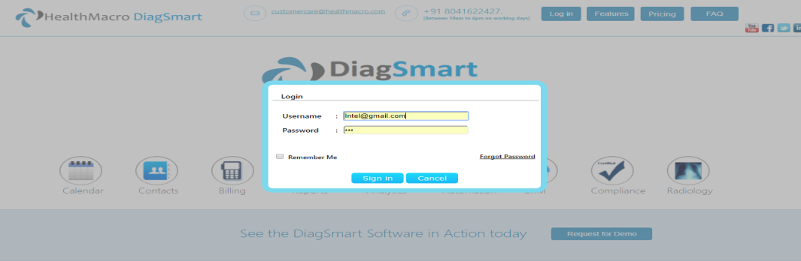

Figure 1.4.1: LOGIN Form Page.

Then registration of patients is done by taking the necessary details like name, age, address, phone number etc which is shown in figure 1.4.2.

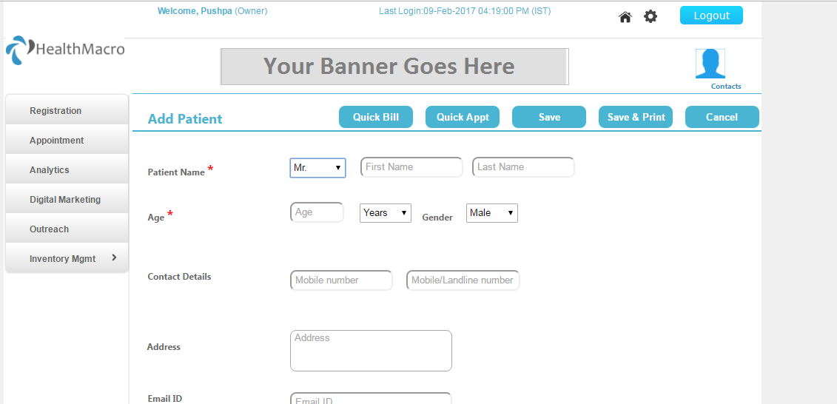

Figure 1.4.2: Registration form for patients.

After registration we can see the dashboard were it includes number of patients visited and transaction details as shown in figure 1.4.3.

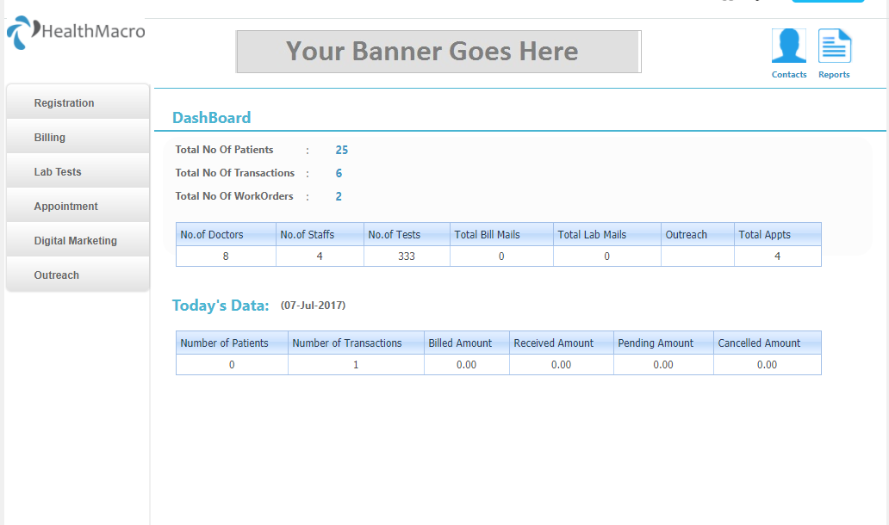

Figure 1.4.3: Dashboard.

Then patients can book for an appointment as shown in figure 1.4.4 and 1.4.5 for specific time well in advance and he gets confirmation message through SMS.

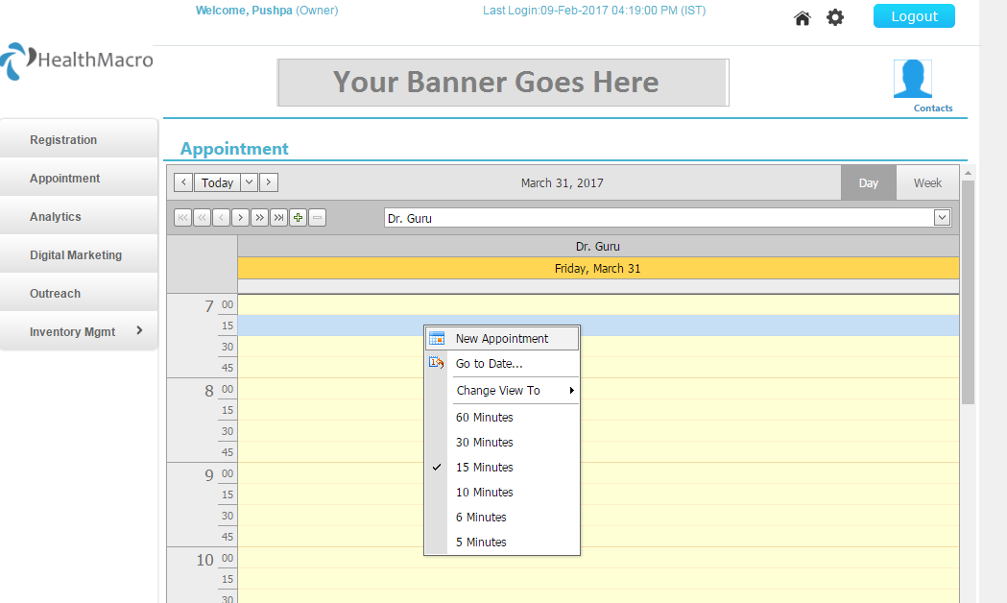

Figure 1.4.4: Appointment page.

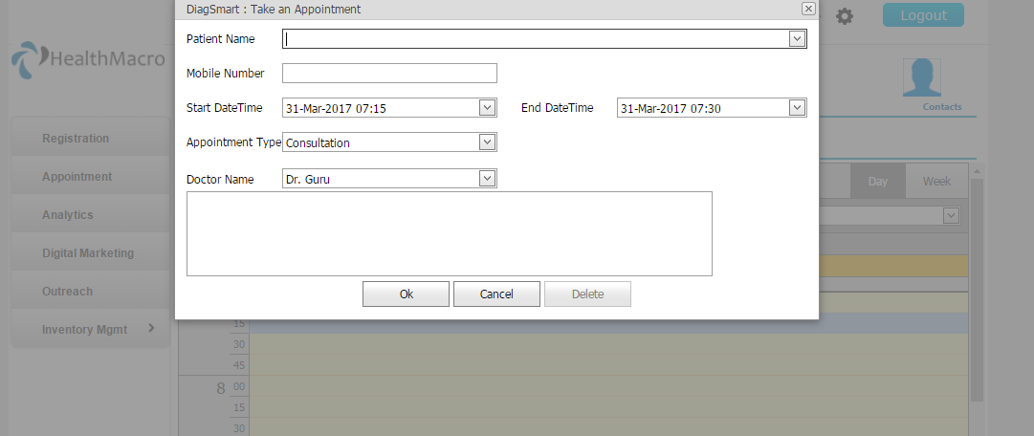

Figure 1.4.5: Patients details to be entered in appointment page.

Once appointment is booked for the confirmation purpose SMS is sent to both the patients and doctors, which is initiated through the module as shown in figure 1.4.6.

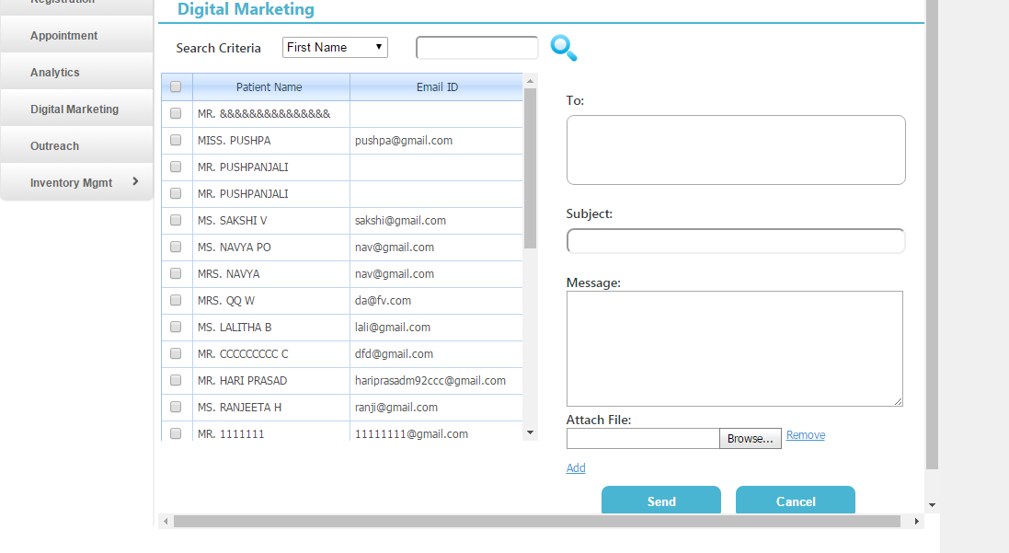

Figure 1.4.6: Message is sent for patients and doctors.

The below page ( figure 1.4.7) shows for the number of patients SMS are sent.

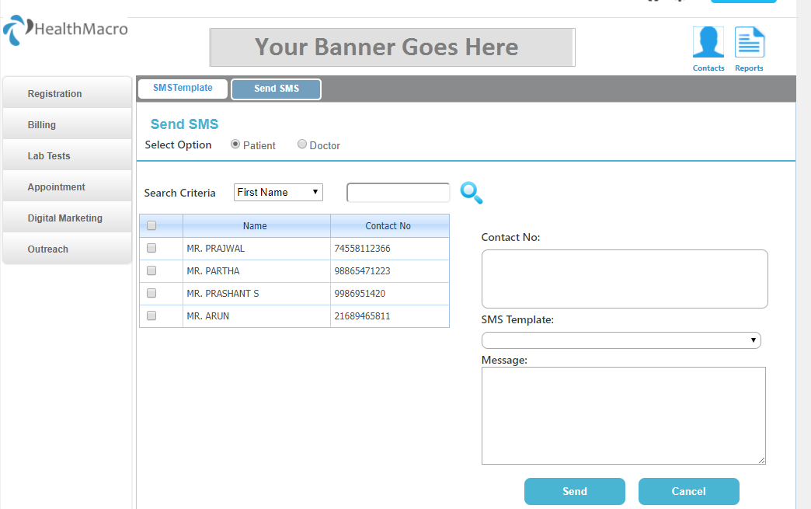

Figure 1.4.7: Page show the details of SMS sent to the patients.

After registering the patient’s details and patient got consulted to doctor, a bill is generated as shown in figure 1.4.8.

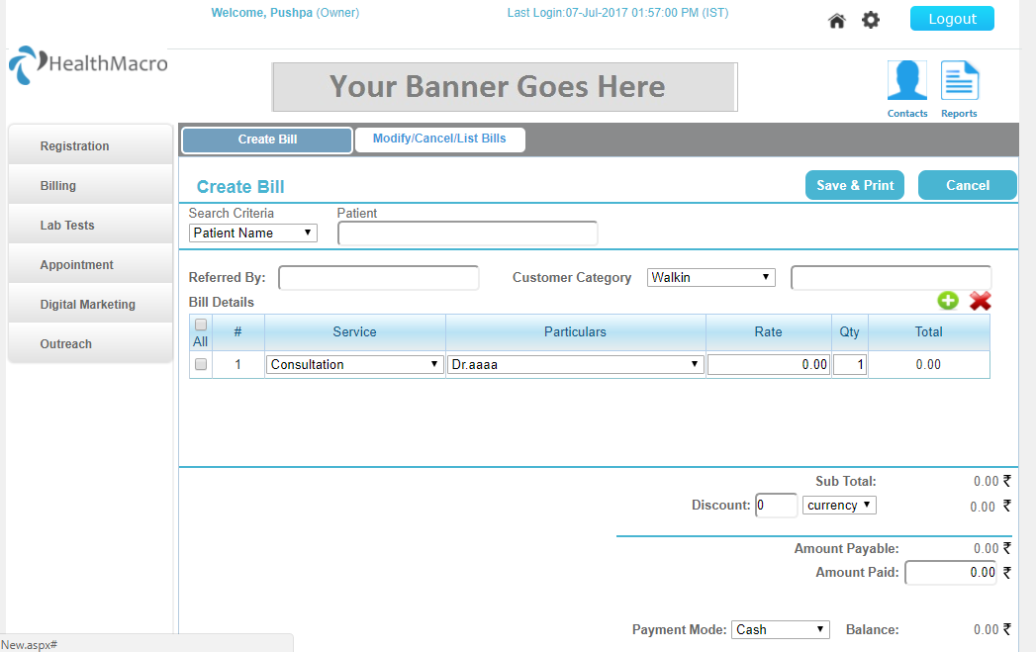

Figure1.4. 8: Billing Page.

**1.5. Conclusion**

The proposed healthcare system helps in lab automation for computerizing the work in a diagnostic lab/hospital. It is a great improvement over manual system. The computerization and smart approach to the diagnostic lab system has speeded up the entire process. In the existing conventional system, the front office management is very slow. The diagnostic lab and hospital managing system was thoroughly checked and tested with real life data and thus found to be very reliable. The software takes care of all the requirements of an average diagnostic lab & hospitals and is capable of providing easy and effective storage of information related to patients visiting the Diagnostic lab and hospitals. It generates the test report and also provides the facility for searching the details of the patients. It also provides billing facility, and uses the seamless communication channel i.e,. internet to send the report to patients to their door step. The system also provides the backup as per the requirement.

This new system is productized and deployed in small scale diagnostic centers and hospitals. This system is of low cost, highly secure and can cater to the needs of about one thousand patients. In comparison to the existing system our proposed system integrates all most all modalities of the hospital such as OPD, ward, billing, reporting; user friendly front end facilities, with cloud integration seamlessly deployed. All these are fully automated, secure, smart and cloud connected. The software takes care of all the requirements of an average Diagnostic lab/ hospital and is capable to provide easy and effective storage of information related to patients that come up to the Diagnostic lab/hospital.

**References**

Bhoomika. B. K and Dr. K N Muralidhara, ‘Secured Smart Healthcare Monitoring System Based on IOT’, International Journal on Recent and Innovation Trends in Computing and Communication, 2015.

Syed Saba Raoof and M. A. Saleem Durai, ‘A Comprehensive Review on Smart Health Care: Applications, Paradigms, and Challenges with Case Studies’, Hindawi Journal of Contrast Media & Molecular Imaging, vol. 2022.

Greg W. Hartley PT, Sabrina Camilo PT, MSPT, GCS, ‘[Geriatric Physical Therapy. [Patient management in postacute inpatient settings](https://www.sciencedirect.com/science/article/pii/B9780323029483000353)’(Third Edition)](https://www.sciencedirect.com/book/9780323029483/geriatric-physical-therapy), 2012.

Ma S, Sood N. A, ‘Comparison of the Health Systems in China and India, Rand Corporation: CA’, 2008.

Peters DH, Rao KS, Fryatt R, ‘Lumping and splitting: the health policy agenda in India, Health Policy Plan’, 18(3): 249–260, 2003.

Ramesh bhat, and Nishant Jain, ‘Analysis of public and private healthcare expenditures’, Vol. 41, No.1, pp. 57-68, 2006.

Peter Berman, Rajeev Ahuja and Laveesh Bhandari ,‘The Impoverishing effects of health Care payments in India: New methodology and findings’, Economic and Political Weekly,Vol. 45, No. 16, pp. 65-71, 2010.

Chaudhuri, A., and Roy, K.,‘Changes in out-of-pocket payments for healthcare in Vietnam andits impact on equity in payments, 1992–2002’, 2008.

Garg, C., Karan, ‘Reducing out -of-pocket expenditures to reduce poverty: adisaggregated analysis at rural-urban and state level in India’, 2009.

O’Donnell, O., van Doorslaer, E., et al,‘The incidence of public spending on health care:comparative evidence’, 2007.