Block Chain for Cloud of Things
Dr. V. S. Anita Sofia¹, Dr. D. Sowmyadevi², Dr. I. Shanmugapriya³
Associate Professor¹, Assistant Professor^{2,3}
Department of Computer Science^{1,2,3}
PSG College of Arts & Science

1. ABSTRACT
The age of blockchain dominates the market. Due to its decentralization, transparency and security features, blockchain has become a disruptive technology for many industries of the future. One of them is the Internet of Things, provided by the combination of cloud computing and IoT.

BCloud of Things is a revolutionary system that combines blockchain and CoT, thus making a major contribution to the relevant model.Blockchain is a distributed information system that differs from traditional information in the way it is stored. The data in the blockchain is stored in blocks that are linked together using cryptography.

When new data is received, add it to the nearest block. When a block is filled with data, the data is linked to the previous block in the order it was written.

Cloud computing and IoT can be combined to form CoT.An advanced cloud-based IoT application platform (called CoT) supports remote monitoring, control and management of IoT devices. IoT represents a continuous flow of next-generation applications of world-class IoT services.

IoT products generate massive amounts of data that can be processed and searched in the cloud to provide valuable insights. This information is sensitive information used by many smart services and applications.

A replacement paradigm, known as the cloud of Things, has been established in the current period by fusing cloud computing and, consequently, the web of things. The term "cloud of things" refers to a platform for the cost-effective and intelligent usage of applications and information. Each technology makes it possible to increase power in the future. However, combining those two technologies presents some challenging problems.

2. Introduction

The blockchain is a distributed, immutable document in business that enables the process of recording transactions and tracking assets.Houses, cars, money or land are examples of tangible or intangible related attributes (elegant products, patents, copyrights, brand names). The blockchain community allows partial tracking and recording of almost anything of value, reducing risk and costs for all parties involved. The sooner there is no inheritance and the more correct it will be.

Blockchain has proven to be one of the best ways to store information as it provides real-time, shared information recorded in an immutable ledger and can only be used by people with permission from the community. The blockchain community will collaborate with orders, payments, money, crafts and more.As people read the facts only once, you will be reassured by seeing all the information where the action stopped with the latest results and time. IoT or Cloud Computing refers to the integration of IoT and Cloud Computing.

It is the best cloud-based IoT application platform that allows you to monitor, control and manage IoT devices. COT simplifies and simplifies data collection, transfer, computation, storage and analysis. You will use CoT to connect IoT-powered devices or systems while you can easily access data at any time.

CoT could be a popular generation that started with the separation of IoT and cloud computing to develop cloud software that can handle data. It provides the latest enterprise version and is more efficient. COTs allow organizations to improve their operations through automation, and these major advances allow for the development of a broader pool of expertise. At the same time, this generation has seen its impact in industries such as healthcare, energy, logistics and manufacturing. It allows police to conduct smart searches in workplaces, improve the functioning of smart buildings, and allow smart city management and environmental monitoring.

3. BLOCKCHAIN AND ITS IMPLEMENTATION

Cloud computing and the Internet of Things (IoT) have revolutionized many aspects of information technology and communication. Along with many new business, consumer and commercial services, the Internet of Things has made our lives easier and more comfortable by improving our quality of life.
As the capacity of IoT devices is limited (such as storage capacity), IoT often distributes IoT application functions to cloud computing, giving rise to the concept of the IoT paradigm. CoT provides a powerful and flexible cloud environment for processing and managing IoT services, with great potential to improve performance and physical performance.

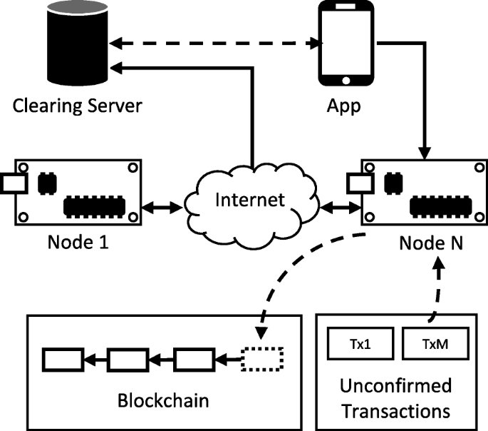

-- Figure 1 –

Figure 1 is a general description of the setup, including reading the blockchain and nodes, delete servers, applications and applications. Each user has an application that connects to the node (for initiating and confirming new transactions) and the swap server (for payments). New transactions (called Tx) are added to the pool of pending transactions until they are removed from the nodes and added to the blockchain. The swap server receives the data from the blockchain and sends it to the user's mobile phone according to the data request.

3.1WORKING FLOW OF BLOCKCHAIN

 It creates separate records for each transaction. These transactions represent the transfer of assets that can be tangible (goods) or intangible (money) (information). To whom, what, when, where, how much, and even the status and temperature of your food delivery can be reported
in statistics.
 The blocks are securely connected to prevent block alteration or block insertion between cutting-edge blocks, and the blocks certify the proper synchronisation and capture of transactions. The connections between transactions form an unbreakable chain: blockchain The blockchain as a whole benefits from each larger block by strengthening the prior block's verification.
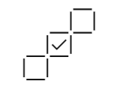 This emphasises lock-in and contributes to the power of immutability. By doing this, the malicious actor's ability to control resource utilisation is removed, and a transaction record is produced that you and another trustworthy user on the network may rely on.
3.2 BENEFITS OF BLOCKCHAIN:
TRUSTABLE TECHNOLOGY:
As a member of a contributors-only community, you may use blockchain to relax knowing that you are getting accurate and timely information and that only community contributors you have specifically authorised access to will have access to your private blockchain information.
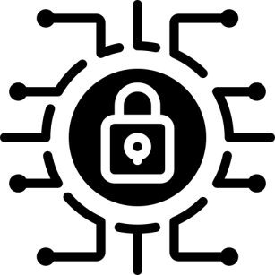 EXTREMELY SECURED:
All members of the community must agree on the veracity of the data, and since all transactions are permanently recorded, they cannot be changed. A transaction cannot currently be deleted by anyone, not even a device administrator.
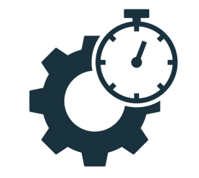EFFICIENCY:
With a distributed ledger, time-consuming file reconciliations are eliminated and this is frequently shared among network users. A strict set of guidelines, known as a smart contract, can be maintained on the blockchain and carried out automatically to speed up transactions.

4. NETWORK TYPES

4.1 Public BC Networks :
In addition to Bitcoin, a public blockchain is one in which any individual can join and contribute. Cons include the need for powerful machines, the lack of transactional privacy, and the vulnerability of the security. These are crucial factors to take into account while using blockchain in business settings.
4.2 Private BC Networks :
A personal blockchain network, which functions somewhat like a public blockchain network, may also be a peer-to-peer network that has been urbanised. However, one organisation controls the network, dictates who may participate, implements the agreed-upon protocol, and keeps track of the shared ledger. Depending on the use case, this can dramatically increase mutual confidence and trust. A private blockchain can even be hosted on-site and run behind a company firewall.
4.3 Permissioned BC Networks :
Businesses that set up a private blockchain typically have access to permissioned blockchain communities. It's crucial to note that permissioned blockchain networks can potentially be public. This section contains guidelines on who is permitted to participate in community activities and in what types of transactions. The participants seek an invitation or authorization to join.
4.4 Consortium BC:
The responsibilities of maintaining a blockchain might be divided among several teams. This previously decided teams decide who may also set up transactions or have access to the data. A syndicate blockchain is ideal for business operations where all participants desire permissions and a shared responsibility for the blockchain.

5.Architecture of Blockchain
The term "blockchain" was first used in 1991. The research team wanted to create a program to create digital files without timestamping or restoring them. Satoshi has also modified and reinvented this technology.

Nakamoto created the main cryptocurrency, a blockchain-based project called Bitcoin, in 2008. The three main ideas behind blockchain technology are decentralization, accountability and security.

This approach will ensure efficiency while reducing costs. Applications created on the basis of blockchain projects can still be discovered and used.

5.1 Highlights: Computational complexity and cryptographic verification by interested parties, blockchain transactions are verified and reliable.

Immutability: Data in the blockchain cannot be modified or deleted.

History: means that the history of each transaction can be determined from the blockchain data. All blockchain participants have access to all distributed information. Unlike core systems, consensus algorithms enable network control through a decentralized model. As a member of the blockchain network, all you have is a designated address. This protects user privacy, especially in systems using public blockchains.

Transparency: Blockchain systems are fraudulent. This is unlikely because replacing the entire blockchain network would require a lot of computing power.
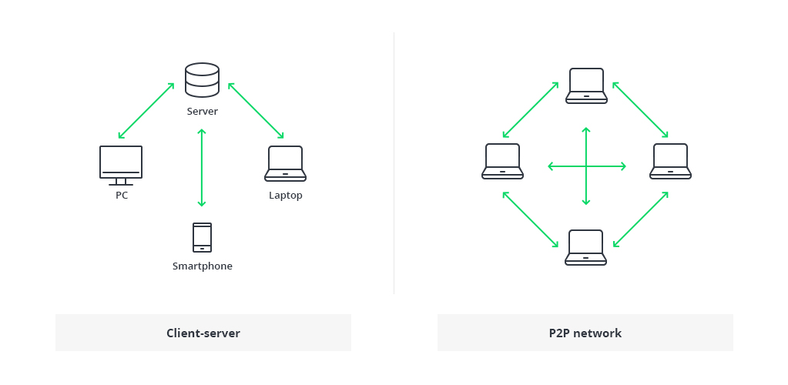

--Figure 2—

Figure 2. The traditional design of the World Wide Web uses a client-server network. Since the server is a central database managed by special administrators with privileges, in this case all the necessary information is stored in one place and is very easy to change.

Each member of the network manages, authorizes and updates new products in the shared network conditions of the blockchain architecture. All participants in the blockchain network have an influence on the system, not just some. All members ensure the security of information by ensuring that all information and procedures are organized. Therefore, parties that do not need to trust each other can come to an agreement.

In conclusion, the blockchain is also a decentralized distributed ledger that regulates various transactions, which can be public or private, in a P2P network.The network consists of many computers, but it is configured to prevent data from being changed without the permission of the entire network (all computers).

Create a blockchain form using a block list containing the transactions in order. This list can be saved as a file (txt format) or a simple file. Blockchain uses two main systems, including:

pointers: Variables that hold information about different variables. In particular, this is where many different variables are pointed out.

Linked List: An array of blocks where each block contains unique data and is linked to the next block with the help of a pointer.

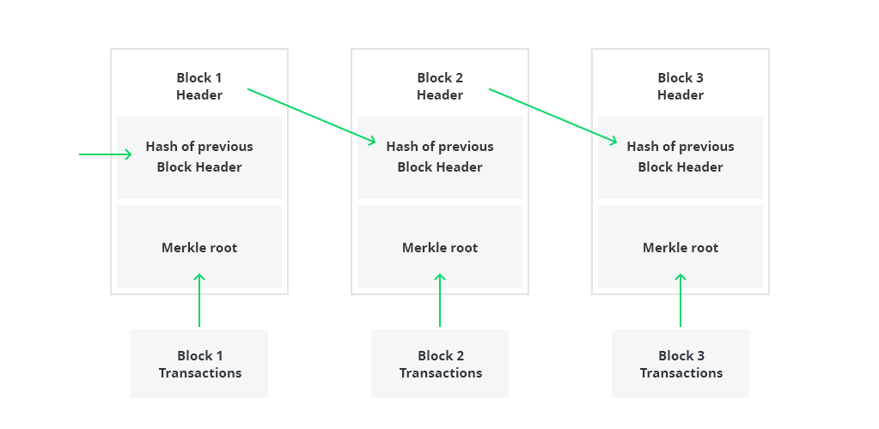

Figure 3., Logically, the number one block does now not incorporate the pointer thinking about that this one is the number one in a chain. At the same time, there is a decent possibility that a block with a pointer but no value will still be present in the blockchain database. The following capacities for organisations and agencies can be served by blockchain shapes:
Cost savings: By using a method of approach that keeps current statistics resistant to cybercrimes and exceptionally corrupt intentions, hundreds of dollars are saved on maintaining centralized databases (such as banks and governmental organizations).
Figure 3. Logically considering as the first block in the chain, the first block no longer has a pointer. At the same time, there is a high chance of blocking with pointers, but there is still no value in the blockchain database. Section , such as banks and government agencies). Section

Historical Data: Details of transactions can be checked in the blockchain model at any time. While the central database may seem like a snapshot of data in 4,444 unique data points, the data is constantly expanding.

Data validity and protection: Due to the nature of blockchain, data is now difficult to change.The verification process takes time, because it happens naturally in all societies, not through complex procedures.

This structure hinders the processing quality of the device but guarantees high data security. data is stored every blocks.For example, blocks in the Bitcoin blockchain model store information about receivers, senders, and account balances.

Hash is a type of fingerprint (long data consisting of some numbers and letters). The hash of each block, , is generated by cryptographic hashing rules. This makes it easy to identify each block in the -blockchain structure.

The hash is automatically added to the block when it is created, and changing the block determines whether the hash has changed.Section The summary of the previous block is the last word in the block. Therefore, many blocks are created, which ensures the security of the blockchain design. For example, represents block 45, pool 46. The first block of the chain can be anything.Any unsuccessful attempts will result in a move. All of the blocks below currently contain data and invalidate the entire blockchain system. On the other hand, with a powerful computer the should be able to process all blocks. However, there is a method called proof of work that eliminates this risk.

This allows users to change the policy of the current building block.In the Bitcoin blockchain architecture, it takes approximately 10 minutes to determine the required proof-of-work and add a transaction to the chain. Miners are private nodes on the Bitcoin blockchain, work. As an incentive, miners can keep the transaction value in block they have confirmed.

Blockchain end-to-end every new user (node) in the network receives a copy of the system.When a new block is created, it is distributed to all nodes of the blockchain.Then, each node verifies the block and determines whether or not the information explicitly stated there is accurate.

A consensus contract is created by each part of the Blockchain configuration. Consensus technology is an indisputable set of community rules that self-regulates on the blockchain if everyone who uses it abides by it. For example, the swap policy of the Bitcoin blockchain states that the transaction amount should be reduced by 0.5% every 200,000 blocks. Announcement said that if a block generates a reward of 10 BTC, the price should be halved every 200,000 blocks. Also, as only 20 out of 1,000,000 BTC can be put into the Bitcoin blockchain machine using the protocol, only has 4 million BTC left for me. After miners issue this code, bitcoins cannot be reused until update . In essence, this makes blockchain generation immutable and cryptographically stable from deletion by third parties.

5.2 Blockchain Networking Article

When a group or group is created to use a blockchain solution, they may already have formed a community Article A community may be viewed as an organization where people work, or may think it is a company. It is a technology infrastructure.

Let's take the diamonds as an example and give a few examples. Every step of the diamond manufacturing process, from the extraction of the diamond to the final product, involves risks and a challenging environment .Customers want to be sure that they are honestly buying genuine diamonds.

A government agency wants to track its exports and taxes. You can use blockchain technology to eliminate these dangers.

Creating Blockchain Code: Confirm the type of business transactions that can occur on Section Blockchain. Architecture is the next step in the development of the blockchain network.

These instructions are written in the contract. A blockchain contract has parties, entities, and transactions, just like in the real world.

Blockchains for Business:
Blockchain is most typically involving Bitcoin, the cryptocurrency and peer-to-peer payments system. whereas its ledger is public, the actors in an passing Bitcoin network are anonymous. to stay up this anonymity, Bitcoin uses a CPU-intensive methodology of agreement that' brought up as proof of work.
In contrast, businesses would like the counter-parties that they act with to possess a old identity. For example, many organizations are required to verify that a consumer exists through a understand Your consumer (KYC) check. the requirement for concrete identities leads on to a permissioned blockchain throughout that associate actor' role among a corporation determines their access to the ledger. A network-agreed policy is utilized to stipulate access rights to a combination of public, private, and confidential ledger information.
Permissioned blockchains gain important usability and performance blessings by combining concrete identities with a network-agreed endorsement policy to contour consensus. In combination, these blockchains enhance resilience by eliminating ledger forks and radically improve throughput, latency, and processor consumption.

6. INTRODUCING THE MULTI-PARTY TRANSACTION
Traditionally, each organization in an exceedingly very business network severally records their Inter-company dealingss in their distinctive IT systems. every organization owns a group of databases that acts as a transaction ledger:
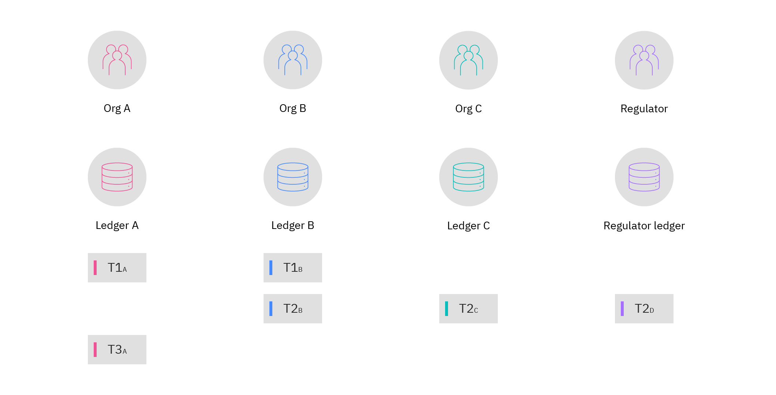
--Figure 4—
Figure 4., Org A and Org B record entirely different versions of identical dealings, T1, in their databases. A regulator who needs to audit transaction T2 between Org B and Org C encompasses a special copy to either party. These severally recorded reads of T1 and T2 kind a broken rather than holistic read of a transaction. Any disagreement a handful of transaction is difficult and takes time to resolve as a results of it desires freelance databases to be reconciled with each other.
A Blockchain introduces a replacement type of multi-party dealings that signed by every participant that's involved in associate degree exchange. These transactions are later distributed throughout a network of replicated ledgers:

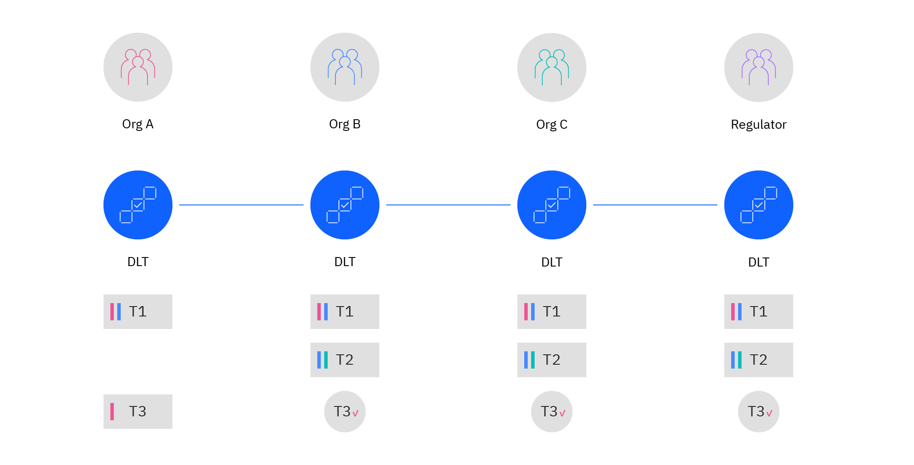
--Figure 5--
Figure 5.., Org A associated Org B presently collaborate to urge an identical, digitally signed version of T1. These dealings can be a real public group action; every organization inside the business network incorporates an in depth to amount copy of T1 in their own ledger. If required, organizations can build transactions personal to a collection of the network, as you see with transaction T2 that' shared by Org B, Org C, and a Regulator. And since each blockchain ledger is immutableand final.
T1 and T2 are digitally verifiable as valid transactions by every organization that holds a replica of them. you furthermore may will see a novel type of confidential dealings. In distinction to a standard database, Org A can prefer to distribute a digital hash of T3 that permits} different organizations to verify it. This conduct additionally permits an actor with get entry to to the blockchain community to confirm the state of a business object whereas not requiring Org A to supply direct access to group action T3. This pattern is helpful in identification scenarios, minimizing sensitive information distribution. Hyper ledger textile blockchain technology, that's delivered as a neighborhood of the IBM Blockchain Platform, provides channels and private information collections to support public, private, and direction sharing.

6.1 Interaction of Application of Blockchain:
- Querying this worth or dealings history of business objects
- Submitting new transactions to the ledger
- Listening for ledger events
6.2 Submit a new transaction
The accord technique is complex, submitting a new transaction to the ledger is created foursquare by the blockchain application SDK. Associate in Nursing application connects to the network and names a wise contract to submit a new transaction to the ledger. the appliance can value more highly to attend until agreement is reached for the transaction or will continue method and listen for asynchronous notification.
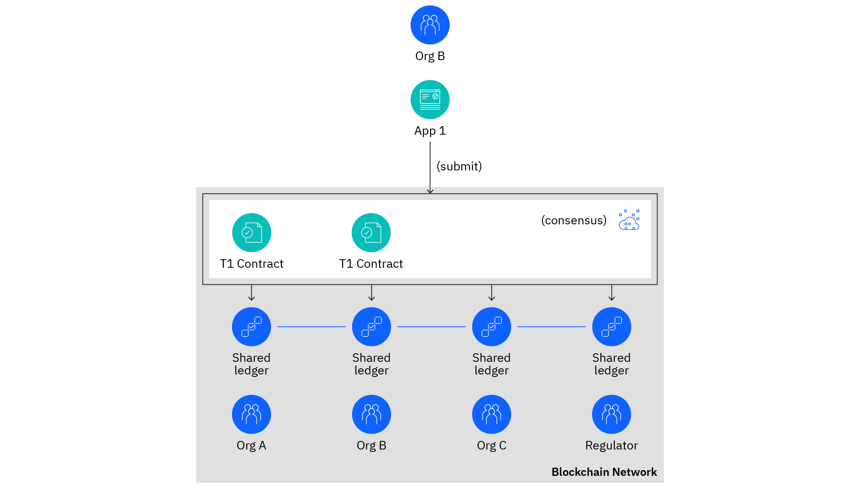
--Figure 6--

Figure 6.., within the example application, from Org B uses a wise contract to submit event T1 to the ledger. The blockchain application SDK ensures that the sensible contract is run and signed in every Org A and Org B before it distributes the contract to any or all organizations for inclusion in their ledgers.
Multi-party group actions ought to be signed by the organizations that are specific by one or plenty of endorsement policies. Associate in endorsement policy determines that organizations should sign a transaction before it' thought-about valid.
Event notification:
Finally, Associate in Nursing application can listen for ledger events notifications throughout a ballroom dance process. It registers for one or plenty of designs of ledger event and it' knowledgeable whenever that event happens through a notification.
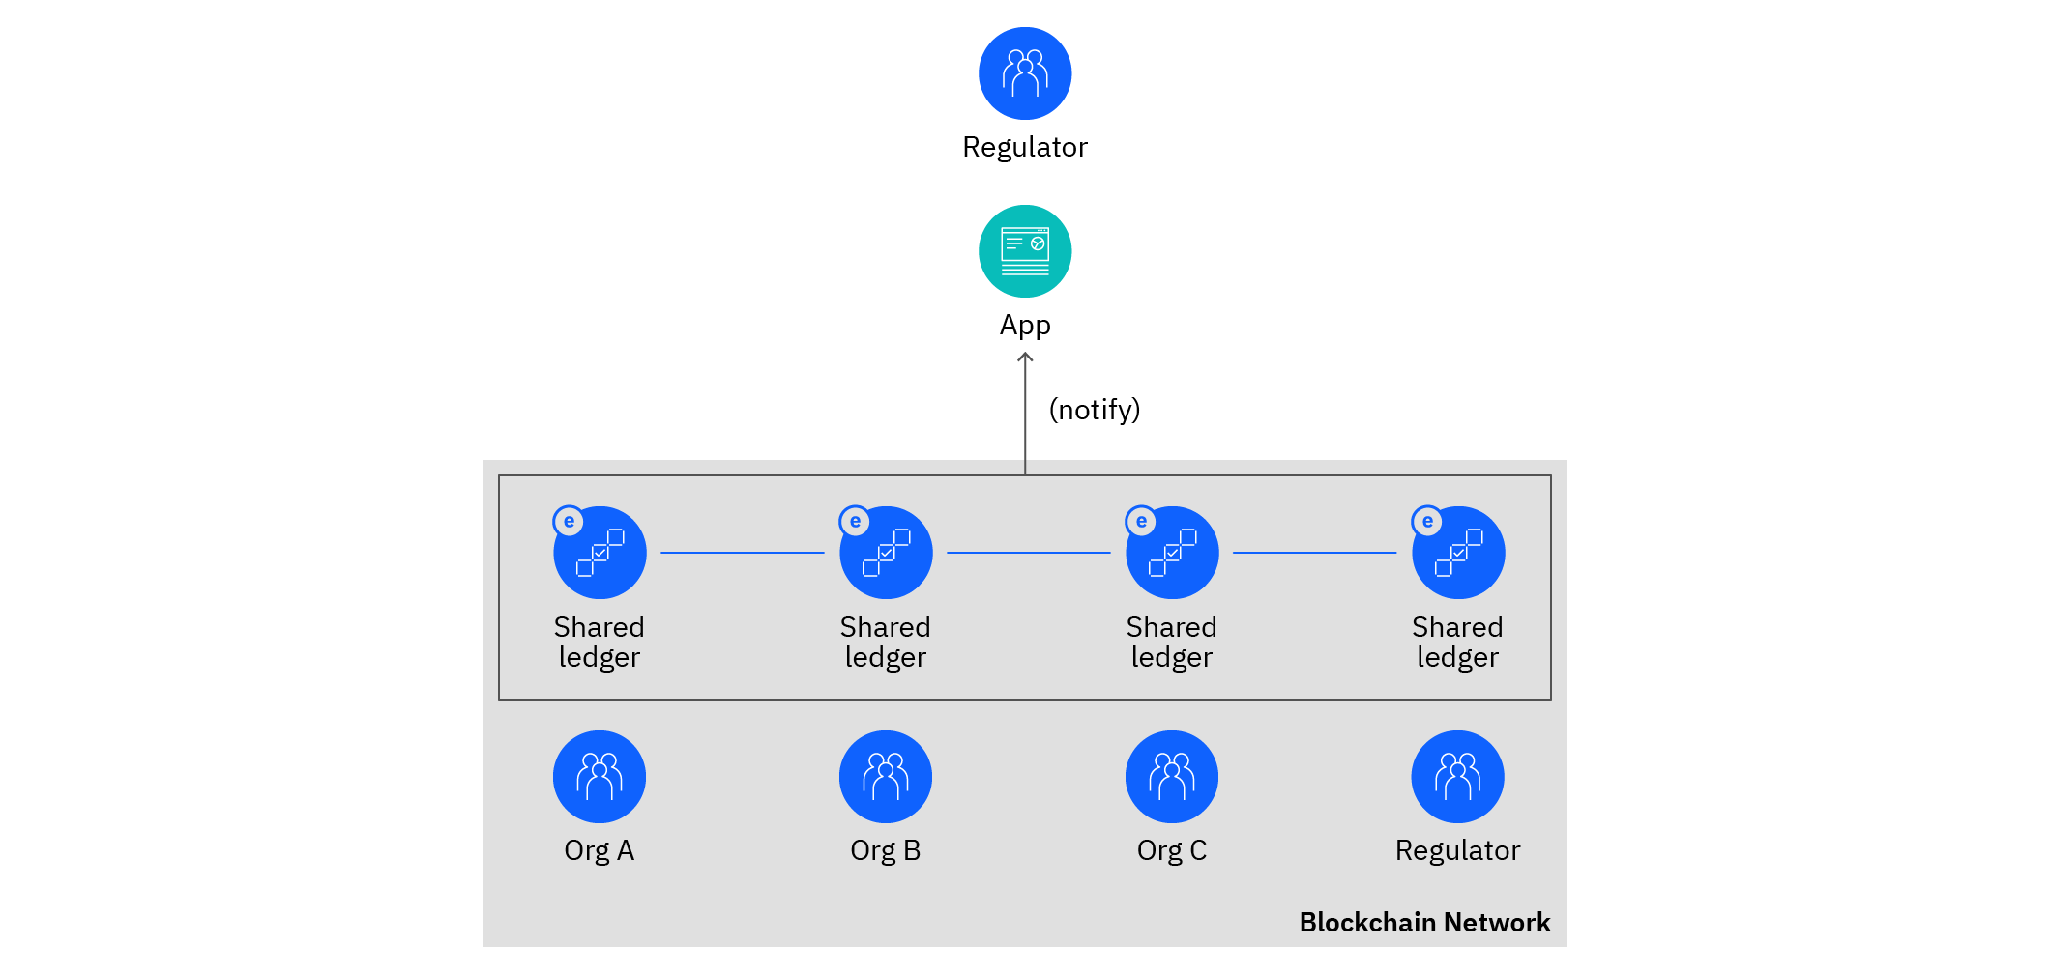
--Figure 7--

Figure7., Associate software that is in hand through a Regulator company will use an example of the disbursed ledger to pay interest for occasion notification, e. The blockchain utility SDK automatically chooses the most relevant example of the ledger to apply for occasion notification, even though this option are regularly overridden through the appliance. Moreover, the SDK guarantees that the utility is notified simply one event according to occasion albeit a couple of copies of the shared ledger exist.
Like ledger query, packages preferentially use their personal agency for notification to enhance local autonomy. For example, the regulator is notified each time the ledger changes. Likewise, it is its personal verifiable reproduction of each organization action.
Ledger notifications facilitate commercial enterprise-technique collaboration among companies in a really commercial enterprise community. New transactions which might be submitted to the ledger will provoke or maintain commercial enterprise methods in opportunity companies. Event technique is loosely coupled, allowing commercial enterprise methods to dynamically evolve.
Once a practical settlement generates an incident for inclusion in a transaction, it usually provides domain-precise data it truly is beneficial for the occasion consumer. Applications can browse this statistics even as now no longer a clever settlement, even though any ensuing ledger query or transaction submission wishes a practical settlement invocation. Applications may also pay attention for plenty of normal events, cherish as soon as a modern block is extra to the ledger.
It' is at the same time an smooth idea, and it' realistic to don't forget after you begin with blockchain. You commonly don’t were given to understand, for example, the Merkel bushes that underpin a blockchain, or but settlement works among nodes at the community. That statistics is satisfactory left to the oldsters which might be running to improve blockchain technology. Instead, consider using a blockchain to faithfully percentage transactions among companies. The community can deal with how the information is disbursed.

7. CLOUD OF THINGS
The term "Cloud of Things" refers to the combination of the internet of things with cloud computing. It is a better cloud-based IoT application platform that enables remote monitoring, management, and management of IoT-enabled devices.
The Cloud of Things is used to connect our devices and equipment while also monitoring and managing them. When Cloud Computing is combined with the Internet of Things, a new technical power/paradigm is developed known as the Cloud of Things, which gives a replacement business model with enhanced efficiency.
Currently, the number of IoT-enabled devices is huge, and the amount of IoT-generated data is expanding, making it impossible to store data domestically and rapidly.
The need for virtual resources and storage capacity is also significant. As a consequence, IoT is being merged with Cloud Computing, resulting in Cloud of Things or CloudIoT. The Cloud of Things has supported the Internet of Things in processing/analyzing data and creating massive amounts of quality from the data supplied by the Internet of Things by facilitating the development of several advanced intelligent applications.
Application areas of Cloud of Things:
- Online data storage
- Backup and Recovery
- Big data analysis
- Testing and Development
- Antivirus application
- Ecommerce application
- In Education
- Environmental Observance

Cloud computing and additionally the Internet of Things are several technology having a complimentary relationship.
The IoT generates large quantities of knowledge, and cloud computing presents a pathway for that facts to ride to its destination. inside the stylish era, through desegregation cloud of things, a today's paradigm has been introduced.
Cloud-primarily based totally internet of Things or cloud of factors arose as a platform for clever use of applications, facts in an exceptionally green manner. every technology facilitates to reinforce efficiency withinside the future. However, the aggregate of these technology is hard and bears a few key issues.The IoT generates large quantities of knowledge, and cloud computing presents a pathway for that facts to ride to its destination.
7.1 COT PLATFORMS:
Designing Cloud of Things systems may result within the improvement of clever infrastructures, which allow good applications.
Several authors withinside the literature arranges to endorse various architectures for CoT systems with the intention to deal with the innovative plan of Cloud of Things. These systems is also open-supply or proprietary.
Unfortunately, they're concerned on addressing nonuniformity issues related to every IoT and therefore the Cloud Computing through imposing a middleware nearer to the Cloud and each alternative one at the things’ side, more to conveyance associate API to ease the interaction with applications.
Government agencies are increasingly relying on Cloud of Things applications to supplement, enhance, or replace proprietary systems.
This reliance is motivated by the promise of increased usefulness associated with lower overall ownership cost, as well as a preference over an inability to develop and maintain proprietary IT solutions vs Cloud of Things IT applications.

8. ARCHITECTURE OF CLOUD OF THINGS
The problem of developing and implementing dependable, efficient, and cost-effective time management systems is becoming more difficult. This is because system designers and developers must contend with the reliability, inflexibility, and occasionally/frequently high cost of specialist hardware/software pieces.
Furthermore, designing systems that rely on specific hardware/software incurs unwelcome extra expenditures. Developers would prefer to use largely general-purpose, reconfigurable/reprogrammable hardware/software pieces in order to reduce costs, accelerate development, and make the end product more versatile. Such components are business ready-made items that are marketed in large quantities in the business sector. For example, industrial ready-made components have become a popular design technique in military and regional applications for the development of unmanned aerial vehicles.
The market for dependable fundamental quantity systems is rapidly expanding as a result of the growing applications in a variety of disciplines and sectors (for example, health care, industrial robots, remote-controlled aviation, intelligent cities, and so on). In such critical time systems, the more severe the consequences of potential system failure, the more specialised the system should be. Typically, such specialised solutions come at a premium.
Because of their immediate availability, quick utilisation, easy reconfiguration, and versatility, new market applications, particularly of reliable embedded systems in important applications in IoT and cloud computing, are seeking to use low-cost Cloud of Things-based components and devices in building time management systems.
Cheaper COTS components are predicted to have an impact on the responsible of many systems, as lower costs may lessen the sting for adopting reliable solutions in fundamental quantity systems as well, where reliability isn't a strict requirement (e.g., in soft real-time systems). Many companies claim the occurrence of such systems supported by COTS components throughout this direction.
Simply put, firms such as Abaco Systems, fundamental quantity Innovations (RTI), and Wind stream Co. announced the joint development of the first hardware, operating system, and communications framework for mobile Systems using commercial-Off-The-Shelf (COTS) components. COTS-based components provide more dependability and quality than made-to-order components because they are used and valid by multiple freelance developers and organisations due to their widespread use in numerous applications and implementations.
However, despite the continuous rise in the use of COTS-based components, their dependable performance in basic quantity systems continues at a lower level, which is a goal of this effort as well.
Provides classes of Service:
- Software As A Service (SAAS)
- Platform As A Service (PAAS)
- Network As A Service (NETWORK AS A SERVICE)
Software As A Service (SAAS):
SaaS is a licencing model in which access to software programme is supplied on a subscription basis, with the software running on external servers rather than on in-house servers.
Software as a Service is frequently accessed via an online browser, with clients entering a username and password into the device. Rather than requiring each customer to install software on their computer, the buyer will gain access to the present system over the internet.
The rise of Software As A Service (SaaS) coincides with the rise of cloud computing. Cloud computing provides internet-based technological services such as data storage, networking, and server access.

Prior to Software as a Service, businesses who wanted to update the computer code package on their computers had to obtain compact discs with the updates and transfer them onto their systems. Modifying software was a time-consuming process for large organisations.
To access a certain service, consumers can log in using a web or application programme and connect to the service provider's network. Technology firms, financial services organisations, entertainment companies, and utilities have led the way in embracing SaaS technology.
SaaS applications are engineered to be hosted on the cloud. The Software as a Service software vendor will host the applying on its own cloud infrastructure or with a cloud service supplier (such as Amazon internet Services (AWS), Google Cloud, IBM Cloud or Microsoft Azure). Hosting with a longtime cloud service provider allows the Software as a Service provider supply the measurability associate degreed international accessibility some customers could require.
Software as a Service applications are accessible to any customer with an internet connection and an internet-connected end-user device (for example, a computer, tablet, or smartphone). SaaS apps normally run in any web browser; on mobile devices, SaaS applications may run more efficiently (or may require) a mobile or tablet app. A few of Software as a Service products, such as Adobe Acrobat, may provide or require an obsessive thin shopper that customers download and install on their computers.
Maybe most important, SaaS applications would like little to no management and nil maintenance from the customer. The Software as a Serviceauthority is chargeable for:
- Provisioning, managing, and maintenance of all servers, networking equipment, storage hardware, and operational code required to run the application.
- PRN capability fixes and security updates are applied.
Providing load balancing, redundant infrastructure, information backup, cloud security, and disaster recovery services to prevent outages and meet service level agreement performance, convenience, and information protection standards.
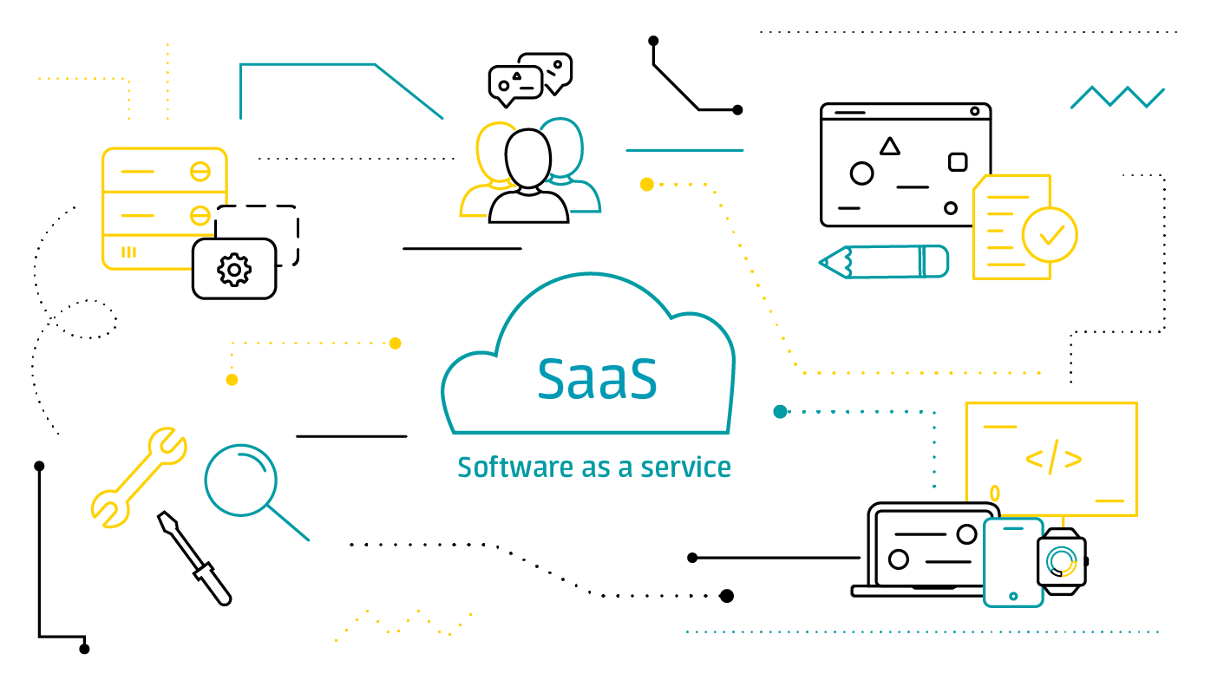
--Figure 8--
Figure 8., Because of changes in the world of IT, enterprises are migrating to the cloud in order to reduce costs, enhance business processes, and use scalability. This is particularly relevant for many businesses that are switching from on-premises installs to the Software as a Service model in order to retain their competitive edge sharper.
Platform As A Service :
Runtime environment is provided via Platform as a Service. It allows developers to easily construct, test, operate, and deploy web apps. These applications are available for pay-per-use from cloud service providers, and you can use a web connection to access them.
Platform as a Service relieves end users of the burden of managing the infrastructure by having the cloud service provider manage face measurability.
Platform as a Service consists of platform such as middleware, development tools, management systems, business analytics, and other components and infrastructure like servers, storage, and networking to support the life cycle of a network application.
Example: Google App Engine, Force.com, Joyent, Azure.
Common PaaS eventualities:
PaaS is commonly used by businesses in the following scenarios:
Development framework:
Platform as a Service provides a platform on which developers can build or customize cloud-based applications. Platform as a Service enables developers to create apps by utilizing inherent computer code components. Cloud options like as scalability, high-availability, and multi-tenancy are included, minimizing the amount of writing that developers must perform.
Analytics or Business Intelligence:
Tools provided as a service with Platform as a Service allow organizations to analysis and mine their data, finding insights and patterns and predicting outcomes to spice up forecasting, product style decisions, investment returns, and totally different business decisions.
Other services:
Platform as a Service supplier would possibly offer different services that enhance applications, love workflow, directory, security, and scheduling.
Platform as a Service allows users to avoid the expense and complexness of shopping for and managing computer code licenses, the underlying application infrastructure and middleware, instrumentation orchestrators such as Kubernetes, or the event tools and other resources.
Platform as a Service helps developers and business users specialise in building nice apps with clicks and code, without concern concerning infrastructure and in operation systems. Development tools, servers and programming environments are simply accessible via the cloud while not the complexness and expense of building them in-house. Applications are often developed and hosted quicker and with terribly low setup costs, without the danger of delays or inefficiencies thanks to infrastructure issues. -Quality results, faster.
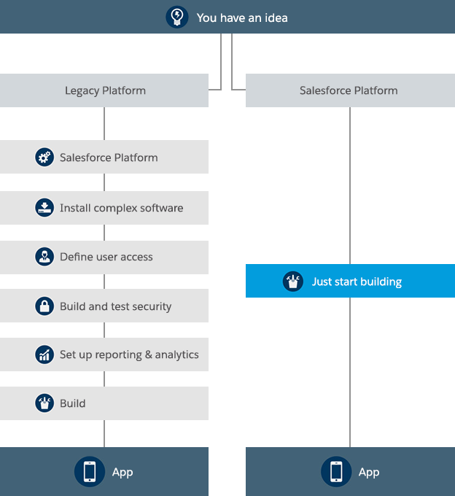
--Figure 9--
Figure 9., Platform as a Service is driving a replacement era of mass innovation and business agility. It shares constant innovative roots as companies like Amazon, eBay, Google and YouTube, who created new capabilities in new markets through the browser. PaaS offers constant moderately cost-effective and specialised model for application development and delivery. For the first time, developers can concentrate on application expertise for his or her business, not managing advanced hardware and package infrastructure.
because the digital atmosphere matures, form of drivers are strengthening the principle for adopting cloud computing.
- The enhancing standardization of digital technologies
- Larger business use of mobile and mobile apps
- Growing quality and usage of web-like interfaces
- Improving broadband access and speed

Network As A Service:
Network as a Service might be a cloud version that permits users to without a doubt perform the community and obtain the consequences they assume from it whilst now no longer owning, building, or keeping their personal infrastructure.
Network as a Service will update hardware-centric VPNs, load balancers, firewall appliances, and Multiprotocol Label shift (MPLS) connections. Users can rescale and down as call for modifications, speedy install offerings, and dispose of hardware costs.
Network as a Service is companion growing version for groups to eat community infrastructure via flexible expense (OpEx) subscriptions, inclusive of hardware, software, control tools, licenses, and lifecycle offerings.
The general community version desires Capital Expenses (CapEx) for bodily networks with switches, routers, and licensing. The home made IT version calls for time for designing and readying moreover as enjoy to install and piece infrastructure and to ensure safety get right of entry to rules are in place. This version entails the following: Diligent tracking for updates and safety patches is essential way to speedy modifications in generation and safety threats.
Provisioning a alternative carrier might be a guide approach that desires a technician to install and piece instrumentality at numerous locations.Service provisioning and difficulty decision have historically been lengthy processes.
Network as a Service offers the pliability to pay cash for offerings supported utilization and to scale as a enterprise desires to change. It conjointly offers the power to observe and manipulate networking offerings and tune utilization and billing. Services is ordered, deployed, and co-controlled on call for. Network as a Service offering can range from controlled Software-Defined WAN (SD-WAN) and community get right of entry to in addition to wi-fi to safety, unified communications offerings, and more-both in a completely public cloud and on Virtualized Client Premise Equipment (vCPE). With the tempo of innovation, maximum companies are locating they may no longer have the funds for the time it takes to create and preserve their personal community infrastructure.

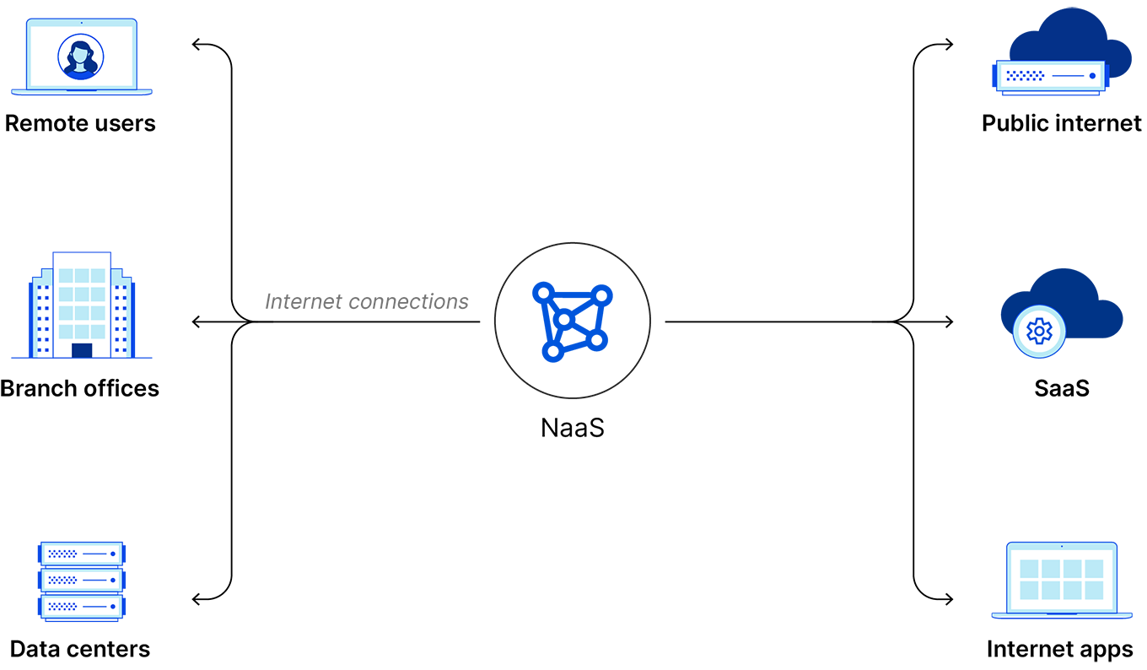
--Figure 10--
Figure 10., Network as a Servicecan replace Virtual non-public Networks (VPNs), multiprotocol label change (MPLS) connections, or different heritage network configurations. it should replace on-premise networking hardware reminiscent of firewall appliances and merchandise balancers. a newer model for routing traffic and applying security policies, Network as a Servicehas had a big impact on enterprise networking architecture.
Organizations have traditionally consumed enterprise network infrastructure via a one-time value of hardware, software, licenses, and services which can or won't be packaged together. Network as a Servicepermits enterprises to consume and optionally supply the whole lifecycle of their enterprise network deployment, with all hardware, software, licenses, and services delivered in a exceedingly in a terribly very versatile consumption or subscription-based offering, that in many cases is accounted for as an operational expense.

9. BLOCKCHAIN WITH CLOUD OF THINGS
The applications of blockchain in cloud computing are connected to the Cloud of Things, a mix of cloud computing associate degreed additionally the Internet of Things . So, before we've a tendency to dive into blockchain cloud computing associate degreed blockchain-based cloud.
Cloud of Things provides a powerful and versatile cloud computing surroundings to manage Internet of Things services plenty of efficiently. this means Cloud of Things inherits the performance of an Internet of Things system.
IoT is also a system of varied interconnected devices, corresponding to sensors, home appliances, vehicles, then on The devices in an IoT system can connect and exchange data over cyber web with none human intervention.
Many industries use Internet of Things systems to assemble information from surroundings and store and analyze it to urge valuable data for taking the right action. However, Internet of Things devices have restricted storage capacity, so as that they use the cloud to store big device data, and this will be what forms Cloud of Things. There are utterly completely different cloud service decisions available, reminiscent of public clouds, personal clouds, and hybrid clouds.
The Necessity for Blockchain Cloud:
Cloud computing and Cloud of Things infrastructure have a variety of risks and limitations that blockchain can facilitate and eliminate. These risks and limitations include:
With cloud computing, users have restricted management over their information, processes, and code once they transfer them to the cloud servers.With cloud computing, users don’t grasp plenty of regarding the inside operation mechanisms, which they need to trust cloud suppliers for information processing, which could cause security and privacy concerns.
Cloud of Things uses centralized communication models, which produces it difficultto scale the service operation and expand the IoT networks to larger deployment. Centralized network infrastructure to boot can increase communication latency and will increase power consumption for Internet of Things devices due to massive info transmissions.
Working terminology of Blockchain with COT:
In blockchain-based cloud computing, blockchain are usually used for secure network management by hosting the blockchain network as Blockchain as a Service in an exceeding cloud environment. BaaS supports IoT applications by giving utterly totally different blockchain-enabled services, likewise contract services, verification services on user transactions, and cloud blockchain storage.
With IaaS, users are chargeable for their information, that suggests if any information is lost, the users ought to recover it themselves. Additionally, setting up and maintaining operational systems and apps is to boot the users’ responsibility. IaaS services are remarked as cloud infrastructure services
Blockchain IaaS is Analogous to the IaaS cloud computing service model but with else security and decentralization. With an IaaS blockchain cloud service, a cloud computing service could use the idle capability of CPUs and GPUs operative throughout a localised network and supply additional computing resources to users on a per-user basis.
Edge Networks:
With a regular, large, centralized data center (a cloud), the information generated by IoT ought to produce several ‘hops’ before the cloud validates it, that's already method an enormous amount of different data.
Edge networks are decentralizedclouds that allow data to be processed at the edge, rather than once making many ‘hops’ before the massive cloud validates it. this suggests higher latency, that is good news for automatic systems and robotics, as a result of it lands up in improved responsiveness and performance. Blockchain may create edge computing even extra effective.
The provision chain should be secure, and it have to be compelled to be realizable to verify every step in that chain in real-time, notably once one issue goes wrong. this could build it attainable to go looking out and address the reason for the issue.

If integration blockchain and CoT has occurred, all movement of data, and additionally the processes it undergoes, are entered into the blockchain. Associate in Nursing One who has access to the blockchain can verify where the data went, but it had been governed, who accessed it, and what happened to it.
An integrated blockchain-cloud system would offer total traceability for the latter, and it'd offer cloud-based systems a further layer of security. it might mean cloud users and administrators are up to the mark of their actions, regulators might audit all processes involved, and each one others with access to the cloud could verify the character and time of all data transactions.
To put it in a nutshell, blockchain offers solutions to CoT challenges adore knowledge privacy, decentralization, and network security. CoT offers quantifiability functionalities and additionally the snap which will build blockchain loads of efficient. Together, as BCoT, they may modify varied applications in many scenarios.
In Gault’s opinion, the result would be nothing less than revolutionary, significantly if blockchain integrates with every cloud. it'd see our society modification from one that’s supported trust, to a minimum of one that’s supported truth. whether or not or not people trust one another or not, they may use blockchain to prove what very happened.
Blockchain functions as a ‘public ledger’ that options a record of every transaction, and it’s distributed to the network’s edge. It wants the input of multiple distributed parties who agree on what' true or false, rather than trying forward to a central authority to make that decision. Once the ledger records that decision, anyone can access it.
The necessity for the accord of multiple parties to vary the ‘ledger’ makes it impracticable for people to vary the records of past transactions.

10. DEVELOPMENT AND ENHANCEMENT OF CLOUD OF THINGS WITH BLOCKCHAIN
Due to the continual growth of IoT devices and additionally the large volume of data to be methoded, storing all this data among the cloud is difficult and costly looking on the desired storage capability requirements. that' why the Cloud of Thingswas born, where IoT is integrated with Cloud Computing, so on analysis and method data in an exceedingly exceedingly plenty of best way. The Cloud of Things permits to develop additional advanced systems, monitor IoT devices and manage them remotely in a more economical way. Some emerging platforms which implements the tech stack are OpenIoT, AWS IoT, CloudPlugs.
Edge Computing:
There are certain improvement techniques to avoid effort a relentless giant volume knowledge to the cloud and to be able to analyze with efficiency and whereas not such high value all this vast amount of data. Solutions comparable to Edge Computing and Fog Computing, modify to research data before causing it to the cloud. Basically, the foremost resolution is that each one data created by many sensors don't appear to be sent on to the cloud, but are treated as shut as potential to the place where it' being made then simply send the relevant information to the cloud. By process the information and analyzing it really getting ready to where it' produced, there' less latency, less consumption due to a quick trip and a lower cost.
Fog Computing:
There could also be a localized computing style through that data is processed and hold on outside the cloud. In various words, thus on be further efficient, contour processes and be faster, the data is processed voluminously nearer to wherever it originates and in smaller decentralized data centers, then the required data is shipped to the cloud. Fog Nodes are the method nodes that act as intermediaries between the cloud and IoT devices. Edge computing, however, consists of process and storing knowledge in real time among an equivalent IoT device that' assortment the data and even responds to certain parameters if necessary.
10.1 Layers of BCoT Architecture
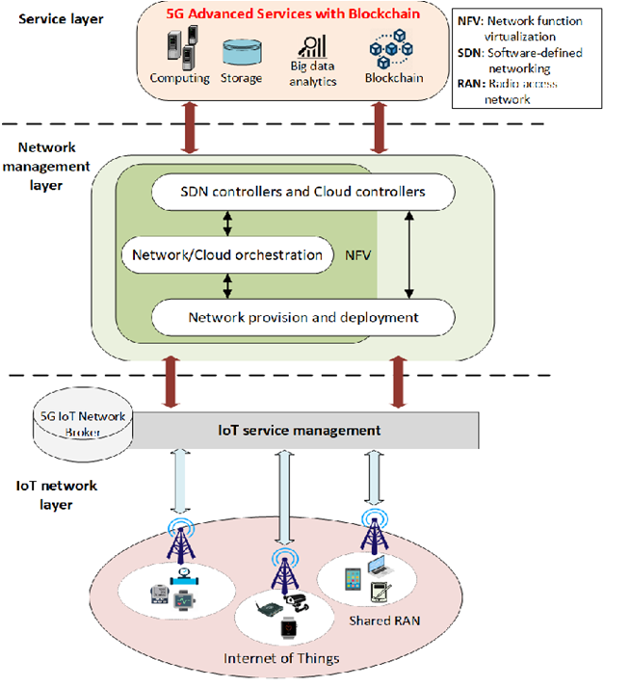
--Figure 11--
Figure 11.., illustrates the layers of BCoT architecture within which it consists of IoT Network Layer, Network Management Layer and repair Layer on wherever these layers lay connect with perform the entire tasks.
IOT Network Layer:
The network layer in IoT is primarily divided into 2 parts. The routing layer sends packages from origin to destination and conjointly the encapsulation layer is basically in command of creating packets.

RPL:
RPL may be a Routing Protocol for low-power and loss networks. Low power and loss networks re resource-constrained networks which suggests that supported the offered resources the networks adapt themselves. Routers are typically restricted in terms of method power, battery, and memory, and their interconnects are characterized by unstable links with large loss rates, low data rates and low packet delivery rates.
RPL could be a distance routing protocol. RPL within the main targets collection-based networks, where nodes periodically send measurements to a gaggle point. the design of the protocol was to be very adaptative to network conditions and to provide alternate routes, whenever default routes are inaccessible. RPL provides a mechanism to distribute info over the dynamically formed network topology. RPL can handle thousands of nodes.
CORPL:
CORPL or Cognitive RPL is an extension of the RPL protocol. cognitive networks and DODAG topology use this network vogue protocol. CORPL to boot makes 2 new updates to the previously existing RPL protocol.
It makes use of opportunistic forwarding to transfer packages between each module or node. rather than exclusively the parents maintaining the knowledge every node put together remembers the knowledge of the forwarding set. each node makes use of DIO messages to update its neighbors.
CARP:
Caching Array Routing Protocol additionally called CARP could be a protocol developed by Microsoft degree implemented within the Microsoft Proxy server. It permits multiple proxy servers to array jointly logical cache for distributed content caching. we've got an inclination to implement CARP as a series of Algorithms that we have a tendency to apply on the prime of machine-readable text Transfer Protocol(HTTP). CARP permits a web browser or downstream proxy server to figure out specifically where within the proxy array we store the info for a requested uniform resource.
CARP permits pursuit proxy servers through associate array membership list that' automatically updated using a time to live count perform. This perform oftentimes checks for active proxy servers at intervals the array. CARP uses hash functions and combines the hash values every} requested address with each proxy server.
6LoWPAN:
6lowpan connects things to the cloud. Low power, IP-driven nodes and mesh network support makes this technology a superb support within the internet of things. 6lowpan could be a descriptor for IPv6 over Low Power Wireless Personal area Network. it' a low-power wireless mesh network where each node has its IPv6 address allowing it to connect on to the internet. web packets are carried efficiently at intervals little link-layer frames.
Properties of 6LoWPAN
- Nano IP
- IPv6 over low power wireless personal space network
- Developed by the IETF(Internet engineering task force)
6lowpan ought to be used with low-power networks with memory-constrained embedded devices. A 6lowpan system is formally product of many low-power nodes in an extremely self-healing mesh form.
Network Management Layer:
This layer focuses on regarding network communication and consequently network topology. This layer's functions include assembling the network topology, establishing routing and signal pathways, and combining fault and activity states across the network.
Two protocol architectures have served as the foundation for the development of practical communication standards: the International Organization for Standardization (ISO) OSI model and the TCP/IP reference model. The OSI reference model was created to uphold the promise that different layers of the protocol provide distinct services and functions. It provides an abstract framework for communication across network components that are completely distinct.
There are seven layers in the model. Network communication occurs at several layers, from the application layer to the physical layer; nevertheless, each layer will only connect with its neighbouring layers. There are significant similarities between the Open Systems Interconnection and Transmission Control Protocol/Internet Protocol reference models. Each is backed by the idea of a stack of independent protocols.
The functionality of the relevant levels is also more or less comparable. The distinction, however, is between the two reference models. The OSI model's fundamental concepts are service, interface, and protocol. The OSI reference model demonstrates the superiority of these three approaches.
The TCP/IP model, on the other hand, does not explicitly discriminate between these three ideas. As a result, the protocols in the OSI paradigm are more hidden than those in the TCP/IP model and may be altered more easily as technology evolves.
The Layers are divided into:
Physical Layer, Data link Layer, Network Layer, Transport Layer, Session Layer, Presentation Layer, Application Layer.
Service Layer:
Enterprise purposes generally desire thoroughly one-of-a-kind types of interfaces to information they shop and moreover the common sense they put in force records loaders, consumer interfaces, integration gateways, and others. Despite their definitely distinctive purposes, these interfaces commonly want frequent interactions with the equipment to get entry to and manipulate its facts and invoke its enterprise logic. The interactions might also even be complex, involving transactions throughout a couple of assets and additionally the coordination of the many responses to an action. Coding the good judgment of the interactions one after the other in every interface motives an splendid deal of duplication.
A Service Layer defines an application’s boundary [Cockburn PloP] and its set of accessible operations from the viewpoint of interfacing consumer layers. It encapsulates the application’s commercial enterprise logic, dominant transactions and coordinating responses at intervals the implementation of its operations.

11. CONCLUSION
Blockchain may well be a decentralized, unchangeable, and shared knowledgebase. Cloud computing may be additional concerning delivering computing services, comprising servers, information bases, storage, then forth Cloud computing uses blockchain peculiarities to increase data security. Blockchain storage is a manner of saving facts in an exceedingly decentralized network that makes use of the unused tough disk space of users the planet over to stay files. The decentralized infrastructure is a chance to centralized cloud garage and may clear up several problems determined in an exceedingly centralized system.
---------------------------------------------------------------------------------------------------------------------
“Develop a passion for learning. If you do, you will never cease to grow”.
-Anthony J. D'Angelo
---------------------------------------------------------------------------------------------------------------------

12. BIBLIOGRAPHY
Referred Books:
1. Vikram Dhillon & David Metcalf & Max Hooper,”Blockchain Enabled Applications: Understand the Blockchain Ecosystem and How to Make it Work”,aPressPublications, ISBN-13 (pbk): 978-1-4842-3080-0, 2017.
2.Bellaj Badr, Richard Horrocks, Xun (Brian) Wu,”Blockchain By Example”,Packt Publishing, ISBN-13: 978-1787122147, November 30- 2018.
3. Ravindhar Vadapalli,”Fundamentals of Blockchain”,ISBN: 301.345.908, October 2020.
4. Debashis De, Siddhartha Bhattacharyya, Joel J. P. C. Rodrigues,”Blockchain based Internet of Things”,Springer Publications,ISBN: 978-981-16-9260-4, 2022.
5. Rashmi Agrawal, Abhishek Kumar, Jyotir Moy Chatterjee, Pramod Singh Rathore, “Blockchain Technology and the Internet of Things Challenges and Applications in Bitcoin and Security”,AAP ,CRC PRESS USA,ISBN: 978-1-77188-897-4, June 2020.
Referred Links :
1. https://www.ibm.com/in-en/topics/blockchain-iot
2. https://www.blockchain-council.org/blockchain/blockchain-implementation/
3. https://www.techtarget.com/searchstorage/definition/blockchain-storage
4. https://www.devteam.space/blog/the-ultimate-guide-to-blockchain-implementation/
5. https://appinventiv.com/blog/blockchain-of-things
-------------------------------------------------------------------------------------------------------------------

