overview of Basic Structure and Advancements of Organic Solar Cells

Manisha Bajpai¹, C. K. Pandey^{2, *}, and Rakhee Malik³

^{1,} Department of Physics, Siddhartha University, Kapilvastu, Siddharth Nagar - 272202, UP, India
2Department of Physics, S.N.S College, Motihari - 845401, BRABU, Muzafferpur, Bihar, India
³Department of Physics, Government Degree College, Nadabhood Badaun - 243723

Abstract
Improvements in energy conversion efficiency over the past three decades have led to the development of recent scientific and economic research on organic solar cells. This is achieved through the device engineering that incorporates of new materials or tuning of materials used. This may lead towards sophisticated device structure of the device. Hence, we review here the different possible structure and how their mechanism changed by choosing different structures.
Keywords: Organic solar cell, tuning of materials, photovoltaic device, organic materials, sophisticated device structure.

chanchalpandey44@gmail.com

- Introduction
Organic-solar-cells (OSCs), nowadays, plays a pivotal role to develop photovoltaic devices that use organic materials to convert sunlight into electrical energy [1]. Unlike established silicon-based-solar-cells (SBCs), that rely on inorganic semiconductors, OSCs use organic compounds as an active layer to absorb light and generate electric current [2-3]. The most important component of an OSC is active layer, which typically consists of a blend of organic molecules or polymers. These materials have unique electronic properties that allow them to efficiently absorb photons across a wide range of wavelengths [1, 2-6]. When light hits the active layer, it excites the organic molecules and electron-hole pairs are created [3]. The separated charges (namely electrons and holes) are then transported through separate pathways within the organic layer to the respective electrodes, usually made of transparent conductive materials. The flow of electrons towards cathode, however, the holes move towards anode, producing an electric current [3-5]. The major advantages of OSCs is their low-cost and ability to be mass produced. Organic materials that can be synthesized by means of relatively simple and inexpensive techniques, such as solution processing or printing methods, which opens up possibilities for flexible and lightweight solar panels [4-6].
However, OSCs currently face challenges in terms of efficiency and stability compared to their silicon counterparts [2]. Efforts are being made to improve the performance of OSCs by developing new organic materials with enhanced light-absorbing and charge- transporting properties, as well as exploring novel device architectures and encapsulation techniques to enhance stability [1-6]. Despite the current limitations, organic solar cells hold promise for various applications, including portable electronics, wearable devices, and building- integrated photovoltaics. Ongoing research and development in the field aims to overcome the existing barriers and unlock the full capability of OSCs in the case of renewable-energy technology.
2. Basic structure
The pictorial representation of the basic-structure of conventional OSCs and inverted OSCs are shown in fig. 1 (a) and (b) respectively [1-8]. In their basic-structure OSCs generally contain the following components:
2.1 Substrate: A transparent material, for example: glass or plastic, that serves as a base of OSCs.
2.2 Transparent Conductive Layer (TCL): The TCL is generally made of indium-tin-oxide (ITO) or a similar material, this layer permits light to go through while granting electrical conductivity [3].
2.3 Active Layer: This is the key component where the conversion of sunlight into electricity occurs. It consists of a thin film of organic semiconducting material, in general a polymer or a small molecule, which absorbs light and creates electron-hole pairs [2].
2.4 Cathode Interface Layer (CIL): This layer typically modifies work function of cathode and thus reduces the energy barrier between the cathode and active layer. In general metal oxides, water/alcohol soluble small molecules and conjugated polymers are preferably used as CIL.
2.5 Anode Interface Layer (AIL): Positioned beneath the active layer, this layer assists in transporting the positively charged holes generated by the absorbed light towards the electrode. conducting, transparent materials like PEDOT:PSS (poly(3,4-ethylenedioxythiophene) polystyrene sulfonate), are most commonly preferred.
2.6 Interconnecting Layer (ICL): It is important for tandem structured solar cell. It should be optically transparent. Choice of ICL depends upon solubility and recombination rate of material since solubility affect the chemical stability of front cell as well as back cell. Metal oxides like Titanium oxide (TiO2) , Zinc Oxide (ZnO) etc. are frequently used as ICL.
2.7 Back Electrode: This layer completes the solar cell structure and serves as the contact for collecting the generated electrons or holes. In general, it is made of metal for examples: aluminum (Al), silver (Ag), or gold (Au) [2-3].
The incoming sun-light passes through the transparent layers and is absorbed by an active layer, causing the generation of electron-hole pairs. These charge carriers then move through their respective transport layers towards the back electrode, where they are collected and used to generate electric current.

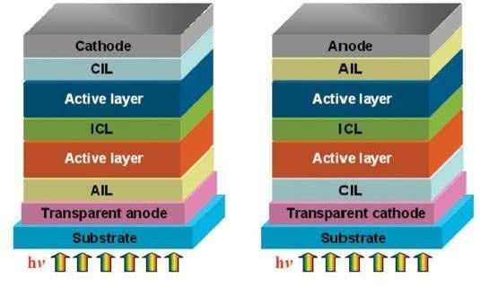
- (b)

Fig. 1: Basic structure of OSCs depicting different layers used in (a) conventional OSCs and (b) inverted OSCs.

3. Possible structure of Organic Solar Cell

3.1 Single layer
A single-layer OSCs, also known as a bulk heterojunction solar cell, is a kind of photovoltaic device that converts sunlight into electricity using organic materials. Unlike established silicon-based-solar-cells (SBCs), which typically consist of multiple layers, single-layer OSC consists of a single layer of an organic semiconductor material [1-3]. The key components of a single-layer OSCs are an active layer and electrodes. The active layer is made up of a blend of two organic materials: a donor material and an acceptor material [1-2]. The donor material, usually a polymer or small molecule, has ability to donate electrons when it absorbs light, while the acceptor material has a high electron affinity and can accept the electrons from the donor material. When sunlight strikes the active layer, photons of light excite the electrons in the donor material, causing them to be released and move towards the interface between the donor and acceptor materials. This creates separated electron-hole pairs, also known as excitons. The electrons then migrate through the donor and acceptor materials, generating an electric current. The electrodes are used to collect the generated current [1,2,7-9].
The advantage of single-layer OSCs lies in their simplicity and low-cost manufacturing potential. The use of organic materials allows for f flexible and lightweight solar cell designs, which can be suitable for a wide range of applications. However, single-layer OSCs generally have lower efficiency as compared to their multi-layer counterparts, which can limit their commercial viability [1,10].

3.2 Double/Multilayer layer
A double-layer OSCs consists of our two distinct layers of organic semiconductors with different electronic properties. The first layer is called the donor layer, which absorbs photons from sunlight and generates electron-hole pairs (excitons). This layer typically contains a polymer or small molecule material that has a high absorption coefficient for sunlight. Examples include polythiophenes, phthalocyanines, and fullerene derivatives. The second layer is known as the acceptor layer or the electron acceptor. It has a different electronic structure compared to the donor layer and is responsible for efficiently separating and transporting the generated charges. Fullerene derivatives, such as PCBM (phenyl-C61-butyric acid methyl ester), are commonly used as acceptor materials because of their excellent electron mobility and compatibility with donor materials [9-11].
An interface also plays an important role in the device's performance. It is essential to ensure efficient exciton dissociation at this interface to separate the electron and hole pairs. To enhance exciton dissociation, an interfacial layer called the exciton-blocking layer or charge-blocking layer is often introduced [1-2]. This layer prevents recombination of excitons and facilitates charge extraction. The separated charges then move through their respective pathways within the cell. Electrons migrate through the acceptor material, while holes migrate through the donor material. Both pathways lead to their respective electrodes, creating a current flow.
To collect the generated current, transparent conducting electrodes, such as ITO are typically used on both sides of the device. These electrodes allow light to pass through while enabling the extraction of the generated charges. In addition to the active layers and electrodes, a double-layer OSCs also includes other essential components. These include a hole transport layer (HTL) and an electron transport layer (ETL). The HTL assists in hole extraction and transport, while the ETL facilitates electron extraction and transport to the electrodes [10-12].

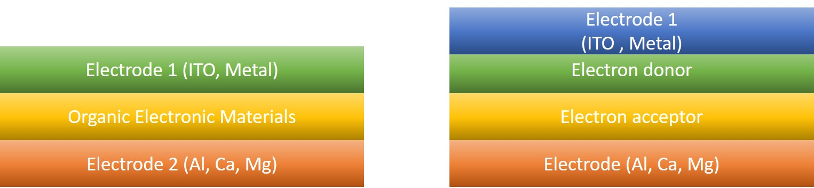

- (b)

Fig. 2: Possible structure of OSCs (a) Single Layer Solar Cell (b) Multilayer solar Cell.

3.3 Active layer and their uses
In OSCs, the active layer is a crucial component responsible for converting sunlight into electricity. It consists of a blend or heterojunction of organic materials with complementary electronic properties [2]. The active layer of OSCs plays a fundamental role in the absorption of photons, charge generation, and charge transport processes. Here's a detailed breakdown of the active layer and its uses in organic solar cells.

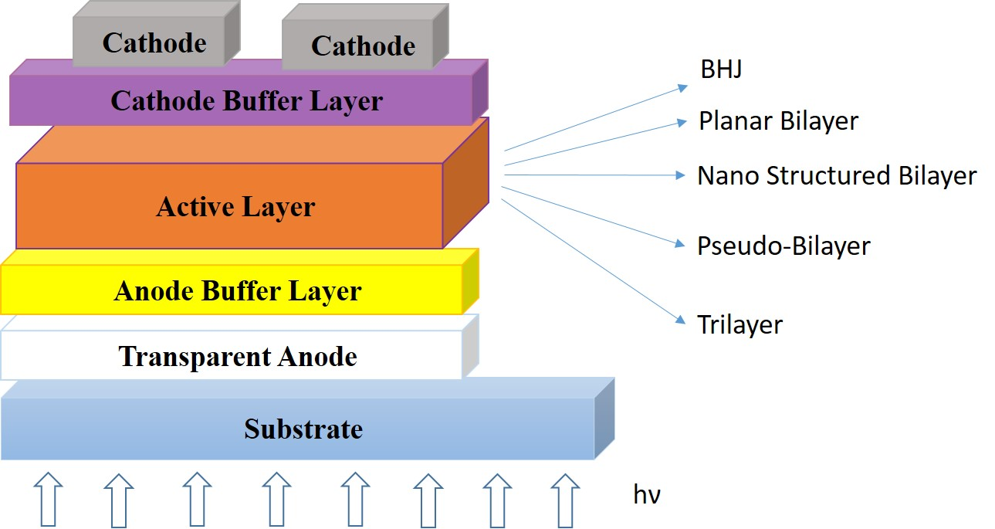

Fig. 3: Different bilayer used as an active layer in OSCs.

4. Material Composition

  - Donor Materials: These are generally conjugated polymers/small organic molecules that have a high tendency to donate electrons upon light absorption [2, 3, 6-9]. They are designed to have a broad absorption spectrum, allowing them to capture photons from a wide range of wavelengths.
  - Acceptor Materials: These materials have high electron affinity and are responsible for accepting electrons from the donor materials. Fullerenes, such as C60 or C70, and non- fullerene acceptors (NFAs) are commonly used in OSCs.

5. Basic Mechanism Involved in Organic Solar Cells
5.1 Light Absorption: - The active layer contains light-absorbing molecules that absorb photons from the incident sunlight. The donor materials, in particular, possess a conjugated structure that enables efficient light absorption over a wide range of energies. The absorption of photons creates excitons, which are bound electron-hole pairs. The excitons need to be dissociated into free charges to generate an electric current.

5.2 Exciton Dissociation: - The interface between donor and acceptor materials is critical for excitons- dissociation. The heterojunction between the two materials forms an energy gradient that promotes charge separation. Excitons migrate to the donor-acceptor interface, where they can separate due to the energy offset between the highest occupied molecular orbital (HOMO) of the donor and the lowest unoccupied molecular orbital (LUMO) of the acceptor. Efficient exciton dissociation is crucial to prevent recombination and maximize the generation of free charges.

5.3 Charge Transport:- Once separated, the free electrons and holes need to reach their respective electrodes to produce an electric current [2-12]. The donor and acceptor materials have different mobilities for charge transport. Generally, donor materials have higher hole mobility, while acceptor materials have higher electron mobility. Balanced electron and hole mobilities are desirable to facilitate efficient charge transport and minimize losses due to trapping or recombination.

6. Factor affecting to device efficiency
The factors which affect the device efficiencies are as follows [1-15]:
6.1 Thickness and Morphology: -T he thickness and morphology of an active layer are critical parameters that influence the device performance [1-2]. Optimizing an active layer thickness ensures a balance between light absorption and charge collection. If the layer is too thick, excessive photon absorption can lead to self-absorption or increased charge recombination. Conversely, if it is too thin, light absorption may be insufficient.
The morphology of an active layer which includes the donor-acceptor nano-scale phase separation, affects exciton diffusion and charge transport. Controlled morphology can enhance the exciton dissociation efficiency and reduce charge carrier recombination [1,2,3, 4-8].

6.2 Material Selection: The choice of materials plays- a-vital role to determine the efficiency of OSCs. The properties of the materials, such as their bandgap, electron mobility and light absorption capabilities, impact the efficiency of converting sunlight into electricity [1-15].

6.2.1 Bandgap: The bandgap of the semiconductor materials used in OSCs determines the portion of the solar spectrum that can be absorbed. The bandgap should be matched to the solar spectrum to maximize light absorption and minimize energy loss.

6.2.2 Light Absorption: Efficient light absorption is necessary for high-performance OSCs. The materials used should have a high absorption coefficient and cover a broad range of the solar spectrum to capture as much sunlight as possible.
6.2.3 Charge Carrier Mobility: The mobility of charge carriers (electrons and holes) within the semiconductor material affects how effectively they can be collected and transported to the electrodes. Higher mobility reduces recombination losses and improves overall cell efficiency.

6.2.4 Interface Quality: The quality of the interfaces between different layers within the OSCs, such as the interface between an active layer and electrodes, affects charge extraction and reduces losses due to recombination. Optimizing interface properties, such as surface passivation, can enhance the efficiency.

6.2.5 Energy Loss Mechanisms: Various energy loss mechanisms, such as recombination, transmission losses, and thermalization of carriers, can reduce the efficiency of solar cells. Minimizing these losses through material design and device engineering is essential to improve efficiency.

6.2.6 Light Trapping: Light trapping techniques like texturing the surface or the use of optical coatings, can enhance the absorption of light within the active layer, thereby increasing the overall efficiency of the OSCs.

6.2.7 Temperature Dependence: The performance of inorganic solar cells can be influenced by temperature. Higher temperatures can lead to increased carrier recombination rates, reducing the overall efficiency. Thermal management techniques are employed to mitigate this effect.

6.2.8 Device Architecture: The design and configuration of the solar cell structure impact its efficiency. Different architectures, such as single- junction, multi-junction, tandem cells, and nanostructured devices, offer unique advantages and challenges that can influence overall efficiency.

6.2.9 Manufacturing Processes: The fabrication processes used to manufacture solar cells, including deposition techniques, annealing conditions, and quality control, can affect the efficiency. Consistent and precise manufacturing processes are necessary for high-performance devices. Optimizing these factors requires a deep understanding of the underlying physics, materials science, and device engineering. Continuous research and development efforts are focused on addressing these factors to enhance the OSCs performance.

7. Recent research on organic solar cell
Recent research on OSCs has focused not only improving their efficiency but also their stability and scalability. Scientists have been exploring newer materials and thus the device architectures also to enhance the performance of OSCs [1, 11-13]. One area of research involves not only to develop novel organic materials having improved light absorption properties but also charge transport capabilities. This includes designing molecules with optimized energy levels and chemical structures to achieve higher PCEs. Researchers are also working on improving the stability of OSCs to ensure their long-term performance [14]. This involves developing materials that are less prone to degradation from environmental factors like moisture, oxygen, and light exposure [1]. Furthermore, efforts are being made to enhance the scalability of OSCs. Scientists are exploring large-area manufacturing techniques to enable cost-effective OSCs devices [1, 15]. Additionally, advancements in device architectures like tandem or multi-junction structures, are being explored to further enhance the efficiency of OSCs.
Overall, recent research on OSCs aims to overcome challenges associated with their efficiency, stability, and scalability, with a focus on developing newer materials having not only improving device architectures but also advancing manufacturing techniques.
8. Advantages of Organic Solar Cells: The OSCs, also called organic photovoltaic's (OPVs), have emerged as a promising renewable energy technology. In summary, the conclusion regarding OSCs can be stated as follows:

- Efficiency: OSCs have made significant progress in terms of power conversion efficiency (PCE). Over the years, researchers have achieved PCE values exceeding more than 18%, closing the gap with established SBSCs. This advancement demonstrates the potential of OSCs as a viable alternative for clean energy generation [1-8].

- Flexibility: OSCs, the key advantages, is their flexibility. These can be fabricated on flexible substrates, enabling applications in various forms like curved surfaces, light-weight devices, and integrated into building materials. This flexibility opens up opportunities for new applications and designs, expanding the scope of solar energy utilization.
- Cost-Effectiveness: OSCs provides potentially cost-effective. These can be constructed solution-based processes like printing or coating techniques, resulting low production costs. Additionally, the use of abundant and readily available organic materials further contributes to their cost competitiveness [2-5].
- Environmental Sustainability: OSCs have a lesser environmental impact as compared to the established solar technologies [1]. The production of organic photovoltaics involves fewer energy-intensive processes and less hazardous waste generation. The use of organic materials also offers the potential for recyclability and end-of-life disposal, aligning with sustainable development objectives.
- Stability and Lifespan: Although, the stability and lifespan of OSCs have improved over time, they are still facing challenges in this regard. Organic materials can be susceptible to degradation over time. Environmental factors like moisture and U-V radiation may be responsible for this. More comprehensive research needs to be focused to enhance the stability of OSCs to ensure longer operational lifespans [1].

- Market Adoption and Integration
The OSCs are gradually gaining attention and market adoption. Their unique characteristics, including flexibility, light weight nature etc., make them suitable for various applications. Ongoing research and development efforts are aimed to further improve the performance, durability, and scalability of OSCs for broader deployment [1-15].

Conclusion
We have summarized that the OSCs provide promising prospects for renewable-energy generation. Continued advancements in efficiency, flexibility, cost-effectiveness, and environmental sustainability will contribute to their wider adoption and integration into various applications, thereby fostering a more sustainable and clean energy future.

Acknowledgement
The author would like to acknowledge department of higher education, Uttar Pradesh for providing financial assistance (F.No. :89/2022/1585/70-4-2022/001-4-32-2022).

References

- Ahmed Salih Mahdi, Lina M. Shaker, Ahmed Alamiery. Recent advances in organic solar cells: materials, design, and performance. Journal of Optics 2023. https://doi.org/10.1007/s12596-023-01262-2.
- Ebru K. Solak, E. Irmak. Advances in organic photovoltaic cells: a comprehensive review of materials, technologies, and performance. RSC Adv., 2023,13, 12244-12269.
- Francisca Werlinger, Camilo Segura, Javier Martínez, Igor Osorio-Roman et al. Current Progress of Efficient Active Layers for Organic, Chalcogenide and Perovskite Based Solar cells: A Perspective. Energies 2023, 16(16), 5868; https://doi.org/10.3390/en16165868.
- S. Li , W. Liu , C. Z. Li , M. Shi, H. Chen . Efficient Organic Solar Cells with Non-Fullerene Acceptors, Small 2017, 13 , 1701120.
- G. Zhang , J. Zhao , P. C. Y. Chow , K. Jiang , J. Zhang , Z. Zhu , J. Zhang , F. Huang, H. Yan. Nonfullerene Acceptor Molecules for Bulk Heterojunction Organic Solar Cells. Chem. Rev. 2018, 118 , 3447 —3507.
- Troshin, P.A., Lyubovskaya, R.N., Razumov, V.F. Organic solar cells: Structure, materials, critical characteristics, and outlook. Nanotechnol Russia 2008, 3, 242–271. https://doi.org/10.1134/S1995078008050029
- Hou W, Xiao Y, Han G, Lin JY. The Applications of Polymers in Solar Cells: A Review. Polymers (Basel) 2019, 15; 11(1), 143. doi: 10.3390/polym11010143. PMID: 30960127; PMCID: PMC6401826.
- Umeyama T., Imahori H. Design and control of organic semiconductors and their nanostructures for polymer-fullerene-based photovoltaic devices. J. Mater. Chem. A. 2014, 2, 11545–11560. doi: 10.1039/C3TA15387H.
- Zhang, M., Zhu, L., Zhou, G. et al. Single-layered organic photovoltaics with double cascading charge transport pathways: 18% efficiencies. Nat Commun 2021, 12, 309. https://doi.org/10.1038/s41467-020-20580-8
- Manisha Bajpai, C.K. Pandey, Ritu Srivastava, Ravindra Dhar. Electrical transport properties of PFO: MEH-PPV polymer blends. Materials Letters 2022, 331, 1334400.
- Yu, R., Wei, X., Wu, G., Tan, Z.. Aggregate 2022, 3, e107. https://doi.org/10.1002/agt2.107
- Eduardo Henrique dos Santos Rosa, Edemir Luiz Kowalski, Luiz Felipe Ribeiro Barrozo Toledo. Simulation of organic solar cells’s power conversion efficiency. Solar Energy 2021, 221, 483-487.
- ACS Energy Lett. 2019, 4, 10, 2537–2539. https://doi.org/10.1021/acsenergylett.9b02071
- Liu, Y., Liu, B., Ma, CQ. et al. Recent progress in organic solar cells (Part I material science). Sci. China Chem. 2022, 65, 224–268. https://doi.org/10.1007/s11426-021-1180-6
- Li, Y.; Huang, W.; Zhao, D.; Wang, L.; Jiao, Z.; Huang, Q.; Wang, P.; Sun, M.; Yuan, G. Recent Progress in Organic Solar Cells: A Review on Materials from Acceptor to Donor. Molecules 2022, 27, 1800. https://doi.org/10.3390/molecules27061800

