An Empirical Evaluation of Technologies
And Applications in Robotics Industry 4.0

Dr.P.Thangavel Mr.N.Senthil kumar
Assistant Professor Assistant Professor
Department of Computer Science Department of Computer Science
SRM Trichy Arts and Science College SRM Trichy Arts and Science College
velmcaccet@gmail.com nsknct@gmail.com

Abstract
The new industrial model industry 4.0 characterizes the fourth industrial revolution. As a result of new technologies like Industry 4.0 there have been drastic changes in the industrial environment in the recent years. Robotics is a field of science that deals with creating machines behaving like humans called humanoids. The proposed approach explains about the researches and robotics applications that can implement the Industry 4.0 in enterprises.
Introduction
The world has now entered into the fourth industrial revolution, though it is in its early stage digital technologies that can create a revolution are being developed continuously. In recent years, the global industrial environment has improved a lot as a result of constant developments and innovations in manufacturing process.
The Industry 4.0 is a blend of information technology (IT) and operational technology (OT) in production. Industry 4.0 is nothing but the result of the evolution in technology of the fourth Industrial revolution. It is a scientific approach with various advancements and also known as technology 4.0. Robotics, Automation, Collaborative robots (cobots), 3D printing and Cloud computing are to be implemented by the smart factories on a large scale in the future.
The robots are programmed to act like humans in particular situations but can they also think like human beings. Now artificial intelligence steps in to permit robots to act intelligently in reliable conditions. These kinds of robot are used to resolve problems in a specified area and also to learn in controlled environments. One such example for this type of robot is “kismet” a social interaction robot developed by M.I.T’s Artificial Intelligence lab.
History
The development of robots over time has paved the road and provided inspiration for making fantasies a reality. Knowledge, experimentation, and enterprise neural innovation are the three key elements that have had the biggest impact on the growth of industry.
The first aspect, knowledge, relates to the depth of comprehension of academics and innovators from many years ago who searched for opportunities to make important new discoveries at the time and were able to improve their conceptual understanding.
The second aspect, experimentation, deals with the process of making the expertise of researchers and collaborators explicit in order to demonstrate a possibility.
The third aspect, entrepreneurial innovation, refers to the willingness of current employers to support and invest in novel findings, work models, and methods of supplying and extending their business and sales in ways they had never before desired.
The robots in science fiction are often human-shaped, androids or humanoids with ISO traits. According to ISO, a robot is a three- or more-axed, multipurpose manipulator that is autonomously controlled and reprogrammable. According to the Robot Institute of America, a robot is a multipurpose manipulator that may be taught to execute a variety of tasks by manipulating objects, tools, or specialized devices in accordance with preprogrammed patterns.
Perspective on Industry 4.0
Industry 4.0 is a recent industrial revolution that stresses the significance of cutting-edge technological advancements and makes it possible for quick, customized production. With forthcoming Smart Factories, the goal of encouraging production and automation inevitably boosts productivity. The integration of the manufacturing process and interaction can be used to identify the fourth industrial revolution.
Industry 4.0 presents more than just a technological problem because it will fundamentally alter how businesses are organized. The planning process in value chains across organisations is carried out by autonomous and self-organized production resources at a new degree of socio-technical interaction.
Smart Products
A certain production process's products and tolerated operational parameter are both known. For the sake of production optimization, certain products can be grouped together.
Smart
Production
Smart plants
Smart
Logistics
Mixed Materials
Raw Materials
Products

Individualized production
It is made possible by flexible configuration, which enables businesses to take particular client demand requirements into account during the design, planning, production, and recycling phases.
Autonomous control
Employees with autonomy can configure intelligent production resources based on targets that are responsive to the current situation.
Controls of product design
Product-related data becomes a key component in controlling its product life cycle.
Design of Industry 4.0
The industry 4.0 consists of six stages of design criteria that includes virtualization, decentralization, modularity, interoperability, real time capability and service orientation. These rules are referred to as "Design Principles" since they aid in the creation of typical Industry 4.0 systems.
i) Virtualization
The fundamental idea behind virtualization is that a virtual twin can be formed by machine-to-machine (M2M) monitoring and communication. Both simulation models and virtual plant models are connected to the sensor data. As a result, it makes a virtual representation of the real world.
ii) Decentralization
This design concept deals with the potential of local industries, specific tasks, as well as automated processes, to make independent judgments. The major objective of this idea is to enable local operators to react to changes and readjust rather than relying on central computers or sending a decision through a hierarchy. It offers additional flexibility and makes applying knowledge simpler.
iii) Modularity
The major goal of modularity is to make the process of adding or deleting modules considerably simpler and to design modular systems that are able to rapidly adjust to changing requirements by altering or extending specific production modules.
iv) Interoperability
In the industry 4.0 production environment, interoperability refers to being able to automatically exchange information, start activities, and control one another independently. By integrating software and programs, embedded manufacturing systems are vertically linked with internal business processes of industries.
v) Real time capability
The primary objective of real-time capability systems is on the processes of manufacturing specifically intelligent machines with software that will automatically adapt to the process and decision-making by CPS to satisfy production needs. The quality of the finished product is also tracked in order to take actions at any point that are necessary.
vi) Service Orientation
The availability of human business services and CPS over the internet, which other interested parties might utilize to facilitate the establishment of product service systems, additionally referred to as product services, which are employed to determine service orientation.
Robotics in Industry
Following the historic encounter between Engineer Berger and Devol, the application of robotics in actual industrial settings began to grow in research labs. The first commercial produced robot, which was operated by limit switches and cams, was created by Plant Corporation in 1954.
The machines have left the research facilities and volunteered in new fields. They are anticipated to keep moving toward the automobile industry and other industries. In the manufacturing industry, robots are already assisting in the production of higher-quality goods. Additionally, it speeds up turnaround.
There are now close to one million robots in existence. 60% of robots were primarily utilized during production two decades ago, especially in the auto industry, where they were used in assembly lines to carry out a range of monotonous activities.
Currently, only 50% of them are employed in automobile manufacturing, with the remaining 50% dispersed throughout other factories including labs, warehouses, energy plants, hospitals, and other types of businesses. Robots from the fourth industrial revolution are also used to assemble and handle items that include hazardous compounds which involves spray painting, cutting, and polishing.
Aspects of robot:
Brawn - It deals with the strength relating to physical-to-physical payload that can be moved by a robot.
Bone - This component relates a robot's physical make-up to the type of task it undertakes. Additionally, this establishes the robot's size and weight in relation to its physical payload.
Brain - This is nothing but intelligence of robot. It describes the thinking capacity and independent actions of robot.

Modern Robotics Advancements
These robots are capable of doing simple tasks and jobs well. The following are a few of the newest robot advancements, and each of them requires a specialist in mechatronics in order to maintain and repair them.
i) Google worker robots
Google is in the process of producing worker robots with personalities of industry 4.0 technology. It also won a patent for the ambitions project. These robots have the ability to store and display multiple personalities during human interactions.
ii) Multitasking bots
A multitasking bot created by the momentum machines can make a government-approved burger in as low as 10 seconds. If everything goes as planned, the robot might someday be utilized in quick service restaurants.
iii) UR3 arm
It is an automated system made by universal robots that is capable of creating new parts on the spot as needed. The adorable and agile robot is capable of carrying out various jobs like painting, soldering, and picking up objects.
iv) Saul Robot
The Saul robot is made to aid in the fight against fatal illnesses like the Ebola virus. The Air Force created the device to get rid of the virus in rooms until quarantine measures are carried out by a medical professional. These Xenex-developed robots, called Sail, eliminate all traces of EBOLA using strong bursts of extremely hot ultraviolet radiation.
v) Asus Zenbo
This is a low-cost robot that can move around on its own and can understand spoken orders. The tool aids users in remembering daily activities including exercise, medication regimens and doctor's visits.
vi) Paro
Paro is a therapy robot that resembles a newborn harp seal. The goal of the fairy gadget is to reduce stress and encourage communication between patients and carers. It has five separate sensors, including ones for light, touch, hearing, and temperature.
vii) Pepper
A talking humanoid robot named Pepper changes its demeanor in response to the emotions of those around it. It can effectively comprehend emotional situations because to this feature. To control movement, the designers incorporated up to 20 engines into the arms, back, and neck.

Comparison of Industry versions

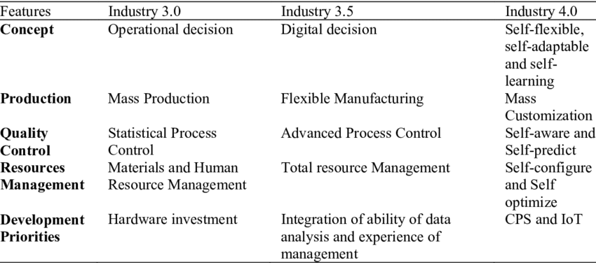

Industry Processes
Utilizing logic processors and information technologies, processes are automated in Industry 3.0. Even while these procedures can function essentially without human intervention, there remains a human element at work. With the availability and utilization of huge amounts of data on the manufacturing floor, Industry 4.0 opens up new opportunities.
Let's use a CNC machine as an example of the traditional method Industry 3.0. Despite being entirely automated, it still requires input from a human supervisor. Process automation relies on human input rather than data. The same CNC machine, however, would be able to use data to streamline production processes in addition to following a set of programming parameters when the new ideas and practices of Industry 4.0 are implemented.
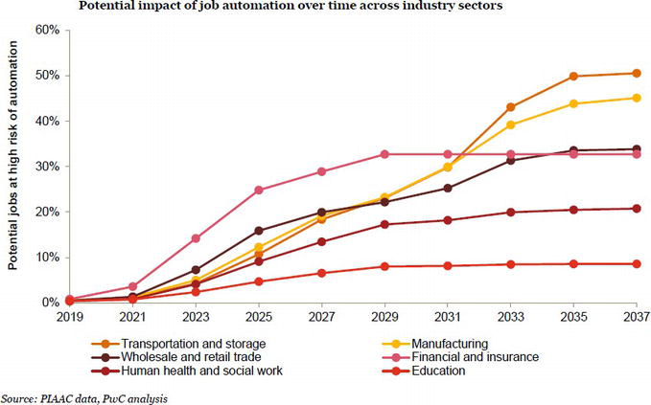
Conclusion
Industry 4.0 denotes a new stage in the structure and control of the industrial value chain and is utilized to be compatible with the fourth industrial revolution. Robotics is a cutting-edge scientific technique that is used to advance numerous businesses. This technology makes it possible for the floor staff to properly carry out their tasks while minimizing or completely eliminating all physical discomfort. The two most crucial factors in supporting Industry 4.0 are network and connectivity. Technology advancements in a wide range of areas, including cloud, time-sensitive networks, low-power networks, 5G technology, and zero-touch networks, are making it possible for factories to implement IoT to transform facilities for industry.

References
- http://www.oemupdate.com/technology/top-robotic-applications-in-automotive-industry/
- https://www.popsci.com/hitachi-hires-artificial-intelligence-bosses-for-their-warehouses
- https://www.rfidjournal.com/articles/view?12083
- https://www.sciencedirect.com/science/article/abs/pii/S0160791X20300932
- https://qz.com/672708/siemens-is-building-a-swarm-of-robot-spiders-to-3d-print-objects-together/
- https://wiprodigital.com/2018/11/13/the-rise-of-industrial-autonomous-vehicles/
- https://newatlas.com/boeing-echo-voyager-trials/50010/
- https://wiprodigital.com/2018/11/13/the-rise-of-industrial-autonomous-vehicles/
- https://compliancenavigator.bsigroup.com/en/medicaldeviceblog/robotics-in-healthcare/
- https://www.industrialpackaging.com/blog/why-robotic-packaging-automation-is-the-future
- https://www.nbcnews.cshiom/mach/science/robots-are-replacing-humans-world-s-mines-here-s-why-ncna83163
- https://www.investopedia.com/articles/markets/011216/4-industries-robots-are-revolutionizing.asp
- https://edition.cnn.com/2018/12/07/business/walmart-robot-janitors-dotcom-store/index.html
- Abele, E.; Reinhart, G. (2011): Zukunft der Produktion. Herausforderungen, Forschungsfelder, Chancen. München: Hanser, Carl
- Ammon, U. (2009): Delphi-Befragung In: Kühl, S. (Ed.): HandbuchMethoden der Organisationsforschung. Quantitative und qualitative Methoden. Wiesbaden: VS, Verlag fürSozialwissenschaften, pp. 458–476
- Atzori, L.; Iera, A.; Morabito, G. (2014): From "smart objects" to "social objects": The next evolutionary step of the internet of things. In: IEEE Communications Magazine, 1 (2014), pp. 97–105
- Kagermann, H.; Wahlster, W.; Helbig, J. (Eds.) Recommendations for Implementing the Strategic Initiative Industrie 4.0: Final Report of
- the Industrie 4.0Working Group. Industrie 4.0: Mit dem Internet der Dinge auf demWegzur 4. Industriellen Revolution; VDI-Nachrichten:Frankfurt, Germany, 2011.
- Securing the Future of German Manufacturing Industry. Final Report of the Industry 4.0 Working Group Forschungsunion. 2013.
- Available online: https://www.din.de/blob/76902/e8cac883f42bf28536e7e8165993f1fd/recommendations-for-implementingindustry-4-0-data.pdf (accessed on 2 February 2020).
- 3. Kagermann, H.; Wahlster, W.; Helbig, J. Final Report of the Industrie 4.0 Working Group; Acatech-National Academy of Science
- and Engineering: München, Germany, 2013. Available online: https://en.acatech.de/publication/recommendationsfor-
- implementing-the-strategic-initiative-industrie-4-0-final-report-of-the-industrie-4-0-working-group/ (accessed on10 January 2020).
- 4. Kagermann, H. Change through Digitization—Value Creation in the Age of Industry 4.0. In Management of Permanent Change;
- Springer: Berlin/Heidelberg, Germany, 2015.

