Challenges and opportunity for higher crop productivity in red-laterite belt of west bengal

Dr. Dhiman Mukherjee
Associate Professor (Agronomy)
Regional Research Station (Red & Laterite Zone)
Bidhan Chandra Krishi Viswavidyalaya
Jhargram -721507, West Bengal, India

- mail : dhiman_mukherjee@yahoo.co.in
Mob : 9474083413

Abstract

Around the world, farmers are constantly seeking solutions for their higher crop productivity with proper insect pest and disease management in response; researchers are striving to come up with promising technologies for crop production in holistic way. Among various soil in India, red and lateritic soils become very problematic and this confined one third part of the soil. This soils cover large area of potentially arable and grazable lands and are abundant in the semi-arid to humid tropical climates. Due to aberrant weather, inhospitable environmental factors and soil-related constraints, the crop production in these soils has remained low and static. These soils suffer from deficiencies of N, P, K and to some extent Ca, S, Zn, B and Mo. Management of this soils should be directed towards enhanced crop productivity either through addition of amendments to correct the soil abnormalities or by manipulating the agronomic practices depending upon the climatic and edaphic conditions. Red-laterite belt of west bengal can be manage through more reliance on improve nutrient, water and land use system etc. These can directly overcome the challenges for higher crop productivity with improved livelihood system in long term sustainable basis.

Keywords: Argo-technology, crop, nutrient management, red-laterite, sustainable, water conservation.

- INTRODUCTION
Agriculture is the leading source of livelihood for almost sixty percent of the Indian population. However, the productivity of crops is much lower than many countries and needs enhancement to produce ∼400 million tons of food grains for meeting food demands of a population of 1.7 billion by 2050. Divers climatic modality in India favour the cultivation of different crops in different part of the country (Mukherjee, 2021). Among various state in India, west bengal play vital role in food grain basket of the country(). West Bengal, an eastern Indian state, has unique geographical features. It is located between 21°31′–27°41′N lat. and 85°91′– 89°93′E long. The snow-capped peaks and the Himalaya in the north greatly influence the weather conditions of the North Bengal districts. The Tropic of Cancer runs across the middle of the state. The extreme south touches the Bay of Bengal (BoB). Profuse clouds with moisture-laden winds from the BoB bring early showers in the state and heavy rainfall during monsoon. The southern districts lie mostly within the equatorial region. The Sunderbans (‘sundar ban’ in Bengali, meaning beautiful forest) is a mangrove forest area in the delta of the southern region. The state shares its boundary with Sikkim and Bhutan in the north, Odisha in the south, Jharkhand and Bihar in the west and Assam in the northeast. There is an extensive network of rivers, tanks, reservoirs, canals and other water bodies. These state had different type of soil topographical feature. Among various class of soil red-laterite zone has sever problem of various nutrient and water management practice, mainly due to distinct soil characteristics. Red and lateritic soils occurring in eight agro-ecological regions of India viz. AER 7, AER 8, AER 12, AER 15 and AER 17-20 as established by the National Bureau of Soil Survey and Land Use Planning (Sehgal et al. 1998) and distributed over the states of Kerala, Tamil Nadu, Karnataka, Andhra Pradesh, Telengana, Madhya Pradesh, Chattisgarh, Maharashtra, Goa, Orissa, West Bengal, North Eastern States and Union Territories of Andaman and Nicobar and Pondicherry (Fig. 1).

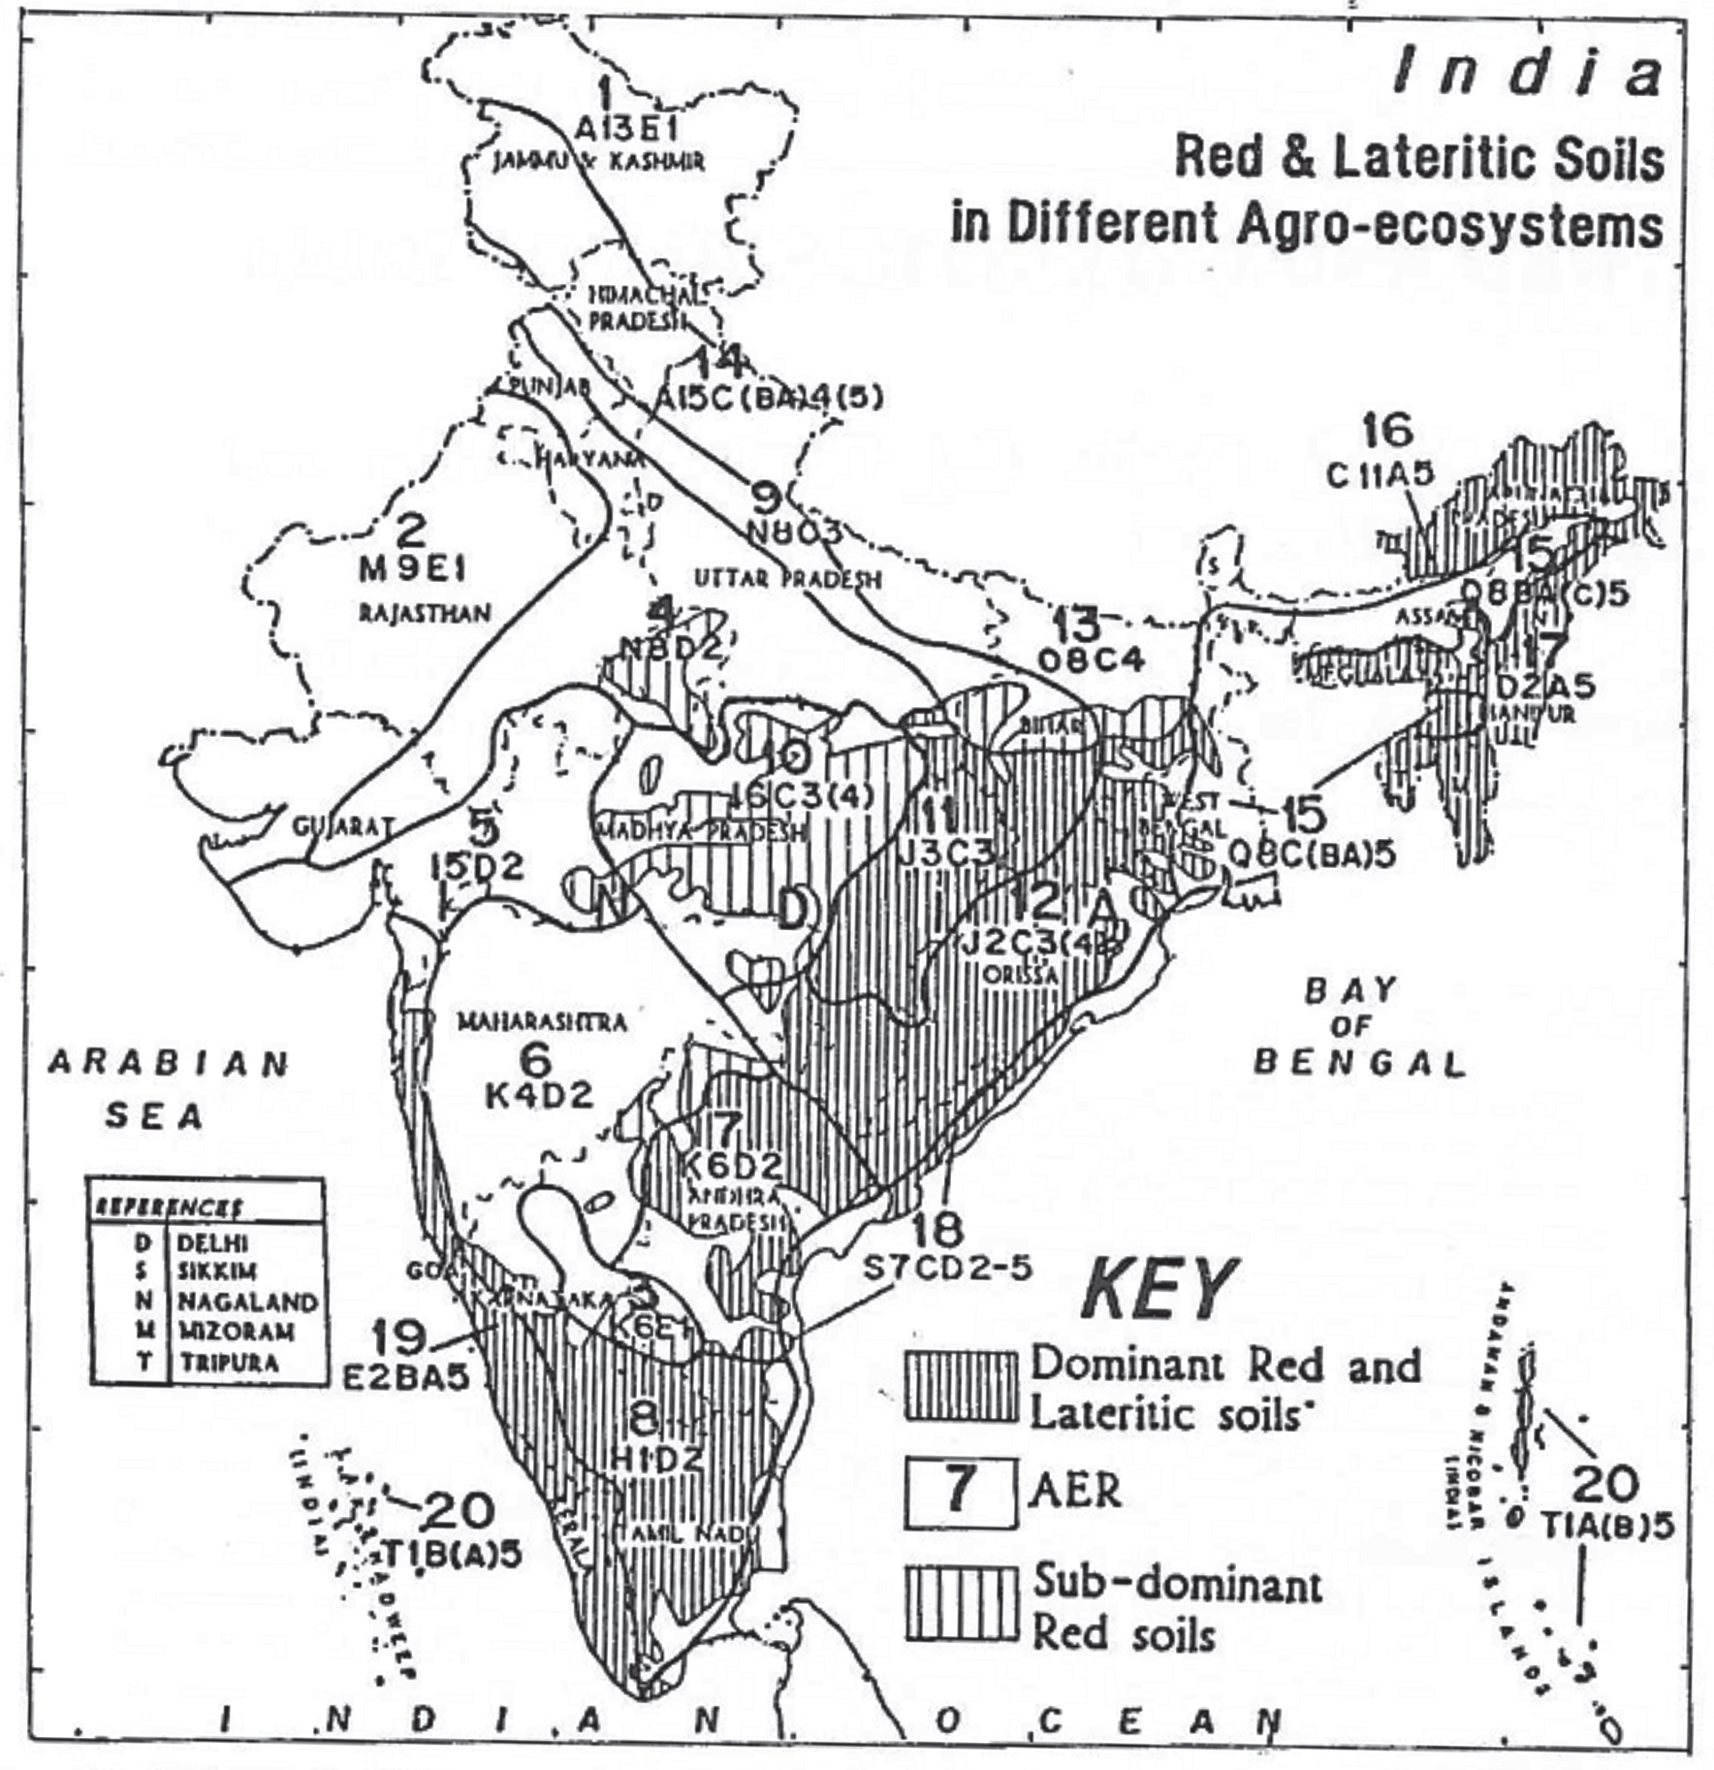
Fig. 1. Red and lateritic soils in different agro-ecosystems of India
Source: Sehgal et al. (1998)

Among the six agro-climatic zones of west bengal, the red and lateritic zone constitute about 10-13.4% of the total cropped area. In the western belt of the state, there exists a vast tract relatively arid where the lands are lateritic and undulating. Such lands represent about one third of the cultivated area in the districts of Purulia, Bankura, Jhargram, parts of Paschim Medinipur, Bardhaman and Birbhum (Chatterjee et al., 2013). The climate of this zone is semi-arid that is markedly differentiable with its hot summer, cool dry winter beside annual average rainfall of 1100-1400mm (Mukherjee, 2023). Like climate, soil of this zone also having some unique identities as coarse in texture, highly drained with honeycomb type of ferruginous concentration at a depth of 15 to 30 cm; acidic in nature (pH 5.5 to 6.2); erosion prone; poor in organic matter; deficient in N and P; sporadically deficient of micronutrients; low moisture holding capacity (Murmur et al., 2016). Due to such problematic soil and climatic condition, most of the agricultural crops failed to grow here and thus most of the lands remain fallow throughout the year. People of this zone have to depend mostly on rain-fed agriculture to produce rice, millets, and vegetables in some pockets. All these backdrops of red lateritic zone result in poor livelihood as evidenced by great number of poor malnourished population, huge number of marginal farmers, increased cases of migrant labour etc. We went through different corner of district Jhargram and it’s adjoining belt and observed, farmer’s here severely face tough challenge not only from soil and environment but also by mismanagement of different agronomic option which directly influence crop productivity of this region (Fig. 2).

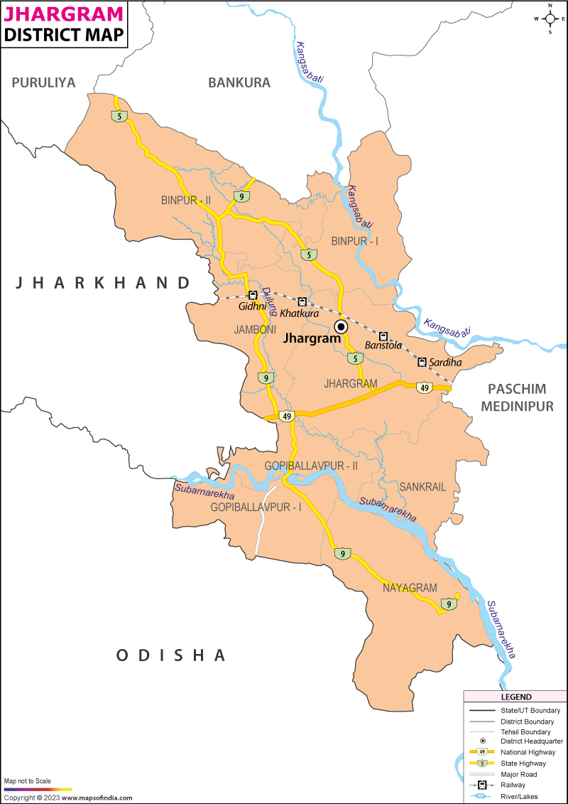

Fig. 2: Red laterite belt of west bengal (Jhargram and it’s adjoining district),
(Source: Internet)

- Challenges and opportunity

Major issues are soil degradation, soil acidity, poor soil organic matter, secondary and micronutrient deficiencies, meagre utilization of ground water resources and soil and water pollution. The soils are highly variable in nature and are subject to erosion, droughtness, crusting, etc. Constraints can be pointed as

- Low in water and nutrient holding capacity because of texture and dominant presence of illite and kaolinite clay minerals.
- High soil-erosion potential, and excessive drainage and surface run-off.
- Poor soil fertility with regards to humus, N, P, Ca, Zn and S.
- Annual rainfall ranges from 1100 to 1300 mm, about 80% of which occurs during June to September, i.e. in the monsoon period. Even within this short period, rainfall may be unevenly distributed. The monsoon may commence early or late and may also retreat early. There is 20–30% probability of dry spells or rainfall breaks occurring within the season.
- Partial or even total crop failure happens in rainfed conditions; drying up of water is a common phenomenon during dry and hot weather.

Productivity of the soil can be considerably improved by adopting soil conservation measures, afforestation, ‘jhora’ control and scientific crop management practices. Along with development of agriculture and horticulture, due attention should be paid to the development of floriculture, plantation crops and animal husbandry. Short-duration high yielding variety (HYV) of rice in medium and medium to high lands, and crop diversification in uplands are suggested from rice to arhar, groundnut, maize, sorghum, soybean and finger millet. Short-duration pulses and oilseeds are suitable for growing with residual moisture, and wheat and vegetables are preferred with irrigation in winter.
Red soils are formed under well drained condition. Eluviation and illuviation of clay, Fe, Al and bases are the main soil forming processes. The main features of red soils are lighter texture, friable structure, absence of lime concretions and free calcium carbonate and low contents of soluble salts. The soils are slightly acidic to slightly alkaline, medium in cation exchange capacity. The dominant clay mineral is kaolinite with admixture of illite. The soils are well drained with moderate permeability. Further, laterite is a geological term means literally a rock. The lateritic soils are those in which laterization is the dominant soil forming process, i.e. eluviation of silica and enrichment with oxides of Fe and Al. Under high rainfall (more than 100 cm) conditions, silica is released and leached downwards and the upper horizons of the soils become rich in oxides of Fe and Al. Red and lateritic soils suffers varying degradation problems. They are prone to severe water erosion and nutrient losses due to excessive rainfall and leaching. Poor water holding capacity resulting from the coarse texture that limits post-rainy season cropping, without irrigation. This kind of soil need proper care with different extension strategy. In addition to this, proper lab to land linkage with local specific problem based training programme become very effective (Mukherjee, 2018). Experimental evidence, however, shows that these soils have high potential to produce food with appropriate soil-based management practices. However, to ensure success, soil scientist, agroclimatologists, agronomists and planners must work together to identify the elements of positive interaction between the environment and the plant.

- MANAGEMENT OPTION FOR HIGHER CROP PRODUCTIVITY

For sustainable agricultural production, it is necessary to focus attention on soil and climate resource base, current status of soil degradation and the soil-based agro-technology for optimizing land use. Management of the red-laterite belt, should be directed towards enhanced crop productivity either through addition of amendments to correct the soil abnormalities or by manipulating the agronomic practices depending upon the climatic and edaphic conditions. In Jhargram and it’s nearby distincter face severe problem of intensive leaching, which leads to drastic nutrient loss and imbalances in terms of N, K, P, Zn and other bases. The release of free Fe- and Al-oxides causes toxicity of these elements. Owing the presence of high amounts of hydrated oxides of Fe and AI and acidification, these soils cause P fixation resulting in deficiency of P. Most of red and lateritic soils are acidic in nature and cultivation of crop become very challenging in term of appropriate nutrient and site specific water management. Certain necessary steps should be followed to manage soil acidity are liming, use of acid-tolerant crops/ varieties, suitable integrated nutrients and water management panorama. Here, I can discuss four major aspect, which are major hurdle for higher crop productivity in red-laterite zone of west bengal are :

- Nutrient management

Appropriate and suitable amount of nutrient application to crop, based on soil test analysis become very challenging because of poor extension and research facility in this area (Mukherjee, 2019). Soil nutrient management mainly confined the application of commercial fertilizers, manure, amendments, and organic by-products to agricultural landscapes as a source of plant nutrients. Nutrient application through 4Rs (Right rate, Right timing, Right source, and Right placement) become very difficult, as because of variation of soil property and poor availability of local resources for proper agriculture use. Red and lateritic soils suffer from deficiencies of N, P, K and to some extent Ca, S, Zn, B and Mo. About 20 elemental nutrients are essential for plant growth. Some of these nutrients are supplied naturally by the air, water, and soil. Fertilizers and manures are used to supplement the natural supplies for optimum crop growth. When nutrients are used correctly after knowing proper time and dose of application, they are very beneficial, but when they are used in the wrong place at the wrong time they become pollutants. This become quite often, we can see in Jhargrame region, because of poor extension and scientific measures. Both groundwater and surface water are very vulnerable to pollution. Water is one of our most valuable resources, and protecting it is an important concern from different kind of pollutant including irrational use of fertilizer and plant protection chemicals.

A whole range of crops responds to N application in red and lateritic soils. Kundu and Pillai (1992) summarized that application of FYM along with N increased the yield and total uptake of N, P and K in rice-rice cropping system in red loam of Hyderabad and lateritic soil of Bhubaneswar. Appropriate utilization of available resources become very challenging (Mukherjee, 2012). Studies revealed that on highly permeable laterites N efficiency can be increased depending on N sources, time and method of their application. Use of sulphur-coated urea, karanj cake coated urea and urea supergranules enhancing the grain yield of rice (Mishra et al., 1994). Application of prilled urea along with neemcakecoated and lac-coated urea (LCU) in red and lateritic soils also become effective for higher utilization of applied nitrogen fertilizer to crop.
The low available P in red-laterite zone of Jhargram and it’s adjoining region are primarily due to the fixation of added P in soils. The P use efficiency of added P fertilizers is very low due to these reasons results low crop productivity levels (<2-3 t/ha) of crops, such as rice, wheat, maize etc. as compared to the desired level of 5 t/ha. This calls for needed changes in the nutrient use policy to make it more rational and scientific. Free Fe- and Al-oxides have been identified as the principal fixers of added P in lateritic soils. Reemphasizing the need of lime and P application in crops grown in acidic red and lateritic soils can bring about desirable changes in the crop production scenario in the region (Sarkar 2013). Phosphorus fixing capacity of laterite and red soils from Tripura, West Bengal, Jharkhand, Orissa and Karnataka ranged between 33 and 63% ( Ghosh and Sarkar 1997). A variety of crops respond to applied P on red and lateritic soils (Ghosh and Sarkar 1997; Ghosh et al. 2003; Pattanayak and Rao 2014). Goswami (1975) reported that 1 kg of P₂O₅ fetched 14.4 to 30.8 kg grain of rice on red soils and 11.5 to 17.0 kg grain on red and yellow soils. Relative response of N, P and K in maize and wheat crops in red soils of Ranchi (Jharkhand) over the past 50 years of Permanent Manurial Trial revealed that response of P to crops is higher than N and K; response of P is more in rabi crops than kharif crops over the years; and extent of response of P application in maize was 15 kg grain /kg P while in case of wheat it was 32 kg grain / kg P (Sarkar 2013). Results suggest the need for a focussed attention on the P fertilizer use for mitigating its deficiency in red and lateritic soils for higher crop productivity . This will not only make agriculture more profitable but will also ensure better utilization of resources with adequate food for masses (Mukherjee, 2010).

Further, we found sever micro-nutrient availability problem, and might be due to fixation of various major plant nutrient. Most of the red and lateritic soils are deficient in Ca, Mg and S. Wide spread deficiency of S in red and lateritic soils have been reported by several workers (Ghosh et al. 2005; Patra et al. 2012). Deficiency of S in acidic red and lateritic soils can be corrected by use of various S sources such as gypsum (15-18% S), SSP (12% S), ammonium sulphate (24% S), ammonium phosphate sulphate (15% S), sulphate of potash (18% S), gromor sulphur bentonite (90% S).
Most of red and lateritic soils are acidic in nature. Three approaches are followed to manage soil acidity for increased agri-productivity are liming, use of acid-tolerant crops / varieties and integrated nutrient management approach (Mukherjee, 2014 a). Commercial limestone and dolomite limestone are the most widely used liming material for acid soil amendments. Carbonates, oxides and hydroxides of calcium and magnesium are referred to as agricultural lime. Among, the naturally occurring lime sources calcitic, dolomitic and stromato litic limestones are important carbonates. The other liming sources are marl, oyster shells and several industrial wastes like steel mill slag, blast furnace slag, lime sludge from paper mills, pressmud from sugar mills, cement wastes, precipitated calcium carbonate, etc equally effective as ground limestone and are also cheaper.
Integration of various nutrient along with local available manure, cultural material, vermicompost etc. become very effective for more return per unit of degraded land (Mukherjee, 2016). Results of several farmers’ field trials have confirmed that balanced and integrated nutrient management (INM) practice has been accepted for sustainable crop production and soil health maintenance in red and lateritic soils ( Pattanayak and Rao 2014). Nutrient use efficiency can be directly correlate with kind of soil and rainfall pattern of the region (Mukherjee, 2013). The application of biofertilizers (Rhizobium and P solubilizing organisms (PSM) for legumes, and Azotobacter and Azospirillum and PSM in 1:1:1 ratio 3-4 kg each / ha inoculated to 5% limed vermi-compost, incubated for 7 days at 30% moisture, applied on the day of sowing or planting of non-legume crops) with soil test based dose of fertilizers resulted in increased production of cereals (7-27%), pulses (10-21%), oilseeds (12-21%) and vegetables (10-17%) in acid soils, pH ranging from 4.56 to 5.47. Integrating amelioration practice of acid soils with lime as PSM with STD + BFs considerably increased the yield of different crops, for cereals from 18-35 per cent, pulses from 20-40 per cent, oilseeds 21-44 per cent and vegetables from 21 to 27 per cent. Not only the yield of different crops but also the extra N gain by legume crops and apparent nutrient recoveries of N, P, K and S were also influenced by adoption of INM practices including use of BFs and lime (Pattanayak and Rao 2014).
In managing Fe toxicity, the two approaches used are (i) cultivation of Fe-tolerant varieties, and (ii) use of additional level of K fertilizer. Application of K on Fe-toxic soils increased yield, reduced Fe uptake and Fe/K ratio in rice plants (Dev 1993). Fe tolerant varieties and increased level of applied K under Fe-toxic conditions in lateritic soils provide handy management practices.

- Crop choice / Crop management

Crops are to be chosen based on the soil acidity level and availability of water during critical crop growth phase. Selection of crops tolerant to acidity is an effective tool to counter this soil problem and breeding of such varieties is of specific importance for attaining higher productivity, particularly in areas where liming is not an economic proposition. The crops can be grouped on the basis of their performance in different soil pH range.

Table 1: Crop choice in red-laterite soil of west bengal

Relative tolerance of crops to soil acidity | Optimum pH range
Cereals
Maize, sorghum, wheat, barley | 6.0-7.5
Millets | 5.0-6.5
Rice | 4.0-6.0
Oats | 5.0-7.7
Legumes
Field beans, soybean, pea, lentil etc. | 5.5-7.0
Groundnut | 5.3-6.6

In addition to above crops, emerging fruit crops in red lateritic zone are mainly Mango (Mangifera indica L.), Citrus, Custard apple (Annona squamosa ), Aonla (Phyllanthus emblica ), Ber (Zyzyphus mauritiana), Cashew (Anacardium occidentale L.). Beside these stated fruit crops, a good number of other potential fruit crops grown in red lateritic soils are Pumello (Citrus grandis Osbeck), Guava (Psidium guajava ), Jamun (Syzygium cuminii L), Waterapple (Syzygium aqueum), Wax apple (Syzygium samarengense), Khejur/Wild Date (Phonix sylvestris), Mahua (Madhuca latifolia), and Wood apple (Feronia limonea ) etc. (Sau and Datta, 2020). Research on different aspects of this potential fruit crops in red lateritic soils are going on for popularizing and developing commercial orchard of those fruits too.

- Water management

Agriculturally, West Bengal is one of the major productive states in India. It has made significant contributions to the gross state value added through agriculture and allied sectors, and water management is the most vital component to ensure stability and sustainability in agricultural production systems (Mukherjee et al, 2019). Water is the main basis of the biosphere found on the earth. Life cannot be imagined without water and water is the priority for its development. Population pressure and environmental imbalance have had the biggest impact on water resources and the red-laterite zone of Jhargram and it’s adjoining district are no exception to it. There is increasing uncertainty in availability, or site-specific excess of water due to climate change. These call for strategic management of this important natural resource to achieve one of the sustainable development goals set by the United Nations, i.e. ensuring availability and sustainability in water management, and also providing sanitation to all by 2030. Both water scarcity and water excess are intricately associated with the agricultural activities in the state, which demand integrated approach in the management of water resources and their efficient utilization. Since water is the most limiting factor in crop
growth, strategies aimed at conserving it and optimizing its use can substantially moderate drought effects. Efficient and water harvest technology should be develop in patches, depending on type of suitable in particular location or zone (Mukherjee, 2013a). For the design of water harvesting systems, it is necessary to assess the water requirement of the crop intended to be grown (Table 2). On the basis of availability of water food growers or farming community can choose their crop. Quality and quantity of water availability become very challenging and it ultimately decide the economic yield of a crop (Mukherjee, 2014).
Table 2 - Crop wise seasonal water requirement
Crop | Crop water need  (mm/total growing period)
Beans | 300 - 500
Citrus | 900 - 1200
Groundnut | 500 - 700
Maize | 500 - 800
Sorghum/millet | 450 - 650
Soybean | 450 - 700
Sunflower | 600 - 1000
Pulses | 300-600

Watershed-based planning with maximum emphasis on rain-water conservation is crucial in attaining the objectives of improved crop production. Evidence-based options are available for effective water management in association with other relevant technologies related to land, soil and crop management (Mandal et al., 2022). Sustainability as a whole will depend on the integration of effective options evolved over time.

Following are few important measures, for efficient water management in red-laterite zone :
- Rainwater harvesting in water storage structures, viz. ponds and dugwells, and utilizing the same for supplemental/life-saving irrigation.
- Conservation and efficient utilization of rainwater in the rainfed, shallow lowland paddy fields, optimum dike height in rice fields for water, soil and nutrient conservation.
- Auxiliary/secondary water-storage ponds under canal commands and development of pond-based integrated farming systems.
- Soil and water conservation through integrated watershed development and management including afforestation.
- Irrigation through conjunctive use of water utilizing both surface and groundwater resources for multiple cropping.
- SRI, alternate wetting and drying method for rice cultivation, dapog nursery method, irrigation during critical growth stages; supplemental irrigation and appropriate crop management, viz. interculture/weeding, gap-filling either with available nursery or by splitting the tillers from surviving hills during dry-spells.
- Raising of seed bed under transparent plastic cover for vegetables, viz. brinjal, cauliflower, cabbage, tomato, chilli, etc. in case of early season drought due to delayed onset of monsoon.
- Drip and sprinkler irrigation to post-rainy season crops become effective for higher crop yield, mainly in plantation crops.
- Sowing of linseed/khesari/lentil as paira crop in case of terminal drought due to early withdrawal of the monsoon.
- Draining out excess water to avoid water congestion due to high rainfall in a short period of time or flooding.
- Mulching with crop residues for soil moisture conservation, effective approach in potato and other vegetable crop cultivation.
- Preparing mounds for sowing of seeds for cucurbits (cucumber, ridge gourd, bottle gourd, bitter gourd, etc.) in early-season drought situations.
- Paired-row, ridge and furrow system for groundnut and other crops under limited water availability situations.

- Alternate land use systems
Due to different constrains for crop production, some crop cultivated area may be manage in such a way, that it may be range/pasture, for tree and ley farming, dryland horticulture and agro-forestry systems (including alley cropping etc.). All these systems which are alternative to crop production are called as alternate land use systems. It involves the addition of perennial component which has drought tolerance, can withstand the aberrations of monsoon and imparts stability to production. Basic principles involve in alternate land use systems are as follows :

- Selection of a suitable land-use model 
- Identification of trees /shrubs that are not relished by livestock 
- Level of competition between bushes and crop for soil & water is minimal 
- Consider the farmers preference for fruit plants 
- Improved planting spot (dug out pit) 
- Undertake in -situ water harvesting (individual) measures

Erosion-induced degradation of rainfed soils can be effectively arrested if they are set apart for perennial pastures, trees or their combinations (Mukherjee, 2022). Agroforesty is an alternative land-use system that integrates the cultivation of woody perennials with pastoral or arable crops. They may be silvipasture (tree + pasture), agrihorticulture (arable crop + fruit trees), and alley cropping (arable crop cultivation in the passage between the rows of trees or shrubs). Social forestry (to meet social objectives) and tree farming are some additional land use systems. Ley farming (rotating arable crops with legume forages) is an alternative land-use system that does not include arboreal species.

Future line of research/extension activity

Under the era of modern gadget and ICTs, communication to the farming community become easier (Mukherjee, 2023a). However, this need proper training and lab to land programme. Soil degradation, soil acidity, low water and nutrient holding capacity, high P fixation, toxicity of Fe, Al and Mn, irratic rainfall patter, poor soil and water conservation measures, are the major constraints.In order to alleviate such constraints and manage these soils for sustainable agricultural production, research efforts need to be oriented towards:
- Develop technology to restore organic matter status to alleviate problems concerning soil acidification, nutrient imbalances, moisture and physical stress.
- Developing location specific genotypes of rainfed crops in moisture-stress environment matching the length of growing period.
- Developing technology specific to farming situations as per land topographical status.
- Agricultural research is to be conducted on well defined, mapped soils in order to assess the productivity potential soils.
- Formulation of water conservation policy and its full implementation.
- Research findings to other areas need to be extended through various agronomic aspect such as on efficient nutrient or water management etc., which act as wheels for aggro-technology transfer.
- Trained and educate the tribal population in the Jangal Mahal, or other part of the state through different extension programme, regarding proper resource conservation, soil-based nutrient application for higher crop productivity.
- Monitoring natural and human-induced land degradation and climatic changes.

CONCLUSION
Soil is a natural finite resource base which sustains life on earth and only limeted factor of sustainable livelihood system. Soil biota is the biological universe which helps the soil in carrying out its functions with the help of surrounding ecosystem. Often soil health can be improve by different remedial measures in problem soil based on soil test for few parameters. There are immense possibilities of improvement red and laterite soil of west bengal in term of water resources, nutrient and crop husbandry practices. Suitable technology with proper extension system this can be feasible by integrated work of agronomist, soil scientist and ago-meteorologist. The process of resource conservation, preservation and promotion has been started keeping in mind the future needs due to the dwindling stock of resources in red-laterite belt of west bengal. The end of some resources forever, the pollution of some resources and the lack of consciousness towards existing forest plantation and indigenous system become very challenging, and this should be solved by holistic approach for higher crop and agriculture productivity.

REFERENCES

Chatterjee, S., Ray, M., Halder, P., and Goswami, R. 2013. Economic characterization of predominant farming systems in West Bengal, India. American Journal of Agriculture and Forestry. 1(3): 40-47.
Dev, G. and Rattan, R.K. 1998. Nutrient management issues in red and lateritic soils. In : Red and Lateritic Soils (Vol. 1) Managing Red and Lateritic Soils for Sustainable Agriculture (J. Sehgal, W.E. Blum, and K.S. Gajbhiye, Eds.), pp 321-337, Oxford and IBH Publishing Co. Pvt. Ltd., New Delhi, India.
Ghosh, G.K. and Sarkar, A.K. 1997. Indices of P availability and fixation of P in acid Alfisols of Chotonagpur plateau of Bihar. Journal of the Indian Society of Soil Science 45, 455-460.
Ghosh, G.K., Chattopadhyay, G.N. and Chattopaddhyay, S.2005. Availability and forms of sulphur in red and lateritic soils of Birbhum district of West Bengal. Indian Journal of Agricultural Sciences, 75 : 358-360.
Ghosh, G.K., Mohan, K.S. and Sarkar, A.K. 2003. Efficiency of ammonium polyphosphate as a P source for soybean–wheat sequence in an acid Alfisol. Journal of Research, BAU 15 : 173-178.
Goswami, N.N. 1975. Phosphorus-deficient rice soils of India. Fertiliser News 20, 25.
Kundu, D.K. and Pillai, K.G.K. 1992. Integrated nutrient supply system in rice and rice based cropping systems. Fertiliser News 37 “: 35-41.
Mandal, K.G., Thakur, A.K., Mohanty, R.K., Mishra, A., Sinha, S and Biswas, B. 2022. Policy perspectives on agricultural water management and associated technologies suitable for different agro-climatic zones of West Bengal, India. Current Science, 122 (4) : 386-395.
Mishra, P.C., Sarkar, A.K. and Mishra, B. 1994. Relative efficiency of different nitrogen sources in transplanted rice of Chotanagpur region. Journal of the Indian Society of Soil Science 42, 333-335.
Mukherjee, D. 2010. Productivity, profitability and apparent nutrient balance under different crop sequence in mid hill condition. Indian Journal of Agricultural Sciences, 80 (5) : 420-22.
Mukherjee, D. 2012. Resource conservation through indigenous farming system in hills of West Bengal. Journal of Crop and Weed, 8 (1): 160-64.
Mukherjee, D. 2013. Nutrient use efficiency for maximization of crop productivity. In ::Advances in Plant Physiology - An International Treatise Series -14 (eds. Hemantaranjan, A.). Scientific Publishers, Jodhpur, India. Pp 173-209.
Mukherjee, D. 2013 a. Sustainable uses of water resources and quality with respect to agriculture. In : Advances in Experimental Agriculture (eds. Maloo, S.R and L.L. Somani). Agrotech Publishing Academy, Udaipur, India. Volume 3, Pp 5-48.
Mukherjee, D. 2014. Irrigation water quality in agriculture. In : Advances in Agro-Technology: a Text book, Volume II (eds. Rodriguez, H., Sarkar, N.C., Ramanjaneyulu, R., and Maity, R). Compilation of international research work. Puspa Publishing House, Kolkata, India. Pp 146-166.
Mukherjee, D. 2014 a. Nutrient and its management: Prospect and challenges under the changing environment scenario. In : Advances in Plant Physiology - Vol. 15 (eds. Hemantaranjan, A.). Scientific Publishers, Jodhpur, India. Pp 413-442.
Mukherjee, D. 2016. Integrated nutrient management practices on growth and yield of field pea (Pisum sativum L.) under mid hill condition. International Journal of Agricultural Sciences, 12 (2) : 309-313.
Mukheree, D. 2018. Impact of improved technology for enhancing wheat productivity in West Bengal. Journal of Experimental Biology and Agricultural Sciences, 36 (1): 258-263.
Mukherjee, D., Mahapatra, S and Singh, D.P. 2019. Rainfed wheat production through efficient water management and disease control measures in new alluvial zone. Indian Journal of Ecology, 46 (7) : 11-14.
Mukherjee, D.2019. Enhancement of productivity potential of wheat (Triticum aestivum) under different tillage and nitrogen-management strategies. Indian Journal of Agronomy, 64 (3) : 348-353.
Mukherjee, D. 2021. Food security under the era of climate change threat. Journal of Advanced Agriculture & Horticulture Research. 13:1-4.
Mukherjee, D. 2022. New paradigm for higher crop productivity through climate smart strategies. In : Innovative Approaches for Sustainable Development-Theories and Practices in Agriculture. (eds. Mahdi, S.S. and Singh Rajbir). Springer Publication, page 65-91.
Mukherjee, D. 2023. Soil nutrient management under forest ecosystem for higher crop yield. MFP News letter (RNI No. 61465/93), 32 (1) : 04-10.
Mukherjee, D. 2023 a. Impact of social media on farming community. In : Mobile Apps for Development of Farmers (eds. Arpita Sharma Kandpal). Jaya Publishing House, Delhi, India. Pp 33-51. (ISBN : 978-93-56512-16-0).
Murmu, S., Dhara, P.K. and Roy, D. 2016. "Agroforestry: A sustainable agro-technique for red and laterite zone of west bengal." Journal of Agroecology and Natural Resource Management. 3 (3): 280-283.
Patra, P., Mondal, S and Ghosh, G.K. 2012. Status of available sulphur in surface and sub-surface soils of red and lateritic soils of West Bengal. International Journal of Plant Animal and Environmental Sciences 2, 276-281.
Pattanayak, S.K. and Rao, D.L.N. 2014. Technical bulletin on biofertilizers improve tiribal livelihood in Odisha. All India Net Work Project on Soil Biodiversity Biofertilizers (ICAR), Orissa University of Agriculture and Technology, Bhubaneswar, pp.1-27.
Sarkar, A.K. 2013. Acid soils of Jharkhand. In acid soils their chemistry and management (A.K. Sarkar, Ed.) pp. 165-196, New India Publishing Agency, New Delhi.
Sau, S. and Datta, P. 2020. Establishment of commercial fruit orchards: An approach to bring better livelihood in red lateritic zone of west bengal. Vigyan Varta 1 (1): 26-29.
Sehgal, J.L., Challa O., Thampi, C.J., Maji, A.K. and Bhushana, S.R. 1998. Red and lateritic soils of India. In Red & Lateritic Soils (Vol. 2) Red and Lateritic Soils of the World (J. Sehgal, W.E. Blum and K.S. Gajbhiye, Eds.), Oxford and IBH Publishing Co. Pvt. Ltd., New Delhi, India, pp 113-25.

