Orchid Biodiversity in Darjeeling Himalaya of West-Bengal and It's Biotechnological Approach for Genetic improvements.
Dipayan Bandyopadhyay¹ and Dipan Adhikari²

1= Post-Graduate Student, Department of Botany, University of Kalyani, Kalyani- 741235 Nadia, West Bengal, India. banaerjeedipayan@gmail.com
2= Associate Professor of Botany, Department of Botany (UG & PG), Hooghly Mohsin College, Chinsurah- 712101 Hooghly,West Bengal, India. dipanadhikari@gmail.com
Abstract

Although cryptogams and phanerogamous plants are abundantly grow here and there but orchids are very rare. They are distributed throughout the world in temperate and tropical regions where the majority of the genus are epiphytes and terrestrial. The largest genera of orchids are Vanda, Dendrobium, Cypripedium, Spiranthes, Bulbophyllum , Habenaria etc. In our country, 1600 species are found in Himalayas and other hill areas.There are many saprophytic orchids like Corallorhiza, Neottia nidus-avis which is popularly called as Bird's nest orchid , etc. Orchids are aesthetically and commercially very important and demandable for it's amazing beauty, medicinal importance and productivity. But due to climate change and extreme anthropogenic activities for civilization, this plant groups lost their diversity and distribution. Even a large amount of orchid genera are already IUCN red listed now. For the progress of Biotechnology and Plant breeding, scientists are able to produce some new intergeneric hybrid of orchids to sustain the ecology of this plant group. This present study mainly focused on the diversity of mostly common orchids found inDarjeeling district of West Bengal and some biotechnological approach for their future existence in nature.

Keywords: - Orchids, Biodiversity, IUCN, Intergeneric hybrids, Biotechnology, Germplamsm preservation.

Introduction: - A distinctive family of flowering plants called the Orchidaceae includes orchids. The Orchid has evolved so successfully and considered the most advanced family among Monocotyledons. They are perennial herbs, epiphyte,saprophyte or terrestrial monocot with bisexual , epigynous and zygomorphic flowers . Perianth 6 in two whorls of which posterior median member of the inner whorl is larger in size forming labellum. Orchids have some salient features:

One stamen is what most orchids have. Gynoecium, also known as a column, is formed when the stamens and pistil are partially or entirely connected. The movement of pollen grains is aided by a modified stigma known as the rostellum. A pollinia is a mass of pollen grains that has formed a sac[1]. Many passionate gardeners are obsessed with the orchid since it is regarded as an exotic plant. Hybrid orchids can be created by enthusiasts as well as occurring naturally. Due to the orchid's capacity for evolution, it is changing constantly; it is probable that hybrid orchids are developing and disappearing more quickly than humans can keep track of them. In addition to their beautiful blossoms, orchids are prized for their numerous medicinal uses [2].

Darjeeling Himalaya Darjeeling is a well-known tourist destination because to its nice weather, lush surroundings, and glittering snow peak, the mountain Kanchanjunga. It is a district of West Bengal that is rich in biodiversity and is a part of the Eastern Himalaya. It is well recognised for its lush vegetation and is one of India's richest regions[3]. There are 140 genera and 1300 species of orchids in India, with the temperate Himalayas serving as their natural habitat [4].The Eastern Himalayan Zoogeographic Zone includes Darjeeling [5].In the eastern Himalayan area of India, Darjeeling is located between 26 and 27 degrees north latitude and 87 and 88 degrees east longitude. There are two tropographical features in this area. In the extensive sketch of this plane, the hilly regions include Darjeeling, Kurseong, and Kalimpong, with Siliguri Railway Station located at the foot of the hill. Darjeeling is a triangular-shaped district with a total area of 3254.7 square kilometres, of which the Terai and Planes make up 934.7 square kilometres and the hilly region occupies 2320 square kilometres. There are many different species of orchids found in this area. The current study examines the variety and distribution of a few distinct orchid species in the Darjeeling district, with a primary focus on their IUCN conservation status as of 2018. It also includes information on each species' botanical name, habitat, location of occurrence, altitude, and flowering season, with special reference to its biotechnology and breeding strategy for future conservation.
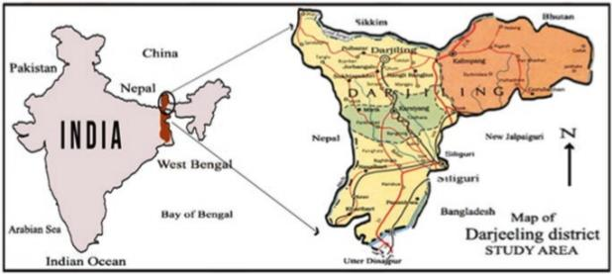

Fig.1 Physical geographic Map of Darjeeling Himalaya [6]

Darjeeling Himalaya's Phytogeography:According to phytogeography, the Eastern Himalayan Province, one of the thirteen provinces that make up the Eastern Asiatic regional centre of endemism, includes the Darjeeling Himalaya [7]. The Eastern Himalaya is one of the florally richest locations in the world and is figuratively known as a botanist's paradise, making it a popular destination for botanists for the past three centuries [8]. Such various enrichment is caused by biotic, edaphic, physiographic, and climatic variables. A tropical semi-evergreen forest, a tropical moist deciduous forest, a subtropical hill forest, an eastern himalayan wet temperate forest, and an alpine forest are the five main types of natural forest in the Darjeeling district.

Depending upon the various forest types of Darjeeling, the orchid habitat broadly categorized into five zones. They are :-
- Tropical Zone (between 400-1200m) :- In this zone, most common orchids are Acampe rigida,Acanthephippium sylhetense, Aerides multiflorus,Anoectochilus roxburghii, Arundina graminifolia, Bulbophyllum andersonii, B. roxburghii, B. leptanthum, B. tortuosum, Cymbidium aloifolium, Dendrobium aphyllum, D. farmerii, D. formosum, D. moschatum,Galeola cathcarti, Goodyeria hispida, G. procera, Nervillea macroglossa , N. plicata, Paphiopedilumvenustum ,Papilionanthe teres, Phalaenopsis lobii, P. mannii, Tropidia angulosa, Vanda testacea, Zeuxine affenis, etc.
- 2. Subtropical Zone (between 1200-2200m) :- Here, the available orchids are Anthogonium gracile, Bulbophyllum guttulatum, B. hirtum, B. reptens, Calanthe mannii, C.plantaginera, C.puberula, Coelogyne crystata, C.elaka, C.flacida, Cymbidium macrorhizon, Dendrobium chrysanthemum, D.densiflorum, D.moschatum, Diplomeris hirsuta, Eria confusa, E.graminifolia, Gastrochhilus affinis, G.calceolaris, Goodyera clavata, G.procera, Malaxis acuminate, Nervilia gamieana, N.hookeriana, Oberonia auriculata, O.micrantha, O.plachyaris, Ornithochilus difformis, Paphiopedilum fairrieanum, P.venustum, Podochilus khasianumetc.
- 3. Temperate Zone (between 2200-3200m) :-Some interesting orchids in this zone are Aphyllorchis montana, A.alpiana, Bulbophyllum eublepharum, B.hymenanthum, B.reptans, Cephalantheropsis longipes, Galeola lindleyana, Gastrochilus distichus, Pleione humilis, Spiranthes sinensis, Stigmatodactylus paradoxus, etc.
- 4. Upper Temperate Zone (between 3200-3600m) :- Orchid varieties in this zone are Bulbophyllum dyeranum, B.griffithii, B.hymenanthum, Calanthe alpina, C.tricarinata, Eria pusilla, Habenaria stenopetala, Liparis perpusilla, Neottia listeroides, Satyrium nepalense etc.
- 5.Alpine Zone (between 3600-6200m) :- In this high altitude, orchid genera are Aorchis spathulata, Androcorys puioniformis, Chusua mana, Diphyllax urceolata, Goodyera fusca, Gymnadenia orchiodes, Habenaria diphylla, Herminium orbiculare, H.josephi and H.macrophyllum. [9].

Although there are many orchids in the Darjeeling flora [9], relatively few of them have already been placed on the IUCN (International Union for the Conservation of Nature and Natural Resources) red list. Here are some of them that we go over:-
- Paphiopedilum fairrieanum (Lindl.) Stein, orchid-Buch : 467.1892
Habitat : Terrestrial
Flowering & fruiting time : October-March
Locality of their availability : Llyod Botanical Garden, Darjeeling Duras (BTR)
Altitudinal Range : 850-2200m.

- Paphiopedilum hirsutissimum (Lindl.ex Hook.) Steein, orchideenbuch,470.1892
Habitat : Terrestrial
Flowering & Fruiting time : February-October
Locality of their availability :Agricultural Research, Darjeeling Campus and Llyod Botanical Garden, Darjeeling.
Altitudinal range: 850-2300m.

- Paphiopedilum insigne (Wall.ex Lindl.) pfitz.,Morph. Stud. Orchideenbl.11.1886
Habitat :Terrestrial
Flowering& Fruiting time : November – January
Locality of their availability : Llyod Botanical Garden, Darjeeling, General distribution.
Altitudinal range : 850-2300m.

- Paphiopedilum venustum (Wall.) Pfitz.ex Steein, Jahrb.wiss.Bot.19:165.1888
Habitat :Terrestrial
Flowering & Fruiting time : February – January
Locality of their availability : Kalimpong, duars (BTR)
Altitudinal range : 850-2300m.

- Dendrobium aphyllum (Roxb.) C.E.C.Fischer in Gamble, FI. Madras 3:1416.1928
Habitat : Epiphytic
Flowering and Fruiting time : March-August
Locality of their availability : Terari to Middle Hills; Kochbehar, Duras (BTR)
Altitudinal range : Up to 1600m.

- Bulbophyllum leopardinum (wall.) Lindl.ex wall.,Numer.List 1981 1829
Habitat : Epiphytic
Flowering & Fruiting time : June – October
Locality of their availability : Kurseong
Altitudinal range : 1200-2200m.

- Vanda tessellata(Roxb.) Hook.ex.G.Don, Hort Brit. 372.1830
Habitat : Epiphytic
Flowering & Fruiting time : April – July
Locality of their availability :More or less every corner of the state.
Altitudinal range : upto 1200m.

- Geodorum densiflorum(Lamk.) Schltr. Var.kalimpongense Rajendra Yonzone, D.Lama, R.B.Bhujel and Samuel Rai, McAllen Int.Orch.Soc.J.13(6)5 – 10.12.
Habitat : Terrestrial
Flowering & Fruiting time : June – September
Locality of their availability : Dello hill.
Altitudinal range : 750-1300m.

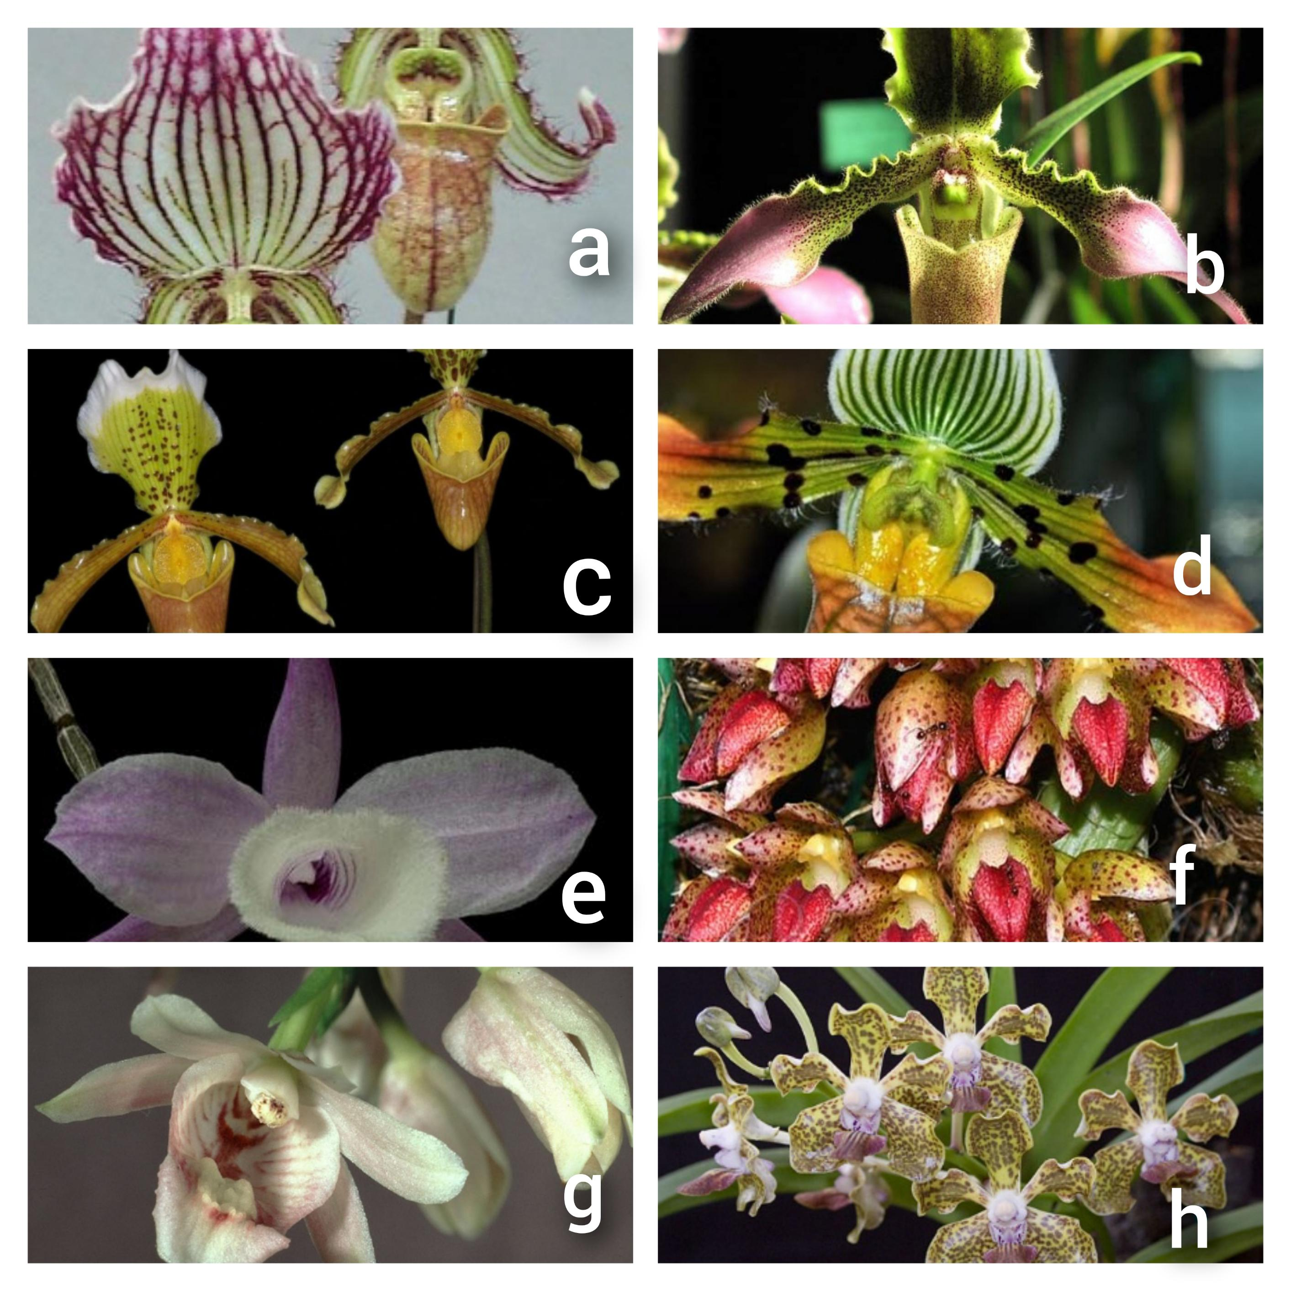
Fig.1.2 (a) Paphiopedilum fairrieanum (b) Paphiopedilum hirsutissium (c) Paphiopedilum insigne (d) Paphiopedilum venustum (e) Dendrobium aphyllum (f) Bulbophyllum leopardinum(g) Geodorum densiflorum (h) Vanda tesellata. [9]

BIOTECHNOLOGICAL APPROACH ON ORCHID FOR FUTURE CONSERVATION:-
Today, biotechnology is a cutting-edge academic discipline with cutting-edge equipment and methods. Through tissue culture, cryopreservation, seed banking, and habitat restoration, orchid biotechnology can significantly contribute to the conservation of endangered orchid species [10, 11, 12].Currently, methods like genetic engineering and RNA interference are being used to alter orchid growth and development as well as their sensitivity to environmental stressors including temperature, humidity, and light [13]. Advanced biotechnological interventions were envisioned as biotechnological methods to improve secondary metabolite production, which might further help in lowering the manufacturing cost of these crucial biomolecules. These interventions included cell suspension culture, metabolic engineering, and synthetic biology [14, 15, 16, 17].
CONSERVATION OF ORCHIDS:-
Due to their specialised habitat and life cycle, orchids are one of the plant species that are most in danger worldwide. Therefore, orchid conservation is a global priority in the current situation. The first step is to identify the factors contributing to the decline in orchid biodiversity. As part of the National Active Germplasm Systems (NAGS) for the long-term protection and use of orchid germplasm, the National Research Centre of Orchids in Sikkim has been designated as an active germplasm site for orchids.
GERMPLASM CONSERVATION:-
Advanced methods have been developed to preserve orchids, including the creation of seed banks, slow growth conservation, cryopreservation of seeds, meristem, tissue culture, shoot primordia, immature leaves, somatic embryos, callus, and other explants [18, 19]. For rare, threatened, and endangered orchid species classified in the IUCN Red Data Book, cryopreservation is a well-known conservation approach. For sustainable use for future generations, conservation will aid in the creation of botanic gardens, orchid biosphere reserves, and orchid corridors [20]. Plant genetic resources (PGR) preservation is primarily divided into two categories: (A) ex situ preservation and (B) in situ preservation. Botanical gardens, orchidaria, field gene banks, and other institutions are only a few instances of ex-situ conservations.
Another alternative for orchid preservation, growth, and development using plant tissue culture is known as in-situ conservation, which has taken on a high priority role in the protection of species that are in danger of going extinct. Studies on genetic stability are required to prevent somaclonal variations, and slow-growing cultures need to be stored for lengthy periods of time to prevent frequent transfer [21].
CRYOPRESERVATION :-
The term "cryopreservation" (from the Greek kratos, "frost") refers to preservation in a frozen state. The basic idea behind cryopreservation is to lower the temperature while using cryo-protectants to get plant cell and tissue cultures to a zero metabolism or non-dividing condition. Techniques for cryopreservation can be utilised to store plant germplasm[22].Rapid rewarming is frequently necessary for the recovery of germplasm following cryo-storage in order to prevent re-crystallization [23].
Traditional cryopreservation techniques are mostly used to freeze calluses and cell suspensions, which are undifferentiated cultures.By freezing tissue at liquid nitrogen (-196°c) or gaseous phase (-140°c), which stops all metabolic activity, cryopreservation at ultralow temperature (-196°c) provides a comprehensive alternative for long-term storage of orchid genetic resources. Cryopreservation has been created to prevent the genetic alterations that may happen in long-term tissue culture storage [24, 25, 26]. Scientists studied the methods of cryopreservation and tissue culture techniqueon Orchids using seeds, pollen, shoot tip, meristematic tissues, aerial root tip, embryoids, protocorms, floral parts etc. Many scientists and researchers are working on the conservation strategy of orchids by using cryopreservation methods and try to discover new species of orchids through biotechnological approach includingtissue culture, somaclonal variation, DNA recombination and cell suspension culture [24, 25].
ORCHID BREEDING: RECENT ADVANCEMENT IN BIOTECHNOLOGY
Orchidaceae family is the most advanced monocot family in the angiosperms group of plants. This plant group is very demandable for it's aesthetic beauty, significant ornamental and economical valuebut most of the members lost their diversity due to global climate change for environmental pollution and anthropogenic activities. Some of them are already designated as vulnerable, endangered, and/or CITES (Convention on International Trade in Endangered Species of Wild Fauna and Flora) red data book species by the International Union for the Conservation of Nature and Natural Resources. Therefore, now is the ideal time to consider the best conservation practices and breeding plans for orchids in order to stop the loss of genetic variety and biodiversity across the planet. Advances in molecular breeding have led to various attempts to apply cutting-edge “genetic and omics” techniques to quicken the breeding process in some commercially valuable orchid species.
Besides, the biodiversity &conservation view, this review also consolidates some recent breeding variety of orchids and discuss their ornamental and commercial applications for future.
OBJECTIVES: • Mass production of plantlets via biotechnology.
• The discovery of new kinds with various colouring variations.
• Development of an orchid variety that is virus-resistant.
• More easily develops new varieties than the conventional procedure.
• To protect endangered species and stop the loss of genetic diversity.
• To strengthen the nation's economy.

BREEDING TECHNOLOGY AND METHODS:-
As economic globalisation has progressed, the market demand for orchids has grown both in number and diversity year after year. This has compelled scientists and plant breeders to create new kinds with distinctive looks as well as to enhance resilience and quality traits [27].
Some breeding methods are discussed below:-
- Micropropagation.
- Polyploidy breeding.
- Mutation breeding.
- Genetic transformation.
Micropropagation :-
Micropropagation (also known as in vitro clonal propagation) is a method of plant tissue culture that entails the vegetative propagation of a large number of true-to-type or clonal plantlets, i.e. genetically identical plantlets, from a small piece of plant tissue (selected genotype/selected donor plant/selected mother plant) and used as explants grown under controlled and sterile conditions in a periodic, cyclic, The process [28] for meristem-culture in Cymbidium to produce virus-free progenies was identified way back in 1960. He calculated that one single explant of Cymbidium could produce four million plants annually. The developmental stages [29] in cultures in vitro is as follows:
Stage I: Explant establishment.
Stage II: Propagule multiplication.
Stage III: Hardening and rooting for planting into the ground.
Vegetative propagation of elite Phalaenopsis [30]

Polyploidy breeding:-
In a plant cell, polyploidy refers to the presence of more than two pair sets of chromosomes. The main effect of it is a growth in cell size, which results in larger vegetative and reproductive organs.Now, many endangered orchid species, including Cymbidium, have undergone successful polyploid breeding in Cymbidium [31] Dendrobium [32], Oncidium[33] and Phalaenopsis [33, 34]. Polyploidy is mainly done by Chromosome doubling by applying chemicals like colchicine (C22H25NO6) and Oryzalin(C12H18N4O6S) [35] and Colchicine was used by the researcher to treat the hybrid, resulting in tetraploid plants with bigger leaves, roots, and rhizomes, as well as deep stem colours and slow growth rates.
Mutation breeding:-
Because many species may be easily propagated, mutation breeding, which includes both natural and artificial mutations, is well suited for breeding ornamental plants [36]. This facilitates the generation of spontaneous and induced mutants. Any group of plants can have their genetic traits permanently altered through mutation breeding. Over time, orchids with phenotypic traits, higher levels of therapeutic compounds, and increased adaptation and resistance have been created through mutation breeding. [37].
Mutating agents that helps in mutation breeding to form mutant breed:-
- X ray
• Gamma rays, a form of ionising radiation, produce free radicals in cells that alter or destroy plant cells' DNA and have varying effects on morphology.
Although random mutations can happen anywhere in the genome, they often only result in single alterations [38]. Additionally, the explant type, a suitable genotype, the induction-mutation method, and the ideal dose all affect mutation breeding.
Genetic transformation:-
One of the most recent methods for creating new plant species is genetic transformation, which involves the exchange of desirable genetic material using plasmid DNA.
This process is mainly done by two methods:-
- Agrobacterium mediated gene transfer.
- Microprojectile bombardment / Particulate Bombardment/ Biolistic / Gene gun method.

I -:Agrobacterium mediated gene transfer :-
Step : 01 - Signal recognition by Agrobacterium tumifaciens / rhizogenes .
Step : 02 - Attachment to the plant cell surface.
Step : 03 - Induction of Vir gene.
Step : 04 - T strand production.
Step : 05 -Transfer of TDNA (Transfer DNA) out of the bacterial cell.
Step : 06 - Transfer of TDNA and virprotein into the nucleus of the plant cell. [39].
II. Microprojectile bombardment / Particulate Bombardment / Gene gun method / Biolistic :-
This method involves the coating of 1micrometer diameter particles of Gold (Au)( called microprojectile or microcarrier) with DNA at high speed and pressure into an evacuated chamber containing the target plant tissues.
DNA coated microprojectile penetrate through the cell wall releasing DNA from projectile with gets integrated genome of the plant.
Procedure :-
- Preparation of microcarriers :- 1micrometer diameter tungsten particle + washing with ethanol and sterile distilled water + DNA + spermidin + calcium chloride + Ethanol.
- Preparation of plant tissue :- Generally 2 weeks old embryonic callus is used. It is present in high conc.of moltose atleast 4 hours. [39].

Some new intergenic hybrids of orchid developed through breeding method:-

- Ascocentrum × vanda = Ascocenda
- Arachnis × vanda = Aranda
- Aerides × vanda = Aeridovanda
- Brassovola × cattleya = Brassocattleya
- Phalaenopsis × vanda = vandanopsis
- Cattleya × Laelia = Laeliocattleya
- Cattleya × Sophronities = Sophrocattleya [40]

Commercial value of orchids :-
- Vanilla (vanillin), which is produced from the pods of Vanilla panifolia, is used as an ice cream and chocolate flavouring.
- The Jumellea fragrans orchid is used to make the popular drink known as "Faham" or "Madagascar tea" on the islands of Madagascar [41].
- Geodorum densiflorum, a medicinal orchid, is used to make a variety of medications for therapeutic purposes.
- Some types of orchids are employed as colouring agents.
- Because of their aesthetic attractiveness, orchids like Dendrobium, Cymbidium, Vanda, and Paphiopedilum are primarily utilised as decorations.
- The tribal tribes of North East India consume a variety of wild orchid species as food. [42]
- Common veggies like potato, tapioca, and others are combined with the pseudobulbs of Cymbidium orchids to make sauce using their fresh shoots as cereal. [43]
- Many orchid species are said to have pseudobulbs, roots, and rhizomes that can be used as food. In the Nagaland region, foods such as Habenaria acuminata, H. sussanae, Orchis latifolia, Pholidata articulata, and Satyrium species are consumed and play a significant part in human nutrition [44, 45].
Conclusion:-
In contemporary culture, flowers have earned a noteworthy place. As a result, there is currently a high demand for flowers, particularly orchids as they maintain their beauty for a long time and offer a wide variety of options for colour and scent. Because orchid populations are alarmingly declining at low levels, conservation, sustainable use, and management of orchids are essential to ensuring their unhindered natural growth and proliferation.
References
- Dressler, L. Robert, 1989 : The Orchids natural History and Classification ; Harvard University Press – ISBN : 0-674-87525-7
- Handa,S.S.1986, Orchids for drugs and chemicals ,Pages 89-100 in S.P.vij(ed.), Biology : conservation and culture of orchids, East West Press, New Delhi.
- Bhujel,R.B (1996) : Studies on the dicotyledonous Flora of Darjeeling District, Ph.D. thesies, University of North Bengal, Raja Rammohanpur , Darjeeling.
- Yonzone, Rajendra and Karman, A. 2008 : Ethnobotanical uses of orchids . Abstract in an International Seminar, “Multidisciplinary Approaches in Angiosperms Systematics “ Kalyani University, West Bengal.
- Negi SS (1992) Himalayan Wildlife, habitat and conservation. Indus Publishing p 207. ISBN : 978-81-85182-68-1
- Orchid Biology : Recent Trends and challengeshttps://www.researchgate.net/publication/338962123.
- Hooker,J.D.1896: List of trees, shrubs and climbers found in Darjeeling District, Bengal, second edition, Calcutta.
- Don.D.,1821: Description of several taxa from the kingdom , taken from specimens preserved in the herbarium of A.S.Lamb.
- https://www.pexels.com/search/orchid/ Internet Orchid species Encyclopedia.
- Bhattacharyya,P., Kumaria,S., Diengdoh,R., Tandon,P., 2014. Genetic stability and phytochemical analysis of the in vitroregeneratedplantsof Dendrobium nobile Lindl., an endangered medicinal orchid. Meta gene 2, 489-504.
- Bhattacharyya, P., Kumar, V., Van Stadeen,J. 2017 Assessment of genetic stability amongst micropropagated Ansellia africana , a vulnerable medicinal orchid species of Africa using SCoT markers. South African J.Bot. 108, 294-302.
- Bose, B.,Kumaria, S., Choudhury, H., Tandon, P.2017b. Insights into nuclear DNA content, Hydrogen Peroxide and antioxidative enzyme activity during transverse thin cell layer organogenesis and ex vitroacclimatization of Malaxis wallichii , a threatened medicinal orchid. Physiol.Mol.biol. https://doi.org/10.1007/s12298-017-0474-3
- Chang, L., Tzean, Y., Hsin,K.T.,Lin,C.Y., Wang, C.N., Yeh, H.H.,2022. Stress associated protein coordinate the activation of comprehensive antiviral immunity in Phalenopsis orchids. New Phytol 233, 145-155.
- Gallage, N.J.,Moller.,2015. Vanillin- bioconservation and bioengineering of the most popular plant flavor and its de novo biosynthesis in the Vanilla orchid. Mol Plant 8, 40-57.
- Bose, B.,Choudhury,H.,Tandon.P.,Kumaria.S.,2017a. Studies on secondary metabolite profiling , anti-inflammatory potentials , in vitro photoprotective and skin-agingrelated enzyme inhibitory activities of Malaxis acuminata, a threatened orchid of nutraceutical importance. J.Photochem.Photobiol.B Biol.173, 686-695.
- Gantait,S.,Das,A.,Mitra,M.,Chain.J.T., 2021: Secondary metabolites in Orchids : Biosynthesis, medicinal uses and Biotechnology. South African J.Bot. 139, 338-351.
- Ghai ,D.,Kaur ,A.,Kahlon,P.S.,Pawar,S.V.,Semvi, J.K.,2022. A walk through the maze of secondary metabolism in orchids : A transcriptomic approach . Front. Plant Sci. 13, 837563.
- Hirano T, Godo, T, A.E., Miyoshi K, Æ Keiko Ishikawa Æ Masaya Ishikawa Æ Masahiro Mii, (2009), Cryopreservation and low-temperature storage of seeds of Phaius tankervilleae, Plant Biotechnol Rep (2009) 3:103–109 DOI 10.1007/s11816-008-0080-5.
- Seaton PT, Hu H, Perner H and Pritchard HW. 2010. Ex situ conservation of orchids in a warming world. Bot Rev 76: 193-203.
- Dixon K.W., Kell S.P., Barrett R.L., and Cribb P.J. (eds) 2003. Orchid Conservation. pp. 1–24. Natural History Publications, Kota Kinabalu, Sabah.
- Chang WC (2007) In vitro morphogenesis and micropropagation of orchids. In H.H.Chen and WH Chen(eds) Orchid biotechnology. World Scientific Publishing Co. Pte. Ltd., Singapore.
- Engelmann F, (2010), Use of biotechnologies for the conservation of plant biodiversity, In Vitro Cell.Dev.Biol.—Plant DOI 10.1007/s11627-010-9327-2.
- Towill L. E.; Walters C. (2000), Cryopreservation of pollen. In: Engelmann F.; Takagi H. (eds) Cryopreservation of tropical plant germplasm—current research progress and applications. JIRCAS, Tsukuba, pp 115–129.
- Reed B. M.; DeNoma J.; Chang Y. (2000), Application of cryopreservation protocols at a clonal genebank. In: Engelmann F.; Takagi H. (eds) Cryopreservation of tropical plant germplasm—current research progress and applications. JIRCAS, Tsukuba, pp 246–249;.

- Reed B. M.; Engelmann F.; Dulloo M. E.; Engels J. M. M. (2004), Technical guidelines for the management of field and in vitro germplasm collections. Handbook for Genebanks N 7. IPGRI/SGRP, Rome;
- Reed B. M.; Uchendu E. Controlled rate cooling. (2008) In: Reed B. M. (ed) Plant cryopreservation: a practical guide. Springer, Berlin, pp 77– 92;
- Chakraborty R. (2019), Floriculture in Northern West Bengal of India- A Dream Sunrise is on Wait". EC Agriculture 5.2
- Morel, G., (1960). Producing virus-free cymbidiums. Am. Orchid Soc. Bull. 29, 495–497
- Murashige, T. Plant Propagation through Tissue Cultures. Annu. Rev. Plant Physiol. 1974, 25, 135–166.
- Trevor A. Thorpe and Edward C. Yeung (eds.), Plant Embryo Culture: Methods and Protocols,Methods in Molecular Biology, vol. 710, DOI 10.1007/978-1-61737-988-8_20,© Springer Science+Business Media, LLC 2011.
- Wang, S.Y., Lee, P.F., Lee, Y.I.,Hsiao, Y.Y., Chain,Y.Y., Pan, Z.J., Lilu, Z.J., Taai.,W.C., 2011b. Duplicated C- class MADS box gene reveals distinct role in gynostemium development in Cymbidium ensifolium ( Orchidaceae). Plant Cell Physiol, 52 : 563-577.
- Zheng S, · Hu Y., Zhao R., Yan S., Zhang X, Zhao T and ·Chun Z, (2018) Genome-wide researches and applications on Dendrobium, Planta , 248:769–784 https://doi.org/10.1007/s00425-018-2960-4.
- Cui G. R., Zhang Zi. Xue, Zhang C.Yu., Hu N. B., Sui Yi. Hu., Li . J. Q. (2010), Polyploidy induction and identification of Oncidium. Acta Prataculturae Sinica 2010 Vol.19 No.1 pp.184-190.
- Huang J, Lin C, Cheng T, Huang Y, Tsai Y, Cheng S, Chen Y, Lee C, Chung W, Chang BC, Chin S, Lee C, Chen F. 2016. The genome and transcriptome of Phalaenopsis yield insights into floral organ development and flowering regulation. PeerJ 4:e2017 https://doi.org/10.7717/peerj.2017.
- Manzoor A, Ahmad T, Bashir MA, Hafiz IA, Silvestri C. Studies on Colchicine Induced Chromosome Doubling for Enhancement of Quality Traits in Ornamental Plants. Plants (Basel). 2019 Jun 28;8(7):194. doi: 10.3390/plants8070194. PMID: 31261798; PMCID: PMC6681243.
- Yamaguchi H., (2018) Mutation breeding of ornamental plants using ion beams, Breeding Science 68: 71–78 . doi:10.1270/jsbbs.17086.
- Li C., Dong Na, Zhao Y., Wu S., Liu Z. and Zhai J (2021), A review for the breeding of orchids: Current achievements and prospects, Horticultural Plant Journal, 7(5), Pp- 380-392
- Su J., Jiang J, Zhang F, Liu Ye, Ding Li, Chen Su, and Chen F., (2021) Current achievements and future prospects in the genetic breeding of chrysanthemum: a review. Horticulture Research, Volume 6, 2019, 109, https://doi.org/10.1038/s41438-019-0193-8.
- https://www.slideshare.net/sakthivelRamar/agrobacterium-mediated-gene-transfer-80094201.
- https://www.slideshare.net/Utpaldas2015/orchids-48741974.
- Die Orchideen Schlechter 1915; AOS Bulletin Vol 28 No 5 1959.
- Tsering J., Tam N., , Hui Tag H., Gogoi B. J., Apang O, (2017) )MEDICINAL ORCHIDS OF ARUNACHAL PRADESH: A REVIEW. Bulletin of Arunachal Forest Research, Vol. 32(1&2), 1-16.
- Medhi RP, Chakrabarti S (2009) Traditional knowledge of NE people on conservation of wild orchids. Indian J. TraditKnowl.8:11-16.
- Deb CR (2013) Orchids of Nagaland, propagation, conservation and sustainable utilization : a review. Pleione 7(1) : 52-58.
- Cribb PJ, Kell SP, Dixon KW, Barrett RL(2003) Orchid conservation : a global perspective. In:Dixon KW, Kell SP, Barrett RL, Crib PJ(eds) orchid conservation. Natural History Pub , Kotakinabalu, pp1-4.

