Novel Method Of High Speed Li-Fi Data Transmission
Jakatheeswar S, Sanjeeth N, Lokesh A, Swaminathan S, Suganya S
SASTRA Deemed University, Srinivasa Ramanujam Centre, Kumbakonam-612 001, India
Abstract
Internet is the fundamental mode of communication which connects people from all over the world and they can transmit the huge data from end to end using Wi-Fi. But Wi-Fi is vulnerable to third person who can access it by radio waves passing through the walls. So, there is a huge black hole in this Wi-Fi technology that is Security to the user. We may replace Wi-Fi with Li-Fi Technology to offer high density wireless data coverage in limited locations.
This is a new technology that was initially proposed in 2011 by German scientist Harald Haas. Li-Fi transmits data using an LED light bulb that changes intensity quicker than the human eye can detect and provides high speed data transmission which is equal to the speed of light.
A light-based Wi-Fi system is known as Li-Fi. This technique is primarily used to transport data utilizing high-efficiency, long-lasting, and dependable LED lights. With the increasing popularity of solid state lighting devices, Visible Light Communication (VLC) technology is a cutting-edge and positive technique for short-range, high-speed, and vast wireless information transfer

Keywords: Li-Fi; Wi-Fi; LED; Visible Light Communication; high speed data transmission;
- Introduction to Li-Fi
Li-Fi is a wireless transmission technique that uses light instead of radio waves to transport data. Li-Fi technology can transmit voice, video and video data information at high data rates. Li-Fi can be called Light Fidelity.

LEDs can change the frequency of light with the combination connected to red, green and green LEDs that includes a different data channel. Central Li-Fi data transfer speeds are 10Mbps faster than the average broadband speed of Wi-Fi and Bluetooth connectivity.
  - Need For Li-Fi
High Speed Data Transmission and Security are the most important issue in Wi-Fi. In Wi-Fi, the data security is less due to the radio waves goes through the wall and due to the number of users increased, the speed of Wi-Fi may get slow. In order to overcome this problem, we need Li-Fi, a high speed wireless communication system.
  - Issues Of Existing Model (Wi-Fi)
There are some problems in the existing model (Wi-Fi), they are

- Wi-Fi uses radio waves spectrum for transmitting the data.
- As the belt is closed and has a limited range its volume leads to drying.
- Despite the fact that the demand for a wireless network is growing every day, the number of channels accessible is restricted.
- The installation cost of a base station and maintaining it at optimum temperatures is more expensive.
- This technology has lesser bandwidths with a low efficiency. Its availability is limited and is less secure.

  - Why Only Li-Fi?
- Even though Gama rays have higher frequency the visible rays cannot be used as they could be dangerous.
- X-rays also have similar health issues. They can also be harmful when our body is continuously exposed to them.
- Ultraviolet light is good for place without people, but otherwise they are extremely dangerous for the human body.
- Infrared spectrum is avoided due to the cause of eye safety regulation, so they can only be used with low power.
- The problems with radio Waves are mentioned prior.
- So, the only spectrum which could provide a good transmission medium is the visible fight spectrum.
- Architecture Of Li-Fi
Li-Fi is the cheapest and quickest version of Wi-Fi, and it represents the future of 5G wireless connectivity. Light works as a visual carrier for data transfer and illumination utilizing optical electromagnetic spectrum light between 400 THz and 800 THz in VLC.
The space spectrum contains many wavelengths such as X-rays, gamma rays, v-zone, infrared space, visible light rays, radio waves, etc. found in us. We can choose any frequency spectrum but why visible light? The reason for this is the small harmful effects that occur due to these rays of light and easy access.
  - Components of Li-Fi system
The following are the major components of a Li-Fi system:
- The Transmitter is a high-brightness white LED.
- The receiver is a silicon photodiode.
Fig. 1. LED and Photodiode
  - Concept of Binary Data transmission
- When the LEDs change from on to off, it will cause them to produce digital inputs with different combinations of 1 and 0.
- Data can be encoded by changing the brightness of the LED to produce new data streams.
- By transforming light into a data stream, the LEDs operate as a transmitter.
- Because it is created to shine at an incredible pace, the LED output seems unaltered to human sight (millions of times per second).
- The human eye is incapable of seeing this naturally.
Fig. 2. Binary Data Conversion in Li-Fi
- Architecture Of Li-Fi
  - Design
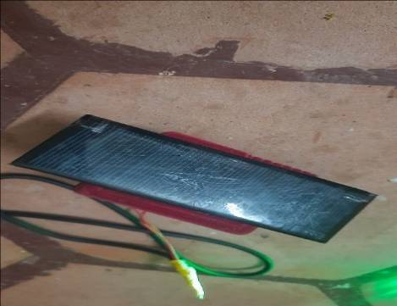
LED light bulbs are used to implement Li-Fi technology, which uses a steady current to illuminate. Light output may be changed at fast rates with quick current adjustments. When the LED is turned on, it broadcasts a binary value of one, and when it is turned off, it transmits a digital value of zero. To send invisible data to the human eye, the LEDs may be switched on and off instantly. As a result, we require an LED as a transmitter and a Photodiode, or solar panel as a detector to receive data, these components are
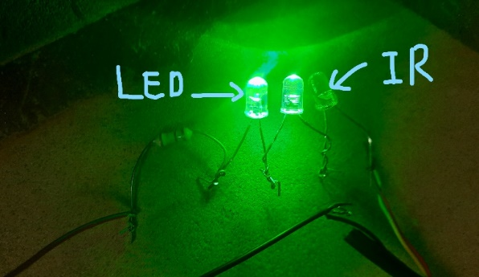
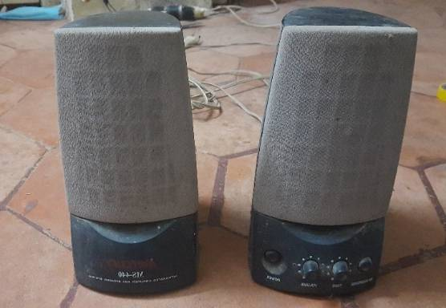
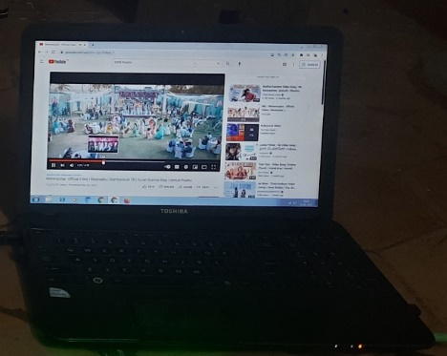
Fig. 3. (a)LEDs; (b) Solar panel;
Fig. 4. Block Diagram of Hardware Used

The data held on a micro-chip will be processed by the LED bulb. Tiny variations in amplitude can be used to modify light intensity to communicate data.
  - Working
The working principle of Li-Fi system is done by single LED or Multi LED for transmission of data. A photo detector is located on the receiver's side, and it turns light into electric impulses, which it then sends to the device linked to it. To generate or maintain a voltage level between both the transmitter and receiver, voltage regulator and level shifter circuits are utilized on both sides.
- Li-Fi uses visible light by flashing the top to transmit data. This can be done through the Visible Light Communications (VLC) data transfer system.
- A fluorescent bulb or a light emitting diode can be used as this light source (LED). VLC's finest light source is LED light bulbs. However, a robust Li-Fi system needs a lot of light output.
- Fluorescent bulbs have a significantly wider range of wavelengths, making them a less efficient light source to emit light than LEDs. LEDs, on the other hand, are a type of light source that generates light in a very narrow spectrum of wavelengths, making them more efficient than fluorescent bulbs.
- LEDs are also semiconductors, which means they can produce lighter and change faster. Because Li-Fi relies on constant streaming of images released as visual light for data transfer, this is a key feature to seek for in a VLC light source.
- The light source fades up and down as the current power utilized in the light source fluctuates somewhat, rendering it unsuitable as a light source, not for the Li-Fi system, but as an interior lighting device.
- This current and optical output are transformed at very fast rates to achieve a balance between the VLC light source and the interior light, making it visible through a photodiode machine and converted to an electric current, but unseen to the human sight.
- Once these signals have been identified and downloaded, they may be transformed into a continuous stream of binary data comprising movies, photos, sound, text, or programs that can be viewed on any Internet-connected device.
- We still have lots of space to develop new technologies because Li-Fi technology is still very young. One of the new proposed technologies includes the creation of a dual-directed communications system such as standard broadband and Wi-Fi.
Fig. 3. Block Diagram for Audio Transfer
- Data Collection and Experimental Setup
The data required for the experiment is the hardware components and the MATLAB software tool for working on the experiment.

The experimental setup mainly consists of two parts,
- Hardware Setup (Audio transmitted from a laptop is given to the speaker).
- Software Block diagram for audio transfer.
- Transmission of data between two laptops, and plotting the audio received from the LED.
Fig. 4. Block Diagram of Hardware Used

Fig. 5. Block Diagram of Data Transmission using Two Laptops (MATLAB)

- Snapshots
  - Case 1
When the light blocked from the receiver.
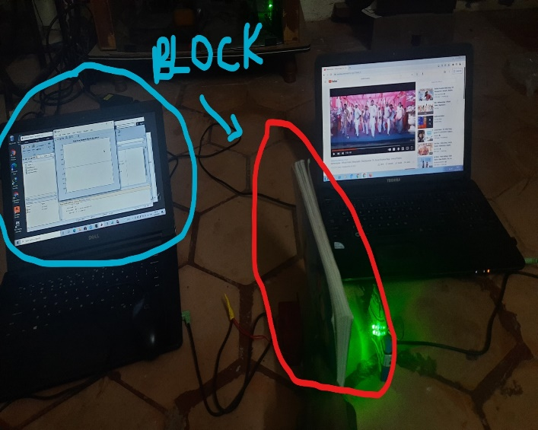
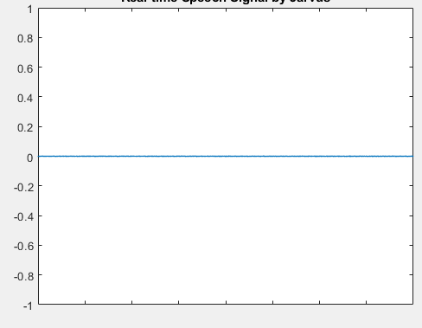
MATLAB output when the light is blocked (zero signal)
Fig. 6. (a)Light is blocked; (b) MATLAB Output as zero
  - Case 2
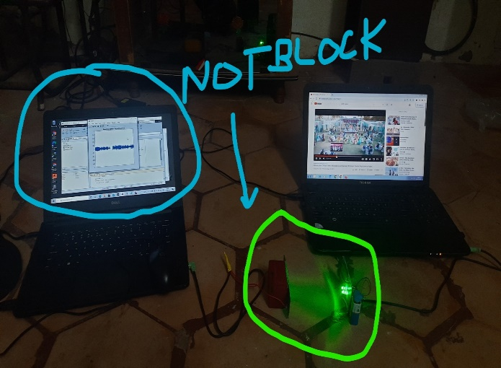
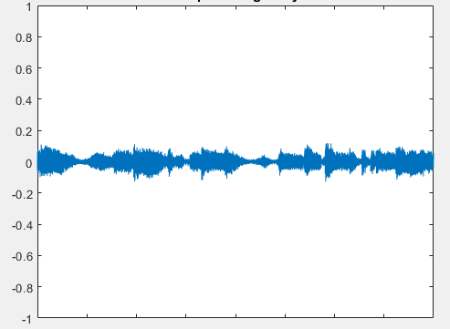
When the light received at correct range.
MATLAB output when the receiver is unblocked. i-e. the receiver receives the data from the LED.

Fig. 7. (a)Light is received; (b) MATLAB Output with some values
- Advantages and Limitations of Li-Fi
  - Advantages
- Li-Fi provides High Speed.
- Li-Fi provides Accessibility.
- Li-Fi provides Security.
- Li-Fi doesn’t require separate routers.
- Li-Fi is Safe and Eco-friendly.
- Li-Fi is Conservation of energy.
- Li-Fi achieve High Efficiency.
  - Limitations
- Li-Fi limited to a single room.
- Li-Fi cannot pass through opaque surfaces.
- Li-Fi requires a compulsory line of sight.
- Conclusion and Future Plans
Opportunities abound and can be considered continuously. Despite the disadvantage if this technology is not used in a practical way, each lamp may be utilized as a Wi-Fi hotspot to transmit wireless data and will leave a clean, green, secure and bright future. Other enhancements can be made this way, such as using the LEDS network for the same data transfer. Such development promises a theoretical speed of 10 Gbps.
This project can be still improved by,
- This Li-Fi can still be secured by adding security using Encryption and Decryption.
- After 10 or more years, Li-Fi will be the base of the upcoming 6G technology which overcomes the 5G.
- In the 6G, we will have lot of applications which is not mentioned in our report that enables us to the techno-world i-e automated with lot of IoT devices which serves humans.
References
[1] Optics and Photonics Journal, 3, 153-157 doi:10.4236/opj.32B037 (http://www.scirp.org/journal/opj)
[2] “Li-Fi (Light Fidelity)-The future technology In Wireless communication?” by Jyoti Rani. “Journal from International Journal of Applied Engineering Research” (IJAER); ISSN 0973-4562 Vol.7 No.11.
[3] https://www.cambridge.org/core/books/visible-light-communication/34CAFB565027F65A82C6E5E6E7A2989D.
[4] Intrty Shubham Chatterjee, Shalabh Agarwal, Asoke Nath, “scope and Challenges in LightFidelity (LiFi)Technology in Wireless Data Communication”, International Journal of Innovative Research in Advanced Engineering (IJIRAE), Issue 6, Vol 2, Page 1-9, (June 2015).
[5] “Harald Haas: Wireless data from every light bulb”, https://www.youtube.com/watch?v=NaoSp4NpkGg
[6]R. Karthika, S.Balakrishnan, (2015). Wireless Communication using Li-Fi Technology SSRG International Journal of Electronics and Communication Engineering (SSRG-IJECE), Vol. 2 Issue 3, Mar 2015
[7] Sunandan, Pratyush (2015). The End of Wi-Fi Era is Here: Li-Fi, https://www.thehdtimes.com/end-of-wi-fi-era-li-fi/
[8] D. K. Son, E. B. Cho and C. G. Lee, “Demonstration of Visible Light Communication Link for Audio and Video Transmission,” Photonics Global Conference (PGC), pp.1-4-2010. doi:10.1109/PGC.2010.5706094

