APPLICATION OF DATA SCIENCE IN RENEWABLE ENERGY SYSTEMS
*Er. HARRIS ANGEL D, Lecturer, Department of Electrical & Electronics Engineering,
CSI Polytechnic College,salem-7,Tamilnadu,India.
Er. REVATHI V, Lecturer, Department of Electrical & Electronics Engineering,
CSI Polytechnic College,salem-7,Tamilnadu,India.
Er. ROSALIN MUSKIL G, Lecturer, Department of Computer Engineering,
CSI Polytechnic College,salem-7,Tamilnadu,India.

ABSTRACT
The increasing Power demand has made the need for optimal use of Renewable Energy systems in Power sector. Non renewable energy sources are depleting every day and causes many impacts in the environment. so in order to meet the global need of clean energy it is important to concentrate on renewable energy sources like solar and wind power. Here we emphasize the application of Data science in renewable power production to improve efficiency and reliability. Changing weather makes the solar power inefficient and non-reliable. The process starts from collecting weather data from weather forecasting sources. A sensor unit to sense temperature, humidity and rain is also set in phase to feed the weather data. Analyzing the weather forecast values and IoT sensor values with the preset reference values through the ML algorithm the Data Modeling will be done. So integrating the IoT sensors and weather forecast data with Solar Panel movement and rotation control will make the Power production more efficient. It makes the Power Generation Capacity of the Solar plant Predictable and makes the operation easy during Peak Demands. Maintenance and installation of new Photovoltaic panels can be done based on the data models and analytics. Thus the overall efficiency of the power system will be improved by optimal result evaluation and testing. The same process can be applied to the wind mills. The direction, speed and velocity values of wind can be fed to the data collection unit using IoT and further analysis and evaluation can be done by ML algorithms and open source soft wares like Python,Anconda and Jupyternotebook.

DATA ANALYSIS THROUGH ML ALGORITMS & STATISTICAL MODELING
IMPROVED EFFICIENCY BY RESULT EVALUATION & TESTING
DATA COLLECTION FROM WEATHER MONITORING UNIT
SOLAR PLANT INTEGRATED WITH IoT & ML

The application of Data Science in Solar Power Production system will make the grid maintenance easy and improve the plant capacity. Power demand of our country rises everyday due to various factors like population, urbanization and industrialization. Our country has planned to meet 50 percent of Power demand from renewable power sources by 2030. Hence optimal use of Data Science in Renewable Power sector will improve the efficiency of the system and pave the way for zero carbon emission.

WEATHER PREDICTION IN SOLAR POWER SYSTEM
Power output from the renewable energy sources is not constant and it varies for every season. Solar power plant could not produce enough power output during rainy season and winter. When the intensity of Sun light varies during cloudy weather it directly reduces the power production from the Photovoltaic panels. When the panels didn’t get enough sunlight the plant would not be able to meet the load demand. So predicting the weather in advance will help to predetermine the power output of the plant. Prediction will also helpful to improve the efficiency and reliability of the plant. Weather prediction involves in receiving data from various sensor units like temperature, humidity and atmospheric moisture. The collected data will be compared with the weather forecast data and the accurate weather prediction will be done. All the weather data like sunlight intensity, humidity and temperature will be fed to the IoT and ML integrated analysis unit. Based on the weather prediction the power output of the plant could be calculated approximately for better operation.
ADVANTAGES OF WEATHER PREDICTION
- Weather prediction helps to maintain balance between generation and load demand.
- Back up units during poor weather can be made ready as per the prediction results.
- Maintenance of the plant can be scheduled based on weather forecast.
- Improved Reliability and efficiency of the system.
- Preventive measures can be taken to protect the panels from hailstorm by using the forecast data.
- Protective covers can be made ready to protect the panels from heavy rain, moisture and dirt using prediction system.
DATA COLLECTION FROM MONITORING UNIT
Solar Plant integrated with IoT collects weather data from monitoring unit. The monitoring unit consist of various sensors to measure humidity, temperature, atmospheric moisture and sunlight intensity. The sensory data will be fed to the Data Analysis unit to match it with the reference values. The reference values are standard values to predict the exact weather of the day which are received from forecast center of the city. Based on the analysis and comparison with the preset values in the Analysis unit using ML algorithm statistical modelling can be done by using IoT. Modelling in graphical form is given below for an example.
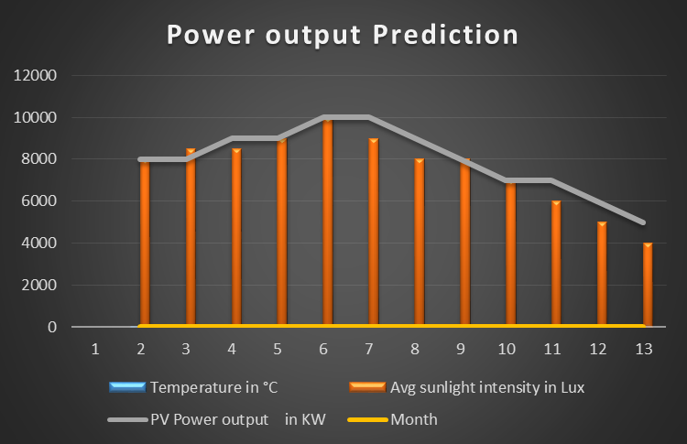

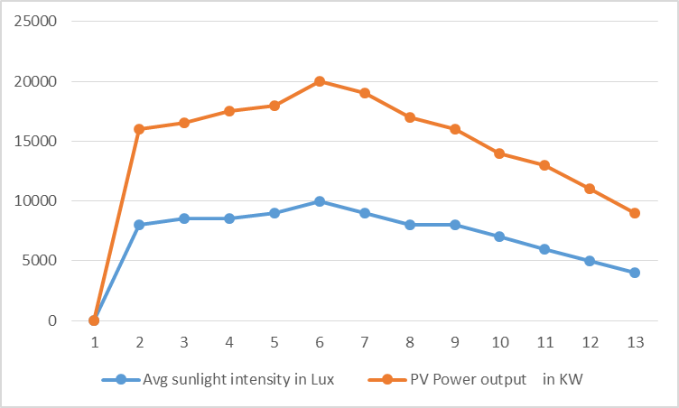

DATA ANALYSIS THROUGH ML ALGORITHM

WEATHER DATA COLLECTION
MONITORING UNIT
DATA ANALYSIS UNIT
REFERENCE VALUES
FORECAST CENTER
DATA MODELLING BY IoT
SOLAR PLANT
EVALUATION & TESTING UNIT

Based on the simulated data model the output Prediction can be done for Plant maintenance. Evaluation unit collects the Plant Production data and calculates the efficiency and saves it for future analysis and testing.
CONCLUSION:
Thus the efficiency and Power Production of the Solar Plant will be improved and Power Prediction will be done accurately using Data Science. This makes the maintenance of the Plant easy and reliability of the system will be significantly improved.

