FORMULATION DEVELOPMENT AND CHARACTERISATION OF PVP BASED PACLITAXEL NANOCRYSTALS AS PARENTERAL PREPARATION
LAGNAJIT MAHAPATRA¹, SURAJIT MAITY¹, SATYAJIT PANDA²
¹Haldia Institute of Pharmacy, Haldia, West Bengal, PIN-721657
²Department of Pharmaceutics, Institute of Pharmacy and Technology, Salipur, Odisha, 754202

ABSTRACT
The present study was aimed at preparing and evaluating Nanocrystals of Paclitaxel (PTX). Various nanocrystal formulations were prepared by nanoprecipitation method using, Povidone as stabilizers as polymer matrix in different molar ratios. The formulations were optimized based on their particle size and zeta potential. Those optimized formulations were then characterized for their surface morphology, assay, in vitro drug release profile, syringeability and injectability, dilution stability, solubility and stability studies. The PTX nanocrystals were rod, spherical, nearly spherical and elongated cylindrical crystals with a size ranging from 40 nm to 120 nm. The assay was found to be in the range of 99.562% to 103.25%. The zeta potential was found to be in the range of -29.6 to 34.5 mV. The release data was plotted for cumulative % drug release as a function of time. In vitro release study was analyzed using various mathematical models. The formulations exhibited burst release and later sustained drug release profile. F1 (PVP). Formulation showed prolonged drug release for 72hr.All the formulations could pass freely through the needle size of 13 mm and showed different levels of redispersibility at different time intervals. Accelerated stability studies were performed and the formulations were found to be stable.
Keywords: Paclitaxel, Nanocrystals, Nanoparticles, Formulations, PLGA.
INTRODUCTION
Among all newly discovered chemical entities about 40% drugs are lipophilic and fail to reach the market due to their poor water solubility⁽¹⁾. Solubility, the phenomenon of dissolution of solute in solvent to give a homogenous system, is one of the important parameters to achieve desired concentration of drug in systemic circulation for desired (anticipated) pharmacological response. Low aqueous solubility is the major problem encountered with formulation development of new chemical entities as well as for the generic development ⁽²⁻³⁾.
Paclitaxel nanocrystals are intended for intravenous administration in the treatment of advanced breast cancer, ovarian cancer and non-small cell lung cancers. A small particle size is desired to avoid embolization. In the past two decades, colloidal drug delivery systems (CCDS), including liposomes, solid lipid nanoparticles, polymeric nanoparticles and micelles have been used to formulate highly insoluble anticancer drugs. Despite the fact that these systems have been extensively studied, various inherent limitations remain. They generally have limited drug-loading capacity. Phospholipid-based structures such as liposomes may also suffer from drug leakage and instability during the preparation, storage and administration process that can compromise the therapeutic outcomes. Therefore, more physically stable and solvent-free nanocrystal-based formulation may be used for delivering antineoplastic drugs to reach the tumor site.
The half life of the Paclitaxel is 5hrs. The marketed liquid injection has Polyoxyl castor Oil as excipient which can cause hypersensitivity reactions in some individuals. A albumin based nanoparticle paclitaxel preparation is also available A simple manufacturing method was envisaged for formulation of parenteral Paclitaxel nanocrystalline systems using Bottom up techniques to prepare the formulations and optimized amounts of polymer shall be used for sustaining the drug release.
MATERIALS AND METHODS
Paclitaxel was received as a gift sample from Laurus Labs, Hyderabad, PVP ( Plasdone C-12 were received from.Poly Purac Biochem, Netherlands.Sodium hydroxide, Potassium dihydrogen phosphate, Propylene glycol, N- Methyl Pyrrolide ,n- Hexane and Oleyl alcohol were purchased from Merck Millipore, Mumbai.
Preformulation studies
Preformulation studies, preparation of buffer solution, determination of λmax, standard graph preparation by UV method.
Formulation and Evaluation of Paclitaxel: PVP nanocrystal formulations
Paclitaxel nanocrystals were prepared by using PVP. The optimized nanocrystals of paclitaxel were evaluated and characterized for particle size, zeta potential, in vitro drug release and shape by SEM.
PREFORMULATION STUDIES
Characterization of Paclitaxel ⁽⁴⁾
The drug was stored in a well closed container, protected from light. It was characterized according to the USP/Ph Eur monograph for description, solubility, pH of solution and melting point.
Drug solubility ⁽⁵⁾
Drug solubility in different solvents estimated by dissolving the drug in solvents at saturate level and mixed for 24hrs using shaker. After that the drug solution was filtered using 0.2μm filter and the drug concentration in the solution estimated by spectrophotometrically at 227nm.
Drug excipient compatibility studies ⁽⁶⁾
Drug: Stabilizer (PVP) and the pure drug were subjected to the Fourier transform infrared spectroscopy (FT- IR) in order to check the possible drug- stabilizer interactions.
IR Spectroscopy:
In order to check the integrity of drug in the formulation, IR spectra of the selected formulation were obtained and compared with the IR spectra of the pure drug. In the present study, potassium bromide pellet method was employed. The sample was thoroughly mixed with dry powdered potassium bromide (KBr) and the mixture was compressed to form a disc using dies. The disc was placed in the spectrophotometer and the spectrum is recorded.
Partition coefficient ⁽⁷⁾
A partition or distribution-coefficient is the ratio of concentrations of a compound in a mixture of two immiscible phases at equilibrium. These coefficients are a measure of the difference in solubility of the compound in these two phases. Normally one of the solvents chosen is water while the second is hydrophobic such as octanol. Hence both the partition and distribution coefficient are measures of how hydrophilic ("water loving") or hydrophobic ("water fearing") a chemical substance is. Partition coefficients are useful for example in estimating distribution of drugs within the body.
Hydrophobic drugs with high octanol/water partition coefficients are preferentially distributed to hydrophobic compartments such as lipid bilayers of cells while hydrophilic drugs (low octanol/water partition coefficients) preferentially are found in hydrophilic compartments such as blood serum.
The partition coefficient of Paclitaxel was determined in octanol/water, n-hexane/water, oleyl alcohol/water and dichloromethane/water systems at room temperature. 5ml of organic phase and 10ml of aqueous phase were taken in a glass stopper graduated tube and 100mg of accurately weighed drug was added. The mixture was then shaken using mechanical shaker periodically for 24 hrs at room temperature. The mixture was transferred to a separating funnel and allowed to equilibrate for 6 hrs. The aqueous and organic phase were separated and filtered through membrane filter and drug content in the each phase was analyzed by UV spectrophotometer. The apparent partition coefficient was obtained by the ratio of Paclitaxel concentration in organic phase to aqueous phase.
Co is concentration of drug in organic phase and C_{w} is concentration of drug in aqueous phase
ANALYTICAL METHOD DEVELOPMENT
Drug scan for λ_{max} and standard graph in IPA
Determination of λ_{max}:
Preparation of Stock solution for IPA:
Accurately weighed Paclitaxel (100mg) was taken in 100mL of volumetric flask and Isopropyl alcohol, was added up to 100mL to get 1000μg/ml (Stock solution –I). From the prepared stock Solution 10mL taken and diluted to 100mL with IPA to get 100μg/mL (Stock solution-II).
Standard Calibration curve of Paclitaxel:
From the stock solution, serial dilutions were done to obtain solutions in the concentration ranging from 5 – 45 ug/ml. The absorbance of the solutions was measured against isopropyl alcohol (IPA) as blank at 227 nm using the UV spectrophotometer. The plot of absorbance versus concentration was plotted.
Drug scan for λ_{max} and standard graph in Phosphate buffer saline 7.4
Preparation of stock solution for pH 7.4 phosphate buffer:
Accurately weighed Paclitaxel (5mg) was taken in 100ml of volumetric flask and PBS pH 7.4 was added up to 100mL to get 50μg/mL (stock solution).
Standard Calibration curve of Paclitaxel:
From the stock solution, serial dilutions were done to obtain solutions in the concentration ranging from 5 – 45 ug/ml. The absorbance of the solutions was measured against PBS 7.4 as blank at 227 nm using the UV spectrophotometer. The plot of absorbance versus concentration was plotted.
FORMULATION OF NANOCRYSTALS
Different molar ratios of Povidone as stabilizer will be evaluated at 1:1, 1:2, 1:4 and 1:10 molar ratios and observed for physicochemical parameters and stability. The composition of the formulations is presented in Table-1.
Table-1: Formulations of Nanocrystals with PVP as Stabilizer

Formulation | F1 | F2 | F3 | F4
Quantity of drug (mg) | 22 | 22 | 22 | 22
Volume of solvent (mL) | 1 | 1 | 1 | 1
Volume of anti solvent (mL) | 1 | 1 | 1 | 1
Stirring speed (rpm) | 150 | 150 | 150 | 150
Quantity of stabilizer (mg) | 129 | 258 | 516 | 1290
Molar ratio | 1:1 | 1:2 | 1:4 | 1:10

CHARACTERIZATION AND EVALUATION OF PACLITAXEL NANOCRYSTALS
The prepared nanocrystals were evaluated for various parameters such as Description, particle morphology, pH, Particle size distribution, Zeta potential, surface morphology, In vitro release, assay and related substances.
Description, Color, clarity and pH ⁽⁸⁾
Procedure: The contents of three vials were collected and the material was transferred to in a dry beaker and examined for description, clarity and pH.
Microscopic evaluation
Procedure: A drop of formulation was placed in the middle of a clean slide and a cover slip was placed gently over the drop at an angle, with one edge touching the slide. The excess liquid and air bubbles were removed. The prepared slide was placed onto the stage of the microscope. The shape of crystals was observed under microscope using 40X eyepiece and the images were captured by using Motic Image softwares.
Particle size and size distribution ⁽⁹⁾
The particle mean diameter and size distribution were determined using particle size analyzer (Horiba, nanoparticle analyzer SZ-100 series).
Procedure: 1mL of the sample was diluted to 10mL with water. 5mL of this diluted sample was transferred to the cuvette and the particle size was measured. The Particle size can be determined by measuring the random changes in the intensity of light scattered from a suspension and Stokes-Einstein equation is used to calculate the particle size.
D_{h} = K_{B}T/3πηDt
Where:
D_{h} = the hydrodynamic diameter
Dt = the translational diffusion coefficient
k_{B} = Boltzmann’s constant
T = temperature
η = dynamic viscosity
Zeta potential⁽¹⁰⁾
Zeta potential is a measure of the charge on a particle surface in a specific liquid medium and useful for understanding and predicting interactions between particles in suspension. Zeta potential is defined as the potential measured in mV at the slipping plane distance from the particle surface. 1mL of the sample was diluted to 10mL with water, 5mL of this diluted sample was transferred to a cuvette and the zeta potential was measured.
Zeta potentials is calculated based on Smoluchowski equation
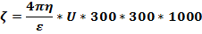
α/[Ѵ/L]
Where
ζ= Zeta potential
η=Viscosity of solution
ε=Dielectric constant
U=Electrophoretic mobility
α=Speed of the particle (cm/sec)
V=Voltage and L=Distance of electrode
Table-2: Thumb Rule: Zeta potential ⁽⁵⁵⁾
Maximum agglomeration and precipitation | +3 to 0
Excellent agglomeration and precipitation | - 1 to – 4
Threshold agglomeration and precipitation | -5 to -10
Plateau of slight stability and few agglomeration | -21 to -30
Moderate stability and no agglomeration | -31 to -40
Good stability | - 41 to -50
Very good stability | -51 to - 60

Shape and surface morphology
Shape and surface morphology of nanoparticles was determined by Scanning Electron Microscopy. Small volume of nanoparticulate suspension was placed on an electron microscope brass stub. The stubs were placed briefly in a drier and then coated with gold in an ion sputter. Pictures of nanoparticles were taken by random scanning of the stub. The shape and surface morphology of the nanoparticles was determined from the photomicrographs of each batch.
In Vitro Drug Release Study⁽¹¹⁾

Dissolution media & Volume optimization

Sink condition and saturation solubility of paclitaxel was determined by adding weighed quantity of API to 50mL Phosphate Buffered Saline with various amounts of polysorbate 80 [2%, 4% and 6%] and mixed thoroughly for 60 minutes. Suspensions were allowed to saturate for 48 hours at room temperature. Samples were collected by filtration and analyzed at 227nm by UV Visible spectrophotometer.
Maximum Dissolvable Dose = V *C_{S} / Sink
Modified diffusion apparatus for In vitro release
The in vitro release of formulations was carried out by membrane diffusion technique using dialysis sack of Molecular weight cutoff 1000. Membrane was soaked in water for 30minutes to remove traces of preservative an tied to one end of the glass test tube which constituted donor compartment. 2ml of the formulation was transferred to donor compartment and placed into receptor compartment of 400mL of Phosphate Buffer saline at pH 7.4 with 6% polysorbate80 maintained at a temperature of 37°C and rotated at 300rpm using a magnetic stir bar. At specified time points the samples were collected and replaced with fresh buffer immediately after sampling. These samples were filtered through 0.45μm membrane filter and analyzed spectrophotometrically at 227 nm after suitable dilution if necessary using appropriate blank.

RESULTS AND DISCUSSION
Preformulation Studies
Drug solubility
Paclitaxel was found to be insoluble in water, soluble in ethanol, dichloromethane and DMSO (dimethyl sulphoxide). A comparative profile of the drug solubility in these solvents is shown in Fig. 1
Table-3: Solubility of Drug in Different Solvents
S. NO. | SOLVENTS | SOLUBILITY[mg/mL]
1 | NMP | 15
2 | Ethanol | 22
3 | PEG | 30
4 | DMSO | 35
5 | Propylene glycol | 0.5
6 | Soy bean oil | 0.5
7 | Water | 0.1
8 | Acetonitrile | 26
9 | Tertiary Butanol | 5
10 | Dichloromethane | 22
11 | Isopropyl alcohol | 15

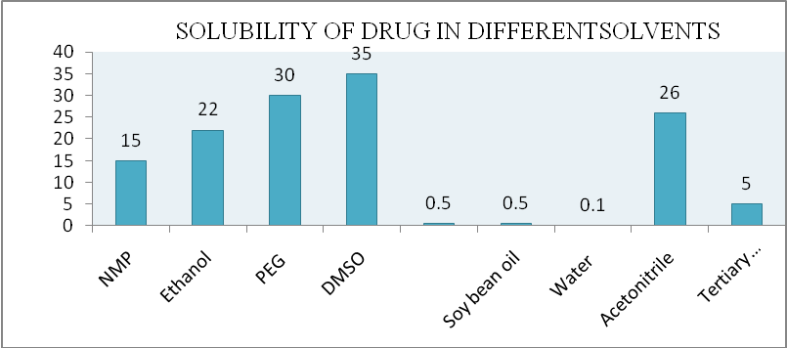
Fig.-1: Solubility Graph of Paclitaxel
As seen in the Table-3, it is clear that the solubility of paclitaxel was highest in DMSO and lowest in water.
Drug excipient compatibility studies
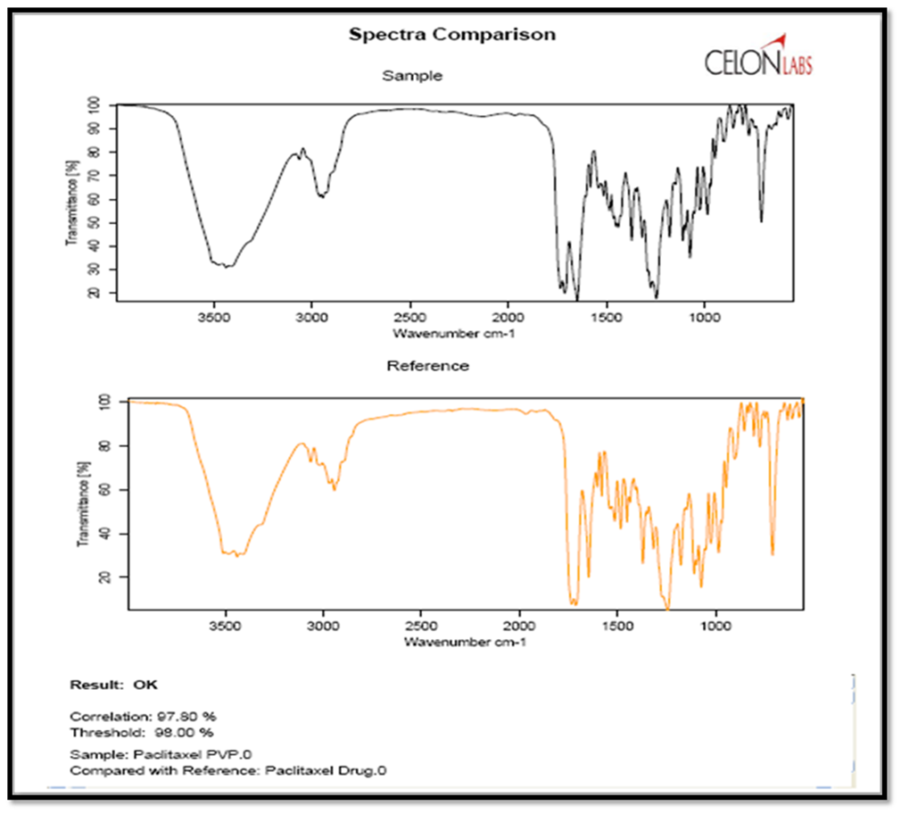
As part of the compatibility studies, FTIR studies were performed. The FTIR spectra are shown in Fig 2. The FTIR studies of pure drug and stabilizer PVP was carried out to detect any major interference between drug and PVP using FTIR (Bruker Corporation).

Fig-2: FTIR studies of pure drug and pure drug with PVP
As seen in the spectra, the physical mixture did not show significant change compared to pure drug. Correlation between the physical mixture and pure drug is more than 98%.
Partition coefficient
The partition coefficient of Paclitaxel was performed in four different solvent systems and the results were shown in the Table-4
Table-4: Partition Coefficient of Paclitaxel
Solvent system | Solvent | Diluted with | Absorbance | Concentration mg/mL | K | Log p
Octanol-water | Octanol | IPA | 0.915 | 98.78 | 461.40 | 2.66
Octanol-water | Water | PBS | 0.118 | 0.216 | 461.40 | 2.66
DCM –water | DCM | IPA | 0.160 | 320 | 612.66 | 2.91
DCM –water | Water | PBS | 0.090 | 0.428 | 612.66 | 2.91
Hexane-water | Hexane | IPA | 0.906 | 101 | 105.7 | 3.02
Hexane-water | Water | PBS | 0.040 | 0.190 | 105.7 | 3.02
Oleyl alcohol-water | Oleyl alcohol | IPA | 0.50 | 111.1 | 271.0 | 3.43
Oleyl alcohol-water | Water | PBS | 0.088 | 0.41 | 271.0 | 3.43

The results of log P values indicate high lipophilicity of Paclitaxel.
Standard calibration curve in Isopropyl alcohol
Spectrophotometric measurements of different dilutions in Isopropyl alcohol are shown in Table-5. The curve was found to be linear in the range of 4- 20µg/ ml at 227 nm with slope 0.046 and regression value 0.998 as shown in Fig-3.
Table-5 Absorbance values of Paclitaxel in Isopropyl alcohol
CONCENTRATION (µg/ml) | ABSORBANCE (227nm)
0 | 0
4 | 0.194
8 | 0.397
12 | 0.548
16 | 0.732
20 | 0.914
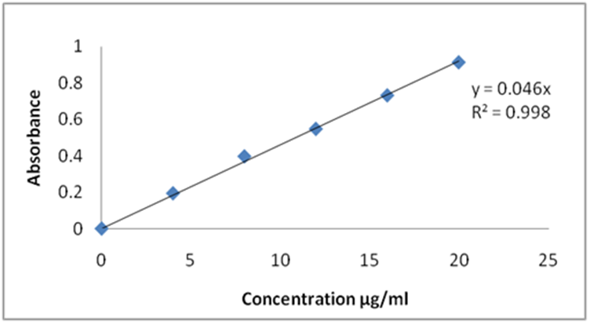

Fig.-3: Standard graph in Isopropyl alcohol

The concentrations of Paclitaxel and the corresponding absorbance values are shown in the Table-6. Plot of concentration versus absorbance is shown in Fig-4. The solutions obeyed Beer-Lambert’s law over a concentration range of 5 to 45µg/ml with a regression coefficient of 0.999.
Table-6: Data for Standard Graph of Paclitaxel in 7.4 pH Phosphate Buffer
Concentration (µg/mL) | Absorbance at 227nm
5 | 0.157
10 | 0.26
15 | 0.37
20 | 0.49
25 | 0.576
30 | 0.68
35 | 0.782
40 | 0.885
45 | 0.979

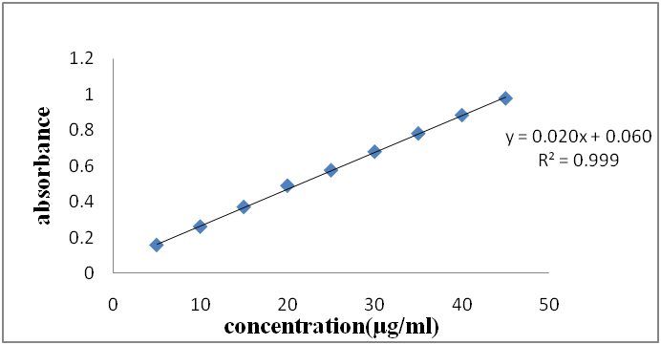

Fig.-4: Standard graph in Phosphate Buffered saline 7.4 pH
CHARACTERIZATION OF PACLITAXEL NANOCRYSTAL FORMULATION
Description, Color, pH
All the formulations of Paclitaxel Nanocrystals were evaluated for their physical description characteristics.
Table-7: Description, Color, pH, Microscopy of Formulations
S. No. | Concentration | Formulation code | Stabilizer | Molar ratio | pH | Type of crystals | Description
 | 10mg/mL | F1 | PVP | 1:1 | 4.67 | Spherical shaped crystals | A clear colorless solution
 | 10mg/mL | F2 | PVP | 1:2 | 4.6 | Spherical shaped crystals | A clear colorless solution
 | 10mg/mL | F3 | PVP | 1:4 | 4.6 | Spherical shaped crystals | A clear colorless solution
 | 10mg/mL | F5 | PVP | 1:8 | 4.7 | Spherical shaped crystals | A clear colorless solution

MICROSCOPIC STUDIES
The morphology of PVP based nanocrystals was observed using Compound Inverted Microscope [Motic Instrument, Canada]. The morphological characterization was shown in Fig 5.
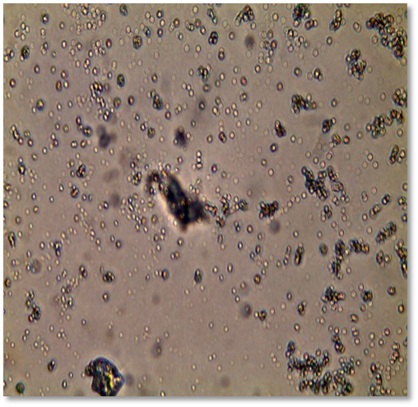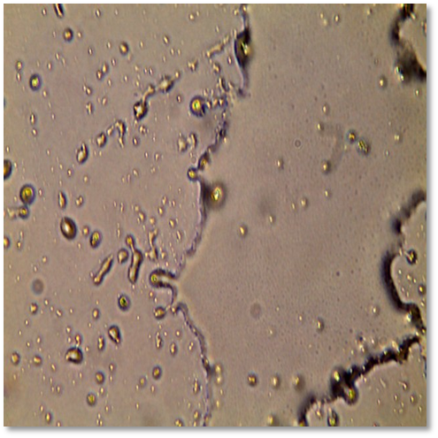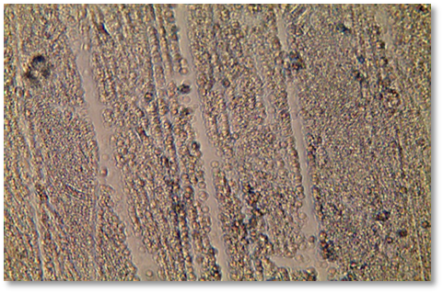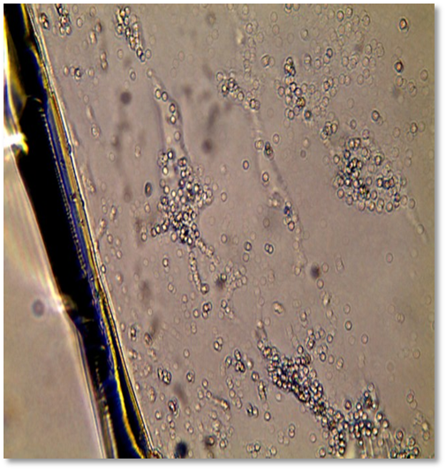
1:1
1:2
1:10
1:4
Fig.-5: Microscopic Images Different Molar Ratios of PVP Formulations

In case of 1:1, the shape of the crystals was found to be spherical and the size was very small. In 1:2 preparations, large sized crystals were observed but the shape was not uniform. In 1:4 preparations, the crystals were found to be layered and 1:10 preparation aggregation was observed.
PARTICLE SIZE DISTRIBUTION
NANOCRYSTAL FORMULATION USING PVP
Particle size of all formulations was found to be in the nanometer range. The particle size data is shown in Table-8.
Table-8 Particle Size of PVP Stabilized Formulations
Particle size | Molar ratio [PVP]
Particle size | 1:1[F1] | 1:2[F2] | 1:4[F3] | 1:10[F4]
D₁₀ | 40nm | 40nm | 57nm | 80nm
D₅₀ | 65nm | 100 nm | 120nm | 125nm
D₉₀ | 78nm | 200nm | 426nm | 500nm
D _{avg} | 71 nm | 120nm | 160 nm | 212nm
PDI | 0.200 | 0.380 | 0.800 | 0.910

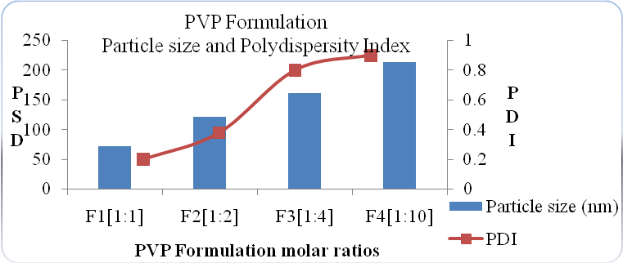
Fig-6: Graphical Representation of Particle Size and PDI Data of PVP Based Formulations

All the formulations showed nanosized particles as seen in Table-8. The size of Paclitaxel Nanocrystals in this study ranged between 71 and 212nm. The particle size of different molar ratios was found to be in the following order F1 [1:1] <F2[1:2]<F3[1:4]< F4[1:10]. Major difference in particle size data was observed in F1 and F2 formulations. As the distribution ratio increased from 1:1 to 1:2, the average size of preparations increased significantly from 71nm to 120nm. As higher concentration of the stabilizer did not yield lower particle sizes, the optimum drug:stabilizer ratio was found to be 1:1.
SHAPE AND MORPHOLOGY
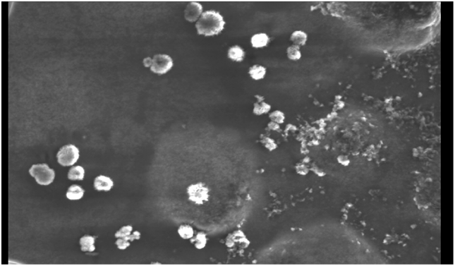
Particles of various formulated batches are found to be spherical rough surfaces, which may be due to the surface deposition of drugs. The photomicrographs are shown below.

Fig.-7: Surface Morphology of Optimized Formulations by SEM
RELEASE KINETICS
The Zero order cumulative % drug release data of various Paclitaxel nanocrystal formulations is shown in the Table-9. As the ‘n’ value is found to be greater than one, so release mechanism may be assumed to be following super-case II transport.
Table-9: Zero Order Release Profile of Optimized formulations
Time in hours | Cumulative % drug release
0 | 0
6 | 39
12 | 59
24 | 70
30 | 76
36 | 80
48 | 89
54 | 95
60 | 95
72 | 98

Table-10: Regression coefficient and diffusion coefficient values
Formulation | Zero Order | First Order | Higuchi | Korsemeyer Peppas
Formulation | R² | R² | R² | R² | N
PVP[F10] | 0.908 | 0.964 | 0.916 | 0.916 | 1.229

ASSAY AND DEGRADATION PRODUCTS:
Assay for four optimized formulations was performed by gradient HPLC method and the results are reported in the Table-11.
Table-11 Assay of Paclitaxel Nanocrystals
Test parameter | Limit | Observed value
Assay of Paclitaxel | 90.0%-110.0% | 99.5%
Any other impurity | NMT 1.0% | 0.6%
Total Impurities | 2.0% | 1.0%
SYRINGEABILITY AND INJECTABILITY
Diluted suspensions of four formulations were evaluated for their syringeability and injectability properties. All the formulations passed freely through the different needle sizes.
STERILITY TESTING
The sterility test was conducted according to the USP XXIII method. No microbial growth was observed after incubation for 14days and the preparation was found to be sterile.
STABILITY STUDIES
Parenteral nanocrystal optimized formulations were kept at accelerated stability at 40⁰C±2⁰C/75%±5% RH. It was observed that there was no change in the physical appearance of the formulation during the stability. Formulation remained clear and colorless solution at the end of stability. The pH of the formulation remained unchanged during stability. Assay and related substances shown gradual increase in however the product complied with specifications.
CONCLUSION:
The present study was to increase the bioavailability and improve therapeutic activity of tumor targeting. Paclitaxel was the drug of our choice. Paclitaxel nanocrystals were successfully formulated using different types of stabilizers and polymer by nanoprecipitation method. No drug-polymer interactions were seen when the drug was formulated. The prepared nanocrystals were characterized for particle size, Zeta-potential and surface morphology and evaluated for in-vitro drug release. The mean particle size of formulation was found to be 17.7nm and 250nm respectively. Zeta potential was found to be -32mV indicating the stability of Nanocrystals. From the particle size analysis, four formulations were optimized based on nano size and zetapotential. In vitro drug release studies were conducted for optimized formulations by using dialysis sac method. The formulations exhibited burst release formulation showed prolonged drug release upto 72hrs. All the formulations could pass freely through the needle size of 13 mm and showed different levels of redispersibility at different time intervals. The formulations F1, F7, F11 and F15 were found to be stable following accelerated stability studies at 40°C±2°C/75±5% RH for 3months. The nanocrystals were found to be stable at stabilizer concentration of 1:4 molar ratio of drug:stabilizer.
REFERENCES:
- Lipinski, Christopher. (2002). Poor aqueous solubility - An industry wide problem in drug discovery. American Pharmaceutical Review. 5. 82-85.
- Stella, Valentino & Borchardt, Ronald & Hageman, Michael & Oliyai, Reza & Maag, Hans & Tilley, Jefferson. (2007). Prodrugs: Challenges and Rewards Part 1. 10.1007/978-0-387-49785-3.
- Kerns, Edward & Di, Li. (2008). Drug-Like Properties: Concept, Structure Design and Methods, From ADME to Toxicity Optimization. 10.1016/B978-012369520-8.50003-6.
- Paclitaxel USP Paclitaxel Injection USP United States Pharmacopeia - National Formulary (34th ed., p.4195-98). United States Pharmacopeial Convention.
- Test No.-105:Water solubility, OECD Guideline for The Testing of Chemicals, 27.07.1995
- Ketkee S Jinnawar and Krishna R Gupta. Drug excipient compatibility study using thermal and non thermal methods of analysis. International Journal of Chemtech Applications 2013; 2 (2): 23-49.
- Test No.123: Partition Coefficient (1-Octanol/Water): Slow-Stirring Method, OECD Guideline for The Testing of Chemicals. 11.07.2006.
- Description and Solubility, United States Pharmacopeia - National Formulary (34th ed.). United States Pharmacopeial Convention.
- Einstein, A. Ann. der Physik 1905;17: 549.
- RJ Hunter. Zeta Potential in Colloid Science: Principles and Applications, Academic Press, New York, 1981.
- Rohrs, Brian. (2001). Dissolution Method Development for Poorly Soluble Compounds. Dissolution Technologies. 8. 6-12. 10.14227/DT080301P6.
- Danhier F, Lecouturier N, Vroman B, Jérôme C, Marchand-Brynaert J, et al. Paclitaxel-loaded PEGylated PLGA-based nanoparticles: in vitro and in vivo evaluation. J Control Release. 2009;133:11–17
- Jin C, Wu H, Liu J, Bai L, Guo G. The effect of paclitaxel-loaded nanoparticles with radiation on hypoxic MCF-7 cells. J Clin Pharm Ther. 2007; 32:41–47
- Chakravarthi SS, Robinson DH. Enhanced cellular association of paclitaxel delivered in chitosan-PLGA particles. Int J Pharm. 2011; 409:111–120
- Vandervoort J, Ludwig A. Biocompatible stabilizers in the preparation of PLGA nanoparticles: a factorial design study. Int J Pharm. 2002; 238:77–92.

