AN OVERVIEW – DIABETIC NEUROPATHY

Introduction

The Disease Diabetic neuropathy (DN) are diversified, influencing different sections of the nervous system that present with various clinical manifestations.
The disease belongs a family of nerve disorders which is due to diaabetic patients. Diabetes patients can start to destruction the nerves all over the body.Some of the patients shows no symptoms with nerve damage.Other patients may show most ordinary symptoms like- pain, tingling, numbness, a burning feeling, cramps,weakness and fail of feelings in the upper and lower limbs.
This disease is a serious complication that may affect as numerous as 50% of diabetes people. Patients can prevent their disease naturally by eat a healthy diet that involves a healthy food especially fruits,vegetables and grains.

1.1 Definition and Risk factors:

The diabetic neuropathy is also k/n as Diabetic nerve damage that can occur with diabetes people. Nerves are present in the form of bundles with particular tissues that transfer signals between the brain and the other parts which are present in our body. The signals mail the information about how the things feel, move your body parts, control body functions like digestion.

The vulnerable factors includes many following factors-
i)Poor blood sugar control.
ii)Diabetes history.
iii)Kidney Disease.
iv)Smoking.
v)Being overweight.

1.2 Diabetic Neuropathy classification:

S.No. | Classification of Diabetes Neuropathy | Symptoms of Diabetes Neuropathy | Diagnosis
1. | Peripheral Neuropathy | - numbness or unkind to pain.  - a tingling and burning.  - sharp pains  - extreme sensitivity to touch  - Balance loss and coordination | - Diagnosis is based on the signs and a physical examination  - Firstly, the doctors measure the blood pressure, heart rate, muscle strength, reflexes, and sensitivity to position changes, vibration, temperature, or light touch.  - With the help of comprehensive foot examine estimate the skin, muscles, bones, circulation, and sensation of the feet.  - By temperature perception or use a tuning fork, which is more sensitive than touch pressure, to assess vibration perception.
2. | Autonomic Neuropathy | - Heart- Nerves are damage which control heartrate.  - Stomach-constipation and Gastroparesismakes the level of glucose fluctuate, swallowing difficulty and uncontrolled diarrhoea.  - Bladder and Sex organs- urinary tract infections, the sexual response is low in both males and females.  - Sweat glands-start sweating at night.  - Eyes- the responsive is low with changes in light.
3. | Proximal neuropathy | - Start discomfort in the highs,legs and hips.  - legs weak.  - feeling difficulty in changing the position.
4. | Focal neuropathy | Difficulty in eyes.  - Double vision.  Causes strain in the bottom back or pelvis.  - Discomfort in the thigh, chest, stomach, or side  - Pain on the outside of the shin or inside of the foot  - Chest or abdominal pain that is sometimes inaccurate for heart disease, a heart attack, or appendicitis

Nerve damage signs and symptoms-
- Numbness and tingling in the legs,hands,arms,toes and fingers.
- indigestion, nausea, or vomiting
- diarrhoea or constipation
- dizziness or faintness
- problems with urination
dysfunction in men or vaginal dryness in women
- fatique.

Classification of diabetic neuropathy (DN) are –
Each neuropathy affects many segments present in the body in different manner.

- Peripheral neuropathy- It is the first and greater type of diabetic neuropathy (DN).The ordinary symptoms are pain and absence of sense in the feet,legs, toes,hands and arms.
- Autonomic neuropathy- This neuropathy develops changes in the procedure of digestion, sexual response and perspiration. It control hypertension and nerves which are present in the lungs and eyes. It can effect hypoglycaemia ignorance, a state in which people no longer experience the warning mark of less blood glucose levels.
- Proximal neuropathy-It mainly causes suffering from the hips,thighs or buttocks and leads to leg weakness.
- Focal neuropathy- It develops sudden deficiency in the nerves and causes muscle weakness and pain.

Peripheral Neuropathy
Peripheral neuropathy, also k/n as distal symmetric neuropathy or sensorimotor neuropathy, is damaging the nerves which are present in the legs and arms. Our arms and hands are less affected than feet and legs. Many diabetes patients shows the signs of neuropathy that only doctor could observe.
Symptoms:
- numbness
- a tingling and burning.
- cramps
- extreme sensitivity to light touch
- coordination
It may also cause muscles weakness, damage of reflexes, mainly at the ankle.

If foot injuries are not treated on time, the infection may transmit to the bone, and the foot may then have to be amputated.

Autonomic Neuropathy
This neuropathy can alter the nerves that regulate the heart, blood pressure, and control the level of blood glucose. It can more affect the internal organs, which causes trouble in digestion, function of respiration, urination, sexual reaction and vision. These system that restores the level of glucose to normal after a hypoglycaemic episode may be affected, resulting in loss of the warning symptoms of hypoglycaemia.
It mainly alter the nerves which is present in our heart, intestines, bladder, sex organs,stomach, sweat glands, eyes, and lungs.

Autonomic Neuropathy alter the following systems:

- Hypoglycaemia Unawareness-Normally, the signs are shakiness, sweating, and palpitations occur when the level of blood glucose drop under 70 mg/dL.
- Blood Vessels and Heart- Both the organs belongs to the cardiovascular system, which controls the blood circulation.It damages the nerves which interferes the body ability to modify the hypertension and heart rate.As a result, blood pressure shows some sharply changes after placed or standing, causing a person to feel light-headed or even to faint.
- Digestive System- This system nerves damages and the most commonly cause is constipation. Damage can also effect the stomach to empty too slowly, a condition known as gastroparesis. Severe gastroparesis can cause nausea, bloating, and loss of appetite. Due to abnormal food digestion.,gastroparesis may also make the level of glucose fluctuate very widely.
- Urinary Tract and Sex Organs-It often may affects the organs that control urination and sexual function. When the nerves present in the bladder are damaged, urinary incontinence may result because sometimes person are not capable to sense when the bladder is full or control the muscles that release urine.
- Sweat Gland- This gland can also alter the nerve fibre that regulates sweating. When the damaging nerves stop the sweat glands, the body can not control its temperature. Nerve damage can also cause sweating while eating or at night.
- Eyes- It can alter the pupils of the eyes, and the reaction is very low with changes in light. Thats why, a person may be not capable to see clear when a light is turned on in a black room.

Proximal Neuropathy
This neuropathy is also k/n as lumbosacral plexus neuropathy, femoral neuropathy, or diabetic amyotrophy.The common symptoms are- discomfort in the thighs, hips, buttocks, or legs. This neuropathy is more common.It causes deficiency in the legs and feeling the difficulty from changing the positions without help.

Focal Neuropathy
This neuropathy alter a nerve or group of nerves and causes sudden pain or weakness. It can guide to focus in the eye, double vision, aching in one eye, paralysis on one side of the face, known as Bell’s palsy,discomfort in the pelvis and in the forepart of a thigh, and in the chest, stomach, or side, pain on the inside of the foot, chest or abdominal pain that is sometimes inaccurate for heart disease, a heart attack, or appendicitis.
The causes of focal neuropathy are- high blood glucose, and the high level of fats like triglycerides, which is present in the plasma from diabetes patients can harm your nerve fibre and the blood vessels which are small.
There are some ordinary classification of pain are-
Acute pain,Chronic pain,Radicular pain,Neuropathic pain and Nociceptive pain.
There are some examples which includes Carpal tunnel syndrome,which causes pain,numbness,tingling in your thumb,index finger and middle finger.

Diagnosis of Neuropathy:

Your health care provider can easily determine the disease by performing a physical exam and diagnose your symptoms and medical history. Providers basically checks your following points-
- Overall muscle strength and tone.
- Tendon reflexes.
- Sensitivity to touch,pain,temperature and vibration.
Along with the physical exam,your health provider may perform or order specific tests to help diagnose the disease such as:

i)Filament testing
ii)Sensory testing
iii)Electromyography
iv)Autonomic testing

Treatment of Neuropathy:

i)Urinary tract problems – Some drugs affect bladder function , so the health care person may recommended stopping or changing medications.Other methods including self-catheterization.

ii)Digestive problems – To relieve light symptoms of gastroparesis – indigestion,
nausea, more frequent meals may help.Diet changes and medications may help to relieve nausea,constipation and diarrhoea.

iii)Sexual dysfunction – Medications which are taken by mouth may improve sexual function in some men,but they are not safe and effective for everyone.

Self care:
-Maintain your Blood pressure undercontrol.
-Make healthy food choices.
-Be active everyday.
-Stop smoking.

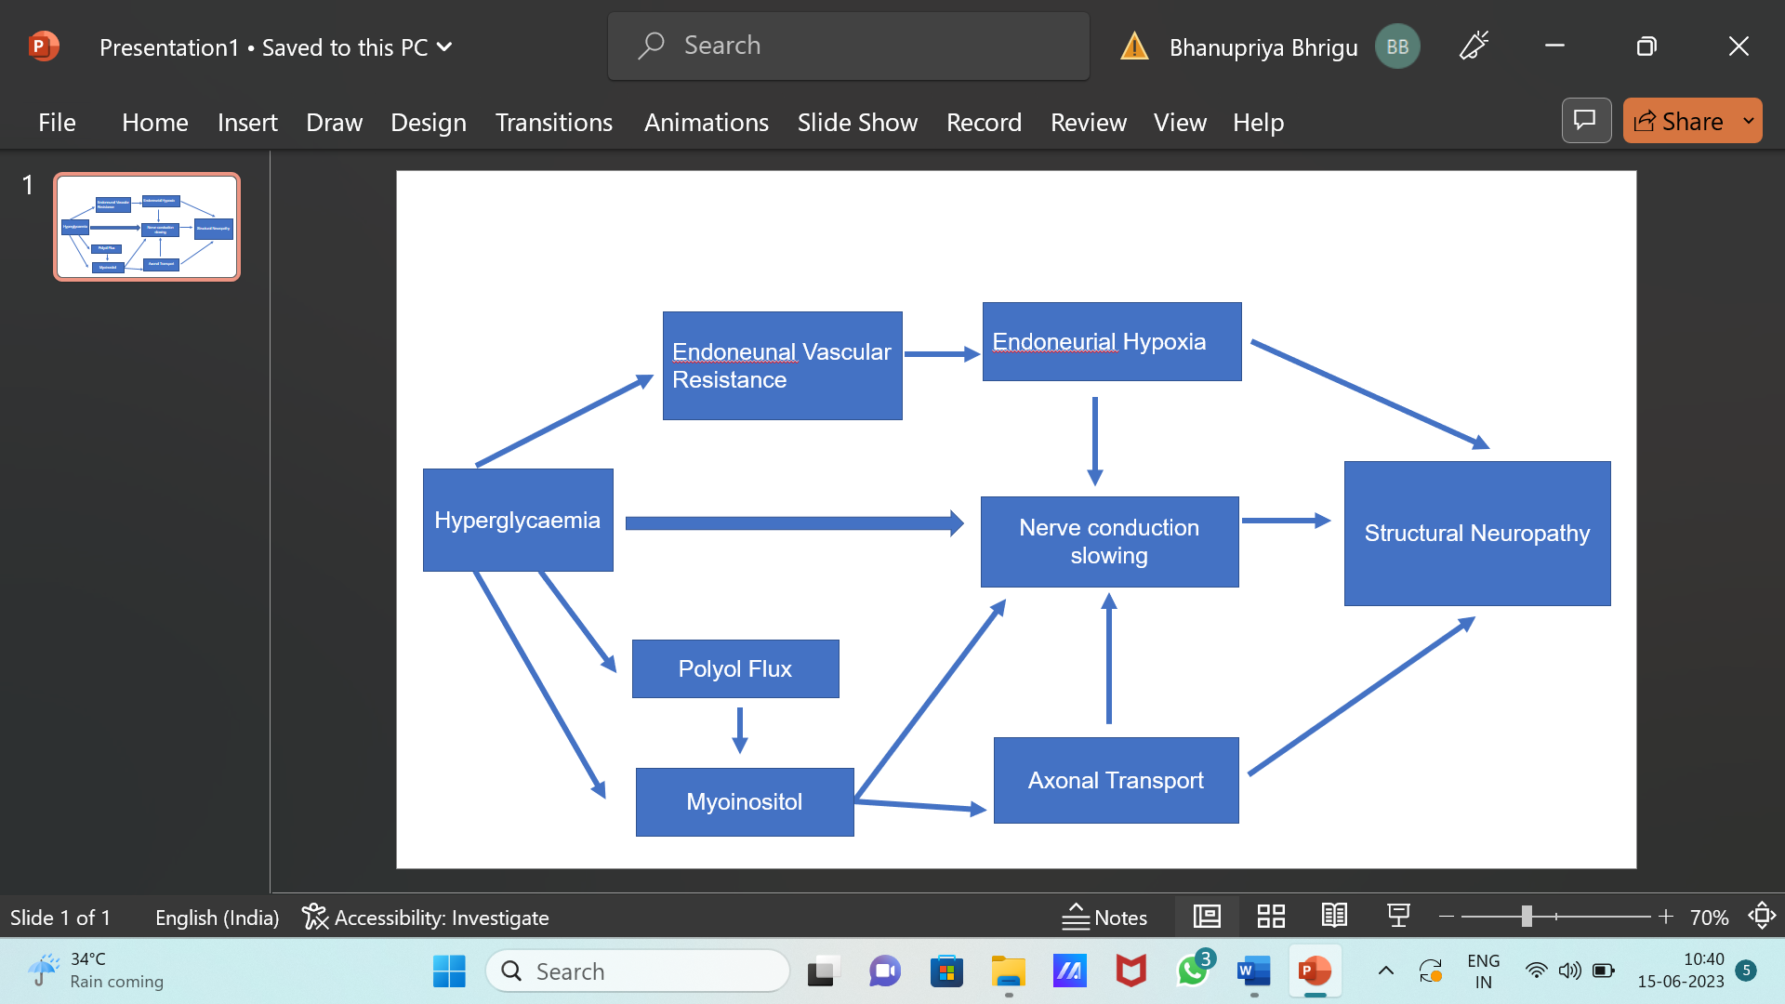

1.3 CURRENT TREATMENT OPTIONS

Duloxetine (Cymbalta)

(+) -(S)-N-Methyl-3-(naphthalene-1-yloxy)-3-(thiophen-2-yl) propan-1-amine

A drug is basically used for peripheral neuropathy and depression. The symptoms are – pain, numbness, tingling, burning or deficiency in the feet and hands that can occur with diabetes.
It may better your mood,sleep.appetite and energy level. The side effects of duloxetine are-

-Difficulty in sleeping.

-Feeling dizzy.

-Blurred vision.

-Diarrheoa and Feeling unwell.

Norpramin

3-(10,11-dihydro-5H-dibenzo[b,f]azepin-5-yl)-N-methylpropan-1-amine

Mitchell B et al 1990 use Desipramine has the low sedative effect and low anticholinergic effect of the first-generation tricyclic antidepressants. It is engaged by mouth and used to handle depression. May be it is not a first choice treatment because it shows many side effects like – confusion, drowsiness and problem in keeping balance.The normal adult dose is 100mg to 200mg per day.In more severely ill patients , dosage may be further increases gradually to 300mg\day if necessary.It may take two to three weeks for you to feel benefit of this medicine.The half life of norpramine is 7 to 65 hours, so limited of the concentartion in your body could be gone within as small as 7 hours.

Gabapentin (Gabantin)

1-(Amino methyl cyclohexane acetic acid)

Backonja Met al 1998 explained that it is a medication which is commonly called as a gamma aminobutyric acid analogue. It decreases the excitability of sensory cells which are present in the brain, plays a very beneficial role in transmission of pain signals and seizures.
The basic side effects are – Feeling sleepy, Diarrhoea, Mood swings, Dry mouth, Blurred vision and nausea.

Carbamazepine (Tegretol)

3, 5 Diamino-6-(2, 3 dichlorophenyl)-1, 2, 4 triazine

Wiffen PJet al2017 reviewed 10 studies involving 480 participants with Diabetic Polyneuropathy, trigeminal neuralgia, or post-stroke pain treated with carbamazepine.
The drug generally provided better short-term pain free in comparison with placebo in Diabetic Polyneuropathy patients, but the authors noted that the relevant studies has badly defined outcomes, incomplete reporting, and small numbers of participants.

Valproate sodium

2-propylpentanoic acid

Kochar DKet al 2004Two randomized, double-blind, placebo-controlled trials have evaluatedvalproate sodium in DPN patients. Firstly, the study of 116 52 patients received valproate sodium. The authorsreported significant improvements in the pain scores (SF-MPQ) of patients treated with valproate sodium compared with those givenplacebo (P < 0.05). It is mainly used to deal epilepsy and bipolar disorder. It is effective in mood and anxiety disorders which are shown.

Dextromethorphan

6-methoxy-11-methyl-1,3,4,9,10,10a-hexahydro-2H-10,4a-(epiminoethano)phenanthrene

Nelson KA et al 1997 conducted two randomized, double-blind, crossover studies of DXM in a total of31 DPN patients, who collect DXM ata mean dosage of 381 mg per day for six weeks. It is basically for temporaily relieve cough because of the upper respiratory tract infection, the flu or many other conditions.

Tramadol

2-[(Dimethylamino)methyl]-1-(3-methoxyphenyl) cyclohexano

The brand name is ultram among others,is an opioid pain medication used for moderate to moderely severe pain. It is basically used for the short-term relief pain. It should only be used when different forms of non-opioid can not treat successfully. It is a selective agonist of mu receptors and inhibits serotonin reuptake. The serious side effects are – feel dizzy, tired and have low energy. It usually 3 to 4 times a day. It can raise or lower the blood pressure.

PREVENTIVE CARE:
- The very first step is to avoid alcohol, improving vitamin deficiencies, eating a healthy diet, losing weight, avoid toxins and exercising regularly. You can stop diabetic neuropathy and its complications.
- Treatment of this neuropathy which is very painful with oral medications, although other types of treatments may help some people. People with severe nerve pain may advantage from a combination of medications or treatments.
- Mainly many of the medications shows side effects and some are not recommended for use in adults or those with heart disease. Treatments that are start from the skin typically to the feetinclude capsaicin cream and lidocaine patches.
- Eat a healthy diet that involves a collection of fresh fruits, vegetables and grains. Fixed portion sizes to help achieve or maintain a healthy weight. Be active and energetic everday. Do regular exercise which helps in lower the level of blood sugar,improves blood flow and keeps your heart safe and healthy.
- Lifestyle choices plays a very beneficial role to stop peripheral neuropathy. Treatments that involve electrical nerve stimulation, magnetic therapy, and laser or light therapy may be helpful but need further study. Researchers are also studying several new therapies in clinical trials.
- People with neuropathy give sometime for special care of their feet. Mainly the nerves of the feet. Circulation problems also increase the possibility of foot ulcers. Routine health care that cover screenings, check-ups and patients counseling to stop illness, disease or health related problems.

CONCLUSION
Limited of the lower-limb sever in the India held in with diabetes patients - 100,000 amputations per year. It is approximate that nearly half of the amputations which is due to neuropathy and poor circulation could be prevented by careful foot care. Numerous pharmacological treatments both approved and off-label have been used to decrease the pain of the diabetic patients and to improve patient’s lifestyle. These treatments include antidepressant, anticonvulsant, analgesic, topical medications and some are under clinical trials for management.

